L6 - Artificial Intelligence and Machine Learning (ACCA6011) – Assignment 1
Charlie Keirl (2103411)

Contents
Introduction 2
Dataset Overview 2
Data Preprocessing 3
Exploratory Data Analysis (EDA) 4
Model Building and Evaluation 7
Logistic Regression 8
Support Vector Machine 9
Comparing LR and SVM 9
SVM Hyperparameter Tuning 10
Conclusion 12
References 13
Appendix 13

Introduction
Customer churn (the loss of clients or customers) is a major challenge in the telecommunications industry [1]. Predicting churn enables businesses to identify at-risk customers and take actions to improve retention.
Within this assignment, we shall be analysing customer churn using the Telco Customer Churn dataset. Machine learning models, including Logistic Regression and Support Vector Machines (SVM), are used to classify customers as churned or non-churned based on features like demographics, account details and service usage.
Key steps include data cleaning, exploratory data analysis, and model evaluation using metrics such as accuracy, precision, recall, and F1-score. The goal is to provide insights into churn prediction and strategies to retain customers.

Dataset Overview
For this assignment, we used the Telco Customer Churn dataset, a dataset that tracks a set of fictional customers for a communications company [2]. It is usually used to analyse customer behaviour and for companies to then develop strategies to try and keep as many customers as possible [2]. The dataset includes both numerical and categorical features about thousands of customers that provide the user with insights into customer behaviour. Some of the features of this dataset include numerical (tenure months, monthly charges and total charges) and categorical (gender, dependants, services, contract information and churn variables).
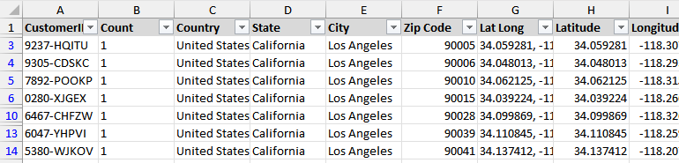
Within this dataset, there is the churn variable which in this case is set as 1 for a churned customer and a 0 for a retained one. This is then used for the prediction later on. However, some of the categories such as CustomerID were identified as irrelevant to this assignment and therefore is not considered within this assignment. The full data preprocessing will be discussed below.
Below is the code snippet used to load and view the first few rows of the dataset:
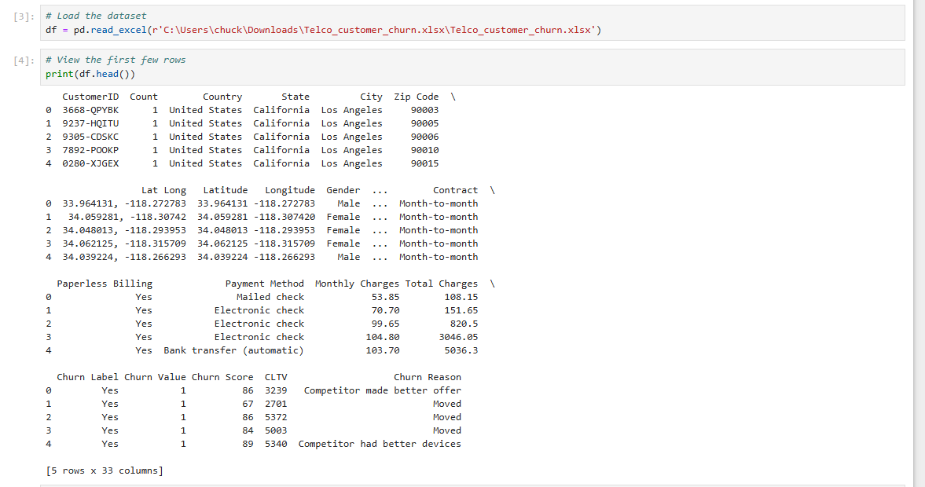

Data Preprocessing
Before we continued to perform the machine learning analysis, the dataset had to undergo some cleaning to ensure that any irrelevant features that would not usually contribute to predicting customer churn were not considered.
The features we removed were:
- CustomerID
- Count
- Country
- State
- City
- Zip Code
- Lat Long
- Latitude
- Longitude
The next change made was to the Total Charges column. This column, although expected to contain numerical values, also contained some non-numerical data. This was then handled by converting the whole column into numerical and then any missing values were replaced by taking the column mean and using that instead. This ensured that there would not be any issues with data handling later on.
For categorical values, such as Gender and Dependents, we used One-hot coding. One-hot coding is a technique that converts categorical data into a format that machine learning algorithms can use to improve predictions [3]. This essentially meant that we transformed those categorical features into numerical ones while also preserving the information they represented. Any binary columns (such as yes/no) were simply converted to 1 and 0. For any numerical value such as Tenure Months, Monthly Charges and Total Charges were standardised using a scaler so that they would be normalised. This ensured that any features on a different scale would not influence the model’s learning disproportionately.
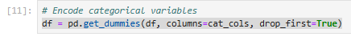
The dataset was then split into two different sets, a training set and a testing set with a 70:30 ratio split. This then ensured that the model would train and test on a balanced set. Any inconsistencies between the training and testing datasets were resolved by aligning their columns and missing columns in the test set and were filled with default values.
Below is the code used to drop any irrelevant columns as well as to separate the numerical from the categorical, convert Total Charges into numerical values and to handle any missing values in the dataset.
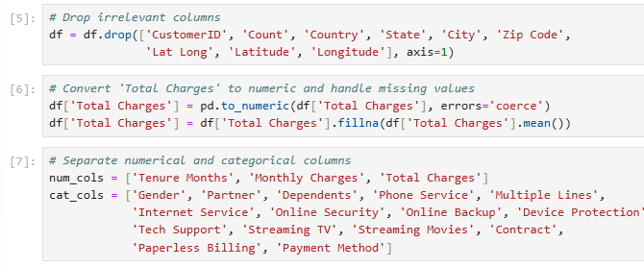
With all this preprocessing completed, the dataset was now clean and ready to be used for the Model’s learning.

Exploratory Data Analysis (EDA)
Within this part of the assignment, EDA was performed to gain any insights into the dataset and to understand any relationships that relate to customer churn between the different features. The features Tenure Months, Monthly Charges and Total Charges were summarised using histograms to show the distribution of customer behaviours, highlighting patterns of early churn, spending habits and revenue generation.
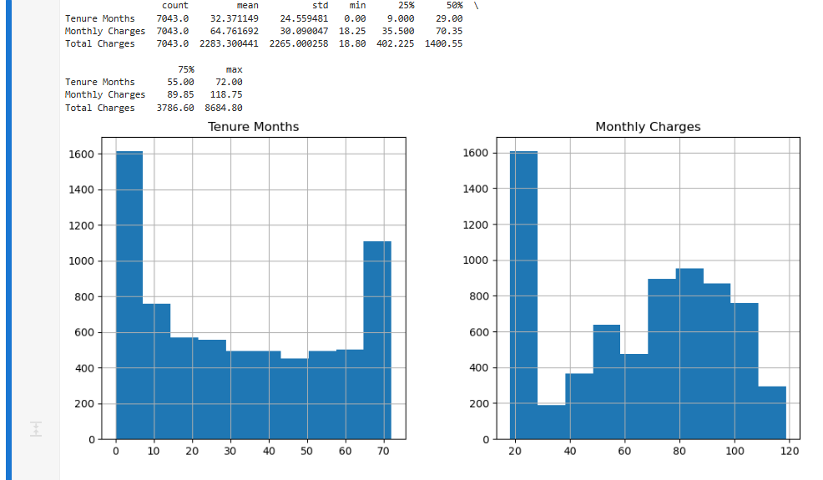
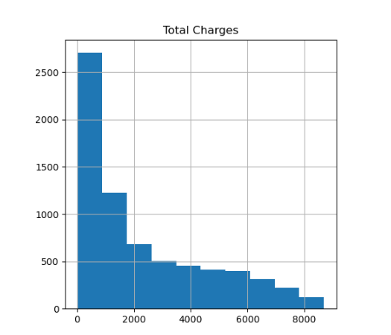
The Tenure Months histogram shows a significant number of customers with short tenures, indicating high churn early in the customer lifecycle, while long-term customers exhibit loyalty. Similarly, the Monthly Charges histogram reveals that most customers pay lower charges, with fewer opting for premium plans.
The Total Charges histogram complements this analysis by showing that most customers have relatively low total charges, clustering below £2000, with fewer accumulating higher amounts. This suggests that many customers churn early, before generating significant revenue. Together, these histograms can help highlight patterns where short-tenured, low-spending customers are more likely to leave. Businesses can use this information to develop targeted retention strategies, such as improving onboarding experiences, offering early-stage incentives, or creating tailored plans to encourage longer tenures and reduce churn.
The program also created some histograms for the categorical data and how it relates to customer churn. Below are a few examples of this, the rest can be found in the appendix.
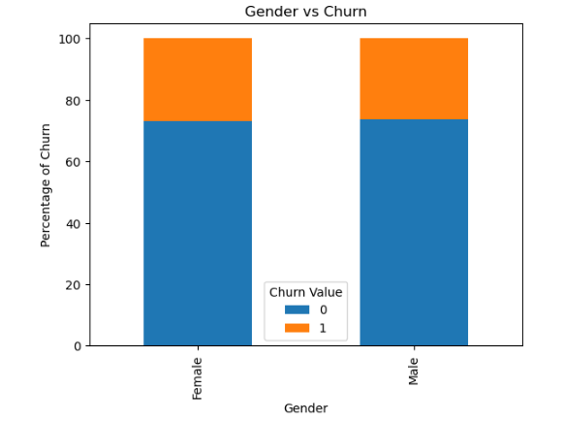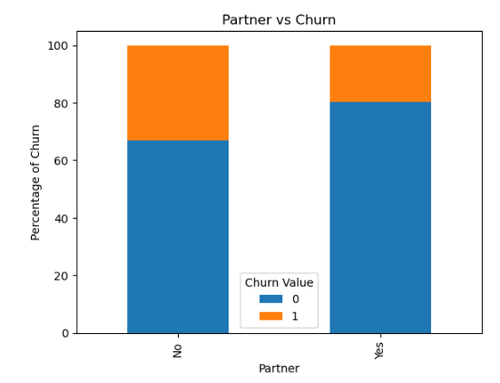
The Gender histogram shows similar churn rates for males and females, while the Partner and Dependents histograms reveal higher churn among customers without a partner or dependent, suggesting personal stability reduces churn. The Phone Service and Multiple Lines histograms show little impact, but the Internet Service histogram highlights higher churn among fibre optic users, possibly due to dissatisfaction.
The Streaming TV, Streaming Movies, Online Security, Online Backup, Device Protection and Tech Support histograms indicate that customers lacking these services are more likely to churn, emphasising the importance of bundled features. The Contract Type histogram shows that month-to-month customers churn more, while long-term contracts encourage retention. Lastly, the Paperless Billing and Payment Method histograms show higher churn among electronic check users and paperless billing customers, pointing to the value of traditional or flexible options.
Together, these histograms highlight the importance of personal stability, bundled services, longer contracts and customer preference in reducing churn and improving customer retention. Businesses can use these insights to target high-risk groups and enhance overall satisfaction.
Next, to analyse the relationships between numerical variables, a correlation heatmap was generated. This helps to highlights strong positive correlations, such as between Tenure Months and Total Charges, while also identifying weak or insignificant correlations, such as between Monthly Charges and Total Charges. These insights help understand how numerical factors may contribute to churn.
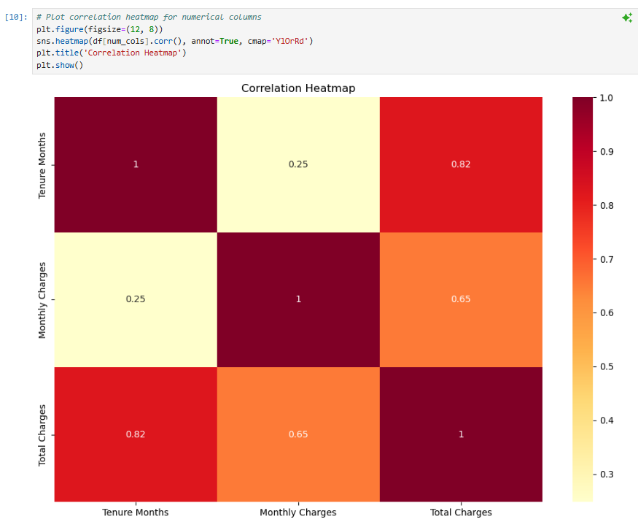
The correlation heatmap shows strong positive relationships between Tenure Months and Total Charges (0.82) and between Monthly Charges and Total Charges (0.65), indicating that longer tenures and higher monthly payments significantly contribute to total charges. However, the correlation between Tenure Months and Monthly Charges is weaker (0.25), suggesting that monthly charges are not heavily influenced by the length of tenure. This shows that total revenue is primarily driven by retaining customers for longer periods and encouraging higher monthly payments. Businesses can use this insight to focus on strategies that promote long-term customer loyalty and the adoption of higher-value plans to maximise their revenue income.

Model Building and Evaluation
For this assignment, two machine learning models were implemented: Logistic Regression and Support Vector Machines. The Logistic Regression algorithm is a commonly used classification algorithm that analyses the relationship between one or more variables and then classifies that data into discreet classes [4]. This was implemented to establish a baseline for churn prediction. The model was trained using the pre-processed dataset, which included the numerical features and the one-hot encoded categorical features.
Support Vector Machines were also implemented to explore their potential as a classifier for churn prediction. SVMs are effective in handling high-dimensional data and creating clear decision boundaries [5]. By training the SVM model on the same pre-processed dataset, this assignment aimed to compare its performance against Logistic Regression, particularly in handling the imbalanced nature of the churn dataset. This provided insights into the strengths and limitations of SVM for real-world customer churn prediction tasks. Both models were assessed based on performance metrics, confusion matrices and their ability to handle the imbalanced nature of the dataset.

Logistic Regression
The Logistic Regression model demonstrated strong performance in both training and testing. On the training data, it achieved an accuracy of 91% with balanced precision, recall, and F1-scores for both churn (1) and no-churn (0) classes. The confusion matrix highlighted that most predictions were correct, with a relatively small number of false positives and false negatives. While recall for churn cases was slightly lower (83%), the model showed good capability to capture churn cases while maintaining high accuracy overall.
Similarly, on the testing data, the model achieved an identical accuracy of 91%, indicating strong generalisation to unseen data. Precision and recall for churn cases were slightly lower than those for no-churn, but the overall metrics remained balanced. The confusion matrix backed this up, showing a manageable number of false positives and false negatives. Therefore, Logistic Regression proved to be effective and reliable for predicting churn.
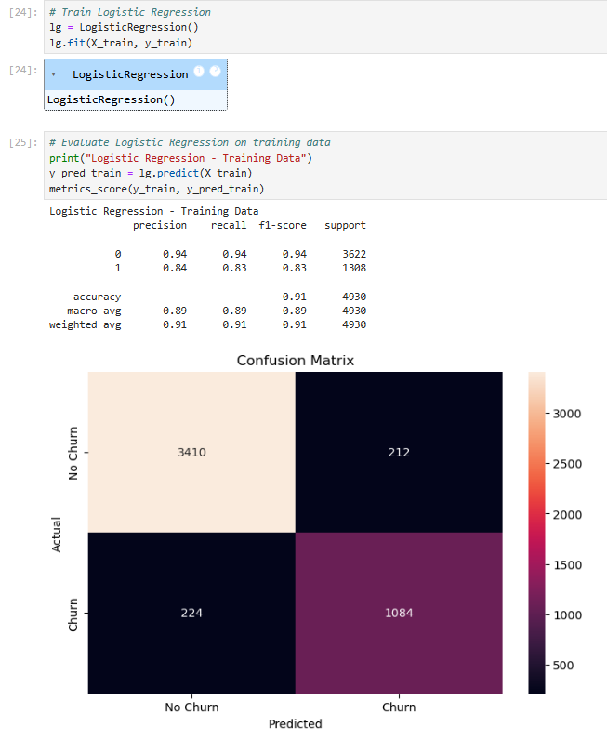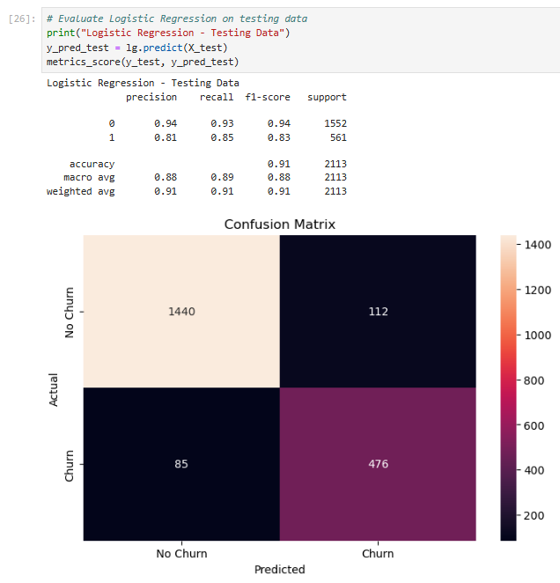

Support Vector Machine
The SVM model struggled significantly with this dataset. During training, it achieved an accuracy of 73%, but this was actually false, as the confusion matrix revealed that it completely failed to predict any churn cases. All actual churn cases were misclassified as no-churn, leading to zero precision, recall, and F1-scores for the churn class. The model showed a strong bias towards the majority class (no-churn).
This issue persisted during testing, where the model again achieved a 73% accuracy while failing to identify any churn cases. The confusion matrix showed identical behaviour to the training phase, with perfect recall for no-churn cases but complete neglect of churn cases. This consistent failure makes the SVM model unsuitable for churn prediction.
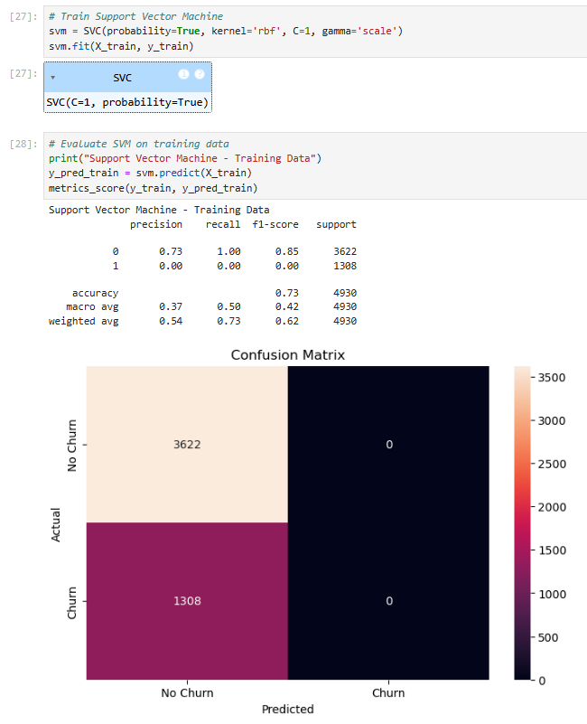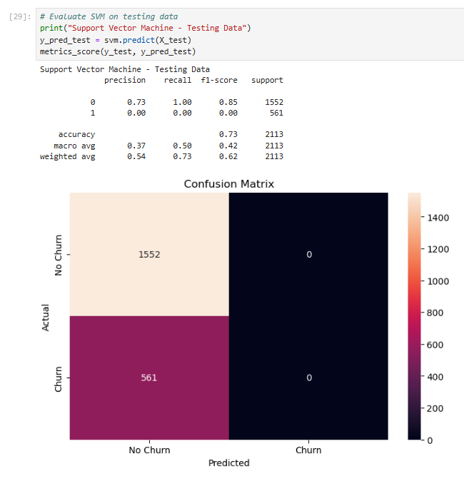

Comparing LR and SVM
When comparing the two models, Logistic Regression performed better in every area. It achieved balanced precision, recall, and F1-scores for both churn and no-churn cases, effectively identifying churn cases while maintaining high accuracy. In contrast, the untuned SVM failed to predict any churn cases, showing its inability to handle the imbalanced dataset.
Logistic Regression's strong performance on both training and testing data demonstrates its reliability and suitability for this task. On the other hand, the SVM model's bias towards the majority class highlights the need for class balancing techniques, hyperparameter tuning, or alternative approaches to improve its performance on imbalanced data.
Overall, Logistic Regression is the more reliable option for predicting customer churn, providing actionable results and generalising well to unseen data. The SVM model requires significant adjustments before it can be considered a viable alternative.

SVM Hyperparameter Tuning
Hyperparameter tuning is the process of optimising the parameters of a machine learning model that are not learned from the data but set before training, such as regularisation strength, kernel type, or learning rate. It aims to improve the model’s performance by finding the best combination of these parameters [6]. One common approach is grid search, which systematically evaluates all possible combinations of predefined hyperparameter values by training and validating the model on a subset of the data using cross-validation [7]. Each combination is tested and the one yielding the highest cross-validation score is selected as the optimal set of hyperparameters [7]. Grid search ensures a comprehensive exploration of the hyperparameter space, making it a powerful, though computationally expensive, technique for fine-tuning models.
Within my own model, the hyperparameter tuning process for the SVM model significantly improved its performance compared to the untuned version. The tuning involved a grid search with cross-validation to explore combinations of key hyperparameters, including C (regularisation strength), gamma (kernel coefficient), kernel type (linear and rbf) and class_weight (balanced to address class imbalance). Using a smaller subset of the training data for faster computational times, the grid search identified the optimal parameters as C=10, gamma='scale', kernel='linear', and class_weight='balanced'. This combination achieved a cross-validation score of 0.86, addressing the shortcomings of the untuned model.
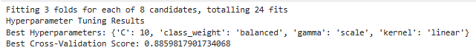
On the training data, the tuned SVM showed significant improvement, achieving 90% accuracy with a recall of 91% and precision of 75% for churn cases, resulting in an F1-score of 0.83. The confusion matrix revealed it correctly identified most churn cases, with only 113 false negatives compared to 1308 in the untuned model. This shows that the tuned model effectively addressed the bias towards the no-churn class, achieving a good balance between churn and no-churn predictions.
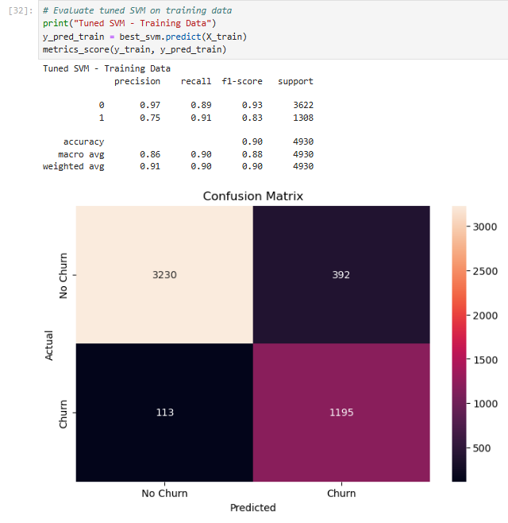
The tuned model also performed well on testing data, with an accuracy of 89%. For churn cases, it achieved a recall of 93%, precision of 74% and an F1-score of 0.82. The confusion matrix highlighted its ability to correctly predict 520 churn cases, a significant improvement from the untuned model, which failed to identify any. False negatives (41) and false positives (181) were greatly reduced, demonstrating balanced performance.
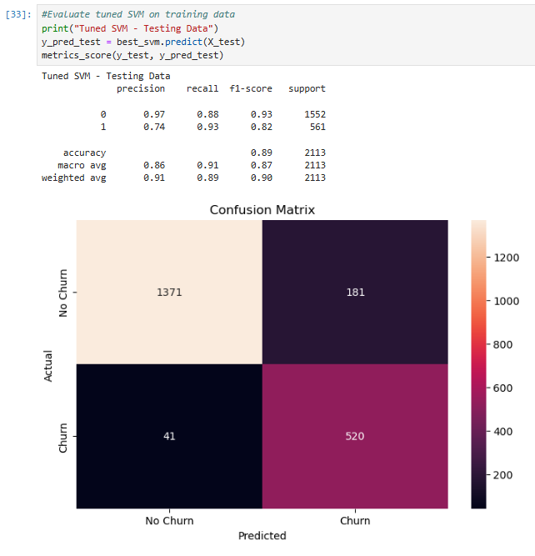
Compared to the untuned SVM, the tuned model showed significant improvements in performance and balance between classes. Using class_weight='balanced' was key to handling the class imbalance in the dataset, enabling the model to better identify churn cases. The linear kernel (kernel='linear') and higher regularisation strength (C=10) simplified the decision boundary, helping the model generalise better to new data.
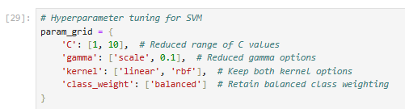
In conclusion, hyperparameter tuning transformed the SVM model from a classifier biased towards the majority class into a viable alternative to Logistic Regression. While the tuned model performs well on both training and testing data, its ability to balance the identification of churn and no-churn cases makes it a strong candidate for churn prediction.

Conclusion
This assignment focused on predicting customer churn using the Telco Customer Churn dataset. Data preprocessing cleaned the dataset by handling missing values, removing irrelevant features and addressing class imbalance. Exploratory Data Analysis provided insights into customer behaviours, highlighting factors like tenure and spending habits that impact churn.
Two models were then tested: Logistic Regression and Support Vector Machines (SVM). Logistic Regression performed well, achieving 91% accuracy on both training and testing data. It effectively predicted churn cases with balanced precision and recall.
The untuned SVM model struggled, failing to predict churn cases due to bias towards the majority class. After hyperparameter tuning, the SVM improved significantly, achieving 90% accuracy on training data and 89% on testing data, with better precision and recall for churn cases.
In conclusion, Logistic Regression was the most reliable model, while the tuned SVM showed it can also be a good option when properly optimised. This highlights the importance of data preparation and model tuning in predicting customer churn, especially when used within a business model.

References
[1] Anonymous . Customer Churn: Definition, Measurement & Prevention. Available: https://www.qualtrics.com/en-gb/experience-management/customer/customer-churn/.
[2] Anonymous (-10-11). IBM Cognos Analytics 11.1.x. Available: https://www.ibm.com/docs/en/cognos-analytics/11.1.0?topic=samples-telco-customer-churn.
[3] Anonymous . Data Science in 5 Minutes: What is One Hot Encoding?. Available: https://www.educative.io/blog/one-hot-encoding.
[4] Anonymous Anonymous Everything you need to know about logistic regression - spiceworks. Everything you need to know about logistic regression - spiceworks. Available: https://www.spiceworks.com/tech/artificial-intelligence/articles/what-is-logistic-regression/.
[5] Anonymous (-01-20T13:39:14+00:00). Support Vector Machine (SVM) Algorithm. Available: https://www.geeksforgeeks.org/support-vector-machine-algorithm/.
[6] Anonymous . What is Hyperparameter Tuning?. Available: https://www.anyscale.com/blog/what-is-hyperparameter-tuning.
[7] Anonymous (-07-05T19:45:42+00:00). SVM Hyperparameter Tuning using GridSearchCV | ML. Available: https://www.geeksforgeeks.org/svm-hyperparameter-tuning-using-gridsearchcv-ml/.

Appendix


