

INTERNATIONAL BUSINESS

Student Name: JOEL BINASH
Student Id: 2237045
Module: LCMB7014
Lecturer: DR. JAYALAKSHMI GOPALKRISHNAN

Table of Contents
Introduction 3
Impact of globalization 3
Cross-cultural issues in international business 6
Macro and micro factors of the international market 9
Global and potential value chain configuration and coordination challenges 19
Market’s entry mode 22
International strategy by Tesco in the global market 24
Reflection on Tesco’s ethical policies and sustainability practices 26
Recommendations 27
Conclusion 29
Reference list 30

Introduction
With operations spanning over a dozen countries, Tesco PLC has emerged as a prominent global retailer utilizing a strategic internationalization approach. However, to strengthen its position as a socially responsible organization and mitigate risks in diverse markets, certain enhancements can be made. This report evaluates Tesco's global expansion strategy and makes targeted recommendations centered around standardizing ethics, enhancing supply chain due diligence, prioritizing transparency, accelerating sustainable investments, and providing cultural competency training. Adopting these measures would foster consistency in Tesco's operations worldwide, build stakeholder trust, and respond to the growing consumer expectation for environmentally-friendly and equitable practices globally. The following analysis explores these recommendations in depth to support Tesco's continued success on the international stage.

Impact of globalization
Globalization has significantly impacted Tesco PLC's operations, offering both benefits and challenges. One of the key advantages is the high market share the company has achieved through its global expansion. Operating in 13 countries and with 65% of its business outside the UK, Tesco has leveraged technological innovations emerging from its international subsidiaries to capture a substantial market share. The use of intra-firm networks and face-to-face transmissions has facilitated knowledge transfer across borders, enabling Tesco to adapt its organizational structure and operating skills to diverse markets (totalassignmenthelp.com, 2023).
Technological advancements have played a crucial role in Tesco's success on the global stage. The company's adoption of innovative technologies and the internet has allowed it to operate as the largest online grocer worldwide, reaching three billion customers across 13 countries. An perfect example of Tesco's skill in using technology to interact with clients is the transport of 6,000,000 enlistment cards in South Korea.
One of the main reasons for Tesco's success is the opportunity for expansion that globalization has brought. The company has broadened its income, market share and productivity by penetrating new business areas through its globalization strategy. Right when Tesco wanders into new foreign countries, it can show up at expected likely clients and exploit of advancement prospects that presumably will not be as clear in its home market (HAO,2023).
Another way that globalization has helped Tesco is by opening up opportunities in HR. In order to vary its work power and offer creative viewpoints that may be valuable, the organization might exploit the global market. By investing in the growth of its employees and providing them with valuable opportunities to participate in return programs, Tesco may develop a workforce that is dynamic and competitive.
One critical benefit of Tesco's globalization plan is the valuable opportunities it presents for access to fresh funding. The company might help to a wide variety of funding options through its global operations, involving neighborhood and worldwide monetary supporters, capital business areas, and money related associations. Additional cash should be available, which mitigates financial restrictions that could obstruct company operations.
The globalization plan of Tesco, though, is not without its obstacles. The company faces significant challenges as cultural variety in obliging global clients' changing wants, needs, and propensities (Çiloğlu, 2021). Notwithstanding nearby and public governmental issues, extraordinary competitions and different showcasing foundations, Tesco stands up to macroeconomic circumstances on an global scale. Tesco must comprehend and resolve these issues if it wants to maintain and improve its worldwide success. While globalization has undoubtedly brought many advantages to Tesco, the company must master the difficulties it has brought in order to maintain its global operating success.
Several strategies have been implemented by Tesco in response to globalization:
International growth
Tesco has entered new markets in China, Eastern Europe, South Korea, and the United States.

Joint ventures
To reduce competition and pool resources, Tesco has partnered with regional businesses in joint ventures (Shin, 2020).

Global sourcing
The global supermarket chain Tesco keeps prices low by purchasing goods in bulk from throughout the world.

Human resources
In the realm of human resources, globalization has opened up several doors for Tesco.
In light of the recent shifts in the global marketplace, Tesco Plc has taken the following actions:
To develop abroad, Tesco has partnered with local shops in several countries and acquired them. This strategy allows the company to leverage local knowledge and expertise while maintaining its brand and core competencies.
Being sensitive to local expectations: Tesco has entered into joint ventures with local partners, such as Samsung Group in South Korea and Charoen Pokphand in Thailand.
Investing in lowering prices: Tesco has invested £200m on more than 1,000 lines.
Launching new products: Tesco has launched 2,100 new and improved products.
Introducing new partners: Tesco has introduced new partners to Clubcard Rewards, such as
London Aquarium and Disneyland Paris.
Investing in research and development: Tesco has invested heavily in the research and development process in the established markets.
Cross-cultural issues in international business

Components of culture
Power distribution
The hierarchical approach followed by the members of the business.
Social relationship
Individualism or collectivism method undertaken by the members in the business.
Environmental relationship
Exploiting the environment for the profit or striving in order to live in harmony.

Cross-cultural issues in International business

Inadequate trust
In international business the manager and the team members may be from different origins and therefore there will be language barriers (Brannen, 2020).

Perception
In international business when a company from a highly-developed country wants to collaborate with a company from a less-developed country. The Highly developed one may consider the other inferior.

Cultural Dimension |  | Tesco's Approach
Power Distance  (PDI) | Index | Tesco embraces a low power distance culture with a flatter organizational hierarchy. Decision-making is decentralized, compensation bands overlap, and power is delegated freely (Hensmans, 2022). The leadership style is charismatic, and there's minimal need for constant supervision due to trust in employees.
Individualism  Collectivism (IDV) | vs. | Tesco strikes a balance between individualism and collectivism. It values employee privacy, maintains work-life balance, and challenges individuals to foster creativity. Individual accomplishments are celebrated, and merit governs decisions, fostering a culture of honesty and transparency.
Masculinity  Femininity (MAS) | vs. | Tesco exhibits a low MAS score, promoting workplace equality. Job roles overlap between genders, and the culture is driven more by quality of life than monetary competition (Bonfrer et al., 2022). Success is achieved collaboratively, and gender role differentiation is actively discouraged.
Uncertainty Avoidance  Index (UAI) |  | Tesco leans towards lower uncertainty avoidance. It welcomes change, fosters open-ended learning and decision-making processes, and maintains a relaxed internal culture with a lower sense of urgency. The company is risk-taking and flexible, embracing innovation.
Long Term Orientation vs. Short Term Normative  Orientation (LTO) |  | Tesco operates with a long-term orientation, focusing on thrift, education, values, and rights. It places importance on obligations and virtues, engaging in ongoing CSR activities (Alt et al., 2021). The organizational mindset is more focused on "how" and "what" for long-term problem-solving.
Indulgence vs. Restraint  (IVR) |  | Tesco's culture is a healthy mix leaning towards indulgence. The organization is optimistic, values personal happiness, and offers freedom of speech. Employees are treated with respect, and there's a focus on emotional well-being, indicating an overall optimistic and employee-centric approach.

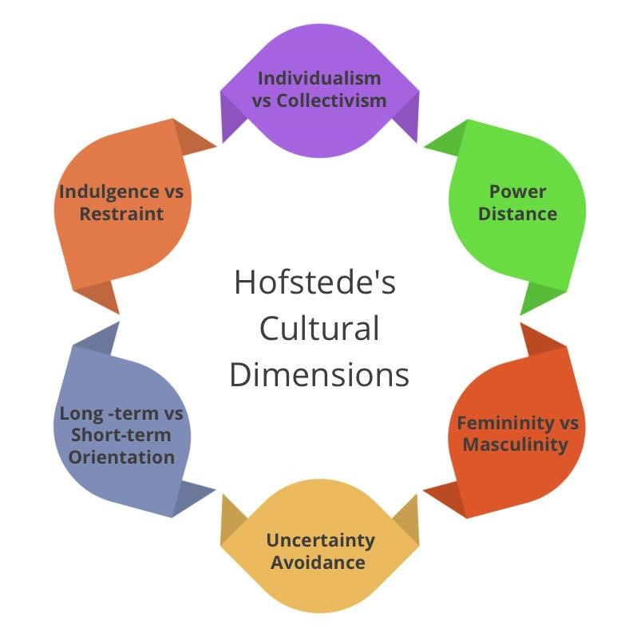

Figure 1: Hofstede model

(Source: bastovida.pt, 2023)

Macro and micro factors of the international market

SWOT Analysis

Strengths  - Financial Turnaround  - Market Share Dominance  - Strong Performance During Pandemic  - Innovation and Adaptability | Weaknesses  - Leadership Change  - Quality Control Issues  - Shortage of Products  - Inventory Management Issues  - Food Safety Concerns
Opportunities  - Growth of Online Grocery Sales  - High-Unemployment Rates  - Rise of Meat Alternatives  - Social Supermarket Initiatives  - AI and Machine Learning Integration | Threats  - UK-EU Relations and Brexit Impact  - Supply Chain Disruptions due to Brexit  - Economic Recession and Reduced  Purchasing Power  - COVID-19 Pandemic Impact  - Intense Competition, Asda Revival

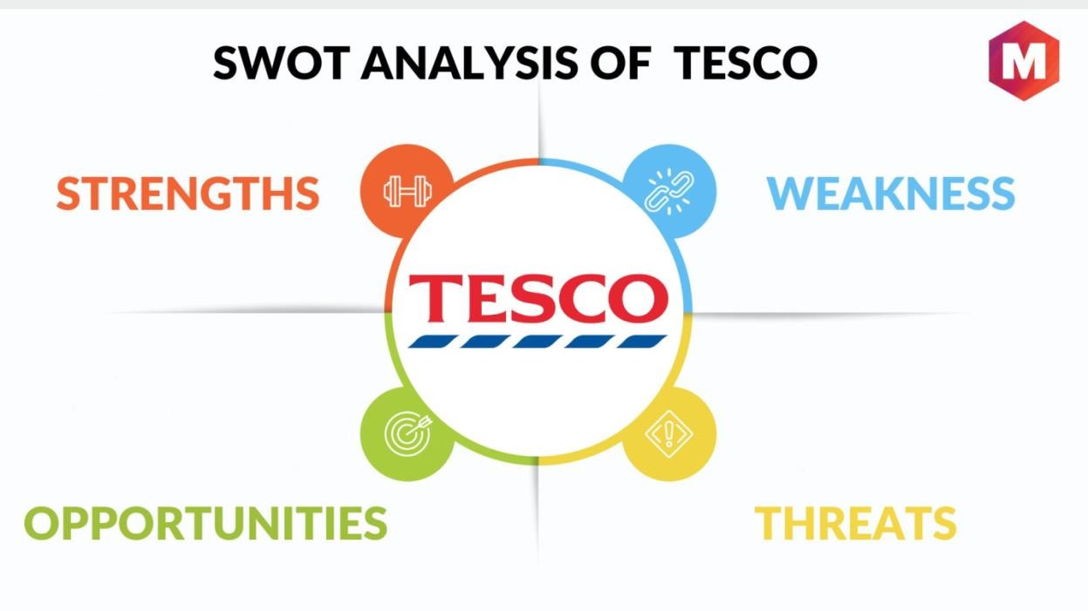

Figure 2: Swot analysis

(Source: marketing91.com, 2019)

Tesco PLC, a leading UK-based supermarket chain, exhibits notable strengths that contribute to its resilience and market dominance. Under the leadership of Dave Lewis, Tesco successfully executed a financial turnaround, rebounding from a staggering £6.4 billion loss in 2015 to achieve an operating profit of £1.9 billion in 2020. With a commanding 26.9% share of the grocery market in Great Britain, Tesco's market dominance is unmatched, positioning it as a leader among the Big 4 supermarket chains (Bakhat and Marroun, 2022). The company's adept response to the challenges posed by the COVID-19 pandemic, including a 10.5% growth in the last three months to September, showcases its adaptability and innovation (pestleanalysis.com, 2020).
Tesco's commitment to online sales growth, coupled with its ability to double delivery capacity during pandemic-induced restrictions, underscores its strategic adaptability. Furthermore, recognition for Advanced NoSQL Architecture and initiatives like a 300% increase in meat alternatives sales demonstrate Tesco's commitment to innovation. Despite these strengths, the company faces internal vulnerabilities, such as quality control and inventory management issues, along with the challenge of leadership transition with Ken Murphy taking over as CEO.
Tesco has various opportunities to capitalize on, including the growth of online grocery sales, high unemployment rates providing a potential workforce pool, and the rise of meat alternatives. The grocery store can improve its operations by looking into social supermarkets and using artificial intelligence and machine learning (Moura, 2021). A number of factors pose hazards to Tesco, including tensions between the UK and the EU, the effects of Brexit on the supply chain, the recession, the persistence of the COVID-19 pandemic, and the resurgence of Asda under new management.

Pestle Analysis :

Factor | Description
Political | The impact of international politics on Tesco's financial results. Thinking about laws and tax rates. Operational country stability. Influence on demand from government support for employment development. The global effects of financial instability (Moura, 2021).
Economic | Concerns regarding expenses, demand, earnings, and prices. Having a 30% share of the UK market makes you very dependent on that market. Policy changes that impact the accessibility of financing should be kept in mind. "Internationalisation and diversification strategies" . In the face of economic difficulties, prioritise advertising value brands (pestleanalysis.com, 2019).
Social | Changing consumer habits, such as the rise of one-stop shopping and bulk purchases. The growth of products other than food. Changing with the minds of shoppers. Supplying the growing demand for organic goods driven by rising health consciousness.
Technological | - Opportunities from online shopping and home delivery. - Self-service checkout points for convenience and cost reduction. - Investment in energy efficiency projects.
Environmental | - Commitment to reduce carbon footprint by 50% by 2020. - Initiatives to minimize waste in stores and increase social conscience in customers.
Legislative | - Impact of government policies and legislations on Tesco's performance. -  Compliance with the Food Retailing Commission (FRC) Code of Practice. -  Implementation of policies affecting pricing and supplier relationships. -  Customer benefits like fuel discounts based on grocery spending.

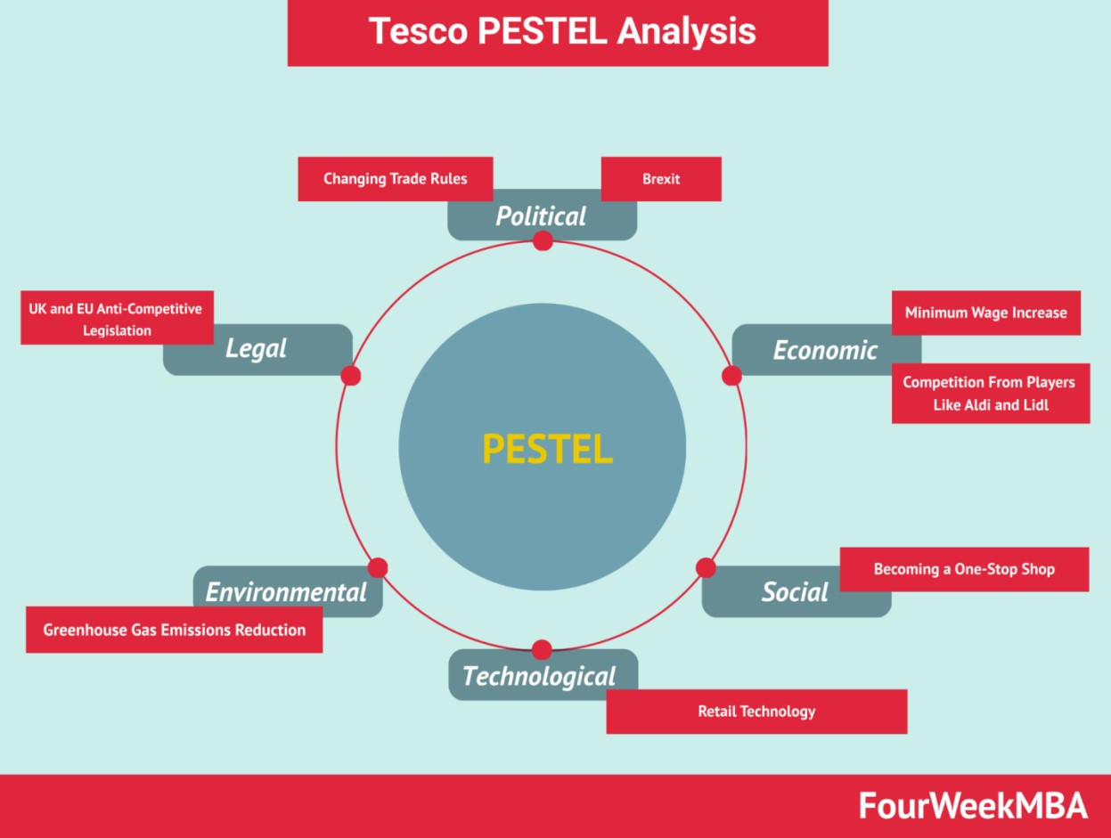

Figure 3:
PESTLE analysis

(Source: fourweekmba.com, 2021)

The ever-changing retail landscape is influenced by a multitude of outside forces, and Tesco PLC runs its business in this ever-changing environment. To have a better grasp of these factors and how they affect Tesco's strategic posture, a PESTLE analysis is useful.

Political
The worldwide operations of Tesco are influenced by different tax rates, legislative acts, and country stability, all of which have a substantial impact on the company's performance. There is a mutually beneficial relationship between the company's job creation efforts and government measures, which increases product demand and also benefits the government.

Economic
The importance of economic issues is crucial, particularly considering Tesco's reliance on the UK market.Profitability, demand and taxation are totally impacted by changes in the availability of capital. In order to ensure continued with improvement, Tesco has been able to diminish risks related with financial volatility through internationalization and expanding approaches.

Social
Social perspectives encompass the changing preferences of clients, which at present slope towards purchasing things in immense quantities and from a single region. Tesco's response to this change is clearly displayed by its wide extent of non-food products. The company stays responsive to evolving client views, practically identical to prosperity discernment, by tending to the necessity for regular things (Rashid, 2023).

Technological
Tesco has more opportunities because of innovative enhancements, particularly with internet shopping and self-service checkout areas. These progress further foster client convenience while simultaneously decreasing work expenses. Tesco's commitment to environment responsibility and carbon impression reduction is found in its investments in energy saving projects.

Environment
Tesco puts significant emphasis on environmental examinations as a fundamental focus of its corporate plan, commiting to a half diminishing in its carbon impression. The implementation of waste reduction efforts and the creating social perception between clients show a dedication to sustainable practices (Adamyk, 2019).

Legal
Tesco's undertakings are impacted by legislative issues, for instance, the Retailing Commission's Code of Practice. The corporation takes action by implementing customer-centric initiatives, such as reducing fuel prices based on grocery store expenditures, in accordance with regulatory rules.
Tesco's success is not only attributed to its market strategies but also its adept response to political, economic, social, technological, environmental, and legislative influences. By proactively navigating these factors, Tesco remains resilient in the dynamic retail landscape, showcasing a commitment to sustainability, innovation, and societal responsibility.

Porters Diamond Model
Elements | Discussion
Factor Conditions | Natural Resources  Capital Resources  Human Resources  Scientific Knowledge  Technological Innovation  Infrastructure
Related and Supporting Industries | Presence of Related Industries  Presence of Supporting Industries  Presence of Rival Industries  Presence of Strong Global Suppliers
Strategy, Structure, and Rivalry | Company Strategy  Structure of the Organizations  Managerial System  Intense Competition Between Local Rivals  Competition with Global Players
Demand Conditions | Size of the Domestic Market  Sophisticated and Demanding Domestic  Customers  Customer Needs Anticipating Those Elsewhere

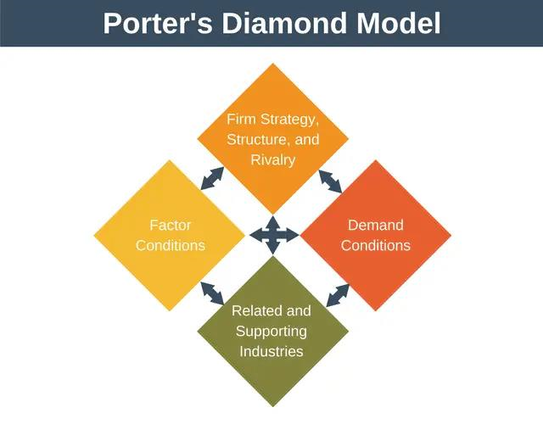

Figure 4: Porter’s Diamond model

(Source: expertprogrammanagement.com, 2019)

Tesco Plc's success can be analyzed through Porter's Diamond Model, which considers four interrelated factors influencing competitiveness: factor conditions, related and supporting industries, strategy, structure, and rivalry, and demand conditions (Al-Gamdi and Balubaid, 2021). In terms of factor conditions, Tesco benefits from diverse resources. Natural resources, such as water channels, offer cost advantages. Capital resources, sourced through equity and debt, fuel financial capabilities. Human resources, with a focus on skill development and training, contribute to operational excellence. Scientific knowledge and technological innovation further enhance competitive advantage. The robust infrastructure, both physical and technological, facilitates global expansion.
Related and supporting industries play a crucial role. Tesco leverages local and global suppliers for efficient distribution, ensuring product availability in various markets. The presence of rival industries stimulates innovation and drives Tesco to explore new markets for revenue growth.
Tesco's strategy, structure, and rivalry are integral to its success. Customer-centric strategies prioritize high-quality products and value for money ( Marimin et al., 2021). A flat organizational structure fosters open communication and a creative culture. The managerial system supports employee growth, while intense competition, both locally and globally, drives innovation. Demand conditions, shaped by the size of the domestic market and sophisticated consumers, have propelled Tesco's internationalization. The company's ability to anticipate customer needs globally, based on domestic insights, has been a key factor in its strategic development and successful expansion into diverse markets.

Global and potential value chain configuration and coordination challenges

Global value chain
Tesco plc is a British multinational groceries and general merchandise retailer headquartered in Welwyn Garden City, England. It is the world's third-largest retailer by revenue and the secondlargest in the United Kingdom. Tesco operates in 12 countries and has over 7,000 stores. The worldwide value chain of Tesco is extensive and spread out across many continents. Many of the firm's suppliers are based in undeveloped nations, where the corporation gets its products.
Manufacturing facilities for Tesco can be found in multiple nations as well (Monte, 2021). A system of distribution centers and transportation providers then gets the company's wares into the hands of retailers.
The goal of Tesco's global value chain setup is to optimize efficiency and reduce costs. Product purchasing from negligible cost merchants is a huge highlight for the company. Tesco in like manner places a tremendous heap of money into logistics and technology so that its supply chain runs seamlessly.
While there are many advantages to Tesco's global value chain plan, there are also many challenges. Managing a worldwide supply is complex, which is one of the challenges. There are a lot of manufacturers, wholesalers, and suppliers that Tesco needs to keep track of. This becomes much challenging in nations when infrastructure and government are lacking.
Challenges with the supply chain are another conceivable prevention. Political trouble and work disputes are several of the various likely potential for aggravation. In the past few years, numerous interferences to Tesco's supply chain have caused harm to its primary concern.
Social and environmental demands on Tesco to increment present assumptions across its supply chain are growing (Frei et al., 2020). The company's relationship in deforestation and its usage of sweatshop work have assembled examination. Tesco is attempting to raise current expectations on its inventory network, despite the fact that this is not an easy task.
Tesco has a well-planned global value chain to maximize efficiency and reduce costs. Incidentally, there are a lot of obstacles that the company must overcome. These involve the difficulty of directing a supply chain that crosses the entire globe, the possibility of interruptions in the chain, and the need to raise the supply chain's moral and social standards.
Some particular difficulties that Tesco encounters throughout its worldwide value chain are as follows,
The usage of sweatshop labour by Tesco in Thailand came under fire in 2011. It came to light that the firm was partnering with vendors that were paying their employees as little as £3.50/day (Reza et al., 2021). Despite Tesco's efforts to address the issue, the working conditions of its Thai suppliers continue to be a concern.
The company Tesco was implicated in deforestation in Indonesia in 2014. Those who supplied the firm with palm oil were allegedly cutting down rainforests for their products. Although it may take time, Tesco has promised to only buy palm oil from sustainable sources going forward.
A cyberattack in 2016 messed with Tesco's supply chain. Some products were temporarily out of stock at Tesco outlets due to the incident. Although Tesco has made investments in new cybersecurity safeguards, there is still a chance that further assaults could happen.
Potential Value chain

Tesco's value chain is divided into three main stages
Activities like as sourcing, manufacturing, and logistics are part of the upstream stage.
The middle stage consists of strategies, transportation, and customer service.
In the following stage, advertising, sales, and customer service are dominant.
The structure of Tesco's value chain allows the company to efficiently source, assemble, and ship products to customers. The extraordinary relationship the company has with its suppliers allows it to negotiate advantageous terms and pricing. Another perk of Tesco's extensive and well-oiled distribution system is the speed and reasonableness with which it can get products into its stores (Zhao, 2021).
Additionally, Tesco's value chain has several barriers. The fact that discount stores like Lidl and
Aldi are becoming more serious is a problem. These shops do not perform up to Tesco's expectations, which reduces the company's total income. Another problem is the rising prices of food and fuel. As a result of these expenses, Tesco's total income has decreased.
Tesco is still a successful and powerful company despite all these obstacles. Memory and consumer devotion are highly respected and noteworthy aspects of the organisation. Tesco is also investing in emerging technologies, such online grocery shopping, to ensure its continued seriousness in the long term.
According to Tesco, the following are the most pressing issues with the value chain's configuration and coordination:

Complexity
Numerous processes and activities make up Tesco's value chain. Because of this, efficient chain management and coordination may become challenging.

Uncertainty
Customer needs and competitive pressures in retail are always shifting, creating an unstable environment. This might hinder Tesco's ability to organise and organise its value chain.

Globalisation
Suppliers and consumers from all around the globe are part of Tesco's globalised environment. Due to this, it may be challenging to manage the chain efficiently and get everyone involved on the same path..

Market’s entry mode
In order to expand into new global markets, the UK-based multinational retailer Tesco has relied on partnerships and strategic alliances, market entry mode. Tesco has been able to enter new markets more quickly and cheaply through these agreements and partnerships than through organic growth or acquisitions.
Forming joint ventures with regional businesses to open stores in new markets is a critical strategic partnership adopted by Tesco. One such example is the Chinese joint venture that Tesco and a local partner established, Vanguard. As a result, Tesco was able to launch its Vanguard hypermarket chain in China instead of its own Tesco brand. It connected Tesco with a local partner that has the understanding of Chinese consumers, as well as robust domestic supply chains, distribution channels, marketing expertise, and more. The political climate was also more favourable to the joint venture because the Chinese government encouraged domestic businesses to form partnerships with international ones.
Tesco’s entry into the United States was defined by an innovative strategic alliance to set up Fresh & Easy grocery stores. Tesco partnered with Safeway Inc., the American supermarket giant, to develop a new chain of small-format neighborhood stores customized to the US market (Krummel, D., 2022). This alliance gave Tesco quick access to Safeway’s vast logistical, distribution, and retail infrastructure within the US along with insights into buying patterns and preferences of American consumers.
In India, Tesco formed a franchise partnership with the prominent Indian conglomerate Tata Group to open Best Price Modern Wholesale stores. These were targeted at the business-to-business and wholesale supply market in India. The alliance with Tata gave Tesco an established local brand name, existing infrastructure and assets, and deep understanding of the complex retail landscape and regulations in India.
Across all these alliances, Tesco aims to leverage the specialized resources, skills, local networks, infrastructure, and market knowledge of its partners to rapidly enter and scale in complex new markets. The alliances also allow Tesco to substantially reduce costs, risks, and timelines for international expansions compared to wholly owned subsidiaries or acquisitions (Čirjevskis, 2022). Partners shoulder some of the upfront investments and risks while Tesco focuses on providing world-class retail expertise, private label products, global sourcing capabilities and steering strategy for these ventures.

Tesco has strategically utilized a variety of partnering and alliance-based approaches for entering intricate Asian and American markets faster and more efficiently. Choosing the right partners has given Tesco quick access to local consumer insights, logistical infrastructure, favorable regulatory policies, and reduced capital commitments associated with international expansion.

International strategy by Tesco in the global market
To get into international markets, the organisation mostly uses acquisitions, Greenfield investments, and joint ventures with local firms. The company's goal, within five years of entering a foreign market, is to become the market leader there. All around Europe and Asia, it has been a smashing success. But things have been different in the US since the firm has had trouble consolidating its market share. One reason Tesco Plc has been so successful in foreign markets is because it pays close attention to the local culture and market conditions in each country it operates in. Partnerships, mergers, and acquisitions have played a significant role in this, allowing the corporation to better meet the demands of local markets and provide them with what they desire (Tian, 2021). This has proven to be especially beneficial in markets with strong context cultures, such as those in Asia.
Sustainability in growth and development is the long-term goal of Tesco Plc, which is why the corporation is diversifying its business and expanding internationally. Since the domestic UK market had matured and reached saturation, the corporation knew it had to look outside for growth prospects if it wanted to maintain its current rate of success. So, this was the only way for the business to stay relevant to the economy over the long term. Tesco Plc's potential dangers in foreign markets are the primary considerations in its entrance strategy. Industrial infrastructure and cultural variables are two examples of typical dangers (Catalão, 2022). Culture, however, remains the driving force behind the company's choice of entrance.
International joint ventures have been Tesco Plc's go-to approach for breaking into the Asian market. Part of the reason for this is that organisations in these nations are expected to prioritise interpersonal ties due to their high context cultures. Personal and close-knit networks of relationships among clients, coworkers, and business associates are common in these cultures. Therefore, it is critical for businesses to establish rapport and trust with their clients and partners. since of their high levels of ambiguity avoidance, these interactions are crucial since they lower the amount of risks, ambiguities, and uncertainties. As an example, the corporation was able to connect with local suppliers and manufacturers in South Korea through its worldwide joint venture with Samsung. This was crucial for breaking into the South Korean market because, unlike their British counterparts, who favour stockpiling, Korean customers value fresh and high-quality produce and meat, and they buy regularly. According to the internalisation idea, Tesco Plc was able to acquire an edge by absorbing the South Korean market. This was accomplished by establishing local networks in order to maintain the highest potential level of sales for the organisation. Thus, it utilised all of Samsung's staff to guarantee that business as usual was not disrupted. Because of their familiarity with the regional market, the local managers were also granted decision-making power by the corporation. The corporation also intended to position itself via localization and decentralisation in response to the competitive environment's issues, rather than pursuing globalisation methods like its competitors. The bargaining hypothesis states that when a corporation is decentralised and localised, it takes on the image of a local business and is therefore better able to cater to the preferences and habits of local consumers (ZXhang et al., 2023). This set Tesco Plc apart from other international companies operating in the South Korean market, such as Carrefour and Walmart.

Reflection on Tesco’s ethical policies and sustainability practices
Tesco's global expansion strategy, as outlined in the provided information, is characterized by a focus on joint ventures, partnerships, and alliances to navigate the complexities of diverse markets. While the company has demonstrated adaptability and success in entering new markets, a critical reflection on its ethical policies and sustainability practices reveals both commendable efforts and potential challenges.

Ethical Standards in Different Locations
Tesco's approach for managing international business areas involves recognizing and with respect to social cultures and economic situations. The fact that it favors collaborative undertakings in Asian and other high-setting cultures is an extraordinary portrayal of this. As the undertaking grasps the significance of spreading out extraordinary corporations and trust in business areas where people will for the most part avoid uncertainty, its thoughtfulness regarding local cultural variables is reliable with ethical concerns.

Challenges in Sustainability Practices
The challenges of Tesco's global value chain plan raise moral issues, even as the company has vowed to help environmental causes involving reducing waste and carbon dioxide aftereffects. Models demonstrate the way that companies acquiring from developing nations might contribute to issues like sweatshop work and deforestation.
Addressing Ethical Inconsistencies:
In order to address its general moral inconsistencies, Tesco requires cross-cultural initiatives based on solid moral standards and a typical measure of effort. It is of the utmost significance to ensure that merchants follow ethical work practices and follow green regulations for this. It is important for the company to regularly assess its suppliers and partners' moral performance.
Tesco might also do more to be open and honest by telling people about their sustainability initiatives and ethical standards. All parties involved, including customers, investors, and advocacy organizations, benefit from this openness since it promotes responsibility and confidence.

Balancing Global and Local Values
Tesco must walk a fine line between its global goals and local beliefs in order to navigate ethical problems. Adapting to local cultures is important, but the corporation should also set a set of global ethical norms to follow. The fundamental principles that support this framework should be human rights, environmental sustainability, and ethical corporate practices; nevertheless, it should also be adaptable enough to accommodate cultural variances.
Tesco can't fix its ethical contradictions and improve its environmental policies in different markets, it will not be able to succeed globally. Tesco can solidify its role as a socially conscious worldwide retailer by cultivating an environment of moral consciousness, openness, and
responsibility.

Recommendations
By entering new markets through partnerships and joint ventures, Tesco PLC has proven to have a winning foreign business strategy. Nevertheless, there are a number of important suggestions that the organisation should prioritise if it wants to increase its worldwide success even further.
Establishing a standardised set of ethical principles applicable across all of Tesco's businesses is essential, but so is recognising local customs. This necessitates the establishment of a universally applicable set of ethical norms, with the goal of achieving universal compliance with respect to environmental practices and labour standards. Tesco can reduce the likelihood of unethical behaviour by being explicit with its suppliers and partners.
In order to find and fix possible sustainability and ethical problems, it is crucial to fortify the due diligence process. The observance of ethical norms, labour practices, and environmental laws should be checked by frequent evaluations and audits. The supply chain will become more accountable and open as a result of this proactive strategy.
Tesco may improve its communication and openness by sharing its sustainability efforts and ethical standards with the public. Communicating openly with stakeholders through reports shows that the firm cares about doing the right thing by its stakeholders and the community. Tesco should better manage its reputation via clear communication, which is especially important in light of recent events involving sweatshop labour and deforestation.
One of the top priorities should be to speed up the process of investing in sustainable practices. Even while Tesco has cut down on waste and carbon emissions, the company might do more to help the environment and society in the long run if it took a bolder stance on sustainable sourcing, packaging, and operations.
Social competence training is essential for all employees at Tesco because to the wide range of social foundations touched by the company's worldwide operations. Staff members will be more equipped to adapt to different social situations and form stronger relationships with locals as a result of this training, which will help them explore other business sectors more efficiently.
Moral normalisation, acceptable effort, clear communication, increased interest in sustainability, and social ability training should be Tesco's priorities. These recommendations will position Tesco as an ethically responsible global company that is resilient in the face of moral challenges and open to embracing evolving consumer expectations globally. Rapid development is required to keep up with the dynamic nature of international trade and to bolster Tesco's position as a global retail market.

Conclusion
In order to ensure Tesco's long-term viability and success, the company must adhere to the highest moral standards in all of its operations as it continues its aggressive global development strategy. For Tesco to adapt its operations to evolving partner expectations, it is necessary to standardise moral principles, reinforce the production network at a fair level of effort, improve transparency through communication, and put more energy into natural and social practices. It is both an opportunity and a responsibility for Tesco, as a massive global retailer, to serve as an exemplar of trustworthy international commerce. As a world-renowned retailer, Tesco is committed to meeting the needs of all social and economic groups through initiatives including social skill training and partnerships with local organisations that respect and uphold community values. As long as it maintains its core principles and is adaptable to other industries, Tesco will be able to build relationships and networks all over the globe.

Reference list
A., Marimin, M., Adrianto, L. and Bura, R., 2021. Determinants of shipbuilding industry competitive factors and institutional model analysis. Decision Science Letters, 10(2), pp.151-
162.http://m.growingscience.com/dsl/Vol10/dsl_2020_37.pdf
Alt, M.A., Berezvai, Z. and Agárdi, I., 2021. Harmony-oriented retail innovations and financial
performance. European Journal of Innovation Management, 24(4), pp.1379-
1399.https://www.researchgate.net/profile/Irma-Agardi-2/publication/343237405_Harmonyoriented_retail_innovations_and_financial_performance/links/5fd20c1c45851568d1517b5c/Har mony-oriented-retail-innovations-and-financial-performance.pdf
Bakhat, R. and Marroun, S., 2022. Investigating the Viability of Implementing Electric Freight Vehicles in Morocco: Using an Integrated SWOT PESTEL Analysis in Combination With
Analytic Hierarchy Process. In Optimization and Decision-Making in the Renewable Energy
Industry (pp. 126-152). IGI Global.https://www.researchgate.net/profile/Rim-
Bakhat/publication/359387108_Investigating_the_Viability_of_Implementing_Electric_Freight_
Vehicles_in_Morocco_Using_an_Integrated_SWOT_PESTEL_Analysis_in_Combination_With
_Analytic_Hierarchy_Process/links/625808809be52845a902cb06/Investigating-the-Viability-of-
Implementing-Electric-Freight-Vehicles-in-Morocco-Using-an-Integrated-SWOT-PESTELAnalysis-in-Combination-With-Analytic-Hierarchy-Process.pdf bastovida.pt. (2023). Basto Vida – Serviços de Acção Social e Cuidados de Saúde. [online] Available at: https://www.bastovida.pt/?a=hofstede-cultural-framework-international-businessfrom-a-business-professor-ww-aGgYX8Ug [Accessed 12 Dec. 2023].
Bonfrer, A., Chintagunta, P. and Dhar, S., 2022. Retail store formats, competition and shopper
behavior: A Systematic review. Journal of Retailing, 98(1), pp.71-
91.https://www.sciencedirect.com/science/article/pii/S0022435922000100
Brannen, M.Y., 2020. Cross-Cultural Management & Cultural Identity: Past Perspectives and Present Prerequisites. B. Szkudlarek, L. Romani, DV Caprar, & JS Osland (Hg.), The Sage
handbook of contemporary cross-cultural management, pp.283-
297.https://www.academia.edu/download/64984268/Brannen_Cultural_Identity_Final.pdf
Catalão, I.D.P., 2022. Equity research-Tesco PLC (Doctoral dissertation, Instituto Superior de
Economia e Gestão). https://www.repository.utl.pt/bitstream/10400.5/26748/1/DM-IPC-2022.pdf
Çiloğlu, B., 2021. Proposed configuration management II based engineering change management framework in product lifecycle management (PLM) system (Master's
thesis).http://earsiv.cankaya.edu.tr:8080/bitstream/handle/20.500.12416/6285/Thesis.pdf?sequen ce=1&isAllowed=y
Čirjevskis, A., 2022. Exploring the Institutional Context of an International Alliance and Micro-
foundations of Its Dynamic Political Capabilities.
https://www.iiis.org/CDs2022/CD2022Summer/papers/SA557BC.pdf .
dspace.wunu.edu.ua.(2023) PESTLE Analysis on Tesco PLC.
http://dspace.wunu.edu.ua/bitstream/316497/35536/1/10.pdf.
fourweekmba.com. (2021). Tesco PESTEL Analysis. [online] FourWeekMBA. Available at: https://fourweekmba.com/tesco-pestel-analysis/.
Frei, R., Jack, L. and Krzyzaniak, S.A., 2020. Sustainable reverse supply chains and circular economy in multichannel retail returns. Business Strategy and the Environment, 29(5), pp.19251940.https://researchportal.port.ac.uk/files/18627095/JACK_2020_cright_BSE_Sustainable_Rev erse_Supply_Chains_and_Circular_Economy_in_Multichannel_Retail_Returns.pdf
HAO, L., 2023. A STUDY ON THE CONFLICT MANAGEMENT SKILLS AND EXPERIENCES OF EMPLOYEES WITHIN THE RETAIL SECTOR IN LONDON (Doctoral
dissertation, SIAM UNIVERSITY).https://e-research.siam.edu/wp-content/uploads/2023/11/3.-
MBA-2023-IS-Lin-Weihao-6317195006-A-Study-On-The-Conflict-Management-Skills.pdf
Hensmans, M., 2022. The innovation pyramid: five approaches to strategic decision-making.
Journal of Business Strategy, 43(4), pp.229-
238.https://dipot.ulb.ac.be/dspace/bitstream/2013/324663/3/10-1108_JBS-12-2020-0292.pdf
Krummel, D., 2022. Expansion in the Retail Sector—Market Entry Strategies in Consideration of
Formal and Informal Institutions: A Tesco Case Study. Open Access Library Journal, 9(2), pp.1-
19. https://www.scirp.org/journal/paperinformation.aspx?paperid=115185 marketing91.com. (2019). SWOT Analysis of Tesco Corporation - Tesco SWOT analysis. [online] Marketing91. Available at: https://www.marketing91.com/swot-analysis-of-tesco-corporation/. Monte, A., 2021. A study of value chain reconfiguration processes under Covid-19 pressures: the
case of Tesco PLC in the United
Kingdom.http://tesi.luiss.it/31586/1/261361_MONTE_ALESSANDRO.pdf
Moura, M.B.L.D., 2021. Equity Research in Food & Retail Industry-TESCO PLC (Doctoral
dissertation, Instituto Superior de Economia e
Gestão).https://www.repository.utl.pt/bitstream/10400.5/23303/1/DM-MBLM-2021.pdf
Moura, M.B.L.D., 2021. Equity Research in Food & Retail Industry-TESCO PLC (Doctoral
dissertation, Instituto Superior de Economia e Adamyk, K.,
2019.Gestão).https://www.repository.utl.pt/bitstream/10400.5/23303/1/DM-MBLM-2021.pdf pestleanalysis.com. (2020). Tesco SWOT Analysis 2020: A Detailed Report. [online] PESTLE Analysis. Available at: https://pestleanalysis.com/tesco-swot-analysis/ .
pestleanalysis.com.(2019). PESTLE Analysis for Tesco discusses its Business Environment.
[online] PESTLE Analysis. Available at: https://pestleanalysis.com/pestle-analysis-tesco/.
Rashid, C.A., 2023. PESTEL Analysis and Porter’s Five Forces as marketing tools to evaluate
Morrison’s performance and strategy. Journal of Global Social Sciences, 4(15), pp.75-83. http://journalsglobal.com/index.php/jgss/article/download/187/204
Reza, N. and Du Plessis, J.J., 2022. The garment industry in Bangladesh, corporate social responsibility of multinational corporations, and the impact of COVID-19. Asian Journal of Law and Society, 9(2), pp.255-285.https://www.cambridge.org/core/services/aop-cambridgecore/content/view/FA597A48D0155C6B28AF4722A32233AF/S2052901522000092a.pdf/thegarment-industry-in-bangladesh-corporate-social-responsibility-of-multinational-corporationsand-the-impact-of-covid-19.pdf
Shin, S., 2020. East Asia’s retail revolution: Diffusion of organized retailing and varieties of market development in Korea and Taiwan. Competition & Change, 24(3-4), pp.358-
387.https://www.researchgate.net/profile/Solee-Shin-
2/publication/340681799_East_Asia%27s_retail_revolution_Diffusion_of_organized_retailing_a nd_varieties_of_market_development_in_Korea_and_Taiwan/links/5e9b94af92851c2f52ae5e22/ East-Asias-retail-revolution-Diffusion-of-organized-retailing-and-varieties-of-marketdevelopment-in-Korea-and-Taiwan.pdf
Tian, Q., 2021. Analysis on the Business Strategy of Tesco in the Chinese Market.
https://pdfs.semanticscholar.org/785e/79755cd945cd569a7993d300b657fe6bdc87.pdf

Zhao, C., 2021. Research on Cost Management of E-commerce Enterprises Based on Value
Chain——Taking Suning Tesco as an
Example.https://webofproceedings.org/proceedings_series/ECOM/IEMB%202021/Y0321.pdf

ZXhang, Y.X., Haxo, Y.M. and Mat, Y.X., 2023. Analyzing Tesco PLC Stock: A Comprehensive
Evaluation of Growth Potential and Investment Opportunities. AC Investment Research Journal,
220(44). https://www.ademcetinkaya.com/2023/05/analyzing-tesco-plc-stock-
comprehensive.html .

