Network Operating Systems and Services (NOSS) (ACCA5023)

Worksheet 3 MANAGING AND MAINTAINING NETWORK RESOURCES
USING NETWORK POLICY AND SECURITY PRACTICES

John M Williams – Student 1202877

Task 1: Understanding NTFS and Share Permissions

- Permissions on folder administrator and non-administrator user

Permissions are set on the new folder created so that the user Tom Jones can only read and not write. The administrator account has full permissions.

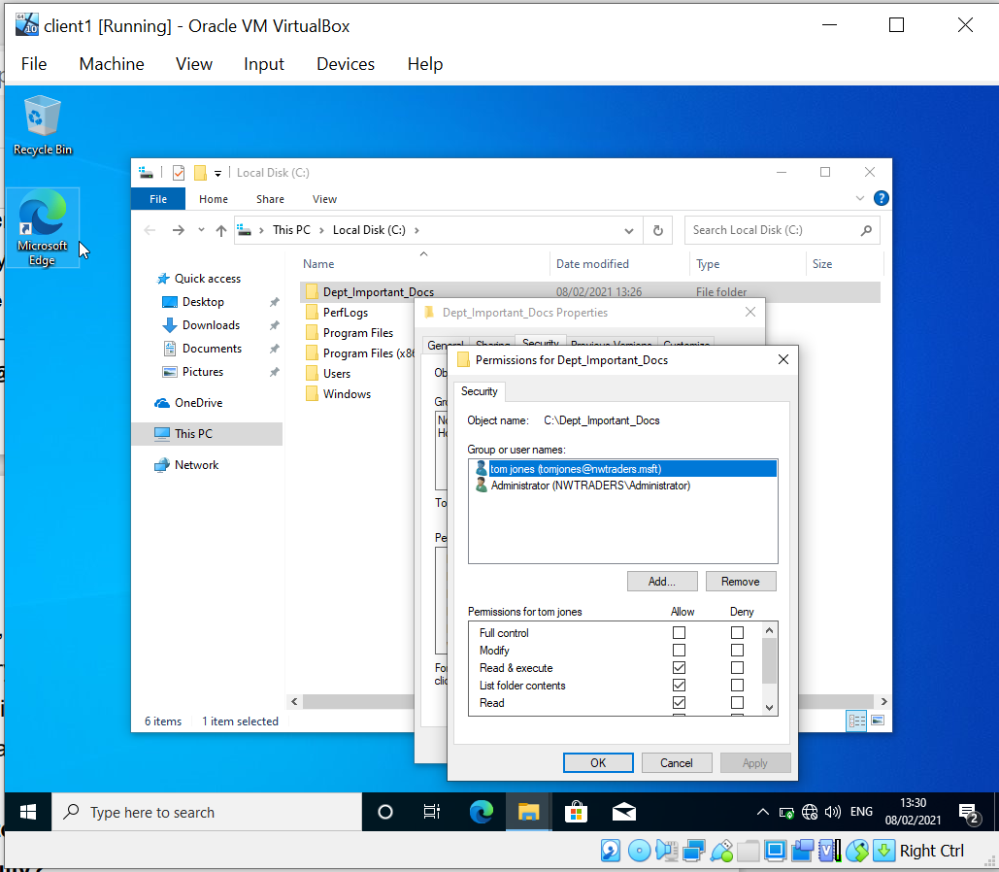
Figure 1 - Modifying the permissions.

- Allowed to save the file as the administrator account. Not allowed to save with user without write permissions. Logged into client1 as Tom Jones and I am unable to save changes made to the file.

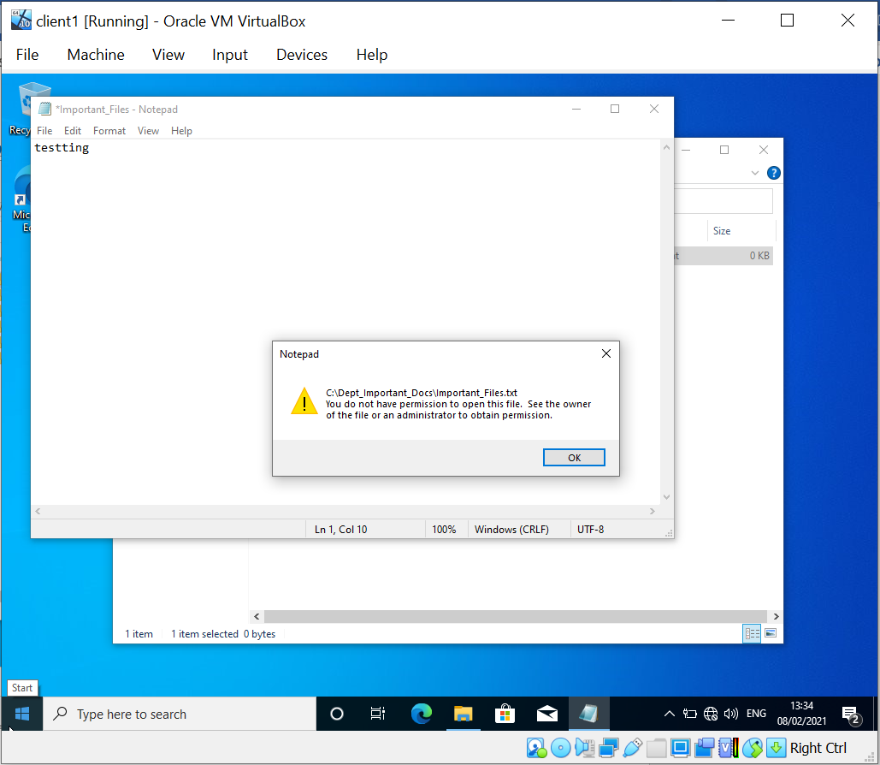
Figure 2 - Testing saving a file change.

- Setting the permissions to share on domain controller (server1)
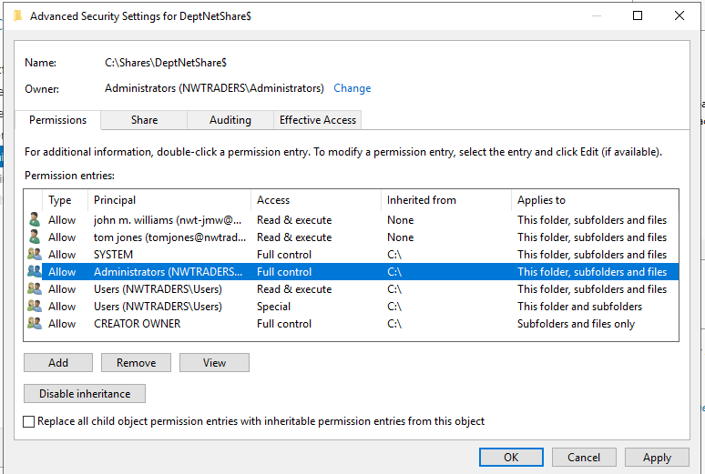
Figure 3 - Creating share in File and Storage Services.

- Share DeptNetShare$ created successfully on server1.
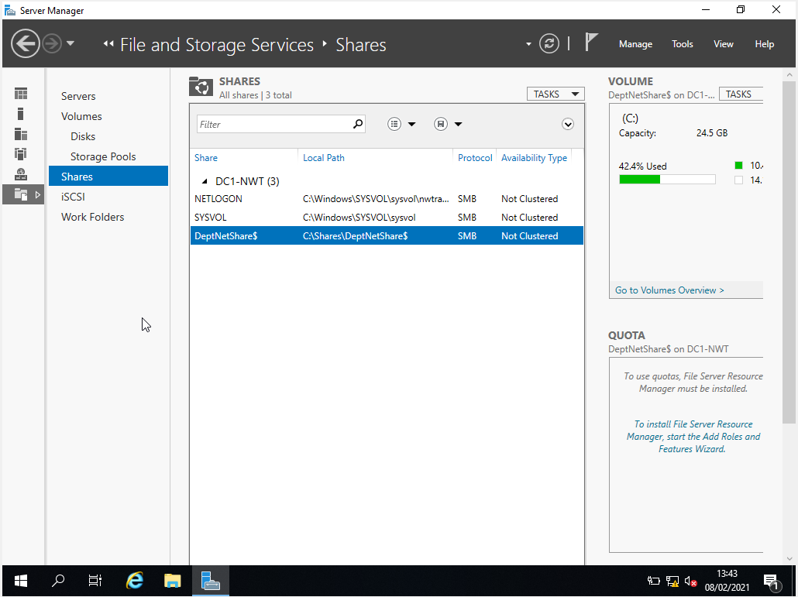
Figure 4 - Share created.

- Network drive mapped on client1 PC. The network drive was mapped on client1 using ‘Map Network Drive’.
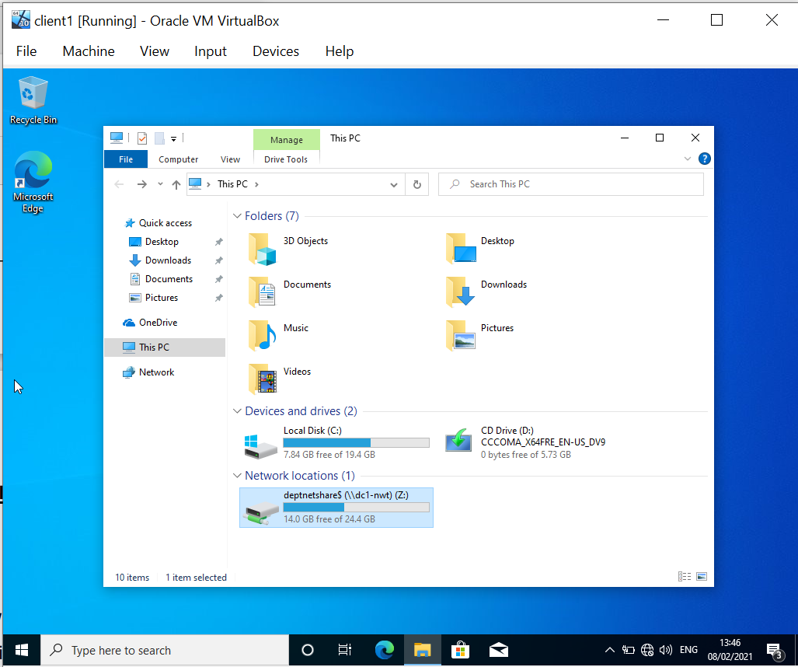
Figure 5 - Network drive mapped

Task 2: Utilising Group Policy Management Console to better facilitate network object management

- Creating Non admin OU on the domain controller (server1).

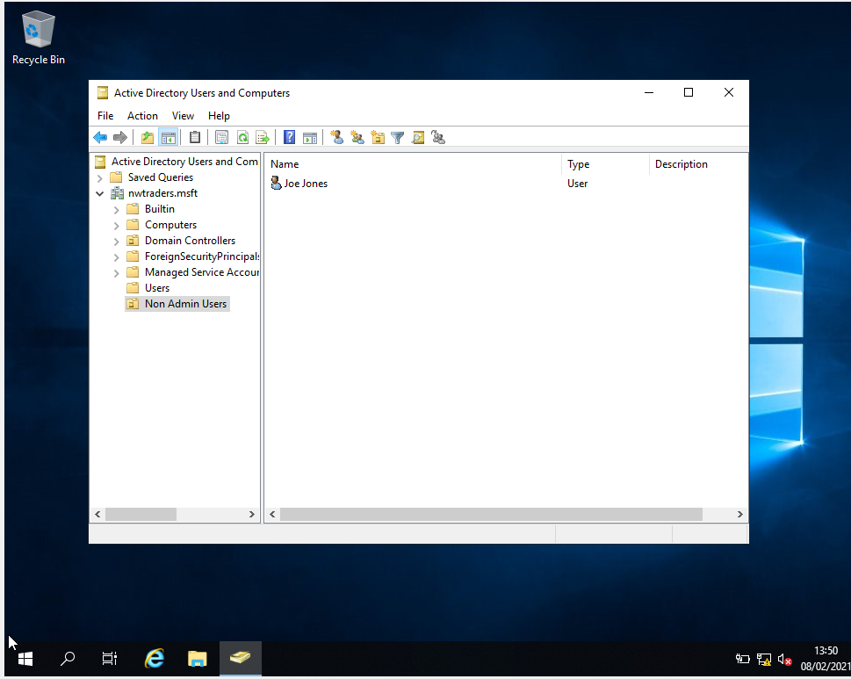
Figure 6 - Creating OU in AD Users and Computers

- Enable GPO for hiding control panel. Load Group Policy Management Console and create new group policy object ‘Non Admin Users OU’ and enable prohibit access to control panel.

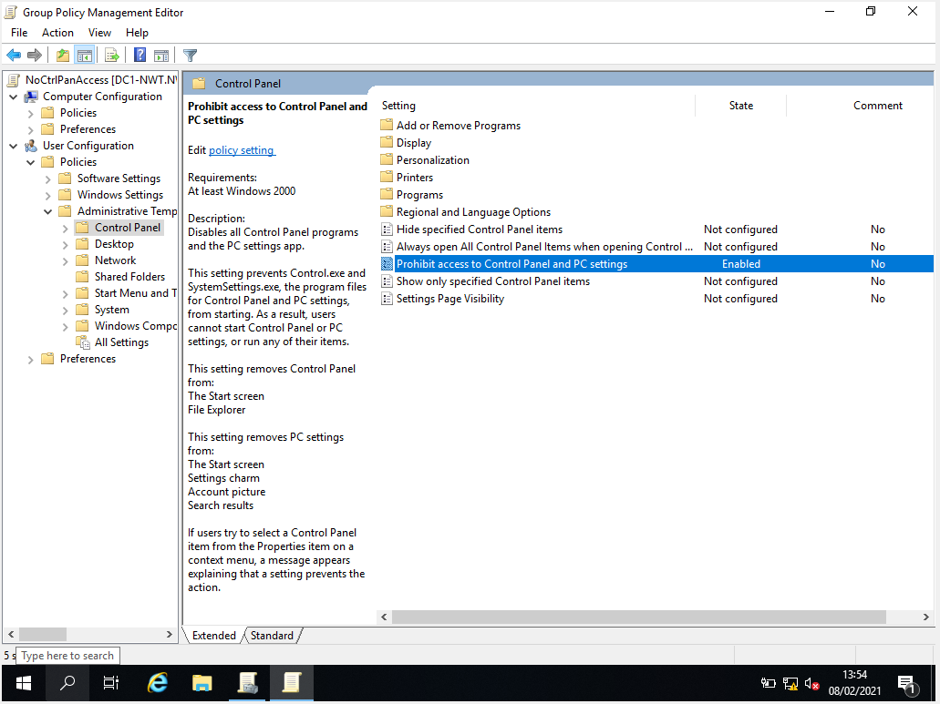
Figure 7 - GPO editor

- Testing on client1. Unable to find or open control panel.
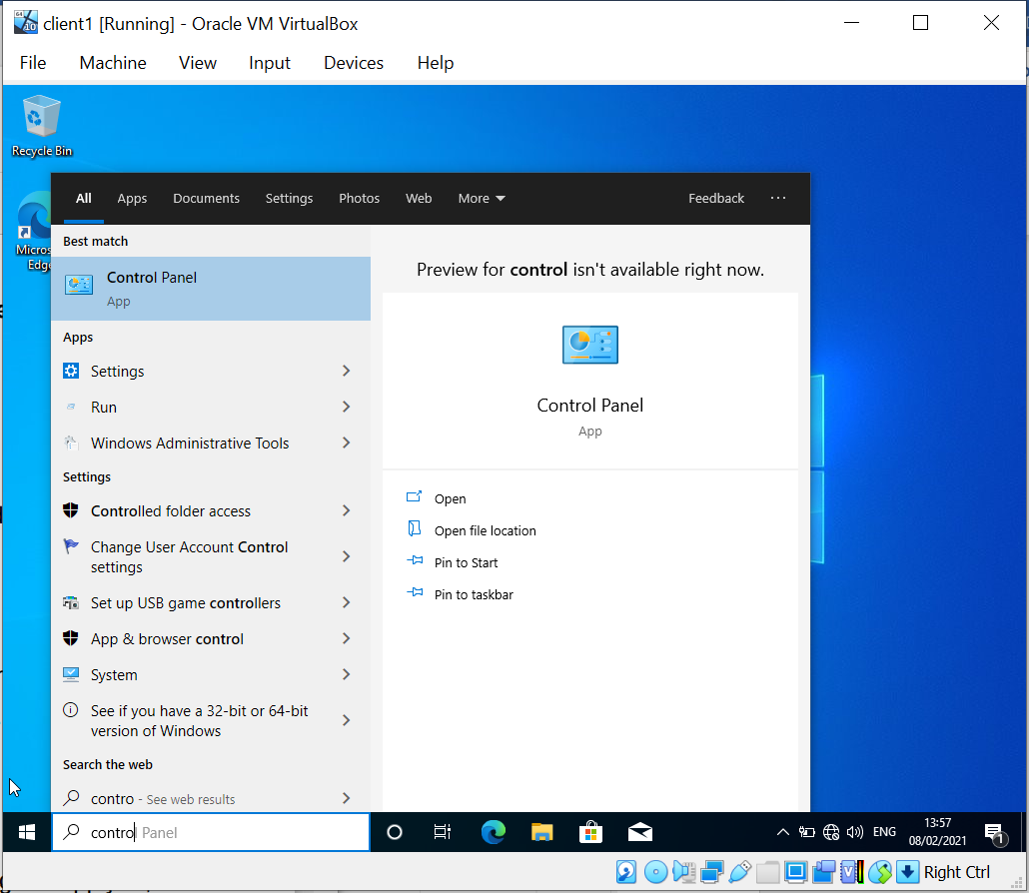
Figure 8 - Testing control panel access on client1

- Removing access to Command Prompt in GPO.

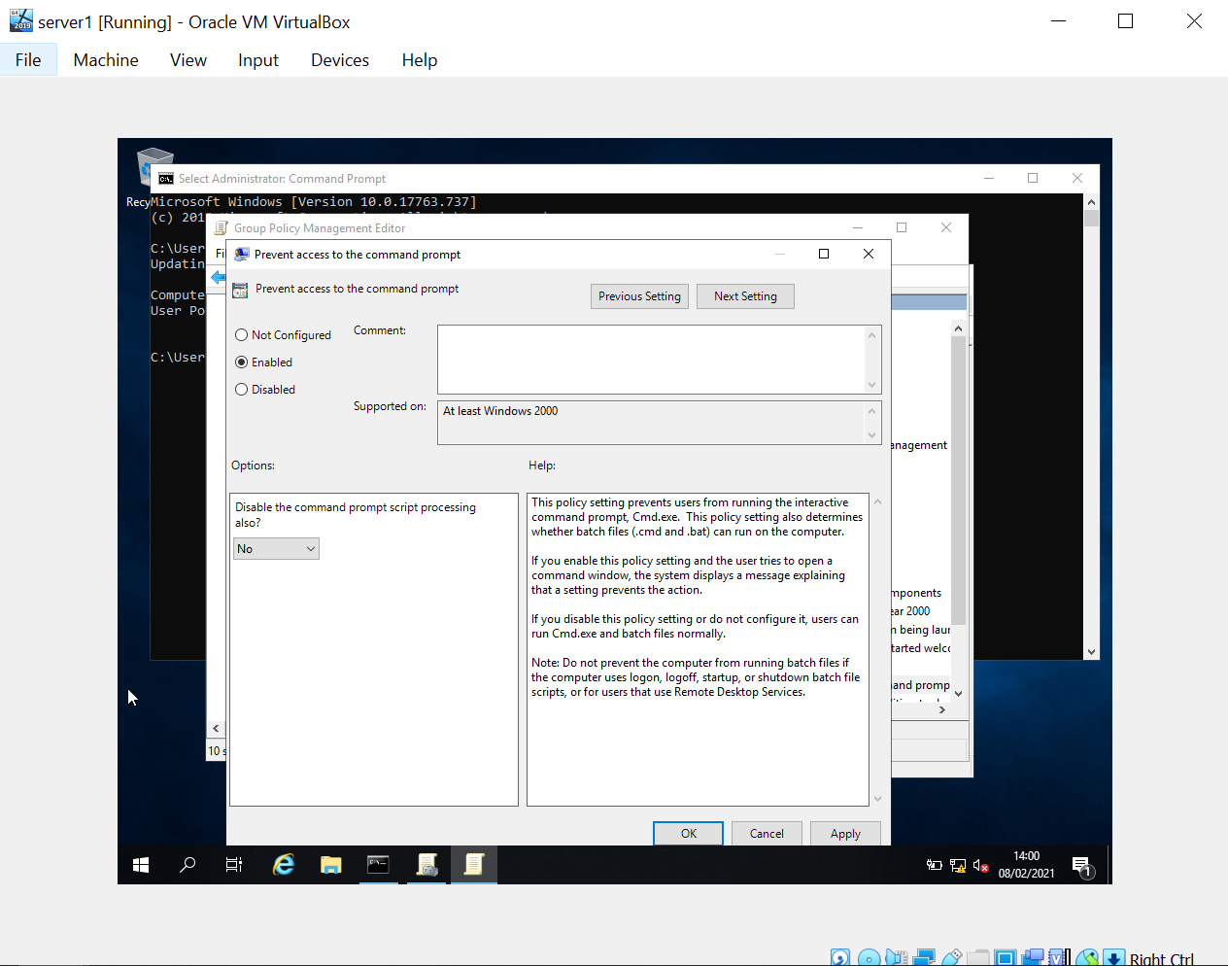
Figure 9 - Enable prevent access to command prompt.

- Testing access to Command Prompt on client1. Access has been disabled by the administrator.
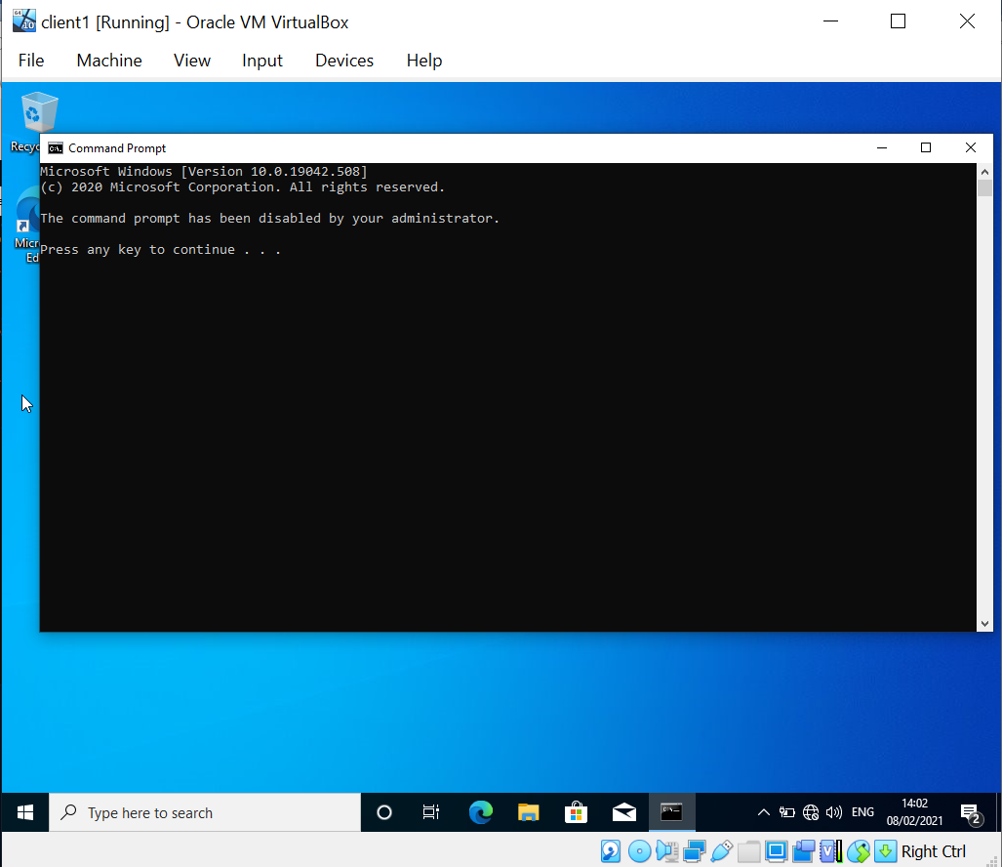
Figure 10 - unable to access command prompt.

- Deny all removable storage access in GPO.

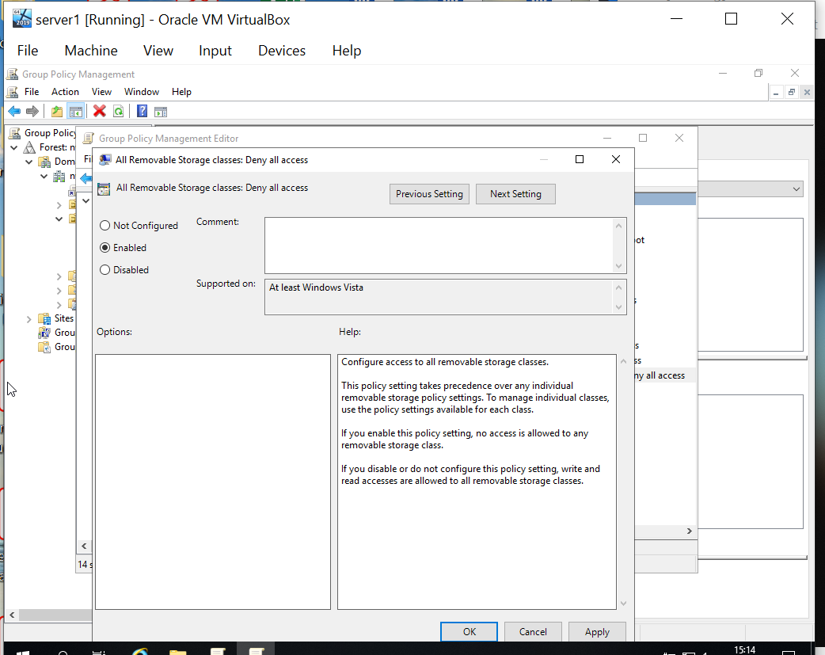
Figure 11 - Enable setting in GPO.

- Testing access to removable storage is denied on client1.

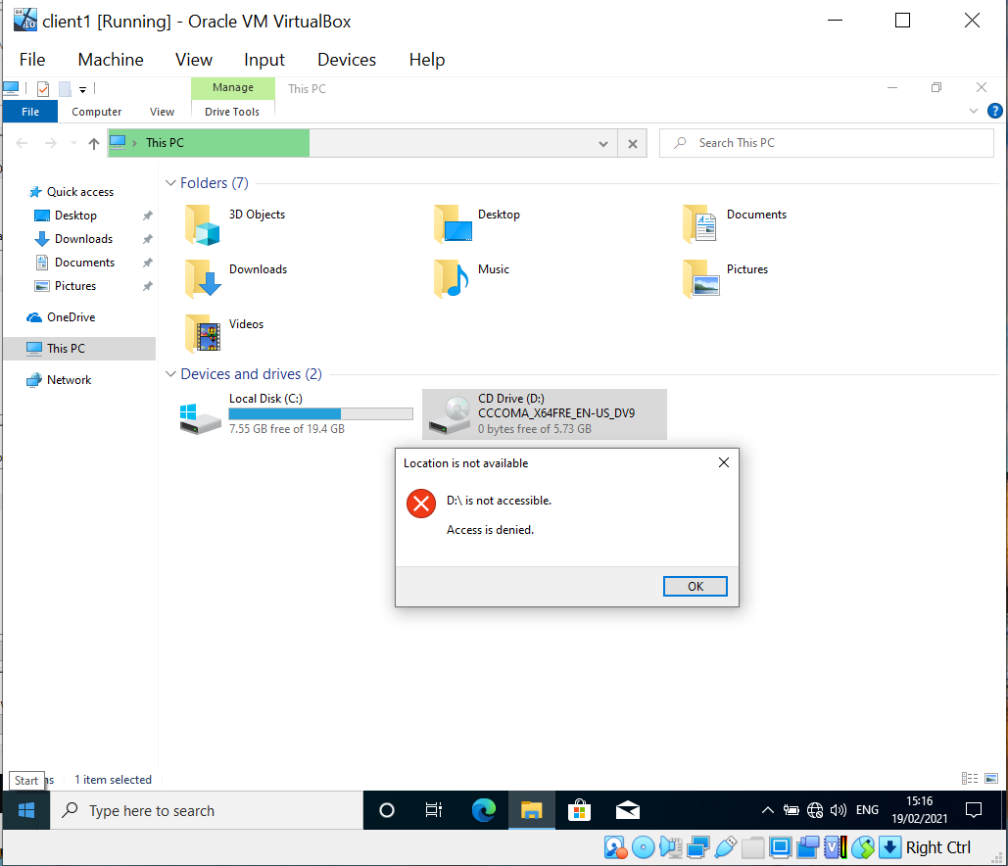
Figure 12 - Access to DVD is denied.

- Prohibit user installs to prevent users installing software.
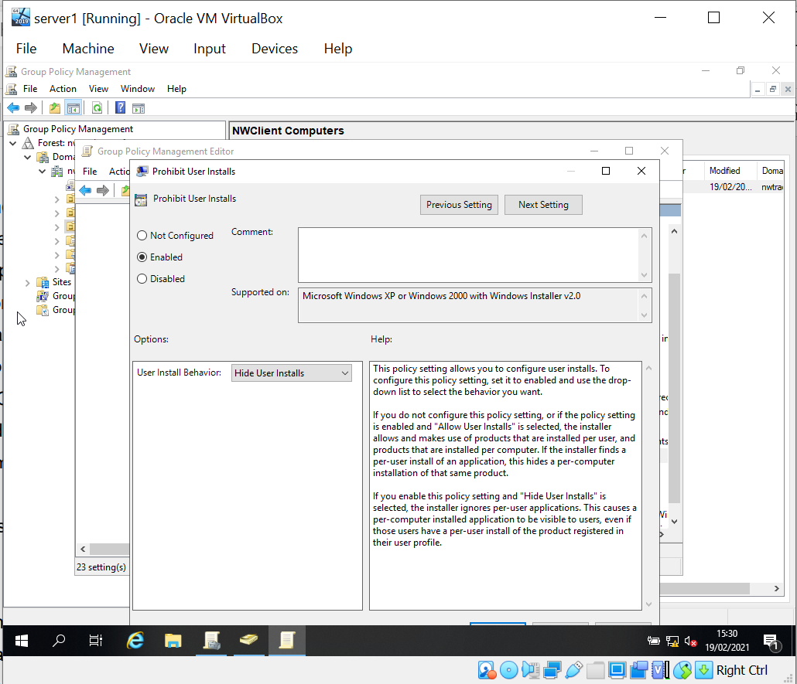
Figure 13 - Prohibit installed in GPO.

- Setting up password complexity rules on the domain controller (server1).

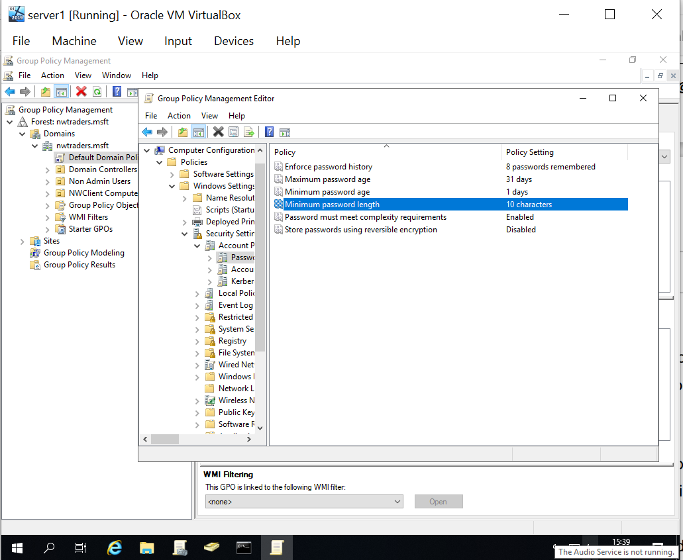
Figure 14 - Creating the rules in GPO.

- Testing password complexity rules by creating a new user.

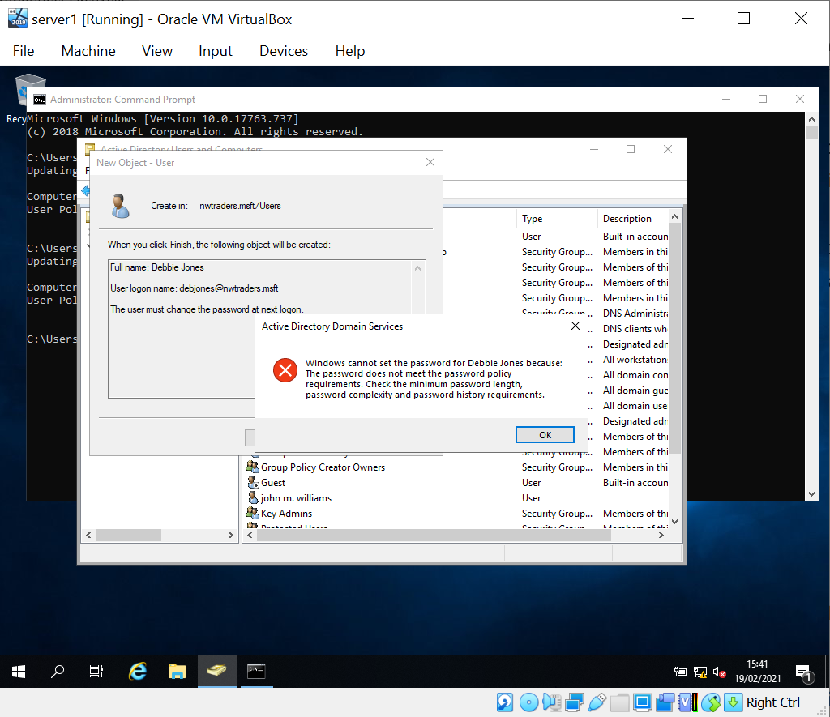
Figure 15 - Password does not meet the password policy requirements.

Task 3: Observational Tasks

3 a) Explain the main differences between local permissions and file shares.
Local share permissions on modern Windows system used NTFS which stands for New Technology File System. This file system is used for applying local file and folder permissions on client and server devices. There are options to apply basic and advanced NTFS permissions. When applying permissions to an NTFS folder, by default files and folders stored within the folder will inherit permissions from the parent folder. These file permissions take effect irrelevantly if the file or folder is accessed locally or remotely (Dell, 2021).
At the basic level, the following permissions can be applied:
- Read
- Read and Execute
- Write
- Modify
- List Folder Contents
- Full Control

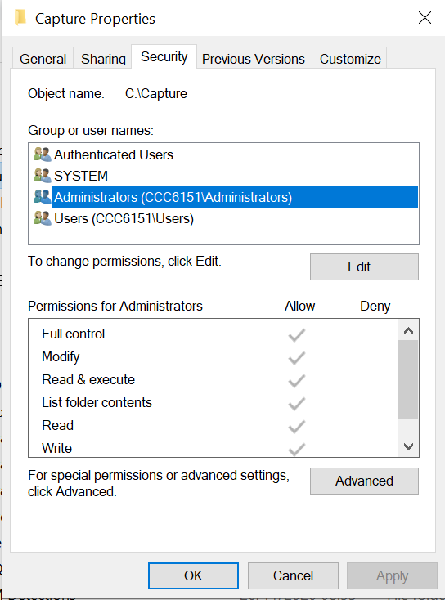
Figure 16 - Basic NTFS permissions.

More granular advanced permissions can also be applied in NTFS. This allows grater control over the permissions being applied to files and folders.
An example of the advanced permissions is show below:

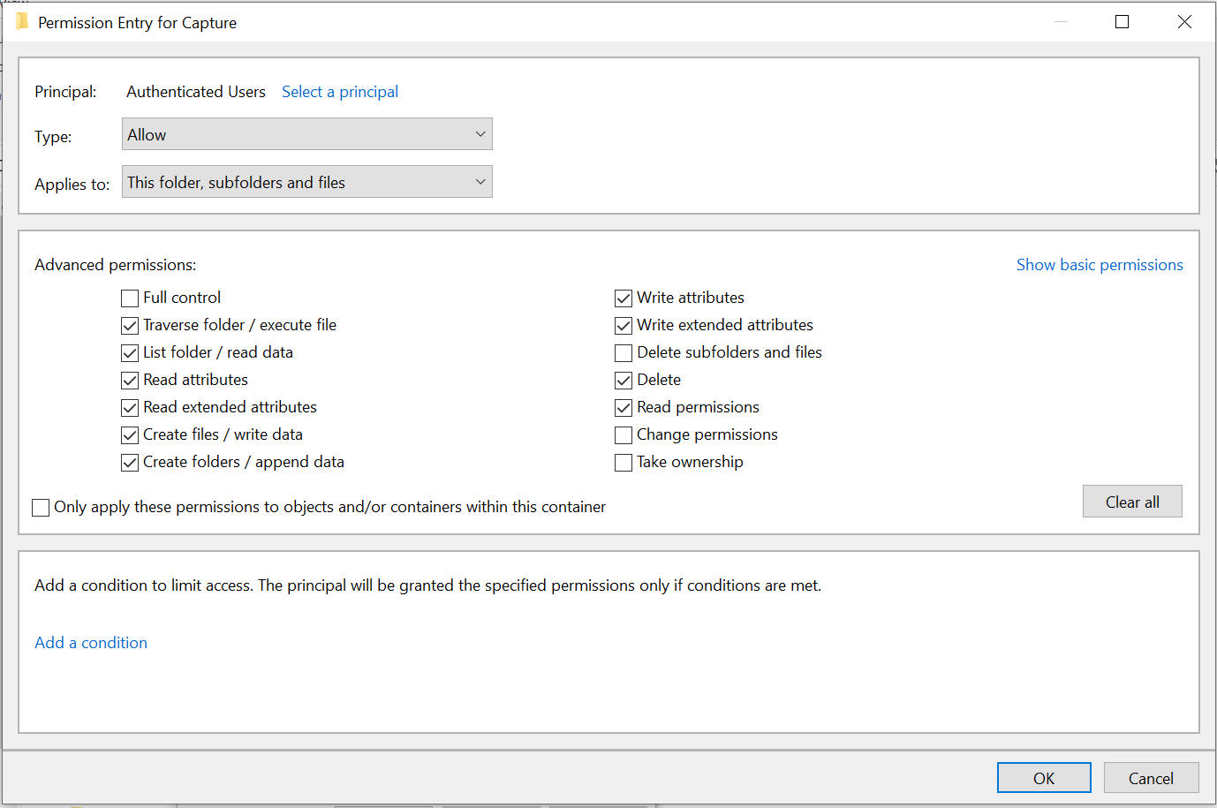
Figure 17 - Advanced NTFD permissions.

Share permissions are applied at folder level and only take effected when a ‘shared’ folder is access remotely. Permissions can be set for local and domain joined users and/or groups. They are less granular than NTFS permissions and can be set to Read, Change or Full Control.

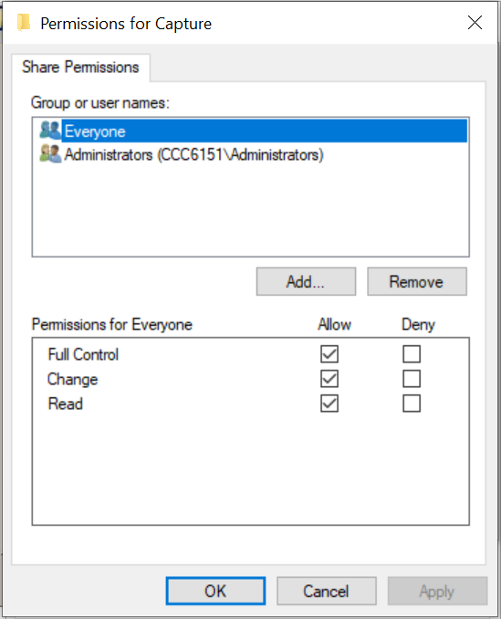
Figure 18 - Share permissions.

NTFS and Share permissions are usually used together by network administrators to set permissions of files and resources on the network.

- When a file or folder is access locally, only NTFS permissions are checked/applied to determine the user’s permissions.

- When network shared are used, both NTFS and share permissions can be applied. The most restrictive permission will take effect.

  - E.g., If a user has read access to the share and modify access via NTFS, the read permissions will be applied when the user is accessing the share remotely.
  - Explicit permissions that are applied directly to a folder always take precedence over inherited permissions.
  - Deny permission always take precedence over allow permissions.

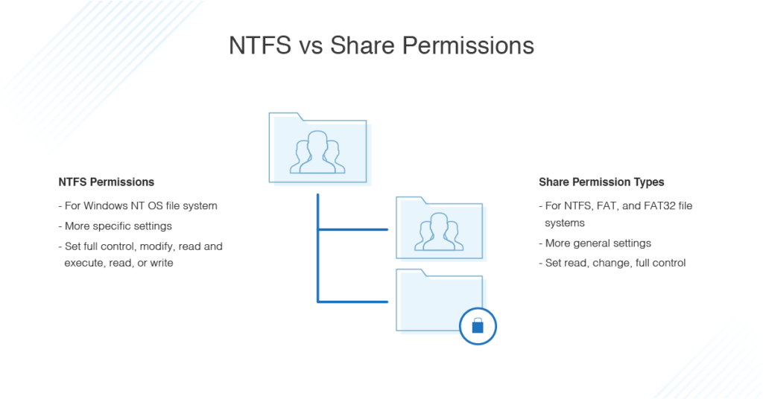
Figure 19 - NTSF vs Share Permissions (dnsstuff.com, 2020)

3 b) Describe the role of Group Policy Management in the network environment, you can use example policies in your answer.
Group policy management is used to set the computers and users policies and settings on a local computer, network or domain device. This can help ensure the correct settings are applied to all the computers on a network, and that features, and functions or operating systems are switched on and off as per the requirements. Applying settings this way is fundamental for large networking as it allows granular control to be set in policies which can help with things such as setting the security standard required.
It provides a centralised management linking in with Microsoft Active Directory Users and Computers environment.
The group policy is set by creating Group Policy Objects (GPO) which can be applied to users, computers or OU groups within the active directory. Policies and permissions can be set and some examples of these are:
- Enforcing password rules – ensure passwords are set to comply with company policies.
- Install and remove software.
- Set local device permissions.
- Turn on and off windows features such as removing the control panel or task manager.
Local group policies can be viewed and edited on Windows devices using the gpedit.msc command or group policy editor from the control panel. Domain controllers can be used to manage and set group policy settings for computers and users joined to the domain (LuPiba, 2019).

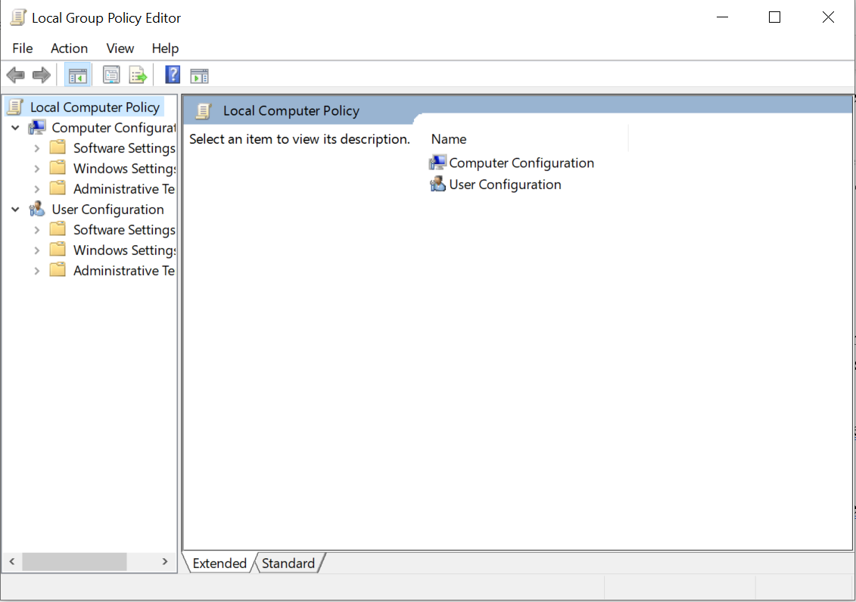
Figure 20 - Group Policy Editor on Windows 10.

The example below shows the group policy setting to manage Windows Cortana. It is currently set to ‘not configured’. The settings ‘enabled’ or ‘disabled’ could be used to enforced via group policy.

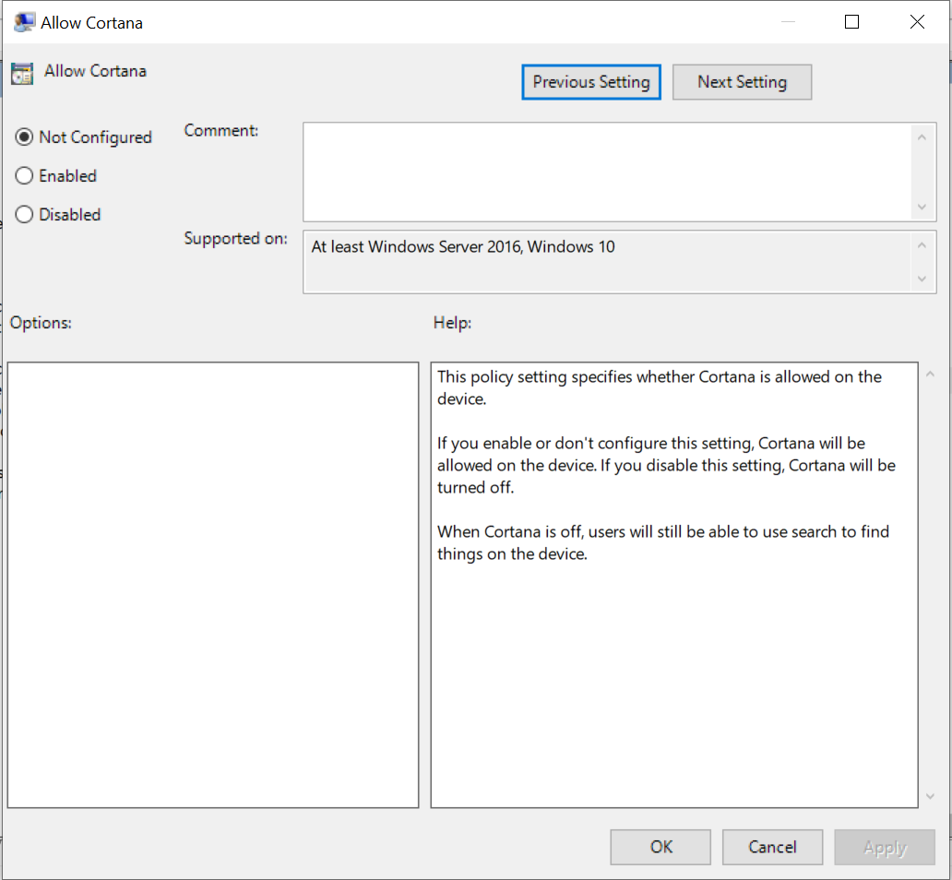
Figure 21 - GPO Windows Cortana.

The Resultant Set of Policy utility (RSOP) tool can be used in Windows to view the group policy objects applied to a domain manage computer.

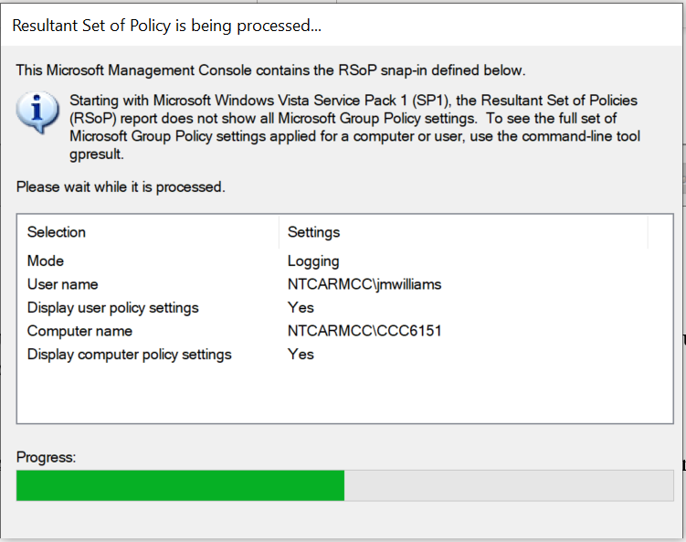
Figure 22 - RSOP running on Windows 10.
The group policy objects that are applied to the computer are displayed.
In the example below, the GPO settings applied to PC CCC6151 are shown.
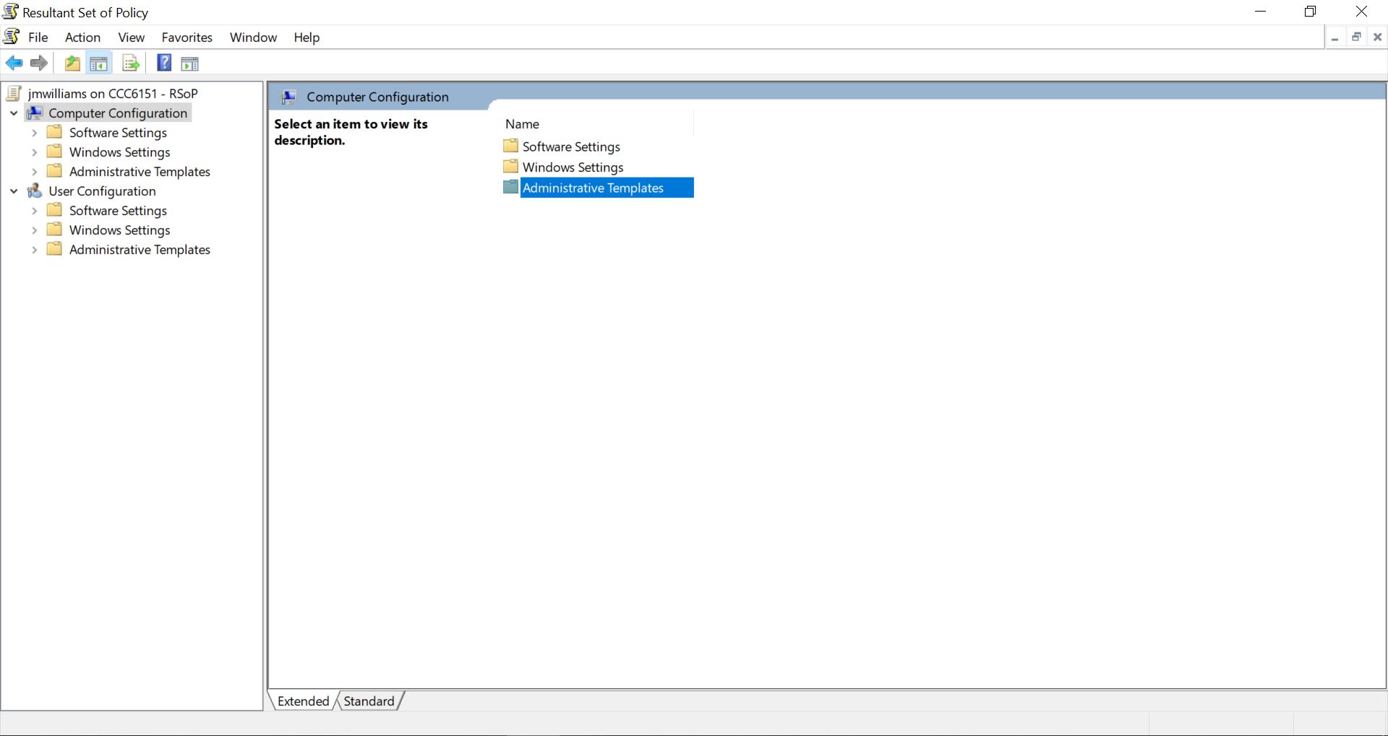
Figure 23 - Policy results.

3 c) Give some examples of sound ‘password’ principles in modern network environments.

Password principals are fundamental in ensuring users are required to set safe and secure password when logging onto the network. Most network administrators set password complexity and expiration rules on the domain using group policy.
Some of the password principals and rules that can be applied are:
- Minimum password length of 8 characters with many administrators now setting this to 12 characters.
- A ‘passphrase’ should be used other than a word based on a dictionary object, as these are harder for hackers to ‘crack’. An example of a passphrase could be to set your password to ‘IlikeToEatApplesOnMondaysIn1982’ rather than ‘Eatapples1982’
- Use upper and lower case, numbers, and special characters where possible.
- Do not write down or share your password with anyone.
- Do not base your password on commonly know information such as date of birth of family members names.
- Educate users on password stealing methods such as phishing emails. Never enter your password on a website which you are unsure of.
There are many methods that can be used to steal or retrieve passwords by cyber criminals, therefore it is important that the methods above are enforced by the network administrator. Some of these methods include:
- Dictionary attacks: This method is used to ‘crack’ passwords using a script that enters words from the dictionary as the password. Therefore, you should never use a common word as a password.
- Cracking security questions: People set the security question for the ‘forgotten password’ feature to commonly know answers such as pets’ names or child’s date on births. These can easily be found out by cyber criminals.
- Guessing simple passwords: The most popular password used in 2020 was123456, with the second most popular password as 123456789. Other passwords used were password, 11111, abc123, 1234 and iloveyou (Top 200 most commonpasswords of the year 2020, 2021).
- Reuse the same passwords across multiple website: If you use the same password to login to multiple websites, one of the sites could be hacked or compromised and the password stolen. The same password could then be used to login to other websites.
- Social engineering is ‘Social engineering is the act of manipulating others into performing cer­tain actions or divulging confidential information It can be employed to trick tar­gets into disclosing passwords’ (Smith, 2019).

Recent recommendation suggests that passwords are no longer suitable as the sole method of authentication to systems, especially where sensitive or confidential information is involved. Methods such as Multifactor Authentication (MFA) and Biometric should be used where at all possible.

Use multi-factor authentication (MFA) for important accounts. One of the most effective ways of providing additional protection to a password protected account is to use MFA. Accounts that have been set up to use MFA require a second factor, which is something that you (and only you) can access (National Cyber Security Centre, 2018)
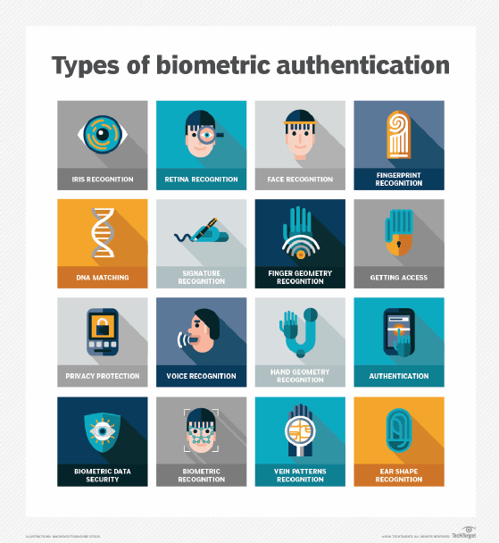
Figure 24 - Biometric authentication (TechTarget, 2021).

Technologies should be used such as geolocation monitoring to detect unusual account logon activities, and lockout policies set. A password deny list can be created so prevent users from using some of the most used password, which are easily known to hackers.

References
dnsstuff.com, 2020. NTFS vs. Share Permissions. [image] Available at: <https://www.dnsstuff.com/ntfs-vs-share-permissions> [Accessed 28 April 2021].
Docs.microsoft.com. 2020. Group Policy Management Console. [online] Available at: <https://docs.microsoft.com/en-us/previous-versions/windows/desktop/gpmc/group-policy-management-console-portal> [Accessed 28 April 2021].
LuPiba, J., 2019. The Importance of Group Policy Management & GPOs | Part 3 #NCSAM. [online] Quest.com. Available at: <https://www.quest.com/community/blogs/b/microsoft-platform-management/posts/it-security-revisit-group-policy-management-often-part-3-ncsam> [Accessed 28 April 2021].
Melnick, J., 2020. Differences Between Share and NTFS Permissions. [online] Blog.netwrix.com. Available at: <https://blog.netwrix.com/2018/05/03/differences-between-share-and-ntfs-permissions/> [Accessed 28 April 2021].
Ncsc.gov.uk. 2018. Password policy: updating your approach. [online] Available at: <https://www.ncsc.gov.uk/collection/passwords/updating-your-approach> [Accessed 28 April 2021].
Nordpass.com. 2021. Top 200 most commonpasswords of the year 2020. [online] Available at: <https://nordpass.com/most-common-passwords-list/> [Accessed 28 April 2021].
Smith, D., 2019. Top 15 Password Management Best Practices | BeyondTrust. [online] Beyondtrust.com. Available at: <https://www.beyondtrust.com/blog/entry/top-15-password-management-best-practices> [Accessed 28 April 2021].
TechTarget, 2021. https://searchsecurity.techtarget.com/definition/biometric-authentication. [image] Available at: <https://searchsecurity.techtarget.com/definition/biometric-authentication> [Accessed 28 April 2021].
UK, D., 2021. Understanding File and Folder Permissions in Windows | Dell UK. [online] Dell.com. Available at: <https://www.dell.com/support/kbdoc/en-uk/000137238/understanding-file-and-folder-permissions-in-windows> [Accessed 28 April 2021].

