Awe and wonder - Science, Mathematics, and the Outdoors.
Module code - ECEY5005
Student number - 2011534
Word count –

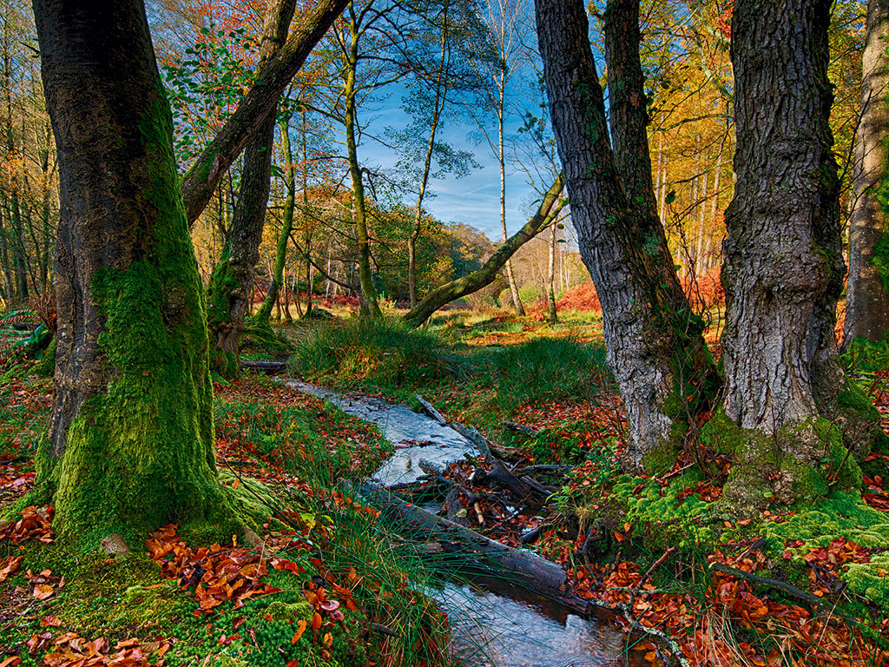
Part one

Part two

The Welsh government (2019) curriculum for schools in Wales states that mathematics and science play a vital role in the lives of children and adults. science and mathematical encounters need to be fun, exciting, and challenging in order to fully capture children’s attention. Maynard et al (2013) states that the foundation phase for Wales conducted research involving children in an early years classroom environment and found that children alleged to be underperformers in an indoor environment, began to thrive when learning in an outdoor environment. The research projected suggested that children embraced the freedom, challenges and opportunities outdoor learning provided for them. Children were given the chance to reconstruct themselves.
When engaging in outdoor learning, children are given the opportunity for firsthand involvement that can assist them to make the connection between the concrete and the abstract whilst engaging in play.
When children learn through play in an outdoor environment, they display their full potential without fear of failure. Many children are impulsively drawn to play, and the importance of play is recognised to be vital to children’s well-being and education. BY WHO? . By engaging in practical activities children are able to learn about themselves and discover their interest. This particular image allows children the opportunities to learn the fascination of science and mathematics in the outdoors WHO SAID. The environment has been chosen to support children’s Mathematical and science development, whilst also being fun and engaging. The environment has the potential to support many areas of a child’s development, besides Mathematics and science, this environment allows for children to develop life skills, problem solving abilities, the improvement of fine motor skills and it encourages self-achievement (Educational play care, Unknown)
Frobel (1837) SORT REF suggests that outdoor play allows children the space and resources to explore speed and gravity ADD TO THIS. He also believed that supporting children to discover nature in outdoor play could assist children in the awareness of the cycle of life and death, and it can instill in children the importance of taking care of the environment, plants, and animals.
Learning outdoors and using natural resources encourages the development of mathematical and scientific skill. All outdoor resources have the possibility to become Mathematics and science. Playing outdoors and in a woodland environment enables children to be involved in projects such as collecting and sorting leaves, leading children to explore different types of species of plants, sizes, and sequence. In this environment, Children have the opportunity to play with logs, trees and twiggs, these types of activities facilitate children to explore weight, 3D shapes, measurements, and height. EXPAND The children have the opportunity to discover symmetry, counting, fractions and volume, all while using natural resources HOW? (Natural resource Wales, 2021)
The environment provided, also supports the holistic development of children. It focuses on the importance of children’s psychological, emotional, and physical welfare HOW The environment encourages children to relate and learn in the natural world, given them the chance to encounter risk and challenge within the confines of a safe environment. Focusing on holistic development in early years can increase children’s self-esteem, and it allows children to build a positive association with learning and education (foundation education, 2018)

Part three

Part four
Froebel (1837) SORT REF believed that allowing children the freedom of the outdoors enables them to appreciate nature and to learn about the seasons and the impacts they have on the world around them.
Sustained shared thinking is a fundamental process in aiding children in their mathematical development. Adults must promote and challenge a child’s critical thinking skills. Engaging in sustained shared thinking with children allows adults to witness how children see the world and it allows adults to assess the child’s true level of development (Brodie, 2009). By truly understanding a child’s level of development it allows adults to tailor the individual learning needs of each child. In order to assist children’s mathematical development adults must provide opportunities where children can engage in problem solving. By providing opportunities for problem solving, children are able to become involved in fun activities such as brainstorming, making comparisons and being able to elaborate on their own ideas. These opportunities promote creativity and self confidence in children (Hewson, 2019).
National Numeracy (2012) suggests that creating a more enthusiastic ethos around Mathematics will lead to a more enthusiastic outcome. An adult’s role is to teach children that although learning can take work, the benefits of learning Mathematics are worth the effort, not only does it develop reasoning and support effective communication skills, but it also creates a broad range of job opportunities in later life. Adults must encourage children to take risk, make mistakes and reap the rewards of overcoming and learning from those mistakes. An adult’s role is to promote confidence in Mathematics and to demonstrate to children how mathematic skills are relevant in real life situations. Adults can assist children in their mathematical development by modeling metacognition. When children develop metacognitive skills, they begin to understand their own learning process. Metacognitive skills enable children to gain a clearer picture of what they need to accomplish and also increases children’s motivation (Welsh government, 2019).

