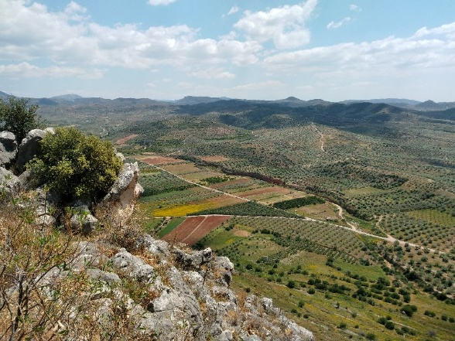
Gregor McClenaghan HPAH7014 Assignment 3

4,017 words, excluding picture captions, footnote and references

Spatial Analysis of:

Midea, Dendra, and the spaces in between

“When we brought the cup up out of the pit, loud cries of joy arose… We shook one another’s hands — we knew that it was one of the great moments of our lives.
The gold cup was carried between closely packed lines of spectators to our quarters, where it received the first preliminary cleaning... The inside was all of gold. Soon designs on the outside were caught sight of; five conventionalised bull's heads executed in gold and niello on a background of silver, with inlaid rings of gold. When the first cleaning was over, the cup was filled with red Nemean wine and passed round the company…
[That evening] our excellent cook, the admirable Orestes, arranged a banquet for us in the tomb, a festivity which none of those present will ever forget.”
Axel Persson, The Royal Tombs at Dendra Near Midea, 1931: 15.

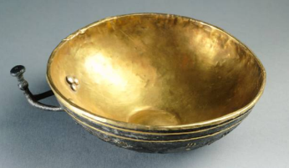
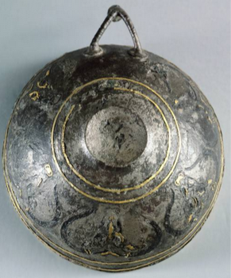
The celebration Persson described took place on the 29th July 1926, in the tholos tomb at Dendra, his team having reached the original floor after weeks moving heavy stones from where the roof of the tomb had collapsed. Theirs and others’ later work at Dendra and the nearby acropolis of Midea re-incorporated those places in to the landscape by manipulating the environment, actions in a continuum of action that resonates back to the tomb’s builders, the dead and those who interred them, and continues to structure Ingold’s (1993) taskscape for the tourists, scholars and locals who interact with and live around these places today. We know libations were part of Mycenaean ritual (Konsolaki‑Yannopoulou, 2001; Boyd, 2014); no doubt the Swedish archaeologists also raised toasts to the dead.

My first portfolio essay looked at the tropaion, a temporary war monument from classical Greece. I agreed with Pritchett (1975: 275) in seeing it primarily as a statement of prestige and psychological control; it communicated with and shaped the memories of those who saw it through manipulation of the physical and visual landscape, but above all it was performance. This was powered in part by the tropaion’s sacred and temporary nature; it was a memorial designed to be forgotten, that exerted power in the short term, but would eventually disappear, letting old grudges fade and wars end. Turner (2020: 233) argues that “performance is more significant than the material object in creating and sustaining memory”, and notes that many Mycenaean tombs were re-used, rebuilt after collapse, and endured in social memory; the community used and re-used them long after the individuals they had been designed for were forgotten.
The “bull cup” from the Dendra tholos tomb, now in the National Archaeological Museum of Athens, NM7336. Picture from Getty images.

I then looked at a boars-tusk helmet, found in Dendra chamber tomb 12, and thought part of its power might be to visually communicate allegiance, prestige, and location in a crowded battle. I examined how it related to aspects of Mycenaean culture, including hunting, which Morris (1990) says expressed a type of soft power, a way of laying claim to territory by showing that the ruler could keep it free of dangerous animals, so rendering it productive.

I now want to consider how Mycenaeans used social performance surrounding death, through actions and the manipulation of objects and the environment, to embed sacred and cultural claims over territory and express themselves as part of it. I will use interpretations of the archaeological record to look at how people may have used Midea and Dendra, and the space between them, in Ingold’s (1993) terms as a complete taskscape; ceramics and stone seals found at Midea have verified the link between the two (Demakopoulou, 2007). Persson’s first excavation report contains an imaginative but (somewhat) plausible description of how a specific Mycenaean funeral might have looked, sounded and felt, rooted in his reading of the evidence his team unearthed in the tholos tomb (Persson, 1931: 68). Given that we know processions were part of Mycenaean ritual (Boyd 2014), I will look at the process by which the dead were brought on the journey from Midea to their resting place at Dendra, the roles played by the living and dead, human and non-human participants in the funeral, and what it might have meant for the community, years or centuries later.
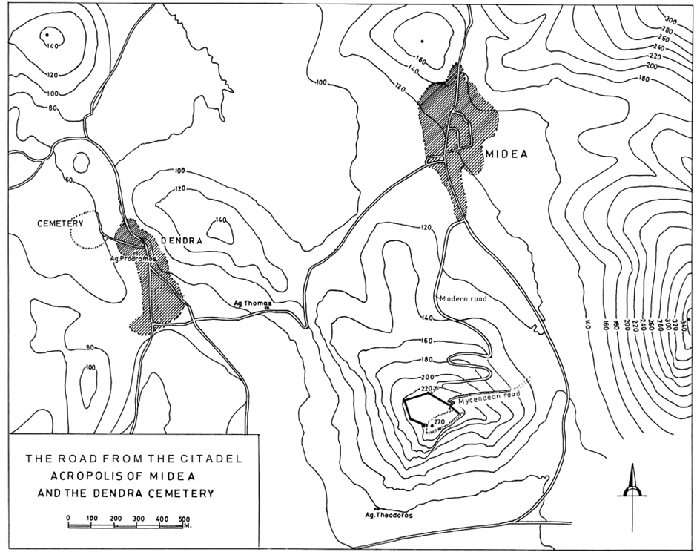
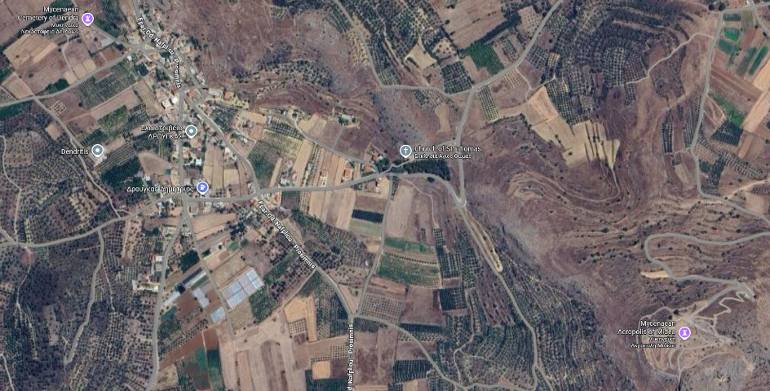
Google maps satellite image showing the Midea Acropolis and Dendra cemetery (L), and contour map, from Walberg, 2007. The two sites are about 1.5km distant from each other in a straight line, but the steep hill and need for a road to have switchbacks would add to the journey.
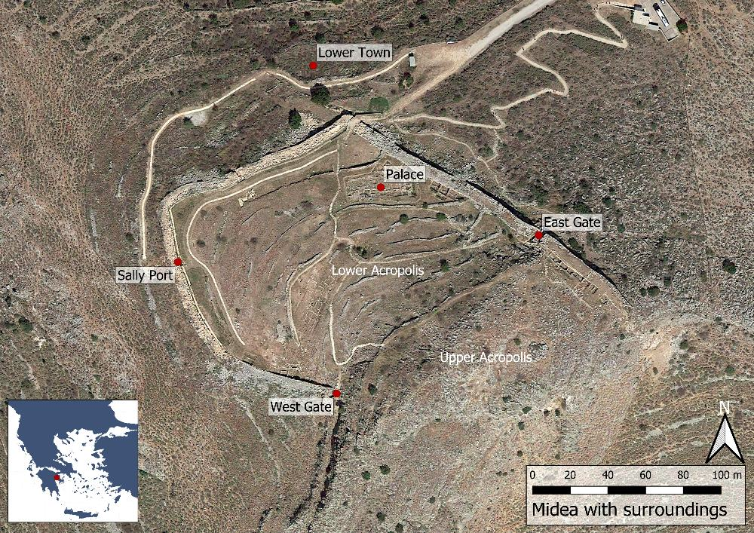

Midea site plan from the Swedish Institute at Athens website.

Midea

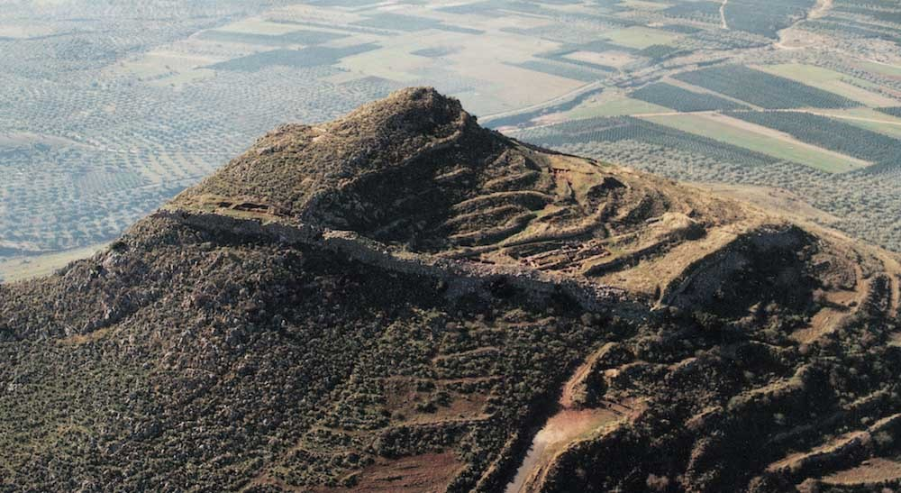
Midea was occupied in the Middle and Final Neolithic (5000 – 3100 BCE), and by the Early and Middle Helladic (3200 – 2000 BCE), it had become a substantial settlement, reaching the peak of its power and wealth in the Late Helladic IIIB (1300 – 1200 BCE) (Demakopoulou, 2007; SIA, 2020). There is an Upper and a Lower Acropolis, and a number of smaller terraces. During the Early Helladic (3100-2000 BCE) only the Upper Acropolis was inhabited; there are the remains of terrace walls and defensive structures near the summit (SIA, 2020). Most archaeological evidence comes from the Lower Acropolis, which was the site of a Megaron, possibly destroyed once and rebuilt on a smaller scale (Walberg, 2007). Persson (1942: 7) thought he saw traces of a Megaron at the site’s Upper Acropolis, and recent examination has confirmed the existence of a large area of levelled rock that could have supported a large building, but the area has been badly eroded and little evidence remains (Demakopoulou, 2007). There have not yet been excavations to definitively locate the site of a town associated with the citadel, but there are indications that it may have been to the north west (SIA, 2020).
Photo from the Ephorate of Antiquities of Argolida website.

Human remains from six individuals have been found at Midea (Ingvarsson-Sundström 2007), the earliest being an approximately one-year-old Middle Helladic child, found in a cist grave at the southwest building complex; it has been identified as “clearly an elite burial” which “can be compared to the richly furnished child’s burial of the same period in the Lower Citadel of Tiryns” (Demakopoulou, 2007). The others are a Middle Helladic newborn infant and adult, found together; an adult, thought to be from the Middle Helladic or Late Helladic IIIB, whose teeth show indications of malnutrition or disease; an approximately six-year-old child identified as being from the Roman period; and one male and one female adults, found in separate locations but both probably from the Roman period (Ingvarsson-Sundström 2007).
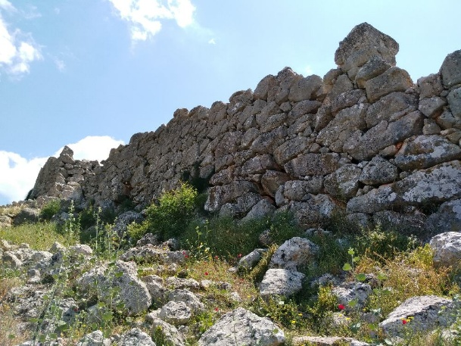
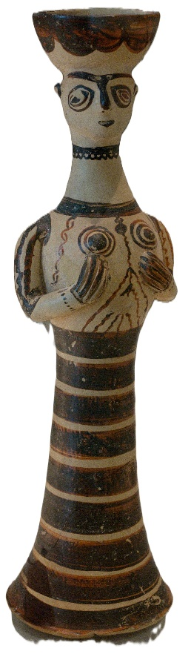
Around 1250 BCE the city built impressive fortification walls on three sides of the acropolis, the south-east being protected by a steep cliff; unlike Mycenae and Tiryns, which built their cyclopian walls at around the same time, there seems to have been only a single building phase (Demakopoulou, 2007; SIA, 2020). Access was through gates in the east and west sides, and a building complex near the west gate has provided some of the richest archaeological finds (Demakopoulou, 2007; Walberg, 2007). A complete, terracotta wheel-made female figure, dubbed “The Lady of Midea” was found near the west gate, and numerous Psi, Tau, and animal figurines have been found in the area; however, while there may have been a shrine there, and they were probably used or intended for religious activity “the assemblage cannot be considered as a cultic assemblage in the true sense”, as most were not found in their original context (Demakopoulou and Divari-Valakou, 2001). Similar female figures, usually said to be deities, have been identified with cult activity at Mycenae, Phylakopi, and Tiryns (Taylour, 1969; French, 1985; Killian, 1976, cited in Demakopoulou and Divari-Valakou, 2001); the Lady of Midea wears a tall polos hat in the shape of a bowl, with an opening in the bottom that may have allowed it to be used for pouring libations. Demakopoulou and Divari-Valakou (2001) say there is no doubt she was a cult object, and was probably intended for display, and/or for use in processions; they note that the figure’s conical stem has a wide opening that could be used to secure it to the top of a stick, making her the focal point of a procession.
The fortifications at Midea. Photo from the Swedish Institute at Athens website.
“The Lady of Midea”. Picture from Wikimedia commons.

The smaller figurines are similar to those found at other Mycenaean sites. Persson (1931: 83, 88) found numerous terracotta psi and proto-phi type figurines during his first excavations (proto-phi in chamber tomb 1; psi types in chamber tomb 3), as well as other figurines made from faience. Interestingly no proto-phi types have been found so far at Midea (Demakopoulou and Divari-Valakou, 2001).

Fresco fragments show that most of the walls in the west gate building complex were covered with painted plaster (Demakopoulou, 2007), which may have simply been decoration, but might have played a role in adjusting and directing visitors’ senses and expectations as they moved from one room to another (Thaler, 2015). Mycenaean architecture was designed to focus attention and direct movement, with doorways and thresholds acting as important liminal spaces, allowing the physical and social exclusion of some and inclusion of others, while transitioning from one mental or emotional state to another (Maran, 2006; Pantou, 2014; Thaler, 2015). Such transitions and bottlenecks may have been especially important in the context of a funeral; the preliminary stages of preparing the body and assembling the necessary objects will have been done by a much smaller group of people than would take part in the later procession. If the funeral in question was that of a king or leader, access to them may have been restricted during their life as well; we have plenty of examples from throughout history where a ruler’s health problems have been kept from the public until a succession can be carefully managed and negotiated (Menger et al., 2015; Zhou, 2021). Middleton (2017) cites Garland’s (1985) suggestion that Greeks saw death more as a process than a single event, with a person beginning their journey while still alive, and not concluding until after the body was laid to rest. Boyd (2014) says that “in preparing the body for burial, mourners effected a transformation that was part of a larger project involving re-negotiating roles and relationships to accommodate the absence of the agency of the newly dead.”

The Fall

It was long thought that an earthquake, or series of them, had hit the region around 1200 BCE, destroying Tiryns (Kilian, 1996, cited by Cline 2021) and Midea, where there appeared to be evidence of destruction by earthquake followed by fire over the entire site (Demakopoulou, 2007; Walberg, 2007). However, more recent, detailed analysis using “active and passive seismic measurements complemented by a gravimetric survey” (Hinzen et al, 2018) has upended that assumption, concluding that while the region has suffered many earthquakes in the last several thousand years, the evidence makes it “unlikely” that a single destructive earthquake contributed to the end of the city in the 13th Century BCE. Among the Mycenaean experts contributing to that paper were Joseph Maran and Katie Demakopoulou, who both previously advocated the earthquake hypothesis (Maran, 2009, 2010, cited in Cline 2021; Demakopoulou, 2007) and it may be that academic consensus can no longer support it. However, no strong evidence has emerged of alternative causes. Midea continued on a smaller scale until around the 5th Century BCE, when the remaining population was forcibly moved to Argos (Pausanias VIII, 27.1, cited in Persson (1931: 7)). The lower acropolis was re-occupied by Romans a millennia later, around 500 CE, abandoned after a century, and re-occupied briefly around 1200 CE before being abandoned for good (Walberg, 2007).

The Journey
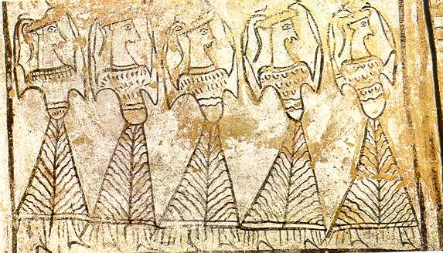
Larnax (painted sarcophagus) from Tanagra. Photo from anistor.gr
Later Greek art features many funeral scenes, showing elaborate processions, often featuring women with upraised arms, accompanied by music, sacrifices, and perhaps funerary hunts and games; Mycenaean representations are rarer, but a funeral procession is clearly depicted in the lanarkes (clay sarcophagi) from Tanagra (Cavanagh and Mee, 1995; Burke, 2008).

Processions could be seen from near and far, and are above all public, open events in which those watching are as much a part of the process as those leading and following along; viewpoints and background vistas change as the group moves through the landscape, and there are ample opportunities to stop and for roles to change, in terms of who leads or takes part in the procession, or where attention is focused at any particular time, whether on specific people, objects, or vistas (Boyd, 2017). In a funeral context, the ability for many people to participate contrasts with the more intimate early stages of preparing the body, and later actions in the tomb, where the enclosed architecture ensured that only a limited number could be present. Hoskins (2006) argues that objects acquire their own biographies and meanings through the context in which they are used; the presentation or manipulation of certain objects at certain times could activate what Gell (1992) called the “technology of enchantment”; magic and spiritual meaning transmitted through art.

Turner (2020: 33) argues that tombs became embedded in the social life and memory of the community because they were repeatedly re-used, not just for burials, but perhaps as focal points for processions on special days, and that many more people would hear about the grandeur of any particular funeral than would actually witness it. Boyd (2017) notes that a procession to a particular tomb could stop to pay respects to other tombs along the way; the event was performance, with participants probably expected to behave in certain ways through their dress, gestures, and sounds, but nevertheless having considerable freedom to choose how they performed their roles, as individuals and groups sought to make their place in proceedings both seen and understood.

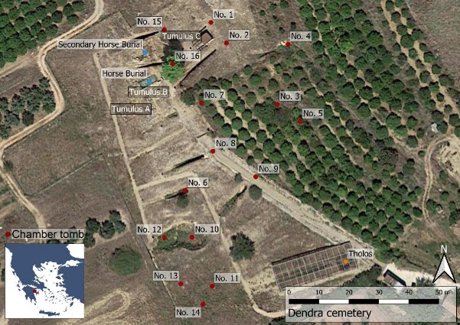
Dendra
Site plan from the Swedish Institute at Athens website.

The Dendra cemetery is further away than similar areas associated with other Mycenaean cities. Persson (1942: 17) considered whether its location and the orientation of the tombs held symbolic meaning, but concluded that it was more probably chosen because rock there would be easier to work.

Turner (2020: 101), in his study of archaeological energetics, found that an average chamber tomb could probably be dug by a team of ten men in around a week. He dismissed the idea that the workers themselves would gain much social capital from the task; instead the costs, risk, and potential social rewards fell to the elites who commissioned them.

In total, three tumuli, one tholos tomb, and 16 chamber tombs were excavated at Dendra, first by Persson (1931; 1942), and then by Paul Åström in the 1960s and 1980s (SIA, 2020). Unfortunately, Åström’s original excavation reports are not available online. The three tumuli were probably built in the Middle Helladic (2000-1550 BCE), as was a tomb, built in to Tumulus B when the mound was constructed (SIA, 2020). During Late Helladic III, three horses were buried in Tumulus B, and two in Tumulus C, indicating repeated horse sacrifice (SIA, 2020). Also in Late Helladic III, four chamber tombs (1, 2, 15, and 16) were cut in to Tumulus C. A burnt area and hearth was found outside Tumulus A. There has long been debate about whether burnt animal sacrifice was practiced by Mycenaeans, or if animal remains found at various sites are just a by-product of feasting; Cosmopoulos and Ruscillo (2014) have argued that burnt offerings probably were a part of Mycenaean cult and religious practice.

Pantou (2014) said that Mycenaean palace architecture was “activated and invoked during formal social occasions, inclusive or exclusive gatherings, and ritualized activities held in the built space.” Tomb architecture functioned in a similar way, with the long dromos entrance tunnel restricting both movement and senses; it helped to frame the funeral performance and the power politics involved as local elites, by altering the landscape, manipulated communal memory and tradition to improve their positions (Galanakis, 2011; 2017; Papadimitriou, 2017).

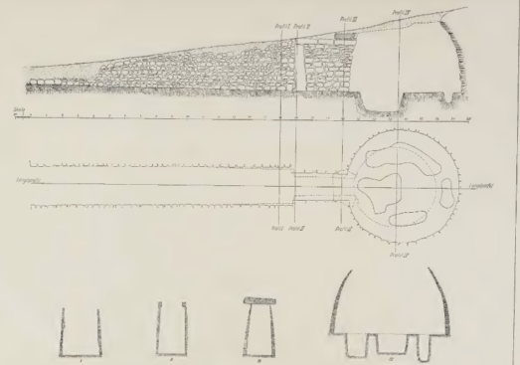
I briefly covered the finds from chamber tomb 12, the “cuirass tomb”, in my last essay. I want to examine two others from Dendra; the tholos tomb, and chamber tomb 2, both of which have unique and interesting features.
Plan of the tholos tomb, from Persson (1931: 20)
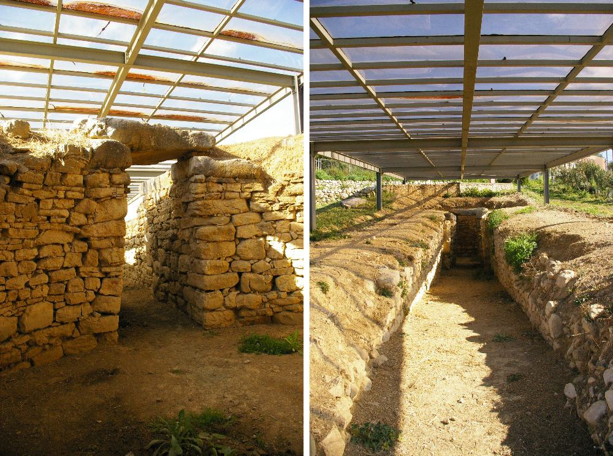
The “Royal” Tholos Tomb
The tholos tomb first excavated by Persson is the only one at the site, and was dated to Late Helladic IIIa. Three undisturbed graves were found in pits, who Persson dubbed the “King”, “Queen”, and “Princess”. There is no way to tell if these individuals really held these titles or their equivalent, but for ease of reference I will continue using them. The tholos collapsed around 1050 BCE (Persson, 1931: 11), shortly after which a secondary burial took place; it was this skeleton, and the proto-geometric vase found with it, that enabled Persson to be so precise. Scattered remains of three other individuals were found at floor level; Persson thought they were tomb robbers who had struck around 1000 BCE, and that they may have caused the tomb to collapse, killing them. Further detail on them is lost; we know that Mycenaean tombs were frequently re-used, and bones from previous burials disarticulated (Boyd 2017), and that might explain the remains (Hughes, 1991: 28).
The tholos tomb doorway and dromos. Picture from the Swedish Institute of Archaeology website.

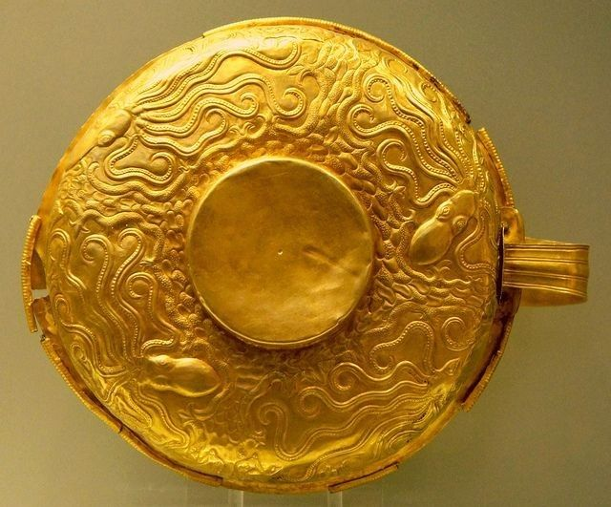
Persson (1931: 68) thought that the King and Queen were buried at the same time; they were laid in the same large pit, each with their own grave goods, including, in the King’s case, a famous gold cup decorated with octopuses, which has been a source of debate about the sophistication of Mycenaean art from the mainland compared to Minoan work from Crete (Hurwit, 1979). Other “shared” goods were lying between them; among these was an ostrich egg, indicating trade or other forms of exchange with North Africa or the Middle East (Hodos et al, 2020). Persson suggested that the Queen may have been a human sacrifice, accompanying the King to the afterlife; he also identified other human bones as possibly belonging to a servant, and bones of a dog, both of whom may also have been sacrificed on the death of their master; he also thought it possible that the three other people found in the tomb might have suffered the same fate. Elsewhere Persson (1931: 89) suggested that psi and proto-phi figurines found in other tombs may have been substitutes for the sacrifice of real women, but no recent scholars have linked this practice to these figurines. Hughes (1991: 26-31), in a comprehensive study of human sacrifice in Ancient Greece, found numerous problems with Persson’s analysis of the evidence, and thought that it more likely that the other remains showed that the tomb had been repeatedly reused. He did not completely dismiss the idea that the King and Queen had been interred at the same time, but pointed out that this could be explained by their simultaneous death from disease, accident, or violence.
The “Octopus Cup”. Photo from pinterest.

The Cenotaph

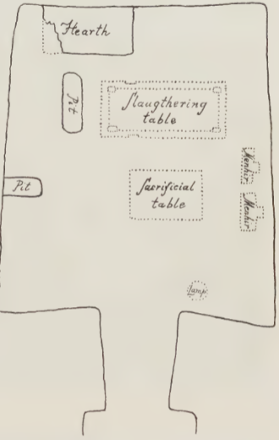
Chamber tomb 2, dubbed “The Cenotaph” by Persson (1931: 108), was excavated in 1927. It was built and had been sealed in much the same way as other Mycenaean tombs. The skeleton of a woman was found in the dromos, together with spindle-whorls and a bronze needle; in the same layer were glass-paste decorations that Persson thought had been discarded by tomb robbers. In a pit in the dromos they found 35 bronze objects, including mirrors, jugs, bowls, and weapons, some still with their wooden handles.
The chamber itself, while clearly having been robbed in the past, contained a large “slaughtering table”, complete with notches that Persson thought were to aid the binding of a victim, and broken pieces of cut stone that together formed a “sacrificial table”. Pottery sherds from the same vessel were found both in the chamber and in the dromos; Persson’s explanation was that after a sacrifice, which involved smashing vessels against the pyre on which other perishable gifts had been offered, the chamber was cleaned, with debris thrown in to the dromos.

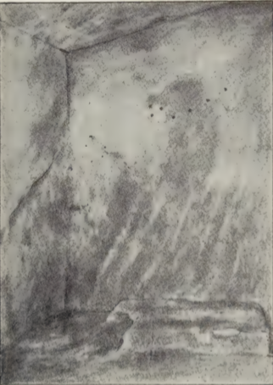
The floor of the chamber itself was covered with around 40,000 glass beads, probably from a garment, and numerous other grave goods, including miniature furniture made from clay. However, despite the tomb being richly furnished, no-one was buried in the chamber. Persson considered whether the chamber had served as an artificial cave sanctuary, but rejected that explanation because the dromos and doorway had been blocked up, exactly as in a normal tomb. Instead he decided that the tomb was a cenotaph, built and furnished for one or more souls who had died far away or at sea, and whose bodies could not be recovered. I have not seen any later theories to contradict this idea.
Sketch of holes found in tomb 2, from Persson 1931; this was based on a photograph which was damaged before publication.

Another interesting feature was a series of seven holes drilled in to the wall about two meters above the hearth or altar, in a configuration that reminded Persson (1931: 115) of the Great Bear constellation, which he said is also seen in some Egyptian tombs; he theorized that the holes might once have held metal stars.

Who lived and died here?

The archaeological evidence is clear that a fairly sudden change in burial customs swept through mainland Greece in the Mid to Late Helladic (Voutsaki, 2025). Earlier archaeologists made convoluted attempts to link this change with an influx of foreign, possibly Egyptian migrants (Persson, 1931: 116; Stubbings, 1965: 9).

Modern academia has largely rejected this hypothesis, and Maran (2022) has issued a strong warning about the need to tread lightly when assigning labels to the past, and to bear in mind our own social context when describing that of others. He was responding to an aDNA analysis of 19 individuals from across the Eastern Mediterranean (Lazaridis et al. 2017); 10 from Crete; four “Mycenaeans” from the Western Peloponnese, Argolis, and Salamis; one from Mycenaean-era Crete; a Neolithic sample from the Southern Peloponnese; and three Bronze Age (2800-1800 BCE) individuals from southwest Anatolia. In brief, the study showed considerable overlap between the DNA of individuals from Crete and mainland Greece, with the majority coming from the first Neolithic farmers of Anatolia, and some from Iran and the Caucuses. However, the “Mycenaean” samples also had significant contributions from a source related to the hunter-gatherers of eastern Europe and Siberia, via the Eurasian steppe or Armenia.

While acknowledging that such research provides insights in to the genetic relations between people living on Crete and the mainland during the Bronze Age, and can help track patterns of mobility, Maran (2020) rejects the idea that specific “cultures” can or should be linked to genetics or ethnicities, pointing out that such ideas were widely held during the darkest days of the 20th Century, and that the resurgence of nationalist extremism in recent years means naïve labels can and will be misused by actors with bad intent to distinguish different groups of people, and fuel arguments over who “belongs”, disregarding the many factors that cause culture and language to change over time. He argues that stable ethnic or state identities did not exist in the Bronze Age Mediterranean, which was politically fragmented, with many small, localised polities home to a complex mix of overlapping regional and cultural influences.

Voutsaki (2025) has examined how the “kin-based, introverted, and austere village societies of the Greek Middle Bronze Age (c. 2100–1700 BCE)” transformed into the “highly differentiated, expansionist, and ostentatious Late Bronze Age (or Mycenaean) kingdoms (c. 1700–1200 BCE)”, and concludes that kinship, gender differentiation, and small group identity were becoming increasingly important, but says that is not enough to explain the emergence of elaborate tomb culture. She sees a more profound change at work, as the establishment of cemeteries marks a clearer division between the world of the living and the world of the dead, and suggests that costly grave goods were not just a way for the living to compete for status, but also to protect themselves from the powers of the dead by extravagant displays of respect.

Turner (2020: 239) argues that although the cost of tomb building was relatively low, there were limits to how extravagant society was willing to allow the “elites” to be. “Social rather than economic constraints encouraged compliance with a recognisable standard, limiting overly ostentatious tomb building… by building larger, more elaborate tombs, commissioners risked family and factional reputations in a costly signalling gamble to secure legacy.”

Midea was, at one point, a thriving cultural, administrative and economic centre, with strong links not only with neighbouring Mycenae and Tiryns, but also Crete, the Levant, and possibly beyond (Demakopoulou, 2004, 2007). It held a commanding position over the Argolid plain, and although its massive walls could not save it in the end, the traces that remain offer a fascinating insight in to a culture that grew and endured for more than a thousand years.

References

Boyd, M. (2014). “The Materiality of Performance in Mycenaean Funerary Practices.” World Archaeology, vol. 46, no. 2, pp. 192–205. JSTOR, http://www.jstor.org/stable/26160172.

Boyd, M. (2017). “Fields of Action in Mycenaean Funerary Practices.” In Dakouri-Hild, A. and Boyd, M. (eds.) Staging Death: Funerary Performance, Architecture and Landscape in the Aegean. Berlin, Boston: De Gruyter, pp. 57-88. https://doi.org/10.1515/9783110480573-004

Burke, B. (2008). “Mycenaean Memory and Bronze Age Lament.” In Suter, A. (ed.) Lament: Studies in the Ancient Mediterranean and Beyond. 1st ed. Oxford: Oxford University Press. Available at: https://doi.org/10.1093/oso/9780195336924.001.0001.

Cavanagh, W., and Mee, C. (1995). “Mourning Before and After the Dark Age.” Bulletin of the Institute of Classical Studies. Supplement, 63, 45–61. http://www.jstor.org/stable/43767567

Cline, E. (2021). 1177 B.C. The Year Civilization Collapsed, revised edition, Princeton University Press.

Cosmopoulos, M.B. and Ruscillo, D. (2014) “Mycenaean Burnt Animal Sacrifice at Eleusis,” Oxford Journal of Archaeology, 33(3), pp. 257–273. Available at: https://doi.org/10.1111/ojoa.12037

Demakopoulou, K. and Divari-Valakou, N. (2001). “Evidence for Cult Practice at Midea: Figures, Figurines and Ritual Objects.” In Laffineur, R. and Hägg, R. (eds.) Potnia – Deities and Religion in the Aegean Bronze Age – Proceedings of the 8th International Aegean Conference, Göteborg University 12-15 April 2000. University of Texas at Austin Program in Aegean Scripts and Prehistory.

Demakopoulou, K. (2004) “Knossos and the Argolid: new evidence from Midea.” British School at Athens Studies, Vol. 12, Knossos: Palace, City, State, pp. 405-410

Demakopoulou, K. (2007). “The Role of Midea in the Network of Mycenaean Citadels in the Argolid.” In: Keimelion: The Formation of Elites and Elitist Lifestyles from Mycenaean Palatial Times to the Homeric Period, pp. 65–80. Denkschriften der Österreichischen Akademie der Wissenschaften, Philosophisch-Historische Klasse, Volume 350. Vienna: Verlag der Österreichischen Akademie der Wissenschaften. ISBN: 9783700137795.

Galanakis, Y. (2011). “Mnemonic Landscapes and Monuments of the Past – Tumuli, Tholos Tombs and Landscape Associations in Late Middle Bronze Age and Early Late Bronze Age Messenia (Greece). In Ancestral Landscapes, TMO 58, Lyon: Maison de l’Orient et de la Méditerranée.

Galanakis, Y. (2017). “A Roof for the Dead: Tomb Design and the ‘Domestication of Death’ in Mycenaean Funerary Architecture.” In Dakouri-Hild, A. and Boyd, M. (eds.) Staging Death: Funerary Performance, Architecture and Landscape in the Aegean. Berlin, Boston: De Gruyter, pp. 57-88. https://doi.org/10.1515/9783110480573-004

Gell, A. (1992). ‘The Technology of Enchantment and the Enchantment of Technology’, in Coote, J. and Shelton, A. (eds), Anthropology Art and Aesthetics, Oxford Academic https://doi.org/10.1093/oso/9780198277330.003.0003

Hinzen, K. et al (2018). “Reassessing the Mycenaean Earthquake Hypothesis: Results of the HERACLES Project from Tiryns and Midea, Greece. Bulletin of the Seismological Society of America, Vol. 108, 3A, pp. 1046-1070, https://doi.org/0.1785/0120170348

Hodos, T. et al. (2020) “The origins of decorated ostrich eggs in the ancient Mediterranean and Middle East,” Antiquity, 94(374), pp. 381–400. Available at: https://doi.org/10.15184/aqy.2020.14.

Hoskins, Janet. (2006). “Agency, biography and objects.” In Tilley, C.Y. et al. (eds.) (2013) Handbook of material culture. Paperback edition. Los Angeles; SAGE.

Hughes, D.D. (1991). Human sacrifice in ancient Greece. London: Routledge.

Hurwit, J. (1979). “The Dendra Octopus Cup and the Problem of Style in the Fifteenth Century Aegean”. American Journal of Archaeology, 83(4), 413–426. https://doi.org/10.2307/504141

Ingold, T. (1993). The Temporality of the Landscape, in World Archaeology, Vol. 25, No. 2, Conceptions of Time and Ancient Society p. 152-174.

Ingvarsson-Sundström, A. (2007) “Appendix B The Human Remains”, in Walberg, G. et al. (2007). Midea: The Megaron Complex and Shrine Area; Excavations on the Lower Terraces 1994–1997 INSTAP Academic Press Philadelphia, Pennsylvania.

Konsolaki‑Yannopoulou, E. (2001). “New evidence for the practice of libations in the Aegean Bronze Age.” In R. Laffineur & R. Hägg (eds), POTNIA: Deities and Religion in the Aegean Bronze Age (Aegaeum 22), pp.79–96

Lazaridis, I., et al (2017). “Genetic origins of the Minoans and Mycenaeans.” In Nature, Vol. 548, 10 August 2017.

Maran, J. (2006). “Mycenaean Citadels as Performative Space.” In Maran, J., Juwig, C.,
Schwengel, H. and Thaler, U. (eds.), Constructing Power - Architecture, Ideology and Social Practice. Hamburg: LIT Verlag.

Maran, J. (2022). Archaeological Cultures, Fabricated Ethnicities and DNA Research: “Minoans” and “Mycenaeans” as Case Examples. In Davidovich, U., Yahalom-Mack, N., and Matskevich, S., Material, Method, and Meaning – Papers in Eastern Mediterranean Archaeology in Honor of Ilan Sharon. Münster, Zaphon.

Menger, R. et al. (2015). “Woodrow Wilson’s Hidden Stroke of 1919: The Impact of Patient-physician Confidentiality on United States Foreign Policy.” Neurosurgical Focus 39, 1, E6. https://doi.org/10.3171/2015.4.FOCUS1587

Middleton, G. (2017). “I Will Follow You into the Dark: Death and Emotion in a Mycenaean Royal Funeral”, Oxford Journal of Archaeology, 36(4), pp. 395–412. doi: 10.17613/80hk-5998.

Morris, C. (1990). “In Pursuit of the White Tusked Boar: Aspects of Hunting in Mycenaean Society”, in Hägg, R. and Nordquist, G. (eds) Celebrations of Death and Divinity in the Bronze Age Argolid, Proceedings of the Sixth International Symposium at the Swedish Institute at Athens 11-13 June 1988, Stockholm.

Pantou, P. (2014). “An Architectural Perspective on Social Change and Ideology in Early Mycenaean Greece.” American Journal of Archaeology, Vol. 118, No. 3 (July 2014), pp. 369-400

Papadimitriou, N. (2017). “Structuring Space, Performing Rituals, Creating Memories: Towards a Cognitive Map of Early Mycenaean Funerary Behaviour” In Dakouri-Hild, A. and Boyd, M. (eds.) Staging Death: Funerary Performance, Architecture and Landscape in the Aegean. Berlin, Boston: De Gruyter, pp. 57-88. https://doi.org/10.1515/9783110480573-004

Persson, A. (1931). The Royal Tombs at Dendra Near Midea, Oxford University Press.

Persson, A. (1942). New Tombs at Dendra Near Midea, Oxford University Press.

Pritchett, W.K. (1975). The Greek State at War, Part 2. Berkeley: University of California Press.

Stubbings, F. (1965). The Rise of Mycenaean Civilization. Cambridge University Press.

Swedish Institute at Athens website https://www.sia.gr/en/

Thaler, U. (2015). “Movement in between, into and inside Mycenaean palatial megara.” In Schallin, A. and Tournavitou, I. (eds.) Mycenaeans Up To Date - The archaeology of the north-eastern Peloponnese - current concepts and new directions. Stockholm: Swedish Institute at Athens.

Turner, D. (2020). Grave Reminders – Comparing Mycenaean tomb building with labour and memory. Sidestone Press, Leiden.

Voutsaki, S. (2025). “Mortuary practices and societal change in Early Mycenaean Greece.” In Norstein, F. and Selsvold, I. (eds.), Archaeological Perspectives on Burial Practices and Societal Change: Death in Transition, Routledge, Abingdon.

Walberg, G. et al. (2007). Midea: The Megaron Complex and Shrine Area; Excavations on the Lower Terraces 1994–1997 INSTAP Academic Press Philadelphia, Pennsylvania.

Zhou, C. (2021). “Last step to the throne: the conflict between rulers and their successors.” In Political Science Research and Methods, 11(1), 2023 pp. 80-94.

Ancient DNA

