Data Handling and Business Intelligence
Data Analytics
May 2019
Data Handling and Business Intelligence
Nia James
1705762
Contents
Topic | Page number
Introduction | 4
Part 1 – EXCEL | 4-10
Profit/loss against product category by order quantity | 4-6
Profit/loss against product category, order quantity and year | 6-8
Profit/loss against technology, order quantity, year and sum of profit | 8-9
Strengths and weaknesses of EXCEL | 9-10
Part 2 - WEKA | 11-16
How prediction, association, and clustering are used for data | 11-12
Prediction – Sarn Helen data set | 12-13
Association – Sarn Helen data set | 14-15
Clustering – Sarn Helen data set | 15-16
Conclusion | 16
References | 17

List of figures
Figure 1: Profit/loss for Sarn Helen against product category by order quantity.
Figure 2: Product category created by =CountIF statement.
Figure 3: Profit/loss for Sarn Helen against product category, order quantity and year.
Figure 4: Number of technology sales of 10 or less units in profit or loss for Sarn Helen by year using =CountIF statement.
Figure 5: Profit/loss for Sarn Helen against technology, order quantity, year, and sum of profit.
Figure 6: How much profit was made each year created by =VLOOKUP to then found out how much profit was a loss in technology.
Figure 7: Classification example 1 – Linear Regression.
Figure 8: Classification example 2 – J48 Decision Tree.
Figure 9: Association example 1.
Figure 10: Clustering example 1.

Introduction
This report provides recommendations for Sarn Helen Office Supplies on how they can engage with analytics in the future to better their decision making. Sarn Helen noticed a reduction in profits in 2017 but were unsure as to why this happened. Their excel records are automatically updated by their sales system, allowing them to be reminded of a loss. This report gives advice for and against using WEKA and if it will benefit their organisation or not, also, an analysis and assessment of their problems to investigate what WEKA can do for them in regards to avoiding reductions in profits in the future.

Part 1 - Excel
Carey (1997) describes Microsoft Excel as a spreadsheet used for data collection, calculation, and analysis. Pemberton et al (2000) adds that in a recent questionnaire of 227 people randomly selected from a range of business disciplines all at different levels within their organisation, a huge 80 per cent of them are regular users of Microsoft Excel being the prevailing spreadsheet as they are led to believe its impact on modern day technology has allowed staff access to more support. However, Baškarada (2011) reports that spreadsheets frequently lead to substantial negative effects on the quality of relevant information.
The pivot table showing profit/loss against product category by order quantity (Figure 1) highlights the extreme loss when 10 or less units of technology were purchased. Further analysis revealed that between 2014 and 2017 there were 204 individual sales of technology involving 10 or less units with only 16 (7.84%) making a profit for Sarn Helen (cells AG3564 to AH3569, Sheet 1, Sarn Helen Data set).
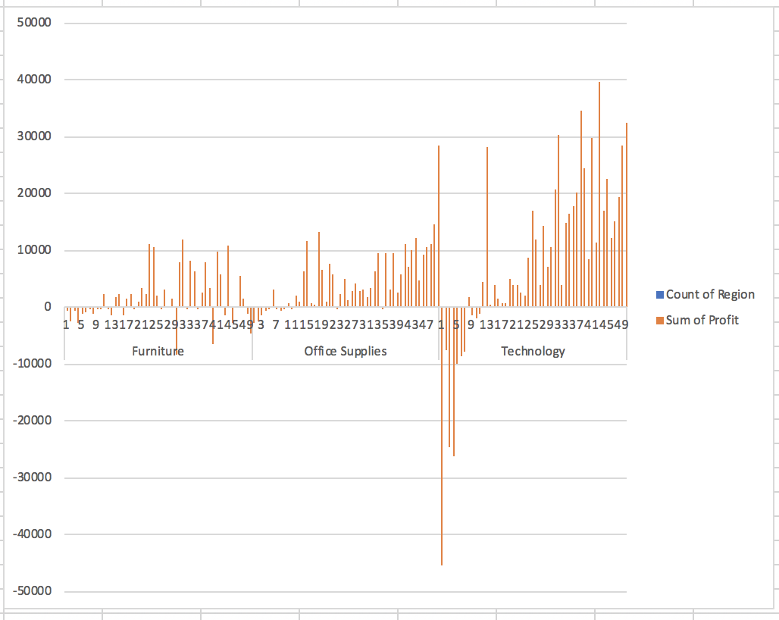
Figure 1: Profit/loss for Sarn Helen against product category by order quantity.
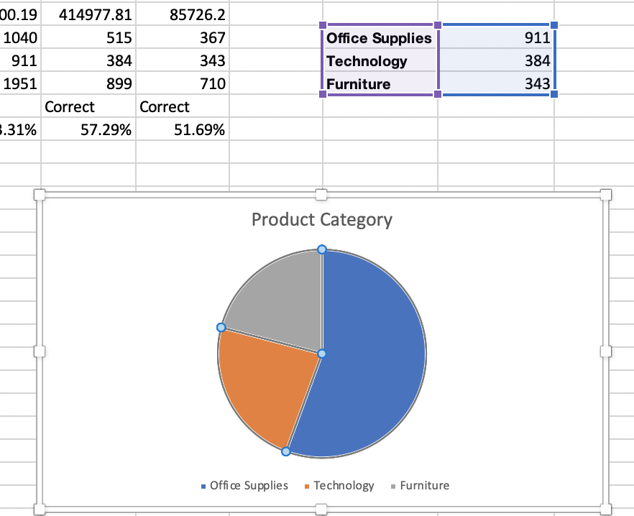
Figure 2: Product category created by =CountIF statement.
Sarn Helen need to investigate further on why when they sell 10 or less technology products, they make a loss, but when they sell more than 10 they make steep profits (figure 1), this could be due to many different factors including each unit being too low in price, each unit being purchased by Sarn Helen at too much of a high cost, or delivery costs being undercharged. Whatever the reasoning, they must engage with their analytics to better their decision-making by identifying their problems and resolving them before it becomes a bigger problem in the future.
A further pivot table showing profit/loss against technology for the years 2014-2017 (Figure 3) revealed that sales of 10 or less technology units caused the most loss of profit in 2014, 2016 and 2017.
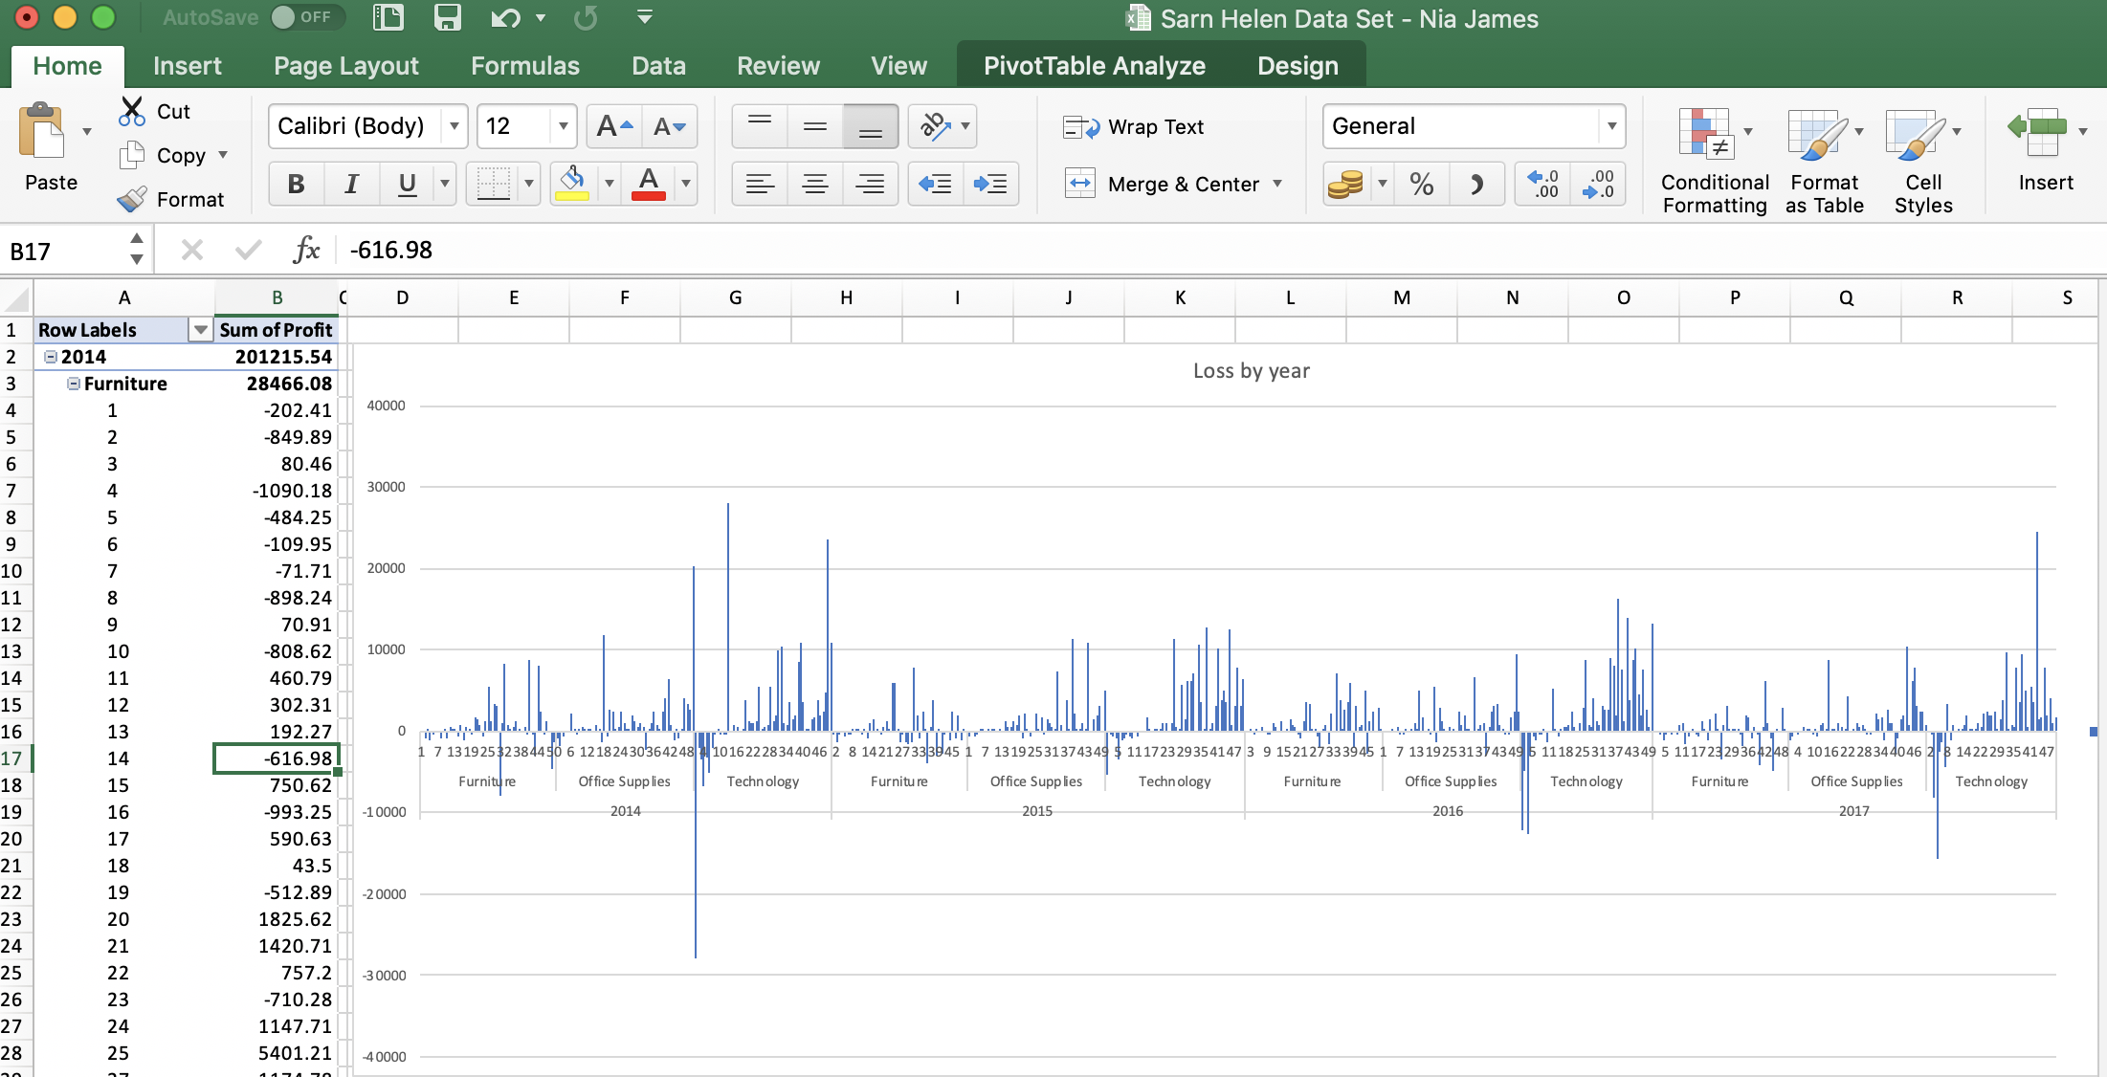
Figure 3: Profit/loss for Sarn Helen against product category, order quantity and year
The proportion of technology sales of 10 units or less returning a profit varied per year (Figure 4) with the least occurring in 2014 (4.17%, cell AI 3569 sheet 1), followed by a small increase in the following two years and a drop back to 8.93% in 29017. These losses ranged from £14,000 to £51,000 (cells AH3573 to AL3579, Sheet 1, Sarn Helen Data set).
If Sarn Helen investigate their data from 2014, 2016, and 2017 in regards to their loss from technology sales, they will be able to identify as to why this has happened. They must be active and even though their excel spreadsheet automatically updates after every sale, excel won’t identify why they have a loss etc. so they must ensure that they have someone who has excel skills to create pivot tables etc. so that they can easily notice an issue, this will better their decion-making.
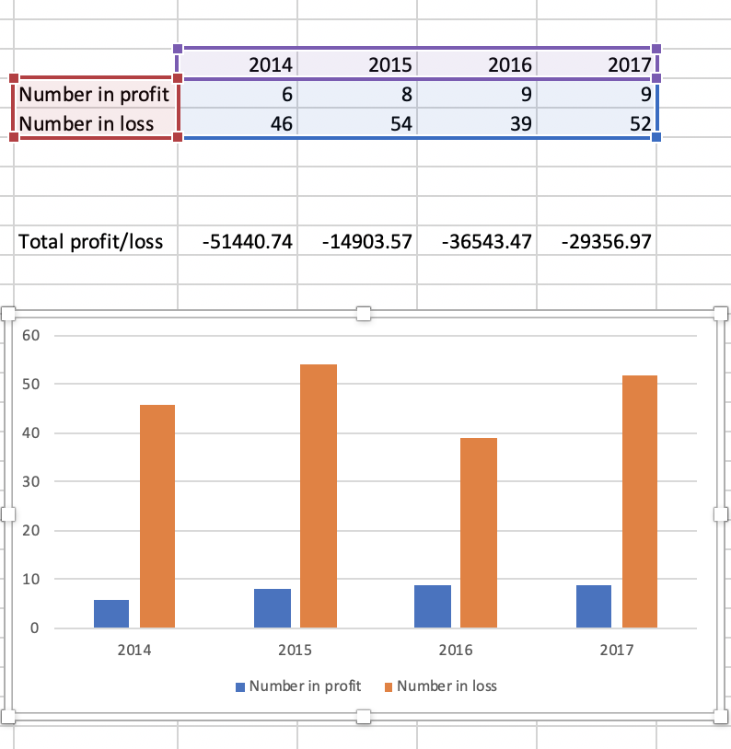
Figure 4: Number of technology sales of 10 or less units in profit or loss for Sarn Helen by year using =CountIF statement.
The company needs to investigate further by checking over their sales each year to prevent issues from occurring. For example, figure 3 shows a massive loss in profits in 2014 for technology unit sales, so if the staff at Sarn Helen noticed this then there could have been a change in decision-making to prevent this from happening up until 2017.
As we know technology is the reason behind the loss of profit over the years, and we know that in 2014, 2016, and 2017 the biggest amount of loss occurred. Another pivot table showing profit/loss against technology by year and region tells us that South Glamorgan overall was the region that made the least amount of money from 2014 to 2017, but especially in 2017 there was a massive decline in profits with only reaching around £4,700 in comparison to Mid Glamorgan sales reaching around £39,000 in 2017 (Sheet 3, Sarn Helen Data set). V LOOKUP was used to find out how much profit overall from 2014 to 2017 was made in each region to make the figures simpler to sort (Sheet 6, Sarn Helen Data Set).
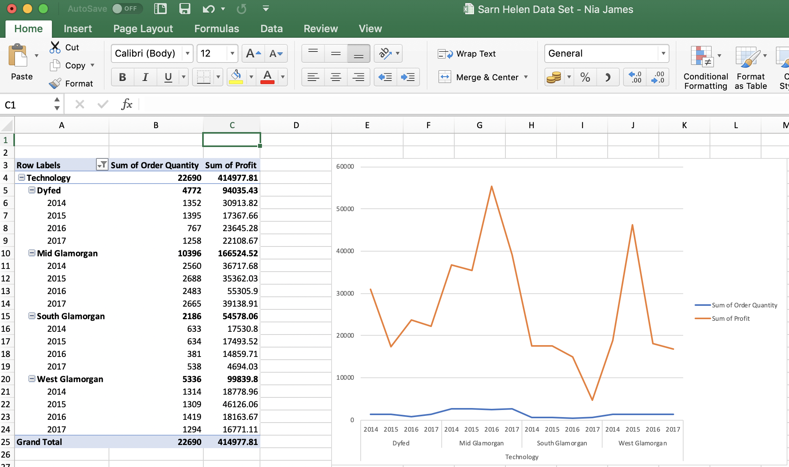
Figure 5: Profit/loss for Sarn Helen against technology, order quantity, year, and sum of profit.
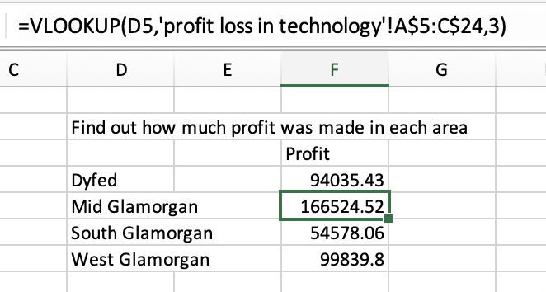
Figure 6: How much profit was made each year created by =VLOOKUP to then found out how much profit was a loss in technology.
It’s clear to see that technology sales in South Glamorgan overall haven’t made an impact on Sarn Helen, in fact, they have caused the most amount of money loss. They must investigate who is purchasing items from this area, if they are charging enough for delivery costs, if too much discount is used in this area, etc. Once they figure out the reason they will be able to make significant changes so that this doesn’t occur again, this highlights why data analytics allow better decision-making strategies for organisations to prevent as much as they possibly can prevent within profits.
Excel allows strengths and weaknesses to pre-processing data, analysing data, and visualising data to organisations. According to Sharda et al (2014), pre-processing data allows organisations to turn raw data into an understandable format, this could be because raw data is often incomplete, inconsistent, and can lack in certain tends which may not be any help to organisations, therefore, pre-processing can resolve these issues by driving applications such as customer relationship management. However, members of staff within organisations may not have excel skills to be able to do this, meaning it won’t make an impact on their business, so in Sar Helen’s case, they need to ensure their staff are trained to use software so they can identify their own strengths and weaknesses in regards to their profit and loss.
Sharda et al (2014), describes that when organisations critically analyse and visualise their data using excel they can identify strengths and weaknesses easily as this software will highlight them. For Sarn Helen, this will better their decision making as they will be able to put their figures into graphs etc. and easily identify what’s going right and what’s going wrong by visualising it. Whitten et al (2011) adds that the tools and techniques available from software allows organisations to prevent further issues they have already faced from previous years, however, excel can only show what’s happened and predict future statistics.

Part 2 - WEKA
Singhal et al (2013) informs us that WEKA is a data mining piece of software, that was built in New Zealand. WEKA is an open source collection of data mining tasks that can utilise in a number of ways which comes with a Graphical User Interface (GUI). Sarn Helen don’t use WEKA, although this section argues reasons for and against them beginning to use it to see if it will make a difference on their decision making and prevention of further money loss. The main data mining approaches of prediction, association, and clustering will be analysed to see if there are any patterns in the Sarn Helens data set, if so, they will be critically evaluated to see how the three methods are relevant and helpful to the organisation.
Data mining is the process through which previously unknown patterns in data are discovered (Conolly et al, 2014), for example, if one of Sarn Helens customers bought a lot of pens, then they will be able to see this so therefore can predict they will need more in the future so can send them promotional offers for pens. Data mining tasks can be classified into three main categories including prediction, association, and clustering.
According to Blenkhorn et al (2005), prediction is what may happen in the future due to certain events based on what has happened in the past such as predicting the weather in a certain country. Prediction is also known as classification if its dealing with values, or regression if dealing with numbers. Techniques used to find data are the decision tree analysis which is how it’s used to understand the data which is done using WEKA.
Association to Collier et al (2014) finds the most commonly occurring groupings of things, meaning consumers of Sarn Helen buying pens and pencils would be found in market-basket analysis as they go together. It’s a popular method in business as it finds interesting data that may not be found otherwise as it is market-based analysis. Applications used for association data mining are cross-marketing, cross-selling, store design etc., and these are all used to understand the data.
Clustering identifies natural groupings of things based on known characteristics such as assigning customers in different segments based on their demographics and past purchase behaviours (Han et al, 2011). Clustering is used for automatic identification of natural groupings or things and learning the clusters of things from the past data which is also known as segmentation. These results may be used to identify natural groupings of customers, provide characterisation, decrease the size of problems etc., this then is used to understand the data.
Prediction
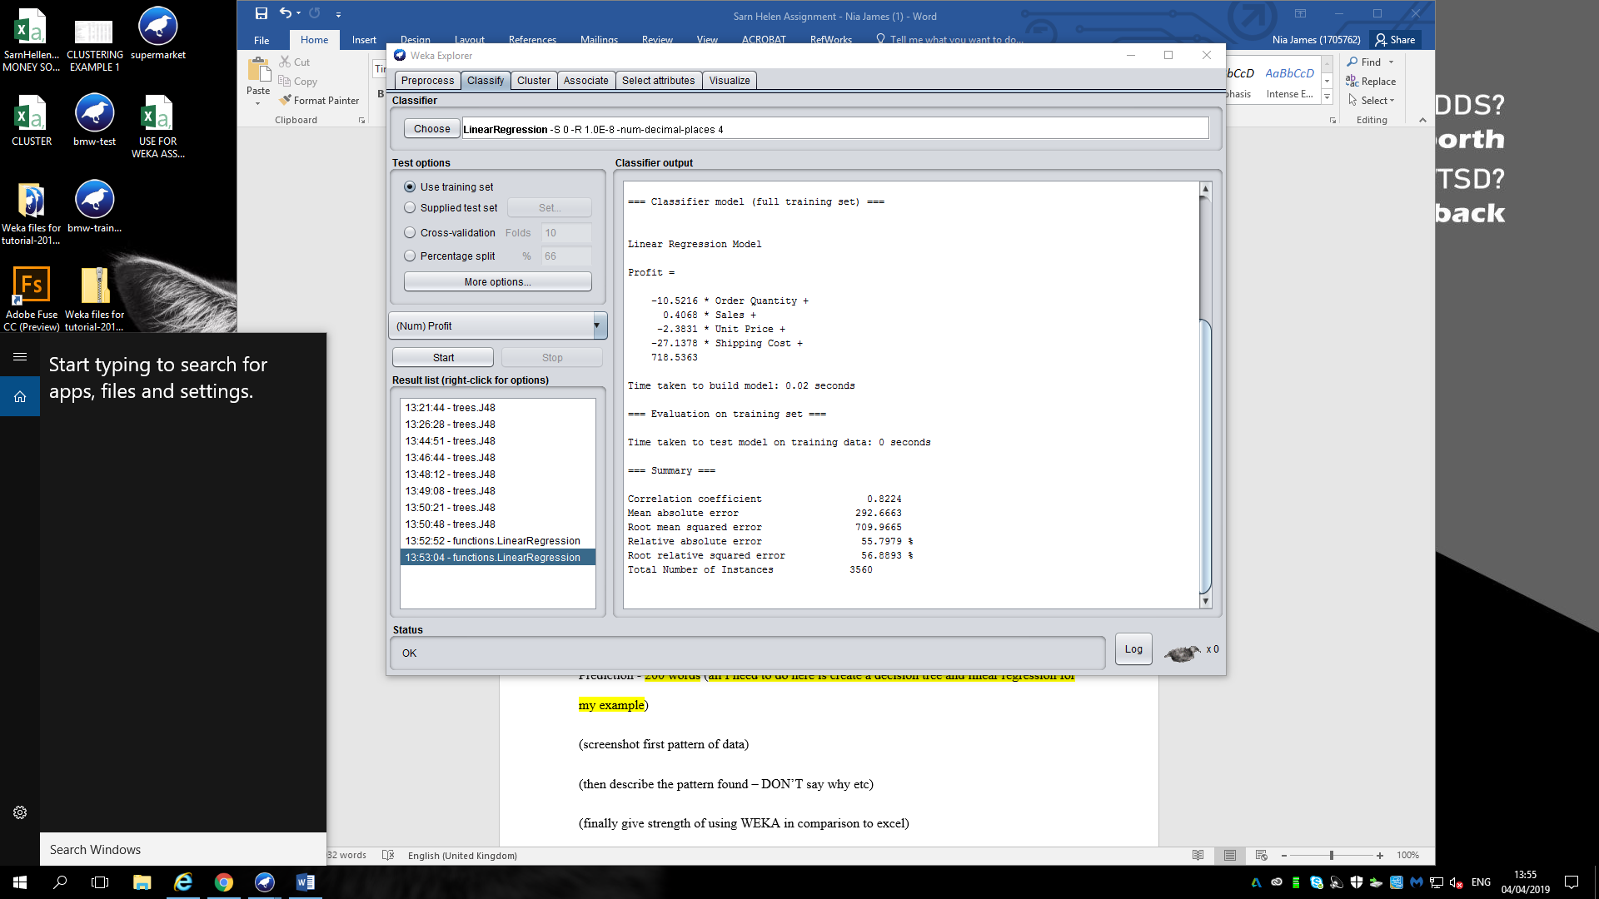
Figure 7: Classification example 1 – Linear Regression
This pattern is showing order quantity, sales, unit price, or shipping cost times by the figures shown equals the profit which highlights to the organisation if the figures are what they have expected or not which only they will be aware of. This pattern could allow Sarn Helen information and reasoning behind their loss in money as they can simply spot that three out of five figures are minus meaning they are in a loss.
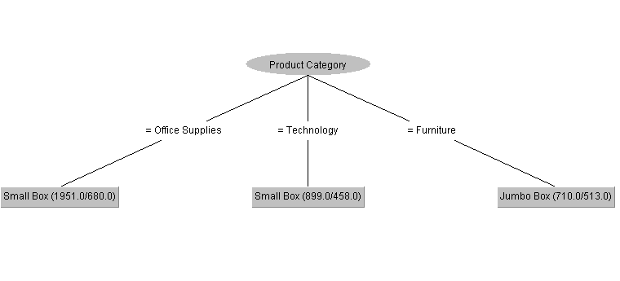Figure 8: Classification example 2 – J48 Decision Tree.
This pattern identifies profit and loss by product category and product container. As you can see office supplies sold in a small box had 1,951.0 profit sales and 680 loss’s, technology items sold in a small box totalled to 899 profit sales and 458 loss’s, and finally furniture that was sold in a jumbo box resulted in 710 profit sales and 513 loss’s.
The positive side of using WEKA in comparison to EXCEL is that it’s a quicker way of getting results and it explains the findings as you can see from figure 7, whereas with EXCEL it finds the answer but you need to figure out yourself how this answer has come about. Although this is the case, Sarn Helen may prefer to use EXCEL as it is easier to use, for example when doing an IF statement, as your typing it out examples come up so you never forget what the next stage to write is.
Association
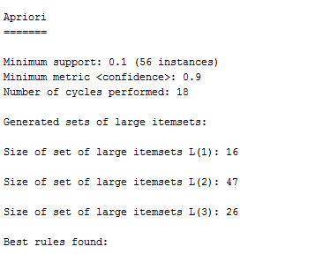
Figure 9: Association example 1
The pattern found within this example is the most common occurring groupings of this sold together by Sarn Helens customers. As shown in figure 9, L(2) has the most amount of groupings, so the business can see that when it comes to selling their products in this category, they need to ensure they partner them up so that current and future customers continue to purchase the items together as they are clearly doing well. Whereas with L(1) a very low percentage of customers purchased a multibuy which could be down to a number of reasons but this just highlights where Sarn Helen need to investigate.
Sarn Helen would benefit from using WEKA as it instantly highlights areas that are making a profit and areas that are causing a loss. Even though EXCEL also does this, WEKA is a more straightforward way as you just need to press a few buttons to get results but with EXCEL you must know formulas to get to the results. Although this is the case, WEKA is an expensive piece of software and as Sarn Helen are a small to medium sized business they may not want or have the funds to be able to go through with it. Adding onto this barrier, if they did then decide to purchase WEKA, they would need to train their staff into using WEKA as it can be complicated for some.

Clustering
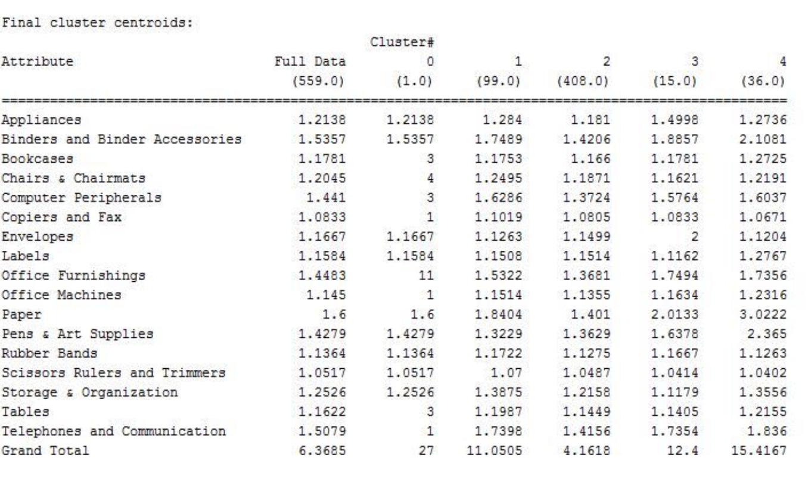
Figure 10: Clustering example 1.
This pattern highlights natural groupings of customers by basing them on different segments on their demographic and past purchase history. As you can see from figure 10, cluster 2 contains the biggest groupings which means that 408 customers that made a purchase have either bought the item before or generally how many people have wanted to buy it, in comparison to cluster 1 who only has 1 customer who has done this. This shows Sarn Helen that customers from cluster 2 are potential loyal customers whereas customers from cluster 1 could just be a one-off customer.
Clustering is a beneficial way of accessing this information through WEKA as you cannot do this on EXCEL. However, it is very time consuming, as you can see from figure 10 there are so many figures to read and understand which may be challenging for many. This could work for Sarn Helen but due to it being time consuming and hard to understand, EXCEL may be the easier and more understanding option for the small business as they can’t afford time or money loss as already nearly half of their sales have caused a loss for them over the years of 2014 to 2017.

Conclusion
Sarn Helen are clearly in a predicament where nearly fifty percent of their sales have caused them a loss. After analysing their data and identifying areas where they have gone wrong, it’s safe to say EXCEL is the better programme of software for them to use for a number of reasons. EXCEL is easy to use, clear, and staff don’t need to be trained as the programme provides step by step instructions. WEKA isn’t beneficial for the organisation as it’s time consuming, expensive software, their staff need to be trained and remember step by step what to do. Overall, WEKA could be a big mistake for the business when EXCEL can already solve many of their current issues and most importantly it can highlight where they’ve made a loss so they can prevent it from happening in the future.

References
Baškarada, S., 2011. How spreadsheet applications affect information quality. Journal of Computer Information Systems, 51(3), pp.77-84.

Blenkhorn, D.L. and Fleisher, C.S. (Eds.), (2005) Competitive Intelligence and Global Business, Westport, Conn.
Carey, P. and Berk, K.N., 1997. Data Analysis with Microsoft Excel. Brooks/Cole.

Collier, K.W., (2011) Agile Analytics: A Value-Driven Approach to Business Intelligence and Data Warehousing: Delivering the Promise of Business Intelligence, Addison-Wesley
Connolly, T. and Begg, C (2014), Database Systems: a Practical Approach to Design, Implementation, and Management, 5th Ed., Pearson, Boston, MA.

Han, J., Pei, J., Kamber, M. (2011) Data Mining: Concepts and Techniques, London.

Pemberton, J.D. and Robson, A.J., 2000. Spreadsheets in business. Industrial Management & Data Systems, 100(8), pp.379-388.

Sharda, R., Dursun, D. and Turban, E., (2014) Business Intelligence and Analytics, Systems for Decision Support, 10th Ed., Pearson, Boston, MA.

Sharda, R., Dursun, D. and Turban, E., (2014) Business Intelligence, A Managerial Perspective, 3rd Ed., Pearson, Boston, MA.

Singhal, S. and Jena, M., 2013. A study on WEKA tool for data preprocessing, classification and clustering. International Journal of Innovative technology and exploring engineering (IJItee), 2(6), pp.250-253.

Whitten, I.H., Eibe, F. and Hall, M. A., (2011) Data Mining: Practical Machine Learning Tools and Techniques, 3rd Ed., Morgan Kaufman.

