Callum Funning
Personal Statement:
I am a confidant, dedicated and efficient individual that will always rise to any challenges or requirement, solving any problems encountered along the way. I am looking to fill the role of a session musician, harbouring both the passion and motivation to achieve this position, on top of the foundation already set by my playing abilities. Being both versatile and a swift-learner grants me the confidence to play new material and interact with new people even at short notice, as well as being able to compose, arrange and create backing tracks amounting from 5+ years of experience in the music industry.
Key Skills & Abilities:
- Flexibility/Adaptability
- Dedication
- Great Communication Skills
- Logical Thinking
- Proficient at Guitar/Bass
- Able to set up live PA/Sound equipment.
Music Industry Experience:
- Recorded an released a single with A Night Like This that featured radio and club play, as well as embarking on a short UK tour with the band.
- Professional musician performing in function bands for two years, most recently being a part of R.E.S.P.E.C.T. performing at events multiple times a week.

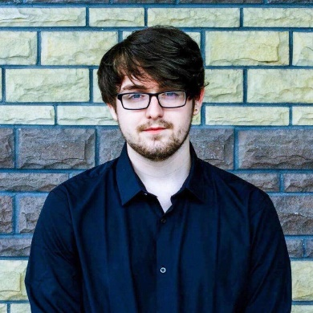


callumjfunning@gmail.com


07592 721753

References:

Alun Roberts – Former Lecturer

Email: alun.roberts@nptcgroup.ac.uk

Telephone Number: 07961 220733

Academic Qualifications:
University of Wales Trinity Saint David | Neath Port-Talbot College Group | (Achievement June 2018)
- FdA Music (Performance & Production) – Foundation Degree

Neath Port-Talbot College Group | (Achieved August 2016)
- Extended National Diploma Level 3 in Music BTEC – D*DD Award

Cwrt Sart Community Comprehensive School | GCSE Qualifications | (Achieved August 2014)
- 2 A*s
- 3 As
- 3 Bs
- Distinction BTEC

1 Ethel Street, Neath, SA11 1BB

