Psychology in Health and Social Care
LCHS4010
Component 2: Written task – report

Student name: Tania Gomes
Student ID: 2418584
Lecturer: Bianca Sanfilippo

Table of Contents
Applying Psychological Theories to Support Older Adults with Dementia in a Care Home Setting 3
1. Introduction 3
2. Overview of Psychological Theories 3
Bowlby’s Attachment Theory 3
Applying Bowlby’s Theory in Dementia Care Homes 4
Practical examples 4
Challenges and strategies 4
Maslow’s Hierarchy of Needs 5
Practical examples 7
Challenges and strategies 7
Conclusion 8

Applying Psychological Theories to Support Older Adults with Dementia in a Care Home Setting
- Introduction
According to Alzheimer’s Society (2021), dementia is a group of symptoms caused by different diseases that damage the brain. Over time, these symptoms can affect memory, thinking, problem-solving, language and behaviour and may also involve changes in mood and emotions. Dementia is usually progressive, meaning symptoms may start mild but worsen over time and it is not a natural part of ageing. Alzheimer’s disease is the most common type of dementia.
This report explores how Bowlby’s attachment theory and Maslow’s hierarchy of needs are crucial for understanding adult development and health behaviour. These theories can inform person-centred care and guide interventions in dementia settings.

- Overview of Psychological Theories

Bowlby’s Attachment Theory

Bowlby’s attachment theory proposes that human beings are biologically driven to form emotional bonds with significant others as a way of gain safety and emotional control. (Bowlby, 1980). Secure attachment develops when caregivers are consistently responsive, leading individuals to adopt a sense of safety and trust. Insecure attachment may develop when care is inconsistent, rejecting or frightening, contributing to anxiety, avoidance or difficulty trusting others.
While attachment theory is commonly associated with early development, it has strong relevance across the lifespan. In later life, especially during illness and dependency, attachment needs may become more visible again. Older adults can experience sensitivity to separation, loss and uncertainty. This is particularly important for those living with dementia, who may struggle to interpret their environment and rely a lot emotionally on trusted caregivers. (Mikulincer, 2005)
Bowlby’s attachment theory says that human beings continue to seek security from trusted figures when distressed. This provides a useful lens for understanding intensive dependency, separation anxiety and reassurance-seeking behaviours often seen in people living with dementia. (Bowlby, 2005)

Applying Bowlby’s Theory in Dementia Care Homes

Attachment-focused care makes the quality and consistency of relationships a central therapeutic tool. In dementia settings, staff can act as secondary attachment figures, especially when family presence is limited. Care that prioritises trust and emotional safety can reduce anxiety and agitation and increase cooperation with care tasks.
A review argues that attachment still matters in older age. It suggests that secure relationships across life can protect wellbeing later on and that some older adults may still look to parents as attachment figures. The authors also link dementia experiences to attachment disruption, noting that people in residential care may show attachment behaviours such as “parent fixation.” They further propose that a person’s earlier attachment style can shape emotional and behavioural responses as dementia progresses. (Browne and Shlosberg, 2006).

Practical examples
Assigning a small, consistent team to a resident can strengthen familiarity and reduce distress. For example, a resident who becomes anxious every evening may settle better when they are supported by the same two carers during the late shift. They learn the carer’s faces, voice and routines, which helps them feel secure.
Residents who resist bathing that may feel vulnerability. Staff can address this by introducing themselves, maintaining eye contact, explaining the process, offering choices and using a reassuring tone.

Challenges and strategies
Attachment theory is a useful tool for understanding distress, but there are challenges. Limited staffing and high turnover can disrupt relationships, time pressure can reduce care quality and dementia can limit new secure relationships, though emotional atonement can still be helpful. (Kyle M., 2025)
Using calm reassurance, reducing triggers, gently redirecting attention and keeping routines familiar can help manage dementia-related behaviours and support wellbeing.
Supporting emotional wellbeing in dementia involves acknowledging and validating feelings, encouraging gentle engagement in enjoyable activities, and monitoring medication effects to help reduce anxiety or agitation.

Maslow’s Hierarchy of Needs

“Maslow’s hierarchy of needs is a motivational theory in psychology comprising a five-tier model of human needs, often depicted as hierarchical levels within a pyramid”. (McLeod,2025)

Maslow’s hierarchy of needs suggests that human needs are arranged in a hierarchical structure, with physiological needs at the bottom and more creative and intellectually oriented ‘self-actualisation’ needs at the top.

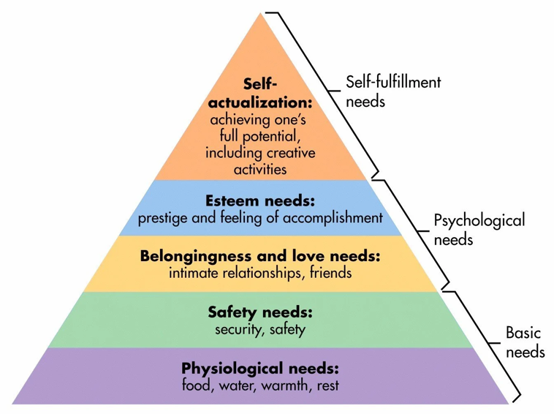
At the lower end of the pyramid, people primarily need a safe place to live with sufficient food, water, and clothes. Family and professional carers usually provide the majority of the support needed here, depending on where the person lives. While these needs may seem basic, meeting them can be challenging. For instance, a person with dementia may be distressed about needing support with personal hygiene, but they could be at risk of serious conditions like skin infections if they go too long without being clean and dry. (A. Kirtley, 2021)

In this framework, Maslow reports that our physiological and safety needs come first, followed by those for love, self-esteem, and then self-actualisation. All of these needs exist on a constant range.

Applying Maslow’s Theory in Dementia Care Homes
First, it is important to meet the person’s basic needs such as nutrition and personal hygiene. For someone who is fully dependent on someone else, continuous support with these tasks is essential.
Promoting a safe environment, maintaining a predictable routine and using calm, simple communication builds trust and reduces anxiety.
Help them feel that , even after leaving their usual space such as their home , they still belong to a group we can say family and new friendships , that they continue to be loved and to love those around them and that even if they are dependent, they are still respected and valued for the life they have lived and for who they are today, so that they can still feel fulfilled.
Promoting dignity and recognition involves giving purpose through simple tasks, acknowledging what they can still do, and offering choices to maintain a sense of autonomy.”
Cognitive activities like reading, puzzles or simple games, art and music and sharing memories support purpose and wellbeing.
The key is to adapt Maslow’s hierarchy by focusing first on the most basic needs and then building upward always with empathy and respect, so that a person living with dementia feels safe, loved, valued, and has a sense of purpose despite the limitations of the illness.

Practical examples
“Prepare easy-to-eat meals (like finger foods), offer water often, keep a regular bathroom schedule, and encourage daytime activity to support better sleep at night.
Maintain a familiar environment with comforting items, reassure them that finances are handled, and validate or gently redirect questions about deceased loved ones to prevent renewed grief.
Support them by validating their thoughts, kindly redirecting instead of correcting, communicating simply, and choosing manageable activities that build confidence.” (Covenant caregivers, 2021)

Challenges and strategies

Professionals often use Maslow’s hierarchy as a guide framework ensuring physiological and safety needs are addressed before moving to higher needs. However, a key challenge is that real people may feel various needs simultaneously and move between levels rather than progressing neatly. In practice, this means balancing urgent basics like comfort, hydration, and safety with psychological needs.
This is achieved by explaining care clearly to reduce fear, encouraging supportive relationships and listening, and promoting independence in tolerated daily tasks to protect dignity and self-esteem. (McLeod, 2025)

Conclusion

In conclusion, Bowlby’s attachment theory and Maslow’s hierarchy of needs provide practical, person-centred frameworks for supporting older adults with dementia in a care home setting. Attachment theory highlights how dementia can increase vulnerability, fear of separation, and reassurance-seeking, meaning that consistent, emotionally attuned relationships with staff can reduce distress and improve cooperation with daily care. Maslow’s model helps professional structure holistic care by ensuring that physiological and safety needs such as nutrition, hydration, hygiene, comfort, and risk reduction are reliably met, while also protecting higher needs such as belonging, dignity, autonomy, and opportunities for purpose and expression.

Therefore, professionals should combine both approaches by creating predictable routines and familiar environments, communicate calmly and clearly, validate feelings, offer meaningful choices and involve residents in achievable activities that maintain identity and self-worth. Despite challenges such as time pressure, staffing turnover, and complex behaviours, applying these theories supports better wellbeing outcomes by helping people with dementia feel safe, valued, connected, and able to experience purpose and fulfilment within their limitations.

References

Alzheimer Society (2021) What is dementia? Available at: https://acceptingthegiftofcaregiving.com/wp-content/uploads/2023/09/asc_what-is-dementia-info-sheet_en.pdf (accessed:10 Dec 2025)
Bowlby, J. (2005) A secure base: clinical applications of attachment theory. Oxon England: Routledge. Available at: https://doi.org/10.4324/9780203440841.
Browne, C. J. and Shlosberg, E. (2006) ‘Attachment theory, ageing and dementia: A review of the literature’, Aging & Mental Health, 10(2), pp. 134–142. doi: 10.1080/13607860500312118.
Covenant caregivers (2021) How Maslow’s Hierarchy of Needs Explains How We Work. Available at: https://covenantcaregivers.com/maslow-dementia/ (Accessed: 17 December 2025)
Mikulincer, M. et al. (2005) ‘Attachment, Caregiving, and Altruism: Boosting Attachment Security Increases Compassion and Helping’, Journal of Personality and Social Psychology, 89(5), pp. 817–839. doi:10.1037/0022-3514.89.5.817.
Michael Bradley, J. and Cafferty, T. P. (2001) ‘Attachment among older adults: Current issues and directions for future research’, Attachment & Human Development, 3(2), pp. 200–221. doi: 10.1080/14616730126485.

McLeod, S. (2025) Maslow’s Hierarchy of Needs. SimplyPsychology. Available at: https://www.simplypsychology.org/maslow.html Accessed: 17 December 2025).

Oath Healthcare (2025) Challenges of dementia care at home. Available at: https://oathhealthcare.co.uk/challenges-of-dementia-care-at-home/ (Accessed: 10 Dec 2025)
Plan With Care (2021) How Maslow’s hierarchy of needs explains how we work. Available at: https://www.planwithcare.co.uk/post/how-maslow-s-hierarchy-of-needs-explains-how-we-work (Accessed:16 December 2025)

