Trinity Saint David University.
Industry 4.0 Advanced Manufacturing.



ACPA7000

Carl Jones Student 2134125.
Cohort 07/22
Lecturer Mahesh Kannath

Assignment 2 – Report
Critically evaluate manufacturing systems at a strategic level to identify opportunities for new and emerging Industry 4.0 technology enablers, whilst identifying the cultural and workforce factors that may contribute to delivering authentic economic and societal benefit.

Contents
Introduction 3
Manufacturing key constituent parts and effect of I4.0 introduction. 4
People 4
Production Staff. 4
Supervision. 4
Material handling. 5
Supply chain. 5
Customer relations. 6
Health and safety. 7
Quality assurance. 7
Design engineering. 8
Maintenance. 8
Marketing 9
Effect of I4.0 and AI on people. 9
Processes. 10
AI and Machine Learning (ML). 13
Cultural and workforce factors. 14
Conclusions 16
Bibliography 17

Figure 1 Kuka AMR 5
Figure 2 Customer Relations robot in Hospitality sector. 6
Figure 3 Autonomous robot inspecting industrial plant. 7
Figure 4 Fluke and Boston Dynamics maintenance robot. 8
Figure 5 (PdM) BD collection. 13
Figure 6 Manufacturing as a % of jobs in the UK.(Rhodes, 2020) 16

Introduction
Breaking manufacturing systems down to an abstract level reveals the core constituent resource parts of a manufacturing system. The introduction of Industry 4.0 (I4.0) Cyber Physical Systems (CPS) has allowed all areas of the manufacturing system to become digitised, allowing potentially vast amounts of Big Data (BD) to be collected by the Industrial Internet of Things (IIoT). This BD allows real-time analysis by Artificial Intelligence (AI) Data Sciences (DS) to give instant feedback of customer requirements, where and what state raw material is at, effectively schedule production, gauge how processes are performing, ensure product quality is maintained and continuously improved, and scheduling delivery of final finished product.
This real time data feedback allows manufacturing sites to be utilised productively, increasing share-holder wealth, and maintaining the competitiveness of businesses, and ensuring customer delight with their purchases.

Manufacturing key constituent parts and effect of I4.0 introduction.

People

Production Staff.
The new dynamic working environment that inevitably comes with adopting I4.0 technologies will affect people working at all levels within manufacturing (Longo, et al., 2017) People will have to develop new skill sets to interact with the new comparatively complex technologies and overcome any anxieties that will inevitably arise when learning these new skills. The human upskilling element in I4.0 will be key in successful adoption of I4.0 allowing smart operators to over-see smart manufacturing operations, indeed one of the major constraints in adopting I4.0 is the lack of skills required to implement, service and control the smart systems involved (Liboni, et al., 2019).
Current employees of businesses thinking of introducing of I4.0 will naturally worry about losing their jobs as some of their functions would be undertaken by Autonomous Mobile Robots (AMRs), self-government of cycle parameters by the production processes, booking of materials and finished goods into and out of production stages, scheduling of production and raw materials initiated by customer ordering the finished goods then I4.0 systems completing the process routing automatically.
In the past 30 years employment rates in manufacturing in the UK have “fallen significantly”, from 15.7% in 1990, to 7.6% in 2018. Manufacturing percentage contribution to the UK economy has fallen from 17.3% in 1990 to 9.9% in 2018. Actual manufacturing output as risen 7% when you compare 1990 to 2018, comparatively, the service sector output has risen 106% in the same period (Rhodes, 2020). With the continuing global recession companies’ adoption of automation will increase as they look to take advantage of the benefits of leaner more flexible I4.0 practices. Lower skilled jobs will then be at risk by the increased automation of repetitive processes. However, as some lower skilled manual job type demand will reduce, other new types will emerge, with potentially greater reward. Job skills will have to continually develop and change as new technologies emerge and these skills will become essential to future innovative companies and will have to focus on continuously up-skilling their workforces to stay current on new developments in I4.0 and beyond.
Adoption of I4.0 will generate redundancies estimated at 30% for the UK for supply chain workers so the human impact will initially be significant. For example, “in China over 60,000 workers were rendered jobless in 2016 when Foxconn decided to replace them with robots” (Liboni, et al., 2019), so the job loss threat is very real.

Supervision.
With real-time data and analytics at their disposal, supervisors can make more informed and data-driven strategic decisions. They can identify operational inefficiencies, optimize processes, and allocate resources effectively. Industry 4.0 empowers supervisors to take a proactive approach in driving organizational success through intelligent decision-making using real-time data, without the errors inherent with manual data gathering.

Material handling.
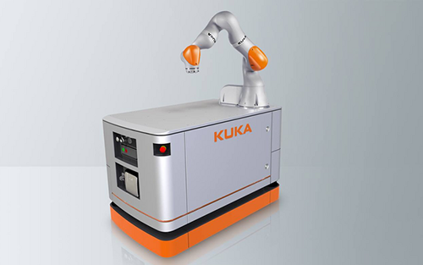
Industry 4.0 introduces advanced automation and robotic systems that can handle various material handling tasks such as order picking. AMRs, robotic arms, and conveyor systems can efficiently move, sort, and transport materials within a facility. As a result, some manual material handling tasks previously performed by workers may be automated, leading to a reduction in the number of purely manual material handling jobs (Wang, et al., 2021). Mistakes in material picking due to human error will be eliminated, and intelligent robotic systems are highly efficient, with AMRs automatically monitoring battery status and visit recharging stations autonomously, with the automatically assigning work to the rest of the AMR fleet.
Figure 1 Kuka AMR

Supply chain.
AI technologies such as machine learning can automate repetitive and manual tasks within the supply chain. This can include data entry, inventory management, order processing, and logistics coordination. As a result, some jobs that involve these tasks may be replaced or transformed.
AI-powered systems can process vast amounts of data quickly and accurately. This improves decision-making processes, reduces errors, and enhances operational efficiency within the supply chain. Workers can leverage AI tools to make more informed decisions and focus on higher-value tasks that require human expertise.
AI algorithms can analyse historical data, market trends, and customer behaviour to predict demand more accurately. This enables better inventory management and optimization, reducing the risk of overstocking or stockouts. Supply chain professionals can utilize AI-generated insights to optimize inventory levels and make informed procurement decisions (Dubey, et al., 2022).
AI technologies facilitate real-time tracking, monitoring, and visibility across the entire supply chain. This enables stakeholders to identify bottlenecks, track shipments, and detect potential disruptions promptly. Supply chain professionals can leverage AI-driven analytics to gain actionable insights and proactively address issues, improving overall supply chain performance (Krishnan, et al., 2021)
With the introduction of AI in supply chains, there is a shift in the types of roles and skillsets required. While some traditional job functions may diminish or evolve, new roles related to managing and optimizing AI systems, data analysis, predictive analytics, and strategic decision-making may emerge. Supply chain professionals will need to upskill and adapt to the evolving technological landscape.

Customer relations.
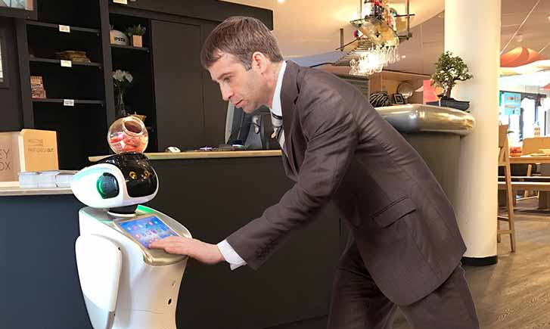
Customer interactions with AI is commonplace, given the number of “AI chatbots” on company websites, but the growing complexity of responses AI driven response is capable of, and the speed of information retrieval is quickly replacing some human customer relation employment (Nguyen, et al., 2022). Currently customer queries that the AI system can’t answer sufficiently are automatically passed on to humans, but as algorithms are refined the number of human referrals will reduce.
Figure 2 Customer Relations robot in Hospitality sector.

Health and safety.
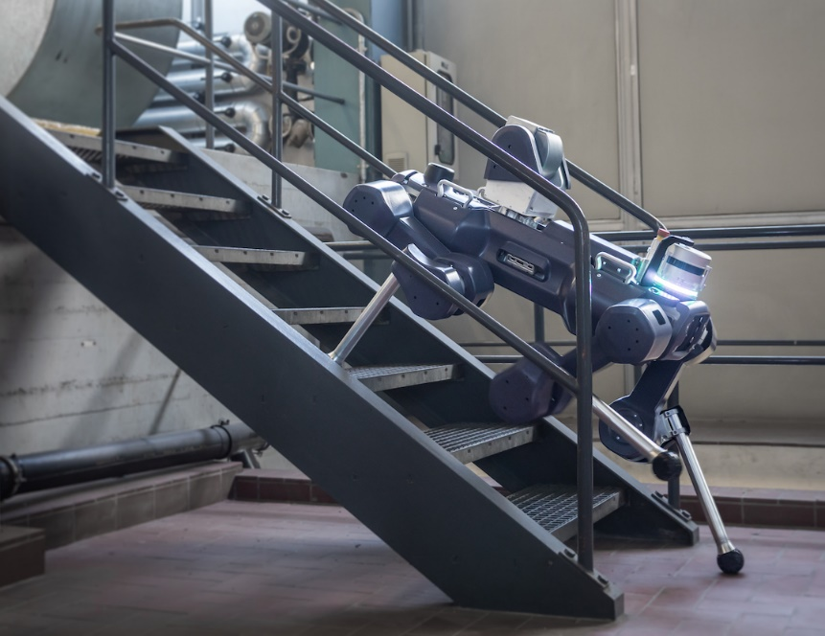
AI has been used in Health and Safety (HS) activities for several years, modelling physical environments to ascertain potential risks in autonomous and human controlled vehicles. New applications include risk assessment using sensors and past learnings to enable AI to identify patterns and highlight potential risks and highlight new designs solutions to reduce the risk. Optical sensors and AI can be used to monitor people and machine process interactions to highlight potential risks and prevent injury. Virtual Reality (VR) and Augmented Reality (AR) can be used in the training of people to new processes highlighting potential risks without exposing them physically (Oxtoby, 2023). Autonomous robots or Unmanned Aerial Vehicles (UAVs) could patrol potentially volatile areas preventing human exposure to danger.
Figure 3 Autonomous robot inspecting industrial plant.

Quality assurance.
With the adoption of BD and AI analytics Quality Assurance (QA) has been applied to many areas of businesses that were neglected previously due to being deemed low importance to business excellence. It was deemed of low importance until AI algorithms highlighted complex interactions of seemingly unrelated data sources.
Autonomous checking of parts to ensure correct quality without human interaction using optical systems is well established and in use at bottling plants and surgical mask production sites as examples (Park & Jeong, 2022).
The potential of AI and the integration into all aspects of product manufacture would allow QA to be a fundamental aspect of I4.0 and be a major contributor to zero defects being allowed to customer, especially important in food and beverage sectors.

Design engineering.
AI is also now used in design engineering, creating innovative solutions to solve complex engineering problems. Computer Aided Design software packages have had design wizards included for several years, but new parameter-based interfaces create solutions with completely automated output.
3D Additive Printing allows rapid prototyping of designs to ascertain feasibility and make design changes if required much more quickly than conventional subtractive prototyping.

Maintenance.
Most maintenance teams presently do not possess the competencies to interact with and interrogate I4.0 systems. Retraining or hiring new engineers is a challenging and costly strategy. “Thus, organisations opt to adopt a more automated I4.0 application and reduce workforce role to support capital by improving production and reducing workforce development costs”. (Margherita & Braccini, 2021). High job losses in relatively unskilled roles are expected to be initially high as automated and autonomous I4.0 solutions are integrated into existing work environments.
This may prove to be true for the operators running the processes, part supply and logistics but the maintenance of these systems still requires skilled human intervention when component parts are identified by the I4.0 AI as wear and fatigue requires them to be changed. Correct upskilling of the maintenance teams of businesses adopting I4.0 and Predictive Maintenance will become a major focus otherwise predicted benefits will not be realised in the long term.
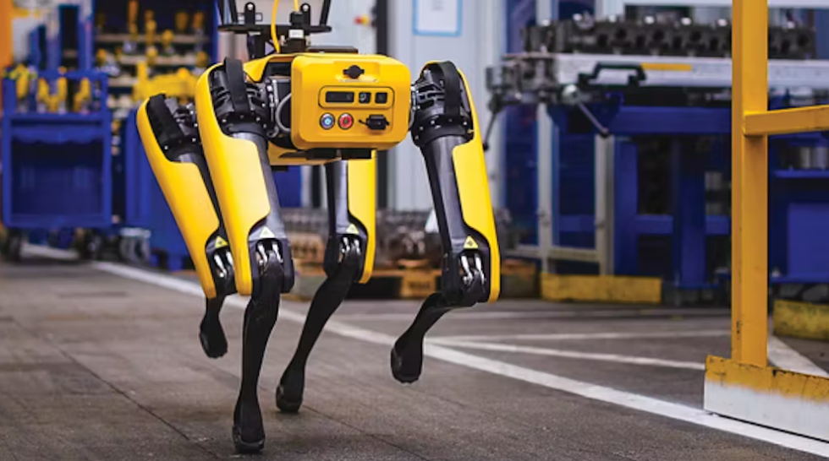
Autonomous robots are being introduced to monitor equipment currently being looked after by human maintenance engineers. Equipped with an array of different sensors including Infra-Red optical to detect unusual heat in equipment indicating wear or potential electrical fire risk.

Figure 4 Fluke and Boston Dynamics maintenance robot.

Marketing
AR is already in mainstream use with Nintendo’s Pokémon GO a market leading gaming software package as an example. It uses phones and tablets to augment our reality with strange creatures that interact with people using the software applications. This interactive AR game was extremely popular from its release in 2016 until the present day.
Marketing until recently was labour intensive, requiring many face to face meetings in varying geographical areas, with lots of non-value added time. Alternately, products are bought but when received do not match descriptions or marketing photos, or do not match perceived attributes such as colour or size. The Covid “Pandemic has accelerated the adoption of AR by companies” (Massa & Ladhari, 2023), and many large multi-national organisations are investing heavily. AR allows customers to visualise items before committing to purchase. Seeing products first hand in the environment they would be used in is a potential game changer and fosters greater brand loyalty given the increased customer satisfaction.

Effect of I4.0 and AI on people.
Without question the impact of wide-spread adoption of I4.0 and AI enabled systems will negatively impact the job market especially on low skill, repetitive manual labour jobs. As new flexible I4.0 solutions are developed the impact on higher skilled jobs will also be felt. Even imaginative non-routine creative job functions such as product and process design, architectural design. music creation, art and sculpture will be affected.
“Most humans depend on income from work for their livelihoods” (Tyson & Zysman, 2022) and government policies will have to change to account for this missing socio-economic income and how social welfare and health care will be funded. During the First and Second Industrial revolutions pay of workers migrating to different employment models fell and did not recover for decades (West, 2018).
As with all evolution some people will be resistant to change, but this will have to be overcome and embraced if they are to thrive in the highly technological I4.0 business environment.

Processes.
Digitising the work environment into CPS allows a level of process interrogation which up until very recently had never been envisaged. New advances in wireless connectivity cost reduction, along with much cheaper storage options have allowed cloud storage of BD to become routine, allowing remote access to vast amounts of data from any geographical position. Sensors (Field Level devices) embedded into each part of the process are connected to the IIoT then store and give access for AI to interrogate, compare and make changes or report unexpected differences to enable optimum process performance (Ayvaz & Alpay, 2021).
Some of the physical aspects of a process that have been digitised and turned into CPS include:
- Temperature using Infrared, Thermocouples and Resistance Temperature Detector (RTD).
These can be used to indicate change or deterioration in process such as gearboxes, bearings, electrical components, environmental control, and process heating. A new application for my employer would be in Compressor Room temperature control of air intakes. Previously the room drew air used by the compressors from the room which was unventilated. In the summer the room temperature was above 45°C caused by the compressor heat and outside summer temperature (Δ inside to outside temperature 17°C). Compressor optimum air intake temperature is between 10 - 30°C (Taylor, 2020) so utilising this temperature range a temperature sensor could control an external vent to be opened to allow cool air into the room, reducing compressor loading. Higher intake temperatures mean the air is less dense, making it harder to compress to running pressure of 6 Bar. This along with reduced pressure setpoint and leak fixes has reduced compressor electrical consumption by 41%, or 186kwh reduction / day.
- Humidity.
Atmospheric humidity can affect process stability in the plastics industry especially if the raw material is hygroscopic (absorbs moisture) and can cause gassing issues in the extrusion process. Humidity sensors monitor relative humidity and can be used to alert staff to potential issues. When analysed using AI this parameter could be cross referenced with extrusion melt pressure and other CPS variables to gauge possible relationship to final product weight which we are seeing unexpected variation.
- Vibration sensing using Accelerometers.
All moving equipment produce vibrations at specific frequencies and amplitude. These frequencies and amplitudes can be used as base lines to indicate if any change in process performance, such as wear in bearings, lack of lubrication, belt wear and out of balance tooling. Product quality could also be cross referenced to vibration levels to gauge effect on finished goods.

- Level sensing using Ultrasonic, Floats, Calorimetric.
- Flow sensing using Turbines and Calorimetric.
Flow rates could be optimised using base lines to establish minimum / maximum flow to maintain quality of finished product. Electrical energy could be saved by reducing flow rates but still maintain product quality, or varying flow rates for different requirements could enhance quality and reduce electrical consumption.
- Pressure sensing using Piezo and Diaphragm.
Increasing fluid pressure to complete work is an expensive operation, with lots of waste in the form of heat. Reducing pressure whilst maintaining process efficiency and finished product quality could realise significant electrical savings. Pressure fluctuation could also signal process wear or non-optimised setting that could be improved using AI control.
- Load (mass) sensing using Strain Gauges.
In-process weighing of completed plastic products could be analysed by AI and speeds of extrusion process optimised to achieve correct weight.
- Proximity sensing using Capacitive, Inductive and Light (photo-sensor).
These are usually on / off switches but can give analogue output to indicate absolute measured positions of things.
- Light sensing.
One of the fundamentally significant characteristics of the product produced by the company I work for is light transmissibility. This important feature measures the amount of light that penetrates the product but is not at present measured correctly. This could be an in-process check of every part produced ensuring correct quality is maintained. Light is also used in optical sensing of parts, Through-beam sensing relies on the part blocking light transmission from transmitting head to receiving head. Retro-reflective uses reflected light off the product to sense presence.
- Speed sensing.
The speed and position of moving parts are fundamental variables and have potentially huge impact in production. Rotational and linear speed and position can be indicated using encoders. As the measure part moves a number of pulses is counted indicating positional change, the rate of pulses can be used to ascertain speed.
- Positional sensing using Angular, Rotational and Glass Scale encoders.
- Image sensing using Optical means.
- Colour sensing using Optical means.
An optical sensor (camera) can verify that product conforms to required specification in terms of length, shape, colour, feature presence and position and that the correct raw material is being used.

- Voltage sensing.
- Current sensing.
These fundamental aspects of electricity can be measured to indicate correct part performance (electronic / electrical / solar products). They can also be measured as a power source variable and AI and ML to autonomously optimise process setting and reduce environmental and economic waste.
- Gas sensing.
Used to detect explosive or poisonous gasses and alert to potential danger to humans. Can also be used to detect leaks in sealed products by pressurising product and detecting gas leakage outside of seal.
- Smoke sensing.
Early detection of fires saves lives and smoke detectors are a fundamental part of fire detection.
- Chemical sensing.
Correct mixing of chemicals can be ensured using chemically sensitive sensors. They can also be used to ensure early detection of chemical leakage helping to minimise human exposure.
- Light Detection and Ranging (LiDAR).
Used in safety applications to prevent entry into unguarded areas that could be dangerous. Also used in autonomous robotics and driverless vehicles to detect obstacles in their paths and prevent collisions.
- Location sensing using Global Positioning System (GPS).
Used to give global grid positions to an object so their position on earth can be known. Used in navigations and logistics to verify positions, plan routes, and give expected arrival time at destination. Also used by logistics companies to track delivery vehicles to optimise delivery routes and provide tracking data to customers.
- Radio frequency sensing (RFID).
An increasingly important means of tracking objects, a tag is attached to an object and information about the object can be obtained by a reader. The RFID tag can contain date, time, position, part numbers, cost, routing etc… Tags containing Blockchains are increasing in use and change for instance as they progress through a process, giving information on customer, process routing, time spent in manufacture, final product codes. Tags can also be embedded into tooling ensuring correct machine setup before commencing production as embedded readers could scan each tool and verify correct program recipe.

AI and Machine Learning (ML).
AI could analyse all these digitised CPS variables and cross reference to historical variable data and relationships identified that would otherwise be missed. Fundamental improvements could be identified that would not be identified when carried out by human analysis, due to the huge amounts of complex, unstructured data. Finished product quality checked using optical sensing could be collected and any variation cross referenced against all the other BD sensor data and potential causes Fig 5 shows the key stages in the I4.0 and Predictive Maintenance (PdM) data collection, storage and decision-making paradigm. Each stage is essential and can be considered key in correct and stable adoption. (Ayvaz & Alpay, 2021).
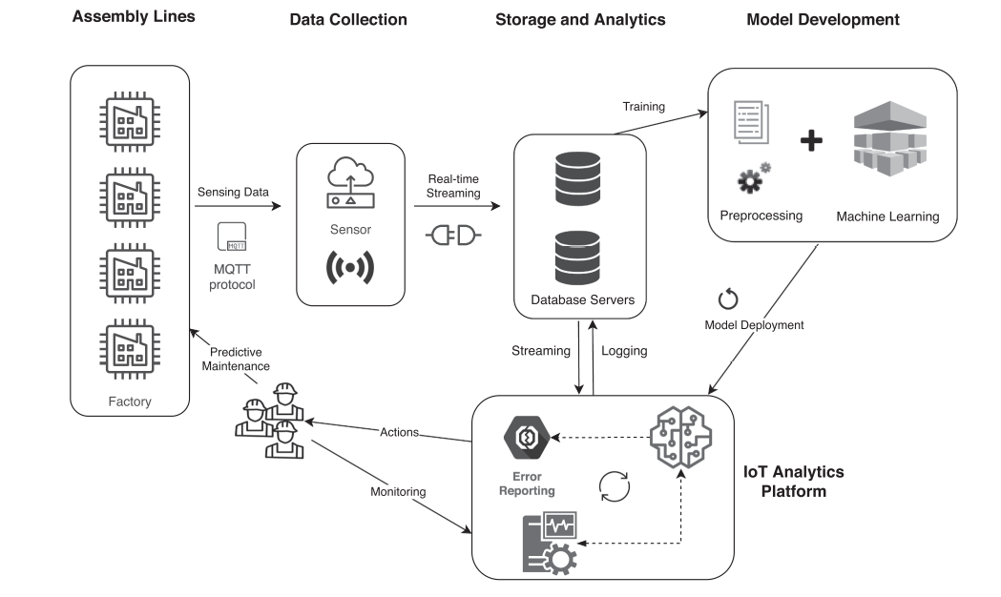
Figure 5 (PdM) BD collection.
Assembly line depicts the field level process equipment and sensor arrays used to digitise the process into CPS.
MQTT is a network protocol with efficient small packet size that speeds up machine to machine communication, and makes reduces data loss. It was designed as part of the IoT (Internet Of Things). Like HTTP (Hypertext Transfer Protocol) it is designed to use TCP (Transmission Control Protocol) but can pass information to clients and servers unlike HTTP which can only respond to clients.
Data collection using MQTT protocol into networks ready to be sent to local and Cloud storage.
Storage and Analytics of collected data and passing data to and from the Analytic Platform and used to build and fine tune the predicted performance model generated by ML.
Intervention information generated by ML algorithms then used by the Maintenance Teams to generate action plans. Information can be passed back to the IoT Analytic Platform from the Maintenance Team to update information and ML algorithms.
The cycle in Fig 5 runs continuously until the next event is identified by the ML. The ML algorithm for each sensor set is continually optimised and faults such as sensor drift are identified for correction.

Cultural and workforce factors.
Industry 4.0 has many benefits as all aspects of a business become vertically and horizontally integrated to each other through the IIoT, where BD is collected from the digitised CPS. Process steps start with customer personal requirements where specific product variations are chosen by the customer, then continue to supply chain, warehousing, scheduling, production, preventative maintenance, accounts, and delivery to customer. These parts of the overall process can be digitally modelled, problems forecasted accurately, and solutions implemented before they affect customer.
This paradigm change to digital environments also has some negatives for businesses especially in terms of capital investment and workforce-wise when it comes to lack of digital skills. Mazali speaks of the importance of people’s “flexibility, passion, participation, responsibility, motivation, integration and team” (Mazali, 2018), but the additional human characteristics that need to be fostered is openness and willingness to learn the new skills required to add value to the business.
Kinkel, et al., have defined the following as some of the key digital skills businesses will have to train existing staff to use, or employ people with existing skills:
- “Software development including skills in modelling and programming, IT security and user-friendly IT design”.
- “Hardware development or adaptation”.
- “Data Science”.
- “Skills in the application of AI or Machine Learning (ML)”.
(Kinkel, et al., 2022).
Zsifkovits, et al., site “strong resistance from the humans” involved with changing the process, as humans get used to doing things in a certain manner and get set in their ways. Also, human goals are quite different from organisational goals. Businesses goals are to get the best possible return from humans (increase profits), While humans want to build careers, increase wages, and maintain stability (Zsifkovits, et al., 2021). Involving the workforce from the beginning is vital to foster positive attitudes to change, being open and honest when dealing with concerns is essential to ensure correct workforce engagement. Developing workforce skills require investment and time and must be factored into business plans when adopting I4.0.

Conclusions
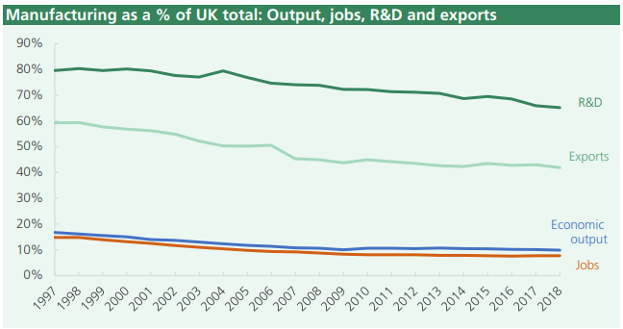
As previously outlined important factors in determining success of adopting I4.0 is the human factor. Initially after introducing I4.0 employment rates will decrease as lower skilled manually intensive jobs will be undertaken by further smart automation, autonomous fixed position and mobile robots and automatic pick and supply of raw material and finished goods. However, over time, the need for highly skilled workers will become more and more important to over-see, maintain, and expand the complex systems involved in I4.0.
Figure 6 Manufacturing as a % of jobs in the UK.(Rhodes, 2020)
While employment in the manufacturing sector has fallen the output has increased marginally generally meaning it has become more efficient (higher productivity) in producing goods. Other sectors are now employing more people than before so there are alternate job sectors for people displaced by business’s move to I4.0, sectors such as Service, Social Care, Retail, Hospitality, Construction etc… However, the difficulty in getting employment with well paid jobs for people without skill in high demand remains very difficult.
For countries with low labour costs the immediate need to transition to I4.0 is less important to remain viable in the short term as the labour savings factor will be reduced compared with countries with higher wages. What will provide impetus to transition will be external forces such as customer demand for a more personalised service, improvement in supply chains’ ability to react to quickly to changing customer requirements along with improved product quality.
Personally, I worry about the long-term socio-economic benefit of adopting I4.0 and the probability that this will lead to further social inequality, where the well off, educated in our society will prosper and people not suited to further and higher education will struggle to lead equally prosperous lives. Will the increase in high skill labour demand equal the loss of lower skill manually labour-intensive jobs? I personally doubt this, and the number of jobs in the manufacturing sector will continue to fall, potentially resulting in over-saturation of people looking for work in other sectors. These extra job burdens in other job sectors could lead to market led reductions in wage growth, further increasing social inequality.

Bibliography
Ayvaz, S. & Alpay, K., 2021. Predictive maintenance system for production lines in manufacturing: A machine learning approach using IoT data in real time. Expert Systems With Applications, 173(1), pp. 1 - 10.
Dubey, G., Gupta, R. K., Kumar, S. & Kumar, M., 2022. Study of industry 4.0 pillars and their uses in increasing productivity and reducing logistics defects.. Materials Today: Proceedings, 63(1), pp. 85 - 91.
Kinkel, S., Baumgartner, M. & Cherubini, E., 2022. Prerequisites for the adoption of AI technologies in manufacturing – Evidence from a worldwide sample of manufacturing companies. Technovation, 110(1), pp. 1 - 17.
Krishnan, S. et al., 2021. Assessing the key enablers for Industry 4.0 adoption using MICMAC analysis: a case study. International Journal of Productivity and Performance Management, 70(5), pp. 1049 - 1071.
Liboni, B. L. et al., 2019. Smart industry and the pathways to HRM 4.0: Implications for SCM. Supply Chain Management, 24(1), pp. 124 - 146.
Longo, F., Nicoletti, L. & Padovano, A., 2017. Smart operators in industry 4.0: A human-centered approach to enhance operators’ capabilities and competencies within the new smart factory context. Computers & Industrial Engineering, Volume 113, pp. 114 - 159.
Margherita, E. G. & Braccini, A. M., 2021. Managing industry 4.0 automation for fair ethical business development: A single case study.. Technological Forecasting & Social Change, 172(1), pp. 1 - 14.
Massa, E. & Ladhari, R., 2023. Augmented reality in marketing: Conceptualization and systematic review.. Intenational Journal of Consumer studies, 11(1), pp. 1 - 32.
Mazali, T., 2018. From industry 4.0 to society 4.0, there and back. AI & society, 33(1), pp. 405 - 411.
Nguyen, T.-M., Quach, S. & Thaichon, P., 2022. The effect of AI quality on customer experience and brand relationship.. The journal of consumer behaviour, 21(3), p. 481 493.
Oxtoby, K., 2023. TRANSFORMING HEALTH AND SAFETY WITH AI. [Online]
Available at: https://www.ioshmagazine.com/2022/12/19/how-artificial-intelligence-transforming-health-and-safety
[Accessed 15 May 2023].
Park, M. & Jeong, J., 2022. Design and Implementation of Machine Vision-Based Quality Inspection System in Mask Manufacturing Process. sustainability, 14(1), pp. 1 - 20.
Rhodes, C., 2020. Manufacturing: statistics and policy. [Online]
Available at: https://researchbriefings.files.parliament.uk/documents/SN01942/SN01942.pdf
[Accessed 28 September 2022].
Taylor, B., 2020. Optimal Temperature Range for Compressed Air Equipment. [Online]
Available at: https://fluidairedynamics.com/how-to-determine-the-optimal-temperature-range-for-compressed-air-equipment/
[Accessed 14 July 2022].
Tyson, L. D. & Zysman, J., 2022. Automation, AI & Work. The MIT Press, 151(2), pp. 256 - 271.
Wang, Z., Sheu, J.-B., Teo, C.-P. & Xue, G., 2021. Robot Scheduling for Mobile-Rack Warehouses: Human–Robot Coordinated Order Picking Systems. Production and Operations Management, 31(1), pp. 98 - 116.
West, D. M., 2018. The Future of Work: Robots, AI, and Automation. 1 ed. Washington, DC.: Brookings Institution Press.

