Catalin Dragomir (2327893)
2327893@student.uwtsd.ac.uk

Data warehouse and data mining
Assessment Part 2 June 2026

Contents
Introduction 2
1.1 – Purpose and Practice of Data Mining 2
1.2 - Dataset Description and Exploration 3
1.3 - Data Pre-processing and Post-processing 4
1.4 - Sample Runs and Analysis Methods 8
1.5 - Business Recommendations 12
1.6: Reflective Commentary 12
References 13

Introduction
This report presents the findings of a data mining analysis conducted on the Online Retail Customer Churn Dataset. The dataset contains transactional, demographic, and behavioural data related to customers of an online retail business, and has been analysed with two primary objectives: predicting customer churn using classification techniques, and identifying customer segments based on behaviour, engagement, and spending characteristics. The analysis was performed primarily in Weka, with additional data exploration and visualisation carried out in Excel and Tableau. The report covers dataset description, preprocessing steps, model selection and evaluation, business recommendations, and a reflective commentary on the overall process.

1.1 – Purpose and Practice of Data Mining
Data mining is the process of discovering patterns, correlations, and insights from large volumes of data using statistical and computational techniques. In a business context, it enables organisations to extract actionable knowledge from raw data that would otherwise remain hidden within operational systems.
In retail and e-commerce environments, data mining has become essential for understanding customer behaviour and improving decision-making. One of the most commercially valuable applications is customer churn prediction, which involves identifying customers likely to stop purchasing before they actually do. Retaining an existing customer is significantly cheaper than acquiring a new one, making churn prediction a high priority use case for retail analytics [1].
Classification techniques are among the most widely used methods for churn prediction. Algorithms such as decision trees, random forests, and logistic regression analyse historical customer data to build predictive models that assign each customer a likelihood of churning based on their behavioural and demographic attributes. These models allow retail managers to intervene proactively, targeting at-risk customers with personalised offers or improved service interactions.
Beyond churn prediction, data mining supports customer segmentation, grouping customers into clusters based on shared characteristics such as spending patterns, purchase frequency, and engagement levels. This enables more targeted marketing and personalised recommendations, both of which improve customer retention and lifetime value.
In this assignment, I will apply classification and clustering techniques to the Online Retail Customer Churn Dataset to predict churn and identify customer segments that can inform business strategy.

1.2 - Dataset Description and Exploration
The Online Retail Customer Churn Dataset contains 1,000 instances and 15 attributes, covering transactional, demographic, and behavioural characteristics of customers in an online retail environment. The target variable is Target_Churn, a binary attribute indicating whether a customer has churned or not.
Attributes and Data Types:
The dataset includes 10 numerical attributes and 4 categorical attributes, plus one identifier column. Numerical attributes include Age, Annual_Income, Total_Spend, Years_as_Customer, Num_of_Purchases, Average_Transaction_Amount, Num_of_Returns, Num_of_Support_Contacts, Satisfaction_Score, and Last_Purchase_Days_Ago. Categorical attributes include Gender, Email_Opt_In, Promotion_Response, and Target_Churn. Customer_ID serves as a unique identifier and was excluded from the analysis.
Missing Values:
The dataset contains no missing values across any of the 15 attributes, making it clean and immediately suitable for analysis without the need for imputation or row removal.
Summary Statistics:
Customer ages range from 18 to 69 years, with a mean of 43. Annual income ranges from 20 to approximately 200 thousand, with a mean of 112. Total spend ranges from 109 to nearly 10,000, averaging around 5,081. Satisfaction scores are rated on a scale of 1 to 5, with a mean of 3.0, suggesting a fairly neutral average customer experience across the dataset. The number of returns ranges from 0 to 9 with a mean of 4.6, and customer support contacts range from 0 to 4 with a mean of 1.9. Last purchase was made between 1 and 364 days ago, with a mean of 183 days, indicating a wide spread of customer engagement levels.
Distributions and Insights:
Gender is roughly equally distributed across Male (33.4%), Female (34.2%), and Other (32.4%). The churn distribution shows a near-balanced split, with 526 churned customers (52.6%) and 474 non-churned (47.4%), which is favourable for classification modelling as it reduces class imbalance concerns(Fig. 1). Promotion response shows that 36.1% of customers unsubscribed, 33.8% responded, and 30.1% ignored promotions, suggesting significant disengagement among a large portion of the customer base(Fig 2).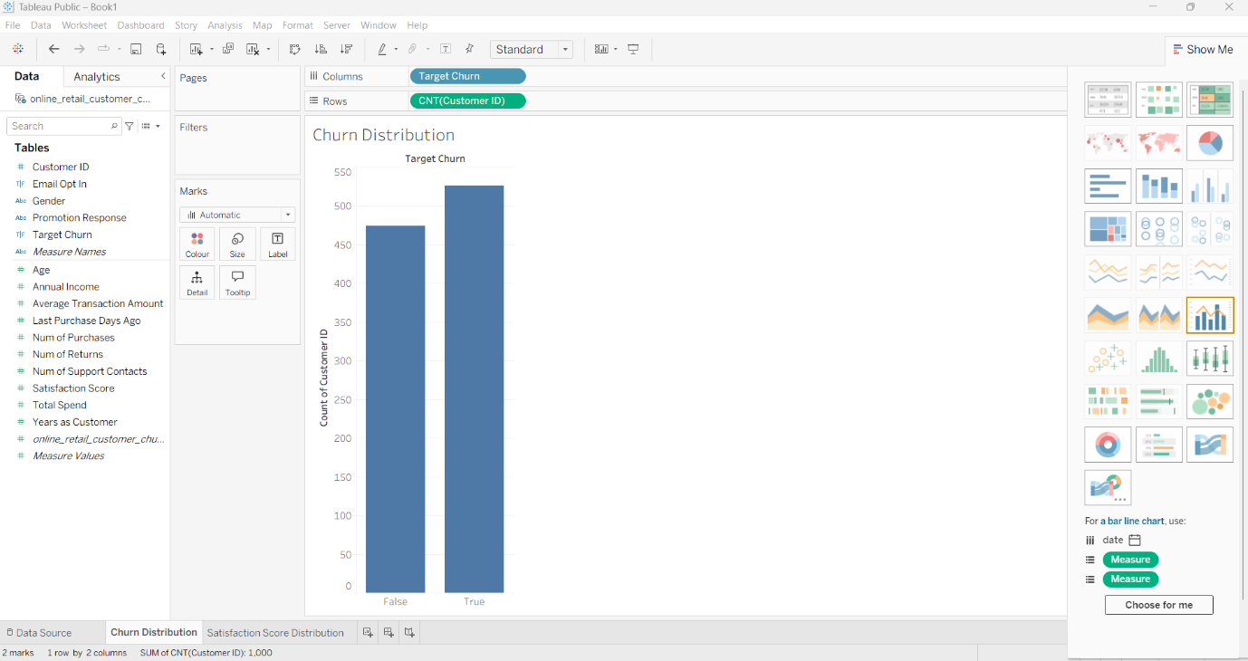Fig 1 – Churn Distribution 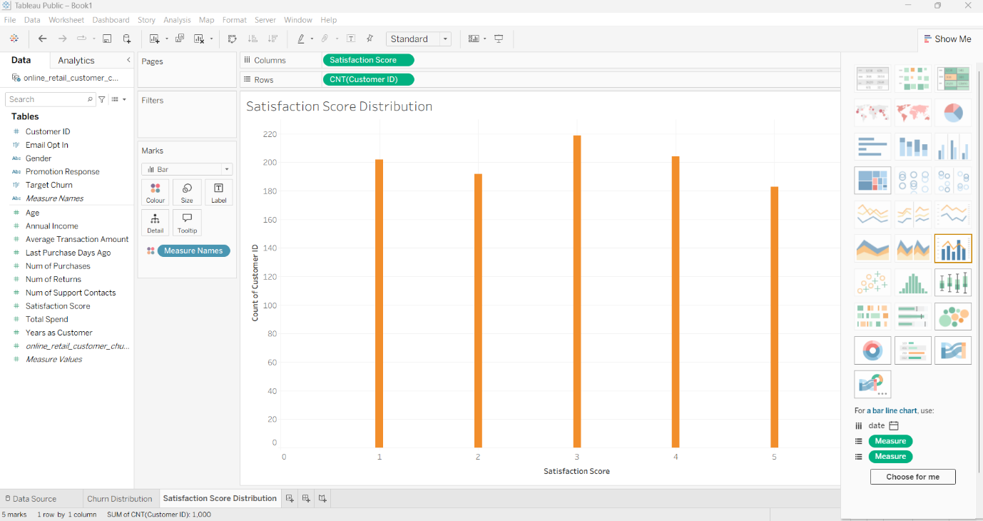Fig 2 – Satisfaction Score Distribution

1.3 - Data Pre-processing and Post-processing
Before applying any classification algorithms, the dataset required a series of preprocessing steps to ensure the data was clean, correctly formatted, and suitable for analysis in Weka.
Handling Missing Values
As identified during the exploration phase, the dataset contained no missing values across any of the 15 attributes. No imputation or row removal was therefore required, and the dataset could proceed directly to the next preprocessing stage. This is an important finding as missing data is one of the most common challenges in real-world datasets and can significantly affect classification performance.
Removing Irrelevant Attributes
The Customer_ID attribute was removed prior to analysis as it serves purely as a unique identifier and carries no predictive value for churn classification. Retaining it in the model would introduce noise and could artificially inflate or reduce classification accuracy by creating false associations between ID values and the target class(Fig 3 and Fig 4).
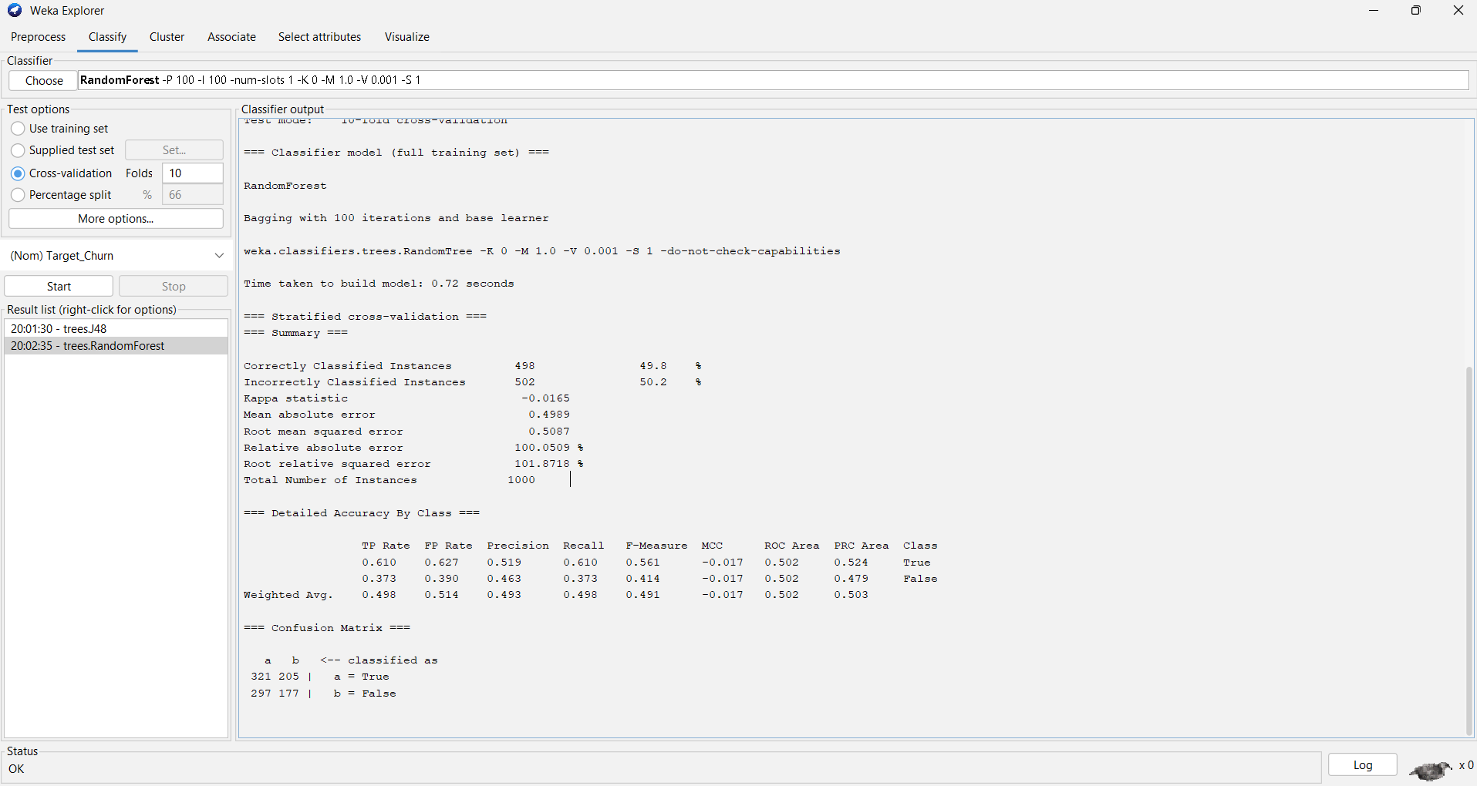Fig 3 – Initial Dataset with 15 attributes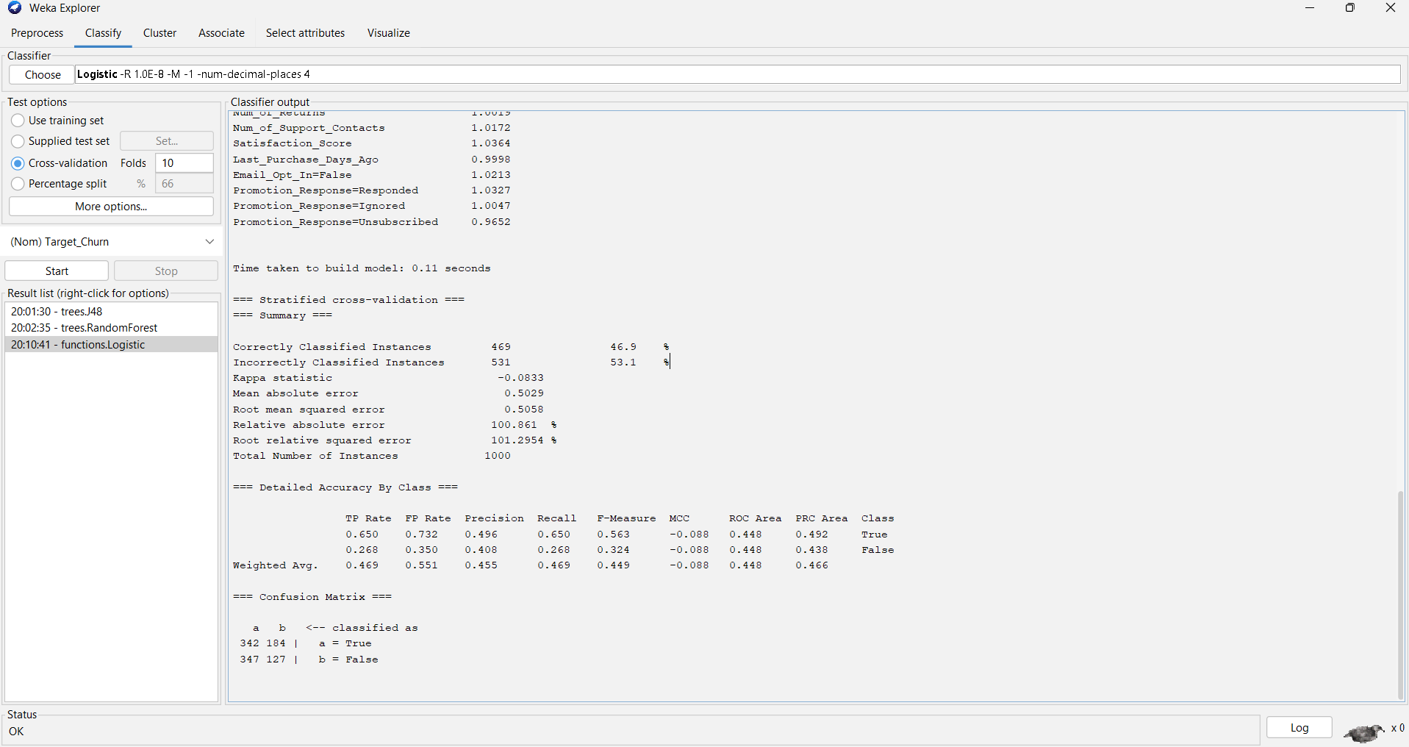Fig 4- Dataset after CustomerID removal
Encoding Categorical Variables
The dataset contains four categorical attributes, Gender, Email_Opt_In, Promotion_Response, and Target_Churn. These were handled using the NominalToBinary filter in Weka, which converts categorical values into numeric binary representations suitable for classification algorithms [2]. Gender contains three values, Male, Female, and Other, which were expanded into three separate binary columns. Promotion_Response contains three values, Responded, Ignored, and Unsubscribed, which were similarly expanded. After applying this filter, the dataset expanded from 14 attributes to 18. This encoding approach ensures that no artificial ordinal relationship is introduced between categorical values, which could otherwise mislead linear or distance-based classification algorithms(Fig 5 , Fig 6).
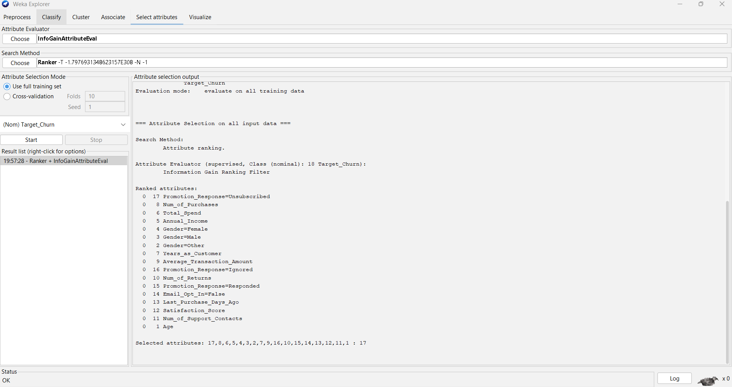Fig 5 – NormalToBinary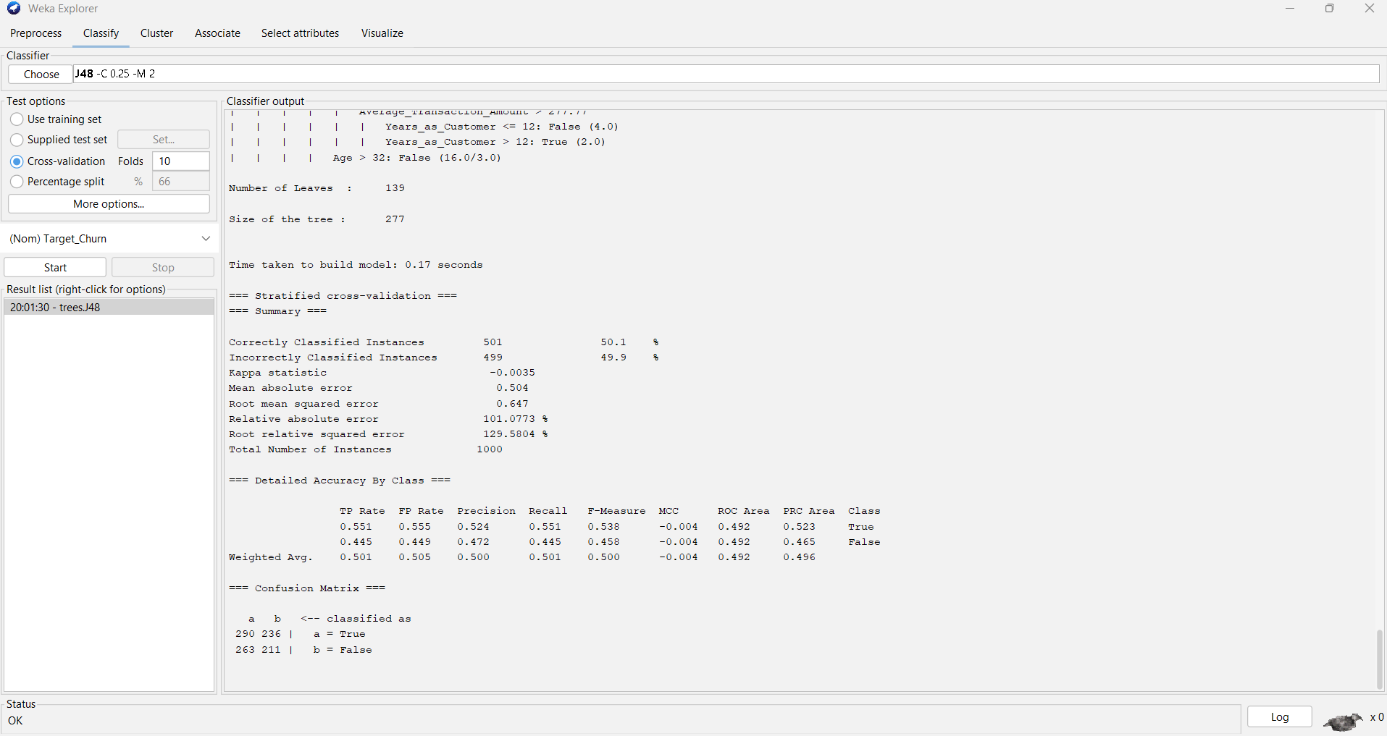Fig 6 – NormalToBinary
Balancing the Dataset
The dataset showed a near-balanced class distribution, with 526 churned instances and 474 non-churned instances, representing a 52.6% to 47.4% split. Although techniques such as SMOTE exist to address class imbalance by generating synthetic instances of the minority class, the difference of 52 instances between the two classes is considered negligible. Applying SMOTE would introduce artificial variability without meaningful benefit, and the near-balanced distribution is acceptable for standard classification without resampling.
Feature Selection
To identify the most relevant attributes for predicting churn, the InfoGainAttributeEval filter was applied in Weka combined with the Ranker search method [3]. Information Gain evaluates each attribute by measuring the reduction in entropy it provides with respect to the target class. The results showed that all attributes received an information gain score of zero, indicating that no individual attribute carries statistically meaningful predictive power for churn in this dataset. This finding suggests the churn labels may have been assigned randomly during the synthetic generation process rather than being derived from genuine behavioural patterns. All 17 attributes were retained for classification despite the zero scores (see Fig 7).
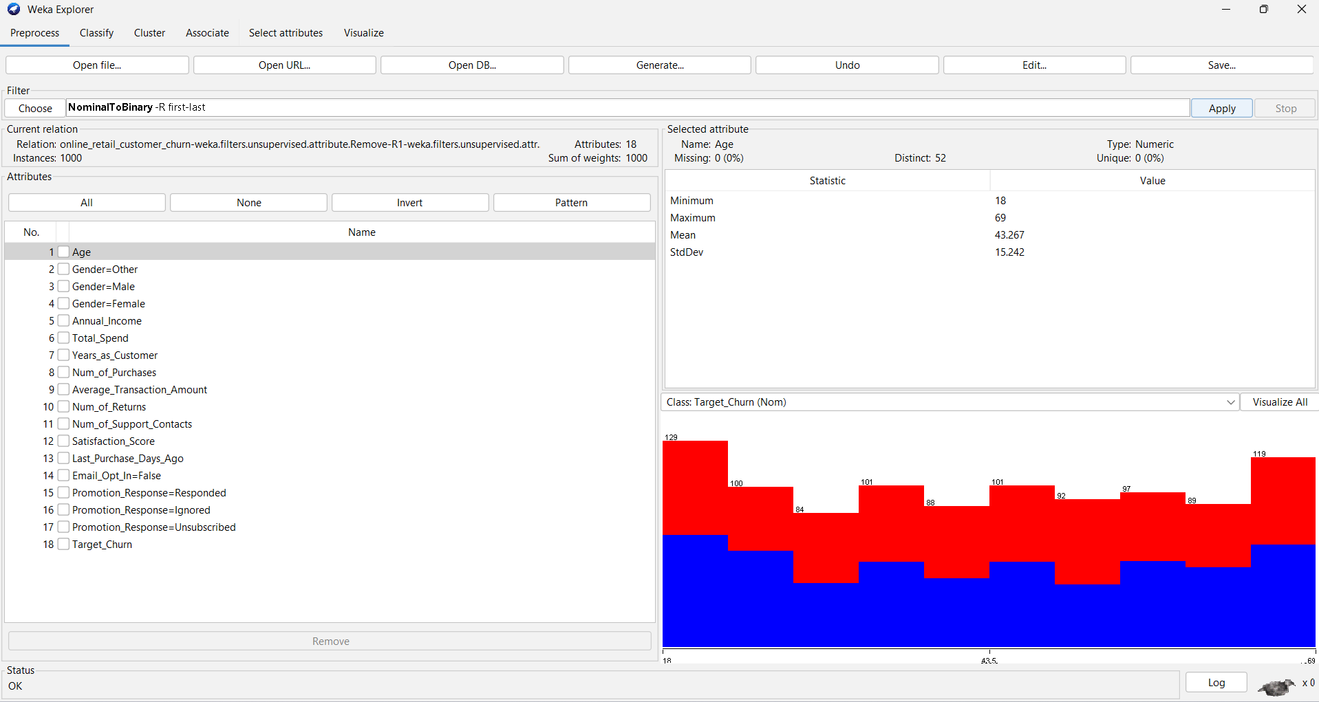Fig 7 – InfoGain Results
Cross-Validation Setup
Before running the classification algorithms, 10-fold cross-validation was selected as the evaluation method. This approach divides the dataset into 10 equal subsets, using 9 for training and 1 for testing in each iteration, repeating the process 10 times so that every instance is used for both training and testing. This method provides a more robust estimate of model performance than a simple train-test split and reduces the risk of overfitting.
Post-processing
After running the classification models, results were interpreted using the confusion matrix and summary statistics generated by Weka, including accuracy, precision, recall, and AUC. Accuracy measures the overall proportion of correctly classified instances. Precision measures how many predicted churners were actually churners. Recall measures how many actual churners were correctly identified. AUC provides a threshold-independent measure of classification performance, where a value of 0.5 indicates random performance and 1.0 indicates perfect classification. These metrics were used to compare model performance and evaluate the practical usefulness of each classifier for churn prediction in a retail context.

1.4 - Sample Runs and Analysis Methods
Four classification algorithms were selected and evaluated in Weka using 10-fold cross-validation: J48 Decision Tree, Random Forest, Logistic Regression, and SMO. These algorithms were chosen because they represent a range of complexity and interpretability, from simple rule-based models to ensemble methods, and are widely used as benchmarks in churn prediction research.[1] [4].
J48 Decision Tree
J48 is an implementation of the C4.5 decision tree algorithm in Weka. It builds a tree structure by recursively splitting data based on the attribute that provides the most information gain at each node. Decision trees are widely used in classification tasks because they are interpretable and require minimal data preparation [5]. The resulting tree had 139 leaves and 277 nodes, indicating a complex model that attempted to find patterns across many attribute combinations.
Results from 10-fold cross-validation showed an accuracy of 50.1%, with a weighted average precision of 0.505, recall of 0.500, and AUC of 0.492. The confusion matrix showed 290 true churners correctly classified and 211 non-churners correctly classified, with 499 instances misclassified overall. These results are essentially equivalent to random guessing, as an AUC below 0.5 indicates the model has no meaningful predictive power above chance (see Figure 8).
The J48 decision tree visualisation is presented below. The root node splits on Gender=Other, however given that all attributes scored zero on the InfoGain evaluation, this split is likely coincidental rather than meaningful.
Fig 8 – J48 results
Random Forest
Random Forest is an ensemble method that builds multiple decision trees using random subsets of features and instances, then combines their predictions through majority voting. It is generally considered more robust than a single decision tree and less prone to overfitting.
Results showed an accuracy of 49.8%, precision of 0.493, recall of 0.498, and AUC of 0.502. The confusion matrix showed 321 true churners and 177 non-churners correctly classified. Despite its increased complexity, Random Forest performed no better than J48, confirming that no meaningful patterns exist in the data (see Figure 9).

Fig 9 - RandomForest
Logistic Regression
Logistic Regression is a linear probabilistic classifier that models the relationship between input features and the binary target variable using a logistic function [5]. It is commonly used as a baseline model in binary classification tasks.
Results showed the weakest performance, with an accuracy of 46.9%, precision of 0.455, recall of 0.469, and AUC of 0.448. The confusion matrix showed 342 true churners but only 127 non-churners correctly classified, indicating the model defaulted to predicting churn for the majority of instances(see Figure 10).
Fig 10 – Logistic Regression
SMO - Support Vector Machine
SMO, Sequential Minimal Optimisation, is Weka's implementation of the Support Vector Machine algorithm. It works by finding the optimal hyperplane that separates classes in a high-dimensional feature space and handles high-dimensional data well.
Results showed an accuracy of 47.7%, precision of 0.466, recall of 0.477, and AUC of 0.468. The confusion matrix showed 336 true churners but only 141 non-churners correctly classified, confirming once again that no meaningful decision boundary exists between churned and non-churned customers in this dataset(see Figure 11).
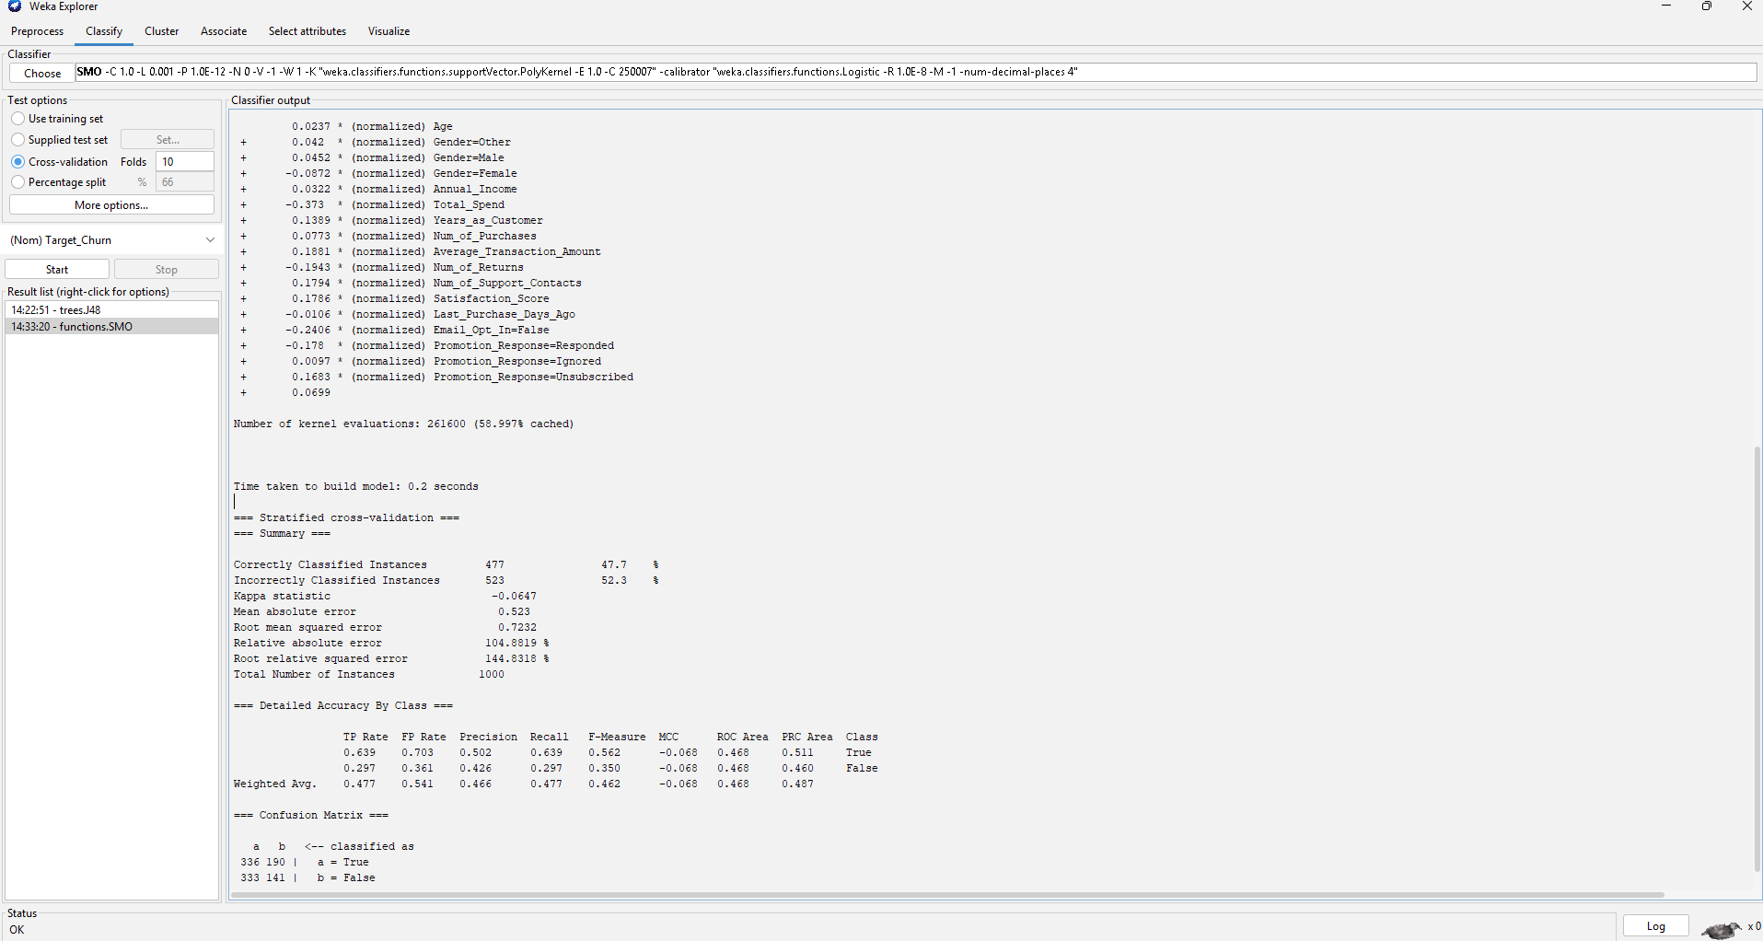
Fig 11 – SMO
Evaluation Metrics
The primary metrics used were accuracy, precision, recall, and AUC. AUC was prioritised as the primary evaluation metric as it measures classification performance independently of the decision threshold and weights both classes equally.
Comparative Summary
Algorithm | Accuracy | Precision | Recall | AUC
J48 | 50.1% | 0.505 | 0.500 | 0.492
RandomForest | 49.8% | 0.493 | 0.498 | 0.502
Logistic Regression | 46.9% | 0.455 | 0.469 | 0.448
SMO | 47.7% | 0.466 | 0.477 | 0.468
All four algorithms performed at or below the level of random classification, consistent with the InfoGain results where all attributes scored zero. The uniformly poor performance strongly suggests the churn labels were assigned randomly rather than reflecting real customer behaviour.

1.5 - Business Recommendations
The classification models applied in this analysis, J48, Random Forest,Logistic Regression and SMO. All produced accuracy levels close to 50% with AUC values near 0.5, indicating performance equivalent to random guessing. Combined with the InfoGain results where all attributes scored zero, this strongly suggests the churn labels were assigned randomly rather than derived from genuine customer behaviour. The primary recommendation is therefore to validate the integrity of the target variable before deploying any machine learning model in a real retail environment [1].
Despite poor model performance, the exploratory analysis revealed several attributes that could serve as meaningful churn indicators in practice. Satisfaction score averaged 3.0 out of 5, suggesting a neutral customer experience. Organisations should monitor customers with consistently low satisfaction scores and intervene proactively through improved customer service and follow-up communications.
Promotion response data showed that 36.1% of customers unsubscribed, indicating significant disengagement. Retail managers should redesign their marketing campaigns to be more targeted and relevant to reduce this unsubscribe rate.
The time since last purchase attribute, ranging from 1 to 364 days, could serve as a simple early warning indicator. Customers who have not purchased within a defined threshold should be re-engaged through personalised email campaigns or exclusive offers.
Finally, any future churn prediction effort should use real transactional data with verified churn labels, as the quality of training data directly determines the usefulness of any predictive model in a business context.

1.6: Reflective Commentary
Overall, this project provided a valuable opportunity to apply data mining techniques to a real world style business problem. Working through the full pipeline in Weka, from data loading and preprocessing through to feature selection and classification, strengthened practical understanding of the data mining process considerably.
The most significant finding was that all four classification models performed at the level of random guessing, with accuracy around 50% and AUC values close to 0.5. Initially this was surprising, but the InfoGain feature selection results, where every attribute scored zero, provided a clear explanation. The dataset appears to have been synthetically generated with randomly assigned churn labels, meaning no genuine patterns existed for the models to learn from. This was an important lesson about the relationship between data quality and model performance.
A strength of the analysis was the systematic approach taken, applying four fundamentally different algorithms and comparing their results, which made it possible to confirm that the poor performance was a data issue rather than an algorithm choice issue.
If this analysis were to be repeated, the first step would be to validate the dataset by checking whether churn labels correlate with any attributes before running classification models. Exploring real retail datasets with verified churn labels would produce more meaningful and actionable results. Despite thorough preprocessing and the application of four classification algorithms, the uniformly poor performance highlights a critical lesson for any data mining project, that the quality and integrity of the target variable directly determines the value of any predictive model in a real world business context.

References

[1] | K. K. Kamil Matuszelanski, “Customer Churn in Retail E-Commerce Business: Spatial and Machine Learning Approach,” Journal of Theoretical and Applied Electronic Commerce Research, vol. 17, no. 1, 2022.
[2] | T. M. K. John T. Hancock, “Survey on categorical data for neural networks,” Journal of Big Data, 2020.
[3] | D. e. a. Stiawan, “CICIDS-2017 dataset feature analysis with information gain for anomaly detection,” IEEE Access, 2020.
[4] | M. B. S. a. R. A. Zaghloul, “Enhancing customer retention in Online Retail through churn prediction: A hybrid RFM, K-means, and deep neural network approach,” Expert Systems with Applications, 2025.
[5] | A. C. K. a. D. B. K. De Caigny, “A new hybrid classification algorithm for customer churn prediction based on logistic regression and decision trees,” European Journal of Operational Research, 2018.

