Module: Socket Programming and Concurrency

Assignment: Concurrent client/server application, design, and build

Student Name: Shannon James

Student ID: 170099

Contents
Design Statement 3
Introduction 3
Statement of Purpose 3
Audience 3
Target Audience 3
Persona 1 4
Persona 2 5
Secondary Research 6
Examples 6
User Requirements 8
Choice of Technologies and Frameworks 8
Application Flow and Page/Screen Layout 9
Wireframes 9
Mock-ups 10
Development Process 11
Test Programme 13
Test Plan 13
Aims and Objectives. 13
User Acceptance Testing 13
User Acceptance Testing 14
Website Tester: Tester 1 14
Website Tester: Tester 2 15
Website Tester: Tester 1 16
Bibliography 17
Appendix 18

Design Statement

Introduction
This project involves the design and development of a review application. The review application will be centred on Disney Movies. Specifically, Disney movie classics at this time, as there is such a huge amount of Disney movies. This allows for further expansion on the project in the future.

Statement of Purpose
The application must allow for users to navigate through all the Disney movies and be able to select on of their choice. Information needs to be given on each movie, such as a current star rating, a movie synopsis, and an age rating. Users should be able to enter their own reviews as well as give their own personal star rating for the movie. Users should also be able to view other users’ reviews.

Audience

Target Audience
The target audience for the application is for the younger generation and parents and therefore the application needs to be family friendly. The application is targeting both children and adults, although, it is for the use of adults to write the reviews. As such, the target age range for the application will be 16-40. The application will be targeted more towards females (1).

Persona 1

Persona:
13-Year-old child, who is a huge Disney princess enthusiast
Fictional Name:
Ella Jane
Demographics:
- 13 Years Old
- Sister to one
- Living with parents
- Student
Goals and Tasks:
Jane is a massive Disney princess enthusiast and loves everything Disney in general as well. She does not get to go to cinemas often when a Disney movie is first released but does not like to wait to find out about a movie. She likes to search online for spoilers and reviews of the movie, so she gets a general idea of what a movie is about.
Environment:
Jane wakes up early every morning, gets dressed, has breakfast and gets driven to school by her parents with her sister. As they drive to school, they listen to the best of Disney music. When it is time to come home at 3:00pm, her father picks them both up and drives home, whilst playing the same music. When they get in, Jane and her sister usually watch some TV, sometimes a movie.
Scenario:
Jane’s parents love spending quality family time together, although they do not get to go out as often as they would like. Jane herself is 13, but her younger sister is 7. With quite an age gap, some movies would be suitable for Jane, but may not be suitable for her sister. The application would allow Jane’s parents to do a quick check on whether or not a movie is suitable for both of their daughters beforehand, and does not require much of their time to find the information.

Quote:
“Hakuna matata”

Persona 2
Persona:
20-year-old film student
Fictional Name:
Michaela Smiley
Demographics:
- 20 Years Old
- Lives in a student accommodation with three flat mates
- Student
Goals and Tasks:
Michaela is huge Disney fan and has been since she was a little girl and brought up with Disney movies. Michaela loves to discuss movies in general along with her flat mates who are all in a similar field of study at the same university. Disney movies are her favourite, and she spends much time discussing them with her flat mates. As a film student, she enjoys analysing movies and giving reviews online, as it improves her expertise in the field.
Environment:
Michaela wakes early every morning to get ready for classes. She walks with her flat mates who are in the same building as her for their classes, and one is in the same class. They all get a coffee first thing and catch up on general news in the morning. Michaela is usually in class until 12:00-1:00 in which she then goes off and carries out her own independent studying. She finishes her work day around 5:00-6:00 and then heads home to her shared accommodation. When she gets home, she catches up with her flat mates on the events of the day.
Scenario:
Michaela loves Disney movies more than any other genre. She also loves analysing movies, debating about them and giving her overview of then. Having a Disney centred application for the purpose of giving reviews is something that attract Michaela to using it on a regular basis, especially as she can read other user reviews and gain other insights and perspectives on her favourite movies.
Quote:
“If you focus on what you left behind, you will never be able to see what lies ahead.”

Secondary Research
Secondary research was conducted to explore similar applications and their design and functionality. General movie websites were looked at, but there was one found that focussed specifically on Disney movies alone.

Examples

The Disney Movie Reviews
The first website found in the research was one centred on Disney movies. They produce podcasts reviewing Disney, Pixar, and Marvel movies. They also keep users updated on news from Disney movie properties and they provide information on the latest updates from Disney. The Disney Movie Reviews website was quite simple in design. The website contained reviews on Disney movies and Disney updates, although, general users are not able to leave their own reviews.
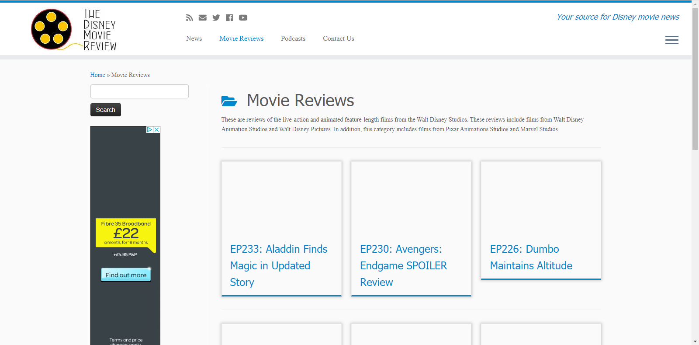
(2)

IMDb
IMDb which stands for Internet Movie Database, is a website containing a database on information relating to movies, shows, games and other media content. The website is not centred on a specific genre or type of movie. They provide users with a wide range of information, such as the cast and production of a movie, general trivia, reviews and ratings and any other relevant information on the content. The website is clear and easy to use. Users are able to enter any movie they wish into the search bar and a whole profile is pulled up for each movie containing all the information they have that relate to it.
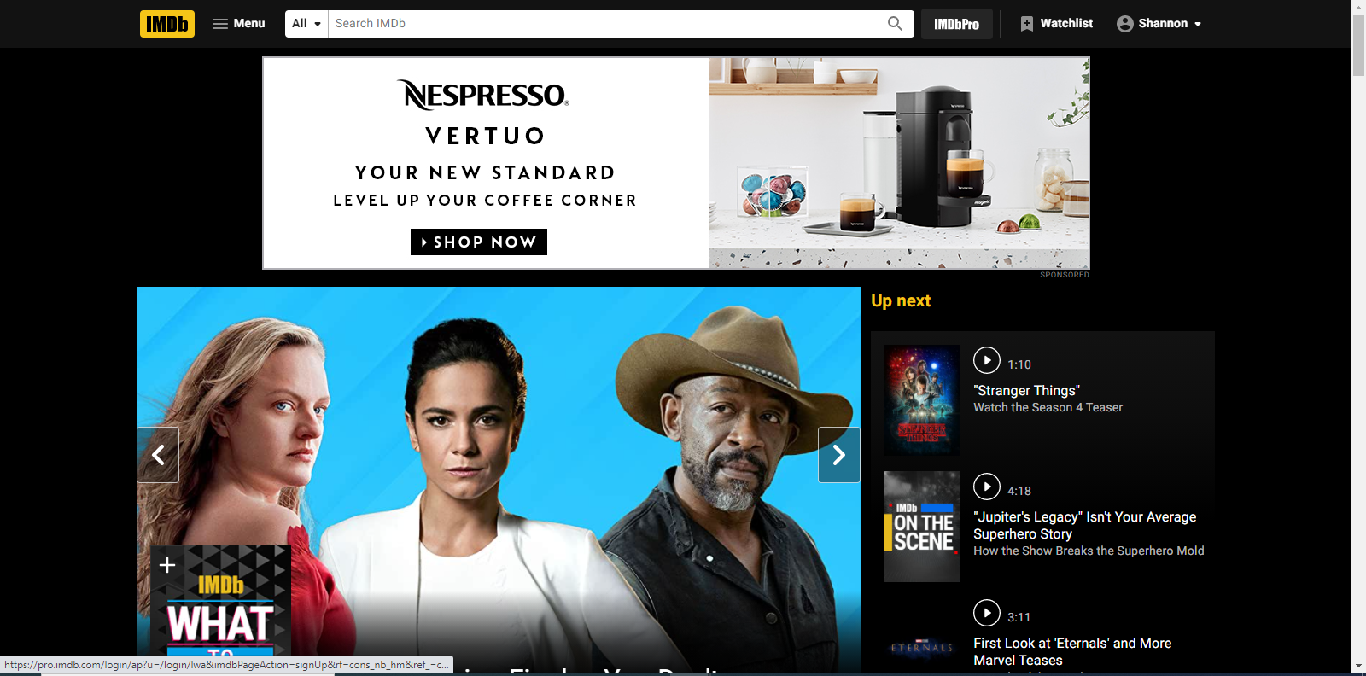(3)

Rotten Tomatoes
Rotten Tomatoes offers users information on a variety of movies and TV shows. Like IMDb, it does not focus on a select type or genre. The website does not utilise its space as much as IMDb, with a lot of blank space around the website. If the space was utilised better, the website itself might look less cluttered. The navigation and functionality of the website however, work effectively and a huge variety of information is given on the movies, for example, cast and crew, reviews and where you can go to watch the movies.
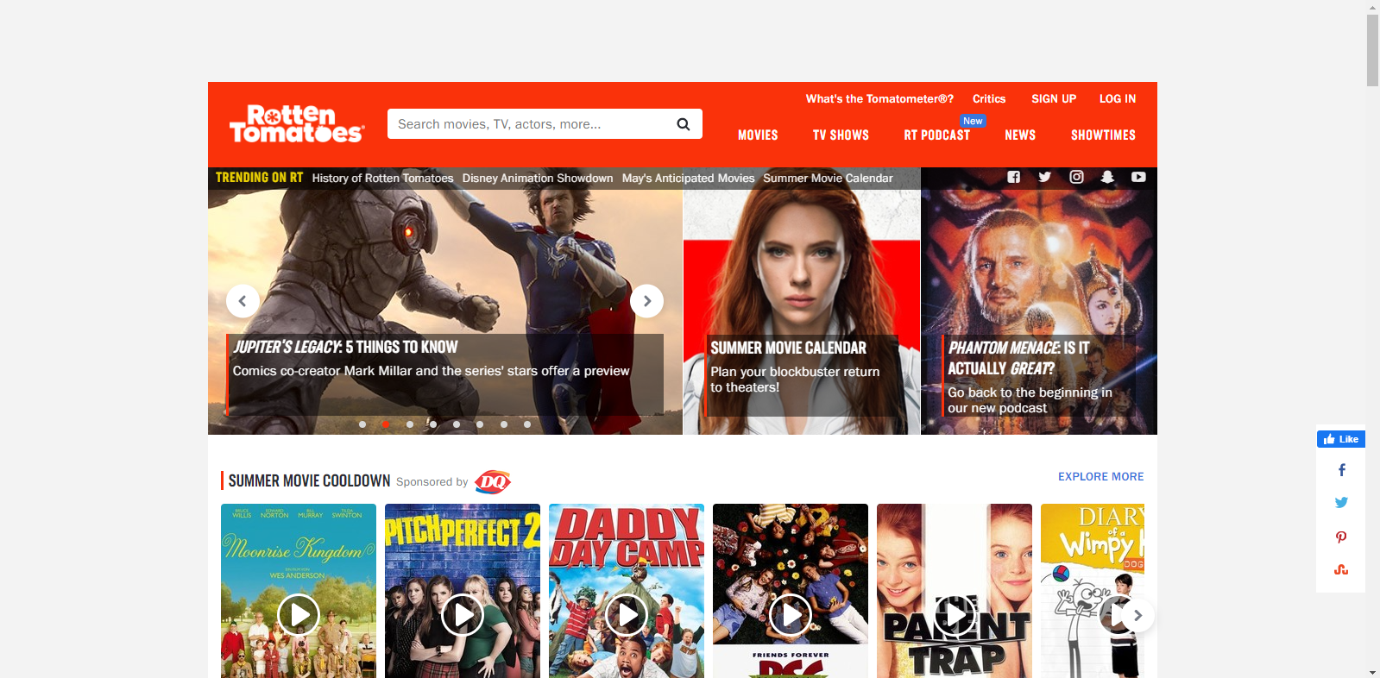(4)

User Requirements
The user requirements were identified and put into a table, along with information on if they were required or desired.
Requirement ID | Description | Required/Desired
1 | Give a review | Required
2 | Give a star rating | Required
3 | View other reviews | Required
4 | Select a movie | Required
5 | Movie profiles | Required
6 | Parental Guidance | Required
7 | User Accounts | Desired
8 | Review Guidelines | Desired
9 | Movie Trailer | Desired

Choice of Technologies and Frameworks
Laravel was chosen for the development of the application. Laravel is built with good security feature in place that protect against Cyber threats. Laravel is beneficial to users as it has good website performance, by reducing the time they would have to wait to gain information from websites. (5) Another benefit to Laravel, is that it is cost beneficial, as it is an open-source framework, meaning it is free for use. (6)
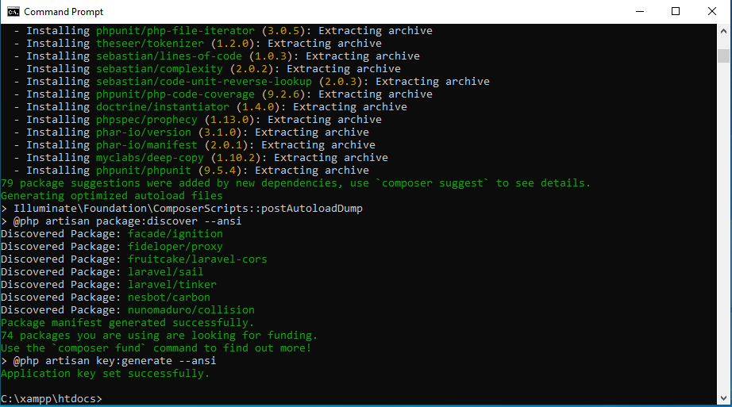

Application Flow and Page/Screen Layout

Wireframes
Wireframes of the application were created to plan an effective layout and ensure it is structured effectively. This may be subject to change further down the development phase, as it is used just as a general idea of what can be created.
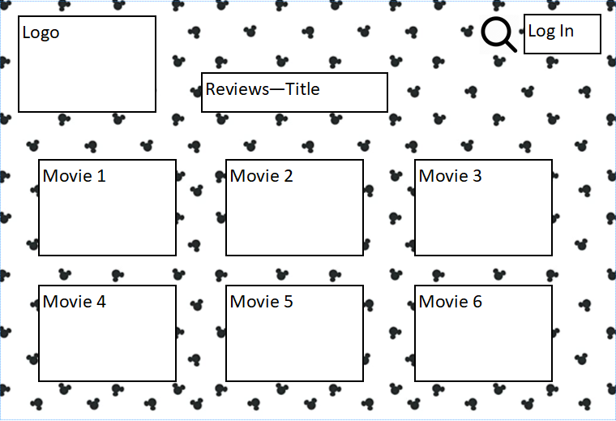
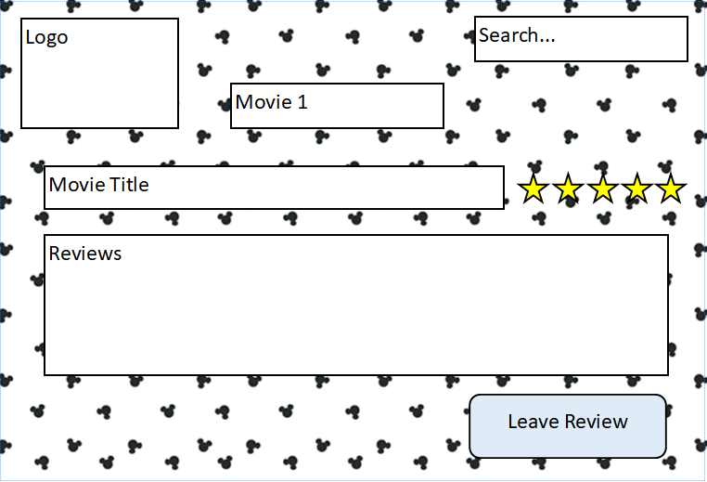
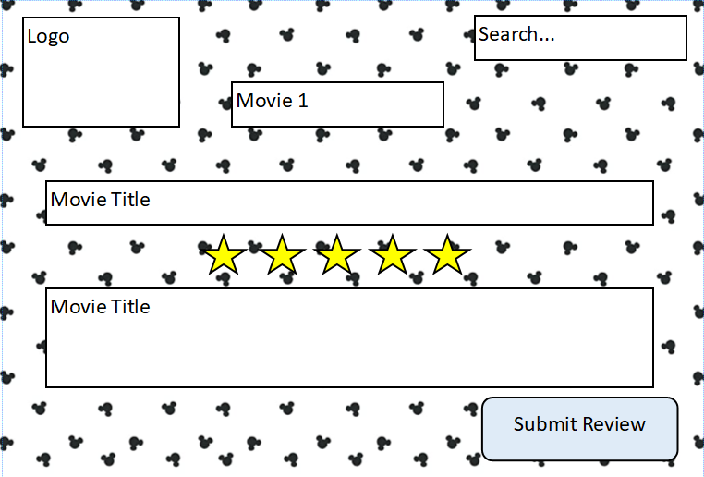

Mock-ups
Mock-ups were created to gain a better understanding of the design. Some modifications were made, such as the background from the wireframes not being used and the application having the name ‘Disney Discuss’, as it will allow users to leave their opinions on the movies.
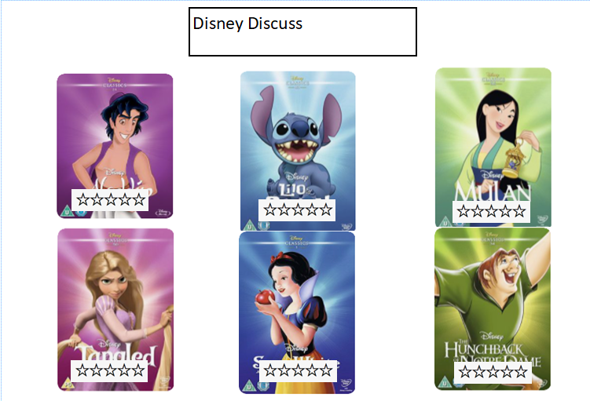
Information will be given on the movie, such as the genre, a synopsis, cast involved in the movie and movie reviews from general users.
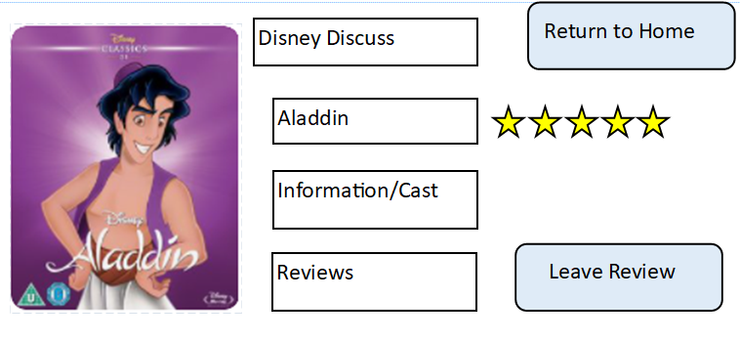
Users should be able to give a star rating of the movie and leave a review. The star rating is for the convenience of users who have not got the time or simply do not want to read reviews to get a general idea on a movie. The reviews can be used for people who want a more detailed insight of a specific movie.
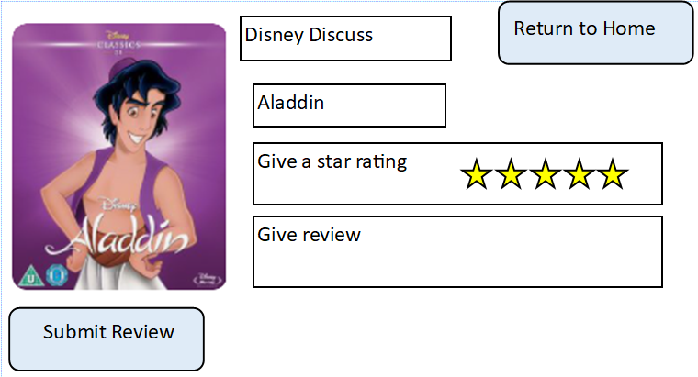

Development Process
The development of the application did not go as intended with the use of Laravel and so a prototype was built using different software.
A prototype of the application was built in visual studio. The application shows the title “Disney Discuss” in the Disney font, and is also used as the logo for the application. The page contains all the Disney classic movies at this point in time and can be expanded on in the future to include other Disney movies, such as Star Wars and Marvel. There is a star rating under the movies, which is to the benefit of people who want to quickly access a general idea on whether or not a movie is good based on users’ opinions. The titles are buttons, that when selected will take the user to the movie profile, as shown in the next screenshot.
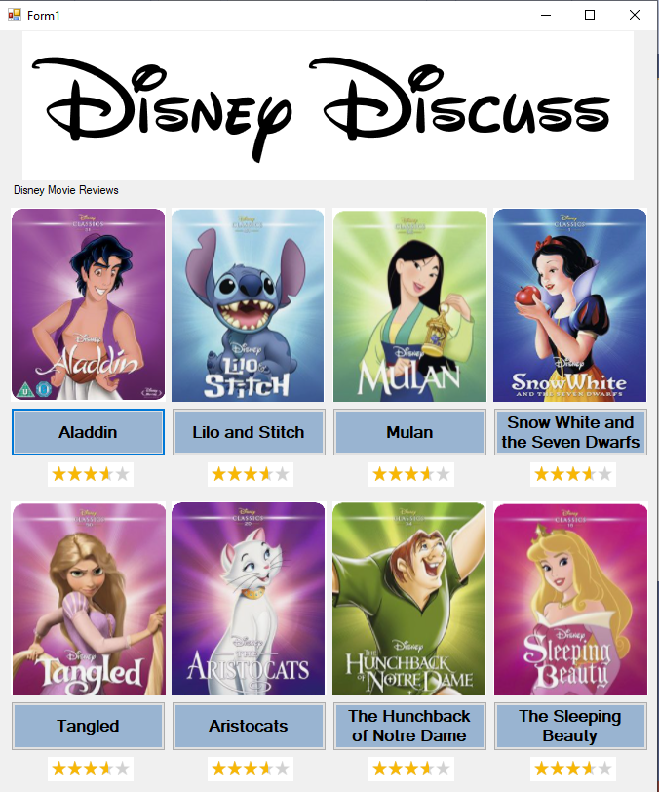

Once a title has been selected, the movie profile will appear, as shown below. The movie profile includes information on the genre of movie, a synopsis of the movie, the cast involved with the movie and the reviews left by the users. The users are able to return to the homepage to select a different movie, simply by selecting the ‘Main Menu’ button. Users are also able to leave their oen reviews of the movie by selecting the ‘Leave Review’ button.
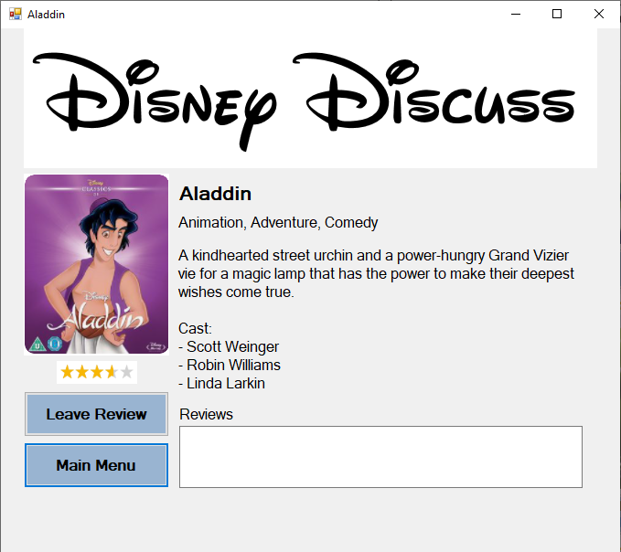
The screen shot below shows the screen that users will be shown if they select the ‘Leave Review’ button. The movie image, name and description all remain the same, so that users remain informed on what movies they are leaving a review for. This is helpful in cases that a user may need to leave their screen and come back to it in a couple minutes, as they may have forgotten what movie they were writing about. The users are able to leave a star rating as well as a review. Users can submit their review by selecting the ‘Submit Review’ button. Users are also able ot go back to the previous screen by simple selecting the ‘Go back’ button.
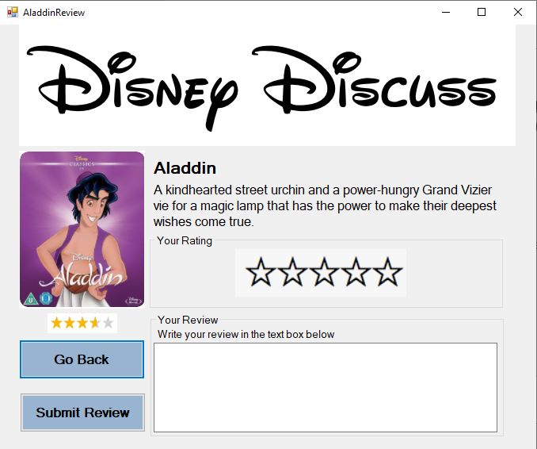

Test Programme
Tests need to be carried out on the application to ensure it works effectively.

Test Plan
A test plan was carried out on the functionality of the website.
Test ID | Test Description | Functions? | Modifications
1 | Users are able to select a movie | Yes | N/A
2 | Users are able to give a star rating | NO | Functionality needs to be added to the star ratings
3 | Users are able to leave a review | Yes | N/A
4 | Users are able to see other reviews | NO | The reviews left need to move to a separate form to be displayed
5 | Users are able to easily navigate the application – navigation button functionality | Yes | N/A

Aims and Objectives.
The aims and objectives were compared against to identify what needs had been met and what had not.
Requirement ID | Description | Required/Desired | Complete?
1 | Give a review | Required | Yes
2 | Give a star rating | Required | No
3 | View other reviews | Required | No
4 | Select a movie | Required | Yes
5 | Movie profiles | Required | Yes
6 | Parental Guidance | Required | No
7 | User Accounts | Desired | No
8 | Review Guidelines | Desired | No
9 | Movie Trailer | Desired | No

User Acceptance Testing
User acceptance testing was carried out on the prototype to gain insight from users on the advantages and disadvantages of the application.

User Acceptance Testing
Website Tester: Tester 1 Date: 27.04.2021
- Is the navigation effective?
Yes, the navigation works.
- Is the navigation easy to identify? (Are the buttons big enough?)
The buttons are big enough and so is the words.
- Did you come across any errors?
Yes, I did not see any reviews that I could read.
- If you make a mistake, how difficult is it to correct?
I can easily go back to the other screens.
- Does the interface provide you with information about where you are and what you can do?
The pages have titles on them, so I know where I am, and the buttons are clear so I know what to do.
- Is it clear what the application is?
Yes, the information tells me its website to use to give your opinion on a movie.
- Was the content of the website easy to understand?
The content was easy to understand and was simple English.
- Do you find the style of the website appropriate for the subject?
The style of the website, I felt could be a bit prettier. Maybe some more colour could be added. Other than the main page which did have a lot of colour from the images.
- How recognisable are the elements? (for example, logo, navigation, buttons)
The are clear as said about the buttons earlier.
- Are all the images appropriate for the website?
The images are correct, yes.
- Did you find the website consistent regarding the style?
The home page was more colourful, but the style was consistent.
- Did you find the website consistent regarding the layout?
Other than the home page because that needed a different layout.
- Did you find the website consistent regarding the content (images, text)
The images were the same. If you picked the Aladdin movie, the image was on the next page and the review page also. The text was the nearly the same on the profiles and the reviews page, so it was overall consistent.

Website Tester: Tester 2 Date: 27.04.2021
- Is the navigation effective?
Yes
- Is the navigation easy to identify? (Are the buttons big enough?)
Yes
- Did you come across any errors?
Yes, the reviews did not go on the movie profiles, and the star rating does not work.
- If you make a mistake, how difficult is it to correct?
Easy enough
- Does the interface provide you with information about where you are and what you can do?
Yes with titles and information
- Is it clear what the application is?
Yes, a Disney movie review application.
- Was the content of the website easy to understand?
Yes
- Do you find the style of the website appropriate for the subject?
Yes
- How recognisable are the elements? (for example, logo, navigation, buttons)
Everything is identifiable, other than a logo, but I assume the title is the logo.
- Are all the images appropriate for the website?
Yes
- Did you find the website consistent regarding the style?
Yes
- Did you find the website consistent regarding the layout?
Yes
- Did you find the website consistent regarding the content (images, text)
Yes

Website Tester: Tester 1 Date: 27.04.2021
- Is the navigation effective?
I can move around the application with ease.
- Is the navigation easy to identify? (Are the buttons big enough?)
The buttons are in a style that is easy to identify.
- Did you come across any errors?
There are errors with leave a review.
- If you make a mistake, how difficult is it to correct?
I can go back to the previous screen.
- Does the interface provide you with information about where you are and what you can do?
Yes, this is clear.
- Is it clear what the application is?
Yes, but not immediately from the title. At first, it looks a little like a blog.
- Was the content of the website easy to understand?
The content was simple and easy to understand.
- Do you find the style of the website appropriate for the subject?
The style is appropriate.
- How recognisable are the elements? (for example, logo, navigation, buttons)
I can easily see the buttons and know what they do.
- Are all the images appropriate for the website?
The images are fitting and very appealing.
- Did you find the website consistent regarding the style?
The style was consistent.
- Did you find the website consistent regarding the layout?
The layout was consistent.
- Did you find the website consistent regarding the content (images, text)
The content was consistent.

Bibliography
- Winsor R. The Magic of the Mouse: An Exploration of Brand Personality in The Walt Disney Company [Internet]. Scholars.unh.edu. 2015 [cited 5 February 2021]. Available from: https://scholars.unh.edu/cgi/viewcontent.cgi?article=1239&context=honors#:~:text=While%20each%20of%20the%20groups,through%20movies%2C%20television%20and%20merchandise.
- Movie Reviews Archives - The Disney Movie Review [Internet]. The Disney Movie Review. 2021 [cited 19 February 2021]. Available from: http://www.thedisneymoviereview.com/category/disney-movies/
- IMDb: Ratings, Reviews, and Where to Watch the Best Movies & TV Shows [Internet]. IMDb. 2021 [cited 19 February 2021]. Available from: https://www.imdb.com/
- Flixster [Internet]. Rotten Tomatoes. 2021 [cited 19 February 2021]. Available from: https://www.rottentomatoes.com/source-1992
- What Makes Laravel Best PHP Framework - An Insight! [Internet]. FATbit Blog. 2021 [cited 26 February 2021]. Available from: https://www.fatbit.com/fab/what-makes-laravel-best-php-framework/?gclid=Cj0KCQjwytOEBhD5ARIsANnRjViqPiLbmCs7K3O2M_bNc_jwGAWLrJ_8WAHstHAM7oJCP36gGPvO580aAovbEALw_wcB
- Why you should use Laravel | 8 Benefits of Laravel Framework | fastfwd [Internet]. fastfwd. 2021 [cited 26 February 2021]. Available from: https://www.fastfwd.com/why-choose-laravel-for-your-next-web-project/

