
Skills for the Workplace
Module Assignment Submission
Student Name: | Mark Evans
Student Number: | 1403013
Module No: | BMSK4004
Module Title: | Problem Solving and Decision Making

Statement of Confirmation of Authenticity
By the act of making this submission, the student declares that this is the work of the student named above. The work has not, in whole or in part, been knowingly presented elsewhere for assessment, or where assessment has been built on a previous assessment, this has been identified. Where materials have been used from other sources it has been properly acknowledged. If this statement is untrue, the student acknowledges that an assessment offence has been committed.
Attention is drawn to the plagiarism and unfair practice policies of UWTSD.

Table of Contents
Introduction 3
Define a complex problem in the workplace, including its scope and impact 3
Analyse information on the identified problem, to help inform the decision making process 5
Propose a range of alternative solutions to the problem 8
Using a decision-making technique, evaluate a range of solutions to identify the most appropriate option 9
Develop a detailed plan for implementing the solution 13
Communicate the plan to relevant stakeholders 13
Assess appropriate monitoring and review techniques to ensure successful implementation of solution 14
References 15
Appendix 1 Gantt Chart 16
Appendix 2 Communication Plan 17

Introduction

The report writer within this assignment will define a complex problem that has arisen within his workplace. In addition to this, he will use various tools and techniques to help him find a suitable solution to solve the problem. He will also add a process that will enable him to monitor and review how the solution has helped the problem.

Define a complex problem in the workplace, including its scope and impact

The report writer firstly defines what an actual complex problem is by carrying out research.
PennState College of Agricultural Sciences (2021) states, “Complex problems are typically defined as those that include the ability to approach them from multiple, sometimes competing, perspectives and which may have multiple possible solutions.”
Since the report writer has returned to work after the outbreak of COVID-19, the business has struggled to keep up with the number of calls that have been coming through. This has resulted in service levels falling and has caused a complex problem by the number of missed calls the business receives throughout a working day. This has been identified as an improvement problem to implement a solution that improves the way we handle and deal with our calls to aim to answer all our calls and prevent missed ones. These missed calls occur throughout the day whilst the business is open; missed calls are also coming through after-hours between 17:30 and 8 pm, also on a Sunday when the business is closed. These missed calls link to new and existing customers trying to get through to discuss potential new and ongoing finance applications. The missed calls are also our dealerships trying to get through to pass us new sales prospects.
This has and is still causing workloads to be expanded, and staff are required to stay behind every day to try and pick up the backlog of these missed calls; however, these are still not all being picked up and addressed.
There have been discussions on whether staff should download an app on their mobile phone to receive calls after office hours, but this was ruled out due to this causing impacts to the staff’s work-life balance.
Although the report writer reports to his line manager, his manager has authorised him to take ownership of this problem and solve it using the correct processes, tools and techniques.

A variety of people will be affected by this problem. These will include customers who call in to try and get finance on a vehicle they have seen. Another would be the dealerships because they rely on the business to deal with all their finance inquiries. The staff would also be affected as they are missing out on new sale opportunities.

The impacts of not providing a solution to stop these missed calls are:
- Customers going elsewhere to apply for their finance.
- Customers share their poor call experiences via reviews or word of mouth, harming the business’s reputation and brand.
- Whether it is a new or returning loyal customer, the business and the staff member would be losing them to a competing business.
- Staff are losing out on potential new sales prospects and on commission for deals they could have executed if they had answered the missed calls.
- The company’s dealership portfolio starts to reduce by dealers placing their business with other brokers because they struggle to get through whenever they need the business to deal with a customer for them.
- If this problem is left for a long time, the business will start to decrease its profits as the company loses money. For example, the business converts 25% of incoming calls into a sale, and the average transaction value is £400.00. Therefore each missed call costs the company about £100.00.

According to Unicom (2019), Missed calls causes more impact than what some business owners realise. The revenue and profit element of it can hurt short term and long term. It shows that 85% of the people whose calls are missed do not call back. Therefore, the business is losing out massively when missed calls happen. Furthermore, its long-term effect on the business is even more significant. Around 70% of people will stop dealing with a company whose service levels are poor, and more than 60% will do business with its competitors.

Analyse information on the identified problem, to help inform the decision making process

For the report writer to help support their decision-making process, they have met with their line manager and workforce to brainstorm ideas on overcoming the problem.


(Gough 2018)

Webster (2015) cited in Besant (2016) “The Meriam Webster’s dictionary defines brainstorming as “a group problem-solving technique that involves the spontaneous contribution of ideas from all members of the group; the mulling over of ideas by one or more individuals in an attempt to devise or find a solution to a problem”.
Ultimately, this problem is affecting its whole workforce by the complexity and implications that it is causing. These include staff are losing out on new sales opportunities, the business is losing out on further sales, the brand and its reputation are being affected, and the portfolio of dealerships are decreasing.
Whilst brainstorming, essential factors were considered and discussed, including the cost of the solution, the timeline of how long it would take to solve it, and the availability of staff to help solve the problem. Other factors were considered, such as purchasing another device that enables customers to get through instead of calling the business line. Another option was to open longer hours, also open on a Sunday.
The report writer has created a Mind Map below (please see next page) to help visualise the ideas that were discussed when brainstorming.
According to Metivier (2021) “Mind mapping is a simple, visual way to organize your ideas for better clarity and recall. Mind maps focus on only one central concept or idea and are based on radial hierarchies and tree structures”.

Management Cover Needed
Cost of Overtime
The staff would need to be trained up
Cost of extra salaries

Extra Equipment Would be Needed
Headsets
Computer

Open on a Sunday
Open Longer hours
Employ more staff

Missed Calls

Reduce the amount of time that each staff member has for their lunch break
Use another contact method
Work Mobile
Webchat, FAQ

Cost to maintain a work mobile & purchase one
Unhappy Staff, which could result staff to leave
Would need to have a staff member to look after the communication that comes through

After the report writer carried out a brainstorming session with his workforce and put ideas into a mind map of possible solutions for the problem, the report writer reviewed the root causes and effects of how and why these missed calls are happening. He has used a modern quality tool known as a Fishbone/Ishikawa diagram to demonstrate this visually and to analyse its root cause.
To back this up, Griffith (2019) states, “Ishikawa’s fishbone diagram is a method for visualising and analysing nearly any problem to find the root cause of an issue. According to TechTarget, the diagram was invented by Dr. Kaoru Ishikawa, a Japanese quality control expert. The methodology can be used both proactively and retroactively to help determine the cause and effect of a current problem or the potential of future problems”.

Staff
Communication Channels

Limited methods to get in contact with the business
Need more staff

Extra costs to the business
Cost to the business
Cost
Reduced amount of business to warrant more staff

Dealerships are using other brokers
Complex Problem
Missed Calls

Quick response to their queries

Not being able to get through straight away

Customer Access

The fishbone analysis above has highlighted some of the main leading causes of missed calls within the business. Although the analysis has demonstrated various causes of this problem, its main reason is the lack of staff and resources to tackle these missed calls and to offer a better service to its customers and its dealers.

Propose a range of alternative solutions to the problem

Following comprehensive research to ascertain the problem, the report writer identified & analysed the following solutions:

- Employing an extra member of staff

In order to improve and try and solve the problems with inadequate resourcing, a recruitment programme could be instigated, thereby supplementing the workforce with an additional member of staff to support taking calls could be a possible successful solution to the issue. This would give the business the capacity and scope to take on more business and increase profitability. Ultimately, this will help to increase its service levels and for the company’s reputation to improve. Although this solution would result in the company having to pay for an extra salary and equipment to aid the member to do their job, this solution would eventually pay for itself by the extra business that it would be taking in. This will also improve the quality of calls as staff will feel more at ease knowing there is another resource to answer the additional calls instead of rushing their calls to get onto the next one.

- Extending the business’s opening hours

Extending the company’s opening hours is another solution that could potentially help with these missed calls. By being open for longer this will give staff the ability to pick up any missed calls that have been abandoned throughout the working day. Being open for longer will also allow the business to gain additional sales and help profitability. It will enable the business to offer a better service to its customers.

Although being open for longer hours would be advantageous because the business can work through the missed calls, extending the hours would mean staff would need to work longer hours, which would cost the business over time. This could also lead to disruption to their work/life balance and cause them to resign.

- Offering additional contact methods

Offering additional contact methods such as a webchat function or whats app facility diverts the customer if they cannot get through via phone call. These facilities would mean customers would always be to get through when their calls are not answered, and it would enable them to pass their enquiry into us even if they are not physically speaking to someone. Although this solution would be advantageous, this could still cause an issue as queries would still need to be answered by a staff member to get back to them with answers. This would mean the business would need to employ an extra staff member to manage these extra contact facilities to make sure these are not being missed. Ultimately, this will cost the business money as they will need to pay an additional salary for these services to be managed.

Using a decision-making technique, evaluate a range of solutions to identify the most appropriate option

For the report writer to choose the most appropriate solution for his problem, he has evaluated his range of solutions using a Grid Analysis.
According to Johnson (2017), “Grid analysis is a technique that can help you take your options into account, factor in the details and come out with the right choice”. Therefore the report writer will start by listing his proposed solutions; he will then add the factors along the top which are essential for making the decision.

Factors: | Cost | Service Levels | Increase in sales | Management  cover needed | Flexibility  of staff | Total
Weights: | 4 | 5 | 4 | 1 | 3
Employing an extra member of staff | 1 4 | 3 15 | 3 12 | 2 2 | 3 9 | 12 42
Extending the opening hours | 2 8 | 2 10 | 2 8 | 1 1 | 2 6 | 9 33
Offering additional contact methods | 1 4 | 2 10 | 2 8 | 3 3 | 3 9 | 11 34

Factors Key
1 | Negative
2 | Neutral
3 | Positive
Weight Key (Most Important/Least Important | 1 Least Important – 5 Most Important
The grid analysis above has helped the report writer to evaluate the range of solutions that have been considered to help solve the issue. A scoring system has been implemented to help the report writer break down the factors into its pros and cons. The number one to three have been used: one being negative, two neutral, and three being positive.
A weighted element has been implemented to the table to weigh up the importance levels for each factor in his decision. He has used numbers to measure the preferences by the importance of the factor. He has used numbers from one to five, one being least important and five being most important. The report writer has then multiplied each of the scores by the values for their relative importance.
Although cost was scored to be negative, ultimately having an extra member of staff means that more calls will be answered, resulting in additional sales; equally, this will help its service levels simultaneously.
In addition to the grid analysis, the report took his solution through a cost benefit analysis to highlight the costings to implement this against its benefits.
According to Hayes (2021) “A cost-benefit analysis is a systematic process that businesses use to analyse which decisions to make and which to forgo. The cost-benefit analyst sums the potential rewards expected from a situation or action and then subtracts the total costs associated with taking that action”.

Cost Benefit Analysis
Employing an extra member of staff
COST (£) | Year |  |  |  |  | TOTALS
 | 1 | 2 | 3 | 4 | 5
Member of Staff salary | £17,880 | £21,400 | £21,400 | £21,400 | £21,400 | £101,600
Equipment | £1000.00 | £0 | £0 | £0 | £0 | £1000,00
Training | £650.00 | £0 | £0 | £0 | £0 | £650.00
Total Costs | £19,530 | £21,400 | £21,400 | £21,400 | £21,400 | £103,250
The cost grid above highlights the costs to the business on employing an extra member of staff. It shows that the first year the business will be paying out nineteen thousand, five hundred and thirty pounds, this will include:
The employee's salary of sixteen thousand pounds with a top-up of £2880.00 based on doing an average of 8 sales per month based on £30.00 bonus to them per sale they generate. The report writer had based these findings on what the current staff members did when they first started. In addition to this, it will cost the business a thousand pounds to fund the equipment that the staff member will need to carry out their job. In addition to this, training would be needed, costing six-hundred and fifty pounds. These costs have increased in years 2, 3, 4 and 5 due to the company having to pay out more commission based on the employee making more sales from year two by picking up more calls. From year two, the employee should be making an additional seven sales per month, calculating a total of 15 sales per month, meaning they are making an additional £2520.00 on top of their earnings per year.

Benefits (£) | Year |  |  |  |  | Total
 | 1 | 2 | 3 | 4 | 5
Additional sales gain | Sales Worth £  £38,400  (96 sales per year at £400 per sale)  (8 per month) | Sales Worth £  £72,000  (180 sales)  (15 per month) | Sales Worth £  £72,000 | Sales Worth £  £72,000 | Sales Worth £  £72,000 | £326,400  816 total number of sales over the five year period
Total | 96 sales x £400 =  £38,400 | 180 sales x £400 =  £72,000 | £72,000 | £72,000 | £72,000 | £326,400

1 in 4 calls makes a sale, and a sale is worth £400 to the company, as discussed in the first section above. Therefore, employing an extra staff member will mean that an extra 384 calls can be answered in year 1 (32 calls per month), meaning the staff member has will generate on average eight sales per month due to the conversion being 1 in 4. The company will generate £38,400 in year one based on the staff member making eight sales per month at £400 each and multiplying this by 12 months. It then shows an increase of calls being picked up from year two as the staff member will be trained and taking an extra 336 calls per year (28 calls per month), resulting in an extra five sales per month at £400, this means the company will generate an extra £33,600 year on year after.
The above benefit grid shows how much the company will generate by employing an extra member of staff. However, the main benefit of this will be the fact that the employee will be answering the extra calls that were originally missed and therefore generating the above figures worth of revenue for the business.

Analysis
Benefit to cost ratio = Total Benefits = 326,400 = 3.1:1
Total Costs = 103,250

Net Annual benefit = annual benefit – the annual cost
First-year - £38,400 - £19530 = £18,870
Second-year – £72,000 - £21,400 = £50,600
Third-year – £72,000 - £21,400 = £50,600
Fourth-year - £72,000 - £21,400 = £50,600
Fifth-year - £72,000 - £21,400 = £50,600

Total annual benefit = total benefits - total costs = £326,400 - £103,250
5 5
= £44,630
The report writer total benefits came to three hundred and twenty-six thousand and four hundred pounds. This total was based over five years. In order to calculate the benefit to cost ratio, he has divided the total amount of benefits by total cost. The total he had was 3.1. For every £1 the business has spent, they have gained £3.10 in return. This shows that employing another member of staff for the problem is financially viable. This shows that the company is almost making three times the amount on every one pound that the company spends.

The analysis also highlighted the net annual benefit that the company is reclaiming back what they had spent out and gaining additional revenue every year over the five years.
For example, in year one, after the company spends a total of nineteen thousand, five hundred and thirty pounds, it would be making their money back by its benefits and an additional £18,870 in profit.

Develop a detailed plan for implementing the solution

The report writer has created a detailed plan for implementing the solution using a GANTT chart (see appendix 1). According to APM (No date), A Gantt chart is a tool Henry Gantt formally invented in 1917. This tool assists with project management. It helps with the planning and scheduling of tasks, allows individuals to set timelines for their tasks, and gives it a responsible owner. The chart allows people to see the whole project as a visual display. It also shows the links and relationships between the people responsible for specific tasks, and it will also show the phases of the project.
(See Appendix 1 for the GANTT Chart )

Communicate the plan to relevant stakeholders

After the report writer completed his analysis, he then looks at how he can manage the communication between the stakeholders that hold an interest in the proposed solution that is going forward. Crowe (2017) states, “Engaging with stakeholders is crucial to the success of any organisation. To succeed, an organisation must have a clear vision derived from a robust strategic planning process, and an effective strategic plan or marketing plan can only come from stakeholder engagement”.
Although the report writer has been given full responsibility and ownership to find a solution and fix the problem, he still needs to consider his stakeholders. The stakeholders considered in this process would be the Chief Executive Officer (CEO) as he would have interest in the cost of employing an extra member of staff against its benefits. The other stakeholder would be the report writer, one of the senior staff members in charge of this problem. In addition to this, the other stakeholders would be the HR manager being Christine Walsh and the line manager being Lloyd O Connor. The report writer needs to keep all stakeholders informed so that they feel part of what is being decided and happy with the steps the report writer is taking to implement the proposed solution. Each stakeholder will be looking at the solution going through from different perspectives.
For example, the current employees would not need to know or be interested in the administration aspect of employing an extra staff member. However, they may want to be informed of when they would be starting due to the pressure they are currently under. Whereas, the CEO would have more interest in the costings of employing an extra member of staff and when they will be starting so that they understand when it will start becoming a cost to the business. In contrast, Christine would be interested in ensuring that the new member of staff is thoroughly trained and compliant in doing their job. At the same time, the line manager (Lloyd O Connor) would be interested in making sure that the staff member is generating the proposed business identified from the benefit analysis. All parties must be kept up to date during the whole progress to ensure no gaps between this implementation.
For example, if the CEO were not informed of when the new staff member was starting, there would be no equipment for the staff member to use when starting. In addition to this, if the H.R manager is not informed on the solution going forward, the recruitment campaign would not be carried out, in which case the solution would not happen.
To demonstrate a communication plan for this, please see appendix 2.
Although the report writer has not included the customers in the communication plan, communication would be made to the customers. These would be considered the dealerships that the company closely works with to let them know that there is more staffing to take on more customers, which will generate more custom.

Assess appropriate monitoring and review techniques to ensure successful implementation of solution

The report writer would first be using his GANTT chart and communication plan to monitor the progress of implementing the solution. The communication plan and GANTT chart will guide him on whom he needs to speak to, also what channel he needs to use to liaise. While the business is recruiting for another staff member, he will refer to the GANTT chart to monitor its implementation progress. After week five of implementing the staff member, the report writer would arrange to meet with his line manager (Lloyd) and his CEO to discuss whether employing a member of staff is helping with the missed calls. The cost-benefit analysis will also be reviewed to see whether the forecasts and predictions that the cost-benefit analysis produced has been generated. In addition to this, the current employees’ commissions would need to be reviewed to see whether employing an extra staff member has impacted the number of leads and sales that the other employees would have generated if the solution did not get implemented. Another review technique would be to carry out reports on the call statistics to see whether the missed calls we were getting are now being picked up and dealt with instead of missed.

References

APM (No date) What is a Gantt chart? Available at: https:// www.apm.org.uk/resources/find-a-resource/gantt-chart/ (Accessed 27th August)
Besant, H., (2016) The journey of brainstorming. Journal of Transformational Innovation, 2(1), pp.1-7.
Crowe (2017) The importance of stakeholder engagement. Available at: https:// www.crowe.com/ie/insights/the-importance-of-stakeholder-engagement (Accessed 28th August 2021)
Gough, O. (2018) What makes a great brainstorming session? Available at: https://smallbusiness.co.uk/makes-great-brainstorming-session-2542095/ (Accessed 21st August 2021)
Griffith, B. (2019) Analysing a Fishbone Diagram for Incident Management. Available at: https://victorops.com/blog/ishikawas-fishbone-diagram-for-incident-management (Accessed 21st August 2021)
Hayes, A. (2021) Cost-Benefit Analysis Available at: https:// https://www.investopedia.com/terms/c/cost-benefitanalysis.asp (Accessed 26th August 2021)
Johnson, J. (2017) Grid Analysis Available at: https://pocketsense.com/compare-stock-market-indices-6400239.html (Accessed 24th August 2021)
Metivier, A. (2021) What is Mind Mapping? The Ultimate Guide to Using This Powerful Tool Available at: https:// www.magneticmemorymethod.com/what-is-mind-mapping/#:~:text=Mind%20mapping%20is%20a%20simple%2C%20visual%20way%20to,and%20tree%20structures.%20What%20does%20all%20that%20mean%3F (Accessed 26th August 2021)
PennState College of Agricultural Sciences (2021) Complex or ‘Wicked Issues’. Available at: https://aese.psu.edu/research/centers/cecd/engagement-toolbox/problems/complex-or-wicked-issues#:~:text=Complex%20problems%20are%20typically%20defined%20as%20those%20that,problems%20in%20which%20there%20is%20little%20or%20no… (Accessed 12th August 2021)
Unicom (2019) The Impact of Missed Calls for Your Business. Available at: https://www.unicomcorp.com/blog/the-impact-of-missed-calls-for-your-business/ (Accessed 17th August 2021)

Appendix 1

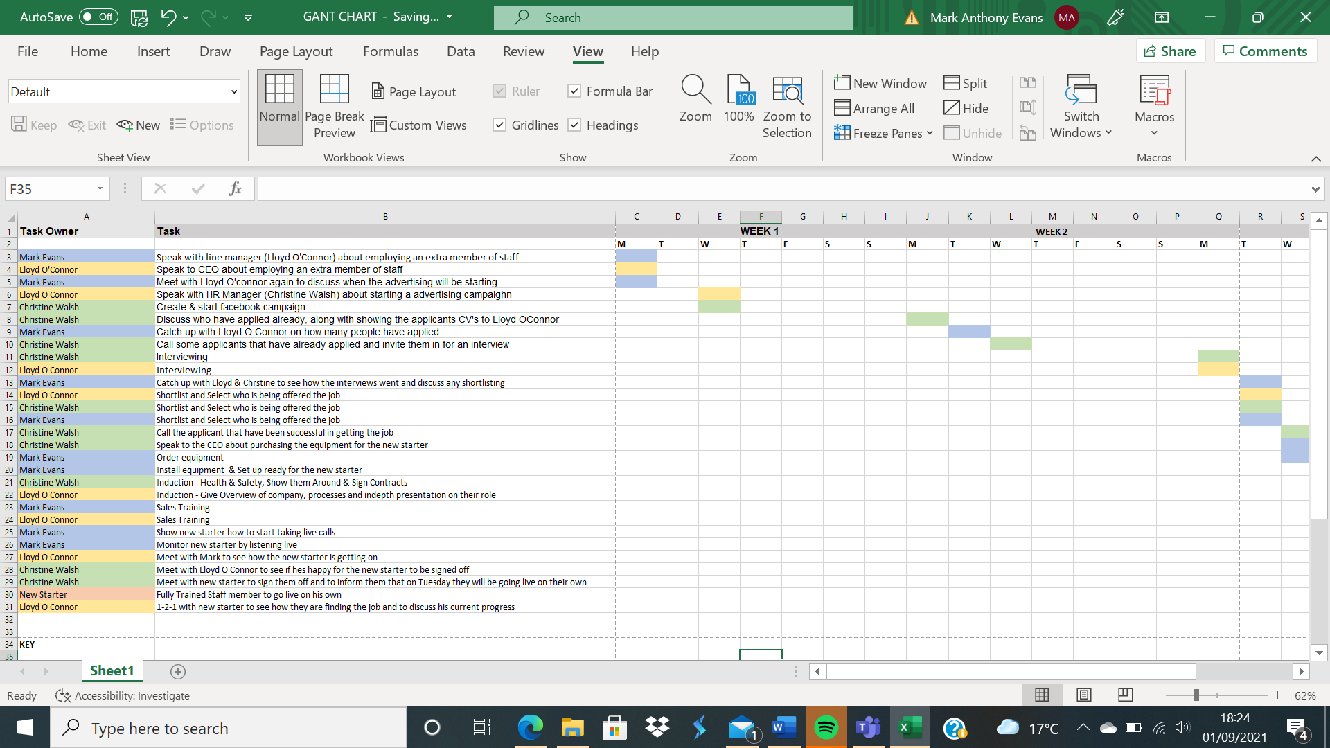

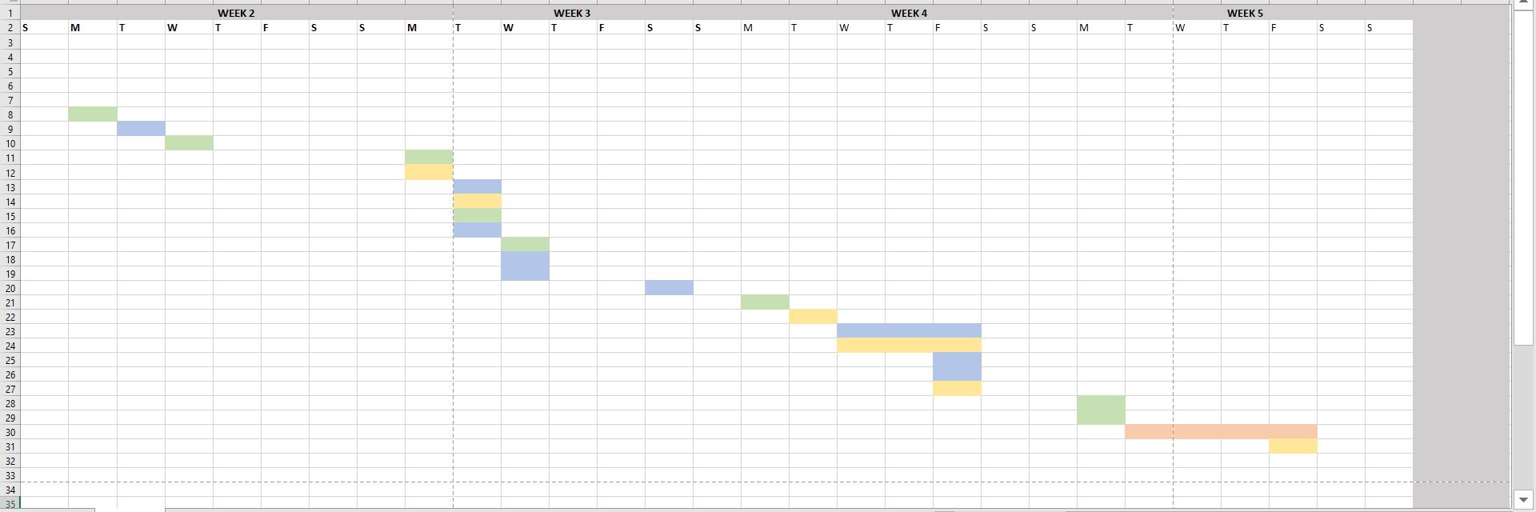

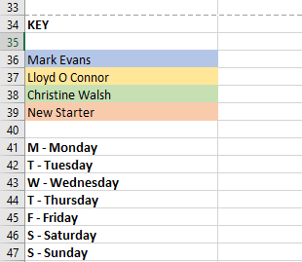

Appendix 2


