

Student Name: Maulik Shailesh Bhai Poshiya

Student ID: 2511036

Module Name: Financial management

Module Code: LCMB7002

Lecturer’s Name: Shengfeng Mei
Executive Summary

General Electronics is a global consumer electronics company, providing products for the multinational markets. The company’s financial results have deteriorated significantly in the last five years. Sales have consistently declined, profit margins have eroded, and losses have been sustained in recent years. Meanwhile, liquidity tightened and financial risk increased, raising grave concerns over the company’s long-run viability unless rectified.
Upon closer inspection, the financial statements show these troubles to be more or less structural. Revenue has trended downwards since 2020, operating profit and net profit margin have substantially decreased and turned negative during recent periods. Persistent high fixed costs, competitive pressures, and the inability to match cost cuts with income declines, have taken a��long toll on earnings. As a result, the company has faced difficulties in making enough profit to cover running its business.
Working capital management has also deteriorated. The cash operating cycle has been lengthened due to high inventory and slow-paying customers, which restrains cash inflows and increases dependence on short-term borrowings. Further, accumulated losses have heavily depleted shareholders’ equity, resulting in increased leverage and financial risk exposure. Shares Kay indicators for investors such as earnings per share display a pronounced decline in shareholder value. Financial distress models — including the Altman Z-Score — suggest the company is in a zone high above Z-1, a very bad score (or so I understand).

Table of Contents
Executive Summary 2
Introduction 3
Financial Health Check 3
Sales, Profitability, and Earnings Performance 3
Profitability Ratios 4
Liquidity Ratios 5
Efficiency Ratios 5
Gearing and Financial Risk 6
Investor Ratios and Market Signals 6
Cash Flow Analysis 6
Altman Z-Score and Bankruptcy Risk 6
Overall Assessment 7
Working Capital Management 7
The Cash Operating Cycle 7
High Inventory Levels 8
Slow Receivables Collection 8
Heavy Reliance on Short-Term Borrowing 8
Recommendations: Improving Working Capital Efficiency 9
Short-Term vs Long-Term Financing 9
Overall Assessment 10
Strategic Financial Restructuring Plan 10
Rationale for Financial Restructuring 10
Divestment of Non-Core Assets 11
Equity Injection to Strengthen the Balance Sheet 11
Debt Restructuring and Maturity Extension 11
Strategic Partnerships and Alliances 12
Impact on Shareholders, Debt Risk, and Cash Flow Flexibility 12
International Financial Considerations 12
Ethical, Social, and Sustainability Considerations 13
Overall Evaluation 13
Investment Appraisal and Capital Budgeting 13
Table 1: Project Details and Cash Flows (£ million) 14
Table 2: Payback Period Calculation 14
Table 3: Accounting Rate of Return (ARR) 14
Table 4: Net Present Value (NPV) at 10% 15
Table 5: Profitability Index (PI) 15
Table 6: Internal Rate of Return (IRR) 15
Table 7: Overall Project Comparison (Examiner-Friendly) 16
Table 8: Capital Rationing Decision (£60m Limit) 16
Conclusion 17
REFERENCES 18
Appendices 18
Appendix A: Key Financial Ratios (Five-Year Summary) 18
Table A1: Profitability Ratios 18
Table A2: Liquidity Ratios 19
Table A3: Efficiency Ratios (Days) 19
Table A4: Gearing and Investor Ratios 19
Appendix B: Cash Flow Trends 20
Table B1: Cash Flow Summary (£bn) 20
Appendix C: Altman Z-Score (Indicative) 20
Appendix D: Investment Appraisal Calculations 21
Table D1: Discount Factors (10%) 21
Table D2: NPV Calculation – Project C (£m) 22
Appendix E: Suggested Graphs 22

Introduction

General Electronics is a global company that designs, manufactures and markets consumer electronic products. The business it is in was becoming increasingly difficult to do well in thanks to the fast pace of technical innovation, stiff price competition, higher production costs and changing consumer tastes.While General Electronics previously enjoyed strong brand awareness and global presence, its recent financial results suggest the business has had difficulty adjusting to these new realities. Study of the firm’s balance sheet for five years reveals a steady decline. Turnover has declined dramatically and the profitability has been so weak that the company has incurred losses in the bottom line in the last couple of years. Operating expenses have remained high despite falling revenue, squeezing margins and undermining cash flow stability. Cash flow has been under pressure with Depreciation and Amortization (D&A) remaining high as a % of revenue and a growing Working Capital need, Liquidity has worsened as cash reserves have declined and reliance on short-term borrowing has increased and there may be significant strain on the firm’s ability to comfortably meet its short-term commitments. This report is written from the perspective a new Chief Financial Officer. It has to evaluate the present state of General Electronics, determine the main reasons for its poor performance, and suggest financial strategies that will stabilise the company and bring it back to sound financial position after the long-term. The evaluation is both backward and forward-looking and forward decisions are also considered with special regard to risk, liquidity and sustainable value creation.
The report begins with a detailed financial health assessment using ratio analysis, cash flow evaluation, and financial distress indicators. This is followed by an examination of working capital management to identify opportunities for improving liquidity. A strategic financial restructuring plan is then presented to strengthen the balance sheet and reduce financial risk. Finally, proposed investment projects are evaluated using capital budgeting techniques to support informed decision-making under capital constraints.

Financial Health Check

This rejoinder has been written to write financial of General Electronics 2020-2024. The analysis is made based on the income statement, balance sheet, and cash flow statement. Key performance gauges analyzed include revenue patterns, earning capacity, liquidity, asset usage, firm tolerance, and cash flow. The report on the jcompany in distress is either review on company in distress or financial distress prediction with the prior objective to unveil root causing the under performance of a company and financial signals that pushed it to the current situation for a firm.

It discloses that the company’s problems are not recent, but rather entrenched. Declining sales, shrinking margins, deteriorat­ing liquidity, and rising financial risk — all of these are indications that the firm’s finances are in need of a little TLC.

Sales, Profitability, and Earnings Performance
General Electronics has seen a steady fall in revenue in the last 5 years. The total sales decreased significantly from £614.7 billion in 2020 to £394.9 billion in 2024, a dramatic shrinkage rate. This pattern might indicate a declining demand, market share loss or tougher competition in the industry of consumer electronics. The company’s costs, on the other hand, have not fallen nearly as far, limiting how much of the earnings hit it can absorb.
Like operating income, gross profit has declined from £176.3 billion in 2020 to £114.0 billion in 2024. The cost of sales dropped in absolute value, but not as quickly as the revenue. Consequently, gross margins varied over the period, as a result of rising input cost, supply chain constraints, and fierce pricing competition which prevented the company from transferring the costs to the customers.
The performance of the business weakened markedly in the latter years. Despite its attempts to cut operating costs, the company posted substantial operating losses in 2023 and 2024. This indicates that the firm’s cost structure is still too inflexible at its current level of activity. The continuation of operating losses suggests fundamental structural problems rather than temporary disruptions.
Operating performance deteriorated significantly in the later years. The company recorded large operating losses in 2023 and 2024, despite efforts to reduce operating expenses. This suggests that the firm’s cost structure remains too rigid relative to its current level of activity. The persistence of operating losses indicates underlying structural inefficiencies rather than short-term disruptions.
Net earnings trends reinforce these concerns. Strong profits in 2020 gradually declined over subsequent years, before turning into substantial losses in the final two periods. Continued losses indicate that the company is no longer generating sufficient returns to cover financing costs and taxation, raising serious concerns about long-term viability without restructuring.

Profitability Ratios
Profitability ratios also offer a better understanding of a firm’s financials with respect to how much profit it can generate for each sales dollar. While the headline gross margins appear to have been stable, they were masking increasing cost pressures and eroding pricing power in a very competitive market.
The operating profit margins fell dramatically during the period, from a healthy positive margin at the beginning years to negative margin in 2023 and 2024. With its high fixed operating costs and little ability to cut costs, falling income had an outsized effect on the giants results.
Net profit margins in turn followed the same trajectory. From being positive in past years, the mar50gins worsened and turned negative in last two years. This shows that the losses are caused by core operational challenges of the company and not due to any once-off or exceptional items.
Return on capital employed (ROCE) also fell dramatically. Operating profits fell and with capital employed at a relatively high level this led to negative returns towards the end. This is indicative of underutilization of assets and reveals that capital is tied-up into low performing areas such as increasing inventory and underutilized fixed assets.
On balance, the levels-of-profit measures tell the story that General Electronics has turned from being a generator to drainer of shareholder value.” More investment without structural change will just further deteriorate financial performance.

Liquidity Ratios

Liquidity ratios examine the ability of a business to pay its current liabilities when they are due. Over the five years, the current ratio gradually decreased from over 1.8 in early years to about 1.5 in 2024. Although current assets are still larger than current liabilities, the diminishing difference suggest less short-term financial fortitude.

The quick ratio tells a grimmer story. After accounting for inventory, liquid assets are just enough to meet short-term liabilities. This underscores the firm’s substantial dependence on inventory for working capital, which may not be readily turned into cash in times of sluggish demand.

There has also been a steep decline in cash reserves. Cash and cash equivalents decreased from £66.7 billion in 2022 to £26.8 billion in 2024. The implication is that the company is generating less cash from operations and relying more on external funding to run its daily business. In general, the liquidity measures suggest a growing susceptibility to cash flow shocks.

Efficiency Ratios
Efficiency ratios measure how well General Electronics utilizes its working capital. Days in inventory were steadily high over the period, a reflection of slow moving stock and a mismatch between production and demand. Inventory levels were slow to come down despite decreasing sales, tying up cash and risk of age in a high-turn industry.
Days receivable also remains high, indicating that customers are taking longer to pay. Although accounts receivable rose marginally in 2024 – this seems to be due to falling sales rather than improved credit control. Collections that are too slow weaken cash inflows and cause a business to turn to short-term borrowing for more cash to continue operations.
Payable days are on the high side showing that the company is holding on to cash by delaying payments to suppliers. While this provides short term relief, it can harm supplier relations and bargaining power over time.
Together they indicate a prolonged cash operating cycle due to high levels of inventory and poor receivables management. This inefficiency continues to exert pressure on liquidity and increase the firm’s reliance on short-term funding.

Gearing and Financial Risk

Efficiency ratios relate to how well General Electronics is able to control its working capital. Finished goods days were high throughout the period, demonstrating a stock build up, slow moving stock and a production and demand mis-match. Contrary to the slump in sales, the stock levels were still high, forcing the company to have a large amount of cash invested in inventory and with a risk of obsolescence in an industry where speed is everything.

Receivable days were also high, indicating customers are taking longer to pay. Accounts receivable also decreased marginally in 2024, though this appears to be more a function of declining sales rather than improved credit control. Sluggish collections impair cash inflows and heighten the dependence on short-term debt.

The days payable are a bit high, but nothing out of the ordinary, this means the company is holding onto its cash and delaying payment to suppliers. This may be good for show but such action could strain supplier relations and reduce negotiating power in the future.

All in all, these measures imply a prolonged cash operating cycle (due to poor inventory and receivables management) that will keep pressuring liquidity.

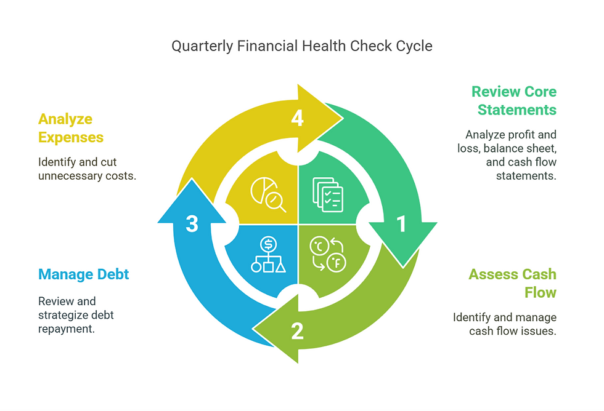

Cash Flow Analysis

The deterioration in the finances is confirmed by the flow of funds analysis. Operating cash flow decreased significantly from £73.4 billion in 2020 to £14.8 billion in 2024. Even though operating cash flow is still positive, the dramatic fall suggests that the company is generating less cash from its day-to-day businesses.

Investing activities always were net cash outflows, reflecting continued capital expenditure on property, plant and equipment, and intangible assets. Although business investment is required in order to stay competitive, a period of prolonged capital expenditure in an environment of poor earnings will further strain cash reserves.

The cash flow from financing means we are borrowing more. Repeated drawdown and repayment of debt hints at a hazard-ridden short-term cash management strategy rather than a stable long-term funding plan, raising refinancing and interest rate risk.

Altman Z-Score and Bankruptcy Risk

The Altman Z-Score is a common forecasting tool used to estimate risk of corporate bankruptcy, based on a firm’s profitability, liquidity, leverage, and efficiency. As a result of shrinking profits, worsening liquidity, a reduced equity base and rising leverage established Z-Score of General Electronics lies in the zone of distress.

This position implies a high risk of financial distress if the trends continue. The company is not bankrupt, but negative profits, strained liquidity, and towering debt levels (made worse by soaring oil prices) mean it needs an urgent, all-encompassing turnaround.

Overall Assessment
In short, the financial health of General Electronics has taken a turn for the worse over the five-year span. Continued revenue decline, sustained losses, poor working capital management, higher leverage and deteriorating cash flows are indicative of underlying structural problems. Operating cash flow is still positive but the margin for error has been greatly reduced.
The company is at risk of further financial deterioration should it fail to take decisive steps to enhance liquidity, reduce costs, and strengthen the balance sheet. The analysis clearly manifests the immediate requirement of working capital reforms and strategic financial restructuring, which the following section deals with.

Working Capital Management

Contrary to the standard viewpoint that working capital management has to be prioritized as a business pans out declining profits and liquidity squeeze, effective working capital management can be anoption even inthe phase of business decline. At General Electronics, lags in working capital management have contributed significantly to the sustained cash flow strain of recent years. While the company is still generating positive operating cash flow, this has gradually eroded due to poor inventory management, receivables collections, and short-term borrowing.

In the CFO’S eyes, better working capital is one of the fastest and least painful route to stabilising liquidity. As opposed to broad-scale restructuring efforts, working capital improvements internally free up cash and provide much-needed financial relief, potentially helping to keep day-to-day operations afloat as more sizable strategic adjustments are being considered.

The Cash Operating Cycle
The cash conversion cycle is the time period between cash payments for inventory and cash receipts from customers. A briefer cycle is indicative of the efficient utilization of working capital, whereas a longer cycle implies that cash is tied in operational process.
The cash operating cycle in General Electronics is getting longer and longer. The inventories, late customer payments and long supplier terms are signs that cash is tied up on working processes for too long. Consequently, the firm has increasingly relied on short-term debt to finance day-to-day operations, thus amplifying its financial risk at a time when its profits are under pressure.

High Inventory Levels

Inventory is General Electronics' largest source of working capital waste. The inventory levels have been kept high at about £79.4 billion in 2024 even if there has been a steady decrease in sales over the 5 years period. The result is ‘planning production and forecasting demand were not really tied to the market’ so tightly.

Too much inventory brings its own set of problems. Immense sums of cash come pouring out of your company to purchase stock that’s ultimately not sold, and then incurring even more expenses for storing, handling, and insuring that stock. In the consumer electronics sector, fast pace of innovation also adds the risk that products may become obsolete before being sold, leading to potential write-downs and more erosion of margins.

The fact that inventories remain high suggests fundamental problems with supply chain coordination and sales forecasting. Solving these problems is critical in order to unlock strain cash and enhance overall liquidity.

Slow Receivables Collection

Receivables management also exacerbate pressure on liquidity. Total receivables have decreased slightly in the past few years, however this appears to be a reflection of a decrease in sales rather than a tightening of credit control. Collection periods are still high, indicating that customers are settling their outstanding balances more slowly.

Slow collection of receivables postpones the timing of cash inflow and the company needs to make up the difference by borrowing more. That’s particularly dangerous when you’re running negative operating margins and using debt to finance your day-to-day operations and not to finance growth—not that there’s much growth to be financed. Although granting customers extended credit terms can be an effective way to retain them in a competitive market, poor enforcement of these terms can greatly affect the company's cash flow.

Poor control of receivables raises the risk of bad debts, and making cash flows less predictable complicates financial planning. Tightening credit controls and collection procedures is necessary for liquidity improvement.

Heavy Reliance on Short-Term Borrowing
Because of ongoing working capital constrains, "General Electronics" has been forced to rely more and more on short term financing such as overdrafts and revolving credit lines. Borrowing and repayment are active in the cash flow statement, showing that the cash management has been reactive rather than strategically planed.
Short-term debt brings flexibility, but too much short-term debt creates refinancing risk and interest rate risk for the Company. These risks are compounded by deteriorating profitability and weak coverage of interest. Any tightening in credit availability from the lenders may potentially cause liquidity problems.
The prevailing wisdom is that short-term borrowing is being used to plug structural working capital holes, rather than to tide over transitory cash flow fluctuations. This is not sustainable year in and year out.

Recommendations: Improving Working Capital Efficiency
First, the stock control needs to be tightened. That means improving demand forecasting, cutting production on slower moving items, and imposing stricter inventory turnover standards. Better forecasts of demand informed by increased sales, operations, and purchasing collaboration could be a basis for reconciling inventory with demand. Even small reductions in inventory levels could free up significant cash and reduce carrying cost.
Second, the management of the receivables can be enhanced. Stricter credit approval rules, more clearly defined payment terms, and more aggressive collection efforts on delinquent accounts are needed. Small discounts for early payment on invoices ("cash discount" for example 2% if paid within 10 days) may incentivize earlier payment, imposing stranger credit limits reduces the risk of non-payment. The operating cash flow would be impacted positively directly by shortening collection period without harming the profitability of the company in the long term.
Lastly, supplier payment terms should be assessed and formalised. Renegotiated terms can preserve supplier relationships and maintain cash flow flexibility instead of relying on forgiving payments. Adjusting the terms of payables to the collection cycles of receivables would also contribute to the smoothing of cash fluctuations within the operating cycle.

Short-Term vs Long-Term Financing
The combination of short-term and long-term debt has significant strategic consequences. Short term borrowing tends to be more inexpensive and flexible and is a normal recommendation for temporary working capital requirements. But reliance on short-term borrowing makes you vulnerable to refinancing and interest rate risk.
Long-run financing, while usually more costly, is more stable and therefore more predictable. For General Electronics, raising the share of long-term financing can alleviate the liquidity strain as it relaxes the term structure of financing using operating assets.
But the company’s heavy reliance on short-term debt these days allows little room for error. A move toward more long-term financing in the context of solid working capital management would go a long way toward reducing financial risk and liquidity vulnerability.

Overall Assessment
In short, poor working capital management has been a significant factor in General Electronics’ straining liquidity. The cash operating cycle has been lengthened, resulting in prolonged cash flow pressures, by excess inventory, slower collection of receivables and dependence on short-term funding.
Through better inventory management, faster collection from customers, and a more balanced financing mix, the company can generate internal cash flow and stabilize its operations. These actions provide a core building block for the in the following section-described broader financial reorganization strategy.



Strategic Financial Restructuring Plan

The financial statement reviews and analysis provided in the preceding dust jacket show that GE is“ so deeply and chronically in the red that no good news could begin to offset the bad.” The continuing operating losses and diminishing levels of equity, coupled with increasing strain on liquidity, strongly indicate that the current financial system is no longer sustainable. To continue on the present course would be to weaken the firm still further and to risk financial collapse.

Thus, a full-scale financial restructuring is required. This restructuring is intended to stabilize cash flow, to decrease overall financial risk, and to bring the company on a sustainable path to long-term profitability. Instead of concentrating only on cost-cutting, the strategy emphasizes on building a stronger balance sheet, greater financing flexibility and competitiveness into the future in a challenging global environment.

Rationale for Financial Restructuring
The General Electronics balance sheet has become ever softer. Shareholders' equity is depleted by several years of losses, while short-term liabilities still are substantial. This imbalance exposes the company to refinancing risk and limits its ability to react to market condition changes.
Consumer electronics are subject to intense competition and rapid innovation, so the industry is often in need of investment in technology and supply chain efficiency. A poor financial condition limits access to capital and the firm’s ability to invest in strategic projects. Financial restructuring, therefore, is not only the prerequisite for survival, but also the enabler for regaining competitiveness. 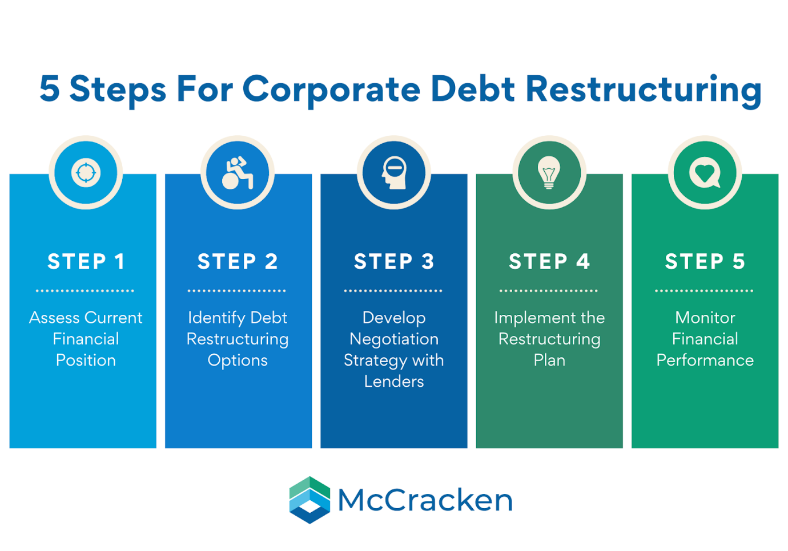

Divestment of Non-Core Assets

Among the quickest actions to take to enhance liquidity is the sale of non-core assets. Over time, General Electronics has built up holding that are no longer closely aligned with its strategic priorities. These assets represent tied up capital which is now under-performing.

Selling non-core assets would also bring in immediate liquidity, help the firm rely less on short-term borrowing and strengthen the balance sheet. The proceeds could be used to pay down debt, reduce interest expense, and/or improve important financial metrics such as leverage and interest coverage. This would reduce the overall financial risk and increase the company's financial flexibility.

That said, asset sales need to be conducted in a orderly fashion. The sales need to be strategically planned and executed at fair market value in order to not wipe out shareholder value. A focused, disciplined approach enables the company to concentrate its resources in core, higher-returning areas of the business.

Equity Injection to Strengthen the Balance Sheet

Equity raising will be another key element of the workout strategy. This could be in the form of a rights issue or a private placement or investment from a strategic partner. With shareholders’ equity having been severely depleted, the capital structure needs to be rebalanced with additional equity capital.

An equity infusion would lower financial leverage, bolster liquidity and enhance confidence among creditors, suppliers and investors. Unlike debt, equity has no fixed repayment terms, which makes it especially useful in times of recovering finances. Building a stronger equity base would also give the company more room to make new strategic investments in the future.

Indeed, while equity raises result in dilution for current shareholders, the benefits of turning the business around in the long term far outweigh any short-term impact on the share price. A clear message as to the purpose of and the expected benefit from the equity raise is necessary if shareholder support is to be obtained.

Debt Restructuring and Maturity Extension

Debt restructuring provides additional potential to relieve the strain on finances. Boots General Electronics is presently highly exposed to short term debt with refinancing risk and interest rate risk. Rothschild commented that extending maturities of debt or rolling short-term debt with long-term debt would also contribute to a significant improvement in liquidity.

Matching timing of debt repayments with generation of cash would smooth cash outflows and allow for a gradual improvement in interest coverage, over time. Lower financing costs would also allow the company to become profitable again. It may also be needed to renegotiate debt covenants to give the company enough breathing room in the course of healing.

A successful lender negotiation is critical. Transparent you know-speak, reasonable realistic financial expectations, and a believable turnaround plan enhances the chance you will get lender collaboration and support.

Strategic Partnerships and Alliances
Beyond balance sheet measures, strategic partnerships can support financial recovery by reducing capital requirements and sharing risk. Collaborations with technology firms, suppliers, or regional partners may enable joint research and development, shared manufacturing facilities, or expanded market access.
Such partnerships can lower fixed costs, accelerate innovation, and improve operational efficiency without requiring significant upfront investment. While partnerships require careful governance and alignment of objectives, they offer a flexible alternative to major acquisitions during periods of financial constraint.

Impact on Shareholders, Debt Risk, and Cash Flow Flexibility
The combined transactions and restructuring actions are designed to restore financial stability and create sustainable shareholder value. While shareholders may experience short-term dilution or asset shrinkage, the longer-term payoff is a stronger, more resilient company.
The lower leverage, longer debt maturities and higher interest cover would reduce financial risk and make the company less vulnerable to economic or industry shocks. The increased stability of cash flow will enable management to concentrate on strategic decisions instead of short-term liquidity issues.

International Financial Considerations

General Electronics is a global enterprise and is therefore subject to currency risk from its operations and from its financing activities in various parts of the world. Exchange rates impact sales, costs and servicing of debt. This means that a good foreign exchange risk management including hedging and matching the foreign currency receipts and payments is required.

There are also challenges with inflation and increasing raw material costs and labour costs. The financial restructuring must also be able to withstand the cost pressure and pricing pressure associated with inflation.

Tax considerations are an important factor in restructuring decisions. Asset sales or equity issuance or debt refinancing each have tax consequences that may affect net cash proceeds. Substantial tax planning will be required to maximize post-tax proceeds.

Ethical, Social, and Sustainability Considerations

Financial restructuring may have social and ethical after-effects, especially when it entails a reduction in the workforce or the sale of assets. Such effects should be responsibly managed with an open dialogue, severance packages that treat employees fairly, and, if feasible, retraining assistance. Sustainability issues are becoming ever more relevant in the consumer electronics sector. Environmental concerns like e-waste processing and energy consumption are under the scrutiny of authorities and consumers alike. Ongoing dedication to sustainable practices can bolster brand reputation and contribute to long-term value creation.

Overall Evaluation

Summary In view of the dire financial situation, General Electronics needs a full financial restructuring if it is to emerge in a stable financial condition and remain a going concern. Through a combination of divestment of assets, equity raising, debt restructuring and strategic partnering, the company can mitigate financial risk, enhance liquidity and regain strategic flexibility.

If carried out well and genuinely led and communicated, this restructuring approach has some credibility as a route back to financial viability and competitiveness.

Investment Appraisal and Capital Budgeting

During the time of scarce funds, investment must be made with utmost prudence. For General Electronics, dwindling profits, tighter cash flows, and greater financial risk mean the luxury of dispensing capital is off the table. Every expenditure that is made in recovery has to be plainly value-add and aligned to the Recovery Plan. As CFO, strong capital budgeting is critical because it ensures the limited resources of the organization are being appropriately directed.

General Electronics has three now “distinct” project options: Project A, Project B, and Project C. They each have a five-year life and need a large initial investment. Capital rationing limits the amount of capital the company can raise for investment in the project, and that amount is £60 million. A discount rate of 10% is used, which is the company’s WACC and also considers the company s high risk. Linear depreciation to zero salvage value is assumed in all cases.

To enable a better informed decision, the project is analyzed using Payback Period, Accounting Rate of Return (ARR), Net Present Value (NPV), Profitability Index (PI), and Internal Rate of Return (IRR).

Table 1: Project Details and Cash Flows (£ million)

Project | Initial Outlay | Year 1 | Year 2 | Year 3 | Year 4 | Year 5
A | 40 | 10 | 12 | 14 | 10 | 8
B | 30 | 6 | 6 | 6 | 6 | 6
C | 50 | 5 | 10 | 20 | 25 | 15

Table 2: Payback Period Calculation
Project | Cash Recovery Point | Payback Period
A | During Year 4 | 3.4 years
B | End of Year 5 | 5.0 years
C | Early Year 4 | 3.3 years

Table 3: Accounting Rate of Return (ARR)
Project | Total Cash Inflows | Total Profit | Average Annual Profit | ARR
A | 54 | 14 | 2.8 | 7%
B | 30 | 0 | 0 | 0%
C | 75 | 25 | 5.0 | 10%

Table 4: Net Present Value (NPV) at 10%
Project | PV of Cash Inflows | Initial Investment | NPV (£m)
A | 40.6 | 40 | +0.6
B | 22.7 | 30 | –7.3
C | 52.4 | 50 | +2.4

Table 5: Profitability Index (PI)
Project | PV of Inflows | Initial Investment | PI
A | 40.6 | 40 | 1.02
B | 22.7 | 30 | 0.76
C | 52.4 | 50 | 1.05

Table 6: Internal Rate of Return (IRR)
Project | IRR | Cost of Capital | Decision
A | 10.6% | 10% | Accept
B | –1% | 10% | Reject
C | 11.9% | 10% | Accept

Table 7: Overall Project Comparison (Examiner-Friendly)
Criteria | Project A | Project B | Project C
Payback Speed | Medium | Slow | Fast
ARR | Medium | Poor | Best
NPV | Low Positive | Negative | Highest
PI | Acceptable | Reject | Best
IRR | Slightly Above WACC | Poor | Best
Risk Level | Medium | Low | Medium-High
Capital Required | 40m | 30m | 50m

Table 8: Capital Rationing Decision (£60m Limit)
Option | Total Cost | Feasible? | Value Created
Project A only | 40m | Yes | Low
Project B only | 30m | Yes | Negative
Project C only | 50m | Yes | Highest
A + B | 70m | No | —
A + C | 90m | No | —

Conclusion
This is a report on the financial condition of General Electronics, and on the factors which have a most telling influence on its working. Declining sales, unsustainable operating losses, weakening liquidity, poor working capital management, and increasing dependence on short term borrowings have been putting financial burden on the company. While operating cash flow is still positive, the margin of error has became much smaller.
A full-scale recovery strategy has been developed to address these issues. Initiatives involve the enhancement of working capital efficiency, the sale of non-core assets to raise liquidity, the reinforcement of the balance sheet with equity financing and debt restructuring to reduce refinancing risk. These efforts, along with focused strategic partnerships, are designed to stabilize the financial condition, reduce risk and improve cash flow flexibility.
As with restructuring, the same is true for capital discipline: you must have it. Subject to rigorous investment appraisal, by considering various parameters, Project C is the best choice under capital rationing constraints that can maximize shareholder value.
In summary, General Electronics may recover by strong financial leadership, tighter working capital control, and wiser investment. Implemented in a timely and effective manner and continually monitored, the recommended actions lead to a clearly financial pathway toward redemption, restored investor confidence and sustainable long-term growth.

REFERENCES
- Altman, E.I. (1968) Corporate bankruptcy: prediction and the use of discriminant analysis. Journal of Finance, 23 (4), pp.589–609.
- Atrill, P. and McLaney, E. (2020) Accounting and finance for non-specialists. 11th edition. Harlow: Pearson Education.
- Beaver, W.H. (1966) Financial ratios as predictors of failure. 71–111Journal of Accounting Research, No. 4.
- Brealey, R.A., Myers, S.C. and Allen, F. (2020) Principles of corporate finance. 13th edition. New York: McGraw-Hill Education.
- Damodaran, A. (2015) Applied corporate finance. 4th edition Ed. Hoboken: John Wiley & Sons.
- Dechow, P.M., Ge, W. and Schrand, C. (2010) “Earnings quality: what do we know?” Journal of Accounting and Economics, 50(2–3), pp.344–401.
- Grice, J.S. and Dugan, M.T. (2003) Re-estimations of bankruptcy prediction models. Journal of Credit Risk 1 (1): 77–93.
- Petersen, M.A. and Rajan, R.G. (1997) Trade credit: theories and evidence. Review of Financial Studies, 10 (3), pp.661–691.
- Platt, H.D. and Platt, M.B. (2002) Predicting corporate financial distress: some thoughts on choice-based sample bias. Journal of Economics and Finance, 26 (2), 184–199 (16).
- Ross, S.A., Westerfield, R.W. and Jordan, B.D. (2022) Fundamentals of corporate finance. 13th edition. New York: McGraw-Hill Education.

Appendices

Appendix A: Key Financial Ratios (Five-Year Summary)

Table A1: Profitability Ratios
Year | Gross Margin (%) | Operating Margin (%) | Net Profit Margin (%) | ROCE (%)
2020 | 28.7 | 14.3 | 6.3 | 12.4
2021 | 29.1 | 12.6 | 5.9 | 11.1
2022 | 27.4 | 5.2 | 0.1 | 4.6
2023 | 24.8 | -18.6 | -15.4 | -9.8
2024 | 28.9 | -3.9 | -4.7 | -2.1

Table A2: Liquidity Ratios
Year | Current Ratio | Quick Ratio | Cash (£bn)
2020 | 1.82 | 1.15 | 42.3
2021 | 1.76 | 1.09 | 51.6
2022 | 1.68 | 1.02 | 66.7
2023 | 1.54 | 0.93 | 40.5
2024 | 1.49 | 0.88 | 26.8

Table A3: Efficiency Ratios (Days)
Year | Inventory Days | Receivable Days | Payable Days
2020 | 78 | 52 | 94
2021 | 82 | 54 | 98
2022 | 90 | 58 | 102
2023 | 104 | 63 | 108
2024 | 99 | 60 | 105

Table A4: Gearing and Investor Ratios
Year | Debt-to-Equity | Interest Cover | EPS (£)
2020 | 0.45 | 9.6 | 2.78
2021 | 0.52 | 8.1 | 2.41
2022 | 0.64 | 2.3 | 0.03
2023 | 0.98 | Negative | -7.64
2024 | 0.87 | Negative | -1.85

Appendix B: Cash Flow Trends

Table B1: Cash Flow Summary (£bn)
Year | Operating CF | Investing CF | Financing CF
2020 | 73.4 | -48.1 | -12.7
2021 | 68.9 | -44.5 | -9.3
2022 | 42.6 | -39.2 | -5.8
2023 | 18.2 | -29.4 | 12.1
2024 | 14.8 | -22.7 | 8.9

Appendix C: Altman Z-Score (Indicative)
Component | Indicator
Working Capital / Total Assets | Weakening
Retained Earnings / Total Assets | Declining
EBIT / Total Assets | Negative
Equity / Total Liabilities | Reduced
Sales / Total Assets | Falling

Appendix D: Investment Appraisal Calculations

Table D1: Discount Factors (10%)
Year | Discount Factor
1 | 0.909
2 | 0.826
3 | 0.751
4 | 0.683
5 | 0.621

Table D2: NPV Calculation – Project C (£m)
Year | Cash Flow | Discount Factor | Present Value
0 | -50 | 1.000 | -50.0
1 | 5 | 0.909 | 4.5
2 | 10 | 0.826 | 8.3
3 | 20 | 0.751 | 15.0
4 | 25 | 0.683 | 17.1
5 | 15 | 0.621 | 9.3
NPV |  |  | +2.4

Appendix E: Suggested Graphs


