Networks and cyber security essentials
Synthesize a solution to a potential real-life scenario
ACCA4024
Carlos Yanez | 2413875
BSc: Computing (Computer Networks & Cybersecurity)

Table of Contents
Introduction 2
Acronyms 3
Identification of Modern Threats 4
Modern Security Policies Aligned with Zero Trust 5
Technical Mitigation Measures 6
Proactive Monitoring and Incident Response 7
Continuous Training and Awareness 9
Conclusion 10
References 11

Introduction

The financial services sector is undergoing a profound operational transformation, characterised by the rapid adoption of cloud computing and the proliferation of hybrid workforces. While these technological advancements optimise service delivery, they simultaneously dissolve the traditional network perimeter, exponentially expanding the attack surface available to sophisticated cyber adversaries. Vigilant Trust & Asset Management (VTAM) is currently navigating this high-risk landscape. Recent security incidents—specifically, a highly sophisticated phishing campaign that bypassed legacy email filters and a subsequent attempted ransomware infection—serve as definitive indicators that perimeter-based security architectures are fundamentally obsolete.

Cybersecurity is no longer solely an IT operational concern; it is a core business risk that directly impacts VTAM’s financial stability, regulatory compliance, and institutional reputation. Financial institutions hold vast repositories of sensitive customer data and manage substantial capital, making them prime targets for financially motivated threat actors. Recognising this, the board of directors has mandated the development of a comprehensive, modern security framework rooted in the Zero Trust paradigm. This academic report synthesises a strategic and technical roadmap for overhauling VTAM’s security posture. By aligning with recognised frameworks, identifying the anatomy of modern threats, proposing feasible technical mitigations, and architecting an automated incident response ecosystem, this report frames cybersecurity as a strategic investment in VTAM’s enduring operational resilience.

Acronyms

- AI: Artificial Intelligence
- CISA: Cybersecurity and Infrastructure Security Agency
- CSF: Cybersecurity Framework
- CSPM: Cloud Security Posture Management
- DNS: Domain Name System
- EDR: Endpoint Detection and Response
- IaaS: Infrastructure-as-a-Service
- IAM: Identity and Access Management
- IoC: Indicator of Compromise
- ISO/IEC: International Organisation for Standardisation/International Electrotechnical Commission
- KEV: Known Exploited Vulnerabilities
- MFA: Multi-Factor Authentication
- MTTR: Mean Time to Respond
- MITRE ATT&CK: Adversarial Tactics, Techniques, and Common Knowledge
- NIST: National Institute of Standards and Technology
- PA: Policy Administrator
- PE: Policy Engine
- PEP: Policy Enforcement Point
- RaaS: Ransomware-as-a-Service
- SaaS: Software-as-a-Service
- SIEM: Security Information and Event Management
- SOAR: Security Orchestration, Automation, and Response
- SP: Special Publication
- TI: Threat Intelligence
- Vishing: Voice Phishing
- VTAM: Vigilant Trust & Asset Management
- WORM: Write-Once-Read-Many
- XDR: Extended Detection and Response

Identification of Modern Threats

The threat landscape facing financial institutions has evolved from isolated attacks into a highly industrialised and technologically advanced ecosystem. Understanding the mechanics of these threats is the foundational step in architecting an effective defence.

Threat Category | Operational Mechanism | Primary Business Impact
Ransomware-as-a-Service (RaaS) | Affiliate-based deployment of encryption and data exfiltration malware. | Catastrophic operational downtime, extortion costs, and regulatory penalties.
AI-Powered Vishing | AI-generated voice cloning used to impersonate executives or trusted entities. | Unauthorised financial wire transfers and widespread credential theft.
Supply Chain Compromises | Exploitation of trusted third-party software, such as the MOVEit Transfer application. | Mass data breaches and cascading systemic access across interconnected networks.
Cloud Misconfigurations | Improperly secured IaaS/SaaS environments stemming from rapid hybrid workforce adoption. | Unauthorised data exposure, privilege escalation, and account takeover.
Table 1: Summary of Modern Threat Categories Facing Financial Institutions

Ransomware has transitioned into a sophisticated business model known as Ransomware-as-a-Service (RaaS). Operators develop cryptographic malware and lease it to affiliates who execute the intrusions, often employing double-extorsion schemes that exfiltrate sensitive financial records before encryption to maximise leverage [1]. Concurrently, the advent of Generative AI has fundamentally altered social engineering. Threat actors now utilise advanced neural networks to clone the voices of corporate executives using mere seconds of audio (vishing). In early 2024, a finance employee at a multinational firm was deceived into transferring $25 million after attackers orchestrated a deepfake video conference, demonstrating that implicit trust in human perception is a critical vulnerability [2].

Furthermore, financial institutions are deeply embedded in digital supply chains. The exploitation of the MOVEit zero-day vulnerability (CVE-2023-34362) by the Cl0p ransomware syndicate compromised thousands of downstream organisations across interconnected networks, with CISA identifying exploitation beginning as early as May 27, 2023 [3]. This illustrates that compromising a single software vendor provides adversaries with lateral access to thousands of downstream enterprise clients. Finally, decentralised hybrid workforces have introduced profound cloud configuration risks, where overly permissive access controls and insecure APIs create massive exposure windows.

Modern Security Policies Aligned with Zero Trust

To mitigate these existential threats, VTAM must comprehensively, overhaul its security governance by aligning with three premier frameworks: NIST SP 800-207, NIST CSF 2.0, and ISO/IEC 27001:2022.

NIST Special Publication 800-207 provides the authoritative architecture for Zero Trust, representing a paradigm shift from static perimeters to dynamic, resource-focused security [4]. The foundational philosophy requires that no entity is implicitly trusted. VTAM’s policies must enforce the principle that access to individual enterprise resources is granted strictly on a per-session basis, determined by dynamic policies that evaluate user identity, behavioural anomalies, and device security posture.

These Zero Trust principles are operationalised through the NIST Cybersecurity Framework (CSF) 2.0, which encompasses six core functions: Govern, Identify, Protect, Detect, Respond, and Recover [5]. The newly introduced “Govern” function elevates cybersecurity to an enterprise-wide risk management imperative, dictating overarching strategies and supply chain oversight. This aligns seamlessly with ISO/IEC 27001:2022 Annex A controls, which provide specific technological directives, such as secure configuration management (Control 8.9), data leakage prevention (Control 8.12), and stringent policies for the use of cloud services (Control 5.23) [6].

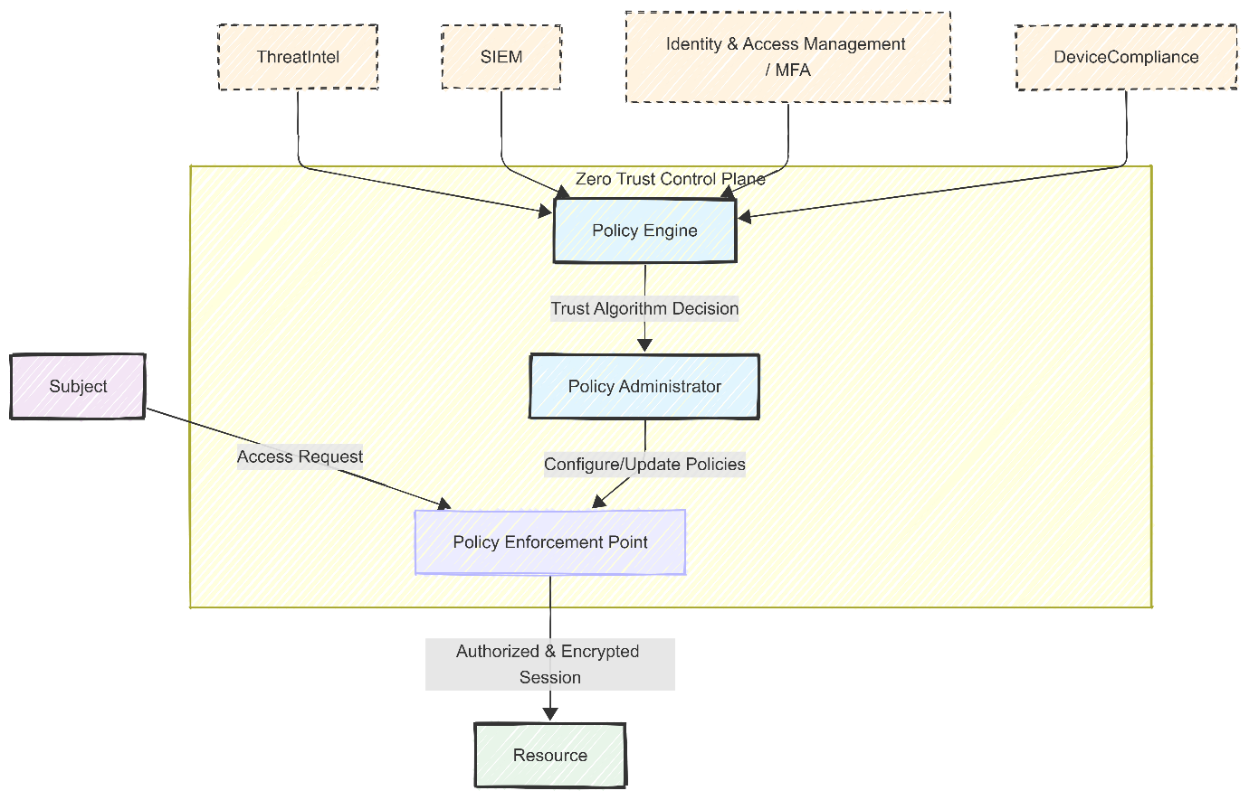
Diagram 1: Logical Components of Zero Trust Architecture. The Policy Engine relies on continuous contextual signals to compute trust scores, directing the Policy Enforcement Point to grant or terminate sessions.

Technical Mitigation Measures

Translating governance into operational resilience requires the deployment of specific, highly automated technical controls. Identity and Access Management (IAM) represents the new perimeter; therefore, VTAM must deprecate legacy authentication in favour of phishing-resistant Multi-Factor Authentication (MFA) integrated with continuous behavioural monitoring.
To secure hybrid infrastructure, VTAM will implement a Cloud Security Posture Management (CSPM) platform. CSPM delivers automated, real-time visibility across multi-cloud environments, systematically identifying and remediating misconfigurations, overly permissive roles, and unencrypted storage buckets that violate security guidelines [7].
Furthermore, to neutralise the leverage of RaaS, VTAM must deploy immutable backups in alignment with NIST SP 800-209. Utilising Write-Once-Read-Many (WORM) storage technology guarantees that backup repositories cannot be modified or encrypted by attackers, ensuring independent recovery capabilities. Finally, vulnerability management will shift to a threat-centric strategy driven by the CISA Known Exploited Vulnerabilities (KEV) catalogue. By integrating KEV data feeds through APIs, VTAM can focus on rapidly addressing vulnerabilities that are actively being exploited, helping to reduce alert fatigue.

Proactive Monitoring and Incident Response

Zero Trust operates on the foundational assumption that a breach is not merely possible—it is inevitable. In this paradigm, the strategic priority shifts from perimeter defence alone to rapid detection, automated containment, and resilient recovery. To operationalise this principle, VTAM will deploy a Next-Generation Security Information and Event Management (SIEM) system designed to continuously aggregate, normalise, and correlate log data across all endpoints, network infrastructure, and cloud platforms in real time.

Traditional, manually driven triage processes produce an unsustainably high Mean Time to Respond (MTTR), leaving critical windows of exposure during which ransomware can propagate laterally, encrypt data, and exfiltrate sensitive assets. To eliminate this vulnerability, VTAM’s SIEM will be tightly integrated with a Security Orchestration, Automation, and Response (SOAR) platform—transforming detection signals into immediate, machine-executed action [8].

Upon identifying behavioural anomalies indicative of ransomware activity—such as abnormal file encryption rates, suspicious lateral movement, or unexpected privilege escalation—the SOAR platform automatically triggers predefined, machine-driven response workflows known as playbooks. These playbooks orchestrate a coordinated sequence of actions across the entire security stack: isolating compromised endpoints, revoking active credentials, blocking malicious network traffic, and initiating forensic evidence collection—all within seconds and without requiring human intervention at each step.

This integrated SIEM-SOAR architecture forms the operational backbone of VTAM’s Automated Ransomware Incident Response Workflow, enabling the organisation to move from reactive firefighting to a proactive, repeatable, and auditable incident response posture aligned with the NIST SP 800-61 framework and MITRE ATT&CK tactics [9].

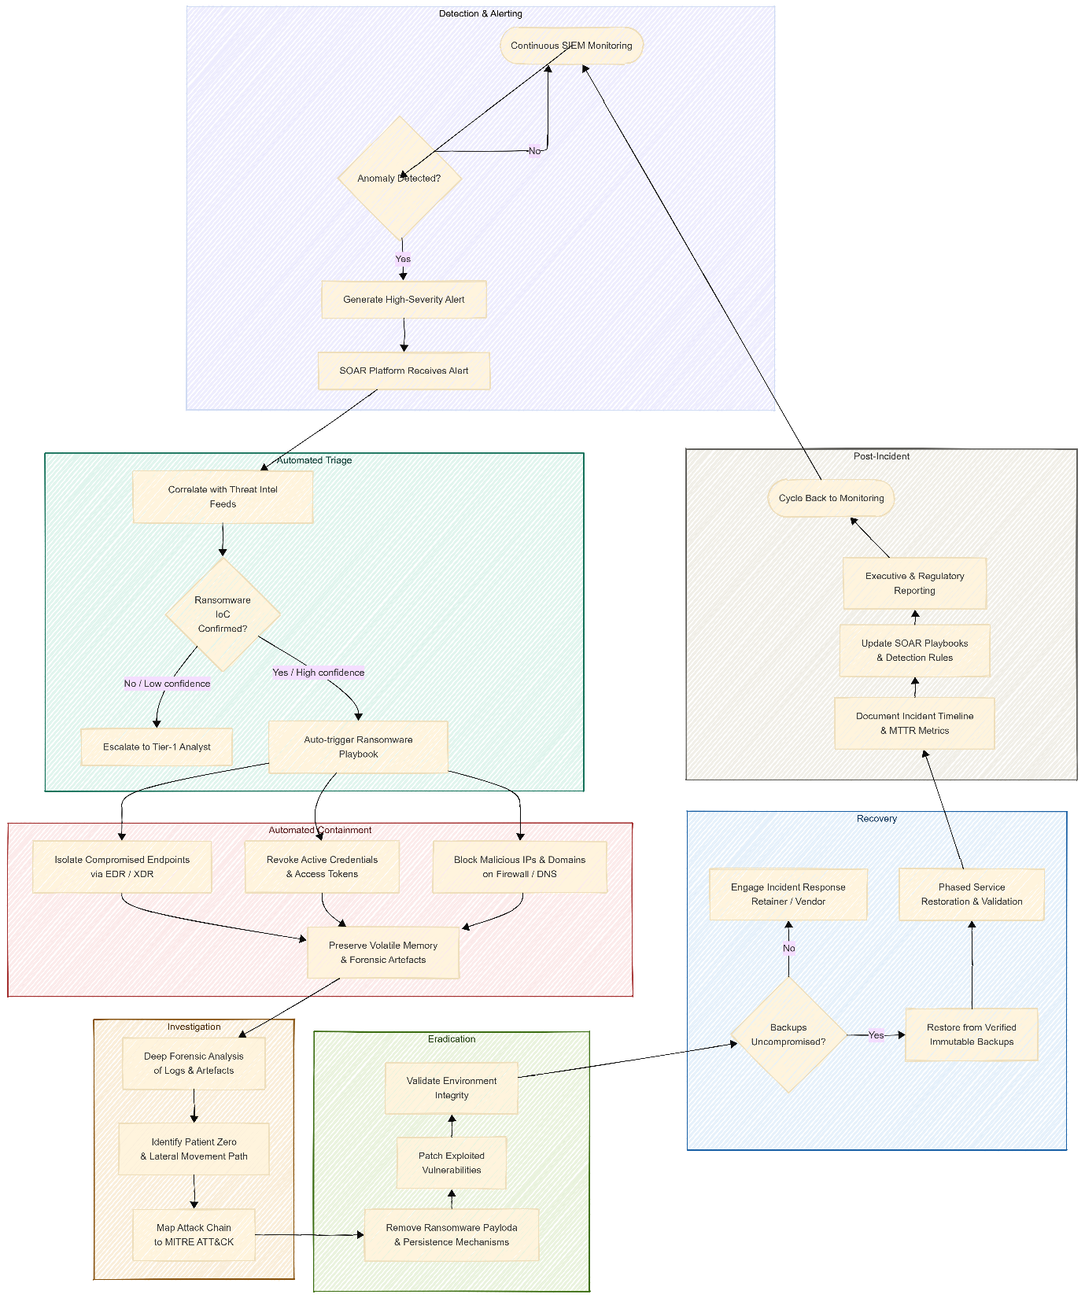
Diagram 2: Automated Ransomware Incident Response Workflow. The SOAR platform orchestrates rapid containment by isolating endpoints and revoking credentials at machine speed.

Continuous Training and Awareness

Technological architectures remain fundamentally susceptible to the human element. Academic research empirically demonstrates that traditional, compliance-driven annual security videos are ineffective against modern, highly targeted social engineering campaigns [10], [11].

VTAM will implement a continuous, behavioural-driven training program featuring hyper-realistic, AI-generated phishing and vishing simulations. These simulations will mirror the exact tactics of contemporary adversaries, exposing employees to deepfake audio and personalised lures in a safe environment. Studies indicate that point-of-failure simulation training reduces susceptibility by an average of 40%, significantly outperforming traditional annual delivery methods [10]. By employing gamification and delivering contextual micro-training immediately upon a failed simulation, VTAM will foster a “trust but verify” culture without punitive measures, empowering employees to act as the final enforcement point in the Zero Trust architecture.

Conclusion

The transition to a Zero Trust architecture is a strategic imperative necessary to protect VTAM against the existential threats of RaaS, AI-driven vishing, and supply chain compromises. By institutionalising policies aligned with NIST CSF 2.0 [5] and ISO/IEC 27001:2002 [6], deploying automated SIEM/SOAR playbooks [8], enforcing immutable backups, and prioritising CISA KEV remediation, VTAM will achieve profound operational resilience. Coupled with an engaging, AI-simulated security awareness program, VTAM will effectively secure its financial assets and maintain stakeholder trust in a hostile digital landscape.

References

[1] T. Meurs, E. Cartwright, A. Cartwright, M. Junger and A. Abhishta, "Deception in double extortion ransomware attacks: An analysis of profitability and credibility," Comput.Secur. vol. 138, pp.103670, 2024, doi: 10.1016/j.cose.2023.103670.
[2] H. Chen and K. Magramo, "Finance worker pays out $25 million after video call with deepfake ‘chief financial officer’." Accessed: May 14 2026. [Online]. Available: https://www.cnn.com/2024/02/04/asia/deepfake-cfo-scam-hong-kong-intl-hnk
[3] Cybersecurity and Infrastructure Security Agency. "#StopRansomware: CL0P Ransomware Gang Exploits CVE-2023-34362 MOVEit Vulnerability | CISA." Accessed: May 14 2026. [Online]. Available: https://www.cisa.gov/news-events/cybersecurity-advisories/aa23-158a
[4] S. Rose, O. Borchert, S. Mitchell and S. Connelly, "Zero Trust Architecture," Aug 2020, doi: 10.6028/NIST.SP.800-207. Accessed: May 14, 2026. Available at: https://nvlpubs.nist.gov/nistpubs/SpecialPublications/NIST.SP.800-207.pdf.
[5] "The NIST Cybersecurity Framework (CSF) 2.0," Feb 2024, doi: 10.6028/NIST.CSWP.29. Accessed: May 14, 2026. Available at: https://nvlpubs.nist.gov/nistpubs/CSWP/NIST.CSWP.29.pdf.
[6] ISO/IEC 27001:2022 - Information security, cybersecurity and privacy protection — Information security management systems — Requirements, ISO/IEC. Switzerland, 2022. [Online]. Available: https://www.iso.org/standard/27001
[7] E. L. "Cloud Security Posture Management: silver bullet or another piece in the cloud puzzle? | National Cyber Security Centre." National Cyber Security Centre. Accessed: May 14 2026. [Online]. Available: https://www.ncsc.gov.uk/blog-post/cspm-silver-bullet-or-another-piece-in-the-cloud-puzzle
[8] S. Ramakrishnan and D. R. Chittibala, "Enhancing Cyber Resilience: Convergence of SIEM, SOAR, and AI in 2024," vol. 5, no. 2, pp.36–44, March 28 2024, doi: 10.47941/ijce.1754. Accessed: May 14, 2026. Available at: https://carijournals.org/journals/IJCE/article/view/1754.
[9] A. Nelson, S. Rekhi, M. Souppaya and K. Scarfone, "Incident Response Recommendations and Considerations for Cybersecurity
Risk Management: A CSF 2.0 Community Profile," Apr 2025, doi: 10.6028/NIST.SP.800-61r3. Accessed: May 14, 2026. Available at: https://nvlpubs.nist.gov/nistpubs/SpecialPublications/NIST.SP.800-61r3.pdf.
[10] D. Hillman, Y. Harel and E. Toch, "Evaluating organizational phishing awareness training on an enterprise scale," Comput.Secur. vol. 132, pp.103364, 2023, doi: 10.1016/j.cose.2023.103364.
[11] N. F. Khan, N. Ikram, H. Murtaza and M. Javed, "Evaluating protection motivation based cybersecurity awareness training on Kirkpatrick's Model," Comput.Secur. vol. 125, pp.103049, 2023, doi: 10.1016/j.cose.2022.103049. Available at: https://www-sciencedirect-com.uwtsd.idm.oclc.org/science/article/pii/S0167404822004412.

