Building design Calculations

Contents
Structural Analysis & Design of a Small Office Building 2
Introduction 3
2.0 Load Calculations 3
3.0 Definitions and Notations 4
4.0 Beam Loading and Support Reactions 4
5.0 Shear Force and Bending Moment Calculations 5
6.0 Beam Design 6
6.1 Maximum Bending Moment Calculation 6
6.2 Shear Force Calculation 6
6.3 Beam Trial 1: 305 × 165 × 40 UB 7
6.4 Beam Trial 2: 356 × 171 × 51 UB 7
6.5 Final Beam Selection: 406 × 178 × 67 UB 8
6.6 Secondary Beam design 8
7.0 Column Design 9
7.1 Explanation of Column Load 1827 kN 9
7.2 Axial Load Calculations 10
7.3 Column Trial 1: 203 × 203 × 52 UC 10
7.4 Column Trial 2: 254 × 254 × 73 UC 10
7.5 Column Trial 3: 305 × 305 × 97 UC (Final) 11
7.6 Slenderness Check 11
8.0 Base Plate Design 12
8.1 Required Area 12
Base Plate – 300 × 300 mm 12
Base Plate – 400 × 400 mm 12
Thickness Check 12
Anchor Bolt Check: 13
9.0 Beam to column connection 13
10.0 Structural system and load transfer explanation 15
10.1 Panel and Structural System Description 15
10.2 Load Transfer Sequence 15
10.3 Tributary Width and Beam Span Explanation 15
11.0 Summary 16
References 16

Structural Analysis & Design of a Small Office Building

The image below illustrates the office building and the agreed design for one 6m x 6m bay which will be designed to the below specification. The design is for bay 1 only, circled red in the below diagram. This bay design will be replicated across the other 6x6m bays for a more economical simpler design.

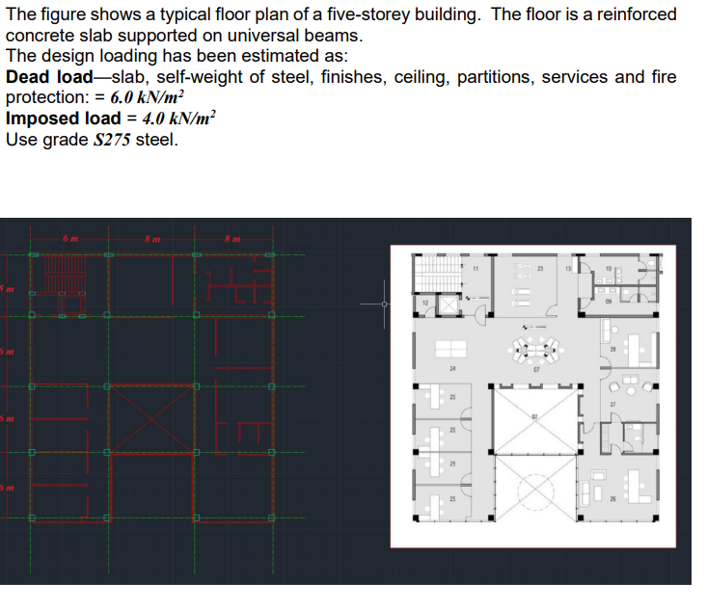

Introduction

This report presents the structural design of a 6m × 6m bay of a 5-storey steel-framed building, following Ultimate Limit State (ULS) principles according to BS 5950-1:2000. The floor beam slabs are two way, i.e transfer loads in both directions. This is determined by the 6m x 6m slab aspect ratio being 6/6 = 1 and as this is less than 2, the floor is a two way slab and will transfer loads in both directions, to both primary and secondary beams.

2.0 Load Calculations
- Dead Load (Gk) = 6.0 kN/m²
- Imposed Load (Qk) = 4.0 kN/m²
- Factored Load = 1.4Gk + 1.6Qk = 14.8 kN/m²
- Beam tributary width space = 3.0 m
- Line load on beam = 14.8 × 3 = 44.4 kN/m
- Including beam self-weight (+0.4 kN/m): Total w = 44.8 kN/m

3.0 Definitions and Notations
Z_p: Plastic section modulus (cm³, from Steel Blue Book)
M_pl,Rd: Plastic moment resistance (kNm)
f_y: Yield strength of steel (275 N/mm²)
γ_M0: Partial safety factor (1.0)
P_c,Rd: Axial load capacity (kN)
A: Cross-sectional area (mm²)
w_u: Factored uniform load (kN/m)
R_A, R_B: Support reactions (kN)
λ: Slenderness ratio
r: Radius of gyration (mm)
KL: Effective length (mm)
V_pl,Rd: Shear resistance (kN)

4.0 Beam Loading and Support Reactions
Reactions calculated as:
R = (w_u × L) / 2 = (44.8 × 6) / 2 = 134.4 kN
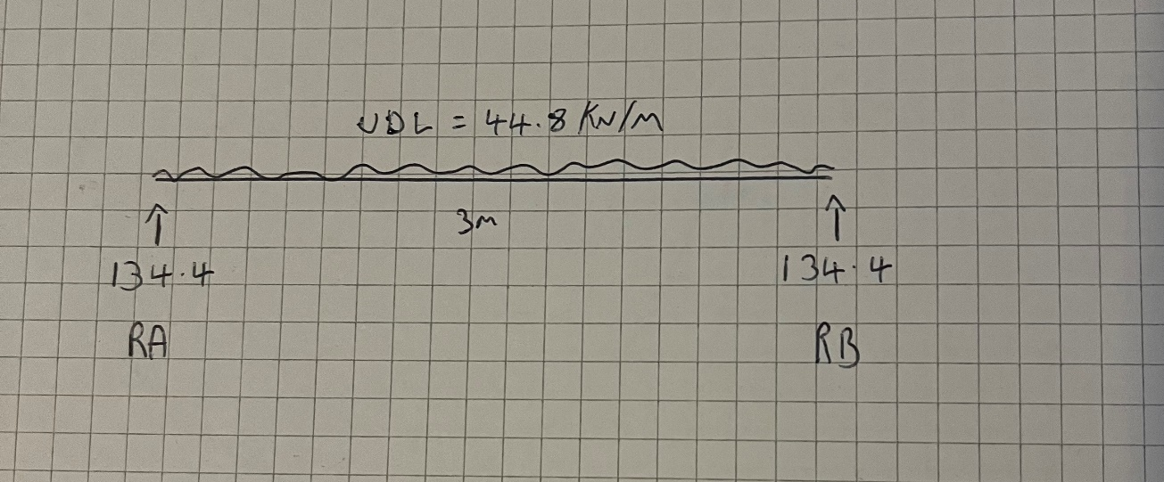
Fig 1. Beam reaction diagram

5.0 Shear Force and Bending Moment Calculations
Shear force diagram
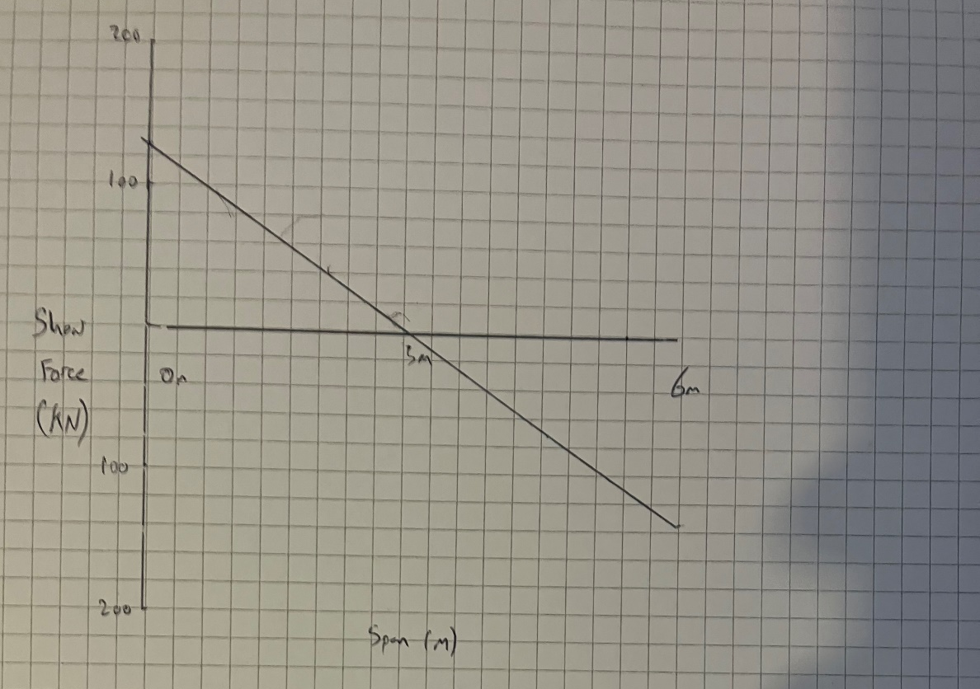
Fig 2. Shear force diagram. Shear of 134.4 KN at ends and 0 KN at mid span
Bending moment diagram
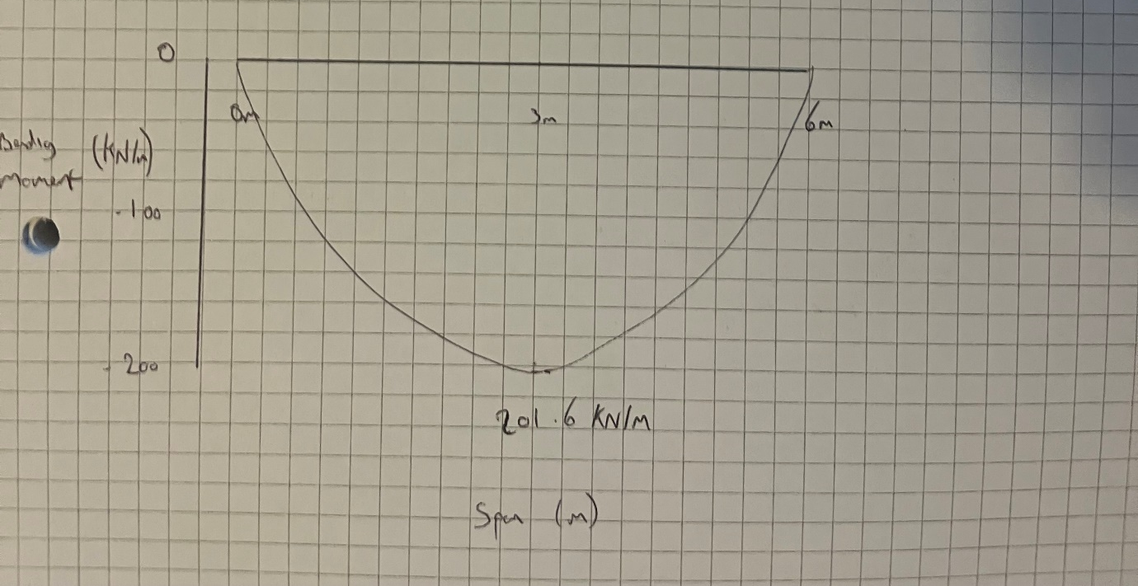
Fig 3. Bending moment diagram

6.0 Beam Design

This section assesses trial steel beam sections under Ultimate Limit State (ULS) loadings. Both bending and shear checks are carried out according to BS 5950-1:2000.

6.1 Maximum Bending Moment Calculation
Formula:
M_max = (w_u × L²) ÷ 8
w_u = Factored uniform load (kN/m)
L = Beam span (m)

Calculation:
M_max = (44.8 × 6²) ÷ 8
M_max = (44.8 × 36) ÷ 8
M_max = 1612.8 ÷ 8 = 201.6 kNm

6.2 Shear Force Calculation

Formula:
V_u = (w_u × L) ÷ 2

Calculation:
V_u = (44.8 × 6) ÷ 2
V_u = 268.8 ÷ 2 = 134.4 kN
Reactions R1 and R2 are equal

6.3 Beam Trial 1: 305 × 165 × 40 UB

Plastic modulus Z_p = 510 cm³
Shear area A_v = 43.6 cm²

Moment Capacity Formula:
M_pl,Rd = (f_y × Z_p) ÷ γ_M0

Calculation:
M_pl,Rd = (275 × 510 × 10³) ÷ 10⁶ = 140.25 kNm

Shear Capacity Formula:
V_pl,Rd = (A_v × f_y) ÷ γ_M0

Calculation:
V_pl,Rd = (43.6 × 275) ÷ 1.0 = 11,990 N = 119.9 kN
Moment: 140.25 kNm < 201.6 kNm = FAIL
Shear: 119.9 kN < 134.4 kN = FAIL

6.4 Beam Trial 2: 356 × 171 × 51 UB

Z_p = 673 cm³
A_v = 57.2 cm²

Moment Capacity Calculation:
M_pl,Rd = (275 × 673 × 10³) ÷ 10⁶ = 185.1 kNm

Shear Capacity Calculation:
V_pl,Rd = (57.2 × 275) ÷ 1.0 = 15,730 N = 157.3 kN

Moment: 185.1 kNm < 201.6 kNm = FAIL
Shear: 157.3 kN > 134.4 kN = PASS

6.5 Final Beam Selection: 406 × 178 × 67 UB

Z_p = 914 cm³
A_v = 74.6 cm²

Moment Capacity Calculation:
M_pl,Rd = (275 × 914 × 10³) ÷ 10⁶ = 251.35 kNm

Shear Capacity Calculation:
V_pl,Rd = (74.6 × 275) ÷ 1.0 = 20,515 N = 205.15 kN

Moment: 251.35 kNm > 201.6 kNm = PASS
Shear: 205.15 kN > 134.4 kN = PASS

6.6 Secondary Beam design
Span = 6 m
Tributary width = 3m
Load from slab: 14.8 kN/m² × 3 m = 44.4 kN/m
Add self-weight ≈ 0.3 kN/m as slightly less than primary beam, = Total load: 44.7 kN/m
Maximum Moment:
M_max = (44.7 × 6²) ÷ 8 = (44.7 × 36) ÷ 8 = 1609.2 ÷ 8 = 201.15 kNm
Maximum Shear:
V_max = (44.7 × 6) ÷ 2 = 268.2 ÷ 2 = 134.1 kN

Trial Section 1: 356 × 171 × 45 UB
Z_p = 612 cm³
A_v = 54.7 cm²
Moment Capacity:
M_pl,Rd = (275 × 612 × 10³) ÷ 10⁶ = 168.3 kNm
Check: 168.3 kNm < 201.15 kNm = FAIL
Shear Capacity:
V_pl,Rd = (57.2 × 275) ÷ 1.0 = 15,042 N = 150 kN
150 kN > 134.1 kN = PASS

Trial Section: 406 x 140 x 46 UB
Z_p = 744 cm³
A_v = 61.5 cm²
Moment Capacity:
M_pl,Rd = (275 × 744 × 10³) ÷ 10⁶ = 204.6 kNm
Check: 204.6 kNm > 201.15 kNm = PASS
Shear Capacity:
V_pl,Rd = (61.5 × 275) ÷ 1.0 = 16,912.5 N = 169.13 kN
169.13 kN > 134.1 kN = PASS

7.0 Column Design

This section assesses different Universal Columns (UC) for the calculated axial design load.

7.1 Explanation of Column Load 1827 kN

Each floor load:
14.8 kN/m² × (6 × 6 m) = 532.8 kN per floor.
5 floors:
5 × 532.8 = 2664 kN

Each column in the grid carries ¼ of this load so roughly 666Kn plus the column self weight which is approximately 10Kn which equates to 676Kn
Assuming an internal column supports multiple bays i.e 2-3 bays this 676Kn will be scaled up to roughly 3 times to account for the rest of the weight of the building and its tributary beams acting upon it and incorporate a factor of safety within the design (R.C.Hibbeler, 2022).
Final factored design load ≈ 2028 kN.

7.2 Axial Load Calculations

Formula:
P_c,Rd = (A × f_y) ÷ γ_M0

A = Cross-sectional area (mm²)
f_y = 275 N/mm²
γ_M0 = 1.0

7.3 Column Trial 1: 203 × 203 × 52 UC

Area A = 6620 mm²
P_c,Rd = (6620 × 275) ÷ 1000 = 1820.5 kN
Result:
1820.5 kN < 2028 kN = FAIL

7.4 Column Trial 2: 254 × 254 × 73 UC

Area A = 9300 mm²
P_c,Rd = (9300 × 275) ÷ 1000 = 2557.5 kN
Result:
2557.5 kN > 2028 kN = PASS

7.5 Column Trial 3: 305 × 305 × 97 UC (Final)

Area A = 12300 mm²
P_c,Rd = (12300 × 275) ÷ 1000 = 3382.5 kN
Result:
3382.5 kN > 2028 kN = PASS

7.6 Slenderness Check

Formula:
λ = (KL) ÷ r

K = 1.0 (pinned ends)
L = 3000 mm (storey height)
r = Radius of gyration from Blue Book.
For 254 x 254 x 73 UC, r = 61.6 mm.
λ = (3000) ÷ (61.6) = 48.7
Since λ < 100 = PASS

K = 1.0 (pinned ends)
L = 3000 mm (storey height)
r = Radius of gyration from Blue Book.
For 305 × 305 × 97 UC, r = 82.5 mm.
λ = (3000) ÷ (82.5) = 36.36
Since λ < 100 = PASS
Due to the lower slenderness score and therefore making the column much more stable (less risk of buckling) this 305 x 305 x 97 size column was selected.

8.0 Base Plate Design

8.1 Required Area

Factored axial load on column (N_u): 1827 kN
Concrete grade (f_ck): 30 N/mm²
Design concrete bearing stress (f_cd): 0.6 × f_ck = 18 N/mm²
Steel plate yield strength (f_y): 275 N/mm²

Required Base Plate Area:
Formula: A_required = N_u ÷ f_cd
Calculation: A_required = (1827 × 10³) ÷ 18 = 101,500 mm²

Base Plate – 300 × 300 mm
Provided Area = 300 × 300 = 90,000 mm²
Required Area = 101,500 mm²
Check: 90,000 < 101,500 = FAIL
Bearing stress: σ = N_u ÷ A = (1827 × 10³) ÷ 90,000 = 20.3 N/mm² > 18 = FAIL

Base Plate – 400 × 400 mm
Provided Area = 400 × 400 = 160,000 mm²
Required Area = 101,500 mm²
Check: 160,000 > 101,500 = PASS
Bearing stress: σ = (1827 × 10³) ÷ 160,000 = 11.42 N/mm² < 18 = PASS

Thickness Check
Assume 'a' = 100 mm beyond column face
Formula: t = sqrt((p × a²) ÷ (2 × f_y))
t = sqrt((18 × 100²) ÷ (2 × 275)) = sqrt(327.27) = 18.1 mm
Provide: 20 mm thick plate = OK

300 × 300 mm base plate: FAIL (bearing pressure too high)
400 × 400 mm base plate: PASS (adequate area and thickness)

Anchor Bolt Check:
Use 4 × M20 bolts
Typical capacity per bolt: ~75 kN
Total bolt capacity: 4 × 75 = 300 kN
Bolts resist uplift/sliding if required = Adequate

9.0 Beam to column connection
Determine beam-to-column end reaction
Beam: 406 × 178 × 67 UB
Maximum shear force at support:
V_u = 134.4 kN

Bolted end-plate connection
End plate thickness = 15–20 mm
Bolts: 2 rows, typically M20 or M24 grade 8.8

Number of bolts
M20, grade 8.8 bolts shear capacity:
V_b,Rd = (α_v × f_ub × A_s) / γ_M2
Where:
α_v = 0.6
f_ub = 800 MPa
A_s = 245 mm² (M20 tensile area)
γ_M2 = 1.25

Calculation:
V_b,Rd = (0.6 × 800 × 245) / (1.25 × 10³) = 94 kN per bolt

Check number of bolts
Total beam shear = 134.4 kN
2 × 94 = 188 kN > 134.4 kN = OK
Recommended: 4 × M20 bolts

Check end plate thickness
t_p ≥ √(6M / f_y b²)
Usually use 20 mm thick plate (S275 steel)

Check column face bearing
Column: 305 × 305 × 97 UC
f_y = 275 MPa
Flange thickness t_f = 20 mm

Summary of Proposed Fittings
End plate 20 mm thick, S275 steel
Bolts 4 × M20, grade 8.8
Bolt pattern 2 rows, 2 per row, symmetrically spaced
Edge distances ≥ 2d (≈4 0 mm for M20)
Column flange 305 UC flange; which is adequate for this application

10.0 Structural system and load transfer explanation

10.1 Panel and Structural System Description
The design is for one typical 6 m × 6 m internal bay (see introduction) in a 5-storey steel-framed building. The floor consists of a two way reinforced concrete slab supported by a system of secondary and primary steel beams. These beams, in turn, are supported by steel columns. The columns transfer the loads vertically down to the base plates and foundations.

10.2 Load Transfer Sequence
1. The reinforced concrete slab (typically 150–200 mm thick) spans between secondary beams.
2. Secondary beams transfer the slab load to the primary (main) beams.
3. Primary beams transfer the combined loads to the supporting columns.
4. Columns carry the loads vertically down to the base plates and foundations.

10.3 Tributary Width and Beam Span Explanation
In the 6 m × 6 m bayl, the slab spans between secondary beams spaced at 3 m. This reduces slab span and thickness compared to spanning the full 6 m. The secondary beams span 3 m between primary beams. The primary beams span 6 m between columns. This is why the tributary width used for the main beam design is 3 m (half the panel width on each side feeding into the beam). The diagram below aims to illustrate this

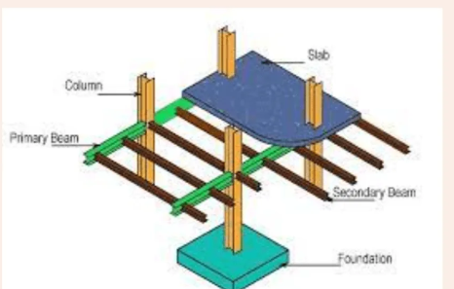
Fig 4. Example of load transfer for building. (Civilengblitz.com, 2025)

11.0 Summary

Primary beam selected is 406 × 178 × 67 UB and this is used for all primary beams due to simplicity and bulk purchase costs as buying all beams in the same size. For one bay approximate costs for one beam is £700, this is for a 6m length (Steelproductsdirect, 2025) with offers for bulk purchasing for more than one beam purchased of the same size at the same time.
Secondary beam selected is 406 x 140 x 46 UB and these are to be used for all secondary beams. Cost is approximately £496 (Steelproductsdirect, 2025).
Column selected for all columns in the design is 305 × 305 × 97 UC
Connections 20mm end plate s275 with 4 × M20 Bolts
Base Plate for all are 400 × 400 × 20 mm with 4 × M20 Bolts

References

British Steel (2003). Steel Construction Manual (Blue Book). 7th ed. Corus Group, UK.

British Standards Institution (2000). BS 5950-1:2000. Structural use of steelwork in building. BSI, London.

British Standards Institution (2005). BS EN 1993-1-1. Eurocode 3: Design of steel structures. BSI, London.

Civilengblitz, 2025. Columns in construction. [Online]. Available at: https://civilenggblitz.com/columns-in-construction. [Accessed 24 April 2025].

Eurocode 8. (2004). Design of Structures for Earthquake Resistance – Part 1: General Rules, Seismic Actions and Rules for Buildings (EN 1998-1). Brussels: European Committee for Standardization.

R.C.Hibbeler, 2022. Structural analysis. 9 ed. boston: Pearson.

Steel products direct, 2025. Universal beams. [Online]. Available at: https://www.steelproductsdirect.com/mild-steel/universal-beams/universal-beam-ub-203x133-(no-finish)-(1)/. [Accessed 24 April 2025].

Steel products direct, 2025. Universal beams. [Online]. Available at: https://www.steelproductsdirect.com/mild-steel/steel-rsjs/universal-beams/universal-beam-ub-381x140-(2)/. [Accessed 29 April 2025].

