HPAH4001 – Everyday Life in Ancient Rome
– “Sexual” imagery in the Roman world

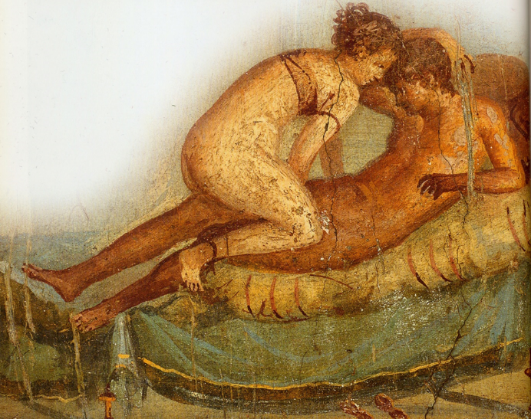

In this short workshop we will briefly consider some the representation of, what might be (anachronistically) term sexual imagery, including on wall-painting and material objects. A series of images are given below which you should examine in relation to the questions set. In addition, you should read the chapter by John R. Clarke in the A companion to Greek and Roman sexualities (2014) – see Moodle.

Questions
1) Why might terracotta imagery be useful for thinking about the wider “sexual” attitudes of the Roman world? What caveats might we need to note?
2) Do you think artistic images reflect contemporary tastes, artistic conventions, fossilization of earlier artistic representations / cultural attitudes or a combination of all of these? Is it easy to make these judgements?
3) How might visual depictions both be similar and differ from the “attitudes” we see in literary sources?
4) How might the location of “sexually explicit” wall-paintings in Pompeii and Herculaneum be interpreted?
5) What might we learn from depictions of “taboo” sexual acts?
6) What function do the sexualised images of pygmies serve?
7) What can images of “active” women tell us about attitudes to sex in the Roman world?
Imagery

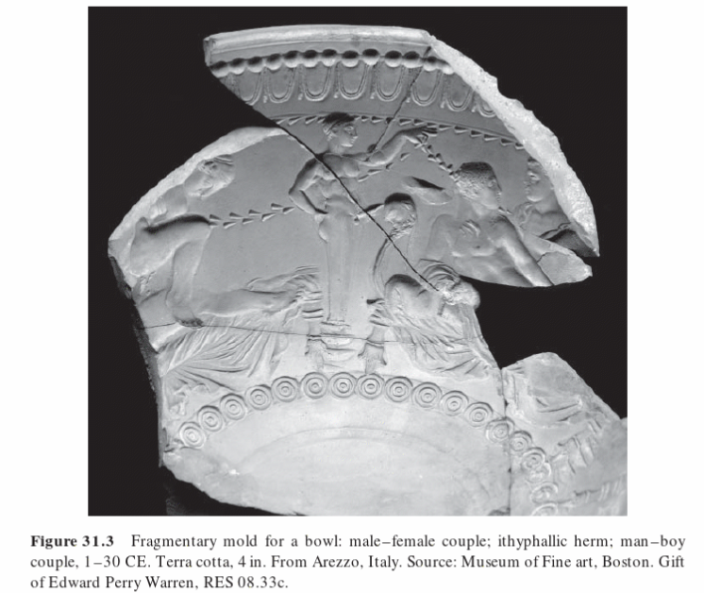

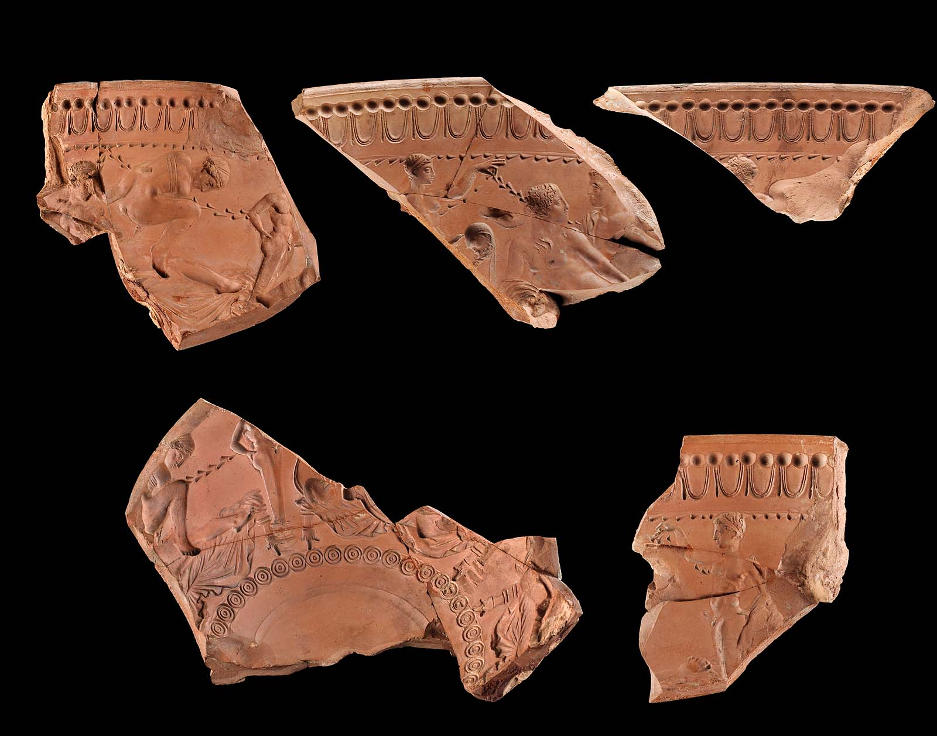
Image reference as above

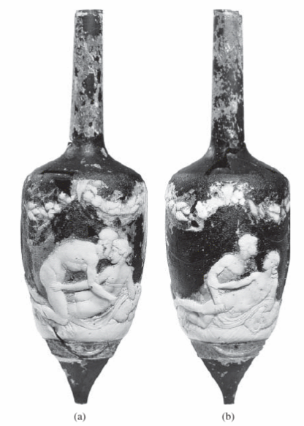
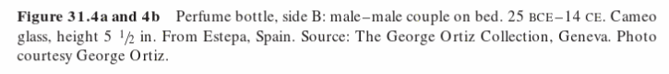

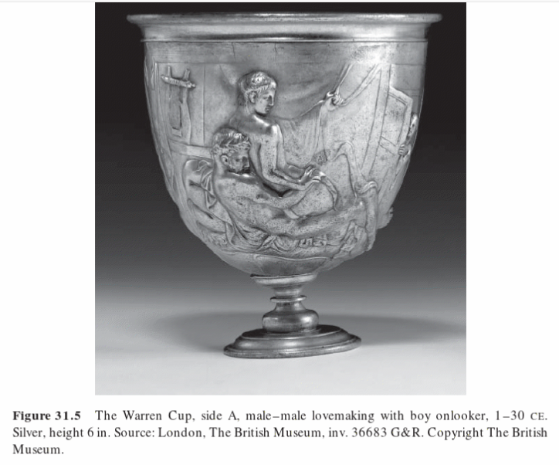

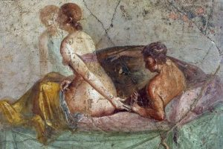
Pompeii, House of Caecillius Iucundus (V, 1, 26), peristyle 1, north wall (AD 62-79)
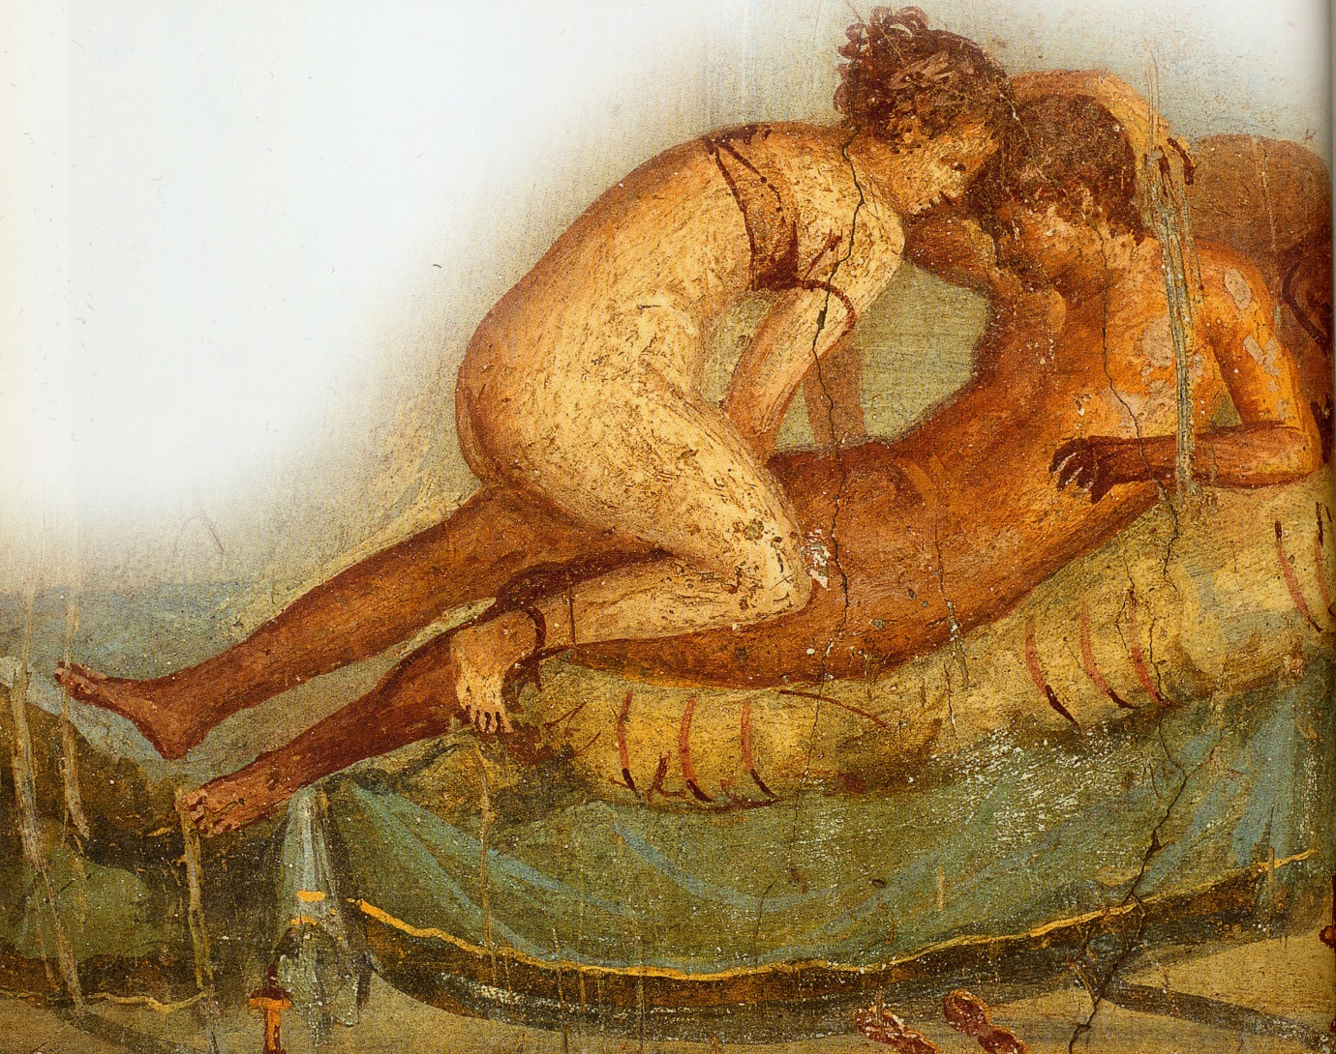
Pompeii, House of the Centenary, room 43, south wall (AD 62-79)

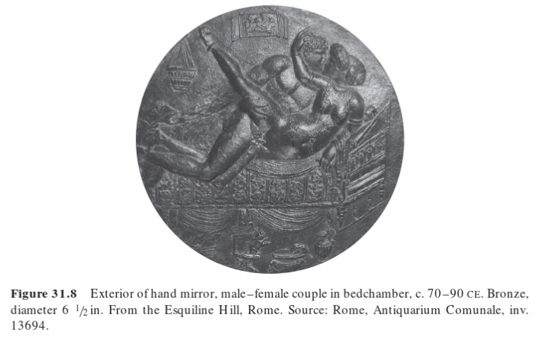
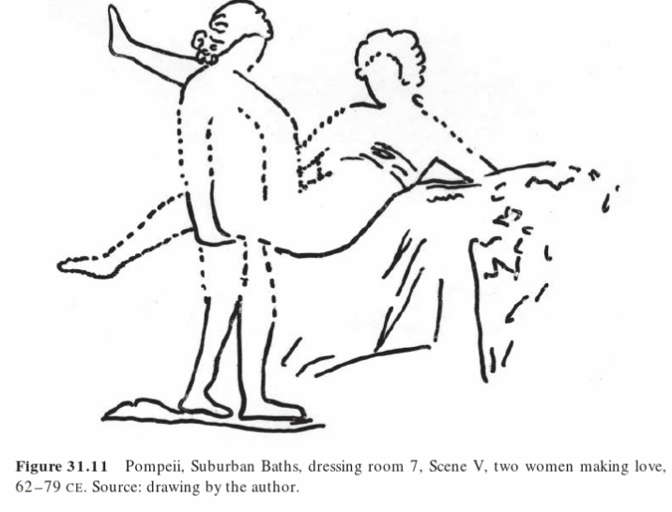
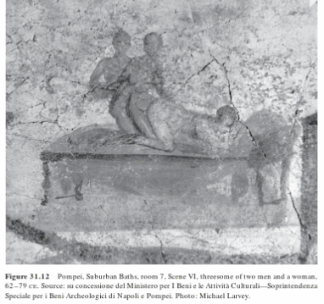
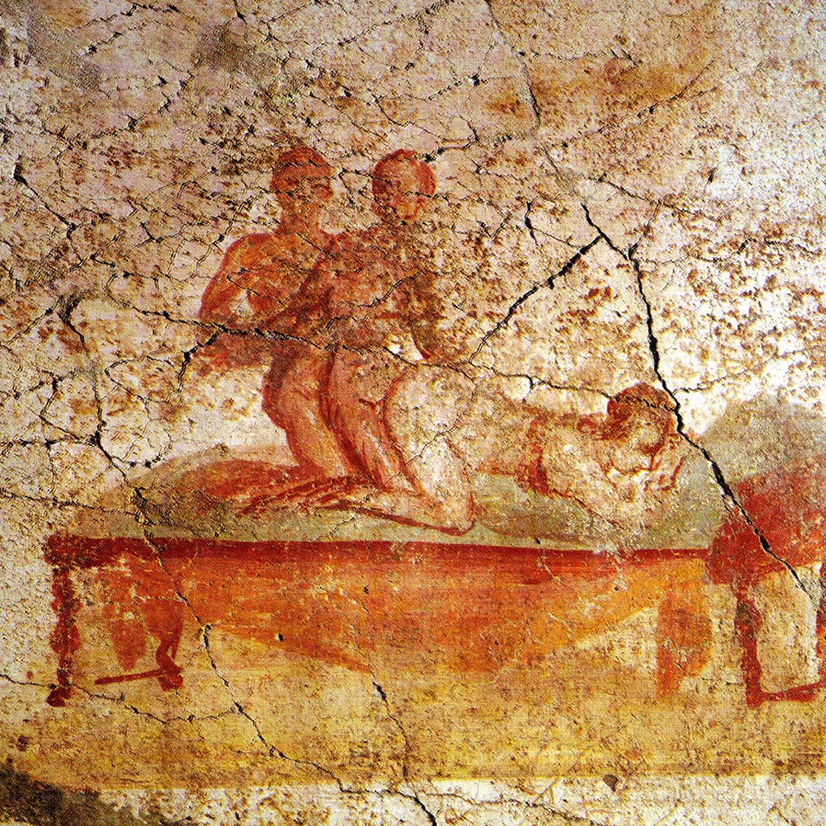
Same as above [Pompeii, Suburban Baths, room 7, (AD 62-79)]

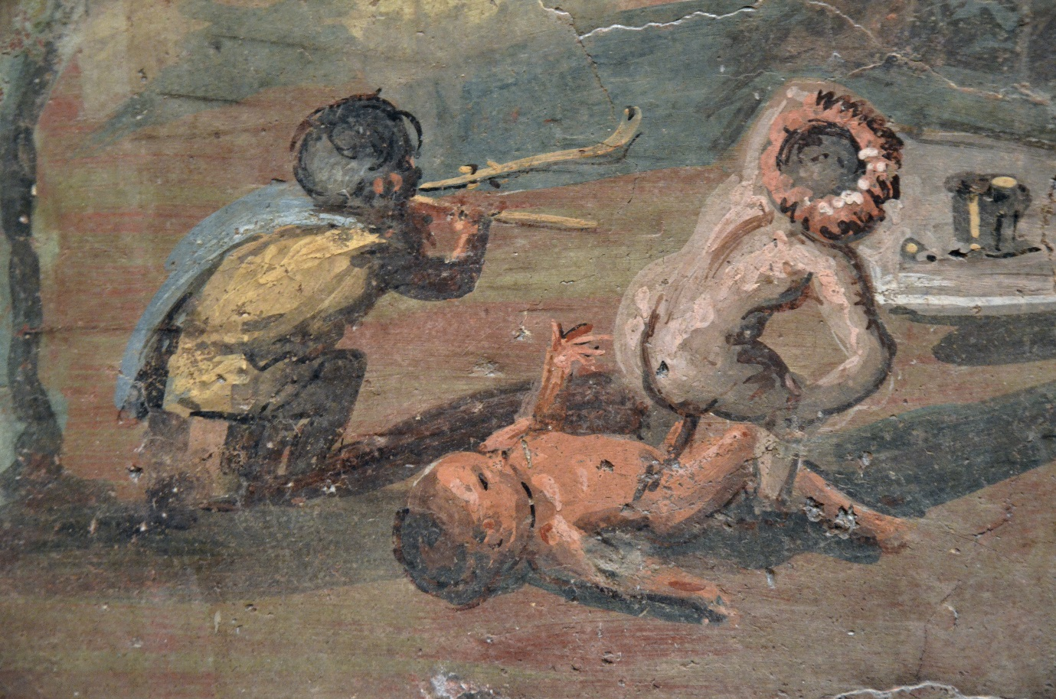
Pompeii, Casa del Medico (VIII, 5, 24), internal decoration of a podium that surrounded the garden

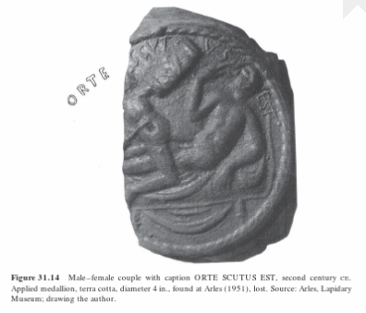
ORTE SCUTUS EST = ‘Look out! That’s a shield.’

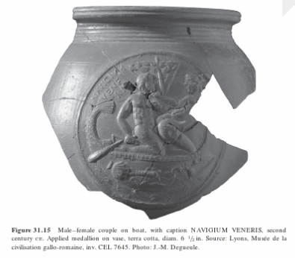
NAVIGIUM VENERIS = ‘The Navigation of Venus’ (‘on course for sex’ / ‘sexual steersmanship’)

