

Course Title: MBA - International Business
Term 1

Student Name: CHARU GAUTAM
Student ID: 2432997

Module Name: Marketing Management
Module Code: LCMB7024

Lecturer’s Name: Dr Laila Maazouz

POSTER

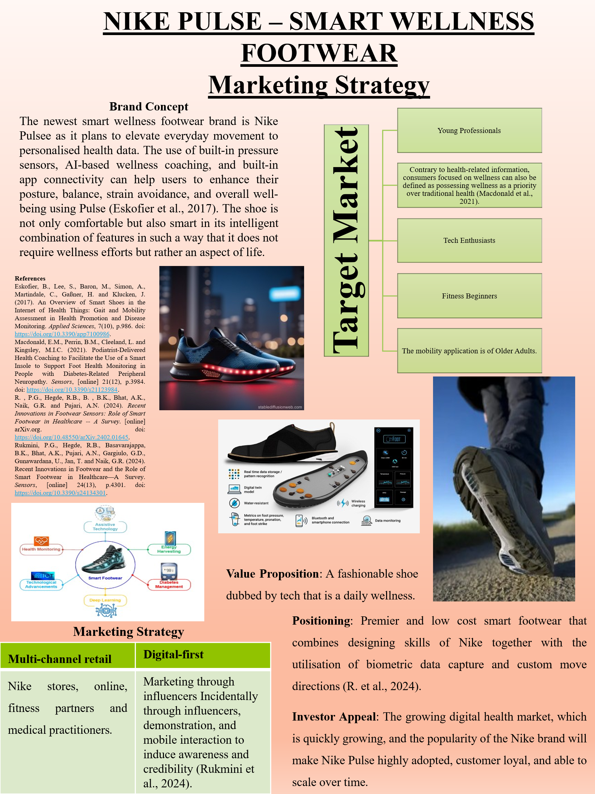

References
Eskofier, B., Lee, S., Baron, M., Simon, A., Martindale, C., Gaßner, H. and Klucken, J. (2017). An Overview of Smart Shoes in the Internet of Health Things: Gait and Mobility Assessment in Health Promotion and Disease Monitoring. Applied Sciences, 7(10), p.986. doi: https://doi.org/10.3390/app7100986.

Macdonald, E.M., Perrin, B.M., Cleeland, L. and Kingsley, M.I.C. (2021). Podiatrist-Delivered Health Coaching to Facilitate the Use of a Smart Insole to Support Foot Health Monitoring in People with Diabetes-Related Peripheral Neuropathy. Sensors, [online] 21(12), p.3984. doi: https://doi.org/10.3390/s21123984.

R. , P.G., Hegde, R.B., B. , B.K., Bhat, A.K., Naik, G.R. and Pujari, A.N. (2024). Recent Innovations in Footwear Sensors: Role of Smart Footwear in Healthcare -- A Survey. [online] arXiv.org. doi: https://doi.org/10.48550/arXiv.2402.01645.

Rukmini, P.G., Hegde, R.B., Basavarajappa, B.K., Bhat, A.K., Pujari, A.N., Gargiulo, G.D., Gunawardana, U., Jan, T. and Naik, G.R. (2024). Recent Innovations in Footwear and the Role of Smart Footwear in Healthcare—A Survey. Sensors, [online] 24(13), p.4301. doi: https://doi.org/10.3390/s24134301.

