

Student Name: DHRUV SANJAYKUMAR PATEL

Student ID: 2431083

Module Name: Strategic Management

Module Code: LCMB7003

Lecturer’s Name: Dr. Jayalakhshmi Gopalkrishnan

Table of Contents
1. ORGANISATION & TARGET MARKET OVERVIEW 4
1.1 Introduction & Company Background 4
1.2 Justification for Target Market Selection (India or UK) 5
1.3 Strategic Objectives of the Expansion 6
2. STRATEGIC ANALYSIS OF TARGET MARKET 7
2.1 Macro Environmental Analysis – PESTLE 7
2.2 Industry & Competitive Landscape – Porter’s Five Forces 10
2.3 Internal Capabilities & Competitive Advantage – VRIO 12
2.4 Critical Evaluation of Strategic Frameworks 13
3. STRATEGY FORMULATION FOR MARKET ENTRY 15
3.1 Market Entry Mode Strategy 15
3.2 Competitive Strategy & Positioning 17
3.3 Growth Strategy (Ansoff Matrix + BCG Matrix) 18
3.4 Strategic Initiatives 19
4. PERFORMANCE MEASUREMENT SYSTEM 21
4.1 Choice of Framework & Justification 21
4.2 Balanced Scorecard Objectives, KPIs & Targets 22
4.3 Limitations of the Balanced Scorecard 24
5. CONCLUSION 24
References 26

1. ORGANISATION & TARGET MARKET OVERVIEW

1.1 Introduction & Company Background
Five Guys is a casual chain of hamburger restaurants, but began in Virginia in 1986. It is a globally known company due to its business concept, which centers on fresh food, allowing consumers to own their own decisions, and ensuring things are not complicated to operate. The brand is based on never-frozen ingredients, open kitchens, and transparent information on the menu. These are something that make it stand out among ordinary fast-food establishments and premium hamburger rivals. Five Guys operates in over 1,800 outlets globally. It is firm in North America, UK, Europe and Middle East and it is expanding in Asia. The company is growing primarily by franchising but maintaining a solid brand promise. This enables it to expand rapidly in the new countries without sacrificing the quality of food or even the experience in all its stores (Jayawardana, Dodamwalage Chaminda Deepal and Jayawardana, Dodamwalage Chaminda Deepal, 2025).
In the recent market research, it was indicated that the fast casuals dining market is steadily increasing all over the world as individuals seek higher quality food, which is yet affordable. Five Guys has experienced a high growth in revenue in this environment particularly in the international market where the premium burger concepts are gaining popularity. Analysts note that the chain is able to price their services higher due to big portions, fresh food, and allowing the customer to customize their food- other elements remain central to the competitive advantage of the company. With consumers seeking authentic and genuine preparation of food products and services, the Five Guy strictness in ingredient selection has improved its status as a brand that is reputable and unique (Mammen, 2024). The expansion strategy into additional foreign locations is also aligned with the long-term objective of the company to increase its international presence and explore the new demand of high-quality fast-casual food. Five Guys has a great opportunity to leverage its distinct operating model and strong brand as more individuals eat out and people are increasing their income in most markets. Further growth also allows the firm to diversify its income in various regions, enjoy the larger economies in its supply chain, and remain competitive in a rapidly changing global food market (MEDINA CINTRON, 2022).

1.2 Justification for Target Market Selection (India or UK)
The Five Guys has a very appealing market in India since the middle-income is growing rapidly, the population is increasing the amount of money they spend, and the number of quick service restaurants is increasing at a rapid pace. It is believed that the foodservice market in India will exceed 79 billion dollars by 2028 and the growth of the quick-service restaurants will be in the double-digit rate. The increase in the number of cities and Western culture make people demand better quality and international food. This is equivalent to Five Guys that comes with quality and custom burger choices. When applying the CAGE model, the cultural differences are present, however, young people of India, English-speaking metropolitan workers and familiar with the global brands relax the barriers and allow the brand to be popularized (Baas, 2023).
The argument of India is even better with the OLI framework. The big Ownership perks of Five Guys are due to the unique mode of operation, a familiar brand and an efficient supply chain that concentrates on good quality. Location advantages of India include an extensive number of city customers, increasing enthusiasm on Western style food and improved laws on foreign investment in foodservice. These internalisation gains also help in a regulated mode of market entry, such as a joint venture or a master franchise. This allows the company to retain its quality and purchase supplies, locate buildings and satisfy regulations with the help of the local knowledge (Batschauer da Cruz, Eliete Floriani and Amal, 2020).
India has superior growth opportunities and minimal competition compared to Japan and South Korea. Change of menus is difficult in Japan because it already has numerous local premium burger joints. South Korea is not as attractive and has high costs of leasing and numerous fast-food establishments. The high end burger market in India remains in its maturity stage, thus Five Guys may become a pioneer.
In the case of the UK, this is not the case. The UK will be able to assist our brand to expand in an already functional market. Online orders are highly used by customers and they prefer premium fast-casual food. Although the market is saturated, Five Guys has recorded good sales and opening up more stores would enable us to access more customers (Hong et al., 2024).

1.3 Strategic Objectives of the Expansion
It is proposed to position Five Guys as the best premium fast-casual dining burger brand in the selected market. To arrive there, we will have specific and quantifiable objectives. The objective of the main goal is to secure a particular market segment of the premium burger within three years. We will achieve this through maintaining a consistent brand image and ensuring that the customers are very happy. We also intend to establish a specific number of stores in large cities at the very beginning. This will assist us to become more visible and operate things in a better manner (Pham, 2024).
The other agenda is to develop a supply chain that is entirely local and has the ability to preserve our food fresh without violating local regulations and sustainability targets. Five Guys have a chance to reduce the amount of waste in packaging, make the operation of the stores more energy-saving and cooperate with certified suppliers. These measures can make us remain environmentally responsible and fulfill the expectations of people in the world.

The other objective is to add value to the customers by providing them with high quality of service and custom experience. Enhancement of online ordering, delivery incentives and reward loyalty will make Five Guys remain strong in every channel. Adding delicious vegetarian items in India can make us more relevant and do not transform our core brand. The combined goals will increase shareholder value through global expansion, the addition of new sources of revenue, and maintaining a distinct competitive advantage through a steady brand efforts. The strategy aligns Five Guys to an uninterrupted growth in an evolving global food service environment by making sure that our expansion strategies are matched with what we have been doing best; freshness, customization, and hassle-free operations (Bakatsis and Verma, 2025).

2. STRATEGIC ANALYSIS OF TARGET MARKET

2.1 Macro Environmental Analysis – PESTLE
The political environment in India provides opportunities and regulations that may be difficult to foreign food companies. The government has been relaxing foreign investment in retail and food allowing companies to acquire up to 100 percent of a business without requesting special permission. This facilitates the entry of such groups as Five 9 Guys to the market. The Food Safety and Standards Authority of India (FSSAI) governs food safety. They impose strict regulations on the labels, cleanliness and monitoring of what enters the food. In order to comply with these regulations, Five Guys shall have to establish credible local suppliers and quality control. The company has to find its way into India through an operation such as a joint venture or master franchise which will enable it to comply with the regulations and expedite approvals (Bhurat, Bhurat and Dhoot, 2025).
The Indian economy is among the fastest growing economies in the world and the GDP of the country is likely to increase at over 6 percent per annum. The individuals in the urban areas have more disposable income and hence are purchasing better quality food and foreign brands. Yet, increases in prices and large disparities in the income among states imply that purchasing power does not always be equal across the regions. Swiggy and Zomato have also created an increasing demand in quick casual food, as India has emerged as one of the most significant markets in the business of online food delivery in the world. Implication: First, Five Guys may concentrate on the city regions with the highest income and deliver to more clients with the help of delivery services (Aggarwal, 2025).
India can be even more appealing to Five Guys because of its social trends.Young population- more than 65 percent of the population is below 35 years old- is an indicator that people like eating out, particularly in urban areas. The western culture of food is more popular due to changing lifestyles, traveling abroad, and working families where both parents are working and prefer convenience. Nevertheless, vegetarian food is liked by quite a number of people and the menu should be altered. Implication: A menu containing good vegetarian selections will be required to make people accept it and allow the business to grow (Ranjan et al., 2024).
In India, fast-casual operations are made to be scalable by technological advancements. Digital payment infrastructure, app-based ordering, loyalty programs, and online delivery are all strong and consumers are accustomed to it. Mobile POS systems and data analytics tools are highly popular and provide opportunities to customize a service and optimize operations. Five Guys can easily incorporate its standard digital systems and increase the customer engagement through local digital capabilities.

Environmental demands are increasingly high, and there is the emphasis on sustainable package, waste management, and energy conservation operations of the store. International brands are supposed to be environmentally responsible to the consumer. Five Guys will have to follow the local regulations and customer desires by using environmentally friendly packaging and sustainable sourcing.
India has undergone a transformation in terms of its labour laws (legally), franchising rules and competition rules. The reforms of new labour are oriented to the facilitation of compliance, however, the regulations on wages and employment are in different states. Franchising is also prevalent in the food service business and enforcing contract is more efficient, yet documentation remains a tedious process. To help avoid risks and stay legal, Five Guys will have to employ a flexible approach to HR and collaborate with legal specialists (Ogunsola-Saliu and Alotaibi, 2025).
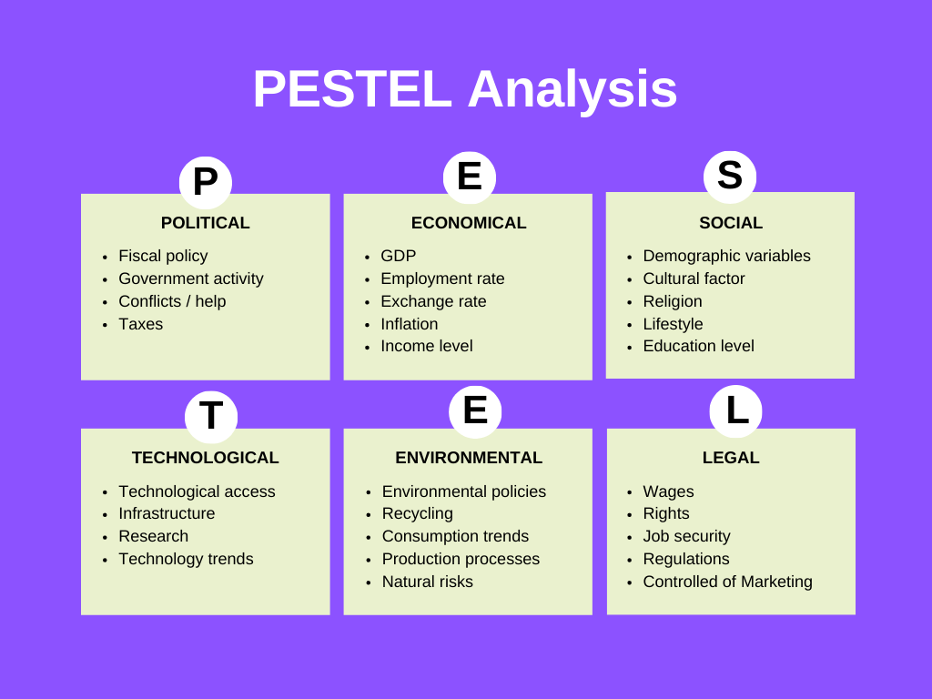

2.2 Industry & Competitive Landscape – Porter’s Five Forces
The level of competition in the Indian burger and fast casual food market is increasing. The market is still owned by big chains such as McDonalds, KFC and Burger King. Brands with more pleasant food such as Chili, Smoke house Deli and local fancy burger shops attract younger people, as they will seek a better experience when they eat. Nevertheless, the fresh, high-end burger market has not been fully developed yet, and thus Five Guys might become first movers. The point is that Five Guys must be differentiated by keeping its burgers fresh and providing consumers with a nice shopping experience (Kizito, 2023).
Possible new entrants are a little high. Food service does not require so much money, but creating a good brand is difficult due to issues with supply. Franchising is widespread, therefore local chains can expand rapidly. However, a fresh-food chain such as Five Guys consumes a lot of resources to set up. This implies that the Five Guys way of operation will be able to churn out new competitors, but local chains may mimic certain menu items and services. Suppliers have mixed power. The supply of basic agricultural products is high, whereas outstanding beef, potatoes, and dairy products supplied by Five Guys are less available and require special sourcing. The chain will have to rely on the local suppliers, particularly due to restrictions on beef in most Indian states. The products will require modification and selection of the vendors. It implies that the suppliers might be more powerful, therefore, effective strategic alliances or monopolized purchasing are significant. The power of customers is high due to their price consideration. City shoppers of middle income may pay higher prices to foreign brands, however, they do not neglect price vs value and quantity of food received. They are also in need of great atmosphere, good service and simple online ordering; hence they can push back. Five Guys needs to justify its increased cost by having a fresher food, consistent quality, and the appealing dining experience (Chowdhury, 2025).
Substitutes are a big threat. Most clients like casual restaurants, street food, pizza shops, cafes, or home cooking. Junk food and local fast-food are not only cheap but also delicious and are a part of daily life. This implies that Five Guys will have to provide something unique- fresh food, customized orders and safe ingredients therefore it will not be like cheaper alternatives. According to scholars, the model proposed by Porter is simplistic. It presupposes the markets as constant, which might not be applicable in the rapidly evolving digital food markets. Nevertheless, the model assists in identifying rivalry forces that influence prices of Five Guys and its market penetration (Wiatrowski, Czarniecka-Skubina and Trafiałek, 2021).
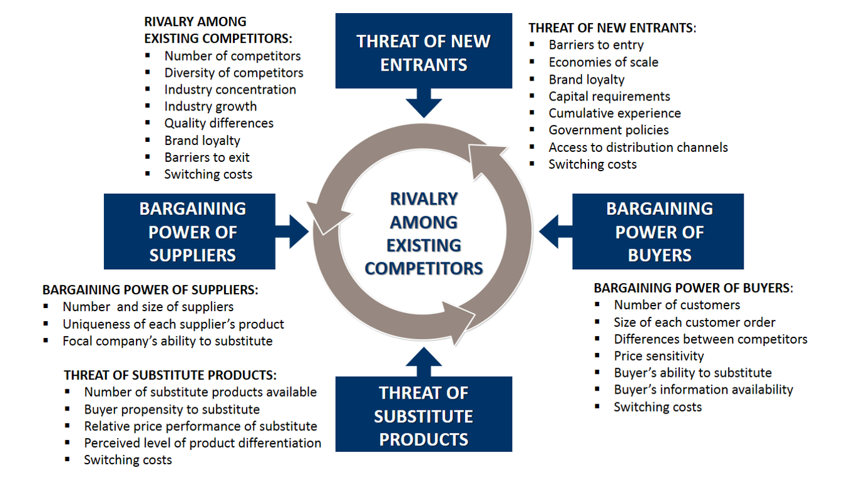

2.3 Internal Capabilities & Competitive Advantage – VRIO
The primary strength of Five Guys is its fresh-food concept, which does not incorporate freezers and is more oriented towards hand-preparation. This is what makes the brand arise in the market which is full of mass-produced fast-food. The reason is that in India food is not kept fresh by many chains. It is also fairly expensive to imitate, as it demands a stable high quality supply chain, high level of operational rigidity and increased input expenses. Five Guys is in a good position to exploit this advantage due to its developed global standards and training systems. Implication: Freshness may be the aspect of its differentiation strategy in India (Wen, 2022).
Another aspect that Five Guys remains ahead is in terms of operation. A limited menu and a well-structured kitchen can enable Five Guys to deliver services to its customers in a fast and regular manner. This skill is practical and well-organized, yet not rare as most restaurants of the area do maintain short menus as well. Nevertheless, it would be costly to replicate the exact Five Guys concept of operation, since it is difficult to replicate its culture and global training. Implication: The company can implement this model in India and continue enjoying its high efficiency (Ziółkowski, 2024).
A significant intangible resource is brand reputation. The Five Guys has a good image internationally in terms of quality, authenticity and customer satisfaction. This brand equity is also valued in India where the international brands are much sought after and the premium burgers lack this. It is also difficult to imitate due to the history of the brand and its uniformity around the world.
Inference: The understanding of the brand allows the company to sell at a high price and compete favorably with the domestic brands. The other strength is supply chain expertise. The Five Guys systems maintain consistency in the ingredients, put suppliers to task, and provide high quality checks. However, in order to enter India, the company will have to localise a lot due to the rules and availability of ingredients. The supply chain skills are valuable and well organized and it might not be a rare one initially until local partners are established. Implication: The supply chain will be modified to maintain its international standards. In general, VRIO analysis reveals the competitive advantage of Five Guys through its fresh food concept, brand name, and good operations. These competitive advantages support a differentiation strategy that is appropriate in the India premium fast-casual market (Hamdoun, Achabou and Dekhili, 2021).
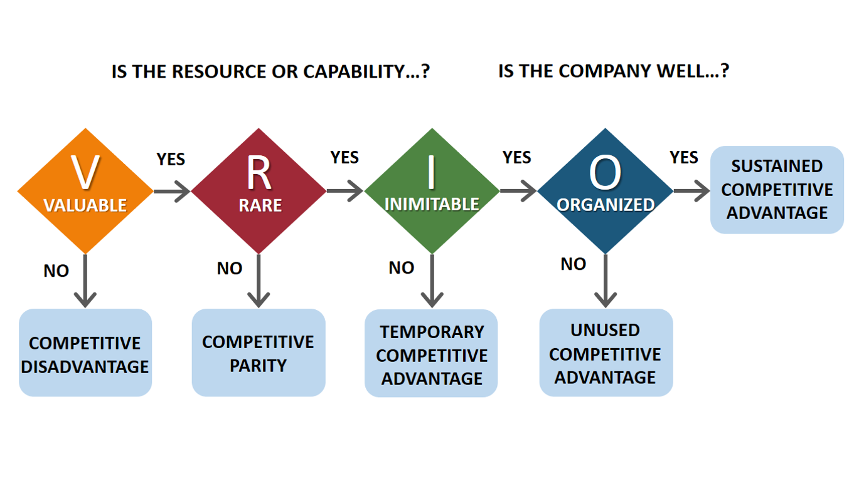

2.4 Critical Evaluation of Strategic Frameworks
PESTLE is one such tool that will assist in examining broad environmental determinants. Other researchers indicate that it merely describes things and is not subject to the movement of the markets or the interaction between factors. According to Johnson and others, PESTLE may simplify complex situations and simplify analysis to a checklist. Despite those issues, PESTLE continues to be useful in locating external threats and opportunities in emerging markets such as India. The Five Forces created by Porter is criticized due to the assumption that industries remain the same and the lack of focus on changes in the digital space. Grundy et al. assert that it lacks competition in platforms as well as new technology-driven consumer behavior. Nevertheless, Five Forces can be considered when analyzing the competition pressure and how competitors, suppliers, and substitutes influence Five Guys strategies. VRIO is effective in verifying the available resources of a company but has been criticized as only concentrating on what is within the firm, and not external factors. According to Peteraf and Barney VRIO can fail to take into consideration the evolving skills that are required in long-term change. However, VRIO assists in evaluating the special strengths of Five Guys, including the brand, operations, and fresh food model, and demonstrates how it can provide the sustainable advantage (Anderson, 2025).
A combination of these frameworks reveals more strategies. PESTLE displays external factors that have made a market appealing; Five Forces reveals how competitive an industry is; VRIO considers internal capabilities to succeed. They combine to eliminate the weak points of any of the models and deliver a multi-layered insight required to develop a powerful market entry strategy (Mccall, 2024).
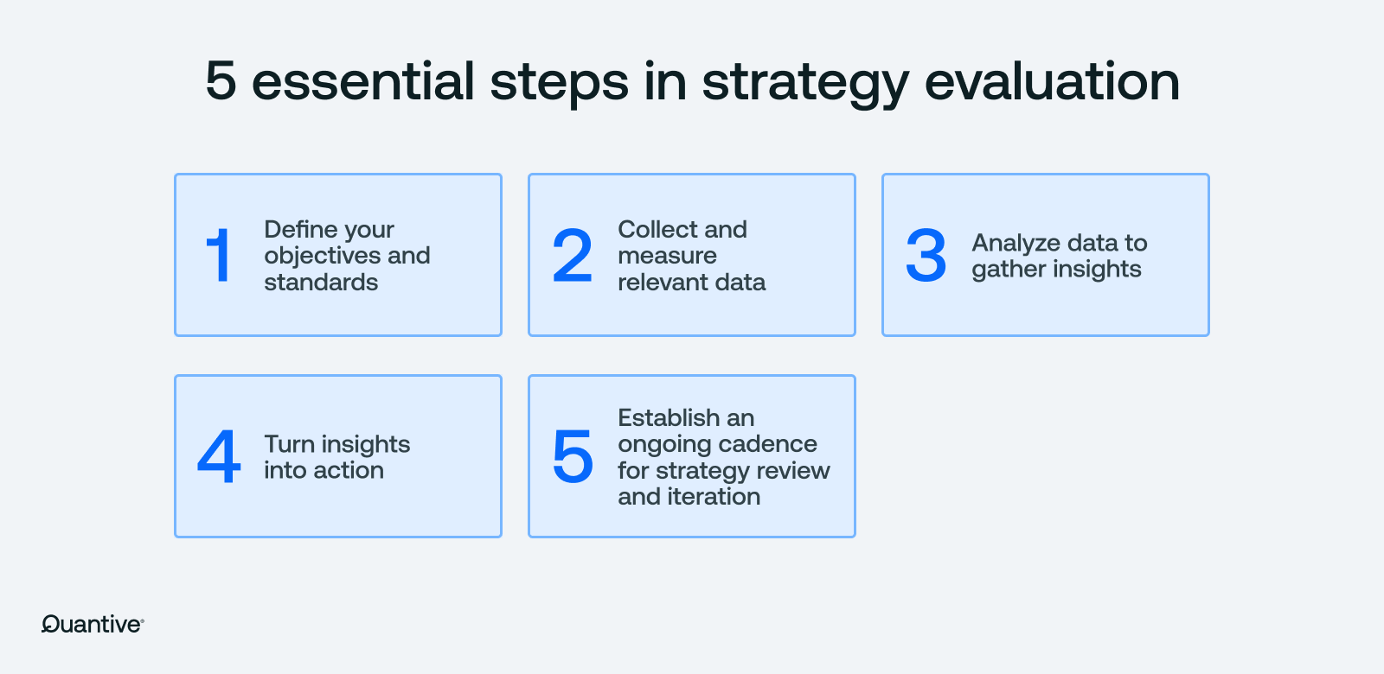

3. STRATEGY FORMULATION FOR MARKET ENTRY

3.1 Market Entry Mode Strategy
In order to enter India, Five Guys must develop a strategy that will maintain quality and adapt to the local market. A joint venture with an Indian based foodservice company that is familiar with India is the best strategy since rules in India are complex, the supply chain is divided, and the food habits in India are very diverse. According to transaction cost theory, when quality is important to winning, companies choose methods that provide them with greater control. Five Guys do not freeze their food, and everything is always fresh, thus they should monitor each stage of purchasing, cooking, and operating the restaurants. It is difficult to maintain that degree of command in case they simply license the brand. A joint venture allows them to share ownership without necessarily controlling the key ones. Joint venture is also a good idea due to cultural differences. Indians have special food regulations, they have a large number of vegetarians, local preferences and regulations regarding a purchase of beef. Local partner can be able to terminate these differences and assist Five Guys in altering the menu to suit the local preferences and make advertisements that attract city populations. This is compatible with the internationalisation theory: the firms entering distant markets receive assistance of the partners that provide training and a proper local identity (Hasan et al., 2024).
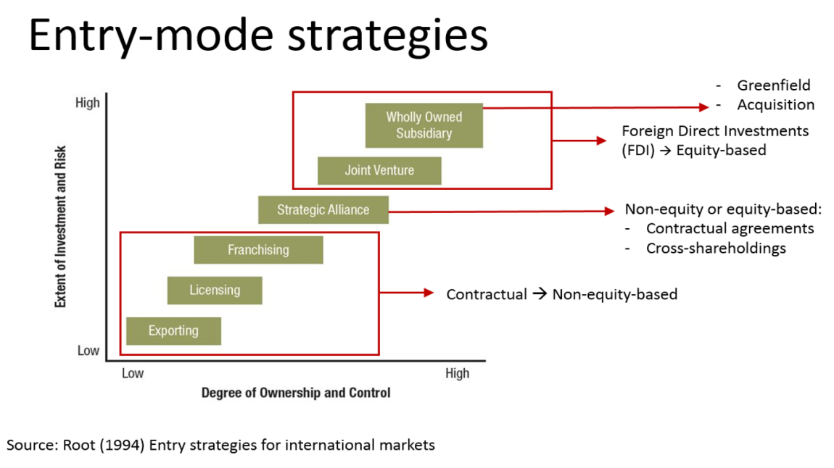
Yet, it is not the best to have a wholly owned subsidiary. It offers much control, however, it comes with increased money and risk. The uncertainty surrounding operations in India can be attributed to complex bureaucracy, real-estate, and supply-chain differences, hence, full ownership is too risky an option when going into business. Moreover, the time, money, and local knowledge would be required to construct an entirely owned supply chain that would comply with the stringent quality regulations at Five Guys.
A master franchise system is not suitable to Five Guys because it is widespread within the Indian quick-service restaurant industry. It restricts the ability of the company to control the day to day activities and the stability of the quality of products which are regarded as the core of the Five Guys brand promise. A master franchisee may be oriented to its rapid development instead of adhering to the international standards that may undermine the brand. Theory of examining transaction cost informs that franchising helps more in the likelihood that partners will act in their self interest, particularly in the markets with weak enforcement or large cultural disparities. It is because of these reasons that a joint venture provides Five Guys with the appropriate amount of control, risk management, and cultural fit. It allows Five Guys to maintain quality, distribute knowledge effectively and leverage a partners established relationships in the supply chain, gaining regulatory assistance and facilitated market entry. When the brand is successfully built and its procedures stabilise, Five Guys can gradually expand with a few selective sub-franchises in the joint-venture system (Geegan et al., 2025).

3.2 Competitive Strategy & Positioning
Five Guys ought to apply the differentiation strategy in India, as part of its global branding strategy. The fast-casual market is highly competitive in India. Big chains like McDonalds and Burger King offer low-price products, whereas other local gourmet chains focus on high-end clients. Five Guys concentrates on freshly made to order burgers without any form of freezing. This makes it unique and a combination of quality and fast service (Banerjee, 2024).
The differentiation strategy is aligned to the social and economic tendencies as discussed in Section 2. The rising middle and upper-middle classes in India are seeking more pleasant and enjoyable food. The primary individuals who consume food delivery and go to restaurants, to whom this theme is applied, are urban millennials, who happen to be sincere, genuine, and consume products of the finest quality produced by international companies that feel natural. Selling homemade burgers, huge portions, and allowing customers to observe the kitchen Five Guys will get access to the people who attach importance to quality and experience rather than cheap prices.
The pricing will be extremely significant. Price is important to Indian shoppers, however, they will pay more in case they can perceive value. Five Guys can employ a high-but-reasonable price strategy, that is, a higher price than such fast-food chains but less than fine restaurants. The large quantities of portions, topping options, and the guarantee of fresh foods make the price seem reasonable and contribute to maintaining it above the prices of the majority of fast-food competitors (Sinha, 2021).

The variousiation strategy should be supported by the store experience. The red-and-white appearance of Five Guys, the open kitchen, and emphasis on honesty can be used to establish the trust and authenticity. The brand must also demonstrate that it is the same everywhere and yet localized touches should also be made such as menu items that fit the area and choices to make as a vegetarian. This strategy supports the elite burger market that appears to be promising in the competitive analysis.

On the whole, differentiation strategy allows Five Guys to establish a clear position in the market that leverages its strong resources, including fresh food and easy operations and large global brand, and addresses the needs of the locals. This fit continues to make the company competitive and helps in achieving its long term objectives in India.

3.3 Growth Strategy (Ansoff Matrix + BCG Matrix)
Five Guys is venturing into India through a conventional Market Development strategy of the Ansoff Matrix. The company introduces its traditional menu to a foreign country; this consists of burgers, fries, and milkshakes. This strategy is based on the global branding of what they are selling and expanding their client base in the fast expanding Indian market. Meanwhile, Five Guys should employ Product Development which will focus on domestic preferences. Since vegetarianism is a popular culture among the Indians, the chain will have to provide quality vegetarian burgers, new side dishes and also local flavors. This will assist the brand to be adapted to the local culture without losing its original style (Wadkar et al., 2024).
With the BCG Matrix, suppose that the core of Five Guys should be a Star since it is selling a lot in all parts of the world and in particular in large cities in India. Their well known fries a fresh and large one may be a Cash Cow worth making good money and liked by people everywhere. Milkshakes, as popular as it may be globally, may even be Question Marks in India initially since the citizens of the country like light beverages and local sweets. Their success will be determined by how well they adapt to the local preferences, charge the appropriate price and the effectiveness of the advertising campaign (Gandhi, 2024).

Both tools have limits. Ansoff Matrix simplifies the strategy since it assumes a linear growth of business. It does not give full attention to the level of competition and how culture alters it. The BCG Matrix too has a limitation since it believes that markets remain unchanged, and products pass through distinct life-cycle stages. The same is perhaps not the case in India where food-service industry is dynamic and fragmented. Despite these issues, the tools can be helpful to establish growth priorities and identify the way to utilize resources.

Applying Ansoff and BCG simultaneously allows Five Guys to concentrate on two aspects, namely, opening more stores in large cities fast and enhancing the products in order to make people test and keep using them. This combination assists Five Guys in maintaining a stable brand on the global level as well as addressing the local preferences.

3.4 Strategic Initiatives
Five Guys needs to implement a series of aligned activities to penetrate and expand in India, which are in line with the primary conclusions made by PESTLE and VRIO analyses (Sushil and Dhir, 2024).
1. Localised Supply Chain Development: Due to regulations and other local traditions that complicate beef supply, Five Guys must establish a local supply chain centered on the high-quality chicken, vegetarian meals, as well as food produced in the area. This will make the business distinctive, as the food will be fresh and the business will be operating smoothly (Patience, 2021).
2. Partnerships with Food Delivery Platforms: India is one of the largest food delivery markets in the world. Working with Swiggy and Zomato will also allow us to access more clients, rise in brand awareness, and purchase our products easier via numerous channels. This is equal to the technology opportunities we discovered in our PESTLE.
3. Tiered Store Expansion Plan: First, increase in the high-income, congested cities such as Delhi, Mumbai, Bangalore, and second, shift to Tier-2 cities where the dining business is expanding. This is a step by step plan, which narrows down on uncertainty and aligns data on the amount that can be spent by people living in cities (Karulkar et al., 2025).
4. Menu Localisation Strategy: Five Guys ought to introduce high quality vegetarian burgers, regional spiced sauces and local regional flavors at specific seasons. This is sensitive to cultural expectations and aids them to shine out in the market as pointed out in the social analysis of Section 2.
5. Talent Development and Operational Training: The VRIO strengths of Five Guys should be operational consistency. Local training academy can ensure that staff are exposed to know the global preparation rules of the brand as they adapt to local service expectations. This ensures efficiency, quality and brand authenticity (Quaranta, 2025).
6. Sustainability and Waste Reduction Plan: The increased environmental consciousness among the people of India implies that companies must package their products in eco-friendly ways, supply materials in a responsible manner, and minimize waste. This will see them fulfill the standards and enhance their image among millennial customers in cities.
7. Digital Customer Engagement: The combination of loyalty programs, ordering on app, and real-time feedback systems can enhance customer retention and enhance the use of data to make decisions. This is based on the willingness of India to embrace technology and the quality service experience (Deshmukh, William and Rana, 2024).
Combined, these efforts lead to an evident strategy of joining the market based on the global advantages of Five Guys and suitable to the unique customers, regulations, and competition of India.
4. PERFORMANCE MEASUREMENT SYSTEM

4.1 Choice of Framework & Justification
The most appropriate way of looking at the effectiveness of the plan of Five Guys to enter the Indian market would be to use the Balanced Scorecard (BSC) since it integrates money, operations, customers, and learning into a single cohesive system. Entering into a new market different culturally and with a high growth rate implies that we have to witness various aspects of performance, not only money. The BSC can enable Five Guys to monitor the performance of its distinctive menu, local supply chain, and customer experience. It also aids in ensuring that long-term objectives are aligned to day-to-day work which is extremely critical when the business is in its infancy (Dwivedi et al., 2020).
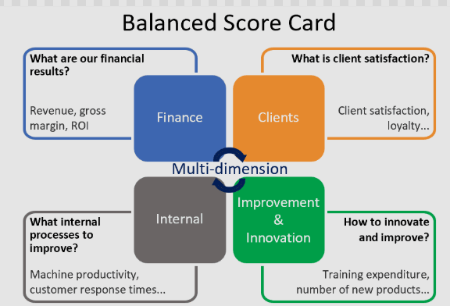

4.2 Balanced Scorecard Objectives, KPIs & Targets
Financial Perspective
The main financial goal of Five Guys in India will be to achieve early profitability and deal with the fact that the initial investment in the country is significantly high because of the necessity to create local supply chains and the premium store formatting. KPIs that can be used to measure performance include the revenue per store, gross margin, and return on investment (ROI) in the initial three years. The realistic goal would be realization of store-level profitability in 18-24 months of operation, which is in line with other premium fast-casual brands. Monitoring the financial performance will assist the Five Guys in negotiating between premium pricing and the price-sensitive nature of the Indian consumers (Biswas et al., 2022).
Customer Perspective
Customers consider the liking of the brand and returns. The most significant figures to consider are NPS, the level of customer happiness, and their frequency of returning. These will assist in determining whether the special approach of Five Guys will succeed with locals. Additional issues to gauge include the ratings of reviews on Swiggy and Zomato on delivery, as this is important since many Indians use online order delivery. In the event that NPS is above 50 and at least 4.2 out of 5 remain fixed in the initial two years, then that is an indicator that the brand is performing (Chauhan, 2023).
Internal Process Perspective
It is necessary to maintain consistency in the operations to make Five Guys stay fresh. Within the restaurant, we observe things such as whether orders are accurate, serving time and food wastage and the meeting schedules with the suppliers. In the first year, we will achieve efficiency and reliability by delivering orders within 8-10 minutes and reducing the food waste by 15%. We monitor the time of suppliers delivery and make sure that they comply with the food-safety regulations of Five Guys, thus local supply chains are aligned with our activities (Zhang et al., 2024).
Learning & Growth Perspective
The learning and growth aspect considers the development of local skills of Five Guys. Our desire is to train our employees, exchange experience, and establish the culture in accordance with the international values of the brand. This will be measured by such things as the number of training hours received by the employees, the number of employees who are retained in the company, and those who are promoted. We want all the new staff to complete 40 hours of training and at least 75 percent to remain with us. Local training academy will assist in increasing skills and contributing to the long-term learning (Chen et al., 2025).

4.3 Limitations of the Balanced Scorecard
Even though the Balanced Scorecard provides a clear mechanism of monitoring performance, it has certain issues. Practitioners allege that it concentrates too much on figures and disregards other significant non-numeric issues such as how well a company corresponds with a culture or the feeling individuals have towards its brand. These are extremely significant in the process of venturing into the Indian market. It is also the assumption of the BSC that the objectives of four areas always complement each other, although in some cases they may be the competition. As an illustration, low cost and high quality product conflict. The BSC also requires too much data and cooperation of managers, which can be challenging to achieve when a business has just begun expanding. Nonetheless, the BSC can be applied even when it is supplemented by good judgment and checked as time goes by (Halkos et al., 2024).

5. CONCLUSION
The discussion indicates that India is an excellent location to Five Guys due to the fact that the nation is experiencing rapid growth, the population has more money, and people desire decent foreign food. The PESTLE and Five Forces checks indicate that the market is not immune to changes and is highly contested, but the brands that provide an alternative fast-casual experience would be successful in the long run. The issues such as a tough supply chain, food preferences of the people, and regulations that require Five Guys to have a clear plan to enter are however, problems. According to VRIO analysis, Five Guys has unique capabilities that cannot be easily replicated by others, namely its pledge of fresh food, easy operations, and well-established international brand and can be properly applied in India when the company collaborates with local partners (George, 2023).
The proposal indicates that it will be a joint venture into the market. This enables us not only to retain control over the quality of products but also to know a local market. We specialize in providing food fresh, openness in ingredients and customizing orders. This is what makes Five Guys uniquely positioned in high-end fast-casual marketplace where consumers seek quality and begin with an awesome experience. In order to expand, we will source locally, modify the menu, take advantage of digital technologies, and expand gradually into other regions. This plan assists in building our brand and maintains the operations. Balanced Scorecard is an instrument to monitor financial issues, customer satisfaction, in-house operation, and employee competency. It maintains our goals and activities in line (YOGANANDHAM, 2024).
On the whole, Five Guys can easily penetrate India, yet they have to adapt to the local culture, regulations and competitors. Their high strengths, distinct unique selling factors, and adequate performance monitoring would provide them with a good opportunity to succeed in the long run. The emphasis on the best quality operations, the rapid response to customer feedback, and continuous learning will become the pillars of transforming this growth into tangible sustainable value (Vuori and Tushman, 2024).

References
Aggarwal, A. (2025). Can India Be the Next Biggest Story? Opportunities and Structural Challenges. WORLD SCIENTIFIC (EUROPE) eBooks, pp.49–71. doi: https://doi.org/10.1142/9781800616226_0003.
Anderson, P. (2025). The pestel framework and its variants for analysing the strategic environment: Evolution, limitations and adoption in energy policy research. SSRN. [online] doi: https://doi.org/10.2139/ssrn.5266562.
Baas, M. (2023). Masculinity and Muscularity in a Changing India. pp.527–539. doi: https://doi.org/10.4324/9781003278436-41.
Bakatsis, P. and Verma, A. (2025). Enhancing the Dining Experience at Restaurant Version to increase Customer Retention and Attraction. Theseus.fi. [online] doi: http://www.theseus.fi/handle/10024/894533.
Banerjee, M. (2024). Elaborating On Ethnic Entrepreneurship: How Differences in Immigrant Founders’ Strategic Choices Regarding Human Capital Sourcing Affect Business Model Designs and Evolution. Entrepreneurship Theory and Practice. doi: https://doi.org/10.1177/10422587241280125.
Batschauer da Cruz, C.B., Eliete Floriani, D. and Amal, M. (2020). The OLI Paradigm as a Comprehensive Model of FDI determinants: a sub-national Approach. International Journal of Emerging Markets, 17(1). doi: https://doi.org/10.1108/IJOEM-07-2019-0517.
Bhurat, K., Bhurat, S.S. and Dhoot, P. (2025). Understanding the possibilities, challenges, and opportunities in relationship between IPRs and food technology. International Journal of Intellectual Property Management, 15(1), pp.41–59. doi: https://doi.org/10.1504/ijipm.2025.145166.
Biswas, S., Bhattacharya, M., Sadarangani, P.H. and Jin, J.Y. (2022). Corporate governance and earnings management in banks: An empirical evidence from India. Cogent Economics & Finance, 10(1). doi: https://doi.org/10.1080/23322039.2022.2085266.
Chauhan, J.S. (2023). Brand Loyalty and Its Impact on Repeat Purchase Behaviour of Customers: a Cross-Sectional Study in the FMCG Context. Psychology and Education Journal, 55(1). doi: https://doi.org/10.48047/pne.2018.55.1.83.
Chen, Y., Guo, X., Shi, Z., Song, Z. and Zhang, J. (2025). T2VWorldBench: A Benchmark for Evaluating World Knowledge in Text-to-Video Generation. [online] arXiv.org. Available at: https://arxiv.org/abs/2507.18107 [Accessed 3 Dec. 2025].
Chowdhury, E. (2025). Market Entry Strategy for New Food Brands. Theseus.fi. [online] doi: http://www.theseus.fi/handle/10024/889793.
Deshmukh, D.K., William, C. and Rana, A.-S. (2024). AI-POWERED PREDICTIVE MARKETING SYSTEMS ENHANCING CUSTOMER RETENTION AND REVENUE OPTIMIZATION IN GLOBAL ENTERPRISES - Repository Universitas Muhammadiyah Sidoarjo. Umsida.ac.id. [online] doi:http://eprints.umsida.ac.id/16403/1/AI-POWERED%20PREDICTIVE%20MARKETING%20SYSTEMS.pdf.
Dwivedi, R., Prasad, K., Mandal, N., Singh, S., Vardhan, M. and Pamucar, D. (2020). Performance evaluation of an insurance company using an integrated Balanced Scorecard (BSC) and Best-Worst Method (BWM). Decision Making: Applications in Management and Engineering, 4(1), pp.33–50. doi: https://doi.org/10.31181/dmame2104033d.
Gandhi, M. (2024). A STUDY ON THE INFLUENCE OF MARKETING STRATEGIES OF FOREIGN FAST-FOOD BRANDS IN THE INDIAN MARKET Dissertation Submitted by TANIA SAJI (SB21ACOM044) MERLIN SARA VINOD (SB21ACOM031) NANDANA A NAIR (SB21ACOM032) Under the guidance of Ms. REEMA DOMINIC In partial fulfillment of the requirement for the Degree of BACHELOR OF COMMERCE Nationally Re-Accredited with A++ Grade Affiliated to. [online] Available at: http://117.239.78.102:8080/jspui/bitstream/123456789/4248/1/tania.pdf.
Geegan, S.A., Guo, S., Bingham, C., Jaffe, D. and Callahan, L. (2025). Meaningful Change from Spare Change: A Multi-Stakeholder Relationship Management Analysis of McDonald’s Round-Up Campaign. International Journal of Strategic Communication, pp.1–20. doi: https://doi.org/10.1080/1553118x.2025.2584543.
George, D.A.S. (2023). Evaluating India’s Economic Growth: Challenges and Opportunities on the Path to 5 Trillion Dollars. Partners Universal International Innovation Journal, 1(6), pp.85–109.
Halkos, G.E., Koundouri, P.C., Aslanidis, P.-S.C. and Angelos Plataniotis (2024). Evaluating the tangible and intangible parameters of cultural heritage: an economic meta-analysis in a global context. Discover Sustainability, 5(1). doi: https://doi.org/10.1007/s43621-024-00398-w.
Hamdoun, M., Achabou, M.A. and Dekhili, S. (2021). Could CSR improve the financial performance of developing countries’ firms? Analyses of mediating effect of intangible resources. European Business Review, 34(1), pp.41–61. doi: https://doi.org/10.1108/ebr-09-2019-0236.
Hasan, M.M., Rayhan, Z., Mukta, R.T. and Faruq, O. (2024). Research on Adapting Marketing Techniques to Different Culture Economics and Regulatory Environment to Entering New International Markets. Информатика. Экономика. Управление / Informatics. Economics. Management, [online] 3(4). Available at: https://cyberleninka.ru/article/n/research-on-adapting-marketing-techniques-to-different-culture-economics-and-regulatory-environment-to-entering-new-international.
Hong, P.C., Young Soo Park, Hwang, D.W. and Mehrdad Jalali Sepehr (2024). A growth theory perspective on the competitive landscape of shipbuilding: a comparative study of Japan, Korea, and China. Maritime Economics & Logistics. doi: https://doi.org/10.1057/s41278-023-00279-5.
Jayawardana, Dodamwalage Chaminda Deepal and Jayawardana, Dodamwalage Chaminda Deepal (2025). The factors affecting the fast-food industry and consumer trends in Sri Lanka. Tdx.cat. [online] doi: http://hdl.handle.net/10803/695043.
Karulkar, Y., Sampat, B., Thapliyal, A., Singh, B. and Gupta, D. (2025). Zepto: redefining the future of rapid delivery. Emerald Emerging Markets Case Studies, 15(1), pp.1–36. doi: https://doi.org/10.1108/eemcs-12-2023-0491.
Kizito, B.A. (2023). Strategic Management Practices and Competitiveness of Fast-food Eatery Chains in Nairobi, Kenya. [online] erepository.uonbi.ac.ke. Available at: http://erepository.uonbi.ac.ke/handle/11295/164829.
Mammen, R. (2024). Indies: Who Are They? Why Are They an Important Demographic Segment of Fast-Casual Restaurants? Journal of hospitality & tourism cases. doi: https://doi.org/10.1177/21649987241241940.
Mccall, A. (2024). Strategic Management and Competitive Advantage. [online] Available at: https://www.researchgate.net/profile/Andrei-Mccall-2/publication/386050766_Strategic_Management_and_Competitive_Advantage/links/67413cd9868c966b9326074f/Strategic-Management-and-Competitive-Advantage.pdf.
MEDINA CINTRON, F. (2022). Innovation Strategies to Create Sustainable Fast-Casual Restaurants. Walden Dissertations and Doctoral Studies. [online] Available at: https://scholarworks.waldenu.edu/dissertations/13577/.
Ogunsola-Saliu, K. and Alotaibi, A. (2025). Critical Circumstances Influencing Franchisees’ Business Performance: A Review of the Saudi Arabian Franchise System. Businesses, 5(3), p.33. doi: https://doi.org/10.3390/businesses5030033.
Patience (2021). An Exploration of Zimbabwean and British Chickenscapes to Understand Food Safety and Supply - White Rose eTheses Online. Whiterose.ac.uk. [online] doi: https://etheses.whiterose.ac.uk/29973/1/THESIS_Patience%20A%20N%20Muchada.pdf.
Pham, T. (2024). The Role of Social Media Marketing in Building Customer Loyalty in Fast Casual and Fast-Food Restaurants in Helsinki. [online] www.theseus.fi. Available at: https://www.theseus.fi/handle/10024/860048.
Quaranta, A. (2025). Applying the VRIO Framework to Clinical and Operative Workflows in Dental Practice Management. Annali di Stomatologia, 16(1), p.31. doi: https://doi.org/10.59987/ads/2025.1.31-36.
Ranjan, D.R., Singh, D.P., Malhotra, D.G., Gupta, D.V. and Lal, R. (2024). The Standards of Attractiveness: Media Influence on Perception of Body Image. SSRN Electronic Journal. [online] doi: https://doi.org/10.2139/ssrn.4998431.
Sinha, R. (2021). Engineering, Technology & Management (IJMRSETM) | ISSN: 2395-7639 | www.ijmrsetm.com | Impact Factor: 7.580| A Monthly Double-Blind Peer Reviewed. International Journal of Multidisciplinary Research in Science, [online] 8(6), p.1209. Available at: https://ijmrsetm.com/admin/img/15_Effect%20of%20Price.pdf.
Sushil and Dhir, S. (2024). Strategy Formulation and Adaptation. Strategic Management, pp.193–211. doi: https://doi.org/10.1007/978-981-97-4788-7_11.
Wadkar, S.K., Kumar, M., Goswami, V. and Kaul, A. (2024). Market Diversification Strategies for Enhancing Competitiveness of Indian Marketing Cooperatives: Lessons from Gujarat State Cooperative Marketing Federation Ltd. (GUJCOMASOL). International Journal of Global Business and Competitiveness. doi: https://doi.org/10.1007/s42943-024-00108-3.
Wen, H. (2022). Between farms and chopsticks : the role of brands in (re)organising the fresh food sector in China - WRAP: Warwick Research Archive Portal. Warwick.ac.uk. [online] doi: https://wrap.warwick.ac.uk/id/eprint/174097/1/WRAP_THESIS_Wen_2022.pdf.
Wiatrowski, M., Czarniecka-Skubina, E. and Trafiałek, J. (2021). Consumer Eating Behavior and Opinions about the Food Safety of Street Food in Poland. Nutrients, 13(2), p.594. doi: https://doi.org/10.3390/nu13020594.
YOGANANDHAM, D.G. (2024). UNVEILING INDIA’S ECONOMIC GROWTH TRAJECTORY: NAVIGATING CHALLENGES AND SEIZING OPPORTUNITIES ON THE ROAD TO A $5 TRILLION ECONOMY. [online] Academia.edu. Available at: https://www.academia.edu/download/115343539/3_DJ1295.pdf.
Zhang, R., Huang, Z., Liu, B. and Wang, J. (2024). Freshness-keeping efforts and value-added service choice in fresh food supply chain. Computers & Industrial Engineering, 190, pp.110063–110063. doi: https://doi.org/10.1016/j.cie.2024.110063.
Ziółkowski, J. (2024). Can innovation enhance the culinary experience? : turning an idea into an MVP step by step. Urn.fi. [online] doi: http://www.theseus.fi/handle/10024/875342.

