CLOSED SYSTEMS

Exercise 1:
A rigid container equipped with a stirring device contains 1.5 kg of motor oil. Determine the rate of specific internal energy increase when heat is transferred to the oil at a rate of 1 W, and 1.5 W of power is applied to the stirring device.

Exercise 2:
A frictionless piston-cylinder device initially contains 200 L of saturated liquid refrigerant 134a. The piston is free to move, and its mass is such that it maintains a pressure of 900 kPa on the refrigerant. The refrigerant is now heated until its temperature rise to 70°C. Using Table A-11 through A-13, calculate the work done if 47.5 MJ of heat is transferred to the refrigerant during this process.

Q

R-134a

P = constant

Exercise 3:
A 4-m × 5-m × 6-m room is to be heated by a base-board resistance heater. It is desired that the resistance heater be able to raise the air temperature in the room from 7 to 23°C within 15 min. Assuming no heat losses from the room and an atmospheric pressure of 100 kPa, determine the required power of the resistance heater. Assume constant specific heats at room temperature.

Notes:
- Air is considered as an ideal gas.
- Gas constant and specific heats values can be found in table A-2.

Exercise 4:
A student living in a 4-m × 6-m × 6-m dormitory room turns on her 150 W fan before she leaves the room on a summer day, hoping that the room will be cooled when she comes back in the evening. Assuming all the doors and windows are tightly closed and disregarding any heat transfer through the walls and the windows, determine the temperature in the room when she comes back 10 hr later. Use specific heats values at room temperature, and assume the room to be at 100 kPa and 15°C in the morning when she leaves.

Notes:
- Air is considered as an ideal gas.
- Gas constant and specific heats values can be found in table A-2.

Exercise 5:
Air is contained in a variable-load piston device equipped with a stirring wheel. Initially, air is at 500 kPa and 27°C. The stirring wheel is now turned by an external electric motor until 50 kJ/kg of work has been transferred to the air. During this isobaric process, heat is transferred to maintain a constant air temperature while allowing the gas volume to triple. Calculate the required amount of specific heat transfer q.

Air
500 kPa
27°C
q

Notes:
- Air is considered as an ideal gas.
- Gas constant and specific heats values can be found in table A-2.
- For the isobaric process of an ideal gas, the boundary work relation is, $w_{b}=P.\left(v_{2}-v_{1}\right)$

Exercise 6:
A mass of 15 kg of air in a piston-cylinder device is heated from 25 to 77°C by passing current through a resistance heater inside the cylinder. The pressure inside the cylinder is held constant at 300 kPa during the process, and a heat loss of 60kJ occurs. Determine the electric energy supplied in kJ.
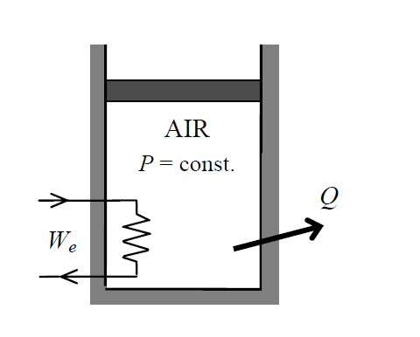
Notes:
- Air is considered as an ideal gas, Table A-17 can be used (or not).
- Gas constant and specific heats values can be found in table A-2.
- For the isobaric process of an ideal gas, the boundary work relation is, $w_{b}=P.\left(v_{2}-v_{1}\right)$

