

COMBINING THE DIGITAL WITH THE PHYSICAL: GAMIFICATION AND IOT
by
Nathan Daniel Morgan

Supervisor: Dr Stephen Hole
Second Marker: NAME HERE

Project submitted as part of the requirements for the award of MSc Applied computing(Software engineering)

September 2022

Declaration form
I, Nathan Daniel Morgan declare that I am the sole author of this Project; that all references cited have been consulted; that I have conducted all work of which this is a record, and that the finished work lies within the prescribed word limits.

This work has not previously been accepted as part of any other degree submission.

Signed : .........Nathan Daniel Morgan....................................

Date : .............04/09/2022..................................

Form of consent
I, Nathan Daniel Morgan hereby consent that my Project, submitted in candidature for the M.Sc. Applied Computing degree, if successful, may be made available for inter-library loan or photocopying (subject to the law of copyright), and that the title and abstract may be made available to outside organisations.

Signed : .........Nathan Daniel Morgan....................................

Date : .............04/09/2022..................................

Acknowledgements
I would like to acknowledge and thank my supervisor Dr Stephen Hole for his help and support in this endeavour making my progress possible. I would also like to thank the University of Wales Trinity Saint David for providing me the opportunity to study with the institution and affording me the opportunity to pursue this level of education through their continued support.

I would also like to thank my partner and my son for their continued inspiration, support and motivation that has driven me to pursue this qualification.

Abstract
In this project the concept of gamification is explored in the context of physical activity, utilising modern technologies such as the IoT and a single page application to serve dynamic content to the user. Aiming to deliver a unique experience that is engaging for long term participation to improve the physical health and wellbeing of the participants. Research will be conducted through a literature review, building a hypothesis that gamification will be applicable to the problem area of long-term engagement. The need for a platform of this nature is becoming increasingly evident as each year the statistics highlight the deterioration of the overall activity levels of the country. The project will utilise the IoT to capture physical activity data from the users, and then incorporate this data through a gamified experience, where the users are rewarded for their participation. There will be a series of rewards for the user to achieve, by ultimately reaching their daily recommended activity milestones consecutively. The implementation will be achieved through a bespoke software solution that will allow the user to view and interact with the platform to get a visual representation of their progress and provide the user with a real time break down of their data. The software will have several requirements such as the ease of use, reasonable performance and highly accessible from the various devices a user may have. Taking inspiration from the wildly successful and popular giants in the gaming industry, incorporating the most modern approaches to user retention and engagement using the battle pass concept.

Contents
Declaration form 2
Form of consent 2
Acknowledgements 2
Abstract 3
Figures and tables 6
1 Introduction 7
1.2 Aim 7
1.3 Objective 1 7
1.4 Objective 2 8
1.5 Objective 3 8
1.6 Objective 4 8
2 Literature Review 9
2.1.2 The ‘battle pass’ concept 10
2.1.3 Examples of a ‘battle pass’ 10
2.1.3.1 Apex Legends 10
2.1.3.2 Fortnite 11
2.1.4 Conclusion of ‘battle pass’ investigation 11
2.2 Exploration of other available platforms and products 11
2.2.1 Nike Run club+ 11
2.2.2 Zombies, run! 12
2.2.3 The Gamercise/Exergame genre 12
2.2.4 Gamification conclusion 12
2.3 Software choices 12
2.3.1 Frontend framework 12
2.3.2 Angular 14
2.3.2.1 Lazy loading versus eager loading 14
2.3.2.2 Reactive programming with Reactive Extensions for JavaScript 14
2.3.2.3 Usability 15
2.3.2.4 Search engine optimisation 15
2.3.3 Server frameworks 15
2.3.4 Data pipeline 16
2.3.5 Database Management Software 16
2.3.5.1 Structured versus Unstructured 16
2.3.5.2 Big data 16
2.3.5.3 Data warehouse 17
2.3.5.4 DBMS choices for Datawarehouse 17
2.3.5.5 Database Management Software Conclusion REIA 17
2.3.6 Software environments 18
2.3.7 Conclusion of software choices 18
2.4 Health and wellbeing 19
2.4.1 The harmful effects of not getting enough physical activity 19
2.4.2 Incentives to maintain a high level of physical Activity 20
2.4.3 How to gauge an increase in activity levels 20
2.4.4 What physical activities are beneficial 20
2.5 Hardware choices, Fitness trackers 20
2.5.1 Fitbit 21
2.5.2 Google Fit 21
2.5.3 Samsung Health 21
2.5.4 Apple Health Kit 21
2.5.6 Huawei 21
2.6 Conclusion of the literature review 21
3 Methodologies 23
3.1 Research methodology 23
3.1.1 Research philosophy 23
3.1.2 Research strategy 23
3.1.3 The methodological limitations 24
3.2 Development methodology 24
3.2.1 Hardware resources 25
3.2.2 Software resources 25
3.2.3 The methodological limitations 26
3.4 Methodology conclusion 26
4 Design and implementation 27
4.1 Design 27
4.1.1 Designing the database 27
4.1.2 Server architecture design 27
4.1.3 Designing the ‘battle pass’ board 27
4.1.4 Design of the point allocation system 28
4.1.5 Design of the data pipeline 28
4.1.6 Designing the quest board 28
4.1.7 Designing the login and register pages 28
4.1.8 Designing the admin panel 28
4.1.9 Designing the Questionnaire 29
4.1.10 Home page design 29
4.2 Implementation 30
4.2.1 Sprint zero: back-end Initialisation 30
4.2.2 Sprint one: back-end user logic 30
4.2.3 Sprint two: front-end project initialisation & security 31
4.2.3 Sprint three: back-end school logic 34
4.2.4 Sprint four - front-end home page 34
4.2.5 Sprint five - back-end Item and reward logic 34
4.2.6 Sprint six - back-end questionnaire logic and front-end questionnaire 35
4.2.7 Sprint seven - back-end and front-end gamification sprint 35
4.2.8 Sprint eight – back-end step tracking 38
4.2.9 Spring nine - data pipeline 39
4.3 Design and implementation conclusion 40
5 Results and evaluation 41
6 Conclusion 42
7 Recommendations 43
8 Reflection 44
9 References and bibliography 45
Appendix 48

Figures and tables
Figure 1 Apex Legends season 1 battle-pass screenshot https://apexlegends.fandom.com/wiki/Season_1 10
Figure 2 Fortnite season 2 – a battle-pass screenshot https://fortnite.fandom.com/wiki/Season_2 11
Figure 3Nike run club screenshot from website https://www.nike.com/gb/nrc-app 11
Figure 4 Adult obesity levels https://gov.wales/sites/default/files/statistics-and-research/2020-07/adult-lifestyle-national-survey-wales-april-2019-march-2020-390.pdf 19
Figure 5 crude wireframe hand drawn concept of the initial design 27
Figure 6 Authorisation flow 28
Figure 7 Login screen 32
Figure 8 Home page and navigation 33
Figure 9 Registration page 33
Figure 10Adventure board 36
Figure 11 Quest UI 37
Figure 12 Reward component 37
Figure 13Manual activity record 38
Figure 14 Data pipeline flow 39

1 Introduction
Heart disease, type two diabetes, and cancer are among the risks associated with not being physically active. A trend has been identified that exponentially more people are not meeting the recommended minimum amount of daily activity, and this poses a huge risk to the health of the nation and the demand on the health service [1].
Preventing this decline has taken the focus of the health service and they began prescribing physical activity such as walking and cycling to combat the decline [2] [3].

One of the main focuses of this project is to create a platform that is engaging and inspires participants to get active while having fun in a gamified experience. Long term engagement will help form healthy habits that improve the health and well-being.
Approaching arduous tasks such as exercise with an exciting revolutionary approach known as gamification will create an incentive that extends beyond the trivial need to exercise simply because physical health is good. The approach will improve the morale and engagement of the users by applying concepts commonly seen in games to the context of exercise, aiming to provide positive reinforcement to their participation by rewarding their effort.
A positivistic research philosophy will be chosen as the methods for achieving the research goal will follow a structured and statistically factual approach backed up by creating correlations between the facts outlined in the literature review. The development took the approach of using a literature review and experimental software development through the Scrum methodology to implement the planned

There will be several requirements of the software development to achieve the implementation as desired. Many considerations must be made to ensure that the delivered artifact is of the highest quality, that can be measured by the performance, ease of use and the achievement of the requirements.
The report structure will follow the approach of literature review, design, implementation, conclusion, and reflection. This will allow for the process to be discussed in a linear and thorough manner.

1.2 Aim
The aim of the project is to increase the long-term health and wellbeing of participants by encouraging them to participate in physical activities using a digital platform for tracking and rewarding their participation and engaging the users through gamification aspects.

1.3 Objective 1
Design and implement a data warehouse to store captured data from IoT devices, gamification data, reward data and user data.

1.4 Objective 2
Investigate the available sources of IoT data from the various smart devices on the market.
Build a data pipeline for gathering data from external APIs to import the data to the data warehouse.

1.5 Objective 3
Build a backend server to act as a CRUD API that can deliver content to the front-end web application.

1.6 Objective 4
Implement a front-end framework to act as the user interface for the platform, handling elements for authentication and authorisation, user management, and gamification.

2 Literature review
In this literature review a thematic approach was taken to investigate the individual areas of interest. The concept of the platform itself is unique and finding relevant literature that covers all aspects of investigation are sparse. Following a thematic approach will allow for an investigation of the individual core areas that are required for completion. The themes covered will be the gamification elements, the medical benefits, and the software requirements, though this research the objective will be undertaken of building a software platform that will be engaging and fun for participants to improve their health and wellbeing through participating in physical activities that are encouraged using the platform.
2.1.1 Gamification
“Gamification is a revolutionary approach to increasing engagement and improving morale by adding a new spin to monotonous tasks. It is described as “gamification is the use of game design elements in non-game contexts” [4] the quote is widely accepted as the most fitting description of Gamification. Gamification will be a major factor in promoting participation, alongside providing incentives for achievements. The typical approach of gamification is to provide points, badges, and leader boards to motivate productivity [5], this can be seen as positive feedback or positive reinforcement. This approach has been seen as amazingly effective when implemented correctly and is being seen in many parts of Western culture, ranging from schools to governments and businesses, everyone wants to join the cause [6]. Gamification relies on the engagement aspect to connect with the target audience and get them invested in the use of the service. Engagement is a term that indicates the connection between a consumer and a product or service [7], Zichermann and Cunningham went on to derive a series of metrics for measuring engagement and these metrics are recency, frequency, duration, virality and ratings. These metrics are amalgamated as engagement score [7], this suggests that the engagement of the user and the platform is the most important aspect for user retention. There are several aspects that can be taken from gaming that improve the engagement, such as that a good game is challenging, and an engaging game will often have clear, actionable, and attainable goals combined these factors will push us to the edge of our abilities and this causes peek motivation, interest, and creativity [8]. Gamification when looked at in the context of the outlined platform that will be designed, requires repeated engagement with the platform to ensure benefits are gained. Gamification will also allow for the efforts of the participants to feel meaningful by painting them in a larger context such as how they are benefiting their lives. A typical engagement with the platform will begin with the user creating a profile that can be used to monitor and measure their activity against their peers, and this creates value by engaging in processes and interactions in online and real-life environments [9]. This provides a platform for social interaction and physical activity in a social context by using the platform as a mediator. Gamification has also proven to be an effective way of organising large groups of people, directing them with a set of rules of engagement, such as what to do and when to do it” [10].

2.1.2 The battle pass concept
The battle pass concept has been a contemporary approach to building a highly engaging tiered system that rewards the player for continued engagement for meeting milestones and has been attributed for high player retention [11]. The system is commonly paired with a series of tasks or quests that allows the progression through the tiered system.
A battle pass will typically be time limited and last a predetermined set amount of time with the tasks required to progress taking a calculated amount of time to complete to ensure that to progress through the pass in the allotted time in its entirety the player will have to play for a minimum amount of time and be highly engaged causing a high level of retention for players that are working towards a goal, with the time sensitive nature and some rewards being exclusive to the battle pass period, this causes players to desire them through the psychological phenomenon of ‘fear of missing out‘ [12]. A further ploy to garner engagement is the battle pass will sometimes have an up-front cost to participate with a refund offered if the pass is completed on time. Time limits such as this then gives the user the sense of urgency and requirement to complete the challenges within the limited time. This has been to be successful even without the offer of a refund where there is either a completely paid experience or a premium and a free to play experience as seen it Fortnite, but rather more lucrative rewards for the premium experience.
With the focus of this study not on the monetisation and the elements associated with monetisation it will be briefly covered as the depth this could cover falls out of the scope.

2.1.3 Examples of a battle pass
The battle-pass concept is being adopted rapidly by the giants in the gaming industry, it can be seen in all the major contenders such as Apex legends, Fortnite, Valorant and Call of Duty Warzone and the term battle pass is a loose generalised term for the concept. The title is loose and is often called by its own designation based on the company implementing it such as a survivor pass in the popular ‘Player unknown’s Battleground’, or rocket pass in the Rocket League game.

2.1.3.1 Apex Legends
The Apex Legends take on the battle-pass was quite successful and had an up-front cost of 950 apex coins (worth £10) with no free tier available, but the hook that got many people interested is that you could get 1000 apex coins for completing the pass, in turn getting your buy in refunded to pay for the next pass. Furthermore, the Apex Legends battle pass rewards are all exclusive to the season unlike Fortnite where the rewards offered are generically available in the in-game shop.

Figure 1 Apex Legends season 1 battle-pass screenshot https://apexlegends.fandom.com/wiki/Season_1

2.1.3.2 Fortnite
Fortnite's battle-pass had an upfront cost of 950 V-bucks (worth £9), their premium currency but with a reward value of over 14,000 V-bucks if you were to purchase the rewards individually, this drew a wide number of players to purchase the pass that usually would not spend any money on the free to play game [13].

Figure 2 Fortnite season 2 – a battle-pass screenshot https://fortnite.fandom.com/wiki/Season_2

2.1.4 Conclusion of battle pass investigation
The battle pass is fundamentally the same in concept regardless of the implementation, it offers a tiered progression through a series of tasks in a time limited scenario, sometimes referred to as a season or a chapter. The rewards are often exclusive or heavily discounted through the battle pass. The battle pass tasks will often follow a similar pattern of activities that take time and keep players engaged in the game itself.
The battle pass can be seen as a tool for player retention requiring elevated levels of player engagement to get their sought-after rewards.

2.2 Exploration of other available platforms and products
The study of Gamification in the context of physical activity has been providing promising results in building and maintaining positive health behaviour and an improved well-being [14]. Platforms such as Nike run club (NRC) [15] and zombies run [16] had been proven to be quite popular gamified physical activity experiences [17].

2.2.1 Nike Run club+
The Nike Run Club (NRC) is an application that aims to increase the physical health of the participants by coaching them while they are training and rewarding their activity. As seen in Figure 3 the app offers challenges such as to run a set distance and gives them relevant on-screen feedback such as how much progress they have made and how they measure up against other participants.
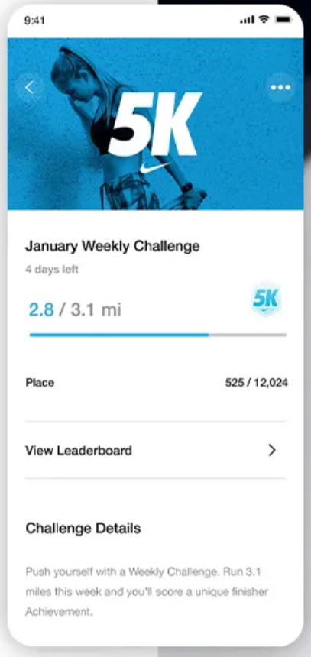
Figure 3Nike run club screenshot from website https://www.nike.com/gb/nrc-app
NRC is more community oriented than rewarding participation, where the best reward you will receive is a literal virtual high five and the health benefits are their own reward.
2.2.2 Zombies, run!
Zombies run is a unique gamified experience that takes an interesting approach to the genre. The primary agenda of the game is to get the player running, the player embodies a character set in a zombie apocalypse and while they are playing the game, they can listen to their own music intertwined with audio narrations to slowly uncover the story. The gamified approach allows the player to start a “mission” where the statistics are tracked such as distance, pace, and time with additional game modes to participate in a zombie chase where they must run at least 10% faster than normal. The game also has mechanics for when the player is physically running they can collect materials and resources to upgrade their base camp [18].
2.2.3 The Gamercise/Exergame genre
The Gamercise genre has been an underdog in the gaming world for many years, but still popular in niche circles. The genre could be seen historically quite a variety of different approaches such as dancing games like ‘Dance Dance Revolution’, Nintendo’s Wii Fit, Microsoft’s Kinect and the current era of virtual reality. The main difference between the Gamercise genre and regular gaming is that Gamercise challenges the stereotype of gaming being sedentary and are seen as an evolving technology that aims to making exercise more fun [19]and has been considered a valid way of fighting obesity [20].

2.2.4 Gamification conclusion
Gamification will prove to be an engaging element that will give the participants a reason to get heavily involved with the platform and encourage participants to return to the platform with incentives and psychological factors such as the fear of missing rewards. There has been a long-standing history of games that involve exercise and a new wave of gamification elements being implemented to turn arduous tasks into something that can be considered as fun or engaging. These factors are why gamification will be a key element in building an engaging platform that will have longevity and sustainability.

2.3 Software choices
Throughout the development of the project a wide variety of software will be necessary to achieve the implementation of the platform, a lot of decisions will be required to determine what software to utilise. The software chosen will be chosen primarily on the scalability and the suitability for the tasks.

2.3.1 Frontend framework
The user interface will be the main point of contact for the end users and the administrators alike, even with the masses of software that will be required on the back end the interface will be an especially important aspect, not only will it be the first impression left on the user it will also be the way the user interacts with the platform. There are many considerations when building the front end, most importantly is the usability and the functionality. A web application such as this is only as good as the user lets it be, if the user struggles to interact with the interface or has trouble navigating it will lead to a poor experience and demotivate them from engaging with the platform further. Other factors such as performance will also impact the users experience and will drive users away if they have a negative experience. There are many ways to measure and rate the performance of an application, a common way of measuring performance is with googles lighthouse [21].
A way to simplify these requirements and reducing the overall amount of work required there are many frameworks available, most notably there are Angular, React, Vue, Svelte and Meteor [22] [23] [24] [25] [26]. The frameworks aim to achieve the same common goal of streamlining the process of building a beautiful and functional web application, with the key differences being in the way that the frameworks approach the tasks.
Angular is a popular typescript framework developed by Google, it has been publicly available for 11 years and is currently in its 14th major version. The framework boasts a range of features out of the box and is highly robust enterprise grade framework and is seen widely across the internet as known as one of the most popular frameworks available with a powerful command line interface that can be used to quickly generate modules and components and build powerful applications rapidly.
Angular is one of the most versatile frameworks featuring capabilities to be deployed as a progressive web application, a cross platform mobile application with the help of ionic or as a desktop application through the electron framework angular can be used to build a vast variety of projects.
React is a contender for the most popular framework, this framework built by the tech giant Meta and a large community of developers. React approaches the common problems seen in web applications by moving away from traditional html approach and works closer to the programming language, JavaScript. With a small library React has a large dependency on external modules and components built by the community that can be downloaded through the CLI.
Vue is much like react in its approach and provides a wide variety of UI components out of the box that can be used to build beautiful websites in a rapid prototyping approach, but Vue is more suitable for smaller websites with an easier learning curve than the other frameworks. Developed by a member of the angular development team at google, who left to build their own platform. Evan You set out to build his own approach to the problem and designed his framework with the idea of building quickly, and beautifully.
The project will be highly interactive, so this eliminates static site generators that are more suited to less interactive websites such as Hugo or 11ty [27] [28].
Because the project will be mostly advertised through referrals and word of mouth, the need for search engine optimisation will be quite minimal with a low reliance on getting participants through SEO [29]. With the content being mostly dynamic and frequently changing a form of server-side rendering would be optimal.
For these reasons Angular would prove to be the most suitable for a project of this scope, allowing for the utilisation of the wide range of features offered by the framework and indulging in the high level of performance offered at large scale.

2.3.2 Angular
Angular has proven itself to be a robust and reliable framework and its adoption has been seen everywhere amongst the industries giants. Google utilise their framework extensively and all the Google services are built on the Angular backbone.
Microsoft have also used it and it can be seen in their legacy implementation of Teams, Xbox dashboard and office. In the latest version of teams for the windows 11 version they experiment with the React framework [30].
Forbes [31] is an American business magazine that turned into media giant that produces globally consumed content where most of its content is now served through and their website. The website is built upon the Angular framework [22] [32].
But these are just a handful of everyday names that have implemented the Angular framework, the list is extensive and ever growing.

2.3.2.1 Lazy loading versus eager loading
An important performance factor of web frameworks is how they load the data, Angular allows for the implementation of both main methods. The first method being eager loading, which is the most seen method of loading, and is inefficient but it is the default functionality, it works by loading all the content as the interpreter reads it, but this loads a lot of data into memory that is not required and can impact load times, performance and the amount of mobile data required to do that initial load. Lazy loading on the other hand is the opposite of eager loading and it will only load what is required when it is required by dividing the project in an object-oriented approach where the individual components and their dependencies are loaded on demand [33].

2.3.2.2 Reactive programming with Reactive Extensions for JavaScript
Angular ships with an incredibly powerful library known as Reactive Extensions for JavaScript (RxJS), it is built by the Google team and is integrated heavily within the core of Angular but can be used anywhere that runs JavaScript. The library introduces an innovative approach to composing asynchronous and call back based code by introducing a concept known as observables [34]. An observable can be thought of like an emitter of values and it can be programmatically subscribed to so when the emitter has an update to the value being emitted all the subscriptions get the new value too [35]! This conceptually allows for an innovative approach to sharing information among many points in a large code base.
The RxJS library introduces a lot of methods for interacting with their observables and the entire system becomes a huge quality of life upgrade when implemented correctly.

2.3.2.3 Usability
Angular has common design paradigms bolster great UI UX practices that will help build the project with a strong underlying focus on UI UX, only requiring minimal effort to maintain the strong fundamentals provided. When building an application that will see a wide variety of different able users, it is important that the layout follows the standard norms that people are familiar with incorporating paradigms that are common practice in the industry.
If the user is in a situation where their experience is hindered by a shift in the norm, they may correlate it with a negative experience and feel less comfortable because they are having to consciously navigate the content. When intuitive design is achieved a user will be able to interact with it effectively by applying knowledge subconsciously [36] [37].

2.3.2.4 Search engine optimisation
The nature of modern single page application frameworks is to heavily utilise JavaScript and typescript to populate the DOM with content, but the problem that this causes is that page crawlers for search engines will have fail to get a good representation of the page as the content is not present as the page is scraped. The impact is this prevents the search engine from indexing the page effectively. The way this frequent problem can be resolved is to implement server-side rendering where the content is generated into static HTML files, this has a few benefits for the performance rating of a website, and that it will be indexed correctly by search engine crawlers [38].

2.3.3 Server frameworks
To serve the content stored within the database an implementation of a REST API will be required, but to build a server of this nature there is a wide variety of choice for the frameworks to implement. The variety is quite extensive, for example there is the popular Node.js framework express, or it is baby brother Deno, C#’s Asp.net and the many Python frameworks such as Django or fast API [39]. Java offers its own variety of frameworks with the most notable being spring and spring boot, offering a wide variety of functionality out of the box to quickly build a production grade REST API with type safety, declarative programming through the class-based multi-threaded object-oriented programming language. This allows for several tasks to be execute concurrently making it the most suitable for large scale projects, electing it the most suitable tool for the task.
The spring boot framework really shines when the project requires a high amount of concurrency, firing up a thread for each request utilising a high amount of CPU power whereas when compared to an equivalent server-side architecture Node.js that uses a single-threaded approach that only handles one request at a time [40]. Spring boot is an excellent choice for IoT, big data or comparable large volume processes such as image manipulation or data pipelines [41]. All the mentioned server-side frameworks will communicate over a REST API web service architecture style. The paradigm allows for the smooth communication between servers through a http connection, in a stateless manner. It is the common choice for serving content over the internet [42].

2.3.4 Data pipeline
A data pipeline is the description of transporting data from source in a raw format to a destination, the destination being a form of data store such as a database, data warehouse or data lake. The overall architecture of a data pipeline is to ingest data, transform the data and then store the data. To effectively commit this operation processing is usually required to shape the data into a form that will fit into the destination, the process is often called extract, transform and load (ETL).There are two common types of data pipeline, foremost is a batch processing pipeline that executes the operation at set intervals, and then alternatively there is streaming which is a constant feed of data. A way this can be achieved is the data pipeline subscribes to the sources using hooks, a form of notification to determine that there is data available to extract from [43]. The Implementation of Oauth2 for authentication with the external API’s will be a large factor in the implementation, this requires extensive research into the regulations surrounding the standard and to implement it the application was registered will be required to register with the relevant developer portals for the services provided [44].

2.3.5 Database management software
The choice of the database management software is a decision that is often made with the consideration of the type of database required, first the decision has to be made on if the type of data held will be of a structured or unstructured form and with this decision in mind the infrastructure of the database can be designed, and in turn the backend server can have queries written to interact with the held data and REST endpoints that can be used to make HTTP calls to the server to execute the queries [45].

2.3.5.1 Structured versus unstructured
There are several DBMS platforms available, and it would be unproductive to just list them, as most achieve the same thing with very minor differences and the platform choices can be summarised as structured approach using a form of SQL or an unstructured approach of the form of a document database. A structured approach to data storage can be implemented when the shape of the data is known before the system is designed, whereas an unstructured approach is more flexible and allows for changes to the shape of the data after initial implementation. A structured approach will reduce repetition, provide referential integrity, and distribute the data across tables and scale vertically, but an unstructured approach will allow for horizontal scaling with no constraints on duplicate data. This approach makes an unstructured approach the most popular choice for ‘Big data’ due to the flexibility of the storage, but ‘big data’ is not limited to unstructured.

2.3.5.2 Big data
Big data can often be summarised as a form of smarter and more insightful data analysis, building on systems that are continuously collecting data, such as from sensors and signals.
These types of systems will often be generating an exceptionally large amount of data continuously, a prime example can be seen in aeroplanes where every system has a sensor that’s data is being communicated in real time to a central location, typically a form of database [46]. Not every stream of information can be summarised as big data, and it is often used as a buzz word by marketing teams to sound innovative and that is where the rule of the 4V’s came to be, to categorise if what information system can be categorised as big data.
- Velocity
-: the data comes fast
- Variety
-: the data comes from a variety of sources and in a variety of shapes
- Volume
-: there is a large volume of data
- Veracity
-: how accurate the data may be is another problem altogether, but if all of it is captured, that assessment can be carried out to determine its accuracy [47].

The accuracy and relevancy of big data will be explored as the design progresses, but the project is going to fit the description of a data warehouse.

2.3.5.3 Data warehouse
A data warehouse is a centralised repository of information, often of many sources of data, known as data-marts and data often flows into a data warehouse through data pipelines, transactional systems, relational databases and through other sources. Data held within a data warehouse will resemble that of a relational database, organising the data in tables and columns whereas a data lake will allow for a mix of relational and unstructured data. A data warehouse will store the contents within, but there may be multiple databases operating simultaneously, and in some architectural cases databases may be hosted on hardware based on the level of demand or frequency of access. Such as having frequently accessed data stored on fast solid-state drives but having data that is infrequently accessed stored in deep storage such as amazons s3 to save costs [48]. To query this data spread across multiple databases a paradigm known as online analytical processing (OLAP) is required [49]. A data warehouse and big data share the similarity that both collect a large amount of information, but at present the design philosophy is leaning towards a data warehouse approach.

2.3.5.4 DBMS choices for data warehouse
Research leads to showing that PostgreSQL performs well compared to alternatives like MySQL [50]. PostgreSQL tries to conform the SQL standards as closely as possible, but it is an immensely powerful tool with a compelling reputation for building resilient fault tolerant systems that can scale to any amount of data making it a strong choice for a data warehouse [51] [52].

2.3.5.5 Database Management Software Conclusion
PostgreSQL will be an excellent choice of ORDBS as it will provide a resilient and well supported software choice to build a foundation of a data warehouse.

2.3.6 Software environments
For developing the front end of the project Visual studio code (VSC) will be used, developed by the web development community and is an open-source IDE that was developed with community contributions at the forefront, allowing the community to expand its versatility as it is required [53]. For testing the back-end server, a tool known as postman will be utilised, this allows for the interaction with the API through a GUI allowing for testing and development as required [54]. For writing the back-end server code Jet-brains community IDE known as ‘IDEA’ will be used, this is an incredibly powerful tool that is packed with features that will improve the quality of life and productivity of the development [55].

2.3.7 Conclusion of software choices
Angular will be an excellent choice as a single page application, offering a solid foundation for a resilient high-performance front-end framework that will be the ideal candidate for serving dynamic content to the user. For the back-end server the Java language will be an ideal candidate, as the spring boot framework has a lot to offer for creating a bespoke data pipeline and the framework will allow the quick generation of a REST API.

2.4 Health and wellbeing
Regular physical activity offers several benefits to those who partake, the range of benefits is quite extensive from the physical aspects, to the mental. People who are physically active have up to a 50% reduced risk of developing the major chronic diseases. These come in many forms such as coronary heart disease, stroke, diabetes, and some cancers.
There is also a 20-30% reduced risk of premature death. Physical inactivity is detrimental to the wellbeing of those who do not maintain their own wellbeing and it also puts strain on national health services, costing Wales £650 million per year [56]. There are many recommendations for the minimum level of activity for adults.
Physical activity guidelines recommend that adults should aim to the minimum of 150 minutes of moderate activity during the week, this could also be met by achieving 75 minutes of vigorous activity, or an equivalent combination of the two [57].

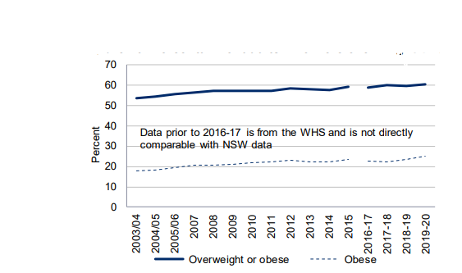
Figure 4 Adult obesity levels https://gov.wales/sites/default/files/statistics-and-research/2020-07/adult-lifestyle-national-survey-wales-april-2019-march-2020-390.pdf
In figure 4 a truly clear trend is visible in that the overall overweight and obesity line is steadily increasing over time and measure should be put in place to try and reduce this increase. One approach to tackle this growing concern is, the health care services in the UK are prescribing patients to go for a Walk [2] [3]. A trend has been spotted that in America 75% of teens and 1 in 2 adults are not reaching their daily recommended activity levels and this has a range of implications on their health [58] [59]. This problem is not limited to America and over a quarter of children are reported to be obese or overweight in Wales, this concerning statistic was captured before the recent world events leading to most people isolating and staying indoors for the safety concerns surrounding Covid-19 [60]. These events have caused an even further decline in the amount of people hitting their daily targets to maintain their health [61].

2.4.1 The harmful effects of not getting enough physical activity
There are numerous side effects associated with not being physically active, there are many ailments such as but not limited to, heart disease, Type 2 diabetes, and Cancer [59]. The overall risk associated with obesity increases with the level of obesity. The effects are not limited to physical attributes either and may also impact a person’s mental health, where exercise and keeping active has been linked with monoamine connection [62]. The negative impact on mental health can in turn can make it harder to lose weight and furthermore it could cause the person to be the subject of weight bias and stigma from others, including health care providers. This can lead to feelings of rejection, shame, or guilt—further worsening mental health problems [63].

2.4.2 Incentives to maintain a high level of physical activity
Regular physical activity is especially important for maintain brain health [64], physical health, preventing noncommunicable diseases and managing weight but this not enough of an incentive as people still do not meet their physical activity goals and their health declines because of it. The two approaches of motivation are intrinsic and extrinsic. There are many ways to help motivate people to participate in physical activity, and most sustainably is from long standing good habits, where activities become hobbies and are a pleasurable experience for the participant often through social activities of groups and clubs such as football teams this is a form of intrinsic motivation [65]. Extrinsic motivation is more complicated, where it often stems from a desire or belief that the activity will reward them in some other way such as being more physically fit will give them a better chance at success in their endeavours [65].

2.4.3 How to gauge an increase in activity levels
To measure the impact of the platform a good baseline would be to compare activity levels before beginning participation and then at intervals during participation. There are many ways of measuring activity levels, one standardised approach is through the International Physical Activity Questionnaire(IPAQ) [66].
2.4.4 What physical activities are beneficial
[67]The World health organisation defines that any exercise that causes body movement produced by skeletal muscles and burn energy are physical activity. Moderate and vigorous activity improve health and people between the ages of 5 and 17 should be doing 60 minutes of moderate to vigorous activity and people 17-65 should be doing at least 150 minutes [68].

2.5 Hardware choices, fitness trackers
users will require them to have some form of fitness tracker, this hardware will be required for the end users to record their activity and automatically send and process that data to the platform for the tracking of their activity. Most mobile phones will have their own form of fitness tracker built in that can measure their steps, this is the ideal type of data that could be used for measuring activity. There are a lot of options available when selecting a fitness tracker but most importantly in the context of this project is the way the data can be extracted from the device itself. The lower quality models will typically just provide information that is human readable but to make the system automated the requirement of software-based synchronisation will be pinnacle in building an easy to use and convenient platform.

2.5.1 Fitbit
The Fitbit platform is an ideal candidate for integration and will be extremely valuable to implement as early as possible. Offering an impressive range of data that will be vital for determining the effectiveness of the platform [69].

2.5.2 Google Fit
Google fit will also be an excellent candidate for implementation, as it will offer similar data to the Fitbit platform but is also available cross platform and can integrate with 56 other fitness tracking applications [70].

2.5.3 Samsung Health
Samsung health would prove to be quite beneficial to the overall data stream but currently they are not accepting applications for new partners [71].
2.5.4 Apple Health Kit
Apple health kit have an interesting approach to the way they share their data. The way you can extract it from apple devices is through the development of an app that can extract the data from their health kit SDK. This would allow for the extraction and communication directly to the back-end server [72].
2.5.5 Garmin
The Garmin developer program requires a live website with a privacy policy stating how the data will be used for the platform to be accepted as a partner. This can be a consideration for future expansions [73].

2.5.6 Huawei
Huawei share a similar requirement to Garmin of requiring a privacy policy on a live site before applications are processed, and they also require information relevant to the business that you are requesting access for [74].

2.6 Conclusion of the literature review
The literature review covers the three key themes that will be required to complete the project, starting with the gamification element. The gamification aspect will be employed to engage the participants for re-occurring interactions and long-term engagement with the platform. The design of the system to manage the gamification aspect will take influence from the concepts covered regarding the battle pass concept, as this has proven to be highly effective at engaging people in for long term participation. The engagement aspect is important as it can be related to the physical activity level of the participants and the physical activity aspect is the overall key factor and motivation to the project. The literature review highlights the importance of maintaining physical activity levels and the risks associated with not maintaining them. To build the platform the most robust software for the task will be required as this will provide a highly scalable and secure approach for the project. The design should be considerate to performance and ensure that the most efficient way of executing the implementation is adhered to, as the requirement of extracting data from a range of sources will prove to be resource intensive and the design must facilitate an extensive volume of data processing. The platform must also be easy to use with a strong focus on the user experience elements. The design of the web application should follow, using elements of the literature review considered to choose the correct framework and the design should be compliant to current web standards and run in a performant manner. The literature review infers that a REST API will be required as the primary element for interacting with the data warehouse and serving content to the web application. Concurrently, the data pipeline should be implemented as this will be a multiple step interaction between the REST API, the front-end web application, and the data provider such as Fitbit, or Google Fit as outlined in the relevant section. The server will then be required to extract data and then transform into the correct shape to be stored in the data warehouse.

3 Methodologies
Here the proposed approach is discussed, and it is theorised what steps will be required to complete the projects aim and objectives through the discussion of the methodology, outlining the approaches taken and justifying the overall design choices required to complete the project. The research methodology will take the following approach of discussing and justifying the philosophy, research type, and the research strategy discussing the constraints faced and the alternative approaches that could have been taken.
The primary focus of the research is to identify a strategy for implementing a platform that can be used to improve the physical activity levels and wellbeing of the participants. Providing additional incentives such as rewards and gamified elements such as a battle pass with tiered rewards and challenges that promote a participant to engage in physical activity and will potentially encourage people to get involved in activities that they usually would not consider through the variety of challenges.

3.1 Research methodology
A positivistic and deductive mixed method approach with elements of applied research. This mixed method approach will be conducted through a review of literature and experimental software development, to achieve an investigation to the relevant areas and the development of the platform.

3.1.1 Research philosophy
The chosen research philosophy is positivistic as the methods for achieving the research goal follow a structured and statistically factual approach backed up by creating correlations between the facts outlined in the literature review. An example of this is the activity levels of the generation are lower, and that gamification can be used for increasing participation in real world scenarios and the potential of using gamification to increase physical activity levels as seen in similar platforms.

3.1.2 Research strategy
The type of research conducted will be of a deductive approach by nature, utilising a mixed method approach of experiments and an applied research strategy building a hypothesis on research conducted through the literature review [75]. Applied research approaches the problem by fulfilling the requirements through research and development, it is a suitable choice for developing a bespoke platform shaped by the research conducted in the literature review building the theory that a gamified experience will improve the physical activity levels of the participants through the platform developed using experimental software development philosophies with a focus on devising the most engaging experience for the user. The literature review concluded that gamification will be a powerful tool for building engagement and user retention, with elements taken from the most current trends seen in the most successful games on the market, adapted to take an innovative approach to gamification that supersedes the concepts commonly adopted from gamification such as badges and leader boards. An investigation will also be carried out with experimental software development onto the suitability of the chosen frameworks for the front end and back end and the performance and security will be analysed to ensure the criteria is met of the platform being secure and performant.

3.1.3 The methodological limitations
Vast potential of a platform of this nature allows for many different approaches and with more time a variety of the approaches could be implemented and analysed to find the most effective approach, but this would take an exponential amount of time as the development of the platform will consume much of the time required to get one working implementation as opposed to multiple with a comparison of each.

3.2 Development methodology
In this chapter the methodology used for the development of the platform is discussed, outlining the planning and design methodologies. An approach was taken that resembles Scrum. Scrum is an abstraction of the AGILE methodology that makes use of extensive project planning, utilising a strategy known as story boarding, sprints, and story points where the developers and the users plan the project from the perspective of the user with the technical knowledge of the developers to discuss what is technically feasible as estimate the time to complete [76]. The Scrum framework puts emphasis on communication by having regular meetings that are known as the daily stand up or Scrum, this was carried out by utilising a team’s channel for the software utilities provided such as a white board for prototyping and wireframing, a task list for managing a form of user stories and the sharing of photos for progress updates for comparing against the specifications [77] [78]. Kanban board is a tool used within agile projects for tracking project stages and user stories with a visual diagram, this was mimicked within teams using the project planning board, a convenient and free tool [79]. Scrum can be thought of as incremental where at the end of each sprint the current progress can be assessed and the direction of the project can be shaped based on the current situation [80] [81] [82]. Throughout the development stages there will be a requirement for thorough testing to be carried out on the individual components and the overall system. This will be achieved by testing at each stage and then when a section is complete and the components are working together there can be further testing carried out for testing functionality, this will be carried out throughout the development to ensure that no section is left untested. An approach that could have been taken is test driven development where the tests are written before the code is written and the developers write the code with the aim of passing the specified tests [83]. Ethical considerations must be made to ensure that the participants are not subjected to situations that would allow for their personal information to be revealed to an un-authorised party, or that the data captured can be used in any way to make the participant feel ashamed or inadequate in comparison to other participants as this will not only give a negative experience but may also lead to further longer lasting damage that could negatively influence how they engage with activities.

3.2.1 Hardware resources
To complete the project there will be a few hardware resources required, such as the relevant hardware for the development of the platform. To host the project there will be a requirement for server hosting for the front-end server, the database, the data pipeline, and the REST API. To capture the user’s data from the smart IOT devices for tracking physical activity, potentially Fitbits as they are highly connectable devices through the Fitbit software discovered in the literature review.

3.2.2 Software resources
An extensive list of the software used, but not limited to.
- Word – used in authoring the report.
- Postman – used for testing endpoints.
- Visual studio code – for developing the project.
- Google Chrome - for researching and viewing the page.
- GitHub – for version control.
- Figma – for design
- Teams – for project management and tracking
- JavaScript – for the final project
- Typescript – A syntactical superset of JavaScript
- SASS – a pre-processor scripting language that is compiled into CSS.
- CSS – a style sheet language for describing the presentation of a page
- HTML – a markup language for structuring a web page
- Angular – a single page application framework for building responsive and dynamic web pages.
- JetBrains IDEA – a development environment for the java language
- Java – a general purpose programming language
- Spring boot - a java application framework for building stand-alone production grade applications
- Spring batch – a modular addition to the spring framework that streamlines the process of building data pipelines
- Spring security – a modular addition to the spring framework that extensively secures the application.
- PostgreSQL – A high performance open-source relational database management system.
- Oauth2- an open standard for access delegation.
- Rxjs – a powerful library for building reactive code
- Angular material – a library for the Angular framework that provides a variety of UI components
- Bcrypt – a password hashing function
- JSON web tokens – an internet standardised communication method that uses JSON payloads.
- UWTSD library and databases

3.2.3 The methodological limitations
Typically, a Scrum approach will be heavily influenced by the product owners’ frequent feedback but working in a scenario where the developer is also the project manager and project owner the usual amount of feedback will be limited to introspective, and the project will not be utilising Scrum to its usual strengths. Alas this still allows for the utilisation of the techniques that streamline the workflow such as Kanban boards, user stories and sprints.
In a project with a larger time scale user testing and feedback could be used to influence the future releases.

3.4 Methodology conclusion
The research methodology will follow a positivistic and deductive mixed method approach with elements of applied research utilising the knowledge gained from the literature review and the results sourced from experimental software development conducted to build an engaging and impactful platform with long standing health benefits for the participants. The development methodology will take the form of an approach known as Scrum, it will allow for the frequent review of the current progress and make changes to the approach after review along with features that help with project planning such as user stories and Kanban boards. To successfully implement this project there will be several software requirements to fulfil and using the elements of the literature review to shape the design and implementation for the highest level of engagement with gamification.

4 Design and implementation
In this chapter the design and implementation of the project is explored, discussing the process involved in designing and building the platform, with a focus on discussing the implemented features and demonstrating the methods of implementation.

4.1 Design
In this section the areas of development are conceptualised before implementation, and the theories and aspirations are outlined before they are implemented. Due to the experimental nature of the software development aspect some features discussed may have taken a completely different approach and they may not resemble the theorised design.

4.1.1 Designing the database
Initial design of the database, primarily focused on user-based authentication and authorisation and tables for managing schools, classes, students, rewards, and vendors.
The database was built into a docker image that imports the SQL files for the shape of the database and during the design phases provide some sample data.

4.1.2 Server architecture design
To serve the information stored within the initial design of the database an approach that was taken that is commonly used with the Spring boot framework as it will utilise the provided annotations that make the framework operate more efficiently. The design of the server architecture followed the security principles the spring boot framework and java language boasts, making use of prepared statements and type safety throughout, along with the features provided by spring security. In the initial implementation of the server several repositories were developed to allow for the interaction of each of the initially implemented tables within the PostgreSQL database. The queried data is then shaped, and logical functions are executed within service classes before the data is served over REST controllers.

4.1.3 Designing the battle pass board
Influence was taken from the various battle passes available in the games outlined in the literature review, and a running theme amongst them is to have tiers that are milestones for the user to hit, so the battle pass must have an array of milestones for the user to progress through.
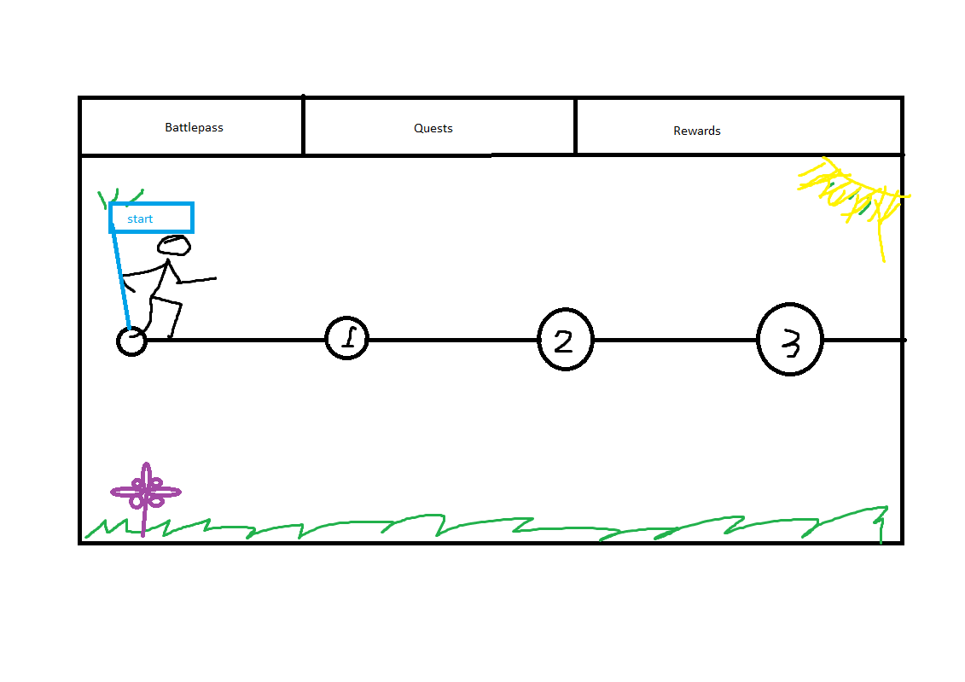
Figure 5 crude wireframe hand drawn concept of the initial design
A design feature of the battle pass is that the number of milestones on the board must be divisible by four to ensure that there are always a consistent number of milestones for continuity. A consideration must be made to how dynamic the pass is with a variable length and a variable duration. These factors should determine the point allocation per task and the duration of the adventure boards run time and the activity required to complete should be comparable to hitting the recommended daily step count.

4.1.4 Design of the point allocation system
The overall goal is to get the participant to exercise, but how much exercise is to be determined within the literature review. A clear standardised metric is the recommended daily activity value, the literature review suggested that around 6000 was a good baseline so the goal should be that to achieve every reward available in the adventure board the participant must hit their daily recommended value consistently.

4.1.5 Design of the data pipeline
The most crucial factor for the data pipeline is the efficiency, a poor implementation will become a costly burden and require regular maintenance. The first step of the design will be to get the process of completing one interacting with the Fitbit API developed, once this is achieved once it can be scaled to be executed asynchronously.
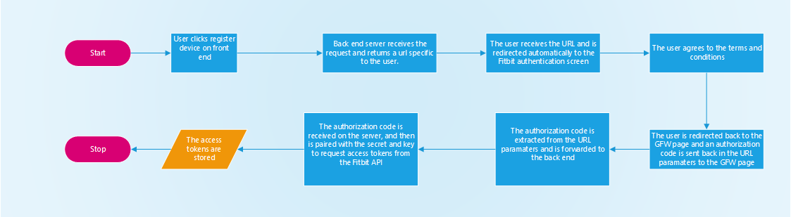
Figure 6 Authorisation flow

4.1.6 Designing the quest board
The design of the quest board must make clever use of colour to identify the various levels of difficulty of the quests, such as green for easy and hard for red. These types of design choices will improve the user experience by communicating with common design paradigms.

4.1.7 Designing the login and register pages
The design of the login and register pages must be very UX oriented, aiming for the smoothest operation with the most relevant feedback to user error. This will allow for a smooth interaction and a pleasant experience as one of the first pages a user will interact with is a register page and this sets the tone of the overall experience.

4.1.8 Designing the admin panel
The administration panel will be required to adapt to the level of permissions the user is granted. A top-level administrator will be required to see more than a standard school administrator and for this reason the design should be mindful to the user of user access levels. The page should be a hub for navigation to relevant sections of control such as pages for editing protected resources for example, the adventure board or for allocating points to a user.

4.1.9 Designing the Questionnaire
Most people are hesitant to commit to answering a questionnaire, especially if it is longwinded and needlessly complex so the design must aid the users’ progress to make the experience as seamless as possible. The questionnaire would ideally be the IPAQ short edition as it will be the easiest to answer.

4.1.10 Home page design
The home page is an especially important factor as it will be the first impression a user has of the platform. Modern design practices such as image masking, parallax scrolling, and general animations will add a sense of panache that will leave an impression and give an interesting experience. Implementing these practices will require a large amount of experimentation as if the paradigm is too extravagant it will be distracting, or if the animation is too verbose it will affect performance and because of these factors, experimentation should determine the intensity of the implementations.

4.2 Implementation
In this section the development of the platform will be discussed, covering the steps taken to achieve the result in a stepwise manner utilising a sprint log adapted from the Scrum methodology discussed in chapter 3.2.

4.2.1 Sprint zero: back-end Initialisation
The project began by initialising the files in the spring initialiser web application, here several dependencies were selected to start the project off
- Spring security
- Spring web
- Spring batch
- Spring JDBC starter
- The PostgreSQL driver
- Spring mailer
- JWT
- Scribe
With all these dependencies selected a download becomes available with all the configurations done automatically, ready to open the project in the IDE, jet brains ‘IDEA’.

4.2.2 Sprint one: back-end user logic
In the first sprint development began by writing up the SQL file, defining the first table as the users table, where users’ relevant data is held such as their name, login details and other personal details. To turn the SQL file into a working database the DBMS was acquired through the docker hub to download the image and build the container that holds the database. Then the attention was turned back to IDEA where a structure to the project must be laid out, separating the project down into repositories, domains, services, and REST controllers. The domain Is a simple Plain old java object (POJO) class, detailing the contents of the SQL table, with a constructor and getters and setters.
With the domain in place for the user the repository can be built, this is the file that is primarily in charge of interacting with the PostgreSQL server through the Spring JDBC driver. Here SQL queries are written in a prepared statement format for the execution on the PostgreSQL server, returning the object in the form of the POJO class from the function.
The types of Queries written for this repository are
- Select by email
- Select by ID
- Select all
- Create
- Update
- Delete
To utilise the repository a service will be required that’s primary responsibility is handling
the logical operations. Some of the operations performed by this service are checking the
validity of the data, Cleaning the data by trimming trailing white space or performing create
operations where the record must be unique. When a user enters some invalid data, and
appropriate error should be returned, these types of error will be caught at a service level
before an interaction with the DBMS is carried out, this will relieve strain on the PostgreSQL
server. An efficient approach is to build a range of generic error types such as a no data
found exception, or a bad request and then these can be utilised in at any point in the
development process of future modules. To interact with the service provided a REST
controller will be the mode of communication through HTTP calls to the server, this will
follow the concept of a URL where the server will have various routes for interacting with
the various modules. Two more POJO classes will be required to conclude the user module,
the first being for the roles and the second for assigning the roles to a user as one user may
have many roles and one role may go to many users. The user repository was expanded to
include the SQL queries for assigning the roles and creating new roles and a service was built
for handling the logic of role assignment, such as the validity of the request, ensuring no
duplicates and ensuring the user is assigned the right roles.
Spring security framework will allow for the streamline of many processes, such as authorising requests on the server with an authorisation filter and an authentication filter for intercepting the requests to authenticate and handling them within the spring security dependency. The authorisation filter can intercept each request, validating their authentication tokens and marking the request with some extra internal information that will allow for the identification of the user to determine if the user has user access rights. To finalise the user module the user will require the ability to update their password if they so choose, so this led to two functions being created, one to generate a password reset URL that can be emailed out and a second to receive the token generated in the password reset URL and the new password and update it on the database. This also required an email mailing solution; this was devised in a modular approach to re-use it later as required.

4.2.3 Sprint two: front-end project initialisation & security
To begin the projects front end visual studio code IDE was used, using Node packet manager(NPM) to install Angular and Node through the terminal to begin the project. Once the project had been initialised it was then the opportunity to launch the server to check that it is working and displaying the default page. After testing the server runs correctly and all the initialisation has been completed the next stage was to implement a basic home page component, a protected page, a login component, and security. To start a basic home page was implemented, this did not require any additional user access rights, and to coincide with this a protected page will be implemented that is purely for testing the route guards.
The initial implementation of the security consisted of a function that exchanges an email and a password for a token set, and the body also includes the users access roles, upon successful authentication these are stored to the local storage. To authenticate access to protected resources an auth guard was implemented, this checks that the user is logged in, and has the correct level of authorisation for the targeted route by checking that the token and role exist in local storage, this is also authorised on the server. To handle any errors that may occur and to assign the most recent access token to each request a HTTP interceptor was implemented at the root level of the application. The HTTP interceptor plays a vital role in ensuring that the user’s access is maintained. Authentication is primarily achieved when an error occurs of a 403-error type the interceptor will act on this error by exchanging the stored refresh token for a fresh access token and up-to-date roles, this will play a vital role in ensuring access is valid. If an error is returned after refreshing the tokens this is when a user is attempting to access protected resources that they do not have the permission to, so re-direct them away. To allow the user to exchange their credentials with the backend server, a login page component was generated along with a module and routing for lazy loading purposes, this also required Angular material to be imported to the module to access the UI components provided by the framework extension. Form validation was achieved with Angular reactive forms another import that was required, and this enabled the development of a login screen.
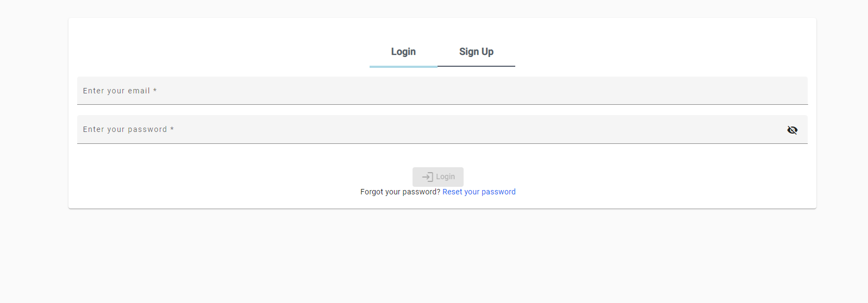
Figure 7 Login screen
Ensuring an effective implementation of the security features provided by the system was especially important, to streamline the process the lifespan of tokens was reduce temporarily to 10 seconds on the server, this will ensure that each access token is short lived allowing to see the system operate in much shorter cycles, this made testing the role-based access and token validity much smoother. For any application with multiple pages a form of navigation will be required, utilising Angular Material for the UI components to implement a tool bar for the top bar and a side navigation panel for the in-app navigation.

Figure 8 Home page and navigation
Allowing users, the ability to register for the application was a vital part of the user authentication process, here it was vital to build an easy-to-use form that captures all the relevant information to get an account created, and assign the correct permissions based on the user scope.
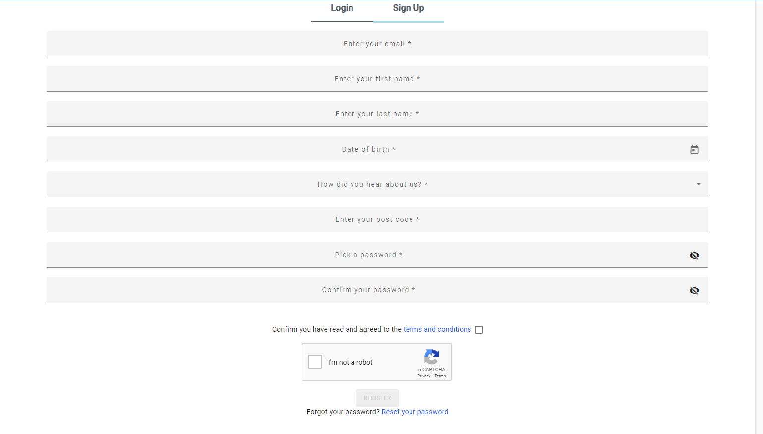
Figure 9 Registration page
Minimising the number of bots accessing the platform was a concern. Implementing googles reCAPTCHA framework allowed for the utilisation of their software solution to this common problem, alas this required the use of cookies to make it work. This led to the implementation of a module for requesting permission to store cookies. With the requirement of capturing and storing users’ data through third party software, a privacy policy was a legal requirement to be permitted to access the data through the third-party systems such as Fitbit and Garmin. To conclude the sprint a password reset module was built, this would be essential for any user that forgets their password or loses access to their account.

4.2.3 Sprint three: back-end school logic
To build the school module a POJO class will be required along with the repository and service along with a REST controller. To accompany the school, each school can have a multitude of classes, and for this the class POJO class will be required along with the repository and service along with a REST controller. The next stage was to build an area for the management of the platform and for school staff to manage their relative areas. The school management panel should allow the staff to have a good control over the students accessing the platform from their institution, such as the students in their school or moving students from one class to another or updating year groups. The next logical stage of the development was to start developing the various areas for control over the stored data, such as editing and deleting records. This was broken down to stages based on the level of access required. The highest level of access required would be the super admins, they will have access rights to see a higher level of information throughout the system, as an administrative role. While school staff will be limited to seeing the data relating to their institution, this is to prevent one member of school staff from seeing and managing students from other schools.

4.2.4 Sprint four - front-end home page
The implementation of the home page followed a trial-and-error approach, where three different pages were built to find something that fit the theme of the overall platform. The first implementation utilised scrolling SVG animations that drew a line down the screen as the user scrolled, this was to draw attention to specific areas, but this was problematic for the various types of devices and was not very responsive. The second approach heavily utilised the design paradigm of parallax scrolling, this is when the different elements on the screen scroll off at different rates. This was a learning curve that elements of it would be taken through to the final design. In the third and final approach a mixed approach was taken utilising the previous attempts to shape the final design, making use of parallax scrolling, image text masks and a carousel for the partners.

4.2.5 Sprint five - back-end Item and reward logic
For the reward item module, a POJO class along with a repository and service will be required, and a REST controller for interactions. This module will also require the ability to upload and manage files. To allow the users to apply relevant feedback to the items a module was devised for tracking the feedback, relationships were constructed to connect the item with the feedback and the user, so a POJO class was written for holding the relative reward feedback along with a repository, service, and a REST controller. To accompany the reward item module there will be a requirement of tracking the vendors of each reward, so for this module the vendors for the reward items will be implemented, this will follow the pattern of POJO class for details, a repository for database interactions and a service for logic and a REST controller for interactions through http. To contact the vendors that a reward offered by has been redeemed, the mailing service implemented in the first sprint was adapted to also allow for the sending of notifications regarding redeemed rewards, for this template were built for informing vendors a reward has been redeemed with additional information such as about who redeemed it and further instructions. This also coincides with a template for sending a notification to the participant with relevant information such as directions to the vendor and the reward they have redeemed.

4.2.6 Sprint six - back-end questionnaire logic and front-end questionnaire
For the questionnaire element for measuring the user’s physical activity levels before participation and after set periods of time, this will allow for the comparison and measurement of impact of the project. To implement the back-end module two POJO classes will be required, one for holding the questions and one for the answers, then the standard composition of repository, service, and REST controller. The questionnaire module was implemented on the front end using Angular materials reactive forms and a stepper module for traversing through the questions with an easy-to-use approach. This will be vital for ensuring the questionnaire is accurately completed and will be presented to the user upon signing up for an account, this will attempt to capture the users baseline data as early as possible.

4.2.7 Sprint seven - back-end and front-end gamification sprint
The gamification aspect of the platform is going to be the section that sees the most engagement from users and this put a lot of focus on 3 key aspects of it, the design, the performance, and the usability. Taking inspiration from the literature review it was clear that a battle pass would be an asset for building engagement between the platform and the users and to accommodate this on the backend a system was implemented that tracked the current battle pass, along with the user’s progress. The first area of the design was the overall battle pass, this would primarily be for tracking the currently active pass, and it would consist of the start and end date. This would be for tracking what and when it is active. Implementing this required a POJO and a repository and service. The next stage was to build off the overall pass module and implement the battle pass stops module, and this would be to expand on the pass by adding as many stops as desired. Each stop would have several attributes such as the points required to reach the stop point, and the reward for reaching it. This would also follow the format of POJO, repository and service. The final stage of the battle pass back-end implementation would be the users’ current points, this would track the users’ current points with a relation to the current overall battle pass, and this would be the primary component for reward distribution also requiring a POJO, repository and service and finally a REST controller that ties the three modules together allowing for the interaction with the three battle pass modules over HTTP calls. Building off the implemented modules on the backend an interface was built to utilise the built module. A slight rebranding on the name of battle pass to adventure board as it comes across more friendly and then some animations were implemented on the various elements to be more appeasing to the eye such as animations on the clouds when traversing through the stops, the grass has animations to flutter in the wind and sparkle particle effects on the current reward.


Figure 10Adventure board
Building the questing system took the approach of a table for storing quests, and a table for storing the users currently activated quest, this has relations that connect the quests with the current battle pass and allow for the tracking in real time of the current progress towards the quest. The backend implementation required two POJO classes, one for each table and relevant repositories, services, and REST API endpoints. Along with the typical services an extra service class was created that handled the interaction of activity data being recorded and calculating the impact on the currently active quests, such as if it is of the right activity or if the quest has been complete through a series of logical checks and the logic of assigning points if a quest is complete, or if the quest expires or runs out of time it will automatically delete the active quest as the user has failed the quest. Another service was created that calculates the amount of effort required from a user to generate a point, and the formula could then be applied to each created quest and the correct number of points for user activity can be allocated.
((Duration * daily recommended steps) / total points to complete)
To act as the user interface for the quest module, this page (fig 10) was produced, it allows a user to navigate through a list of available quests and select the quest they wish to participate in.
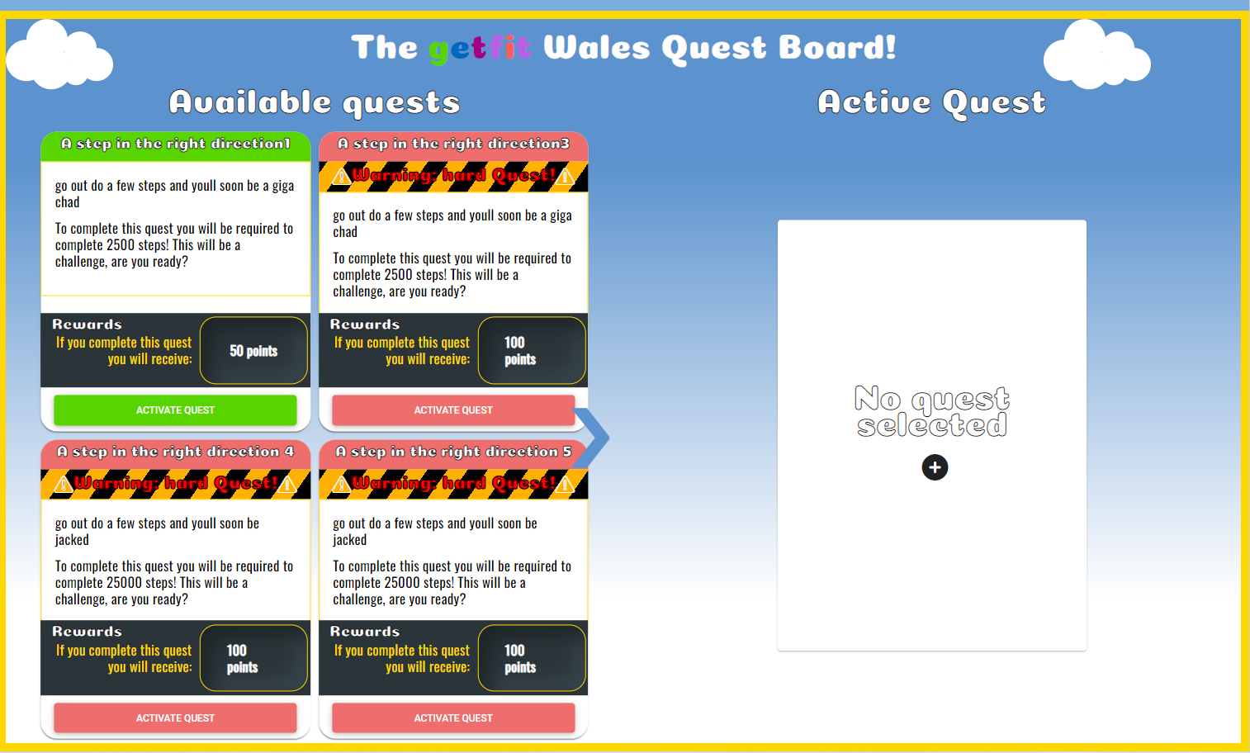
Figure 11 Quest UI
To provide the user with a user interface for the rewards and the rating of the rewards a user interface component was developed, taking a basic shape that resembles the typical ecommerce style, allowing users to leave a review and a rating of the reward.
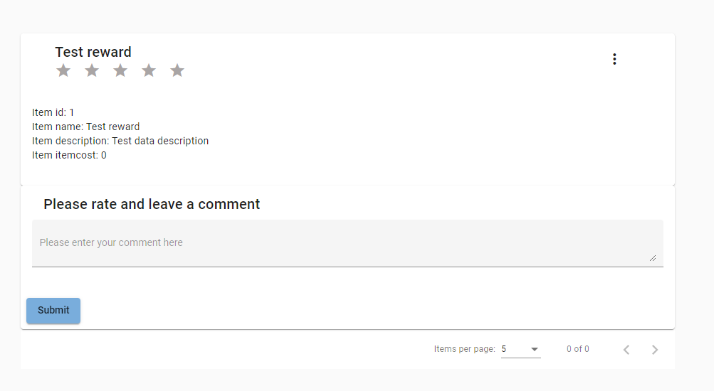
Figure 12 Reward component
Another form of reward implemented was user achievements, these are a common sight in gamified experiences but allow for the representation of achievements through accolades on a user’s profile. To implement achievement management, two tables were required, first for tracking the achievements themselves and second for the allocation of achievements to users. This was handled on the back end through two POJO classes, a service for tracking the users progress towards an achievement and the repository and REST API for interactions.

4.2.8 Sprint eight – back-end step tracking
To allow for the recording of user’s physical activity a table was devised that would hold the user’s activity data, taking shape of the typical format of data returned from the fitness trackers such as active times and step counts. This table will also require some relations to be implemented to tie the user to the data. The back end accommodates this entry with the format of POJO, repository and service served over a REST controller, with a wider range of query types for interacting with the activity data in a greater variety. The module was also written in a way that makes it adaptable to the data pipelines requirements for interacting with the data. It was evident that users may want to participate and may not have a IoT connection enabled smart device, for these considerations had to be made as to how they can participate and track their activity. This left one obvious conclusion that they should be able to manually input what they have achieved, and to do this a new page was designed to allow for input of data. The data can range from a simple number of steps to an exercise activity from a pre-compiled list of activities and their conversion metric to steps per minute [84].
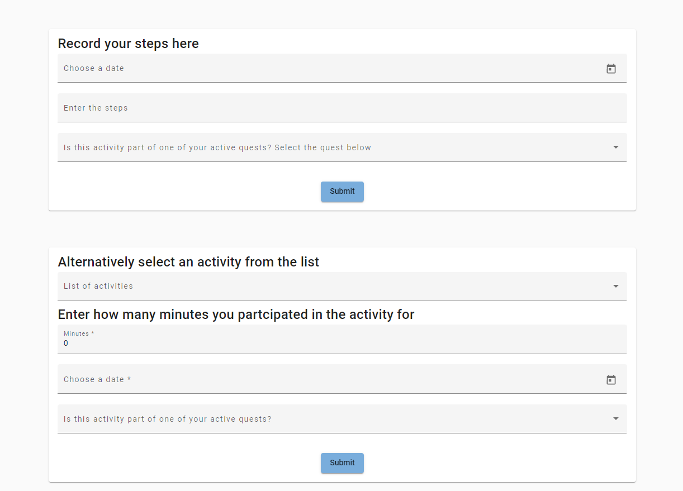
Figure 13Manual activity record
This concept opened the vulnerability of users potentially lying about what they have achieved to try and get the lucrative rewards, and this led to the development of a system that tracks manually recorded activity and requires human approval to validate the data before it is applied to the user’s profile to reduce the chance of falsification.
To reduce the amount of effort required from a staff’s perspective there are options available to confirm all the activity in one swoop implemented to the admin panel.

4.2.9 Spring nine - data pipeline
The data pipeline utilised the spring batch framework, this additional dependency allows spring to process data asynchronously allowing for a high throughput of requests per second. The initial design was approached without the use of the framework, tackling the multithreaded approach manually but to save time and increase productivity the framework was discovered, and it matched all the criteria for building the pipeline. The first source of data, Fitbit, requires an account to be registered on their development portal. This gave the access keys and other credentials for an Oauth2 authorisation flow. This would allow for the exchange of the provided keys for access tokens and the exchange of access tokens for user data. The access tokens are stored to a created table that is purely for storing a user’s access tokens and the link to the user. To streamline the process of interacting through the Oauth2 standard with Fitbit the scribe framework was implemented as it would save a lot of time and provide a highly efficient solution. Implementing Fitbit required building various utilities server side such as the generation of URLs for each user to link the Fitbit account to the platform, this is then served over the front-end interface where the user can register their devices with the platform. The spring batch framework generates several tables for tracking the progress of the operations, and these are programmatically generated and do not require any additional information or interaction outside of the spring batch framework.
The pipeline starts by retrieving the stored access tokens from the data store, processes them where it exchanges them for fresh tokens as tokens expire after 3 hours and stores them back to the data store. The next step retrieves the fresh access tokens from the data store and exchanges them for user data from the Fitbit API, this step concludes by saving the data as a step record to the data store. The last step of the data pipeline is to retrieve the latest step record from the data store, and then update the user profile with the step new total step count.
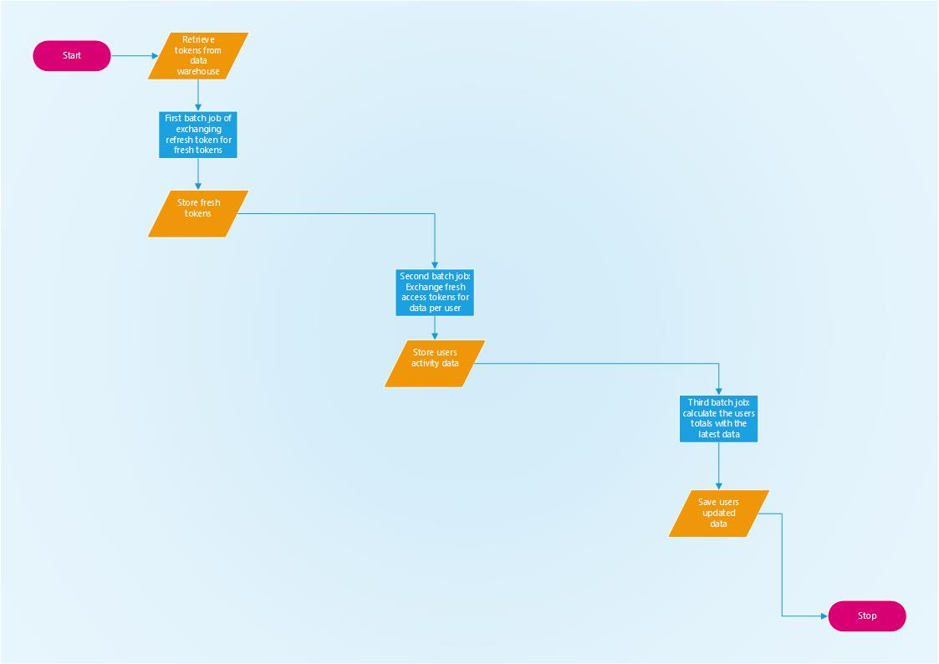
Figure 14 Data pipeline flow

4.3 Design and implementation conclusion
In this section the design of the platform is discussed, with the key areas of interest outlined, specifically the gamification elements, the data pipeline and the overall user experience and user interface. The overarching theme of the design is to outline the concepts that are planned to be implemented, but with considerations to the fact that it is a form of experimental software development so the design may not match the implementation. The section carries on by covering the implementation, discussing the trials and tribulations faced when implementing a platform of this calibre outlining the progress achieved through the sprints adapted from the Scrum methodology. The overarching theme is to conduct the implementations in blocks of relevant sections, starting with the user module working towards the gamification and data pipeline. The process of implementing a module on the back end had a pattern of a datastore entry within the PostgreSQL server, a POJO class that resembles the shape of the table, a repository that houses the queries sent to the PostgreSQL server, a service for logical operations and a HTTP controller, that handled all the CRUD operations. The front end had a similar pattern, but for each component a module was created to host it and the requirements, and a routing file was created to provide in-module navigation. Each module was allocated a URL at the root navigation file, allowing for the implementation of lazy loading. Within the initial implementation of the front-end framework an authentication system was implemented that send the users credentials to the server and expect a refresh token, user access roles and an access token in exchange. This process can then check their freshly obtained access roles and will allow for updates to permissions to be implemented instantly and if they are attempting to access protected resources it will refuse their access with confidence. This is handled at two stages, primarily on the backend server where a hard check is carried out against each request made to ensure that the right level of access required is permitted and then on the front end the required role to access different routes is compared against the stored roles for the user.

5 Results and evaluation
The desired outcome of the project is to build a platform that can be used to improve participants health and wellbeing. There are a range of health benefits to being physically active and the statistics show that the average amount of activity is declining rapidly, especially during the era of peak Covid-19. The platform should be easy to use across any platform and allow for dynamic content to presented to the user through a single page application. The literature review suggested that a framework such as Angular would be an ideal toolbox for the task as it will allow for a performant enterprise grade solution.
The platform should also allow for the connection of the users smart and IoT devices to track their physical activity, participate in the gamification aspects and to get a visual representation of their activity. This will be achieved through a bespoke data pipeline. Gamification aspect will provide the participants with a purpose within the platform and should create an engaging experience that will inspire re-occurring participation and long-term health benefits. Feedback collected from the users through an in-application ‘contact us’ form will allow for the coalition of first-hand experience and will allow for future developments to be guided by the voice of the users, this could be further shaped by allowing users to suggest the types of rewards they would like to receive and take suggestions through votes and polls on the types of activities and events to be incorporated.
The overall software quality of the application can be gauged by the metric of the size, complexity, and maintainability [85]. The effectiveness of the application can be determined by the comparison of user activity levels from the starting period to set intervals thereafter, this would give a clear indication of whether their overall activity levels have increased and if they have could they be attributed to their participation with the platform, this could also be captured using a questionnaire. When the user registers they shall be directed to the IPAQ questionnaire, and this will be ideal for capturing a baseline indication of their current activity level and then this could be compared to against their statistics after participation for extended periods. A further metric for gauging the effectiveness is the user retention levels, how frequently the users return to the platform and how often they activate quests or complete quests are all statistics that can be used for measuring their current engagement and this can be acted upon by offering exclusive rewards to attempt to re-engage the user in question, or offering access to additional activities such as joining a running club or promoting a free pass at a local leisure centre. This would work as a means of marketing for third parties and promoting more ways of getting active.

6 Conclusion
A platform that promotes health and wellbeing will be an asset to those that choose to participate in it. The literature review discovered that within the current health statistics the trend suggests that most people are not achieving their recommended activity levels, and because of this are not able to live a healthy lifestyle. The literature review also highlights the activity statistics have been on a steady decline for several years. There are many negative implications to not meeting these recommendations, the physical implications having a cumulative effect of applying additional strain on the national healthcare service.
As a form of preventative medicine, the health care services in the UK are prescribing patients to go and participate in physical activities such as going for a Walk [2] [3].
The overarching goal of the platform is to encourage people to maintain a level of physical activity that can be measured by the amount of activity they participate in.

Gamification has been proven to be an effective means of creating long term engagement and turning arduous activities into an engaging experience and adding a level of competitiveness that people are naturally drawn in by. Gamification is a form of manipulation that will add an extra level of engagement and user retention, through the phenomenon ‘the fear of missing out’ as outlined in the literature review. Implementing Gamification took the shape of a modern gaming concept commonly seen in the most popular games created by the industry giants, the battle pass. The battle pass in concept is a tiered reward system that tasks the user to complete objectives to receive rewards that can be unique to the time sensitive challenges presented. These have several impacts on the users that are all leading to the key concept of user retention, satisfaction, and high interactivity with the platform. Research conducted through the literature review identified a need for various areas of software development and the development utilised an adaptation of the development methodology known as Scrum. Each stage of the development utilised the sprint aspect of the methodology, building areas in stages, with testing conducted at the end of each stage along with analysing the progress and making decisions about the next sprint based on the evaluation. The element the user will interact with is often referred to as a front end, and it will be used to server dynamic content through a web application. The application will have a range of requirements from user authentication, to serving the gamification user interface. It will play a vital role of being the point of interaction for the users. To streamline the process a framework will be implemented known as Angular, a popular framework that is ideal for enterprise grade applications. The next area of software development required will be the backend, this is the system that will authorise users and serve the content from a data store to the front-end interface. This also required the development of the data warehouse. Final area of development required was the data pipeline, this software area was crucial for collating the data from the various devices by extracting the IoT data from the fitness trackers and saving it to the data warehouse and associating it with the correct user.

7 Recommendations
For future developments of the platform there are several areas to explore that are highlighted in hindsight that will improve the overall experience of the user, the efficiency of the platform and the veracity of the data. The first suggestion would be to implement Apache Khafka as a means of facilitating streaming data from APIs through a subscription-based model, where a notification is sent out to alert the pipeline when fresh data becomes available, and a request can be made in turn. This is only applicable to APIs that support this type of exchange. The data-pipeline can be further improved by increasing the variety of devices that can connect, such as Garmin and Huawei. A concept that could be explored is utilising GraphQL for the database interactions, this popular tool allows for serving content to the client without strongly typed HTTP handlers, this will solve over/under-fetching issues that occur when pulling data from several different tables. Currently the system returns the data in a plain manner, this could be expanded to provide a wide range of visualisations through bespoke designs, or implemented through a provider such as Tableau [86] or Power BI [87].The variety of data that is returned could also be increased, showing trends such as reward spending, grouped trends such as showing how much a school/class has improved.
To streamline the process of creating a new battle pass season, a tool could be built that streamlines the process with validation and select boxes to make the process easier.
This would make the implementation of new quests easier to provide a greater variety of quests to the user. There are a few design changes that could be implemented such as geo-location-based quests, translating the platform bilingually through the median of English and Welsh, various relevant sounds for immersion and an effort could be made to improve the gamification aspects by implementing an anonymised leader board, achievements, and streaks for tracking consecutive milestones. To garner more users through initial impressions, user testimonials could be displayed, this could also show how the platform has helped users by giving some anonymous statistics such as how most users activity has increased x% amount since participation began. A further investigation into the psychological effects of gamification, exploring how the concept achieves its engaging nature and building off this research to further improve the impact of the gamification element. A small addition that could be added that gives insight for the user could potentially be daily facts section that gives interesting health related info and notes on how their participation has affected them.

8 Reflection
In this chapter I reflect on what has been learned and how the project has impacted me. There are several health benefits to physical activity, and the implications of not looking after yourself are very concerning, the research conducted inspired a great deal of reflection on to the lifestyle choices I have made and has inspired me to reduce my sedentary minutes and to partake in more physical activities such as walking. Throughout the project there have been several moments where decisions were to be made on the software that would be used going forward, this put a lot of emphasis on the evaluation of the type of project and the requirement of the software and to then chose the correct software solutions to fit the scope of the project. This skill will be vital going forward, helping shape decisions for future developments. Deciding on a software solution can be difficult, as if you decide to change after investing time in development, and to change the chosen software solution may require you to remove your progress in that area, an example of this is choosing how to store the data. An example of this could be opposed to using a structured approach to data storage MongoDB would have been a better choice for the storage of the data, allowing for an approach that resembles big data more closely, and would allow for much greater flexibility to the shape of the stored data. Another example as highlighted in the recommendations, Apache Khafka would have been a much more efficient approach to the supporting providers, this would have been a highly effective approach to the data pipeline area. In reflection on the implemented design choice, the quest screen may have been too busy and by separating it out to two screens, one for available quests and one for the currently active quest may increase the user experience as the screen will be less congested and flow better. This project was insightful to the elements of gamification that have been extracted from the scenarios commonly portrayed in games, such as the elements that users enjoy, and feel gratification for their involvement. With a greater understanding of how these elements are used to incite engagement, it has given a new perspective and awareness of day-to-day activities that have been gamified and how a simple design choice can impact the user. The experience gained through this project ultimately helped with the alignment with my career goals as I can now see a lot of satisfaction working in the development sector of gamified experiences. This area of development will likely have a meaningful impact on the potential end users, and this is a very rewarding feeling.
In conclusion, this experience has been highly engaging and worthwhile. It has taught me an array of new technologies and skills and has enabled me to test and develop a series of hypothesis and apply a systematic and structured approach to the creation of a gamified experience.

9 References and bibliography

[1] | gov.wales, adult-lifestyle-national-survey-wales-april-2019-march-2020.
[2] | NHS.
[3] | Gov.
[4] | S. Deterding, From Game Design Elements to Gamefulness: Defining Gamification, 2011.
[5] | in Rethinking Gamification, 2014.
[6] | R. E. Silverman, “Wall Street Journal,” Gamification, 2011.
[7] | Z. a. Cunningham, Gamification by design, 2011.
[8] | J. McGonigal, “CONCLUSION; Reality is better,” in Reality Is Broken: Why Games Make Us Better and How They Can Change the World, Penguin Press HC, The, 2011.
[9] | L. M. author and M. Helmefalk, Utilizing gamification in servicescapes for improved consumer engagement, IGI Global, 2020.
[10] | N. M. (me), Literature review on gamification.
[11] | D. Joseph, Battle pass capitalism.
[12] | A. K. Przybylski, K. Murayama, C. R. DeHaan and V. Gladwell, Motivational, emotional, and behavioral correlates of fear of missing out, 2013.
[13] | f. wiki.
[14] | D. D. S. K. K. A. S. A. S. S. &. H. L. Johnson, “Gamification for health and wellbeing: A systematic review of the literature.,” 2016, pp. Internet Interventions, 6, 89–106.
[15] | Nike.
[16] | https://zombiesrungame.com/.
[17] | T. &. O.-K. H. Alahäivälä, “Understanding persuasion contexts in health gamification: A systematic analysis of gamified health behavior change,” International Journal of Medical Informatics, 2016, pp. 96, 62–70.
[18] | Zombies, Run!.
[19] | T. Parker-Pope, The PlayStation Workout: Videogames That Get Kids To Jump, Kick and Sweat, Oct. 4, 2005.
[20] | C. P. 2. M. 2. L. 3. R. S. 1. V. 3. V. 2. a. G. 3. Federica Valeriani 1, Exergames in Childhood Obesity Treatment: A Systematic Review, 2021.
[21] | Google.
[22] | G. Angular. [Online]. Available: https://angular.io/start.
[23] | react.js.
[24] | E. You, Vue.
[25] | Svelte.
[26] | Meteor.
[27] | https://gohugo.io/ Hugo static site generation.
[28] | 11ty static site generation.
[29] | H. Davis, Search Engine Optimization.
[30] | T. M. o. Microsoft.
[31] | “Forbes,” [Online]. Available: https://www.forbes.com/?sh=50b0d87e2254 .
[32] | MadeWithAngular.
[33] | Angular, a Lazy loading.
[34] | Google, RxJS.
[35] | Google, RxJS observable.
[36] | https://www.interaction-design.org/.
[37] | the-encyclopedia-of-human-computer-interaction.
[38] | G. F. I. Fink, Search Engine Optimization for SPAs.In: Pro Single Page Application Development., Apress, Berkeley, CA, 2014.
[39] | N. js. [Online]. Available: https://nodejs.org/en/ .
[40] | Node.js vs Java spring boot for microservice, June 8, 2021.
[41] | C. Walls, Spring boot in action, ISBN-10 ‏ : ‎ 1617292540: MANNING, 1 Dec. 2015.
[42] | R. T. fielding, “Chapter 5 part 0,” 2000. [Online]. Available: https://www.ics.uci.edu/~fielding/pubs/dissertation/rest_arch_style.htm.
[43] | IBM, Data pipelines.
[44] | OAuth2.
[45] | S. Y. H. O. V. S. K. V. H. M. I. Y. a. A. O. P. P. V. Openko, Problem of Choosing a DBMS in Modern Information System, 2019 IEEE International Conference on Advanced Trends in Information Theory (ATIT).
[46] | P. B. R. B. TH Davenport, How big data is different, 2012, pp. 22-24.
[47] | Market Trends, THE FOUR V’S OF BIG DATA – WHAT IS BIG DATA?.
[48] | A. w. services, Data Warehouse Concepts.
[49] | J. P. C. 741/459, Data Warehousing and OLAP.
[50] | X. Liu, A Data Warehouse Solution for eGovernment, ACADEMIA Accelerating the world's research..
[51]
[52] | PostgreSQL.
[53] | microsoft. [Online]. Available: https://visualstudio.microsoft.com/.
[54] | “Postman,” [Online]. Available: https://documenter.getpostman.com/view/10808728/SzS8rjbc#00030720-fae3-4c72-8aea-ad01ba17adf8.
[55] | J. brains.
[56] | Climbing higher: creating an active wales - Welsh Assembly Gov', 2009.
[57] | W. Gov', National Survey for Wales, 2019-20.
[58] | I. M. I. T. C. Janani Rajbhandari-Thapa, School climate-related determinants of physical activity among high school girls and boys, 24 April 2022.
[59] | C. o. d. control.
[60] | W. Gov, Healthy Weight Healthy Wales: renewed priorities for 2020 to 2021.
[61] | W. G. r. o. t. w. o. W. 2022.
[62] | 2. Tzu-Wei Lin1 and Yu-Min Kuo1, Exercise Benefits Brain Function: The Monoamine Connection, Institute of Basic Medical Sciences, National Cheng Kung University, Department of Cell Biology and Anatomy, National Cheng Kung University.
[63] | N. i. o. D. a. D. a. k. diseases, Health Risks of Overweight & Obesity.
[64] | Physical Activity guidelines for americans, p. Chapter 2. Physical Activity and Health 39.
[65] | lovetoknowhealth, What motivates people to exercise.
[66] | International Physical Activity Questionnaire - Short Form SHORT LAST 7 DAYS SELF-ADMINISTERED FORMAT, August 2002.
[67] | uwyo.
[68] | World Health Organization, Physical activity, 26 November 2020.
[69] | Fitbit.
[70] | Google, Google Fit.
[71] | Samsung, Samsung health.
[72] | Apple, Apple health kit.
[73] | Garmin.
[74] | huawei.
[75] | “Principles of Sociological Inquiry: Qualitative and Quantitative Methods, 2.3 Inductive or Deductive? Two Different Approaches,” 2012.
[76] | K. Eby, “What's the Difference? Agile vs Scrum vs Waterfall vs Kanban,” Smartsheet, Feb 15, 2017.
[77] | teams.
[78] | M. B. Ken Schwaber, “Agile Software Development with Scrum,” p. Page 31 ch3.
[79] | techagilist.com, “Planning Poker – Agile Estimation Method”.
[80] | D. Kocurek, “Understanding the Scrum Burndown Chart,” ScrumDesk.
[81] | K. Schwaber, “What Is Scrum?”.
[82] | https://www.scrum.org/, “What is a Daily Scrum?”.
[83] | D. Farley, Modern Software Engineering: Doing What Works to Build Better Software Faster, 10 Dec. 2021.
[84]
[85] | S. C. T. P. Andreas Gizas. [Online]. Available: https://dl.acm.org/doi/abs/10.1145/2187980.2188103.
[86]
[87]
[88] | https://airbrake.io/, “Scrum – What is it and how do you use it?,” March 27, 2017.
[89] | Derek, “Estimating in Scrum”.
[90] | scrum.org Derek Davidson, “Why do we use Story Points for Estimating?”.
[91] | adobe workfront.
[92] | scrum.org, “What is a Sprint Retrospective?”.
[93] | processexam, “Differences and Similarities Between Agile and Scrum”.
[94] | brackets. [Online]. Available: http://brackets.io/.
[95] | atom. [Online]. Available: https://atom.io/.
[96] | M. Bostock, “d3.js,” [Online]. Available: https://d3js.org/.
[97] | A. l. wiki.
[98] | ofcom, research and data.
[99] | [Online]. Available: https://github.com/nodejs/node.
[100] | “Asynchronous I/O Model,” in UNIX Network Programming.
[101] | Center of disease control and prevention, health and academics, 2010.
[102] | “Implementing JWT based authentication in Node.js,” april 2019. [Online]. Available: https://www.sohamkamani.com/blog/javascript/2019-03-29-node-jwt-authentication/#:~:text=The%20JSON%20web%20token%20(JWT,js%20to%20implement%20it.
[103] | “JWT,” [Online]. Available: https://jwt.io/ .
[104] | “lodash,” [Online]. Available: https://lodash.com/ .
[105] | smartbear, “SOAP vs REST. What's the Difference?,” 02 January 2020. [Online]. Available: https://smartbear.com/blog/test-and-monitor/soap-vs-rest-whats-the-difference/.
[106] | Internet Engineering Task Force (IETF) Dick Hardt (editor), “The OAuth 2.0 Authorization Framework,” pp. section-10.4.
[107] | M. DB. [Online]. Available: https://www.mongodb.com/ .
[108] | delftstack, “The Dot (.) Operator in Java”.
[109] | ETL vs stream.
[110] | data pipeline software repo.
[111]
[112]
[113] | UK physical activity data.
[114] | minutes-of-physical-activity-by-gender-in-wales.

Appendix

Endpoints
All of the endpoints will be listed here, with the input method, and the response

User endpoints

POST /api/login
takes email & password
returns access token and refresh token

GET /api/token/refreshtoken
requires no auth level
authorization header with a valid token
returns a fresh access token and the passed refresh token

GET /api/roles
requires auth header with super admin access priv OR GFW rep priv
takes users email and name of the role to apply
returns the users roles

POST /api/role/addtouser
requires auth header with super admin access priv OR GFW rep priv
takes users email and name of the role to apply
returns result of ok or rejected

POST /api/role/save
requires auth header with super admin access priv
takes the name of the new role to add
returns result of ok or rejected

POST /api/user/save
requires no auth level
takes the first name, last name, email and password
returns the created user

GET /api/users
requires auth header with super admin priv
requires no paramaters
returns all users

GET /api/users/gfw/all
requires auth header with super admin or GFW rep
requires no paramaters
returns all students

GET /api/users/gfw/class/{ClassID}
requires auth header with super admin or GFW rep
requires class id as a url paramater
returns all students that belong to the class

GET /api/users/gfw/school/{SchoolID}
requires auth header with super admin or GFW rep
requires SchoolIDd as a url paramater
returns all students that belong to the school

GET /api/users/rep/school
requires auth header with school rep
requires SchoolIDd as a url paramater
returns all students that belong to the school

GET /api/users/gfw/{StudentID}
requires auth header with super admin or GFW rep
requires the students id as a url paramater
returns the specified students details

POST /api/users/rep/add/class
requires auth header with school rep role
requires the student name and the class name as subject body
adds the class id to the student record

POST /api/users/rep/add/school
requires auth header with school rep role
requires the student name and the school name as subject body
adds the school id to the student record

School endpoints

GET /api/school/gfw/all
requires auth header with gfw or super admin role
requires no paramaters
returns all schools

GET /api/school/gfw/{SchoolID}
requires auth header with gfw or super admin role
requires the school id as a url paramater
returns the details about the specified record

POST /api/school/gfw
requires auth header with gfw or super admin role
requires the school name, school contact, school address,
local authority, health board, target as request body
returns the created school

DELETE /api/school/gfw/{SchoolID}
requires auth header with gfw or super admin role
requires the school id as a url paramater
deletes the specified school record

Class endpoints

GET /api/class/gfw/all
requires auth header with gfw or super admin role
requires no paramaters
returns all classes

GET /api/class/rep/classes
requires auth header with school rep role
requires no paramaters
returns all classes for the school

GET /api/class/gfw/{ClassID}
requires auth header with gfw or super admin role
requires the class id as a url paramater
returns the details about the specified record

GET /api/class/classes/{SchoolID}
requires auth header with user role
requires the school id as a url paramater
returns all of the classes by the school id foreign key

POST /api/class/rep
requires auth header with school rep role
requires the class Description, Class Name, School Name,
Year Group, and target as request body
returns the created class

DELETE /api/class/rep/{ClassID}
requires auth header with school rep role
requires the class id as a url paramater
deletes the specified class record

POST /api/class/rep/addClassToSchool
requires auth header with school rep role
requires the school name and the class name
adds the school id to the class record

DELETE /api/class/rep/school
requires auth header with school rep role
requires the school name and the class name
removes the school id from the class record

IPAQ endpoints

GET /api/ipaq/questions
requires auth header with user role

GET /api/ipaq/question/{QuestionID}
requires auth header with user role

GET /api/ipaq/answers
requires auth header with user role

GET /api/ipaq/answer/{AnswerID}
requires auth header with user role

GET /api/ipaq/answers/student/{StudentID}
requires auth header with user role

GET /api/ipaq/answers/school/{SchoolID}
requires auth header with user role

POST /api/ipaq/question
requires auth header with user role

POST /api/ipaq/answer
requires auth header with user role

Daily steps endpoint

GET api/dailysteps
requires auth header with user role
returns all step records

GET api/dailysteps/{StudentID}
requires auth header with user role
returns all daily steps associated to the student id

GET api/dailysteps/record/{StepsID}
requires auth header with user role
returns a single record by the id of the record

POST api/dailysteps
requires auth header with user role
creates a daily steps record with the paramaters date of record, amount of steps and student id

Steps endpoint

GET /api/steps
requires auth header with user role
returns the total step count for every student

GET /api/steps/class/{ClassID}
requires auth header with user role
returns the total step count for every student in a specified class

GET /api/steps/school/{SchoolID}
requires auth header with user role
returns the total step count for every student in a specified school

Item endpoint

GET /api/item/all
requires auth header with user role
returns all item rewards

GET /api/item/{ItemID}
requires auth header with user role
returns the specified items details

POST /api/item
requires auth header with user role
Creates a new item object on the database

Vendor endpoint

GET /api/vendor/all
requires auth header with user role
returns a list of vendors

GET /api/vendor/{VendorID}
requires auth header with user role
returns a specified vendors details

POST /api/vendor
requires auth header with user role
creates a new vendor record

Points endpoint

GET /api/points
requires auth header with user role
returns a list of point entries

GET /api/points/school/{SchoolID}
requires auth header with user role
returns a list of point entries by school id

GET /api/points/class/{ClassID}
requires auth header with user role
returns a list of point entries by class id

GET /api/points/{PointsID}
requires auth header with user role
returns a point record by id

POST /api/points
requires auth header with user role
creates a point record

PUT /api/points/{PointsID}
requires auth header with user role
patches a point record

Redeemed Points endpoint

GET /api/redeem/all
requires auth header with user role
returns all point redeem records

GET /api/redeem/school/{SchoolID}
requires auth header with user role
returns all point redeem records by school id

GET /api/redeem/class/{ClassID}
requires auth header with user role
returns all point redeem records by class id

GET /api/redeem/{RedeemedpointsID}
requires auth header with user role
returns a specific record by id

POST /api/redeem
requires auth header with user role
creates a redeemed points record on the database

PUT /api/redeem/{RedeemedPointsID}
requires auth header with user role
updates a redeemed points record on the database

Reward Satisfaction endpoint

GET /api/rewardfeedback/all
requires auth header with user role
returns all feedback records

GET /api/rewardfeedback/school/{SchoolID}
requires auth header with user role
returns all pfeedback records by school id

GET /api/rewardfeedback/Student/{StudentID}
requires auth header with user role
returns all feedback records by student id

GET /api/rewardfeedback/{RewardSatisfactionID}
requires auth header with user role
returns a specific record by id

POST /api/rewardfeedback
requires auth header with user role
creates a feedback record on the database

Appendix: APPLICATION FOR ETHICAL APPROVAL

SECTION A: About You (Principal Researcher)
1 | Full Name: |  | Nathan Daniel Morgan
2 | Tick all boxes which apply: |  | Member of staff: | x | Honorary research fellow: | ☐
3 | Undergraduate Student | ☐ | Taught Postgraduate Student | x | Postgraduate Research Student | ☒

4 | Institute/Academic Discipline/Centre: | School of applied computing
5 | Campus: | Bay campus (Swansea)
6 | E-mail address: | n.morgan@uwtsd.ac.uk/1801338@student.uwtsd.ac.uk
7 | Contact Telephone Number: | 07565756126
 | For students:
8 | Student Number: | 1801338
9 | Programme of Study: | MSc Software Engineering
10 | Director of Studies/Supervisor: | Dr Tim Bashford

Page Break
SECTION B: Approval for Research Activity
1 | Has the research activity received approval in principle?  (please check the Guidance Notes as to the appropriate approval process for different levels of research by different categories of individual) |  | YES | ☐ | NO | ☒
 |  |  |  |  | Date
2 | If Yes, please indicate source of approval (and date where known): Approval in principle must be obtained from the relevant source prior to seeking ethical approval | Research Degrees Committee |  | ☐
3 |  | Institute Research Committee |  | ☐
4 |  | Other (write in) |  | ☐

SECTION C: Internal and External Ethical Guidance Materials
 | Please list the core ethical guidance documents that have been referred to during the completion of this form (including any discipline-specific codes of research ethics, and also any specific ethical guidance relating to the proposed methodology). Please tick to confirm that your research proposal adheres to these codes and guidelines.
1 | UWTSD Research Ethics & Integrity Code of Practice | ☒
2 | UWTSD Research Data Management Policy | ☒
3 |  | ☐

SECTION D: External Collaborative Research Activity
1 | Does the research activity involve collaborators outside of the University? |  | YES | ☒ | NO | ☒
2 | If Yes, please provide the name of the external organisation and name and contact details for the main contact person and confirmation this person has consented to their personal data being shared.as part of this collaboration.
3 | Institution | WIDI(Internal) & getfit wales (Newyd)
4 | Contact person name | Ian Wells & Scott Tandy
5 | Contact person e-mail address
6 | Has this individual consented to sharing their details on this form? |  | YES | ☐ | NO |  |  | ☒
7 | Are you in receipt of a KESS scholarship? |  | YES | ☐ | NO |  |  | ☒
8 | Is your research externally funded |  | YES | ☐ | NO |  |  | ☒
9 | Are you specifically employed to undertake this research in either a paid or voluntary capacity? | Voluntary | YES | ☐ | NO |  | ☒
10 |  | Employed | YES | ☒ | NO |  | ☒
11 | Is the research being undertaken within an existing UWTSD Athrofa Professional Learning Partnership (APLP) | If YES then the permission question below does not need to be answered. | YES | ☐ | NO |  |  | ☒
12 | Permission to undertake the research has been provided by the partner organisation | (If YES attach copy)  If NO the application cannot continue | YES | ☐ | NO |  |  | ☐

Where research activity is carried out in collaboration with an external organisation
13 | Does this organisation have its own ethics approval system? | YES | ☒ | NO | ☒
14 | If Yes, please attach a copy of any final approval (or interim approval) from the organisation  TBD

SECTION E: Details of Research Activity
1 | Indicative title: | The development of a platform to facilitate Incentivized participation
2 | Proposed start date: | 08/03/2022 | Proposed end date: | 08/10/2022
3 | Introduction to the Research (maximum 300 words)  Ensure that you write for a Non-Specialist Audience when outlining your response to the three points below:  - Purpose of Research Activity  - Proposed Research Question  - Aims of Research Activity  - Objectives of Research Activity  Demonstrate, briefly, how Existing Research has informed the proposed activity and explain  - What the research activity will add to the body of knowledge  - How it addresses an area of importance.
4 | Purpose of Research Activity  To develop and implement a platform that facilitates rewarding physical activity  (this box should expand as you type)
5 | Research Question  Will a platform such as this increase the activity of participants and what features will have the largest impact  (this box should expand as you type)
6 | Aims of Research Activity  Increase activity in end users by offering rewards for increased activity  (this box should expand as you type)
7 | Objectives of Research Activity  Build a web application to facilitate the platform  Design and implement a data warehouse  Build a REST api server to interact with a data warehouse  Implement a data pipeline that extracts activity data from 3rd party services such as fitbit transforms it to within a format that fits into the data warehouse  Assign experience points to profiles based on the amount of activity recorded.  Allow the user to spend their experience points for rewards  (this box should expand as you type)
8 | Proposed methods (maximum 600 words)  Provide a brief summary of all the methods that may be used in the research activity, making it clear what specific techniques may be used. If methods other than those listed in this section are deemed appropriate later, additional ethical approval for those methods will be needed.
9 | Investigation through experimental software development  Collection of potential user feedback in the form of a preliminary questionnaire  Questionnaire about activity before usage then compare to activity while using in the form of an IPAQ https://youthrex.com/wp-content/uploads/2019/10/IPAQ-TM.pdf  (this box should expand as you type)
10 | Location of research activity  Identify all locations where research activity will take place.
11 | Digitally  (this box should expand as you type)
12 | Research activity outside of the UK  If research activity will take place overseas, you are responsible for ensuring that local ethical considerations are complied with and that the relevant permissions are sought. Specify any local guidelines (e.g. from local professional associations/learned societies/universities) that exist and whether these involve any ethical stipulations beyond those usual in the UK (provide details of any licenses or permissions required). Also specify whether there are any specific ethical issues raised by the local context in which the research activity is taking place, for example, particular cultural and/or legal sensitivities or vulnerabilities of participants.
13 | No activity outside of the UK  (this box should expand as you type)

14 | Use of documentation not in the public domain: Are any documents NOT publicly available? | NO | ☒
14 |  | YES | ☐
15 | If Yes, please provide details here of how you will gain access to specific documentation that is not in the public domain and that this is in accordance with prevailing data protection law of the country in question and England and Wales.  (this box should expand as you type)

SECTION F: Scope of Research Activity
1 | Will the research activity include: | YES | NO
2 | Use of a questionnaire or similar research instrument? | ☒ | ☐
3 | Use of interviews? | ☐ | ☒
4 | Use of diaries? | ☐ | ☒
5 | Participant observation with their knowledge? | ☐ | ☒
6 | Participant observation without their knowledge? | ☐ | ☒
7 | Use of video or audio recording? | ☐ | ☒
8 | Access to personal or confidential information without the participants’ specific consent? | ☐ | ☒
9 | Administration of any questions, test stimuli, presentation that may be experienced as physically, mentally or emotionally harmful / offensive? | ☐ | ☒
10 | Performance of any acts which may cause embarrassment or affect self-esteem? | ☐ | ☒
11 | Investigation of participants involved in illegal activities? | ☐ | ☒
12 | Use of procedures that involve deception? | ☐ | ☒
13 | Administration of any substance, agent or placebo? | ☐ | ☒
14 | Working with live vertebrate animals? | ☐ | ☒
15 | Other primary data collection methods, please explain in this box  For example, ‘focus groups’. Please indicate the type of data collection method(s) in this box and tick the accompany box. | ☐ | ☒
16 | Details of any other primary data collection method:  (this box should expand as you type) | ☐ | ☒
If NO to every question, then the research activity is (ethically) low risk and may be exempt from some of the following sections (please refer to Guidance Notes).

If YES to any question, then no research activity should be undertaken until full ethical approval has been obtained.

SECTION G: Intended Participants
1 | Who are the intended participants: | YES | NO
2 | Students or staff at the University? | ☒ | ☐
3 | Adults (over the age of 18 and competent to give consent)? | ☒ | ☐
4 | Vulnerable adults? | ☐ | ☒
5 | Children and Young People under the age of 18? (Consent from Parent, Carer or Guardian will be required) | ☒ | ☐
6 | Prisoners? | ☐ | ☒
7 | Young offenders? | ☐ | ☒
8 | Those who could be considered to have a particularly dependent relationship with the investigator or a gatekeeper? | ☐ | ☒
9 | People engaged in illegal activities? | ☐ | ☒
10 | Others (please identify specifically any group who may be unable to give consent) please indicate here and tick the appropriate box. | ☐ | ☒
11 | Other – please indicate here:  (this box should expand as you type) | ☐ | ☒

12 | Participant numbers and source  Provide an estimate of the expected number of participants. How will you identify participants and how will they be recruited?
13 | How many participants are expected? | 10-50  (this box should expand as you type)
14 | Who will the participants be? | Peers, fellow students, potentially anyone that wants to be healthier and be rewarded for it  (this box should expand as you type)
15 | How will you identify the participants? | At random  (this box should expand as you type)

Page Break
16 | Information for participants: | YES | NO | N/A
17 | Will you describe the main research procedures to participants in advance, so that they are informed about what to expect? | ☒ | ☐ | ☐
18 | Will you tell participants that their participation is voluntary? | ☒ | ☐ | ☐
19 | Will you obtain written consent for participation? | ☒ | ☐ | ☐
20 | Will you explain to participants that refusal to participate in the research will not affect their treatment or education (if relevant)? | ☒ | ☐ | ☐
21 | If the research is observational, will you ask participants for their consent to being observed? | ☒ | ☐ | ☐
22 | Will you tell participants that they may withdraw from the research at any time and for any reason? | ☒ | ☐ | ☐
23 | With questionnaires, will you give participants the option of omitting questions they do not want to answer? | ☒ | ☐ | ☐
24 | Will you tell participants that their data will be treated with full confidentiality and that, if published, it will not be identifiable as theirs? | ☒ | ☐ | ☐
25 | Will you debrief participants at the end of their participation, in a way appropriate to the type of research undertaken? | ☒ | ☐ | ☐
26 | If NO to any of above questions, please give an explanation
27 | (this box should expand as you type)

28 | Information for participants: | YES | NO | N/A
29 | Will participants be paid? | ☐ | ☒ | ☐
30 | Is specialist electrical or other equipment to be used with participants? | ☒ | ☐ | ☐
31 | Are there any financial or other interests to the investigator or University arising from this study? | ☐ | ☒ | ☐
32 | Will the research activity involve deliberately misleading participants in any way, or the partial or full concealment of the specific study aims? | ☐ | ☒ | ☐
33 | If YES to any question, please provide full details
34 | Potentially using their personal smart devices to upload their physical activity details such as the steps taken, floor climbed, laps ran etc.  (this box should expand as you type)

SECTION H: Anticipated Risks
1 | Outline any anticipated risks that may adversely affect any of the participants, the researchers and/or the University, and the steps that will be taken to address them.  If you have completed a full risk assessment (for example as required by a laboratory, or external research collaborator) you may append that to this form.
2 | Full risk assessment completed and appended? |  | Yes | ☐
2 |  |  | No | ☒
3 | Risks to participants  For example: emotional distress, financial disclosure, physical harm, transfer of personal data, sensitive organisational information
4 | Risk to Participant:  Personal data will be transferred and held in a database  (this box should expand as you type) | How will you mitigate the Risk to Participant  Implementing a framework that is tried and tested for managing the securing of the REST API and using a strong and secure password for accessing the database.  Ensuring that any identifiable personal data is not visible to anyone that does not need access it.  (this box should expand as you type)
5 | If research activity may include sensitive, embarrassing or upsetting topics (e.g. sexual activity, drug use) or issues likely to disclose information requiring further action (e.g. criminal activity), give details of the procedures to deal with these issues, including any support/advice (e.g. helpline numbers) to be offered to participants. Note that where applicable, consent procedures should make it clear that if something potentially or actually illegal is discovered in the course of a project, it may need to be disclosed to the proper authorities
 | (this box should expand as you type)
6 | Risks to investigator  For example: personal safety, physical harm, emotional distress, risk of accusation of harm/impropriety, conflict of interest
 | Risk to Investigator:  There is some level of risk, such as if the platform does not work as expected or if the security has a vulnerability and data is leaked, the fault is that of the investigator.  (this box should expand as you type) | How will you mitigate the Risk to Investigator:  Taking all relevant steps to ensure that the implementation is secure and data is stored in adhering to best practices.  (this box should expand as you type)
7 | University/institutional risks  For example: adverse publicity, financial loss, data protection
 | Risk to University:  As with the risk of the investigator, the risks of holding any form of data will fall on to the owners of the data  (this box should expand as you type) | How will you mitigate the Risk to University:  By taking the correct steps to ensure that any data held is stored and accessed in a secure manner.  (this box should expand as you type)

8 | Disclosure and Barring Service
9 | If the research activity involves children or vulnerable adults, a Disclosure and Barring Service (DBS) certificate must be obtained before any contact with such participants. | YES | NO | N/A
10 | Does your research require you to hold a current DBS Certificate? | ☒ | ☒ | ☒

SECTION I: Feedback, Consent and Confidentiality
1 | Feedback  What de-briefing and feedback will be provided to participants, how will this be done and when?
Set up an email address that can be contacted by participants if they wish to get further details

(this box should expand as you type)
2 | Informed consent  Describe the arrangements to inform potential participants, before providing consent, of what is involved in participating. Describe the arrangements for participants to provide full consent before data collection begins. If gaining consent in this way is inappropriate, explain how consent will be obtained and recorded in accordance with prevailing data protection legislation.
A screen before the questionnaire to acquire consent from the participant

(this box should expand as you type)
3 | Confidentiality / Anonymity  Set out how anonymity of participants and confidentiality will be ensured in any outputs. If anonymity is not being offered, explain why this is the case.
Not naming participants or organizations to ensure anonymity

(this box should expand as you type)

SECTION J: Data Protection and Storage
In completing this section refer to the University’s Research Data Management Policy and the extensive resources on the University’s Research Data Management web pages (http://uwtsd.ac.uk/library/research-data-management/).
1 | Does the research activity involve personal data (as defined by the General Data Protection Regulation 2016 “GDPR” and the Data Protection Act 2018 “DPA”)? | YES | NO
 | “Personal data” means any information relating to an identified or identifiable natural person (‘data subject’). An identifiable natural person is one who can be identified, directly or indirectly, in particular by reference to an identifier such as a name, an identification number, location data, an online identifier or to one or more factors specific to the physical, physiological, genetic, mental, economic, cultural or social identity of that natural person. | ☐ | ☐
2 | If YES, provide a description of the data and explain why this data needs to be collected:
Personal data will be captured using their smart devices, this includes sensor data, usernames and emails. The users will also have personal profiles for tracking their experience points, this requires an account to be registered for them to gain experience and rewards.

(this box should expand as you type)
3 | Does it involve special category data (as defined by the GDPR)? | YES | NO
 | “Special category data” means sensitive personal data consisting of information as to the data subjects’ –  (a) racial or ethnic origin,  (b) political opinions,  (c ) religious beliefs or other beliefs of a similar nature,  (d) membership of a trade union (within the meaning of the Trade Union and Labour Relations (Consolidation) Act 1992),  (e) physical or mental health or condition,  (f) sexual life,  (g) genetics,  (h) biometric data (as used for ID purposes), | ☐ | x
4 | If YES, provide a description of the special category data and explain why this data needs to be collected:
 | (this box should expand as you type)

5 | Will the research activity involve storing personal data and/or special category data on one of the following: | YES | NO
6 | Manual files (i.e. in paper form)? | ☐ | ☒
7 | University computers? | ☐ | ☒
8 | Private company computers? | ☐ | ☒
9 | Home or other personal computers? | ☐ | ☒
10 | Laptop computers/ CDs/ Portable disk-drives/ memory sticks? | ☐ | ☒
11 | “Cloud” storage or websites? | ☒ | ☐
12 | Other – specify: | ☐ | ☒
13 | For all stored data, explain the measures in place to ensure the security of the data collected, data confidentiality, including details of password protection, encryption, anonymisation and pseudonymisation:
Data will only be stored on secure computers and all data held within a database will be secured to the highest standard possible, the possibility of using a 3rd party cloud provider will also be utilizing a GDPR compliant storage service. The server architecture will be with a tried and tested security framework implemented for managing the interactions with the database. No data will be shared with other people, organisations, or bodies without due notification and approval.

(this box should expand as you type)
14 | All Data Storage
15 | Will the research activity involve any of the following activities: | YES | NO
16 | Electronic transfer of data in any form? | ☒ | ☐
17 | Sharing of data with others at the University? | ☐ | ☒
18 | Sharing of data with other organisations? | ☐ | ☒
19 | Export of data outside the European Union or importing of data from outside the UK? | ☐ | ☒
20 | Use of personal addresses, postcodes, faxes, emails or telephone numbers? | ☒ | ☐
21 | Publication of data that might allow identification of individuals? | ☐ | ☒
22 | Use of data management system? | ☒ | ☐
23 | Data archiving? | ☒ | ☐
24 | If YES to any question, please provide full details, explaining how this will be conducted in accordance with the GDPR and DPA (and/or any international equivalent):
All data will be stored in a secured location, where all steps to ensure security are implemented, such as multi factor authentication and a strong and secure password.

All transfers will be password protected and encrypted.

Any collected data will be deleted once no longer required.
(this box should expand as you type)
25 | List all who will have access to the data generated by the research activity:
Principal researcher, possibly the supervisor
(this box should expand as you type)
26 | List who will have control of, and act as custodian(s) for, data generated by the research activity:
Principal researcher,

(this box should expand as you type)
27 | Give details of data storage arrangements, including security measures in place to protect the data, where data will be stored, how long for, and in what form. Will data be archived – if so how and if not why not.
All data will be stored in a password protected cloud storage on the universities office 365 system.
Any collected data will be deleted once no longer required.

(this box should expand as you type)
28 | Please indicate if your data will be stored in the UWTSD Research Data Repository (see https://researchdata.uwtsd.ac.uk/ ). If so please explain. (Most relevant to academic staff)
No
(this box should expand as you type)
29 | Confirm that you have read the UWTSD guidance on data management (see https://www.uwtsd.ac.uk/library/research-data-management/) | YES | ☒
29 |  | NO | ☐
30 | Confirm that you are aware that you need to keep all data until after your research has completed or the end of your funding | YES | ☒
30 |  | NO | ☐
SECTION K: Declaration
31 | The information which I have provided is correct and complete to the best of my knowledge. I have attempted to identify any risks and issues related to the research activity and acknowledge my obligations and the rights of the participants.  In submitting this application I hereby confirm that I undertake to ensure that the above named research activity will meet the University’s Research Ethics and Integrity Code of Practice which is published on the website: https://www.uwtsd.ac.uk/research/research-ethics/
 | Signature of applicant: | Nathan Daniel Morgan | Date:  08/03/2022

For STUDENT Submissions:
32 | Director of Studies/Supervisor: |  | Date:23/3/2022
33 | Signature: | Nathan Daniel Morgan | Date:23/3/2022

For STAFF Submissions:
34 | Academic Director/ Assistant Dean: |  | Date:
35 | Signature: |  | Date:

Checklist: Please complete the checklist below to ensure that you have completed the form according to the guidelines and attached any required documentation:
☒ | I have read the guidance notes supplied before completing the form.
☒ | I have completed ALL RELEVANT sections of the form in full.
☒ | I confirm that the research activity has received approval in principle
☒ | I have attached a copy of final/interim approval from external organisation (where appropriate)
☐ | I have attached a full risk assessment (and have NOT completed Section H of this form) (where appropriate) ONLY TICK IF YOU HAVE ATTACHED A FULL RISK ASSESSMENT
☒ | I understand that it is my responsibility to ensure that the above named research activity will meet the University’s Research Ethics and Integrity Code of Practice.
☒ | I understand that before commencing data collection all documents aimed at respondents (including information sheets, consent forms, questionnaires, interview schedules etc.) must be confirmed by the DoS/Supervisor, module tutor or Academic Director.
☒ | I have deleted the guidance notes before submitting the PG2 for consideration

