
Redevelopment of the central transport hub

A Comprehensive Project Management Report

Submitted by
Student Name – Alhaji Abu Bakar Bangura
Student ID - 2428995

Table of Contents
List of Figures 3
Part A Academic Poster 4
Part B Reflection 6
Part C Project Report 8
Executive Summary 8
1. Introduction 9
2. Project Description 9
2.1 Existing Transport Challenges 9
2.2 Project Justification 9
2.3 Project Objectives 10
2.4 Major Deliverables 10
2.5 Expected Outcomes and Strategic Importance 10
3. Project Scope 10
3.1 Scope Statement 10
3.2 In Scope 10
3.3 Out of Scope 10
3.4 Project Constraints 11
3.5 Project Assumptions 11
3.6 Project Deliverables 11
3.7 Acceptance Criteria 11
4. Work Breakdown Structure (WBS) 11
5. Quad Chart 13
6. Gantt Chart / Project Schedule 13
7. Stakeholder Management 15
7.1 Stakeholder Register 15
7.2 Power–Interest Matrix 16
7.3 Communication Strategy 16
8. Resource Allocation 16
8.1 Resource Categories 16
8.2 Responsibility Assignment Matrix (RACI) 17
9. Risk Analysis 18
Project Management Methodology 19
Sustainability Strategy 20
Digital Innovation 21
Conclusion 21
References 23

List of Figures

Figure 1 Working Breakdown Structure of the Project 11
Figure 2 Gantt Chart (Concise Presentation from my Academic Poster) 12
Figure 3 RACI Matrix (Collected from my Academic Poster) 15

Part A Academic Poster
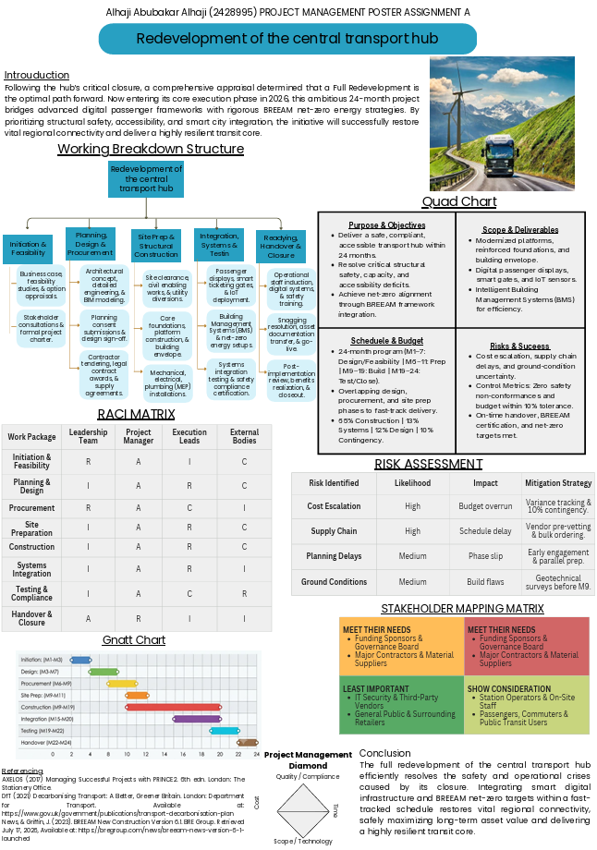

Part B Reflection
Developing and presenting the project management poster on the Redevelopment of the Central Transport Hub provided me with a valuable opportunity to apply theoretical project management concepts to a realistic and complex infrastructure project. The project focused on a 24-month redevelopment programme addressing structural safety, accessibility, digital transformation, sustainability and the restoration of regional transport connectivity. One of the main things I learned was the importance of effective project initiation and structured planning. Developing the business case, feasibility assessment, objectives and scope helped me understand that successful project delivery begins with clearly defining the problem and establishing realistic outcomes. Creating the Work Breakdown Structure (WBS) also helped me understand how a large and complex project can be divided into manageable work packages, from initiation and design through procurement, construction, systems integration, testing and final handover.

I also developed a stronger understanding of the relationship between scope, cost, time and quality. The Project Management Diamond demonstrated how changes to one constraint can influence the others. For example, accelerating construction may increase costs or create pressure on quality and safety. Preparing the 24-month schedule and Gantt chart helped me appreciate the importance of sequencing and overlapping activities, particularly design, procurement and site preparation, to achieve timely project completion. Another important learning outcome was risk and stakeholder management. The risk assessment allowed me to identify potential challenges such as cost escalation, supply-chain delays, planning issues and uncertain ground conditions. I learned that effective risk management requires not only identifying risks but also assessing their likelihood and impact and developing appropriate mitigation strategies. The stakeholder mapping exercise also showed me that different stakeholders require different levels of communication and engagement. Similarly, developing the RACI matrix helped me understand the importance of clearly defining responsibility and accountability within each work package.

The project also increased my awareness of sustainability and digital technology in modern infrastructure projects. Incorporating BREEAM requirements, net-zero energy strategies, Building Management Systems, IoT sensors, smart ticketing and digital passenger displays demonstrated how contemporary projects must consider environmental performance, technological innovation and long-term operational efficiency alongside traditional construction objectives. Following my presentation, my teacher thanked me and positively commented on the quality of my poster and presentation, which was encouraging and gave me confidence that I had communicated the project effectively. The feedback also helped me recognise areas for further improvement, particularly in making stronger connections between the project objectives, risks, stakeholder responsibilities, schedule and performance measures. I understood that a successful presentation requires not only accurate content but also clear visual communication and the ability to explain complex information concisely.

Overall, this assignment significantly strengthened my practical understanding of project management. I learned that successful project delivery requires structured planning, stakeholder engagement, proactive risk management, clear accountability, realistic scheduling, cost control, quality management and sustainability. The positive feedback from my teacher reinforced my confidence, while the areas for improvement encouraged me to develop a more integrated and analytical approach to future projects.

Part C Project Report

Executive Summary
This report presents a comprehensive project management case for the redevelopment of the city's central transport hub, following its closure in November 2025 due to non-compliance with current structural safety, accessibility, capacity, and environmental standards. Of the four strategic options considered - full redevelopment, a temporary multimodal transport solution, digital modernisation of passenger flow, and a sustainable net-zero redesign - the redevelopment of the central transport hub is recommended as the preferred course of action, since it is the only option capable of resolving the structural non-compliance at source while simultaneously delivering long-term economic, operational, environmental, and social benefits.
The proposed programme is structured around a twenty-four-month delivery schedule spanning feasibility, design, procurement, construction, systems installation, testing, commissioning, staff training, and handover. A hybrid project management methodology, integrating PRINCE2 governance, PMBOK Guide performance domains, the APM Body of Knowledge, and the guidance set out in ISO 21502:2020, is recommended to balance the need for stage-gate control with the flexibility required to manage design evolution and stakeholder change requests (Gemino, Reuch and Serrador, 2021; Fernandes et al., 2024).
Key deliverables include a fully compliant, accessible, and resilient transport interchange; modernised digital passenger and logistics systems; a net-zero-aligned building envelope and energy strategy; and a strengthened regional economic base. The report sets out a detailed Work Breakdown Structure, Quad Chart, Gantt schedule, stakeholder register and Power–Interest Matrix, resource and RACI plan, and a twelve-risk register, alongside dedicated strategies for sustainability and digital innovation. Overall, the programme is assessed as feasible, strategically justified, and capable of delivering long-term value to the city and its residents, provided that governance, risk, and stakeholder management are actively and continuously maintained throughout delivery.

1. Introduction
Following the closure of the city's central transport hub in November 2025, the local authority has initiated an urgent regeneration programme to restore a safe, compliant, and high-capacity interchange serving rail, bus, and freight logistics operations. The hub's closure, precipitated by a structural inspection identifying non-compliance with current safety, accessibility, and environmental regulation, has produced significant commuter disruption, freight and logistics delays, reduced business productivity, and mounting public and political pressure for a credible long-term solution.
Effective project management is essential to this programme. The scale, visibility, and complexity of the redevelopment - spanning structural engineering, digital systems, sustainability compliance, and multi-agency stakeholder coordination require a disciplined approach to governance, planning, risk, and change control. Without such discipline, infrastructure programmes of this nature are demonstrably prone to cost overrun, schedule slippage, and stakeholder conflict (Li et al., 2021). This report therefore applies recognised project management standards and scholarly evidence to structure a deliverable, well-governed programme capable of meeting both the immediate operational crisis and the city's longer-term strategic objectives, including Net Zero transport, smart city development, and inclusive urban regeneration.

2. Project Description

2.1 Existing Transport Challenges
- Complete loss of the primary rail, bus, and freight interchange, forcing commuters and logistics operators onto constrained alternative routes.
- Non-compliance of the forty-year-old structure with current structural safety, fire, and accessibility legislation.
- Insufficient operational capacity to meet current and forecast passenger and freight demand.
- Absence of digital passenger information, smart ticketing, and logistics coordination systems.
- Measurable economic losses across regional business and logistics sectors during the closure period.

2.2 Project Justification
Redevelopment of the central transport hub is justified on structural, operational, economic, and strategic grounds. A temporary multimodal solution would address short-term capacity but would not resolve the underlying structural non-compliance and would require subsequent replacement, generating duplicated capital expenditure. Digital modernisation alone cannot restore physical capacity or safety compliance. A sustainable redesign confined to net-zero features, without addressing the structural deficit, would leave the asset non-operational. Full redevelopment is therefore the only option that resolves the root cause while allowing net-zero, digital, and accessibility objectives to be embedded into the new asset from first principles, consistent with UK government policy on decarbonising transport infrastructure (Department for Transport, 2021).

2.3 Project Objectives
The project aims to deliver a safe, accessible, high-capacity, and environmentally sustainable transport interchange within twenty-four months, restoring regional connectivity while establishing a platform for long-term economic regeneration and smart city integration.

2.4 Major Deliverables
- A structurally compliant, accessible central transport hub building and platform infrastructure.
- Integrated digital passenger information, smart ticketing, and logistics coordination systems.
- A net-zero-aligned energy, materials, and construction strategy.
- A fully tested, commissioned, and staffed operational facility, formally handed over to the operating authority.

2.5 Expected Outcomes and Strategic Importance
The redeveloped hub is expected to restore commuter and freight connectivity, reduce regional economic losses, strengthen public confidence in local infrastructure governance, and position the city as a reference example of sustainable, digitally enabled transport regeneration, in line with national Net Zero Strategy commitments (HM Government, 2021).

3. Project Scope

3.1 Scope Statement
The project comprises the demolition (where required), redesign, and reconstruction of the central transport hub, including all structural, digital, and sustainability elements necessary to deliver a fully compliant and operational interchange within an approximate twenty-four-month programme.

3.2 In Scope
- Structural redesign and reconstruction of the transport hub building and platforms.
- Integration of rail, bus, freight, cycle, and pedestrian access points.
- Digital passenger flow, smart ticketing, and logistics coordination systems.
- Net-zero energy systems, sustainable materials, and BREEAM-aligned building performance.
- Staff training, systems testing, commissioning, and formal operational handover.

3.3 Out of Scope
- Wider regional road network upgrades beyond the immediate hub access points.
- Long-term commercial retail development within the hub precinct (subject to a separate future business case).
- Rolling stock or bus fleet replacement, which remains the responsibility of individual transport operators.

3.4 Project Constraints
- A fixed twenty-four-month delivery window driven by public and political pressure to restore service.
- Capital budget constraints requiring disciplined cost control and value engineering.
- Live operational interfaces with surrounding rail and road networks during construction.
- Regulatory and planning approval timescales.

3.5 Project Assumptions
- Planning consent and statutory approvals will be secured within the programmed feasibility and design period.
- Funding will be confirmed and released in line with the agreed programme milestones.
- Key contractors and specialist consultants will be available through competitive procurement without material delay.

3.6 Project Deliverables
- Approved feasibility study and business case.
- Detailed design and planning consent.
- Constructed and commissioned transport hub facility.
- Trained operational staff and completed handover documentation.

3.7 Acceptance Criteria
- Full compliance with structural, fire, and accessibility regulations, verified by independent inspection.
- Successful completion of systems testing and commissioning with no critical defects outstanding.
- Achievement of agreed net-zero and BREEAM performance targets.
- Formal sign-off by the client authority and operational transport bodies.

4. Work Breakdown Structure (WBS)
The Work Breakdown Structure below decomposes the programme into major phases, work packages, and representative activities, providing the basis for scheduling, resourcing, and cost control.
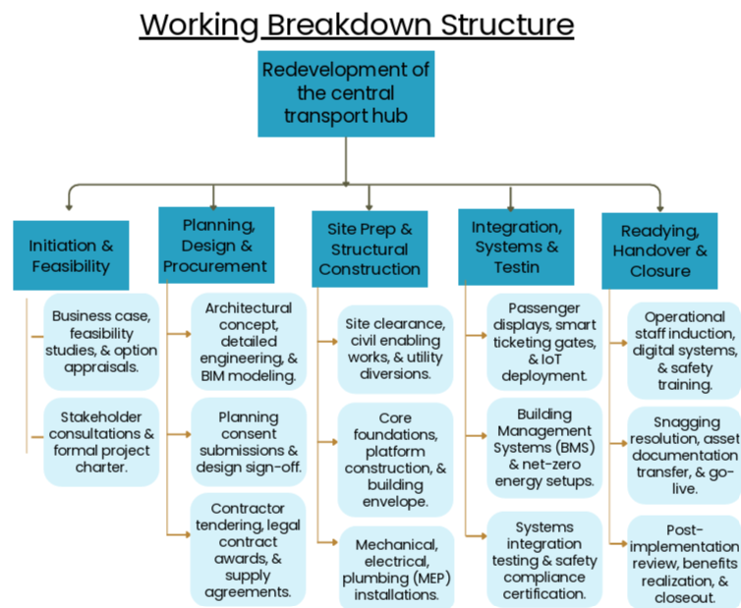
Figure 1 Working Breakdown Structure of the Project

WBS Ref. | Work Package | Representative Activities
1.0 | Project Initiation & Feasibility | Business case; feasibility study; stakeholder consultation; option appraisal; project charter
2.0 | Planning & Design | Concept design; detailed engineering design; BIM model development; planning application; design review
3.0 | Procurement | Contractor and consultant tendering; contract award; supply chain agreements; materials procurement
4.0 | Site Preparation | Site clearance; enabling works; temporary access and safety hoarding; utilities diversion
5.0 | Construction | Structural works; platform and interchange construction; building envelope; MEP installation
6.0 | Systems Installation | Digital passenger information; smart ticketing; IoT sensors; BMS and energy systems
7.0 | Testing & Commissioning | Systems integration testing; safety certification; operational trials
8.0 | Staff Training | Operational staff induction; systems training; emergency procedures training
9.0 | Handover | Snagging resolution; documentation handover; operational go-live
10.0 | Project Closure | Post-implementation review; lessons learned; benefits realisation review; contract closeout

5. Quad Chart
Category | Summary
Project Objectives | Deliver a safe, accessible, net-zero-aligned transport hub within 24 months and within approved budget.
Key Deliverables | Compliant structure; integrated digital systems; net-zero energy strategy; trained operations team.
Timeline | 24 months: feasibility (Months 1–3), design (Months 3–7), procurement (Months 6–9), construction (Months 9–19), testing/commissioning (Months 19–22), handover (Months 22–24).
Budget Estimate | Capital allocation across design (12%), construction (65%), systems/digital (13%), contingency (10%).
Strategic Benefits | Restored connectivity; regional economic regeneration; Net Zero alignment; enhanced passenger experience; smart city integration.
Major Risks | Cost escalation; supply chain delay; planning delay; ground condition uncertainty; stakeholder resistance.
Success Indicators | On-time handover; budget variance within approved tolerance; zero critical safety non-conformances; achievement of BREEAM and net-zero targets.

6. Gantt Chart / Project Schedule
The table below presents an indicative twenty-four-month schedule suitable for direct conversion into Microsoft Project, Excel, or PowerPoint. Milestones are indicated in bold; dependencies are described in the final column.
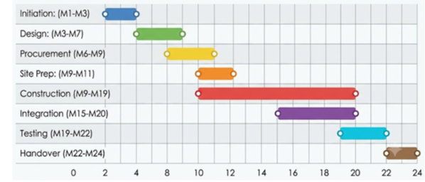
Figure 2 Gantt Chart (Concise Presentation from my Academic Poster)

Activity | Start | Finish | Dependency / Notes
Planning & Feasibility Study | M1 | M3 | Start of programme; precedes design
Design (Concept & Detailed) | M3 | M7 | Depends on approved feasibility study
Planning Consent Milestone | M7 | M7 | Depends on completed detailed design
Procurement | M6 | M9 | Overlaps design; depends on outline specifications
Site Preparation | M9 | M11 | Depends on planning consent and contractor mobilisation
Construction | M9 | M19 | Depends on site preparation completion
Systems Installation | M15 | M20 | Overlaps construction; depends on structural completion of relevant zones
Testing | M19 | M21 | Depends on completed construction and systems installation
Commissioning Milestone | M21 | M22 | Depends on successful testing
Staff Training | M20 | M23 | Overlaps commissioning; depends on systems availability
Handover Milestone | M23 | M23 | Depends on commissioning and training completion
Project Closure | M23 | M24 | Depends on formal handover sign-off

7. Stakeholder Management
Effective stakeholder engagement is consistently identified as a critical success factor in infrastructure megaprojects, particularly where multiple public and private interests intersect (Prebanić and Vukomanović, 2021). The stakeholder register and Power–Interest Matrix below classify key stakeholders and set out corresponding engagement strategies.

7.1 Stakeholder Register
Stakeholder | Role | Power | Interest | Influence | Expectations | Engagement Level
Local Authority | Sponsor | High | High | High | Restored infrastructure, regeneration | Manage Closely
National Government / DfT | Funder / Regulator | High | Medium | High | Policy alignment, value for money | Keep Satisfied
Rail & Bus Operators | Operational Partner | High | High | High | Operational continuity, safety | Manage Closely
Passengers / Commuters | End User | Low | High | Medium | Reliable, accessible service | Keep Informed
Local Businesses | Affected Party | Medium | High | Medium | Minimised disruption, footfall recovery | Keep Informed
Contractors & Consultants | Delivery Partner | Medium | High | High | Clear scope, timely payment | Manage Closely
Environmental Regulators | Regulator | High | Medium | High | Environmental compliance | Keep Satisfied
Local Residents | Affected Party | Low | Medium | Low | Noise, disruption control | Monitor / Inform

7.2 Power–Interest Matrix
Applying the Power–Interest Matrix (Maqbool, Deng and Rashid, 2022), stakeholders are grouped into four engagement categories:
- High Power / High Interest - Manage Closely: Local Authority, Rail and Bus Operators, Contractors and Consultants.
- High Power / Lower Interest - Keep Satisfied: National Government/DfT, Environmental Regulators.
- Lower Power / High Interest - Keep Informed: Passengers, Local Businesses.
- Lower Power / Lower Interest - Monitor: Local Residents not directly adjacent to the site.

7.3 Communication Strategy
A tiered communication strategy is recommended: high power/high interest stakeholders receive fortnightly governance board briefings and direct escalation routes; keep-satisfied stakeholders receive monthly progress and compliance reporting; keep-informed stakeholders receive regular public updates via newsletters, websites, and community briefings; and monitored stakeholders receive periodic bulletins. This tiered approach reflects established practice in infrastructure stakeholder governance (Prebanić and Vukomanović, 2021).

8. Resource Allocation
A comprehensive resource management plan is required to coordinate human, financial, technical, and material resources across the programme lifecycle.

8.1 Resource Categories
- Human Resources: project sponsor, programme director, project manager, design team, construction management team, digital systems specialists, health and safety officers, training coordinators.
- Financial Resources: capital budget, contingency reserve, operational transition funding.
- Construction Equipment: cranes, piling rigs, site plant, temporary works equipment.
- Materials: structural steel, low-carbon concrete, sustainable timber and cladding, glazing systems.
- Technology: BIM platforms, IoT sensors, digital twin software, smart ticketing infrastructure, cloud-based project management tools.
- Consultants and Contractors: structural and civil engineering consultants, sustainability consultants, main works contractor, specialist systems integrators.
- Software: scheduling software, cost management systems, document control platforms, BIM authoring tools.

8.2 Responsibility Assignment Matrix (RACI)
Work Package | Responsible | Accountable | Consulted | Informed
Feasibility & Business Case | Programme Director | Sponsor | Finance, Legal | Governance Board
Design Development | Design Lead | Project Manager | Sustainability Consultant | Planning Authority
Procurement | Procurement Manager | Project Manager | Legal, Finance | Contractors
Construction | Site Manager | Project Manager | Health & Safety Officer | Local Authority
Systems Installation | Digital Systems Lead | Project Manager | IT Security | Operators
Testing & Commissioning | Commissioning Manager | Project Manager | Quality Assurance | Regulators
Training & Handover | Training Coordinator | Operations Manager | HR | All Staff
Project Closure | Project Manager | Sponsor | Finance | Governance Board

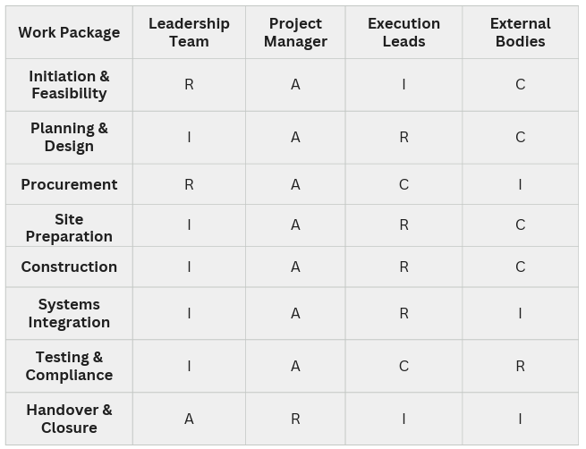
Figure 3 RACI Matrix (Collected from my Academic Poster)

9. Risk Analysis
Infrastructure megaprojects are demonstrably exposed to a broad range of interacting risks spanning construction, cost, procurement, environmental, and stakeholder dimensions (Li et al., 2021). The register below identifies twelve major risks with corresponding ratings, mitigations, and ownership.
Risk Description | Probability | Impact | Rating | Preventive Actions | Contingency Plan | Owner
Cost overrun due to material price volatility | Medium | High | High | Fixed-price contracts; contingency reserve | Activate contingency; value engineering | Cost Manager
Construction delay from adverse ground conditions | Medium | High | High | Pre-construction ground investigation | Design contingency; revised sequencing | Site Manager
Procurement delay in specialist contractor market | Medium | Medium | Medium | Early market engagement; framework agreements | Alternative supplier activation | Procurement Manager
Supply chain disruption for structural materials | Medium | High | High | Dual sourcing; early material ordering | Substitute materials; schedule buffer | Procurement Manager
Environmental compliance breach during construction | Low | High | Medium | Environmental management plan; monitoring | Immediate remediation; regulator liaison | Sustainability Lead
Health and safety incident on site | Low | High | Medium | H&S management system; regular audits | Incident response plan activation | H&S Officer
Political or funding policy change | Low | High | Medium | Regular government liaison; phased funding release | Scope re-prioritisation | Programme Director
Cybersecurity breach of digital systems | Medium | High | High | Secure-by-design architecture; penetration testing | Incident response; system isolation | Digital Systems Lead
Climate-related extreme weather disruption | Medium | Medium | Medium | Resilient design standards; weather contingency planning | Schedule adjustment; protective measures | Project Manager
Stakeholder resistance / community objection | Medium | Medium | Medium | Early and continuous stakeholder engagement | Mediation; scope adjustment | Stakeholder Manager
Planning consent delay | Medium | High | High | Early pre-application engagement with planners | Programme re-sequencing | Design Lead
Design changes / scope creep | Medium | Medium | Medium | Robust change control process | Formal change board review | Project Manager

Project Management Methodology
A hybrid project management methodology is recommended, integrating PRINCE2 governance and stage-boundary control (AXELOS, 2017), the performance-based, principle-led structure of the PMBOK Guide, seventh edition (Project Management Institute, 2021), the competence framework of the APM Body of Knowledge (Association for Project Management, 2019), and the process guidance set out in ISO 21502:2020 (International Organization for Standardization, 2020). Scholarly evidence indicates that hybrid approaches, combining traditional stage-gate discipline with iterative, agile elements for design and digital work packages, consistently outperform purely traditional or purely agile approaches in complex, multi-stakeholder environments (Gemino, Reuch and Serrador, 2021).
PRINCE2 provides the governance backbone, structuring the programme into manageable stages with defined tolerances and board-level decision points, well suited to a publicly funded infrastructure programme requiring clear accountability. The PMBOK Guide's principle-based performance domains - stakeholders, planning, delivery, and measurement - complement this by offering flexible, outcome-focused guidance particularly relevant to the digital and sustainability work packages, where iterative refinement adds value (Fernandes et al., 2024). The APM Body of Knowledge contributes a strong emphasis on professional competence, ethics, and the human dimensions of project delivery, while ISO 21502:2020 provides internationally recognised, standard-setting guidance ensuring the programme's governance, quality, and reporting structures meet global best practice.
Governance is exercised through a Programme Board chaired by the Sponsor, with defined escalation routes, stage-gate reviews, and a formal risk and issue log. Quality management follows a plan-do-check-act cycle aligned with ISO 21502:2020, incorporating independent design reviews and third-party structural certification. Procurement follows a two-stage competitive tendering process to balance cost certainty with design flexibility. Communication follows the tiered stakeholder strategy set out in Section 7. Change control operates through a formal Change Control Board with defined tolerance thresholds, and monitoring is conducted through monthly earned-value reporting supplemented by a post-implementation benefits realisation review at project closure.

Sustainability Strategy
The redevelopment is designed to make a substantive contribution to the city's and the UK's Net Zero targets, in line with the Net Zero Strategy (HM Government, 2021) and the Department for Transport's decarbonisation agenda (Department for Transport, 2021). Carbon reduction will be pursued through low-embodied-carbon materials, energy-efficient building services, and on-site renewable generation, consistent with recommendations set out by the Environmental Audit Committee on costing carbon in construction (House of Commons Environmental Audit Committee, 2023).
A circular economy approach will govern material selection and end-of-life planning, applying recognised selection criteria for circular building components (Rahla, Mateus and Bragança, 2021). Sustainable procurement practices will prioritise suppliers demonstrating verified environmental performance, reflecting evidence that green construction procurement supports both environmental and economic outcomes (Marcelline et al., 2022). The project will adopt Modern Methods of Construction, including off-site prefabrication, to reduce waste, improve quality, and accelerate delivery, aligned with government workplace design guidance on sustainable construction (UK Government, 2024).
The building will be designed to meet a high BREEAM rating, applying the current BREEAM UK New Construction technical criteria across energy, water, materials, waste, and ecology categories (BRE Group, 2023). Green infrastructure, including permeable surfacing, urban greening, and sustainable drainage, will be integrated into the surrounding public realm to enhance biodiversity and passenger amenity.

Digital Innovation
Digital technologies are central to the successful delivery and long-term operation of the redeveloped hub. Building Information Modelling (BIM) will be used throughout design and construction to coordinate multidisciplinary design information, reduce clashes, and support lifecycle asset management, reflecting the growing role of digital technologies across the built-environment project lifecycle (Papadonikolaki, Krystallis and Morgan, 2022).
A Digital Twin of the completed asset will be developed to support predictive maintenance, energy optimisation, and passenger flow simulation, building on established approaches to construction digital twin information systems (Sacks et al., 2020). Internet of Things (IoT) sensors will provide real-time monitoring of structural performance, air quality, and passenger density, feeding a Geographic Information System (GIS) for spatial asset management. Smart ticketing and predictive analytics will improve passenger experience and support demand forecasting for future capacity planning. Cloud-based project management platforms will support real-time programme reporting and document control across the multi-organisation delivery team, while a secure-by-design cybersecurity architecture, including regular penetration testing, will protect passenger data and operational technology systems from the cybersecurity risks identified in Section 9.

Conclusion
The redevelopment of the central transport hub represents a feasible, strategically justified response to the structural, operational, and economic challenges created by the facility's closure. By addressing the root structural deficit while embedding net-zero, digital, and accessibility objectives from the outset, the project delivers materially greater long-term value than the alternative options considered. The hybrid governance framework, comprehensive risk register, tiered stakeholder engagement strategy, and integrated sustainability and digital innovation strategies together provide a credible basis for successful delivery within the proposed twenty-four-month programme.
Successful delivery will depend on the disciplined maintenance of governance, risk, and stakeholder management processes throughout the programme lifecycle, supported by robust change control and continuous monitoring. On this basis, the project is recommended for approval and progression to the feasibility and design stage, with the Programme Board retaining oversight of the risk register, budget tolerances, and stakeholder engagement plan throughout delivery.

References
Association for Project Management (2019) APM Body of Knowledge. 7th edn. Princes Risborough: Association for Project Management.
AXELOS (2017) Managing Successful Projects with PRINCE2. 6th edn. London: The Stationery Office.
BRE Group (2023) BREEAM UK New Construction: Technical Manual. Watford: BRE Global.
Department for Transport (2021) Decarbonising Transport: A Better, Greener Britain. London: Department for Transport.
Fernandes, G., Tassari, G., Rocha, L., Santos, J.M.R.C.A., Ferreira, L.M.D.F., Ribeiro, P. and O'Sullivan, D. (2024) 'Overcoming the "use misfit" of project management practices in collaborative research, development and innovation', Project Leadership and Society, 5.
Gemino, A., Reuch, B.H. and Serrador, P.M. (2021) 'Agile, traditional, and hybrid approaches to project success: is hybrid a poor second choice?', Project Management Journal, 52(2), pp. 161–175.
HM Government (2021) Net Zero Strategy: Build Back Greener. London: HM Government.
House of Commons Environmental Audit Committee (2023) Building to Net Zero: Costing Carbon in Construction: Government Response to the Committee's First Report. London: House of Commons.
International Organization for Standardization (2020) ISO 21502:2020 Project, Programme and Portfolio Management - Guidance on Project Management. Geneva: ISO.
Li, Y., Xiang, P., You, K., Guo, J., Liu, Z. and Ren, H. (2021) 'Identifying the key risk factors of mega infrastructure projects from an extended sustainable development perspective', International Journal of Environmental Research and Public Health, 18(14), p. 7166.
Maqbool, R., Deng, X. and Rashid, Y. (2022) 'Renewable energy project success: internal versus external stakeholders' satisfaction and influences of power-interest matrix', Sustainable Development, 30(6), pp. 1542–1561.
Marcelline, T.R.S., Yang, C., Avotra, A.A.R.N., Hussain, Z., Zonia, J.E. and Nawaz, A. (2022) 'Impact of green construction procurement on achieving sustainable economic growth influencing green logistic services management and innovation practices', Frontiers in Environmental Science, 9, p. 815928.
Osborne Clarke (2023) Net Zero in UK Construction – Where Are We Now? Available at: https://www.osborneclarke.com/insights/net-zero-uk-construction-where-are-we-now (Accessed: 3 July 2026).
Papadonikolaki, E., Krystallis, I. and Morgan, B. (2022) 'Digital technologies in built environment projects: review and future directions', Project Management Journal, 53(5), pp. 501–519.
Prebanić, K.R. and Vukomanović, M. (2021) 'Realizing the need for digital transformation of stakeholder management: a systematic review in the construction industry', Sustainability, 13(1), p. 27.
Project Management Institute (2021) A Guide to the Project Management Body of Knowledge (PMBOK Guide). 7th edn. Newtown Square, PA: Project Management Institute.
Rahla, K.M., Mateus, R. and Bragança, L. (2021) 'Selection criteria for building materials and components in line with the circular economy principles in the built environment: a review of current trends', Infrastructures, 6(4), p. 49.
Sacks, R., Brilakis, I., Pikas, E., Xie, H.S. and Girolami, M. (2020) 'Construction with digital twin information systems', Data-Centric Engineering, 1, e14.
UK Government (2024) Sustainability and Net Zero Annex: The Government Workplace Design Guide. Available at: https://www.gov.uk/government/publications/the-government-workplace-design-guide/sustainability-and-net-zero-annex (Accessed: 3rd August 2026).

Appendix
Feedback from the Teacher


