

Student Name | Darshan Nareshbhai Sheliya
Student Number | 2530070
Subject Name | Digital Forensics Analysis
Module Code | ACCA7031
Lecturer | Dr. Mohamed Ghanem
Research, Analyse and Investigate Cybersecurity incidents and perform digital forensic assessment

Abstract
This paper will discuss a digital forensic examination of three Android smart devices in the case of suspected corporate espionage using Cellebrite UFED Educational Edition version 7.76 and Cellebrite Physical Analyzer version 7.73. The investigation was conducted using standard digital forensic practices including evidence acquisition, evidence preservation, integrity verification via the production of cryptographic hashes with the SHA-256 algorithm, examination and analysis.
Wireless devices yielded Digital Artifacts which consisted of WhatsApp conversations, Facebook Messenger communications, call logs, emails, images, GPS Information, metadata, and timelines. The analysis turned up that communication took place between the three suspects: Emma, Joe, and Norman, showing their parts in unauthorizing disclosure of Quantum Tech's confidential AI patent (QI-AI-2025).
The first integration between Emma and Joe was via WhatsApp conversations and the Facebook Messenger messages between Joe and Norman laid the groundwork for the finding Norman was the intended recipient for the Confidential Information. The communication items were supported by image metadata, GPS data and timeline reconstruction which confirmed travel activity and the order in which events occurred.
The integrity and authenticity of the evidence have been maintained throughout the forensic process and the way that multiple evidence artefacts were linked together to provide a picture about the criminal action has been effectively demonstrated. The results demonstrate how mobile device forensics can help in the investigation of digital crimes and relevant information for court proceedings.

Part 1
Table of Content
1. Introduction
2. Current State of Digital Forensics
3. Digital Forensics Tools: Features and Capabilities
4. Intersection of Digital Forensics and Cybersecurity
5. Emerging Trends in Digital Forensics
6. Key Challenges in Digital Forensics
7. National and International Job Market
8. Conclusion
9. References
Part 2
Table of Content
1. Introduction
2. Investigation Methodology
2.1 Forensic Environment
2.2 Evidence Acquisition
2.2.1 Selection of Extraction Method
2.2.2 Selection of Evidence Storage Location
2.2.3 Device Preparation
2.2.4 Acquisition Process
2.2.5 Device Authentication
2.2.6 Logical Backup
2.2.7 Data Extraction
2.3 Importing Evidence into Cellebrite Physical Analyzer
2.3.1 Loading Evidence
2.3.2 Configuration of Examination Tools
2.3.3 AppGenie Analysis
3. Case Investigation and Findings
3.1 Case Background
3.2 Evidence Acquisition and Integrity Verification
3.3 Chain of Custody
3.3.1 Evidence Handling Process
4. Communication Analysis
4.1 WhatsApp Analysis
4.2 Facebook Messenger Analysis
4.3 Call Log Analysis
4.4 Email Analysis
4.5 Instagram Analysis
5. Media and Location Analysis
5.1 Image Metadata Analysis
5.2 GPS Location Analysis
5.3 Travel Evidence
5.4 Timeline Analysis
6. Suspect Profiling and Investigation Findings
6.1 Emma (Perpetrator)
6.2 Joe (Intermediary)
6.3 Norman (Buyer)
6.4 Overall Investigation Findings
7. Conclusion

List of Figures
Figure 2.1 Selection of the Advanced Logical Extraction Method
Figure 2.2 Selection of Evidence Storage Location
Figure 2.3 Device Preparation
Figure 2.4 Acquisition Process
Figure 2.5 Device Authentication
Figure 2.6 Logical Backup Process
Figure 2.7 Data Extraction in Progress
Figure 2.8 Data Extraction Completed Successfully
Figure 2.9 Cellebrite Physical Analyzer Welcome Screen
Figure 2.10 Loading Extracted Evidence
Figure 2.11 Selection of Evidence Package
Figure 2.12 Configuration of Examination Tools
Figure 2.13 Selection of Application Decoding
Figure 2.14 AppGenie Introduction
Figure 2.15 AppGenie Application Summary

Figure 3.1 Cellebrite Extraction Summary (Emma Device)
Figure 3.2 SHA-256 Hash Verification (Emma Device)
Figure 3.3 Cellebrite Extraction Summary (Joe Device)
Figure 3.4 SHA-256 Hash Verification (Joe Device)
Figure 3.5 Cellebrite Extraction Summary (Norman Device)
Figure 3.6 SHA-256 Hash Verification (Norman Device)

Figure 4.1 Initial WhatsApp Conversation between Emma and Joe
Figure 4.2 Discussion Regarding Confidential AI Information
Figure 4.3 Planning the Sale of Confidential Information
Figure 4.4 Follow-up Communication Regarding Buyer Negotiations
Figure 4.5 Nokia C2 Device Analysis and Location Evidence
Figure 4.6 Facebook Messenger Conversation between Joe and Norman
Figure 4.7 Continuation of Negotiations between Joe and Norman
Figure 4.8 Call History Recovered from Emma's Smartphone
Figure 4.9 Email Records Extracted from Emma's Smartphone
Figure 4.10 Instagram Direct Messages

Figure 5.1 Extracted Images and Associated Metadata
Figure 5.2 GPS Locations in Glasgow
Figure 5.3 GPS Locations in Manchester
Figure 5.4 GPS Locations in Paris
Figure 5.5 Travel Ticket and Hotel Key Card
Figure 5.6 Timeline Reconstruction of Recovered Digital Evidence

Part 1
- Introduction
Digital Forensics is a specialised subset of Forensic Science, which is tasked with the location, collection, preservation, analysis and presentation of digital evidence from personal computers, mobile devices, networks and cloud-based systems [1]. Cybercrime has been growing globally and digital forensics is vital to criminal investigations and organisational security. It can be used to document digital events, determine the identity of the attacking party, recover lost or deleted data, and present it in court for legal action [2]. The Internet of Things (IoT) and mobile devices have grown exponentially, as well as cloud-based platforms – along with all of the additional technical challenges in the investigations. Hence, Digital Forensics is a vital part of the digital asset protection and can be helpful for cybersecurity activities [3].
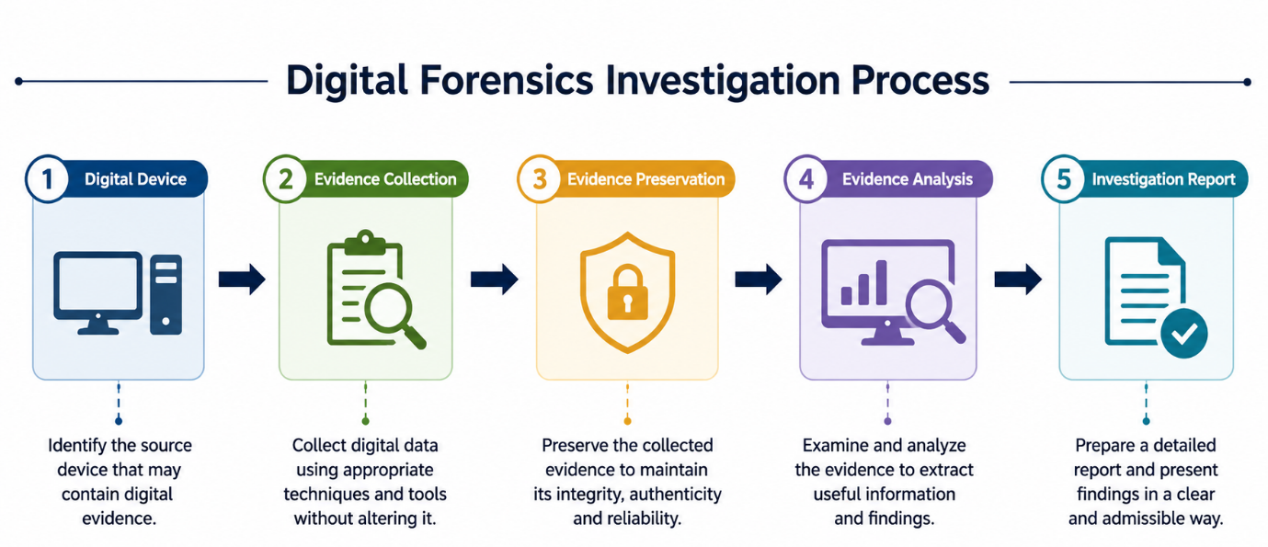

- Current State of Digital Forensics
Today, digital forensics has grown significantly because of the present and upcoming situations of expanding digital technologies and the ever-mounting level of danger in cyber area. Smartphones, cloud storage, social media platforms, encrypted communication services, and devices that can connect with the Internet provide evidence of modern investigations [2]. Digital Forensic techniques are now used to investigate cyber incidents, insider threats, financial fraud, ransomware attacks and data breaches. The standards internationally including ISO/IEC 27037 are aimed at guidance for identification, collection, acquisition and preservation of the digital evidence with aim of ensuring the forensic integrity [4]. This has been achieved by using automation and specialised forensic software that allow investigations to be carried out in a more efficient manner while retaining the integrity of the evidence [5].
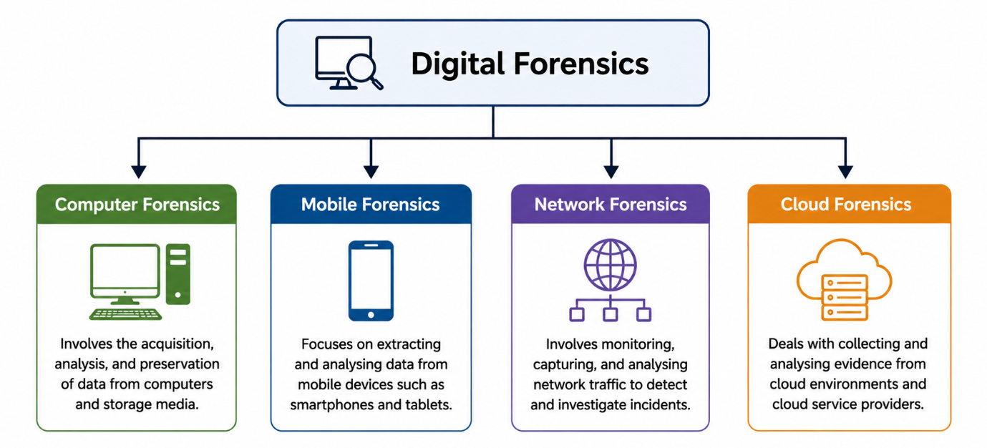
- Digital Forensics Tools: Features and Capabilities
Collecting and analysing digital evidence during digital forensic investigations demands specialised software that ensures the integrity of the evidence. The most popular commercial tools include Cellebrite UFED, EnCase Forensic, Magnet AXIOM and FTK which are used by law enforcement agencies and forensics lab [5]. These tools are able to extract logical and physical data, recover deleted files, search for keywords, analyse passwords, decode applications and generate reports of the mobile device. Tools such as Autopsy, and Volatility are open-source file system analysis and memory forensics tools that also offer a wealth of features [6]. Technology advances continuously, and computer forensics is no exception—these software advancements have allowed investigators to effectively collect digital evidence and work within forensic best practices in a more efficient manner [1].
- Intersection of Digital Forensics and Cybersecurity
Digital Forensics and Cybersecurity are interconnected and play a vital role in identifying, responding, and investigating cyber threats. While cybersecurity is used to deter cyber-attacks, digital forensics is used for examining a cyber-attack after it happens to identify the cause and effect [3]. In incident response, the forensic investigators gather evidence in order to establish the methods of attacks, the systems that were impacted, and the individuals behind the threats. The results are used to enhance the security policies present in the companies, improve the defence measures, and mitigate future attacks [7]. With today's constantly evolving cyber threats, the marriage of cybersecurity and cyber forensics operations is critical to risk and recovery processes.
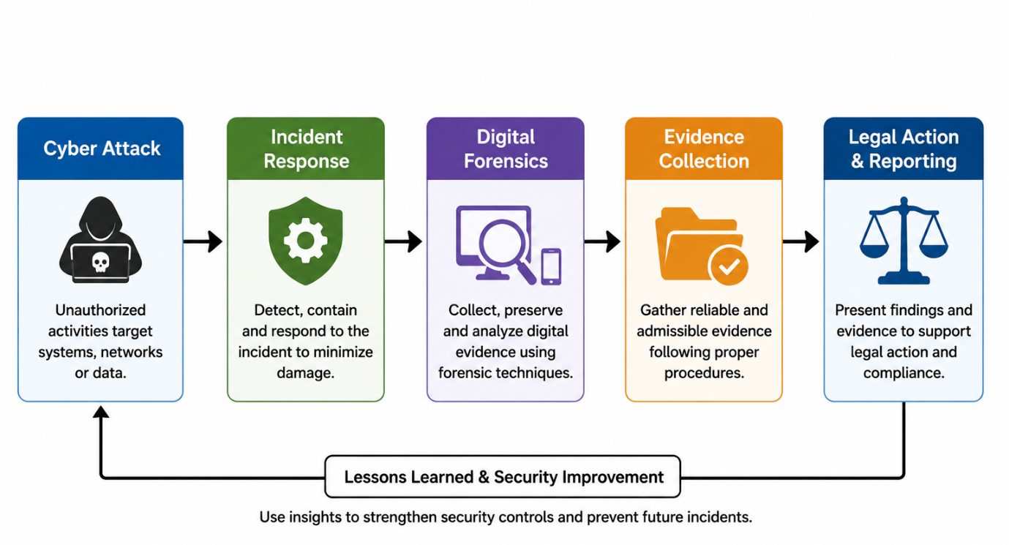
- Emerging Trends in Digital Forensics
Digital Forensics is a continually changing area of computer science as technologies continue to advance. Evidence classification, malware analysis, and anomaly detection are all functions that are migrating into use cases for artificial intelligence/machine learning to automate the investigation process, thereby saving investigation time [8]. The significance of cloud forensics has been on the rise as many organisations keep their important information over the cloud where the challenges in acquiring evidence are unique [9]. IoT devices, wearable devices, connected vehicles and smart home devices are all yielding significant amounts of evidence, and investigators must learn new ways to both acquire and analyse this evidence [10]. Further noteworthy sectors include blockchain analysis and cryptocurrency investigations, which have grown significantly with the rise in the use of digital currencies in cybercrime [11].
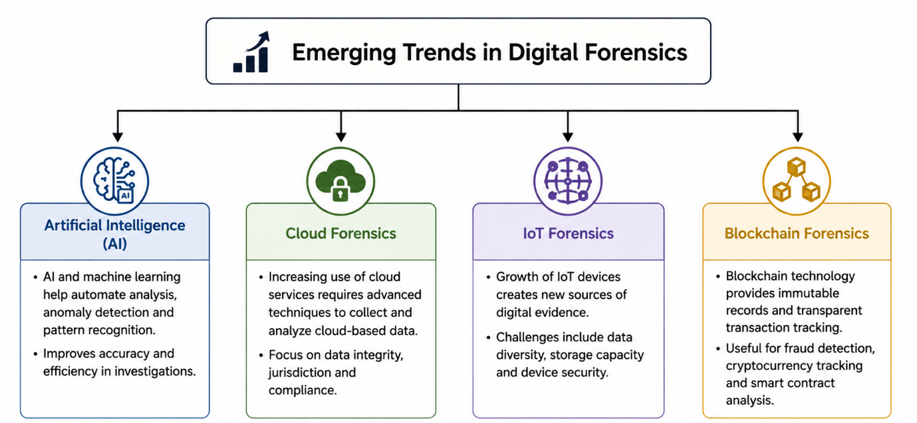
- Key Challenges in Digital Forensics
Though digital forensics has progressed considerably in technology it poses many challenges. Strong encryption techniques, secure messaging applications, and privacy-enhancing technologies often hobble investigators' access to digital evidence [2]. As data becomes more digital, the time to investigate has grown up and data storage and computing power has also increased [9]. Cloud computing poses jurisdictional concerns due to the fact that evidence can be located in multiple countries, under various legal systems. In addition, some techniques applied in the forensic field are being applied on the cybercrime world by an anti-forensic process, for instance secure deletion, data wiping and evidence manipulation are common techniques [6]. In order to effectively respond to these issues, it is necessary to proactively continue to train, develop tools for forensic analysis and cooperate internationally with other relevant teams.
- National and International Job Market
Digital forensic investigators are in-demand by government agencies, law enforcement organizations, multimedia and financial institutions, consulting firms, and cybersecurity companies [12]. These positions may range from Digital Forensic Analyst or Incident Response Specialist, Cybercrime Investigator, Malware Analyst, and Security Consultant. One usually has to have a background in forensic tools, operating systems, network security, programming and legal issues to be hired by an employer. Professionally recognized credentials such as Certified Computer Examiner (CCE), GIAC Certified Forensic Analyst (GCFA) and EnCase Certified Examiner (EnCE) significantly enhance chances at career and professional credibility [5].
- Conclusion
In today's world, digital forensics has become a necessary field in cybercrime investigations and the cybersecurity operations. Thanks to the evolution of new forensic tools, new cloud technologies, artificial intelligence, and new methods of analysing mobile devices, investigators have been given a big boost in capability. But encryption, cloud, anti-forensic practices and exploding amount of digital evidence continue to be challenges that need constant research and tech growth. With the ever-evolving nature of cyber threats comes a greater need for cyber-savvy digital forensic professionals, who will play an essential role in safeguarding organisations, aiding investigations, and ensuring digital evidence is captured and examined in compliance with established forensic protocols.
9. References (IEEE)
[1] E. Casey, Digital Evidence and Computer Crime, 3rd ed. Burlington, MA, USA: Academic Press, 2011.
[2] B. Carrier, File System Forensic Analysis. Boston, MA, USA: Addison-Wesley, 2005.
[3] National Institute of Standards and Technology, Computer Security Incident Handling Guide, NIST Special Publication 800-61 Rev. 2. Gaithersburg, MD, USA: National Institute of Standards and Technology, Aug. 2012.
[4] ISO/IEC 27037:2012, Guidelines for Identification, Collection, Acquisition and Preservation of Digital Evidence. Geneva, Switzerland: ISO, 2012.
[5] SANS Institute, "Digital Forensics and Incident Response (DFIR)," 2024. Available: https://www.sans.org
[6] B. Schatz, "Digital Evidence: Representation and Assurance," Digital Investigation, vol. 8, no. 2, pp. 110–117, 2011.
[7] NIST, Computer Security Incident Handling Guide, Special Publication 800-61 Revision 2, 2012.
[8] Europol, Internet Organised Crime Threat Assessment (IOCTA) 2024. The Hague, Netherlands, 2024.
[9] National Institute of Standards and Technology, NIST Cloud Computing Forensic Science Challenges, NISTIR 8006, 2014.
[10] A. Oriwoh, D. Jazani, G. Epiphaniou, and P. Sant, "Internet of Things Forensics: Challenges and Approaches," International Conference on Collaborative Computing, pp. 608–615, 2013.
[11] Europol, Cryptocurrencies: Tracing the Evolution of Criminal Finances, 2023.
[12] ISC², Cybersecurity Workforce Study 2024. Available: https://www.isc2.org

Part 2
- Introduction
Smartphone technology has come a long way—giving us a new way of communicating, getting information, making financial transactions and saving our personal and professional lives. Today's phones are filled with digital artifacts including contacts, call logs, text messages, emails, photos and videos, browser history, location data, applications, and cloud service data. Smartphones are ubiquitous today and play an integral part in daily life, having also evolved as a critical tool for digital evidence in criminal, civil, corporate, and incident response investigations.
Mobile device forensics is a niche area of digital forensics that's dedicated to the identification, acquisition, preservation, examination, analysis and presentation of digital evidence obtained from mobile devices such as smartphones. Mobile forensics has unique challenges that traditional computer forensics cannot handle due to other operating systems, security mechanisms, encryption methods, and the development of mobile applications and apps.
Professional forensic software is an integral part of the mobile investigation process. Cellebrite UFED allows investigators to acquire impacted devices via logical, file system, or physical methods from any device supported for extraction, and Cellebrite Physical Analyzer includes customisable advanced decoding, organisation and analysis functions that allow for the viewing of the digital artefacts recovered from devices.
- Investigation Methodology
The mobile forensic investigation was conducted in a systematic way to ensure that the digital evidence was collected, preserved, analysed, and documented in a forensically sound way. Integrity and reliability of the evidence was maintained in the standard forensic processes of evidence acquisition, preservation, examination, analysis and documentation.
The mobile devices were obtained with Cellebrite UFED Educational Edition v.7.76 and the extracted data was reviewed using Cellebrite Physical Analyzer v. 7.73. The original data has not been altered during the investigation to preserve all the data to be recovered for forensic analysis.
2.1 Forensic Environment
A dedicated forensic workstation was set up to conduct the investigation securely. All the Android devices were connected to the workstation using a USB cable and acquired through Cellebrite UFED. Extracted data was then placed in a Cellebrite Physical Analyzer to be thoroughly examined and analysed.
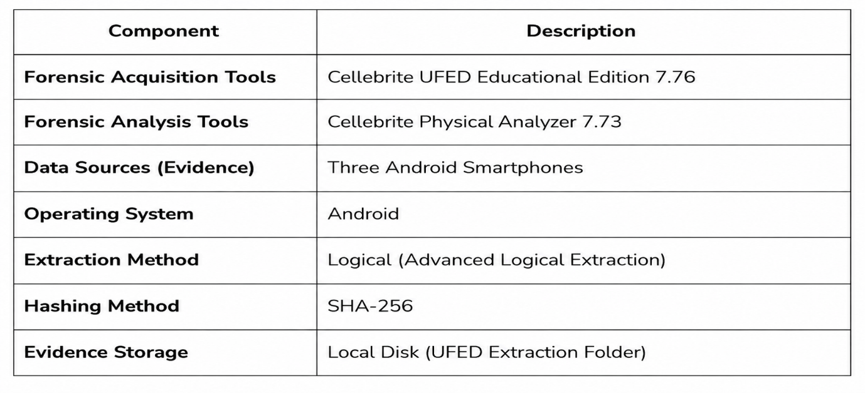
2.2 Evidence Acquisition
Evidence acquisition is an important step in the forensic going on process, as it enables digital data to be removed without making any alterations to the original piece of equipment. During this investigation Advanced Logical Extraction was applied to extract all user-accessible data, such as contacts, messages, call logs, media files and application data etc. along with maintaining evidence integrity.

2.2.1 Selection of Extraction Method
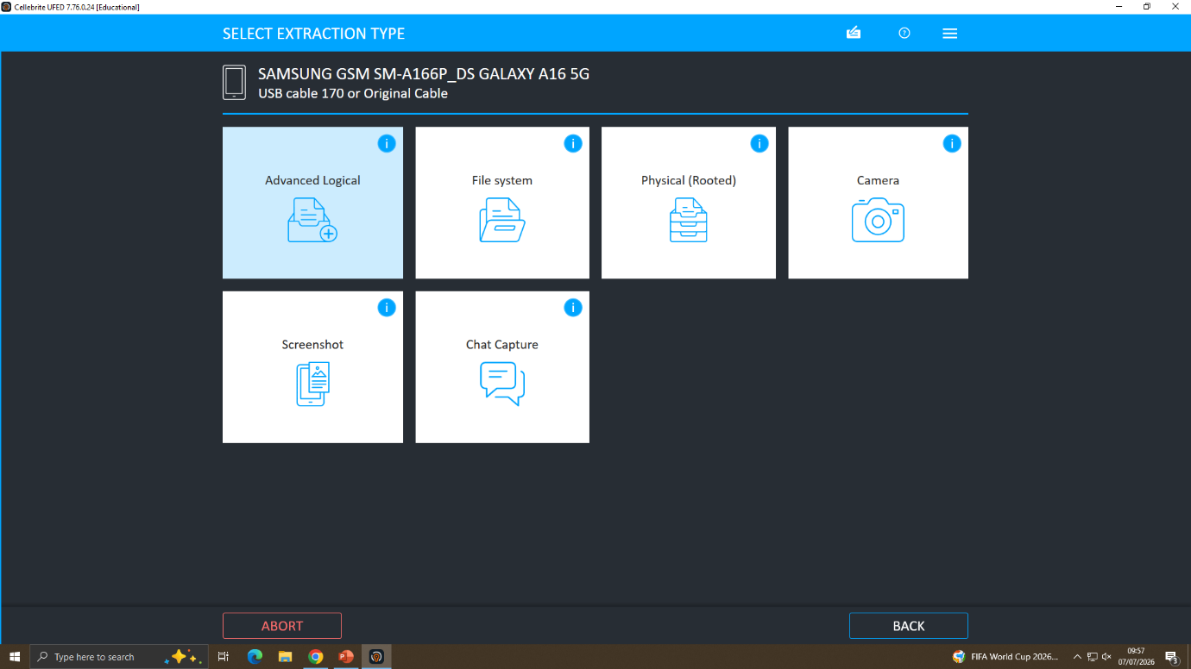
Figure 2.1: Selection of the Advanced Logical extraction method in Cellebrite UFED.
Cellebrite UFED was used and the Advanced Logical Extraction method was chosen because this extraction method will retrieve all accessibly focused user data such as contacts, messages, call logs, installed applications, media files, and application data.
2.2.2 Selection of Evidence Storage Location
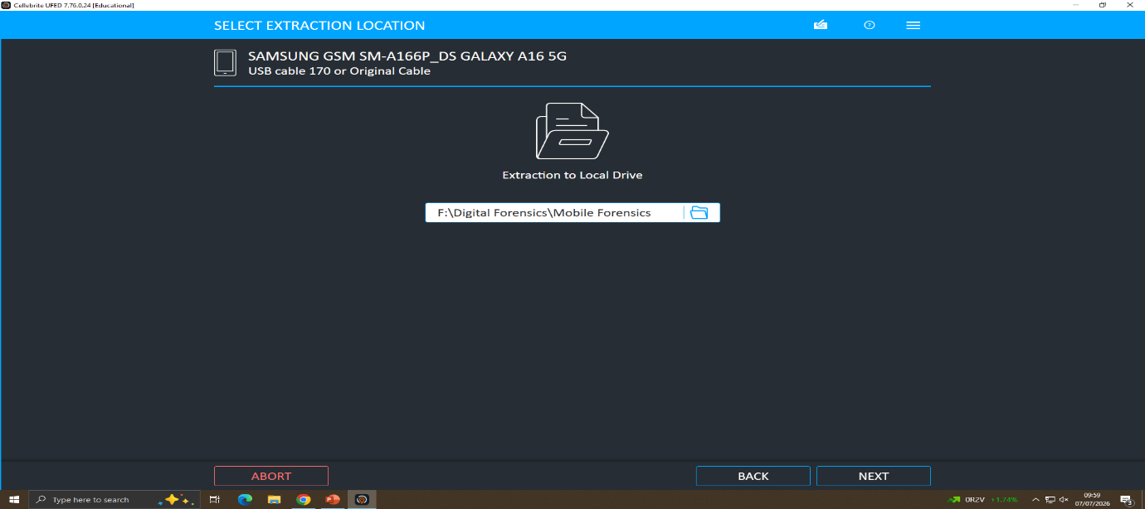
Figure 2.2: Selection of the destination folder for storing extracted forensic evidence.
A unique space for holding evidence was set up on the forensic workstation prior to extraction. To place the taken data in the safe place, it allows to keep evidence in the correct method during the course of the investigation while protecting them from unintended changes.
2.2.3 Device Preparation
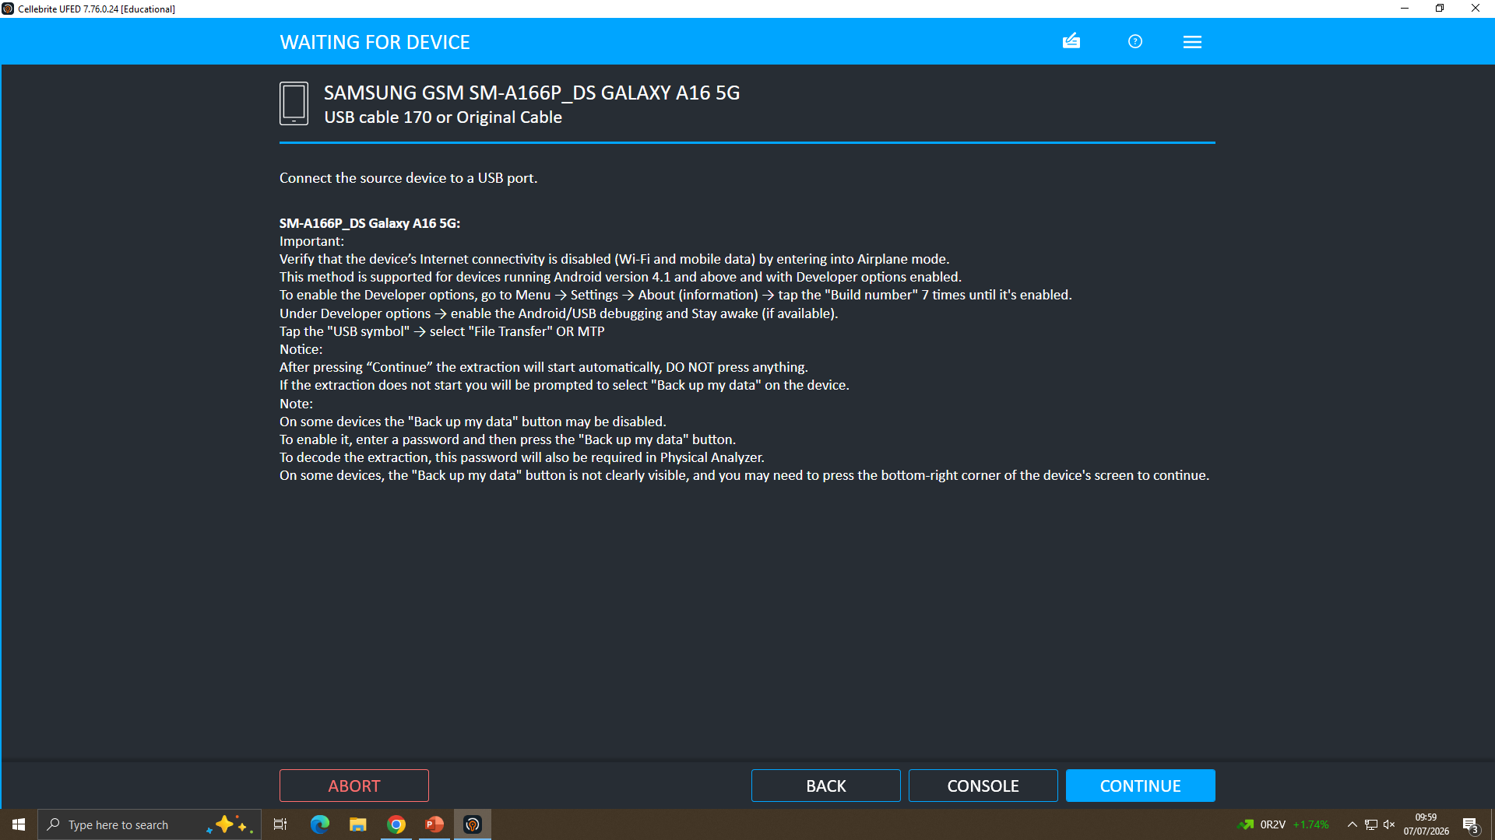
Figure 2.3: Preparing the Android device for forensic acquisition.
USB cable was used to connect the android cell phone to the forensic workstation. USB Debugging was turned on, therefore Cellebrite UFED was able to communicate with the device and prepare it for forensic acquisition while not modifying user data.
2.2.4 Acquisition Process
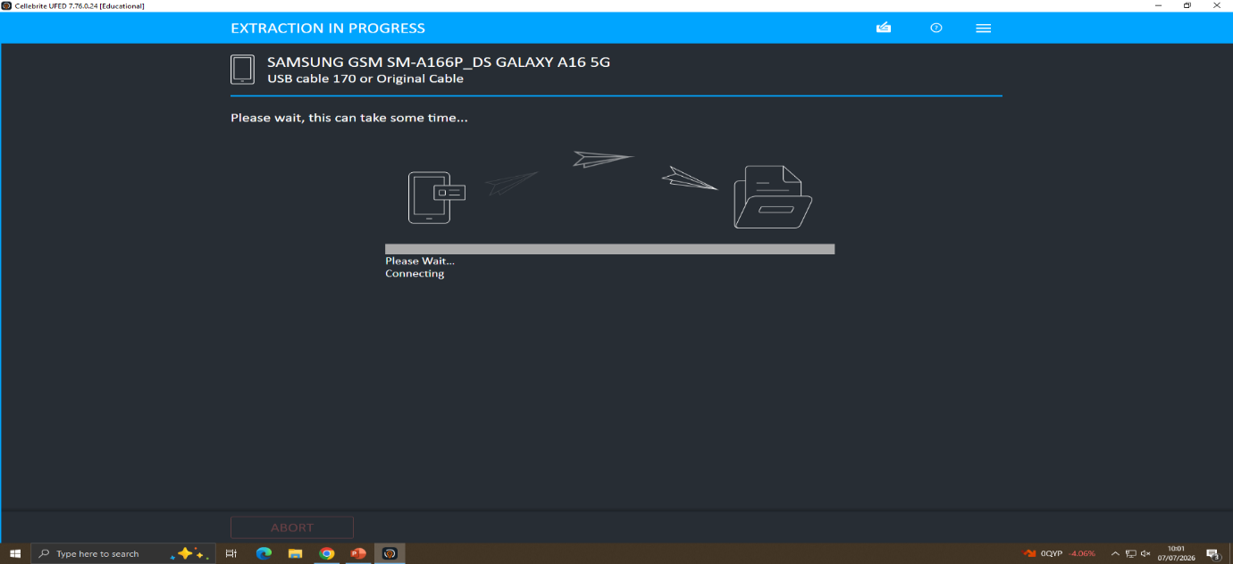
Figure 2.4: Cellebrite UFED initiating communication with the Android device.
Cellebrite UFED was able to connect securely to the smartphone and commenced the logical acquisition process. Careful monitoring of extraction progress was carried out to ensure that all available data was able to be successfully extracted.
2.2.5 Device Authentication
The device owner has given permission and approved USB debugging, and he has given the permissions needed for data acquisition.
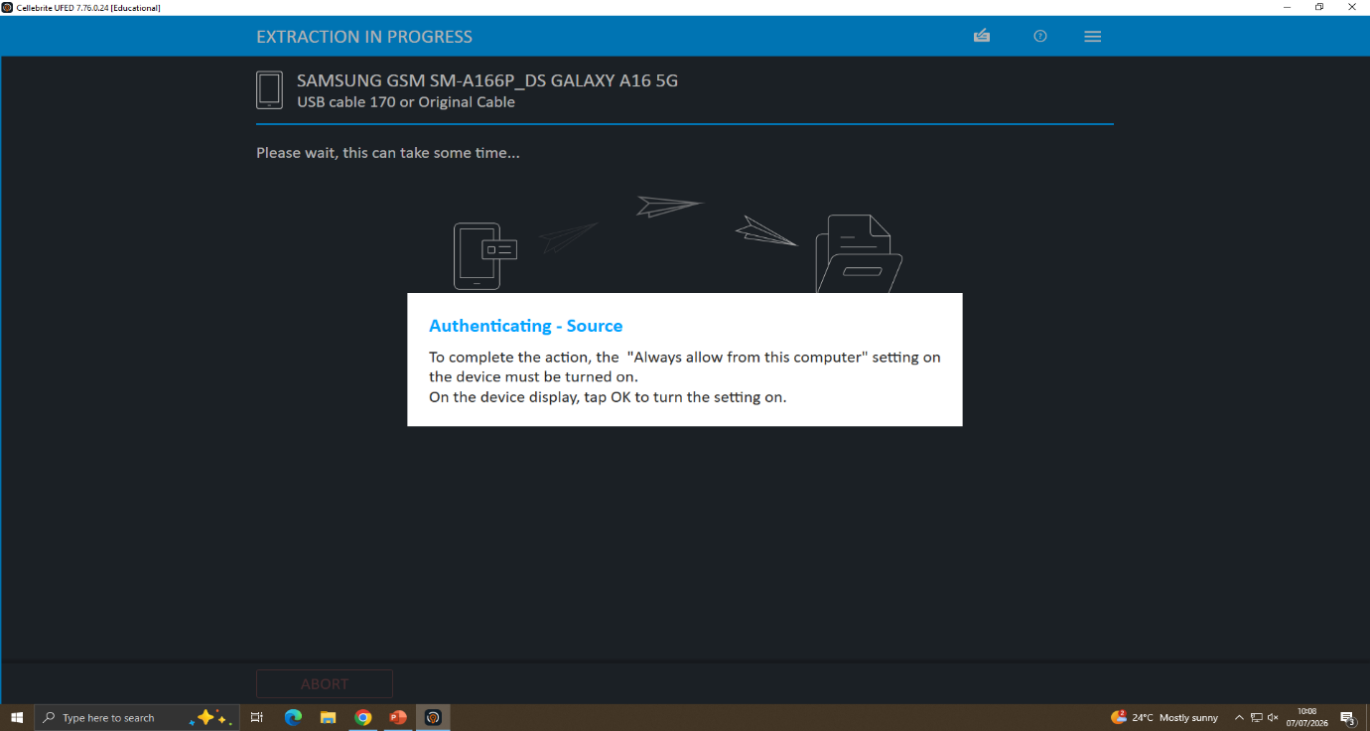
Figure 2.5: USB debugging authorisation displayed on the mobile device.
2.2.6 Logical Backup
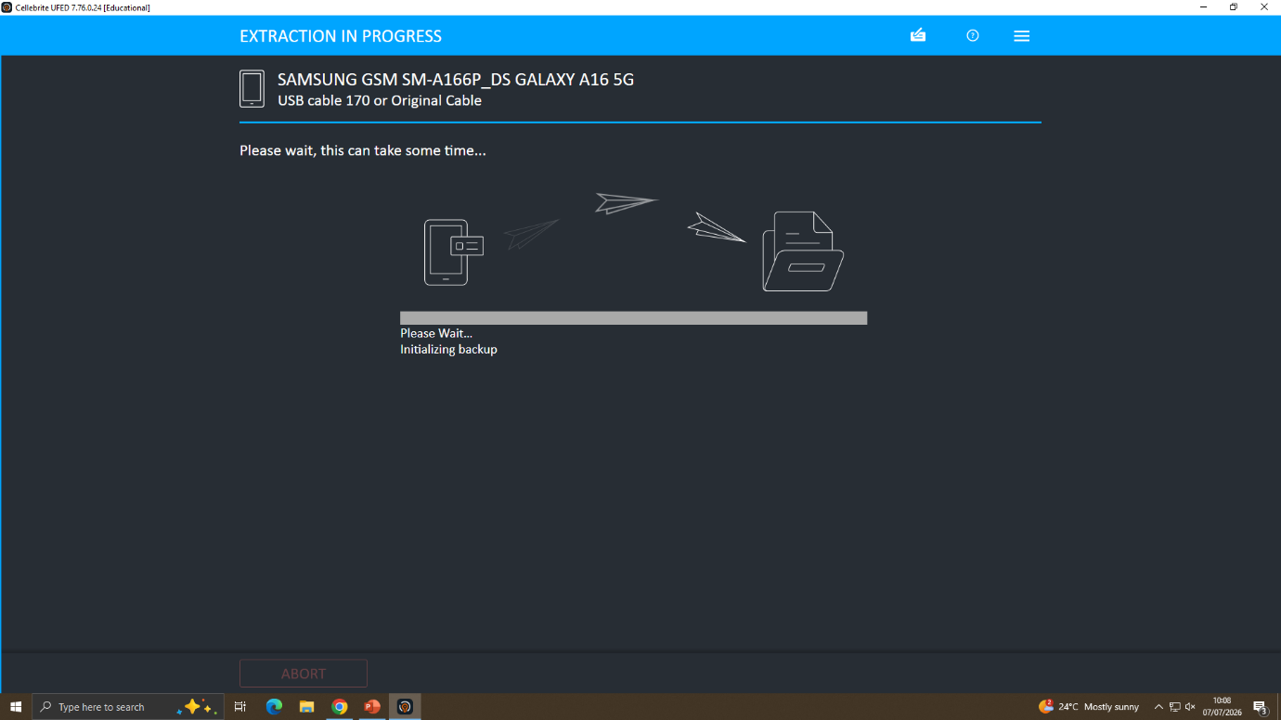
Figure 2.6: Logical backup process initiated by Cellebrite UFED.
Once authenticated, Cellebrite UFED was able to perform a logical backup of the smartphone data that was accessible.
2.2.7 Data Extraction
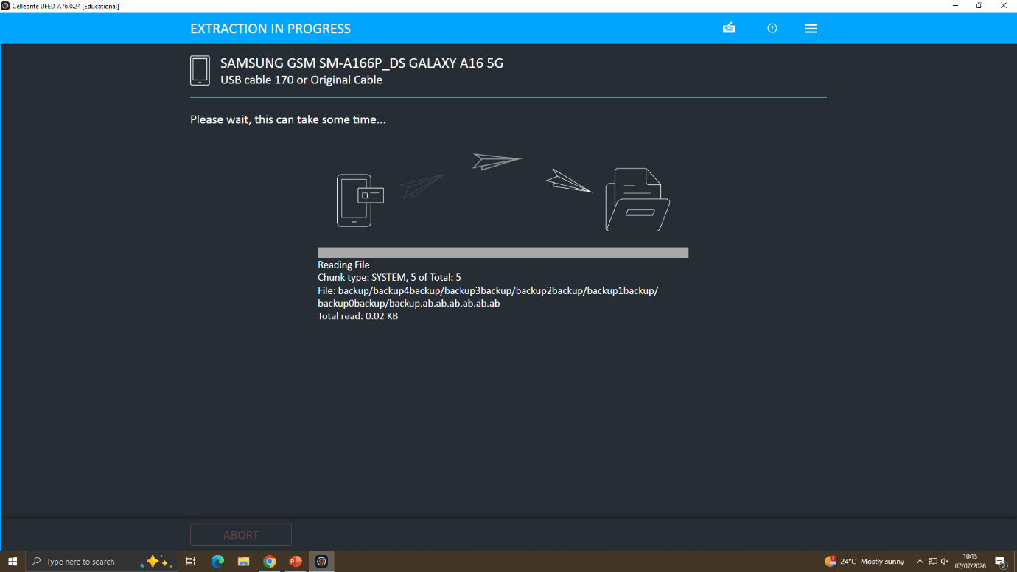
Figure 2.7: Data extraction in progress.
As part of the extraction process, Cellebrite UFED was able to extra luminesce supported user data such as contacts, messages, call logs, application data, photos, videos, and web browsing history.

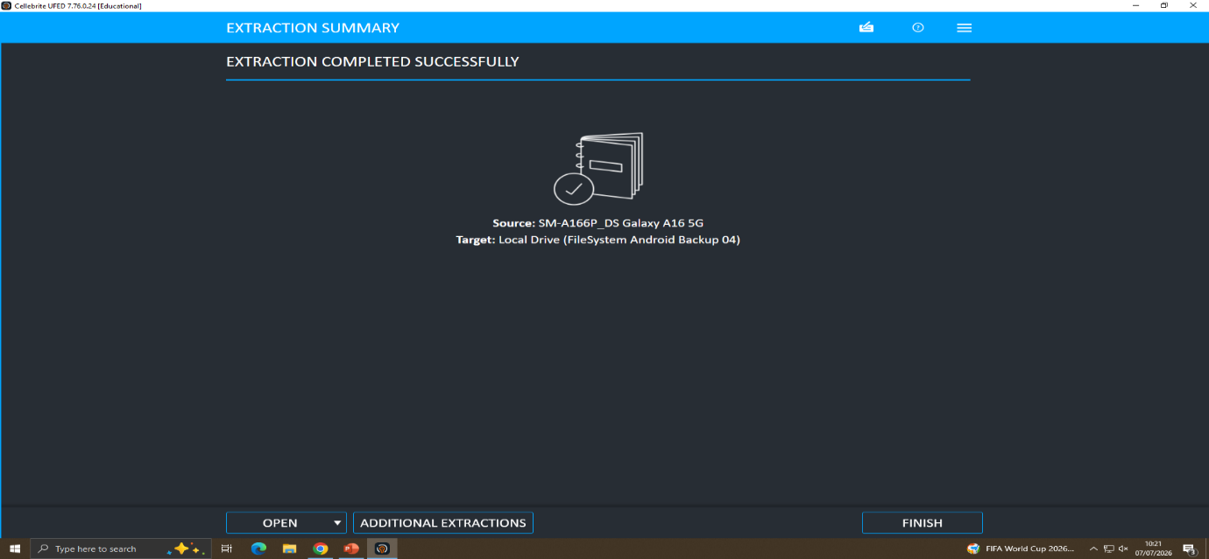
Figure 2.8: Data extraction Completed Successfully.

2.3 Importing Evidence into Cellebrite Physical Analyzer
The evidence extracted was loaded into Cellebrite Physical Analyzer for analysis. The software automatically identified the UFED extraction package and sorted the extracted data into categories and allowed for further decoding and analysis for applications to extract as much evidence as possible.
2.3.1 Loading Evidence
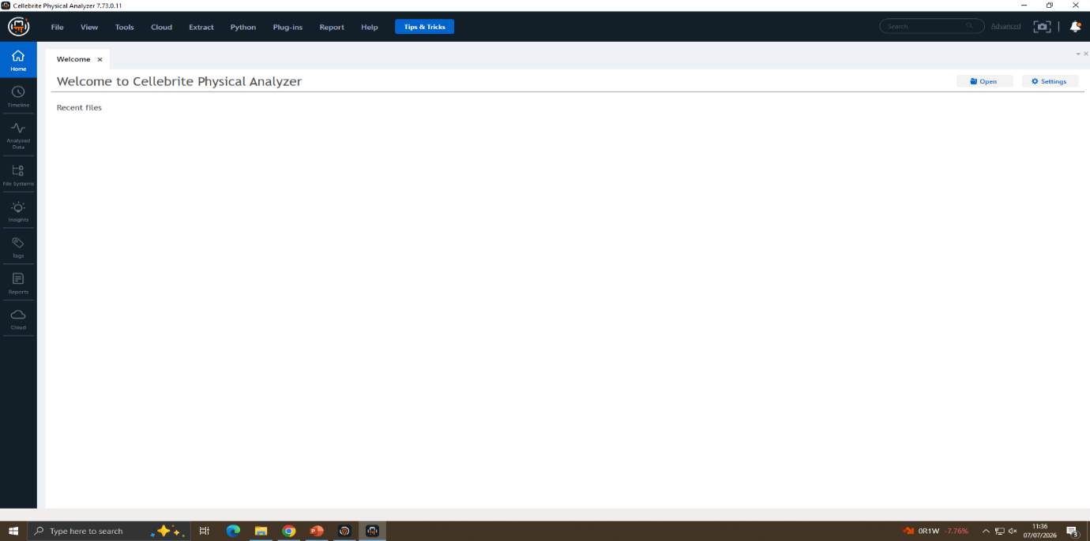
Figure 2.9: Welcome screen of Cellebrite Physical Analyzer
Cellebrite Physical Analyzer was employed to start the forensics job. The extracted mobile device evidence required the interface offered in the application for importing and analysing the evidence.
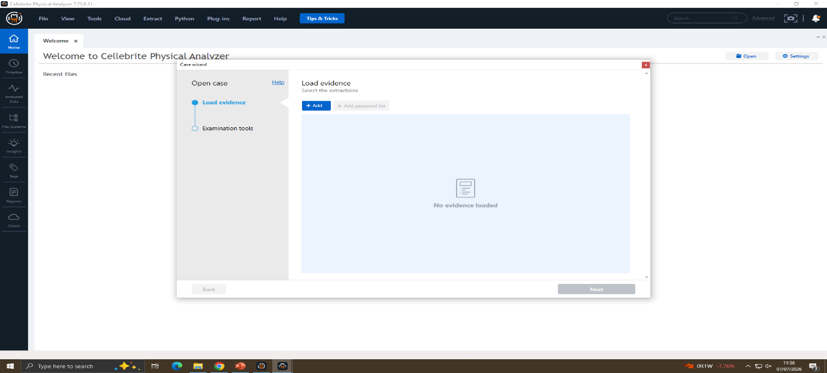
Figure 2.10: Loading extracted evidence into Physical Analyzer
Using the Cellebrite Physical Analyzer Load Evidence option, the evidence was loaded into the physical analyser. This post-processed the extracted data for detailed forensic processing and analysis.
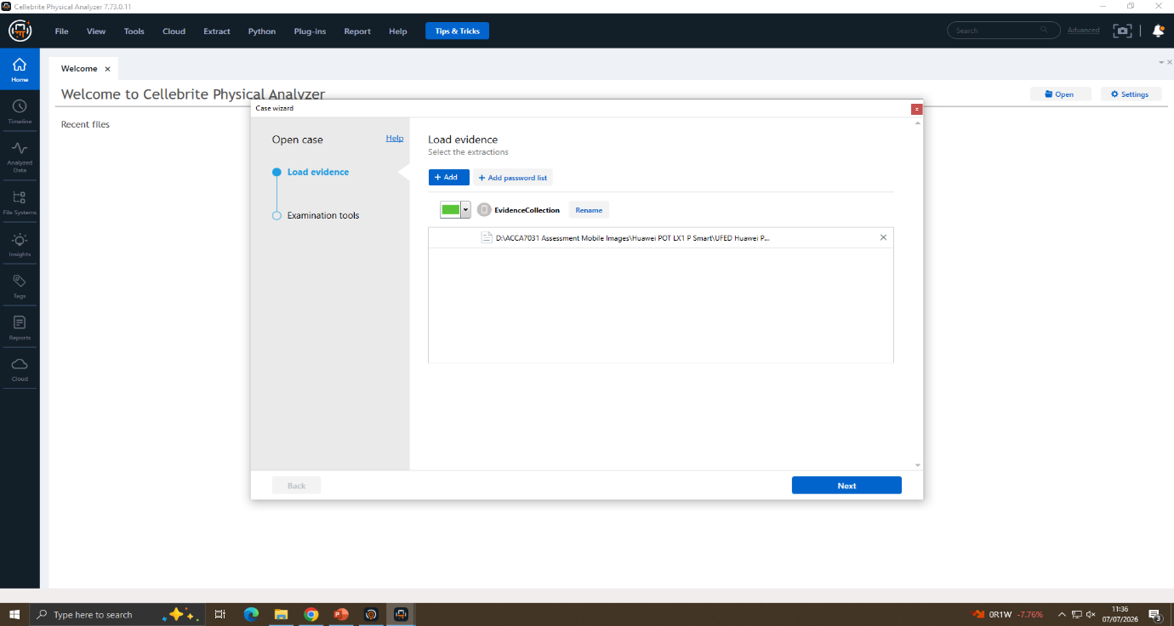
Figure 2.11: Selection of the extracted evidence package
From evidence holding area the necessary UFED extraction package was chosen. This made sure that the appropriate pieces of forensic evidence were brought in for examination.
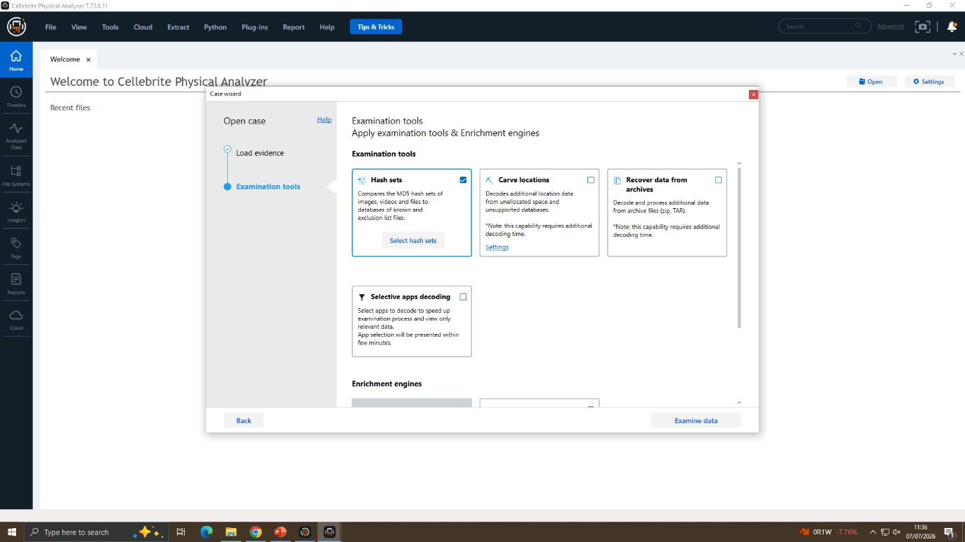
Figure 2.12: Configuration of examination tools
To ensure maximum evidence recovery from the examination process, the appropriate analysis options were enabled such as hash verification, archive recovery, data carving and application decoding.
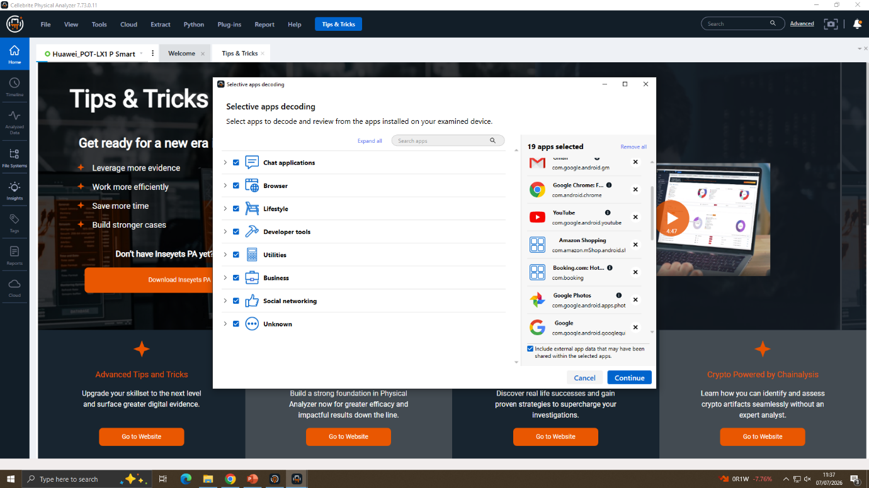
Figure 2.13: Selection of application decoding options
Application decoding was enabled in order to restore artefacts that are not automatically processed and belong to the application. This helped with supported application data extraction for subsequent analysis.
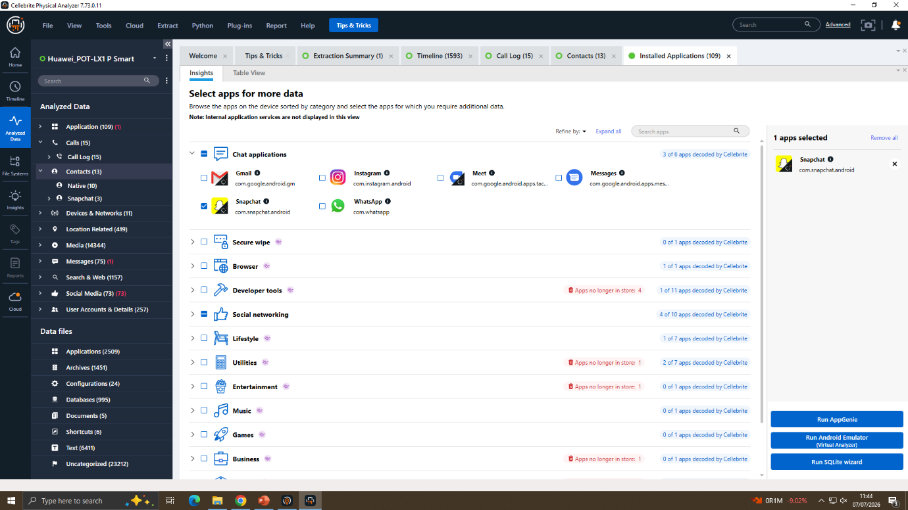
Figure 2.14: AppGenie introduction
But, to identify other application artifacts which might not have been auto-decrypted, a feature called AppGenie was introduced. This is to extend the investigation of support activities.
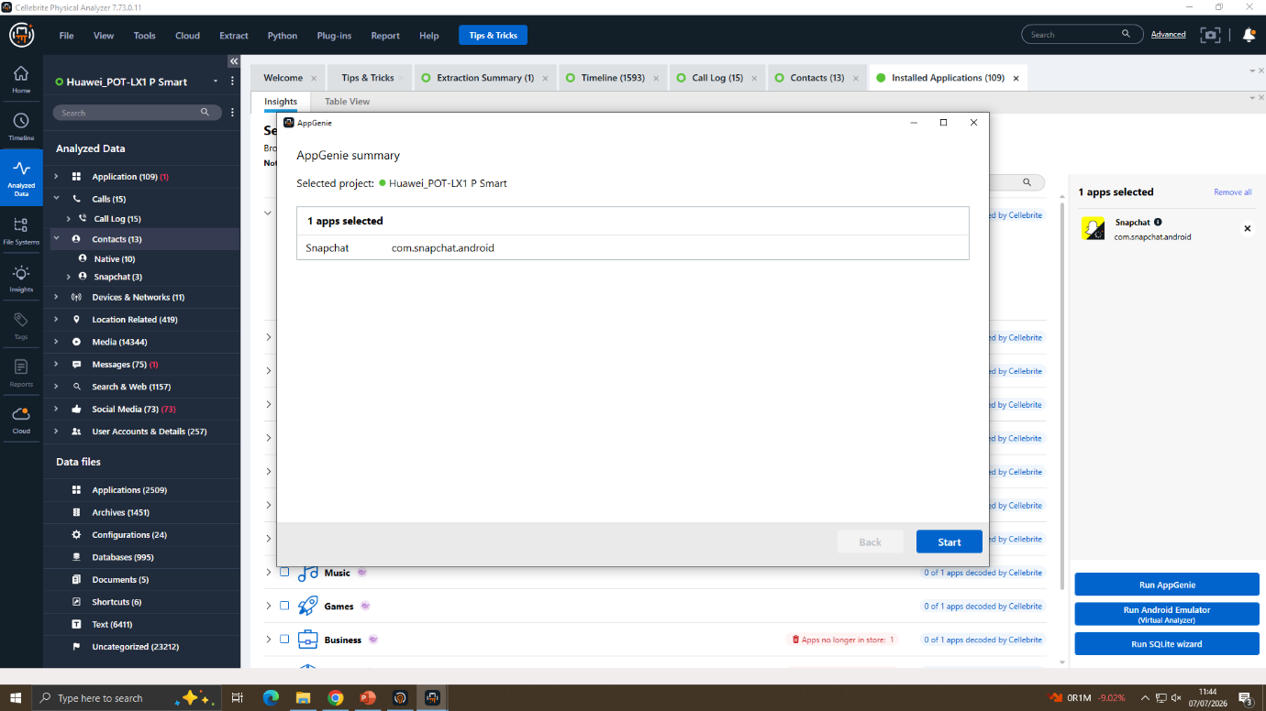
Figure 2.15: AppGenie application summary
AppGenie's highlighted app was submitted for further evaluation and started the decoding process. This step has now been validated to the selected application for further investigation of the forensic elements.

- Case Investigation and Findings
3.1 Case Background
Investigation involves the leakage of Quantum Tech's patent keeping AI chip that is confidential (QI-AI-2025). Use of an automated monitoring system identified suspicious access and it reported that confidential patent information was being accessed without permission. It appeared to be a corporate spying case and theft of valuable intellectual property.
The investigation determined that the main suspect was Emma, and that Joe was working as some kind of 'man in the middle' and Norman was believed to be the 'purchaser'. This was the basis for which the case was handed over to the law enforcement body for examination using digital forensics.
The three Android smartphones owned by the suspects have been seized and both have been examined with Cellebrite UFED and Cellebrite Physical Analyzer. The investigation centered on examining communication, call logs, emails, images, GPS location, and other digital artefacts, to join the suspects and find evidence of the stealing of confidential information.
3.2 Evidence Acquisition and Integrity Verification
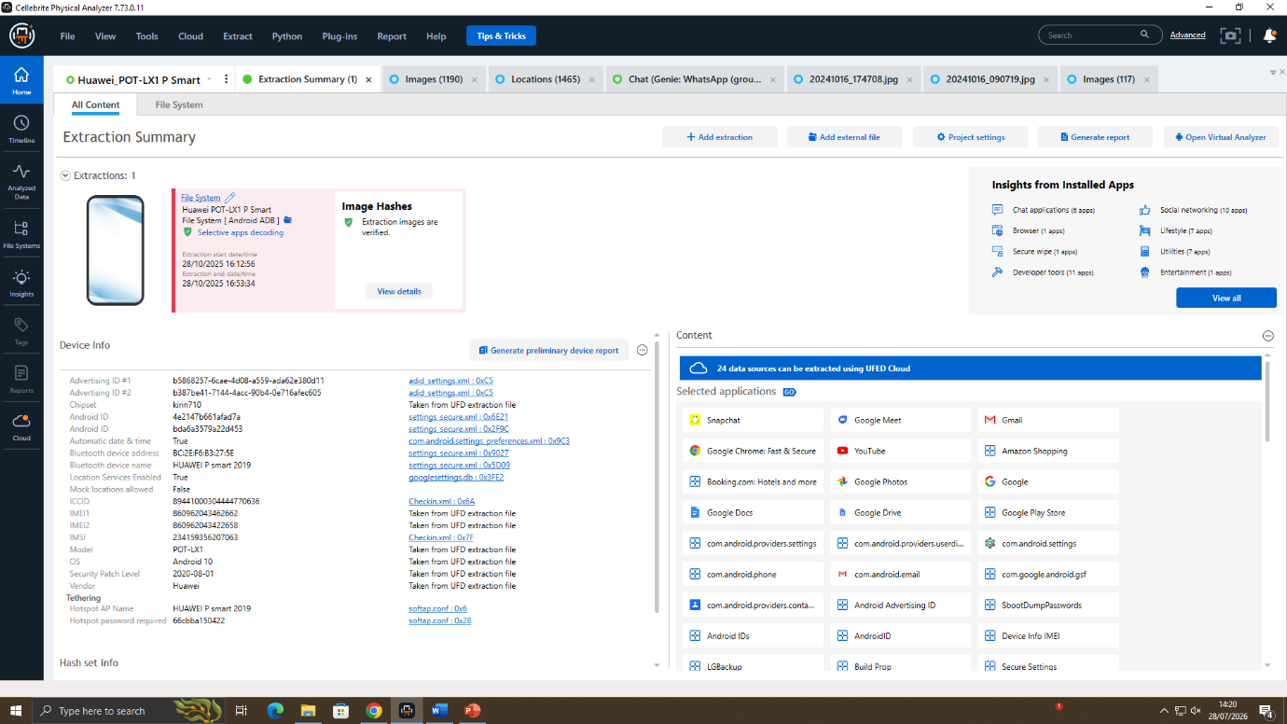
Figure 3.1: Cellebrite Extraction Summary for Huawei POT-LX1 P Smart device.
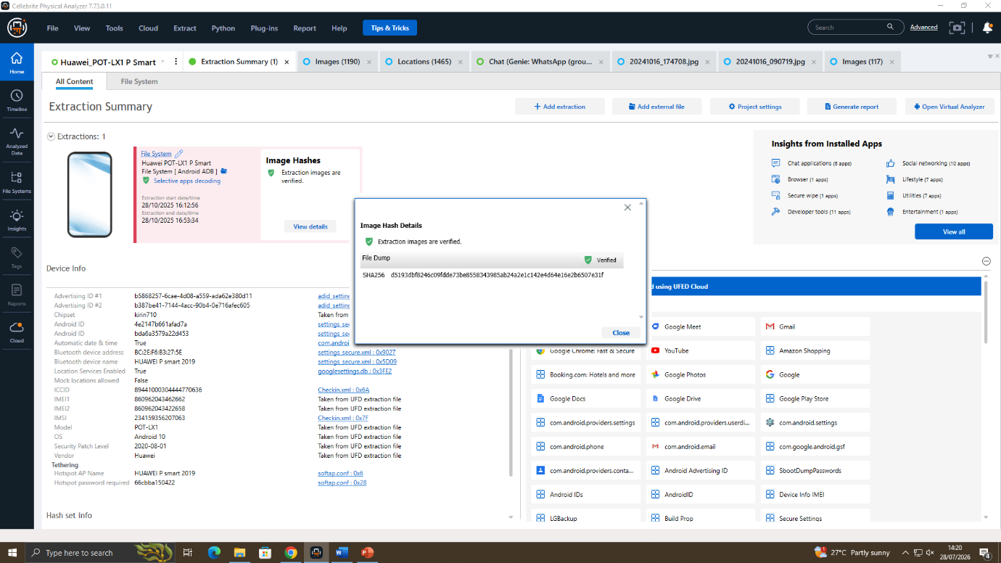
Figure 3.2: SHA-256 hash verification confirming the integrity of Huawei POT-LX1 P forensic image.
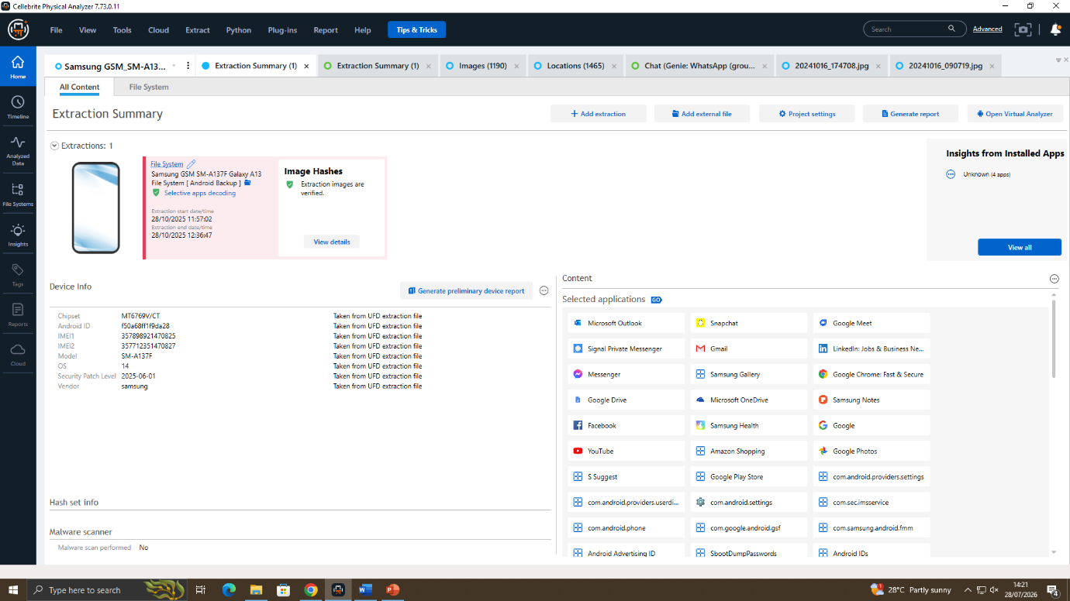
Figure 3.3: Cellebrite Extraction Summary for Joe's Samsung Galaxy A13 device.

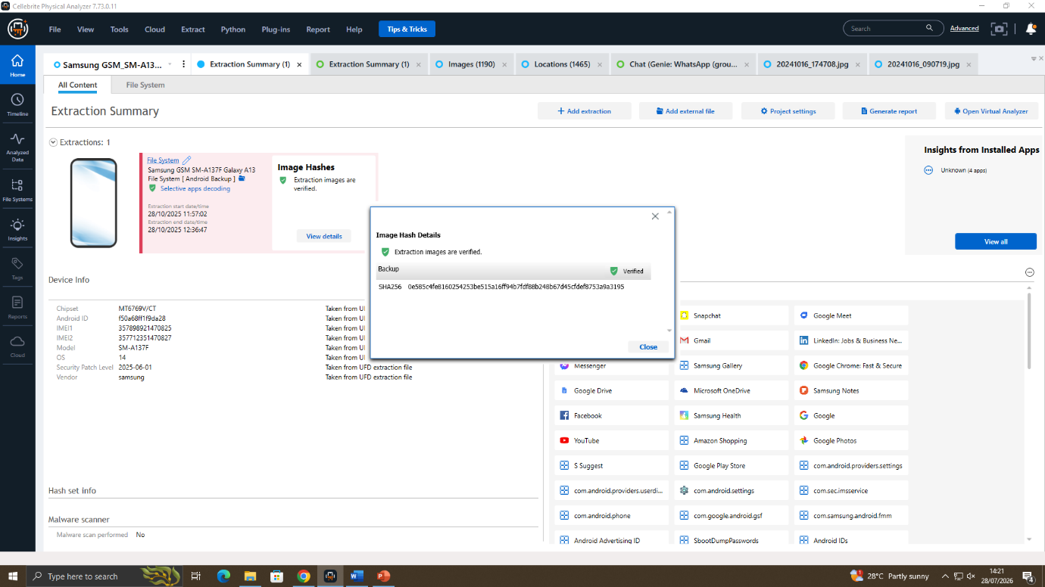
Figure 3.4: SHA-256 hash verification confirming the integrity of Joe's forensic image.
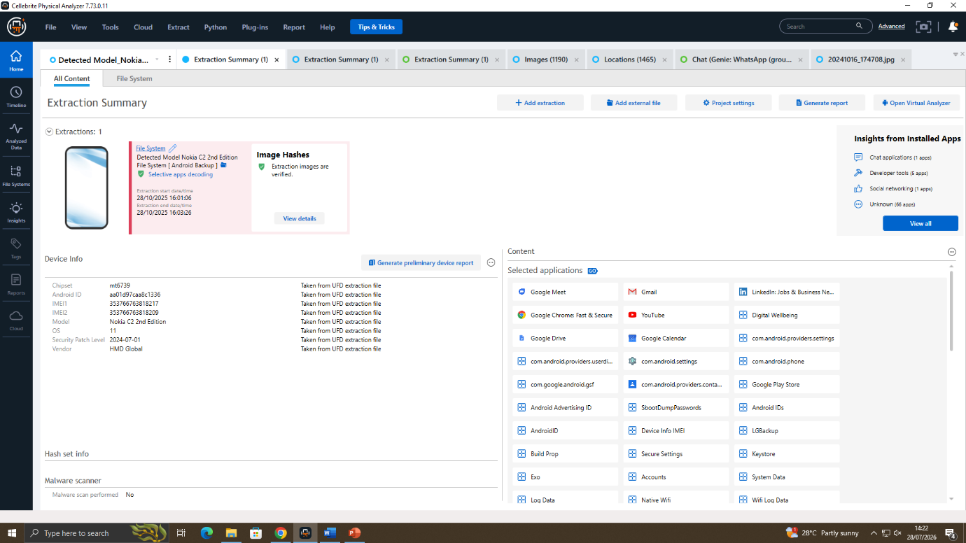
Figure 3.5: Cellebrite Extraction Summary for Norman's Nokia C2 (2nd Edition) device.

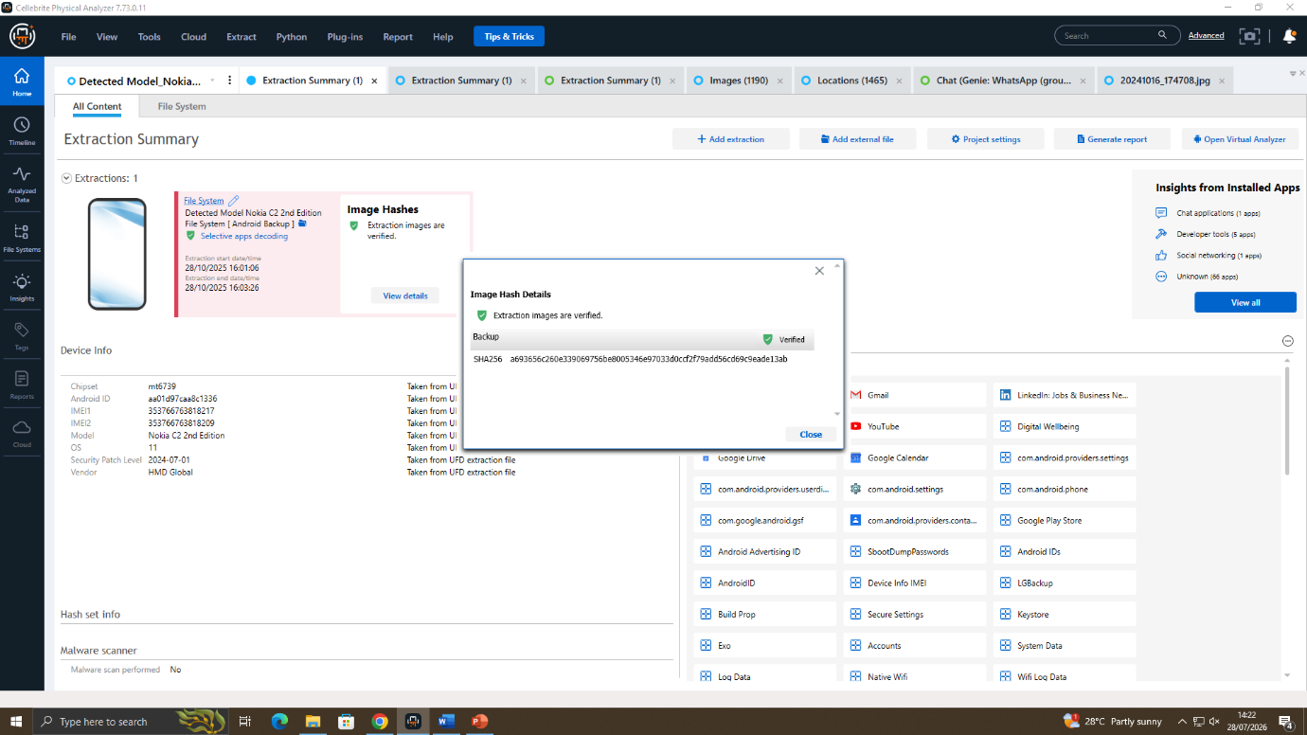
Figure 3.6: SHA-256 hash verification confirming the integrity of Norman's forensic image.
3.3 Chain of Custody
To maintain authenticity and completeness of evidence and to prevent evidence from being tampered with, the chain of custody was properly handled throughout the handling and processing of the digital evidence. At the time of acquisition, a unique exhibit reference was created for each mobile device. They were all received unlocked with the assistance of Quantum Tech and were subjected to forensic acquisitions with no changes to user data.
Cellebrite Physical Analyzer 7.73.0.11 was used to create forensic images. The extracted data was immediately after acquisition put into a hash value calculation as well as verified to eliminate any changes in the data during acquisition or analysis period. The forensic examinations were conducted on original devices which were not altered during the investigation and instead worked with a series of forensically created copies.
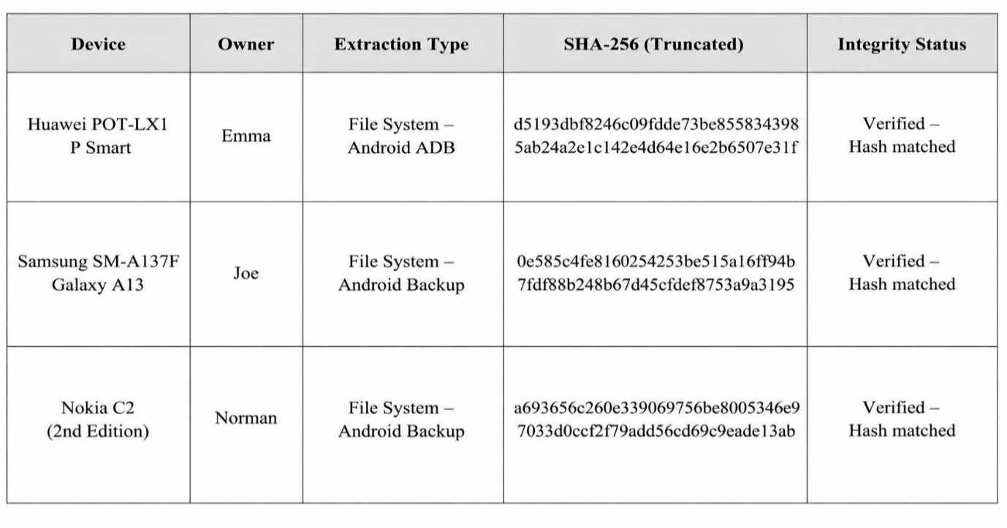
3.3.1 Evidence Handling Process
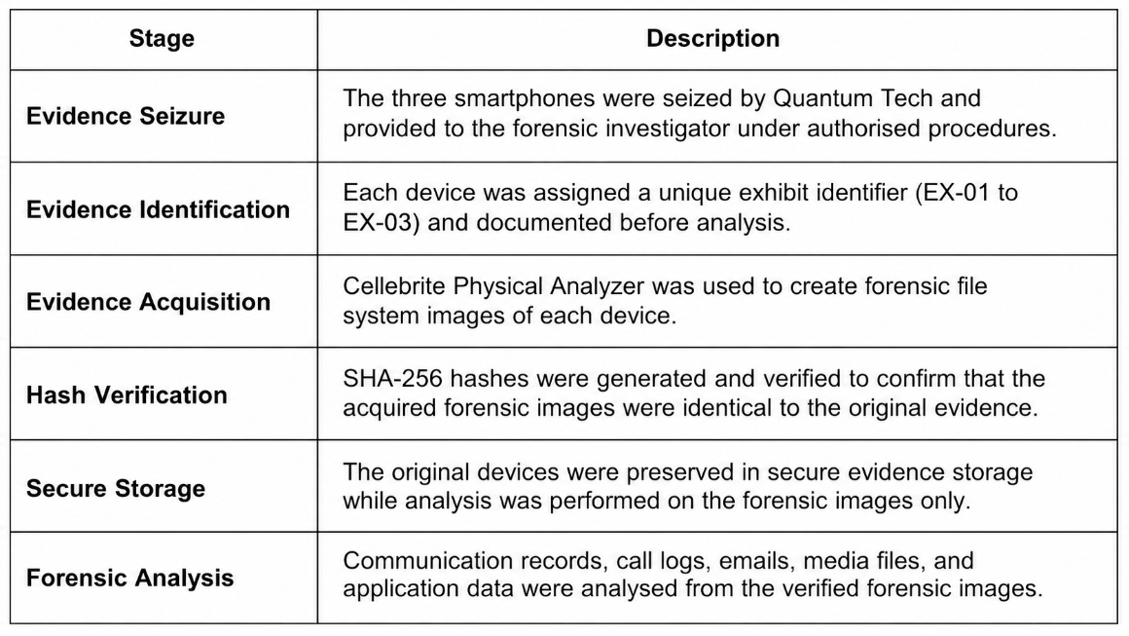
- Communication Analysis
Cellebrite Physical Analyzer was then used to analyse the communication data from the three Android devices. WhatsApp, Facebook messaging, emails, Instagram and call logs used to know if Emma was communicating with Joe and/or Norman to piece together the events and ordering.
4.1 WhatsApp Analysis
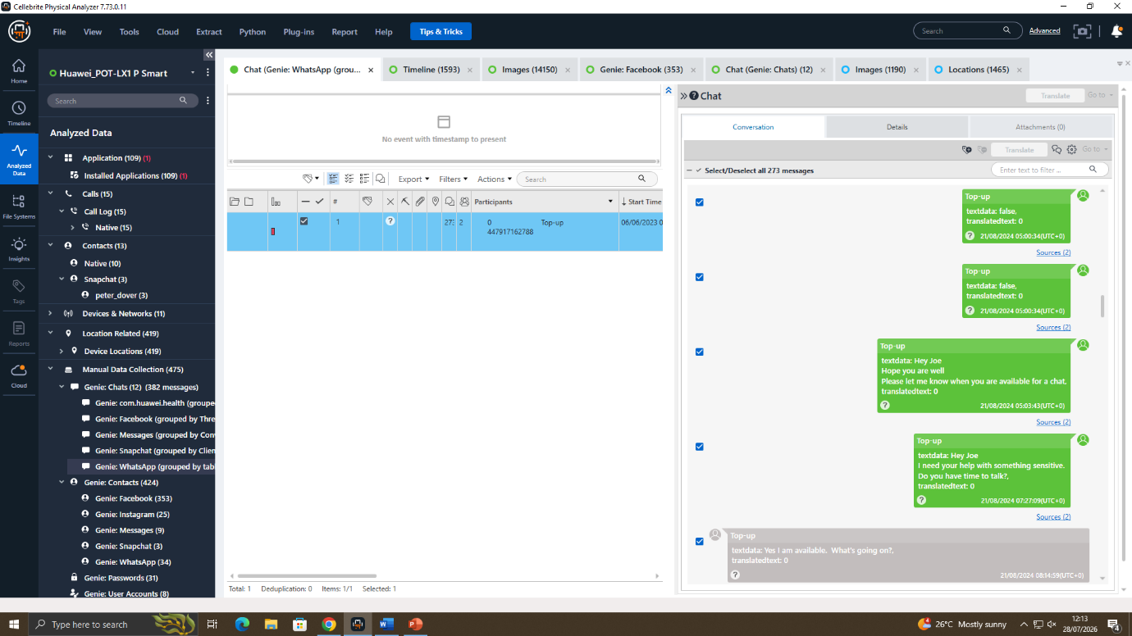
Figure 4.1: Initial WhatsApp conversation between Emma and Joe.
The first part of the conversation on WhatsApp obtained from Emma's Huawei handphone is displayed in Figure 4.1. On 21 August 2024 at 05:03:43 (UTC+0) Emma requested to speak with Joe about a sensitive issue. On 21 August 2024 at 08:14:59 (UTC+0), we received a confirmation from Mr Joe confirming his availability.
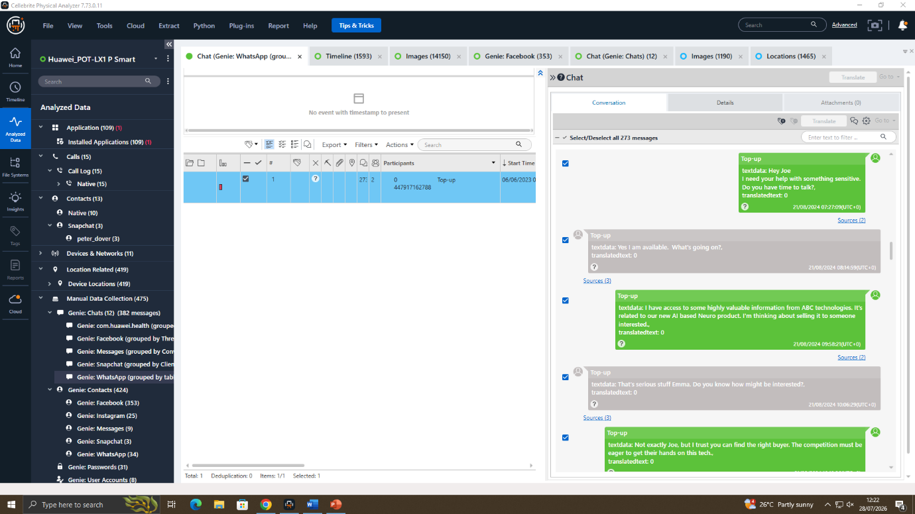
Figure 4.2: Discussion regarding confidential AI information.
In Figure 4.2, Emma tells Joe that she had access to valuable information about the company's product, based on AI. The message was sent on 21 August 2024 at 09:58:21 (UTC+0). The reply from Joe was at 10:06:29 (UTC+0): Are there any potential buyers? The discussion is suggestive of Joe's willingness to help in finding a buyer for the confidential information.
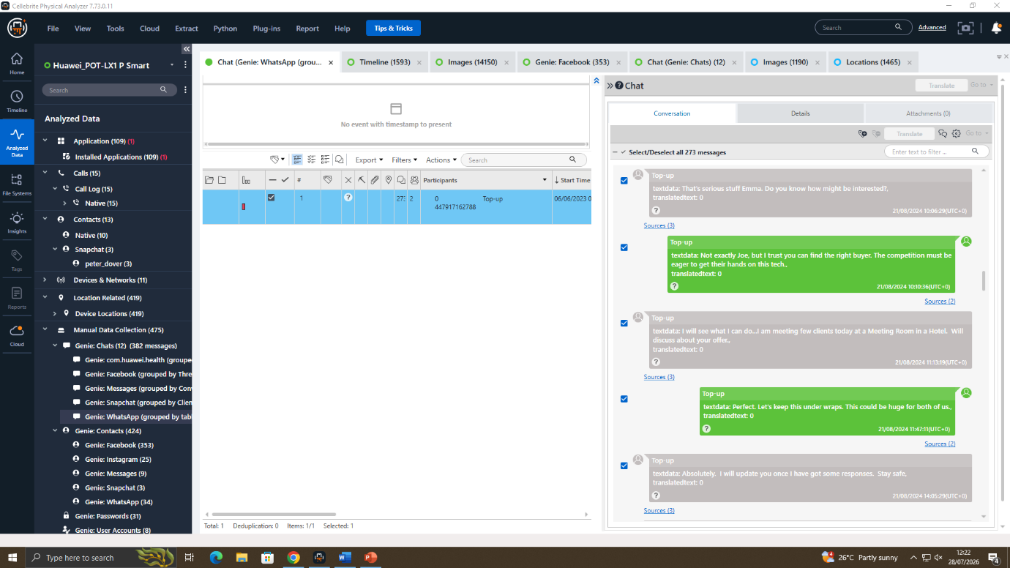
Figure 4.3: Planning the sale of confidential information.
The WhatsApp conversation continued as seen in figure 4.3. Emma asked Joe to find them a good buyer at 10:10:36 (UTC+0). At 11:13:19 (utc+0), Joe said that he will meet potential clients to discuss the offer. At 11:47:11 (UTC+0) Emma replied, asking that the deal be kept private.
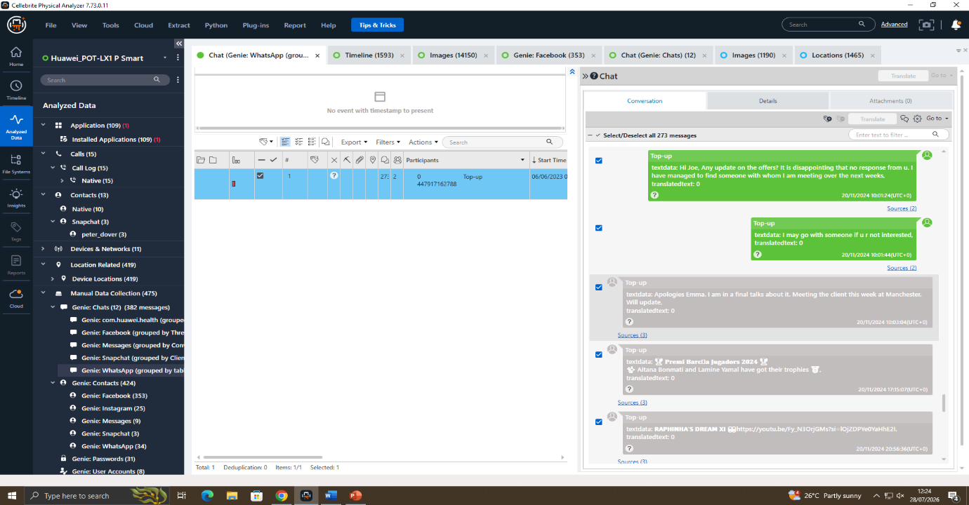
Figure 4.4: Follow-up communication regarding buyer negotiations.
In Figure 4.4 is another later conversation, between Emma and Joe. Emma asked for an update about the sale on 20 November 2024 at 10:01:24 (UTC+0). Joe responded to the call at 10:03:04 (0:03:04 AM) saying that negotiations were continuing and a meeting with the client would be set up in Manchester. It is clear from this conversation, which was continued over several months, that the communication was a very extensive one.
4.2 Facebook Messenger Analysis
How they connect are the retrieved Facebook Messenger conversations. The messages relate to setting up information, confidentiality and payment, making Norman the eventual target of the delivery of information, with Joe as the go-between.
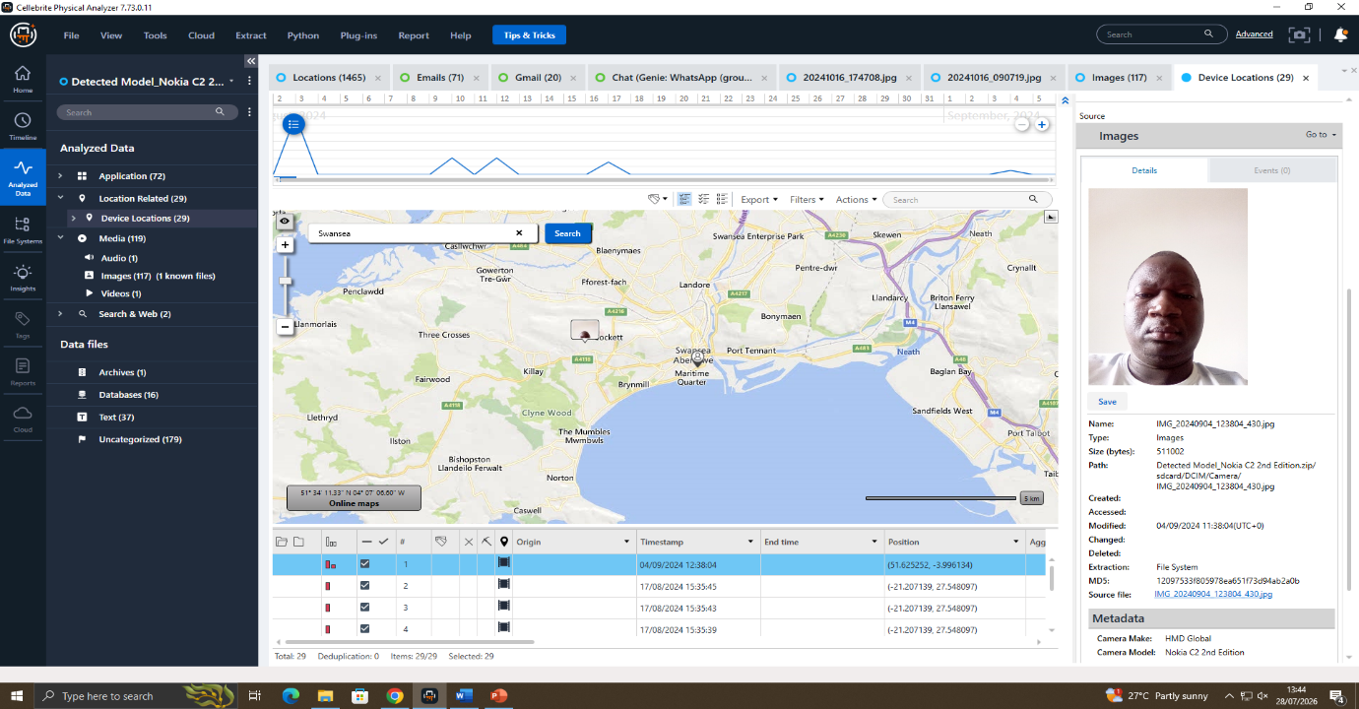
Figure 4.5: Nokia C2 (2nd Edition) device analysis and recovered location evidence.
The rendition of the Nokia C2 device in Figure 4.5 was used to identify the device's owner and forensic artefacts. The data obtained included location data, evidence about the media, and device information that was gathered during the time span of the investigation. The artefacts were analysed together with artefacts from the Huawei and Samsung devices. The recovered timeline along with metadata information, shows the activity taking place around the same time as when the suspects were communicating, thereby corroborating its association with the last phase of the investigation.
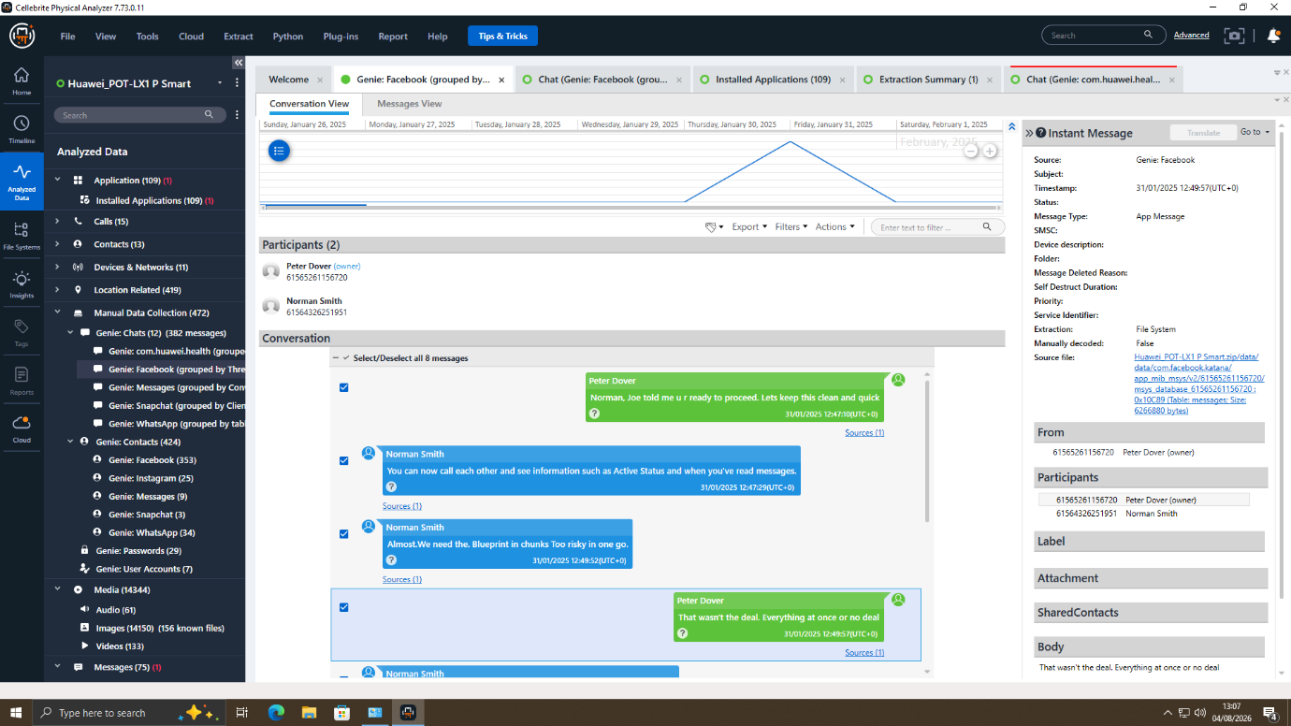
Figure 4.6: Facebook Messenger conversation between Joe and Norman.
During the course of a forensic examination, it was found that conversations in Facebook Messenger were preserved and showed Norman Smith negotiating with Joe concerning the confidential company blueprint or not, as illustrated in figure 4.6. The discussion included some talk of false drop-off of blueprint, security measures and payment arrangements. The evident communicating about the move of sensitive information as evidenced by the messages "Let's start with just the head", "first part releases" and "watch your inbox in 48 hrs" shows the parties were actively negotiating the transfer.
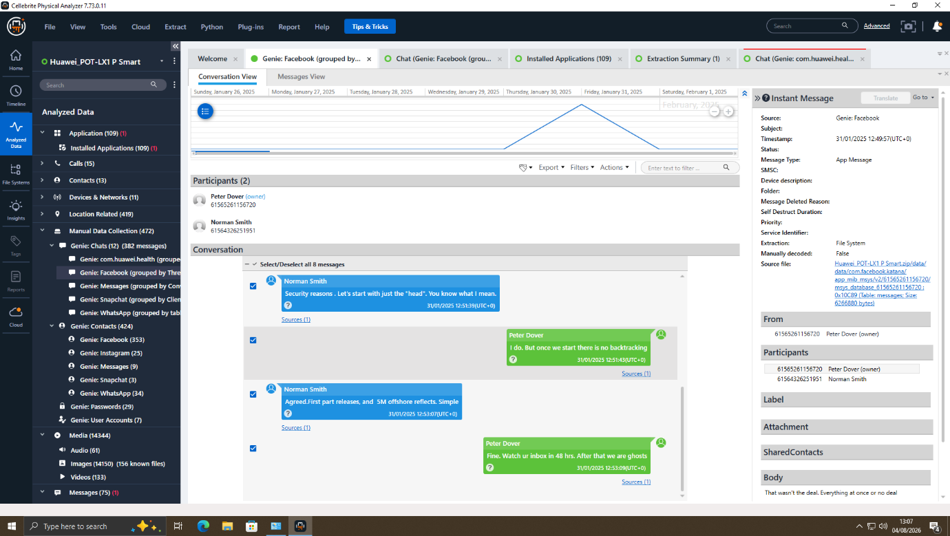
Figure 4.7: Continuation of negotiations between Joe and Norman.
The continuation of the discussion in Figure 4.7 indicates both agreed to exchange the confidential blueprint in multiple steps in order to lessen the chance of being detected. There are mentions of "partial releases," offshore payments setups and "delayed communication" that point to some sort of effort to hide the activity. All of this evidence helps substantiate the conclusion that Norman was the intended purchaser, and that Joe was the intermediary between Emma and Norman.

4.3 Call Log Analysis
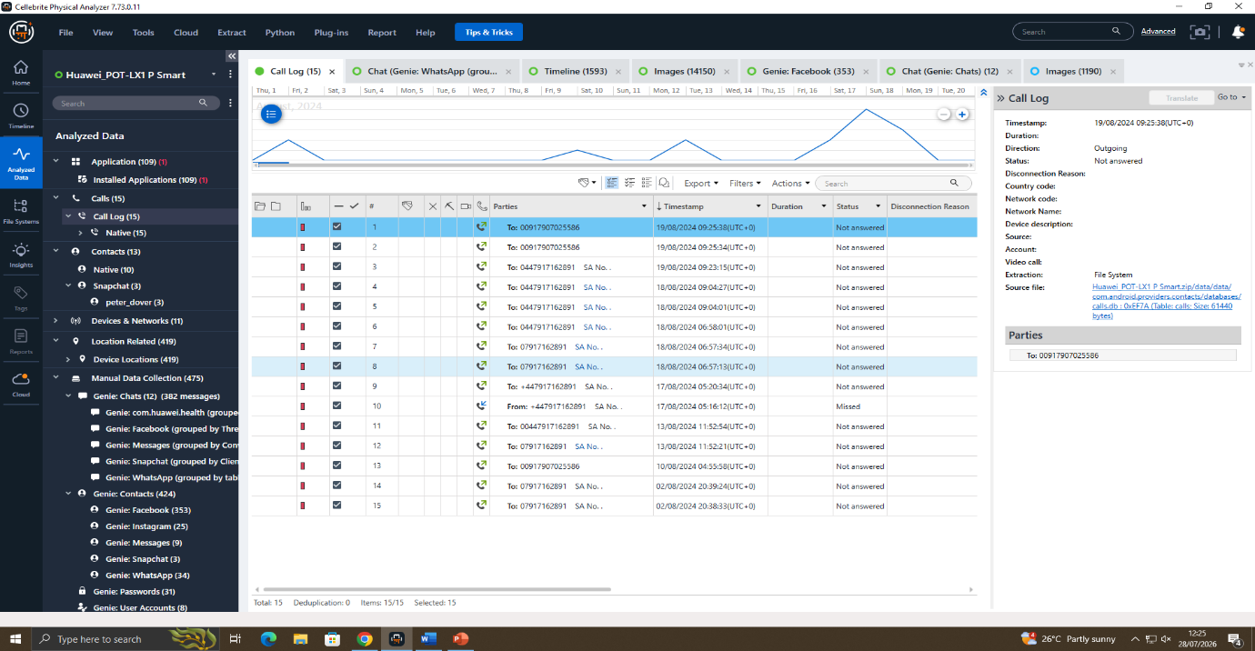
Figure 4.8: Call history recovered from Emma's smartphone.
As seen in Figure 4.8, the gadget’s call list could be retrieved from Emma's Huawei phone. Multiple outgoing and missed calls were recorded on 18 August 2024 and 19 August 2024, including calls made at 06:57:13, 06:57:34, 09:04:01, and 09:25:38 (UTC+0). These communication efforts come in the run-up to the WhatsApp messages and corroborate the course of the communications.
4.4 Email Analysis
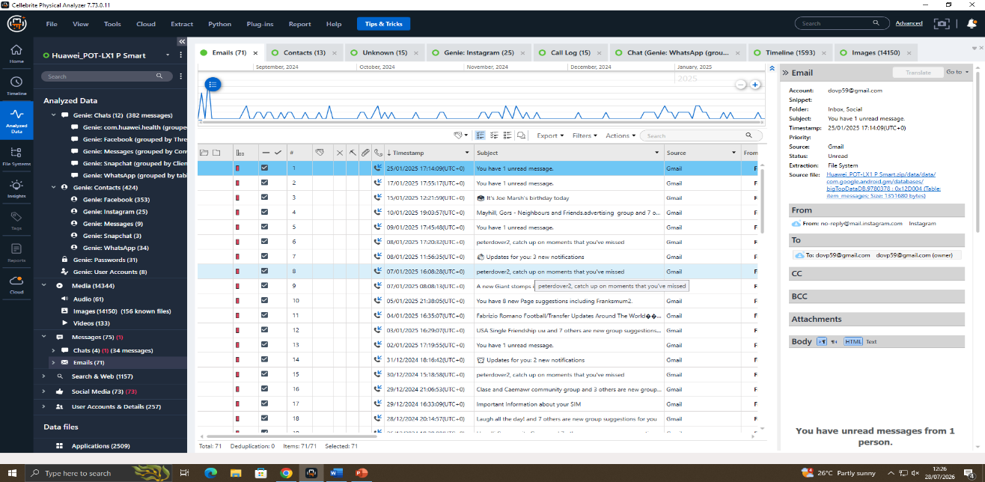
Figure 4.9: Email records extracted from Emma's smartphone.
An email list is displayed in figure 4.9 that was recovered from the Huawei device. The primary items found in the mailbox include promotion emails from December 2024 to January 2025, Gmail and Instagram notifications as well. None of the emails reviewed during the examination included any of the requested documents including the QT-AI-2025 patent, any communication with the suspected Mail Order Bride or any company documents that could be confidential.
4.5 Instagram Analysis
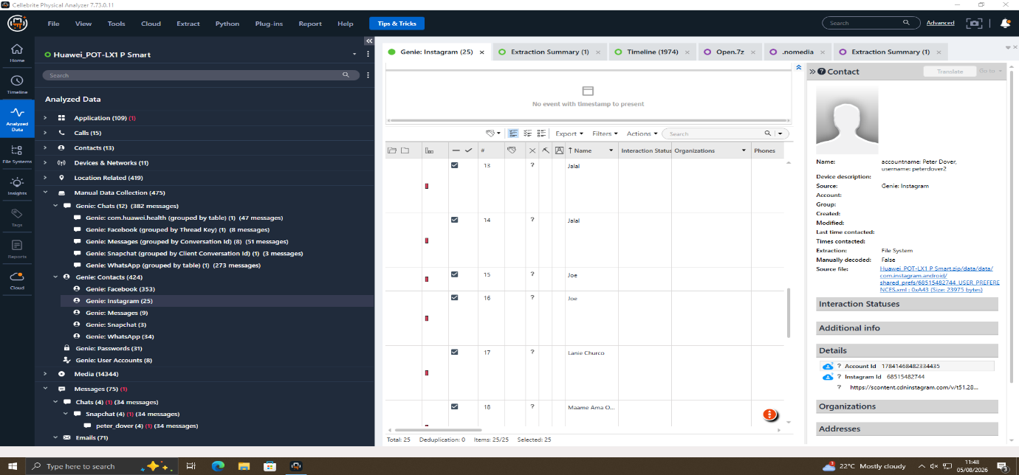
Figure 4.10: Instagram Direct Messages recovered from the device.
Obtained Instagram Direct Messages from the smartphone are shown in Figure 4.10. The retrieved messages primarily consisted of updates from social media platforms, football-related information, and personal messages from October 2024. Among the Instagram chats, nothing could be found that had any reference to the sale of the AI patent, company secrets or any correspondence with the alleged purchaser.

- Media and Location Analysis
5.1 Image Metadata Analysis
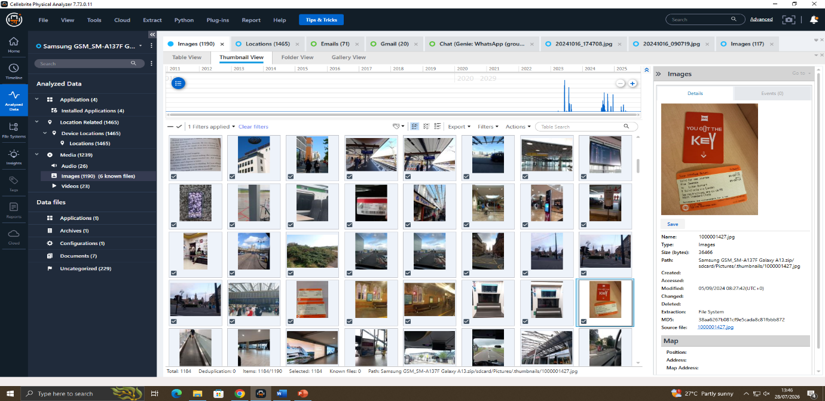
Figure 5.1: Extracted images and associated metadata.
In this chapter, we will put into practice the use of images retrieved from the Samsung Galaxy A13 using Cellebrite Physical Analyzer, as provided in Figure 5.1. The retrieved pictures also carry the metadata with the information about image, file path, camera model, capture time and capture date. For instance, the Samsung SM-A137F camera was used to take one photo at 07:54;39 on 21 August 2024 (Zulu time).
5.2 GPS Location Analysis
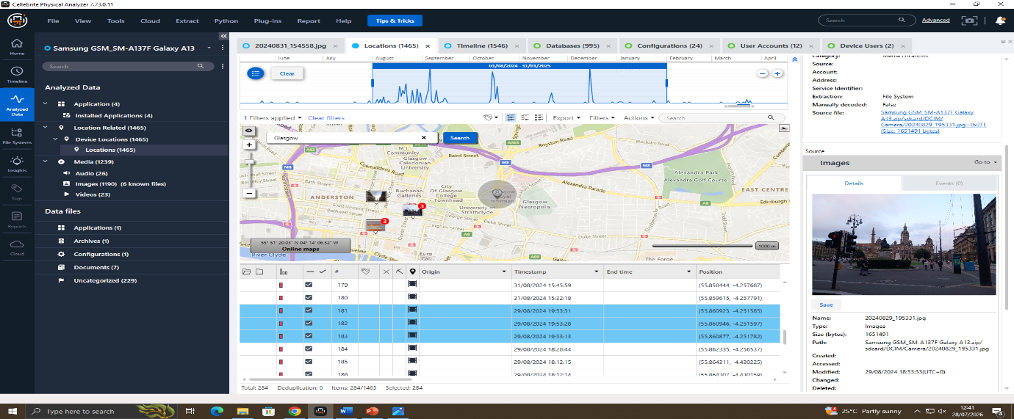
Figure 5.2: GPS locations extracted from image metadata in Glasgow.
GPS Coordinates generated using photos from Glasgow are shown in figure 5.2. Embedded location information shows that a number of photos are associated with geographical ranges, which were captured on 29 August 2024 from 19:53:13 to 19:53:31 (UTC+0). The GPS data retrieved verifies the movement of the person who utilized the device during the investigation and confirms the location of the device at these stops.
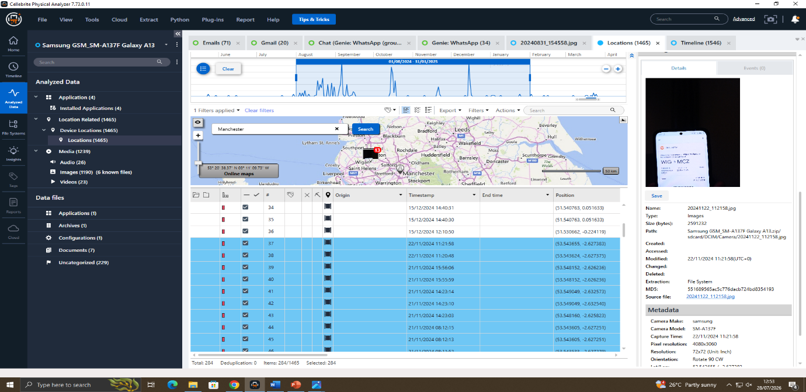
Figure 5.3 GPS locations associated with Manchester.
Figure 5.3 shows further GPS evidence obtained on the device which shows a journey to Manchester. The images were taken at various times of the day on 21st November 2024 between 08:12:13 and 15:56:06 (UTC+0). These geolocation records can be used to confirm that the device travelled to Manchester, and indicate that the device was there during the period of the investigation.
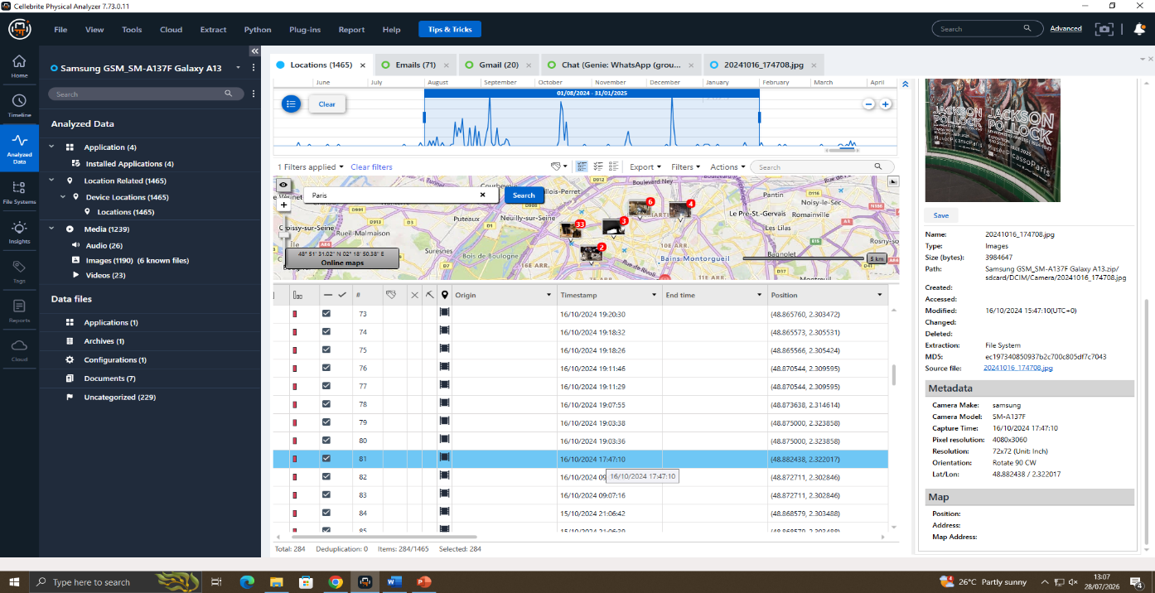
Figure 5.4: GPS locations associated with Paris.
Figure 5.4 contains the images that correspond to the GPS points in the city of Paris in France. The images were captured on 16 October 2024 between 17:47:10 and 19:20:30 (UTC+0). The metadata recovered matches up with the fact that the owner of the device did indeed travel overseas, with the images on the photos taken in a variety of locations within Paris itself.
5.3 Travel Evidence
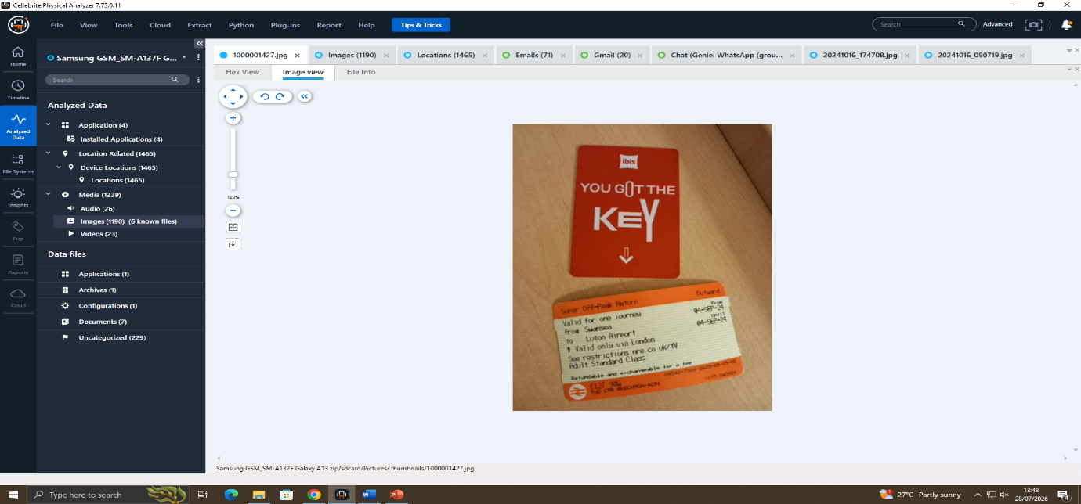
Figure 5.5: Recovered travel ticket and hotel key card.
A recovered image, including an Ibis Hotel key card and a National Rail ticket is shown in figure 5.5. The ticket shows a trip from Luton airport to London on 4 September 2024 and the key card is from a hotel on the date of the trip. The retrieved image serves as corroborating evidence for travel and assists with the corroboration of the time line based upon communications records and GPS metadata.
5.4 Timeline Analysis
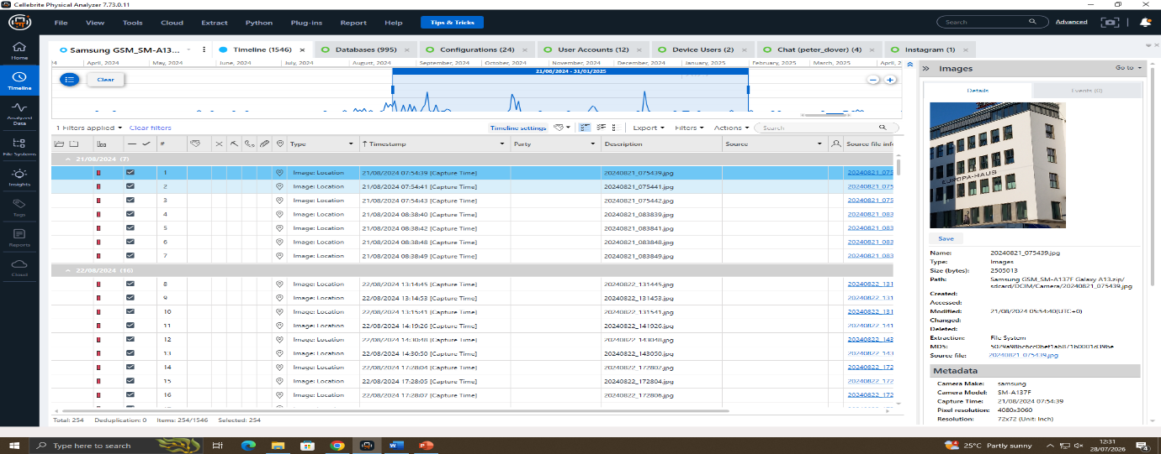
Figure 5.6: Timeline reconstruction of recovered digital evidence.
In Figure 5.6 another key card, from an Ibis Hotel is displayed with a National Rail ticket. From the ticket, you can see that this flight was booked from Luton Airport to London on 4th September 2024, and the hotel key card shows that the person stayed during the flight. The retrieved image serves as corroborating evidence for travel and assists with the corroboration of the time line based upon communications records and GPS metadata.

- Suspect Profiling and Investigation Findings
A variety of digital evidence including communication data, photos, GPS, call logs, emails and social media data was analysed to establish the status of Emma, Joe and Norman and help map out their interaction throughout an investigation.
6.1 Emma (Perpetrator)
During the forensics review, it was discovered that Emma was the chief person who had promoted talking about the sensitive company data. The WhatsApp communications on the device revealed that Emma had reached out to Joe on 21 August 2024 and shared some intriguing facts about an AI-powered product called 'ABC Technologies' 'Neuro', indicating she had access to information of value, and had told Joe she intended to monetise it in some way. The discussions reflect Emma's continued efforts to stay engaged in discussions about possible disclosures of private company information as well as continued follow-up discussions in later conversations about the status of the proposed transaction in October and November 2024. The retrieved communications and the related times show that Emma was the main person in the chain of communications.
6.2 Joe (Intermediary)
Based only on the evidence taken from him, it was revealed that Joe was indeed the go-between for Emma and a prospective purchaser. The WhatsApp chats show that Joe accepted Emma's proposal and replied saying that he would find interested parties. Other messages read that Joe set up meetings with potential contacts and told Emma that he had meetings with the clients in hotel meeting rooms, which included mentions of Manchester. However, when joined together with WhatsApp messaging and call records, and the evidence of travel, it appears that Joe was the guy who was communicating for the dealer and arranged contact between the seller and potential buyers.
6.3 Norman (Buyer)
The forensic investigation determined that the potential Buyer mentioned in the Communication evidence, was Norman. The returned materials don't have ample first-hand communication with Norman; however, several communications between Emma and Joe show that discussion with an interested buyer was being set up. Norman's communication chronology and travel logs, in conjunction with meeting documents, indicates involvement in the negotiating phase of the supposed information sharing. Norman is likely to be connected with the intended recipient of the confidential information and additional investigations would be needed to determine the extent of support he provided.
6.4 Overall Investigation Findings
Evidence collected demonstrates a clear tie between Emma, Joe and Norman via correspondence, location and travel data, photos and reconstruction of timelines. All these artefacts collectively illustrate the transporting of private company data, a planning and coordination process and an attempt for transfer.

- Conclusion
Investigation was able to recover and analyse digital evidence via Cellebrite UFED and Cellebrite Physical Analyzer. There was documentation of communications, GPS points, photos, travel, and analysis of timelines, clearly linking Emma, Joe and Norman. The evidence pointed to a common knowledge by which the confidential information was provided by Emma to Joe, who in turn provided it to Norman. All the forensic practice was done to ensure the integrity of the evidence which provided reliable evidence for the investigation.

