Database analysis and design

Farley staines 2204098
Introduction to web and database concepts
Contents
How the tables link together 2
Examples of entering an event by staff 4
Example 1 4
Example 2 5
Example 3 7
Examples of customer queries 9
Example 1 9
Example 2 10
Event Queries by branch 11
Event Queries by staff 12
Purchase Queries by branch 13
Finance query by branch 14
Supplier queries 15
Finance Reports 16
Customer Invoices 18

How the tables link together
The tables all link around the event table, with the event id linking most of the tables together. This includes the branch and customer tables. Everyone can see update the event table either linking directly to it or through queries.
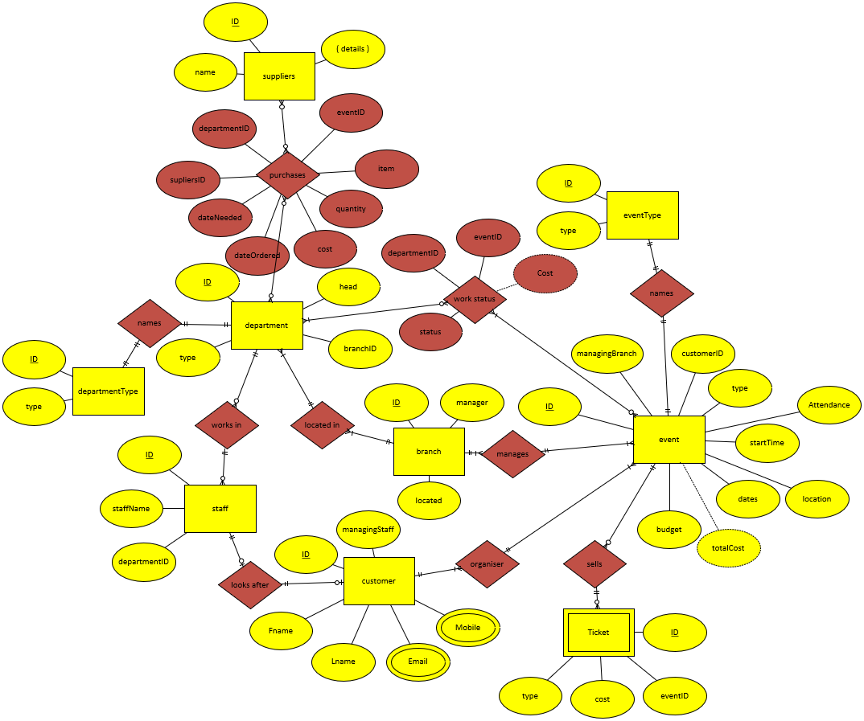
The customer details are stored within the customer tables with the staff being able to view and update them.
The staff details are stored within the staff table and viewable by staff but only updated through the department head.
The branch table stores details about the location and the manager can oversee everything. It is linked to the department table as each branch has its own departments with its own staff and suppliers.
The department tables store details on the type of department, its head, as well as purchases and suppliers.

How the system works
When a customer approaches the Northern Lights Company, their details and the event would be stored. The customer would be assigned to a staff member who would help sort out the event. When the event gets created, they would be linked to a branch for which would organise all the supplies that would fit within the required budget. As the event is being set up, the customer and staff can view event details as well as the cost, either being directly connected or through the branch. Each department as part of an event will be able to see details like, cost, quantity and date ordered for each item ordered from the suppliers from a purchases table between suppliers and department. With each item purchased the cost of the event will increase which the customer will be able to see, as well as being able to query a department’s spending and their progress for a given event.

Examples of entering an event by staff

Example 1
- Mr Jones morning meeting for 10 people with coffee throughout. The event starts at 9am with table and chairs. No extra equipment needed; cost is £50.
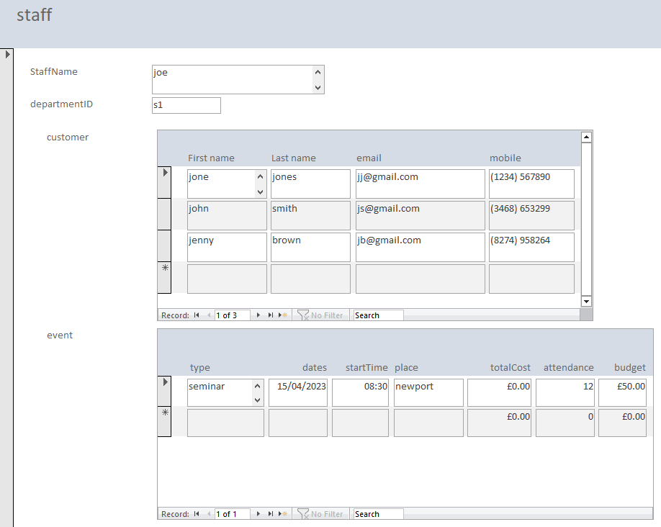
The customer can see the event and update the details in a separate form.
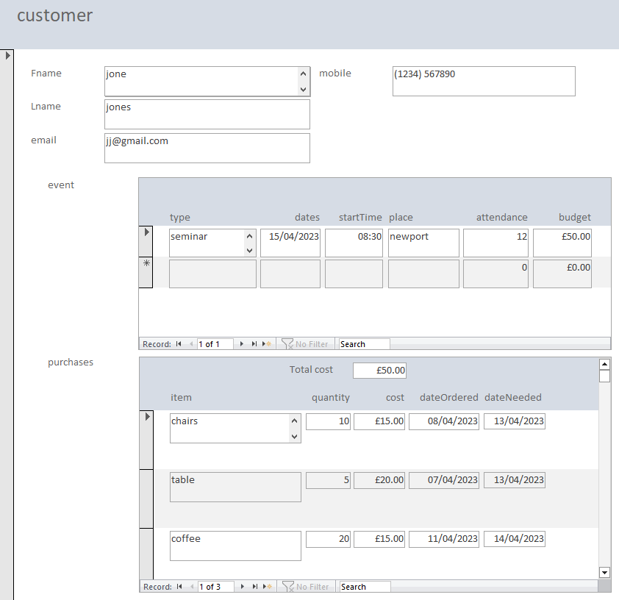

Example 2
- Mr Smith conference for 50 people with tea and coffee, electrical requirements include projector screen, start time 12.30, cost is £15 per person, projector hire is £250.
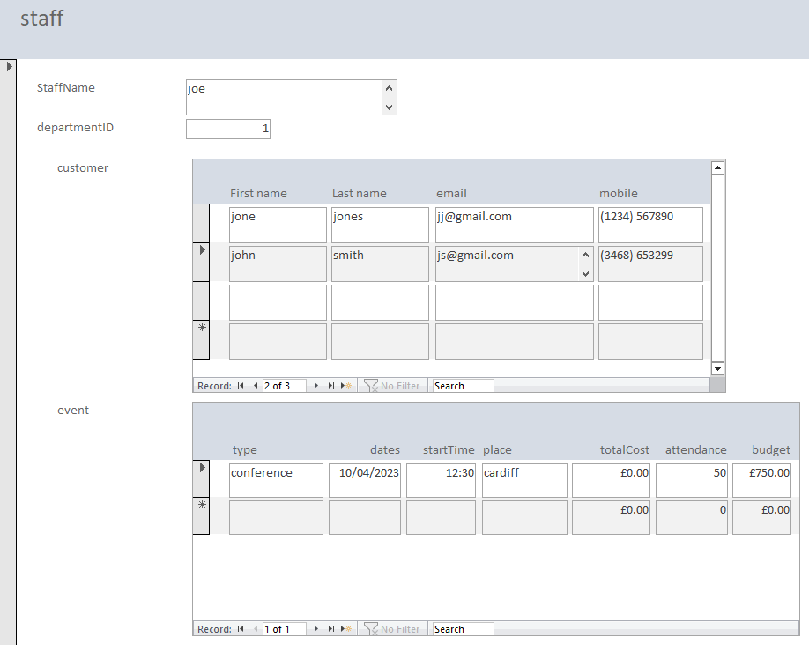
The customer can see the event and update the details in a separate form.
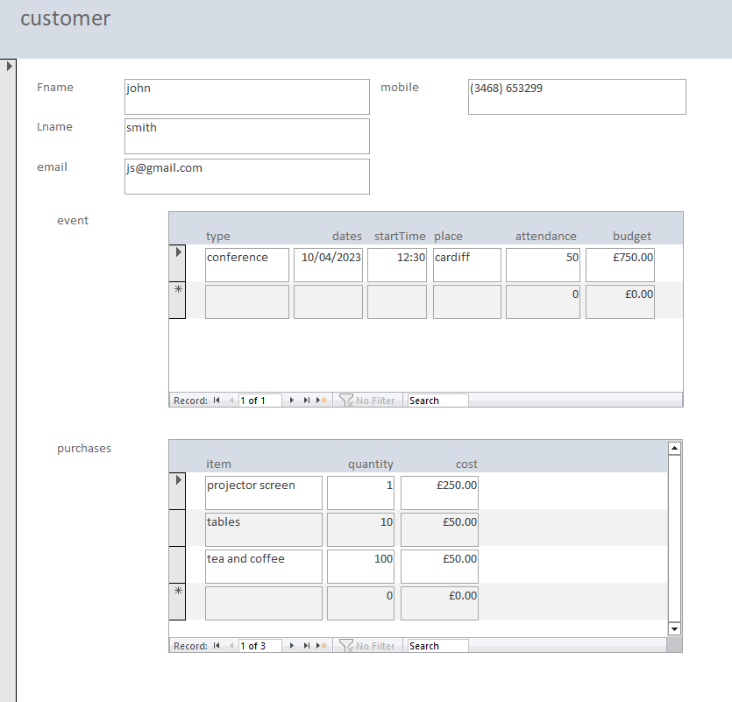

Example 3
- Mrs Brown presentation for 30 people, need chairs, tea and coffee and bacon butties for lunch. Large projector screen, speakers, and small table for flyers with equipment budget £200.
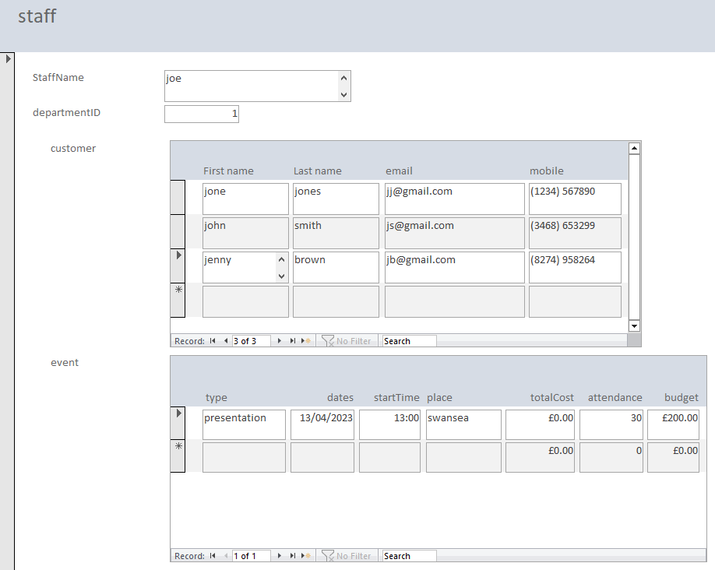
The customer can see the event and update the details in a separate form.
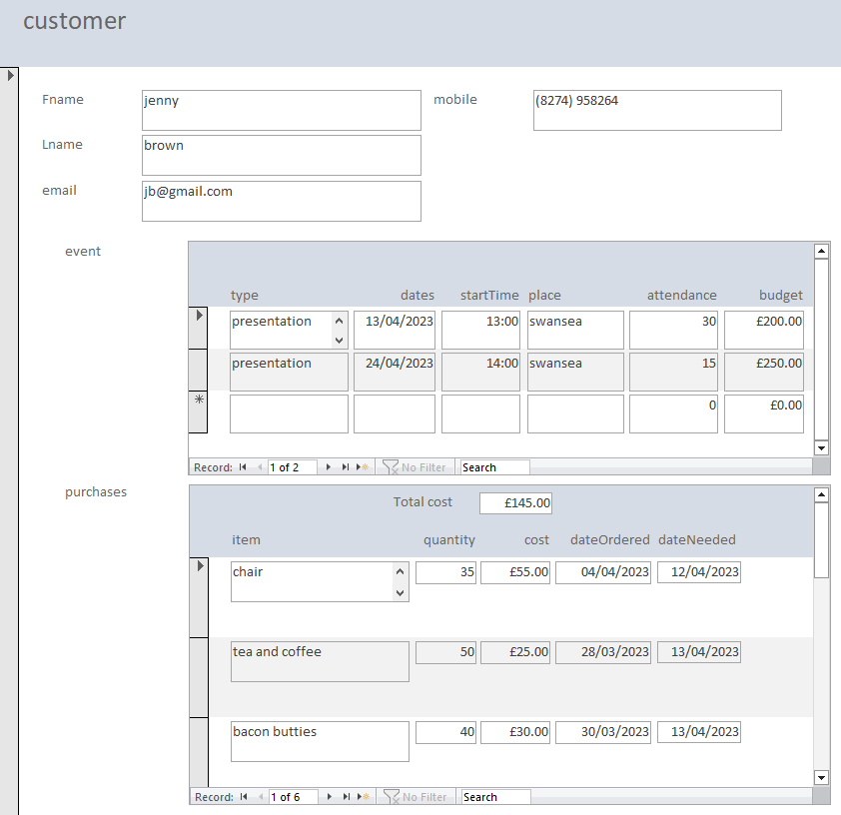

Examples of customer queries
Customers can update their event details whenever.

Example 1
1. Mr Jones wants to update numbers 10 to 12 and change the start time from 9 to 8:30.

Example 2
2. Mr Smith also wants to give each person a custom water bottle, so he adds this to his list of purchases.
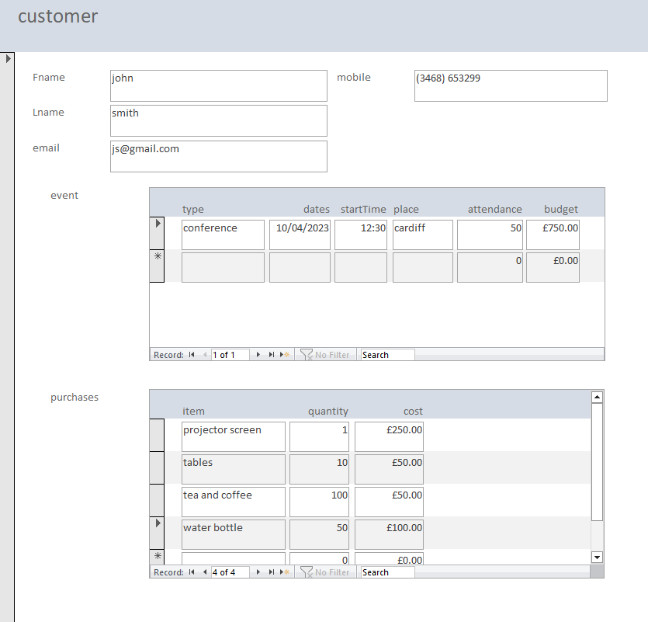

Event Queries by branch
In the below example Joe can use a date filter to view events from last week at Swansea, but equally he would be able to see various other date ranges and filters.
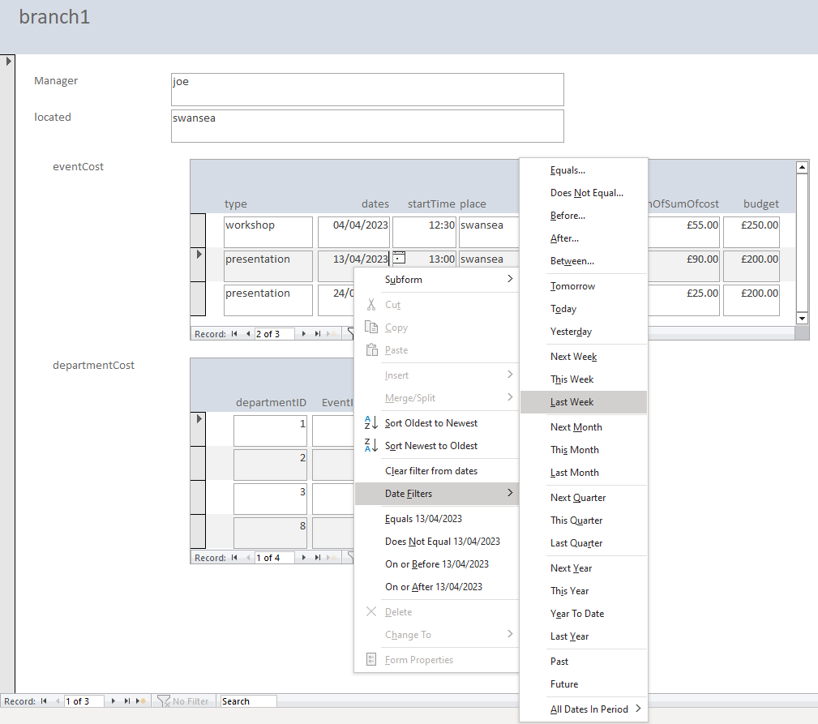

Event Queries by staff
In the example below Joe can see he has three customers. By selecting one customer more detailed information is shown. If the customer has more than one event, all these are shown, and can be sorted by any field, i.e., date or meeting type.
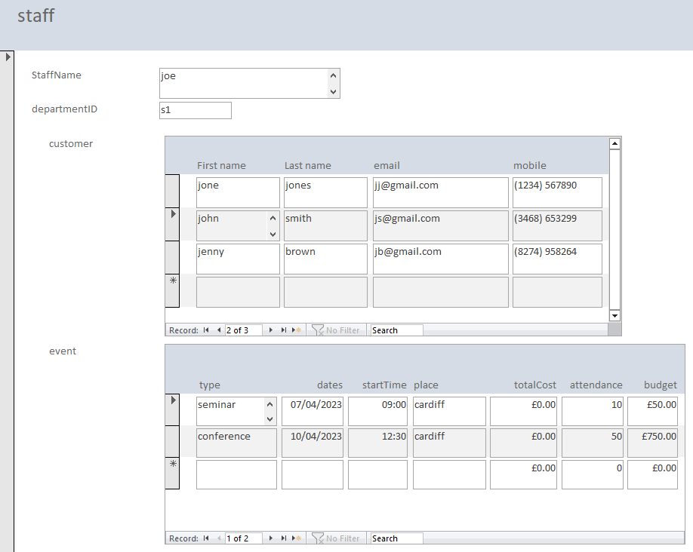

Purchase Queries by branch
Each branch can view all departments within the branch and view any equipment they have purchased. This allows the department to ensure they have the correct equipment.
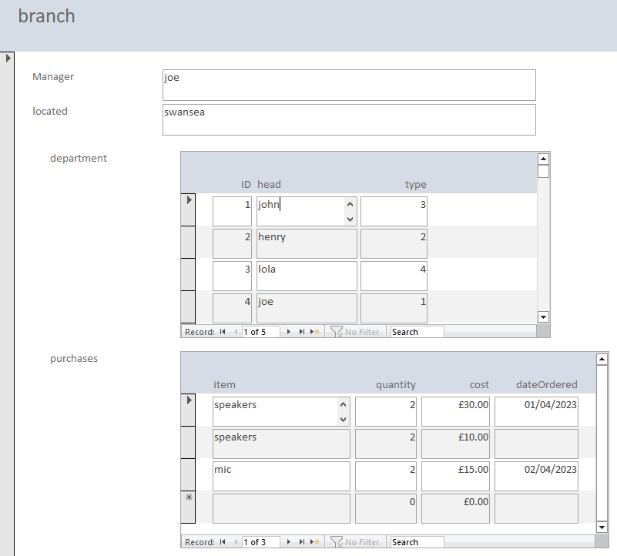

Finance query by branch
Finance would want to know how much an event is going to cost, it also gives a breakdown of how much each department is paying and whether they have everything needed and ready.
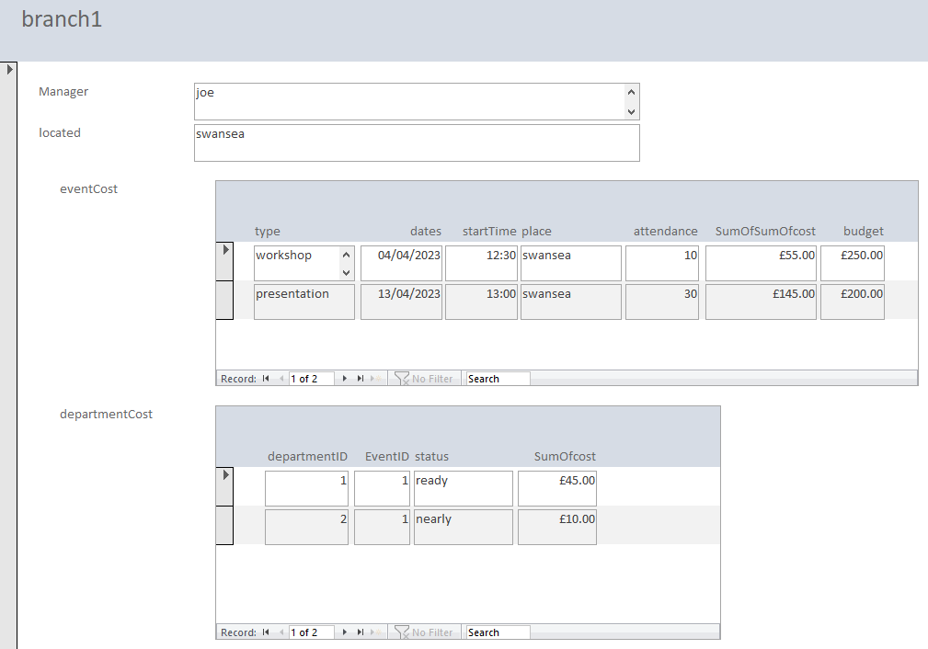

Supplier queries
In the example below Furniture Ltd can see the items needed, for what department , event and when it is needed.
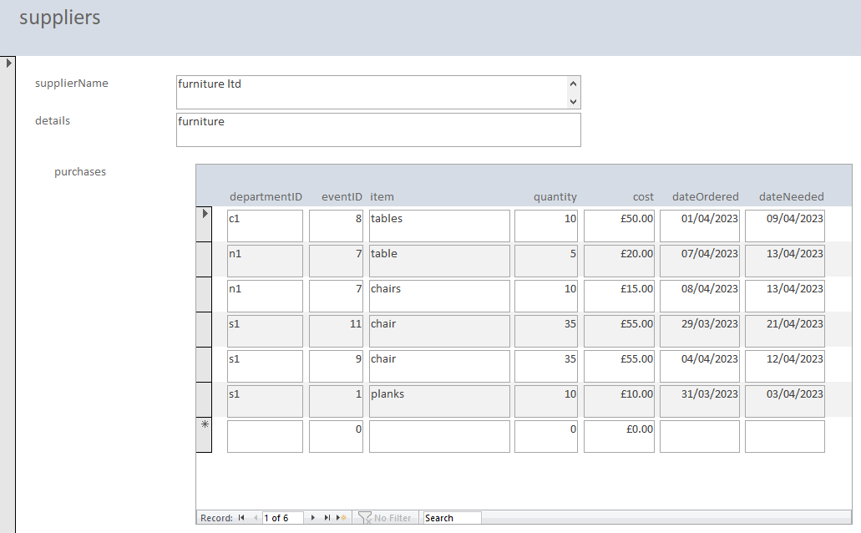
Sorted by date needed, oldest to newest.
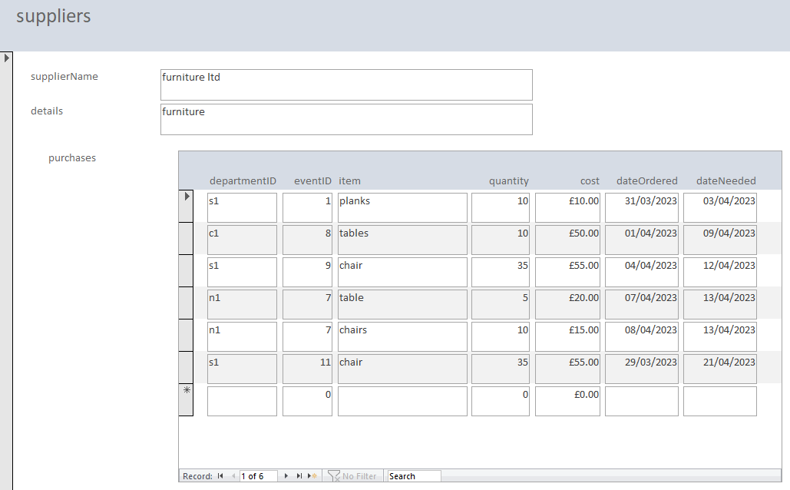

Finance Reports
The reports show income by branch or by customer. This allow the company to see how well each branch is performing and which events are bringing in the most income.
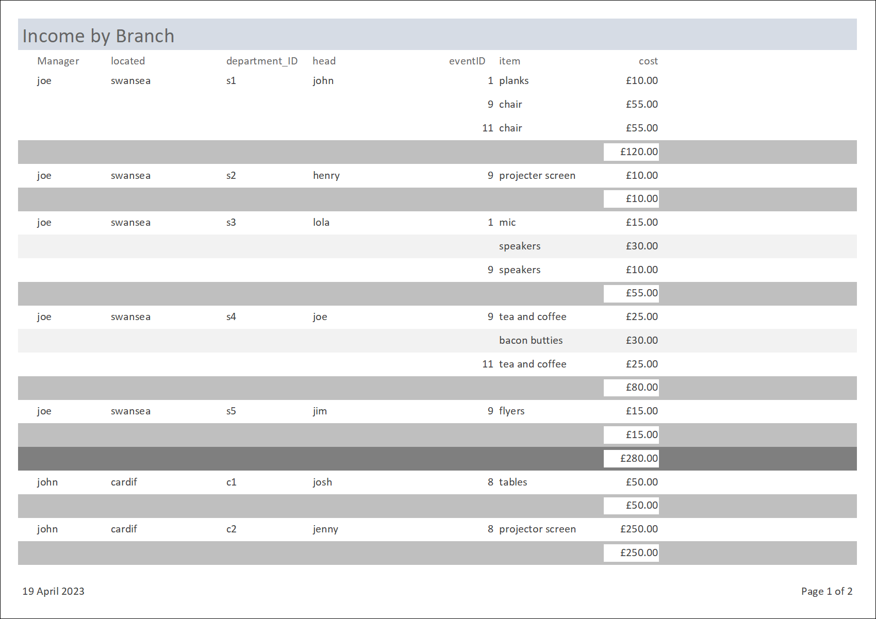
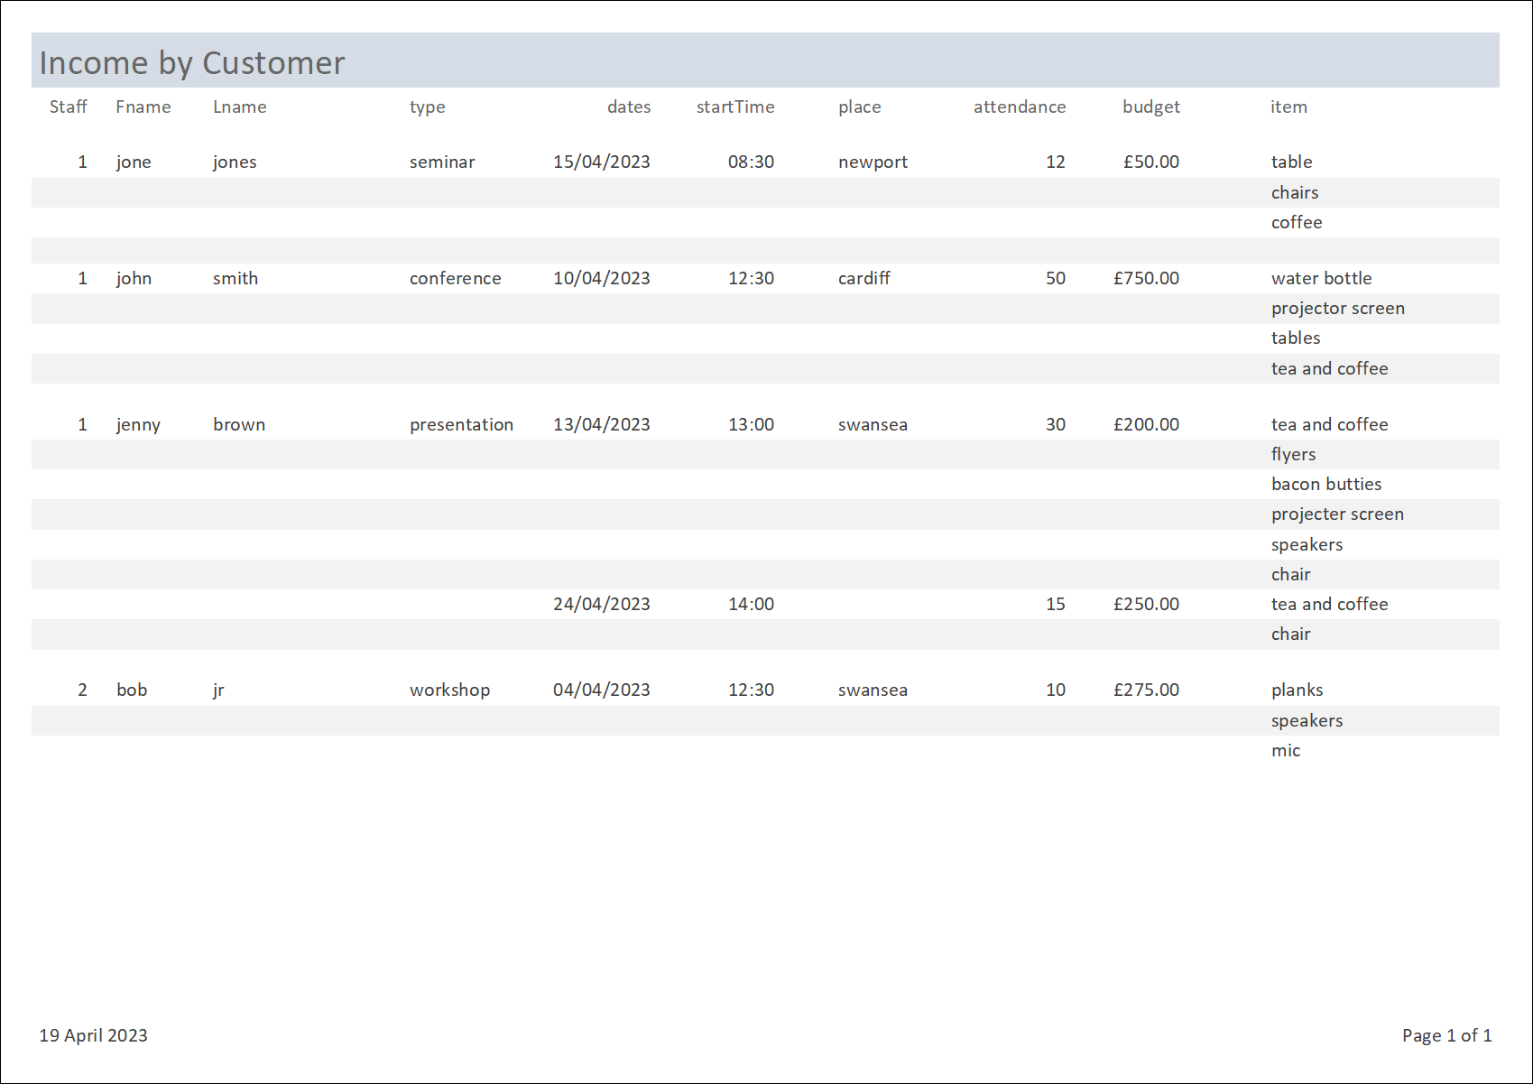
Expenditure reports show where money is being spent. The following itemised one is ordered by supplier .
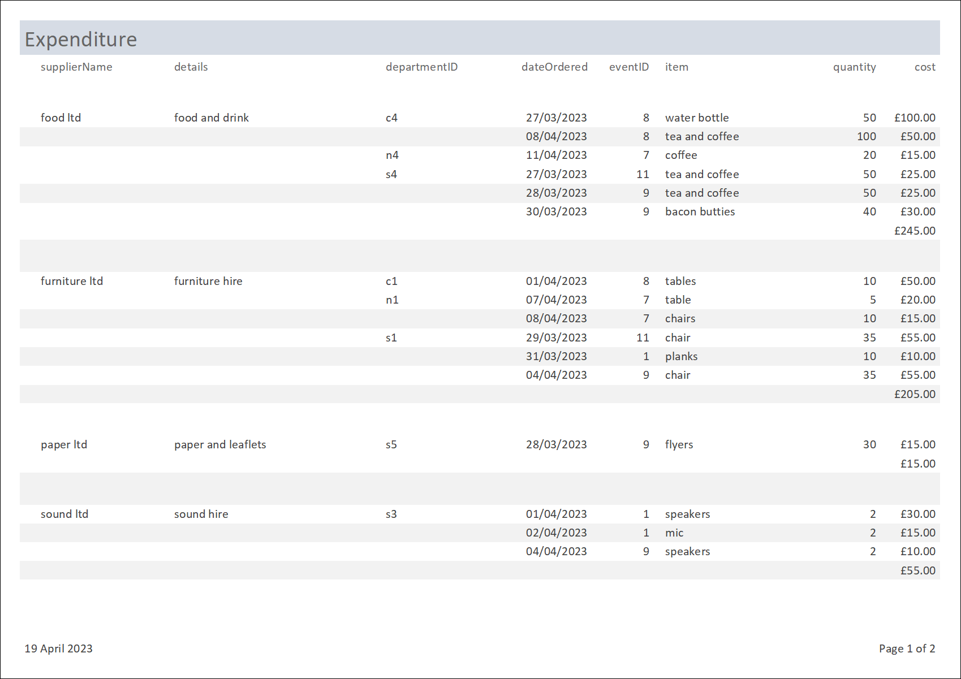

Customer Invoices
This is an example of a typical invoice to be sent to the customer. It displays details of their event costings.
Invoices can be generated in batches across all customers.


