

An Analysis: The insufficient reporting of sexually related offences to Police.
Katie Rogers
Student ID: 2125114
BSc (Hons) Professional Policing Practice
07th October 2024

Word Count: 10396

Recognition
I would like to express my gratitude to my colleagues for their valuable contributions to my dissertation, as well as to the numerous study participants who generously dedicated their time to provide thorough and thoughtful responses.

Declarations
- Declaration - This work has not previously been accepted in substance for any degree and is not being concurrently submitted in candidature for any degree.
Signed: K. Rogers Date: 07.10.2024

- Statement 1 - This dissertation is being submitted in partial fulfilment of the requirements for the degree of BSc.
Signed: K. Rogers Date: 07.10.2024

- Statement 2 - This dissertation is the result of my own independent work/investigation, except where otherwise stated. Other sources are acknowledged by footnotes giving explicit references. A bibliography is appended.
Signed: K. Rogers Date: 07.10.2024

- Statement 3 - I hereby give consent for my dissertation, if accepted, to be available for photocopying and for interlibrary loan, and for the title and summary to be made available to outside organisations.
Signed: K. Rogers Date: 07.10:2024

- Statement 4 - I hereby give consent for my dissertation, if accepted, to be available on the university’s IT system to those who have consent to use the system.
Signed: K. Rogers Date: 07.10.2024

Abstract
The objective of this research project was to investigate the reasons behind the underreporting of sexual offences or rapes against victims to the police. It was observed that only about one in every six victims actually report these incidents. Additionally, the project aimed to provide recommendations on how to motivate women to report these kinds of crimes when they happen.
The research was conducted using surveys with the general public and interviews with members of Gwent Police to address the aforementioned objectives. The responses revealed reasons such as victims' fear of being blamed or judged, the limited availability of evidence, and apprehension towards the court process, among others, in relation to the first objective. To address the second objective mentioned earlier, suggestions were made regarding the investigation procedure to prevent any loss of evidence and to ensure that investigations were handled promptly and efficiently.
The primary study was supported by many pieces of literature, which are discussed in the dissertation. These sources offer a comprehensive overview of the public opinion on the subject.
The research successfully achieves the objectives outlined in Chapter 1 of the dissertation. Participants in the study and the supporting literature suggest recommendations, including further training for first responders and allocating more resources to units such as CID or Public Protection Units.

Table of Contents
Abstract ……………………………………………………………………………………. 5
Chapter 1: Introduction ……………………………………………………………… 8
  - Background …………………………………………………………………………… 8
  - Objectives ……………………………………………………………………............. 11

Chapter 2: Literature Review …………………………………………………………… 13
  - Introduction ………………………………………………………………….............. 13
  - Culture………………………………………………………………………………………… 14
  - Trauma………………………………………………………………………………………… 19
  - Distrust in the Criminal Justice System…………………………………………. 24
  - Conclusion and areas for further study ………………………………………… 29

Chapter 3: Methodology …………………………………………………………………… 31
  - Introduction ………………………………………………………………………………. 31
  - Research Strategy ………………………………………………………………………. 32
  - Data Collection and Analysis ……………………………………………………… 35
  - Limitations and Potential issues ……………………………………………. 37

Chapter 4: Research Analysis …………………………………………………………… 38
4.1 Introduction ………………………………………………………………………………. 38
4.2 Analysis of Surveys ………………………………………………………………….. 38
4.3 Analysis of Interviews ………………………………………………………………. 46

Chapter 5: Research Findings …………………………………………………………. 48
5.1 Theme 1 ………………………………………………………………………….……….. 48
5.2 Theme 2 ………………………………………………………………………….………... 49

Chapter 6: Conclusion ……………………………………………………………………… 50

Chapter 7: Limitations and Recommendations …………………………………. 51
7.1 Limitations …………………………………………………………………………......... 51
7.2 Recommendations ………………………………………………………………........ 52

Bibliography ……………………………………………………………………………………… 54

Appendices ……………………………………………………………………………............. 69
Appendix A – Survey Responses …………………………………………………......... 69
Appendix B – Interview t of Respondent 1 ………………………………………….. 76
Appendix C – Interview Notes of Respondent 2 …………………………………… 81
Chapter 1: Introduction
1.1 Background
This dissertation aims to examine the issues pertaining to the underreporting of sexual assault and rape incidents involving both males and females in the United Kingdom, Stewart, Sophie, et al, (2023). Although both are classified under the Sexual Offences Act 2023, there exists a notable distinction between both offences (Crown Prosecution Service,2021). Rape is the deliberate act of purposely inserting a penis into another person's vagina, anus, or mouth without their consent (Metropolitan Police,2019). Consent must be provided volitionally, and the lack of opposition does not constitute consent. Furthermore, the law recognises that an individual may not always possess the ability to provide consent owing to circumstances such as intoxication, compulsion, mental capacity, and unconsciousness (Crown Prosecution Service,2021).
Wieberneit, Michelle, et al, (2024) state, sexual assault is an increasing concern impacting individuals of both genders, yet underreporting represents a major obstacle in effectively dealing with the matter. Although public focus frequently focusses on the experiences of female victims, male victims have significant barriers, leading to the underreporting of their experiences. Comprehending the variables that lead to underreporting in sexual assault incidents for both genders is essential for formulating more effective interventions, guaranteeing justice, and offering suitable assistance to victims (Tan, Sze Eng, and Katie Kuschminder, 2022).
Nevertheless, Sexual assault is legally defined in the Sexual Offences Act 2003 as the deliberate physical contact or touching of another person in a sexual manner, without their agreement, and when the perpetrator does not have a reasonable belief that the other person has given consent (Gov.uk, 2003). A touch can encompass any bodily part, whether through clothing or direct contact, with or without an item, and is deemed sexual if a rational individual would see it as such.
On an international scale, sexual offences are now acknowledged as one of the most greatly underreported crimes (Dworkin, Emily R., et al, 2010). The phenomenon of sexual assaults being insufficiently reported to police is well-documented throughout this paper and is shaped by a multifaceted interplay of social, cultural, psychological, and systemic elements. Notwithstanding the gravity of these offences, a significant proportion of both male and female victims choose not to disclose them, resulting in significant repercussions for both individual justice and the broader societal welfare (Walker, Sarah-Jane Lilley, et al, 2019).
A Crime Survey for England and Wales (CSEW) provided crucial information into the frequency of sexual assault in England and Wales, using both continuous and annual data.
During the year ending March 2022, 2.3% of adults aged 16 and over (3.3% of women and 1.2% of men) experienced sexual assault, including attempts. This corresponds to an estimated 1.1 million adults. 798,000 of them being females and 275,000 thousand men (Office for National Statistics,2023).
16.6% of adults (about 7.9 million individuals) aged 16 and older had encountered sexual assault (including attempts) after reaching the age of 16. Among these, 1.9 million individuals were victims of rape, constituting 7.7% of women affected by this crime and
0.2% of men. While the number of cases of sexual assault amongst individuals aged 16 to 59 remained relatively stable from March 2020 (2.2%) to March 2022 (2.7%), there has been a substantial increase since March 2014, when the prevalence was 1.5%. This augmentation corresponds with patterns in police-reported crime (Office for National Statistics,2023).
Survey data from Rape Crisis England and Wales reveals that roughly 25% of women, amounting to 6.54 million individuals, have encountered rape or sexual assault throughout their adult years. Among the 6.54 million documented incidents, about half of the rapes are perpetrated by the victim's current or previous spouse, and six out of seven rapes are carried out by someone known to the victim (Rape Crisis England and Wales, 2023). The fundamental rights of women encompass the ban of illegal sexual conduct and the eradication of all manifestations of violence and manipulation.
Nevertheless, Amnesty International, women and girls worldwide still face discrimination and unfair treatment based on their biological sex and gender. The existence of gender inequality is the basis for a multitude of problems that have a greater impact on women and girls, such as domestic and sexual abuse (Amnesty International, 2022). Although men may also experience sexual assault, women generally face higher incidence and more serious injuries, a fact that has garnered considerable global recognition during the twenty-first century (Li, Liqing, et al,2023).
While sexual offences and rape can happen at any time and involve anybody, it is common for victims of sexual offences to be assaulted by those they are familiar with, such as family members, spouses, former intimate partners, friends, and acquaintances.
A 2021 publication by the Office of National Statistics revealed that one out of every two rapes against women are perpetrated by their current or former partner. 5 out of every 6 instances of rape against women are perpetrated by someone they are acquainted with.
In order to understand the causes of this inadequate reporting, the author of this paper intends to examine current research by exploring the historical, social, and legal aspects, as well as conducting their own primary survey to determine what has contributed to the current situation (Hansen, Maria, et al, 2020),

  - Objectives
The dissertation focuses on the following aims by conducting a literature review and initial investigation utilising surveys with the general public and interviews with members of Gwent Police.
The purposes will be consistent with the overarching goal of improving the statistics mentioned previously by promoting women and men to report sexual incidents to the Police.
1. To calculate the recorded statistics of sexual offences in England and Wales in relation to the reported number of sexual offences to the Police.
2.To have an understanding of the cultural barriers that make it difficult for victims to come forward and report.
3.To gain an understanding of the impact of psychological obstacles and trauma that victims are subjected to and what support is available to them.

4. To gain an understanding of the overall lack of trust in the criminal justice system and concerns surrounding the lengthy legal process.
5. To carry out primary research in order to truly understand the factors that hinders victims from reporting sexual offences to the Police.

Chapter 2: Literature Review
2.1 Introduction
Brunton-Smith, Ian, et al, suggest the under-reporting of sexual offenses remains a significant concern in England and Wales, contributing to the gap between the true prevalence of these crimes and official statistics (Brunton-Smith, Ian, et al.2020). This literature review aims to explore and critically evaluate the reasons why victims often choose not to report sexual offences to the police. By examining a broad spectrum of offences, ranging from low-level sexual assaults to more serious crimes such as rape, this review seeks to uncover the multifaceted factors that influence reporting behaviours (Dalton, Charlotte T., et al, 2022).

This investigation is crucial for understanding the real scale of sexual violence and for identifying the social, cultural, and institutional barriers that hinder women from seeking justice. In doing so, the research will not only highlight areas where the criminal justice system may be failing but also provide insights into how support services and legal frameworks can be improved to better serve victims (Varghese, Femina P., et al, 2019). Through a comprehensive analysis of existing studies and reports, this review will contribute to the ongoing discourse on sexual violence and help to inform future policies aimed at reducing under-reporting and supporting victims more effectively.

2.2- Culture
Cultural factors exhibit significant impact on the formation of attitudes towards sexual assault and can give rise to obstacles that hinder victims from reporting such offences to the police. The influence of cultural norms and values on views of shame, honour, and justice can subsequently impact the willingness of individuals to report incidents of sexual assault (Ajayi, Chinyere Elsie, et al,2021). This essay analyses the manner in which cultural elements can impede victims from reporting incidents of sexual assault to law enforcement. It investigates the interaction between honour, stigma, gender norms, and community dynamics.
An omnipresent cultural element that significantly influences reporting is the notion of honour and shame. Personal and family honour holds highest significance in numerous civilisations. Sexual assault can be regarded as a significant challenge to this sense of dignity, not just for the individual who has been assaulted but also for their family (Mulvihill, Natasha, et al,2019) In many societies, a sexual assault may be perceived as a public disgrace that detracts from the reputation of the entire family or community. The concern of causing disgrace to one's family might serve as a potent discouragement to reporting (Mayeza, Emmanuel, 2022). Victims may experience concerns about being subjected to judgement or social exclusion by their community, which can result in significant pressure to remain silent (Wemmers, Jo-Anne, et al,2022).
For example, throughout several South Asian societies, the preservation of family honour is intricately linked to the conduct of its female members. Submission of a sexual assault report might be perceived as a means of disrespecting the family, resulting in significant social consequences (Mansoor, Nasreen,2015). In order to safeguard the family's reputation, victims may be urged to maintain silence, even if it entails enduring hardship without expressing their emotions. Many times, the cultural focus on maintaining family reputation takes precedence over the legal and moral obligations to disclose and confront the crime (Bates, Lis,2020).
Das, Sarbopriya, et al 2020, states, sexual assault on men, especially by another man, can be seen as emasculating. The act may be regarded as depriving the survivor of power and dominance, both of which are essential components of masculine identity. This power dynamic is particularly evident in cases of same-sex assault, where the survivor may believe the attack weakens his manhood (Kar, Anindya, et al, 2022). The social stigma associated with male-on-male assault can heighten emotions of bewilderment, isolation, and shame. Patriarchal societies frequently place men in dominant roles and women in subservient roles, which can normalise sexual abuse and make it more difficult for survivors to come forward (Scott-Storey, Kelly, et al,2022). Male survivors suffer additional challenges because to cultural notions of masculinity. Men are expected to be tough, stoic, and invulnerable, making it difficult for men to confess their vulnerability. Reporting sexual assault may be perceived as a weakness or disrespect to one's manhood (Westmarland, Nicole, and Stephen Robert Burrell,2023).
Community and social dynamics can significantly influence whether victims choose to report incidents of sexual assault. Within tightly knit communities is often a significant focus on maintaining social cohesiveness and preventing public controversies. Publicly reporting incidents of sexual assault might be perceived as undermining social cohesion and drawing unwelcome scrutiny (Mulder, J., et al,2021)
For instance, among specific ethnic and minority groups, there may be a notable sense of internal cohesion and a reluctance to interact with external governing authorities. This may be driven by a desire to resolve matters privately or a lack of faith in the legal system that is perceived as unjust or prejudiced against their community. Minority groups frequently encounter systematic racism and bigotry while interacting with the police and the justice system (Hetey, Rebecca C., and Jennifer L. Eberhardt, 2018). This fosters a perception that the system does not serve its objectives, making survivors unwilling to speak up. According to a study carried out by Savanta ComRes for the RSA, with 2,600 participants in Great Britain, which includes an equal sample of 1,000 individuals from ethnic minority backgrounds, reveals:
Discrimination in local services is significantly higher among ethnic minorities: 52% of Asian and 50% of Black respondents have experienced discrimination when utilising local services, in contrast to 19% of the white population. The police, legal system, and UK government are perceived as unsupportive by Black and Mixed communities. 25% of Black respondents and 20% of individuals from mixed ethnic origins indicated that the police 'actively complicate my life,' as contrast to merely 9% of white respondents. In evaluating the efficacy of the police and judicial system, 42% of white respondents asserted that the police 'perform their duties,' but Black respondents and individuals of mixed ethnicities were more inclined to indicate that improvements are necessary or that the system is inadequate (RSA, 2021). With statics as compelling as this there is no wonder that ethic communities mistrust the police.
In addition, marital home sexual offences, addressing these instances can be especially difficult since they include an amalgamation of marital behaviour and cultural expectations. Various cultural beliefs minimise or don't criminalise marital rape (Singh, Vijay P, 2021). Because traditional marital customs perceive sexual intercourse as a marital responsibility rather than a consented act, marital rape is rarely considered a serious crime (Deosthali, Padma-Bhate, et al, 2022). Sexual offences in marriage are typically trivialised or considered private due to normalisation.
Historically, multiple legal systems conformed to the idea of implied consent, which maintained that by entering into marriage, a woman was considered to have granted lifelong assent to sexual contact with her husband (Eatherstone, Lisa, et al,2023). This legal premise negated the idea of marital rape, positing that sexual access was an intrinsic right of the husband (Deosthali, Padma-Bhate, et al,2022). The concept that a wife might deny sexual relations or allege her husband of rape was largely unacknowledged in numerous legal systems until the late 20th century (Cody, Lisa Forman, 2022)
Until recently, most Western nations, including the United States and the United Kingdom, failed to acknowledge marital rape as a criminal offence. Legislation began to evolve in the 1970s and 1980s that recognised marital rape as a criminal offence (Featherstone, Lisa,2021). This has effectively resulted in the individuals not actually believing are victims of crime. Cultural gender roles can subordinate women in marriage. Sexual offences may be accepted or excused if wives are expected to be dependent and serve their husbands' sexual desires. These positions may inhibit women from speaking out.
The Crime Survey for England and Wales (CSEW) for the year ending March 2020 projected that 1.6 million adults aged 16 to 74 had been sexually assaulted by rape or penetration (including attempts) since the age of 16. The analysis of the nature of these assaults is based on CSEW data from March 2017 to March 2020, and it is confined to adults aged 16 to 59. Nearly half (49%) had been a victim more than once. More than four out of ten (44%) were sexually assaulted by their partner or ex-partner (Office for National Statistics,2021).
Cultural diversity factors are of extreme significance in moulding attitudes towards sexual assault and determining the willingness of victims to disclose these offences. The complex interaction of honour, stigma, gender norms, community dynamics, and distrust of police forces gives rise to a multifaceted setting in which the act of reporting sexual assault might introduce numerous difficulties. Overcoming these cultural obstacles necessitates a comprehensive strategy that encompasses education, assistance, and structural changes to establish a setting in which victims of sexual abuse feel secure, assisted, and empowered to report such incidents and pursue legal recourse (Dickson, Nicola, 2021).

2.3 -Trauma
Sexual Assault survey in England and Wales report that approximately 25% of women, totalling 6.54 million, have experienced rape or sexual assault in adulthood. Among the 6.54 million recorded instances, fifty percent of rapes are executed by the victim's current or former spouse, and six out of seven rapes are performed by an acquaintance (Rape Crisis England and Wales, 2023).
In 2023, another Crime Survey for England and Wales (CSEW) reported that 275,000 male victims have encountered some sort of sexual assault since the age of 16. Annually, approximately 12,000 men (ages 16-59) are victims of rape in the UK. It is essential to acknowledge that the actual figures are likely significantly higher, as some victims may not have reported the rape to the police (Criminal Injuries Helpline,2023).
The numbers clearly indicate the widespread problem of sexual assault in society, impacting both women and men, predominantly within interpersonal or familiar settings. The figures also highlight the pervasive underreporting of these crimes, which perpetuates the obscurity of the problem's true magnitude.
Nevertheless, women and men internationally endure prejudices and biases, based on their sex and gender. The disparity in gender underpins other issues that disproportionately affect victims, such as domestic and sexual abuse (Hazel, Kelly L., and Kerry S, 2019). Although men can also experience sexual assault, women generally face greater incidence rates and more serious injuries, a fact that has garnered considerable global attention since the twenty-first century (Farahi, Narges, and Morgan McEachern, 2021)
Experiencing sexual assault or rape frequently leads to significant and enduring psychological trauma, impacting all facets of an individual's existence. Trauma from such experiences might manifest in various manners, compromising emotional, physical, social, and mental health. Survivors often have a complex range of obstacles in managing the aftermath of the assault (Crivatu, Ioana M., et al,2021). Sexual assault represents a deeply distressing event that can profoundly erode an individual's sense of trust and security. Self-blame represents a profoundly troubling and prevalent psychological reaction that numerous individuals encounter. Despite the inherent illogic and injustice of this reaction, many victims might undergo a cognitive process that leads them to justify the assault (Brown, Sarah J, et al,2019). This can be accomplished through navigating through an array of emotions, which will ultimately cultivate a sense of responsibility. This is often clarified by a victim's tendency to deflect blame to themselves in an effort to reclaim the sense of control they believe was forfeited during the initial assault (Harsey, Sarah, and Jennifer J. Freyd, 2020). This can be significantly harmful to the victim, as it fosters the notion that alternative actions or responses might have produced a different result.
This point of view has a complex relationship to the cultural phenomenon of victim blaming. This belief is profoundly entrenched in many different groups and cultures and as survivors they are compelled to perceive themselves as responsible for the assault based on their actions, behaviour, clothing, or perceived vulnerabilities (Gobel, Matthias S., et al, 2018). This detrimental perspective often leads survivors to engage in self-blame and self-destruct behaviours regarding the incident. Rather than fostering the confidence and building the resilience needed to acknowledge their victimisation and seek support from the police or other services that can assist them (Jankowitz, Sarah E, 2017). Beecher, Ruth, and Stephanie Wright, that this perspective may result in sexual crime suspects going unchallenged. This could encourage criminals to view their behaviour as acceptable, hence heightening their likelihood of ongoing criminal activity (Beecher, Ruth, and Stephanie Wright, 2023).
Self-blame may adversely affect mental health and impede recovery. Survivors who engage in self-blame are more susceptible to a deterioration in their mental health, thereby heightening the probability of having symptoms of anxiety, depression, and PTSD. Sexual assault represents a profound violation of an individual's physical autonomy and sense of security. The psychological consequences of victimisation can be devastating. Certain victims may experience just transient stress, whilst individuals facing prolonged trauma will notice a deterioration in their quality of life (O’Doherty, Lorna, et al,2023).
Individuals often initiate self-isolation as a result of their fear of judgement and the weight of shame they carry. This detrimental mindset may dissuade survivors from pursuing help, causing them to perceive themselves as unworthy of support and subject to judgement. The failure to address the fundamental origin of the trauma, specifically the assault, will impede the victim's advancement in the journey towards healing. Over time, unresolved guilt can impede individuals from reclaiming their self-esteem and self-trust (Muldoon, Orla T., et al, 2019)
Individuals who have endured a sexual assault may find themselves reliving the traumatic event as a consequence of PTSD. This may present itself through recollections, distressing dreams, and heightened levels of anxiety associated with the traumatic event. The ramifications of sexual assault on survivors extend profoundly into their mental health, leading to persistent psychological trauma that often lingers well beyond the resolution of physical injuries (Henin, Sally, and Lauren Page Black, 2021). Post-Traumatic Stress Disorder, anxiety, despair, and diminished self-esteem represent a myriad of challenges that survivors face in their efforts to rebuild their lives (Bryant, Richard A,2019). Although victims are urged to pursue assistance through therapy, support groups, or conversations with loved ones, this does not necessarily imply that they will feel at ease reporting the incident to the police. The underlying trauma and PTSD resulting from victimisation might add to the fear of recounting the occurrence, perhaps leading to subsequent trauma for the victim.
An extensive range of methods of therapy exists for individuals who have endured sexual assault and rape, each tailored to confront the complex psychological, emotional, and physical traumas that survivors face. These therapies are meticulously designed to assist survivors in navigating and understanding their trauma, they include, CBT, EMDR and DBT (Khan, Ali M, et al,2018)
Cognitive Behavioural Therapy (CBT) is a prominent, evidence-supported therapeutic approach that emphasises the recognition and modification of detrimental thought patterns and behaviours. Cognitive Behavioural Therapy aids in confronting and reassessing distorted beliefs surrounding the assault, such as tendencies towards self-blame. Cognitive Behavioural Therapy imparts various coping mechanisms and assists the individual in reclaiming mastery over their cognitive processes and emotional responses (Curtiss, Joshua E., et al,2021).
Eye Movement Desensitisation and Reprocessing (EMDR) is a systematic therapeutic approach designed to assist individuals in processing and recovering from traumatic experiences through the application of guided eye movements or alternative methods of bilateral stimulation, such as tapping. EMDR demonstrates notable efficacy in the treatment of PTSD. This approach assists individuals in navigating unsettling recollections and diminishes the emotional weight associated with those experiences, facilitating recovery without the necessity of repeatedly confronting the trauma (Geusau, van, et al, 2023)
Dialectical Behaviour Therapy (DBT) represents a synthesis of cognitive-behavioural methodologies and mindfulness practices. DBT assists individuals who have experienced sexual assault in managing overwhelming emotions, navigating distress, and fostering more constructive interpersonal connections. This approach proves especially beneficial for those facing challenges with emotional regulation, self-harm, or suicidal thoughts, often stemming from experiences of sexual trauma (Oppenauer, Claudia, et al,2023).
While specific statistics comparing the mental health outcomes of sexual assault survivors who undergo therapy versus those who do not, are not universally standardised, research consistently indicates that therapy markedly diminishes the probability of severe mental health issues, including PTSD, depression, and anxiety, among these survivors.
Research from 2021, suggested that one-month post-sexual assault, 75% of survivors exhibited evidence for PTSD. Forty-one percent of survivors reflected the requirements for PTSD twelve months post-sexual assault. Whereas trauma-Focused Cognitive Behavioural Therapy indicated that 50-60% of survivors who finished the treatment had substantial improvement in trauma symptoms, in contrast to those who did not undergo therapy. (Dworkin, Emily R., et al,2021).
Furthermore, an additional study from Dworkin, Emily R., et al implies that persons subjected to sexual assault (SA) have markedly elevated rates of suicidality relative to those who have not experienced such trauma. In a study, subsamples subjected to sexual assault had a suicidality prevalence of 27.25%, in contrast to 9.37% to those who weren’t a victim of sexual assault. This significant disparity underscores the deep psychological impact that sexual assault can impose on survivors. The study emphasises the necessity of acknowledging the increased suicide risk in sexual assault survivors and executing proactive, continuous mental health interventions to mitigate the severe psychological repercussions of this trauma (Dworkin, Emily R., et al,2020).

2.4- Distrust in the Criminal Justice System.
The disillusionment with the criminal justice system and concerns over the lengthy legal procedures involved in reporting sexual assault or rape are closely linked problems that mirror wider systemic barriers. Victims of sexual assault and rape often possess considerable sceptical thinking in the criminal justice system, which significantly contributes to the underreporting of these offences (Charman, Sarah, and Emma Williams,2021). The following reservations is multifaceted and can be attributed to various sources, including individual experiences, societal perceptions, and institutional problems within the justice system. Comprehending these elements is essential for overcoming the obstacles to reporting and enhancing support for survivors (Mifsud, Rebekah, and Gordon Sammut, 2023).
Survivors may have experienced prior adverse interactions with law enforcement or the legal system, thus fostering a lasting perception of animosity or apathy. Experiences of dismissive treatment, insensitivity, or being blamed for the assault may deter individuals from reporting the incident. Numerous victims apprehend that revealing their experiences may subject them to additional scrutiny or judgement, resulting in hesitance to disclose the crime (Lorenz, Katherine, et al, 2019). Prior encounters with police or the legal system may have had adverse effects, resulting in a persistent perception of animosity or apathy. When victims perceive dismissal or trivialisation during initial interactions, it significantly deters them from reporting subsequent incidents (Hopkins, Anna, 2023).
Survivors frequently recount experiences of insensitivity from the police or judicial authorities, including being perceived as exaggerating or fabricating their accounts. Such dismissive attitudes can significantly erode a survivor's trust and sense of safety within the system (Franklin, Cortney A., et al, 2019).
Experiences of being held accountable for the assault either through explicit remarks or implicit attitudes can result in survivors feeling guilt and a sense of responsibility for the incident. This may deter individuals from pursuing assistance or justice, since they could fear retaliation or additional victimisation.
Distrust in the legal system frequently originates from historical injustices. Numerous marginalised communities, encompassing racial and ethnic minorities, LGBTQ+ individuals, and individuals from lower socioeconomic strata, have enduring experiences of discrimination and violence inflicted by state authorities (Lehmann, Peter S., and Anna I. Gomez, 2021). These historical settings engender a persistent distrust of police forces and the Criminal Justice System. Individuals from these cultures may view the judicial system as an instrument of oppression rather than a safeguard.
The criminalisation of specific communities and systematic racism have led to considerable adverse encounters with the police. Allegations of racial profiling, brutality, and insensitivity have reinforced the perception that the justice system is biassed and unreliable. This historical trauma influences both individual perspectives and community attitudes around criminal reporting, including sexual assault (Shaw, Jessica, and HaeNim Lee. 2019).
Systemic deficiencies within the legal framework further exacerbate distrust. Notable instances of sexual violence that culminate in acquittals or dismissals, especially those involving celebrities or popular personalities, may engender cynicism regarding the probability of achieving justice. Survivors may perceive the system as biassed towards offenders, particularly when the criminal proceedings prioritise the rights of the accused over the experiences and needs of victims (Holder, Robyn, et al, 2020).
Furthermore, discrepancies in the handling of sexual assault cases police might result in feelings of dissatisfaction and uncertainty. For example, victims may observe that certain cases receive priority over others, resulting in feelings of favouritism or bias. The absence of uniformity in the training of police officers concerning sexual assault cases frequently leads to inconsistent reactions, exacerbating victims' feelings of distrust and abandonment (Maguire, Linda, et al, 2024).
A major obstacle to reporting sexual assault is the perceived inefficacy of the legal system in obtaining convictions. Survivors frequently encounter discussions regarding low conviction rates and the difficulties inherent in pursuing sexual assault cases. These numbers may engender a sense of despair, since victims would perceive their prospects of attaining justice as minimal The worry that their case may not result in a successful prosecution can deter individuals from reporting the incident (Wieberneit, Michelle, et al, 2024).
Prosecuting sexual assault cases is notably difficult due to several variables, including the necessity for corroborative evidence, complexities related to permission, and the inherently private nature of the offence (Gore, Ashlee, 2020).
The legal proceedings for sexual assault cases can be protracted and intricate, frequently encompassing several phases of investigation and trial. Survivors may be inundated by the thought of traversing a system that seems formidable and antagonistic. The intricacy of the situation, along with the emotional burden of revisiting their trauma via criminal process processes, may deter numerous individuals from seeking justice.
The legal intricacies of proving guilt beyond a reasonable doubt can induce emotions of despair in survivors, as they may fear their case lacks adequate evidence for a successful conviction (Ho, Hock Lai, 2021). To address the perception of inefficacy within the legal system and motivate further survivors to disclose sexual assault, various tactics may be employed, enhancing understanding of the realities surrounding sexual assault prosecution and emphasising successful cases can alter opinions regarding the efficacy of the Criminal Justice System. Thorough training in trauma-informed methodologies can furnish police forces and legal experts with the competencies required to address sexual assault situations with sensitivity and efficacy. Promoting alterations in the legal framework, such adjustments to evidentiary standards or the establishment of specialised divisions within police forces, can improve the system's responsiveness to sexual assault cases (Brodie, Zara P, et al, 2023).
A high-profile case such as, The Sarah Everard case, which tragically underscored concerns regarding violence against women and police behaviour, has profoundly influenced public image of the legal system, especially in relation to the handling of sexual assault and violence. Sarah Everard's case, characterised by a brutal kidnapping and murder, elicited widespread apprehension regarding women's safety and the efficacy of the police and legal systems response to such offences (Lowerson, Ashley J, 2022).
The End Violence Against Women Coalition commissioned national research indicating that 47% of women and 40% of men felt a decrease in their confidence in the police amid the disclosure of information regarding the rape and murder of Sarah Everard by serving Metropolitan Police officer Wayne Couzens. It was releveled a staggering Seventy-six percent of women, along with seventy-one percent of all surveyed adults, believe that the policing culture must undergo transformation to more effectively address violence against women and girls. 10% of women would be less inclined to disclose sexual assault to the police subsequent to the Sarah Everard case. Sixty-five percent of individuals believe the government need to enhance efforts to decrease violence against women and girls (End Violence Against Women,2021).
Additionally, the mistrust of the police is not limited to women and girls, men also experience it, as emphasised in the "Gay Rape" case alludes to a series of assaults directed at gay males, which garnered public notice in 2019. This case underscored critical concerns regarding the treatment of LGBTQ+ victims by the police and the wider societal ramifications of violence against marginalised communities this is a summary of the case and its implications (Girardi, Rachele, 2021). The incident intensified preexisting apprehensions over police management of violence allegations involving LGBTQ+ individuals. A significant number of community members voiced doubts about the police's dedication to comprehensively investigating hate crimes and sexual assaults (Flores, Andrew R., et al,2022). Survivors expressed concerns about not being taken seriously or encountering bias when recounting their experiences, so exacerbating a culture of mistrust.

2.5 Summary and areas for further study
The literature reviewed in this study, alongside additional sources, reveals a clear consensus on the primary reasons for the under-reporting of sexual offences, highlighting systemic failures within the Criminal Justice System (CJS). Survivors' disillusionment stems from personal experiences, societal stigma, and institutional inadequacies, which collectively hinder their access to justice. The cultural, racial, and socioeconomic backgrounds of individuals significantly shape their perceptions and interactions with the legal system, further complicating the reporting process and influencing their overall experiences when seeking justice.
Additionally, the significant psychological effects endured by survivors requires a reaction that supersedes legal procedures. Emotional, emotional, physical, and social well-being are all adversely affected, and survivors frequently struggle with a diminished sense of control over their life.
Despite these identified needs, existing research has not provided effective solutions for many of these problems. This highlights a critical gap in understanding and responding to the complex issues surrounding sexual offence reporting. Therefore, further qualitative research is recommended, particularly through interviews with individuals working within the CJS. Such research could illuminate operational inefficiencies, identify challenges in victim care, and explore the dynamics between law enforcement and prosecuting authorities.
By delving deeper into these areas, future studies can generate actionable insights that will not only enhance the reporting process for survivors but also foster a more supportive and effective criminal justice system. This could ultimately lead to improved outcomes for victims of sexual assault and rape, reinforcing the justice system's role as a protector rather than a barrier.

Chapter 3 Methodology
3.1 Introduction
Sexual offences and rape remain a somewhat controversial and complex topic, so it was chosen to approach this dissertation with research conducted in libraries. Secondary research is the use of results and research obtained from previously conducted studies, including books, journals, and other publications. To obtain access to different journal articles and books, several methods were employed, one of which was utilising the Trinity David online Library, which offers a compilation of relevant publications. Additionally, Google Scholar is a valuable tool that enables users to get several books and periodicals that are considered pertinent to the specified keywords. Through the analysis of several studies, solid evidence was collected to substantiate the dissertation question and conclusion.

This literature study found several areas with inadequate research, particularly with deficiencies in the investigation process for addressing sexual offences. If the approach was more effective, conviction rates for sexual assaults might rise and victims would feel more empowered to report such offences to the police. Another topic that necessitates additional investigation pertains to the public sentiment regarding the reporting of sexual offences and the reasons victims may hesitate to disclose such incidents.

3.2 Research Strategy
This primary research has to deal with the following two objectives,
- To comprehend the factors that inhibit victims from reporting sexual offences to the Police.
2. To propose strategies for encouraging victims to disclose sexual offences to investigators.

This study examined the two objectives; however, current studies may offer new insights and depth to inform the research. Recent empirical studies, case analyses, and newly released data may elucidate emerging trends, legal reforms, or shifts in cultural views that influence the underreporting of sexual assault. Furthermore, incorporating recent studies facilitates a more contemporary comprehension of how legislation, cultural transformations, and institutional practices persistently influence reporting rates and the experiences of survivors within the criminal justice system.
Likewise, undertaking primary research customised to the particular requirements of this study has distinct benefits. Lim, Weng Marc (2024) suggests primary research facilitates a tailored methodology that closely corresponds with the research objectives and generates information directly pertinent to the researcher's emphasis. By formulating targeted questions and methodologies aimed at addressing deficiencies in current literature or investigating under-explored domains, primary research can produce new perspectives and practical findings that transcend the limitations or focal points of previous studies (Goorts, Kaat, et al, 2021). This customised data gathering allows the researcher to refine conclusions and recommendations to better align with the project's aims. The study methodology consisted of a survey conducted with members of the general population and qualitative discussions with professionals in the Criminal Justice System who specialise in sexual offences.
The survey was be disseminated via online platforms to maximise public participation, targeting roughly 30 respondents. The survey aimed to gather current responses from the general population regarding the reasons victims do not report sexual assaults to the police, as well as any experiences they may have encountered when making these disclosures. No identifiable information from volunteers was solicited, and they were be advised against disclosing any sensitive information in order to prevent ethical concerns. The surveys were distributed through a social media platform, ensuring they were accessible to a diverse group of participants. This method enables the survey to reach individuals of various ages, genders, and life experiences, contributing to a broader and more representative sample (Reveilhac, Maud, et al,2022).
By allowing participants to share the survey on their profiles, the potential reach expands even further, increasing the likelihood of engaging a wider audience. This approach has been chosen for its efficiency, as it allows for the collection of responses from a large number of participants quickly and without the time-consuming need to engage with each person individually. Social media offers an accessible and convenient way for participants to complete the survey at their own pace, and the ability to reach a diverse population enhances the reliability and inclusivity of the data (Wong, Adrian, et al,2022).
In addition, the viral nature of sharing on social media ensures a snowball effect, where the survey might reach populations that the researcher may not have direct access to, such as marginalized groups or individuals hesitant to engage with more formal survey methods. This broad dissemination can provide a well-rounded dataset that enhances the study's validity generalisation (Yang, Bo, et al, 2023).
The interviews were be carried out with two primary people of the Criminal Justice System (CJS) engaged in sexual offence investigations. The participants consisted of Police Constables, Sexual Offences Liaison Officer (SOLO), Detectives responsible for initial investigations. The research strived to offer a thorough understanding of the obstacles and issues encountered at all phases of the investigation, support, and prosecution process by including persons from diverse roles throughout the Criminal Justice System (Kubrin, Charis E,2022). This research methodology was selected for its ability to provide comprehensive answers to questions concerning sexual offence investigations.
This approach ensures that multiple perspectives are considered, rather than focusing solely on one group (e.g., the police), which could result in a skewed representation of where responsibility for potential systemic issues lies. By involving professionals from across the process, including those who support victims, (SOLO) and those who prosecute cases (CPS), the study will be able to identify where breakdowns occur and how different roles within the CJS contribute to the overall handling of sexual offence cases. This multifaceted perspective helps avoid the common issue of one part of the system placing blame on another, ensuring a more balanced and insightful analysis of the barriers and challenges faced in securing justice for sexual offence victims (Davies, Pamela Ann, and Paul Biddle, 2017).
This research methodology has been selected for its ability to comprehensively analyse the challenges associated with sexual assault investigations. The interview questions will be pre-structured to maintain focus and organisation, however they will be flexible, enabling the interviewer to ask additional questions in response to participants' answers. This adaptability is vital for unveiling intricate thoughts and acquiring comprehensive responses. The capability to alter questions depending on interviewees' responses enables for the study to explore particular difficulties that may not have been initially foreseen (Cairns-Lee, Heather, et al,2021). This method not only gathered factual data but also uncovers the reasoning, attitudes, and emotions behind actions and decisions within the criminal justice process, providing a more holistic view of the challenges faced in sexual offence investigations. This makes it particularly valuable in research that seeks to understand the complexities of human behaviour, institutional practices, and the interactions between various components of the justice system.

3.3 The collection of data and Analysis
Data collection was conducted through a combination of online questionnaires and interviews with members of the Criminal Justice System (CJS). The surveys predominantly produced quantitative information through standardised question formats to collect statistical information. For instance, enquiries may require participants to evaluate their concurrence with particular assertions on a scale from 1 (disagree completely) to 5 (agree completely). This method facilitates the measurement of attitudes and views concerning sexual offence investigations.
To improve data presentation, responses were documented using graphs and tables. This visualisation will enhance comprehension and interpretation of the results. The visual representations are included into the data analysis chapter of the dissertation, facilitating accessibility and comprehension.
The combined use of quantitative survey information with qualitative interview findings will result in an extensive understanding of the pertinent topics. The quantitative information gathered will facilitate statistical analysis, while the qualitative insights obtained from interviews will enhance results by providing complexity and context, so bolstering the entire research narrative. The combined methods enhanced reliability and provided a comprehensive analysis of the underreporting of sexual assault and the factors affecting victims' experiences in the criminal justice system.
The interviews were structured to gather qualitative information from those who participated. The qualitative information was systematically arranged into subject tables that categorise responses according to primary topics including the reporting process for sexual assaults, evidential requirements, support accessible to victims, and other relevant issues.
Each table outlines the views and insights of different interviews regarding the chosen topics, facilitating a concise and straightforward comprehension of the various perspectives on the topic in question. Analysing the responses in a format that helps in identifying recurring issues and possible solutions for improving the sexual offence investigation procedure.

3.4 Limitations and Potential Problems
The research may encounter multiple challenges throughout the information gathering phase due to participant availability and scheduling difficulties. Concerning the surveys, there exists a risk of obtaining an inadequate number of responses from willing participants on social media platforms. To alleviate this difficulty, the survey was accessible for an extended duration. Furthermore, it was disseminated widely, encouraging others to share it within their social circle, including colleagues to enhance engagement and participation.
A limitation regarding the survey is that responses may be mainly gathered from specific populations, including those categorised by age, gender, and employment. This socioeconomic bias may be affected by the composition of friends and followers on social media. The strategies listed above attempt to mitigate this possible issue by encouraging a diverse array of participants.
Administering surveys on sensitive subjects such as sexual assault presents further difficulties in guaranteeing the accuracy and reliability of the responses provided by participants. Given that surveys depend on personal information, it is essential to adopt strategies that bolster the credibility and reliability of the responses. Basic approaches to enhance the reliability of participants' responses include fostering honesty, creating clear and structured questions, and conducting pilot testing to verify the survey's validity and precision.
The purpose of the interviews is to involve various individuals within the Criminal Justice System, including police officers, Sexual Offence Liaison Officers (SOLO), and CPS investigators. Nonetheless, participant involvement is solely police officers. Time limitations presented a barrier, as both the surveys and interviews were completed and analysed expeditiously.

Chapter 4: Research Analysis
4.1 Introduction
The primary research aimed to achieve the following objectives through the execution of surveys and interviews:
1. To comprehend the factors that inhibit victims from reporting sexual assaults to The Police.
2.To examine the cultural barriers that victims encounter when reporting sexual assaults to law enforcement authorities
3.To develop an understanding of the extent of victims' knowledge regarding the availability of support services and therapeutic interventions
4.2 Analysis of Surveys
The methodology chapter previously specified a target of approximately 30 survey participants. nevertheless, the study successfully reached 107 people via social media engagement. The enhanced number of samples allowed a more comprehensive and accurate data set, providing a more extensive and broad range of responses. Therefore, the expanded sample of 107 respondents accurately represents the diversity of the general population than the initially expected 30 respondents. The survey response enabled the completion of the initial target, as detailed below.
After the surveys were completed two interviews were conducted: One with a female Response Officer and another with a female Detective Sargent. This smaller sample provides a more comprehensive and representative insight into the officer views, thereby enhancing the reliability of the findings related to the first objective.
The survey results are documented below, demonstrating the fulfilment of the first objective. The findings from the interviews accomplished the second purpose, since the participants provided proposals to enhance the investigative process, hence increasing prosecution rates. This should subsequently motivate victims of sexual offences to notify police of these incidents as they arise.

To initiate the survey, participants were presented with the following question: What do you think are the reasons victims may hesitate to report sexual offenses or rapes to the police?
According to Gravelin, Claire R., et al (2019), the fear of not being believed is the most significant reason preventing victims from reporting sexual offences to the police. This was also echoed in the primary research indicating that this concern ranks as the most prevalent reason, with 70 respondents selecting this option. Notably, participants identified the Concerns About Reliving the Trauma as a more substantial barrier to reporting incidents to the police.

Supporting this finding, Goodman-Williams, Rachael, et al (2023) highlights the disparity in how victims' do not wish to report sexual assault for fear of re living the trauma. This reinforces the notion that victims choose to protect their mental health over wanting to bring offenders to justice (Gekoski, Anna, et al, 2023).

Q. What do you think are the reasons victims may hesitate to report sexual offenses or rapes to the police? Please select all that apply.
Table 1
Reason for Not Reporting | Number of Responses | Percentage
1. Fear of Not Being Believed | 70 | 65.4%
2. Fear of Being Blamed | 40 | 37.4%
3. Lack of Faith in the Police | 60 | 56.1%
4. Fear of Repercussions from the Offender | 50 | 46.7%
5. Court process | 45 | 42.1%
6. Fear of Public Exposure | 35 | 32.7%
7. Fear of Family Reaction | 25 | 23.4%
8. Belief That the Justice System Favors Perpetrators | 55 | 51.4%
9. Perception of the Police's Attitude Toward Victims | 48 | 44.9%
10. Concerns About Reliving the Trauma | 30 | 28.0%
11. Cultural or Religious Beliefs | 20 | 18.7%
12. Shame and Stigma | 42 | 39.3%
13. Fear of Impact on Personal Relationships | 27 | 25.2%
14. Uncertainty About What Constitutes Sexual Assault | 33 | 30.8%
15. Lack of Awareness of Reporting Procedures and support | 22 | 20.6%
Total Responses | 107 | 100%

The findings that 33 participants were unsure about what constitutes sexual assault underline a critical issue that may be influenced by cultural and societal factors. This lack of clarity around the definition of sexual assault could contribute to underreporting, as victims may not realize their experiences fall within the legal definition of an offence. The confusion may arise from:
- Cultural norms that obscure the boundaries of consent.
- Limited education on sexual rights and assault in certain communities.
- Assumed societal beliefs that normalise certain non-consensual behaviours.
As highlighted by Kalra, Gurvinder, and Bhugra (2013), cultural barriers and societal perceptions play a crucial role in shaping attitudes toward reporting sexual offenses. Their research emphasises the importance of culturally sensitive education and intervention efforts to break down these barriers. In light of this, the uncertainty expressed by participants underscores the urgent need for more comprehensive education on sexual assault and the broader societal changes necessary to support victims in recognising and reporting these crimes.
By addressing these cultural barriers through targeted awareness programs, community outreach, and legal clarity, victims can be better informed and feel more empowered to report their experiences without fear of judgment or misunderstanding. This approach aligns with the need for systemic shifts in both societal attitudes and the way sexual offences are addressed within various cultural contexts (Hulley, Joanne, et al, 2022).

Table 2
Reason for Not Reporting | Number of Responses | Percentage
11. Cultural or Religious Beliefs | 20 | 18.7%
12. Shame and Stigma | 42 | 39.3%
13. Fear of Impact on Personal Relationships | 27 | 25.2%
14. Uncertainty About What Constitutes Sexual Assault | 33 | 30.8%
15. Lack of Awareness of Reporting Procedures and support available | 22 | 20.6%

Furthermore, respondents were questioned about their understanding of what constitutes as sexual assault and the lack of awareness of reporting procedures and support, as well as the potential influence this may have on their willingness to report incidents to the Police (see Appendix A, Q,14 and Q 15). 22 of the 107 respondents said that they have limited knowledge on the reporting procedures to the police and a staggering 33 participants stated that they were unsure what constitutes as sexual assault. According to Baldwin-White, students aged 18 to 25 "are inconsistent in their knowledge about sexual assault. They possess both accurate and problematic understandings of sexual assault." This statement suggests that while university students may have some correct information, there are still misconceptions or misunderstandings that need to be addressed, particularly in the context of prevention and education efforts (Baldwin-White, Adrienne,2020).
Pie chart 1
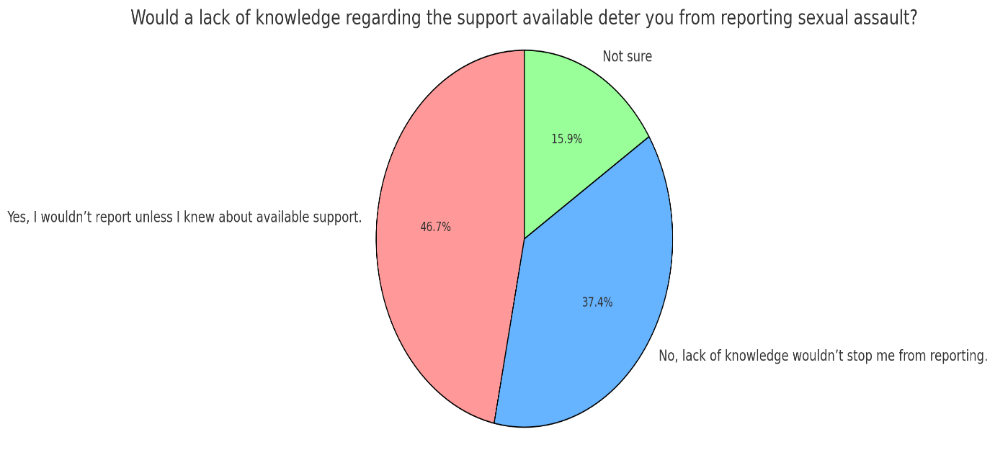

When considering the result illustrated in the above pie chart and The Victims' Code, a framework in the UK delineating the rights and entitlements of crime victim, we understand a lack of clarity in support available. “The Victims Code” seeks to guarantee that victims receive equitable treatment, are respected, and that their interests are considered throughout the criminal justice system (Ministry of Justice,2024).
The Victims' Code constitutes the UK's dedication to enhancing the treatment of victims in the criminal justice system. Law enforcement and other entities must comply with these standards to guarantee that victims obtain the necessary support and information.
The Victims' Code functions as an essential foundation to guarantee that victims are acknowledged and treated with dignity and respect during their interactions with the criminal justice system. This approach aims to empower victims and facilitate reporting, therefore fostering justice and healing (Ministry of Justice, 2024). Along with the Victims Code there is also Victim Support who is dedicated service to providing victims of crime with the necessary support to recover and manoeuvre through the intricacies of the criminal justice system. They provide a range of emotional, practical, and educational assistance to empower victims, assisting them in reclaiming their agency and obtaining the support essential for healing (Victim Support,2024).
The literature review revealed a significant gap in the exploration of how the availability of support affects victims’ willingness to report sexual offences. While existing studies often address the emotional and psychological barriers faced by victims, there is limited reflection on the crucial role that accessible support systems play in influencing reporting behaviour.
To address this gap, the primary research was conducted, which included surveys and interviews with 107 participants. The findings indicate an even divide in perspectives regarding support availability, underscoring its importance in the decision-making process of victims. Notably, a substantial portion of respondents nearly half expressed that they would only consider reporting incidents if they were assured of adequate support. This insight suggests that enhancing awareness and accessibility of victim support services could be a key factor in encouraging victims to come forward.
The data points to the need for increased awareness campaigns focused on victim support resources. By informing potential victims about the various forms of support available such as counselling, legal guidance, and emotional assistance there is a potential to foster a more supportive environment that empowers victims to report incidents without fear or hesitation.
Additionally, collaboration between Police forces, CJS, support organisations, and community groups could further facilitate the dissemination of information about support services, ensuring that victims feel recognised and supported in their experiences. This proactive approach could not only enhance reporting rates but also contribute to a broader cultural shift in how society addresses sexual offences and supports victims.

4.3 Analysis of Interviews
Given that both the primary and secondary research indicates a lack of successful prosecutions deters victims from reporting sexual offences and rapes to the police, two officers (one response officer and one detective sergeant) were interviewed to gain an understanding of the underlying issues and potential solutions. When asked about the major challenges within the investigation process (see Appendices B and C, Q2), both interviewees identified victim withdrawal as a significant factor, citing issues such as the lengthy nature of investigations and intimidation from either the offender or the court process. Murphy-Oikonen et al, emphasised comparable findings, suggesting that victim’s disengagement, evidential difficulties, and lack of resources are the primary components leading to increased rates of attrition in sexual offence cases (Murphy-Oikonen et al, 2022). These issues substantially hinder case progression, thereby impacting overall conviction rates.
Respondent one, a response officer, highlighted that insufficient knowledge and training regarding the early evidence kit can significantly hinder the investigation process. Similarly, Respondent two (detective sergeant) emphasised the critical nature of proper execution of the early evidence kit, noting that a lack of training may result in errors that could compromise the integrity of the investigation. Smith et al. (2014) suggest that early evidence kits are an effective tool for DNA recovery, emphasizing that the timely collection of evidence in the early stages of the investigation can significantly improve the likelihood of obtaining crucial forensic material. This, in turn, enhances the overall effectiveness of sexual assault investigations. (see Appendix B, Q2 and Appendix C Q2).
Both respondents highlighted concerns about the extended duration of the investigation process, noting that it often becomes a source of frustration for victims (see Appendix B, Q7; Appendix C, Q11). They observed that, although officers avoid providing specific time frames for the investigation, there is a tendency to set unrealistic expectations for victims regarding the length and complexity of the process. This miscommunication can lead victims to feel disillusioned and disheartened, potentially resulting in their disengagement from the investigation, which may consequently hinder its progress or lead to its discontinuation. Holder (2023) asserts that "victim participation is essential to a functioning system of criminal justice," emphasising that the active involvement of victims is crucial for the effective operation of the legal process. Victims play a pivotal role by providing essential information and evidence, which form the foundation for investigations and prosecutions. Without their engagement, cases may lack the necessary support to proceed, potentially resulting in lower conviction rates and an overall reduction in the effectiveness of the criminal justice system.
In conclusion, both the interviews and literature point to the need for systemic reforms. Improved communication with victims, realistic expectations about the investigative process, better training for officers, and enhanced collaboration between police and prosecuting bodies like the CPS are essential to address the issues that currently impede justice in sexual offence cases. Victim participation is vital for the criminal justice system to function effectively, and any reform must prioritise fostering and maintaining this engagement to improve conviction rates and ensure justice is served.
Chapter 5: Research Results
Upon analysing the quantitative surveys and qualitative interviews, several significant trends emerged that closely align with the findings of the literature review. This chapter will systematically examine each of these themes, drawing on insights from both primary and secondary research. Following this analysis, the chapter will provide recommendations aimed at addressing the critical issue of under-reporting of sexual offences and rapes to the police.

Theme one
The first theme directly addresses the research question regarding the factors that influence victims' decisions not to report sexual offences or rapes to the police. The survey data indicates that a significant barrier to reporting is the fear of not being believed, coupled with a lack of confidence in the likelihood of a successful prosecution. Other prevalent concerns include the fear of being blamed for the incident and apprehension regarding potential repercussions from the offender.
Additionally, the research reveals that many victims hesitate to report incidents due to the emotional burden of re-living the trauma associated with the assault and the complexities involved in navigating the court process. In instances where women do choose to report RASSO (Rape and Sexual Assault) incidents, victim withdrawal emerges as a critical factor contributing to the low rates of successful prosecutions, likely influenced by the aforementioned fears. To gain deeper insight into this issue, further investigation into the causes of unsuccessful prosecutions was conducted.
Theme two
The second theme identified pertains to the increased attrition rates in Rape and Sexual Assault (RASSO) cases. Supporting data indicate that victim withdrawal, largely attributed to the protracted nature of investigations and evidential challenges, plays a significant role in the low rates of successful prosecutions. Participants in the primary research underscored the existing resource shortages, which further exacerbate these issues.
Moreover, subsequent analysis revealed that inadequate training for response officers often leads to inconsistencies during the initial phases of investigations. Such errors can result in the loss of critical evidence, particularly forensic materials, thereby impeding the potential for successful prosecution.

Chapter 6: Conclusion
The under-reporting of rape and sexual assault remains a pressing issue that significantly undermines the effectiveness of the criminal justice system. Factors such as trauma, mistrust in the justice system, and cultural barriers contribute to the reluctance of victims to come forward. The psychological aftermath of these crimes often leaves victims feeling isolated, fearful, and doubtful about the likelihood of a favourable outcome, leading to a pervasive sense of mistrust towards law enforcement and the judicial process. Many victims grapple with the emotional toll of reliving their trauma during investigations and court proceedings, further deterring them from reporting these offenses.
Cultural barriers, including societal stigma and victim-blaming attitudes, exacerbate these challenges. Many victims face the additional burden of navigating a landscape where they may fear judgment or discrimination, particularly in communities where sexual violence is not openly discussed. This lack of support and understanding from both society and the justice system creates an environment where victims feel vulnerable and unsupported.
To combat these issues and promote confidence among victims in reporting sexual offenses, a multi-faceted approach is essential. Firstly, prioritising trauma-informed training for officers and the (CJS) to enable a better understanding of the psychological complexities faced by victims. This training should include education on dismantling rape myths and addressing biases that can hinder investigations. Furthermore, enhancing communication and transparency in the reporting process is crucial.
Additionally, the implementation of dedicated victim support services within police departments can provide victims with the guidance and emotional support they need throughout the process. Collaborating with community organisations to conduct outreach and awareness campaigns will help to foster trust and encourage victims to come forward.
It is also vital to simplify the reporting process and ensure confidentiality protections are in place to create a safer environment for victims. By advocating for policies that prioritise victims' rights and offering resources such as counselling and peer support networks, empower survivors and facilitate their engagement with the justice system. Addressing the under reporting of rape and sexual assault requires a concerted effort to dismantle the barriers that victims face. By fostering an environment of support, trust, and understanding, we can encourage more victims to report these crimes, ultimately leading to a more effective and responsive criminal justice system and more conviction rates.

Chapter 7: Limitations and Recommendations
7.1 Limitations
During the original research, certain restrictions were identified that may have affected the results. A notable concern was the lack of personal enquiries in the surveys pertaining to respondents' age, gender, race, and other pertinent attributes. This information would have enhanced the sample's validity by ensuring it accurately represented the broader population (Fink, 2003). Furthermore, incorporating these demographic characteristics would have enabled an investigation of whether particular groups encountered unique problems or maintained divergent viewpoints regarding the reporting of sexual offences.
In the secondary research phase, it was evident respondents recognised some challenges in the investigative process, there was a notable absence of practical ideas for enhancement. As a result, numerous recommendations outlined in Theme 3 of the research findings may not correspond with established literature, so constraining the incorporation of these findings into wider academic discussions.
Furthermore, the restricted quantity of interviews undertaken is a considerable limitation. Owing to time constraints, only two interviews were conducted, which may not sufficiently represent the varied experiences and perspectives of police professionals. Engaging in supplementary interviews with a wider array of seasoned officers would result in a more thorough comprehension of policing viewpoints and offer further suggestions for improving the investigative process.
7.2 Recommendations
Given the identified restrictions, it is advisable to undertake additional primary research that includes demographic enquiries regarding age, gender, and ethnicity. This method would provide a more refined comprehension of public perceptions and reveal patterns in experiences or opinions across various demographic groupings.
Additional research should be conducted on the topic of motivating women to disclose sexual assaults to The Police. Gaps in research include both primary methods, such as supplementary interviews with criminal justice system (CJS) professionals, and secondary methods, comprising an extensive literature review. Engaging with police officers and other criminal justice system stakeholders, including Independent Sexual Violence Advocates (ISVAs) and Crown Prosecution Service (CPS) prosecutors, could yield a wider array of views and recommendations to impact the reporting of such crimes and smooth process for victims through the Criminal Justice System.

Bibliography
Ajayi, Chinyere Elsie, et al. “The Role of Cultural Beliefs, Norms, and Practices in Nigerian Women’s Experiences of Sexual Abuse and Violence.” Violence against Women, vol. 28, no. 2, 5 Apr. 2021, p. 107780122110001, https://doi.org/10.1177/10778012211000134.
Amnesty International. “Women’s Rights.” Amnesty International, 2022, www.amnesty.org/en/what-we-do/discrimination/womens-rights/.
Baldwin-White, Adrienne. “College Students and Their Knowledge and Perceptions about Sexual Assault.” Sexuality & Culture, 3 June 2020, https://doi.org/10.1007/s12119-020-09757-x.
Bates, Lis. “Honor-Based Abuse in England and Wales: Who Does What to Whom?” Violence against Women, vol. 27, no. 10, 31 Aug. 2020, p. 107780122095216, https://doi.org/10.1177/1077801220952168.
Beecher, Ruth, and Stephanie Wright. “Historicising the Perpetrators of Sexual Violence: Global Perspectives from the Modern World.” Women’s History Review, 19 Apr. 2023, pp. 1–12, https://doi.org/10.1080/09612025.2023.2197790.
Brodie, Zara P, et al. “The Impact of Trauma-Awareness Session on Police Officers’ Trauma-Informed Attitudes in Scotland.” Psychology, Crime and Law, 18 May 2023, pp. 1–15, https://doi.org/10.1080/1068316x.2023.2210736.
Brown, Sarah J, et al. “Psychosocial Interventions for Survivors of Rape and Sexual Assault Experienced during Adulthood.” Cochrane Database of Systematic Reviews, vol. 11, no. 11, 7 Nov. 2019, https://doi.org/10.1002/14651858.cd013456.
Brunton-Smith, Ian, et al. “Prevalence of Sexual Violence: A Comparison of Estimates from UK National Surveys.” European Journal of Criminology, vol. 19, no. 5, 22 June 2020, p. 147737082093207, https://doi.org/10.1177/1477370820932077.
Bryant, Richard A. “Post‐Traumatic Stress Disorder: A State‐Of‐The‐Art Review of Evidence and Challenges.” World Psychiatry, vol. 18, no. 3, 9 Sept. 2019, pp. 259–269, www.ncbi.nlm.nih.gov/pmc/articles/PMC6732680/, https://doi.org/10.1002/wps.20656.
Cairns-Lee, Heather, et al. “Enhancing Researcher Reflexivity about the Influence of Leading Questions in Interviews.” The Journal of Applied Behavioral Science, vol. 58, no. 1, 18 Aug. 2021, pp. 164–188, https://doi.org/10.1177/00218863211037446.
Charman, Sarah, and Emma Williams. “Accessing Justice: The Impact of Discretion, “Deservedness” and Distributive Justice on the Equitable Allocation of Policing Resources.” Criminology & Criminal Justice, vol. 22, no. 3, 20 May 2021, pp. 404–422, journals.sagepub.com/doi/10.1177/17488958211013075, https://doi.org/10.1177/17488958211013075.
Cody, Lisa Forman. ““Marriage Is No Protection for Crime”: Coverture, Sex, and Marital Rape in Eighteenth-Century England.” Journal of British Studies, vol. 61, no. 4, Oct. 2022, pp. 809–834, https://doi.org/10.1017/jbr.2022.118.
Criminal Injuries Helpline. “Sexual Assault & Rape Statistics - 2023 UK Data | CIH.” Criminal Injuries Helpline, 1 Jan. 2023, criminalinjurieshelpline.co.uk/blog/sexual-assault-data-stats/.
Crivatu, Ioana M., et al. “The Impacts of Working with Victims of Sexual Violence: A Rapid Evidence Assessment.” Trauma, Violence, & Abuse, vol. 24, no. 1, 18 May 2021, p. 152483802110160, https://doi.org/10.1177/15248380211016024.
Crown Prosecution Service. “Police-CPS Joint National RASSO (Rape and Serious Sexual Offences) Action Plan 2021 | the Crown Prosecution Service.” Www.cps.gov.uk, 2021, www.cps.gov.uk/publication/police-cps-joint-national-rasso-rape-and-serious-sexual-offences-action-plan-2021.
---. “Rape and Sexual Offences - Chapter 7: Key Legislation and Offences | the Crown Prosecution Service.” Www.cps.gov.uk, 21 May 2021, www.cps.gov.uk/legal-guidance/rape-and-sexual-offences-chapter-7-key-legislation-and-offences.
Curtiss, Joshua E., et al. “Cognitive-Behavioral Treatments for Anxiety and Stress-Related Disorders.” Focus, vol. 19, no. 2, 17 June 2021, pp. 184–189, www.ncbi.nlm.nih.gov/pmc/articles/PMC8475916/, https://doi.org/10.1176/appi.focus.20200045.
Dalton, Charlotte T., et al. “A Systematic Literature Review of Specialist Policing of Rape and Serious Sexual Offences.” International Criminology, vol. 2, 23 June 2022, https://doi.org/10.1007/s43576-022-00062-1.
Das, Sarbopriya, et al. ““The Unheard Voices”: Lived Experiences of Sexual Abuse in Male Survivors.” Indian Journal of Psychological Medicine, vol. 44, no. 5, 21 Dec. 2020, p. 025371762097291, https://doi.org/10.1177/0253717620972912.
Davies, Pamela Ann, and Paul Biddle. “Implementing a Perpetrator-Focused Partnership Approach to Tackling Domestic Abuse: The Opportunities and Challenges of Criminal Justice Localism.” Criminology & Criminal Justice, vol. 18, no. 4, 15 Oct. 2017, pp. 468–487, https://doi.org/10.1177/1748895817734590.
Deosthali, Padma-Bhate, et al. “Women’s Experiences of Marital Rape and Sexual Violence within Marriage in India: Evidence from Service Records.” Sexual and Reproductive Health Matters, vol. 29, no. 2, 1 Jan. 2022, https://doi.org/10.1080/26410397.2022.2048455.
Dickson, Nicola. “Exploring the Experiences of Sexual Abuse Survivors Engaged in Non-Formal, Arts-Informed Adult Learning, Using an Arts-Based Research Methodology.” Studies in the Education of Adults, 22 Apr. 2021, pp. 1–17, https://doi.org/10.1080/02660830.2021.1910404.
Dworkin, Emily R., et al. “PTSD in the Year Following Sexual Assault: A Meta-Analysis of Prospective Studies.” Trauma, Violence, & Abuse, vol. 24, no. 2, 19 July 2021, pp. 497–514, https://doi.org/10.1177/15248380211032213.
---. “The Global Prevalence of Sexual Assault: A Systematic Review of International Research since 2010.” Psychology of Violence, vol. 11, no. 5, Sept. 2021, pp. 497–508, www.ncbi.nlm.nih.gov/pmc/articles/PMC8562086/, https://doi.org/10.1037/vio0000374.
End Violence Against Women. “Home.” Endviolenceagainstwomen.org.uk, 26 Feb. 2019, www.endviolenceagainstwomen.org.uk/.
Farahi, Narges, and Morgan McEachern. “Sexual Assault of Women.” American Family Physician, vol. 103, no. 3, 1 Feb. 2021, pp. 168–176, pubmed.ncbi.nlm.nih.gov/33507052/.
Featherstone, Lisa. “Rape Law Reform in the 1970s and 1980s.” Sexual Violence in Australia, 1970s–1980s, 2021, pp. 127–155, https://doi.org/10.1007/978-3-030-73310-0_6.
---. Sexual Consent and Its Contexts. 12 Nov. 2023, pp. 1–21, https://doi.org/10.1007/978-3-031-46622-9_1.
Flores, Andrew R., et al. “Hate Crimes against LGBT People: National Crime Victimization Survey, 2017-2019.” PLOS ONE, vol. 17, no. 12, 21 Dec. 2022, p. e0279363, https://doi.org/10.1371/journal.pone.0279363.
Franklin, Cortney A., et al. “Police Perceptions of Crime Victim Behaviors: A Trend Analysis Exploring Mandatory Training and Knowledge of Sexual and Domestic Violence Survivors’ Trauma Responses.” Crime & Delinquency, vol. 66, no. 8, 12 May 2019, p. 001112871984514, https://doi.org/10.1177/0011128719845148.
Gekoski, Anna, et al. ““A Lot of the Time It’s Dealing with Victims Who Don’t Want to Know, It’s All Made Up, or They’ve Got Mental Health”: Rape Myths in a Large English Police Force.” International Review of Victimology, vol. 30, no. 1, 11 Jan. 2023, p. 026975802211428, https://doi.org/10.1177/02697580221142891.
Geusau, van, et al. “The Effectiveness, Efficiency, and Acceptability of EMDR vs. EMDR 2.0 vs. the Flash Technique in the Treatment of Patients with PTSD: Study Protocol for the ENHANCE Randomized Controlled Trial.” Frontiers in Psychiatry, vol. 14, 9 Nov. 2023, www.ncbi.nlm.nih.gov/pmc/articles/PMC10665892/, https://doi.org/10.3389/fpsyt.2023.1278052.
Girardi, Rachele. ““It’s Easy to Mistrust Police When They Keep on Killing Us”: A Queer Exploration of Police Violence and LGBTQ+ Victimization.” Journal of Gender Studies, vol. 31, no. 7, 14 Sept. 2021, pp. 1–11, https://doi.org/10.1080/09589236.2021.1979481.
Gobel, Matthias S., et al. “Europe’s Culture(S): Negotiating Cultural Meanings, Values, and Identities in the European Context.” Journal of Cross-Cultural Psychology, vol. 49, no. 6, 21 June 2018, pp. 858–867, www.ncbi.nlm.nih.gov/pmc/articles/PMC6024379/, https://doi.org/10.1177/0022022118779144.
Goodman‐Williams, Rachael, et al. “Domestic Violence Survivors’ Housing Stability, Safety, and Well-Being over Time: Examining the Role of Domestic Violence Housing First, Social Support, and Material Hardship.” American Journal of Orthopsychiatry, vol. 93, no. 5, 1 June 2023, https://doi.org/10.1037/ort0000686.
Goorts, Kaat, et al. “The Effectiveness of Implementation Strategies for Promoting Evidence Informed Interventions in Allied Healthcare: A Systematic Review.” BMC Health Services Research, vol. 21, no. 1, 2021, www.ncbi.nlm.nih.gov/pmc/articles/PMC7977260/, https://doi.org/10.1186/s12913-021-06190-0.
Gore, Ashlee. “It’s All or Nothing: Consent, Reasonable Belief, and the Continuum of Sexual Violence in Judicial Logic.” Social & Legal Studies, vol. 30, no. 4, 13 Aug. 2020, p. 096466392094781, https://doi.org/10.1177/0964663920947813.
Gov.uk. “Sexual Offences Act 2003.” Legislation.gov.uk, 2003, www.legislation.gov.uk/ukpga/2003/42/contents.
Gravelin, Claire R., et al. “Blaming the Victim of Acquaintance Rape: Individual, Situational, and Sociocultural Factors.” Frontiers in Psychology, vol. 9, no. 2422, 21 Jan. 2019, www.frontiersin.org/articles/10.3389/fpsyg.2018.02422/full, https://doi.org/10.3389/fpsyg.2018.02422.
Hansen, Maria, et al. “Non-Reporting of Sexual Violence as Action: Acts, Selves, Futures in the Making.” Nordic Journal of Criminology, vol. 22, no. 1, 29 Dec. 2020, pp. 42–57, https://doi.org/10.1080/2578983x.2020.1867401. Accessed 22 July 2021.
Harsey, Sarah, and Jennifer J. Freyd. “Deny, Attack, and Reverse Victim and Offender (DARVO): What Is the Influence on Perceived Perpetrator and Victim Credibility?” Journal of Aggression, Maltreatment & Trauma, 8 June 2020, pp. 1–20, https://doi.org/10.1080/10926771.2020.1774695.
Hazel, Kelly L., and Kerry S. Kleyman. “Gender and Sex Inequalities: Implications and Resistance.” Journal of Prevention & Intervention in the Community, vol. 48, no. 4, 12 Aug. 2019, pp. 1–12, www.tandfonline.com/doi/full/10.1080/10852352.2019.1627079, https://doi.org/10.1080/10852352.2019.1627079.
Henin, Sally, and Lauren Page Black. “Understanding the Long‐Term Trauma of Sexual Assault Patients.” Journal of the American College of Emergency Physicians Open, vol. 2, no. 4, 3 July 2021, https://doi.org/10.1002/emp2.12490.
Hetey, Rebecca C., and Jennifer L. Eberhardt. “The Numbers Don’t Speak for Themselves: Racial Disparities and the Persistence of Inequality in the Criminal Justice System.” Current Directions in Psychological Science, vol. 27, no. 3, 2018, pp. 183–187, journals.sagepub.com/doi/full/10.1177/0963721418763931, https://doi.org/10.1177/0963721418763931.
Ho, Hock Lai. “Justification, Excuse, and Proof beyond Reasonable Doubt.” Philosophical Issues, 5 Oct. 2021, https://doi.org/10.1111/phis.12200. Accessed 19 Nov. 2021.
Hohl, Katrin, and Elisabeth A. Stanko. “Complaints of Rape and the Criminal Justice System: Fresh Evidence on the Attrition Problem in England and Wales.” European Journal of Criminology, vol. 12, no. 3, Mar. 2015, pp. 324–341, https://doi.org/10.1177/1477370815571949.
---. “Complaints of Rape and the Criminal Justice System: Fresh Evidence on the Attrition Problem in England and Wales.” European Journal of Criminology, vol. 12, no. 3, Mar. 2015, pp. 324–341, https://doi.org/10.1177/1477370815571949.
Holder, Robyn, et al. “Transforming Crime Victims’ Rights: From Myth to Reality.” International Journal of Comparative and Applied Criminal Justice, vol. 45, no. 1, 10 Dec. 2020, pp. 1–13, https://doi.org/10.1080/01924036.2020.1857278.
Holder, Robyn L, and Elizabeth Englezos. “Victim Participation in Criminal Justice: A Quantitative Systematic and Critical Literature Review.” International Review of Victimology, vol. 30, no. 1, 1 Feb. 2023, p. 026975802311512, https://doi.org/10.1177/02697580231151207.
Hopkins, Anna. “Examining Reasons for Victim Retraction in Domestic Violence and Abuse: A Qualitative Analysis of Police Retraction Statements in the United Kingdom.” The Police Journal: Theory, Practice and Principles, vol. 97, no. 2, 27 Feb. 2023, p. 0032258X2311598, journals.sagepub.com/doi/full/10.1177/0032258X231159807, https://doi.org/10.1177/0032258x231159807.
Hulley, Joanne, et al. “Intimate Partner Violence and Barriers to Help-Seeking among Black, Asian, Minority Ethnic and Immigrant Women: A Qualitative Metasynthesis of Global Research.” Trauma, Violence, & Abuse, vol. 24, no. 2, 2 Feb. 2022, pp. 1001–1015, https://doi.org/10.1177/15248380211050590.
Jankowitz, Sarah. “Intergroup Struggles over Victimhood in Violent Conflict.” International Review of Victimology, vol. 24, no. 3, 18 Dec. 2017, pp. 259–271, https://doi.org/10.1177/0269758017745617. Accessed 6 Jan. 2020.
Kalra, Gurvinder, and Dinesh Bhugra. “Sexual Violence against Women: Understanding Cross-Cultural Intersections.” Indian Journal of Psychiatry, vol. 55, no. 3, 2013, pp. 244–249, www.ncbi.nlm.nih.gov/pmc/articles/PMC3777345/, https://doi.org/10.4103/0019-5545.117139.
Kar, Anindya, et al. “Intimate Partner Violence in Same-Sex Relationships: Are We Aware of the Implications?” Journal of Psychosexual Health, vol. 5, no. 1, 30 Nov. 2022, p. 263183182211342, https://doi.org/10.1177/26318318221134268.
Khan, Ali M, et al. “Cognitive Behavioral Therapy versus Eye Movement Desensitization and Reprocessing in Patients with Post-Traumatic Stress Disorder: Systematic Review and Meta-Analysis of Randomized Clinical Trials.” Cureus, vol. 10, no. 9, 4 Sept. 2018, www.ncbi.nlm.nih.gov/pmc/articles/PMC6217870/, https://doi.org/10.7759/cureus.3250.
Kubrin, Charis E., and Rebecca Tublitz. “How to Think about Criminal Justice Reform: Conceptual and Practical Considerations.” American Journal of Criminal Justice, vol. 47, no. 6, Dec. 2022, pp. 1050–1070, www.ncbi.nlm.nih.gov/pmc/articles/PMC9763086/, https://doi.org/10.1007/s12103-022-09712-6.
Lehmann, Peter S., and Anna I. Gomez. “Racial, Ethnic, Gender, and Economic Sentencing Disparity.” Handbook of Issues in Criminal Justice Reform in the United States, 5 Dec. 2021, pp. 127–142, https://doi.org/10.1007/978-3-030-77565-0_8.
Li, Liqing, et al. “Sexual Violence against Women Remains Problematic and Highly Prevalent around the World.” BMC Women’s Health, vol. 23, no. 1, 26 Apr. 2023, https://doi.org/10.1186/s12905-023-02338-8.
Lim, Weng Marc. “What Is Qualitative Research? An Overview and Guidelines.” Australasian Marketing Journal (AMJ), 25 July 2024, https://doi.org/10.1177/14413582241264619.
Lorenz, Katherine, et al. “A Qualitative Study of Sexual Assault Survivors’ Post-Assault Legal System Experiences.” Journal of Trauma & Dissociation, vol. 20, no. 3, 9 May 2019, pp. 263–287, https://doi.org/10.1080/15299732.2019.1592643.
Lowerson, Ashley J. “Proportionate? The Metropolitan Police Service Response to the Sarah Everard Vigil.” The Journal of Criminal Law, vol. 86, no. 4, 23 May 2022.
Maguire, Linda, et al. “Care for Both Victim-Survivors and Police Investigators of Rape and Serious Sexual Offences in England and Wales.” Criminology & Criminal Justice, 10 May 2024, https://doi.org/10.1177/17488958241248034.
Mansoor, Nasreen. “The Concept of Honour and Shame for South Asian British Muslim Men and Women.” Therapy, Culture and Spirituality, 2015, pp. 56–69, https://doi.org/10.1057/9781137370433_5.
Mayeza, Emmanuel. “Rape Culture: Sexual Intimidation and Partner Rape among Youth in Sexually Diverse Relationships.” Sexualities, vol. 0, no. 0, 6 Dec. 2022, p. 136346072211446, https://doi.org/10.1177/13634607221144618.
McAlinden, A.-M. “Sexual Assault and the Justice Gap: A Question of Attitude. By Jennifer Temkin and Barbara Krahe (Oxford: Hart Publishing, 2008, Xi + 257pp. 30.00 Pb).” British Journal of Criminology, vol. 49, no. 4, 21 Apr. 2009, pp. 588–590, academic.oup.com/bjc/article/49/4/588/324657, https://doi.org/10.1093/bjc/azp019.
Metropolitan Police. “What Is Rape and Sexual Assault?” Police.uk, Metropolitan Police, 2019, www.met.police.uk/advice/advice-and-information/rsa/rape-and-sexual-assault/what-is-rape-and-sexual-assault/ .
Mifsud, Rebekah, and Gordon Sammut. “Worldviews and the Role of Social Values That Underlie Them.” PLOS ONE, vol. 18, no. 7, 26 July 2023, pp. e0288451–e0288451, www.ncbi.nlm.nih.gov/pmc/articles/PMC10370735/, https://doi.org/10.1371/journal.pone.0288451.
Ministry of Justice. “Code of Practice for Victims of Crime in England and Wales (Victim’s Code).” GOV.UK, 29 Feb. 2024, www.gov.uk/government/publications/the-code-of-practice-for-victims-of-crime/code-of-practice-for-victims-of-crime-in-england-and-wales-victims-code.
Mulder, J., et al. “Reporting after Sexual Violence: The Influence of Victim, Assault and Perpetrator Characteristics.” Journal of Forensic and Legal Medicine, vol. 79, Apr. 2021, p. 102076, https://doi.org/10.1016/j.jflm.2020.102076. Accessed 1 Nov. 2021.
Muldoon, Orla T., et al. “The Social Psychology of Responses to Trauma: Social Identity Pathways Associated with Divergent Traumatic Responses.” European Review of Social Psychology, vol. 30, no. 1, 1 Jan. 2019, pp. 311–348, www.tandfonline.com/doi/full/10.1080/10463283.2020.1711628, https://doi.org/10.1080/10463283.2020.1711628.
Mulvihill, Natasha, et al. “The Experience of Interactional Justice for Victims of “Honour”-Based Violence and Abuse Reporting to the Police in England and Wales.” Policing and Society, vol. 29, no. 6, 30 Jan. 2019, pp. 640–656, https://doi.org/10.1080/10439463.2018.1427745.
Murphy-Oikonen, Jodie, et al. “Sexual Assault Case Attrition: The Voices of Survivors.” SAGE Open, vol. 12, no. 4, Oct. 2022, p. 215824402211446, https://doi.org/10.1177/21582440221144612.
Office for National Statistics. “Nature of Sexual Assault by Rape or Penetration, England and Wales - Office for National Statistics.” Www.ons.gov.uk, 18 Mar. 2021, www.ons.gov.uk/peoplepopulationandcommunity/crimeandjustice/articles/natureofsexualassaultbyrapeorpenetrationenglandandwales/yearendingmarch2020.
---. “Sexual Offences in England and Wales Overview - Office for National Statistics.” Office for National Statistics, 2023, www.ons.gov.uk/peoplepopulationandcommunity/crimeandjustice/bulletins/sexualoffencesinenglandandwalesoverview/march2022.
---. “Sexual Offences in England and Wales Overview - Office for National Statistics.” Office for National Statistics, 2023, www.ons.gov.uk/peoplepopulationandcommunity/crimeandjustice/bulletins/sexualoffencesinenglandandwalesoverview/march2022.
Oppenauer, Claudia, et al. “Dialectical Behaviour Therapy for Posttraumatic Stress Disorder (DBT-PTSD): Transportability to Everyday Clinical Care in a Residential Mental Health Centre.” European Journal of Psychotraumatology, vol. 14, no. 1, 10 Jan. 2023, www.ncbi.nlm.nih.gov/pmc/articles/PMC9848310/, https://doi.org/10.1080/20008066.2022.2157159.
Rape Crisis England and Wales. “Statistics about Sexual Violence and Abuse.” Rape Crisis England & Wales, Rape Crisis England & Wales, 2023, rapecrisis.org.uk/get-informed/statistics-sexual-violence/.
Reveilhac, Maud. “The Deployment of Social Media by Political Authorities and Health Experts to Enhance Public Information during the COVID-19 Pandemic.” SSM - Population Health, vol. 19, July 2022, p. 101165, https://doi.org/10.1016/j.ssmph.2022.101165.
RSA. “Ethnic Minorities Twice as Likely to Face Discrimination in Local Services.” The RSA, 12 Apr. 2021, www.thersa.org/press/releases/2021/ethnic-minorities-twice-as-likely-to-face-discrimination-in-local-services.
Scott-Storey, Kelly, et al. “What about the Men? A Critical Review of Men’s Experiences of Intimate Partner Violence.” Trauma, Violence, & Abuse, vol. 24, no. 2, 30 Jan. 2022, pp. 858–872, journals.sagepub.com/doi/10.1177/15248380211043827, https://doi.org/10.1177/15248380211043827.
Shaw, Jessica, and HaeNim Lee. “Race and the Criminal Justice System Response to Sexual Assault: A Systematic Review.” American Journal of Community Psychology, vol. 64, no. 1-2, 6 May 2019, pp. 256–278, onlinelibrary.wiley.com/doi/abs/10.1002/ajcp.12334, https://doi.org/10.1002/ajcp.12334.
Singh, Vijay P. “Judicial Approaches to the Criminalisation of Marital Rape.” Indian Journal of Gender Studies, vol. 29, no. 1, 19 Dec. 2021, pp. 10–32, https://doi.org/10.1177/09715215211056791. Accessed 3 Feb. 2022.
Smith, Debbie A., et al. “Early Evidence Kits in Sexual Assault: An Observational Study of Spermatozoa Detection in Urine and Other Forensic Specimens.” Forensic Science, Medicine, and Pathology, vol. 10, no. 3, 22 Apr. 2014, pp. 336–343, https://doi.org/10.1007/s12024-014-9562-7.
Spohn, Cassia, and Katharine Tellis. “The Criminal Justice System’s Response to Sexual Violence.” Violence against Women, vol. 18, no. 2, Feb. 2012, pp. 169–192, journals.sagepub.com/doi/abs/10.1177/1077801212440020, https://doi.org/10.1177/1077801212440020.
Stewart, Sophie, et al. ““I Thought I’m Better off Just Trying to Put This behind Me” – a Contemporary Approach to Understanding Why Women Decide Not to Report Sexual Violence.” Journal of Forensic Psychiatry & Psychology, vol. 35, no. 1, 7 Dec. 2023, pp. 1–17, https://doi.org/10.1080/14789949.2023.2292103.
Tan, Sze Eng, and Katie Kuschminder. “Migrant Experiences of Sexual and Gender Based Violence: A Critical Interpretative Synthesis.” Globalization and Health, vol. 18, no. 1, 28 June 2022, https://doi.org/10.1186/s12992-022-00860-2. Accessed 25 July 2022.
Varghese, Femina P., et al. “Injustice in the Justice System: Reforming Inequities for True “Justice for All.”” The Counseling Psychologist, vol. 47, no. 5, July 2019, pp. 682–740, https://doi.org/10.1177/0011000019892329.
Walker, Sarah-Jane Lilley, et al. “Rape, Inequality and the Criminal Justice Response in England: The Importance of Age and Gender.” Criminology & Criminal Justice, vol. 21, no. 3, 16 July 2019, p. 174889581986309, https://doi.org/10.1177/1748895819863095.
Wemmers, Jo-Anne, et al. “Restoring Victims’ Confidence: Victim-Centred Restorative Practices.” International Review of Victimology, vol. 29, no. 3, 19 Oct. 2022, p. 026975802211288, https://doi.org/10.1177/02697580221128830.
Westmarland, Nicole, and Stephen Robert Burrell. ““I’m a Red-Blooded Male”: Understanding Men’s Experiences of Domestic Abuse through a Feminist Lens.” Criminology & Criminal Justice, 6 Nov. 2023, https://doi.org/10.1177/17488958231210985.
Wieberneit, Michelle, et al. “Silenced Survivors: A Systematic Review of the Barriers to Reporting, Investigating, Prosecuting, and Sentencing of Adult Female Rape and Sexual Assault.” Trauma Violence & Abuse, 30 July 2024, https://doi.org/10.1177/15248380241261404.
Wong, Adrian, et al. “The Use of Social Media and Online Communications in Times of Pandemic COVID-19.” Journal of the Intensive Care Society, vol. 22, no. 3, 22 Oct. 2020, pp. 255–260. Sagepub, journals.sagepub.com/doi/10.1177/1751143720966280, https://doi.org/10.1177/1751143720966280.
Yang, Bo, et al. “Exploring Information Dissemination Effect on Social Media: An Empirical Investigation.” Personal and Ubiquitous Computing, vol. 27, 7 Feb. 2023, pp. 1469–1482, https://doi.org/10.1007/s00779-023-01710-7.

Appendices
Appendix A
Q1. What do you think are the reasons victims may hesitate to report sexual offenses or rapes to the police? Please select all that apply.
Reason for Not Reporting | Number of Responses | Percentage
1. Fear of Not Being Believed | 70 | 65.4%
2. Fear of Being Blamed | 40 | 37.4%
3. Lack of Faith in the Police | 60 | 56.1%
4. Fear of Repercussions from the Offender | 50 | 46.7%
5. Court process | 45 | 42.1%
6. Fear of Public Exposure | 35 | 32.7%
7. Fear of Family Reaction | 25 | 23.4%
8. Belief That the Justice System Favors Perpetrators | 55 | 51.4%
9. Perception of the Police's Attitude Toward Victims | 48 | 44.9%
10. Concerns About Reliving the Trauma | 30 | 28.0%
11. Cultural or Religious Beliefs | 20 | 18.7%
12. Shame and Stigma | 42 | 39.3%
13. Fear of Impact on Personal Relationships | 27 | 25.2%
14. Uncertainty About What Constitutes Sexual Assault | 33 | 30.8%
15. Lack of Awareness of Reporting Procedures and support | 22 | 20.6%
Total Responses | 107 | 100%

Q2 How likely are you to report a sexual assault or rape to the police if it were to occur?
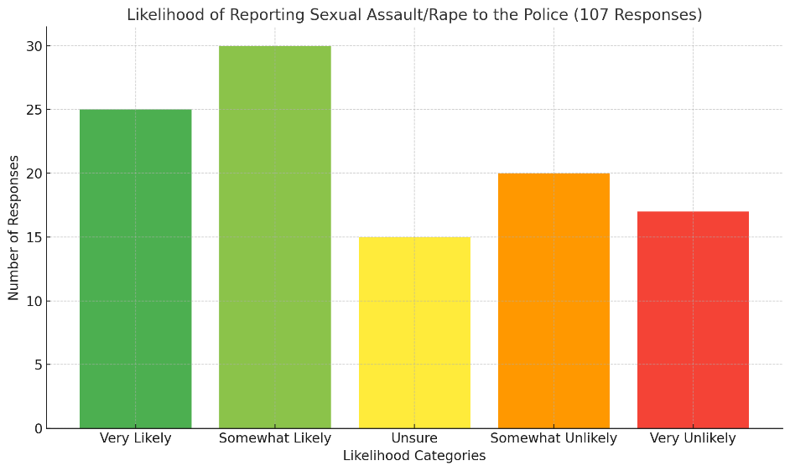

Q3. What are the reasons that would encourage you to report a sexual offense to the police?
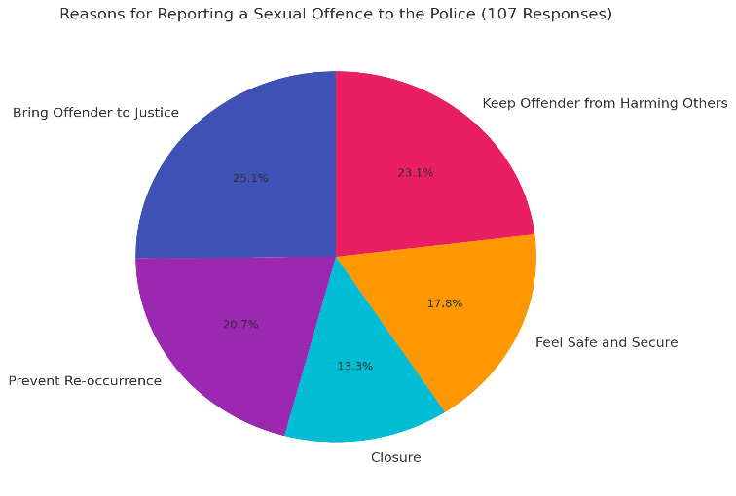

Q4. How knowledgeable are you of all the support that is available that is to you?

- Very Knowledgeable: 20
- Somewhat Knowledgeable: 35
- Neutral/Unsure: 25
- Somewhat Unaware: 15
- Completely Unaware: 12

Q5. What challenges or concerns might you face if you were to report a sexual offence?

- Fear of Not Being Believed: 44
- Retaliation from the Offender: 21
- Emotional Trauma: 9
- Social Stigma: 3
- Lengthy Legal Process: 21
- Impact on Relationships: 2
- Fear of Further Victimisation: 3
- Don’t know: 4

Q6. How much faith do you have in the police and the criminal justice system to successfully secure convictions?

- Highly Likely: 11
- Somewhat Likely: 18
- Unsure: 35
- Somewhat Unlikely: 24
- Highly Unlikely: 19

Q7. What do you believe are the main reasons behind the widespread distrust in the police?

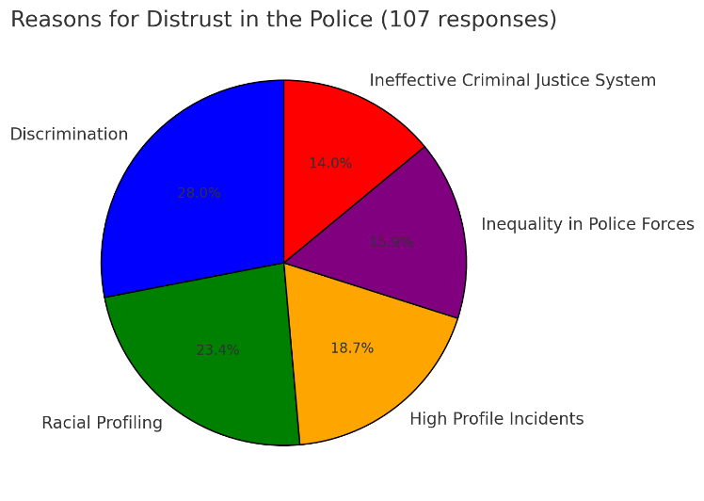

Q8. Would uncertainty about the duration of an investigation and its progression to court discourage you from reporting a sexual assault to the police?

- Yes: 44
- No: 39
- Unsure: 24

Q9. In your opinion, how adequately trained are police forces to manage sexual assault cases during their initial training?

- Highly Likely: 25
- Somewhat Likely: 30
- Unsure: 20
- Somewhat Unlikely: 18
- Highly Unlikely: 14

Q10. Would a lack of knowledge regarding the support available deter you from reporting sexual assault?

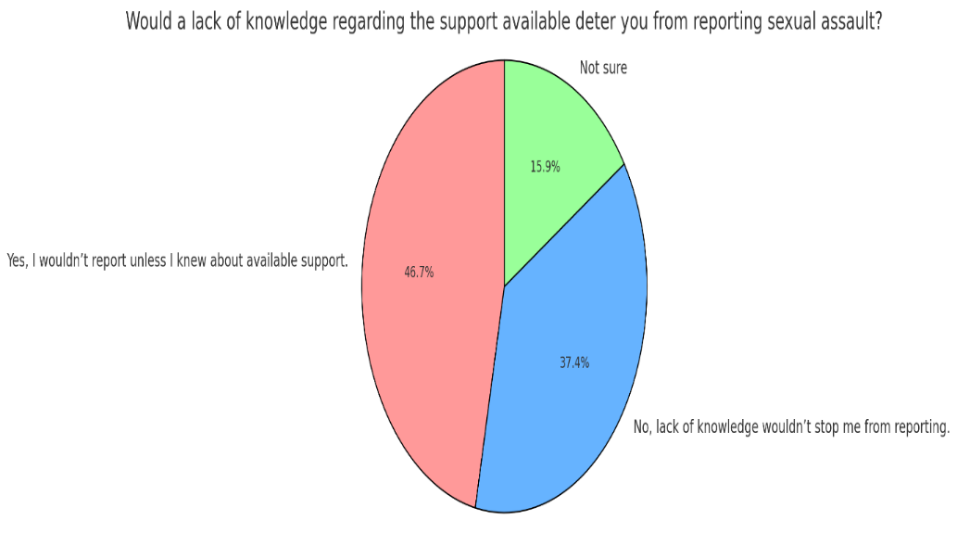

Q11. Do you believe cultural beliefs could prevent victims from reporting sexual assault to the police?
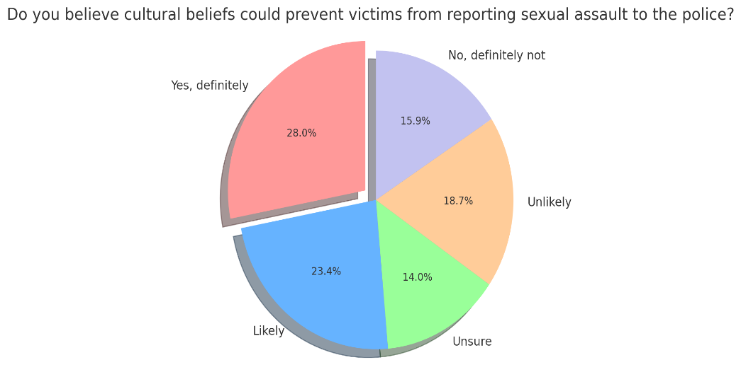

Q12. What do you believe are the cultural belief barriers that prevent individuals from reporting sexual assault to the police?

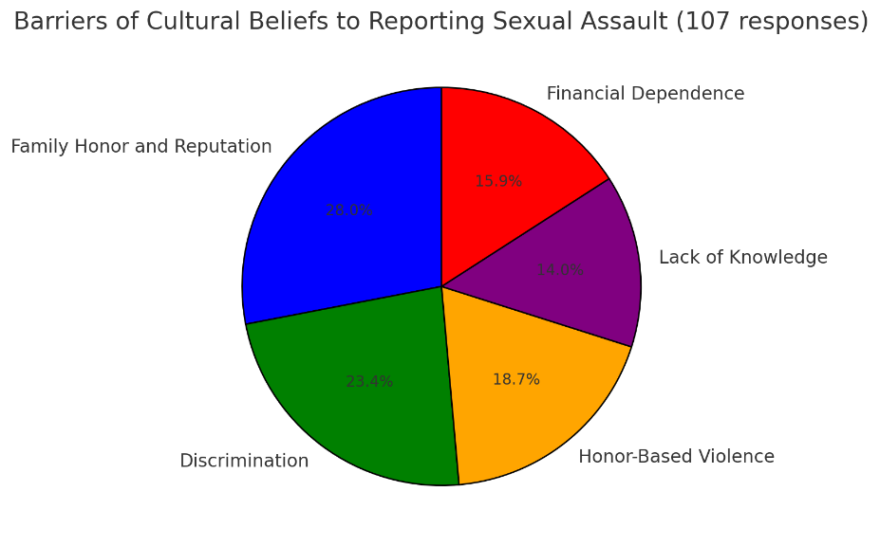

Q13. Are you aware of the trauma informed therapy available to you?

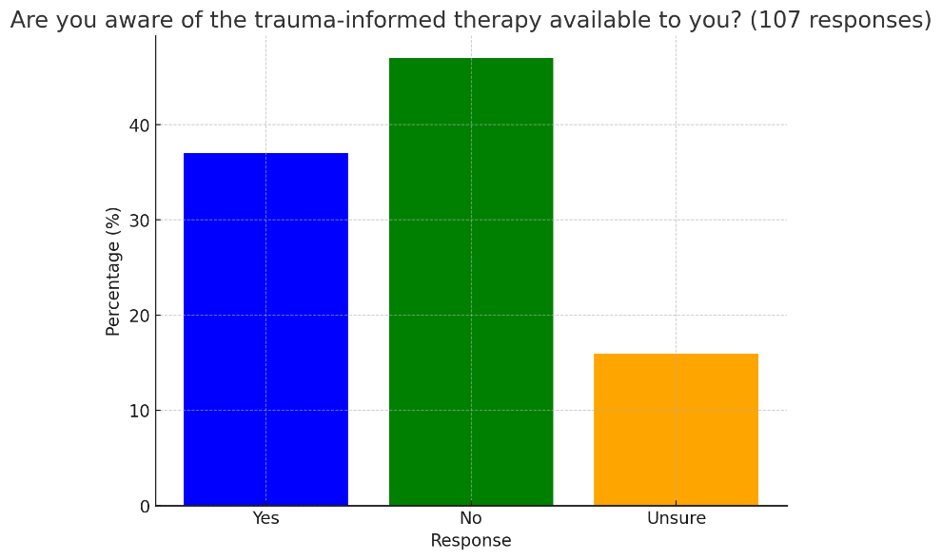

Q14. If you had to choose a specific type of therapy, which one would you choose?

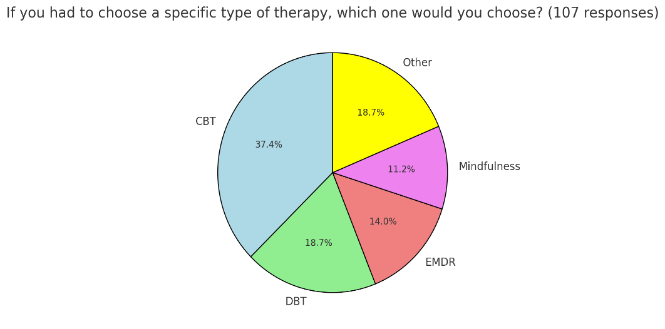

Appendix B: Interview of Respondent 1
Q1: Can you explain the sexual assault/rape investigation process?
A: It starts with a report, and response officers go out to take the first account, secure forensics, safeguard the victim, and identify the offender. They then prepare a handover for CID or the rape team, who take over from there.
Q2: What are the major issues in this process?
A: Response officers deal with a wide variety of incidents and may not always be in the right mindset for sensitive cases like rape. The lack of knowledge/ training regarding early evidence kit could negatively impact the case if done incorrectly. SOLO officers are often unavailable. The handover process between multiple officers’ response, SOLO, CID creates inefficiencies. It would be better if CID handled cases from the beginning to ensure consistency and avoid unnecessary repetition of accounts.
Q3: Do you think response officers are adequately trained to handle sexual assault cases?
A: Not really. There is a tendency to send female officers to female rape cases, but male officers often feel uncomfortable and lack confidence in handling such cases. A dedicated team dealing with these cases daily would be much more effective. Response officers are not always equipped to answer victims' questions, which can negatively impact the victim's trust in the process.
Q4: Would CID or Rape Investigation Teams (RIT) being first responders improve the process?
A: Yes, having CID respond from the start would make the process smoother. Victims would likely feel more comfortable with trained professionals handling their case from the outset, rather than uniformed response officers who pass the case along. This approach could also prevent victims from losing faith in the system.
Q5: How would you describe the police response to sexual offences?
A: It's often disorganized, relying on whoever is available. Response officers handle initial enquiries like filling out ONYX booklets but lack confidence with more specific tasks like handling forensic kits. The training on these issues is insufficient, and a more unified approach, with CID handling cases from the start, would yield better results.
Q6: Would increasing the number of SOLOs improve the process?
A: Yes, more SOLOs or training CID officers to also be SOLOs would help. This would provide more flexibility and ensure that the first responders are consistently trained and qualified to handle sensitive cases.
Q7: Do response officers know enough about support services for victims of sexual assault?
A: No, we don’t know enough about specialised support like ISVAs (Independent Sexual Violence Advisors) or Rape Crisis services. We often refer victims to generic mental health or domestic violence services because that is all we know. Having more knowledge about these resources could improve the victim’s experience and their likelihood to continue with the prosecution.
Q8: What evidential challenges are faced in rape investigations?
A: It’s a highly intimate offence, and most evidence is either forensic or based on the victim’s account. Consent becomes a major challenge since it’s often one person’s word against the other. If victims refuse to provide forensic evidence or go to the SARC (Sexual Assault Referral Centre), we have very little to work with. In cases of intimate partner violence, where the defence of consent is raised, it’s even harder to prosecute.
Q9: Does an officer’s workload impact the investigation?
A: For response officers, not as much, since we pass the case to CID. But CID officers with multiple rape cases on their workload can feel overwhelmed. When they repeatedly see cases result in no further action (NFA), it can affect their morale and commitment to the next case, which can lead to missed opportunities or delays.
Q10: Are communication issues between agencies affecting the process?
A: Yes, especially with the CPS (Crown Prosecution Service). Communication is poor and inconsistent, which makes it hard to get guidance during investigations. This hampers prosecution efforts and contributes to the rocky relationship between police and CPS.
Q11: Why do victims often withdraw from the process?
A: The process is not explained well to victims from the start. Response officers may not have the knowledge or time to set realistic expectations, therefore they become frustrated with the process and loose hope of a conviction. When CID eventually takes over, the process may seem slow, leading victims to lose faith. By the time CPS asks for more evidence to pursue a case without the victim’s cooperation, it often feels too late, and the system isn’t built to deal with victim withdrawals well.
Q12: What recommendations do you have for improving the investigation process?
A: CID officers should all be SOLO-trained and act as first responders. This would ensure consistency, speed up the process, and ensure a more sensitive approach from the start. Response officers could focus on other aspects of the investigation, such as dealing with suspects, while CID handles the victim.
Q13: How can communication between police and CPS be improved?
A: It would be helpful to have a dedicated CPS advice line for officers during the investigation, rather than waiting until the end. Better communication and collaboration between police and CPS are essential for more effective prosecutions.

The recommendations from Interview Respondent 1
- CID officers, or specialised Rape Investigation Teams (RIT), should respond to sexual assault cases from the start. This would ensure consistency, provide victims with trained professionals from the outset, and avoid the inefficiencies caused by multiple handovers between officers.
- The number of SOLOs (Specially Trained Officers) should be increased. Additionally, CID officers should be trained as SOLOs to provide greater flexibility and ensure the first responders are consistently trained to handle sensitive sexual offence cases.
- Response officers need more comprehensive training, particularly in the areas of sexual offences, forensics, and victim support services. This would reduce the discomfort male officers may feel and improve the overall quality of the first response.
- Response officers should be more knowledgeable about specialised support services such as ISVAs (Independent Sexual Violence Advisors) and Rape Crisis services. This would enhance the support provided to victims and increase the likelihood of victims continuing with the prosecution.
- Ensuring victims are encouraged to provide forensic evidence and visit Sexual Assault Referral Centres (SARC) is critical. More proactive engagement in this area would address challenges related to lack of forensic evidence.
- Workload distribution needs to be addressed to prevent CID officers from being overwhelmed with multiple rape cases. This would help maintain their morale and focus on each case.
- The police and CPS (Crown Prosecution Service) need better, more consistent communication. A dedicated CPS advice line should be established to provide officers with real-time guidance during investigations, rather than waiting until the final stages of the process.
- The process needs to be explained more clearly to victims at the outset, particularly by response officers, to set realistic expectations and reduce the chances of victims losing faith and withdrawing from the process.

Appendix C – Interview with Respondent 2 (Detective Sargent)
Q1: Can you explain the process for investigating sexual assault/rape cases?
- The victim reports the incident to the police.
- Response officer responds or if a SOLO is available, they would be dispatched however, more than likely it’s a response officer who is first with the victim.
- ONYX is used for live RASSO (Rape and Serious Sexual Offences) cases.
- Forensic evidence is gathered in live cases, such as gathering clothing taking the victim to the SARC.
- Golden Hour Tasks: CCTV collection, house-to-house enquiries, , Identify, and Eliminate suspects.
- The suspect is to be arrested
- DNA and forensic swabs are obtained.
- An Achieving Best Evidence (ABE) interview is conducted after building rapport with the victim, ensuring they are ready to discuss the incident.
- Information from medical records, social services, and other relevant third parties (if applicable).
- Statements are collected from any relevant witnesses.
- Bail conditions if applicable
- External agencies, such as social services, IDVAS and the rape crisis team to support the victim.
- The suspect’s phone is examined for evidence of contact or discussions with the victim.
- Clothing seized from the suspect is forensically analysed.
- Guidance is sought from the Crown Prosecution Service (CPS) early in the process.
- A case file is compiled for CPS review and potential charges.
- Files are updated for Crown Court proceedings if charges are pressed.
- The police and CPS discuss the case and trial preparation. Close collaboration between the two is key in RASSO cases.
- The case proceeds to its initial court hearing.

Q2: What are the main challenges in this investigation process?
- Victims may feel intimidated or scared of the offender, or overwhelmed by the court process, causing them to withdraw.
- Victims’ credibility is often scrutinised, particularly if they have a history of offences like theft, which can be portrayed as dishonesty in court.
- In cases where the offender claims consensual sex, it becomes one person’s word against the other, diminishing forensic evidence.
- Historical cases often lack forensic evidence.
- The defence may focus on undermining the victim by questioning their actions post-assault, such as maintaining a normal life for their family's sake.
- The lengthy investigation process can make it difficult for victims to stay engaged.
- It’s challenging to gather enough evidence to meet the threshold for court proceedings.
- The nature of the final questions at trial makes obtaining convictions difficult.
- Lack of police and forensic resources slows down investigations.
- Delays in obtaining crucial information from external agencies like social services or paramedics can slow down investigations.
- Inexperienced officers can make mistakes, such as improperly collecting swabs or not securing crime scenes this can have a detrimental effect on the investigation.
Q3: How effective is the initial police response to sexual assault cases? Are response officers adequately trained?
- No, they are not sufficiently trained. Investigating sexual offences requires experience, which many response officers lack. Frontline officers, who often have little experience, aren’t trained in how to handle cases involving sexual offences (e.g., completing ONYX forms, collecting forensic evidence, etc.). Many response officers feel intimidated by the complexity of the process, leading to mistakes in evidence collection or storage.
- There’s often insufficient forethought regarding the need to secure crime scenes or preserve forensic evidence, and officers sometimes fail to consult CID (Criminal Investigation Department) or RIT (Rapid Investigation Team) for advice.

Q4: Would increasing the number of SOLO officers improve the investigation process?
- Yes, absolutely. More SOLOs would provide better victim support, reduce pressure on officers, and ensure that evidence is collected and preserved correctly. There are many cases where SOLOs are unavailable, and this could have a detrimental impact on the case progressing.
Q5: What is your opinion on the support available to victims of sexual offences? How does this impact their decision to support the prosecution?
- Victims can receive support from organisations like ISVAs, New Pathways, Women’s Aid, MIND and the Rape Crisis team. Although the police can refer victims to support services, there’s a lack of immediate support available from police at the first point of contact. However, Post-reporting, ABE officers can guide victims through the process and inform them of available support options.

Q6: What do you think of the ISVA’s role in supporting victims?
- I think the ISVA’s play a vital role in advocating for victims and acting as a bridge between victims and the police. Many victims feel more comfortable expressing concerns or asking questions via their ISVA rather than directly contacting the police.

Q7: What evidential challenges arise throughout the investigation process?
There are many evidential challenges faced throughout the investigation process, the most challenging one I have face is victim disengagement due to the lengthy court process. Another challenge is often one person’s word against another, especially when forensics are lacking as 9/10 the perpetrator is often a partner or ex-partner of the victims.
Q8: Does an officer’s workload affect the success of an investigation?
- Yes, unfortunately. Although it shouldn’t, the high demand on officers can lead to elongated investigations and a lack of focus on each case. Threats, risk, and harm from newer incidents often take precedence over ongoing investigations.

Q9: How does communication between agencies within the Criminal Justice System impact the investigation and prosecution processes? Dedicated RASSO Unit:
There’s a specialised CPS unit for RASSO cases, but cooperation depends on the individual prosecutor assigned. Having contact details for the CPS lawyer significantly simplifies communication and coordination between agencies.

Q10: What recommendations do you have for improving the investigation process for sexual offences and rapes?
Improving the investigation process for sexual offences and rapes requires a lot of agencies that addresses the complexities of these cases while prioritising victim support and effective evidence collection. Implement comprehensive training programs focused on handling sexual offences for example the early evidence kits. Increase the number of SOLOs to ensure that victims receive specialised support throughout the investigative process and gaining a stronger partnership with organisations that provide victim support, such as ISVAs (Independent Sexual Violence Advisors), Women’s Aid, and mental health services, ensuring immediate access to help. I also think having a diverse team will help this.

Q11: What suggestions do you have for improving the prosecution process and communication within the CJS?
Improving the prosecution process and communication within the Criminal Justice System for sexual offences and rapes is crucial to ensuring justice for victims, Assign specific liaison officers within police departments and the Crown Prosecution Service (CPS) to facilitate communication, Provide all investigating officers with direct contact details for CPS prosecutors assigned to their cases, and allowing for timely communication and clarification of legal issues and lastly Develop training programs.

Recommendations
- Allocate more resources to investigations, including staffing and forensic capabilities.
- Having more SOLOs available would provide better support to victims, improve evidence collection, and reduce the pressure on officers.
- Ensure that direct contact details for the Crown Prosecution Service (CPS) prosecutors are provided to the investigating officers, to facilitate smoother communication.
- Encourage continuous communication between the police and CPS throughout the investigation process, rather than waiting until the final stages. This would ensure better collaboration and address any evidential issues early on.

