

Module Name: ENTREPRENEURIAL INNOVATION
Module Code: BMBM4011
Assignment Name: Developing a Venture Plan for Sustainable Delivery and Longevity
Topic: L Square
Student Name: Lidia Z Ciszynska
Student Number: 2505186
Lecturer: Robyn Griffiths
Deadline: 24/04/2026

Executive Summary
L Square is an online modest fashion brand for Muslim women in the UK who want modest clothing that reflects their values and their personal style. The idea responds to everyday frustration around hijab styling, such as limited fashionable options, time consuming styling and undercaps that slip or fail to protect the hair properly. Similar concerns appear in research on modest clothing and hair protection among Muslim women (Ashraf, Williams and Bray 2022; Alhanshali et al., 2023). Rather than treating the hijab only as a basic garment, L Square positions it as part of personal style. The brand will offer fashion forward hijabs, hijab and undercap design and non-slip undercap that combine comfort, hair protection and visual appeal. This helps customers feel confident while making everyday styling easier. L Square will target young women who value modesty, self-expression and current fashion. Early sales will be carried out online through Instagram, TikTok and Vinted. This approach will allow L Square to build visibility and test customer demand before launching its own ecommerce website (Molina-Prados and Munoz-Leiva, 2021). Social media has made hijab styling more visible and creative, increasing demand for fresh styling options (Karakavak and Özbölük, 2022). At the same time, negative perceptions surrounding the hijab show why greater representation and acceptance are still needed in mainstream society (Randeree, 2019). That gives L Square an opportunity to combine fashion, convenience and empowerment in an offer that focuses on customer.

Project Overview and Context
The idea for L Square developed from personal experiences and observations within the modest fashion community. One of the founders experienced difficulties with traditional undercaps, particularly issues related to hair health and discomfort, while another one felt that existing hijab styles limited creativity and self expression. In addition, styling a hijab can be time consuming, especially for younger consumers who are influenced by fashion trends and social media content. These experiences highlighted an opportunity for modest fashion products that combine practicality with creativity and modern style (Tarlo and Moors, 2013). Social media platforms have changed how younger Muslim women discover and engage with modest fashion. Hijab styling content on TikTok and Instagram allows viewers to see different ways of wearing modest clothing (Karakavak and Özbölük, 2022). This encouraged young women to experiment with fashion while maintaining modesty. This demonstrates that modest fashion is no longer only about coverage. For many customers, it is also linked to identity, styling and personal expression (Poulis, Farache and Elbayouk, 2024). This is important for our company because it shows that the products need to look attractive online but also solve practical problems. Several modest fashion brands already operate within the UK market, including Aab, Bokitta and Hayaa The Label (Aab; Bokitta; Hayaa The Label). Based on the competitor review, these brands focus more on elegance and basic colors that can be easy to style. This creates space for L Square to offer practical, comfortable and visually current hijabs and undercaps within a niche fashion market (Nilmini Bhagya, 2024). The business targets women aged 18 to 35 and younger consumers in the UK who are interested in modest fashion, hair care and social media trends. The brand is positioned as a mid range and trend focused business that combines handmade elements with modern fashion aesthetics. Rather than presenting the hijab solely as a religious garment, the business aims to encourage creativity, confidence and individuality through modest fashion. This reflects the wider view that Islamic branding can include symbolic and brand-based meanings (Wilson and Liu, 2010). Figure 1 shows that L Square is positioned between fashion focus and functionality. This supports the business opportunity because existing competitors appear to focus more on style or practical use, while L Square aims to combine both.
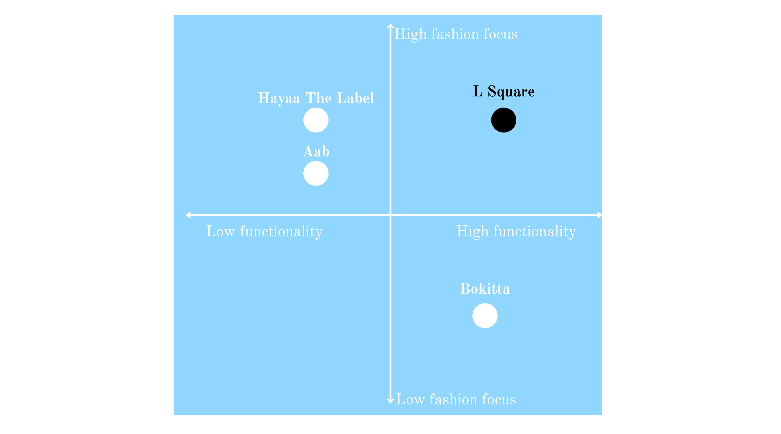
Visual 1
Figure 1: Competitor positioning map for L Square
Source: Author’s own creation based on competitor review of Aab, Bokitta and Hayaa The Label.
Strategy for Longevity
For a fashion brand to survive long term, it needs more than initial customer attention. It needs customer loyalty, repeat purchases and the ability to build a strong brand community. L Square aims to build this relationship through regular interaction on social media. Customers will be involved in the brand through styling content, polls and feedback on future collections. This approach will allow the business to adjust the offer to the changing customer needs and build stronger emotional connections with the brand. As younger customers value authenticity and presentation, social media branding may strengthen customer engagement and support customer loyalty (Ozuem et al., 2021). A stronger long-term approach would be to encourage repeat purchases through small loyalty rewards, early access to limited collections and personalised packaging. Customer polls could also be used before launching new designs, allowing the business to reduce the risk of producing styles that customers do not want. Reposting customer styling content may help customers feel more connected to the brand and provide a low-cost way to strengthen engagement and trust (Vazquez et al., 2020). The business also aims to maintain a clear position within the modest fashion market. This will be based on offering products that are stylish but also practical for daily use. This supports a differentiation strategy, as the brand focuses on value that separates it from competitors (Porter, 1985). Existing brands often focus on minimalist or traditional styles while L Square focuses mostly on current styling and creative expression. Our product design responds to practical customer problems. Non-slip undercaps can make daily wear more comfortable and help the hijab feel more secure. In addition, integrated hijab and undercap designs may reduce slipping and support hair protection. This supports the brand’s aim to respond to customer needs while addressing gaps identified in the current market (Solomon, 2020). Among younger consumers, fashion trends change quickly as they are shaped by fast fashion culture and social media engagement (Barnes and Lea-Greenwood, 2006). L Square will need to avoid building the brand around one fixed style. Instead, we will be using smaller trend-focused collections to respond to current customer interests, while keeping a core range of more timeless products. This gives the brand flexibility without losing long term appeal. Limited edition launches and seasonal collections may also help create interest in the brand. They may encourage customers to return and see what is new (Byun and Sternquist, 2011). However, the handmade model also creates a capacity risk. In the first year, custom manufacturing will help reduce stock waste and keep lower costs (Ferreira, Sousa and Gonçalves, 2018). During that stage, the focus should be on testing products, customer reviews, social media visibility and identifying the designs that are selling the most. This would allow us to understand which products have real demand before investing in a larger website or wider product range. Nevertheless, if demand develops faster than planned this technique could lead to longer waiting times and pressure on the founders. To avoid this, L Square can set up a clear quality policy to be followed for each order and can prepare cloths that have already been cut in advance. Another way to reduce the risk is setting up batch production for its most popular designs. By the end of that year, the business should review sales data, customer feedback, return issues and delivery times. If monthly demand becomes consistent in the second year, the business could also consider part-time sewing support for basic production tasks. During that time, the company could move from testing to controlled growth by improving supplier relationships and expanding seasonal collections. This flexibility is important because businesses are more likely to survive long term when they can adapt to market changes (Teece, 2018). This approach is safer as it allows the business to grow from evidence instead of assumptions. As the business grows, it intends to create a dedicated ecommerce website to reduce its reliance on social media sales. This would help with increasing brand credibility and give the business greater control over customer experience and product presentation (Chaffey and Ellis-Chadwick, 2022). Future growth could begin with modest fashion influencer collaborations. This may help increase trust and brand visibility among younger consumers (Lou and Yuan, 2019). Over time, the business could also introduce new accessories and limited-edition collections (Byun and Sternquist, 2012).

Business Model Canvas
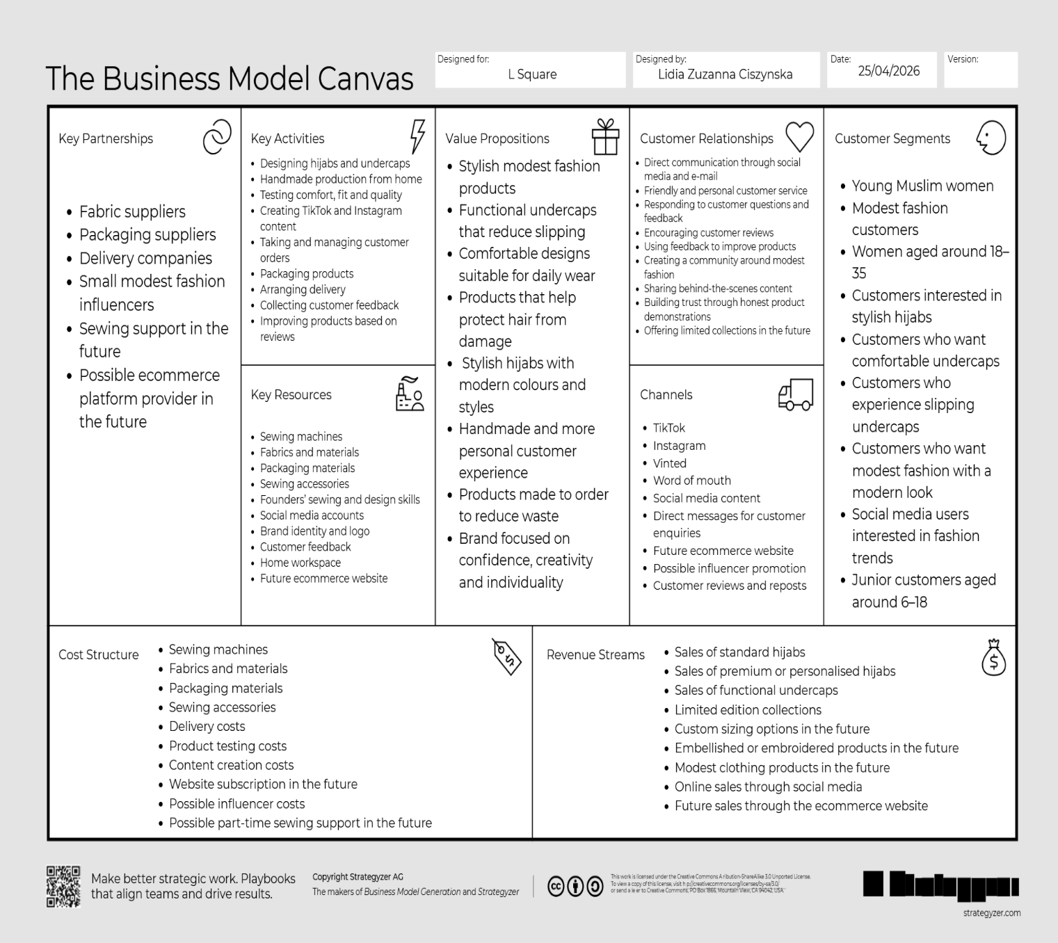
Figure 2 summarises L Square’s value creation, delivery and capture. It shows that the brand relies on mostly online channels, handmade production, customer feedback and customised order model to reduce early financial risk.

Figure 2: Business Model Canvas for L Square Source: Adapted from Osterwalder and Pigneur (2010).
Viability Finance and Resources
L Square will start as a small-scale handmade business run from home. This approach will help to reduce financial risk during the early stage, as financial pressure is a common issue for new companies (Barringer and Ireland, 2021). The business will mainly sell online through social media platforms such as TikTok, Instagram and Vinted. This will allow the business to test customer demand before investing in a separate ecommerce website (Molina-Prados, Muñoz-Leiva and Prados-Peña, 2021; Bocken and Snihur, 2020). Products will be made after customers place an order, which makes the model suitable for the testing stage. It also reduces the need to keep large amounts of stock. The initial startup costs are assumed to be around £1,400. The biggest investment will be two sewing machines which are expected to cost around £400 in total and £350 which will be required for basic fabrics and supplies. Around £150 will be needed for packaging materials and a further £100 will cover sewing accessories and minor equipment. The remaining £400 will be used for product testing and delivery. A standard adult hijab is expected to cost approximately £7 per unit to produce, including operating costs. The average selling price is expected to be £22, giving an estimated gross profit of £15 per unit. A premium personalised hijab is expected to cost around £12 per unit to produce and sell for approximately £38, giving an estimated gross profit of £26 per product. Based on an average sales of 35 mixed products per month at an average price of £26, L Square could generate around £910 in monthly revenue. This sales figure is based on around 20 production hours per week, with each product expected to take approximately 1.5 to 2 hours to be made and packed. This would equal around £10,920 annually during the testing phase. Break-even analysis can be used to estimate how many products a business needs to sell to cover its costs (Sintha, 2020). Based on an average gross profit of approximately £16.50 per product, the company would need to sell around 88 products to cover the estimated start-up costs of £1,450. The break-even point could be reached after approximately three months if the business sells around 35 products per month. There is a chance that the process will take longer if monthly sales are lower than expected. Nevertheless, the risk remains manageable, as operating from home helps the business avoid large, fixed costs. In conclusion, the projections suggest that L Square could be financially realistic on a small scale. The main risks are material price changes, inconsistent sales and the time needed for handmade production.
Visual 2
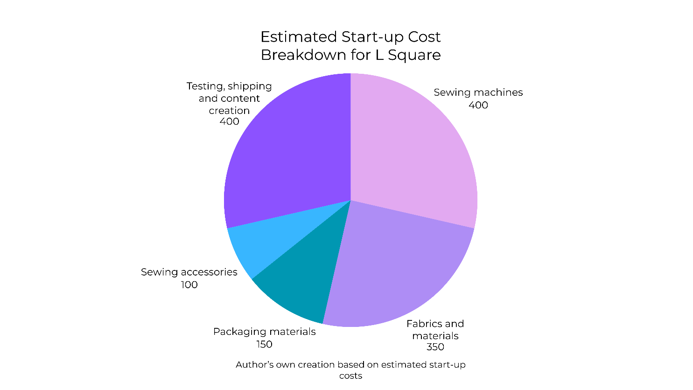
The biggest start-up costs shown in Figure 3 are sewing machines, product testing, shipping and content creation. This means the business can start with relatively low fixed costs, as most spending is related to equipment, materials and early product development.

Figure 3: Estimated start-up cost breakdown for L Square Source: Author’s own creation based on estimated start-up costs.
Implementation and Learning Loop
In the beginning, L Square will introduce a small collection of approximately three to four hijab designs. A limited selection will allow the business to test customer interest and minimise financial risk in the early stages. Products will be particularly promoted on TikTok and Instagram to reach younger audiences interested in modest fashion trends (Godey et al., 2016; Ortiz and Santos Corrada, 2023). To avoid large amounts of stock, products will be created to order based on consumer demand. This is reflective of a lean startup approach, in which organisations will evaluate ideas on a smaller scale before expanding (Ries, 2011). Customer feedback will play an important role in the development of the business. Feedback may be collected through comments, direct messages, customer reviews and email communication, allowing the founders to identify customer preferences and areas for improvement. Polls and social media engagement can also enable customers to influence future collections and product development, consequently building a more collaborative relationship between brand and buyers (Hoyer et al., 2010). Social media engagement will help the business identify which products and styles generate the strongest interest (Kim, Leung and McKneely, 2023; Bonilla-Quijada et al., 2023). After the testing period, L Square plans to expand with seasonal collections and a wider range of products based on desires of buyers and trend analysis. This flexibility is important because fashion trends and customer preferences change regularly. It is happening particularly in social media driven markets, making adaptability important for sustainability for longer time (Teece, 2018). However, the lean startup approach also creates limitations for handmade fashion businesses. If products are only manufactured after ordering, it may increase waiting times for customers and put pressure on manufacturing capacity during times of strong demand. In addition, handmade production limits scalability compared to mass production fashion retailers. Despite these limitations, the testing phase allows the business to reduce inventory waste, improve product quality and avoid financial risks. This organised strategy supports stronger market understanding before larger expansion.
Conclusion and Recommendations
L Square might compete in the UK modest fashion industry with its handmade products, practical design and direct consumer engagement. The business will grow its foundation progressively through social media presence, client feedback and tailored product development. Such an approach could help the brand build better customer loyalty and create more sustainable growth opportunities over time.

Reference list
Aab (no date) Modest Fashion Online, Aab. Available at: https://aabcollection.com/ (Accessed: 30 April 2026).
Alhanshali, L. et al. (2023) ‘Understanding perceptions of hair loss in hijab-wearing women: a pilot survey study’, International Journal of Women’s Dermatology, 9(4), pp. e115–e115. Available at: https://doi.org/10.1097/jw9.0000000000000115.
Ashraf, S., Williams, A.M. and Bray, J. (2022) ‘Female Muslim identity and modest clothing consumption in the UK’, Journal of Islamic Marketing, 14(9). Available at: https://doi.org/10.1108/jima-05-2021-0167.
Barnes, L. and Lea‐Greenwood, G. (2006) ‘Fast Fashioning the Supply chain: Shaping the Research Agenda’, Journal of Fashion Marketing and Management: an International Journal, 10(3), pp. 259–271. Available at: https://www.emerald.com/insight/content/doi/10.1108/13612020610679259/full/html.
Barringer, B.R. and Ireland, R.D. (2021) Entrepreneurship : Successfully Launching New Ventures. 6th edn. New York, NY: Pearson.
Bocken, N. and Snihur, Y. (2020) ‘Lean Startup and the Business Model: Experimenting for Novelty and Impact’, Long Range Planning, 53(4), p. 101953. Available at: https://doi.org/10.1016/j.lrp.2019.101953.
Bokitta (no date) Bokitta, Bokitta. Available at: https://bokitta.co.uk/ (Accessed: 30 April 2026).
Bonilla-Quijada, M. et al. (2023) ‘Customer engagement on Instagram for luxury fashion brands: An empirical comparative analysis’, Cogent Social Sciences, 9(1). Available at: https://doi.org/10.1080/23311886.2023.2235169.
Byun, S.-E. and Sternquist, B. (2011) ‘Fast Fashion and In-Store Hoarding’, Clothing and Textiles Research Journal, 29(3), pp. 187–201. Available at: https://doi.org/10.1177/0887302x11411709.
Byun, S.-E. and Sternquist, B. (2012) ‘Here Today, Gone Tomorrow: Consumer Reactions to Perceived Limited Availability’, Journal of Marketing Theory and Practice, 20(2), pp. 223–234. Available at: https://doi.org/10.2753/mtp1069-6679200207.
Chaffey, D. and Ellis-Chadwick, F. (2022) Digital Marketing: strategy, implementation and practice. 8th edn. Harlow: Pearson Education Limited.
Ferreira, J., Sousa, B.M. and Gonçalves, F. (2018) ‘Encouraging the subsistence artisan entrepreneurship in handicraft and creative contexts’, Journal of Enterprising Communities: People and Places in the Global Economy, 13(1-2). Available at: https://doi.org/10.1108/jec-09-2018-0068.
Godey, B. et al. (2016) ‘Social Media Marketing Efforts of Luxury brands: Influence on Brand Equity and Consumer Behavior’, Journal of Business Research, 69(12), pp. 5833–5841. Available at: https://doi.org/10.1016/j.jbusres.2016.04.181.
Hayaa The Label (no date) Noor AL-Layl, Hayaa The Label. Available at: https://hayaathelabel.co.uk/ (Accessed: 30 April 2026).
Hoyer, W.D. et al. (2010) ‘Consumer Cocreation in New Product Development’, Journal of Service Research, 13(3), pp. 283–296. Available at: https://doi.org/10.1177/1094670510375604.
Kalavila Pathirage Nilmini Bhagya et al. (2024) ‘Fashion niche market strategies: a systematic literature review’, Journal of Fashion Marketing and Management, 29(1). Available at: https://doi.org/10.1108/jfmm-06-2024-0228.
Karakavak, Z. and Özbölük, T. (2022) ‘When modesty meets fashion: how social media and influencers change the meaning of hijab’, Journal of Islamic Marketing, 14(11). Available at: https://doi.org/10.1108/jima-05-2021-0152.
Kim, J., Leung, X.Y. and McKneely, B. (2023) ‘The effects of Instagram social capital, brand identification and brand trust on purchase intention for small fashion brands: the generational differences’, Journal of Fashion Marketing and Management: An International Journal, 27(6). Available at: https://doi.org/10.1108/jfmm-05-2021-0126.
Lou, C. and Yuan, S. (2019) ‘Influencer Marketing: How Message Value and Credibility Affect Consumer Trust of Branded Content on Social Media’, Journal of Interactive Advertising, 19(1), pp. 58–73. Available at: https://doi.org/10.1080/15252019.2018.1533501.
Osterwalder, A. and Pigneur, Y. (2010) Business Model Generation: a Handbook for visionaries, Game changers, and Challengers. Hoboken, New Jersey: Wiley.
Ozuem, W. et al. (2021) ‘Effects of online brand communities on millennials’ brand loyalty in the fashion industry’, Psychology & Marketing, 38(5), pp. 774–793. Available at: https://doi.org/10.1002/mar.21466.
Porter, M.E. (1985) Competitive Advantage: Creating and Sustaining Superior Performance. New York: Free Press.
Poulis, A. et al. (2024) ‘Branding Muslim hijabi fashion: exploring influencer trends and impact’, Corporate Communications: An International Journal, 30(5), pp. 867–887. Available at: https://doi.org/10.1108/ccij-02-2024-0024.
Prados, A.M., Leiva, F.M. and Peña, M.B.P. (2021) ‘The role of customer brand engagement in the use of instagram as a “shop window” for fashion-industry social commerce’, Journal of Fashion Marketing and Management: An International Journal, 26(3), pp. 495–515. Available at: https://doi.org/10.1108/jfmm-12-2020-0275.
Randeree, K. (2019) ‘Demography, demand and devotion: driving the Islamic economy’, Journal of Islamic Marketing, 11(2). Available at: https://doi.org/10.1108/jima-06-2018-0102.
Ries, E. (2011) The Lean Startup: How Constant Innovation to Creates Radically Successful Businesses. London: Portfolio Penguin.
Sintha, L. (2020) ‘IMPORTANCE OF BREAK-EVEN ANALYSIS FOR THE MICRO, SMALL AND MEDIUM ENTERPRISES’, International Journal of Research -GRANTHAALAYAH, 8(6), pp. 212–218. Available at: https://doi.org/10.29121/granthaalayah.v8.i6.2020.502.
Solomon, M.R. (2020) Consumer behavior : buying, having, and being. 13th edn. Harlow, Essex: Pearson.
Tarlo, E. and Moors, A. (2013) Islamic Fashion and Anti-Fashion. A&C Black.
Teece, D.J. (2018) ‘Business models and dynamic capabilities’, Long Range Planning, 51(1), pp. 40–49. Available at: https://doi.org/10.1016/j.lrp.2017.06.007.
Vazquez, D. et al. (2020) ‘Examining the influence of user-generated content on the fashion consumer online experience’, Journal of Fashion Marketing and Management: An International Journal, 25(3), pp. 528–547. Available at: https://doi.org/10.1108/jfmm-02-2020-0018.
Wilson, J.A.J. and Liu, J. (2010) ‘Shaping the Halal into a brand?’, Journal of Islamic Marketing, 1(2), pp. 107–123. Available at: https://doi.org/10.1108/17590831011055851.

