

Assessment 1 – Reading Task Template
PART 1: Upload your photo of your A3 in-class notes here:
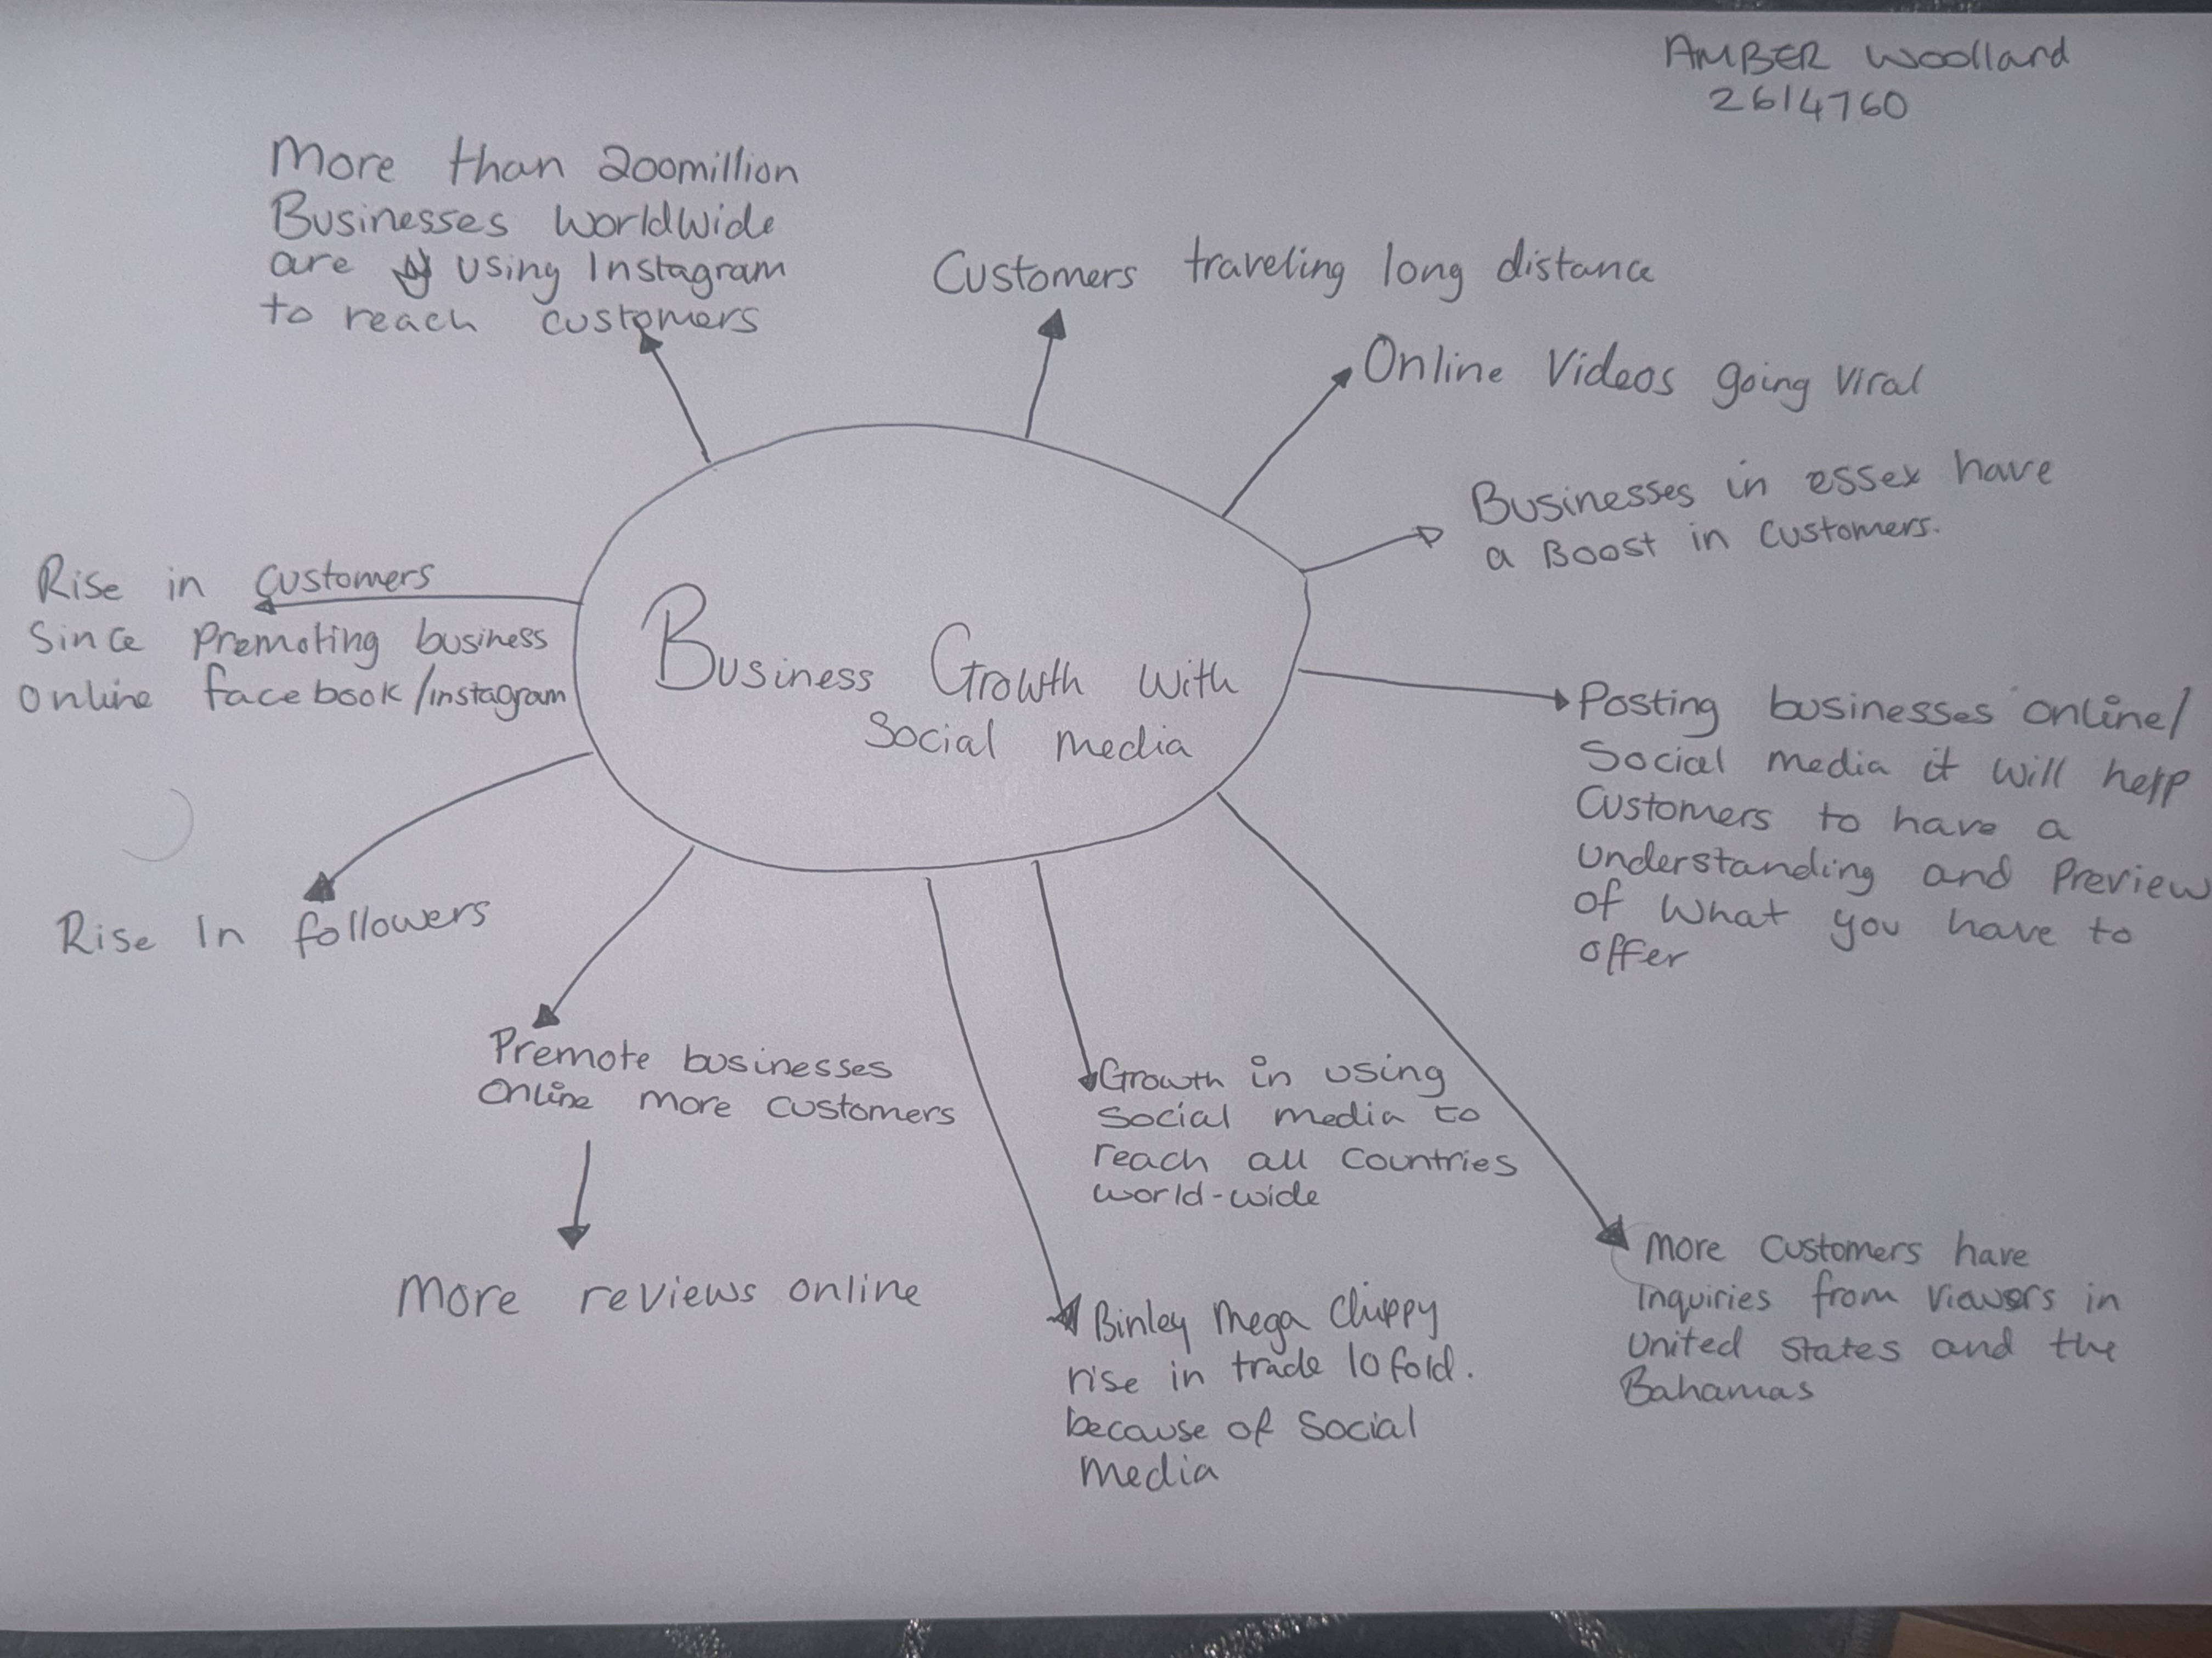

- The main idea of the text is to show people how much social media and promoting their businesses online will help their business grow and improve

- The key point of the text is how social media has a great impact helping grow and make a business more popular it shows in the BBC text when they haven increases in smaller businesses having more customers.

- The key points of the text are
-using social media
-helping business grow
-worldwide customers making enquiries

- The Most important part of the text is where social media platforms like tick Tok and Instagram get businesses noticed more, like the Binley mega chippy saw an increase up to ten folds because of social media

5.what helped me was going over the BBC text and all my notes it helped me to understand the module more and how social media plays a big role in all kinds of businesses.

