Abstract

2219350@student.uwtsd.ac.uk
Daniel Garton (2219350)

Safety and hazard assessment – AK47 practice firing

Contents
1. Task/System Description 2
2. Hazard identification 2
3. Risk assessment 5
4. Conclusion 6
Part 2 - ALARP Justification 7
1. Introduction 7
2. Hazard Description 7
3. Suitable Controls 7
4. Discounted Controls 8
5. Maintenance of ALARP Status 9
Conclusion 9
Bibliography 10

1. Task/System Description
This risk assessment covers the controlled shooting at targets using a AK47 weapons system. The objective is to ensure the safety and minimise the risk associated with operation the AK47 weapons system including the preparations, operation, post operation and phases of firing the weapon.
The weapon systems are used on a shooting range. In the shooting range there are shooting bays to provide physical separation of the operators. There is a backstop across the back of the range to collect discharge rounds and has distance markers for where the targets placed.
For safety the range contains barriers to prevent operators getting access to the range and any debris exiting the range. There is emergency equipment in the case of an accident and signage of protocols and safety rules.

2. Hazard identification

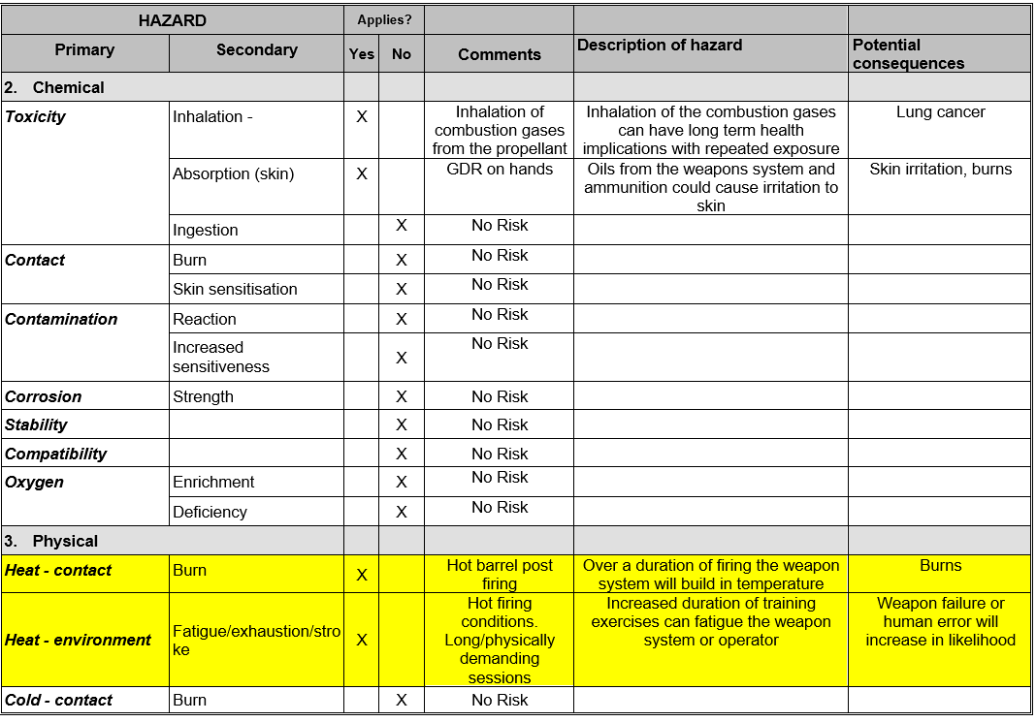
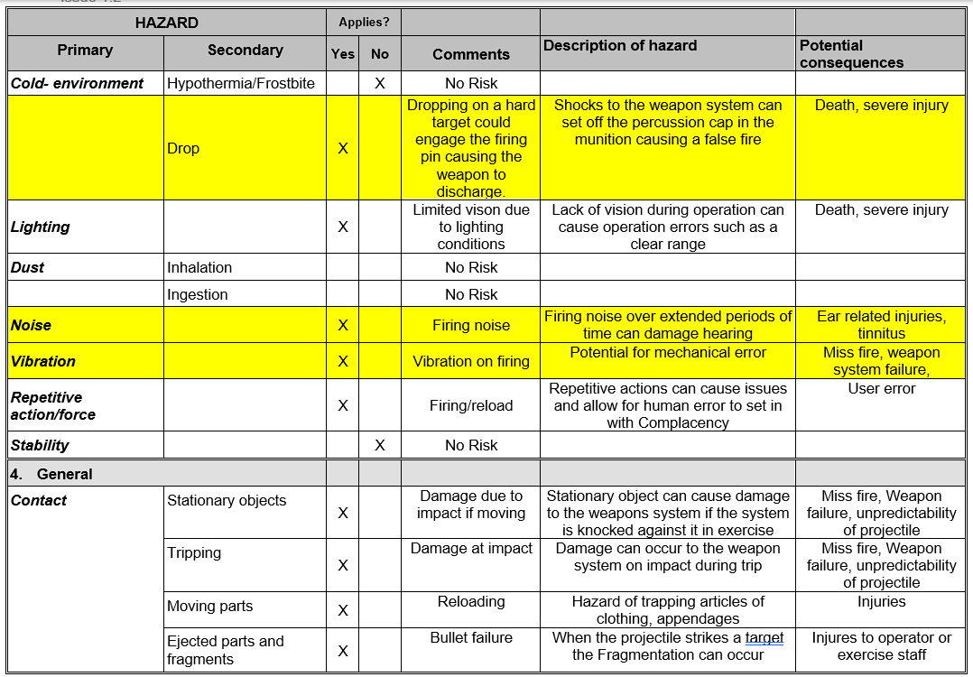
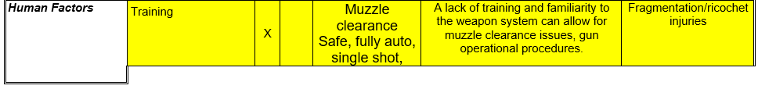
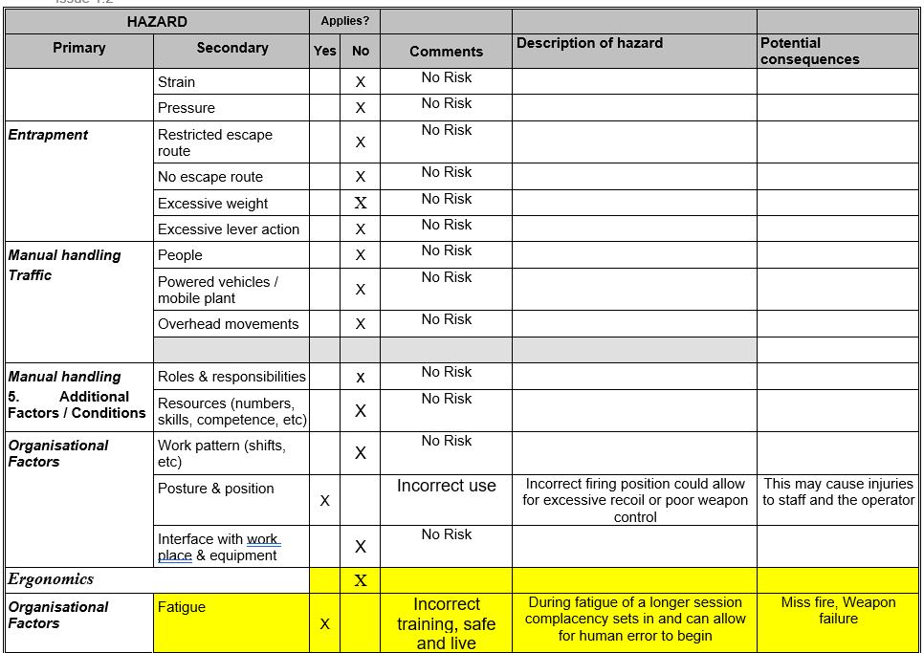
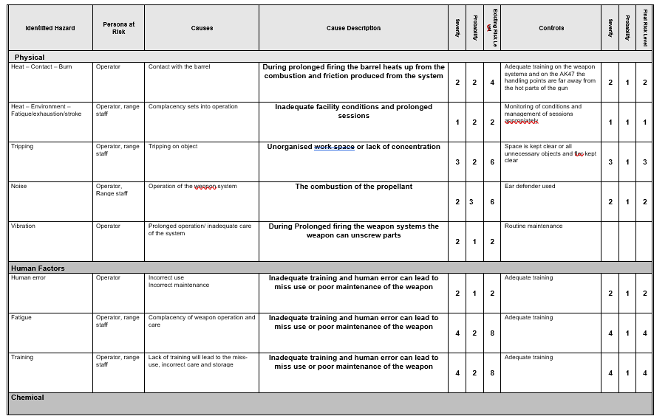

3. Risk assessment
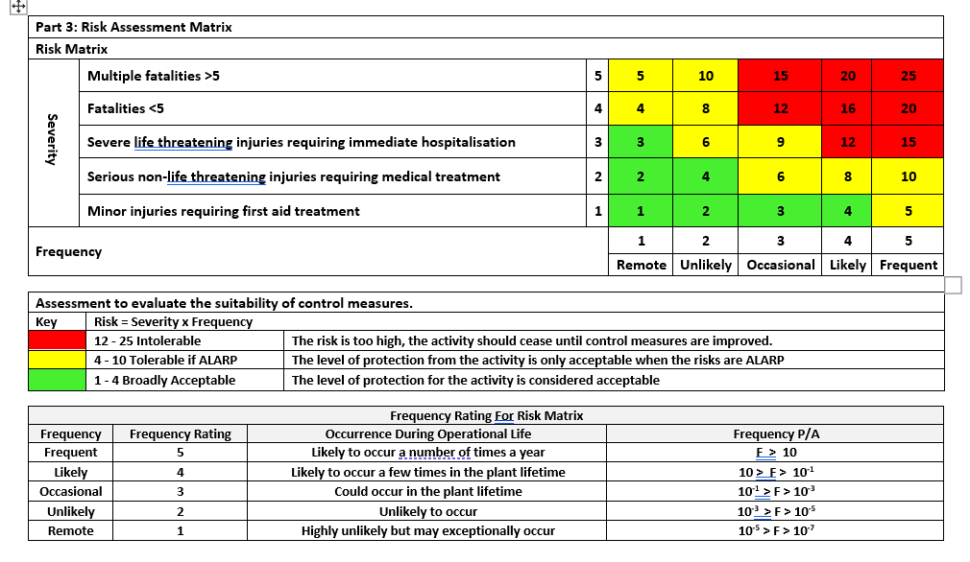
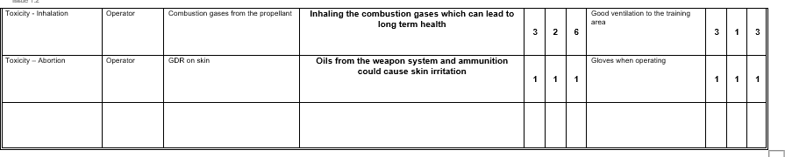

4. Conclusion
The risk matrix is created to easily identify risk that are too severe which need a risk management plan and which hazards are safe. This allows for businesses to make informed decisions about risk and management the risk in the best way possible.
It is also important to see how the controls can effect the specific risk to ensure they are contributing to reducing the risk.

Part 2 - ALARP Justification

1. Introduction
ALARP stand for as low as reasonably practicable [1] is key principle in risk management, it ensures risks are kept to the lowest level possible, considering cost, time, and efficiency of implementation of risk reduction measures. This focuses on the [2]ALARP justification for mitigating the effects of accidental fire under controlled conditions identified in part 1.
In this report, we will discuss:
- Detail the controls applied to mitigate the risk of accidental discharge.
- Assess the controls for their ability to reduce risk relative to their implementation costs and efforts.
- Identify any controls considered but not implemented, along with the reasoning for their exclusion.
- Outline a plan for maintaining the ALARP [2] status over time, considering potential technological advancements and changing conditions.
By systematically addressing these elements, we aim to provide a comprehensive justification for the measures taken to ensure the safety of individuals during AK47 target shooting exercises.

2. Hazard Description
Accidental fire refers to the unintentional firing of the weapon system [3], this can potentially cause severe injury or death. In a controlled target environment this creates a hazard to firing ranger staff.

3. Suitable Controls
There are multiple ways of mitigating the effects of an accidental fire [4].
- Comprehensive training
  - Comprehensive training ensures the operators have knowledge of firearm operation, etiquette, and care. This will reduce the likelihood of an accidental fire dramatically due to increase competency and accountability.
  - This can easily be implemented in a standardised system and repeated for multiple cohorts of operators. It has relatively low cost and can easily be retrofitted to any range.
  - An industry standard is NRA (National rifle association) [5]they offer standardised training for a variety of weapons systems that are considered to be industry standard for safety and responsible firearm handling.
- Mechanical safety devices
  - This is mechanical system which physically prevents the explosive train from initiating. Proper use of this system can eliminate the chance of an accidental fire in all situations when engaged.
  - The AK47 has a safety, full auto, and single shot, being able to utilize these functions correctly is crucial to the operation of the weapon and will prevent accidental fire when in safety mode. All modern guns have a safety and live function factory fitted.
  - SAAMI (Sporting Arms and Ammunition Manufacturing Institute) sets standards [6] for safety and performance of firearms and ammunition including safety devices.
- Procedural protocols
  - Having a set of established protocols for handling, operation and maintenance ensure all the safe practices are followed and allows for fellow operators to peer check each other from the same protocols.
  - Procedural protocols are easily implemented on any range through correct and up to date training. This will improve safety and operation of the range ensuring the weapons are used appropriately and maintained correctly.
  - NRA Range safety Rules [7]have established comprehensive set of rules including protocols for handling and operation.
- Supervision
  - Having a qualified safety officer the range monitoring all operators follow the protocols can easily rectify any deviations.
  - Having a qualified supervisor ensures all operators are checked to be following the protocols, a supervisor can be implemented into a range easily and will have a recuring staff charge.
  - NRA range safety officer offer [7]certifications for ranger supervisors which comprehensively train personnel to oversee and ensure compliance in shooting environment.
- Only have the number of bullets required in the operation in the magazine.
  - Having the number bullets in the magazine planned to be shot means once operation has completed this is no risk of misfire no matter the operation of the weapon system.
  - Ensure at the end of a session where complacency might creep in the munition cannot be fired. It can easily be implemented at any range.

4. Discounted Controls
- Electronic safety catches system
  - An electronic safety system would allow for a range wide system to engage the safety on all weapons active on the range. This would mean if there were any concerns of an operator a supervisor could disarm all active weapons, minimising the risk for all staff.
  - This would have a large cost to retro fit the weapon systems and the range with the system and make new weapon systems difficult to implement into the range. The system could also potentially be susceptible to hacking.
  - SAAMI (Sporting Arms and Ammunition Manufacturing Institute) [6] sets standards for safety and performance of firearms and ammunition including safety devices so could theoretically be responsible for a system like this in the future.
  - However, it has a large cost implication for the range and retro fitting weapons systems with this functionality would be time consuming. It also limits the weapons systems that can be used on the range as they would all need to be on this system. The system is unrealistic to a real-world situation where systems like this do not occur.
- Automated firing system
  - A system that can automatically assess the situation [8]in real time to assess whether the situation is safe to discharge the weapon systems and automatically apply the safety as required.
  - A system like this would have high implementation costs and have a high complexity. A viable system does not exist yet.

5. Maintenance of ALARP Status
To keep an ALARP status it requires continuous review to [9] assess the effectiveness of the control and any new hazards that may have raised. The systems in place and the systems that are not in place such as electronic safety catch systems or automated firing system as in the future these may become viable and become the ALARP [2] control for the range.
The control should be monitored throughput its active time to ensure it is affecting the range in the correct manner [10], these can then be amended if required to fit the range situation better.
Emerging technologies may create new controls and or may existing controls more viable than before. As these technologies emerge the ALARP status of existing controls may change as the emerging technology may become the ALARP option.
Regulatory changes may affect the ALARP status of existing. Regulatory boards such as OSHA, NRA and SAAMI can change regulations and it is vital that controls are compliant with these regulations.

Conclusion
The Range has risk of accidental firing has been mitigated to an ALARP position. The selection of the controls detailed above significantly reduce the risk and account for cost, infrastructure needs. On going ALARP assessment is crucial to remain at an ALARP status and should be reassessed.

Bibliography

[1] | HSE, “Health and safety excutive,” Health and safety excutive, [Online]. Available: https://www.hse.gov.uk/comah/alarp.htm. [Accessed 05 07 2024].
[2] | HASpod, “HASpod,” HASpod - The ALARP Principle With 5 Real World Examples, 3 October 2023. [Online]. Available: https://www.haspod.com/blog/management/alarp-principle-and-examples. [Accessed 08 07 2024].
[3] | “Wikipeida - Unintentional discharge,” Wikipeida, [Online]. Available: https://en.wikipedia.org/wiki/Unintentional_discharge. [Accessed 03 07 2024].
[4] | “Wikipedia - Gun control,” Wikipedia, [Online]. Available: https://en.wikipedia.org/wiki/Gun_control. [Accessed 05 07 2024].
[5] | “NRA - policy,” NRA, [Online]. Available: https://nra.org.uk/nra-policy/. [Accessed 09 07 2024].
[6] | “SAAMI - Standards,” SAAMI, [Online]. Available: https://saami.org/technical-information/ansi-saami-standards/. [Accessed 09 07 2024].
[7] | National Rilfe assoiciation, “Range safety officer handbook,” National Rilfe assoiciation, 2024.
[8] | Shooting times, “Shooting UK,” 19 October 2021. [Online]. Available: https://www.shootinguk.co.uk/answers/gun-safety-catch-19332/. [Accessed 08 07 2024].
[9] | H. H. R. Management, “ALARP Guidance,” HHRM, 2016.
[10] | Susan Dearden, “Finch Consulting - ALARP – What does it mean and how is it applied in practice?,” Finch Consulting, [Online]. Available: https://www.finch-consulting.com/alarp-what-does-it-mean-and-how-is-it-applied-in-practice/. [Accessed 10 07 2024].
[11] | The editors of Enclopaedia, Briannica, “Britannica,” Birtannica - AK47, 27 May 2024. [Online]. Available: https://www.britannica.com/technology/AK-47. [Accessed 28 06 2024].

