Models of Communication
&
Communication Skills

Module Code: BMSW4002
Student’s name: Otilia Ghinet
Student’s ID: 1922158
Lecturer’s Name: Saqib Shamim

Table of Content

Introduction………………………………………………………………………3
Models of Communication………………………………………………………5
Shannon and Weaver (1948)……………………………………………….5
Schramm (1954)……………………………………………………………..6
Berlo (1960)………………………………………………………………….7
Communication Skills…………………………………………………………..10
Verbal Communication…………………………………………………….10
Non-verbal Communication……………………………………………….11
Listening……………………………………………………………………..12
Conclusion……………………………………………………………………….12

Models of Communication
&
Communication Skills

Introduction

Communication can be defined as participants who involve in interaction. This definition helps us to have a better understanding of the process of communication and it’s models. In order to have an effective communication, there are some things that need to be accomplished because the communication is not just a transmission of data and information, but it is a complex process. There are three parts f the communication process: the message that will be send, the sender, who is sending the message and the recipient, who is receiving the message. The encoding of a letter means the use of non-verbal communication and the receiver needs to decode it in order to understand the message. In this situation, when it comes to numerous receivers, the message can be understood in different ways. There is another aspect in non-verbal communication, the body language which also can be read in many different ways so the perception upon the message may be different than what the sender wants to express. The situation between a sender and numerous receivers may be difficult even if there is a clear message as verbal communication and the non-verbal communication which comes naturally from gestures or eye contact. The hardest to understand, is the written language which has lack of gestures, eye contact or intonation, so the receiver can guide only by punctuation and grammar.

Models of Communication

- Shannon and Weaver (1948)

Shannon was a mathematician and an electronic engineer and Weaver was a scientist from America. They wrote an article in “Bell System Technical Journal” named as “A Mathematical Communication Theory” in 1948. This theory explained they communication model named “Shannon and Weaver communication model”, describing the efficient communication between the sender and receiver. The noise is the principal factor of disturbance so from here we have the components of their communication model: information, sender, noise, channel, message, receiver, destination, encoding and decoding.

Source: https://www.communicationtheory.org/shannon-and-weaver-model-of-communication/ - Accessed on 24th of August at 01:28

Example of Shannon and Weaver model of communication:
I was calling my assistant to come to me because I need to see her but because of the lack of transmission she received the message “I want” so she asked me what I want. This is how some factors can affect the received message and people use not to understand each other. This is why the noise and the error affected the sender’s message, so the receiver understood something else and the response was different from what I expected to hear from the assistant.
- Schramm (1954)
This model is developed by Schramm in 1954 and it is a cyclical model of communication containing all the principles and components of the previous one. This model of communication is designed to find out if the communication process between two people works when sharing ideas or knowledge. This may be called a traditional communication model.

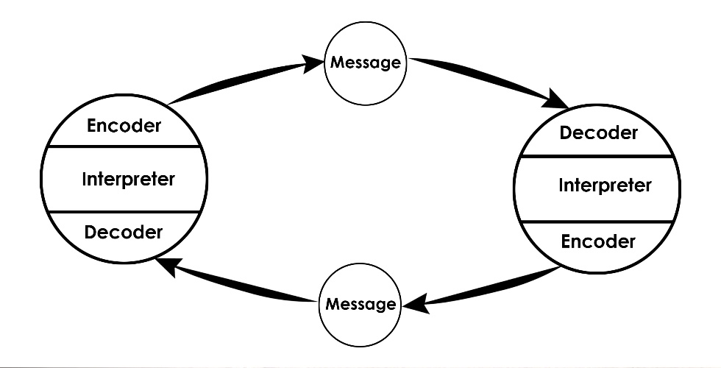
Source: https://www.communicationtheory.org/osgood-schramm-model-of-communication/ (Accessed on 24th of August at 02:55)
The Encoder: Is the person who is sending the message
Decoder: Is the person who receives the message. The encoder sends the message to the decoder.
Interpreter: Is the person who is decoding the message figuring out what it means

Example:
At the University, our professor claims up a problem about the group assessments. In order to solve this issue, we need to listen him about the mistakes, then ask questions. After that, we need to meet and every group member should say it’s opinion and the other should listen him in order to give a feedback and then to have a group conversation in order to improve the project and solve the issues.

- Berlo (1960)
This model focuses on encoding and decoding before the message is sent and received by the Receiver. When the model was created by Berlo, there were only four elements explaining the communication model: Source, Message, Channel, Receiver.

Source: https://www.communicationtheory.org/berlos-smcr-model-of-communication/ (Accessed on 24th of August at 01:51)

Berlo's model contains multiple factors:
Origin: is the place the message comes from
Communication skills: are the capacity of the people involved in the conversation to communicate. For example, listening, writing, speaking.
Attitudes – are the way the sender and receiver see the conversation.
Knowledge – is the percentage of knowing what the conversation is about
Note: is the familiarity the sender and receiver have with the spoken subject
Social structure – The social structure covers the different facets of society such as ideals, interests, history, faith and a general view of society.

For example, there are situations when people act different, they are learning in different ways that’s because the different cultures around the world.
Note: The students can interact on their own knowledge and at their level according to the culture they are part of.

Culture: It means the beliefs and traits people are used to and the place they come from.
Encoder: Is the origin of the message

Bookmark
Content – The body of a message contains the content from the beginning to the end. For starters, whatever the class teacher teaches in the class, the content of the message is from beginning to end.
Elements – Involves various items such as words, movements, body language, etc. They all constitute the elements of a particular document. A few elements accompany any material.
Treatment – It refers to how the message is seen by others or how the situation is seen by the receiver
Structure – It refers to how the message is arranged
Code – The message code refers to the means it is sent by, and in what form such as body language or gestures.
Channel– It refers the senses through which the message is received such as hearing, touching, seeing, tasting or smelling.
For a successful communication, Berlo thinks that the Sender and the Receiver need to be on the same level so they can understand each other better so the contact can occur properly but also that the source and the sender must be the same. If the sender have good communication skills and the receiver have good listening skills, then the conversation can flow smoothly and the most important thing, the receiver will get exact the correct meaning of the message.

Communication Skills

Verbal communication
The verbal communication is the most popular form of communication that is used and it is a very strong skill for anyone. This communication skill is exchanging information between two or more people verbally.
Speech vs Written Message
Even if the most common communication for is the verbal one which means the exchange of words or sentences between two people or a group of people, the written communication is also a very important and used model of communication. There are 3 types of written communication and the first one discussed it is the formal and informal written communication. The formal communication is when you send a message to a superior, to a professor or to an institution, where you do not use the abreviation’s of the language, while the informal method of writing is about writing to a friend or a family member when abreviations are totally allowed. Synchronous and Asynchronous communication refers to the communication which happens right now or immediately and the asynchronous is about e-mails or letters, when you need to wait a while in order to get an answer for your message. Recorded or unrecorded messages are about the messages that are in evidence or not.

Example:
The best example is about the verbal communication with the customers in the workplace. There are many jobs that requires direct communication with the customer’s so verbal communication is a vital skill that you need to have in order to do your job properly and have good results. The main idea in the verbal communication with the customer is to understand very well what this wants to be able to provide the product or service he or she needs and also by using these skills you can figure out many requests or even thoughts of the customer such as predicting future issues, asking the customer to explain their needs, ask questions to raise the level of the conversation, to relax the stressed customer, to emphasize and also to note non-verbal gestures.

Nonverbal Communication
The non-verbal communication is all about gestures such as facial expressions, smiling, turning towards the speaker to show interest for the conversation, hand gestures, sad face and so on. The body language is often enhance the verbal communication but also it can contradict it and change the whole conversation direction. The facial expressions are happy, sad, angry and help you to see clearly what attitude is involved in the communication. For example, your sister comes to you and she says she is very happy for you because you get a new iPhone but her facial expression does not show happiness, so you can clearly get that her verbal communications does not show you the real feelings she has for your achievement. So from this example is important to understand that the message can be clearly understood by the receiver when he or she is paying attention to the body language or facial expressions. Gestures are another types of how to understand the proper meaning of a message. For example, in the workplace you can be asked by your coworker to do a certain task but you can observe the indignation on his face so you should understand that this task must be finished in a short time and it have to be perfect. Proximity is about the distance between the sender and the receiver in order to understand it’s gestures, facial expressions and get clear understanding about their attitude towards the conversation. When the distance between the people involved in the communication process is big, there will lack of understanding regarding the gestures used by the receiver or by the sender and there will be issues to understand the perception of the message or of the answer. Touching is another type of gesture which can be such as hand shaking and it gives you the needed source to see if the message was well understood and not but also it shows the other’s attitude. Eye contact is the sign that both you and the other participant are engaged in the conversation, for example if you tell a story to your friend and he is looking somewhere else, there is clear that he is not interested in the message you want to send him. The integrity is shown by the eye contact between the communication’s participants. Appearance is another aspect of the non-verbal communication because it can show the respect of the other participant towards you and the communication process. Likewise, your clothing's quality and condition, how it suits, if it's suitable for the season — all of these items speak nonverbally to you as a communicator.
The non-verbal communication shows what attitude and what feelings we have towards the communication process and it helps in understanding the exactly feelings involved in the conversation, this is why the non-verbal communication is one of the most important in the communication skill.
Example:
When you have an interview there will be taking into account all your gestures in order for the employer to figure out if the skills you mentioned in de resume are real or not, so they will pay attention in order to find out if you are shy, lazy or active.

Listening

The listening skills are also very important in the communication process because it can lead to a good understanding of the message or not understand the message at all. This is the case of active listening, while the passive listening is the process of just listening the message but not remember what was this about. If you are a good listener, then you should be actively listening the message in order remember the details and the circumstances and to give the proper answer or feedback about the message sent towards you. The effective listeners are using both verbal and non-verbal and non-verbal communication in order to have a better understanding of the message towards them.

Examples:
You are working for an interior design and a client calls you. If you are not a good listener you will lack of information and your final project may not fulfill the customer’s requirement, but if you listen carefully the result will make the customer happy.

Conclusion

Communication skills are crucial in any field or any situation we are facing of. There are any types of models of communication which helps us to have a better understand toward the communication process and also, they give us a direction in how a communication process can be affected about different factors. The three mentioned models of communication are different in order to have a better understand of how a communication process can be evaluated and how it can be understood effectively or not. Every employer requests good communication skills from it’s employees because there are everyday situations when they are needed. Not just the verbal communication but also the listening skills and the non-verbal gestures help to have a better understanding of the message sent or received. This is particularly true in circumstances where managerial goals centered on the 'three E's, efficacy, economy, and productivity, (Stepney, 2000). All the communication theories have both positive and negative aspects such as, the Shannon and Weaver model for communication is allowing us to see how noise can occur in the conversation and how it can affect the conversation so there will be lack of understanding. The Schramm’s model of communication speaks about the traditional communication in a cyclic way by putting accent on the listening skill in order to receive the complete meaning of the message. The Berlo’s model is about many factors that can involve in the communication process and how they can affect or help us understand the message. The communication process is based on receiving the proper feedback when a message is sent and we can assume that many factors are involved, not just words or gestures.

References

(Shannon, Weaver, 2013) from http://communicationtheory.org/shannon-and-weaver-model-of-communication/
(Miller, 2009)
(Reuben, Steward, 2006)
(Rothwell, 2004)
(Stepney, 2000).

