Student Name: Shahreen Akhtar

Student number: 2440149

Module code: LCHS4003

Module Name: Introduction to Health and Social Care

Lecturers Name: Mrs Azida Zainol

Assignment Title: Portfolio Task 1 Post and Task 2 Essay

Date : 16 October 2025

Contents
Task 1 ………………………………………………………………………. page 3
Task 2 ……………………………………………………...……………… page 4 & 5
References Task 1 …………………………………………………………page 6 & 7
References Task 2 …………………………………………………………page 8

Poster

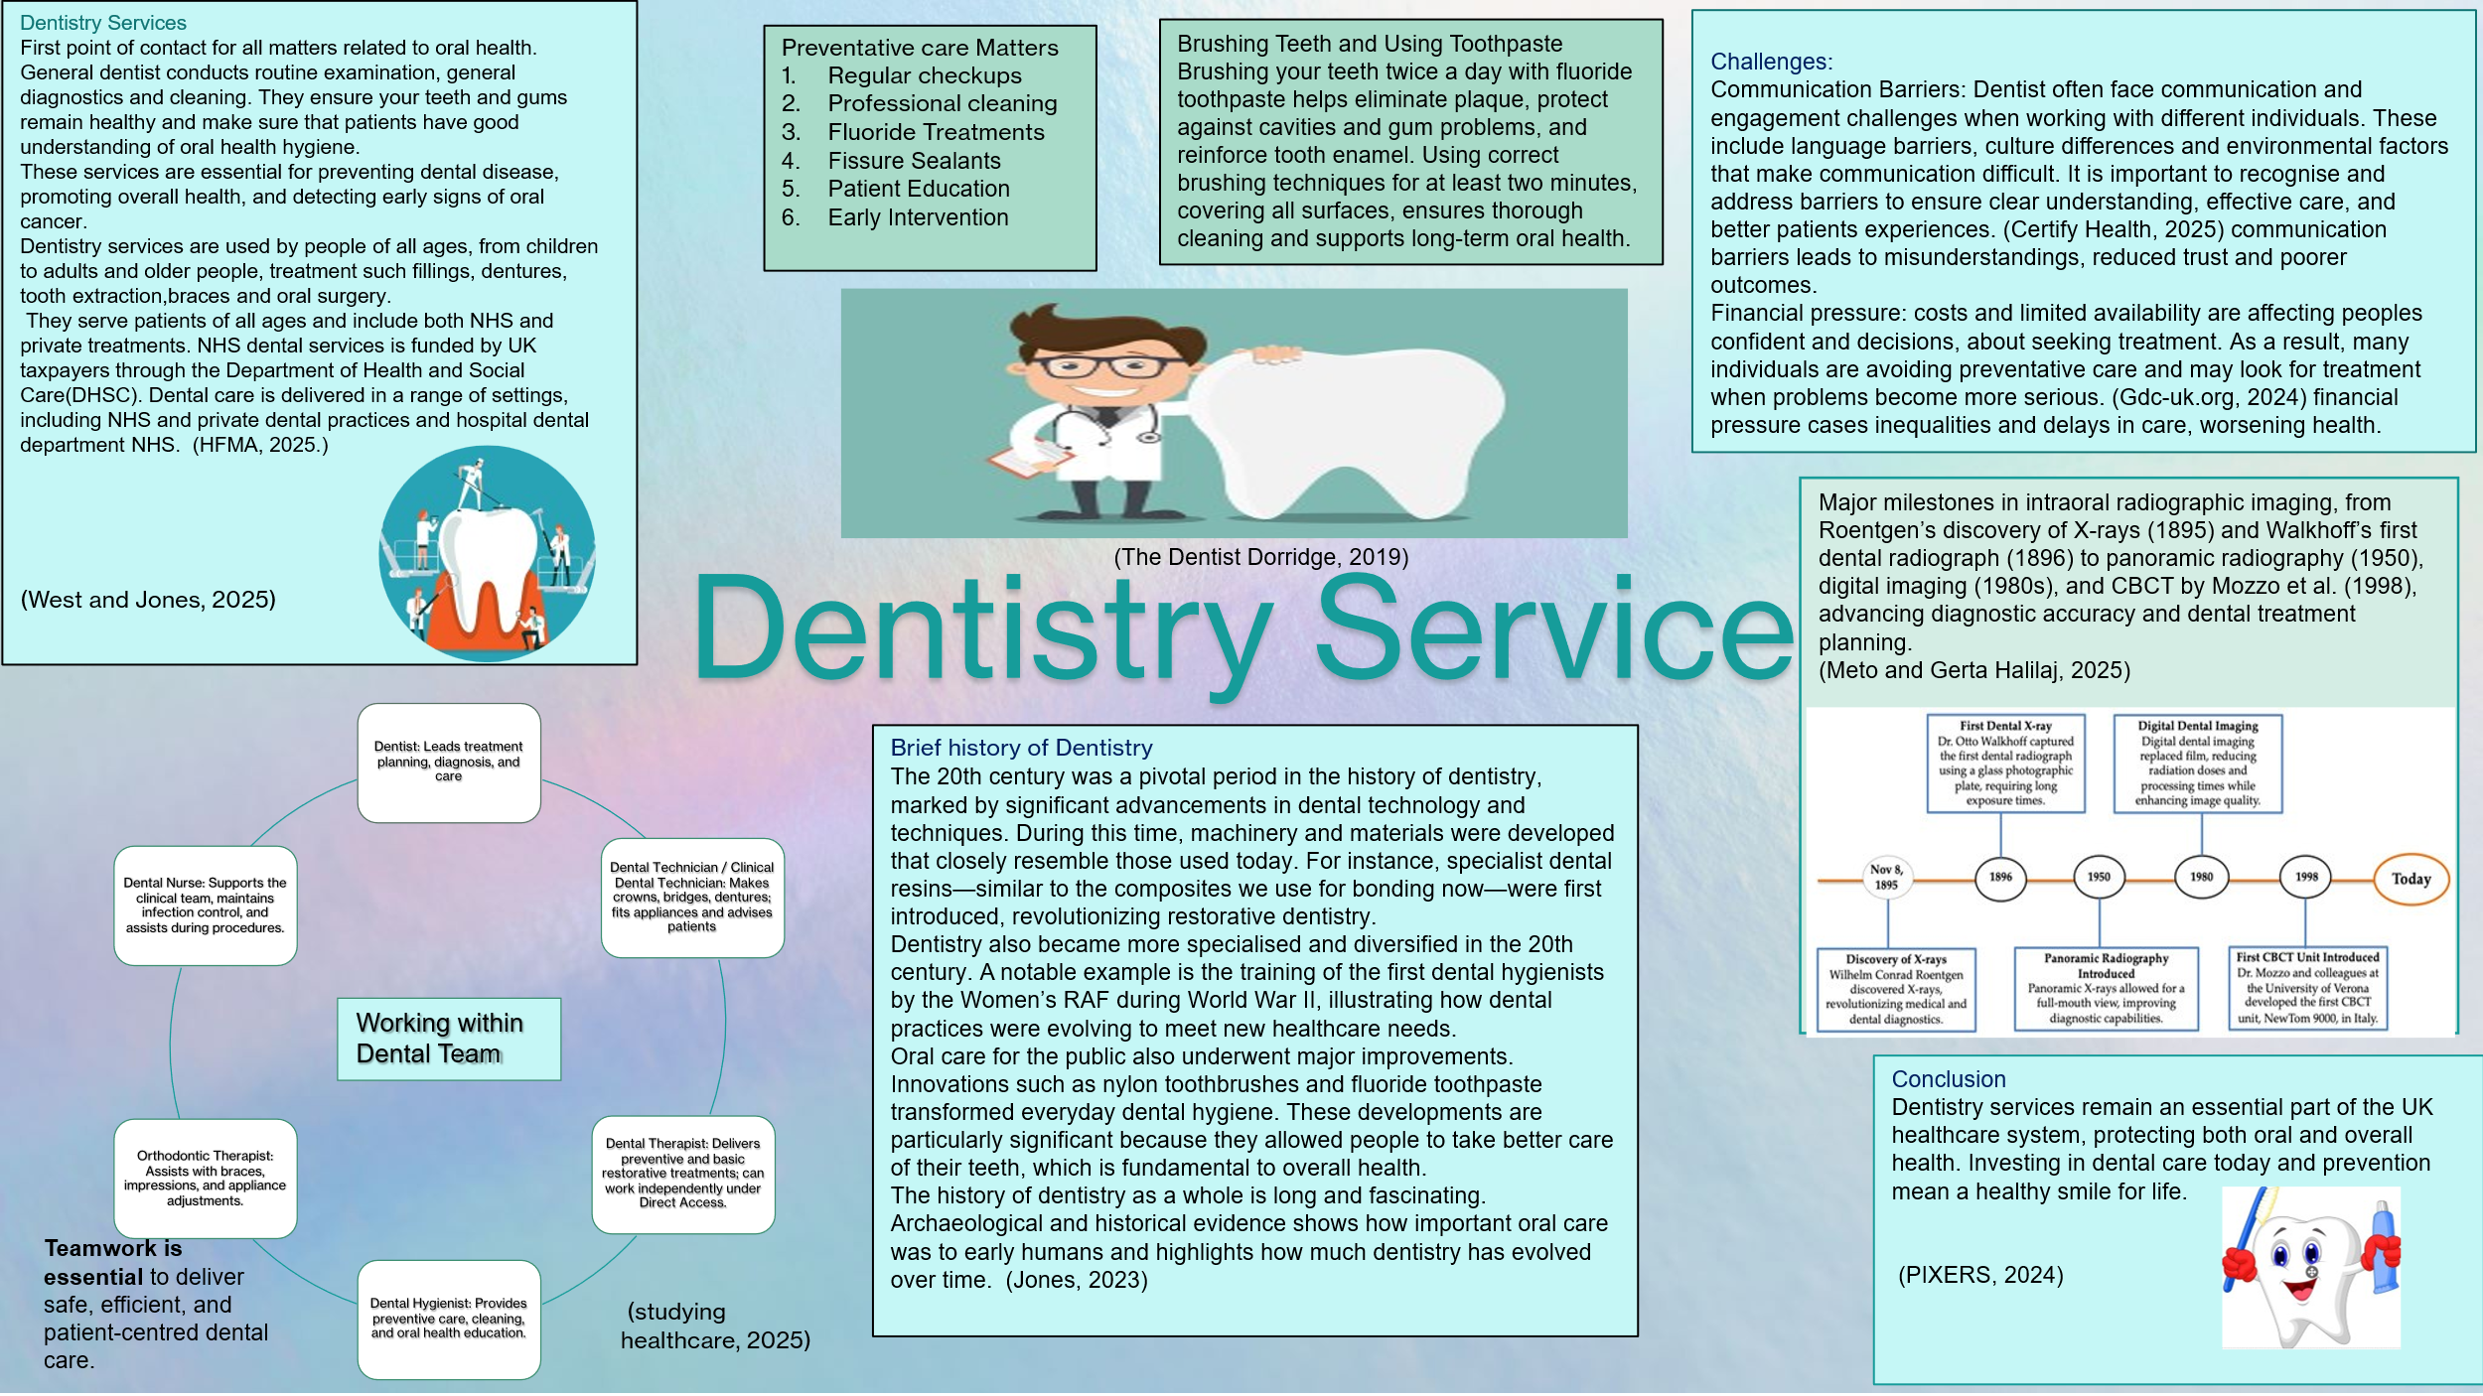

NHS Introduction
In England, social care involves personal care, social work and support services for individuals who need assistance due to illness, disability, old age or poverty. It aims to promote independence, protect individuals from abuse or neglect, and uphold their wellbeing and rights (Department of Health and Social Care, 2025). A turning point in UK health and social care came with the National Health Service and Community Care Act 1990, which required local authorities to assess people’s needs, arrange care, promote independence, and encourage cooperation between health services and social care providers (Legislation.gov.uk, 2020).

Established in 1948, the National Health Service (NHS) introduced a publicly funded system of healthcare, making Britain the first Western nation to provide universal and comprehensive health care. Its origins can be traced to the Beveridge Report of 1942, authored by William Beveridge, which identified five “giant evils” such as poverty, disease, ignorance, idleness, and poor living. Beveridge argued that tackling these issues required coordinated social welfare reforms, including universal healthcare provision (UK Parliament, 2025).

Before the establishment of the NHS, healthcare in Britain was a mixture of private practice, charity, and local government support. Poor individuals relied on charitable hospitals, while wealthier citizens paid for private doctors. The National Insurance Act 1911 improved access to general practitioners for lower paid workers but left many groups without coverage. This led to inequality and inconsistency in healthcare provision until the introduction of the NHS in 1984, which ensured that all citizens had access to free healthcare.

Today, the NHS continues to be funded through taxation and National Insurance contributions. Taxes collected by national and local governments help fund healthcare services, while National Insurance also contributes to pensions and NHS services. Funding flows from the Secretary of State for Health and Social Care to NHS providers, supporting the treatment and services delivered in hospitals and other care settings.
Wales, Scotland, and Northern Ireland each have their own NHS system, which operates differently from NHS England. NHS Wales is a publicly funded system providing healthcare to around three million people, following strategies set by the Welsh Government (NHS Wales, 2023). The UK Government Treasury allocates funding to Northern Ireland to support the Department of Health, Social Services, and Public Safety (DHSSPS) in the provision of essential health and social care services (Health Service Navigator, 2025). In Scotland, the UK Government grants funding to the Scottish Government, which allocates resources for health and care services across the country. In England, the NHS is organised through Integrated Care Systems (ICSs) to improve population health outcomes, reduce inequalities in access and patient care, make more efficient use of resources, and support broader social and economic benefits (NHS, n.d.).
Health Education England (HEE) is a vital part of the UK’s healthcare system. Its role is to train and educate future health care professionals ensuring they have the skills needed to provide safe and quality care. HEE collaborates with universities, social organisations and educational institutions to develop research programmes and learning opportunities. This helps healthcare workers to stay up to date with new developments and respond to the changing needs of patients and the wider healthcare system. (NHS, n.d.)

While ICSs aim to integrate health and social care more effectively, several challenges remain, including communication gaps, inconsistent programme performance, and regional differences. Workforce shortages, high turnover, and uneven distribution of healthcare workers continue to limit consistent service delivery. Financial pressure and budget constraints also restrict NHS effectiveness. Despite these challenges, training initiatives and workforce development programmes continue to improve care, although outcomes vary across regions.

The NHS faces significant challenges, including workforce shortages, rising demand, and financial integration with social care. Reforms like integrated Care Systems improve efficiency and patient’s outcomes. Since 1948, the NHS has transformed health care in the UK, ensuring equal access and improving population health. As a result, the NHS continues to be a fundamental institution in the UK, safeguarding health, equity, and public welfare for generations.

References (Poster)

The Dentist Dorridge. (2019). The Dentists Dorridge - So You Want To Be A Dentist. [online] Available at: https://thedentistsdorridge.co.uk/so-you-want-to-be-a-dentist/

Gdc-uk.org. (2024). Views and experiences of dentistry 2024. [online] Available at: https://www.gdc-uk.org/itineris/research/detail/report/views-and-experiences-of-dentistry-2024.

Patient Experience Solution - CERTIFY Health. (2025). 10 Proven Dental Patient Engagement Strategy. [online] Available at: https://www.certifyhealth.com/blog/10-proven-dental-patient-engagement-strategy/?utm_source.

Jones, O. (2023). The Fascinating History Of Dentistry. [online] Beyond Dental. Available at: https://beyond-dental.co.uk/the-fascinating-history-of-dentistry/

Studying Healthcare (2025) Working within the dental team - Studying Healthcare. [online] Available at: https://studyinghealthcare.ac.uk/why-dentistry/working-within-the-dental-team/ [Accessed 12 Oct. 2025].

Working within the dental team – Studying Healthcare. [online] Available at: https://studyinghealthcare.ac.uk/why-dentistry/working-within-the-dental-team/ [Accessed 12 Oct. 2025].

Meto, A. and Halilaj, G., 2025. The integration of cone beam computed tomography, artificial intelligence, augmented reality, and virtual reality in dental diagnostics, surgical planning, and education: A narrative review. Applied Sciences, 15(11), pp.6308. Available at: https://doi.org/10.3390/app15116308

West, N. and Jones, R. (2025) ‘Why the future of oral health depends on us all’, BDJ Team, 12(8), pp. 390–391. doi: https://doi.org/10.1038/s41407-025-3095-7

PIXERS (2024) Sticker Tooth cartoon holding toothbrush and toothpaste - PIXERS.UK. [online] Pixers. Available at: https://pixers.uk/stickers/tooth-cartoon-holding-toothbrush-and-toothpaste-58097485 [Accessed 12 Oct. 2025].

HFMA. (2025). Funding NHS dentistry. [online] Available at: https://www.hfma.org.uk/publications/funding-nhs-dentistry.

References (Task 2 )

UK Parliament (2025). 1942 Beveridge Report. [online] UK Parliament. Available at: https://www.parliament.uk/about/living-heritage/transformingsociety/livinglearning/coll-9-health1/coll-9-health/.

Legislation.gov.uk. (2020). National Health Service and Community Care Act 1990. [online] Available at: https://www.legislation.gov.uk/ukpga/1990/19/introduction.

GOV.UK. (2025). Care and support statutory guidance. [online] Available at: https://www.gov.uk/government/publications/care-act-statutory-guidance/care-and-support-statutory-guidance?utm_source.

Doyle, B. (2018). What was healthcare like before the NHS? [online] University of Huddersfield. Available at: https://blogs.hud.ac.uk/academics/2018/august/whatwashealthcarelikebeforethenhs/

NHS (n.d.). NHS England» What are integrated care systems? [online] www.england.nhs.uk. Available at: https://www.england.nhs.uk/integratedcare/what-is-integrated-care/#what.

NHS Wales (2023). About Us. [online] NHS Wales. Available at: https://www.nhs.wales/about-us/.

Health Service Navigator. (2025). How do NHS systems work in the 4 nations of the UK? - Health Service Navigator. [online] Available at: https://www.myhsn.co.uk/top-tip/how-do-nhs-systems-work-in-the-4-nations-of-the-uk/.

