strategic management and Sustainability
Assessment 1

Student name: Carolina Cioinac
Student ID: 1921599
Lecturer name: Dr Hossein Shokri
Module code: LCBB6004
Contents
1. Introduction 2
2. Providing evidence of the key business strategies of VW over five years 3
3. Determining the resource and capabilities of the company with evidence of 5 years 7
4. Evidence showing VW becoming competitive considering sustainability 10
5. Recommendations for VW for considering further sustainable practices in gaining more competitive advantages 12
6. Conclusion 14
References 15

Introduction
Strategic Management (SM) in business is associated with the understanding of business goals and procedures that helps companies in becoming more competitive. Designing policies and optimising resources and strategic management help companies gain an advantage over competitors. Developing future-oriented goals, and strategic management assists companies to overcome challenges by formulating and implementing business decisions. Based on the importance of strategic management in business, this particular report will shed light on the sustainability challenges faced by Volkswagen. Providing evidence of the last 5 years regarding the business strategy of the company, an overview of the resources and capabilities of the company will be analysed. In addition, discussing the sustainable practices of Volkswagen the competitive advantages will be overviewed. Further, recommendations will be provided that will help Volkswagen to gain competitive advantages in future in sustaining business viability for the long term.


Figure 1: Logo of Volkswagen
(Source: Volkswagen, 2022)

Providing evidence of the key business strategies of VW over five years

Volkswagen uses the slogan 'Das Auto' which has benefited the brand to retain a unique strategy of the business. For the last five years, the company has focused on the development of a strategy to delight customers worldwide by providing them with innovative experiences (Bogers et al., 2019). Expanding business in India, China, North America etc., Volkswagen has been able to retain a strong position in the automobile market by facilitating customers with exclusive business attributes. The cost leadership strategy of the company is helping the brand to offer affordable vehicles to customers to retain a potential customer base.
The strategy of Volkswagen in 2018
In 2015, Volkswagen faced criticism regarding its sustainable practice for business and the company had to pay a lump sum amount to settle the case. After the incident, Volkswagen faced challenges regarding its corporate strategy in 2018. In 2018, the company aimed to sell more than 10 million units of the vehicle to enhance sales by 15% (Henry, 2021). Gaining competitive advantages, over Skoda, Audi, Porsche and others, the business strategy of Volkswagen has benefited the company to improve market sales. In 2018 Volkswagen has encountered a record new delivery by selling 6.2 million vehicles. Below presented figure 2, states that due to the criticism, the sales of Volkswagen reduced extensively.
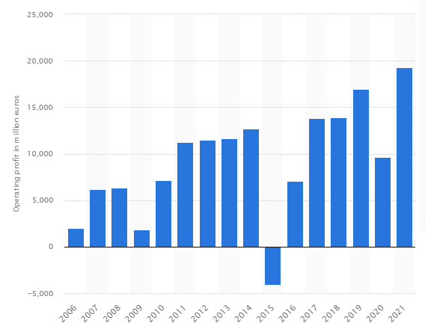
Figure 2: Sales of business in the last 15 years
(Source: Henry, 2021)
The strategy of Volkswagen in 2019
In 2019, Volkswagen has been able to emphasize innovative strategies to manufacture new vehicles. 2019 has been a milestone as Volkswagen has the brand launched the new models of Arteon, Atlas, Beetle, Golf etc. Generating sales revenue of £252.6 million, Volkswagen has been able to earn an operating profit of 19.3 billion in the fiscal year of 2019 (Teece, 2019). Further, compared to the previous year 1.3% of the deliverance have been increased. The figure 3 has presented the newest model of Volkswagen.
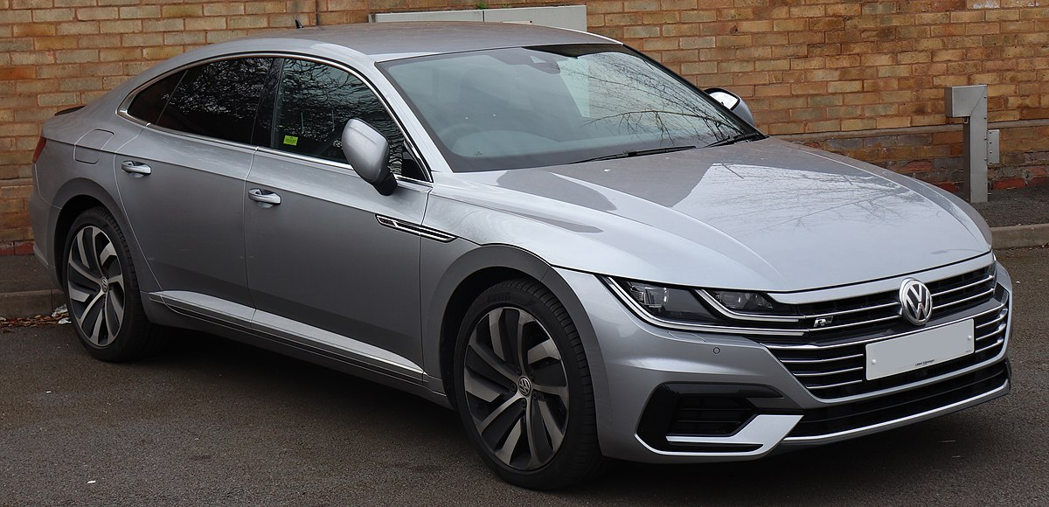
Figure 3: Logo of Volkswagen
(Source: Teece, 2019)

Strategy for Volkswagen in 2020
The strategic management framework that the company was using
Over the years, Volkswagen has been focused on a value discipline strategic framework that has been able to increase customer intimacy by enhancing operational excellence. However, the framework failed to address the sustainability issues that have increased challenges for the company (Boon et al., 2018). This is because the model failed to address the flexible attributes of the business that could have benefited Volkswagen to understand the need for a change within the business. Below figure 4 has presented the three elements of Volkswagen. Therefore, Volkswagen has emphasized the implementation of innovative attributes of the business that has benefited the brand by reinventing the sustainable attributes of the business to introduce zero-emission electric cars. As a result, the company has installed software to allow for proper air quality regulation with diesel-powered automobiles.
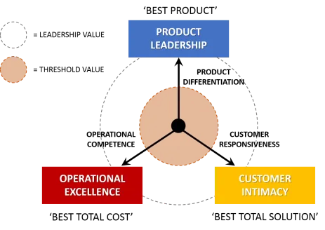
Figure 4: Three elements of value discipline framework
(Source: Teece, 2019)

Currently, the strategy that the company is using
Detecting the complaints against the brand, in 2020 Volkswagen has been able to focus on the development of sustainable attributes to buy to environmental and energy policy in improving the quality of the supply chain (Sergio and Rylova, 2018). Therefore, with the help of McKinsey 7S strategic framework, Volkswagen has been able to understand the organisational design that has benefited the brand to improve business functions. The framework is associated with the understanding of the 7S elements of the strategic framework which include structure, strategy, systems, skill, shared value, staff and style which are presented in the figure 5. Determining the need for change in business, Volkswagen has been able to manage the capacity that has determined the need for the introduction of sustainable business practices (Mačaitytė and Virbašiūtė, 2018). Educating staff members and accessing skills the company has therefore focused on the introduction of a transformational leadership style that will help the company in managing corporate social responsibilities strategies. In 2020, the gradual change for determining the sustainable practice of business is determined.
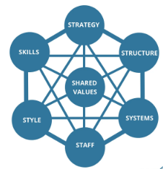
Figure 5: Mckinsey 7S model
(Source: Sergio and Rylova, 2018)
Strategies of Volkswagen in 2021-2022
The new initiative of 'New Auto' to reinvent vehicles with autonomous driving has been fitted to Volkswagen to boost potential sales. Considering the innovative technology platform Volkswagen is aiming to increase business growth and functions to enhance profitability. The current strategy of Volkswagen is safely associated with sustainable business attributes to generate a positive impact on the environment (Drobyazko et al., 2019). Based on the current sustainable strategy the company is able to promote a renewable economy to reduce resource costs. Therefore, aligning with the Clean Air Act strategy of Volkswagen is helping the company to accomplish the transition in facilitating customers with the sustainability initiative.

Determining the resource and capabilities of the company with evidence of 5 years
VRIO analysis is considered a strategic tool that evaluates the core competencies of businesses. Analysing the internal resources of business value analysis benefits brands in gaining comparative advantages by measuring valuable and rare resources. For Volkswagen, a value analysis has been conducted to evaluate the resource and capabilities of the company for the last 5 years.
Valuable
Brand uniqueness: For the last 5 years, Volkswagen has been able to establish a strong brand image to represent trust and honesty. This is helping the company to retain a potential customer base for the last 5 years enhancing profitable margins.
Supply chain: By establishing a strong relationship with the supplier, Volkswagen is able to gain competitive advantages by strengthening the distribution system (JOHN-EKE and EKE 2020). The supply chain consistency is therefore helping Volkswagen to promote ethical business standards in order to increase profitability.
Innovation: Based on the aspects of innovation to navigate environmental threats, the company is able to innovate business growth and capabilities. This is helping Volkswagen to achieve business success by reducing competition and increasing market penetration.
Rare
International presence: The global presence of the brand is a rare resource of business that is helping the increment of financial strength (Alfaro et al., 2019). Considering its international presence Volkswagen has been able to gain competitive advantages over companies like Toyota, Audi etc.
Strong employee base: The brand has been able to foster problem-solving strategies within the business with the help of a strong employee base.
Risk-taking capabilities: One of the important and rare features of the company is the exclusive risk assessment strategy that is helping Volkswagen to enhance business growth (Andersen and Young, 2021). As a result, the company is able to localise products in the global market.
Imitable
Quality products: Volkswagen facilitates its customers with high-quality vehicles. Without compromising the quality, the brand has been able to make the products appealing to increase productivity and profitability (Kostelijk and Alsem, 2020). The competing players can therefore face difficulties regarding the imitation of products.
Marketing communications: With strong marketing communication, Volkswagen is able to gain competitive advantages to retain a potential customer base.
Competitive pricing: Controlling the operational cost, the competitive pricing strategy is able to integrate technology in order to improve business processes. This is an eminent resource of business as the brand is able to facilitate customers with affordable vehicles.
Organisational
Technological integration: Technological advancement is another important resource of Volkswagen that has benefited the brand in gaining competitive advantages.
Investment in research development: Since the company invests in research and development plans, the sustainable initiative of manufacturing energy-efficient vehicles is helping Volkswagen to increase business productivity and profitability.
Corporate leadership strategy: Corporate leadership business attributes are helping companies to expand business efficiently (Brown et al., 2018). The strong corporate leadership of Volkswagen is increasing production capacity by managing human resource aspects of the business. Below, the checlist of VRIO analysis is presented.
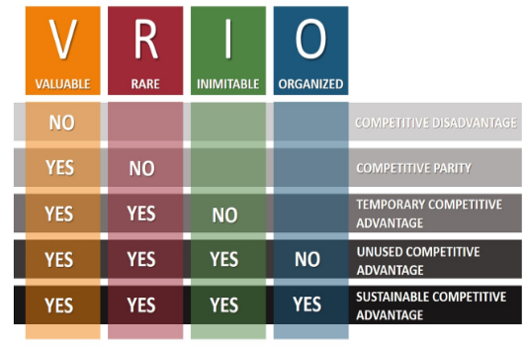
Figure 6: VRIO analysis
(Source: Brown et al., 2018)
Extent for aligning resources and capabilities to current business strategies
Aligning with the resources, Volkswagen is able to manage resources that are helping the brand to initiate sustainability ideas to reduce carbon emissions. Overcoming the challenges of criticism, the brand has also invested in sustainability plans that are helping the company to focus on current business strategies (Sergio and Rylova, 2018). The company has therefore aligned with the rare resource of accessing a strong employee base to focus on the prospect of boosting technology performance in improving business growth. This strategy is also aligned with new ideas that are helping Volkswagen to determine 'mobility for a generation' with the gradual transformation of business. With the transformation and realignment of strategies, Volkswagen is able to implement software measures that will help in boosting technological advancements. The company is therefore able to align with the business objectives to focus on the optimisation of resources. As a result, the autonomous strategy of business will help in developing network transportation in future to enhance sustainable measures of business.

Evidence showing VW becoming competitive considering sustainability
Strengthening economic, social and environmental aspects, Volkswagen has been able to improve business growth and functions to align with the corporate social responsibilities (CSR) strategies. CSR in business helps in increasing company value (Hitt et al., 2019). Giving back to the community, CSR improves brand image by strengthening financial performance. Evaluating the importance of sustainability, Volkswagen has improved the working conditions of the business by generating a positive impact on the community. The sustainable practice considered by the company includes- Go to ZERO strategy
Committing to improving air quality
Focusing on the improvement of local air, Volkswagen has committed to the electrification of vehicles to reduce the consumption of fossil fuels (Bogers et al., 2019). Sharing batteries with the electric portfolio the company has aimed to reduce its carbon footprint by 2050. Further, the company will be able to reduce emissions which are helping Volkswagen to improve the air quality.
Towards climate change
Volkswagen has committed to The Paris Agreement, to emit zero carbon by 2050. Reducing greenhouse emissions by 2025, the brand has also contributed towards the transition by using renewable energy sources (Ansoff et al., 2018). This is generating a positive impact on the environment by utilising renewable energy sources. Reducing global warming climate change strategies are also benefiting the passengers with light vehicles by 30% compared to the manufacturing of the units in 2015.
Resources
By optimising resources and considering economic approaches, Volkswagen has been able to promote a circular economy. The sustainable initiative is therefore helping the company to reduce environmental externalities including water, energy and CO2 waste (Boon et al., 2018). Using resources, Volkswagen focuses on the initiative to improve sustainable practices in business.
Environmental compliance
Enhancing transparency, Volkswagen has been able to comply with the environmental attribute that is helping the company to control the management system. Reflecting upon the successful attributes of the business, environmental compliance is assisting Volkswagen to become a role model in the automobile company to promote sustainable mobility to its customers.
VWGoA Environmental Policy Statement
Complying with the policy statement, Volkswagen is able to integrate strategies to innovate new ideas in manufacturing electric vehicles (Teece, 2019). Based on the environmental mission statement, the company is able to manage business ideas to focus on environmental attributes.
Stakeholder collaboration
Another sustainable advantage of Volkswagen is its relationship with internal and external stakeholders. Since stakeholders are considered important business aspects, companies are able to align stakeholders' interests with Environmental Compliances Management System. As a result, Volkswagen is able to facilitate customers with reliable information.
Continual improvement
Volkswagen has emphasized the initiative to improve business processes and services by integrating with environmental requirements. Investing in society for education and reducing poverty and hunger, the company is managing stakeholder interest to make effective business decisions (Brown et al., 2018). Based on the continual improvement, decisions are helping the company to manage science, regulation, technology and stakeholder expectations.

Recommendations for VW for considering further sustainable practices in gaining more competitive advantages
In future, it is important for Volkswagen to focus on further sustainable practices that will help Volkswagen in gaining competitive advantages over existing competitors like Audi, Toyota, Mercedes Benz, BMW etc. The recommendations are therefore associated with the-
Providing proper training to employees
Volkswagen, in future, should embrace the diversity that will help the company to integrate employees from different cultural backgrounds. By providing proper training to the employees regarding the promotion of sustainability practices in business, Volkswagen should encourage feedback that will help them in managing employee engagement (Kostelijk and Alsem, 2020). With the help of feedback, the company will be able to strengthen the employee base to integrate business aspects. In the future onboarding training system should be implemented that will help the company to enhance technical knowledge among the employees.
Embracing technological aspects
The technological attributes of business will benefit Volkswagen in fundamentally designing new vehicles that will generate a positive impact on the environment. Embracing the technology, the new vehicles can be manufactured with solar panels on the roof (Henry, 2021). The new initiative of 'Auto Car', will therefore benefit the brand to gain competitive advantages over the competitors. By updating the automatic software Volkswagen company is currently using, CARIAD, the company will be able to accelerate its business functions to become the top automobile brand.
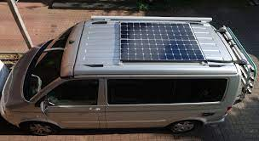
Figure 7: Solar panel infused car
(Source: Henry, 2021)
Environmental protection
Reflecting upon the sustainable concepts of decarbonization, supply chain consistency, renewable energy sources and others, the brand will be able to protect the environment extensively (Alfaro et al., 2019). Reducing environmental impact, aligning with the environmental policies, the company should promote management that will help in making decisions to generate a positive impact on the environment by reducing

Conclusion
The above research work is based on the importance of sustainable practice in business that is helping companies to enhance growth and functions. By understanding the importance of sustainability, companies are able to improve brand reputation by generating a positive impact on the environment. Based on the sustainability challenges faced by Volkswagen, the brand has focused on sustainability initiatives to improve business functions in overcoming the criticisms. Understanding the current business strategies of Volkswagen, evidence is provided from the past 5 years in relation to the framework. Identifying the resources and capabilities of business with the help of the VRIO framework, the above assignment has reflected upon the sustainable practices that have benefited Volkswagen to become competitive. In addition, recommendations are provided for the company that will help the brand in gaining sustainable advantages to benefit the retention of strong business aspects.

References
Alfaro, E., Yu, F., Rehman, N.U., Hysa, E. and Kabeya, P.K., (2019). Strategic management of innovation. In The Routledge companion to innovation management (pp. 107-168). Routledge.
Andersen, T.J. and Young, P.C., (2021). Strategic risk leadership: Context and cases. Routledge.
Ansoff, H.I., Kipley, D., Lewis, A.O., Helm-Stevens, R. and Ansoff, R., (2018). Implanting strategic management. Springer.
Bogers, M., Chesbrough, H., Heaton, S. and Teece, D.J., (2019). Strategic management of open innovation: A dynamic capabilities perspective. California Management Review, 62(1), pp.77-94.
Boon, C., Eckardt, R., Lepak, D.P. and Boselie, P., (2018). Integrating strategic human capital and strategic human resource management. The International Journal of Human Resource Management, 29(1), pp.34-67.
Brown, S., Bessant, J. and Jia, F., (2018). Strategic operations management. Routledge.
Drobyazko, S., Okulich-Kazarin, V., Rogovyi, A., Goltvenko, O. and Marova, S., (2019). Factors of influence on the sustainable development in the strategy management of corporations. Academy of Strategic Management Journal, 18, pp.1-5.
Henry, A., (2021). Understanding strategic management. Oxford University Press.
Hitt, M.A., Ireland, R.D. and Hoskisson, R.E., (2019). Strategic management: Concepts and cases: Competitiveness and globalization. Cengage Learning.
JOHN-EKE, E.C. and EKE, J.K., (2020). Strategic planning and crisis management styles in organizations: a review of related literature. Journal of Strategic Management, 5(1), pp.36-46.
Kostelijk, E. and Alsem, K.J., (2020). Brand positioning: Connecting marketing strategy and communications. Routledge.
Mačaitytė, I. and Virbašiūtė, G., (2018). Volkswagen emission scandal and corporate social responsibility–a case study.
Sergio, R.P. and Rylova, M., (2018). Employee engagement and empowerment as gateway towards retention: The case of Volkswagen group. Journal of Eastern European and Central Asian Research, 5(2).
Teece, D.J., (2019). A capability theory of the firm: an economics and (strategic) management perspective. New Zealand Economic Papers, 53(1), pp.1-43.
Volkswagen (2022) Official home of Volkswagen Cars & suvs VW.com | Official Home of Volkswagen Cars & SUVs. Available at: https://www.vw.com/en.html (Accessed: December 19, 2022).

