
UNIVERSITY OF WALES TRINITY SAINT DAVID
Master of Business Administration (MBA)

Dissertation
Module Code: LCMB7035

The Impact of AI Chatbot Service Quality on Customer Trust and E-Brand Loyalty in the UK E-Commerce Sector

Submitted By
Student Name: VEDIKA GANESH BHOITE
Student ID: 2422538

Supervisor: MR. ALIREZA NAZARIAN

Word Count: 14975
Submission Date: 8TH JUNE 2026 BY 02PM



Master’s Degrees by Examination and Dissertation
Declaration Form.

I, VEDIKA GANESH BHOITE, declare that this dissertation has been composed by myself, that the work contained herein is entirely my own except where explicitly stated otherwise in the text, and that this work has not been submitted for any other degree or qualification, in whole or in part, except as specified.

Signature: 

Date: 04/06/2026

ACKNOWLEDGEMENTS
I truly appreciate the support and feedback I've received from my supervisors Hoang Nguyen and Masud Ibrahim during this dissertation. This research very much benefited from their encouragement and expertise.
I would like to thanks University of Wales Trinity Saint David for providing all the academic resources and the learning environment that were necessary to conduct this study. We express our sincere gratitude to every respondent who took part in the questionnaire survey and helped us with this research.
I would like to express my sincere gratitude to my family and my friends for their patience, my motivation and continuous support.

ABSTRACT
This study aims to investigate AI chatbot service quality, customer trust, and e-brand loyalty in the UK e-commerce industry. The digital customer service of online retailers is increasingly powered by artificial intelligence technologies. A key determinant of customer perceptions and behavioural outcomes is the chatbot service quality. Though the growing use of AI chatbots, existing literature does not have conclusive findings about the effect of chatbot service quality on consumers’ trust and long-term loyalty.
The study used quantitative research, in line with a positivist philosophy and a deductive method. An online questionnaire was distributed to UK consumers who engaged with an AI chatbot system on an e-commerce marketplace to collect primary data. Statistical analysis of 150 valid responses was carried out with the help of a software, SPSS. To test the proposed hypotheses, descriptive statistics, reliability analysis, Pearson correlation, and regression analysis were used.
This research shows that the quality of AI Chatbot service positively affects trust level and e-brand loyalty of customers. The study further suggests that digital commerce powered by AI creates a depth of trust in consumers. Based on the study findings, important dimensions include responsiveness, reliability, communication quality and personalisation that influence positive customer perceptions towards chatbot systems.
This study adds to scholarly discourse on the subject by providing practical proof of AI chatbot service quality and customer behavioural results in the UK e-commerce sector. The results show that e-commerce companies must have efficient, responsive and trustworthy chatbot systems which can help improve customer relationships, strengthen customer loyalty and enhance long-term digital competitiveness.

Table of Contents
Chapter One: Introduction 9
1.1 Background 9
1.2 Research Problem 10
1.3 Research Aim 11
1.4 Research Objectives 11
1.5 Research Questions and Hypotheses 12
1.5.1 Research Questions 12
1.5.2 Hypotheses 12
1.6 Research Justification 12
1.7 Literature Gap 13
1.8 Dissertation Structure 14
Chapter Two: Literature Review 14
2.1 Introduction 14
2.2 Theoretical Background 15
2.3 AI Chatbot Service Quality 17
2.4 Customer Trust 19
2.5 Loyalty 21
2.6 Relationship between AI Service Quality and Trust (H1) 22
2.7 Relationship between AI Service Quality and Loyalty (H2) 24
2.8 Relationship between Trust and Loyalty (H3) 25
2.9 Conceptual Framework 26
2.10 Literature Gap 27
2.11 Conclusion 28
Chapter Three: Methodology 28
3.1 Introduction 28
3.2 Research Onion 28
3.3 Research Philosophy 29
3.4 Research Approach 30
3.5 Research Strategy 31
3.6 Research Method Choice 31
3.7 Time Horizon 32
3.8 Research Technique and Procedure 32
3.8.1 Sample Size 33
3.9 Data Collection Method 33
3.10 Measurement 34
3.11 Data Analysis Method 35
3.12 Ethical Considerations 36
3.13 Conclusion 37
Chapter Four: Data Analysis & Findings 37
4.1 Introduction 37
4.2 Industry Overview 38
4.3 Demographic Analysis 38
4.4 Reliability Analysis 41
4.4.1 AI Chatbot Service Quality 41
4.4.2 Customer Trust 42
4.4.3 User Experience 43
4.4.4 E-brand Loyalty 44
4.5 Hypothesis Testing 45
4.5.1 Correlation Analysis 45
4.5.2 Regression Analysis 46
4.6 Discussion 52
4.6.1 Discussion 1 52
4.6.2 Discussion 2 54
4.6.3 Discussion 3 56
4.6.4 Hypotheses Summary and Decision Table 58
4.7 Conclusion 59
Chapter Five: Conclusion 60
5.1 Introduction 60
5.2 Summary of Findings 60
5.3 Recommendations 62
5.4 Limitations 63
5.5 Future Research 63
5.6 Final Reflection 64
6. References 66
7. Appendix 78
7.1 Questionnaire 78
7.2 Ethic Form 94
7.3 Survey Link 97
7.4 Raw Data 97
7.5 SPSS Analysis 98

List of Figures
Figure 1: Technology Acceptance Model (Davis, 1989) 8
Figure 2: Trust theory (Morgan and Hunt, 1994) 8
Figure 3: Relationship Marketing Theory (Berry, 1995) 9
Figure 4: Conceptual Framework 19
Figure 5: Research Onion framework developed by Mark Saunders, Philip Lewis, and Adrian Thornhill (2019) 22
Figure 6: Age Group of Respondents 31
Figure 7: Gender Distribution of Respondents 31
Figure 8: Highest Level of Education of Respondents 32
Figure 9: Frequency of Online Shopping from UK E-commerce Websites/Apps 33
Figure 10: Histogram of Regression Standardized Residuals for Hypothesis 1 39
Figure 11: Histogram of Regression Standardized Residuals for Hypothesis 2 41
Figure 12: Histogram of Regression Standardized Residuals for Hypothesis 3 43

List of Tables
Table 1: Reliability Analysis for AI Chatbot Service Quality 33
Table 2: Reliability Analysis for Customer Trust 34
Table 3: Reliability Analysis for User Experience 35
Table 4: Reliability Analysis for E-brand Loyalty 36
Table 5: Correlation Analysis among Study Variables 37
Table 6: Model Summary for Hypothesis 1 38
Table 7: ANOVA Results for Hypothesis 1 38
Table 8: Coefficients Analysis for Hypothesis 1 39
Table 9: Model Summary for Hypothesis 2 40
Table 10: ANOVA Results for Hypothesis 2 40
Table 11: Coefficients Analysis for Hypothesis 2 41
Table 12: Model Summary for Hypothesis 3 42
Table 13: ANOVA Results for Hypothesis 3 42
Table 14: Coefficients Analysis for Hypothesis 3 43
Table 15: Summary of Hypotheses Testing Results 50

Chapter One: Introduction

1.1 Background
The increasing internet penetration, changing buying behaviour and rapid digitalisation led to transformation of global e-commerce industry. Research suggests that UK retail and its sectors have become one of the largest growing industries as consumers expect fast, bespoke and always available digital services (Wadud, Liang and Polkinghorne, 2025). As a result, online retailers are increasingly deploying AI-enabled technologies into customer service operations to improve efficiency, customer engagement, and competitive advantage (Chau et al., 2025). The e-commerce boom has thus increased organizational dependence on automated service systems capable of efficiently managing a broad-based range of customer relationships in highly competitive online marketplaces (Criveanu, 2025).
The use of AI chatbots is constantly gaining traction among e-commerce businesses to cater for customer service digitally. AI chatbots are computer programmes that employ machine learning and natural language processing technologies to interact with customers, answer queries, recommend products, and provide continuous online support. According to researchers, chatbot systems enhance operational efficiency and decrease organisational costs by replacing repetitive human service functions using automated communication systems (Uzoka, Cadet and Ojukwu, 2024). Also, with chatbot technologies, companies can always provide instant replies and reply to many customers at once. Nonetheless, these advantages, have given rise to issues related to emotional authenticity, quality of service and relationship building, which are detrimental for not only human agents but also for AI agents (Kleinert et al., 2026). Critics argue that excessive automation could undermine emotional involvement in online service experiences (for example, empathy and contextual understanding), which, in turn, could decrease customer confidence. (Meng, Lu and Xu, 2025).
The increasing adoption of AI across online retail industries has made the quality of chatbot service delivery more critical than ever in determining customer perceptions and behavioural outcomes. The service quality of AI chatbots, as defined by Deshmukh and Sharma (2023), mostly concerns the responsiveness, reliability, accuracy, personalisation and communication. Research indicates that efficient and reliable chatbot systems positively influence customer satisfaction and the acceptance of technology (Wahbi, Khaddouj and Lahlimi, 2023). But there is still a lot of academic discussion whether technical efficiency on its own gives positive results for the customer. According to some researchers, empathy, warmth and emotional responsiveness make the customer relationship and engagement stronger (Park and Whang, 2022 ) . In contrast, other studies say that consumers in utilitarian e-commerce sites prefer efficiency and problem-solving capacity over emotional interaction (Pires et al., 2024). This inconsistency suggests that the factors of successful chatbot service quality are still under debate.
In AI-enabled e-commerce environments, customer trust and e-brand loyalty have assumed strategic significance. Trust plays a key role in online commerce because customer perception of risk is higher in an online environment with limited physical contact between the customer and the firm (Lăzăroiu et al., 2020). As per researchers, dependable chatbot interactions boost the confidence of customers and mitigate uncertainty with online transactions (Alagarsamy and Mehrolia, 2023). In the same vein, due to low switching costs, consumer movement to competing online brands is easy and so customer loyalty in e-commerce is quite important (Beyari, 2025). The United Kingdom has advanced e-commerce ecosystem and increasing usage of AI-enabled customer service technologies, which provides an interesting context to study these relationships. Despite the increasing implementation of chatbot systems, existing literature does not reach any consensus on the extent to which chatbot service quality enhances customer trust and e-brand loyalty in the UK e-commerce context. Further explorations are needed to critically evaluate these relationships in today’s digital trading environments.

1.2 Research Problem
The digital customer service systems of global retail markets have swiftly adapted to the latest AI chatbot technologies through e-commerce. In an endeavour to enhance service efficiency, minimise operational costs and improve the quality of customer interaction, organisations are increasingly using AI chatbots.
Nonetheless, while chatbot technology is widely adopted, it is still uncertain whether a high-quality chatbot service can indeed improve customer trust and long-term e-brand loyalty. According to existing studies, technology adoption intention, continuance intention, customer satisfaction, and perceived usefulness have received attention from prior studies. While e-brand loyalty in AI-enabled commerce has not received strong attention (Li et al., 2023).
Previous literature also presents differing opinions on the most important dimensions of chatbot service quality. According to Rita, Vong and Correia (2026) and Aly (2025), while some researchers believe that the more a robot engages in human-like qualities such as empathy and emotional responsiveness, the more positive the customer relationships, others who follow a different approach think that technical efficiency, responsiveness, and reliability matter more in generating positive customer outcomes. Moreover, there has been limited research on the relationships found in the UK e-commerce. As such, there remains a lack of understanding of the association between UK e-commerce AI chatbot service quality and customer trust and e-brand loyalty.

1.3 Research Aim
This study aims to measure the effect of AI chatbot service quality on customer trust and e-brand loyalty within the UK e-commerce over time.

1.4 Research Objectives
- To examine the effect of AI chatbot service quality on customer trust within UK e-commerce.
- To analyse the impact of AI chatbot service quality on e-brand loyalty.
- To evaluate the relationship between customer trust and e-brand loyalty.
- To assess the role of AI-enabled customer service interactions within UK digital commerce environments.

1.5 Research Questions and Hypotheses
In this study, the researchers will find out how the service quality of AI Chatbot affects customer trust and e-brand loyalty in UK-based e-commerce platforms. This study will answer the following questions.

1.5.1 Research Questions
- RQ1: How does AI chatbot service quality influence customer trust in UK e-commerce?
- RQ2: What is the impact of AI chatbot service quality on e-brand loyalty?
- RQ3: How does customer trust affect e-brand loyalty?
Based on existing theoretical and empirical literature, the following hypotheses are proposed:

1.5.2 Hypotheses
- H1: AI chatbot service quality positively influences customer trust significantly.
- H2: AI chatbot service quality positively influences e-brand loyalty significantly.
- H3: Customer trust positively influences e-brand loyalty significantly.
Customer trust and loyalty are important relationships that are increasingly recognized as strategic determinants of competitive advantage and customer retention in AI-enabled digital commerce systems.

1.6 Research Justification
This study is academically important because current literature on AI-enabled customer service is theoretically fragmented and evolving at a rapid pace. Past studies have concentrated on user satisfaction, technology acceptance and continuance intention. Limited studies have directly examined the e-brand loyalty in AI chatbot contexts (Li et al. 2023). Also, prior works frequently study chatbot service quality, customer trust, and user experience in isolation rather than bringing these variables into one framework.
Whether a chatbot’s efficiency or human-like characteristics carries more weight in influencing consumer perceptions and behaviours, researchers are still debating (Dewanti and Ikhsan, 2025; Rita, Vong and Correia, 2026). Moreover, the study is practically significant in the sense that e-commerce firms are investing immense resources in AI chatbot system to bolster customer engagement and competitiveness. As low switching costs increase the intensity of online competition, the strategic understanding of the influence of chatbot service quality on customer trust and loyalty has become important for sustainable digital business performance (Beyari, 2025).

1.7 Literature Gap
Although AI chatbot research has witnessed major growth, there are clear gaps in the literature. To begin with, earlier studies mostly focused on variables like customer satisfaction, continuance intention, perceived usefulness, technology adoption, and the like, instead of examining the e-brand loyalty outcomes directly in AI-enabled e-commerce environments (Li et al., 2023). As a result, little is known about the long-term relational influence of chatbot service quality.
Secondly, existing research has often studied chatbot technology in selected industries such as banking, insurance, and cosmetics and luxury retail so these findings may not be applicable to UK e-commerce settings (Huang, Markovitch and Stough, 2024). Many researchers have examined customer trust, service quality and user experience separately. However, a lot fewer studies integrate these three variables into one framework to study their collective effect on e-brand loyalty.
Finally, previous studies contradict each other’s findings regarding which is more important – functional efficiency or human-like interaction qualities. Some researchers stress responsiveness and reliability, while others identify emotional intelligence and humanoid communication elements as the key determinants of customer results (Rita, Vong and Correia, 2026). To this end, the study will carefully analyse how AI chatbot service quality impacts customer trust and in turn, how this relationship influences e-brand loyalty within the UK e-commerce industry.

1.8 Dissertation Structure
The dissertation contains five chapters. Chapter 1 includes the background justifies the aims and objectives, the research problem, research question and literature gap. By researcher’s focus on the literature review on AI chatbot service, feature quality, customer trust, user experience and e-brand loyalty as in chapter 2, the conceptual framework and hypotheses were developed. The research philosophy and approach, strategy, data collection, sampling and statistical analysis used in this study are discussed in detail in chapter three. Discussion of empirical findings from the data analysis conducted through SPSS and critical discussions of finding vis-a-vis literature and theories is done in chapter four. Finally, Chapter 5 wraps up the results of the study along with its conclusions, recommendations, limitations and suggestions for further study.

Chapter Two: Literature Review

2.1 Introduction
The chapter literature reviews AI chatbot services in the e-commerce sector and their effectiveness, customer trust, user experience, and e-brand loyalty. With the growing use of AI chatbots to perform online customer service support, the relationship between the quality of services these AI bots offer, and customers’ perceptions and behavioural outcomes has become an important area of research. In this research, the quality of AI chatbot services is the rating of the quality of the chatbot by the customers based on its responsiveness, accuracy, reliability, personalization, and overall services delivery. Customer trust is the confidence of a user that they have in the chatbot and the interactions with the brand using AI, whereas loyalty is the interest of a customer in the online brand that he chooses to continue, repeat, and commit to do so. The chapter starts with the theoretical background; it is then followed by the discussion of AI chatbot service quality, customer trust, and customer loyalty. It further analyses how these variables relate to each other as per the hypotheses proposed, gives the conceptual framework, states the gap in the literature and finally gives a summary of the chapter.

2.2 Theoretical Background
The study is supported by several important theoretical frameworks, which explain the interaction of consumers with AI chatbot technologies, as well as the impact of such interactions on the results of trust, experience, and loyalty in e-commerce contexts. The most applicable theories are the Technology Acceptance Model, trust theory and relationship marketing theory.
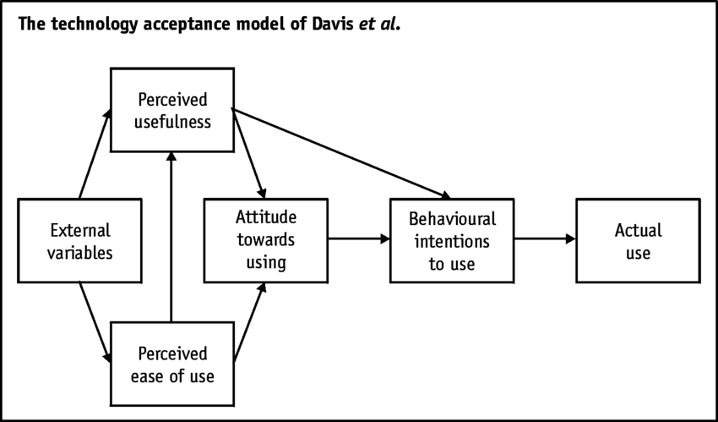
Figure 1: Technology Acceptance Model (Davis, 1989)
One of the most used theories to explain technology acceptance is the Technology Acceptance Model (TAM) (Davis, 1989). This model suggests that the perceived ease of use and the perceived usefulness are the key factors affecting technology acceptance. In terms of AI chatbots, several studies have demonstrated that ease of use and providing efficient, helpful responses increases the likelihood of users interacting with and continuing to use the chatbots (Hsu and Lin, 2023). The model is applicable as it explains the consequences of the quality of the services of the chatbots on the perceptions of the users and their behavioural intentions.
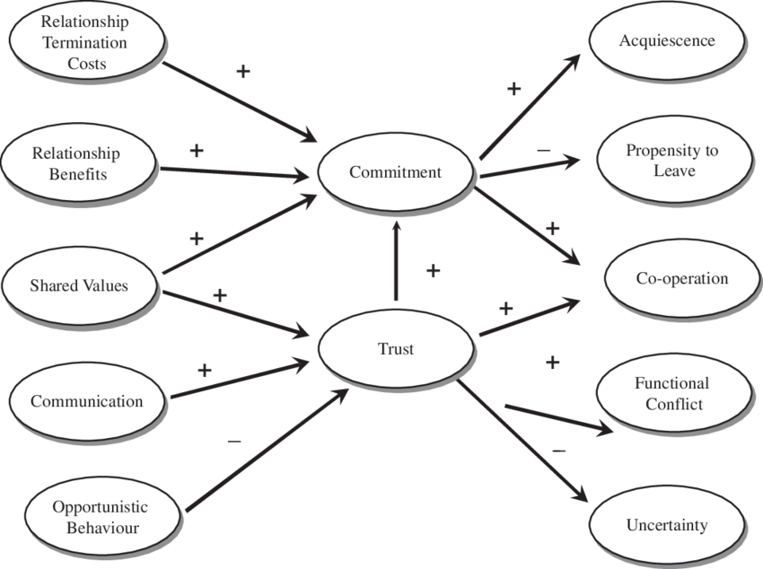
Figure 2: Trust theory (Morgan and Hunt, 1994)
The theory of trust also describes how users gain trust in AI system (Morgan and Hunt, 1994). In online contexts where there is a high degree of uncertainty and perceived risk, trust is of great essence. Gambetta (2019) defines trust as a subjective likelihood that an agent will act in a certain way that will benefit the trustor. In an AI chatbot communication, reliability, transparency, responsiveness, and perceived competence are the factors that influence trust (Li, Fang and Chiang, 2023). Users will trust the system more when they believe chatbots to be accurate and reliable, which subsequently affects satisfaction and loyalty levels. This theory is highly relevant as trust acts as a key mediating variable in this study.
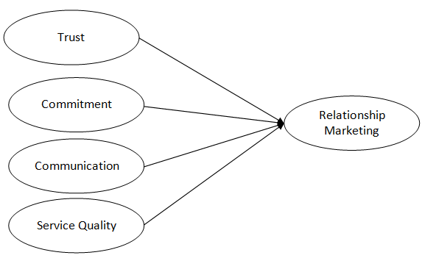
Figure 3: Relationship Marketing Theory (Berry, 1995)
Moreover, the Relationship Marketing Theory proposed by Berry (1995) aims at creating long-term relationships between the customers and firms. It is proposed in the theory that continuous value creation, trust and engagement are what leads to customer retention and customer loyalty as opposed to a one-time transaction. AI chatbots are essential in e-commerce to ensure continuous communication with customers, give them personalized service, and improve customer experience. According to the previous studies, the quality of interactions with the chatbot enhances the emotional and relational relationships with the customers, which ultimately results in the loyalty (Huang, Markovitch and Stough, 2024).
All in all, these theories will be a good basis to this research. TAM is a theory that describes how users accept chatbot technology, trust theory is a theory that describes a development of confidence in AI interactions, and relationship marketing theory is a theory that describes how the interactions lead to long-term loyalty. They jointly promote the recommended relationships between the quality of AI chatbot performance, trust, user experience, and e-brand loyalty in the e-commerce environment.

2.3 AI Chatbot Service Quality
Customer experience and behavioural outcomes are crucial in e-commerce, making the quality of AI chatbot services a significant metric to capture. The quality of chatbot service, in contrast to the traditional e-service quality, is multidimensional, combining functional performance with the ability to interact in a human-like manner (Hsu and Lin, 2023). As stated by Chen et al. (2022), the quality of AI chatbot services consists of several key dimensions: efficiency, understanding of semantics, personalization, collaboration between humans and AI, and ongoing enhancement. Furthermore, the capabilities of a specific chatbot have evolved beyond that of a basic system to enable adaptive and intelligent interactions.
A wealth of literature is devoted to the importance of critical functional qualities of chatbots service quality. Researchers have continuously demonstrated that system reliability, information quality, response accuracy, and capability to solve problems are key motivators of user satisfaction.
As an example, Rita, Vong and Correia (2026) and Syafitri and Alfansi (2024) define the quality of information (accuracy, relevancy and timeliness) as one of the most effective predictors of customer satisfaction and repeat usage intention. In the same vein, Zhang, Liang and Li (2024) emphasize that speed of response, ease of use, and efficiency of the system can contribute to a high degree of task-technology fit, which in turn translates into higher levels of user satisfaction and continuance intention. This utilitarian approach is also evidenced by Gao et al. (2025) as they suggest that the problem-solving capacity of chatbots has a direct impact on user satisfaction due to the confirmation of expectations, and therefore, it becomes a major factor in subsequent use.
Nevertheless, AI chatbots cannot be judged by their technical performance exclusively in terms of service quality. Emergent literature that focuses on experiential and relational. Li et al. (2023) state that chatbots have characteristics such as interactivity, visibility and connectivity. These results indicate that the quality of chatbot services works based on both cognitive (efficiency, accuracy) and emotional (engagement, interaction quality) processes.
Even now, however, there is a debate about the relative significance of functional versus human-like features. The research claims that human-like traits like empathy, warm, and anthropomorphism have a significant influence on user perceptions and behavioural results (Dewanti and Ikhsan, 2025; Ding and Najaf, 2024). These characteristics enhance trust and interaction by developing a feeling of social presence and emotion. Other studies disagree with this, however, indicating that the functional performance is still more significant. In a study by Rita, Vong and Correia (2026), anthropomorphism and response humanness did not strongly predict satisfaction, and this result supports the claim by users that, in most cases, they value efficiency and accuracy in e-commerce more than social interaction. This paradox indicates that the significance of the human-like features can be context-specific, specifically, different in the utilitarian and hedonic service contexts.

Communication quality is another important aspect of the quality of chatbot services. According to Naqvi et al. (2023) and Chung et al. (2020), accuracy, credibility, and clarity of responses provided by chatbots are the most important aspects to ensure customer satisfaction and trust. The breakdown of communication, or a lack of conversations, can severely hurt its user perceptions and trust (Følstad, Law and van As, 2024).
Also, the aspect of personalisation has been considered in general as another significant factor of quality of chatbot services. One-on-one conversations help chatbots to provide custom advice and response that make them more relevant and customer focused. Researchers like Shahzad et al. (2024), Hassan, Abdelraouf, and El-Shihy (2025) show that personalization improves the relationship between service quality, trust levels, and customer loyalty by enriching the customer experience and value. This is in line with the larger notion of value co-creation, wherein customers can interact with AI systems in a way that creates valuable service experiences (Sboui, Baati and Sfar, 2024).
Altogether, the literature indicates that the quality of the AI chatbot service is a multidimensional phenomenon, which includes the functional efficiency, the quality of communication, personalization, and the interaction with the human. Although it is widely agreed that service quality has a positive effect on satisfaction and behavioural outcome, the relative significance of the various dimensions of service quality is less agreed upon. Most of the studies, however, end up concluding that the good experience of using a chat bot increases the customer experience and consequently trust, satisfaction and loyalty in e-commerce environments.

2.4 Customer Trust
One of the core concepts of online space is customer trust since online transactions are associated with uncertainty, information asymmetry, and decreased human contact (O’Higgins and Fatorachian, 2025). Trust in the context of e-commerce is typically the readiness of a customer to trust a technology or services provider despite their possible riskiness, based on the expectation of reliability, competence, and integrity. In AI-driven environments, this definition is more complicated since the trust is not only placed on the brand, but on the technological mediator of the service experience as well.
Consequently, trust in chatbot situations is a confidence in the system to deliver correct, secure, helpful, and suitable responses when interacting online (Jenneboer, Herrando and Constantinides, 2022).
Trust plays a greater role in AI and automation since, in most cases, customers cannot see how decisions are made or how information is processed in full. Conversational commerce studies indicate that trust is among the most valuable requirements of adoption, satisfaction, and further usage of AI-based service tools (Lim et al., 2022; Li et al., 2023). An especially helpful approach by Huang, Markovitch and Stough (2024) is that they differentiate between dispositional trust and learned trust and situational trust. According to their results, trust does not exist as a one-dimensional belief, but a stratified judgment, formed through previous technology attitudes, experience with chatbots, and experience with the immediate service experience (O’Higgins and Fatorachian, 2025). This is significant as it clarifies the reason why not all consumers are convinced by chatbots even in the case when the performance of the service is objective.
The literature shows that there are several factors that affect the trust in chatbots. To begin with, functional competence is essential. Consistency, precision, usefulness, and user-friendliness always enhance trust as they minimize doubts and indicate the ability of the chatbot to handle service functions efficiently (O’Higgins and Fatorachian, 2025; Jyothsna, Subbaiah and Kryvinska, 2024). On the same note, the quality of communication is significant since customers tend to trust the systems that can give credible, clear, and relevant answers (Akdemir and Bulut, 2024). Second, trust is also influenced by social and emotional cues. Cheng et al. (2021) demonstrate that perceived human-likeness may boost the levels of trust and satisfaction, whereas Ltif (2023) believes that empathy and friendliness can greatly enhance trust in text-based chatbots. As Wang et al. (2023) suggest, more recently, the establishment of trust with chatbots implies the affective type of trust, which is premised on empathy and personalization, and cognitive trust, which rests upon competence, transparency, and security.
However, the literature offers that the degree of trust in chatbots is low and cross-situational. All studies do not imply that only the quality of technical service suffices.
Examples include Moussa, Kortam and Mahmoud (2025) who discovered that service quality enhanced by AI did not have significant influence on customer experience and that users might perceive simple technical performance as a base requirement, not a source of trust or differentiation. Also, chatbots may not be as trusted as human agents, especially when it comes to service-oriented situations that are either emotionally sensitive or complicated (Huang, Markovitch and Stough, 2024). This means that automation can also be efficient, but trust is yet to be established through the perceived credibility, intelligibility and suitability of the interaction to the service situation.
Overall, the body of literature that confirms the multidimensionality of customer confidence in chatbot environments includes technological confidence, emotional confidence, and interaction-based evaluation. Trust is thus not simply a by-product of effective system design, but an interactive process whereby AI services quality affects satisfaction, loyalty, and acceptance in the long term in e-commerce.

2.5 Loyalty
E-brand loyalty is defined as the preference and commitment of a customer to an online brand which is a sustained loyalty expressed in both positive attitudes and intentions to repeat behaviour in online contexts. Loyalty is particularly significant in e-commerce since changing the platform is typically inexpensive and customers can readily transition to rival systems. Consequently, loyalty cannot be achieved in a single successful transaction, but it is measured by whether the digital experience of service generates satisfaction, trust, and value in the long-term (Beyari, 2025).
Attitudinal and behavioural loyalty are generally differentiated in the literature. Attitudinal loyalty is the psychological commitment, positive brand preference and readiness to recommend or to further support a brand. Behavioural loyalty, on the other hand, is the observable behaviour that is expressed by the repeat purchase, reuse intention, continuance intention and patronage behaviour. Chatbot-enabled commerce is applicable to both forms. Indicatively, Cheng and Jiang (2020) demonstrate that satisfaction because of the chatbot interactions enhances the loyalty and subsequent usage, whereas Zhao et al. (2026) associate satisfaction with repurchase intention in e-commerce.
In a similar vein, as shown by Wahyuni, Yuningsih and Arisandy (2025) and Singh and Singh (2024), positive service experiences that are supported by AI contribute to customer loyalty by mediating the effects of these experiences, which include satisfaction, engagement, and perceived efficiency.
Service encounters are highly influential in shaping loyalty in digital commerce since such interactions often replace the support that is traditionally provided face-to-face. This predisposes AI-facilitated customer service as a strategic element in building loyalty. The meta-analytic evidence indicates that AI has a high overall positive impact on the loyalty of customers to the e-commerce sector, but the extent of this effect depends on the type of AI application and the circumstances of a service (Beyari, 2025). Studies also suggest that when chatbot-enhanced services are efficient, responsive, and psychologically stimulating, customers will be more loyal (Hussain et al., 2025).
Of special importance is the connection between the experience of loyalty and digital services. The experience of chatbots is not only functional but also experiential and includes the ease of use, pleasure, personalization, and the quality of emotion. Haugeland et al. (2022) demonstrate that interaction design has an impact on pragmatic and hedonic quality, implying that user experience is how customers judge chatbot experiences. Similarly, Pham et al. (2025) observed that personalization and quality of the systems greatly enhance satisfaction, which consequently leads to loyalty among the Generation Z users. Overall, the literature indicates that e-brand loyalty in chatbot settings is the result of a synthesis of attitudinal commitment and behavioural repetition, the latter, in turn, being strongly dependent on the quality of digital service experiences.

2.6 Relationship between AI Service Quality and Trust (H1)
The literature supports the hypothesis that the quality of AI chatbot services and customer trust is strongly correlated. Service quality in online environments lowers uncertainty by indicating that the system can execute service tasks effectively and efficiently and is reliable. This is particularly necessary when it comes to AI-mediated interactions, where the customers might be initially sceptical of automation.
Regular research indicates that customers tend to trust chatbots more when their information is accurate, helpful, they respond and are user-friendly (Alagarsamy and Mehrolia, 2023; Wut et al., 2025).
Empirical studies determine that functional and relational dimensions of service quality are significant trust drivers. Functional quality encompasses the system reliability, information accuracy, security, usefulness, and efficiency. Alagarsamy and Mehrolia (2023) discovered that the quality of services and information have a positive impact on trust, whereas perceived risk and privacy issues undermine it. On the same note, Chi and Hoang Vu (2022) state that the quality of communication is a key mediating factor between AI characteristics and customer trust. In this light, trust is built upon the feeling of credibility, understandability, and technical capability of the chatbot interactions by the users.
Simultaneously, relational and human like cues also influence the formation of trust. Wang et al. (2026) differentiate between cognitive and affective trust grounded on the reliability and transparency and empathy, tone, and personalization respectively. They propose that the trust in chatbots is a multidimensional concept as opposed to a technical one. This further supports the point that the high standard of service within chatbot environments is not solely on what the system is performing, but rather how the system is communicating with the user. In the same vein, Singh et al. (2024) demonstrate that trust modulates the relationship between various chatbot characteristics and acceptance intention, although human-like and socially responsive designs can promote user trust.
This correlation is theoretically consistent with the trust-based perception of the logic of digital service and technology acceptance. The good service quality decreases perceived uncertainty and enhances perceived usefulness and ease of use and consequently leads to reliance on the chatbot by the users. The connection is not necessarily direct as well. The empirical evidence indicates that on the one hand, it can be believed that when the appearance of a human-like design is like it, it becomes natural and authentic, and on the other hand, it turns unnatural and unauthentic (Shahzad et al., 2024).

To illustrate, the effects of uncanny valley might decrease trust when chatbot avatars are too human, and AI disclosure during emotional interactions can also lead to the decrease of perceived authenticity (Hao et al., 2025; Song and Shin, 2022). This implies that it must be an average quality of service: it must be competent, cordial as much as possible without arousing discomfort or suspicion.
Overall, the hypothesis that the improvement in the quality of AI chatbots services has a positive impact on customer trust is verified by the literature, but the quality of this relationship depends on the technical performance as well as the design of interaction.
H1: Quality of AI chatbot services positively influences customer trust significantly.

2.7 Relationship between AI Service Quality and Loyalty (H2)
The literature tends to advocate a positive correlation between the quality of AI chatbot services and customer loyalty. Service quality is a determinant of loyalty in e-commerce as it enhances customer attitude towards convenience, responsiveness, and value when using digital services. When chatbots work successfully, customers feel more inclined to communicate with the brand again, re-use the service, and form repeat purchase intentions (Li et al., 2023; Beyari, 2025).
Several studies point to the fact that high-quality AI service directly boosts the outcomes regarding loyalty. As an example, the service assisted by AI is proven to enhance customer loyalty by making the interaction more efficient and gratifying (Singh and Singh, 2024). On the same note, research by Beyari (2025) indicates that AI has a very strong positive overall relationship with customer loyalty in e-commerce, which indicates that AI-based service has the potential to facilitate retention, engagement, and repeat behaviour. Zhao et al. (2026) are also able to demonstrate that chatbot responsiveness and social presence are a driver of repurchase intentions, whereas Wahyuni, Yuningsih and Arisandy (2025) identify chatbot service as a positive influence on loyalty, particularly due to improved engagement and satisfaction.
The relationship is not direct though. The literature indicates that service quality tends to influence the loyalty via intervening factors like satisfaction, trust and customer experience rather than on a one-step basis.
An example is Pham et al. (2025), who discovered that the quality of the systems and personalization enhanced satisfaction, which in turn affected the loyalty. This implies that although service quality is a base, its influence on loyalty can be contingent on the way customers emotionally and cognitively process the service experience.
Most importantly, not all service quality dimensions play an equal role. According to some of the studies, the technical competence and personalization are more relevant than all the traditional dimensions of service, and certain characteristics can even demonstrate weak or unimportant effects based on the situation and the target audience. It means that companies cannot presume that every type of chatbot enhancement is bound to lead to loyalty.
All in all, the literature confirms that AI service quality and loyalty have a positive relationship but that this correlation can be enhanced by mediating variables.
H2: AI chatbot service quality has a significant positive effect on e-brand loyalty.

2.8 Relationship between Trust and Loyalty (H3)
Trust is a well-known predictor of loyalty in digital contexts as it minimises the perceived risk and makes customers consider long-term relations with a brand. Trust is particularly critical in determining attitudinal commitment and behavioural loyalty in contexts of e-commerce where service delivery is mediated by technology and uncertainty is high (Syarifudin, Yulianto and Nugroho, 2024). Those customers who feel that the service system is reliable, safe, and in line with their interests will also tend to stay loyal (Beyari, 2025).
This relationship is highly supported by empirical research. Alagarsamy and Mehrolia (2023) discovered that trust is a key determinant of attitude, satisfaction, and behaviour intention, which supports its leading role in the outcomes of chatbots. Likewise, Wang et al. (2026) demonstrate that affective and cognitive trust enhance engagement and satisfaction as the main avenues to loyalty. Trust has also been reported to boost purchase intention and positive behavioural reactions in related e-commerce studies, particularly when customers believe the chatbot to be trustworthy and socially acceptable (Hu, Xu and Chen, 2025).
The mediation logic is especially applicable to the current research. Trust is not necessarily the ultimate result of chatbot interaction but rather a relationship system between service quality and enhanced brand results (Al-Oraini, 2025). Good service quality can lead to the creation of trust and that trust further leads to satisfaction, involvement, repeat use and loyalty. The trend is echoed in several studies. As an illustration, trust increases chatbot acceptance and usage intention (De Andrés-Sánchez and Gené-Albesa, 2024; Nguyen and Le, 2024), with a broader range of evidence indicating that trust is closely related to satisfaction, which, in turn, promotes further loyalty and repurchase behaviour (Ding et al., 2025; Sujová, 202
An important detail, though, is that trust might not be a panacea. Satisfaction, efficiency or experience seem to have greater direct impacts with loyalty than trust in particular contexts. Despite this, trust is a pillar relational variable in that it underlines the intention to trust the chatbot and the brand in the long run. In AI-mediated service environments, there is a chance that without trust, loyalty will not be maintained.
H3: Customer trust has a significant positive effect on e-brand loyalty.

2.9 Conceptual Framework
H1
AI Chatbot service quality
H2
E-brand loyalty
Customer trust
H3

E-brand loyalty

Figure 4: Conceptual Framework
The conceptual framework of this study demonstrates that AI chatbot service quality is the primary independent variable that affects the customers' trust and e-brand loyalty in the UK ecommerce industry. The framework is developed based on literature which posits that chatbot quality through responsiveness, reliability, accuracy, personalisation and communication will positively impact customer perception and behaviour (Chen et al, 2022; Hsu and Lin, 2023). The belief that customers are trusting serves as a mediating relational mechanism through which consumers develop confidence in AI-enabled service interactions and brands online (Morgan and Hunt, 1994). The model also suggests that customer trust enhances e-brand loyalty positively by inducing customer commitment, repeat purchase intention, and long-term engagement with online retailers. As such, the conceptual framework posits that the AI chatbot service quality positively impacts customer trust and e-brand loyalty, while customer trust, in turn, strengthens e-brand loyalty in AI-enabled e-commerce environments.

2.10 Literature Gap
While the existing literature provides insights into the quality of the AI chatbot service, trust, user experience, and loyalty, there are some critical gaps identified. First, a significant part of the earlier studies has been conducted on adoption intention, continuance intention or satisfaction, but not on e-brand loyalty as an independent variable in the context of e-commerce (Li et al., 2023; Li et al., 2023a; Jyothsna, Subbaiah and Kryvinska, 2024). Second, a significant amount of literature explores these relationships in industries like banking, insurance, cosmetics, and luxury retail, which restricts the contextual applicability of the results to the e-commerce industry overall in the UK (Huang, Markovitch and Stough, 2024; O’Higgins and Fatorachian, 2025). Third, the literature mostly focuses on trust or satisfaction or user experience separately and there are limited studies that integrate all three variables in one consistent model that ties the quality of chatbot services with loyalty (Shahzad et al., 2024; Widayanti et al., 2025). Moreover, the question of which aspects of chatbot quality are the most important is incongruent, with some articles focusing on functional efficiency and others on human-like or emotional qualities (Rita, Vong and Correia, 2026; Zhao et al., 2026).
Thus, the study fills these gaps by discussing the impact of the quality of AI chatbots services on e-brand loyalty within the UK e-commerce environment and specifically considers how the concept of customer trust and user experience mediates the effect.

2.11 Conclusion
The review revealed that the quality of chatbot services is multidimensional and trust and experience are significant mechanisms where AI-enabled service affects loyalty. The chapter also revealed significant gaps in theoretical and empirical knowledge especially regarding the integrated models in the UK e-commerce environment. The following chapter is the research methodology that was employed to empirically test these relationships.

Chapter Three: Methodology

3.1 Introduction
The research’s methodology applied in this study to examine the relationship between AI chatbot service quality, customer trust, user experience and e-brand loyalty in the UK e-commerce context has been discussed in this chapter. Using the Research Onion Framework of Saunders, Lewis, and Thornhill (2019), the chapter justifies the selected research design, philosophy, approach and methods. The emphasis placed on quantitative methodology ensures that relationships among the variables are measurable. It utilises statistical analyses which ensure that the results are objective and the findings are also generalisable. In the next section, it describes the procedure for data collection, sampling procedure, measurement scales, techniques for data analysis and ethical consideration that was used for addressing research questions and to test the proposed hypothesis.

3.2 Research Onion
To present the research methodology in a systematic manner, this study uses the Research Onion created by Mark Saunders, Philip Lewis and Adrian Thornhill (2019).
The model allocates various methodological choices into organisational layers and the development of the research process. Includes research philosophy, research approach, research strategy, method choice and time horizon. It uses the research onion to ensure that the goals of the research, the theories used and the analytical tools are aligned in the study. The research is positivist in philosophy, deductive in paradigm, quantitative in strategy, mono-method in choice, and cross sectional in time horizon, used to test the relations among e-brand loyalty, user experience, customer trust and service quality of AI chatbot in e-commerce sector in UK.
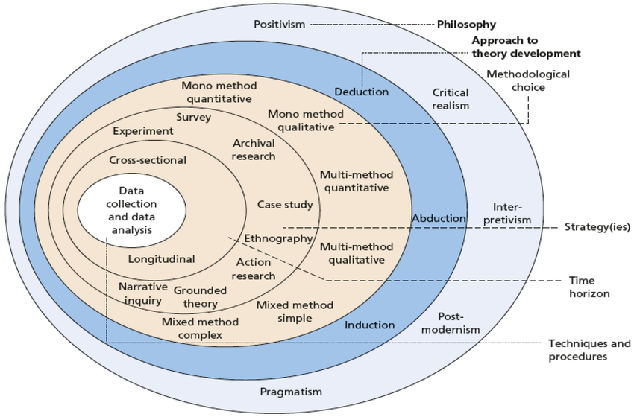
Figure 5: Research Onion framework developed by Mark Saunders, Philip Lewis, and Adrian Thornhill (2019)

3.3 Research Philosophy
The research philosophy used in this research is positivist research that states that reality is objective, observable and measurable by the researcher without interacting with the object of the research (Maretha, 2023). Positivism is especially adequately applied to the research that aims to test the theoretical relationships and produce empirical evidence based on the structured and quantifiable data (Maksimovic and Evtimov, 2023).
The elements of the research, namely chatbot service effectiveness, customer confidence in digitalization, user satisfaction and brand loyalty in digital space, can be measured in numerical units and correspond to the positivist philosophy.
According to Lionello et al. (2021), the positivist approach allows the use of standardised data collection tools such as structured questionnaires and Likert-scale measures. Through this method, it also possible to systematically test hypothesis using various statistical methods. As a result, the study has more reliability and replicability which is a scientific study.
Positivism has been criticized for failing to address the subjective experiences and deeper meanings linked to human behaviour (Maksimovic and Evtimov, 2023). The study has its drawbacks in that the emotion of the user during interaction with the bot can't be considered. For the primary goal, however, is NOT to study the individual, but to find patterns and test relationships, positivism is appropriate. Therefore, the philosophical perspective has been chosen as the basis for the investigation of the influence of quality of AI chatbot services in a systematic and scientific manner on trust and loyalty.

3.4 Research Approach
Research method used in this research is deductive research, that is, carrying out research to formulate a hypothesis based on the theory that has already been formed and testing it with empirical data (Casula, Rangararajan and Shields, 2021). This approach was used because the study is based on theories, namely the Technology Acceptance Model and trust theory to obtain the relationships suggested in the study.
The processes of deduction and induction make great displays as far as the study is concerned. They both take the study to a point of observation by enabling statistical testing of specific hypotheses. For example, it is possible to statistically test the hypothesis that service quality has a positive influence on trust and loyalty. The Bergdahl and Bertero publication states that the inductive approach is a more exploratory approach than the deductive hunting do develop new theories rather than testing existing ones.
The scientific validity of the research is enhanced by the deductive method as the results are theory-driven and empirically tested.
It is also consistent with the quantitative design and the positivist philosophy and strengthens consistency throughout the research methodology (Paudel, 2024). Thus, this method is suitable to study causal relationships and confirm the conceptual framework.

3.5 Research Strategy
The survey research method has been chosen to collect primary data from consumers who have utilized AI chatbots within the UK e-commerce sector. The survey strategy is a widely used quantitative research technique for efficiently gathering standardized data from a large sample (Mohajan, 2020). It allows measuring attitudes, perceptions, and behaviours with the help of structured questionnaires.
The strategy is particularly suitable in this research since it will provide the collection of like data on variables such as service quality, trust, user experience and loyalty. This survey will consist of closed-ended questions and Likert scales ensuring consistency of the survey and statistical analysis. Moreover, surveys promote generalisation of results when implemented on a suitable sample size (Rahman, 2023).
More importantly, surveys are a breadth method but might not be a depth method as compared to qualitative. Nevertheless, since the aim of this research is to test the relationships, but not to discuss the subjective experiences in detail, the survey method is still suitable. Moreover, online surveys are affordable and available, and they enable data gathering of respondents who are geographically spread (Oliveri et al., 2021). Thus, the use of the survey strategy is justified because it is in line with the research goals and enables the collection of credible data.

3.6 Research Method Choice
This research is a mono-method quantitative research design, i.e. data is gathered and analysed through one quantitative technique. Such a decision is suitable since the study is going to test statistically the relationships between predetermined variables instead of examining the intricate social meanings (Saunders and Darabi, 2024).

The mono-method approach provides a methodological consistency and reduces complexity, which enables focused analysis with statistical tools of correlation and regression. Conversely, the qualitative or mixed-method design would add interpretive aspects that do not correspond to the positivist and deductive character of this study (Nair, Shantha and Prem, 2020).
Importantly, mixed methods may be more informative but are more time-consuming, resource-consuming, and methodologically more complex. Since the aim of this study is evidently to test hypotheses, a mono-method quantitative design will guarantee efficiency, clarity, and analytical accuracy. Thus, this option of the method is justified because it complies with the research design and allows effective statistical analysis.

3.7 Time Horizon
The research design was a cross-sectional design as the information were collected at one time. In quantitative research, cross sectional studies can be used to explore the relationship between variables, without having to observe the variables for an extended period (Baumeister et al., 2026). As this approach will focus on gaining insights into the current consumer perception of the quality of services provided by AI chatbots, trust and loyalty in the e-commerce market in the UK, it is an appropriate approach. Although a longitudinal design might offer an understanding of changes over time, it is not as feasible because of the time and resource limitations (Wanat, Boylan and Borek, 2021). Thus, the cross-sectional method is efficient and relevant in studying the current behavioural patterns.

3.8 Research Technique and Procedure
The study is conducted in a systematic manner to provide systematic data collection and analysis. The initial step entails designing a structured questionnaire based on validated constructs in the existing literature. This guarantees content validity and research objectives. The questionnaire is subsequently sent online to the respondents who have been using AI chatbots in e-commerce sites.
After collecting data, the second step is data screening and preparation such as checking the presence of missing values and outliers. Using descriptive statistics, the characteristics of the respondents were summarised to give an overview of the data. To examine the internal consistencies of the measurements-scale, reliability analysis is performed with particular attention on Cronbach alpha (Izah, Sylva and Hait, 2023).
Hypotheses are then tested with inferential statistics including correlation and multiple regression analysis to explore the relationships between the variables to be tested, and the findings are then reported. Essentially, following a systematic way will ensure transparency, replicability, and analysis. Thus, the study process will generate valid and reliable results that will help in achieving the goals of the study.

3.8.1 Sample Size
A sample of 150 respondents and consumers in the UK who have interacted with AI chatbot services on e-commerce platforms was used for the study. The sample size was suitable for quantitative analysis due to sufficient statistical testing correlation and regression analysis technique (Rahman, 2023). In addition, earlier quantitative studies in digital commerce and consumer behaviour research have typically employed comparable sample sizes to produce reliable and generalizable results (Mohajan, 2020) The sample size chosen was also deemed enough to achieve the research objectives.

3.9 Data Collection Method
The research strategy employs the primary data collection approach with the help of online questionnaire, which is conducted with the help of Google Forms. This method allows the effective and organized data gathering of a geographically scattered population, especially among UK e-commerce users who often use digital products. The use of online questionnaires is well known to be effective in quantitative research because it provides the opportunity to gather large amounts of standardised data in an economically efficient and time-efficient way (Chand, 2025).
The study population will consist of consumers living in the UK and who have engaged in online shopping with AI chatbots in the past 6-12 months. This criterion will make sure that the participants have been exposed to chatbot interactions in the recent past and hence increase the validity of the responses.
The distribution will be done via the digital platforms of social media and university networks, which are in line with the convenience sampling strategies.
More importantly, data can be recorded automatically with the use of Google Forms, minimizing human error and enhancing data accuracy. It is also anonymous and can reduce the bias in the response and promote honest feedback (Ani, Dalimunthe and Daulay, 2025). Nevertheless, online surveys can omit people with minimal digital access, which can impact representativeness. Despite this limitation, the approach is still suitable due to the digital nature of the research environment. Thus, the online questionnaire can be justified as a valid and feasible instrument of data collection, which is consistent with the goals of the study and allows obtaining quantifiable data.

3.10 Measurement
The study uses a structured measurement method with a scale ranging from a strong disagree (1) to a strong agree (5) to measure the perception of the respondents. Likert scales are also very popular in quantitative research because they offer a simple but effective way of quantifying attitudes and behavioural intentions in a standardised form (South et al., 2022). This scale is suitable because it allows statistical comparison of the variables and it is clear to the respondents.
The constructs that are important in this study are measured according to the dimensions that have been developed in previous literature. The quality of AI chatbot service is measured using items that capture the responsiveness, accuracy, reliability and personalisation, which are in line with the frameworks suggested by Hsu and Lin (2023) and Chen et al. (2022). The measure of customer trust is based on the perceptions of reliability, competence, and credibility of chatbot interactions, which aligns with the literature on trust in AI-enabled services (Jenneboer, Herrando and Constantinides, 2022).
The ease of use, enjoyment, quality of interaction, and overall satisfaction are some of the indicators that evaluate user experience, indicating the functional and emotional nature of interaction with digital services (Haugeland et al., 2022).
Lastly, the e-brand loyalty is gauged using behavioural and attitudinal measures, such as the intention to purchase the brand again, preference, and recommendation willingness (Beyari, 2025).
To determine the reliability of the measurement scales, internal consistency is measured using Cronbach alpha. Items from each construct are reliably measuring the same concept if the score is 0.70 or higher (Izah, Sylva and Hait, 2023).
Importantly, the validated scales improve construct validity and comparison with the past research. Thus, this method of measurement is strong, valid, and can be statistically analysed to determine relationships among variables.

3.11 Data Analysis Method
The information collected in this study will be examined using the Statistical Package for the Social Sciences (SPSS), a widely used software for analysing quantitative data in social science research. The SPSS is especially appropriate when dealing with large data sets, conducting statistical tests and producing credible results to test a hypothesis (Rahayu, Muktiarni and Hidayat, 2024). The employment of this system in this research ensures results accurate, efficient, and replicable.
The analysis will conduct descriptive statistics including frequencies, means and SDs to make interpretative summary of demographic profile of the respondents and over all distribution of the data. Descriptive analysis is necessary for identifying trends and ensuring that data may be subjected to further statistical testing (Cooksey, 2020).
Cronbach's alpha will be determined to measure the reliability of the measurement scales. A score of 0.7 or more is acceptable and shows that all items are measuring the same underlying concept in each construct (Izah, Sylva and Hait, 2023). This is important to verify that the measurement tools are strong and dependable and then move to inferential analysis.
After that, the strength and direction of relations between the primary variables, including quality of chatbot services, trust, user experience, and e-brand loyalty, will be analysed by correlation analysis. The correlation coefficient by Pearson is suitable in this study because it is used to measure linear relationships among continuous variables (Alsaqr, 2021).
To test the hypotheses proposed, multiple regression analysis will be done. Regression enables the analysis of the predictive ability of independent variables on a dependent variable in the presence of other variables (Ali and Younas, 2021). Regression analysis will be used in this study to establish the degree to which the quality of chatbot services has an impact on trust and loyalty. In general, the descriptive, reliability and inferential statistical methods are used in combination to guarantee a thorough and rigorous analysis in accordance with the aims of the study.

3.12 Ethical Considerations
Ethics is essential in promoting integrity and credibility of the research process. The research complies with the main ethical standards such as informed consent, anonymity, confidentiality, and data protection.
The purpose of the study will be made clear to the participants before they fill in the questionnaire. In case of voluntary participation informed consent will be taken and respondents will have an option to abort participation without any consequences (Shah et al., 2024).
To preserve the anonymity of participants, the study will maintain their anonymity, that is, no personal data like names or contact information will be gathered. This minimizes the chances of biasness and promotes sincerity. In addition, data will be kept securely, and only the researchers will have access to them, which will guarantee confidentiality (Kang and Hwang, 2023).
The study will adhere to the data protection laws to make sure that all the data obtained will be utilized only with academic purposes and stored in a safe digital place. Furthermore, no sensitive or intrusive questions are included in the questionnaire and therefore does not harm the research subjects. These ethical rules will ensure transparency of the study, safety of the subjects and the credibility of the findings.

3.13 Conclusion
The chapter has described the research design that will be used to examine the relationship between quality of the AI chatbot services, customer trust, user experience, and e-brand loyalty. Quantitative, positivist and deductive approach was justified with a survey strategy and structured data collection using online questionnaire. Measurement methods, sampling methods, and statistical analysis using SPSS with regression and mediation analysis were also described in the chapter. Ethical issues were considered to promote research integrity. The following chapter will provide the data analysis and findings, in which the data collected will be analysed to test the hypotheses proposed and interpret the findings.

Chapter Four: Data Analysis & Findings

4.1 Introduction
The finding and analysis of the study on AI Chatbot service quality, customer trust, user experience and e-brand loyalty in the UK e-commerce sector are presented in this chapter. In the present study, Statistical Package for the Social Sciences (SPSS) was used to assess the proposed hypotheses as well as the relationship among the study variables. This chapter begins with the description of the respondents based on demographic analysis. Reliability analysis was used to assess the reliability of the study. Next, correlation analysis was done to test the strength and direction of relationships among other variables and testing the hypotheses in the conceptual framework was done using regression analysis. Moreover, the interpretation and discussion of findings have been linked with the statistical results and corresponding theoretical and empirical literature mentioned in the Chapter 2. So, the chapter presents enough empirical evidence regarding the quality of AI Chatbots and customer trust e-brand loyalty.

4.2 Industry Overview
The e-commerce industry in the UK is growing at a rapid speed owing to increasing internet penetration, smartphone usage and consumer purchasing behaviour. The chatbots of online retailers foster customer engagement, operational efficiency, and service responsiveness through the assistance of AI-enabled technology (Chau et al. 2025). AI chatbots offer round-the-clock customer assistance, tailored suggestions, and swift messaging features in e-commerce. Nonetheless, there are doubts about the chatbot service quality, customer trust, and whether AI-mediated interactions will content e-brand loyalty in competitive online markets (Huang, Markovitch and Stough, 2024).

4.3 Demographic Analysis
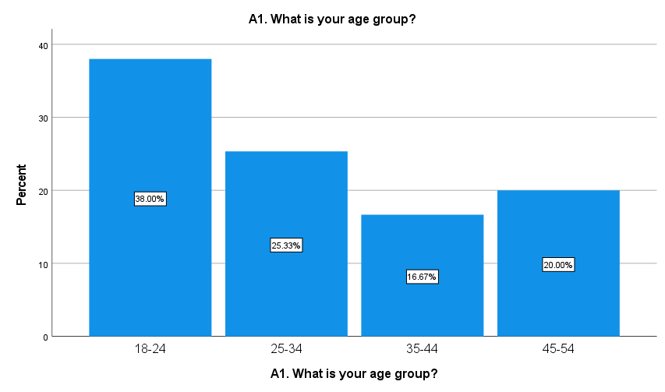
Figure 6: Age Group of Respondents
The age distribution of respondents is shown in Figure 5. The results shows that most of the respondents were aged between 18-24 years with 38.00% of the sample. Thereafter, 25.33% of the respondents were 25-34 years. The percentage of Respondents 45-54 is 20.00% while the 35-44 age group represents the lowest percentage of 16.67%. Researchers revealed the results stating that younger consumers formed the largest segment of respondents. This suggests that younger age groups tend to be more engaged with UK e-commerce websites and AI chatbots.
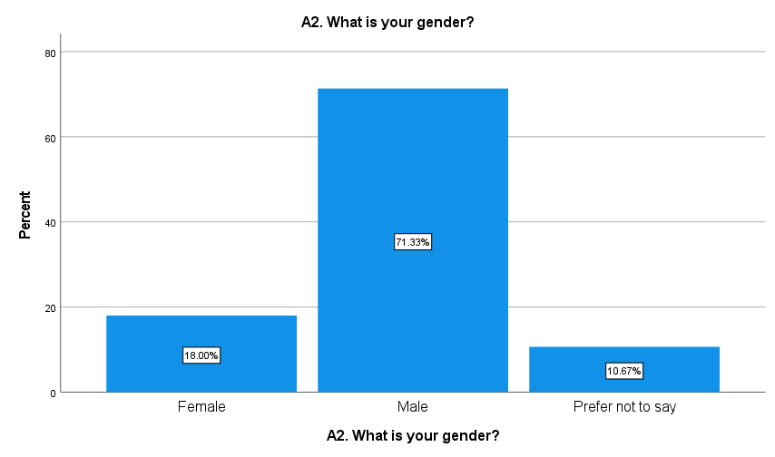
Figure 7: Gender Distribution of Respondents
The gender distribution of respondents involved in the study is shown in Figure 6. Male respondents dominated the sample which accounted for 71.33% of respondents from the study. Of the total sample, female respondents were 18.00% and gender not specified was 10.67%. "The study sample was predominately male, the findings show." This distribution implies that male consumers formed most of the respondents who utilise AI chatbot services on UK e-commerce platforms in this study.
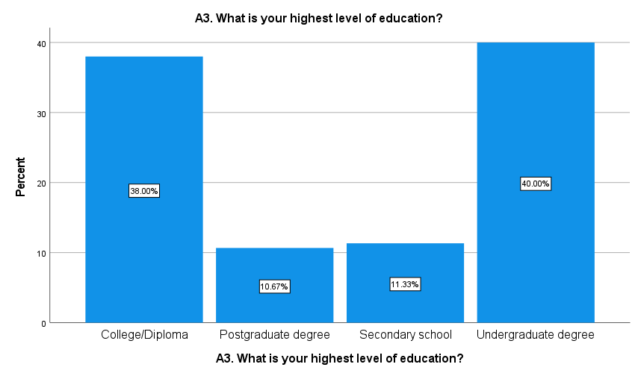
Figure 8: Highest Level of Education of Respondents
The education level of participants is shown in Figure 7. Among respondents, the largest proportion was of undergraduate degree holders, with a percentage of 40.00%. The second most likely group were respondents holding a university undergraduate qualification (38.00%) A total of 11.33% were with secondary school education while those with a postgraduate degree were 10.67%. According to the findings, respondents were highly educated, which means that the participants were relatively educated, with the benefit of online shopping and digital technologies such as AI chatbot services.
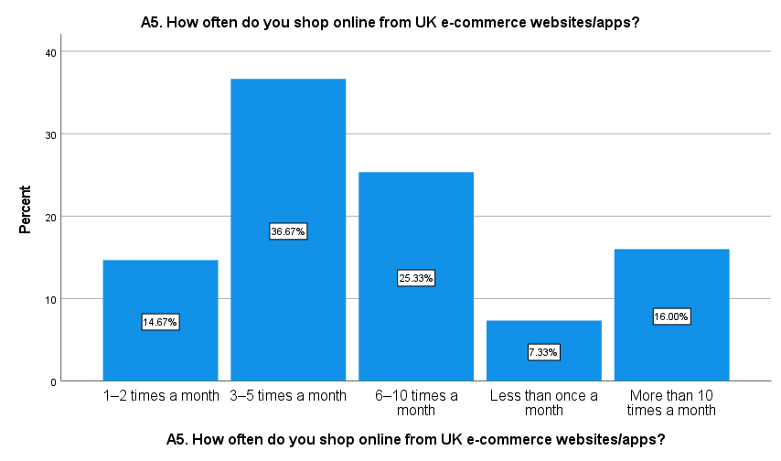
Figure 9: Frequency of Online Shopping from UK E-commerce Websites/Apps
According to figure 8, the frequency of online shopping behaviour on UK sites and apps for e-commerce. Most respondents, 36.67%, reported to shop online 3–5 times each month. Then, we have shopping for 6-10 times a month at 25.33%. Also, 16.00% went shopping more than 10 times in a month, and 14.67% shopped 1–2 times per month. Only 7.33% of respondents mentioned that they shop online less than once a month. Most of the participants were found to shop online quite often.

4.4 Reliability Analysis

4.4.1 AI Chatbot Service Quality
Table 1: Reliability Analysis for AI Chatbot Service Quality
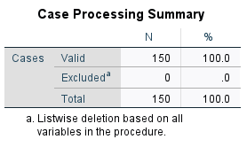

The findings from the reliability analysis of the AI Chatbot service quality construct are shown in Table 1. An investigation was done using Cronbach’s Alpha in testing the internal consistency of the measurement items 8, this variable contained. The results have shown that all 150 responses were valid and no cases were excluded in the study. Cronbach Alpha coefficient for AI chatbot service quality was found as 0.716 on 8 items. Since the value of alpha lies above the recommended acceptable threshold of 0.70, the scale demonstrates acceptable to moderate reliability (Izah, Sylva and Hait, 2023). Consequently, the measuring instrument used in this study to measure AI Chatbot service quality are reliable for further analysis.

4.4.2 Customer Trust
Table 2: Reliability Analysis for Customer Trust

Table 2 illustrates the reliability analysis results for the customer trust construct. The analysis included seven measurement items and was performed using Cronbach’s Alpha to evaluate scale consistency. The analysis shows that all the 150 responses were valid, while none of the responses were rejected. The 7 items for customer trust had a Cronbach’s Alpha value of 0.714. This value is above the recommended threshold of 0.70, indicating acceptable reliability and satisfactory internal consistency among the measurement items (Izah, Sylva and Hait, 2023). Therefore, the customer trust scale was considered reliable and appropriate for use in subsequent correlation and regression analyses.

4.4.3 User Experience
Table 3: Reliability Analysis for User Experience

Table 3 shows the reliability statistics for the user experience construct. The internal consistency of the eight measurement items under the user experience was assessed by the reliability analysis Cronbach’s Alpha. All 150 cases in the analysis process were valid and excluded no case were the analysis results. Cronbach’s Alpha for user experience was 0.720 based on 8 items. Alpha coefficient was more than the acceptable limit of 0.70. So, the scale was said to be reliable and have acceptable internal consistency (Izah, Sylva and Hait, 2023). Items measuring user experience were, therefore, found suitable for further statistical testing and hypothesis testing.

4.4.4 E-brand Loyalty
Table 4: Reliability Analysis for E-brand Loyalty

As shown in Table 4, the reliability analysis results of e-brand loyalty. The analysis comprises of a total of eight measurement items. The analysis process was done through the Cronbach’s Alpha. In addition, it helps the researcher to analyse the consistency of the items on the scale. The results indicate that no cases were excluded during the analysis process, as all 150 responses were valid. The reliability of 8 e-brand loyalty items was established via Cronbach Alpha of 0.730. The value was above 0.70, the minimum acceptable value, indicating acceptable reliability and good internal consistency of the items (Izah, Sylva and Hait, 2023). Consequently, the e-brand loyalty scale was regarded reliable and fit for further statistical analysis.

4.5 Hypothesis Testing

4.5.1 Correlation Analysis
Table 5: Correlation Analysis among Study Variables
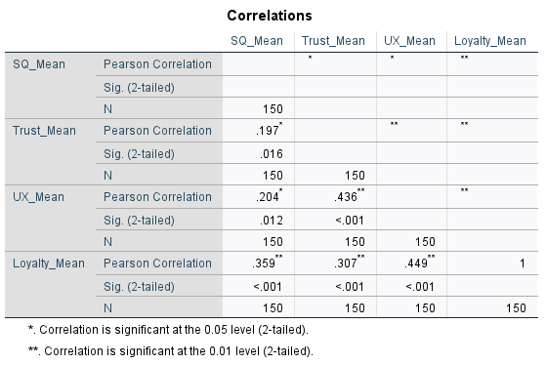
The findings from the Pearson correlation analysis of the relationship between the service quality of the AI chatbot, customer trust, user experience, and e-brand loyalty are presented in Table 5. The results show that all the variables were positively and significantly correlated. The quality of the AI chatbot facility has a positive correlation with customer trust (r = 0.197, p = 0.016), user experience (r = 0.204, p = 0.012), and e-brand loyalty (r = 0.359, p < 0.001). Customer trust was also positively related to user experience (r = 0.436, p < 0.001) and e-brand loyalty (r = 0.307, p < 0.001). User experience has the highest positive relation with e-brand loyalty (r = 0.449, p < 0.001). Finally, the results show that all the variables in this study are substantively mutually related.

4.5.2 Regression Analysis

H1: AI chatbot service quality positively influences customer trust significantly.
Table 6: Model Summary for Hypothesis 1
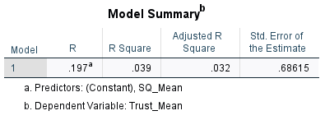
The results of the model summary in Table 6 indicate that there is a positive and significant influence between AI chatbot service quality and customer trust. From the regression model, the R value is 0.197 indicating a weak positive relationship between AI chatbot service quality and customer trust. The finding from the R Square value of 0.039 indicated AI chatbot service quality contributes to 3.9% of customer trust. The R square adjusted value was 0.032 and standard error of the estimate was 0.68615. Although the model was not very explanatory, results indicate that service quality is an important factor for the prediction of customer trust in the use of AI chatbots in e-commerce in the UK.
Table 7: ANOVA Results for Hypothesis 1
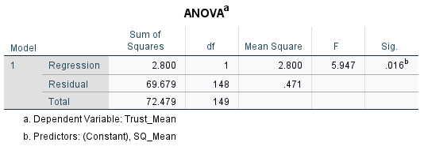
According to Table 7, the analysis of variance (ANOVA) results of the regression between the AI chatbot service quality and customer trust. It can be concluded that the regression model is significant. The F value is 5.947 with a significance of 0.016 which is lower than threshold value 0.05.
The sum of squares of regression is 2.800 while the sum of squares of residual is 69.679 The regression model can significantly predict customer trust from AI chatbots service quality.
Table 8: Coefficients Analysis for Hypothesis 1
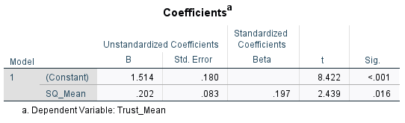
The coefficient analysis of relationship between AI chatbot service quality and customer trust is displayed in Table 8. The results showed that the beta coefficient value of the quality of AI chatbot service variable was 0.197 and had been standardized. The unstandardized coefficient value is 0.202, indicating that the quality of the AI chatbot service has a positive impact on customer trust. The significance value for the AI chatbot service quality was 0.016 which is lesser than 0.05. Thus, this is a statistically significant finding. Moreover, the t -value of 2.439 also indicates that the quality of AI chatbot service has a positive impact on customer trust. As a result, Hypothesis 1 was accepted and it has been found that there is a significant and positive correlation between the variables.
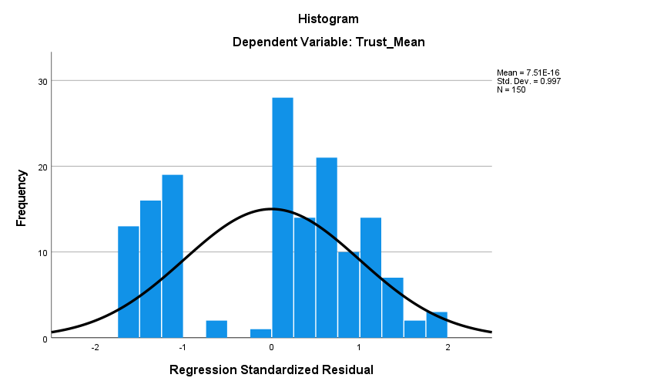
Figure 10: Histogram of Regression Standardized Residuals for Hypothesis 1
The histogram of regression standardized residuals of the relationship between AI chatbot service quality and customer trust is illustrated in Figure 9. The histogram indicates that the residual value is roughly normal with a mean value close to zero. The distribution is roughly bell-shaped indicating that normality assumption in regression analysis has been reasonably satisfied. Standard deviation is 0.997 with a total sample size of 150 respondents. The lack of substantial skewness or extreme outliers indicates that the regression model was statistically appropriate and that the residuals were sufficiently normally distributed for linear regression analysis.

H2: AI chatbot service quality positively influences e-brand loyalty.
Table 9: Model Summary for Hypothesis 2
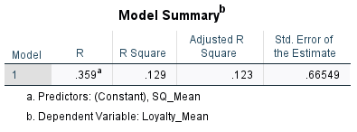
Table 9 shows the model summary results from the study of the effect of service quality in AI chatbot on e-brand loyalty. The R value obtained by the model is 0.359 which means that the service quality of AI chatbot positively affects e-brand loyalty. It had a R Square of 0.129, which it showed that AI chatbot service quality accounted for 12.9% variance of e-brand loyalty. The value of adjusted R Square is 0.123 and a standard error of estimate with 0.66549. Consumers’ use of AI chatbots in UK e-commerce grade platforms has a positive effect on the quality of AI chatbots which in turn positively affects the e-brand loyalty.
Table 10: ANOVA Results for Hypothesis 2
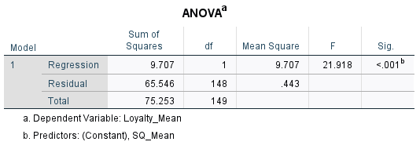
According to Table 10, the regression analysis between AI chatbot service quality and e-brand loyalty proceeds. The regression model was statistically significant with an F value of 21.918 and a significance value less than 0.001. The residual sum of squares is 65.546 and the regression sum of squares is 9.707. The regression model was determined to be statistically significant because the significance value was less than 0.05. Accordingly, AI chatbot service quality highly predicts e-brand loyalty of respondents in the UK e-commerce context included in this study.
Table 11: Coefficients Analysis for Hypothesis 2
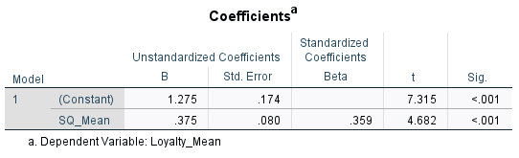
Table 11 depicts the correlation relationship between the quality of AI chatbot service and e-brand loyalty. It was found that the AI chatbot service quality has a standardized beta coefficient of 0.359 The unstandardized coefficient value of 0.375, which demonstrates that the better the AI chatbot service quality, the better the e-brand loyalty. The value of the significance of the service quality of AI chatbot was less than 0.001 which showed significant relationship. Furthermore, the t value was equal to 4.682 which was also an indication of the positive relationship. Therefore, Hypothesis 2 was accepted as the quality of AI Chatbot service significantly affects e-brand loyalty.
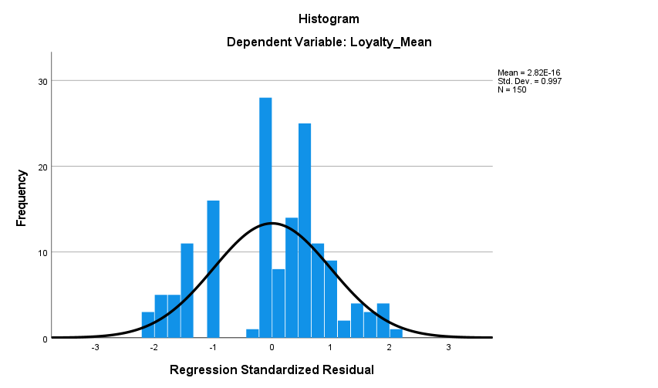
Figure 11: Histogram of Regression Standardized Residuals for Hypothesis 2
The histogram in this figure represents the regression standardized residuals between the quality of AI chatbot service and e-brand loyalty. As the histogram shows, the distribution of residual values was approximately normal for almost all linear fittings. The bell shape shows that normality assumption in regression analysis is satisfied reasonably well. The overall sample size of 150 respondents produced the standard deviation of 0.997. Also, no significant skewness or extreme outliers were detected in the distribution. Consequently, this regression model was statistically fit to study the relationship between AI chatbot services quality and e-brand loyalty.

H3: Customer trust positively influences e-brand loyalty.
Table 12: Model Summary for Hypothesis 3
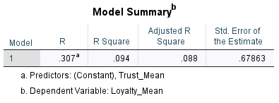
Table 12 shows the results of the model summary on customer trust regarding e-brand loyalty. Based on the analysis, we find the value of regression R to be equal to 0.307. Thus, there is a moderate positive relation between customer trust and e-brand loyalty of Nest Bookstore. The R Square value was 0.094, revealing that customer trust accounts for 9.4% of e-brand loyalty variance. The adjusted value of R Square was 0.088 and standard error of the estimate was 0.67863. Findings indicate that customer trust is a positive predictor of e-brand loyalty among respondents using UK e-commerce platforms and AI chatbot services.
Table 13: ANOVA Results for Hypothesis 3
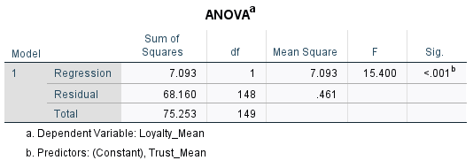
The regression analysis results of customer trust and e-brand loyalty are given in table 13 above. The F-value for the regression model is 15.400 which is significant at p < 0.001 level of significance. The regression sum of squares was 7.093 and the residual sum of squares was 68.160. As the value of significance is below the threshold level of 0.05, the regression model is considered significant. As such, customer trust is a significant predictor for e-brand loyalty among respondents in the studied UK e-commerce context.
Table 14: Coefficients Analysis for Hypothesis 3
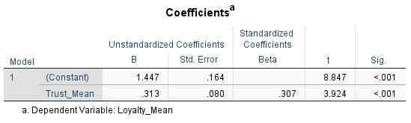
Table 14 shows the coefficients analysis on customer trust and e-brand loyalty relationship. The results showed that customer trust had a standardized beta coefficient of 0.307 which was positive. The unstandardized coefficient value of 0.313 shows that the level of Customer Trust affects E-Brand Loyalty. The significant value for the trust of the customers lay at a range below 0.001. The researcher also found the t-value to be 3.924 thereby supporting positively the customer trust on e-brand loyalty. As a result, Hypothesis 3 was accepted. Customer trust positively and significantly affects e-brand loyalty.
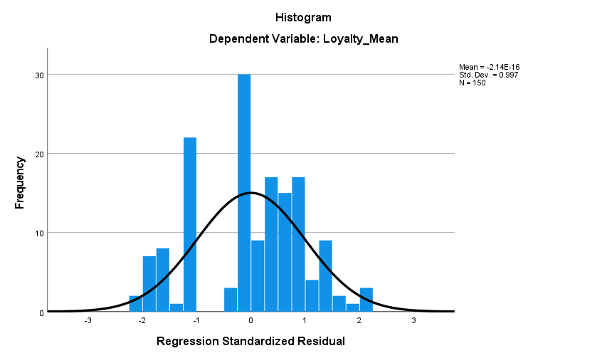
Figure 12: Histogram of Regression Standardized Residuals for Hypothesis 3
The histogram of residuals from the regression of customer trust on e-brand loyalty is shown in Figure 11. The histogram shows that the residual values are distributed nearly normally around a mean value of about zero. The distribution is generally bell-shaped, implying that the required normality assumption for regression analysis was to a reasonable extent satisfied. The standard deviation was 0.997 with 150 respondents. There wasn't any considerable skewness or outlier in the histogram. Thus, the regression model was deemed statistical adequate to the extent of customer trust affecting e-brand loyalty.

4.6 Discussion

4.6.1 Discussion 1
The findings of the study showed that there was a significant and positive effect of the quality of AI chatbot service on customer trust in the context of UK e-commerce. The regression results indicated a positive and significant effect of AI chatbot service quality on customer trust (β = 0.197, p = 0.016) showing an increase in levels of customer trust as the chatbot quality in terms of responsiveness, reliability, accuracy and personalization improves. Thus, the hypothesis 1 was accepted. It is in-line with the theory that the more “efficient, useful, reliable” the customer service systems are with the help of AI, the more likely people will trust them.
Results fit well with the Technology Acceptance Model of Fred Davis (1989) which posits that user acceptance and positive perceptions regarding technology are dependent on the perceived usefulness and ease of use. As part of this project, positive chatbot experiences could have contributed to increased satisfaction with the technology. This boost in confidence increases the chatbot's trust and brand's online trust. Trust will only grow when a consumer enters a service that he/she feels is reliable, competent and consistent, as per the Trust Theory of Robert Morgan and Shelby Hunt (1994). Thus, the findings showcase a similarity with each other.
Overall, the results provide strong empirical support for earlier studies outlined in Chapter 2. For example, Alagarsamy and Mehrolia (2023) found that information quality and service reliability positively influence customer trust in AI-enabled commerce settings. According to Wut et al. (2025), the clearer and more responsive a chatbot is, the less ambiguous the communication is. The present findings support the conclusion by Chi and Hoang Vu (2022) that communication quality is a significant antecedent to the trust formation of AI service systems. As AI chatbot interactions take the place of many conventional human interactions in e-commerce, customers lean heavily on system competence and communication quality in forming trust judgments.
The results also support the differentiation made by Wang et al. (2026) between cognitive trust and affective trust in trust in chatbots. The significant link shown in this study suggests that chatbot service quality may simultaneously bolster the two forms of trust. The cognitive trust may have been strengthened by functional dimensions such as accuracy and reliability and emotional reassurance and affective trust by conversational responsiveness and personalization. This aligns with a more extensive literature that suggests that trust in a chatbot is multidimensional.
AI chatbot service quality explained 3.9% (R² = 0.039) of customer trust, indicating there was a relationship, however, it was not very strong as shown by the regression model. In other words, trust creation in AI-enabled services is not only dependent on service quality. The research revealed that humans’ trust in AI systems is complex and context dependent.
According to Huang, Markovitch and Stough (2024), trust is determined by system performance, as well as users’ prior experiences, subjective attitudes towards AI, perceived risk and uncertainty in the situation. Consequently, chatbot service quality positively contributes to the development of trust, although it does not determine total customer trust.
In addition, the weak relationship found in this paper appears to corroborate the viewpoint by Moussa, Kortam and Mahmoud (2025) that consumers tend to view effective AI service as a necessity rather than a strong differentiator. As e-commerce becomes more competitive, customers assume bot systems can efficiently and accurately service them. As a result, having a great service quality, on its own, may not create strong trust unless it comes bundled with transparency, security assurance, emotional intelligence, and personalisation.
In summary, the results indicate that the quality of AI chatbot services positively influences customer trust in UK e-commerce. The findings are in line with theoretical and empirical literature which emphasize that reliable, responsive and personalized chatbot service can reduce uncertainty and boost customer confidence in AI services.

4.6.2 Discussion 2
The findings of the study confirmed that the quality of AI chatbot service has a significant positive effect on e-brand loyalty in the UK e-commerce industry. In the regression analysis, results showed that AI chatbot service quality has a significant and positive relationship with e-brand loyalty (β = 0.359, p < 0.001). As a result, Hypothesis 2 was accepted. According to the results, an improvement in a chatbot’s responsiveness, communication quality, reliability, and personalized content leads positively toward customer loyalty, which further results in repeat purchases and continued patronage of the online brands that employ AI-enabled customer services systems.
This shows that the Relationship Marketing Theory (Berry, 1995) assumptions hold when the focus is on engaging customers, creating continuous value, and building relationships to produce loyal customers and advocates.
According to this study, continuous interaction between consumers and e-commerce brands with the help of AI chatbots boosts customer trust and loyalty intentions. The findings indicate that the customers are more likely to buy the same online brand if the chatbots are able to provide a better service experience and satisfaction.
The findings also correlate closely with previously reviewed empirical studies in Chapter 2; for instance, Singh and Singh (2024) find that AI-assisted customer service enhances customer loyalty by improving service convenience and efficiency. In a similar vein, Beyari (2025) determined that AI-supported service systems enhance retention and behavioural loyalty in e-services. The present study also shows similar results, where customers view chatbot services positively and have a stronger tendency to stay loyal to online brands. The results also provide support to Zhao et al. (2026) who discovered that chatbot responsiveness and social presence positively affect repurchase intention and continuance intention.
Significantly, the link between chatbot quality of service and e-brand loyalty was stronger than the link between chatbot quality of service and customer trust established in Hypothesis 1. Moreover, the regression model accounted for 12.9% of the variance in e-brand loyalty (R² = 0.129). The implication is that chatbot service quality likely has a more direct impact on loyalty compared to trust in UK e-commerce. There is the possibility that the consumer’s digital retailing spends more time on what is offered and, on the speed, and efficiency of a seamless service experience. In consequence, customers may be more loyal to brands because the chatbot enhanced the shopping experience and efficiency of the service.
Literature also emphasizes the experiential aspects of AI-enabled customer service, in line with findings. The interaction design shapes user evaluation of chatbot experience, Haugeland et al. (2022). Pham et al. (2025) suggest that personalization and system quality have positive effect on satisfaction and loyalty of digital consumers. According to the results of the study, chatbot service quality positively affects loyalty. The consumers value a personalized service, which is why responsive service affects online shopping. This shows that the quality of chatbot service goes beyond merely technical functionalities, adding to a broader customer experience and customer engagement.
However, findings suggest that chatbot service quality is not sufficient to fully explain customer loyalty. Although the regression model was statistically significant, much of the variance was not explained. The earlier literature stated that loyalty is multidimensional and relies on several relationship and emotional factors. Service quality is not the only factor. Pham et al. (2025) contended that customer satisfaction mediates the relationship of service quality and service loyalty. In contrast, other studies revealed that trust, emotions, perceived value, and brand reputation are some of the factors ensuring loyalty in the long run.
Also, the findings are informative in the ongoing discussion of whether human-like interaction or technical efficiency is more important in chatbots. The positive findings imply that functional aspects of service quality remain very relevant in e-commerce contexts. Rita, Vong and Correia (2026) have argued that features that assist consumers with efficient service delivery and problem-solving capability are more highly valued than merely anthropomorphic features that are mostly social in nature. In utilitarian shopping setting like e-commerce, consumers may prefer instantaneous and accurate service than emotional or human-like conversation.
In sum, the results confirm the positive and significant influence of the AI chatbot service quality on e-brand loyalty. The findings corroborate theoretical and empirical evidence which indicates that effective, responsive, and personalized AI service interactions boost customer retention, repeat purchase intention, and long-term loyalty to e-commerce brands.

4.6.3 Discussion 3
The study results confirmed that customer trust significantly and positively influences e-brand loyalty in the UK e-commerce sector. The relationship between customer trust and e-brand loyalty was statistically significant and positive as indicated by the regression analysis (β = 0.307, p < 0.001). Thus, Hypothesis 3 was accepted. Consumers tend to develop higher loyalty toward an online brand when they feel that the interaction with AI chatbots is reliable, safe, or credible. This discovery emphasizes the significance of trust as a vital relationship mechanism that shapes long-term customer commitment and re-purchase behavioural intentions in AI-enabled e-commerce settings.
The results provide substantial support for the Trust Theory by Morgan and Hunt (1994) that highlights the importance of trust for long-lasting relationship between customer and supplier. Trust becomes particularly important in digital commerce environments characterized by uncertainty, perceived risk and a diminished role of the human element as the customer is encouraged to keep engaging with a brand. The study suggests that consumers who trust a chatbot system have confidence in the overall service process, which positively influences their repurchase and brand loyalty intentions.
The results reflect strong consistency with empirical studies discussed previously in Chapter 2. For example, Syarifudin, Yulianto, and Nugroho (2024) argued that trust enhances behavioural loyalty in digital commerce significantly because it reduces uncertainty and perceived transaction risk. Beyari (2025) also established trust as a key consumer determinant for long-term customer retention and repeat purchase behaviour in AI e-commerce systems. The current finding provides additional support for Wang et al. (2026) as they concluded that both cognitive trust and affective trust positively influence customer engagement and loyalty outcomes. This means that customers value not only the chatbot’s competence and reliability but also appreciate emotionally reassuring and responsive responses.
Moreover, these findings support the arguments of Alagarsamy and Mehrolia (2023), who found that trust positively impacts customer attitudes, satisfaction, and behavioural intentions in chatbot-mediated environments. In the current study, customers who had faith in chatbot systems remained loyal toward e commerce brands. Thus, this proposes that trust strengthens the relationship between consumers and digital brands. This lends credence to the overarching relationship marketing view that loyalty very much develops from repeat positive interactions and trust in service reliability over time.
Essentially, the impact of consumer trust on e-brand loyalty was considerable, yet not overwhelming. Specifically, trust explained only 9.4% of the variance in e-brand loyalty (R² = 0.094). As highlighted in the study, the customers may not be loyal even when they trust. The results of the study support existing literatures which sleep loyalty is multidimensional and is influenced by other factors namely satisfaction, personalization, service convenience, user experience, emotional engagement.
According to Ding et al. (2025) and Sujová (2024) for instance, trust may interdependently with satisfaction and customer experience to enhance other loyalty outcomes. While trust matters, customers may also find the efficiency, speed, and overall experience of shopping as effectiveness.
Furthermore, the findings will add to the literature concerning online trading mediated through AI. Since interactions with chatbots substitute consumer service interactions with humans, customers seem to depend more on technological trust. This backs up the evidence of Jenneboer, Herrando and Constantinides (2022) whereby trust in the brand goes beyond the brand itself and ensures service mediator technology. As a result, trustworthy chatbot systems can make customers feel more at ease and reduce anxiety directly related to internet-based interaction.
All in all, the findings show that customer trust has a significantly positive effect on e-brand loyalty in the UK e-commerce context. This is a study that is in line with theoretical and empirical evidence that trust is a vital factor for strengthening customer retention, repeat purchase intention and long-term loyalty in AI-enabled digital service contexts.

4.6.4 Hypotheses Summary and Decision Table
Table 15: Summary of Hypotheses Testing Results
Hypothesis | Relationship Tested | Beta (β) | Sig. Value | Decision
H1 | AI chatbot service quality → Customer trust | 0.197 | 0.016 | Accepted
H2 | AI chatbot service quality → E-brand loyalty | 0.359 | < 0.001 | Accepted
H3 | Customer trust → E-brand loyalty | 0.307 | < 0.001 | Accepted
The overview of the results of the hypothesis tests in the research is presented in Table 15. Results indicate that all hypotheses were statistically accepted. Hypothesis 1 tested the relationship between service quality of AI-chatbot and customer trust. The regression results show positive and statistically significant results (β = 0.197, p = 0.016).
This indicates that improvements in chatbot service quality positively influence customer trust. Hypothesis 2posited that the influence of AI chatbots service quality on e-brand loyalty showed a stronger positive relationship at β = 0.359 and p < 0.001. Thus, having a good quality chatbot interaction result in higher customer loyalty to online brands. In the end, customer trust and e-brand loyalty were tested under hypothesis three. According to the findings, higher levels of customer trust contribute toward e-brand loyalty (β = 0.307, p < 0.001). In general terms, all hypotheses were accepted as the significance values for all relationships was less than threshold level 0.05.

4.7 Conclusion
The study findings related to AI chatbot service quality, customer trust, user experience and e-brand loyalty in the context of the UK e-retail sector has been covered in this chapter. The demographic analysis reveals that most respondents are younger and a frequent online shopper which signifies that they have a strong recognition of e-commerce websites and AI chatbots. The internal consistency of all the measurements is consistent with the reliability analysis making them suitable for statistical analysis. The correlation study found positive and significant associations among all the study variables. Regression analysis was further conducted, and the results indicate that AI chatbot service quality has a significant effect on customer trust and e-brand loyalty. Thus all three hypotheses were accepted. According to the discussion section, findings are consistent with other studies which note that trust, responsiveness, personalization and service quality strengthen customer loyalty. Furthermore, this is also the case with AI-enabled e-commerce systems.

Chapter Five: Conclusion

5.1 Introduction
This final chapter in the study examines the correlation between AI Chatbot service quality, customer trust, and user experience and e-brand loyalty within the e-commerce industry in the UK. Results of the statistical analyses are presented in the chapter and related to the theoretical and empirical studies presented in previous chapters. The research investigated the impact of employing an AI chatbot on customer perception of a brand and their overall loyalty. The study used a quantitative study design with SPSS statistical analysis, which investigated the correlation between service quality of AI chatbots, customer trust, and e-brand loyalty. Apart from the suggestions to the e-commerce business and AI servicing developer, it also explains the limitations of the research work and future suggestions. The chapter concludes with a discussion on the importance and contributions of the research in the customer service system that is becoming increasingly AI-powered.

5.2 Summary of Findings
The results show that service quality of AI chatbots in the UK e-commerce has a significant effect on customer trust and e-brand loyalty. The findings show that reliability, responsiveness, quality of communication, accuracy and personalization of chatbot positively influences the customer's perceptions towards the online brand. Based on the reliability assessment, all the measurement constructs obtained the internal consistency with Cronbach's Alpha exceeding the recommended minimum of 0.70, demonstrating the reliability of the questionnaire items for statistical analyses (Izah, Sylva and Hait, 2023).
Analysing the demographics revealed that most of the respondents were young consumers who often engaged with AI chatbot systems and frequently shop online. This suggests that customers will likely be familiar with AI-powered customer service solutions in e-commerce settings through their online interactions.
Correlation analysis results shows that all the variables are positive, highly significant. The quality of AI Chatbot service is positively related to e-brand loyalty.
Moreover, there are also significant positive relationships between customer trust, user experience and e-brand loyalty. A strong relationship was found between user experience and e-brand loyalty. This implies that the overall quality of digital relationship matters to customers and thus influences their e-brand loyalty.
The regression test accepted all the proposed hypotheses. To begin with, there is a significant impact of AI chatbots on customer trust. Evidence suggests that customers trust AI-enabled services when they perceive interactions with chatbots as reliable, useful accurate, and responsive. The findings of the study are in conformity with Davis 1989 Technology Acceptance Model (TAM) that argues that perceived usefulness and ease of use positively affect technology acceptance and intention to use it. The findings also support Trust Theory as proposed by Morgan and Hunt (1994) since trust is built through reliability.
Second, the quality of AI Chatbot has a significant and positive impact on e-brand loyalty (β = 0.359, p < 0.001). This was the strongest relationship found in the study, suggesting efficient interactions with chatbots lead to repeat engagements, which aids customer retention and long-term loyalty. The findings strongly support the Relationship Marketing Theory proposed by Berry (1995), which emphasizes how creating new superior values ensures new relationships and creates customer engagement strategies for continuity of relationship. Findings that are reported also support the findings of previous empirical studies such as Singh and Singh(2024), and Beyari (2025), which argued that AI supported service systems positively affect customer loyalty in digital commerce.
Thirdly, e-brand loyalty was significantly influenced by customer trust (β = 0.307, p < 0.001). This finding shows that trust is still an important relational mechanism in AI service. Customers are likely to stay loyal toward online brands that make use of chatbot systems they consider safe and trustworthy. The finding is in accordance with the previous research done by Syarifudin, Yulianto and Nugroho (2024) which state that trust reduces uncertainty and improves loyalty behaviour in digital commerce.
The results confirm that AI chatbot service quality significantly contributes to improving customer trust and e-brand loyalty on UK e-commerce platforms.
Nonetheless, the regression models’ moderate explanatory power implies that loyalty is determined by additional factors in addition to chatbot quality and trust, including emotional engagement and satisfaction, perceived value, and customer experience dimension.

5.3 Recommendations
Considering the study findings, several practical recommendations can be made regarding e-commerce and AI chatbots.
First organisations must focus on enhancing the functional quality of AI chatbot systems. Chatbot service quality affects customer trust and loyalty. Businesses should focus their chatbot systems on fast response time, accurate information and response, reliable and available support, as well as effective problem-resolution ability. When there are technical failures or problems with the quality of the communication, the confidence of the customer may reduce, having, in turn, a negative influence on the loyalty outcomes.
In addition, the chatbot should be personalized with the company’s investment. With personalisation, customers are more likely to interact and develop more meaningful digital experiences. AI chatbots should improve their recommendations and generate better responses with personalized suggestions that know the customers’ needs, preferences and emotions for better user satisfaction.
Aiming to increase customer trust in AI is another focus of organisations. It is important to ensure transparency about the functionality and privacy protection of chatbots, so consumers can trust them. Users should feel assured that any information will not be released and that the communication is not human signed off.
Fourthly, businesses need to consider efficiency, as well as the ability to interact with humans like real people. While the performance of the function still matters a lot for e-commerce contexts, a friendly, sympathetic and responsive conversation can enhance the customer experience as well as emotional attachment. Thus, the chatbot systems must have not only technical skills but also have a communication with the user.
Lastly, businesses should keep tracking feedback and chatbot activities. Application systems must constantly be upgraded, evaluated and services expanded to stay competitive in digital commerce markets as consumers' expectations of what AI technologies can do are constantly shifting.

5.4 Limitations
The findings of this study have a couple of limitations which must be noted. The study design employed in the research was cross sectional in which the data were collected at a particular point of time. For this reason, the study concluded that it was not feasible to investigate the changes in perceptions and loyalty over time. As chatbot systems become more sophisticated, consumers’ views on AI technologies are expected to evolve.
The study convenience sampling and dissemination of the online questionnaire can be seen as a limitation of the research. Even though the sample included active e-commerce consumers from the UK, this described group may not be all online consumers. As a third point, the research was related to UK e-commerce. As a result of this, the results may not be transferrable to other sectors in other countries with different cultural expectations, technology and consumer behaviour.
The research investigated how service quality of AI chatbots affects customer trust, user experience and e-brand loyalty. The other important variables such as satisfaction, emotional attachment, perceived risk, brand reputation, and technology anxiety were left out of the conceptual framework. The self-reported questionnaire responses may cause response bias or subjective interpretation by participants. The respondents may have responded on the perceptions and not on the behaviour.

5.5 Future Research
Longitudinal design can be used in future studies to investigate the changes in customer trust and loyalty in the long term for AI chatbot systems. As AI Technologies evolve, continual study approaches can provide more insight on changing consumer attitudes.

Future researchers should investigate other mediators and moderators that can affect the results of loyalty, Customer satisfaction, emotional engagement, perceived value, perceived enjoyment and technology anxiety are some variables that may offer a better insight into customer behaviour in AI-enabled commerce.
Contextual inferences relating to the effectiveness of chatbots can be drawn from comparative studies done in diverse industries and nations. Future studies, which can be replicated in other service industries such as tourism/hospitality and banking could help to determine if customer expectations of chatbots vary across service industries.
Further, qualitative or mixed-method approaches may be used by future studies to further investigate emotional and psychological aspects in such situations. Interviews and focus groups offer a more comprehensive understanding of what customers want to see, what they struggle with and their experiences with AI communication. Future research should investigate whether newer technologies, such as generative AI, emotional AI and voice-based conversational simulation systems can facilitate relationship-building in terms of trust, engagement and loyalty in digital commerce.

5.6 Final Reflection
This study contributes to the understanding of AI-enabled customer services systems and their influence on customer behaviour in UK e-commerce. Per the results, AI chatbot service quality influences customer trust directly and at the same time is a crucial factor for long-term e-brand loyalty. As the world of commerce rejoices in the ever-changing digital world, businesses are turning to automated customer service technology. As such, the perception of customers at AI interactions is gathering growing interest amongst scholars and businesses.
Countless things define consumer loyalty in a digital environment. Besides technical efficiency, institutions are viewed more favourably because of relational and experiential efficiency through trust, personalization and interaction. Despite more chatbot systems in use, customers still expect a service experience that is dependable, safe and emotionally rewarding. So, businesses must not only depend on how efficient automation is but also develop trust and customer-centred AI interactions.
The research confirmed that Technology Acceptance Model, Trust Theory, and Relational Marketing Theory are adequate for explaining customer behaviour in AI-mediated environments. The research findings show that there are practical implications for the study; specifically, the study points to the fact that organizations can improve customer engagement through deployment of AI technology.
Through an empirical study of technology, researchers find that AI chatbot technology can help strengthen customer relationships as well as customer loyalty outcomes. With the ongoing evolution and the growth of AI, enterprises that find a balance between technological capabilities and consumer trust and expectations will be better positioned to gain a competitive edge in the digitalised e-commerce landscape.

6. References
Akdemir, D.M. and Bulut, Z.A. (2024). Business and Customer-Based Chatbot Activities: The Role of Customer Satisfaction in Online Purchase Intention and Intention to Reuse Chatbots. Journal of theoretical and applied electronic commerce research, [online] 19(4), pp.2961–2979. doi:https://doi.org/10.3390/jtaer19040142.
Alagarsamy, S. and Mehrolia, S. (2023). Exploring chatbot trust: Antecedents and behavioural outcomes. Heliyon, 9(5), pp.e16074–e16074. doi:https://doi.org/10.1016/j.heliyon.2023.e16074.
Ali, P. and Younas, A. (2021). Understanding and Interpreting Regression Analysis. Evidence Based Nursing, [online] 24(4), pp.116–118. doi:https://doi.org/10.1136/ebnurs-2021-103425.
Al-Oraini, B.S. (2025). Chatbot dynamics: trust, social presence and customer satisfaction in AI-driven services. Journal of Innovative Digital Transformation. doi:https://doi.org/10.1108/jidt-08-2024-0022.
Alsaqr, A.M. (2021). Remarks on the use of Pearson’s and Spearman’s correlation coefficients in assessing relationships in ophthalmic data. African Vision and Eye Health, 80(1). doi:https://doi.org/10.4102/aveh.v80i1.612.
Aly, E. (2025). Compassion through technology: Digital empathy concept analysis and implications in nursing. Digital Health, [online] 11(1). doi:https://doi.org/10.1177/20552076251326221.
Ani, A., Dalimunthe, M. and Daulay, E. (2025). The Effectiveness of Creating Assessment Questions Through Google Form as a Digital Learning Assessment Tool. IDEAS: Journal on English Language Teaching and Learning, Linguistics and Literature, [online] 13(2), pp.7484–7497. doi:https://doi.org/10.24256/ideas.v13i2.8578.
Baumeister, S., Kocher, T., Papapanou, P.N., Birte Holtfreter and Demmer, R.T. (2026). Cross‐Sectional Studies: Strengths, Limitations, and Methodological Considerations. Journal of Periodontal Research. doi:https://doi.org/10.1111/jre.70063.
Bergdahl, E. and Berterö, C.M. (2023). Creating theory: Encouragement for using creativity and deduction in qualitative nursing research. Nursing Philosophy, 24(4). doi:https://doi.org/10.1111/nup.12421.
Berry, L.L. (1995). Relationship Marketing of Services--Growing Interest, Emerging Perspectives. Journal of the Academy of Marketing Science, [online] 23(4), pp.236–245. doi:https://doi.org/10.1177/009207039502300402.
Beyari, H. (2025). Artificial intelligence’s effect on customer loyalty in the context of electronic commerce. Deleted Journal. doi:https://doi.org/10.1007/s43995-025-00142-z.
Casula, M., Rangarajan, N. and Shields, P. (2021). The Potential of Working Hypotheses for Deductive Exploratory Research. Quality & Quantity, 55(1), pp.1703–1725. doi:https://doi.org/10.1007/s11135-020-01072-9.
Chand, S.P. (2025). Methods of Data Collection in Qualitative Research: Interviews, Focus Groups, Observations, and Document Analysis. Advances in Educational Research and Evaluation, [online] 6(1), pp.303–317. doi:https://doi.org/10.25082/aere.2025.01.001.
Chau, H.K.L., Ngo, T.T.A., Bui, C.T. and Tran, N.P.N. (2025). Human-AI Interaction in E-Commerce: The Impact of AI-Powered Customer Service on User Experience and Decision-Making. Computers in Human Behavior Reports, [online] 19, p.100725. doi:https://doi.org/10.1016/j.chbr.2025.100725.
Chen, Q., Gong, Y., Lu, Y. and Tang, J. (2022). Classifying and measuring the service quality of AI chatbot in frontline service. Journal of Business Research, 145(145), pp.552–568. doi:https://doi.org/10.1016/j.jbusres.2022.02.088.

Cheng, X., Bao, Y., Zarifis, A., Gong, W. and Mou, J. (2021). Exploring consumers’ Response to text-based Chatbots in e-commerce: the Moderating Role of Task Complexity and Chatbot Disclosure. Internet Research, 32(2). doi:https://doi.org/10.1108/intr-08-2020-0460.
Cheng, Y. and Jiang, H. (2020). How Do AI-driven Chatbots Impact User Experience? Examining Gratifications, Perceived Privacy Risk, Satisfaction, Loyalty, and Continued Use. Journal of Broadcasting & Electronic Media, 64(4), pp.1–23. doi:https://doi.org/10.1080/08838151.2020.1834296.
Chi, N.T.K. and Hoang Vu, N. (2022). Investigating the customer trust in artificial intelligence: The role of anthropomorphism, empathy response, and interaction. CAAI Transactions on Intelligence Technology, 8(1). doi:https://doi.org/10.1049/cit2.12133.
Chung, M., Ko, E., Joung, H. and Kim, S.J. (2020). Chatbot e-service and Customer Satisfaction regarding Luxury Brands. Journal of Business Research, 117(117), pp.587–595. doi:https://doi.org/10.1016/j.jbusres.2018.10.004.
Cooksey, R.W. (2020). Descriptive Statistics for Summarising Data. Illustrating Statistical Procedures: Finding Meaning in Quantitative Data, 1(1), pp.61–139. doi:https://doi.org/10.1007/978-981-15-2537-7_5.
Criveanu, M.M. (2025). The Impact of Digital Technology on E-Commerce and Sustainable Performance in the EU. Economies, [online] 14(1), p.5. doi:https://doi.org/10.3390/economies14010005.
Davis, F.D. (1989). Perceived usefulness, perceived ease of use, and user acceptance of information technology. MIS Quarterly, [online] 13(3), pp.319–340. doi:https://doi.org/10.2307/249008.
De Andrés-Sánchez, J. and Gené-Albesa, J. (2024). Not with the bot! The relevance of trust to explain the acceptance of chatbots by insurance customers. Humanities and Social Sciences Communications, [online] 11(1), pp.1–12. doi:https://doi.org/10.1057/s41599-024-02621-5.
Deshmukh, S. and Sharma, A. (2026). Impact of AI Chatbots on Consumer Service Experience and Perceived Accountability of Firms. Advances in Social Science, Education and Humanities Research, [online] pp.107–117. doi:https://doi.org/10.2991/978-2-38476-547-8_13.
Dewanti, R. and Ikhsan, R.B. (2025). Do chatbots support consumer performance? Investigating the role of E-lifestyle and anthropomorphism in the service industry. International Journal of Information Management Data Insights, [online] 5(1), p.100339. doi:https://doi.org/10.1016/j.jjimei.2025.100339.
Ding, Y. and Najaf, M. (2024). Interactivity, humanness, and trust: a psychological approach to AI chatbot adoption in e-commerce. BMC Psychology, 12(1). doi:https://doi.org/10.1186/s40359-024-02083-z.
Ding, Z., Zhang, Y., Sun, J., Goh, M. and Yang, Z. (2025). Harmonizing Human Touch and AI Precision in Customer Service. Journal of Service Research. doi:https://doi.org/10.1177/10946705251384692.
Følstad, A., Law, E.L.-C. . and van As, N. (2024). Conversational Breakdown in a Customer Service Chatbot: Impact of Task Order and Criticality on User Trust and Emotion. ACM Transactions on Computer-Human Interaction. doi:https://doi.org/10.1145/3690383.
Gambetta, D. (2019). Trust. Making and Breaking Cooperative Relations. [online] Philpapers.org. Available at: https://philpapers.org/rec/GAMTMA-2 [Accessed 13 Mar. 2025].
Gao, J., Abdullah Promise Opute, Jawad, C. and Zhan, M. (2025). The influence of artificial intelligence chatbot problem solving on customers’ continued usage intention in e-commerce platforms: an expectation-confirmation model approach. Journal of Business Research, 200, pp.115661–115661. doi:https://doi.org/10.1016/j.jbusres.2025.115661.
Hao, X., Dong, D., Zhang, Y. and Demir, E. (2025). When customers know it’s AI: Experimental comparison of human and LLM-Based Communication in service recovery. Journal of Marketing Communications, pp.1–28. doi:https://doi.org/10.1080/13527266.2025.2540376.
Hassan, N., Abdelraouf, M. and El-Shihy, D. (2025). The Moderating Role of Personalized Recommendations in the Trust–satisfaction–loyalty relationship: an Empirical Study of AI-driven e-commerce. Future Business Journal, 11(1). doi:https://doi.org/10.1186/s43093-025-00476-z.
Haugeland, I.K.F., Følstad, A., Taylor, C. and Alexander, C. (2022). Understanding the user experience of customer service chatbots: An experimental study of chatbot interaction design. International Journal of Human-Computer Studies, 161, p.102788. doi:https://doi.org/10.1016/j.ijhcs.2022.102788.
Hsu, C.-L. and Lin, J.C.-C. (2023). Understanding the user satisfaction and loyalty of customer service chatbots. Journal of Retailing and Consumer Services, 71, pp.103–211. doi:https://doi.org/10.1016/j.jretconser.2022.103211.
Hu, X., Xu, X. and Chen, C. (Crystal) (2025). Empowering Consumers: The Role of Avatar Choice in Consumer-Chatbot Interaction and Psychological Ownership. International Journal of Human–Computer Interaction, pp.1–12. doi:https://doi.org/10.1080/10447318.2025.2495845.
Huang, D., Markovitch, D.G. and Stough, R.A. (2024). Can chatbot customer service match human service agents on customer satisfaction? An investigation in the role of trust. Journal of Retailing and Consumer Services, [online] 76, p.103600. doi:https://doi.org/10.1016/j.jretconser.2023.103600.
Hussain, M. A., Hussain, A., Rahman, M. A. U., Irfan, M. and Hussain, S. D. (2025) 'The effect of AI in fostering customer loyalty through efficiency and satisfaction' Advances in Consumer Research 2(1), pp. 331-340.
Izah, S.C., Sylva, L. and Hait, M. (2023). Cronbach’s Alpha: A Cornerstone in Ensuring Reliability and Validity in Environmental Health Assessment. ES Energy & Environment, [online] Volume 23 (March 2024) In Progress(0), p.1057. Available at: https://www.espublisher.com/journals/articledetails/1057.
Jenneboer, L., Herrando, C. and Constantinides, E. (2022). The Impact of Chatbots on Customer loyalty: a Systematic Literature Review. Journal of Theoretical and Applied Electronic Commerce Research, 17(1), pp.212–229. doi:https://doi.org/10.3390/jtaer17010011.
Jung, S.J. (2021). Introduction to Mediation Analysis and Examples of Its Application to Real-world Data. Journal of Preventive Medicine and Public Health, 54(3), pp.166–172. doi:https://doi.org/10.3961/jpmph.21.069.
Jyothsna, Subbaiah, V. and Kryvinska, N. (2024). Exploring the Chatbot usage intention-A mediating role of Chatbot initial trust. Heliyon, [online] 10(12), pp.e33028–e33028. doi:https://doi.org/10.1016/j.heliyon.2024.e33028.
Kang, E. and Hwang, H.-J. (2023). The Importance of Anonymity and Confidentiality for Conducting Survey Research. [online] ResearchGate. Available at: https://www.researchgate.net/publication/370048267_The_Importance_of_Anonymity_and_Confidentiality_for_Conducting_Survey_Research.
Khneyzer, C., Boustany, Z. and Dagher, J. (2024). AI-Driven Chatbots in CRM: Economic and Managerial Implications across Industries. Administrative Sciences, [online] 14(8), pp.182–182. Available at: https://www.mdpi.com/2076-3387/14/8/182.
Kleinert, T., Waldschütz, M., Blau, J., Heinrichs, M. and Schiller, B. (2026). AI outperforms humans in establishing interpersonal closeness in emotionally engaging interactions, but only when labelled as human. Communications Psychology. doi:https://doi.org/10.1038/s44271-025-00391-7.
Lăzăroiu, G., Neguriţă, O., Grecu, I., Grecu, G. and Mitran, P.C. (2020). Consumers’ Decision-Making Process on Social Commerce Platforms: Online Trust, Perceived Risk, and Purchase Intentions. Frontiers in Psychology, 11(1). doi:https://doi.org/10.3389/fpsyg.2020.00890.
Li, B., Chen, Y., Liu, L. and Zheng, B. (2023). Users’ intention to adopt artificial intelligence-based chatbot: a meta-analysis . Service Industries Journal, pp.1–23. doi:https://doi.org/10.1080/02642069.2023.2217756.
Li, C.-Y., Fang, Y.-H. and Chiang, Y.-H. (2023). Can AI chatbots help retain customers? An integrative perspective using affordance theory and service-domain logic. Technological Forecasting and Social Change, 197, p.122921. doi:https://doi.org/10.1016/j.techfore.2023.122921.
Lim, W.M. (2024). What Is Qualitative research? an Overview and Guidelines. Australasian Marketing Journal (AMJ), 33(2), pp.199–229. doi:https://doi.org/10.1177/14413582241264619.
Lim, W.M., Kumar, S., Verma, S. and Chaturvedi, R. (2022). Alexa, what do we know about conversational commerce? Insights from a systematic literature review. Psychology & Marketing, 39(6). doi:https://doi.org/10.1002/mar.21654.
Lionello, M., Aletta, F., Mitchell, A. and Kang, J. (2021). Introducing a Method for Intervals Correction on Multiple Likert Scales: A Case Study on an Urban Soundscape Data Collection Instrument. Frontiers in Psychology, 11. doi:https://doi.org/10.3389/fpsyg.2020.602831.
Ltifi, M. (2023). Trust in the chatbot: a semi-human relationship. Future Business Journal, 9(1). doi:https://doi.org/10.1186/s43093-023-00288-z.
Maksimovic, J. and Evtimov, J. (2023). POSITIVISM AND POST-POSITIVISM AS THE BASIS OF QUANTITATIVE RESEARCH IN PEDAGOGY. Research in Pedagogy, [online] 13(1), pp.208–218. Available at: https://www.ceeol.com/search/article-detail?id=1132657.
Maretha, C. (2023). Positivism in Philosophical Studies. Journal of Innovation in Teaching and Instructional Media, 3(3), pp.124–138.
Meng, H., Lu, X. and Xu, J. (2025). The Impact of Chatbot Response Strategies and Emojis Usage on Customers’ Purchase Intention: The Mediating Roles of Psychological Distance and Performance Expectancy. Behavioral Sciences, 15(2), pp.117–117. doi:https://doi.org/10.3390/bs15020117.
Mohajan, H.K. (2020). Quantitative research: A successful investigation in natural and social sciences. Journal of Economic Development, Environment and People, [online] 9(4), pp.50–79. Available at: https://www.ceeol.com/search/article-detail?id=939590.
Morgan, R.M. and Hunt, S.D. (1994). The Commitment-Trust Theory of Relationship Marketing. Journal of Marketing, 58(3), pp.20–38. doi:https://doi.org/10.2307/1252308.
Moussa, T.F.M.A., Kortam, A. and Mahmoud, R. (2025). The Impact of AI-Enabled Service Quality and Perceived Convenience on AI-Enabled Customer Experience: A Quantitative Study in E-Marketing. [online] Available at: https://jces.journals.ekb.eg/article_437842_07b82fd9964294a007c168925a29c89f.pdf [Accessed 17 Apr. 2026].
Nair, S., Shantha, S. and Prem (2020). A Framework for Mixed-method Research. Shanlax International Journal of Management, [online] 8(2), pp.45–53. Available at: https://pdfs.semanticscholar.org/e857/51bdafd40163b9fe516bf48b9af01ec2db4e.pdf.
Naqvi, M.H., Zhang, H., Muhammad and Li, K. (2023). Impact of service agents on customer satisfaction and loyalty: mediating role of Chatbots. Journal of Modelling in Management. doi:https://doi.org/10.1108/jm2-01-2023-0004.
Nguyen, T.H. and Le, X.C. (2024). Artificial intelligence-based chatbots – a motivation underlying sustainable development in banking: standpoint of customer experience and behavioral outcomes. Cogent Business & Management, 12(1). doi:https://doi.org/10.1080/23311975.2024.2443570.
O’Higgins, B. and Fatorachian, H. (2025). Consumer trust in artificial intelligence in the UK and Ireland’s personal care and cosmetics sector. Cogent Business & Management, 12(1). doi:https://doi.org/10.1080/23311975.2025.2469765.
Oliveri, S., Lanzoni, L., Petrocchi, S., Janssens, R., Schoefs, E., Huys, I., Smith, M.Y., Smith, I.P., Veldwijk, J., de Wit, G.A. and Pravettoni, G. (2021). Opportunities and Challenges of Web-Based and Remotely Administered Surveys for Patient Preference Studies in a Vulnerable Population. Patient Preference and Adherence, [online] Volume 15(15), pp.2509–2517. doi:https://doi.org/10.2147/ppa.s327006.
Park, S. and Whang, M. (2022). Empathy in Human–Robot Interaction: Designing for Social Robots. International Journal of Environmental Research and Public Health, 19(3), p.1889. doi:https://doi.org/10.3390/ijerph19031889.
Paudel, P. (2024). Examining Paradigmatic Shifts: Unveiling the Philosophical Foundations Shaping Social Research Methodologies. Journal of the University of Ruhuna, [online] 12(1), pp.45–58. doi:https://doi.org/10.4038/jur.v12i1.8033.
Pham, T.C.T., Huynh, T., Tran, P.T. and Ly, A.Q., 2025. Exploring How Ai Chatbots Influence Customer Loyalty Among Generation Z on E-Commerce Platforms. Advances in Consumer Research, 2, pp.2473-2486.
Pires, P.B., Prisco, M., Delgado, C. and Santos, J.D. (2024). A Conceptual Approach to Understanding the Customer Experience in E-Commerce: An Empirical Study. Journal of Theoretical and Applied Electronic Commerce Research, [online] 19(3), pp.1943–1983. Available at: https://www.mdpi.com/0718-1876/19/3/96.
Rahayu, N.I., Muktiarni, M. and Hidayat, Y. (2024). An Application of Statistical Testing: A Guide to Basic Parametric Statistics in Educational Research Using SPSS. ASEAN Journal of Science and Engineering, [online] 4(3), pp.569–582. doi:https://doi.org/10.17509/ajse.v4i3.76092.
Rahman, Md.M. (2023). Sample size determination for survey research and non-probability sampling techniques: A review and set of recommendations | journal of entrepreneurship, business and economics. [online] www.scientificia.com. Available at: http://www.scientificia.com/index.php/JEBE/article/view/201.
Rath, S., Tripathy, A. and Tripathy, A.R. (2020). Prediction of new active cases of coronavirus disease (COVID-19) pandemic using multiple linear regression model. Diabetes & Metabolic Syndrome, [online] 14(5), pp.1467–1474. doi:https://doi.org/10.1016/j.dsx.2020.07.045.
Rita, P., Vong, C. and Correia, C. (2026). How AI-Driven Chatbots Shape Customer Satisfaction and Loyalty to Chatbot Usage in Digital Service Experience. Computers in Human Behavior Reports, p.101017. doi:https://doi.org/10.1016/j.chbr.2026.101017.
Saunders, M.N.K. and Darabi, F. (2024). Using multi- and mixed methods research designs. Edward Elgar Publishing eBooks, pp.71–87. doi:https://doi.org/10.4337/9781035313891.00018.
Saunders, M.N.K., Lewis, P. and Thornhill, A. (2019). Research Methods for Business Students. 8th Edition, Pearson, New York. - References - Scientific Research Publishing. [online] www.scirp.org. Available at: https://www.scirp.org/reference/referencespapers?referenceid=2907709.
Sboui, M., Baati, O. and Sfar, N. (2024). Influencing factors and consequences of chatbot initial trust in AI telecommunication services: a study on Generation Z. The TQM Journal. doi:https://doi.org/10.1108/tqm-02-2024-0085.
Shah, P., Thornton, I., Turrin, D. and Hipskind, J.E. (2024). Informed Consent. [online] National Library of Medicine. Available at: https://www.ncbi.nlm.nih.gov/books/NBK430827/.
Shahzad, M.F., Xu, S., An, X. and Javed, I. (2024). Assessing the impact of AI-chatbot service quality on user e-brand loyalty through chatbot user trust, experience and electronic word of mouth. Journal of Retailing and Consumer Services, [online] 79(1), p.103867. doi:https://doi.org/10.1016/j.jretconser.2024.103867.
Singh, C., Dash, M.K., Sahu, R. and Kumar, A. (2024). Investigating the acceptance intentions of online shopping assistants in E-commerce interactions: Mediating role of trust and effects of consumer demographics. Heliyon, [online] 10(3), p.e25031. doi:https://doi.org/10.1016/j.heliyon.2024.e25031.
Singh, P. and Singh, V. (2024). The power of AI: enhancing customer loyalty through satisfaction and efficiency. Cogent Business & Management, [online] 11(1). doi:https://doi.org/10.1080/23311975.2024.2326107.
Song, S.W. and Shin, M. (2022). Uncanny Valley Effects on Chatbot Trust, Purchase Intention, and Adoption Intention in the Context of E-Commerce: The Moderating Role of Avatar Familiarity. International Journal of Human–Computer Interaction, 40(2), pp.1–16. doi:https://doi.org/10.1080/10447318.2022.2121038.
South, L., Saffo, D., Vitek, O., Dunne, C. and Borkin, M.A. (2022). Effective Use of Likert Scales in Visualization Evaluations: A Systematic Review. Computer Graphics Forum, 41(3), pp.43–55. doi:https://doi.org/10.1111/cgf.14521.
Sujová, A.J. (2025). Implementing AI Chatbots in Customer Service Optimization—A Case Study in Micro-Enterprise. Information, [online] 16(12), pp.1078–1078. doi:https://doi.org/10.3390/info16121078.
Syafitri, R. and Alfansi, L. (2024). The power of information: boosting users’ chatbot through trust and satisfaction in Indonesian e-commerce. Manajemen dan Bisnis, [online] 23(1), pp.137–150. doi:https://doi.org/10.24123/mabis.v23i1.743.
Syarifudin, M., Yulianto, E. and Nugroho, A. (2024). Modeling AI-Chatbot Service Quality and Purchase Intention: Mediating Mechanisms and the Moderating Role of Intrusiveness. Journal of Digital Marketing and Halal Industry, [online] 6(2), pp.211–240. doi:https://doi.org/10.21580/jdmhi.2024.6.2.27893.
Uzoka, A., Cadet, E. and Ojukwu, P.U. (2024). Leveraging AI-Powered chatbots to enhance customer service efficiency and future opportunities in automated support. Computer Science & IT Research Journal, [online] 5(10), pp.2485–2510. doi:https://doi.org/10.51594/csitrj.v5i10.1676.
Wadud, I., Liang, Y.D. and Polkinghorne, M. (2025). Digital Transformation in the UK Retail Sector. Encyclopedia, [online] 5(3), p.142. doi:https://doi.org/10.3390/encyclopedia5030142.
Wahbi, A., Khaddouj, K. and Lahlimi, N. (2023). Study of the relationship between chatbot technology and customer experience and satisfaction. International Journal of Accounting, Finance, Auditing, Management and Economics, [online] 4(6-1), pp.758–771. doi:https://doi.org/10.5281/zenodo.10442472.
Wahyuni, E.S., Yuningsih, A. and Arisandy, Y. (2025). Managing customer service through artificial intelligence-driven chatbot systems in Islamic Banking institutions. al-Uqud : Journal of Islamic Economics, [online] 9(1), pp.96–104. doi:https://doi.org/10.26740/al-uqud.v9n1.p96-104.
Wanat, M., Boylan, A.-M. and Borek, A.J. (2021). Value, challenges and practical considerations when designing, conducting and analysing a longitudinal qualitative study in family medicine. Family Medicine and Community Health, [online] 9(Suppl 1), p.e001283. doi:https://doi.org/10.1136/fmch-2021-001283.
Wang, C., Li, Y., Fu, W. and Jin, J. (2023). Whether to trust chatbots: Applying the event-related approach to understand consumers’ emotional experiences in interactions with chatbots in e-commerce. Journal of Retailing and Consumer Services, 73, p.103325. doi:https://doi.org/10.1016/j.jretconser.2023.103325.
Wang, S., Fatima, N., Shahbaz, M. and Asif, M. (2026). Building user trust in AI chatbots for customer service through human-like cues and perceived reliability. Scientific Reports. doi:https://doi.org/10.1038/s41598-026-38179-2.
Wut, T.M., Lee, S.W., Xu, J. (Bill) and Kwok, M.L.J. (2025). Do Trusting Belief and Social Presence Matter? Service Satisfaction in Using AI Chatbots: Necessary Condition Analysis and Importance-Performance Map Analysis. Informatics, [online] 12(3), p.91. doi:https://doi.org/10.3390/informatics12030091.
Zhang, Y., Liang, C. and Li, X. (2024). Understanding virtual agents’ service quality in the context of customer service: A fit-viability perspective. Electronic commerce research and applications, 65, pp.101380–101380. doi:https://doi.org/10.1016/j.elerap.2024.101380.
Zhao, X., Khan, A.N., Shahzad, K. and Soomro, M.A. (2026). Chatbots that win hearts and wallets: Maximizing customer satisfaction and repeat purchases. European Research on Management and Business Economics, [online] 32(1), p.100307. doi:https://doi.org/10.1016/j.iedeen.2026.100307.

7. Appendix

7.1 Questionnaire
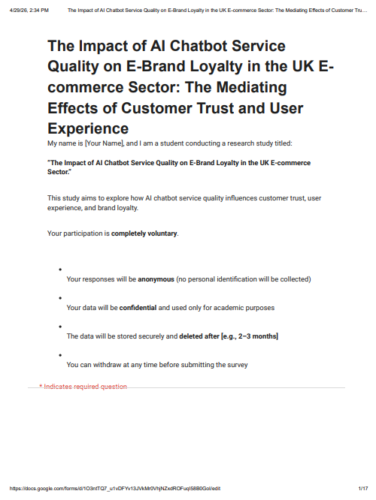
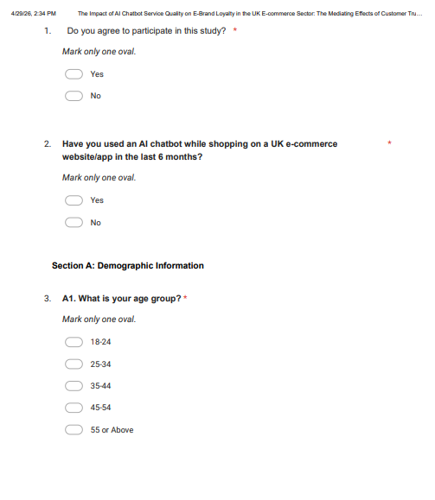
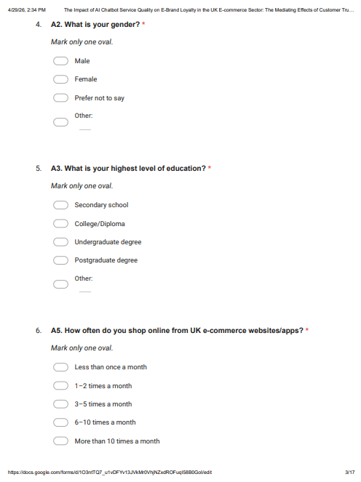
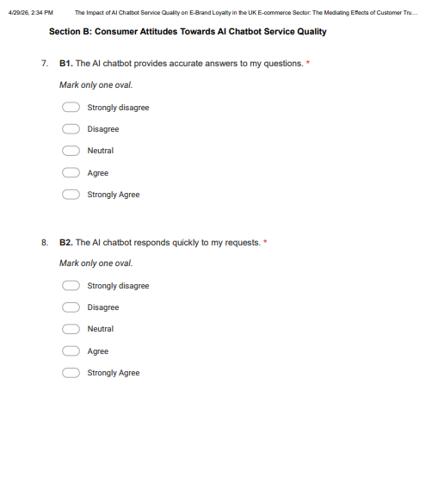
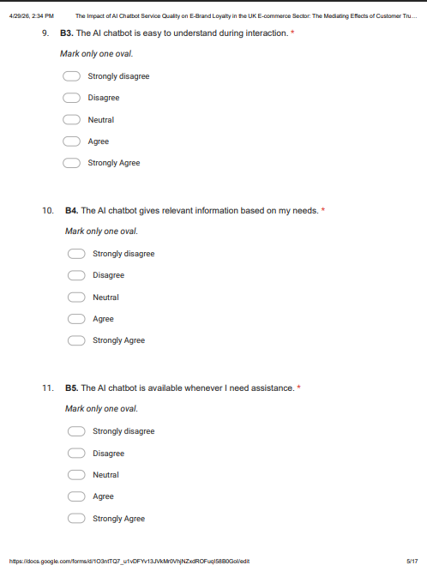
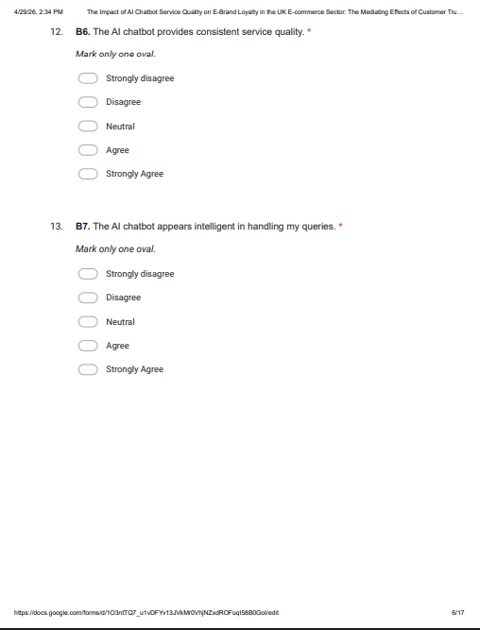
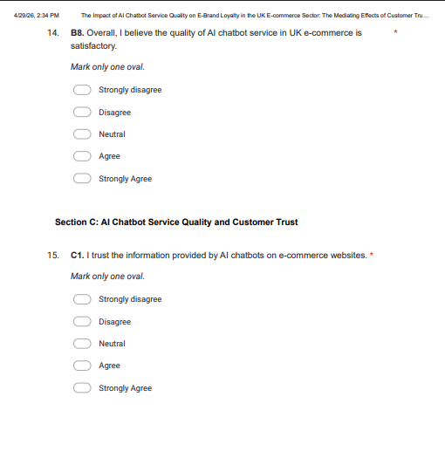
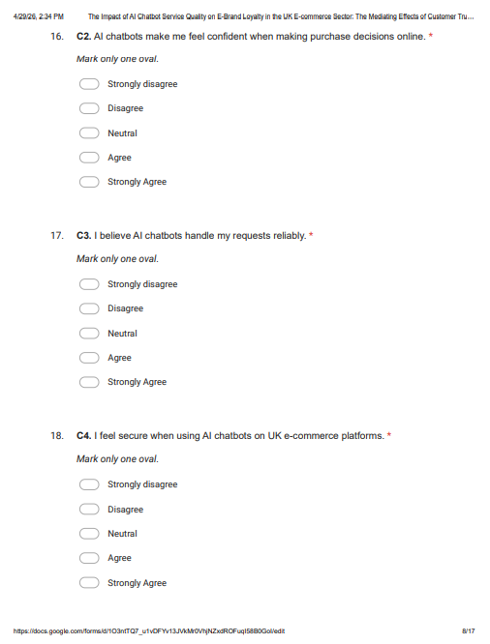
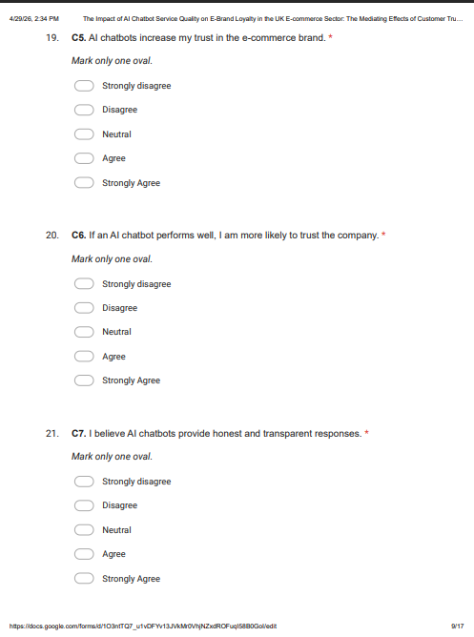
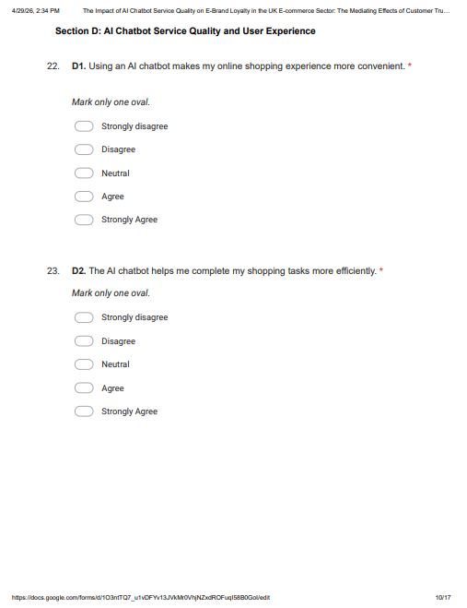
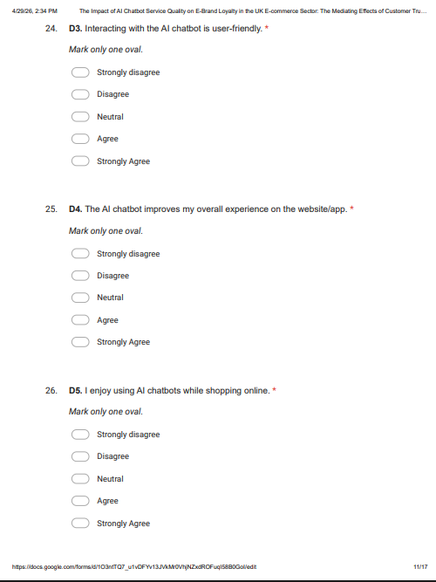
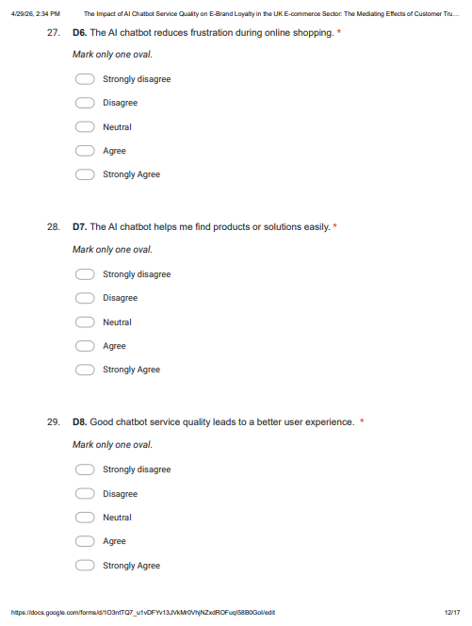
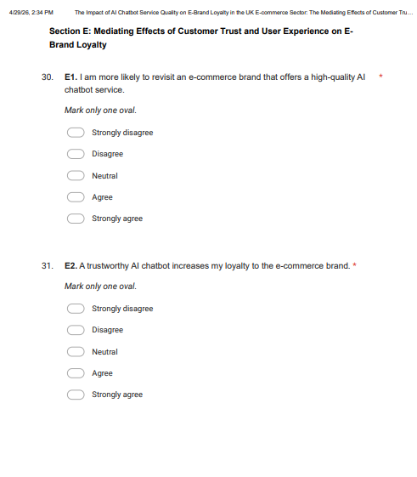
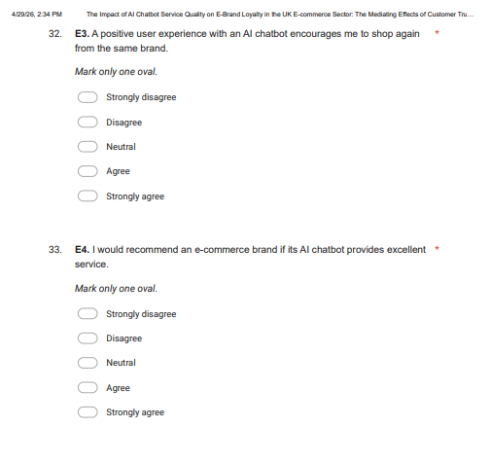
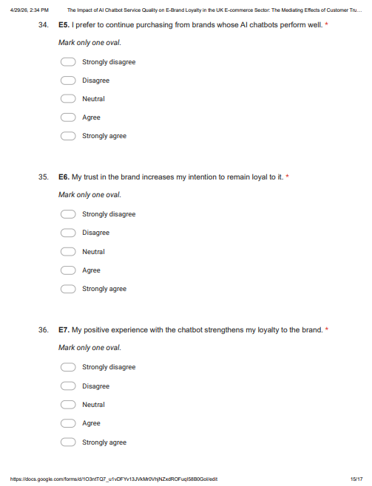
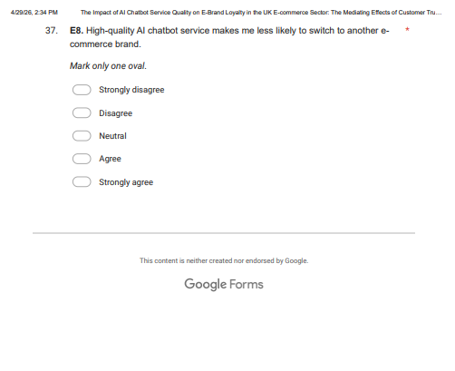

7.2 Ethic Form
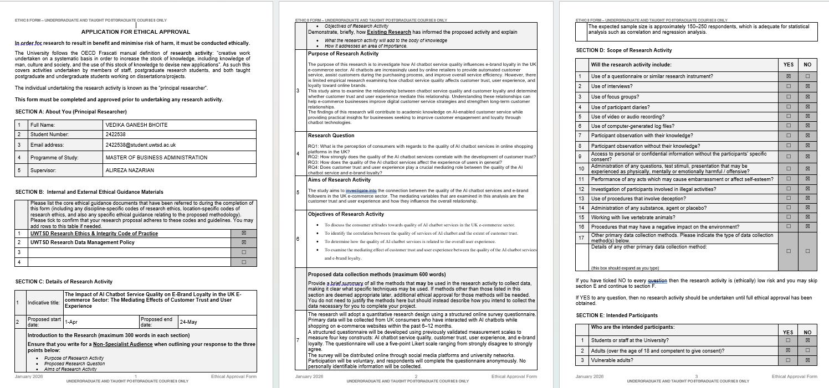

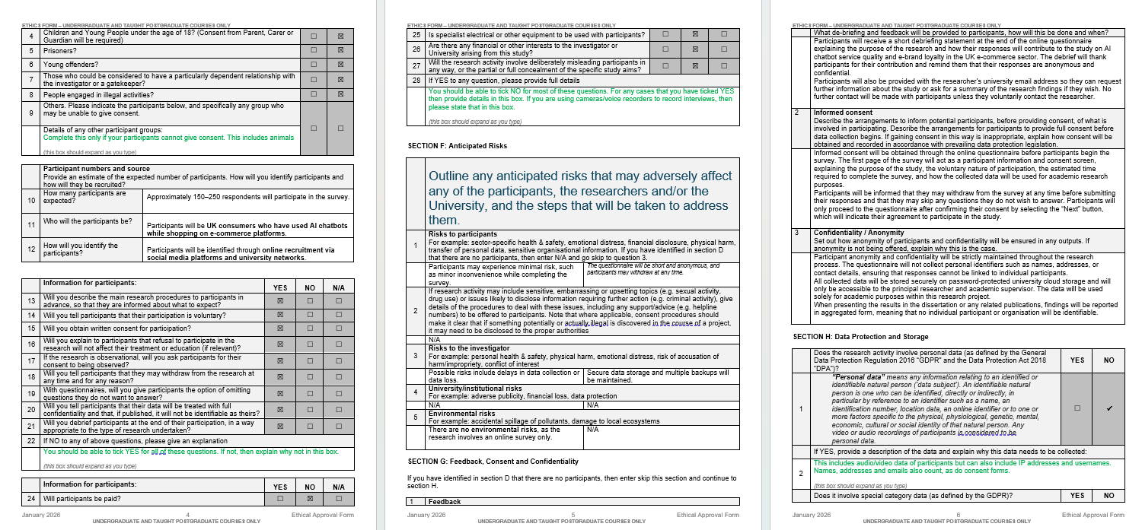

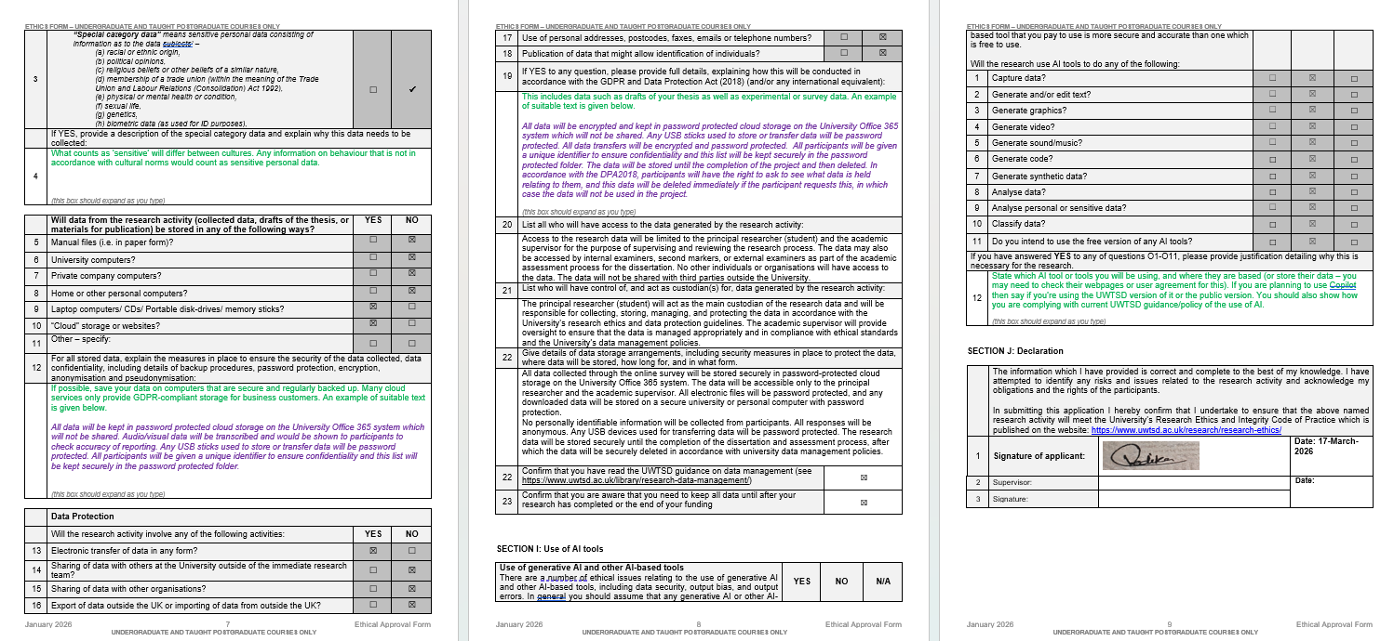

7.3 Survey Link
https://docs.google.com/forms/d/e/1FAIpQLSdTGWn_n7aFaL7IecQGraj-Z6P8V4X7TN0SZ_Yjz_YurJ3awQ/viewform?usp=header

7.4 Raw Data


7.5 SPSS Analysis


