

COMPARISON OF MARKETING EFFORTS OF ROLLS ROYCE IN THE UK AND IN SAUDI ARABIA

Module: International Marketing
Module code: LCMB7006
Student Name: Ramanpreet kaur
Student Id: 2226502

Table of Contents
Introduction 4
Company Background 4
Analysis of Rolls Royce Macro Environment 6
PESTEL Factors 6
HOFSTEDE Module of Cultural Dimension 9
Analysis of Industry Attractiveness for Rolls Royce in Saudi Arabia and UK Markets 12
Porter’s Five Forces 12
Benefits of Applying Porter’s Five Forces Situational Model 15
Market Segmentation Strategies 19
Rolls Royce Marketing Mix Elements 20
Rolls Royce Market Entry Method 21
Advantages and Disadvantages of Chosen Entry Methods 22
Directional Development Strategy 23
Ansoff Matrix 23
TOWS Matrix 23
Recommendation 24
Conclusion 25
Reference List 26

List of Figures
Figure 1: PESTLE Analysis 7
Table 1: PESTLE Analysis 9
Figure 2: Country Comparison 10
Table 2: Cultural Dimension Analysis 12
Figure 3: Global market of luxury cars 13
Table 3: Porter’s 5 Forces Comparison 16
Figure 4: SWOT analysis of the UK automobile industry 17
Table 4: SWOT analysis of Rolls Royce 20
Figure 6: Business model of Rolls Royce 24
Table 5: Ansoff Matrix 26
Figure 7: Ansoff matrix 26
Table 6: TOWS Matrix 27
Figure 8: TOWS matrix 28

Introduction
The name Rolls-Royce is renowned in Britain and has come to represent elegance, skill, and engineering brilliance. The company was founded in 1904 by Charles Rolls and Henry Royce and has a long history. Rolls-Royce is well known for its luxurious cars and important contributions to the aerospace sector.
As the pinnacle of elegance and refinement, the term Rolls-Royce conjures feelings of grandeur and exclusivity. Each Rolls-Royce automobile is a work of art that has been painstakingly created using the best materials and attention to detail. Every Rolls-Royce has the recognizable Spirit of Ecstasy mascot on the hood, representing the grace and refinement of the brand.
Rolls-Royce's automobiles have long been highly sought after by sophisticated buyers looking for the pinnacle of luxury and performance. The brand serves an exclusive clientele that frequently includes monarchy, celebrities, and prosperous businesspeople. The experience of owning a Rolls-Royce comprises beauty, craftsmanship, and individualized luxury; it goes beyond simply owning a car.
Rolls-Royce has made great progress in the aerospace sector in addition to its automotive operation. The business is a world leader in the development, production, and upkeep of state-of-the-art engines for civil and armed forces aircraft as well as power systems for diverse uses. The aerospace sector of Rolls-Royce is well known for its engineering breakthroughs, dependability, and innovation.
Rolls-Royce provides a wide range of international markets thanks to its global presence. The company's authorized dealerships and showrooms can be found in strategic places around the world, meeting the needs of wealthy clients who value the unmatched performance and timeless beauty that Rolls-Royce represents.
Rolls-Royce has recently embraced environmental responsibility and sustainability. To mix luxury with a better future, the firm has been actively exploring hybrid and electric powertrain systems for its automobiles. This attention to sustainability exemplifies Rolls-Royce's commitment to satisfying changing customer demands while guaranteeing a more sustainable future.

Company Background
Formation and Early Years:
Charles Rolls and Henry Royce's relationship resulted in the creation of Rolls-Royce Limited in 1906. Henry Royce was a talented engineer who was renowned for his attention to detail and high-quality engineering, whereas Charles Rolls was a wealthy automobile enthusiast and a successful car dealer. The alliance sought to produce the greatest luxury vehicles on the market.
The Silver Ghost Era:
The Rolls-Royce Silver Ghost, which would go on to become one of the most recognizable and significant automobiles in history, was first presented in 1906. The Silver Ghost established Rolls-Royce as the apex of automotive luxury thanks to its remarkable dependability, smoothness, and opulent styling.
Rolls-Royce and World War I:
Rolls-Royce turned its emphasis to the manufacturing of aircraft engines during World War I. The company was able to provide strong and dependable engines that were essential to the war effort thanks to its competence in engineering and precision manufacture. The growth of Rolls-Royce into the aircraft sector began with this.
The Phantom Series:
The Phantom I, II, III, IV, V, VI, and the current eighth-generation Phantom were all introduced by Rolls-Royce in the 1920s. These high-end vehicles displayed state-of-the-art engineering, superb craftsmanship, and unique customization choices, enhancing Rolls-Royce's position as the pinnacle of automotive luxury.
Rolls-Royce and World War II:
Once again, during World War II, Rolls-Royce was essential to wartime production. The organization created the Merlin engines that propelled enduring aircraft like the Spitfire and the Lancaster bomber. The effectiveness and dependability of the Merlin engine were essential to the victory of the Allied forces.
Rolls-Royce and Aerospace:
Rolls-Royce increased its aircraft industry influence in the years following World War II. The business created jet engines, such as the well-known RB211, which propelled commercial aircraft like the Boeing 747. For both commercial and military applications, Rolls-Royce is a prominent supplier of aircraft engines, propulsion systems, and services today.
Ownership Changes:
Over the years, Rolls-Royce's ownership changed multiple times. The aerospace and automotive divisions were split off in 1971, with the automobile section becoming Rolls-Royce Motors. While the automotive branch of Rolls-Royce established a separate business known as Rolls-Royce plc in 1998, the aerospace division was licensed to the BMW Group.
Modern Rolls-Royce:
Rolls-Royce started a new phase of development and innovation when owned by BMW. To meet the changing needs of luxury automobile aficionados around the world, the brand expanded its product selection and launched models including the Phantom, Ghost, Wraith, Dawn, and Cullinan. These models continue to represent what Rolls-Royce is all about: fine workmanship, luxurious extravagance, and cutting-edge technology.

Analysis of Rolls Royce Macro Environment

PESTEL Factors
As per Da Silva et al. (2021), PESTLE analysis is an approach utilised to gain a macro perception of the sector environment. In this context, this PESTLE analysis has been used to allow Rolls Royce to create a perception impression of the factors that may affect the business in 2 different countries.
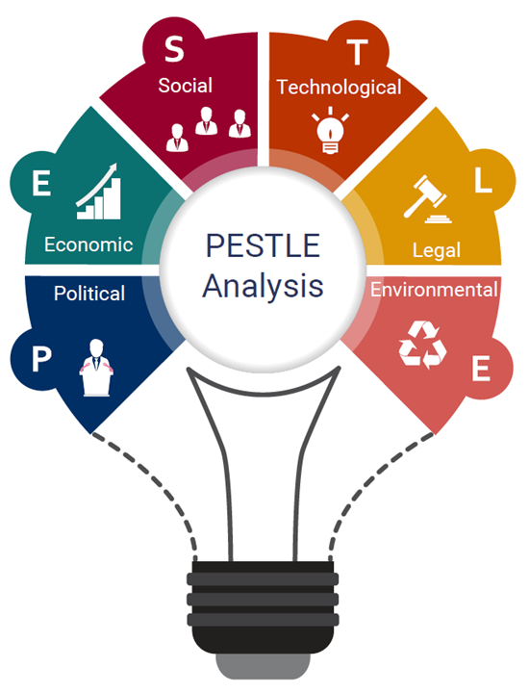

Figure 1: PESTLE Analysis
(Source: Da Silva et al. 2021)
Factors | Analysis
Political | Rolls-Royce is a global organisation that operates all over the globe. Since the manufacturer sells to different nations all over the globe, different political reasons are persuading these nations that directly impact the sales of Rolls-Royce. The UK is one of the strongest nations all over the globe and it is a current parliamentary autonomy and constitutional monarchy. However, the importance of the monarch in the legal process is widely ceremonial (BBC NEWS, 2022). Similarly, Saudi Arabia also follows monarchy rules in its democracy. It means that Rolls-Royce, operating in these two countries can reduce the possibility to face any kind of disputes on political conflicts.
Economic | Since Rolls-Royce operates in different nations, the degree of economic stability in that country is the biggest player. The UK is an extremely developed and market-based global economy. It has a significant role in global trade. Various reports manifest that the economy is getting stronger than anticipated with the rise in household savings (Inman, 2021). It can positively affect the purchasing power of the customers in the UK region. On the other hand, Saudi Arabia is referred to as a stable and developing economy as it has maintained sustainable economic growth for several years. despite, the increasing oil prices in Saudi Arabia can affect the sales of Rolls-Royce cars in the nation.
Social | Rolls-Royce, now owned by BMW is assumed as one of the luxury car brands all over the globe. Hence, the cultural dimension in the nation it operates extremely important for anticipating sales in the country. Certainly, the UK has a comparatively higher level of social mobility, and has historically been impacted by the notion of social class; however, the UK population is multicultural. Whereas, Saudi Arabia has a higher level of foreign workers, which includes cultural diversity in the nation. Moreover, 50%+ of the overall population of the country is between the age group of 25 to 54. In 2020, approximately 452.54 thousand vehicle units were sold in Saudi (Research and Markets, 2023). The educational similarity between both nations is teaching.
Technological | Both nations have similarity to be technically advanced in near future. The UK is one of the most technologically developed nations all over the globe and gives businesses different chances to find a new customer base (OEC, 2023). Whereas, the government of Arabia has developed a vision for 2030 that focuses on achieving digital transformation and an economy of knowledge-base as a part of the future development plan. It means, Rolls-Royce, being a role model for research and development can positively spread their businesses in these two nations.
Legal | The Employment Act, of 1996 in the UK, safeguard the right of workers with minimum wage, holidays, and so on. Hence, Rolls-Royce, operating in the UK region can have the possibility to increase their expenditure. On the other hand, in Saudi Arabia, there is no recently formally implemented minimum wage for workers in the private industry (Wego Travel, 2023). Following this, Rolls-Royce can positively use this for reducing their expenditure. Similarly, both countries have “2007 Double Taxation Convention and Protocol”.
Environmental | Economic activities affect the environment; however, the UK has made remarkable improvements in diminishing the consequential effect of organisations by imposing laws and regulations that increase the expenses of organisations on R&D. Similarly, the Saudi Arabia administration has also identified the significance of taking necessary steps to secure the environment as different climate change, implement serious execution. It also gives distress on the organisations for being eco-friendly. Also, Saudi have biggest oil pollution concerns, whereas, UK has biggest air pollution concerns that leads to different policies.

Table 1: PESTLE Analysis
(Source: Self-made)

HOFSTEDE Module of Cultural Dimension
The theory of cultural dimensions Hofstede was developed by Gert Hofstede, which is a structure utilised to analyse the differences between different cultures over nations and analyze the manner that business is done over different cultures. The following is the resulting image achieved after differentiating two countries of Saudi Arabia and the UK. The advantage of using this model is that this model is beneficial for expanding business into global market without encountering cultural distress. Whereas, the biggest disadvantage of using this model is that it has own limitations to different culture and environment of the nations.
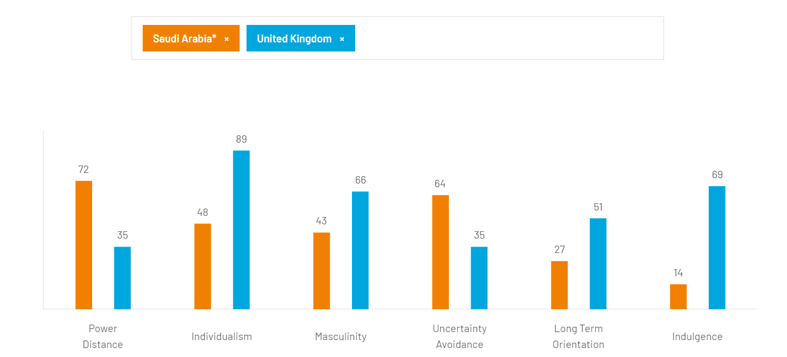

Figure 2: Country Comparison
(Source: Self-developed)
Dimensions | UK | Saudi Arabia
Power distance | This dimension acts with the fact that all people in the societies are not similar (Kaasa, 2021). The score from the Country Comparison has been achieved as 35 for power distance. It means that society assumes that inequalities among individuals need to be reduced. In this nation, a perception of fair pay leads to the belief in equality. | Whereas, the score for Saudi Arabia is 72 which is on the higher side of this dimension, indicating the fact that individuals accept a hieratical level where everyone has their own place that does not need any further justification. This means organisations can also show inherent imbalances and power centralisation.
Individualism | UK have the maximum score in individualism, which is 89, more than some of the most developed economies like Australia, and the USA. This means, the UK believes in capitalism and in these nations, the children are told from a young age to think about themselves and to discover their own different purposes in life. | This dimension acknowledges the level of interdependence in the country's society (Chun et al. 2021). The score of Saudi Arabia here is 48 indicating a collective mystic society. Rolls-Royce, operating in the nation can assume more official connections with your workers and customers.
Masculinity | A higher score in this dimension indicates that society is led by competition, success and achievement (Sabri et al. 2020). The score of the UK in this dimension, which is 66 indicates about the country is success-oriented and driven. This means, Rolls-Royce, operating in this country can expect performance ambition. | The score of Saudi Arabia, here is 43 indicating a fool feminine society and hence, the standard of life of the customers of Rolls-Royce can be signified as a success.
Uncertainty avoidance | The score for this dimension is 35 for the UK, which means the nation is not worried about the future. In this case, Rolls-Royce, operating in this country needs to be flexible to the emerging and transforming business environment and the planning periods need to be shorter. also, the company needs innovation and creativity for successful operation in the UK. | Uncertainty avoidance has to do with the manner that a society copes with the fact that the future is uncertain (Jackson, 2020). The score here is 64 indicating the preferences of Saudi Arabia to avoid uncertainties. It means, Rolls-Royce, operating in Saudi Arabia, needs to maintain some fixed codes of believes and behaviours to influence the customers.
Long-term orientation | This dimension explains the way every society needs to maintain some connections with its past while coping with issues in the present and in the future (Rojo et al. 2020). With an average score of 51, it is evident that UK culture cannot be influenced by the past and the companies working in this nation need to be future-oriented. | The lower score of 27 in this dimension mentioned that the society of Saudi Arabia may not show any interest in the increasing innovations and technologies as they exhibit respect for their cultural traditions.
Indulgence | A higher score of 69 in indulgence indicates that people in these nations will show their willingness and desires. It can also positively affect the purchasing behaviour of the customers and hence positively affect the sales of Rolls-Royce. | This explains the level at which individuals try to control their needs and impulses (Gerlach, and Eriksson, 2021). The least score in this dimension 14, manifests that the customers in Saudi Arabia may not be influenced by the innovations given by Rolls-Royce for increasing the number of sales.

Table 2: Cultural Dimension Analysis
(Source: Self-made)

Analysis of Industry Attractiveness for Rolls Royce in Saudi Arabia and UK Markets

Porter’s Five Forces
The worldwide market size for luxury cars was approximately USD 617.36 billion in the year 2022 and was anticipated to increase at a rate of 6.9% from 202-2030 (Grand View Research, 2023). In this regard, Porter's five forces tool has been used to analyse the market attractiveness of the UK and Saudi Arabia for assisting Rolls-Royce.
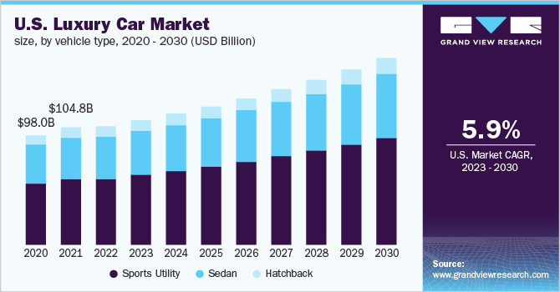

Figure 3: Global market of luxury cars
(Source: Grand View Research, 2023)
Forces | UK | Saudi Arabia
Threat of new entrants | The threat of new entrants in the automobile industry of the UK is comparatively lower. Because it is very critical for new organisations to enter into this highly competitive market. also, after the pandemic and Brexit, the reduction in client trust is impacting automobile sales (MMR, 2023). In UK, sales of passenger cars increased recently indicating the increasing demand. | The threat of new entrants in the automotive sector of Saudi Arabia is higher. Recently in 2022, Enovate, a Chinese new manufacturer of energy vehicles implemented collaborative cooperation with Sumou Holdings of Saudi (Zygiaris et al. 2022). Similarly, the demand for passenger cars in the Saudi Arabian market increases the possibility for new entrants. One similarity is that in both nations, Rolls Royce has a huge popularity.
Bargaining power of suppliers | The bargaining power of suppliers in the UK automobile sector is comparatively higher after the Brexit and pandemic. Due to the disturbance, in the supply line of the manufacturer, there are vulnerabilities seen in this industry. | The bargaining power of suppliers in Saudi Arabia is lower due to the huge number of suppliers operating in the sector. The distributors of special elements and materials for the car industry engineers hold huge importance in both nations. Rolls-Royce, being a bigger player in the sector, has probably established connections with suppliers and might have the capability to negotiate more terms because of its scale and reputation.
Threat of substitute products | The threat of substitute products in the UK region is somewhat average. In regards to brand share, BMW, which is the owner of Rolls-Royce is in 3rd place with a 1% rise in the market share done in the last year reducing the threat of substitute products through brand loyalty (MMR, 2023). One similarity is that given the criticality, safety standards, and specialized type of aircraft engines, there are only a few alternatives that can efficiently replace the offerings given by Rolls-Royce. | Since there are numerous automobile companies operating in the automotive industry of Saudi Arabia, the threat of substitute products is also higher. Among all the luxury car brands all over the globe, Audi, Bugatti and Lamborghini also operate in Saudi (MMR, 2023).
Bargaining power of consumers | The bargaining power of consumers in the UK industry is higher as the maximum market share in the automobile sector is captured by passenger cars which is 60%. Whereas, there are also various budgeted car companies operating in the UK market. hence, Rolls-Royce, being a luxury car company, may face issues for attracting customers. Bigger buyers, like aircraft manufacturers and airlines, holds considerable bargaining power in both nations. These buyers frequently demand high-standard products, competitive budgets, and easier terms. Rolls-Royce needs to control these negotiations smoothly to maintain its place and profitability. | The bargaining power of consumers in the market of Saudi Arabia for automobile products is extremely higher. This is due to the fact that there are numerous luxury and budget-friendly automobile companies operating in the country and giving different product categories to their customers.
Industry competition | Industry competition in the UK is extremely higher because of the numerous car manufacturers operating in the sector. among the major players in the automotive market in the UK, Rolls-Royce is in the last place. | The industry competition in the market of Saudi Arabia is extremely higher. The major automobile organisations present in the interior market of Saudi Arabia are Robert Bosch, Continental AG, Denso Corporation and so on (MMR, 2023). Whereas, there are also numerous luxury brands available in the market. This similarity points out the requirement for Rolls-Royce to constantly innovate, invest in R&D, and differentiate its products to maintain a competitive advantage.

Table 3: Porter’s 5 Forces Comparison
(Source: Self-made)

Benefits of Applying Porter’s Five Forces Situational Model
In general, the five forces too used given by Porter helps the organisation to recognise where the strength lies in the business environment. This is also applicable for analysing the strength of the current competitive age of an organisation and the strength of a situation that a company may search to shift into. After the pandemic destruction, the shortage of cheap has led to approximately 11.3 million cars being cut out from global production in 2021 (Mathilde Carlier, 2023). Hence, being a luxury car manufacturer, Rolls-Royce needs to analyse the market attractiveness of different organisations before implementing its operations. Also, the competitive situation of the market of luxury cars is focused on only a few biggest players dominating the industry. Hence, analysing the competition in the focus countries may help in creating the marketing strategy of Rolls-Royce in such a manner that it can compete effectively.
SWOT Analysis Highlighting Rolls Royce Strengths, Weaknesses, and Opportunities in Saudi Arabia and UK Markets-600
As per Yan, and Li (2020), SWOT analysis is a structure utilised to analyse the competitive position of an organisation and to create strategic planning. In this context, this has been used to analyse the current and future opportunities of Rolls-Royce highlighting its strengths and weaknesses.
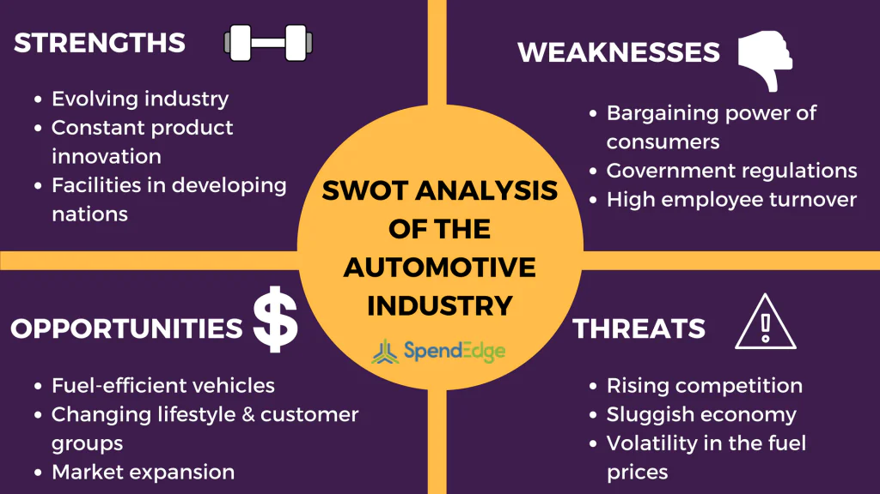

Figure 4: SWOT analysis of the UK automobile industry
(Source: Yan, and Li, 2020)
UK | Factors | Saudi Arabia
- The automobile industry of the UK is constantly innovating its products and having technological development with the vehicles.  - This can be a strength for Rolls-Royce as the company is top-rated for its strong record for involvement in research and development, making cutting-edge solutions. The concentration of this creativity allows the company to maintain a competitive edge.  - In 2021, Rolls-Royce has invested more than £1 billion on R&D (UK Parliament, 2021).  - Also, Rolls-Royce is at the centre of the defence, aerospace, and aviation ecosystem of the UK, which is a strength of the organisation. | Strengths | - Similarly, the automotive market in Saudi Arabia is observing a strong restructuring in demand from the downtown of the pandemic and after the supply chain disruptions.  - Rolls-Royce runs a worldwide purchasing organisation with a SC total spent of more than £4.7 billion (Rolls Royce, 2023).  - The increasing number of sales in Saudi Arabia is another strength of Rolls-Royce as it had announced a 25% increase in sales all over the world in 2019 and Saudi Arabia is the 2nd biggest market.
- The increased focus of government regulations on the UK car market is a weakness of the company in attaining sales.  - The global competitiveness of the UK is imposing distress on Rolls-Royce. | Weaknesses | - Whereas, with the increasing number of new entrants into the Saudi Arabian market, the bargaining power of the customers is also increasing making an effect on the sales of Rolls-Royce.  - Similarly, with the increasing regulation of the Saudi Arabian administration on environmental impact increases the expenses of luxury brands like Rolls-Royce.
- Rolls-Royce is committed to maintaining the global competitiveness of the UK and gives power to the Armed Forces of the UK.  - The mission of Rolls-Royce is to innovate effective and sustainable power solutions and increases opportunities to joining the UN Race to reduce emissions on behalf of the UK. | Opportunities | - Similarly, Saudi Arabia is one of the most rapidly transforming and promising automobile industries all over the globe.  - On the other hand, the new player is constantly entering into the market specifically with the low-priced car segment which gives Rolls-Royce a competitive differentiation.
- As the UK is one of the most developing countries, the increased accessibility to information and shifting demand of the customers, huge competition, and increase regulatory needs have given Rolls-Royce a rising competition.  - The critical supply chain of Rolls-Royce is susceptible to disturbances led by natural disasters, or other factors.  - The “Royal College of Physicians” anticipated that more than £20 billion in a year be spent on social expenses of death and health issues that are resulting from air pollution exposure (UK Parliament, 2023). This underpins the motivation towards more strict emission standards and increases the pressure on companies like Rolls-Royce to follow the agenda of clean air. | Threats | - The increasing oil prices in Saudi Arabia are increasing the threat of Rolls-Royce to affect the consumer purchasing pattern.  - Rolls-Royce encounters strong competition in the market of Saudi Arabia with well-established worldwide players like Audi and Bugatti.  - Also, the increasing acceptance of EVs and increasing demand for developed safety, convenience, connectivity, and features of driver assist are registering changes in the current automobile sector in both countries.

Table 4: SWOT analysis of Rolls Royce
(Source: Self-made)

Market Segmentation Strategies
According to Wuori (2023), market segmentation is the manner of leading and categorising the market into different classes of buyers with different needs, characteristics, and behaviours that may necessitate different product or programmes.
Segmentation: Rolls-Royce as a car manufacturing brand has been effective in delivering market efficiency by segment in the car market in which it operates as a great leader among the others. It had categorised the market to its own benefit always targeting the rich and higher classes individuals that have a focus on good lifestyle in both countries (Tonini, 2022). The company also segments its respective market, depending on demographic criteria like age, earnings, gender, and ethnic city. The consumers are differentiated based on their buying patterns like usage frequency, usage context, benefits sought, and brand loyalty.
Geographic: since Rolls-Royce is popular as a luxury automobile manufacturer, most of the products of the company are sold in the developed nations and the economies that are developed. Hence, it has targeted only just develop and first-world nations for its marketing. Among the cities, Rolls-Royce primarily markets its products in cities where only wealthy people live.
Demographic: Whereas, as demographic segmentation, Rolls-Royce also focuses on those individual segments that have a very higher level of earnings and can afford a luxury car. Also, in a recent study, the company said that Rolls-Royce on focuses on those groups of customers that have a liquid assets of more than $30 million and are only the main target of Rolls-Royce.
Targeting and Positioning: Rolls-Royce has positioned itself as a symbol of luxury and a status of flight. As a result, it targets, those individuals that are ultrarich and belong to a royal and well-known status and need a fast, rapid ride, and luxurious products as well as those individuals that want a personalised car experience due to exclusivity (Tonini, 2022). The cars at Rolls-Royce are also manufactured in a special way with different features.
Similarities and Differences in Both Markets
Since, Rolls-Royce is a luxury car manufacturing brand, the market segmentation of the company in both UK and in Saudi Arabia is somewhat similar. It means, Rolls Royce focuses on premium class customers in both UK and Saudi. In both countries, Rolls-Royce tends to capture the customers that are entrepreneurs, entertainers, and elite athletes. As, in the UK, London is the hub for business transformation and technological development, there is a maximum number of showrooms of Rolls-Royce in London with overall 133 automobile dealers in the UK. In UK, the car industry is matured, whereas, in Saudi, it is still emerging. In UK, the company had created a huge reputation over time, whereas, in Saudi, it is yet to create presence. Both nations need cutting edge automation and commitment which Rolls Royce gives.

Rolls Royce Marketing Mix Elements
Product: The brand name of Rolls-Royce is a synonym of top standard luxury for a cause and the standard has to be the best. The quality of the cars is the primary leading feature of any Rolls-Royce car, and among these, the Serene experience is more significant (Wuori, 2023). Among the products of the company, Dawn, Wraith, and Ghost are the most popular ones. Rolls-Royce offers a range of advanced aerospace engines known for their efficiency, performance, and safety characteristics and focuses on constant innovation and technological advancements. Similarly, the products of Rolls-Royce in Saudi Arabia would emphasize developed engineering, reliability, and ecological sustainability.
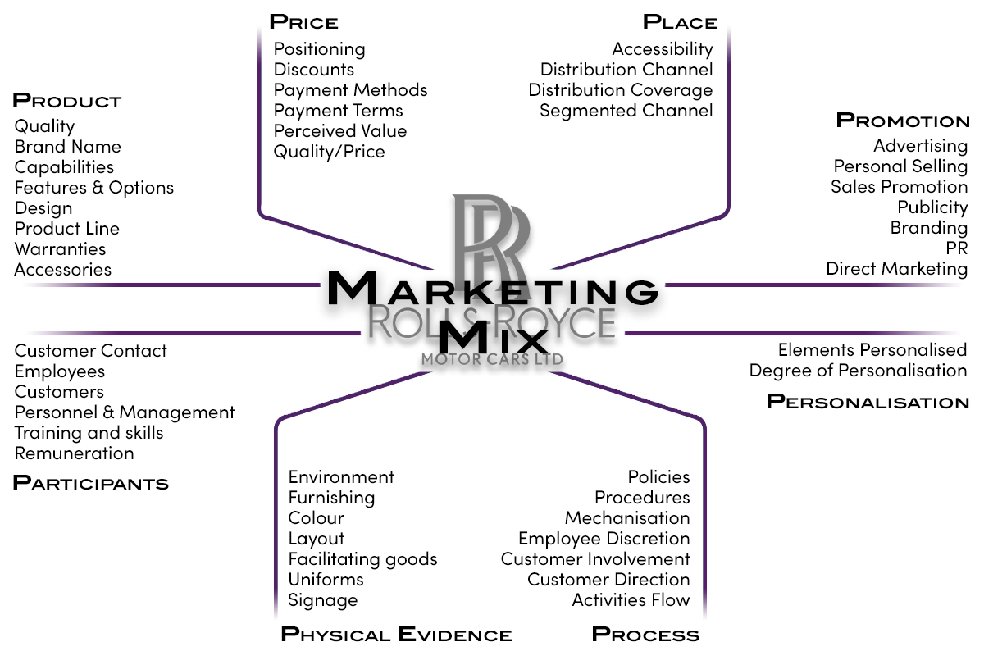
Figure 5: Marketing Mix of Rolls Royce
(Source: Wuori, 2023)
Price: Pricing strategies in the UK would likely take into account factors- production expenses, competition, and value proposition. Rolls-Royce may use premium pricing because established reputation and high-standard products. Whereas, pricing in Saudi Arabia could be impacted by factors like local economic conditions, administrative regulations, and the emerging type of the aerospace industry. In both markets, Rolls Royce has implemented a pricing strategy that are high premium in the luxury market. the pricing strategy at the company is important and none of their company products will be given at less than the current price. The entry-level price for the Ghost model is £233,235. It has strategically positioned itself as the top luxury brand among other luxury companies.
Place: the sales of Rolls-Royce are done through a connection of 138 authorised distributors spread over more than 50 nations. The dealers are situated in high net-worth areas or clustered areas. In order to ensure rapid delivery, Rolls-Royce has associated to its services with BMW (Wuori, 2023). Rolls-Royce has a good presence in the UK's aerospace sector, with manufacturing hubs, research hubs, and strong industry partnerships.
Whereas, the company's presence in Saudi Arabia might include strategic partnerships, joint ventures, or collaborations to establish a regional footprint and control the country's Vision 2030 plan for aerospace advancement.
Promotion: Rolls-Royce promotes itself as a company that strips for perfection and for inspiring greatness. It encourages ownership experiences to its customers through different exclusive events and events related to art. Rolls-Royce works in a highly exclusive and niche market. In the UK, promotional activities of Rolls-Royce could include a mix of trade programs, industry occassions, advertising, and digital marketing. The focus might be on pointing out the company's automotive leadership and heritage. On the contrary, promotion in Saudi Arabia could include targeted marketing to associate with Vision 2030 goals, highlighting the way Rolls-Royce contributes to local economic development, job creation, and technological growth.
People: client contact is extremely significant as it is the internal part of the experiences of brands. where other automobile companies search for clients through digitisation, luxury brands like Rolls-Royce do not do that. It motivates rich and classy clients to enter in direct connections at Rolls-Royce (Wichmann et al. 2022). Human capital is a most important asset for the company's continued success in the UK. While, in Saudi Arabia, Rolls-Royce might use collaborations with local talent, training programs, and knowledge transfer to support the growth of a skilled workforce.
Process: change process is followed at Rolls-Royce as technology improves the encounter for clients in different manners. It increases the power and accuracy of automobile configurations to give the best ownership in counters. Rolls-Royce also gives opportunities to their clients to spend time at their outlets to work in close association with the staff to customise their cars. In processes in both nations would includes constant quality control, R&D and efficient manufacturing.
Physical Evidence: since Rolls-Royce wants to reflect its need for luxury and perfection through its physical stores also, it locates itself in such places that are clustered with classy and rich individuals (Wichmann et al. 2022). physical evidence includes its manufacturing facilities, research hubs, and the engines themselves. Its history and presence in the UK gives credibility. Whereas, Saudi Arabia might focus on highlighting the company's commitment to local partnerships.

Rolls Royce Market Entry Method
Rolls-Royce believes that there are opportunities for development, both within their current businesses and from new fresh domains which are emerging (Rolls Royce, 2023). Hence, entering into a new market can help the company to seize the opportunity for growth. In order to enter into the new markets of the UK and Saudi Arabia, Rolls-Royce should use FDI as this may help in taking a full controlling position of the business in the new country. With all this, the company can also be directly included in the daily operations of the company in another country along with creating sustainable connections in the market.
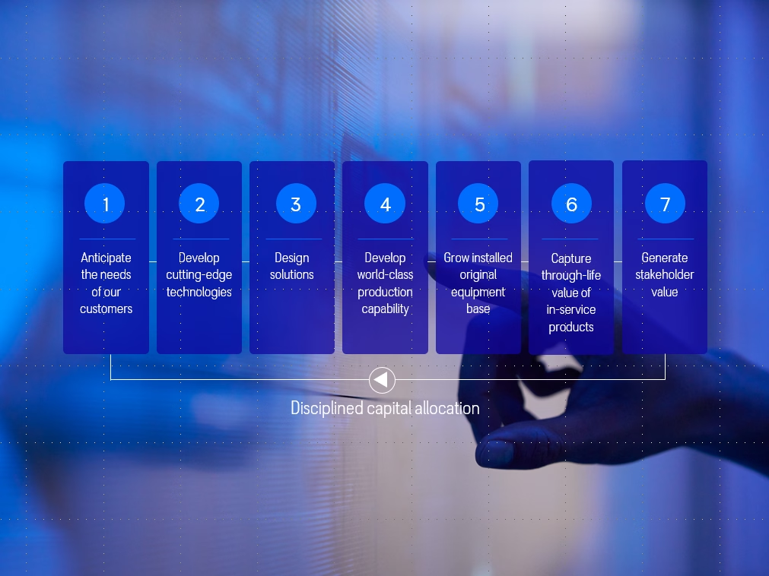

Figure 6: Business model of Rolls Royce
(Source: Rolls Royce, 2023)

Advantages and Disadvantages of Chosen Entry Methods
The advantages of the selected entry mode are:
- With the help of FDI, Rolls-Royce can create a competitive environment in the new markets with constantly improving their processes and products by allowing innovation.
- Associating with the motivations of the UN, Rolls-Royce can help in overcoming climate change using FDI (Mix, 2021).
- Using FDI, Rolls-Royce can get aligned with the most latest capital tools, automation, and operational practices.
The disadvantages of the FDI entry mode are:
- With the FDI entry mode, Rolls-Royce can be exposed to any political imbalances in the new markets (Mix, 2021).
- FDI can consequently impact the exchange rates of Rolls-Royce and the new markets.
- Considering that FDI might be capital intensive from investors' perception, it can be economically non-viable for Rolls-Royce (Clarissia, 2020).

Directional Development Strategy

Ansoff Matrix
Ansoff Matrix, give marketers a basic and efficient manner of winning the opportunities and options along with the risks included while taking different new strategic decisions (Clarissia, 2020). This is used in the context of Rolls-Royce to outline the possible growth avenues.
Market development  - Regional expansion can be helpful for Rolls-Royce in market development.  - Rolls-Royce can recognise new product uses and characteristics and target new segments of customers with their current products. | Diversification  - For entering the new markets of the UK and Saudi Arabia, it should use a new product range.  - Implementing a new product class of EV can help in capturing the new market more rapidly.
Market penetration  - Improved attractiveness and competitive prices within a similar market will help in increasing consumption and sales of Rolls-Royce.  - Developing and engaging marketing and communication content can help in reaching a wider customer base. | Product development  - Considering the increased demand for TVs, Rolls-Royce should also develop new products that are oil efficient and battery-operated.  - The strategic partnership of Rolls-Royce with other luxury brands can help in improving their current product range.

Table 5: Ansoff Matrix
(Source: Self-made)

Figure 7: Ansoff matrix
(Source: Self-made)

TOWS Matrix
TOWS matrix can be categorised as a structure to make, differentiate, and determine the business strategies (Khajezadeh et al. 2019). It will help in scrutinising the business of Rolls Royce from both inside and outside.
Threats
- The increasing threat of Rolls-Royce with new consultants, and more than 30,000 job losses of the Rolls-Royce employees may put the company at risk (The Economic Times, 2023).
- The biggest trait that Rolls-Royce is exposed to at the current time in the sector is the rising commodification of the items.
Opportunities
- with the increasing importance of TBL, the announcements of Rolls-Royce to raise £2 billion from disposals help in improving your brand value (Rolls Royce, 2023).
- Accelerated innovations and technological advances can give Rolls-Royce a remarkable venture to adjust their products.
Weaknesses
- The business model of the company can be easily copied by its competitors in the industry of aerospace and defence.
- Limited investments for services oriented to customers in Rolls Royce can give its competitors an advantage in future.
Strengths
- Till now, Rolls-Royce has successfully registered its innovation for driving customers.
- Diversity and inclusion is the biggest strength of Rolls-Royce (Rolls Royce, 2023).
- The company has a very powerful position of market leadership in the industry of aerospace and defence.

Table 6: TOWS Matrix
(Source: Self-made)

Figure 8: TOWS matrix
(Source: Self-made)

Recommendation
- With the increasing demand for climate efficiency, Rolls-Royce should improve its operations in the aerospace industry. it can help the company to effectively deliver cost and carbon savings. For example, Rolls-Royce is using next-generation materials to increasingly limit environmental effects.
- The business model of Rolls-Royce needs to be changed by reducing their limited expenditures to create a competitive edge with good investment options and a strong product portfolio.
- in order to improve Rolls-Royce as an employer in the global market, it needs to give different service offerings and benefits to its employees to streamline efficient management.
- Lastly, for increasing its market share in the global market, Rolls-Royce needs to expand itself apart from the aerospace sector together with improving operational effectiveness and increasing market responsiveness.

Conclusion
From the discussion above, it is evident that Rolls-Royce has a very strong positive brand image in the global automobile market and the luxury products offered by the company are also popular among high-class and reach customers. In this report, from the discussions of both the internal and external environment of Rolls-Royce, it is evident that Rolls-Royce entering into the new market needs to look for a few factors. For taking decisions regarding business and marketing, Hofstede’s cultural dimension can be used by the company. Contrarily, from Porter’s five forces, Rolls-Royce can take ideas before entering into the new market. Also, it can be concluded that the company, using Ansoff Matrixx and TOWS matrix can effectively analyse the growth avenues in the new market along with using the recommendations given. Also, among the UK and Saudi Arabian markets, the UK can be the most profitable.

Reference List
BBC NEWS, 2022. United Kingdom country profile. Bbc.com. [Online] Available at: https://www.bbc.com/news/world-europe-18023389 [Accessed on: 17th July 2023]
Chun, D., Zhang, Z., Cohen, E., Florea, L. and Genc, O.F., 2021. Long-term orientation and the passage of time: Is it time to revisit Hofstede’s cultural dimensions?. International Journal of Cross Cultural Management, 21(2), pp.353-371.
Clarissia, S.M.S., 2020. A study on Ansoff Matrix Technique: As a growth strategy and an adaptive learning technique adopted in the leading brand of products. BIMS Journal of Management, 18.
Da Silva, A.L. and Castañeda-Ayarza, J.A., 2021. Macro-environment analysis of the corn ethanol fuel development in Brazil. Renewable and Sustainable Energy Reviews, 135, p.110387.
Gerlach, P. and Eriksson, K., 2021. Measuring cultural dimensions: external validity and internal consistency of Hofstede's VSM 2013 Scales. Frontiers in Psychology, 12, p.662604.
Grand View Research, 2023. Luxury Car Market Size, Share & Trends Analysis Report By Vehicle Type, By Propulsion Type (Internal Combustion Engine, Electric), By Region, And Segment Forecasts, 2023 – 2030. grandviewresearch.com. [Online] Available at: https://www.grandviewresearch.com/industry-analysis/luxury-car-market-report [Accessed on: 17th July 2023]
Inman, 2021. UK economy bouncing back stronger than expected amid savings boom. Theguardian.com. [Online] Available at: https://www.theguardian.com/business/2021/mar/31/uk-economy-savings-expansion-recovery [Accessed on: 17th July 2023]
Jackson, T., 2020. The legacy of Geert Hofstede. International Journal of Cross Cultural Management, 20(1), pp.3-6.
Kaasa, A., 2021. Merging Hofstede, Schwartz, and Inglehart into a single system. Journal of cross-cultural psychology, 52(4), pp.339-353.
Khajezadeh, M., Niasar, M.S.F., Asli, S.A., Davari, D.D., Godarzi, M. and Asgari, Y., 2019. Application of neural network in portfolio product companies: Integration of Boston Consulting Group Matrix and Ansoff Matrix. International Journal of Economics and Management Engineering, 13(6), pp.821-825.
Mathilde Carlier, 2023. Automotive industry worldwide - statistics & facts. Statista.com. [Online] Available at: https://www.statista.com/topics/1487/automotive-industry/#topicOverview [Accessed on: 17th July 2023]
Mix, P., 2021. Marketing MIX for the Food and Business Industry in California Market-Paper Example.
MMR, 2023. Automotive Market in UK: Analysis and Forecast (2022-2027) Trends, Statistics, Dynamics, and Segmentation by Vehicle Type, Sales type and Region. Maximizemarketresearch.com. [Online] Available at: https://www.maximizemarketresearch.com/market-report/automotive-market-in-uk/86645/ [Accessed on: 17th July 2023]
MMR, 2023. Saudi Arabia Automotive Interior Markets, Competition, Forecasts & Opportunities, 2027 - High Demand for SUVs and Increased Customer Preference for Comfort Features Bodes well for the Sector. Maximizemarketresearch.com. [Online] Available at: https://www.globenewswire.com/news-release/2023/04/17/2648241/28124/en/Saudi-Arabia-Automotive-Interior-Markets-Competition-Forecasts-Opportunities-2027-High-Demand-for-SUVs-and-Increased-Customer-Preference-for-Comfort-Features-Bodes-well-for-the-Sec.html [Accessed on: 17th July 2023]
OEC, 2023. United Kingdom. Oec.world. [Online] Available at: https://oec.world/en/profile/country/gbr [Accessed on: 17th July 2023]
PwC, 2023. UK: Taxes on corporate income. taxsummaries.pwc.com. [Online] Available at: https://taxsummaries.pwc.com/united-kingdom/corporate/taxes-on-corporate-income [Accessed on: 17th July 2023]
Research and Markets, 2023. Saudi Arabia Automotive Interior Markets, Competition, Forecasts & Opportunities, 2027 - High Demand for SUVs and Increased Customer Preference for Comfort Features Bodes well for the Sector. Globalnewswire.com. [Online] Available at: https://www.globenewswire.com/news-release/2023/04/17/2648241/28124/en/Saudi-Arabia-Automotive-Interior-Markets-Competition-Forecasts-Opportunities-2027-High-Demand-for-SUVs-and-Increased-Customer-Preference-for-Comfort-Features-Bodes-well-for-the-Sec.html#:~:text=High%20Demand%20for%20SUVs%20Drives,of%20oil%20at%20low%20prices. [Accessed on: 17th July 2023]
Rojo, J., Everett, B., Ramjan, L.M., Hunt, L. and Salamonson, Y., 2020. Hofstede's cultural dimensions as the explanatory framework for performance issues during clinical placement: A mixed methods study. Nurse education today, 94, p.104581.
Rolls Royce, 2023. Diversity & Inclusion. Rolls-royce.com. [Online] Available at: https://careers.rolls-royce.com/india/what-we-offer/inclusion-and-diversity/ [Accessed on: 17th July 2023]
Rolls Royce, 2023. Pioneering the power that matters. Rolls-royce.com. [Online] Available at: https://www.rolls-royce.com/about/our-strategy.aspx [Accessed on: 17th July 2023]
Rolls Royce, 2023. Supply Chain Management. Rolls-royce.com. [Online] Available at: https://www.rolls-royce.com/~/media/Files/R/Rolls-Royce/documents/customers/nuclear/so-supply-chain-management-tcm92-24001.pdf [Accessed on: 17th July 2023]
Sabri, O.M.A.R., Hakim, T.A.H.I.R. and Zaila, B.A.D.R.I.A.H., 2020. The role of hofstede dimensions on the readiness of iot implementation case study: Saudi universities. Journal of Theoretical and Applied Information Technology, 98(16), pp.1-12.
The Economic Times, 2023. Rolls-Royce may cut thousands of jobs in turnaround plan. economictimes.indiatimes.com. [Online] Available at: https://economictimes.indiatimes.com//news/international/business/rolls-royce-may-cut-thousands-of-jobs-in-turnaround-plan/articleshow/100575312.cms?utm_source=contentofinterest&utm_medium=text&utm_campaign=cppst [Accessed on: 17th July 2023]
Tonini, F., 2022. A critical analysis of Rolls-Royce Holdings plc’s Shareholder Wealth creation in the five-year period from 2017 to 2021.
UK Parliament, 2021. Commitments. Committees.parliament.uk. [Online] Available at: https://committees.parliament.uk/writtenevidence/110224/html/#:~:text=In%202021%20Rolls%2DRoyce%20invested,and%20net%20zero%20technologies. [Accessed on: 17th July 2023]
UK Parliament, 2023. Commitments. Committees.parliament.uk. [Online] Available at: https://committees.parliament.uk/writtenevidence/121503/html/ [Accessed on: 17th July 2023]
Wego Travel, 2023. Saudi Arabia Minimum Salary and Wages 2023: How Much Can You Expect to Earn in Saudi Arabia?. Blog.wego.com. [Online] Available at: https://blog.wego.com/saudi-arabia-minimum-salary-and-wages/#:~:text=In%20Saudi%20Arabia%2C%20there%20is,rate%20of%203%2C000%20Saudi%20riyals. [Accessed on: 17th July 2023]
Wichmann, J.R., Uppal, A., Sharma, A. and Dekimpe, M.G., 2022. A global perspective on the marketing mix across time and space. International Journal of Research in Marketing, 39(2), pp.502-521.
Wuori, P.E.M., 2023. Analysing the Differences Between Luxury and Premium in Marketing–Case Study: BMW and Rolls-Royce.
Wuori, P.E.M., 2023. Analysing the Differences Between Luxury and Premium in Marketing–Case Study: BMW and Rolls-Royce.
Yan, P.G. and Li, J.N., 2020. Advances in the understanding of the intestinal micro-environment and inflammatory bowel disease. Chinese medical journal, 133(07), pp.834-841.
Zygiaris, S., Hameed, Z., Ayidh Alsubaie, M. and Ur Rehman, S., 2022. Service quality and customer satisfaction in the post pandemic world: A study of Saudi auto care industry. Frontiers in Psychology, 13, p.842141

