Module code: ECIE4010

Module name: Contemporary Challenges Making a Difference

Student name: Jessica Huykman

Student number: 2506421

Slide 8:
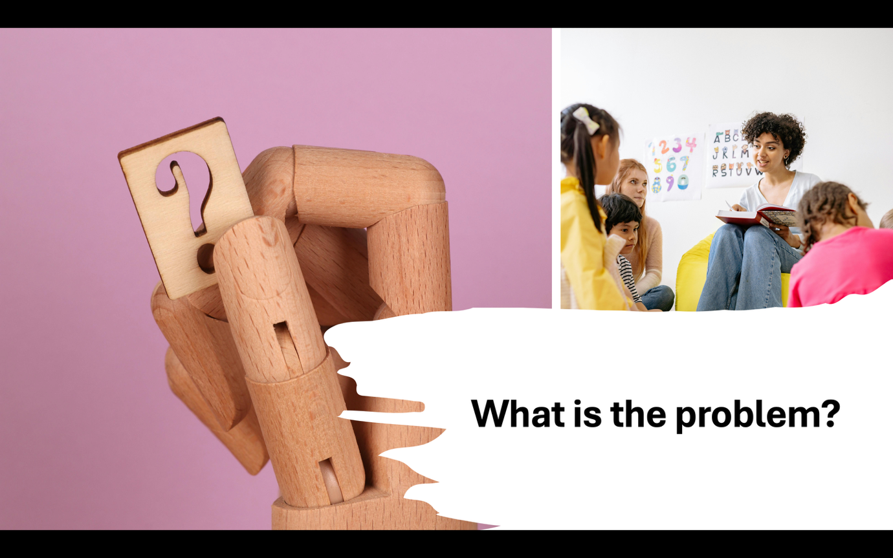

Slide 9:


Slide 10:
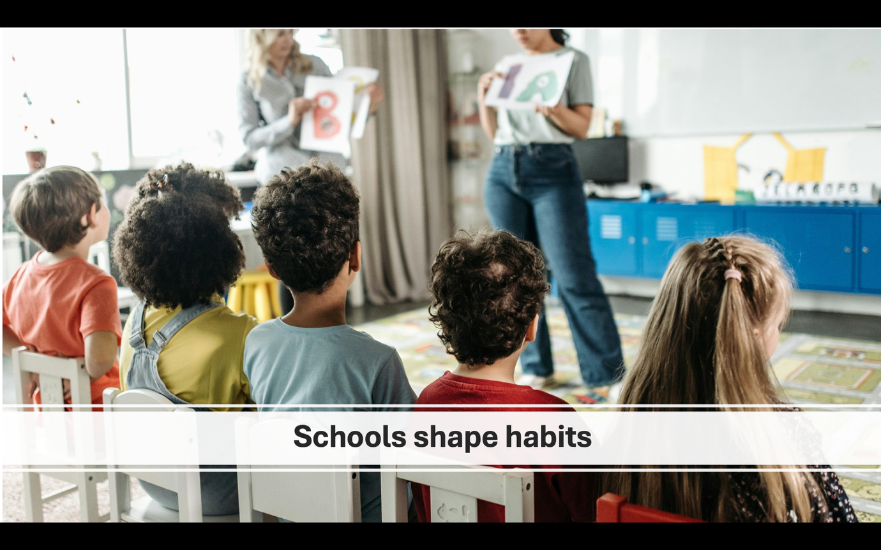

Slide 11:
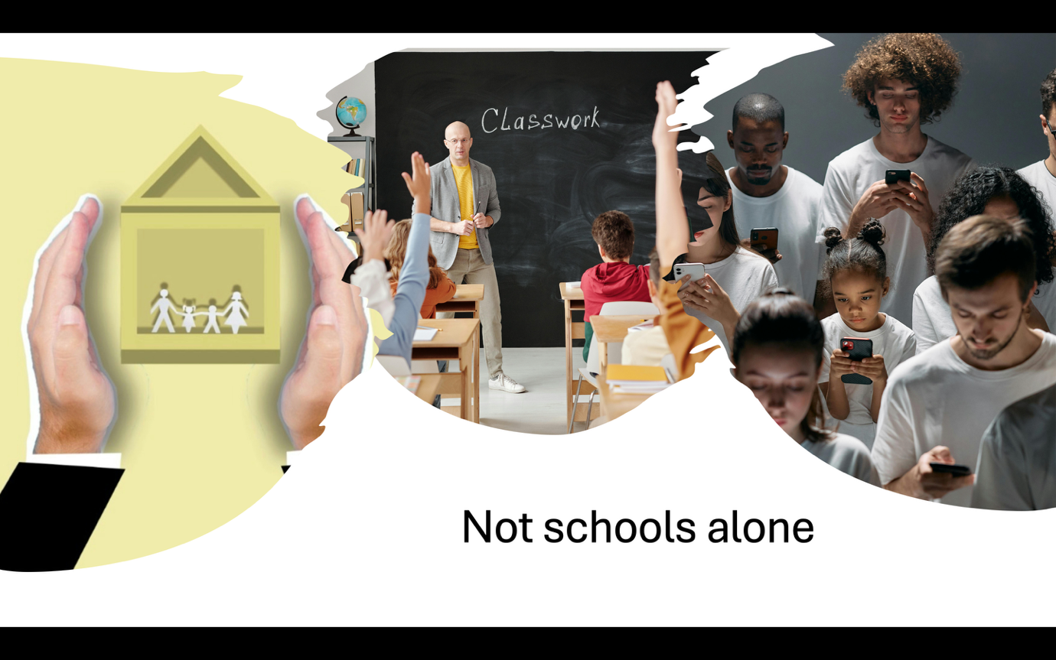

Slide 12:
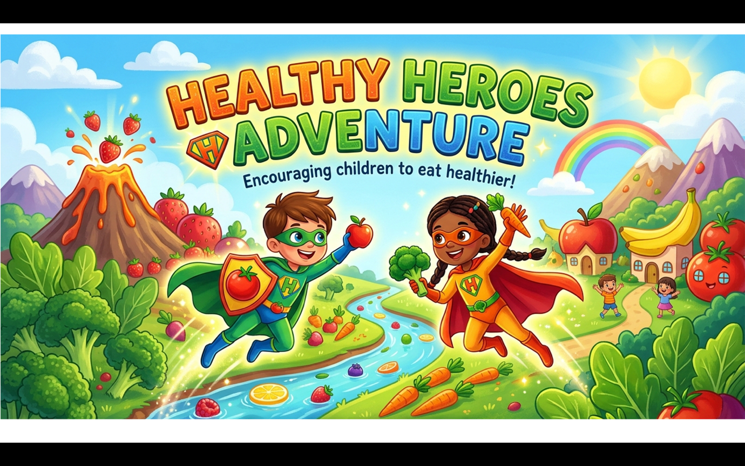

Slide 13:
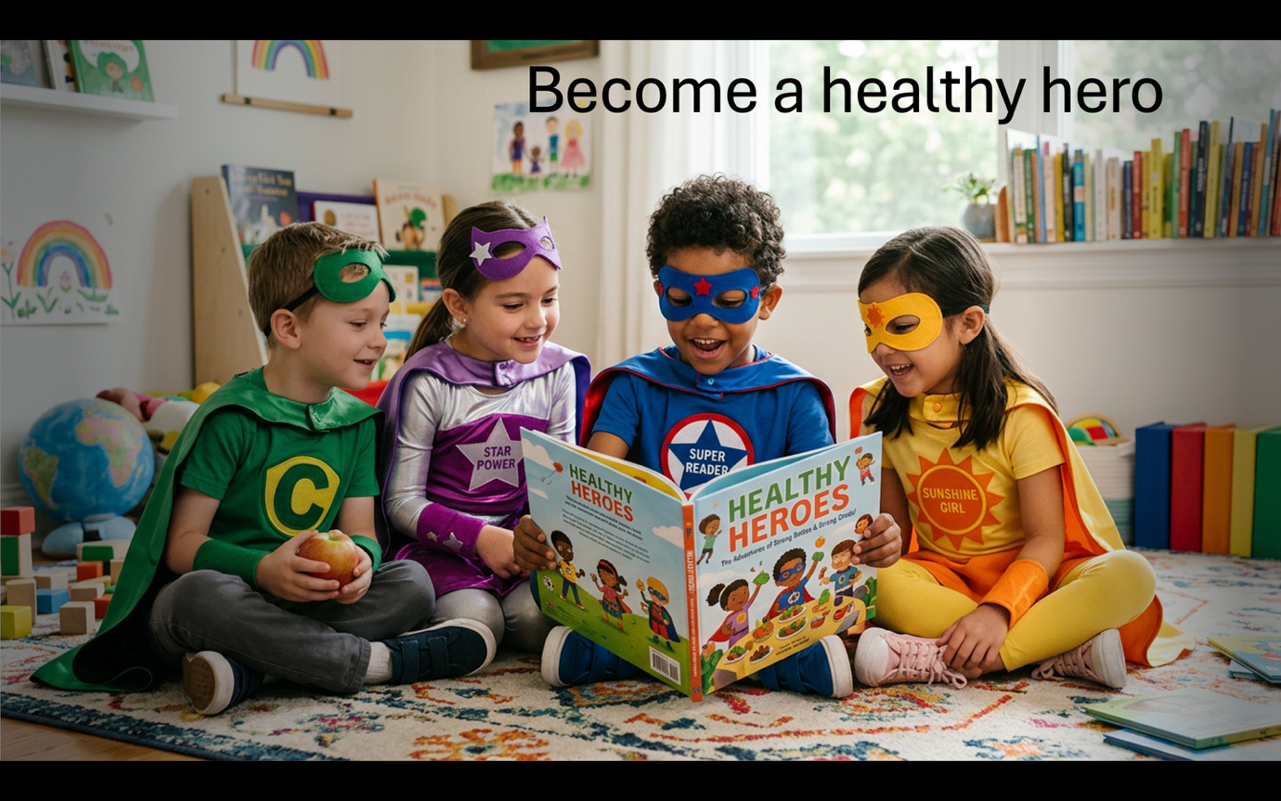

Reference slide:
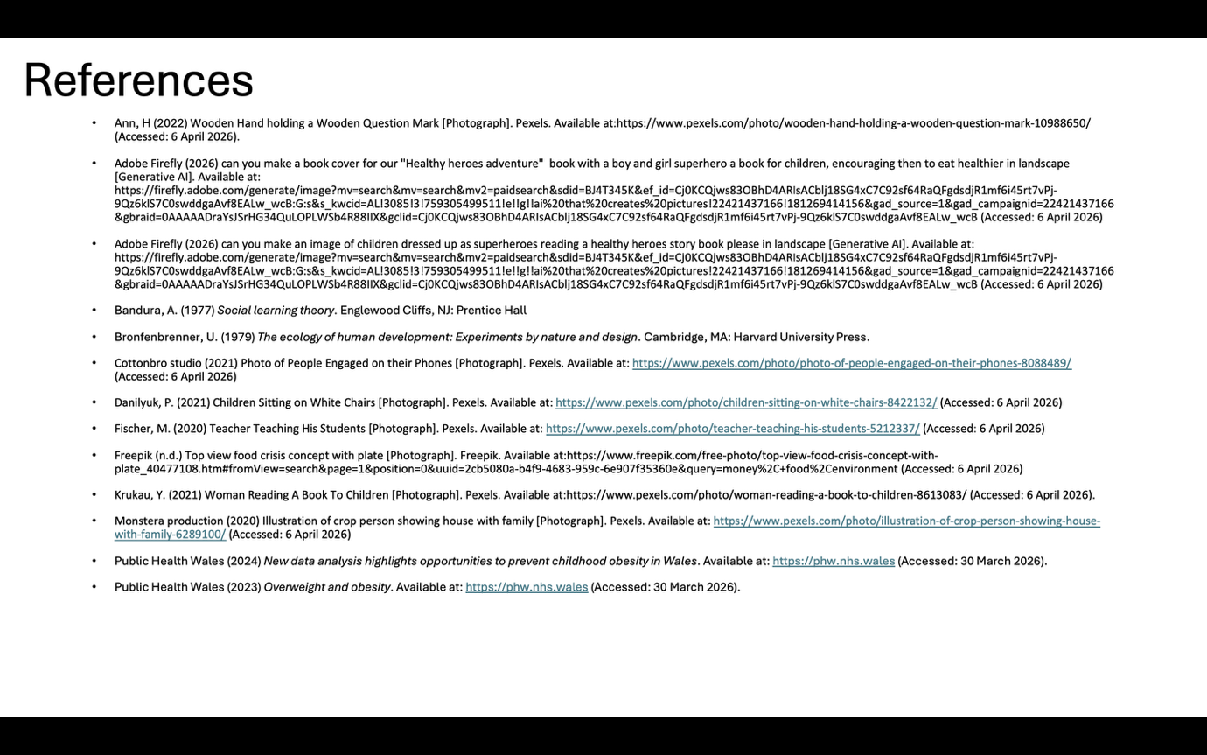

Slide 8: “So what is the real problem we are trying to solve? In Wales, nearly one in three children are already overweight or obese by the time they start primary school. This shows the issue begins early, highlighting the importance of early childhood development in shaping long-term health behaviours, and suggesting that prevention needs to start before unhealthy habits become normalised.”

Slide 9: “The problem is not just individual choice. Children face barriers shaped by their environment, including food access, lifestyle, and family circumstances. This links to Urie Bronfenbrenner’s ecological systems theory, which shows how a child’s development is influenced by multiple environments such as family, school, and society, all interacting and reinforcing behaviours over time.”

Slide 10: “Schools are key because they shape children’s habits and behaviours daily. According to Albert Bandura’s social learning theory, children learn behaviours by observing others, meaning teachers and peers can positively influence healthy choices, especially when those behaviours are modelled regularly and reinforced in everyday routines.”

Slide 11: “However, schools cannot solve obesity alone. In Wales, children in more deprived areas are significantly more likely to be obese. This highlights how wider social and economic factors, such as income, access to food, and local environments, play a major role in shaping health outcomes, often limiting the choices available to families.”

Slide 12: “To respond to this, we developed Healthy Heroes, a classroom-based programme that focuses on building positive habits in a fun and engaging way. Instead of focusing on weight, it encourages participation, confidence, and healthy behaviours, helping children feel motivated rather than judged or pressured.”

Slide 13: “Children take part in a story in which they become ‘healthy heroes’ and complete weekly missions to improve their wellbeing. Research shows early interventions and supportive environments are key to preventing obesity, making this approach both engaging and evidence-based, while helping children gradually build healthier habits that can continue beyond the classroom.

References:
- Bandura, A. (1977) Social learning theory. Englewood Cliffs, NJ: Prentice Hall
- Bronfenbrenner, U. (1979) The ecology of human development: Experiments by nature and design. Cambridge, MA: Harvard University Press.
- Public Health Wales (2024) New data analysis highlights opportunities to prevent childhood obesity in Wales. Available at: https://phw.nhs.wales (Accessed: 30 March 2026).
- Public Health Wales (2023) Overweight and obesity. Available at: https://phw.nhs.wales (Accessed: 30 March 2026).

PowerPoint Link:
Alleviating Obesity - Group Work ECIE4010 PPT Final.pptx​

