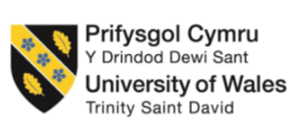

Programme: BA (Hons) International Hotel Management
Module: Organisational Consultancy
Module code: BMIH6005

Executive Summary
The Elite Hospitality Advisory consultancy report focuses on what the Grand Hotel Excelsior Vittoria is facing as a result of the COVID-19 pandemic. In order to aid the hotel in recovery and return to the competitive edge, strategic recommendations like digital marketing enhancement, personalisation of guest services and better health protocol are made in this report. This in-house problem report discusses the major issues Grand Hotel Excelsior Vittoria, a distinguished lavish hotel in Sorrento, Italy, confronts at the present moment of Coronavirus pandemic. The ongoing global crisis has affected the travel sector and particularly the hotel significantly by thinning the flow of the hotel’s key business focus, the international high-end guests. Being one of the oldest luxury hotels, the Grand Hotel Excelsior Vittoria of Sorrento has always attracted wealthy guests eager to taste exquisite service and sensuous atmosphere complemented by splendid views of the Bay of Naples. But such drastic changes in the trend have been triggered by the effect of the pandemic more so in the luxury segment of the traveller market. Being aware of the fact that guests are now looking for health, safety, and sustainable solutions, the hotel requires essential transformations to restore the competitive advantage and achieve sustainable development (Niewiadomski, 2017).
The COVID-19 pandemic has greatly affected the position of hotel businesses around the world, including many five-star hotels, primarily in terms of demand and gross revenue. The Grand Hotel Excelsior Vittoria has not been immune to this reality either because geopolitics and the globalization of travel, fluctuating economy, and consumer behavior mean it is gradually becoming hard to book international guests. The high-end segment, which originally belonged to elites travelling through different countries has now migrated to domestic and local tourism, thanks to Covid-19. Also, there is increased competition within the luxury hotel industry segment in Italy since many luxury hotels are being established to cater for the limited number of more affluent tourists. This report, therefore, seeks to find out the various causes of the current put off state of the hotel and proceed to offer a timely solutions on how the hotel could grow again in the post-pandemic world (Sharifovich, 2021).
The macro- environment was analyzed using the PESTEL framework for Political, Economic, Social & Cultural, Technological, Environmental and Legal factors that would impact the luxury hotel industry. Of the external threats, the bigger one is the unpredictable travel bans put in place by governments across the world in an attempt to curb the virus. Unfortunately, these restrictions have served to discourage international travellers from visiting Italy especially from major source markets such as the United States of America, the United Kingdom and the Middle East. The hotel also has had to contend with economic factors such as more consumers experiencing a squeeze on their disposable income and leading to few patronizing high end services. At a societal level, the trends are pointing at wellness, health, and Safety, especially now, most tourists are interested in hygienic accommodations, and travellers-attractive offers. In essence, the adaptability of the hotel to these trends will be crucial in being able to convince people to book again in the hotel (Wynn and Jones, 2022).
In another way technological development and new trends in digital marketing also help to influence consumers’ perception within luxury hospitality industry. It is clear that hospitality firms who can apply digital marketing strategies, and tailor marketing techniques for high-end consumers, have an advantage over their competitors when booking online rooms. On the other hand, hotel businesses that are slow in adopting digital investment standards may similarly be overtaken by competitors that are more capable of making pattern shifts in the market environment. The Grand Hotel Excelsior Vittoria needs to concentrate on enhancing a digital avenue to reach out to the international consumers. Another factor that has recently gained significant importance though stems back from earlier days is environmental friendly accommodation where high profile guests opt for accommodation that take a friendly stand towards mother nature. In the last place, the hotel has to be loyal to the rules of health and safety legislation in Italy, thus, the hotel has to act in accordance with these laws while being situated in the country (Niewiadomski, 2016).
The internal analysis of the hotel has also been done by the help of SWOT analysis together with other factors that enable to define the hotel’s position within the luxury hospitality market. Some of the key positive factors apparent at the Grand Hotel Excelsior Vittoria include a great history, a high location profile in Sorrento, and excellent guest service. The location of the hotel on the cliff top with overlook views of the beautiful Bay of Naples has made it a hub of some of the most elite persons who are on relax Search Resort and Adventure trips. Also, the high ranks of the hotel and the long years it has being in the market puts it in a vantage place in the competition. However, there are several internal weaknesses as well especially in the area of digital marketing as well as guest customization. The current digital strategy plan is inactive and thus hampers the hotel to effectively market itself in the ever competitive online platform. In addition, there are no special services that could be provided depending on the guest’s preferences, which has recently gained the significance of carrying importance in luxury accommodations.
The hotel, for instance, chooses environmentally friendly practices and publicizing them to the individual who is a green traveler, the hotel gains a new clientèle of green travelers. At the same time, based on the technological factor, the hotel may also benefit from an increased availability of the internet increasing its online visibility, a deeper insight into the customer needs in utilizing data and analysis companies to boost its digital marketing strategy across the international market. However, threats consists of: Present and future competition with other luxury hotels in Italy and other countries as well as new trends such as wellness, health and safety (Sharifovich, 2021).
Based on finding of the SWOT analysis, the TOWS shows the methods that will help the Grand Hotel Excelsior Vittoria to overcome the problem. Self competent: Among the key recommendations one finds that more could be done regarding digital marketing by the hotel. Thus, social media, jointly with such tools as influencer marketing and SEO targeted at the segment of the international high-end tourists should become the major components of the digital marketing campaign. The campaign should focus the growth of the industry on small, specialized segments of tourists, like the luxury wellness tourists or tourists that are sensitive to the environment. With an investment of €180,000 in a six-month intensive advertising campaign, it is estimated that the volume of foreign customers will increase by 10-15%, lifting revenue to an additional €150,000 per year.
With the establishment of a preferable guest database the hotel would be able to develop policies and train staff to give the guest experiences that they would not forget. A similar strategy is believed to enhance the frequency of customers’ returns and place emphasis on customer retention. €100,000 for this project is proposed to increase repeat customer ratio by 5% which in turn will bring €75,000 additional revenue from repeat customers only.

Introduction
The luxury hospitality sector has been badly disturbed by the COVID-19 pandemic, including the Grand Hotel Excelsior Vittoria. In this post pandemic era, this report by Elite Hospitality Advisory analyzes the key challenges that the hotel faces which not only require addressing but are required to be addressed in ways that can help the hotel cater to the evolving consumer preferences, improve its digital engagement, and enhance the guest experience. The Grand Hotel Excelsior Vittoria is a five star luxury hotel in the centre of Sorrento, Italy. Located with its stunning views over the Bay of Naples, and with its traditions of providing exquisite services, the hotel has become a well known destination for the international visitors. The hotel is famous for its historical charm, its luxurious amenities, and impeccable service that have long brought high net worth individuals (HNWI) — from political dignitaries to celebrities and discerning international tourists. With 84 elegant rooms and suites that encompass the grandeur of 19th century Italian style but modern amenities that help create a world class experience (Baum, 2019), the hotel stays true to its name, Cavour Hotel Florence. Grand Hotel Excelsior Vittoria rises above the luxury crowd thanks to its Michelin star dining, lavish spa and personalised services. But, alongside many hotels in the luxury segment, its continued presence is threatened by daunting challenges brought on by the ongoing ramifications of the COVID-19 pandemic and the evolving landscape in the global travel market.
The main market segment for Grand Hotel Excelsior Vittoria is an international one that has decreased significantly. In previous years, the hotel attracted affluent North American, European, Middle Eastern and Asian clients. However, most of the international tourism has been severely impacted by travel restrictions that have been extended from the pandemic, long closures and health safety concerns. As a result, a huge gap has developed in the hotel’s revenue because the number of high end international visitors has just declined as much. At the same time, the pandemic has also been emblematic of a seismic upheaval in behavior by consumers where they are now looking to ensure health, safety, wellness and sustainability when choosing where to stay (Bera, 2021). From a new set of challenges comes this shift, which threatens to interfere with the delivery of the tailor-made luxurious services for which Grand Hotel Excelsior Vittoria is renowned.
According to this consultancy report, Visionary Consulting was commissioned by Grand Hotel Excelsior Vittoria to develop strategies to tackle the issues related to the strategic matters that have emerged because of the pandemic and changed market conditions. Based out of Dallas, TX, Visionary Consulting is a company that provides change management and strategic development services to the hospitality industry as it has had successful results helping luxury hotels resolve complicated issues. Our advantage in the game comes from having deep industry inside, customer outside, and organization inside out. We are dedicated to assist luxury hotels like Grand Hotel Excelsior Vittoria to retain their brand identity over time and to apply new strategies in the face of modern issues. We’ve been engaged by the hotel to help reverse the loss of its traditional international clientele and develop a multi-year plan for returning its occupancy levels to pre-pandemic levels and building a future focused on wellness, sustainability and health for the guest.
For which the report relies on the common theoretical frameworks and methodological approaches used for hospitality and luxury services sectors. First analytical tool is that of PESTEL which is used to study the macro environmental conditions related to the performance of the hotel. Grand Hotel Excelsior Vittoria, an anticipation under the PESTEL which represent external forces are political, economic, social, technological, environmental and legal forces. When we pull all of these factors together, we can determine how the industry, in general and the global market, is affecting the Hotel’s business.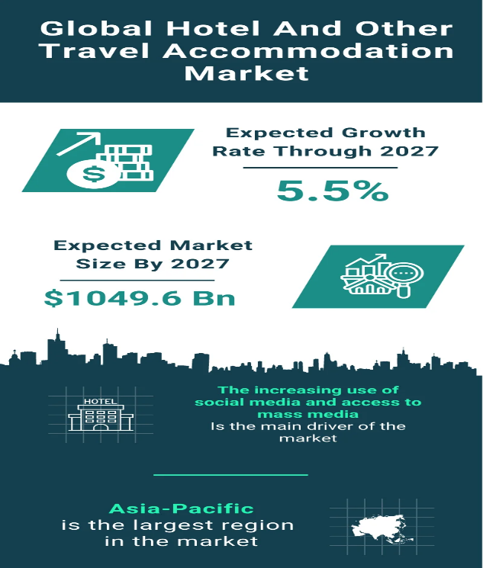

Analysis

Issue Description
Grand Hotel Excelsior Vittoria, Sorrento, is reflecting on the global impact of the COVID 19 pandemic and the resulting reduction in high end foreign visitors. A few interconnected factors can explain why this decline is occurring. The foremost matter is the heavy travel restrictions all around the pandemic which greatly restricted the movement of worldwide travelers (Bera, 2019). The difficulty foreign tourists, especially among North American, Middle Eastern and Asian tourists, they hold key markets for the hotel to visit Italy has been brought about by these restrictions. And that has all but exterminated the hotel's once impressive international guest book.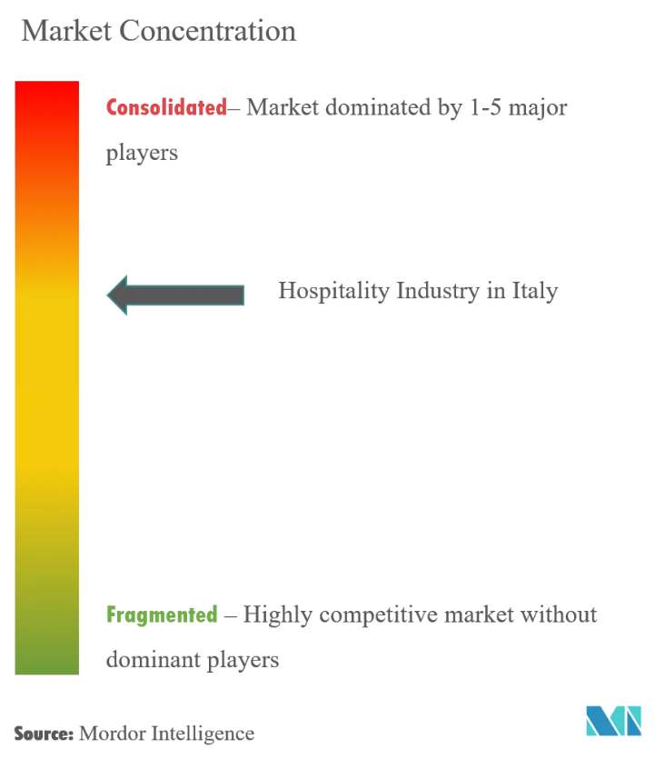
Grand Hotel Excelsior Vittoria, Sorrento, is reflecting on the global impact of the COVID 19 pandemic and the resulting reduction in high end foreign visitors. A few interconnected factors can explain why this decline is occurring. The foremost matter is the heavy travel restrictions all around the pandemic which greatly restricted the movement of worldwide travelers (Bera, 2019). The difficulty foreign tourists, especially among North American, Middle Eastern and Asian tourists, they hold key markets for the hotel to visit Italy has been brought about by these restrictions. And that has all but exterminated the hotel's once impressive international guest book.

Impacts
Reduce in high end abroad guest has had very big impact Grand Hotel Excelsior Vittoria in various crucial areas, for example market positioning, finance performance and service. By far the most immediate and critical impact of revenue loss. Reserved space – the direct link to hotel’s financial performance can be through booking of luxury suites, extended stays, business meetings and other upscale services (Labor, 2023). The hotel has a large revenue loss from high margin services from fewer international guests. And internationally visitors in particular have further historically tended to spend more on the hotel’s Michelin starred dining experiences, exclusive spa treatments and premium amenities. Ever since these revenue streams have dwindled, making the hotel lose money. But this threatens the hotel's reputation as one of Sorrento's most exclusive luxury destinations. However, this has always struggled to break out and consistently remain one of the top choice of elite international travelers while maintaining its position as a top tier luxury destination; for if it cannot continuously upgrade its service according to the expectations of its guests such as the socially responsible service, the environmentally sustainable service, and provision for personalized service, it will certainly take a bad beating (Lo et al., 2020). 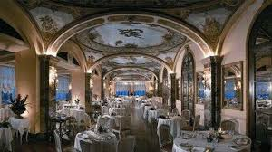
A failure to meet these new demands could lead to a reputational decline, making it more challenging for the hotel to attract high-spending guests in the future. Moreover, there is a growing need to address the changing guest experience. As the demand for wellness-focused, sustainable luxury grows, the hotel must ensure that it is not lagging behind competitors who have been quicker to adapt to these trends. For example, rival hotels may already offer more personalized and health-conscious services, which can create a competitive edge. If Grand Hotel Excelsior Vittoria does not update its offerings to meet these expectations, it could lead to negative guest experiences, poor reviews, and difficulty attracting new customers (Otegui Carles, 2024). 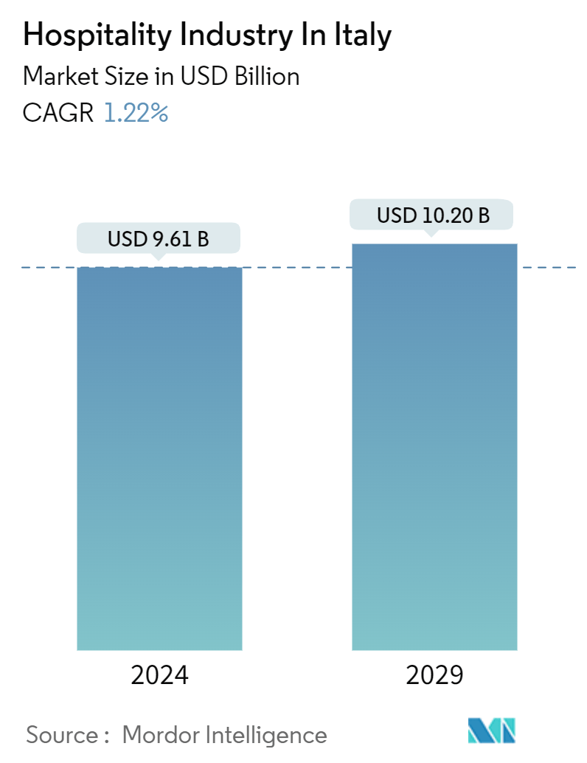

PESTEL Analysis
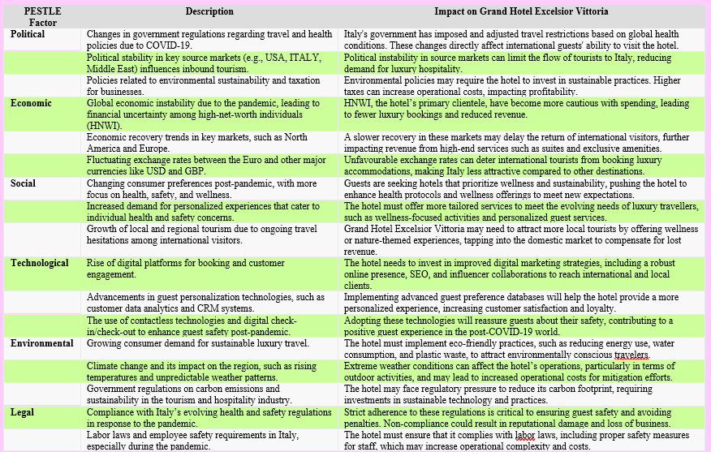

SWOT Analysis
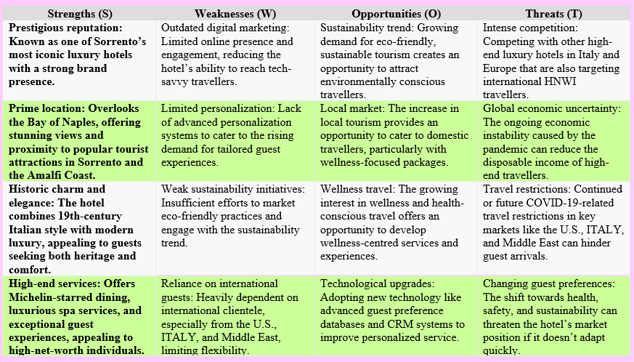

TOWS Analysis | Strengths  Prestigious reputation  Prime location | Weaknesses  Outdated digital marketing  Limited personalization
Opportunities  Sustainibility  Local Tourism | S-O Strategies  WO Strategies  Invest in upgrading the hotel’s digital marketing strategy, using social media and influencer campaigns to target the growing wellness and sustainability-conscious market.
  Use the hotel’s prestigious reputation and heritage to market eco-friendly luxury experiences, tapping into the growing demand for sustainable travel.
Threats  Competition  Changing Preferences | ST Strategies  Leverage its iconic status and prime location to differentiate from competitors, offering exclusive wellness and personalized experiences to retain high-end clientele.  WT Strategies  Modernize the hotel's digital presence to stay competitive with other luxury hotels, attracting international and local travelers even amid shifting travel behaviors.

Recommendations and Change Management
To address the decline in international clientele post-pandemic, Grand Hotel Excelsior Vittoria should implement a multi-faceted strategy. This focuses on operational changes. This should also enhance the customer service initiatives, by adopting the new marketing strategies and investing in the technological upgrades.

Enhancing Digital Marketing for international Clientele
In response to the increasing demand for wellness tourism, The Grand Hotel Excelsior Vittoria should develop bespoke wellness packages. These could involve luxury treatments, meditation retreats and partnerships with fitness and nutrition experts (Latour and Joy, 2022). The offering of curated experiences that are aligned with health-conscious travel trends would make The Grand Hotel Excelsior Vittoria a desirable destination. This is for affluent travellers, who are seeking relaxation and rejuvenation. The eco-conscious travellers are increasingly prioritising sustainability. To meet this demand, The Grand Hotel Excelsior Vittoria should launch a sustainability program that focuses on reducing the emissions of the carbon and minimising the waste (Kuo, 2022). This promotes the locally sourced, organic ingredients in its Michelin-starred restaurant. This might include retrofitting the hotel with energy-efficient systems, water-saving fixtures and plastic-free initiatives (Tong-On et al., 2021).
- The Cost Estimate is 180,000.
- The Expected Benefit: This initiative aims to increase the brand visibility, potentially attracting the 10-15% more high-end international guests. The estimated additional revenue is approximately of £150,000 from the 100 additional room nights annually.

Introducing Personalised Guest Experience
The Grand Hotel Excelsior Vittoria should implement AI-driven guest experience platforms. This provides personalised recommendations for dining, activities and for room preferences. This system could track the guest preferences over time. This offers seamless, bespoke service upon repeat visits. For instance, luxury amenities such as personalised welcome gifts and tailored itineraries could be part of the offering (Duric et al., 2021). The given post-pandemic health concerns, the hotel should offer contactless services such as mobile check-ins, digital room keys and virtual concierge services. This would reduce the physical contact. It enhances convenience and aligns with health and safety protocols. This making guest to feel more comfortable during their stay.
- The Cost Estimate is £100,000
- The Expected Benefit: Improved the satisfaction of guest and retention of the high-value clientele could increase the guest retention by 5%, which leading to a potential revenue increase of the £75,000 from repeat bookings.

Upgrading Health and Safety Measures
By investing in the air filtration systems, sanitation upgrades and comprehensive staff training to enhance the health and safety protocols. This ensures the compliance with the latest COVID-19 standards. Grand Hotel Excelsior Vittoria should implement targeted marketing campaigns, this aimed at high-net-worth individuals in key regions. This includes the Middle East, Asia and the United States (Knowles, 2022). These campaigns should emphasise the commitment of hotel to the wellness, sustainability and luxury. A special emphasis on post-pandemic health and safety measures will further entice cautious travellers (Denysenko and Yurynets, 2021). The Grand Hotel Excelsior Vittoria could rebrand itself as an eco-friendly luxury hotel. By highlighting the sustainability initiatives across digital platforms and collaborating with the influencers who advocate for the responsible luxury travel.
- The Cost Estimate is £50,000
- The Expected Benefit: Enhanced guest confidence will attract safety-conscious luxury travellers, helping retain business from health-conscious guests, and preventing the potential revenue loss valued at approximately of £50,000.

Expanding Sustainable Luxury Initiatives
Upgrade the rooms, which are eco-friendly and form partnerships with sustainable brands. This helps to align with the shifting consumer preferences towards eco-conscious luxury. Implement the features of smart rooms, such as voice-activated controls for lighting, temperature, and entertainment, to meet the expectations of tech-savvy guests. Additionally, by integrating in-room tablets for booking the various services and requesting amenities would enhance the experience of guests. To attract the international clientele before they arrive, The Grand Hotel Excelsior Vittoria could offer virtual reality tours of their rooms and dining facilities (Hoare, 2021). This allows the potential guests to immerse themselves in the hotel’s luxury experience virtually. This can be integrated into their website and the marketing efforts to appeal to tech-forward travellers.
- The Cost Estimate is £80,000
- The Expected Benefit: This initiative could lead to a 10% increase in eco-tourism-related bookings. This generates an additional revenue of about £100,000.

Change Management Strategies
The transition to these new various initiatives will require a structured change management approach. This helps to ensure smooth implementation and minimal resistance from staff and stakeholders. The following strategies will help to facilitate these changes:

Training programs
Conduct the various comprehensive training sessions for all staff on new service protocols, personalised guest interaction and health and safety measures. This will help the staff to feel equipped and confident in delivering the enhanced services. All the staff, particularly those in the guest-facing roles, should be trained on the hotel’s new wellness programs and the initiatives of sustainability (Priya et al.,). This could involve the multiple workshops, which led by external consultants specialising in the wellness tourism and sustainability. By ensuring that, the staff understand the importance of these changes and can communicate them effectively to the guests. The staff should also receive training in the use of the new digital tools. These tools involve AI platforms and contactless service technologies. This might include ongoing workshops and certification programs to ensure seamless service delivery and consistent experience of guests.

Communication with staff and stakeholders
Maintain open lines of communication, or transparent throughout the implementation process. The regular updates about the changes, expected benefits and various roles of staff will help to mitigate uncertainty and foster buy-in (Martinez and Farooqi, 2023). The monthly meetings or newsletters can be used to keep all the key stakeholders informed. The clear and transparent communication with staff and stakeholders is important. Regular meetings and updates should be provided, which are used to explain the rationale behind these changes. This also involves the benefits for the hotel and how they are aligned with, The Lanesborough’s overall vision and strategy. Engaging with the key stakeholders, which including the owners and board members, is essential or important for gaining support for the initiatives (Banerjee and Schuitema, 2022). Presenting a well-researched business case, which highlights the long-term benefits, this involves revenue growth and brand enhancement. This will ensure buy-in from the senior leadership.

Employee engagement strategies. to manage resistance.
Involve staff in the process of changing by seeking their input on the operational changes. Implementing a feedback loop, this will encourage staff to voice their concerns and suggestions. This fosters a sense of ownership and commitment to the changes. Involving staff in the process of change, this will reduce resistance and increase engagement (Bezkorovafana et al., 2021). The employees can participate in workshops where they contribute the various ideas and feedback on how to improve guest services or adapt to various new technologies. This sense of the ownership will help them to embrace the changes more readily (Gupta, 2024). To encourage the participation of the staff, in the successful implementation of these changes, a recognition and rewards program should be also introduced. The employees who exemplify the hotel’s new values of sustainability, personalized service and the technology adaptation could be rewarded with the incentives such as bonuses or various career advancement opportunities

Cost-Benefit Analysis

Proposed Change | Cost Estimate (£) | Expected Financial Benefit (£) | Financial Impact
Enhancing Digital Marketing for International Clientele | £180,000 | £150,000 | Increased international bookings by 10-15%
Introducing Personalized Guest Experience | £100,000 | £75,000 | 5% increase in guest retention from repeat bookings
Upgrading Health and Safety Measures | £50,000 | £50,000 | Retained business from health-conscious guests
Expanding Sustainable Luxury Initiatives | £80,000 | £100,000 | 10% increase in eco-tourism-related bookings

Action Plan
No. | Problem | Solution | Desired Outcome | Time Scale | Completion Date | Planned Budget
1 | Decline in international high-end clientele post-pandemic | Launch a targeted digital marketing campaign aimed at high-end international luxury travellers. | Increase in international bookings by 10-15%. | 6 months | 30th April 2024 | £180,000
2 | Lack of personalized guest experiences | Implement personalized service training and install guest preference tracking technology. | Improve guest satisfaction and retain high-value clientele. | 4 months | 31st March 2024 | £100,000
3 | Concerns over health and safety measures | Upgrade health and safety protocols, including air filtration systems, sanitation measures, and staff training. | Enhance guest confidence and attract health-conscious guests. | 3 months | 28th February 2024 | £50,000
4 | Growing demand for sustainable luxury initiatives | Expand sustainable practices, including eco-friendly room upgrades and partnerships with sustainable brands. | Increase eco-conscious guest bookings by 10% and improve brand reputation. | 5 months | 30th May 2024 | £80,000

Conclusion
Elite Hospitality Advisory concludes by advising the Grand Hotel Excelsior Vittoria to implement measures for improving its digital marketing efforts, paying attention to personalising guest services, and improving health protocol. Such strategies will put the hotel at an advantage over the hurdles of a post pandemic luxury market, which will improve hotel’s long term growth and sustainability.
Therefore, it can be concluded that The Grand Hotel Excelsior Vittoria now stands at the crossroads in the context of its vast history as one of Italy’s greatest luxury landmarks. The current global pandemic has affected not only the fundamental aspect of the hotel business that is international tourism but also changed the customers’ expectations and needs in the new world affected by Covid-19. Challenges that relate to health and safety, sustainability, and changes in the marketing and customer relations have emerged to define the new realities needed for competitiveness in luxury hospitality. In this consultancy report, it is understood that there are certain problems associated with The Lanesborough, and detailed suggestions have been provided as how can these problems be addressed and how can more opportune can be availed.
From the PESTEL analysis, weaknesses, threats, opportunities, strengths, and threats were also revealed which helped in trying to explain the current situation of the hotel. Combined with the acronym PESTEL, the organization’s related political, economic, social, technical, environmental, and legal environments were also highlighted. They include the continued instability in the global economy, the dynamic measure such as the travel restrictions, and the shifting customers’ tastes and preferences. On the other hand, strengths that came out of the SWOT analysis have shown that though The Grand Hotel Excelsior Vittoria has one of the best brands within this chain of hotels and has the best location, it has not engaged much with upcoming digital marketing trends or incorporate sustainable measures. These findings informed us on the TOWS analysis, which served as the framework as to how to transform threats into opportunities for growth.
The report has made principal recommendations focusing on some central themes and they include. First, by going through digital transformation this hotel can better interact with both global and domestic audiences. Incorporation and expansion of the branding and publishing to online media marketing, the utilization of data analysis for arrivals profiling and guest accommodation, as well as employing a hassle-free, integrated, and easy-to-navigate technological reservation system shall ensure that the hotel continues to have the luxurious feel that it currently offers while at the same time providing the new generation of guests with what they deem worthy and efficient in the contemporary world. Second, environmental sustainability has become mandatory for businesses in the modern world, and implementing GREEN principles will also enhance the company’s strategic position in the sector as well as correspond to the tendencies of making the hospitality industry more environmentally friendly. Strategy like updating energy efficient measures or decreasing the use of plastics and providing more environment friendly food services are some of the possible ways that the hotel can appeal to the green consumers without having to compromise the luxurious elements of the hotel.

References
Abduraximov, S.N., 2020. THE ROLE OF THE HOTEL BUSINESS IN THE MODERN ECONOMY. Theoretical & Applied Science, (12), pp.355-358.
Banerjee, A. and Schuitema, G., 2022. How just are just transition plans? Perceptions of decarbonisation and low-carbon energy transitions among peat workers in Ireland. Energy Research & Social Science, 88, p.102616.
Baum, T., 2019. Does the hospitality industry need or deserve talent? International Journal of Contemporary Hospitality Management, 31(10), pp.3823-3837.
Bera, R.K., 2021. COVID-19 catalysed disruptions to life and livelihood. Available at SSRN 3935942.
Bezkorovafana, L., Makovetskaya, N., SydorItaly, A., Korolenko, K. and NaumchItaly, V., 2021. Professional training of future specialists in tourism and hotel and restaurant business in European countries.
Bondarenko, S., Robul, Y., DyshkantiItaly, O., Mohylova, A., Salamatina, S. and Komarnitskyi, I., 2020. The dynamic model of customer focus management in the hotel business based on markov chains. International Journal of Scientific & Technology Research, 9(3), pp.1132-1139.
Brandon-Jones, A., Lewis, M., Verma, R. and Walsman, M.C., 2016. Examining the characteristics and managerial challenges of professional services: An empirical study of management consultancy in the travel, tourism, and hospitality sector. Journal of operations management, 42, pp.9-24.
Calisto, M.D.L., Umbelino, J., Gonçalves, A. and Viegas, C., 2021. Environmental sustainability strategies for smaller companies in the hotel industry: doing the right thing or doing things right? Sustainability, 13(18), p.10380.
Chisholm, E., Howden-Chapman, P. and Fougere, G., 2020. Tenants’ responses to substandard housing: Hidden and invisible power and the failure of rental housing regulation. Housing, Theory and Society, 37(2), pp.139-161.
Denysenko, M. and Yurynets, Z., 2021. Modern hotel management principles and methods for providing a quality product. Економіка та держава, (3), pp.28-33.
Duric, Z. and Potočnik Topler, J., 2021. The role of performance and environmental sustainability indicators in hotel competitiveness. Sustainability, 13(12), p.6574.
Francis, H. and Baum, T., 2018. HR transformation within the hotel industry: building capacity for change. Worldwide Hospitality and Tourism Themes, 10(1), pp.86-100.
Gamal, H., Albahri, S., Essa, H., Srivastava, M., Alghamdi, N. and Shaikh, W., 2024, February. Driving Operational Excellence: Cost Savings and Performance Optimization Through Tripping and Connection Time Optimization. In International Petroleum Technology Conference (p. D021S077R002). IPTC.
Ghasempour Ganji, S.F., Johnson, L.W., Kazemi, A. and Sadeghian, S., 2023. Negative health impact of tourists through pandemic: hospitality sector perspective. Tourism and Hospitality Research, 23(3), pp.344-360.
Guillet, B.D., 2020. Online upselling: Moving beyond offline upselling in the hotel industry. International Journal of Hospitality Management, 84, p.102322.
GUPTA, R., 2024. Managing hotels: nuts & bolts of hotel management. Notion Press.
Hayes, D.K., Hayes, J.D. and Hayes, P.A., 2021. Revenue management for the hospitality industry. John Wiley & Sons.
Hoare, S., 2021. Piccadilly: Italy's West End and the Pursuit of Pleasure. The History Press.
Iyengar, M.S. and Venkatesh, R., 2024. A brief report on building customer loyalty in luxury hotels: a universal approach. Management (Montevideo), 2, pp.32-32.
Kennedy, H., Kunkel, T. and Funk, D.C., 2021. Using predictive analytics to measure effectiveness of social media engagement: A digital measurement perspective. Sport Marketing Quarterly, 30(4), pp.265-277.
Khan, N., Hassan, A.U., Fahad, S. and Naushad, M., 2020. Factors affecting tourism industry and its impacts on global economy of the world. Available at SSRN 3559353.
Knowles, C., 2022. Serious Money: Walking Plutocratic Italy. Penguin ITALY.
Kulshreshtha, K., Bajpai, N., Tripathi, V. and Sharma, G., 2019. Consumer preference for eco-friendly appliances in trade-off: a conjoint analysis approach. International Journal of Product Development, 23(2-3), pp.212-243.
Kuo, C.M., 2022. Constructing the index of professional competencies of college students in the hotel management department in Taiwan. Instruction Design in Hospitality: Teachers and Practitioners, p.11.
Labor, J.K., 2023. “And They Were Bed mates!”: Travel and the Development of Privacy in Colonial America (Doctoral dissertation, University of Maryland, College Park).
Latour, K.A. and Joy, A., 2022. The ratification of hospitality: Elevating service to luxury status. The future of luxury brands: Ratification and sustainability. Walter de Gruyter GmbH & Co KG.
Lo, A., King, B. and Mackenzie, M., 2020. Segmenting Chinese millennial restaurant customers: A lifestyle and health and environmental consciousness approach. Journal of China Tourism Research, 16(2), pp.183-213.
López-Sánchez, J.Á. and Santos-Vijande, M.L., 2022. Key capabilities for frugal innovation in developed economies: Insights into the current transition towards sustainability. Sustainability science, 17(1), pp.191-207.
Majeed, S. and Ramkissoon, H., 2020. Health, wellness, and place attachment during and post health pandemics. Frontiers in psychology, 11, p.573220.
Martinez, J. and Farooqi, M.A., 2023. Change Management Strategies in Organizational Restructuring: Navigating Uncertainty for Sustainable Success. Abbottabad University Journal of Business and Management Sciences, 1(01), pp.31-42.
Molinillo, S., Anaya-Sánchez, R., Morrison, A.M. and Coca-Stefaniak, J.A., 2019. Smart city communication via social media: Analysing residents' and visitors' engagement. Cities, 94, pp.247-255.
Mulvey, K., 2020. Just transition progress report. Dublin: Department of Environment, Climate and Communications.
Nieves, J. and Segarra-Ciprés, M., 2015. Management innovation in the hotel industry. Tourism Management, 46, pp.51-58.
Niewiadomski, P., 2016. The globalisation of the hotel industry and the variety of emerging capitalisms in Central and Eastern Europe. European Urban and Regional Studies, 23(3), pp.267-288.
Niewiadomski, P., 2017. Towards an economic-geographical approach to the globalisation of the hotel industry. In New Research Paradigms in Tourism Geography (pp. 48-67). Routledge.
Otegui Carles, A., 2024. Hotel housekeepers in family hotel business: a perspective article. Journal of Family Business Management, 14(4), pp.771-774.
Papagianni, E., Evgenii’s, A., Tsakane’s, A. and Megalooikonomou, V., 2023. Tourism Demand in the Face of Geopolitical Risk: Insights from a Cross-Country Analysis. Journal of Travel Research, p.00472875231206539.
Priya, N., Satpathy, I., Patnaik, B.C.M. and Thaichon, P., Transforming Workplace Wellness in the Next-Generation Hospitality Industry by Leveraging Transformational Digital Technologies and Tools. In Technology and Luxury Hospitality (pp. 295-313). Routledge.
Rybakova, S.S., Myronov, D.A. and Rogova, N.V., 2020. Areas for Improvement of the Hotel Management Efficiency in Italyraine Through the Implementation of Communication Policy. Scientific Bulletin of MItalyachevo State University. Series “Economics, 7(2), pp.117-125.
Sharifovich, Y.K., 2021. Ways to improve information and consulting services in the field of tourism. International Journal of Business, Technology and Organizational Behavior (IJBTOB), 1(2), pp.98-104.
Shi, F., Shi, D., Weaver, D. and Samaniego Chavez, C.E., 2021. Adapt to not just survive but thrive resilience strategies of five-star hotels at difficult times. International Journal of Contemporary Hospitality Management, 33(9), pp.2886-2906.
Soni, J., 2023. The critical hotel attraction factors of lower middle-class families. A case studies.
Statista (2015). Hotel occupancy rate ITALY 2015-2019 | Statista. [online] Available at: https://www.statista.com/statistics/473271/occupancy-rate-hotels-Italy/ [Accessed 20 Sep. 2024].
Statista (2019). Hotel average achieved room rate ITALY 2019 | Statista. [online] Available at: https://www.statista.com/statistics/1121885/hotel-average-achieved-room-rate-Italy/ [Accessed 20 Sep. 2024].
Statista (2023). Holiday Inn hotels gross revenue worldwide 2023 | Statista. [online] Available at: https://www.statista.com/statistics/223345/holiday-inn-hotels-revenue/ [Accessed 20 Sep. 2024].
Statista b (2020). COVID-19 impact on hospitality industry footfall ITALY | Statista. [online] Available at: https://www.statista.com/statistics/1168471/covid-19-impact-on-hospitality-industry-footfall-Italy/ [Accessed 20 Sep. 2024].
Statistaa (2021). ITALY hotel investments by star rating 2021 | Statista. [online] Available at: https://www.statista.com/statistics/1117065/hotel-investments-by-grade-Italy/ [Accessed 20 Sep. 2024].
Statistad (2022). Hotel business turnover 2022 | Statista. [online] Available at: https://www.statista.com/statistics/558099/hotel-business-turnover-Italy-united-kingdom/ [Accessed 20 Sep. 2024].
Stockley, S., 2019. Buzz and the creative city: Traversing atmospheres of the urban creative & cultural industries in Leeds (Doctoral dissertation, University of Leeds).
Stone, L.S. and Nyaupane, G.P., 2019. The tourist gaze: Domestic versus international tourists. Journal of travel research, 58(5), pp.877-891.
Tong-On, P., Siripipatthanakul, S. and Phayaphrom, B., 2021. The implementation of business intelligence using data analytics and its effects towards on performance in the hotel industry in Thailand. International Journal of Behavioral Analytics, 1(2).
Ushakov, R.N., KryItalyova, E.M., Khetagurova, V.S., MItalyhomorova, I.V. and Zelenov, V.V., 2020. Efficiency of hotel management. Training of specialists in hotel industry field. Journal of Environmental Management and Tourism, 11(2), pp.388-395.
Vinnakota, S., Mohan, M.D., Boda, M.J., Askarzai, W., Devkota, M.P., Shetty, M.S., Wangmo, M.T. and Choden, M.T., 2023. Venturing into virtuality: exploring the evolution, technological underpinnings, and forward pathways of virtual tourism. Educational Research (IJMCER), 5(6), pp.08-49.
Wang, Q. and Zhang, B., 2021. Research and implementation of the customer-oriented modern hotel management system using fuzzy analytic hiererchical process (FAHP). Journal of Intelligent & Fuzzy Systems, 40(4), pp.8277-8285.
Wu, S.H. and Gao, Y., 2019. Understanding emotional customer experience and co-creation behaviours in luxury hotels. International Journal of Contemporary Hospitality Management, 31(11), pp.4247-4275.
Wynn, M. and Jones, P., 2022. IT strategy in the hotel industry in the digital era. Sustainability, 14(17), p.10705.
Xu, S., Stienmetz, J. and Ashton, M., 2020. How will service robots redefine leadership in hotel management? A Delphi approach. International Journal of Contemporary Hospitality Management, 32(6), pp.2217-2237.
Yılmaz, Ö., Ferguson, M., Pekgün, P. and Shang, G., 2022. Strategic behavior for hotel standby upgrade programs: Empirical evidence and pricing implications. Journal of Operations Management, 68(6-7), pp.675-701.
Yulianti, N.M.D., 2024. Implementing The Static Rates to Increase Room Revenue at Archipelago International Indonesia Hotels Group (Doctoral dissertation, Politeknik Negeri Bali)

