
Module Assignment Submission
Student Name: | OLIVIAN MAJORANT
Student Number: | 2005325
Module Code: | BMSK6003
Module Title: | Leading and Implementing Workplace Change

Statement of Confirmation of Authenticity
By the act of making this submission, the student declares that this is the work of the student named above. The work has not, in whole or in part, been knowingly presented elsewhere for assessment, or where assessment has been built on a previous assessment, this has been identified. Where materials have been used from other sources it has been properly acknowledged. If this statement is untrue, the student acknowledges that an assessment offence has been committed.
Attention is drawn to the plagiarism and unfair practice policies of the University.

Table of Contents
Introduction 3
1.0 Critically analyse the nature of change and evaluate complex concepts relating to leadership in relation to change management 3
2.0 Critically analyse the nature of change and evaluate complex concepts relating to leadership in relation to change management 8
3.0 Explore contemporary issues and their impact on business management 11
Organizational Learning: 15
4.0 Analyse and evaluate the relationship between organisational culture and change 17
4.1 Lewin's Change Theory 21
Conclusion 24
References 26
APPENDICES : 35
APPENDIX A : 35
APPENDIX B: 37
APPENDIX C: 38
APPENDIX D: 39
APPENDIX E: 40
APPENDIX F: 41

Introduction
Environmental shifts, complexity, and resource scarcity define external surroundings. "Environmental change" refers to shifts in a business's global and local contexts. External variables are numerous and large. The scarcity of resources refers to the availability of important resources nearby. Accelerating environmental change, increasing complexity, and scarcer resources reduce managers' confidence in their capacity to understand, predict, and respond to enterprise trends. The punctuated equilibrium hypothesis says businesses experience relative stability and rapid, drastic upheaval periods.
"Change management is an organised, systematic application of the knowledge, techniques, and resources of change that provides businesses with a vital procedure to fulfil their business plan," claims a study by Markus Wanner.
Within organisations, organisational change is a significant challenge. Changes may result from a variety of factors, including modifications to the management system, the accounting system, changes in market demand, and modifications to the market's competitors. An organisational action or group of actions is one intended to alter the course or method of the Company's activity. Additionally, change is a constant in business. The organisation must alter how it operates if it is to survive.

1.0 Critically analyse the nature of change and evaluate complex concepts relating to leadership in relation to change management
Society-wide trends affect all businesses. Because the economy affects even basic corporate decisions, managers use economic information and business confidence indices to predict economic activity. Technological advances can help or hurt businesses by affecting how inputs become products. Diversifying consumer bases affects business practices. Shifts in consumers' actions, outlooks, and values affect a company's product demand (Rehman et al., 2019). Judgements and new federal and state regulations have expanded companies' political and legal responsibilities. The best way to handle a company's legal responsibilities is to make sure all management and employees are familiar with the applicable laws, regulations, and lawsuits that could be launched against the organization.
Five pillars make up the unique environment: customers, competition, suppliers, government, and advocacy groups. Analyzing consumer input and fixing problems as they develop are the best strategies for organizations to track customer wants. Too focused on the big names in their field, managers often miss new competitors. Suppliers and customers are interconnected; thus, one side often takes advantage of the other. Businesses are affected when governments adopt and enforce policies. Advocates can't control business practices. They use PR campaigns, media advocacy, and product boycotts to change firms' ways.
Managers use a three-step approach to understand external contexts: environmental scanning, information interpretation, and responding to threats and opportunities. Environmental scanning helps managers track business developments, reduce unknown factors, and spot emerging issues (Rehman et al., 2019). When management realizes external factors pose a risk, they take preventative steps. When managers recognize environmental events as opportunities, they can increase company performance. Cognitive maps help managers summarizes external factors and potential reactions.
An organization's external environment is not a single, unchanging item; it's the outcome of interrelated aspects that each have their impact. The environment constrains the organization. Legal, technical, sociocultural, and other environmental issues hinder organizations (Rahimian et al., 2020). Together, they provide the organization's framework or broader context. The environment directly or indirectly affects the organization's activity and dynamics in its environment.
An open system influences and is influenced by its external surroundings. No organization can operate without its environment, which presents opportunities and limits. The organization must adapt to new situations to prosper (Dubey et al., 2021). Businesses fail because their CEOs aren't flexible enough to adapt to changes.
It can be difficult to determine direct causal links between an organization's activities and its operating environment. Since it's plausible to assume these are concurrent processes, speculating on their influences is popular. External factors substantially affect a company's success or failure. Environment resources, stakeholder demands, and change rates all affect an organization's ability to function (Rehman et al., 2019). Many environmental variables may not have evenly positive or negative effects but rather nonlinear patterns that pose distinct challenges at different levels.
The number and variety of environmental variables affecting individuals are good indicators of environmental complexity. In a low-complexity context with equivalent decision criteria, choosing is easy (Rahimian et al., 2020). In complicated contexts, decision units must weigh several external factors. State-dynamic measures whether a decision unit's external conditions are stable over time (Kumar et al., 2018). Uncertainty assumes that a company's external interactions can't be controlled or predicted. Inability to assign probabilities to events. Recent definitions of "uncertainty" in the workplace include "lack of information about future occurrences, so alternatives and consequences are unknown." Due to their numerous exterior activities, their internal operational conditions are as diversified (Dubey et al., 2021). Businesses must understand their contexts to function and grow. Failure to anticipate changes in an organization's external environment and make appropriate modifications leads to crisis and failure.
Change has been a difficult topic that has impacted several companies. Organizations must adapt to such radical change if they want to thrive in the fast-paced, cutthroat economic world. To encourage the intended results, the change must be in line with organisational culture, values, people, and habits. As a result, human leadership is essential to the success of transformation.
Employee resistance and anger will undoubtedly be there as a result of such a tough shift. The process of change will be impacted by the psychological and social dread of change as well as a lack of technical ability. Therefore, leaders should have the necessary competencies to implement strategic change successfully.
David (2004) also highlighted the role that leadership may have in overcoming change reluctance. According to him, "management must recognise that change is inevitable and that they alone are accountable for overcoming employee resistance via solid management and change-oriented leadership for World Class Organizations to thrive" (David, 2004).
Four key forces—globalization, technology advancements, knowledge management, and cross-border collaboration—affect organisational transformation. Either the macro environment or the external environment might change. Organizations want visionaries who can make judgments throughout these shifts and are imaginative and creative. Tappin (2009).
According to Tappin (2009), a leader must cultivate the following traits in order to manage change.
-the ability to articulate their vision to their groups
-a tutorial on serving
-a mindset of entrepreneurship
-a dedication to ongoing innovation
-global perspective
-confidence and comfort using technology
-knowledge of systems thinking, which takes a wide view of how many elements of an organisation interact rather than a view that is narrowly focused on a single element or event.

-In the workplace, a sense of ethics and a respect for spirituality
-a dedication to lifelong study, personal growth, and professional advancement
According to Tappin, a change leader should have the following qualities. To determine the best strategy a leader might use while managing change, a thorough study must be conducted.
Because the traits of a change leader have been outlined above. It is appropriate to do a comprehensive review of different leadership philosophies and methods in order to determine which is best.

2.0 Critically analyse the nature of change and evaluate complex concepts relating to leadership in relation to change management
Strong leadership is critical to most companies' success and growth today. Intelligent leaders have the experience and resources to minimize waste and maximize productivity. Change requires great leadership (Kumar et al., 2018). Researchers have cited a culture of quiet, independence, and secrecy as cultural impediments to change management when discussing organizational change. Capable administration can handle such difficulties (Dahmardeh & Nastiezaie, 2019). Competency is knowledge and skills. Some leadership skills are crucial for the position's success. A leader's ability to transform an organization depends on many skills. According to the authors, leadership skills are linked to organizational performance and transformation.
Literature shows that change requires competent leadership. Change resistance is unavoidable in most organizational situations; a competent leader can lessen this opposition and see change through. Identifying and overcoming resistance is a time-consuming and challenging task for any group (Singjai et al., 2018). Only a leader's ability to motivate people to accept change may succeed. Just as a qualified doctor is needed to treat an emergency, so is a capable leader. With incremental change, a formal launch is typically unnecessary (Ashrafi et al., 2019). Most employees are acclimated to these short-term, basic, and easy-to-adapt shifts. Radical changes have a higher barrier to the entrance and cause more criticism, requiring more leadership skills (Bhaduri, 2019). Leaders must help their personnel adjust to significant changes by raising awareness of the need for change and encouraging a willingness to reject old methods.
Changes require different leadership than maintenance. Extreme changes require bold, inventive leadership. The table below compares leadership styles with increasing degrees of extreme transformation (Oreg & Berson, 2019). Combining logic and inspiration helps leaders grasp the larger picture and push for daring changes and innovations. A leader's vision can inspire action and change (Rachinger et al., 2018). Good leaders have a clear vision of the future for successful change. Without planning, change is difficult. Kotter says that leaders must communicate their vision. Effective leaders communicate goals and prioritize innovation.
Leadership plays a crucial part in fostering an environment conducive to change, which is essential for its successful implementation and management. The leader brings new approaches to building or controlling organizational culture and plays a role in the organization's evolution. The organization's leadership can devise plans to improve communication and collaboration within the workforce (Ashrafi et al., 2019). An organization's culture may include its core values and principles, influencing how the company operates and shaping its trajectory from traditional to cutting edge (Kohtamäki et al., 2020). The leadership position may be educational, consultative, or supportive, and there may be unwritten rules, disciplines, and an emphasis on the outside world. The author argues that a leader's most crucial function in the management and growth of a culture is a supporting one.
Leadership can also prove useful in the management of technological systems. Leadership in technology management can take either a transactional or transformative approach (Sweeney et al., 2019). When a leader adopts a transactional style, he pays more attention to technological developments and technical expertise than he does to people and problem-solving (Bartik et al., 2020). A transformational leader, on the other hand, demonstrates his role as a trailblazer and conveys his vision by the skillful application of his abilities, all while keeping an eye on the human relations aspects that arise from technological advancements (Oreg & Berson, 2019). This kind of leader can better bring about organizational change and innovation (Ali et al., 2018). A leader's ability to motivate their team members is enhanced by the leader's ability to devise effective techniques, the most effective of which is using rewards. The effectiveness of a company's reward programs in inspiring its employees to give their all is directly proportional to the quality of performance they receive in return (Bhaduri, 2019). Therefore, it is the responsibility of the leader to determine what kinds of incentives and training programs should be implemented to bring about strategic change in the firm (Ali et al., 2018). The authors agree that a culture where employees are encouraged to take the initiative and take ownership of their work is essential for a productive workplace. That atmosphere must be fostered, and it is the leadership's job to do so.
While leaders are crucial in managing companies and facilitating organizational transformation, other elements influence significantly. Organizational management can be complicated by a wide variety of internal and external factors (Kohtamäki et al., 2020). We've established that company culture plays a role in shaping businesses and can even impact transformational initiatives (Faupel & Süß, 2019). We argue that a leader's influence in shaping an organization's culture is constrained by a variety of other factors, including the specifics of the business itself, the location in which it operates, the employees themselves, and the nature of the work they do (Rachinger et al., 2018). Organizational effectiveness and organizational change process are also susceptible to external factors, including shifts in the political, social, and technical landscapes (Coghlan, 2021). The authority of a leader over such matters is extremely constrained.
Order to improve organizational performance is dependent on change project leaders who have direct responsibility over personnel who are undergoing change. The following are some of the primary responsibilities that leaders may play in driving change in the organisation.
The team working on the change transition must look up to the leader as a role model. Leaders must be willing to go first and lead their colleagues through the process. Leaders must be self-aware and purposeful in their actions.
A leader makes decisions. Leaders have complete power over resources such as the personnel, money, and equipment available for the transition phase of change. Leaders must regulate their decision-making authority during change and pick the choice that will assist the project. The Decision-Maker has clout and sets priorities that promote change.
Employees are motivated by the leader. The leader provides inspiration for the transformation to occur. Leaders project the significance of change and demonstrate dedication and enthusiasm for getting things done.
In change management, the leader is an enforcer. With power, the leader holds the individual accountable for the change. Perfect leaders recognise that change will not occur until they fulfil the duties that authority allows them to perform.

3.0 Explore contemporary issues and their impact on business management
The problems and issues facing modern businesses are constantly evolving and adapting to the new realities of the modern business world (Ali et al., 2018). Here are some examples of the business and management challenges that companies are currently facing:
Talented Workers
A talent paradox has emerged as a result of the recent financial crises around the world. Despite the unemployment rate continuing to rise and the state of the labor market, many businesses are still struggling to fill open positions (Sweeney et al., 2019). Organizations point fingers at the educational system for producing graduates that fall short of their standards. Despite improved retention rates, organizations still need to work on their HR strategies, as poaching and headhunting are rising due to intensifying competition (Kohtamäki et al., 2020). Examples of companies with great HR policies include Marriott Hotels.
Online shopping
As a result of the more widespread availability of the internet and more convenient electronic devices, online trading has experienced explosive growth in recent years. The internet, social media, and cloud computing are the primary drivers (Whysall et al., 2019). It is widely anticipated that the traditional "brick and mortar" retail format will face formidable competition from online retailers (Kohtamäki et al., 2020). Therefore, businesses are adopting online trade options simultaneously, and they need to place equal emphasis on their virtual business as it tends to grow as a result of companies' efforts to expand their customer bases into new regions, as well as to maintain and improve the quality of their websites and online services (Alqatawenah, 2018). Both business-to-business and business-to-consumer transactions can be conducted online. People's knowledge, education, and access to additional options have all increased thanks to the proliferation of information on the Internet (Van Tulder & Keen, 2018). As a result, companies face the arduous chore of differentiating their products, brands, and customers across both distribution channels.
Controlling The Rate Of Change And Introduction Of New Ideas
A company's ability to compete in the global market depends on its ability to encourage innovation within its product line and adapt to market shifts. Businesses nowadays are making concerted efforts to innovate in ways that minimize expenses (Singjai et al., 2018). The only way for businesses to survive is to constantly innovate. To successfully integrate innovation and change management into the fabric of a business, leaders must first create the conditions for creative problem-solving (Turner & Baker, 2019). Companies like Amazon, Red Hat, Alexion Pharmaceuticals, etc., enjoy a worldwide reputation for innovation.
Sustainability
The importance of sustainability is growing, and it is becoming a top priority for businesses. Sustainability is the primary source for gaining a competitive advantage, fostering innovation, and providing real bottom-line outcomes; corporate social responsibility is simply one facet of sustainability that is being exploited strategically for marketing goals (Cenamor et al., 2019). Therefore, there is a growing need for frameworks to help managers evaluate sustainability indicators, such as systems, processes, and controls. It presents a unique difficulty for businesses (Stouten et al., 2018). Sustainability efforts by companies like Microsoft, Tata Group, and Reliance Group are admirable.
Work Ethics
An organization's employment agreements, risk tolerance, growth prospects, and overall health directly impact its employees' work ethics. To ensure long-term financial benefits, companies must ensure that their sustainability programs are adhered to by their management and leadership teams (Singjai et al., 2018). However, one of the greatest difficulties is maintaining a culture of ethics in the workplace and instilling that culture in the company's processes and employees (Mosteanu et al., 2020). Companies like American Express, GE, and Infosys are known worldwide for their commitment to ethics. Businesses must be alert to developments at all business intersections and make necessary adjustments as they emerge. However, problems will always arise, and businesses must learn to adapt.
The knowledge management, learning organisations, and knowledge economy are some of the modern management topics I will be covering in this paper. The success of every firm depends heavily on knowledge management and learning organisations. Thus, in our constantly evolving management environment, these current strategic management concerns require more attention than ever.
Knowledge Management:
The connection between organisational learning and organisational knowledge as well as the impact knowledge management has on both are both developing and immature in terms of their foundations and orientations to organisations, as well as emerging and uncharted. As the renowned scientist and astronomer Carl Sagan used to remark, "There are billions and billions and billions of stars in the cosmos." The same may be said of the breadth and depth of the area of information management.
The gathering body of academics and students should be cautious and concerned about the studies and the gathered basis of research that are captured in and by the selection of articles this paper will utilise to support this discussion of these three difficult but important entrance points.
Knowledge Economy:
The term "knowledge economy" describes a knowledge-based economy that focuses on the management and production of knowledge. The latter phrase, which is more frequently used, refers to the use of knowledge to produce economic value. Numerous commentators described the current status of the global economy as one that is evolving towards a "knowledge economy" as an extension of the "information society."

Organizational Learning:
What is organisational learning precisely, and why should we care? The following table, which was carefully prepared based on research done by the School of Public Health at the University of Albany, may be found by performing a web search. The table is divided essentially into individual and group domains with the assumption that the "best practises" listed will fall, roughly speaking, into four categories:
-communication and openness;
-inquiry and feedback;
-adequate time;
-mutual respect and support.
“Knowledge is not as vital as imagination. In contrast to imagination, which alludes to everything that we may still discover and create, knowledge specifies what we presently know and comprehend. “( Alfred E. Neumann )(Lewis)
The fundamental tenet of any company organisation could be the cost, the calibre of the good or service, consistency, or compatibility. However, a lot of organisations try to prioritise their interactions with customers. Since these clients represent the lifeblood of the company, managers may legitimately devote more of their efforts to them if they can build strong long-term relationships with them (Narayanan, 2001, p 158).
If a company is having issues, then so are the clients. However, it is more important than ever to convey to employees that the company is committed to helping them thrive by helping them to adjust to the unsteady market (Hatch, 2006, p. 67). The management can start simple by conducting an inquiry to see why some customer connections had deteriorated and by proposing new strategies to ensure that these relationships are better maintained and improved upon.
Customer loyalty becomes a crucial tool during a downturn. Managers may be certain that a robust sales force provided input and enabled the company to innovate its goods to address specific demands (Howard, 1993, p 56).
To survive the recession, it is imperative to be able to have a distinctive competitive edge. Innovation has been a highly effective strategy for achieving this. Strategic actions are required in trying circumstances. Market shifts may be fought by managers making the right changes to guarantee that the business goals are still accomplished in a new economic environment.

4.0 Analyse and evaluate the relationship between organisational culture and change

The pattern of values, conventions, beliefs, attitudes, and assumptions that may not have been explicitly stated but nonetheless influence how people act and how things are done is known as organisational or corporate culture. Norms are unspoken laws and customs.
The way things are often done in a company may be described as its culture in a fairly straightforward manner. It specifically has to do with the connection and behaviour pattern. An organization's culture evolves over a lengthy period of time. It is often developed by those who work for the company, including both management and employees.
The definition of organisational culture as a system of common meaning shared by members that sets the organisation apart from other organisations appears to be widely accepted. On closer inspection, this shared meaning system appears to be a collection of crucial components that collectively capture the essence of the culture of the organisation.
These components make up the framework's core and can be used to examine organisational culture. These are listed below.
The degree to which employees are encouraged to be innovative and take risks is measured by the innovation and risk-taking tasking.
The degree to which personnel are required to demonstrate accuracy, thoughtfulness, and attention to detail.

The degree to which management places more emphasis on results or outcomes than on the methods and procedures utilised to get there.
People Orientation: How much thought is given to how management choices will affect the individuals that make up the organisation.
Team orientation refers to how much work is focused on teams as opposed to individuals.
Behaviour: How hostile and competitive a person is compared to how laid back.
The extent to which organisational efforts prioritise maintaining the status quo as opposed to progress is referred to as stability.
Each of these components has a range from low to high. A composite image of the company's culture may be obtained by evaluating the organisation in light of these seven traits or components.
Internal Elements
Top Management's activities - The culture of the organisation is significantly influenced by the senior management's activities. Senior executives create norms that trickle down through the organisations in terms of whether risk-taking is desirable, how much freedom managers should grant their employees, what is appropriate dress, and what actions will result in pay raises, advertising, and other remuneration. These norms are established through what senior executives say and do.
Human resources Practices - Once a culture has been established, the organization's practises help to preserve it by providing employees with a certain set of experiences. For instance, a lot of human resources procedures support the culture of the company. The hiring process, performance assessment standards, career development opportunities, training programmes, and promotion processes all make sure that new hires fit in with the culture.
Socialization - Despite the organization's excellent hiring and selection practises, new hires are not fully assimilated into the company's culture. Most importantly, new hires run the risk of upsetting established beliefs and traditions because they are unfamiliar with the company's culture. Therefore, firms will seek to aid new hires in assimilating into their culture. The term "socialisation" refers to this adaption process.
External variables
The community context - People have an inner existence that is fed and fed by meaningful labour that occurs in the community environment. The community is one aspect of this issue that affects the organisation from the outside, and on the other hand, workers who are a part of that community will also have an impact on internal elements. Organizations that support a spiritual culture understand that individuals have both a mind and a spirit, and that they want to connect with others and feel a sense of belonging via their job.
Government laws and regulations also have a significant impact on company culture. The culture of a business may be influenced by a variety of factors, particularly those pertaining to how employees are treated, legal requirements, and customer interactions.
National Culture must be taken into consideration if forecasts regarding organisational behaviour in various nations are to be correct. Nevertheless, does national culture take precedence over organisational culture.
The qualities necessary for business success can only be cultivated within a great company culture. All team members are expected to perform following a set of shared values and norms that have been established through established procedures. You might think of it as a list of the characteristics that define our business (Cenamor et al., 2019). A great corporate culture exhibits the good characteristics that contribute to enhanced performance, whereas a dysfunctional company culture brings out the characteristics that can impede even the most successful organizations (Alqatawenah, 2018). Behaviors that are genuine and consistent over time are what build a culture, not official statements or plans.
Our company's culture impacts every facet of operations, from timeliness and politeness to legal protections and compensation (Cenamor et al., 2019). Our employees are more likely to feel at ease, supported, and appreciated when the company culture is a good fit. Businesses that put cultural values first tend to be more resilient in the face of economic and industry shifts.
Organizational culture and organizational transformation have a separate and reciprocal relationship. The ease with which change is implemented, the efficacy of change communication, and the overall impact of change are all influenced by an organization's culture. Major changes can significantly alter the culture of an organization (Figueroa et al., 2019). It is called "organizational change" when an establishment has major shifts. This term typically means changes that have a significant effect (Turner & Baker, 2019). It could be a merger with another company, a move to a new site, becoming public, or a change in management.
Adaptability could be the single most important factor connecting company culture and transformation. Not all businesses resist alteration; the most successful ones actively seek new methods to innovate and better their processes (Whysall et al., 2019). Some businesses are more set in their ways and would rather stick to such practices even if the market were to shift. Companies that follow the status quo struggle to adjust to new circumstances, often resisting change until it is too late.
Communication efficiency is another cultural aspect that influences transformation. Organizational readiness to communicate change and change strategies to employees, customers, and suppliers in a timely, clear, and effective manner is correlated with the success of change projects (Figueroa et al., 2019). Another benefit to a corporation that values employee input is less anxiety among staff members during transitional periods.
Change's influence on culture reflects the connection between culture and transition in an organization. It is especially true when there will be a shift in leadership due to the sale or acquisition of the business or the departure of key personnel from the organization (Chernyak-Hai & Rabenu, 2018). If this occurs, the firm's culture will almost certainly undergo profound shifts due to the new leadership or governing organization.

4.1 Lewin's Change Theory
In the 1940s, the physicist and social scientist Kurt Lewin established a three-stage model for changing the behavior of organizations that has since been known as Lewin's change theory. This model has now become widely used.
These steps include things like:
Unfreeze
Change
Refreeze
The theory of change proposed by Kurt Lewin can be understood by thinking about transforming a solid block of ice into a liquid puddle of water and then back into a solid block of ice again. According to Lewin's change model, workers accustomed to a particular behavior are considered "frozen" or resistant to change (Ferasso et al., 2020). Lewin contends that for transformation to occur, these workers need to be thawed out of their routines so they can be exposed to new experiences. Following this changeover, the third phase will start, during which the workers will be refrozen. It is the point at which the changed behavior will remain consistent. The idea put forth by Lewin applies to many different types of organizations (Rosenbaum et al., 2018). According to Lewin, following these three phases can assist individuals in kicking old habits, picking up new ones, and reinforcing the desired behavior to the point where it becomes automatic.
Factors That Are Forcing and Restricting Change
Lewin's strategy for managing organizational change considered the possible benefits and cons of accepting change as part of his methodology. Lewin listed potential drivers of change, such as pressure from customers, efficiency increases, and other growth prospects (Ferasso et al., 2020). He referred to them as "driving forces" throughout the conversation. Lewin also mentioned that certain conditions acted as roadblocks to the change process (Bartik et al., 2020). There are a lot of potential causes for resistance to change, including feelings of unease or a deficiency in available resources. According to what he said, there are constraints.
Equilibrium
According to Lewin, equilibrium is achieved when the pushing and restraining forces are almost equal. Nothing shifts when the conditions are maintained in such a way as to achieve this balance (Barnett et al., 2020). Understanding this concept is essential to get a handle on Lewin's thesis since he believed that the status quo had to be abandoned before any change could occur. Lewin theorized that change is doable if the number of driving forces exceeds the number of restraining factors.
Unfreezing
To begin the unfreezing process, personnel must be persuaded to give up using outdated practices and equipment. According to Lewin's definition, Unfreezing is the process of convincing a corporation to abandon its use of outmoded practices and methods. The most effective strategy for gaining organizational buy-in at this level is to present evidence demonstrating why change is necessary (Van Tulder & Keen, 2018). It is feasible that modernizing the technology utilized by the organization might assist reduce the frustration experienced by workers and that modifying the manufacturing process could result in an increase in earnings.
Workers are more inclined to accept change if they are informed about the reasoning for its necessity. The firm's leaders must understand the driving force behind the targeted transformation for the company to implement it successfully (Rosenbaum et al., 2018). Unfreezing is the third and final stage, and it is also the most difficult since individuals find comfort in routine, and disruption or change to the status quo is frequently met with resistance (Coghlan, 2021). The unfreezing process is essential if one is attempting to make a change.
Change
According to Lewin, the first step in the change process is the beginning for the individuals impacted by the change to start accepting and even embracing it (Hussain et al., 2018). They may, for example, initiate the process of suggesting improvements that ought to take place and initiate the process of transitioning to a new way of doing things (Mosteanu et al., 2020). It is helpful to demonstrate to people how they would benefit from changing their behavior to persuade them to adopt the desired behavior.
Rumors regarding the changes must be dispelled as soon as possible because they may cause widespread anxiety throughout the organization (Bhayangkara et al., 2020). It's possible that some workers, for instance, will be hesitant to adapt because they're worried that they don't have the necessary skills (Barnett et al., 2020). The possibility that the transition will be embraced by the organization as a whole increase when there is an investment in it from both the management and the workers.
Refreezing
When previously acquired behaviors are practiced repeatedly, they become second nature and part of the routine. It is essential to encourage the new behavior and ensure that it is employed daily to guarantee that the ice will refreeze. If the group does not refreeze, there is a good chance that they will revert to traditionally doing things and give up on the improvements they made.

Conclusion
According to the explanations above, the effective implementation of key managerial innovations such as customer-centric restructuring, six sigma, and the like, which are vital to the survival of any business, is dependent on the integration of both change management and change leadership (Griffith and Karyl, 2007). Integrating both, according to them, adds value to a specific project or campaign for a variety of reasons. According to Lewthwaite (2010), a leader who lacks basic management abilities is unlikely to advance further than a manager who cannot lead. She asserted that, while a leader might inspire people with a vision, he may lack the ability to turn it into a reality. On the contrary, change management may not understand the big picture.
To summarise, the study found that, while management makes people and technology systems work well by planning and budgeting, organising and staffing, controlling and solving problems, leadership creates and transitions systems that managers administer by creating a vision and strategy, communicating and setting directions, motivating action, and aligning people to avoid hazards (Kotter, 2011). Furthermore, while management takes complicated systems and technologies and makes them function efficiently, leadership as a profession produces such systems that managers can administrate and alter in times of organisational development, evolution, opportunities, and hazard avoidance (Kotter, 2011). Hannagan (2008) concludes his thesis by stating that, although change management is concerned with dealing with complexity, leadership is concerned with dealing with change.

References
Ali, M., Ali, I., Al-Maimani, K. A., & Park, K. (2018). The effect of organizational structure on absorptive capacity In single and dual learning modes. Journal of Innovation & Knowledge, 3(3), 108-114. Available at : https://www.sciencedirect.com/science/article/pii/S2444569X1730029X -[Accessed 20/08/22]
Alqatawenah, A. S. (2018). Transformational leadership style and its relationship with change management. Verslas: Teorija Ir Praktika/Business: Theory and Practice, 19, 17-24. Available at : https://www.econstor.eu/handle/10419/247923 -[Accessed 19/08/22]
Ashrafi, A., Ravasan, A. Z., Trkman, P., & Afshari, S. (2019). The role of business analytics capabilities in bolstering firms’ agility and performance. International Journal of Information Management, 47, 1-15. Available at : https://www.sciencedirect.com/science/article/abs/pii/S0268401218307734 -[Accessed 18/08/22]
Barnett, M. L., Henriques, I., & Husted, B. W. (2020). Beyond good intentions: Designing CSR initiatives for greater social impact. Journal of Management, 46(6), 937-964. Available at : https://journals.sagepub.com/doi/abs/10.1177/0149206319900539 -[Accessed 20/08/22]
Bartik, A. W., Bertrand, M., Cullen, Z., Glaeser, E. L., Luca, M., & Stanton, C. (2020). The impact of COVID-19 on small business outcomes and expectations. Proceedings of the national academy of sciences, 117(30), 17656-17666. Available at : https://scholar.google.co.uk/scholar?hl=en&as_sdt=0%2C5&q=Bartik%2C+A.+W.%2C+Bertrand%2C+M.%2C+Cullen%2C+Z.%2C+Glaeser%2C+E.+L.%2C+Luca%2C+M.%2C+%26+Stanton%2C+C.+%282020%29.+The+impact+of+COVID-19+on+small+business+outcomes+and+expectations.+Proceedings+of+the+national+academy+of+sciences%2C+117%2830%29%2C+17656-17666.&btnG= -[Accessed 20/08/22]
Bhaduri, R. M. (2019). Leveraging culture and leadership in crisis management. European Journal of Training and Development. Available at : https://www.emerald.com/insight/content/doi/10.1108/EJTD-10-2018-0109/full/html -[Accessed 17/08/22]
Bhayangkara, A. N., Ahmadi, W. H., Firdaus, D. B., Prestiadi, D., & Sumarsono, R. B. (2020, November). The Role of Instructional Leadership Through Kurt Lewin Model in Improving the Teacher Capability. In 2nd Early Childhood and Primary Childhood Education (ECPE 2020) (pp. 307-317). Atlantis Press. Available at : https://www.atlantis-press.com/proceedings/ecpe-20/125946149 -[Accessed 20/08/22]
Cenamor, J., Parida, V., & Wincent, J. (2019). How entrepreneurial SMEs compete through digital platforms: The roles of digital platform capability, network capability and ambidexterity. Journal of Business Research, 100, 196-206. Available at : https://www.sciencedirect.com/science/article/pii/S0148296319302188 -[Accessed 22/08/22]
Chernyak-Hai, L., & Rabenu, E. (2018). The new era workplace relationships: Is social exchange theory still relevant?. Industrial and Organizational Psychology, 11(3), 456-481. Available at : https://www.cambridge.org/core/journals/industrial-and-organizational-psychology/article/new-era-workplace-relationships-is-social-exchange-theory-still-relevant/F4E7EA06887C7CD12A3BF6F038D88CE6 -[Accessed 26/08/22]
Coghlan, D. (2021). Edgar Schein on change: Insights into the creation of a model. The Journal of Applied Behavioral Science, 57(1), 11-19. Available at : https://journals.sagepub.com/doi/full/10.1177/0021886320924029 -[Accessed 27/08/22]
Dahmardeh, M., & Nastiezaie, N. (2019). The impact of organizational trust on organizational commitment through the mediating variable of organizational participation. Management Researches, 12(44), 155-180. Available at : https://jmr.usb.ac.ir/article_5043_en.html?lang=fa -[Accessed 28/08/22]
Dubey, R., Gunasekaran, A., Childe, S. J., Fosso Wamba, S., Roubaud, D., & Foropon, C. (2021). Empirical investigation of data analytics capability and organizational flexibility as complements to supply chain resilience. International Journal of Production Research, 59(1), 110-128. Available at : https://www.tandfonline.com/doi/abs/10.1080/00207543.2019.1582820 -[Accessed 28/08/22]
Faupel, S., & Süß, S. (2019). The effect of transformational leadership on employees during organizational change–an empirical analysis. Journal of Change Management, 19(3), 145-166. Available at : https://www.tandfonline.com/doi/abs/10.1080/14697017.2018.1447006 -[Accessed 27/08/22]
Ferasso, M., Beliaeva, T., Kraus, S., Clauss, T., & Ribeiro‐Soriano, D. (2020). Circular economy business models: The state of research and avenues ahead. Business Strategy and the Environment, 29(8), 3006-3024. Available at : https://onlinelibrary.wiley.com/doi/full/10.1002/bse.2554 [Accessed 20/08/22]
Figueroa, C. A., Harrison, R., Chauhan, A., & Meyer, L. (2019). Priorities and challenges for health leadership and workforce management globally: a rapid review. BMC health services research, 19(1), 1-11. Available at : https://bmchealthservres.biomedcentral.com/articles/10.1186/s12913-019-4080-7 [Accessed 18/08/22]
Hussain, S. T., Lei, S., Akram, T., Haider, M. J., Hussain, S. H., & Ali, M. (2018). Kurt Lewin's change model: A critical review of the role of leadership and employee involvement in organizational change. Journal of Innovation & Knowledge, 3(3), 123-127. Available at : https://scholar.google.co.uk/scholar?hl=en&as_sdt=0%2C5&q=Hussain%2C+S.+T.%2C+Lei%2C+S.%2C+Akram%2C+T.%2C+Haider%2C+M.+J.%2C+Hussain%2C+S.+H.%2C+%26+Ali%2C+M.+%282018%29.+Kurt+Lewin%27s+change+model%3A+A+critical+review+of+the+role+of+leadership+and+employee+involvement+in+organizational+change.+Journal+of+Innovation+%26+Knowledge%2C+3%283%29%2C+123-127.&btnG [Accessed 02/09/22]
Kohtamäki, M., Parida, V., Patel, P. C., & Gebauer, H. (2020). The relationship between digitalization and servitization: The role of servitization in capturing the financial potential of digitalization. Technological Forecasting and Social Change, 151, 119804. Available at : https://scholar.google.co.uk/scholar?hl=en&as_sdt=0%2C5&q=Kohtam%C3%A4ki%2C+M.%2C+Parida%2C+V.%2C+Patel%2C+P.+C.%2C+%26+Gebauer%2C+H.+%282020%29.+The+relationship+between+digitalization+and+servitization%3A+The+role+of+servitization+in+capturing+the+financial+potential+of+digitalization.+Technological+Forecasting+and+Social+Change%2C+151%2C+119804.&btnG [Accessed 28/08/22]
Kumar, G., Subramanian, N., & Arputham, R. M. (2018). Missing link between sustainability collaborative strategy and supply chain performance: Role of dynamic capability. International Journal of Production Economics, 203, 96-109. Available at : https://scholar.google.co.uk/scholar?hl=en&as_sdt=0%2C5&q=Kumar%2C+G.%2C+Subramanian%2C+N.%2C+%26+Arputham%2C+R.+M.+%282018%29.+Missing+link+between+sustainability+collaborative+strategy+and+supply+chain+performance%3A+Role+of+dynamic+capability.+International+Journal+of+Production+Economics%2C+203%2C+96-109.&btnG [Accessed 03/09/22]
Mosteanu, N. R., Faccia, A., Ansari, A., Shamout, M. D., & Capitanio, F. (2020). Sustainability integration in supply chain management through systematic literature review. Calitatea, 21(176), 117-123. Available at : https://scholar.google.co.uk/scholar?hl=en&as_sdt=0%2C5&q=Mosteanu%2C+N.+R.%2C+Faccia%2C+A.%2C+Ansari%2C+A.%2C+Shamout%2C+M.+D.%2C+%26+Capitanio%2C+F.+%282020%29.+Sustainability+integration+in+supply+chain+management+through+systematic+literature+review.+Calitatea%2C+21%28176%29%2C+117-123.&btnG [Accessed 02/09/22]
Oreg, S., & Berson, Y. (2019). Leaders’ impact on organizational change: Bridging theoretical and methodological chasms. Academy of Management Annals, 13(1), 272-307. Available at : https://scholar.google.co.uk/scholar?hl=en&as_sdt=0%2C5&q=Oreg%2C+S.%2C+%26+Berson%2C+Y.+%282019%29.+Leaders%E2%80%99+impact+on+organizational+change%3A+Bridging+theoretical+and+methodological+chasms.+Academy+of+Management+Annals%2C+13%281%29%2C+272-307.&btnG [Accessed 01/09/22]
Rachinger, M., Rauter, R., Müller, C., Vorraber, W., & Schirgi, E. (2018). Digitalization and its influence on business model innovation. Journal of Manufacturing Technology Management. Available at : https://scholar.google.co.uk/scholar?hl=en&as_sdt=0%2C5&q=Rachinger%2C+M.%2C+Rauter%2C+R.%2C+M%C3%BCller%2C+C.%2C+Vorraber%2C+W.%2C+%26+Schirgi%2C+E.+%282018%29.+Digitalization+and+its+influence+on+business+model+innovation.+Journal+of+Manufacturing+Technology+Management.&btnG [Accessed 30/08/22]
Rahimian, S., ShamiZanjani, M., Manian, A., & Esfiddani, M. R. (2020). Developing a Customer Experience Management Framework in Hoteling Industry: A Systematic Review of Theoretical Foundations. Journal of Business Management, 12(3), 523-547. Available at : https://scholar.google.co.uk/scholar?hl=en&as_sdt=0%2C5&q=Rahimian%2C+S.%2C+ShamiZanjani%2C+M.%2C+Manian%2C+A.%2C+%26+Esfiddani%2C+M.+R.+%282020%29.+Developing+a+Customer+Experience+Management+Framework+in+Hoteling+Industry%3A+A+Systematic+Review+of+Theoretical+Foundations.+Journal+of+Business+Management%2C+12%283%29%2C+523-547.&btnG [Accessed 30/08/22]
Rehman, S. U., Mohamed, R., & Ayoup, H. (2019). The mediating role of organizational capabilities between organizational performance and its determinants. Journal of Global Entrepreneurship Research, 9(1), 1-23. Available at : https://scholar.google.co.uk/scholar?hl=en&as_sdt=0%2C5&q=Rehman%2C+S.+U.%2C+Mohamed%2C+R.%2C+%26+Ayoup%2C+H.+%282019%29.+The+mediating+role+of+organizational+capabilities+between+organizational+performance+and+its+determinants.+Journal+of+Global+Entrepreneurship+Research%2C+9%281%29%2C+1-23.&btnG [Accessed 28/08/22]
Rosenbaum, D., More, E., & Steane, P. (2018). Planned organisational change management: Forward to the past? An exploratory literature review. Journal of Organizational Change Management. Available at : https://scholar.google.co.uk/scholar?hl=en&as_sdt=0%2C5&q=Rosenbaum%2C+D.%2C+More%2C+E.%2C+%26+Steane%2C+P.+%282018%29.+Planned+organisational+change+management%3A+Forward+to+the+past%3F+An+exploratory+literature+review.+Journal+of+Organizational+Change+Management.&btnG [Accessed 02/09/22]
Singjai, K., Winata, L., & Kummer, T. F. (2018). Green initiatives and their competitive advantage for the hotel industry in developing countries. International Journal of Hospitality Management, 75, 131-143. Available at : https://scholar.google.co.uk/scholar?hl=en&as_sdt=0%2C5&q=Singjai%2C+K.%2C+Winata%2C+L.%2C+%26+Kummer%2C+T.+F.+%282018%29.+Green+initiatives+and+their+competitive+advantage+for+the+hotel+industry+in+developing+countries.+International+Journal+of+Hospitality+Management%2C+75%2C+131-143.&btnG [Accessed 01/09/22]
Stouten, J., Rousseau, D. M., & De Cremer, D. (2018). Successful organizational change: Integrating the management practice and scholarly literatures. Academy of Management Annals, 12(2), 752-788. Available at : https://scholar.google.co.uk/scholar?hl=en&as_sdt=0%2C5&q=Stouten%2C+J.%2C+Rousseau%2C+D.+M.%2C+%26+De+Cremer%2C+D.+%282018%29.+Successful+organizational+change%3A+Integrating+the+management+practice+and+scholarly+literatures.+Academy+of+Management+Annals%2C+12%282%29%2C+752-788.&btnG [Accessed 01/08/22]
Sweeney, A., Clarke, N., & Higgs, M. (2019). Shared leadership in commercial organizations: A systematic review of definitions, theoretical frameworks and organizational outcomes. International Journal of Management Reviews, 21(1), 115-136. Available at : https://scholar.google.co.uk/scholar?hl=en&as_sdt=0%2C5&q=Sweeney%2C+A.%2C+Clarke%2C+N.%2C+%26+Higgs%2C+M.+%282019%29.+Shared+leadership+in+commercial+organizations%3A+A+systematic+review+of+definitions%2C+theoretical+frameworks+and+organizational+outcomes.+International+Journal+of+Management+Reviews%2C+21%281%29%2C+115-136.&btnG [Accessed 30/08/22 ]
Turner, J. R., & Baker, R. M. (2019). Complexity theory: An overview with potential applications for the social sciences. Systems, 7(1), 4. Available at : https://scholar.google.co.uk/scholar?hl=en&as_sdt=0%2C5&q=Turner%2C+J.+R.%2C+%26+Baker%2C+R.+M.+%282019%29.+Complexity+theory%3A+An+overview+with+potential+applications+for+the+social+sciences.+Systems%2C+7%281%29%2C+4.&btnG [Accessed 29/08/22]
Van Tulder, R., & Keen, N. (2018). Capturing collaborative challenges: Designing complexity-sensitive theories of change for cross-sector partnerships. Journal of Business Ethics, 150(2), 315-332. Available at : https://www.narcis.nl/publication/RecordID/oai:pure.eur.nl:publications%2F67d43bd8-2a50-4eba-9514-d43b1acd986d [Accessed 17/08/22]
Whysall, Z., Owtram, M., & Brittain, S. (2019). The new talent management challenges of Industry 4.0. Journal of management development. Available at : https://www.emerald.com/insight/content/doi/10.1108/JMD-06-2018-0181/full/html [Accessed 29/08/22]

APPENDICES :

APPENDIX A :
CHANGE MANAGEMENT

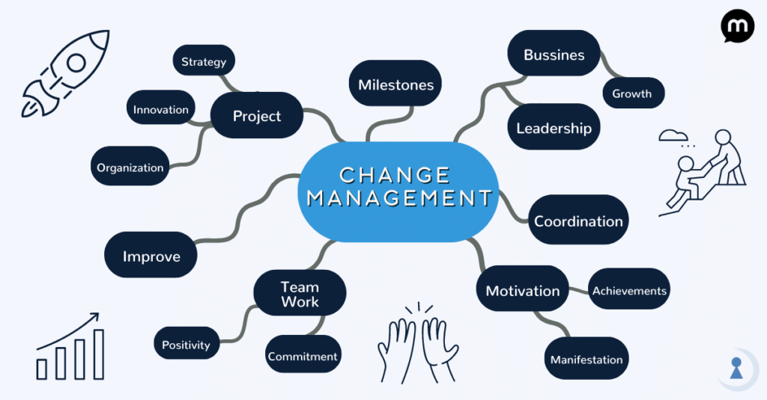

APPENDIX B:
CHANGE CURVE
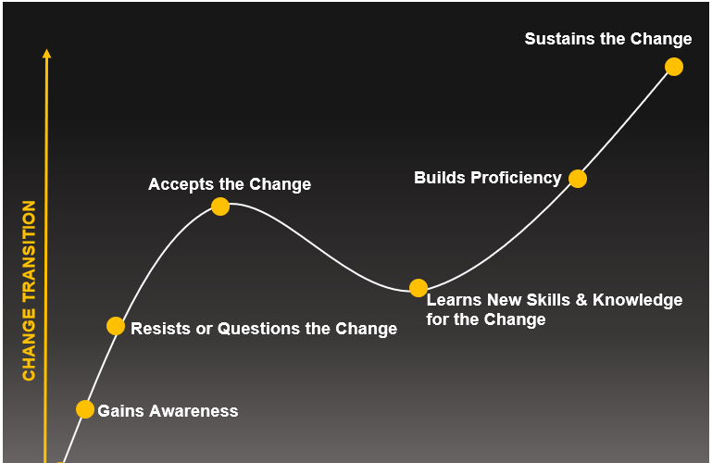

APPENDIX C:
MIND MAPPING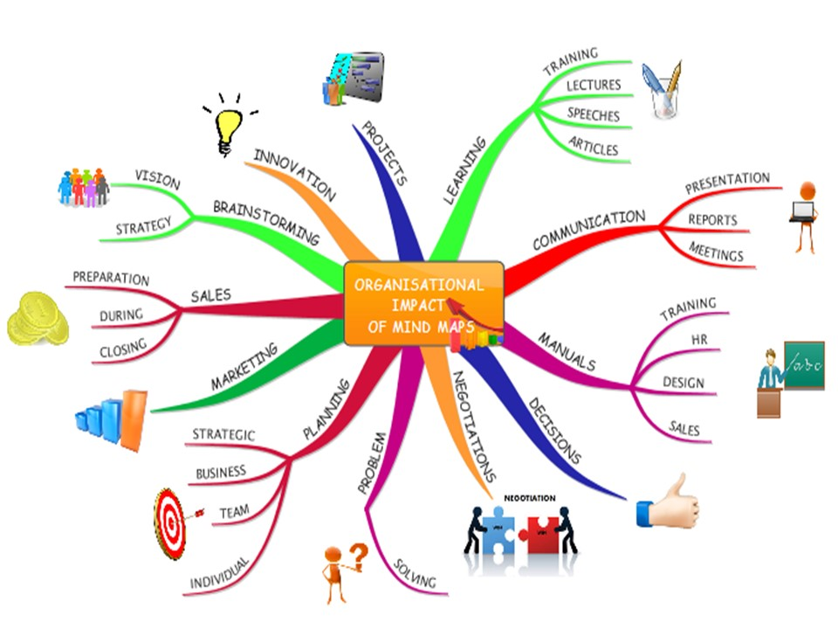

APPENDIX D:
Characteristics of a Learning Organization and Associated Best Practices
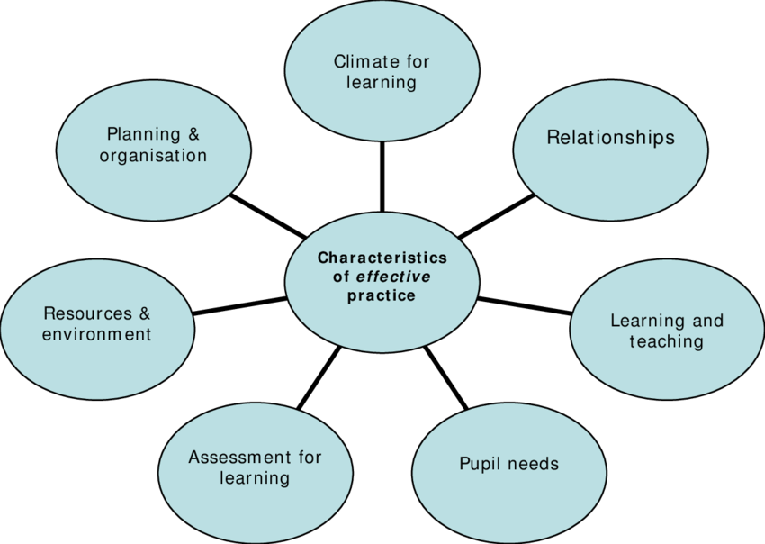

APPENDIX E:
PESTLE ANALYSIS
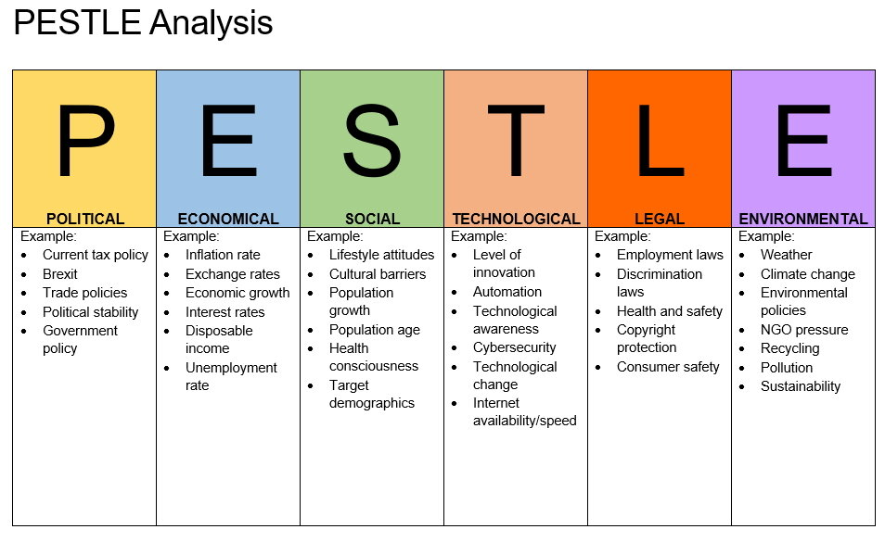

APPENDIX F:
Lewin's Change Theory


