

Design and implementation of a mountable interactive safety storage unit for delivery of domestic parcels.
By
Adam Mark Newman
BEng / HND Electrical & Electronic Engineering
BEng Independent Project

Final Report

Written by: Adam Mark Newman
Supervisor: Gareth Jones
Second Marker: Stephen Mosey
Employer: Expleo
Submission date: 29/04/2025

Declaration Form and Form of Consent
DECLARATION

I, Adam Mark Newman declare that I am the sole author of this Project; that all references cited have been consulted; that I have conducted all work of which this is a record, and that the finished work lies within the prescribed word limits.

This work has not previously been accepted as part of any other degree submission.

FORM OF CONSENT

I Adam Mark Newman hereby consent that my Project, submitted in candidature for the BEng / HND Electrical & Electronic Engineering degree, if successful, may be made available for inter-library loan or photocopying (subject to the law of copyright), and that the title and abstract may be made available to outside organisations.

Abstract
The rise in e-commerce has led to a substantial increase in parcel deliveries, with over 96 million packages delivered weekly across the UK. However, missed deliveries continue to pose challenges for both consumers and couriers, costing UK customers an estimated £320 million annually. This project presents the design and implementation of the Mountable Interactive Safety Storage Unit (MISSU), a removable, secure, and electronically controlled parcel drop-box aimed at reducing failed deliveries, parcel theft, and logistical inefficiencies. The MISSU system features a programmable microcontroller, keypad access, and an electronic locking mechanism. It will be developed using a waterfall lifecycle model and evaluated through component testing, data collection, and public feedback. The outcome is expected to improve user satisfaction, reduce environmental impact, and enhance the operational efficiency of delivery services.
Contents
Declaration Form and Form of Consent 2
Abstract 3
1. Introduction 8
1.1 Overview 8
1.2 Problem Statement and Motivation 8
1.3 Project Objectives 8
2. Research & Review of Literature 9
2.1 Introduction 9
2.2 Missed Deliveries and Market Demand 9
2.3 Mechanical Parcel Boxes 9
2.4 Electronic Keypad Systems 9
2.5 Microcontroller-Based Safes 9
2.6 Gaps in the Market 9
2.7 Comparative Research and Similar Designs 10
Smart Modular Locker Systems 10
IoT-Enabled Delivery Boxes 10
GSM-Based Parcel Receiving Systems 10
IoT Parcel Alert Systems During COVID-19 10
Industry Integration of Smart Postboxes 10
2.8 Summary 11
3. Development Methodology 12
3.1 Rationale for using the Waterfall Model 12
Advantages: 12
Disadvantages: 12
3.2 Tools and Resources 12
Hardware 12
Software 13
Documentation 14
3.3 Development Stages 14
4. Design and Implementation 16
4.1 Requirement Specifications 16
4.1.1 Functional and Non-Functional Overview 16
4.1.2 Summary of the Initial Problem MISSU Aims to Solve 18
4.2 System Design Approach 18
4.2.1 Justification 18
4.2.2 Trade-offs Made During the Design Process 18
4.2.3 Tools Used to Model the Design 18
4.3 Hardware Design 19
4.3.1 Hardware Component selection 19
4.4 Circuit Design 29
4.4.1 Battery Charging Protection Circuit 29
4.4.2 12VDC Battery 30
4.4.3 Power Output to Circuit 30
4.4.4 PIC Microcontroller Circuit 31
4.4.5 LCD Display Design 33
4.4.6 Microcontroller Timing Circuit 33
4.4.7 Buzzer Circuit 34
4.4.8 Keypad 35
4.4.9 Motor Control Circuit 35
4.4.10 LED Circuit 36
4.4.11 Mount & Dismount Control Circuit 37
4.4.12 Motor Design 37
5 Software Design 39
5.1 MIKROC Code 39
6 Implementation Design 47
6.1 Galvanised Steel Bin COTS 47
7 Development Challenges and Solutions 51
7.1 Flat Battery Access 51
7.2 Battery Charging 51
7.3 Physical Design 51
8 Testing and Validation 52
8.1 Microcontroller Functionality Test 52
8.2 LED and Buzzer Circuit Testing 52
8.3 Keypad Input Testing 52
8.4 LCD Display Testing 52
8.5 Motor Control and PWM Testing 52
8.6 Timer and Keypad Timeout Testing 53
8.7 Password Logic Testing 53
8.8 Full System Integration Test 53
9 Evaluation 55
9.1 Conclusion from Data 55
9.2 Objective and Aims Achieved 55
9.3 Improvements 55
10 Conclusion and Recommendations 57
10.1 Suggestions for Further Work 57
11 Reflection 58
13 Appendices 60
Appendix A 60
Appendix B 68
Proteus Circuit Design. 68
Appendix C 69
Appendix D 70
Appendix E 72
Appendix F 73
Appendix G 74

Table of Figures

Figure 1 - Battery Charging Protection Circuit 29
Figure 2 - 12VDC Battery Circuit 30
Figure 3 - Output Regulator Circuit 30
Figure 4 - PIC16F877A Circuit 31
Figure 5 - PIC16F877A Spec 32
Figure 6 - LCD Display Design 33
Figure 7 - Microcontroller Timing Circuit 34
Figure 8 - Buzzer Circuit Design 34
Figure 9 - Keypad Design 35
Figure 10 - Motor Control Circuit 36
Figure 11 - LED Circuit Design 36
Figure 12 - Mount & Dismount Control Circuit Design 37
Figure 13 - Motor Circuit Design 37
Figure 14 - Motor Design Circuit for Mount and Dismount 38
Figure 15 - MIKROC Code 1 39
Figure 16 - MIKROC Code 2 40
Figure 17 - MIKROC Code 3 40
Figure 18 - MIKROC Code 4 41
Figure 19 - MIKROC Code 5 41
Figure 20 - MIKROC Code 6 42
Figure 21 - MIKROC Code 7 43
Figure 22 - MIKROC Code 8 43
Figure 23 - MIKROC Code 9 44
Figure 24 - MIKROC Code 10 45
Figure 25 - MIKROC Code 11 46
Figure 26 - B&Q Steel Bin COTS 47
Figure 27 - Concept Drawing 1 48
Figure 28 - Concept Drawing 2 49
Figure 29 - Concept Drawing 3 49
Figure 30 - Concept Drawing 4 50
Figure 31 - PIC Microcontroller Testing 52
Figure 32 - Design Flow Chart 54

Table of Tables

Table 1 - Hardware Used Within Proteus Simulation 13
Table 2 - Requirements list 17
Table 3 - Microcontroller Selection 20
Table 4 - Keypad Selection 21
Table 5 - LCD Display Selection 23
Table 6 - DC Motor Selection 24
Table 7 - 12VDC Power Supply/Battery 26
Table 8 - Power Adapter 27
Table 9 - Further Components Required 28

Introduction

1.1 Overview
With the ongoing boom in online shopping, the reliability and efficiency of home delivery systems have become increasingly significant. Despite advancements in tracking and delivery scheduling, a large percentage of UK residents still experience missed parcel deliveries on a regular basis. Current solutions on the market are either mechanical in nature or lack portability and adaptability to modern domestic setups.
This final year engineering project aims to address this problem by developing the Mountable Interactive Safety Storage Unit (MISSU) — an innovative, removable electronic parcel drop-box designed to be securely mounted to external domestic walls. The MISSU will utilise a PIC microcontroller, keypad interface, and electronic locking mechanism to allow secure delivery and retrieval of parcels, accessible only to those with the correct access code.

1.2 Problem Statement and Motivation
Recent statistics show that 66% of UK adults miss at least one delivery per month, causing inconvenience for customers and increased operational strain for delivery companies. These missed deliveries also contribute to environmental impacts due to unnecessary re-delivery trips. Furthermore, the number of stolen or lost parcels continues to rise, especially in Wales, which is reported to be the most affected region in the UK.
The MISSU is proposed as a solution to reduce these issues by offering a secure, user-friendly, and adaptable method for parcel delivery and collection. It is specifically designed with the UK housing market in mind, aiming to strike a balance between security, ease of installation, and technological integration.

1.3 Project Objectives
The project aims to:
• Design and construct a functional prototype of the MISSU using off-the-shelf electronic components.
• Ensure secure access through keypad entry and electronic locking mechanisms.
• Evaluate the performance and reliability of the system through functional testing and public feedback.
• Consider ethical and environmental factors throughout the product’s lifecycle, including power usage, material sourcing, and user safety.

Research & Review of Literature

2.1 Introduction
This chapter provides a comprehensive review of scholarly work and existing research relevant to the development of the Mountable Interactive Safety Storage Unit (MISSU). It is divided into several sections: missed deliveries and market needs, current delivery solutions, technological underpinnings (keypads, microcontrollers, and electronic safes), and critical evaluation of similar projects. Each section aims to position the MISSU project within the broader field of embedded electronic systems and smart delivery technologies.

2.2 Missed Deliveries and Market Demand
According to GOPHR (2024), over 66% of UK adults miss parcel deliveries at least once a month, a statistic underscoring the need for improved delivery infrastructure. Research by Shiply and The Independent highlights that this issue results in more than £320 million in losses annually. Additionally, Wales is disproportionately affected. These findings reveal a significant market demand for secure, unattended delivery solutions.

2.3 Mechanical Parcel Boxes
Several commercial products, such as the INMOZATA Wall Mounted Parcel Box and Alibaba drop-boxes, offer mechanical storage solutions. However, they lack electronic features, limiting usability in smart home contexts. These products are fixed, non-removable, and operate with traditional lock-and-key mechanisms. While functional, their static nature and lack of interactivity hinder their adaptability in diverse household environments.

2.4 Electronic Keypad Systems
Keypad security systems are widely used in access control. ButterflyMX (2024) outlines five major keypad types used in residential and commercial applications. These systems provide reliable, programmable access, making them ideal for delivery applications where users must control access for couriers. The simplicity of keypad input, combined with reliability, supports its integration into the MISSU design.

2.5 Microcontroller-Based Safes
Electronicsforu (2024) and Circuit Digest (2024) detail electronic safe designs built using Arduino or PIC microcontrollers. These systems use programmed access control, enabling secure storage. MISSU draws inspiration from such safes, replacing manual locks with electronic control using a PIC18F452. This allows programmable behavior and integration with other electronic components.

2.6 Gaps in the Market
While smart locks and parcel lockers exist, there is a noticeable absence of wall-mounted, removable units that combine portability with security. Current research does not address removable designs or units that can interact dynamically with users. This is where MISSU positions itself, offering a secure, portable, and programmable storage solution.

2.7 Comparative Research and Similar Designs
Recent studies have addressed the shortcomings in secure parcel delivery using IoT, GSM, and embedded system solutions. This section reviews key peer-reviewed research that explores similar design challenges, the effectiveness of those solutions, and how the MISSU project builds on this foundation.

Smart Modular Locker Systems
A Smart Modular Parcel Locker System using IoT technology was developed and tested by Tan et al. [1]. This system incorporated ESP8266 microcontrollers and DC motors to form networked parcel lockers accessible via PIN code. The study demonstrated a significant reduction in missed deliveries and highlighted improved user satisfaction due to accessibility and security enhancements. These results validate the benefits of integrating microcontroller-based systems into parcel delivery infrastructure.

IoT-Enabled Delivery Boxes
Researchers at De La Salle University designed and evaluated an IoT-enabled delivery box system [2]. Their approach included microcontrollers and integrated sensors to control access, ensuring only authorized users could retrieve parcels. The system received positive feedback for its practicality and potential for residential application. The structured feedback emphasized its alignment with smart home systems and its scalability.

GSM-Based Parcel Receiving Systems
A GSM-integrated Smart Parcel Receiving System was evaluated by Kandelkar et al. [3]. This design allowed users to remotely receive notifications and control access through GSM communication. The project improved delivery efficiency and security, with results indicating fewer missed deliveries and enhanced user interaction through mobile feedback.

IoT Parcel Alert Systems During COVID-19
A study by Zainuddin et al. [4] simulated an IoT Parcel Alert System during the COVID-19 pandemic. It focused on ensuring delivery safety and efficiency in contactless scenarios. Simulation data showed a considerable decrease in delivery failure rates and parcel thefts, highlighting the system's potential for future crisis preparedness.

Industry Integration of Smart Postboxes
The Royal Mail's trial of smart postboxes with solar panels, barcode scanners, and parcel hatches demonstrates how industry players are integrating technology into traditional infrastructure [5]. Though not peer-reviewed, the trial indicates significant institutional investment in electronic delivery technologies, complementing the direction taken in academic projects.
These studies collectively affirm the relevance and feasibility of integrating microcontroller, GSM, and IoT technologies into parcel delivery systems. The MISSU design follows this trajectory by focusing on removability, keypad authentication, and low-power embedded control, filling a gap in consumer-oriented, portable delivery security.

2.8 Summary
The literature reveals a growing need for innovative delivery solutions. Existing research and commercial designs either lack portability or electronic integration. The MISSU project addresses this gap by offering a secure, microcontroller-based storage unit. By incorporating keypad access, microcontroller control, and user-focused design, MISSU builds on existing technologies while filling a clear void in the market.

Development Methodology
The development of the Mountable Interactive Safety Storage Unit (MISSU) follows a structured and methodical approach that ensures a reliable, secure product through simulation design. The Waterfall Model was chosen as the development strategy for this product as it provides a sequential development tool. Additionally, agile elements such as the Kanban board is used in parallel to monitor individual sub-task progression of the overall goal.

3.1 Rationale for using the Waterfall Model
The waterfall model is used due to divide the project into clear and distinct phases. This development tool best suits a solo development project with well-defined objectives and deliverables. It provides a clear understanding of what is needed to be complete at each stage set out – ensuring a structured progression.

Advantages:
- Straightforward to manage and track progress.
- Clear documentation at each phase supports traceability.
- Ideal for hardware-based projects

Disadvantages:
- Less flexibility for mid-project changes. To mitigate this, agile-style task reviews using a Kanban board were employed, providing opportunities to reflect and adjust plans during development.

3.2 Tools and Resources
Tools used throughout the project and discussed further are:
Hardware – Hardware used is simulated in proteus due to no physical design implemented
Software – Proteus and MIKROC
Documentation – Microsoft Word, Excel, Google drawings and Notepad

Hardware
A list of the Hardware is shown in table 1.

Table 1 - Hardware Used Within Proteus Simulation
Component | Function
PIC16F877A Microcontroller | To provide logic, input and output handling
4x3 Keypad | Interaction between product and user for password entry
16x2 LCD Display | Display messages to user and guidance of use
Red LED | Visual indicator of the products state (Closed or incorrect password)
Green LED | Visual indicator of the products state (Open)
Buzzer | Audio feedback
DC Motor x5 | 4 used to mount and dismount unit. 1 used to lock hatch
L293D Motor Driver x2 | Control motor direction and speed
Push Button Switches x2 | Manual selection to enable mount or dismount.
12VDC Power Supply | Power circuit
Resistors | Electronic support within circuit
Crystal Oscillator | Provide clock for PIC microcontroller
Capacitors | Stabilize power supply and works with oscillator

Software

Proteus
Proteus will play a crucial role in the development and validation of the Mountable Interactive Safety Storage Unit (MISSU) by enabling rapid design, simulation, and testing of its electronic subsystems. The MISSU system will involve a combination of sensors, actuators, keypads, motors, and microcontroller-based control logic—components that can be accurately represented and tested within the Proteus environment.
One of the most significant advantages of Proteus for this project will be its Virtual System Modelling (VSM) feature. This will allow for real-time simulation of the PIC microcontroller interacting with the connected components, such as the LCD display, keypad, and motors. The ability to run and debug the embedded C code within a virtual circuit will help identify logic and hardware-related issues early, reducing time spent on physical testing and troubleshooting.
Moreover, Proteus will provide a platform for experimenting with different circuit layouts and control sequences without the risk of damaging real hardware. This will be especially useful when integrating safety-critical features such as lock/unlock mechanisms and visual/auditory feedback through LEDs and buzzers.
Overall, the use of Proteus will ensure a more efficient and structured development process, enabling the MISSU prototype to be both cost-effective and functionally reliable prior to physical implementation.

MIKROC
MikroC will play a pivotal role in the simulation development of the Mountable Interactive Safety Storage Unit (MISSU) by providing a user-friendly, efficient, and reliable environment for writing and testing the embedded software that will power the system. As the main programming tool intended for use with the PIC16F877A microcontroller, MikroC will allow for seamless integration of logic and control for various hardware components including the keypad, LCD, LEDs, buzzer, and motor drivers.
The extensive built-in library support in MikroC will significantly streamline the coding process. Functions for PWM control, LCD interfacing, and keypad input will be readily available, reducing development time and ensuring greater code stability. These libraries will be especially useful for executing key system features such as password input, motor control for locking/unlocking, and managing feedback via visual and audio signals.
In conclusion, MikroC will enable fast, reliable, and scalable code development for the MISSU prototype, enhancing both the functionality and robustness of the final embedded system.

Documentation
Throughout the development of the Mountable Interactive Safety Storage Unit (MISSU), a variety of documentation tools will be utilised to support project planning, organisation and design support. These tools will play a key role to ensure that the design and implementation processes are well-documented and efficient.
Microsoft Word – will be used to produce the primary written report. This will include all formal documentation such as system specifications, design plans, implementation details, and evaluation findings.
Microsoft Excel – will be employed to manage task traceability, track development progress, and perform data analysis. It will also support the use of a Kanban board to visualise workflow and monitor task completion, ensuring that the project timeline remains on track.
Google Drawings – will be used to create a drawing diagram representations of the MISSU product. for both development and presentation purposes.
Notepad – will serve as a lightweight tool for drafting and storing code snippets. It will facilitate quick editing and cross-referencing of various code iterations that are designed throughout the project, which will assist in testing and refining embedded C logic for the system.

3.3 Development Stages

Requirements Specification
A set of functional and non-functional requirements will be produced during the planning phase. These will cover essential aspects such as security needs, battery life, environmental resistance, and ease of installation for the Mountable Interactive Safety Storage Unit (MISSU).

System Design
The system will be modelled as a closed-loop embedded control system. Logical flowcharts will be created to visualise system behaviour and user interaction

System Simulation
Code will be written in embedded C and uploaded to the PIC microcontroller to ensure functionality. Initial integration of components will be carried out using Proteus to provide a good understanding of products design its functionality to the standards set.

Testing
Each module – such as keypad input, lock actuation, LED, LCD and mount and dismount will be tested to throughout the design to ensure each component works as expected in line with the set requirements.

Review
A final project review will compare actual performance outcomes with the original requirements to verify that the system meets its objectives and delivers it’s intended functionality.

Evaluation Criteria
The success of the project will be measured against the following key criteria:
- Functionality: The system must respond correctly to keypad inputs and reliably operate the locking mechanism. As well as the mount and dismount inputs.
- Outputs and LCD work as expected.
- Security: Access will be restricted to users with the correct PIN.
- User Experience: Ease of use and system reliability will be assessed.

Design and Implementation

Requirement Specifications

4.1.1 Functional and Non-Functional Overview
To meet the project’s objective, a set of functional and non-functional requirements were created, stored and monitored through excel [Table 2]. The requirement numbers are labelled – MISSU-F(functional)-00 and MISSU-NF(Non-Functional)-00. This is to segregate and define the specific actions that the system must perform.
Functional requirements are actions of which the system is expected to achieve such as accepting four-digit PIN, actuating motors which perform locking and separately mounting and dismounting etc. Additionally, other functional requirements included support for mounting and dismounting operations through toggle switches.
Non-Functional requirements focus on system quality and performance. As shown in table 2 this includes sections such as security, reliability and environmental durability. These are requirements that don’t necessarily contribute to the systems behaviour but used to specify criteria that can be used in order to judge the operation of a system.

Table 2 - Requirements list

4.1.2 Summary of the Initial Problem MISSU Aims to Solve
The MISSU is designed to solve the problem of missed parcels, parcel theft and reduce emissions of redelivery. As this is shown to be an increasing issue within the UK, with the increase of online shopping. As households often experience frustration when their parcel is missed, lost or even stolen during the delivery phase. The MISSU aims to address this issue by providing a compact, wall-mounted electronic drop-box system with the ability of user interaction for controlled access and locking mechanism.

4.2 System Design Approach

4.2.1 Justification
The design approach used for development of the MISSU is based on a modular, closed-loop control system. A modular approach was chosen to break the overall system into independent components such as the user interface (keypad and LCD), access control logic (PIN verification), and physical actuation (motorized locking and mounting). This allows for simpler debugging, easier updates, and future scalability, where individual modules can be improved without altering the entire system.
The closed-loop system is to ensure that the user interaction commands result in real-time feedback and appropriate actions. An example of this is where the PIN code being pressed triggers the motors functionality as well as other components such as LEDs, Buzzer, LCD providing visual and audio feedback. The closed loop system enhances both usability and security.

4.2.2 Trade-offs Made During the Design Process
During the design of the MISSU, several trade-offs were considered and decisions made throughout the process. For the current stage and budget of the product, simplicity was prioritized over advanced features to ensure that the system remained operable and affordable. Where control options such as Bluetooth and wi-fi connectivity could add further security and convenience, they were decided against to keep costs low, simple and less power consumption.
Further trade offs were considered due to software and availability of components. Component availability and compatibility was decided on simple and accessible components that are compatible and available on proteus software for simulation and coding. The PIC16F877A microcontroller was chosen for its balance between functionality and cost, despite limitations in processing speed compared to more advanced controllers.

4.2.3 Tools Used to Model the Design
Ensuring a structured development process, modelling tools such as flowcharts and block diagrams are used, creating a visual understanding of the logic behind key operations of the system. This provides clarity and consistency throughout the design phase and served as references for implementation and testing.

4.3 Hardware Design

4.3.1 Hardware Component selection
When selecting components that are used within the system design. A careful and strategic approach is used to determine each component is suitable for the system with its specifications and that it is compatible with the system. This is a crucial role of the development stage to ensure the system functions and meets the needs of the requirements.
Several key factors are considered when selecting components. This is to ensure compatibility with the system requirements and the chosen microcontroller, in this case – PIC16F877A. These considerations include but not limited to:
Functionality – Whether the component performs the required role effectively (e.g., keypad for user input, motor for physical actuation).
- Compatibility – Whether it integrates smoothly with the microcontroller in terms of voltage levels, communication protocols, and control logic.
- Power Consumption – As the unit is battery-operated, low-power components are prioritized to extend operational time.
- Size and Mountability – Components should be compact and suitable for a wall-mounted system to support the design goals of MISSU.
- Cost and Availability – Commercial viability is essential; thus, components should be affordable and easily sourced.
- Reliability and Durability – Since the system is meant for frequent outdoor or semi-protected use, components need to be robust and able to withstand repeated usage.
This section will explore the reasoning behind each major component selection—such as those mentioned in table 2, supported by comparative justification where relevant. The following tables outline each hardware element, its purpose within the system, and the justification for its inclusion over possible alternatives.

PIC Microcontroller:
Table 3 - Microcontroller Selection
Microcontroller
Detail | PIC16F877A | PIC16F887 | PIC18F4520
Key Features | 8-bit MCU, 5 Ports, 8 ADC channels, USART, PWM | Enhanced 8-bit MCU, more efficient core | High-performance 8-bit MCU with advanced features
I/O Pins | 33 | 35 | 36
Memory | 368 Bytes RAM, 14K Flash | 368 Bytes RAM, 14K Flash | 1.5K RAM, 32K Flash
Peripheral Support | USART, SPI, I²C, PWM, 8xADC, LCD compatibility | ADC, CCP, SPI, I²C, EUSART | Full ADC, CCP, SPI, I²C, USB support
Speed | 20MHz | 20MHz | 40MHz
Voltage – supply (Vcc/Vdd) | 4V ~ 5.5V | 2V ~ 5.5V | 4.2V ~ 5.5V
Operating Temperature | -40°C ~ 85°C | 40°C ~ 85°C | -40°C ~ 85°C
Power Consumption | Moderate | Lower than 877A | Power efficient with idle/sleep modes
Justification | Well-balanced for medium complexity systems; popular in prototyping with ample I/O and peripheral support, proven reliability. | Offers similar features with more program memory and better efficiency, but less supported in older development environments. | Advanced but may be excessive for a simple lock system, more expensive, steeper learning curve for entry-level use.
Image | 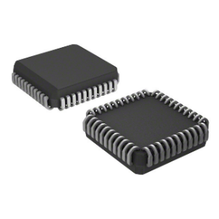 | 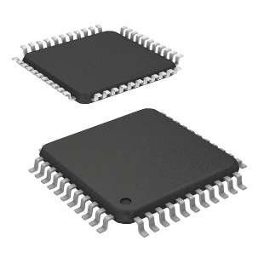 | 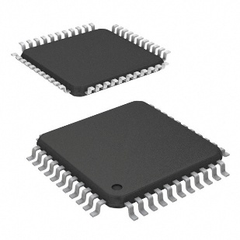
Link | PIC16F877A-I/L Microchip Technology | Integrated Circuits (ICs) | DigiKey | PIC16F887-I/PT Microchip Technology | Integrated Circuits (ICs) | DigiKey | PIC18F4520-I/PT Microchip Technology | Integrated Circuits (ICs) | DigiKey
In conclusion the PIC16F877A, was selected for the MISSU as its ideal balance of features, cost and development support. It provides sufficient I/O pins to handle multiple components simultaneously (LCD, keypad, motors, buzzer, LEDs), while also including built-in peripherals like PWM and ADC which are essential for real-time motor control and signal processing.
Additionally, its compatibility with the MikroC [6] development environment and simulation in Proteus makes it highly suitable for the prototype-based application. Although newer microcontrollers offer more memory and lower power consumption, the PIC16F877A remains favourable due to its wide documentation, ease of use, and cost-efficiency for the scope of the MISSU system. Studies suggest that for embedded applications requiring low power and robust I/O, the PIC16F877A remains a strong contender compared to newer models, especially when real-time performance is crucial [7].

Keypad
Table 4 - Keypad Selection
Keypad
Detail | Grayhill 12 Key ABS, Cycolac FR15 Keypad | Storm IP65 16 Key Polymer Illuminated Keypad | APEM IP65 12 Key Stainless Steel Keypad
Configuration | 4 Rows x 3 Columns | 4 Rows x 4 Columns | Touch-based input
Number of keys | 12 (0–9, *, #) | 16 (0–9, A–D, *, #) | Varies (usually 12 or 16)
Ease of Integration | Very easy with MikroC/Proteus libraries | Similar to the 4x3 with more keys, meaning more inputs | More complex (requires capacitive controller)
Size/Form Factor | Slightly smaller than 4x4 | Compact; fits project casing | Sleek and modern, but not tactile
Cost | Low - £28 | Low - £64.28 | Moderate-High - £136.99
Feedback | Tactile | Tactile | Touch Sensitive
Justification | Suitable for basic input but lacks extra keys for future expansion or multifunction use. | Provides numeric and functional keys. Perfect for secure PIN entry. Widely available and well-supported. | Aesthetically modern. Less tactile feedback. Harder to integrate into early prototypes without additional circuitry.
Image | 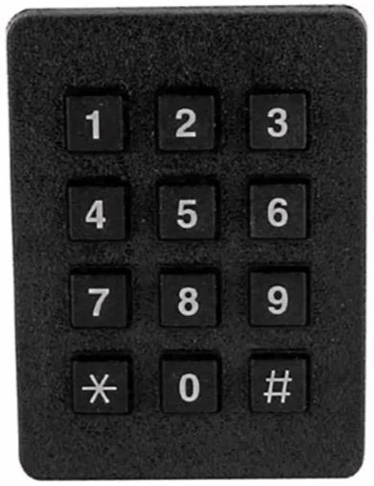 | 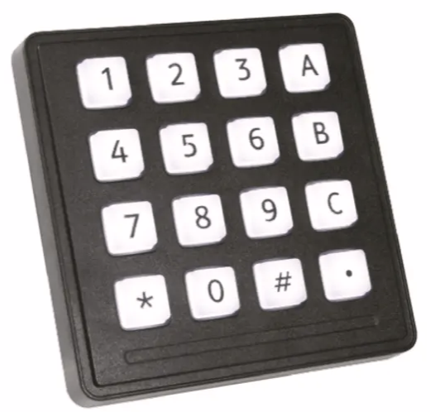 | 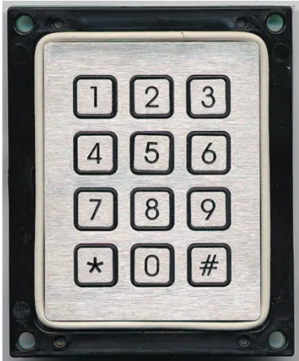
Link | 96AB2-102-F | Grayhill 12 Key ABS, Cycolac FR15 Keypad | RS | 7203-16TW202 | Storm IP65 16 Key Polymer Illuminated Keypad | RS | T8P0120010001 | APEM IP65 12 Key Stainless Steel Keypad | RS
The decided Keypad is the 4x3 as it provides the required 12 keys for a 4-digit password from 0-9. The keypad also provides two additional keys (* & #), These can be used to introduce functional coding for lock, mount and dismount options.
The Keypad using a 4x3 matrix provides an advantage when working with he selected PIC microcontroller as there is a limited number of I/O pins. This design is the perfect number of pinouts for the microcontroller and requires less code than the 4x4. The design is simpler to wire and program, and unlike capacitive touch keypads, it is better suited for outdoor or variable environments where physical keypresses are more reliable than touch-sensitive surfaces. The other advantage is the cost of the keypad being low compared to its competitors, allowing to stay within budget.
Overall, the 4x3 keypad aligns perfectly with the system requirements of the MISSU in terms of cost, ease of use, and robustness.

LCD Display
Table 5 - LCD Display Selection
LCD Display
Detail | MikroElektronika MIKROE-55, Character LCD 2x16 with blue backlight LCD Display Development Board | RS PRO 7-Segment LCD Display, Black on Grey, 1 Row by 4 Characters, Reflective | Displaytech 204A-CC-BC-3LP Alphanumeric LCD Display, White on Blue, 4 Rows by 20 Characters, Transflective
Type | Character LCD | 7-Segment LCD | Alphanumeric LCD
Display Size | 2 Rows x 16 Characters | 1 Row x 4 Characters | 4 Rows x 20 Characters
Backlight | Blue backlight | Reflective (no backlight) | White on Blue with Transflective Backlight
Character Support | Full ASCII | Numbers only | Full ASCII
Interface | Parallel (HD44780 compatible) | Parallel | Parallel (HD44780 compatible)
Power Consumption | Low | Very low | Moderate
Ease of Integration | Easy (commonly supported in MikroC) | Very simple (commonly supported in MikroC) | Slightly more complex (commonly supported in MikroC)
Code/Library Support | Extensive support in MikroC | Minimal | Moderate
Size/Compactness | Compact | Very compact | Bulky
Display Quality | Clear, readable | Limited Characters and basic display | High quality, Large Display
Cost | Low - £9.08 | Low - £12.78 | Moderate - £23.65
Image | 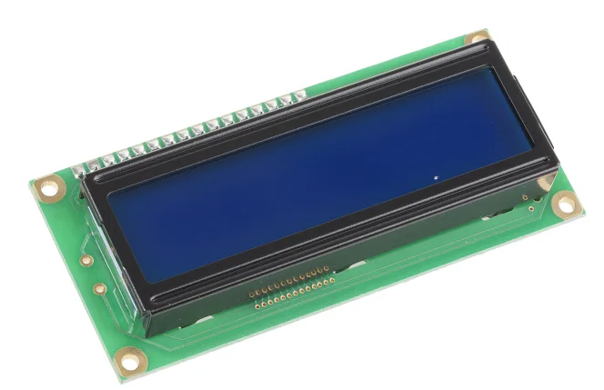 | 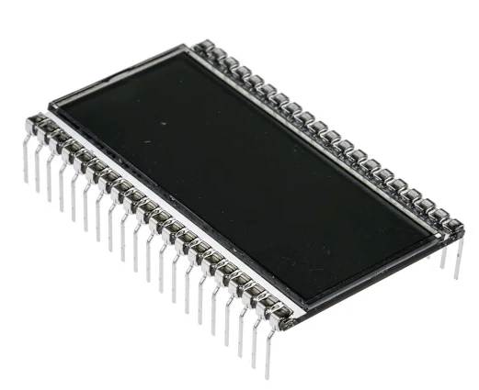 | 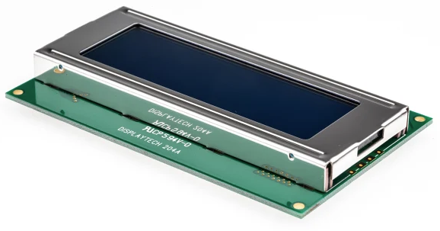
Link | MikroElektronika MIKROE-55, Character LCD 2x16 with blue backlight LCD Display Development Board | RS | RS PRO 7-Segment LCD Display, Black on Grey, 1 Row by 4 Characters, Reflective | RS | Displaytech 204A-CC-BC-3LP Alphanumeric LCD Display, White on Blue, 4 Rows by 20 Characters, Transflective | RS

LCD Justification
The MikroElektronika MIKROE-55 2x16 character LCD is the preferred choice for the readability, compatibility and simplicity. It offers two rows of sixteen characters – enough to clearly display system messages such as status updates (e.g., “LOCKED”, “UNLOCKED”, “Enter PIN”), user prompts or error messages.
Unlike the RS PRO 7-segment display, which is limited to numeric output and cannot display full system prompts or words, the 2x16 LCD provides full alphanumeric support and is compatible with the MikroC LCD library, simplifying code development.
While the Displaytech 204A (4x20) offers more screen space, it would have increased both the cost and physical footprint of the device. For a compact, wall-mounted security unit like MISSU, this additional size and complexity was not justified.
In conclusion, the MIKROE-55 2x16 LCD provides the right combination of functionality, compact size and ease of integration, making it the most cost-effective with reliable power where complex graphic is mot needed and practical choice for this project [8].

DC Motor
Table 6 - DC Motor Selection
DC Motor
Detail | RS PRO Brushed Geared DC Motor, 0.46 W, 6 V dc, 202 g.cm, 145 rpm, 3mm Shaft Diameter | RS PRO Geared DC Motor, 5.75 W, 6 → 15 V dc, 58.8 gcm, 10668 rpm, 2.31mm Shaft Diameter | RS PRO Brushed Geared DC Geared Motor, 19.8 W, 12 V dc, 59 Ncm, 84 rpm, 6mm Shaft Diameter
Voltage | 6 V DC | 6–15 V DC | 12 V DC
Power | 0.46 W | 5.75 W | 19.8 W
Torque | 202 g.cm (≈0.0198 N.m) | 58.8 g.cm (≈0.0058 N.m) | 59 N.cm (0.59 N.m)
Speed | 145 rpm | 10668 rpm | 84 rpm
Shaft Diameter | 3 mm | 2.31 mm | 6 mm
Size | Compact | Very Small | Large
Control requirements | Simple | Requires high-speed control | Needs stronger motor driver
Efficiency for low power systems | Very efficient | Moderate | Higher power draw
Cost Effectiveness | Low - £12.43 | Very Low - £4.71 | Moderate - £22.57
Image | 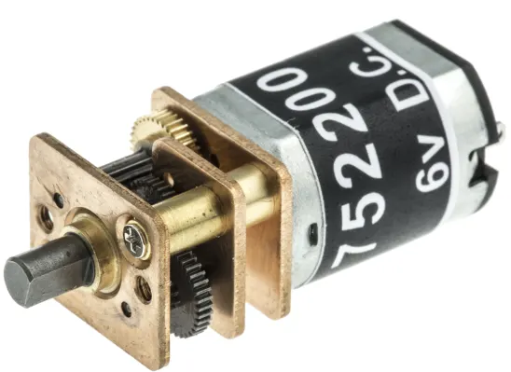 | 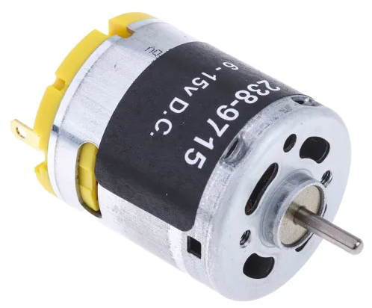 | 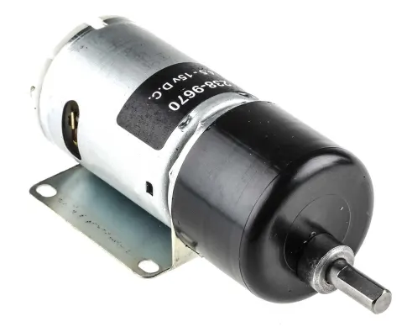
Link | RS PRO Brushed Geared DC Motor, 0.46 W, 6 V dc, 202 g.cm, 145 rpm, 3mm Shaft Diameter | RS | RS PRO Geared DC Motor, 5.75 W, 6 → 15 V dc, 58.8 gcm, 10668 rpm, 2.31mm Shaft Diameter | RS | RS PRO Brushed Geared DC Geared Motor, 19.8 W, 12 V dc, 59 Ncm, 84 rpm, 6mm Shaft Diameter | RS

Justification
The RS PRO 0.46 W, 6 V DC motor is the most suitable for the MISSU application. It balances low power consumption, moderate torque and ease of control, making it perfect for simple locking/unlocking mechanisms within a compact embedded design. The other options offer either excessive speed (requiring advanced control circuitry) or unnecessarily high torque that could stress the physical structure and power system.

12VDC Power Supply/Battery
Table 7 - 12VDC Power Supply/Battery
12VDC Battery
Detail | Yuasa 12V Faston 4.8mm Sealed Lead Acid Battery, 7Ah | Yuasa 12V Faston 4.8mm Sealed Lead Acid Battery, 2.1Ah | RS PRO RS PRO NiMH Rechargeable D Battery, 7Ah
Voltage | 12V | 12V | 1.2V (x10 in series for 12V)
Capacity | 7Ah | 2.1Ah | 7Ah (per cell)
Type | Sealed Lead Acid (SLA) | Sealed Lead Acid (SLA) | Nickel-Metal Hydride (NiMH)
Rechargable? | Yes | Yes | Yes
Terminal Type | Faston 4.8mm tabs | Faston 4.8mm tabs | Standard cylindrical terminals
Size (mm) | 151 x 65 x 94 | 178 x 34 x 60 | Standard D-cell (per unit)
Weight | ~2.3 kg | ~0.9 kg | ~1.5 kg (combined 10 cells)
Advantages | High capacity, reliable backup | Compact, lightweight | Modular, flexible design
Disadvantages | Bulky and heavy | Lower capacity, shorter runtime | Needs 10 cells in series and additional circuitry
Cost | Low £39.91 | Low £26.58 | Low £19.72/1
Image | 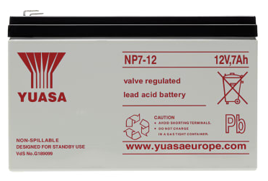 | 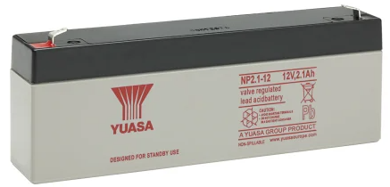 | 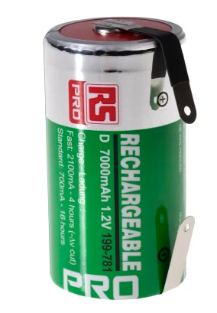
Link | NP7-12 | Yuasa 12V Faston 4.8mm Sealed Lead Acid Battery, 7Ah | RS | NP2.1-12 | Yuasa 12V Faston 4.8mm Sealed Lead Acid Battery, 2.1Ah | RS | RS PRO RS PRO NiMH Rechargeable D Battery, 7Ah | RS

Justification
For the MISSU system, the Yuasa 12V, 2.1Ah battery is the most appropriate choice, balancing compact size with sufficient power for low-duty microcontroller operation and actuation. It simplifies circuit design, offers good reliability, and is easier to mount than heavier alternatives. If extended battery life is needed, the 7Ah version is suitable but increases size and weight. The NiMH D-cell approach is less favourable due to complexity and cost of managing multiple cells.
As this is a rechargeable battery pack. The use of a Power adapter will be used in support of battery charging. This will also be connected with a protection circuit within the circuit design. Reason for selection can be found in table 8.

Table 8 - Power Adapter
Power Adapter
Feature | Why its useful for MISSU
12V Output | Matches the required charging voltage for 12V sealed lead acid or NiMH battery systems.
High Power Output (60W) | Provides up to 5 Amps of current (60W ÷ 12V = 5A), sufficient for fast and stable charging.
Regulated DC Supply | Ensures stable and consistent voltage, critical to protect battery health.
Plug-and-Play Design | UK plug format simplifies connection to mains; no wiring or assembly needed.
Barrel Jack Connector | Easy to integrate with common DC jacks in the circuit without complex soldering.
Compact & Enclosed Design | Reduces the need for heat shielding or additional protection circuitry externally.
Cost | $98.33
Image | 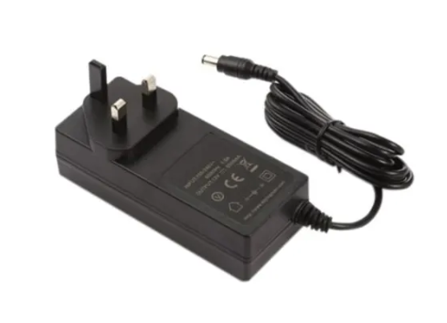
Link | RS PRO 1753328 POWER ADAPTER UK PLUG IN 12V 60W
The RS PRO 1753328 12V 60W adapter is an ideal external power supply for charging the system's battery safely, efficiently, and reliably, while being easy to implement into the system. It supports robust power delivery without requiring complicated external regulation.

Further Components Required
This section identifies all other components required to support a physical design of the MISSU. These devices/components did not require comparison to others on the market as they were selected due to familiarity and low general low cost. Each of these components will not alter the MISSU’s functionality significantly. There for, comparison was not required for the prototype.

Table 9 - Further Components Required
Component | Quantity | Reasoning
LM338T Voltage Regulator | 1 | Adjustable regulator for battery charging.
7805 Voltage Regulator | 1 | For 5V output supply to microcontroller and logic.
7806 Voltage Regulator | 1 | For 12V
2N1711 NPN Transistor | 1 | Used in charge cutoff protection.
1N4742A Zener Diode (12V) | 1 | Over-voltage protection across the battery.
General Purpose Diodes (1N4007) | 4 | D3, D4, D6, and reverse current protection.
10kΩ Resistors | 3 | Pull-downs / base resistors
1kΩ Resistors | 4 | RV2 reset and potential use for LED/buzzer limiting
180Ω Resistor | 1 | current limiting for regulator adjustment.
Variable Resistor (Potentiometer) 1kΩ | 1 | For adjusting LM338 output voltage
Capacitor 100µF, 25V+ Electrolytic | 1 | Output smoothing
Capacitor 22pF | 2 | Used for crystal oscillator stabilization.
Crystal Oscillator 20MHz | 1 | Connected to the microcontroller clock pins
Push Button (Tactile Switch) | 1 | Manual reset button.
NPN Transistor (e.g., BC547) | 1 | For controlling the buzzer.
Buzzer (5V Active) | 1 | Sound alert feedback.
Red LED | 1 | Indicates lock/error state.
Green LED | 1 | Indicates unlock/success state.
Resistors for LEDs (220–330Ω) | 2 | For limiting current to LEDs.
L293D Motor Driver IC | 2 | Dual H-bridge for controlling direction and speed of DC motors.
Female Header Pins / Sockets | N/A | For modular connections to LCD/keypad/microcontroller.
Power jack connector (DC barrel) | 1 | For connecting 12V adapter into your system safely.
Screw Terminals | N/A | For connecting battery wires, motors, etc.
PCB / Breadboard | N/A | For initial prototyping and final assembly.

4.4 Circuit Design
The circuit design of the Mountable Interactive Safety Storage Unit (MISSU) serves as the foundation for integrating all functional elements of the system. It combines power management, microcontroller-based logic, user interface components, and motor control into a cohesive and reliable platform. The design is structured to ensure modularity, allowing each subsystem to be developed and tested independently before full integration.
This section will go for each section of the system describing its functionality and purpose to the system. Providing understanding of the MISSU functionality and how each component and circuit will provide a working product.

4.4.1 Battery Charging Protection Circuit
The proposed device is portable and therefore requires a battery pack which is rechargeable. This is achieved though the input of the selected Power Adapter [Table 8] being connected to the device through a power jack connector. This will connect to the positive and negative lines of this circuitry [Fig 1]. The circuit is designed to protect the battery from overcharging and protection from reverse current.
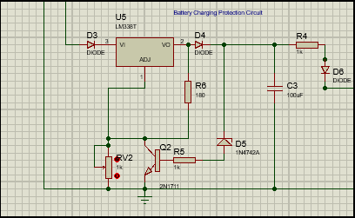
Figure 1 - Battery Charging Protection Circuit

In reference to Figure 1. The circuit uses a LM338T adjustable voltage regulator to provide a stable charging voltage to the selected 12V battery. Diodes (D3 & D4) are used to protect against reverse current. The Zener diode (D5) can clamp any over-voltage in the circuit. To fine tune the charging voltage of the battery, the potentiometer and resistor (R6) are used to alter resistance of the conductive pathway. Transistor (Q2) prevents over current during faults as it acts as a current limiter. Capacitor (C3) is used to smooth output voltage by reducing any potential ripple input. Diodes such as D6 are located to prevent battery power from flowing back into the circuit.

4.4.2 12VDC Battery
The 12VDC battery proposed is located between the battery charging circuit and battery output circuit [Fig 2]. This is a simple design of the battery with a switch for a mechanical/manual control of the power to the circuit. This is the source of power for the whole circuit.
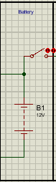
Figure 2 - 12VDC Battery Circuit

4.4.3 Power Output to Circuit
For the battery to provide power to the circuit safely, a 7805 and a 7806 voltage regulator was inserted [Fig 3]. Providing a stable output voltage that’s required to circuit areas of the system.
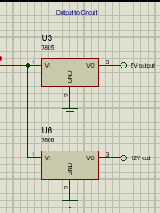
Figure 3 - Output Regulator Circuit
Each voltage regulator can ensure stable output voltage to 5V (U3-7805) to power components such as PIC microcontroller, keypad, LCD, buzzer and LED’s. Voltage Regulator U6-7806 provides regulated 12V output to components that require larger voltage such as DC motors.

4.4.4 PIC Microcontroller Circuit
The PIC16F877A is used as the systems brain, allowing its embedded code to signal outputs and inputs in accordance with what’s being pressed/energised within the circuit [Fig 4]. It manages all inputs and outputs such as processing signals from the keypad, control buttons and driving inputs such as motors.
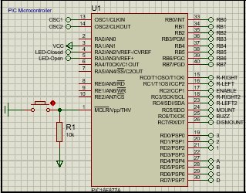
Figure 4 - PIC16F877A Circuit
The microcontroller is connected to a reset circuit, which is a button and a pull up resistor to ensure the microcontroller can be safely reset during operation. Over connections are connected via the terminal default block in proteus. These are labelled and linked through the circuit design for simpler design visuals. Ports RA, RB, RC and RD are linked to specific functions of the circuit in accordance with the Microcontrollers Port specification [Fig 5].
The microcontroller being split into Ports shows which inputs and outputs are connected via the default terminal.
- PortA – has the LED outputs
- PortB – Provides the LCD logic
- PortC – has all functional outputs of the MISSU for mounting/dismounting, Lock/Unlocking and Buzzer.
- PortD – provides all keypad control.

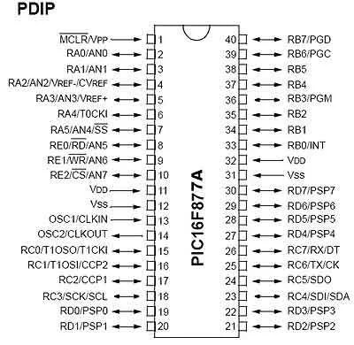
Figure 5 - PIC16F877A Spec

4.4.5 LCD Display Design
The LCD module [Fig 6] is used to provide visual feedback using a 2x16 character display. The LCD is connected to PORTB of the PIC microcontroller RB0 to RB6 pins. D4-D7 being the data lines and RS and E being the control lines. In order to adjust the contrast of the LCD if needed, a 1k potentiometer is connected to the VEE. Standard connections are made to the VSS (Ground, VDD (Positive and RW (Read/Write that is grounded to set – always to write).
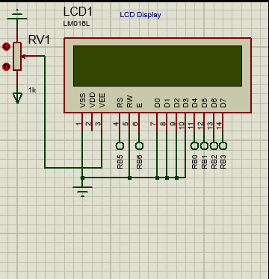
Figure 6 - LCD Display Design
The purpose of the LCD is to provide a display to represent the current function/state of the MISSU being caried out.

4.4.6 Microcontroller Timing Circuit
The circuit provides a clock signal that is necessary for the operation of the PIC16F877A microcontroller. With X1 being a crystal oscillator which is connected to microcontroller pins – OSC1and OSC2. Providing stable frequency reference for accurate timing determining how fast the microcontroller executes instructions. This affects the overall timing, synchronization and performance of the system that works off the PIC.
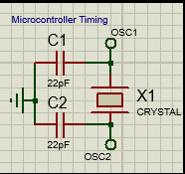
Figure 7 - Microcontroller Timing Circuit
The two capacitors are connected between the oscillator and ground to stabilize and reduce noise. The crystal oscillator works by using mechanical vibrations of a quartz crystal to create a precise electrical signal.

4.4.7 Buzzer Circuit
The buzzer circuit [Fig 8] is used to provide audio signal of the MISSU locking. The circuit uses a NPN transistor to control the buzzer. As the input line is connected to the transistors base, when the microcontroller sends a high signal to the buzz input, providing a small amount of current to the base. This switches the transistor on whilst allowing the gate to open, allowing a higher current to low from VCC through the buzzer to ground. Thus, energising the component and producing a buzzing sound as part of the components function. When the input is low, the transistor turns off, de-energising the buzzer and muting the sound.
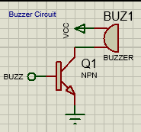
Figure 8 - Buzzer Circuit Design

4.4.8 Keypad
The keypad [Fig 9] works in a 4x3 matrix for the embedded system. Each button is connected in a row line: A-D, and a column line: 1-3. When each button is pressed individually, the microcontroller scans the keypad. This is done by each row being set to low at a tie and reading the columns. Once a key is pressed, a connection is made between the row and column. This is then detected by the microcontroller and identifies which specific key has been pressed. Once a key has been pressed a connection is closed between a specific row and column allowing the microcontroller to detect which button has been pressed.
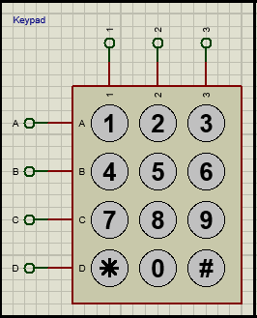
Figure 9 - Keypad Design

4.4.9 Motor Control Circuit
As the system will be using motors for different outputs in order to meet the requirements set list. Two L293D [Fig 10] motor driver ICs were used. Where U2 controlled the Lock and unlock of the MISSU and U4 controlled the mount and dismount motors.
The L293D is a dual H-bridge motor driver, which allows it to control two motors independently of one another. This also allows for a forward and reverse function of the motor. Inputs (IN1, IN2, IN3 & IN4) receive the signal from the microcontroller. The L293D is connected accordingly to provide forward and reverse logic. Enabler (EN1 & EN2) are the to enable or disable to component, additionally disabling the motors connected. This is due to the enable pin being actives, allows output to the output pins (OUT1, OUT”, OUT3 & OUT4).
This device and circuit ensures safe and controlled motor movement with the ability to reverse its direction and stop in sufficient time.
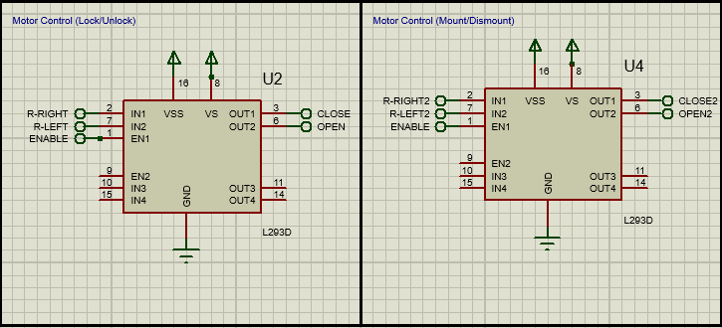
Figure 10 - Motor Control Circuit

4.4.10 LED Circuit
The LED circuit [Fig 11] provides visual feedback to indicate the lock status of the MISSU system. It consists of two LEDs: D1, a red LED, and D2, a green LED. The red LED (D1) lights up when the system is locked, while the green LED (D2) illuminates when the system is unlocked. Each LED is connected in series with a 220Ω resistor (R2 and R3, respectively) to limit the current and prevent damage to the LEDs.
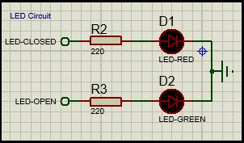
Figure 11 - LED Circuit Design

4.4.11 Mount & Dismount Control Circuit
The Mount and Dismount control circuit allows the user to initiate mounting or dismounting operations for the MISSU unit. It consists of two push-button switches, each paired with a 10kΩ pull-down resistor (R10 & R11). The "MOUNT" switch, when pressed, sends a high logic signal to the microcontroller to trigger the mounting motor control sequence. Similarly, pressing the "DISMOUNT" switch signals the system to initiate the dismounting process. The pull-down resistors ensure that the inputs remain at a defined low logic level when the buttons are not pressed, preventing false triggering due to electrical noise.
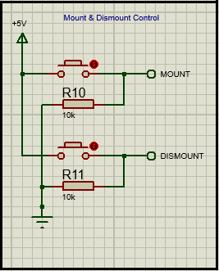
Figure 12 - Mount & Dismount Control Circuit Design

4.4.12 Motor Design
The Lock/Unlock [Fig 13] and Mount and Dismount [Fig 14] Motor section of the circuit is responsible for mechanically securing or releasing the door mechanism of the MISSU unit. It features a single DC motor controlled via two inputs: "CLOSE" and "OPEN." Depending on the signal received, the motor rotates in the appropriate direction to either engage the locking mechanism (CLOSE) or disengage it (OPEN). This motor receives control commands from the motor driver circuit (L293D), ensuring precise and reliable actuation.
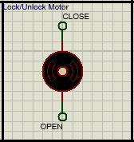
Figure 13 - Motor Circuit Design
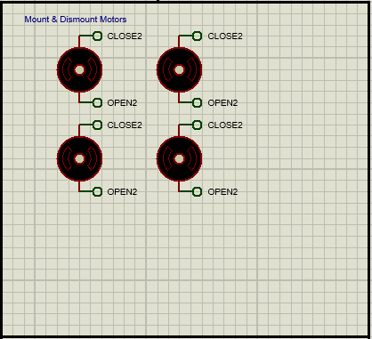
Figure 14 - Motor Design Circuit for Mount and Dismount

5 Software Design
This section will go into detail on the code. This is the essential logic which controls the operation of the system. The code is written in embedded C through MIKROC software. This was chosen due to the familiarity of the software through previous designs and understanding of the software throughout the university. The code handles the systems user interaction, motor control, keypad input, LCD display, LEDs, buzzer and overall system communication. Once the code is designed, the embedded C can be uploaded to the PIC Microcontroller to monitor its functionality with the code written and the output compared to the expected output.

5.1 MIKROC Code

LCD Pin Configuration
This section defines the pin configuration from the LCD to the microcontroller [Fig 15]. The Sbit assigns specific microcontroller pins from RB0 to RB6 to the corresponding LCD display. Allowing communication between microcontroller and LCD.
TRISB0_bit, TRIB1_bit etc. specifies the data direction for each LCD pin which correctly configures the pins as outputs. This allows the microcontroller to send commands and data to the LCD.
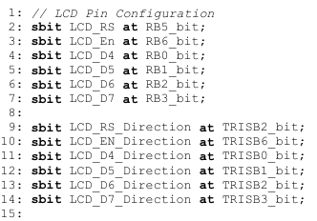
Figure 15 - MIKROC Code 1

Timer0 Setup and Interrupt Routine
This is where the code initializes and manages the Timer0 module [Fig 16]. This creates a 10ms time base for system operation. Variable cnt is a software counter that increments every 10ms. The Interrupt() function handles any Timer0 overflow events by checking the Timer0 interrupt flag is set – if set, in increments the cnt variable. resets the interrupt flag and reloads TMR0 with the preload value.
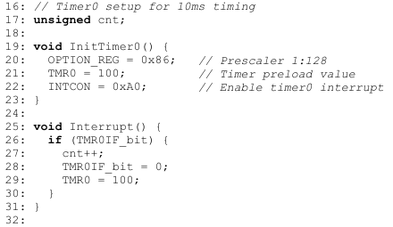
Figure 16 - MIKROC Code 2

Global Variables Declaration
Here [Fig 17] kp and d1 are declared as unsigned short variables to store keypad input values and lock decision statuses. KeypadPort is assigned to PORTD as PORTD connect directly and only to the keypad. The integers t,a,b,q and x are set as counters and logic variables for password verification and system control.
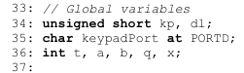
Figure 17 - MIKROC Code 3

Mount and Dismount Motor Control Function
Here [Fig 18], the checkmoutdismount() function is set. This is responsible for detecting if the mount or dismount buttons have been activated in the system. This is continuously monitored and separate from the rest of the codes loop to prevent issues and delays. The function continuously monitors the states of the corresponding pin that are set on the microcontroller. The PWM signal is started with a duty cycle of 180 to drive the motor, simulating the mounting action. After a short delay, the motor stops. Similarly, when the dismount button is pressed. The outputs between high and low determines the motors direction of rotation.
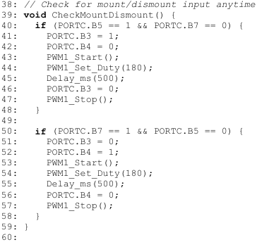
Figure 18 - MIKROC Code 4

Input/Output Configuration
This section of the code initializes the microcontroller’s ports and peripherals [Fig 19 & 20]. It sets the TRIS registers to configure pins as inputs or outputs, depending on their roles. This is shown as a ‘0’ – output or ‘1’ – input. PORTC and PORTA are cleared to start from a known state. Then, the LCD, keypad, and PWM modules are initialized. A startup sequence follows where the LCD displays a welcome message, and the locking motor briefly activates to lock the system, with LEDs indicating system status. This ensures the MISSU system starts properly configured and ready for user interaction.
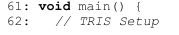
Figure 19 - MIKROC Code 5
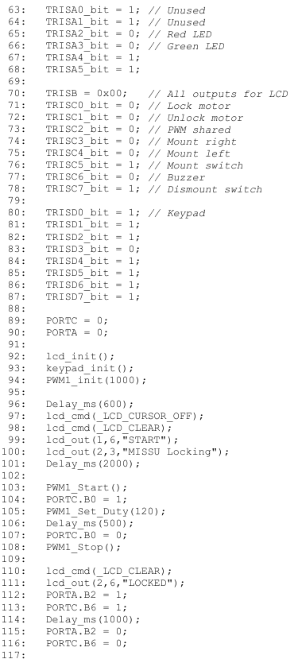
Figure 20 - MIKROC Code 6

System Initialization and User Input Prompt
Here is where the code initializes the main operation loop [Fig 21 & 22]. A continuous loop is set using while(1) which ensures the program runs indefinitely to check for user interaction. Point1 is for re-entry into this section where required. Variables on line 120 are set to zero at the beginning to prevent residual values from affecting the systems operation.
ADCON1 register is configured to disable analog inputs and register them as digital for reading of the keypad.
Throughout the code lcd_cmd(_LCD_Clear) is used to clear LCD display with the lcd_out being used to show what text will be shown after LCD is cleared for this section. The numbers within the brackets are for the written message’s location on the LCD display.
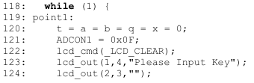
Figure 21 - MIKROC Code 7
Figure 22 - MIKROC Code 8

Password Entry and Verification Logic
This is where the keypad password is processed to determine correct input [Fig 23]. With another while(1) loop, the system monitors the mount/dismount and keypad inputs. If the set timer, dedicated by the cnt exceeds its set threshold then the LCD clears and restarts the login procedure.
The ‘switch’ statement is where the numerical values are assigned for the key inputs for the password logic. Each successful key press is displayed in real time on the LCD via Lcd_Chr_Cp(Kp) and counter t, tracking how many keys have been pressed.
If (t >= 4) indicates that four keys have been pressed to which the inputs are evaluated against the expected value (x == 5). If the input is correct, unlock function is triggered. The green LED is lit and display message appear with the motor rotating to it’s unlock state through PWM control.
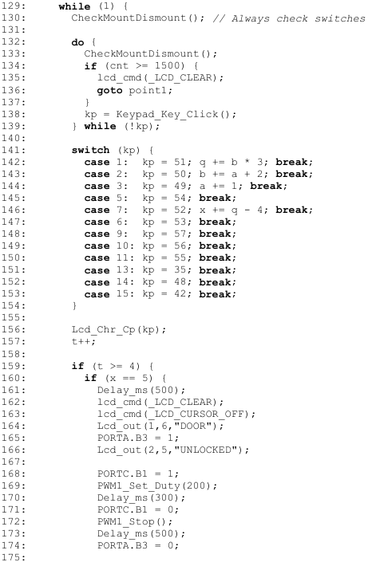
Figure 23 - MIKROC Code 9

Door Locking Sequence and Final Code
This section of the code handles the final stage of the system's operational flow by managing the door locking sequence based on user input [Fig 24 & 25]. Once the door is unlocked, the LCD prompts the user with a message asking whether they wish to lock the door again by pressing the ‘#’ key. The code continuously checks for mount/dismount activity during this stage to maintain system responsiveness. When the correct key is detected the locking motor is activated to re-lock the door and a "SECURITY ACTIVE" is displayed. If an invalid key or sequence is entered, the system triggers an "Access Denied" alert, blinking the red LED before returning to the beginning of the user input stage. This ensures security while providing clear user feedback through the display and LEDs.
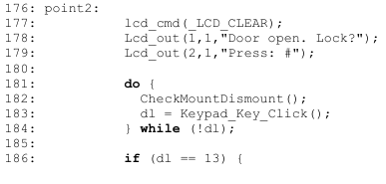
Figure 24 - MIKROC Code 10
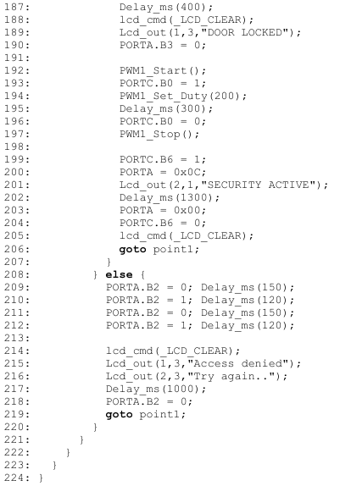
Figure 25 - MIKROC Code 11

6 Implementation Design
The proposed design of the MISSU is highlighted in this section. The design is a modification of a commercial product from B&Q (1 Compartment Galvanised Steel Storage Bin) [9]. The compartment is altered to accommodate the circuit design and components.

6.1 Galvanised Steel Bin COTS
In figure 26, the steel bin can be seen. The proposed design strategy is to alter this design with the MISSU electrical/electronic circuitry to provide the functionality of the MISSU.
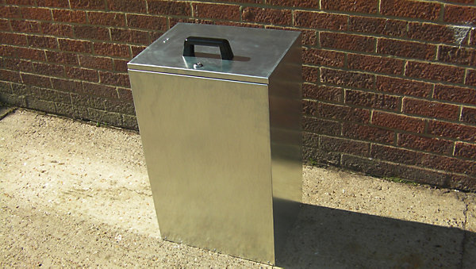
Figure 26 - B&Q Steel Bin COTS
From this, the design shown in the figures below, provides detail where each component of the MISSU system is expected to be located and fixed to the original steel bin. Figure 27 shows the dimension of the existing design with no modifications.
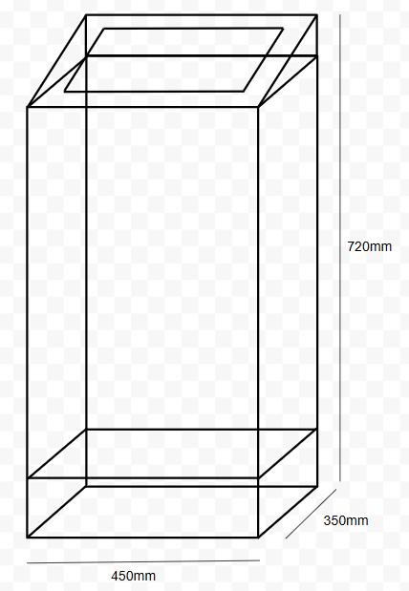
Figure 27 - Concept Drawing 1
From figure 27, you can see the lower section is a separate container, which is to be installed as a modification. This is to house all working electrical equipment which is not external to the steel bin. This will also provide access to the battery for external charging, as well as the parcel inside. This is to provide entry to the parcel if the electrical circuit malfunction or the battery life depletes, and the circuit is without power. A fail-safe mechanical mechanism to the parcel. This will be locked with a key. Further details of this section is shown in figure 28.
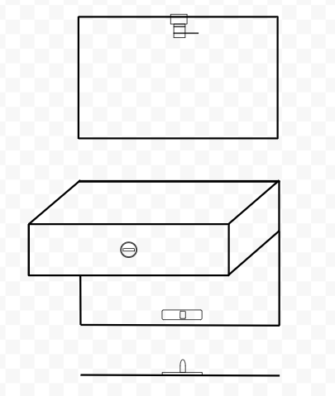
Figure 28 - Concept Drawing 2
The lid will be modified with the visual and keypad components of the system to provide interaction with the user. This is shown in figure 29 below.
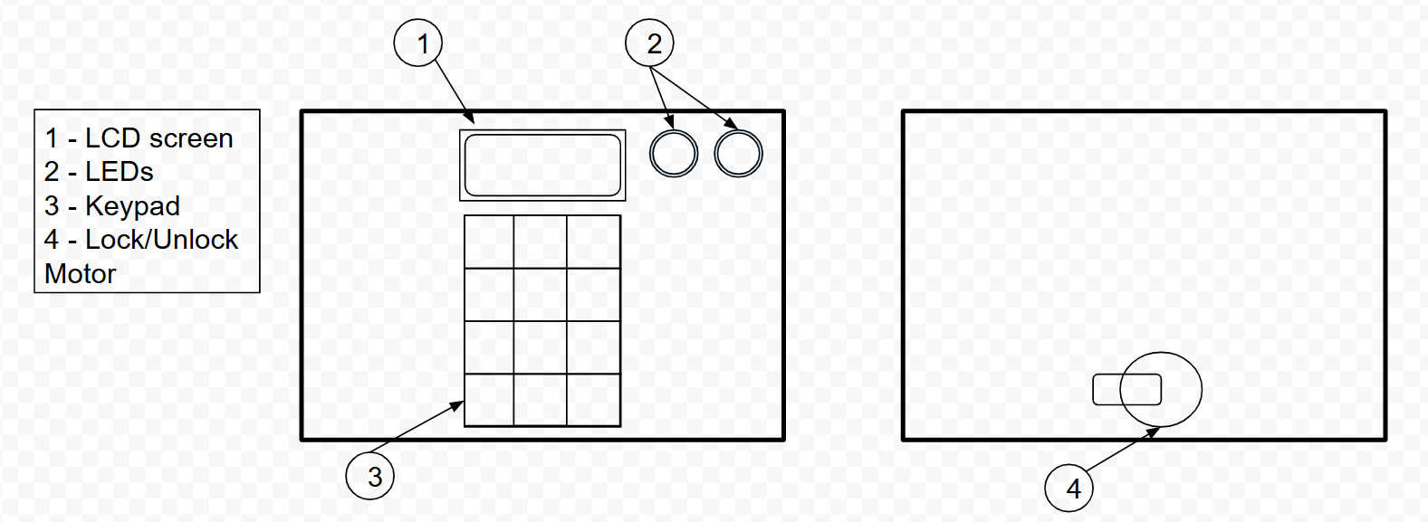
Figure 29 - Concept Drawing 3
Within the parcel storage container (Steel Bin) the 4 motors will be mounted and internally connected to the electrical circuit. Where the locking mechanisms external for mounting to the brackets for mounting and dismounting functions. This is provided in figure 30.
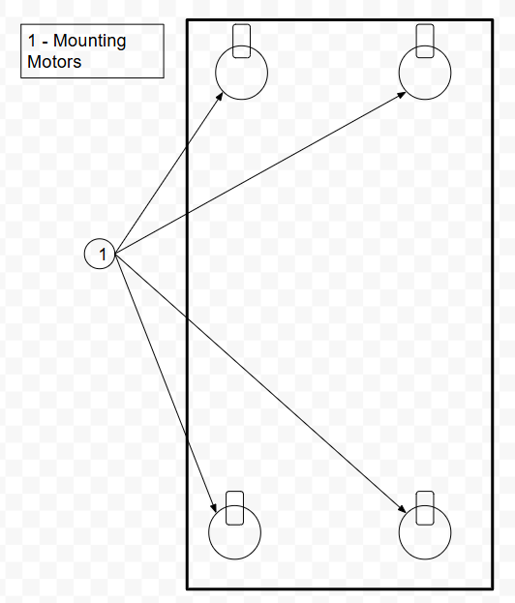
Figure 30 - Concept Drawing 4

7 Development Challenges and Solutions
During the design and development process of the MISSU project, an interim viva presentation was delivered to a panel of academic assessors. This session provided an opportunity to present the project's concept, technical progress, and initial designs. Crucially, the viva highlighted significant issues that had not previously been considered, including a major flaw related to power management and user access in the event of system failure. Additionally, challenges in the physical design and integration of system components into the container were encountered. This section will explain these challenges in greater detail, as well as the engineering solutions that were adopted to address them.

7.1 Flat Battery Access
One major flaw identified during the viva was the issue of accessing the parcel if the battery became flat, rendering the electronic lock and system inoperable. Originally, there was no contingency for user access in the event of power loss. In response to this, a separate compartment within the container has been incorporated into the design, housing the internal electrical circuit and battery. This compartment is secured using a mechanical key lock, allowing manual access when necessary. This design improvement ensures that users can access the battery for recharging purposes and retrieve stored parcels even if the electronic system fails. It provides an essential backup, maintaining the system’s functionality and user reliability under all conditions.

7.2 Battery Charging
Another key development challenge was implementing an effective method for charging the internal 12V battery while ensuring safe and reliable operation. Without a proper charging solution, battery performance and system reliability would degrade over time. To solve this, a 12VDC power adapter was selected to facilitate recharging. To further ensure safe and efficient charging, a dedicated battery charging and protection circuit was designed and integrated into the system. This circuit manages the voltage and current supplied to the battery, preventing overcharging, improving battery lifespan, and ensuring the MISSU remains operational with minimal maintenance.

7.3 Physical Design
Although the design, simulation, and component selection for the MISSU system were successfully completed, the physical construction of the prototype could not be achieved within the project timeframe. During the project, a promotion within employment required an increase in working hours and greater professional responsibilities. As a result, priority was given to these new work commitments, limiting the time available for hands-on development.
Despite this, the complete electronic design, schematics, and component specifications were finalised, meaning that physical construction and testing can still be carried out in the future without significant modification to the project plans.

8 Testing and Validation
Throughout the development of the MISSU system, continuous testing was performed to ensure the correct operation of both hardware components and the embedded software. Each sub-system was tested independently prior to full system integration. This staged approach allowed for identification and resolution of potential faults early in the development process.

8.1 Microcontroller Functionality Test
An initial test was carried out to confirm correct operation of the PIC16F877A microcontroller. A basic connection of an LED connected to one of the output pins (PORTA.B2 and PORTA.B3). Successful LED demonstrated that the microcontroller could be programmed correctly, and that input/output pin control was functional. Shown to be one of the best practices in embedded hardware development [9].This was used to monitor the output and inputs of the microcontroller to ensure expect system output was being achieved [Fig 31].
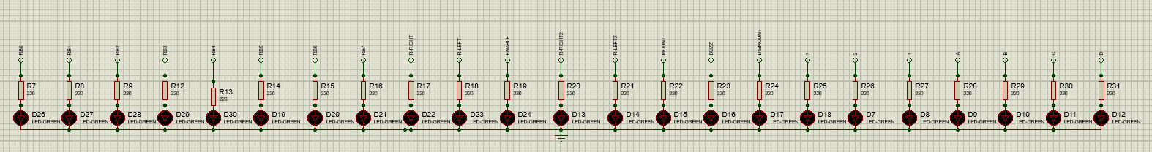
Figure 31 - PIC Microcontroller Testing

8.2 LED and Buzzer Circuit Testing
LEDs (Red and Green) and the buzzer were connected individually to the microcontroller outputs. Separate test codes were uploaded to activate each component at specific intervals. This verified that the PIC outputs were correctly driving external loads and that indicator feedback could be reliably delivered to the user. This also helped to provide further understanding to the code when written separately.

8.3 Keypad Input Testing
The 4x3 keypad was tested by writing a simple code to display the pressed key onto the LCD screen. Each key was pressed in sequence, and the corresponding character was confirmed on the display. This ensured that the keypad scanning logic and the electrical connections were correct.

8.4 LCD Display Testing
A test program was created to output static and dynamic messages to the LCD. Both the data and control lines were verified, and the display was checked for correct contrast and backlight functionality. Successful LCD operation confirmed that the display subsystem was ready for integration.

8.5 Motor Control and PWM Testing
The motor drivers were tested using PWM signals generated by the microcontroller. Test programs were used to spin the lock and mount motors in both forward and reverse directions at various speeds. Motor response, speed control, and switching between directions were all confirmed.

8.6 Timer and Keypad Timeout Testing
The Timer0 module was tested to implement a 15-second timeout if no keypress occurred. Testing verified that the system returned to the initial state after the timeout, ensuring that the unit would not hang or stay idle in an insecure state.

8.7 Password Logic Testing
Software simulations and practical tests were conducted to ensure correct password validation. Correct entry of the four-digit code triggered unlocking routines, while incorrect codes caused the system to display appropriate error messages with LED warning indications.

8.8 Full System Integration Test
After individual module testing, the full MISSU system was integrated and tested in simulation using Proteus to identify any logic errors [10]. The full operational flow including locking, unlocking, mounting, dismounting, password validation, and timeout behaviour was verified to work as expected before physical assembly. The test was used by following the flowchart [Fig 32] of the designed system. It is important to note that the mount and dismount is not a part of this as it runs outside of the loop.
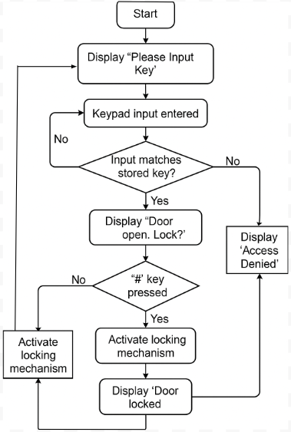
Figure 32 - Design Flow Chart

9 Evaluation
The MISSU project aimed to develop a secure, electronically controlled parcel storage system that reduces missed deliveries whilst enhancing the security of the parcel transaction between supplier and customer. With the wider purpose to support anti-theft on the increasing issues of parcels in the UK and provide support on emission footprint for suppliers and customers. Through the design and development stage, an evaluation is carried out to assess whether the project objectives and aims were achieved.

9.1 Conclusion from Data
Testing throughout the design process was used to confirm if the main electrical system functions as expected via simulations using proteus and MIKROC for embedded C coding. This supported simulated testing on all electrical components such as the keypad password input, motor locking and unlocking, LEDs, buzzer, battery and LCD display. All validated through simulation outputs.

9.2 Objective and Aims Achieved
Most objectives were met during the design process of the MISSU. This product was designed, simulated and partially testing. However, the physical design and testing were not able to be achieved due to external work commitments and limited time to order and fabricate the final physical design. This led to a unfinished product that was not able to meet its objective of a working prototype and therefore further understanding of any other potential issues of the design were not able to be acknowledge, tested and rectified if any had been flagged.

9.3 Improvements
If the project was to be repeated, more time would be allocated for a hardware prototype and additional support where needed to achieve a full physical design. There are some areas within the system where the product would benefit from.
While the system code ultimately functioned as intended, considerable time was spent achieving basic functionality, which limited the opportunity for refinement. Specifically, issues were observed with the LCD screen when displaying messages across multiple code scenarios, such as key input, lock/unlock actions, and mount/dismount operations. Improvements could be made by better structuring the code, enhancing the timing sequences, and optimising LCD clear and output commands for more consistent messaging.
The mount and dismount buttons work and can achieve the objective that was asked. However, the code could be improved to signal the outputs of the motor by setting a separate keypad password which signals the motors for mount and dismount. This would reduce material needed such as 2 buttons and wiring. It would also take up less room as the buttons are to be located within the lower compartment for secure and safe housing of the buttons which secure the unit and parcel (upon delivery) to the bracket system. The keypad password to control this would allow an easier solution when mounting – making it more user-friendly.
A sensor could also be included in the design to activate the LCD and power to the system. The sensor would be able to detect when a user is in range and turn on with an additional failsafe of the keypad being touched to also activate the system power output incase of sensor failure.
During the physical design and testing, other ideas may have been identified to work best. One option which would have been consider is other forms of mounting, such as magnetic. If the mounting and dismounting of the motor and bracket worked well, then this may not be a desire. However. A magnetic mount and dismount would provide a sleek design, easier form of mounting and more aesthetically please. The bracket required to mount and dismount the product would require sticking out of the user domestic building. Whereas a magnetic mount would require a single sheet of conductive material. However, this again would change the design as a constant magnetic connection to be made would require a lot of power and may lead to the product falling off it mount if power is cut.
The biggest area of improvement that would be exercised is password selection via keypad and LCD Display. Prompting the user to select a password which is preferred and can be changed whenever they wished. The current design requires a password to be set for the user and can only be changed via its code. This is achievable but requires additional code.

10 Conclusion and Recommendations
The development of the Mountable Interactive Safety Storage Unit (MISSU) aimed to design and simulate a secure, user-friendly parcel storage system capable of locking, unlocking, mounting, and dismounting via electronic control. Throughout the project, the objectives outlined at the beginning were successfully met through simulated detailed system design, simulation, and testing.
The project achieved the following key outcomes:
- The design and successful simulation of a secure locking and unlocking system controlled by a user-inputted password via a keypad and monitored with an LCD display.
- Implementation of motor control for mounting and dismounting operations to allow flexible storage installation and retrieval.
- Integration of feedback mechanisms through LEDs, LCD display and a buzzer to provide visual and audio status updates to the user.
- Development of a charging system for a 12V battery to ensure continuous and reliable system operation.
Testing and evaluation demonstrated that the core system functions as intended, with secure password authentication and clear user feedback. Minor challenges were encountered, particularly regarding the physical hardware construction due to time constraints, but these were mitigated through comprehensive simulation using Proteus.

10.1 Suggestions for Further Work
Future developments could focus on implementing a fully user-configurable password system directly through the keypad interface, enhancing security and user flexibility. Refining the code to improve LCD screen handling and streamline input detection would also improve overall system responsiveness. Incorporating advanced features such as motion sensors to wake the system, or exploring alternative mounting mechanisms like magnetic solutions, would improve the system’s usability and aesthetic integration into domestic environments.

11 Reflection
The development of the Mountable Interactive Safety Storage Unit (MISSU) provided the opportunity to apply theoretical understanding into a practical project. Throughout the project, technical skills were developed in system design, microcontroller programming, circuit simulation, and project planning. A structured Waterfall methodology was used throughout to ensure each phase was completed before progressing to the next.
During the design process, key issues were identified, particularly regarding battery access and charging, which led to revisions in the design. Early simulation and testing were crucial in identifying potential faults before physical implementation. Although the full physical build was not achieved, all simulations and system testing met the set objectives and confirmed system functionality.
A significant skill development occurred in coding. At the start of the project, there was minimal understanding of embedded C programming. Through structured learning, testing, and refinement, the necessary coding skills were developed to create working, efficient system logic. This included writing code for keypad entry, motor control through PWM, LCD output, buzzer and LED feedback, and system timing using interrupts.
Time management was one of the main challenges faced during the project, mainly due to external work commitments. This highlighted the importance of building in contingency time during project planning. Overall, the project allowed for the demonstration of key skills in electronic system development and provided a strong foundation for future improvements and expansion of the MISSU system.

[1] T. C. Cheah, "Smart Modular Parcel Locker System using Internet of Things (IoT)," ResearchGate, 2021. [Online]. Available: https://www.researchgate.net/publication/356668049_Smart_Modular_Parcel_Locker_System_using_Internet_of_Things_IoT
[2] De La Salle University, "Smart Box Delivery System," Research Congress, 2023. [Online]. Available: https://www.dlsu.edu.ph/wp-content/uploads/pdf/conferences/research-congress-proceedings/2023/HCT-03.pdf
[3] Y. Kandelkar et al., "Secure Smart Parcel Receiving System," Int. J. Prog. Res. Eng. Manag. Sci., vol. 4, no. 11, pp. 1005-1008, Nov. 2024.
[4] A. A. Zainuddin et al., "Simulating the Effectiveness of an IoT Parcel Alert System for Enhancing Delivery Efficiency and Safety During COVID-19," Malays. J. Sci. Adv. Technol., vol. 3, no. 1, pp. 28-36, 2023.
[5] Royal Mail, "Royal Mail trials postbox with parcel hatch, solar panels and barcode scanner," The Guardian, Apr. 10, 2025. [Online]. Available: https://www.theguardian.com/business/2025/apr/10/royal-mail-trials-postbox-parcel-hatch-solar-panels-barcode-scanner
[6] S. Ahmed, "Efficient Peripheral Integration with PIC Microcontrollers Using MikroC," International Journal of Scientific Research in Engineering and Management (IJSREM), vol. 5, no. 12, 2021. [Online]. Available: https://ijsrem.com/download/efficient-peripheral-integration-with-pic-microcontrollers-using-mikroc/
[7] S. Prasad and A. Kumar, "Comparative Study of PIC Microcontrollers for Industrial Applications," International Journal of Advanced Research in Electrical, Electronics and Instrumentation Engineering, vol. 9, no. 6, 2020. [Online]. Available: https://www.ijareeie.com/upload/2020/june/6_Comparative_NC.pdf
[8] J. Singh, "Design Considerations for LCD Display Modules in Embedded Systems," Journal of Embedded Systems and Applications, vol. 8, no. 2, 2020. [Online]. Available: https://jesaonline.org/article/view/1205
[9] B&Q, Galvanised Steel Storage Bin, available at: https://www.diy.com/departments/1-compartment-galvanised-steel-storage-bin/0756406347439_BQ.prd?&&&&gclid=dadc20f4f34c16ff47be477cf5ba9e6f&gclsrc=3p.ds&msclkid=dadc20f4f34c16ff47be477cf5ba9e6f
[10] A. Tiwari, "Testing Strategies for Microcontroller Based Embedded Systems," International Journal of Scientific and Technology Research (IJSTR), vol. 9, no. 2, 2020. [Online]. Available: https://www.ijstr.org/final-print/feb2020/Testing-Strategies-For-Microcontroller-Based-Embedded-Systems.pdf
[11] P. Rana and R. Chauhan, "Application of Proteus for Simulation of Embedded Systems," International Journal of Engineering Research and Technology (IJERT), vol. 8, no. 5, 2019. [Online]. Available: https://www.ijert.org/application-of-proteus-for-simulation-of-embedded-systems

13 Appendices

Appendix A
Full Code Listing:
// LCD Pin Configuration
sbit LCD_RS at RB5_bit;
sbit LCD_En at RB6_bit;
sbit LCD_D4 at RB0_bit;
sbit LCD_D5 at RB1_bit;
sbit LCD_D6 at RB2_bit;
sbit LCD_D7 at RB3_bit;

sbit LCD_RS_Direction at TRISB2_bit;
sbit LCD_EN_Direction at TRISB6_bit;
sbit LCD_D4_Direction at TRISB0_bit;
sbit LCD_D5_Direction at TRISB1_bit;
sbit LCD_D6_Direction at TRISB2_bit;
sbit LCD_D7_Direction at TRISB3_bit;

// Timer0 setup for 10ms timing
unsigned cnt;

void InitTimer0() {
OPTION_REG = 0x86; // Prescaler 1:128
TMR0 = 100; // Timer preload value
INTCON = 0xA0; // Enable timer0 interrupt
}

void Interrupt() {
if (TMR0IF_bit) {
cnt++;
TMR0IF_bit = 0;
TMR0 = 100;
}
}

// Global variables
unsigned short kp, dl;
char keypadPort at PORTD;
int t, a, b, q, x;

// Check for mount/dismount input anytime
void CheckMountDismount() {
if (PORTC.B5 == 1 && PORTC.B7 == 0) {
PORTC.B3 = 1;
PORTC.B4 = 0;
PWM1_Start();
PWM1_Set_Duty(180);
Delay_ms(500);
PORTC.B3 = 0;
PWM1_Stop();
}

if (PORTC.B7 == 1 && PORTC.B5 == 0) {
PORTC.B3 = 0;
PORTC.B4 = 1;
PWM1_Start();
PWM1_Set_Duty(180);
Delay_ms(500);
PORTC.B4 = 0;
PWM1_Stop();
}
}

void main() {
// TRIS Setup
TRISA0_bit = 1; // Unused
TRISA1_bit = 1; // Unused
TRISA2_bit = 0; // Red LED
TRISA3_bit = 0; // Green LED
TRISA4_bit = 1;
TRISA5_bit = 1;

TRISB = 0x00; // All outputs for LCD
TRISC0_bit = 0; // Lock motor
TRISC1_bit = 0; // Unlock motor
TRISC2_bit = 0; // PWM shared
TRISC3_bit = 0; // Mount right
TRISC4_bit = 0; // Mount left
TRISC5_bit = 1; // Mount switch
TRISC6_bit = 0; // Buzzer
TRISC7_bit = 1; // Dismount switch

TRISD0_bit = 1; // Keypad
TRISD1_bit = 1;
TRISD2_bit = 1;
TRISD3_bit = 0;
TRISD4_bit = 1;
TRISD5_bit = 1;
TRISD6_bit = 1;
TRISD7_bit = 1;

PORTC = 0;
PORTA = 0;

lcd_init();
keypad_init();
PWM1_init(1000);

Delay_ms(600);
lcd_cmd(_LCD_CURSOR_OFF);
lcd_cmd(_LCD_CLEAR);
lcd_out(1,6,"START");
lcd_out(2,3,"MISSU Locking");
Delay_ms(2000);

PWM1_Start();
PORTC.B0 = 1;
PWM1_Set_Duty(120);
Delay_ms(500);
PORTC.B0 = 0;
PWM1_Stop();

lcd_cmd(_LCD_CLEAR);
lcd_out(2,6,"LOCKED");
PORTA.B2 = 1;
PORTC.B6 = 1;
Delay_ms(1000);
PORTA.B2 = 0;
PORTC.B6 = 0;

while (1) {
point1:
t = a = b = q = x = 0;
ADCON1 = 0x0F;
lcd_cmd(_LCD_CLEAR);
lcd_out(1,4,"Please Input Key");
lcd_out(2,3,"");

cnt = 0;
InitTimer0();

while (1) {
CheckMountDismount(); // Always check switches

do {
CheckMountDismount();
if (cnt >= 1500) {
lcd_cmd(_LCD_CLEAR);
goto point1;
}
kp = Keypad_Key_Click();
} while (!kp);

switch (kp) {
case 1: kp = 51; q += b * 3; break;
case 2: kp = 50; b += a + 2; break;
case 3: kp = 49; a += 1; break;
case 5: kp = 54; break;
case 7: kp = 52; x += q - 4; break;
case 6: kp = 53; break;
case 9: kp = 57; break;
case 10: kp = 56; break;
case 11: kp = 55; break;
case 13: kp = 35; break;
case 14: kp = 48; break;
case 15: kp = 42; break;
}

Lcd_Chr_Cp(kp);
t++;

if (t >= 4) {
if (x == 5) {
Delay_ms(500);
lcd_cmd(_LCD_CLEAR);
lcd_cmd(_LCD_CURSOR_OFF);
Lcd_out(1,6,"DOOR");
PORTA.B3 = 1;
Lcd_out(2,5,"UNLOCKED");

PORTC.B1 = 1;
PWM1_Set_Duty(200);
Delay_ms(300);
PORTC.B1 = 0;
PWM1_Stop();
Delay_ms(500);
PORTA.B3 = 0;

point2:
lcd_cmd(_LCD_CLEAR);
Lcd_out(1,1,"Door open. Lock?");
Lcd_out(2,1,"Press: #");

do {
CheckMountDismount();
dl = Keypad_Key_Click();
} while (!dl);

if (dl == 13) {
Delay_ms(400);
lcd_cmd(_LCD_CLEAR);
Lcd_out(1,3,"DOOR LOCKED");
PORTA.B3 = 0;

PWM1_Start();
PORTC.B0 = 1;
PWM1_Set_Duty(200);
Delay_ms(300);
PORTC.B0 = 0;
PWM1_Stop();

PORTC.B6 = 1;
PORTA = 0x0C;
Lcd_out(2,1,"SECURITY ACTIVE");
Delay_ms(1300);
PORTA = 0x00;
PORTC.B6 = 0;
lcd_cmd(_LCD_CLEAR);
goto point1;
}
} else {
PORTA.B2 = 0; Delay_ms(150);
PORTA.B2 = 1; Delay_ms(120);
PORTA.B2 = 0; Delay_ms(150);
PORTA.B2 = 1; Delay_ms(120);

lcd_cmd(_LCD_CLEAR);
Lcd_out(1,3,"Access denied");
Lcd_out(2,3,"Try again..");
Delay_ms(1000);
PORTA.B2 = 0;
goto point1;
}
}
}
}
}

Appendix B

Proteus Circuit Design.
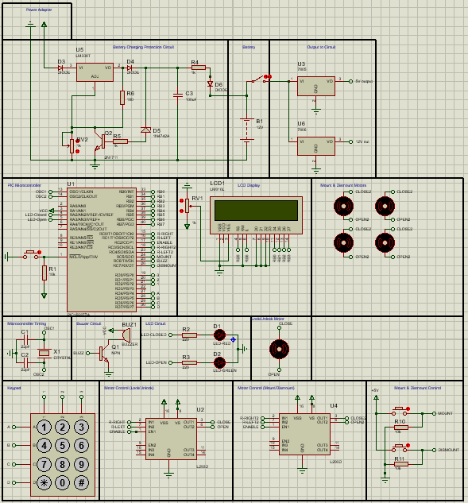

Appendix C
Requirements Traceability Matrix.
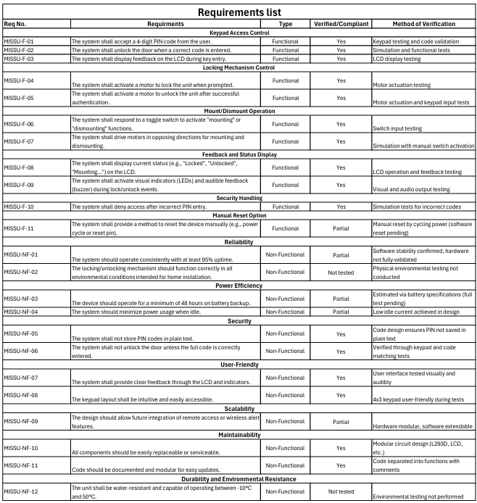

Appendix D
Drawings.

Appendix E
Testing and Result Logs.

Appendix F
GANTT Chart.
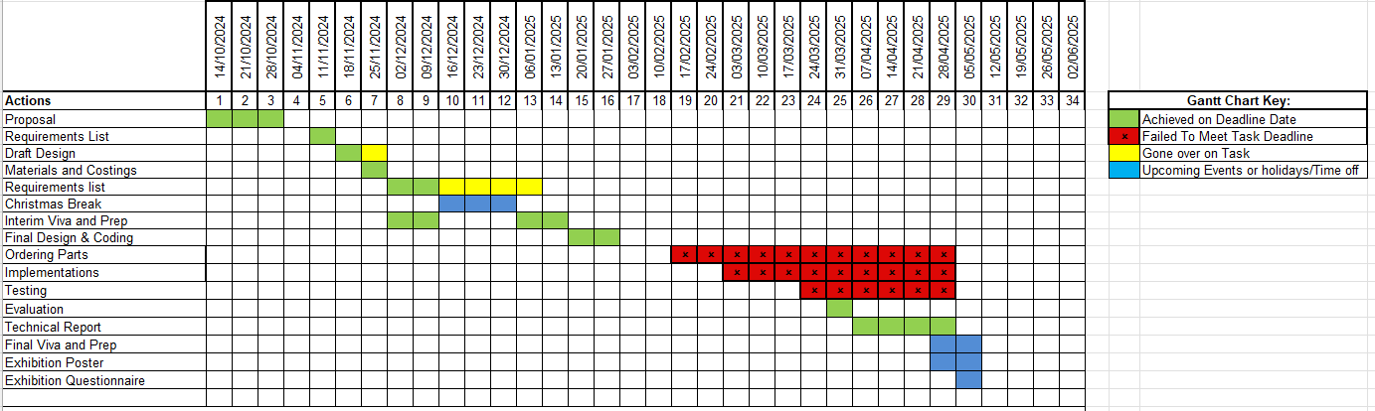

Appendix G
Kanban Board.


