MANAGING ENTERPRISE IN THE 21ST CENTURY (MAE)
Group of Members
Anghel Radu- 1921640
Alexandru Munteanu – 1920944
Alina Pavlov- 1921481
Alexandru Postolache- 1921646
Diana Elena Stanculet (1920967)

Cover Letter
Mr X,
College St, Lampeter SA48 7ED, United Kingdom,
Abc@gmail.com
Respected Mr X,
This letter aims to express our interest in developing a business plan for PL to cope with the ongoing pandemic. PL is a leading online market place that connects sellers across the world with customers. We have outlined a business plan for enhancing PL’s profitability in light of the changing customer and business requirements due to the pandemic. Please find the enclosed business plan. We look forward to hearing from you set a date for an interview.
Thanking you,
Yours sincerely,
The PL Team

Executive Summary
PL provides numerous services like overnight delivery services and standard delivery services to influence customers. The objectives of PL are to develop, train and attract talent through enhanced and more integrated HR management practices and strategies. Along with this, PL is to increase number of subsidiaries of products and services to compete with rival online businesses and retain in markets for a longer period of time with improving features of web services.
PL’s growth potential is huge in UK’s market as it has a strong market presence. Its top competitors include Tesco and eBay. PL can attain its marketing goals effectively by tracking its competitor performance. Tesco is one of the emerging online retail stores in UK due to its staring market presence and credibility in the UK market. It has succeeded in using its opportunities for market expansion and meet changing consumer preferences by improving its online operations. eBay is considered as a pioneer of the online retail marketplace. Its first-mover advantage is evident from its large customer and seller base. However, the brand has a negative image as well as increased online security attacks making it face increased difficulties in competing with PL and Walmart, among other organisations. Evaluation of the present online retail industry in the UK indicates the impact of political uncertainty caused due to “Brexit”. The online retail industry would be significantly affected due to the outcomes of “Brexit” as it would influence trade regulations and taxation policies of goods supplied from other European countries.
PL may suffer from increased inflation rates in the UK after Brexit's outcomes and need to be prepared for price inflation accordingly. Apart from this, the present economic conditions of the UK, including its inflation rate and annual GDP growth rate indicate a favourable environment. This would be greatly beneficial for PL to market its products and services in the UK successfully. The changing customers' preferences towards online retail channels due to health and safety concerns caused by COVID-19 are advantageous for PL.
PL enlistment of programming improvement engineer for taking care of entanglements that emerged during organising of information and calculations. This architect can quantify arrangements of assignment through executing innovation aptitudes to deal with convoluted issues proficiently. Personalisation of their particular item by creating uncommon physical marks approved by the government provides protection to their exercises which have been executed by standards in recorded copyright act. Support of a working environment of decent variety is one of the significant methodologies of CSR strategy which should be kept up by the HR office for giving equivalent chances to representatives working in an association.
Table of Contents
Introduction 5
Business Overview of PL 5
Business objectives 7
Business Structure 9
Product and Services 11
Market Analysis and Needs 11
Operations 19
Operational considerations 20
Analysis of staff roles 21
Business operation area 22
Laws and regulations 23
Analysis of insurance 24
Technology plan 24
Social responsibility and sustainability 27
Analysis of CSP policy 27
Financial Plan 30
Conclusion 33
Reference List 35

Introduction
Enterprise activities can be properly maintained by support of analysing strengths, weaknesses, threats and opportunities. Along with internal factor analysis, enterprises obtain positive outcomes that deal with a projection of positive changes in an organisation to move forward in markets. Therefore, this study explores an effectiveness of business plans towards business of Parcel logistics (PL), an online retail sector that serves customers via online catalogue inventory means. Objective of this study is to provide comprehension of improved marketing process and techniques regarding changes on the part of PL.
Parcel logistic is an online product delivery company which has been established in UK for delivering products easily to customers by aligning with large enterprise which involves in manufacturing of products. Online delivery of products is one of prime principles of this company which incorporates various marketing processes that alternate lifestyles of customers during time of covid-19. Government of UK in listed versatile regulations for overcoming pandemic situation through enlistment of lockdown that create a negative impact over traditional shopping. In this particular concept aligning with large enterprises such as Amazon, this company gets an opportunity to grab attention of customers through delivering products that Amazon Company is offering to customers. Apart from this, Delivery Company enlisted experts for handling customer requirements which is one of main expected help in identifying requirements of consumers. Development of a positive relationship with consumer facilities to promote products which a large enterprise is willing to position by making targeting to their customers. This study focuses on different regulations that PL needs to follow for making improvements in operations to develop technical plans. Proper allocation of responsibility among employees so that this company gets an opportunity to sustain its strategy which has ability to enhance competitive advantages. Apart from this, a financial plan is also discussed in this study that focuses on cash flow.

Business Overview of PL
PL is willing to structure business plans for entering UK market that gets aligned with large retailing enterprises which have potential to deal with customer by offering high-quality products. 4 types of delivery services will be enlisted by this company that makes service specialized. Delivery of retailing products according to places by customers to collaborated companies is one of main approaches that is incorporated under product delivery. On other hand management of positive relationships with customers through estimating their requirement has been identified by expert delivery employees incorporated in this company. Delivery process has been by involving a group of members having knowledge regarding practical scenarios that decline external complexities. In this particular concept, development of delivery infrastructure provides an opportunity to maintain a Service Delivery team that reduces internal conflict within organization and leaves to conduct team process in an efficient manner. Identification of prioritizing tasks to developing task management skills supports managers to guide your employees regarding immediate deadline which is one of main concerns of customers. The satisfaction of customer is highlighted over delivery of product according to deadline. On a similar note, area in delivery of product according to time is limited by large enterprise's Amazon or Tesco regarding their delivery, this company will have such limitations in terms of experiencing high loss for not providing product according to deadline. Behind product increases that sacrifices satisfaction level of customers which is one of negative activities of a delivery company. Connecting with this previous context it has been identified that, having a high competitor in market is a company that will face accumulation in terms of not considering order deadlines in a high priority list. Structuring of delivery criteria according to product and services increases quality of performance. Comparing with this company will offer solutions to issues faced by customer after purchasing a product that is not up to mark based on their needs.
Legal Compliance
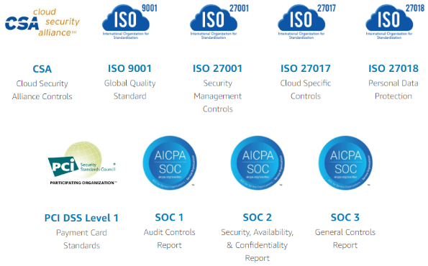
Figure 1: Legal Compliances of PL
(Source: Aws.PL.com, 2019)
The consumer Council of UK has established new websites to convey different parcel rights as well as responsibilities speech a personal company needs to follow while dealing with the online orders of products. The signposting facility is included under this regulation which allocates report problem options while not getting accurate parcels from delivery companies that have been ordered from a large retailing company (nibusinessinfo.co.uk, 2020). Apart from this implication of internet for buying and selling products to maintain information that provide customers while getting delivery of product. According to ISO 90001, delivery of equal rights to all customers while ordering products increases interest rate of customer to develop commercial bonds with aligned company. Extension of profit of that company regarding fast and quality services for delivery indirectly increases sale rate of large companies.
Notifications regarding delivery of a product are one of main legal compliances that have been fixed by government of UK for ensuring precious time for customers. In this particular concept, as opined by Rani et al. (2019), delay delivery is one that customer is facing regarding online companies. Making payment for premium services which highlight accurate day delivery within a given time period otherwise payment will be refunded to customer is applied by government for incorporating flexibility in parcel delivery. In this link concept development of actions for offering flexibility in lifestyles of consumers increases motivations for customers to engage in this digital platform for ordering their products. On other hand, Galati et al. (2020) mentioned in an article that handling damaged products by communicating with consumer is vital for handling bonding with customers. Additional compensation and replacement of items are included under these regulations which provide an alternative opportunity to replace damaged product without any challenging situation facing consumers. Additional charges for delivery need to be conveyed to customer before purchasing a product that maintains authentication regarding price which has been structured for a product. Connecting with a similar context it has been identified that extension of price after purchasing a product creates limitations for customer to make amount.

Business objectives
Short term objectives
- To develop, train and attract talent through enhanced and more integrated HR management practices and strategies
Specific | PL tends to expand its workforce by recruiting more numbers of appropriate candidates.
Measurable | It is measurable by monitoring and controlling activities of employees in PL.
Attainable | It is achievable by implementing a talent management pool that would be successfully recruiting employees for PL.
Relevant | This objective is relevant since an increase in employees would aid in increase in productivity.
Time - bound | It is time bound based on two weeks for the recruiting process, followed by training to required and newly joint employees.
Table 1: Short-term SMART objective
(Source: Created by author)
Medium term objective
- To enhance diversity in products and services, enabling PL to compete more efficiently with competition
Specific | Medium term objective of PL is to increase number of companies to compete with rival online businesses in markets.
Measurable | It can be measured by increasing sales points of customers and obtaining loyalty and satisfaction in return.
Attainable | It is attainable by making proper efforts for promotional events by taking support from social media platforms.
Relevant | Accomplishment of this objective would facilitate PL to expand further in markets.
Time - bound | Subsidiaries need to be implemented every six months so that they would be helping customers to be engaged in buying different products provided by PL.
Table 2: Medium-term SMART objective
(Source: Created by author)
Long term objective
- To retain market share for extended periods of time through improved web services
Specific | PL aims to retain in markets for a longer period of time with improving features of web services.
Measurable | This can be measured by developing website software and monitoring and controlling the feedback section from customer’s end.
Attainable | It can be attained by implementing software to enhance functions of websites and ensures to keep safe, confidential information from external companies.
Relevant | It is relevant since it would aid PL to gain sustainability in global markets.
Time - bound | It needs to keep updated every four months in terms of keeping track of latest marketing trends and accordingly make changes.
Table 3: Long-term SMART objective
(Source: Created by author)

Business Structure

Figure 2: Corporate structure of PL
(Source: Influenced by Sunko et al. 2018)
Line organizational structure has been adopted by the company for developing direct as well as particle bonding between different levels of organization so that the company gets orders from large enterprises for conducting their delivery services. In this particular conservation, as per views of Sunko et al. (2018), developing a chain for receiving the organizational objectives is one of the main principles of this organizational structure that involves operators of different levels of organizations. A state of comment has been developed for controlling the departments that are involved in the extension of the quality of the performance.
The selection of regulation for services offered to the customers based on their needs is considered as the independent decisions that a business manager uses to adapt (Stverkova and Pohludka 2018). Construction of a unified structure through communicating with all the members having efficient knowledge regarding business makes the stability of the delivery services by aligning with organizations like Amazon. The following context portrays that selling off the accurate services for delivering packages ordered by the customer from the aligned organization is included under the sales department that gets facilities to communicate with the fabrication department.
Authority flow is one of the main aspects which is included under the responsibilities of line manager that facilitates making effective decisions regarding the improvement of the employees based on the scenario. As claimed by Stalph (2020), the allocation of experts for handling the scenario and understanding the basic concept for taking decisions is considered as an additional role that boosts up the sales rate. Marketing activity has been changed by the involvement of adversary concepts through engaging line managers to deliver accurate solutions to the issues faced by the customers regarding the product order online. Development of planning regarding researching off the market by involving staff in the practical scenario increases the rate of success of a plan. Moreover, as alleged by the systematic process which has been used for dividing the work, it provides an opportunity to develop efficient decisions regarding the coordination of activity used for the delivery of products by communicating with the leading companies established in the UK. Construction of efficient coordination with the employees increases the motivation bread that supports the development of a free environment at the workplace which increases its specialty.

Product and Services
PL allocates overnight services for delivery of parcels so that customers get the product in the early morning based on their time schedules. Apart from this, FedEx (FDX) is another forwards services that influence the mentioned services in terms of parceling products through airlines so that customers get an easy delivery of the products. As discussed by Hussain et al. (2019), the inclusion of overnight services, 24hrs reaching capability increases of a company that is dealing with online delivery in terms of involving local depot. In this particular concept, this service provider who is involved in a local community ensures delivery of correct order to the correct person by cross-checking of the information enlisted by the customer while ordering a product.
The easiest way to engage customers by providing effective delivery is to enlist the owner and services that have been considered as a reasonable pricing strategy. Like other authors, Sawadsitang et al. (2018) have claimed in article that restriction of a time period for delivery of product reduces productivity rate in terms of extending high competition in the market which has been offering flexible services to customers. Standard courier services and other approaches that are also listed by this company for delivering retailing products from Amazon which is urgent. Urgency product has been distinguished by its categorizations while placing orders, these large retail companies categories some of products as essential groups.
This specific situation during time of pandemic of covid-19 that led to introduction of social distancing for overcoming physical health situation arose in 2020. Different retailing companies offer estimated time and tracking id to courier companies so that give an exact idea regarding destination and emergency which makes them alert regarding privatization of that courier. Stocker et al. (2017) analysed in an article regarding delivery of quick notification after delivering a product to company which is highly concerned regarding requirements of the customer gets an opportunity to directly notify customer regarding their product delivery. This approach facilities in the planning of prodding activity in terms of not delivering accurate product to right person. Confirming delivery increases the security of the product that grabs the attention of new customers and increases the service quality m which makes them unique.

Market Analysis and Needs
Target Customers
Determination of target customers is an essential aspect of developing a strategic marketing plan. In this context, the estimated potential customers of PL in its target regions across UK include London, Birmingham, Manchester, Bristol and Glasgow. An estimated 150,000 potential customers would be targeted by PL. Teece (2018) observed that the determination of key features of the target customers enables a brand to take a specified approach towards marketing. It is essential for determining key promotional activities that would enable the brand to persuade this demographic. Distinguishing features of the target customers in the UK includes those aged between 16 years to 35 years. This age range would provide PL with an opportunity to attract customers for the purpose of school, college, office and home supplies essential for working during the ongoing pandemic. The products and services offered by PL aim to address the work and personal needs of customers during the COVID-19 crisis due to the need for touchless payments and doorstep speedy delivery. A competitive pricing approach has been taken by PL for promoting the use of its products and services.
Target Market
Online along with social media research has been undertaken for analysing the key market trends for PL. This has enabled the researchers to gain a broader understanding of the implications of changing environmental conditions on the online retail industry and consequently on PL. An external environmental analysis along with competitor and company analysis has been conducted below to gain a better understanding of the shape of the online retail industry and competitors of PL.
PESTLE Analysis
Factors | Impact
Political | - The outcome of Brexit is a major political threat for the business sustainability of the online retail industry in UK.
Economical | - The rate of inflation in UK reduced to 1.79% in 2019 indicating economic stability (Statista.com, 2020).  - The annual growth rate of UK’s GDP increased to 1.4% in 2019 highlighting a favourable environment for the online retail industry (Data.worldbank.org, 2020).
Social | - Changes in consumers’ preferences from physical retail stores to online stores due to the ongoing pandemic have positively impacted the online retail industry.
Technological | - Fraud and cyber-crimes against retailers were noted to have risen by 55% in 2016 indicating increased online threats of buying and selling products (Brc.org.uk, 2016).
Legal | - Application of the “Data Protection Act 2018 (c. 12)” has enabled online retail organisations to legally comply with the protection of confidential data of its users and uses the same ethically.  - Online retail businesses need to comply with the “Equality Act 2010 (cth.)” and provide opportunities to all employees without discrimination (Gov.uk, 2020).
Environmental | - Online retailers are required to comply with the “Environmental Protection Act 1990 (c. 43)” to operate in an environmentally responsible and sustainable manner (Legislation.gov.uk, 2020).
Table 3: PESTLE Analysis
(Source: Legislation.gov.uk, 2020)
Evaluation of the present online retail industry in the UK indicates the impact of political uncertainty caused due to “Brexit”. The online retail industry would be significantly affected due to the outcomes of “Brexit” as it would influence trade regulations and taxation policies of goods supplied from other European countries. Blake (2020) observed that economic uncertainty is a direct consequence of “Brexit”. PL may suffer from increased inflation rates in the UK after Brexit’s outcomes and need to be prepared for price inflation accordingly. Apart from this, the present economic conditions of the UK including its inflation rate and annual GDP growth rate indicate a favourable environment. Team (2017) observed that organisations need to comply with legal regulations to avoid legal complications. In this aspect PL needs to ensure that it complies with the “Equality Act 2010 (cth.)” and “Data Protection Act 2018 (c. 12)” efficiently. Moreover, Amaan needs to take proactive steps to reduce online cybersecurity issues and frauds to safeguard its customers and sellers’ private information. By taking the necessary technological measures, PL would be able to create a safe and secure online platform and focus on increasing its sales in the UK market successfully.
Competitor Analysis using SWOT
Competitor 1: City Sprint

Strength  - Deliver versatile fleet  - High investment over software  - 35 service center | Weakness  - Having unskilled employees  - The high price of services  - Lack of flexibility in online app
Opportunity  - Customer-focused company  - Allocation of innovative technology | Threats  - High market competitions  - Lack of employee retention rate
Table 4: City Sprint SWOT Analysis
(Source: Influenced by Du et al. (2018)
Having versatile sleep increases the number of interests of the customer due to providing flexible parcels based on their demand. Blinking with the previous context it is also identified that having physical stores provide an opportunity to customers regarding visiting their office regarding any issues that arise while delivering and receiving products. One of leading challenges that company is facing is high price of delivery services that reduce engagement rate of customers who are having a low-income scale. Lack of skills among employees engaged in organization while handling this innovative technology reduces its flexibility and its investment potential energy. As described by Du et al. (2018), development of strategies that will be beneficial for customer is considered as a customer based approach. This mentioned approach facilities in targeting a vast range of customers who are involved in delivering activities. Different challenges regarding receiving products by customer increase market competition due to appearance of different flexible strategies of other companies. Versatile opportunities to employees increase competition that leads to extension of shifting of employees from this mentioned company to other companies that are established within UK in reputed managers.
Competitor 2: DPD
Strength  - Involvement of expert  - Large customer base in Europe  - Multiple categorizations in the courier services | Weakness  - Lack of customer services  - High employee turnover rate  - Lack of online website
Opportunity  - Award-winning company  - Having International recognition | Threats  - Low rate of competitive advantages  - Over investment in innovation
Table 5: DPD SWOT Analysis
(Source: Influenced by by Troudi et al. 2018)
Issues faced by customer can be handled by involvement of experts who have accurate knowledge regarding delayed delivery as well as irrelevant processing of product which has not been ordered by customers. Additionally, as commented by Troudi et al. (2018), handling of situation increases performance quality that engages customers rapidly. Moreover, versatile segments of customers get attracted to services due to appearance of different types of courier services. Moreover, having International recognition is another aspect that increases brand value for new customers. On other hand, as suggested by Lee and Hwang (2018), extension of budget clears negative impact over employee turnover rate which has a high chance of declining satisfaction. Installation of Technology which has been incorporated for maintaining flexibility in delivery of products reduces lack of skills of handling this innovative technology. In this in particular capability employee reduces that made a failure of organizational objectives that have a higher ability to make a profit in a vast amount. Linking with a similar text, retention rate of customer also declined due to lack of flexibility within an organization in terms of not having accurate training sessions that increase their knowledge regarding innovative technology. Self-development is another approach that provides motivation to Employees which supports them in achieving their goals which have been established by these courier companies for meeting requirements of customers.

SWOT of PL
Strength  - Overnight service towards customers  - Skilled employees  - High discount over services | Weakness  - Costly services  - Lack of innovation in technology
Opportunity  - Location of tracking IDs  - Establishment of commercial bonds with leading companies such as Tesco as well as Amazon | Threats  - High market competition  - Delay delivery
Delivery of 24-hour services to customers, this company gets an opportunity to fulfil alternations in market regarding courier services. In this situation, create a limitation over traditional shopping system which is one of main marketing opportunities for this company for launching their services regarding delivery of products from aligning with leading companies like Amazon. Over one of issues which cannot be overcome by this company due to lack of involvement of experts in this operation is a high delay in delivering products. Linking with a similar context it has been distinguished that market competition increases due to extension of prices of services. Having a moderate income scale generates challenging situations for customer to experience new courier service that is not up to mark due to its delay in delivering products.
Marketing and Sales Plan
Marketing and Sales Objectives
The key objectives of PL include:
- Using a customer-friendly interface leading to the provision of personalised product recommendations.
- Increasing product availability in the UK market by 65% at the end of 2021.
- Increasing number of active customers of PL UK by 1.7 million by 2020.
- Increasing product sales in the UK by 79.5% at the end of 2020.
Marketing Budget
Components | Estimated Costs (in £)
Market Scanning | 30,000
Planning | 40,000
Resources | 75,000
Branding | 15,000
Positioning | 25,000
Promotion | 45,000
Monitoring | 10,000
Evaluating | 10,000
Total Budget | 250,000
Table 7: Marketing Budget

Marketing and Sales Plan
Marketing Mix | Objectives | Activities Required | Timeframe | Expected Outcomes
Product | Increasing product availability in the UK market by 65% at the end of 2021. | Inclusion of a wider demographic of third-party suppliers in the UK market. | 6 months | Increase in product diversity and accessibility by UK consumers.
Price | Increasing product sales in the UK by 79.5% at the end of 2020. | Reduction of prices through discounts | 4 months | Rise in forecasted sales in UK target customer segments.
Place | Using a customer-friendly interface leading to the provision of personalised product recommendations. | Development and implementation of a customer-friendly interface within the PL official website and mobile application. | 4 months | Increase in customer purchasing motive and sales due to personalised recommendations for shopping.
Promotion | Increasing number of active customers of PL UK by 1.7 million by 2020. | Use of free-delivery services and promotion through “social media marketing” for increasing active users of PL.  Use of limited-period offers. | 4 months | Rise in the number of consumers beguiling PL’s products and services due to increased discounts and limited period offers.
Table 8: Marketing and Sales Plan
Promotional Activities
Activities | Description
Social Media | PL uses viral marketing in “social media” for promoting its brands, serviced as well as innovations. The organization further uses celebrity endorsements for promoting its main AI product “Alexa”.
Website for e-commerce | PL’s website provides information regarding its upcoming seasonal sales as well as loyalty programs including the “PL Prime Membership” (PL.co.uk, 2020).
Search Engine marketing | PL uses “a9” and “FireOS” powered devices as its main search engine. It uses search engine marketing for optimising its sales and increasing website traffic.
Table 9: Key Promotional Activities of PL

Operations
Supplier 1
Organisation -Optoelectronics | Relationship status (RS) -  Maintain a private level business commerce
Service provided (SP)-  Offer data centre equipment to PL  This organisation has been considered as a PL Web service supplier which provides an opportunity to maintain their online services. | Key term relationship (KTR)-  Offer ASIN search feature  Maintains privacy in their interaction by utilising this tracking system
Supplier 2
Organisation - GoPro Inc | RS  Tracking of supplier through using extension supplier databases such as Jungle Scout’s Supplier tracking system
SP  Offer electronic products to PL. | KTR  As claimed by Delventhal (2019), demonstration of services by utilising supply track which helps in communicating with suppliers in a straightforward manner.
Supplier 3
Organisation - United Natural Foods Inc. (UNFI) | RS  Develops a Seattle-based retailing relationship with this company
SP  Offer Wholesale food services to PL | KTR  Delivery of high-quality food in a short time is a fundamental principle which has been maintained by this supplier.

Operational considerations
PL makes their employee recruitment by focusing on their job vacancies. In this context, quality assurance is one of the significant aspects which have been managed by this company through recruiting experts. As opined by Lindsey Hall et al. (2016), customer attachment remains maintained by management of product quality. Lack of expertise experiences, turnover rate of employee increases while recruitment of experts in quality assurance. This company is now recruiting employees having expert knowledge regarding quality of product.
On the other hand, the organisation is searching technicians for maintaining technical solutions which is one of the major requirements of this organisation in year 2020 due to appearances of the global crisis for covid-19. As discussed by Hamzah (2020), availability of technicians in an online selling organisation is a vital aspect for identifying web traffic appears during searching of products.
Moreover, Data Structuring capability has been identified by this company for determining accurate language that has been used by employees for dealing with technical equipment (aboutPL.co.uk, 2020). PL makes their worker enlistment by cantering over their activity vacancies. In this specific situation, quality confirmation is one of the significant perspectives which have been overseen by this organisation through enrolling experts by Off-campus recruiting (aboutPL.co.uk, 2020). Availability of professionals in a web-based selling association is a crucial viewpoint for recognising web traffic when looking at items. One of the major approaches which have been adopted by this organisation is granting recommendation from experienced employees of that organisation ensure their retention rate due to maintenance of a conflict-free working environment. Moreover, telephonic screening process has been adopted by this organisation for maintaining their employment status, which will support this organisation in execution of technical interviews during the social distance phase.

Analysis of staff roles
PL recruitment of software development engineer for handling complications that arose during structuring of data and algorithms. This engineer has the ability to measure solutions allocation flexibility through implementing technology and skills to handle complicated problems efficiently. In addition, as alleged by Ritter et al. (2018), data designing skills are required by an engineer while working at a technical department which helps in making alterations based on situation. Handling a small developmental team by utilising this mentioned skill, an organisation gets an opportunity to implement critical software for improving their customer service procedures. On a similar note, PL is involved in the development process of object-oriented programs incorporating efficient engineers in a team that supports handling complex arrows in large-scale computing processes.
On the other hand, this organisation arranges a testing program before allocation of their engineers in the industrial technology department, which fascinates them in covering the vast range of challenges that arose while handling online websites. In this concept, as discussed by Afify (2018), diagnostic capability of an individual has been determined by utilising automation and drive testability.
However, PL has a Web Development Engineer for handling issues of errors during construction of content while promoting their products. As suggested by Umachandran et al. (2019), this mentioned above engineer has knowledge regarding development of User experience web page Increases of sessions of consumers regarding searching products in that web system. PL gets an opportunity to experience a high response from consumers due to the constitution of the Creative web system, which has high scalability.

Business operation area
PL will execute its business operations by adopting an online strategy which has been continued by using mobile devices. Delivery will be done by using vehicles which will increase the production scales in terms of fulfilling customer requirements. As alleged by Nguyen and Khoa (2019), adoption of online facilities, an organisation gets an opportunity to maintain its professionalism in terms of declining use of papers which focus its environment awareness approach towards consumers. In addition, companies get a scope to manage their investment scale by refusing their labour cost while showcasing products in a physical store. In this way, delivery of high security in the data of customers, PL has been becomes successfully able to maintain credibility of functions to serve better to the customers. In addition to this, a conclusion can be drawn from this study that top competitors of PL are DPD and City sprit. Appearances of Brexit creates limitation due to developing bond with EU for delivering products which conveys that PL has faced issues in settling of business in European countries. Implications of sustainable energy sources while fabricating items that have versatile methodology embraced through PL for cutting off vitality from their activity that decreases their vitality speculation cost. In this case this, this company need to allocate their employees based on their practical knowledge instead of their degrees. Lack of experiences for handling complexity of customer will creates limitation to handle issues that are faced by the customers. Time management skill is needed for identifying priority of the task among multiple deals of this company which making bonding with Amazon.
However, as discussed by Mohd Nawi et al. (2017), consumers get a long time to choose their product due to the appearance of Global accessing method for 24 hours in 7 days which incorporate accessibility in ordering of products according to customers own time. Presence of online websites, PL gets an opportunity to communicate with their customers that provide an opportunity regarding their changing Trends and requirements based on their search history.

Laws and regulations
Copyright Infringement Act is one of the legal approaches which has been adopted by PL for maintaining copyright practices while launching their electronic products (PL.co.uk, 2020). Personalisation of their specific product by developing unique physical signature of authorised person from government insurance their activities which have been executed according to standard in listed in this copyright act. Moreover, with the involvement of Microchip's Copyright Agent in this activity, PL gets a scope to ensure a professional relationship with the copyright owner. On a similar note, Electronic Communication has been executed by this organisation following this the support in maintaining push notifications which have been verified by the message centre. Contract has been developed regarding disclosure of Communications of consumer PL service that ensure acceptance of applicable mandatory laws. Database right is another legal requirement of PL from the Government of UK in terms of their button icons and audio clips (PL.co.uk, 2020). Maintaining the rights this company gets an opportunity to develop digital downloading options that maintain their relationship with contact content suppliers.
PL also considers Data Protection Act 1998, which maintains page accessing information in a secure manner that grabs the attention of consumers in terms of managing their personal information in a confidential process (PL.co.uk, 2020).According to Data Protection Act 1998 section 7 credit reference information’s remain secured by incorporation of data control notification alerts that provides data security rights to an organisation or a public authority in terms of preventing their processing information's from Malware attack (legislation.gov.uk, 2020). Rectification of agreement has been executed by following the standard of this act which incorporates your dissertation based on registration of a company that provides power in terms of making changes in information.

Analysis of insurance
PL has adopted insurance Premium Payment (IPP) for maintaining its building procedure allocation of website and mobile site that ensure money transaction process. In addition, delivery of money insurance while choosing building options from the transaction page provides an opportunity for consumers to use accurate websites for execution of their buying practice increasingly. In addition, as opined by Koijen and Yogo (2016), having actual policy numbers in insurance maintains a physical address of account holders which is one of the major principles of this IPP. On other hand, trademark standards of UK have been followed by this organisation that ensures refunding and discredit sessions of PL. In addition, Respective owners get an opportunity to sponsor different services by involving owners of PL.

Technology plan
Technology | Actions | Impact | Time
QuickBooks software | - Measurement of cash flow in a short time  - Less time investment in admin work by self- employing in finance management process. | - As opined by Hingorani and McNeal (2018), competitive age has been maintained by this technology  - Business expenses become decline by installation of critical activities through adoption of this technology | 5-6 months
5G networks | - Faster connectivity by interacting with internet of things | - Reduces entire cities in Latin City by quick connectivity with others.  - Low consumption of power in terms of developing connectivity with others | 7 months
AI-enabled platforms | - Scheduling of task according to time in an errorless manner  - Rote clearance by online search engine adoption | - PL will get an opportunity to manage their task by neglecting unnecessary work from their working schedules.  - In addition, interlinking machines with experts' solutions this organisation will reduce is there they were caused by automating their workforce. consumer will get an opportunity to experience these services from this online approach in error freeway | 4 months
Token Payments | - Management of menstrual cycle.  - Adoption of Corporate responsibilities  - Direct communication with consumer regarding their please faced while experiencing buying activities | - Security risk will be discarded by these organisations to adopt mentioned technology.  - Data privacy remains under control which will engage a vast range of consumers to this organisation due to lack of bridging of data protection.  - Confidentiality within the information which are related to business will be managed by installing this technology | 5 months
Table 1: Technology plan for PL
(Sources: Influenced by Hingorani and McNeal, 2018)
Management and Organisation
In case of the management of the organisation it can be viewed that team member 4 is performing the role of CFO for PL. Caglio et al. (2018), indicates that the CFO of an organization is primarily responsible for overlooking all the pertinent financial requirements of the organisation. CFO responsibilities further extend to the prospect of developing a sound financial management system and constantly evaluating performance of financial assets of an organisation. This plays a major role in resource allocation efficiency. The need for a sound policy of financial management is required to ensure that resources of an organization are not wasted and further can be used in a sustainable manner which ensures business longevity and sustenance.
The role of team member 2 is that of Chief Operations Officer (COO). Chief Operations Officers are required by organisations in order to ensure that their operational processes function smoothly and with ease. Tumbas et al. (2018), indicates that COOs make decisions regarding operations which are necessary to increase operational efficiency and end product quality. Thus, it is derived that COO’s have a primary responsibility of ensuring that operational processes which are present are constantly kept in check and corrected depending on feedback received. The responsibility lies on the COO to generate a higher rate of quality compliance within the scope of an organization as well. The role of the COO for this company is also to engage and integrate operations with other major departments and keep the company value proposition aligned.
Team member 2 plays the role of the Chief Marketing Officer for the firm. The chief marketing officer has major functions within a purview of marketing activities These include development of marketing strategies, ideation of new methods of marketing, ideation of contact, ensuring marketing is aligned to value proposition and business objectives and ensuring that resources allocated are being used appropriately. A CMO is also required to provide feedback to other departments regarding customer attitudes, demand trends and customer preferences in order to help in generating a customer oriented approach for an organisation overall. A CMO is also required to ensure that marketing strategies help in boosting the business of their organisation with respect to the present market. In this case, the CMO is required to ensure efficient business processes.
Team Member 1 is playing the role of CEO in this organization. Li et al. (2018), indicates that the responsibilities of a CEO indicate leadership elements and further integration and business continuity. Business continuity needs are important and are derived from the prospect of business integration. A CEO is responsible for integrating different business departments and aligning them to a similar scope. This helps in enhancing business flexibility and further helps in enhancing the proposition of a firm. It also images each department through a scope of collaboration and allows for mutually supported growth of the business overall. This helps in ensuring a higher rate of productivity and efficiency in an organisation. For this company the CEO helps to catalyse the business processes and adjoin them to develop a sound system of collaborative effort.

Social responsibility and sustainability

Analysis of CSP policy
Environment
According to CSR policy, discarding harmful environmental activities from organisational operation is a major approach which has the potential to maintain natural resources of a country (gov.uk, 2020). Linking with the similar context, PL is involved in e-commerce by incorporating cloud-based computing services that reduce the use of paper, which is generating limitations over natural resources. As stated by Özdemir and Çam (2016), adoption of digital technology in handling business cooperation organisations get an opportunity to maintain its workforce in terms of discarding manual processes which are a costly and time-consuming approach. Based on CSR policy, it has been identified that its consumption of natural raw materials has been considered as a wastage process claims penalty from different organisations which offer an environment awareness approach. Apart from this, PL makes their involvement in carbon footprint investigation, which will support this organisation in developing large scale solutions for decarbonisation of their business that will ensure their supply chain. On the other hand, utilisation of renewable energy while manufacturing products is another approach adopted by PL for cutting off excess energy from their operation that reduces their energy investment cost. In the year 2019, PL has utilised 42% renewable energy for manufacturing purposes which make their involvement in Environmental processes (sustainability.aboutPL.com, 2020). However, no shipment is one of the major environmental studies which has been adopted by this organisation is shipment zero strategies. This company takes sustainable processes by recycling materials while shipping of their products. Investment in transportation for receiving which have been used for packaging of their products has been declined by recycling of their waste materials from their product produced. Investment rate in electrification also declined that provides and initiatives its implications of their renewable energy within their organisation.
People
As discussed by Apospori (2018), maintenance of workplace diversity is one of the major approaches of CSR policy which needs to be maintained by the HR department for providing equal opportunity to employees working in an organisation. Following the context, PL offers medical plans for their employees which causes the physiological needs of their employees by offering them government ensured Health Care coverage. Medical program also provides medical support to the family members of their employees that maintain their mental satisfaction while working in this organisation.
Development of health savings accounts by involving multiple network providers increases employee motivation in terms of delivery assurance to them regarding their financial security. Installation of PL 401 K plan, this company provides long-term savings opportunities to employees for maintaining their dental and vision plans which make them dependent regarding their health care procedure. Apart from this, this company offers Accidental Death insurance to employees' families which increases their job satisfaction.
In addition, as mentioned by Nikhat (2017), delivering job satisfaction to employees is an approach which is included under CSR policy. In addition, Restricted Stock Units (RSUs) is another approach which has been adopted by this company for delivering compensation opportunities to their staff. Productivity level becomes boosted by monitoring employee performances which play a role in management of their retention rate.
Procurement
Incorporation of government Framework for management of supply chain provides financial stability scope to a company in terms of following standards of CSR regulations. In this particular context, auditing has been executed with suppliers for checking their criteria based on compliances fixed for environment awareness financial sustainability. Advancement of wellbeing bank accounts by including different system suppliers expands worker inspiration as far as conveyance affirmation to them concerning their money related security. Establishment of PL 401 K plan, this organisation gives long haul reserve funds chances to representatives for keeping up their dental and vision plans which make them subordinate with respect to their human services methodology. Aside from this, this organisation offers Adoption Assistance to representative which maintains international expenses by analysing domestic financial capability along with that available resources in organisation. Conveying work fulfilment to representatives is a methodology which is incorporated under CSR strategy. Likewise, RSUs is another methodology which has been received by this organisation for expressing pay changes to their staff. Profitability level becomes helped by checking representative exhibitions which assume a job in the board of their degree of consistency
Community
As per views of Klosa and Kisperska-Moroń (2017), allocation of organisational activities in such a way which provides a decisive role in the social developmental process by forecasting their voluntary actions. Recruitment of employees by identifying their efficiency based on job role is one of the significant community approaches by CSR that has the ability to central to employability standards which has been fixed by the government of the UK. In addition, involvement of local suppliers is a Community Process that directs attention of local customers as well as International, which involves the promotion of employee volunteering processes.
In view of CSR strategy, it has been recognised that its utilisation of ordinary crude materials has been considered as a wastage procedure which is managed by incorporating experts to offer a situation mindfulness approach. Aside from this, PL makes their inclusion in carbon impression examination, which will bolster this association in growing a massive scope of answers for decarbonisation of their business that will guarantee their graceful chain. Health challenges appear due to excessive air pollution in UK that has been controlled by estimation of proper strategy which provides a social welfare overview. In addition, PL adopts a customer-centric approach which pulses the requirements of external stakeholders of UK by fulfilment of their consideration in their vision statement. PL partners with innovative industries in the UK which will help them in cross-cutting sustainability issues through their voluntary activities at low cost. Delivery of economic security while picking choices from the exchange page gives a chance to buyers to progressively utilise specific sites for execution of their purchasing practice. Implications of sustainable energy sources while fabricating items that have versatile methodology embraced through PL for cutting off vitality from their activity that decreases their vitality speculation cost. In this case this, this company need to allocate their employees based on their practical knowledge instead of their degrees. Lack of experiences for handling complexity of customer will creates limitation to handle issues that are faced by the customers. Time management skill is needed for identifying priority of the task among multiple deals of this company which making bonding with Amazon.

Financial Plan
Sources of Finance
It can be viewed that there are numerous sources of finance for the organization of PL effectively. It can be understood that one of the primary sources is the revenue which is accumulated through its services such as that of PL Web Services and PL Prime Video. Further, services include PL’s retail and delivery chain based services which indicate a large level of revenue which PL streams into its business. Other sources of finance for PL include its personal assistant service Alexa and further different propositions of services which it has in case of the international market. However, investors also play a major role in financing the organisation along with listed shares.
Personal Survival Budget
In terms of survival it can be viewed that PL reached its breakeven point back in 2014. The company is also not performing too badly in the case of the market and thus, there is no requirement of a survival budget. However, it can be understood that the organisation of PL has a benchmark limit at $ 225,248. This is because this is the total value of PL’s shareholder’s equity and total liabilities. It can be further derived that PL has a significant amount of sustainability in its market and it also has a significant potential to innovate. However, there are requirements of working capital that the organisation needs to ensure and maintain effectively.
Cash Flow Statement
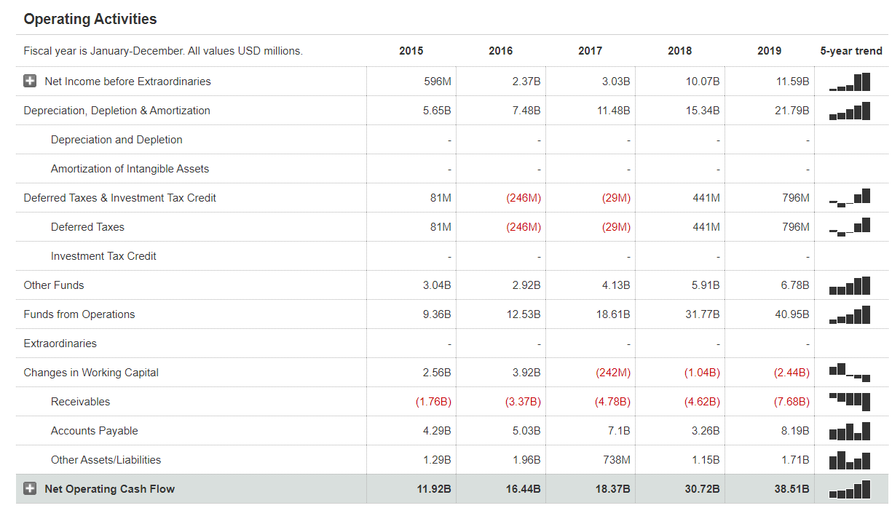
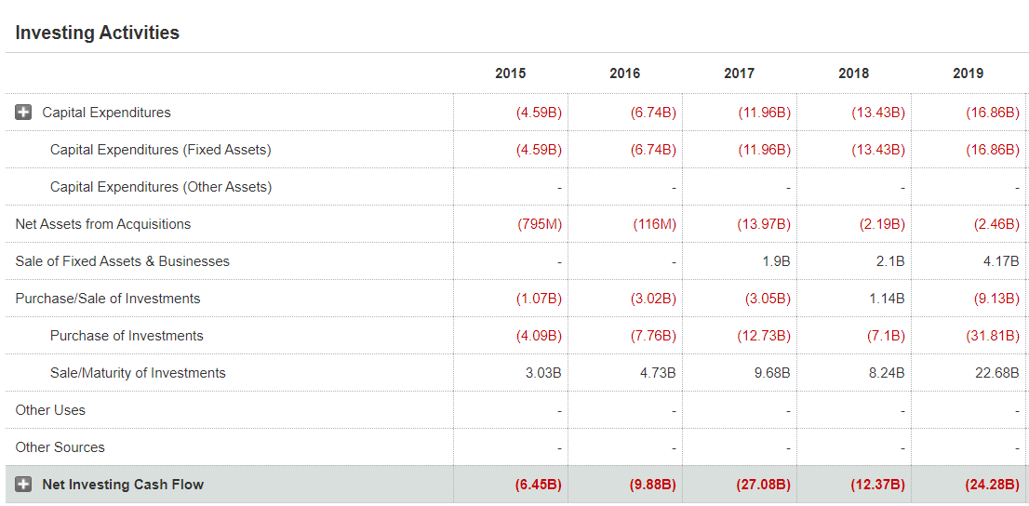
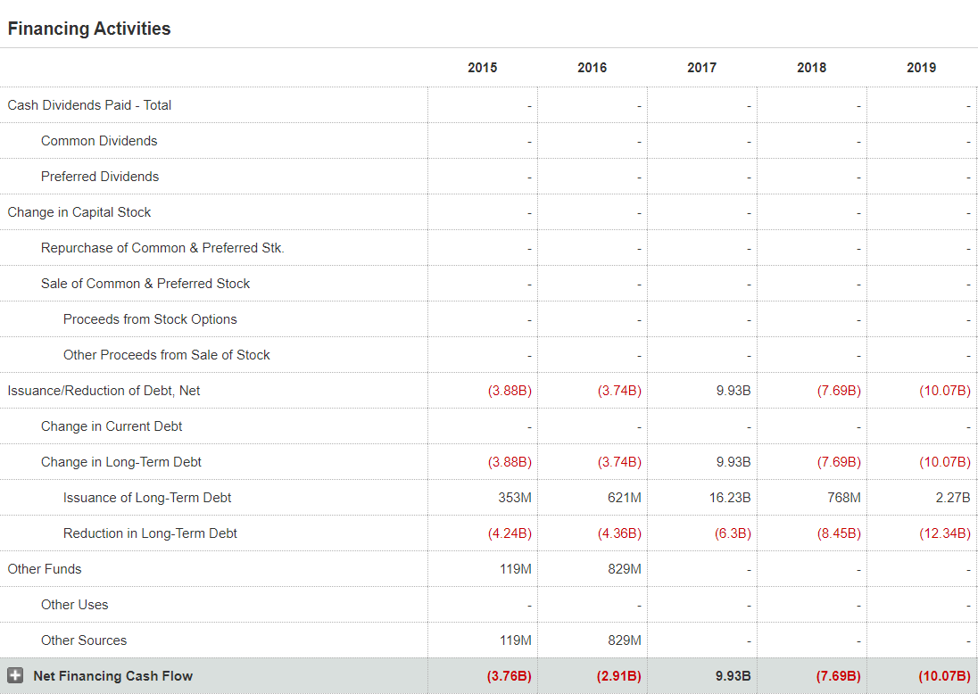
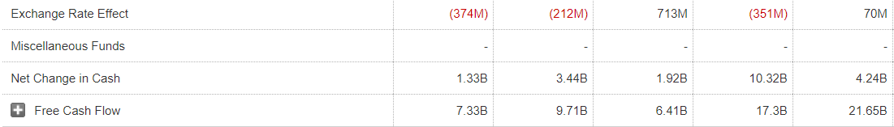
Balance Sheet
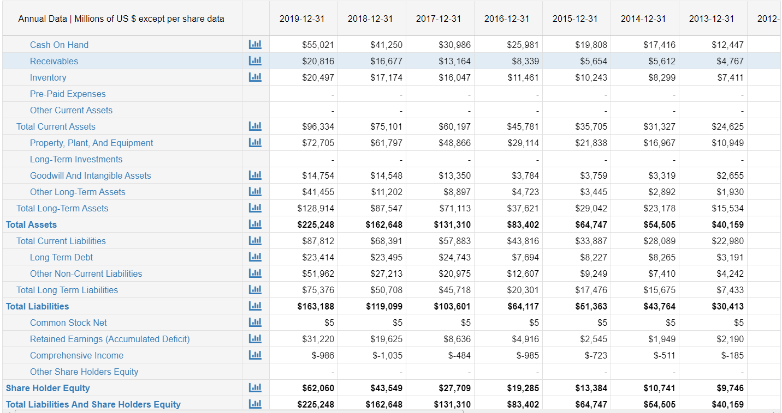
Sales Forecast
It can be viewed that PL expected greater sales growth in the case of its market. The company’s earnings per share in the first quarter of 2019 was at $7.09 (reuters.com, 2019). However, this saw a decline trend and the second quarter EPS fell to $5.22 and further in the third quarter of 2019 it fell to $4.23. The sales of the company grew to $70 billion, however, this was lower than the expected growth of $ 80 to $ 86.5 billion which was expected by PL (reuters.com, 2019). The best performing asset of PL was PL’s AWS system which saw a revenue growth of 35% year-on year, second to that of Microsoft’s 36% year-on-year growth (reuters.com, 2019). The business costs are also expected to rise and this indicates that revenue for the company may be bottlenecked even if the sales for the firm increase significantly.
Business Ratio
Current Ratio
Current Ratio = Total current assets / Total current liabilities
Current Ratio = 96334 / 87812 = 1.1
The current ratio indicates that the organisation of PL has a low rate of cash flow in the business. This indicates probable cause for concern for the business of PL.
Quick Ratio
Quick ratio = (Total current assets - Inventory) / Total Current Liabilities
Quick Ratio = 96334 - 20497 / 87812 = 0.87
This indicates that the company of PL may not be able to pay off all of its current liabilities at present. This is determined as a quick ratio of 1 is considered to be a normal quick ratio.

Conclusion
From this study, it has been found that an organisational structure of PL follows the norms of working efficiently in terms of exploring business in competitive markets. This study has helped in analysing that PL follows four main principles based on “customer obsession”, “ownership”, “invent and simplify” and increase of employee’s workflow efficiency. Collaboration and maintenance of these four types of principles have been beneficial for PL in improving business conditions properly. Projection of minimum federal wage in PL has aided opportunities in gaining position as “largest employer”. This has been possible for PL since Bezos firmly believes in motivating employees and provides positive outcomes based on marketing activities for customers. Other than this, it has been found from this study that PL takes the help of legal compliance in the forms of cloud security alliance controls, ISO 19001 and others that deal with protection of confidential information from hackers and other online businesses. In this way, delivery of high security in the data of customers, PL has been becomes successfully able to maintain credibility of functions to serve better to the customers.
This study has also helped in analysing various objectives of PL leading to further expansion of business in markets. Therefore, it has been interpreted with smart objectives that providence of training would help PL to increase proficiency of employees by implementing HR policies and strategies. Other than this, study tends to comprehend that the providence of PL. In addition to this, a conclusion can be drawn from this study that top competitors of PL are DPD and City sprit. However, through internal and external analysis has helped in comprehension that “Brexit” has provided political uncertainty that also influentially provides changes in trade and taxation regulations. Appearances of Brexit creates limitation due to developing bond with EU for delivering products which conveys that PL has faced issues in settling of business in European countries. Apart from this, it can be analysed that an inflation rate along with annual GDP growth rate has helped in further market expansion of this business.

Reference List
Afify, M.K., (2018). The effect of the difference between infographic designing types (static vs animated) on developing visual learning designing skills and recognition of its elements and principles. International Journal of Emerging Technologies in Learning (iJET), 13(09), pp.204-223.
Ascarza, E., Neslin, S.A., Netzer, O., Anderson, Z., Fader, P.S., Gupta, S., Hardie, B.G., Lemmens, A., Libai, B., Neal, D. and Provost, F., (2018). In pursuit of enhanced customer retention management: Review, key issues, and future directions. Customer Needs and Solutions, 5(1-2), pp.65-81.
Blake, D., (2020). How bright are the prospects for UK trade and prosperity post-Brexit?.Journal of Self-Governance and Management Economics, 8(1), pp.7-99.
Blanco-Oliver, A., Veronesi, G. and Kirkpatrick, I., 2018. Board heterogeneity and organisational performance: The mediating effects of line managers and staff satisfaction. Journal of Business Ethics, 152(2), pp.393-407.
Brc.org.uk (2016). British Retail Consortium: Crimes Against Retailers Survey. Available at:https://brc.org.uk/media/116322/10081-brc-retail-crime-survey-2016_v6.pdf [Accessed on: 27 July 2020]
Caglio, A., Dossi, A. and Van der Stede, W.A., (2018). CFO role and CFO compensation: An empirical analysis of their implications. Journal of Accounting and Public Policy, 37(4), pp.265-281.
Community.ebay.com (2020). The eBay Community. Available at:https://community.ebay.com/t5/Member-To-Member-Support/ebay-co-uk-ebay-com/qaq-p/25641644 [Accessed on: 30 July 2020]
Data.worldbank.org (2020). GDP growth (annual %) - United Kingdom. Available at:https://data.worldbank.org/indicator/NY.GDP.MKTP.KD.ZG?locations=GB [Accessed on: 29 July 2020]
Delventhal, S., (2019) PL Forces Suppliers to Play By Its Rules. investopedia [Online]. Available at: https://www.investopedia.com/news/PL-forces-suppliers-play-its-rules/ [Accessed on: 31/07/2020]
Du, J., Sun, Y. and Ren, H., (2018). The relationship of delivery frequency with the cost and resource operational efficiency: a case study of jingdong logistics. Mathematics and Computer Science, 3(6), pp.129-140.
Forbes.com (2020). The 2020 World's Most Valuable Brands. Available at:https://www.forbes.com/the-worlds-most-valuable-brands/#25d24c96119c [Accessed on: 30 July 2020]
Galati, A., Crescimanno, M., Vrontis, D. and Siggia, D., (2020). Contribution to the Sustainability Challenges of the Food-Delivery Sector: Finding from the Deliveroo Italy Case Study. Sustainability, 12(17), p.7045.
gov.uk (2020) Our commitment to corporate social responsibility (CSR). Available at: https://www.gov.uk/government/news/our-commitment-to-corporate-social-responsibility-csr#:~:text=As%20a%20government%20organisation%20and,our%20employees%2C%20customers%20and%20communities. [Accessed on: 31/07/2020]
Gov.uk (2020). Equality Act 2010 (cth.). Available at:https://www.gov.uk/guidance/equality-act-2010-guidance#equalities-act-2010-legislation [Accessed on: 26 July 2020]
Hamzah, H., (2020). The Importance of Product Liability Insurance in Indonesia: A Preliminary Analysis. journal of legal, ethical and regulatory issues, 23(2), pp.1-7.
Hingorani, K. and McNeal, B., (2018). Using Quickbooks Online Plus for Enhancing Learning of Erp Concepts: A Case Study. Issues in Information Systems, 19(4), pp.132-139.
Hussain, A., Asif, M., Jameel, A. and Hwang, J., (2019). Measuring OPD patient satisfaction with different service delivery aspects at public hospitals in Pakistan. International Journal of Environmental Research and Public Health, 16(13), p.2340.
Klosa, E. and Kisperska-Moroń, D., (2017). International Scope of Operations and the Nature of Supply Chain Members’ CSR Policy. International Journal of Management and Economics, 53(2), pp.23-38.
Koijen, R.S. and Yogo, M., (2016). Shadow insurance. Econometrica, 84(3), pp.1265-1287.
Lee, S. and Hwang, T., (2018). Estimating emissions from regional freight delivery under different urban development scenarios. Sustainability, 10(4), p.1188.
legislation.gov.uk (2020) Data Protection Act 1998. Available at: https://www.legislation.gov.uk/ukpga/1998/29/contents [Accessed on: 31/07/2020]
Legislation.gov.uk (2020). Environmental Protection Act 1990 (c. 43). Available at:https://www.legislation.gov.uk/ukpga/1990/43/contents [Accessed on: 25 July 2020]
Li, Y., Gong, M., Zhang, X.Y. and Koh, L., (2018). The impact of environmental, social, and governance disclosure on firm value: The role of CEO power. The British Accounting Review, 50(1), pp.60-75.
Lindsey Hall, K.K., Baker, T.L., Andrews, M.C., Hunt, T.G. and Rapp, A.A., (2016). The importance of product/service quality for frontline marketing employee outcomes: The moderating effect of leader-member exchange (LMX). Journal of Marketing Theory and Practice, 24(1), pp.23-41.
Mohd Nawi, M.N., Deraman, R., Bamgbade, J.A., Zulhumadi, F. and Mehdi Riazi, S.R., (2017). E-procurement in Malaysian construction industry: benefits and challenges in implementation. International Journal of Supply Chain Management (IJSCM), 6(1), pp.209-213.
Nguyen, H.M. and Khoa, B.T., (2019). The Relationship between the Perceived Mental Benefits, Online Trust, and Personal Information Disclosure in Online Shopping. The Journal of Asian Finance, Economics and Business, 6(4), pp.261-270.
nibusinessinfo.co.uk (2020) Delivery law advice for businesses. Available at: https://www.nibusinessinfo.co.uk/content/delivery-law-advice-businesses [Accessed at: 24/09/2020]
Nikhat, R., (2017). CSR Policy and its Implementation: A Study of Select IT Companies. IPE Journal of Management, 7(1), pp.116-126.
Özdemir, A. and Çam, H., (2016). The importance of e-commerce in terms of local development: A study in turkey. International Journal of Business and Management Information, 5(1), pp.9-16.
pospori, E., (2018). Regional CSR Policies and SMEs’ CSR Actions: Mind the Gap—The Case of the Tourism SMEs in Crete. Sustainability, 10(7), p.2197.
Rani, S., Rana, R., Saraogi, G.K., Kumar, V. and Gupta, U., (2019). Self-emulsifying oral lipid drug delivery systems: advances and challenges. AAPS PharmSciTech, 20(3), p.129.
reuters.com, (2019). PL sales forecast, slower cloud growth disappoints investors. Available at: https://www.reuters.com/article/us-PL-com-stocks/PL-sales-forecast-slower-cloud-growth-disappoint-investors-idUSKBN1X41MS [Accessed on: 29 July 2020]
Ritter, B.A., Small, E.E., Mortimer, J.W. and Doll, J.L., (2018). Designing management curriculum for workplace readiness: Developing students’ soft skills. Journal of Management Education, 42(1), pp.80-103.
Sawadsitang, S., Niyato, D., Tan, P.S. and Wang, P., (2018). Joint ground and aerial package delivery services: A stochastic optimization approach. IEEE Transactions on Intelligent Transportation Systems, 20(6), pp.2241-2254.
Stalph, F., (2020). Evolving data teams: Tensions between organisational structure and professional subculture. Big Data & Society, 7(1), p.2053951720919964.
Statista.com (2020). Inflation rate in the United Kingdom. Available at:https://www.statista.com/statistics/270384/inflation-rate-in-the-united-kingdom/ [Accessed on: 28 July 2020]
Stocker, V., Smaragdakis, G., Lehr, W. and Bauer, S., (2017). The growing complexity of content delivery networks: Challenges and implications for the Internet ecosystem. Telecommunications Policy, 41(10), pp.1003-1016.
Stverkova, H. and Pohludka, M., (2018). Business organisational structures of global companies: Use of the territorial model to ensure long-term growth. Social Sciences, 7(6), p.98.
Sunko, T., Komadina, P. and Mihanović, L., (2018). Organisational structure and analysis of the contribution of the Coast Guard of the Republic of Croatia to maritime safety on the Adriatic Sea. Pomorstvo, 32(2), pp.312-319.
sustainability.aboutPL.com (2020) Sustainable Operations. Available at: https://sustainability.aboutPL.com/environment/sustainable-operations [Accessed on: 31/07/2020]
Team, I.P., (2017). EU General Data Protection Regulation (GDPR). IT Governance Limited.
Teece, D.J., (2018). Business models and dynamic capabilities. Long range planning, 51(1), pp.40-49.
Tescoplc.com (2020). Annual Report- 2019. Available at:https://www.tescoplc.com/media/476423/tesco_ar_2019.pdf [Accessed on: 26 July 2020]
Theguardian.com (2017). Tesco to pay £129m fine over accounting scandal. Available at:https://www.theguardian.com/business/2017/mar/28/tesco-agrees-fine-serious-fraud-office-accounting-scandal [Accessed on: 28 July 2020]
Theguardian.com (2018). Tesco beats forecast with 28% rise in annual profits. Available at:https://www.theguardian.com/business/2018/apr/11/tesco-reports-28-rise-in-profits-for-last-quarter [Accessed on: 30 July 2020]
Thisismoney.co.uk (2018). Tesco hacks Clubcard Boost rewards: Everything you need to know and the tricks to make up the shortfall. Available at:https://www.thisismoney.co.uk/money/cardsloans/article-5274251/Everything-need-know-Tescos-Clubcard-shakeup.html [Accessed on: 29 July 2020]
Troudi, A., Addouche, S.A., Dellagi, S. and Mhamedi, A.E., (2018). Sizing of the drone delivery fleet considering energy autonomy. Sustainability, 10(9), p.3344.
Tumbas, S., Berente, N. and Brocke, J.V., (2018). Digital innovation and institutional entrepreneurship: Chief Digital Officer perspectives of their emerging role. Journal of Information Technology, 33(3), pp.188-202.
Umachandran, K., Della Corte, V., Amuthalakshmi, P., James, D.F., Said, M.M.T., Sawicka, B., del Gaudio, G., Mohan, T.R., Refugio, C.N., Aravind, V.R. and Jurcic, I., (2019). Designing learning-skills towards industry 4.0. World Journal on Educational Technology: Current Issues, 11(2), pp.150-161.

