Ilona Kleina
2115855
REPORT
Digital Skills and Research Methods
Amitave Banik
January 2022

Introduction

Graduates of modern universities will have to live and work in a society in which the networking of data, services, tasks, people and social groups. They can obtain competences corresponding to new challenges only on based on practical experience of using network communications and productive activities (educational, research, social) in computer networks.
In modern education, it is formally possible to distinguish two practiced levels of use of information and communication technologies: the level of increasing efficiency solving traditional educational problems; the level of solving new problems due to informatisation of society and professional activity.
Optimal learning methods at the first level are predominantly live-oriented communication with the teacher and the use of a book textbook. Therefore, the inclusion of information technology systems in the educational process, as a rule, is of an auxiliary nature. The second level is associated with the use of information technology as a necessary tool solving new educational problems that have appeared in connection with the informatization of society. This tasks of introducing new content elements into subject courses (including issues of integration of multilingual and multicultural network communications, filtering and search engine optimization of communicatively significant content, security of network transactions, etc.)
The current level of development of the Internet, which is defined as the Social Web, is not only a new technological stage in the development of the Internet, but also the result of humanitarian development and understanding the possibilities of the global network. All this changes the assessment of the very phenomenon of technology, in that number and information. The essence of technology is increasingly interpreted as a means of interaction people, allowing to reveal the structures of communication that did not exist yesterday, equipping a person with new possibilities for cognition, expanding the space of communicative acts. Information technologies cause changes in the entire education system, having a significant impact on educational communications, the abilities and motives of participants in educational process, social order, tasks, means and teaching methods. At the same time, based on the concept of immersive learning, an innovative toolkit for solving modern problems is being created. Teaching, implying the immersion of students in a virtual educational environment and providing a real substantive, social and communicative experience.
The need for pedagogical innovation in the process of forming VLE (virtual learning environment, virtual educational environments) is determined by essential features community versus traditional society.

Research results
Information and communication technologies of education are considered as an information model of not only traditional subject, but also innovative experience, assubject and pedagogical. The introduction of modern networked virtual educational environments provides conditions for better assimilation of the content of education, including a set of competencies, a certain level of development of cognitive forces and practical experience.
In order to implement this approach at Brest State University, a systemically organized set of network communication technologies, hardware, software and organizational support "EOS" was created and which allows, on the basis of the integration of electronic manuals for specific educational courses with elements of distance learning, to effectively meet the educational needs of students in the context of solving pedagogical problems. The "EOS" core is an educational and methodological complex in the form of a site located on the university server. Educational material - this is a detailed illustrated hypertext. Apparatus for assimilation and orientation of electronic manuals include laboratory tasks, a list of practical skills, project tasks, educational, control and diagnostic tests.
Students work with educational and authentic materials hosted on the server universities and in the global network, participate in their creation, support, development. Assignments are completed electronically and broadcast over the network. The student sends to the teacher and your assessment of laboratory work in accordance with defined and justified criteria (complexity, difficulty, usefulness, fun), as well as self-assessment of their activities in laboratory work. The results of checking assignments are published on pages integrated into educational resources.
The educational process at the Faculty of Foreign Languages ​​in the "EOS" is built on the basis of logic solving special language and translation tasks that correspond to the educational profile of students and are in the problem area of ​​their "professional" interests. Providing a holistic consideration of computer support for translation activities is implemented through the main topics: computer lexicography and electronic translation dictionaries; educational and professional networking communities; technologies, systems and services of computer translation and localization; technologies, network language, linguistic and translation competitions; language education and translation into a virtual learning environment.
An essential feature of the educational process is the widespread use of network technologies as a communication and learning environment based on the implementation of user content generation - one of the fundamental principles of Web 2.0, which consists in the active formation of Internet resources by the users themselves. This approach is expressed in the fact that the use of online electronic translation dictionaries and online translation services is complemented by the personal participation of students in the development of such resources, for example, through participation in morphological markup and markup of named entities of Open Corpora
(http://opencorpora.org), on the lexicographic networking community Lingvo Live (https://www.lingvolive.com), in a network project for the translation of materials for online educational courses Coursera (http://coursera.abbyy-ls.com/ru) and WikiMedia projects (https://wikimediafoundation.org/wiki/Our_Projects ).
Experience of personal participation of students in the life of professional networking is essential. communities corresponding to the profile of their education. For example, translation communities, where professional problems are discussed and mutual assistance is provided, are an indispensable means of exchange of experience between translators and a source of the latest information. The most versatile translation resource is Lantra-L (http://segate.sunet.se/cgibin/wa?A0=LANTRA-L), uniting translators of dozens of states who are native speakers of more than 50 languages ​​of all language groups and are engaged in translation activities in a huge set of language pairs. Almost in all European countries, including in the Republic
Belarus, there are active participants. Most of the Lantranauts are freelance translators, freelancers. However, many members of the community work in large corporations, in international organizations (UN, European Union), in government agencies. Lantra not only opens a shop floor, corporate view of the world, but also immerses future translators into this world thanks to modern communication technologies.
Crowdsourcing technologies are a promising way of organizing educational and research activities in virtual learning. Crowdsourcing – networked organizing the work of the community on any task for the sake of achieving common benefits; practice obtaining necessary services, ideas or content by requests for assistance addressed to groups of people. It is essential that the phenomenon of non-formal education is generated by the same changes taking place in the anthropological, cultural, social and technological levels as the phenomena of crowdsourcing, “co-creation” and “user-generated content”, which are basic for the economy of the information society and the transition from society to community. The number of successful hands-on projects using crowdsourcing in a wide variety of areas is constantly growing .
The educational potential of crowdsourcing is realized, for example, in Wikipedia and lies in based on the educational project Duolingo (duolingo.com), which combines the study of foreign languages ​​with the translation of real texts that are in demand by the network community and are not only educational. Educational crowdsourcing, based on innovative economic models, is able, on the basis of crowdfunding (public funding, crowd funding), to ensure a relatively stable functioning of educational communities, overcoming the extremes of both irresponsible unfounded enthusiasm and threatening formalization of external contract financing.
Implemented on the basis of modern information and communication technologies,
educational crowdsourcing:
- assumes, at the exit of the educational process, the receipt of a complete socially demanded product. This opens up opportunities for socially significant productive activity in the very process of education and is most consistent with the activation of abilities for social self-realization;
- provides a new system for assessing educational achievement based on external transparent educational control of the community, which, in turn, facilitates both recognition
(validation) of the results of the received education, and the responsibility of the student;
- opens the way for students to socialize in high-tech networked multilingual communities, which is an indispensable component of modern education. How in
In traditional society, education plays a major role in the entry of a person into the professional environment, so in networked communities it is called upon to become a decisive factor in his "social inclusion" (social inclusion). Educational crowdsourcing for teaching staff
allows you to get used to the new sociality of the digital era;
- organically integrates in solving educational problems with formal institutions
education through the creation of open universities, distance courses, etc. and opens up its educational opportunities for a wide range of people who practice informal
education;
- contains a huge educational potential, fully corresponding
modern socio-cultural situation, affirming by personal example the intrinsic value of education and giving hope to overcome the tendency of consumerization of education.
Educational crowdsourcing can form the technological basis of various approaches to the management of the process of development and formation of personality: activity, communicative, systemic, personal. However, the realities of modern life are increasingly actualizing the development of educational crowdsourcing technologies in the context of the environmental approach. On the basis of information technologies, VLEs that are most adequate to modern challenges are being created, which make it possible to implement a promising methodology of immersive learning (learning through immersion). However, the very high cost of developing VLEs still limits their use mainly to the sphere of business and military education, despite recognition of their high efficiency. For example, the results of a study on the use of immersive learning simulations in corporate training among hundreds of companies conducted by
eLearning Guild Shows Learning Time Reduced By 50%, Learning Outcomes Increasedby 30% and an overall reduction in training costs - at least 50%
At the same time, for the VLE organization there are publicly available high-tech gaming and leisure platforms (Wolrd of Warcraft, Blue Mars, Eve, Second Life), which, as a rule, are perceived by the pedagogical community with exclusively negative connotations. Here it is important to distinguish between "role-playing games" with a severe limitation of functionality and "virtual worlds", which allow almost any activity within the framework of the technological platform.
The virtual world is presented only by the context, where there is no content, but there is a set of tools that offer new possibilities. Combining this with the built-in structured rules, then you get a finished product, through which the creators able to convey to users what they wanted: be it a VLE or a game. Virtual worlds enable “learning by doing” in an environment that fosters the immediate, practical application of skills in the performance of learning responsibilities. Opportunity to pass level-by-level simulation keeps the learner keenly interested in achieving result. Virtual worlds have multidimensional elements of individual feedback, forcing the student to show all the time a diverse educational activity.
Computer simulations allow you to move from quasilinear courses, in which the student simply chooses one of several proposed options, to multi-level scenarios with complex intrigue, when the simulation becomes like an adventure film with pronounced element of competition. All this makes leisure virtual environments convenient platforms for creating and testing innovative pedagogical tools for modeling and solutions to modern educational problems in the immersive learning paradigm.
One of these environments, which is supposed to be involved in the educational process, is Second Life (http://secondlife.com). Among the millions of Second Life residents are students
teachers and researchers from dozens of educational institutions around the world (Harvard and Oxford universities, MIT, University of Berkeley, etc.), which successfully organize educational process in the virtual world. There, virtual branches of dozens of modern libraries provide real library services, which thus realize the possibility of Web 2.0. for a library environment. Many of them can be found in Cybrary City, some in the archipelago.
Second Life. It is important for students that along with access to library resources they learn the skills of interacting with Library 2.0 - new innovative library services of the 21st century.
Second Life's primary language is English, but more than half speak others languages. The most common are German, French, Spanish, Chinese, Portuguese, Turkish and Korean, making SL a unique foreign language learning environment.
You can learn languages ​​in the multilingual virtual world of SL on your own, based on communication with by native speakers or in one of the many language schools. Avatar English (http://www.avatarenglish.com) is one of the most popular English language schools in SL offers one-to-one lessons in virtual classrooms.
A distinctive feature of virtual worlds is to ensure maximum similarities (in human perception) of a virtual three-dimensional communicative environment with a real the world, which makes it possible to ensure his deep involvement in the educational process. For example, vAcademia (http://vacademia.com) is a 3D interactive multi-user virtual environment that provides services that you can use to conduct and attend training sessions in conjunction with physically distributed users. This environment simulates dozens of educational sites and classrooms. She consists of sets of three-dimensional models that have the appearance and functionality of tool presentation of materials (screens, interactive whiteboards, etc.) and communication tools for organizing joint educational work (chat, audio and video, voting systems, relaying the image from the monitor screen or webcam).
In vAcademia, you can conduct lectures, seminars, practices, trainings for groups of dozens of users, conduct negotiations, presentations and organize round one hundred tables. Users through their avatars can freely communicate with each other and move in the virtual space (halls, classrooms, admissions committee, etc.), which is equipped with
various static and dynamic 3D-objects of study that can change and respond to the influence of users inside the environment. The avatars that represent vAcademia users are 3D characters with unique customizable appearances and behaviors. The choice of an avatar template is carried out during registration, and a communicatively significant change in its appearance is carried out in a special avatar editor. Avatars make it possible to supplement the speech communication standard for computer networks with non-verbal means of communication in a virtual environment, which is carried out mainly through text messages (user responses are displayed in the form of "clouds" associated with the corresponding avatar). To non-linguistic forms and methods implemented in vAcademia information transmission can be attributed to the user's chosen clothing, shoes, hairstyle, accessories, as well as gestures, body postures and facial expressions, reflecting the dynamics of the emotional state.
VAcademia designed landscapes and interiors for educational. Practitioners also have a certain communicative meaning and can have a direct impact on the choice of user-preferred settings for their avatars. All avatars, user-driven, have the ability to move freely through the 3D space in a variety of customizable running or stride styles. Special communicative meaning has the ability of avatars to carry out gestures at the user's choice, which, depending on the specific communicative context, can carry a variety of semantic load through the external expression of agreement, disagreement, applause, shrug of the shoulders, waving hands, laughing, approving, glancing at the clock, etc.
Adding new non-verbal means of communication (expression of emotions of sadness, thoughtfulness, direction of gaze, etc.) is included in the competence of developers and programmers of educational courses. VAcademia's avatar animation model enables the generation of unique, complex character animations from simple templates.
The communicative toolkit always defines the new texture of the discourse. Today VLE enrich verbal communication with a diverse system of non-verbal means: phonation (tempo speech, sighs), temporal (distances, etc.), sign-symbolic
(interior items, clothing features, etc.), optical-kinetic (facial expressions, gestures, features of the figure and posture). However, having significant specificity that requires deep and comprehensive study, network communication in virtual environments still cannot be recognized as complete for the modern educational process. For virtual learning environments where a person is reduced to a set of symbolic messages of varying degrees of truth and detail,
the very concept of reality is problematized. This refers to the reality of the environment, communicators, subjects of communication, communication itself and for everyday (constant) reality, the presence in which is no longer a guarantee that a person will achieve his communication identity and authenticity. Here emerges a new pedagogical task of developing the ability learners to see and understand each other as an essential component of such an enduring value, which is direct interpersonal communication.
It is important that virtual worlds become not only educational, but also unique scientific and educational environments in which innovative
learning technologies. For example, since 2007, Second Life has hosted annual international pedagogical conferences on work and education in virtual worlds - Virtual Worlds Best Practices in Education. These are open conferences for educators and technicians with all over the world. Virtual Worlds Best Practices in Education allow you to exchange your ideas, achievements, teaching methods, ask questions, pose and solve problems for those who teach and create professional learning environments, resources, tools, and provide support services in virtual worlds. Discussion platforms of the conference are deployed in many regions of SL and are broadcast on the Internet. Second Life regularly hosts a conference Languages, dedicated to language learning issues in Second Life. The holding of scientific conferences Immersive Education Initiative and Annual Immersive Learning Conference & Symposium reflects the interest in using immersive learning and VLE and the need to share what is learned in this area of ​​experience of pedagogical achievement. From March 29 to April 1, 2017 in Second Life with The X International Pedagogical Conference VWBPE-2017 was a success, which reflected the growing interest in the use of immersive learning and VLE and the need to exchange this area experiences pedagogical achievements and challenges. The conference recommendations contain a high assessment of immersive learning and VLE and a proposal to actively implement them in a wide variety of areas of both academic and other education. Suggestions from teachers for participation in VWBPE 2018 Science Fair with its developments in the field of design and development virtual educational environments in a variety of specialties and topics.

Since only 4 people answered my questionnaire, I can research their answers, so I realized:

1. All women answered
2. Study full time
3. Everything adapted quite well in the natural learning environment
4. It is convenient for everyone to study in a natural environment.
5. The motivation to learn increased by 3/4, but in one it did not change
6. All needs met
7. UWTSD Hwb (Moodle) is used most of all
8. Most of everyone has mastered the UWTSD Hwb site
9. 3/4 is used by UWTSD Hwb (Moodle) one of them is using online class
10. They like to study full time more.

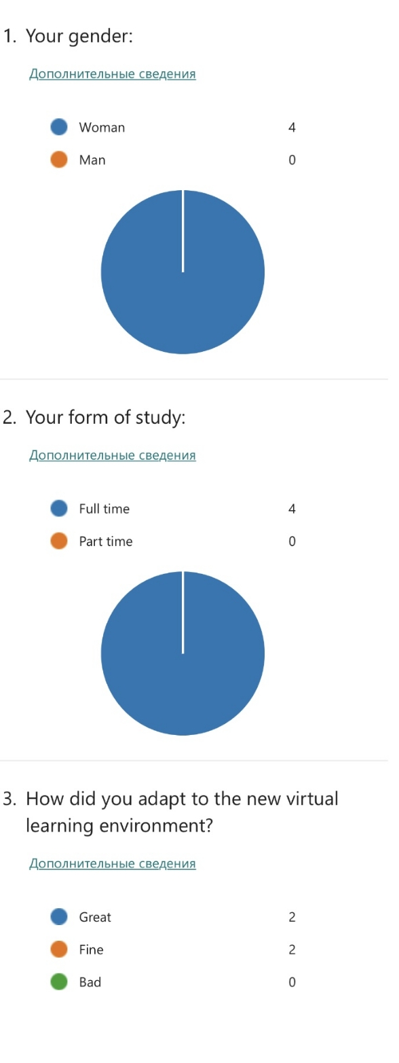
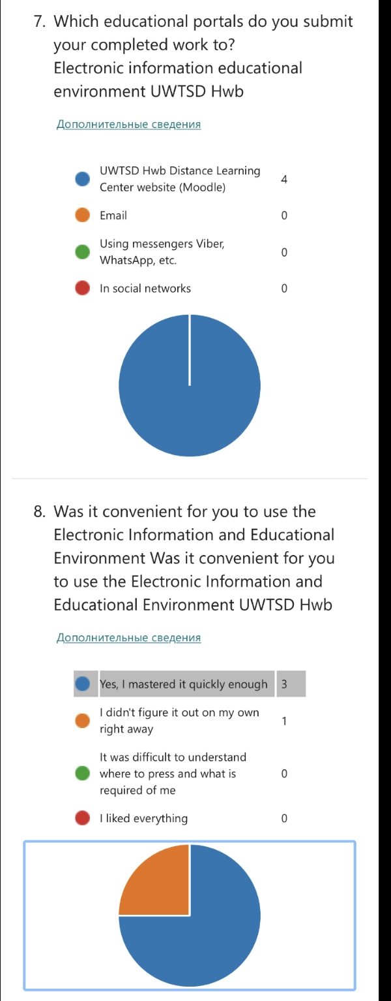
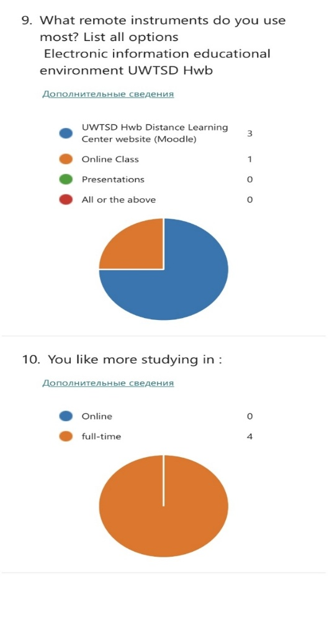
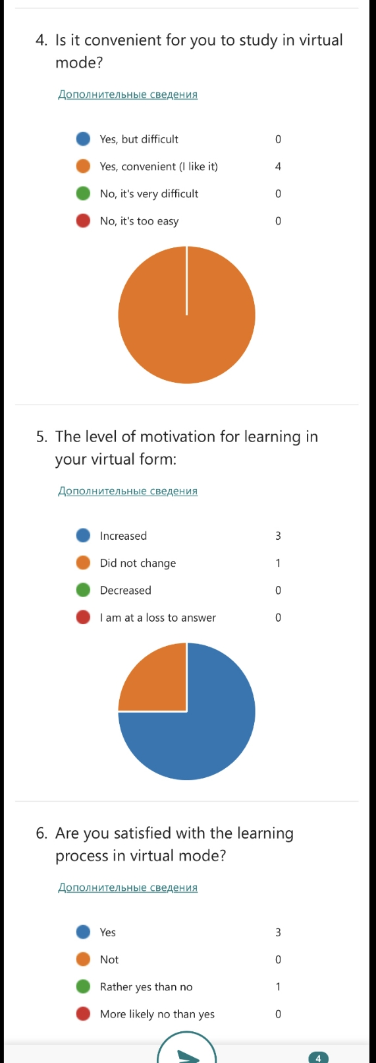
Conclusions

Networked information technologies cause changes in the entire education system, having a significant impact on educational communications, the abilities and motives of participants in the educational process, social order, tasks, means and teaching methods. Simultaneously on
On the basis of information technologies, an innovative toolkit is created for solving modern teaching problems.
The concepts of immersive learning and virtual learning environment, which imply immersion of students in virtual educational environments that provide not only
subject, but also real social and communicative experience, require relevant and adequate pedagogical comprehension.

