ASSIGNMENT FOR CEN
(COMMUNITY ENGAGEMENT)
ROLE PLAY
UWTSD AUGUST 2019
BUSINESS MANAGEMENT – TERM 1 GROUP 2
IZABELA CRISTINA ANTONESCU
STUDENT NUMBER 1817787

TABLE OF CONTENTS

Definition of reflection…………………………………………….3
Definition and importance of reflective practice…………4
Role Play – Complaint to a manager……………………….…5
Feelings, evaluation, analysis, conclusion……………..…..6
References…………………………………………………..…………11

Reflection

Reflection is about students that are becoming aware of their own thinking process.
‘’Reflective learners assimilate new learning, relate it to what they already know, adapt it for their own purposes, and translate thought into action. Over time, they develop their creativity, their ability to think critically about information and ideas, and their metacognitive ability (that is, their ability to think about their own thinking’’. – (Effective Pedagogy, The New Zealand Curriculum p.34)
When students review the learning events that once happened , they give their learning a new meaning. Reflecting helps people to develop their skills and review their effectiveness, to evolve, rather than doing things the same way over and over.

Reflective practice

The process of reflection is a cycle which needs to be repeated in order to teach, self-asses, consider, practice and repeat.
Reflective practice is ‘learning through and from experience towards gaining new insights of self and practice’ (Finlay, 2008).
There are five important principles which will allow you to ace your reflection and these are: reacting, recording, reviewing, revising, reworking, reassessing.
Reflective practice is important because it can help teachers to understand their students in a better manner and make them understand and succeed in their studying, it can also make you more aware of their strengths and weaknesses.
Innovation is encouraged by reflective practice and students will be able to work in a more creative way, develop new ideas, use their imagination and be eager to find new ways and methods of thinking.
With all being said reflective practice benefits everybody and it encourages engagement.

Role play

On a busy Thursday I was clearing a table which were sat a family of four: a mother with her two young children and her husband. She approaches me asking for the manager. This question made me wonder what happened and I tried to assist her with her request. She looks unhappy and she explains that her daughter’s food is ‘’ disgusting and old’’ and she also wants her money back. I try to engage with he, listen to her complaint and first I apologize and offer something else from the menu, she denies and starts becoming impacient and upset. I try to calm her down and offer her a free dessert and to take the food from the bill and the fact that she is getting more angry is agitating me while I try to deal with the complaint. She is making me feel very uncomfortable wishing that I have avoided that table, she is hard to deal with. After a couple of demands that she wants her money back on all her meal she calms down while I explain her the procedure and the fact that I am not entitled to offer food for free because I am not a manager. I try to maintain my calm while I offer her the free dessert for both of her children now and she finally accepts. Even though it is not my fault I feel embarrassed and relieved that she accepted my offer and we can settle the complaint. After settling down I am getting my happy mood again and I try to let go of the negative vibe that she gave me.

Feelings

The feelings before acting were good, I was feeling happy and enjoying work.
While acting I went from a good mood to being surprised, to feeling uncomfortable, a little bit upset to feeling relieved.
After acting I felt relieved and I started to get my good mood back.

Evaluation
The situation dealing with a customer complaint is inevitable and it is necessary in any business that deals with customers directly.

Analysis
The situation was handled professionally and it did not go further that required . The complaint was handled and the customer felt at peace.

Conclusion
If I would have the change I wouldn’t try do to something different because some customers are very difficult to handle indeed. But the customer accepted the offer and she was happy with the solution offered. If it would have come to a complaint that couldn’t be resolved then a manager would be the solution for this situation to be handled.
Feedback received

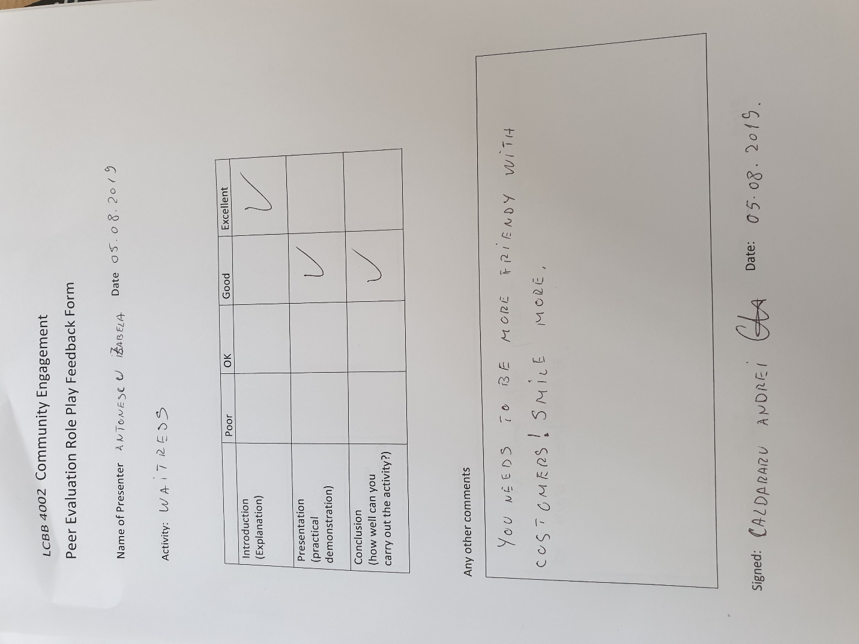
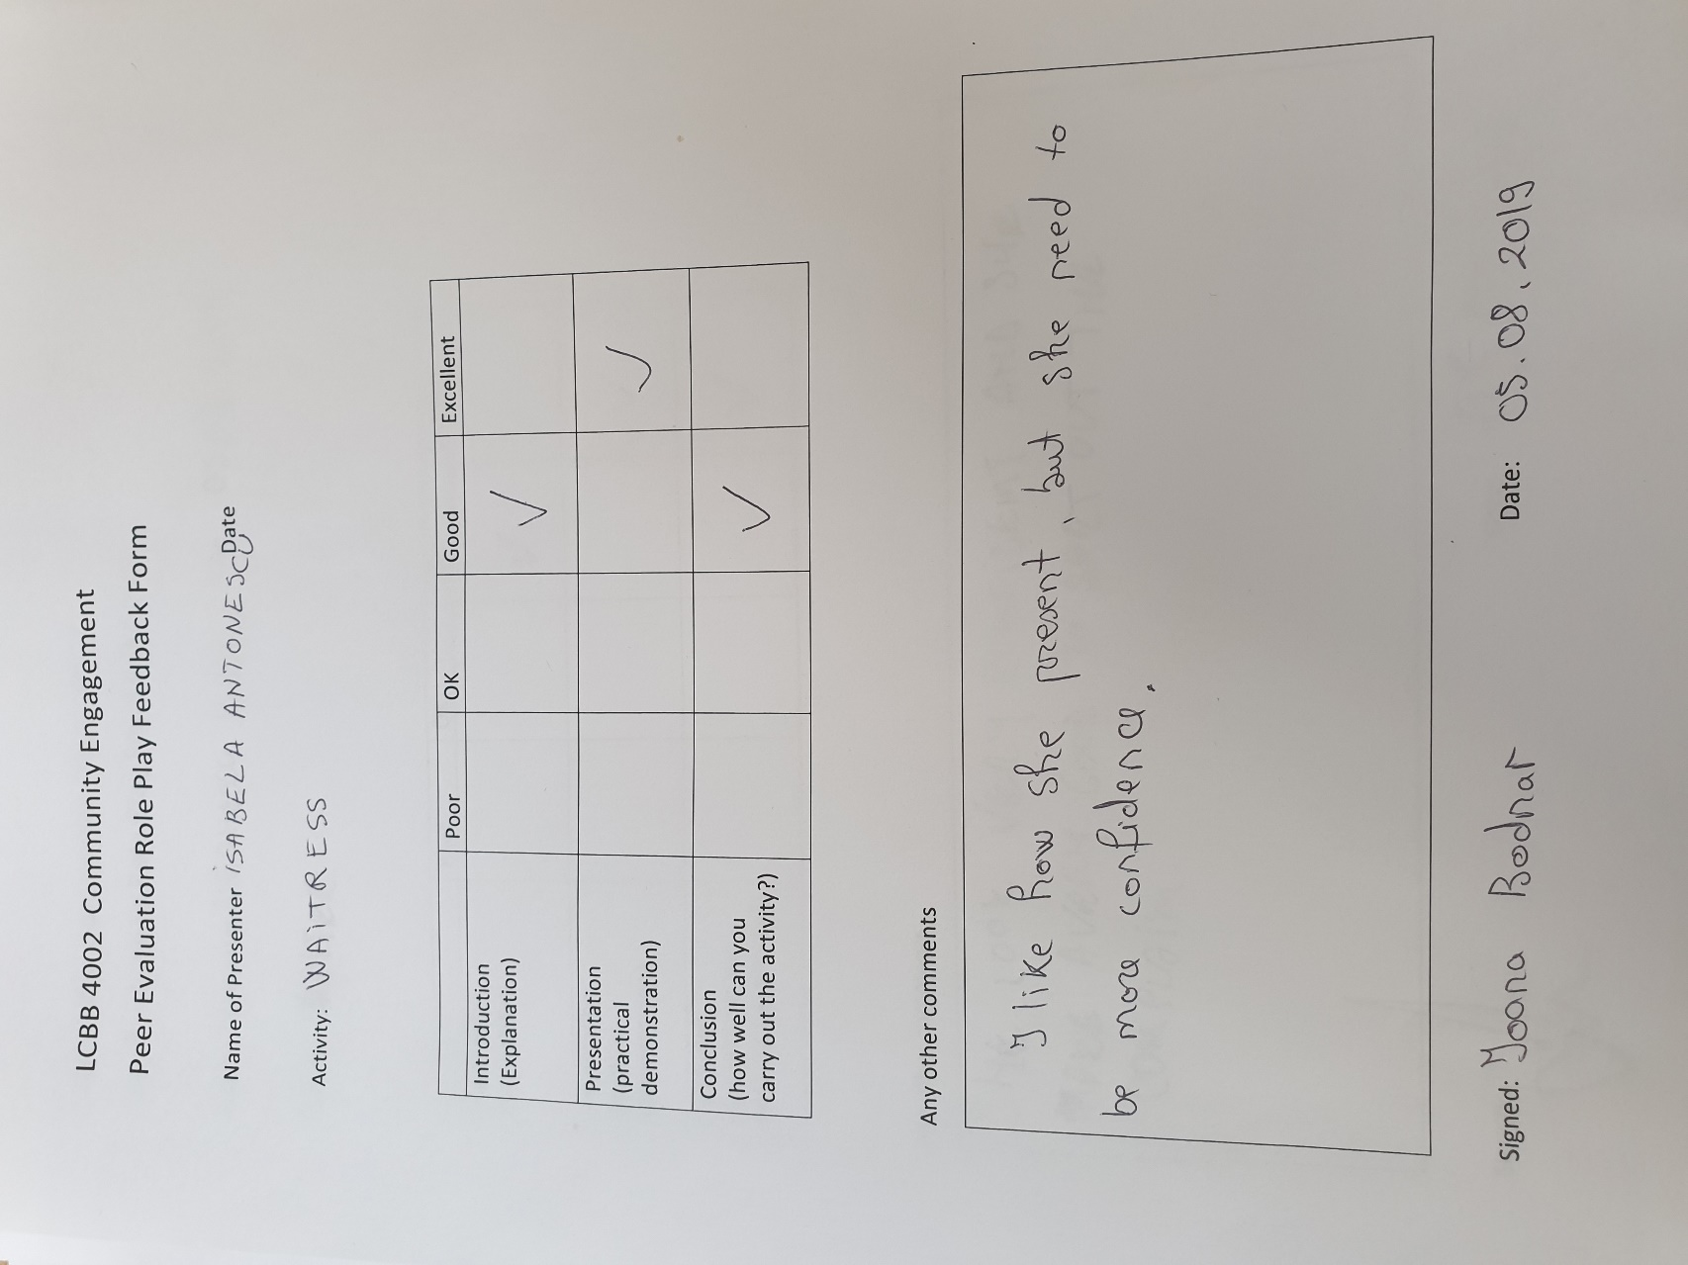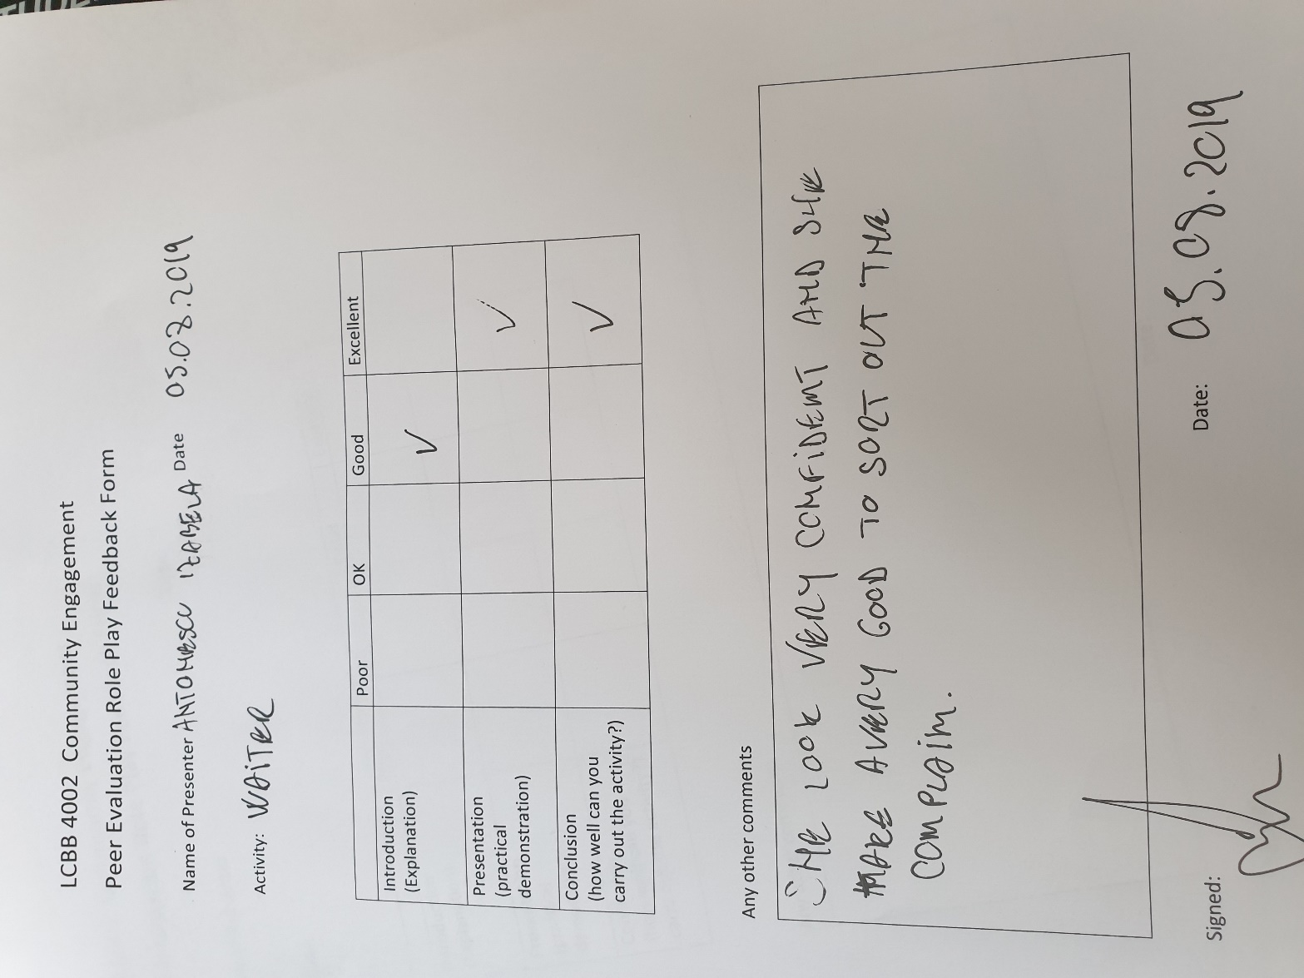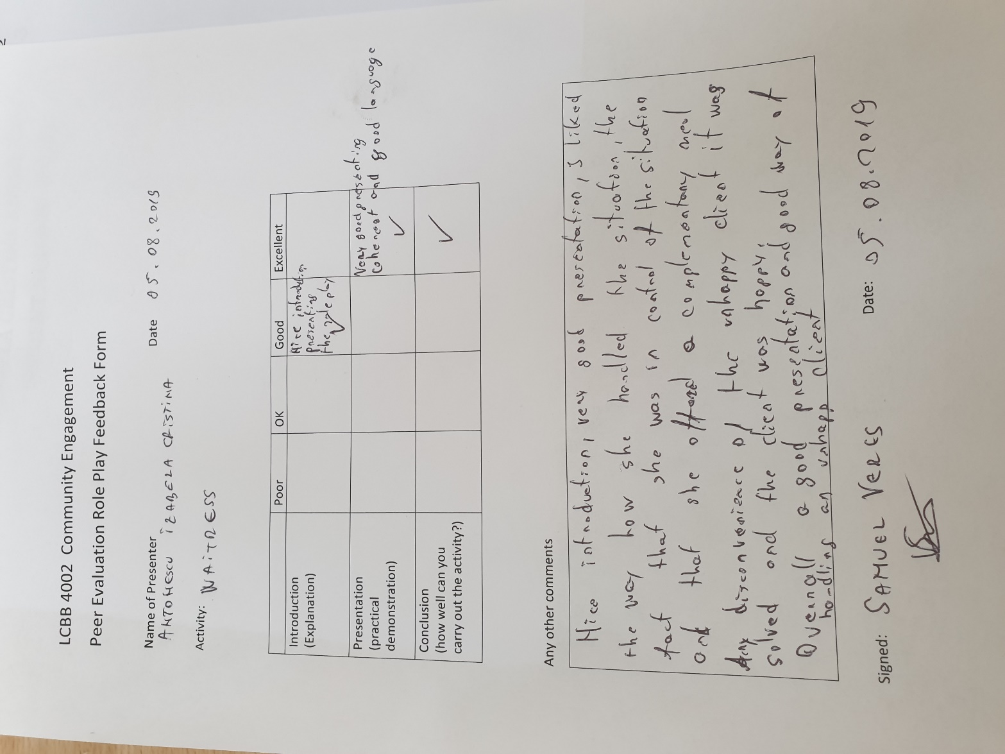

References :

Online :
Getting started with the reflective practice : can be found at https://www.cambridge-community.org.uk/professional-development/gswrp/index.html ( accessed on 6/08/2019 )
Reflection on the learning : can be found at https://assessment.tki.org.nz/Assessment-for-learning/Assessment-for-learning-in-practice/Reflection-on-the-learning ( accessed on 6/08/2019)

