Individual Project
Project

Lewys Gibby
HNC Mechanical Engineering | John Williams



Summary
In summary the project has become quite a challenge, although trying to meet deadlines and to get the cash to complete the job, there has been an even bigger with COVID-19 coming in to spoil the party. Making everyone go into locked down has seriously prevented this from going any further. All quotes, energy savings and equipment that is going to be used has been confirmed, however the equipment such as the turbo blower as incoming parts from abroad which has indefinitely stopped the project until further notice. With a bit of luck, the project should start up again later on in the year or as soon as this pandemic as passed so that it is safe to carry on working in larger groups.
2.0 Table of Contents
1.0 Summary 2
3.0 List of Figures 3
4.0 Nomenclature 3
5.0 Acknowledgements 3
6.0 Introduction 5
7.0 Literature Review 5
8.0 Project Specification and Testing Plan 5
9.0 Project Planning 5
10.0 Project Solutions 5
11.0 Design and Implementation 5
12.0 Analysis, Results and Evaluation 5
13.0 Conclusion 5
14.0 Recommendations 5
15.0 Bibliography 5
16.0 Appendices 5

3.0 List of Figures
Figure 1 – Photo taken from google maps locating Pembroke Dock WwTW.
Figure 2 – Diagram that shows the process of wastewater being treated.
Figure 3 – Timing plan.
Figure 4 – Criteria Analysis.
Figure 5 – Internals of a turbo blower.

4.0 Nomenclature
DCWW – Dwr Cymru Welsh Water
MaRS – Maintenance and Reliability Service
DO – Dissolved Oxygen
RPM – Revs Per Minute
PPE – Personal Protective Equipment
dB – Decibels
PM – Planned Maintenance

5.0 Acknowledgements
Firstly, a huge thanks should be mentioned to DCWW that allowed me to carry out my project efficiently and safely in order to improve the current site and therefore investing in some long-term savings.
Secondly, a huge thanks to Sam John who is an engineer a part of the MaRS team. Without Sam completing some of the cost savings and putting forward a proposal to the head of wastewater would have been very difficult. Sam was able to inform everyone of the job being carried out and of any alterations that needed to happen, people knew in advance so that it could be changed with plenty of time to spare to complete the project on time.
Lastly a thanks to Hadron who was contacted about the job and to use their turbo blower for the project. They were very helpful and kept everyone in the loop on what was happening and what alterations that occurred.

6.0 Introduction
Dwr Cymru Welsh Water (DCWW) is a sewerage and water company that supply everyone in Wales. My role within the company is a mechanical fitter, based in Fort Road, Pembroke Dock in the South Pembrokeshire catchment area. Within this area are electricians, operators, instrumentation technicians and mechanical fitters. One mechanical fitter being senior craft of the area called Barrie Williamson, me and Barrie have been working together since I started in the area in September 2019 and still continuing to learn new skills day in day out becoming more efficient in the way of working to become a better fitter. Another colleague is Sam John who was once an electrician in the team but been promoted to the maintenance and reliability team. Sam is the main point of contact for this project who should be able to fully fund the project with approval from the head of wastewater Marc Davies. Above Barrie is my supervisor Rob John, he is the person in charge of the South Pembs catchment area and of the people who work amongst it. Above Rob is the newly appointed West Catchment manager Aled Howells, Aled is in charge of all the catchment areas located in the west of Wales these include: North and South Pembs, Cardigan, Carmarthen and Lampeter teams. Then lastly above Aled is Marc Davies who will have the final say on whether or not this goes ahead. These all have more authority than myself to enforce something happening, so I will propose my idea to firstly Barrie, followed by Rob, Aled and finally Marc to make sure everyone is happy for the project to commence. If any contractors are used then Barrie, Rob or Sam will be able to write out and sign a permit to works. An electrician will be needed on site when disconnecting the old blowers and can be done before work commences or during, but only if the blowers have been electrically isolated inside of the panel.
Since working with the company, I have found especially in my area that there is an increased demand in jobs and planned maintenance, meaning that less jobs are being completed because there are more faults being found. Therefore, I felt that there could be more efficient ways of getting jobs done by choosing the correct equipment to allow this to happen. My aim is to change the four current blowers on Pembroke Dock treatment works to just one turbo blower that will do the equivalent work. This is being done to become more efficient and save massive energy costs, but it will also decrease the amount of PM jobs cards from four down to one, thus freeing up time to complete other jobs. The site I am going to try this on is Pembroke Dock WwTW, which is based in south west Pembrokeshire; this site is trying to be as lean and efficient as possible to save as much money as possible. The current blowers that are in place are the Hadron bi-lobe bare shaft machines which are a good machine for the cost but due to wanting more efficiency a different approach is required. The bi-lobe blower requires more maintenance, which will take long durations to complete and due to their being four the time taken to carry out all of these efficiently just isn’t productive. There are air filters needing changing, oil at one end dropping and replaced, bearing greased at other end, belts replaced and ensure no air leaks. Attached in the report is an alarms page that consists of all alarms that have occurred with the pieces of equipment that have been changed. Going forward, with the energy costs that this will save it would be a massive positive and use the idea on more sites which will just keep saving the company more money.
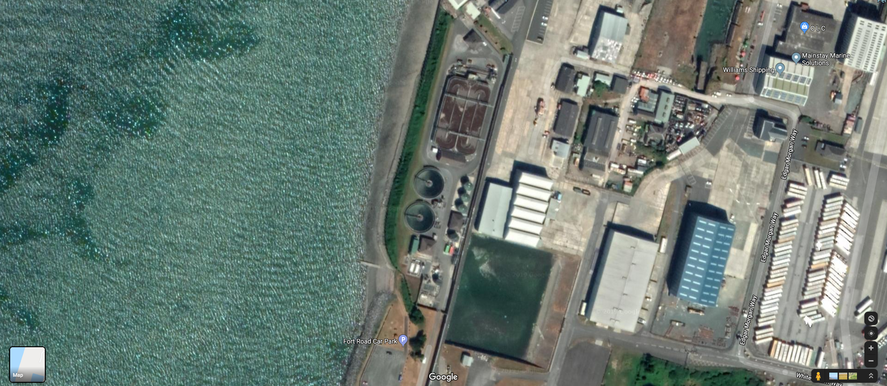

Figure 1: Photo above has been taken from google maps locating Pembroke Dock WwTW. https://www.google.com/maps/@51.6955468,-4.9589053,358m/data=!3m1!1e3 and I have drawn a red circle surrounding Pembroke Dock WwTW locating the treatment works and a green circle locating where the blowers are within. As you can see from the photo this works is located right next to the sea meaning that it can suffer from the salt air corroding some pieces of equipment. Luckily the blowers are inside a building and inside and enclosed unit. This minimises the chance of salt air getting to the blowers and corroding them. The equipment needs to be inside to prevent as much noise coming from the blowers. This reduces noise complaints from the houses in the local area. Appropriate PPE must be worn at all times when inside this workspace.

7.0 Literature Review
Welsh water takes serious precautions and care when considering wastewater and the environmental impacts that can occur if pollutions happen. They collect the wastewater safely through the pipes which deposit at the local pumping station or sewage treatment works where the process occurs before leaving site and entering the sea/stream. The first process that occurs which is also known as the primary treatment is to remove old large particles, grit and rag and other parts of debris so that the wastewater can be left to separate and help form a layer of sludge at the bottom of the tank. The liquid part is then gravity fed to another tank where the same process happens, filtering out the liquid into two parts, sludge and water. The liquid if meeting local environment standards can then be sent out to see but if further processes are needed then an ultra-violet or UV disinfection is used to help further clean the effluent before leaving site. At each stage, the sludge is removed and treated separately and used for other purposes such as a source of energy or as a soil conditioner in agriculture.
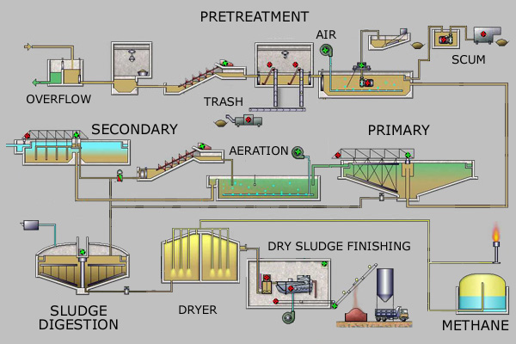
Figure 2 – Diagram that shows the process of wastewater being treated.

This moves nicely onto why this project had even started in the first place. Why is aeration such an important factor is the process of human waste? It’s actually very clever once looked at in detail and for most people who still think the waste fairy comes and collects everything would be shocked at what actually happens in the process. The aeration system, therefore, blowers, on any site provide oxygen (O₂) for a ditch that contains wastewater. The oxygen provided is the pivotal aspect as without it, it could be very damaging on the effluent that goes out of site. The oxygen provided help so that the bacteria stay alive which are required to treat the liquid and let biodegradation happen. There has to be just the right amount needed throughout the ditch for it to work correctly. Too little and nothing will happen and too much could actually cause more damage than good. The best average figure for the amount of oxygen supplied to any ditch is 2 mg/l. The above is known as a biological aerated process, this basically means removing waste particles from treated wastewater to create activated sludge which is then either circulated through the works to help keep bacteria alive and the system working or progressed through the site where it will be turned to a dry substance known as cake. This substance is then reused for other activities and used as a biofuel.

8.0 Project Specification and Testing Plan

8.1 Project Design Specification (PDS)

Design Brief

To carry out and oversee the installation of a hydro blower unit that will be more efficient and will do the work of 2, in turn saving power and saving man hours on planned maintenance. In addition to this as there would be one less blower it would allow this room to have extra storage and will therefore be able to store spare parts for these units.

8.1.1 Performance

- Deliver Oxygen to the aeration lanes.
- Be powered by local Motor Control Centre (MCC)
- The pumps should cut out after exceeding the designated bar pressure.
- The pumps will run auto duty rotation so both get working hours, preventing seized parts.
- These pumps cannot be reversed if blocked
- If one pumps fail there is always a second to keep the site running.
- In the event of a power failure, there will be alarms on telemetry that are passed out to the team.
- To prevent the blower from overheating, a temperature probe will be fitted.
- The product will be permanently mounted.
- The product must use a portable power source. If power failure MCC has a diesel engine generator as its back up.
- Efficiency of the unit should be very high, preferably in the area of 95-100%.
- It will have a variable speed drive connected to the blower to maintain the desired oxygen level in the aeration lanes at above 2 mg/l.

Environment

- The unit used in European weather conditions but kept indoors.
- Temperature range: European -28ºC.
- The product may experience humid conditions.
- Corrosion resistance considered by the use of special materials or surface protection methods.
- Any noise from the equipment should not exceed 50 dB at a distance of 1.0m.
- The spares and repairs will be kept indoors in the stores on site.

Product Life Span

- Product will be on the market for 5+ years.
- Spare parts will be available for a minimum of 5 years after that.

Life in Service

- Should withstand an operating period of 2hr uninterrupted use per day for 5 years.
- Life in service, assessed against the criteria outlined in the Performance and Environment categories.

Shelf Life

- The product will be stored on-site for up to 1 month before dispatched.

Target Costs

- The product should have a purchase cost of less than £50000
- The cost of installation should be less than £5000.
- The addition costs for upgrades to pipework and room ventilation should be less than £20000.

Quantity

- 1 immediately dispatched to site with spares such as blower air filters manufactured and delivered to site to keep in stores.

Maintenance

- To be maintenance free except for a recommended service every 6 months.
- All fasteners and pieces of equipment that is specific to this standard used should comply with BS6105.
- Spares should be available for 5 years after the product replaced with a new model.

Equipment Selection

Initially manufactured for the European market as the dimensions, fasteners and tools will all be made in metric design.
It is a possibility that the dimensions, fasteners and tools could be made imperial for countries that require this but costs and manufacturing will all need to be considered.
The Turbo blower should be operating against equivalent models that include the following companies:
- Aerzen – Germany
- Xylem – United States of America
- Howden – Scotland
- Secomak – England

Summary of market requirements:

- Use the local power supply, powered from the MCC.
- To be used in an indoor environment.
- To allow one-man operation.
- To have at least 20m of cable.
- To produce the desired oxygen to maintain 2mg/l in the aeration lane.

Packaging

- Packaging / transport cost kept to a minimum and below £1000

Size and Weight Restrictions

- There are no weight or size restrictions as long as the pipework is adjusted to fit the pumps face flange

Shipping

- Product shipped by road by couriers.
- Product shipped by sea and road to European markets.

Manufacturing Processes

- Common pump configuration can be bought off the shelf from the manufacturer.
- Specific pump configuration must be ordered from the manufacturer with a lead-time of approximately 4 weeks.
The following components can be purchased through the manufacturer itself:

- Electric motor
- Air foil bearing
- Couplings
- Nuts, Bolts and Washers
- Rubber seals
- Gaskets
- Oils
- Air filters

- Castings and injection moulds produced by external suppliers.

Aesthetics

- The form can follow function.
- If cost dictates, the blower should look attractive and be enclosed in a sound proof box to improve our perception within the market.

Ergonomics

- Controls to be mounted in an accessible position, relative to the operator i.e. waist height - around 1m, to accommodate 95% of the working population.
- All controls should be hand operated, requiring one-hand operation allowing the operator to control the blower in either auto or hand (start/stop) control.
- One man should be able to operate the product using the control panel, which is located in the MCC room.

Customer Requirements

N/A

Competition

The blower will be operating against equivalent models that include the following companies:
● Aerzen – Germany
● Xylem – United States of America
● Sulzer – Switzerland
● Secomak – England

Quality and Reliability

- Quality should be such that the turbo blower will not fail unless caused by something during manufacturing that is not linked with the blower and should not generally fail within a period of three years and only 1 in 80 should fail within the first year.
- No turbo blower should fail unless due to installation or electrical supply has been setup incorrectly. There are temperature probes and pressure gauges fitted along with a flow rate monitor located on the discharge pipework to calculate the flowrate of the oxygen been produced.

Standards and Specifications

Standards to adhere to:
- BS 5000 part 99 Motor Performance
- BS 6105 and BSEN 20898(1) Bolts
- BS 6322(2) & BS 4320 Nuts and washers
- BS 7676 and BS 4517 Gears
- BS 3019 Welding
- BS 5989 Bearings
- BS 2754 Electrical Insulation
- BS 5646 pt4 Bearing Housing
- BS 4235 Keys and Keyways
- BS 7664 Painting
- BS 1399 Seals

Company Constraints

- None - accept those outlines in Manufacturing and Processes.

Processes

- All components to be of metric form and comply with ISO 4900 for limits and fits.

Safety

- As a safety feature the will be a pressure gauge operated and the blower will fail once it reaches over the allocated pressure system. Also, the blower will be given a temperature probe to show if it is being overworked i.e. possible hot air in room (ventilation failure) and will automatically switch itself off.
- Blower should not operate when maintenance carried out because the user should use electrical lock off equipment to turn off power supply.

Testing

- Testing carried out on 5% of units.
- All cables tested to BS3621.

Legal

- Possible pressure will remain in the pipework if the user does not isolate local valves situated on the pipework.

Installation

- A work manual will be supplied with every full set ordered. An online PDF file of the blower documentation can also be found once you email so that a copy can be sent to you.

Documentation

- Product will be supplied with a user manual covering a step-by-step guide, dimensions, parts list, operation and maintenance.
- Suppliers require maintenance and repair manual.

Disposal

- All used and worn parts should be placed in the specified skips such as metals, cardboard, wood, electrical cable.

9.0 Project Planning
Figure 3 – Timing Plan.
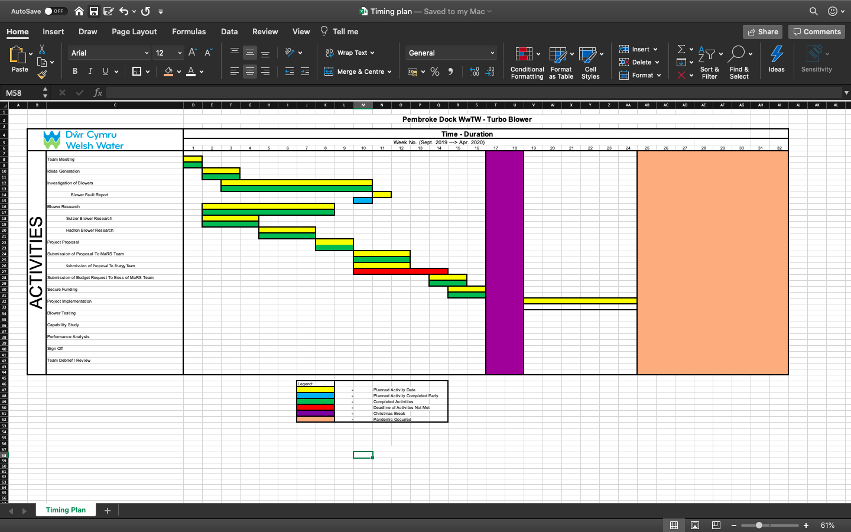

10.0 Project Solutions
When carrying out a project it is essential that other solutions/proposals have been thought of in case of a last-minute hiccup that prevents the job from being carried out. Although the design being carried out is the best it is important to compare this against other to ensure that the best idea is thought of and being used and all avenues have been covered. All the solutions thought about before deciding on one are written below.
- Installation of a Turbo Blower.
- New blower and repair existing.
- Repair old existing blowers.
The first solution is the one being used to become more efficient and to help Pembroke Dock WwTW become as LEAN as possible. The second solution is to install a new bi-lobe blower and repair the existing to have a spare one on the shelf in case of a breakdown. It sounds good because there’s one spare so it prevents downtime of any blowers but realistically it just isn’t productive and would cost way too much in the long term. Not only this but there will be no energy savings costs due to still have the four blowers running. Finally, the last solution is to repair all the old bi-lobe blowers and give them a complete overhaul with new everything; seals, bearings, oils and pulleys. Even this would cost a fortune and again there will be no energy savings costs at all.
Its clear to see from the criteria analysis that the first proposal has come out on top. Other than its size and weight it came out as a clear winner in every other aspect, it will also save the company a huge sum of money with how efficient it will run due to the minimum amount of maintenance required. It is designed differently, and this is how that is allowed to happen. The energy saving costs from having four blowers running down to just one is ridiculous and a no brainer.
Figure 4 – Criteria Analysis.

11.0 Design and Implementation

11.1 Design

The turbo blower that has been picked to carry out the task, as can be seen by the attached documentation showing the amount of savings it will produce. It will produce that greater savings that it will pay for itself in just 1.5 years which for the total amount being spent to purchase it is a very short time frame. The reason it is able to do this is because of the excellent high efficiency motor that will be able to achieve over 70% of total power efficiency. Not only will the motor generate a huge savings, but it will be powered by an inverter, thus being driven and controlling the airflow and pressure within the discharge pipework.
In comparison to the old tri-lobe blowers that are currently in Pembroke Dock the new turbo blower will have a lower noise level and a longer lifespan. Because of the air foiled bearing motor, there will be hardly any noise and be estimated to be around 75-80dB therefore there will be no need to purchase any added silencer to prevent noise from leaving the building and potentially get noise complaints at night.
The turbo blower is very special due to the minimal amount of maintenance that is required to run it. When three to six monthly planned maintenance checks are required the job time will be reduced greatly from over half a day to around a quarter. The ait foil bearing requires no oil lubrication; therefore, no contamination of other components will occur. The only maintenance of piece of equipment that will needed to be changed is the air filter, thus only taking 30 minutes maximum.
Unfortunately, due to the recent outbreak of COVID-19 the implementation of the project had come to a complete stop. The work is due to carry on either later in the year and or when it is safe to do so as following guidance from the government.
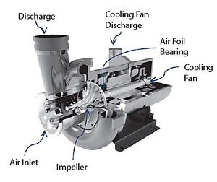
Figure 5 – Internals of a turbo blower.

12.0 Analysis, Results and Evaluation
Regarding this section it is very hard to complete when the project has been put on hold because of the recent events of COVID-19 placing the whole of the UK and surrounding countries on lockdown. Although the project will not be able to compile results and show evidence of the savings. There is a breakdown of savings and costs which have been calculated showing exactly what should happen given all the configurations and power ratings that should be used once the turbo blower has been installed and placed online. These savings and costs will be placed into this report has an appendix.

13.0 Conclusion
The best way of conducting a conclusion for the project would be to do one up until the point where it has come to a stop. Everything up until this point has ran fairly smoothly and efficiently. Apart from a few delayed responses from people and the awaiting time to get it all approved it has been on time and all goals to do have been reached. The target was to be finished and to have a month or so of results and efficiency savings calculated but unfortunately it is not to be because of the current ongoing pandemic. Once this has finally gone and everyone is able to work safely together again the project can resume and hopefully it won’t be too long before this project will be back up and running to complete the final stages of implementation. The treatment works is currently desperate for this blower and it will save so much time and money on maintenance and energy savings that this little bump in the road should make it worth the wait.

14.0 Recommendations
Its very hard to conduct any recommendations since the project has not completely been finished. However, if there were any changes to this present date it would probably be to have better communication between all parties involved. Although its positive and productive sending emails, it would’ve been very beneficial for all involved to get together and have a meeting on site to clear everything up and to get the ball rolling as soon as it possibly could.

15.0 Bibliography
Hadronengineering.co.uk. n.d. Turbo Blower - Products - Sound Enclosures, Frequency Drive + Prepared Elmotor. [online] Available at: <http://www.hadronengineering.co.uk/blowers/turbo-blower.php> [Accessed 17 April 2020].
Image – En.wikipedia.org. n.d. Sewage Treatment. [online] Available at: <https://en.wikipedia.org/wiki/Sewage_treatment> [Accessed 15 April 2020].

16.0 Appendices

All appendices are attached as hard copies.

