Marketing plan written for
Marriott hotel

Student name: Melis Shaban
Student ID number: 2212035
Marketing Essentials BMIH4005
Lecturer: Gayathri Senanayake Mudiyanselage

Introduction
This study is a research and analysis of Marriott Hotel UK's marketing activities and the hospitality sector in which it operates in the United Kingdom, employing proper marketing tactics and research tools to determine how these actions contribute to Marriott UK's performance.
Buckinghamshire is the destination, which is close west of London but is worlds apart in terms of peacefulness. The Langley, a Luxury Collection Hotel in Buckinghamshire, is set in a grand old manor residence originally owned by the Third Duke of Marlborough and features 150 acres of formal gardens and parks. Buckinghamshire, which is close to the royal enclave of Windsor, boasts abundance of undulating hills and stately estates—relics of British royalty. The Langley itself assures a luxury retreat in the countryside, complete with exquisite food, cozy accommodations, and a modern, luxurious spa. Wander the huge estate, originally the third Duke of Marlborough's royal hunting grounds, and a traditional English countryside activities like falconry, horse riding, and polo.

Situation analysis
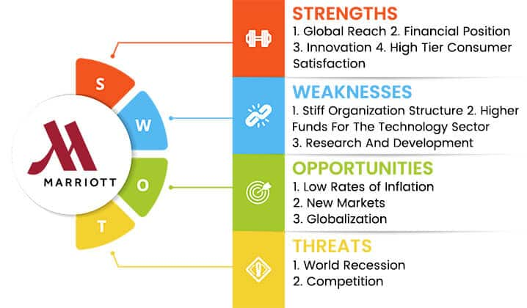
(Vaneet Verma)
Segmenting the market into smaller groups helps firms determine how to effectively spend resources, offer products and services that are appealing and capable of fulfilling the segment market while earning a profit. When it comes to product selection and purchasing goods and services, consumer requirements differ and are considered to be diverse (Kotler and Armstrong, 2018).

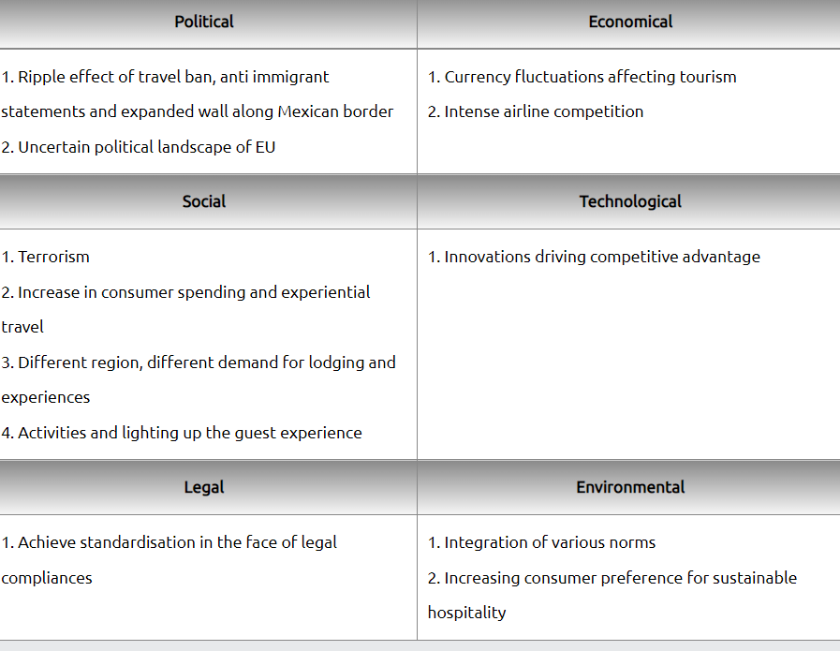

(Vaneet Verma)
The PESTLE analysis report is a framework for researching the effects of external variables such as political, economic, social, technological, legal, and environmental aspects on the hospitality business, specifically Marriott International.

Marriott's Competitors

There are other brands on the market that compete for the same clientele. Marriott's top three competitors are listed below:
1. Hilton Hotels and Resorts
2. Starwood Hotels and Resorts
3. Taj Hotels

Collaborators
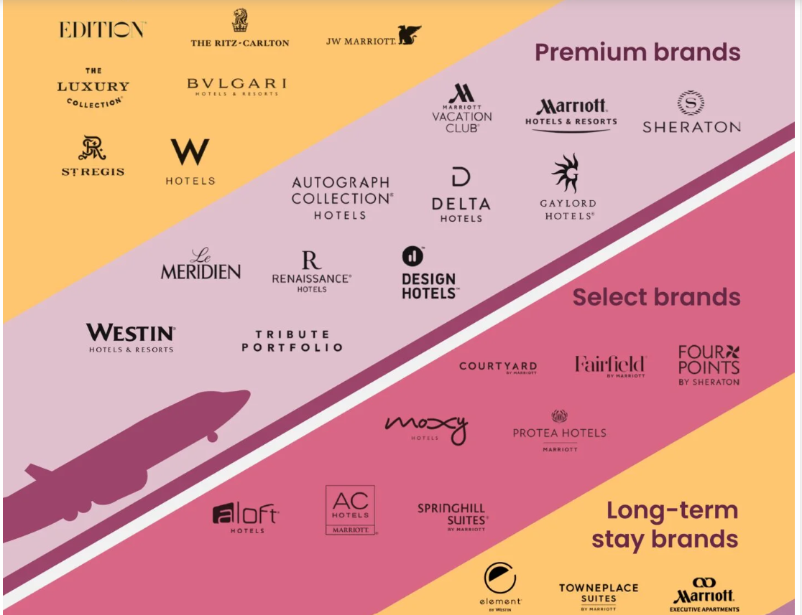
Source: milionmilesecrets.com

Objectives
Marriott UK targets a variety of markets, including travelers seeking a comfortable and peaceful environment, high-quality cuisine, and excellent customer service, to mention a few. Marriott's services to these groups have been excellent. (Kuang 21, 2019) Marriott UK has the option of targeting both narrowly and broadly.

Strategy
Strategy formulation
-Differentiation
-Ritz Carlton
-Courtyard Marriott
-Residence Inn
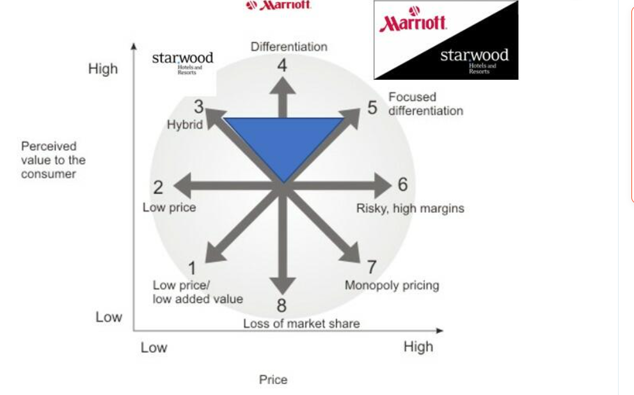
Source: aspectc-of-marriott

The blue triangle in the graphic above illustrates the positioning of Marriott, Starwood, and their merged brands before and after the merger. Prior to the merger, Starwood took position 3, reflecting a balance of cheap pricing for its segment and product distinctiveness. Prior to the merger, Marriott took on Position 3 as well, but concentrated on Position 4, which is distinctiveness. Using its brand and high-quality services, Marriott strove to differentiate itself, establishing great awareness and client loyalty that it sustained after the merger. However, following the merger, the merged firms also implemented Position 5, the concentrated differentiation strategy. Using the perceived additional value approach, the firm places a product or service at the greatest price level at which customers are prepared to pay above market cost for the return of the value distinct from a certain brand. Marriott adapted some of the characteristics of Starwood's premium property positioning for the bulk of its worldwide brand.

Tactics
Marketing mix
Kotler et al. (2005) Marketing mix is described as the set of controllable tactical marketing tools—products, price, place, and promotion—that firms typically use to elicit the desired reactions from their target market. The components of the marketing mix are depicted in the illustration.

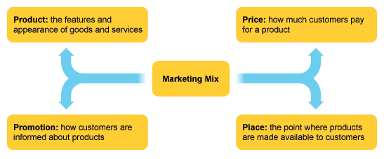

Source: bbc.co.uk

Product
Products are defined as everything created and made available to the market in order to reach the desired audience and fulfill the wants and wishes of customers, generally through the expansion or consumption of products and services (Kotler, et al 2004). These might be individuals, services, tangible objects, or locations.
Marriott's success is driven by how well it serves the wants and wishes of its customers. Customers typically desire more than just a company's products and services; they also want to buy the company's experiences and what its offer must deliver them when purchased or consumed. According to a recent customer review (Kotler et al, 2009), consumers were pleased with Marriott's products and services, with 4.3 out of 5.0 ranking Marriott's high and 90% recommending Marriott's to relatives and friends searching for sophisticated products and services (Marriotts.co.uk)

Place
When it comes to location, Marriott is specialized in that area. They built their hotels in areas that would surely attract guests. This might be near a highway, an airport, or a market.

Price
A price is any amount that a consumer is required to pay in exchange for a product or service (Solomon et al, 2009). The only P that creates money for the organization is price; the other Ps are purely expenses. According to Kotler et al. (2009), enterprises should not constantly cut their prices, but rather persuade customers that the goods and services they are receiving are worth the price they are paying. Marriott charges a premium for its products and services in exchange for providing consumers with efficient and luxurious products and services.

Promotion
The fundamental purpose of promotion is to increase customer awareness of the company's product or service. It also generates good value in the minds of clients by communicating with those who have visited the organization.

Action
15 years after Adamiecki, Henry Gantt, an American engineer and project management consultant, made his own version of the chart, which became well recognized and famous in Western countries. As a result, Henry Gantt's name came to be associated with these sorts of charts.
The diagram depicts today's gantt chart of work scheduling.
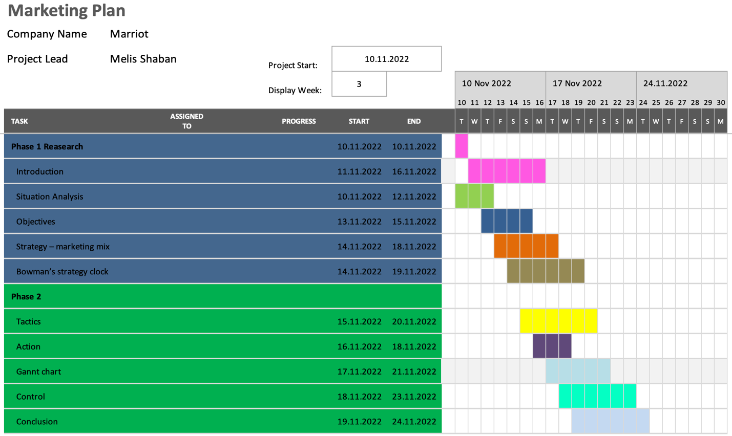

Control
Understanding of Marriott's USP, mission statement, and vision statement. As millennials and Generation Z have come to contribute to economic success, new marketplaces are forming. This will help Marriott widen its already vast business perspective. It has already purchased more than 1.2 million rooms. Because of the new marketplaces, these statistics might skyrocket. Opportunities are external elements that a company may earn from and gain from. Marriott's SWOT analysis will help executives examine them before making their next major decision.

Conclusion
Here are some recommendations for Marriott to improve their market game from the experts:
They should hire more people from around the world to diversity their workforce and increase team spirit.
They should strive to systematize and diversify their business.
They should priorities training their personnel over stringent restrictions.
To summaries, Marriott's core characteristics are a consistent profit line and worldwide presence. Its tight organizational structure is its greatest drawback. It may not appear to be much, yet it is a great weight to carry.
A drop in the VAT rate will thereby benefit both the hospitality industry and the United Kingdom economy by creating much-needed employment in the UK. Marriott's UK can get around this by lobbying and participating in the legislative discussions process for favorable legislation.

References:
Cleverism. (2018). 7Ps of Marketing | Additional Elements of Marketing mix. [online] Available at: https://www.cleverism.com/7ps-additional-aspects-marketing-mix/.
Gantt (2019). What is a Gantt Chart? Gantt Chart Software, Information, and History. [online] Gantt.com. Available at: https://www.gantt.com/.
https://www.facebook.com/marketing91 (2018). Top 10 Marriott Competitors - Marriott Competitor analysis. [online] Marketing91. Available at: https://www.marketing91.com/marriott-competitors-analysis/.
Kellykuang (2019). How Marriott International Target Their Market and Audience. [online] Blogspot.com. Available at: http://kellykuang21.blogspot.com/2012/11/how-marriott-international-target-their.html. [Accessed 24 Nov, 2022]
‌Kotler et al (2004) Principles of marketing, 4th European Edition
Kotler, Armstrong, G., & Opresnik, M. O. (2018). Principles of marketing (17th edition; global edition.). Pearson.
Marriott International. (2018). Annual | Marriott International. [online] Available at: https://marriott.gcs-web.com/annual.
‌prezi.com. (n.d.). Marriott International Hotel Group. [online] Available at: https://prezi.com/j0awrdlffpud/marriott-international-hotel-group/ [Accessed 24 Nov. 2022].
Solomon, M.R. (2009). Consumer Behaviour: Buying, Having and Being. (8th edtn). USA: Prentice Hall. Chapter 1-9
SWOT & PESTLE.com. (2022). Marriott SWOT & PESTLE Analysis - SWOT & PESTLE.com. [online]
Available at: https://www.swotandpestle.com/marriott/. [Accessed 24 Nov, 2022]
‌swothub.com. (2022). Marriott SWOT Analysis 2022: A Detailed Report! | SWOT Hub. [online] Available at: https://swothub.com/marriott-swot-analysis/.
Team, M.S. (n.d.). Marriott SWOT Analysis, Competitors & USP. [online] MBA Skool. Available at: https://www.mbaskool.com/brandguide/tourism-and-hospitality/2370-marriott-international.html#:~:text=Below%20are%20the%20top%203%20competitors%20of%20Marriott%3A [Accessed 27 Nov. 2022].
‌The Langley, www.marriott.com. (n.d.). The Langley, a Luxury Collection Hotel, Buckinghamshire. [online] Available at: https://www.marriott.com/en-us/hotels/loniv-the-langley-a-luxury-collection-hotel-buckinghamshire/overview/ [Accessed 24 Nov. 2022].
The Luxury Collection. (n.d.). Explore London and Buckinghamshire. [online] Available at: https://the-luxury-collection.marriott.com/itineraries/explore-london-and-buckinghamshire/ [Accessed 24 Nov. 2022].
‌

‌

‌Appendices:
Appendix I (Marriott Brands)
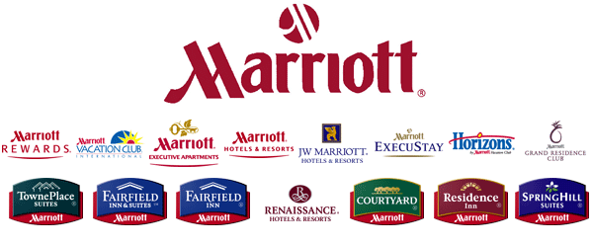
Source: www.biznews.com
Appendix II (Marriott Customer Ratings)
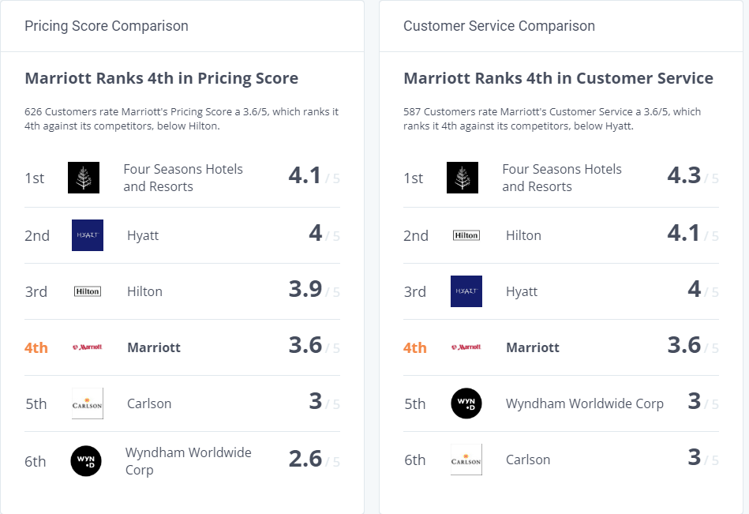
Source: companies/marriott/competitors

Appendix III (Marriott financial statement)

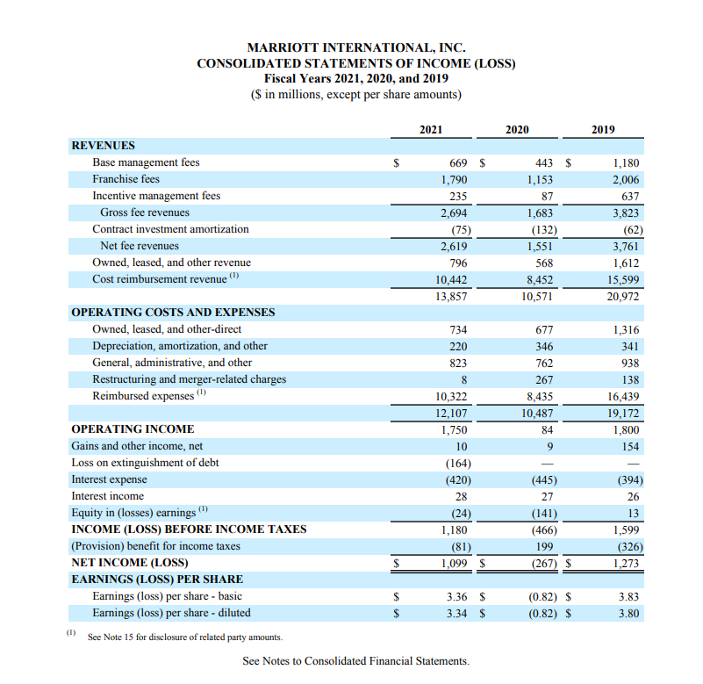
Source: 2021 Annual Report



