

Name: James Cullen
Student Number: P151951
Module Name: Contract Practice & Procedures
Assignment Title: Administration within Contracts
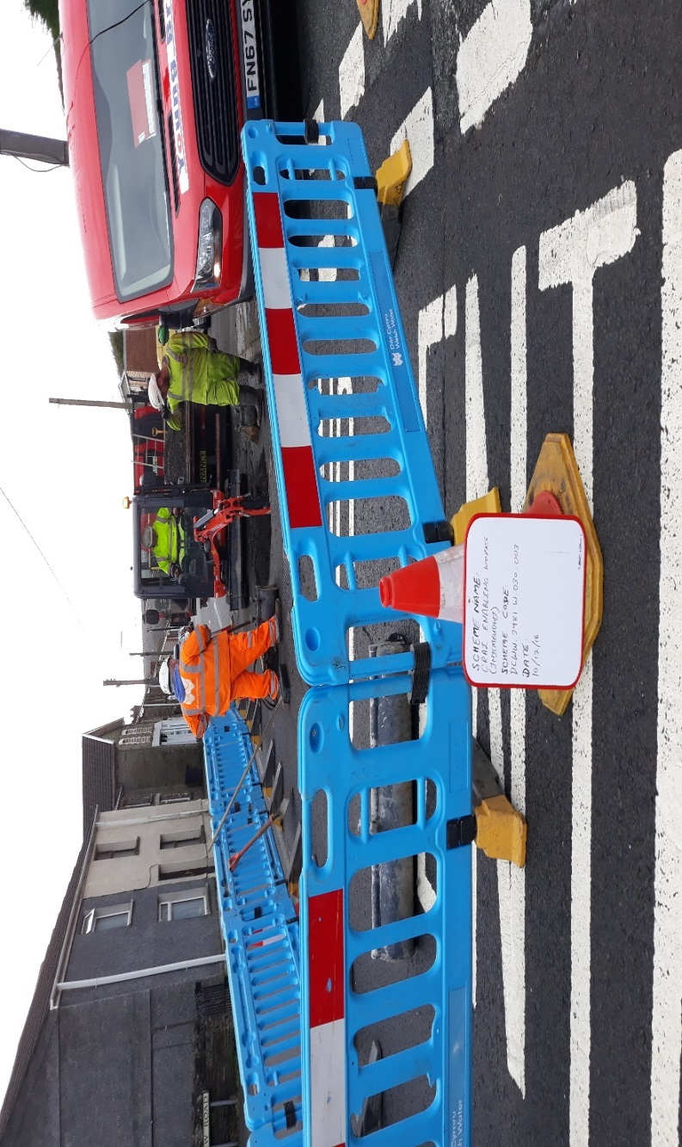
Contents

- Page 5 – Introduction

- Page 6 – Variations in Contracts

- Page 8 – Conclusion

- Page 9 – List of Figures

- Page 10 – List of References

- Page 11 - Appendices

Introduction
By 2016, the construction industry in the UK was said to be worth roughly 105 billion pounds (Statista, 2019) covering a vast array of schemes across many sectors. Studies however show that a minority of construction projects are completed on time or budget, with many corporations employing contract administrators to oversee the processes involved with the non-site aspects. Depending on the type of agreement, they initiate procedures defined in the contracts designed to limit delays and overspend and to also compensate parties when unforeseen events occur during construction schemes.
This report will describe the proceedings and actions taken by a contract administrator following an unforeseen event occurring that could result in a variation of the contract terms.

Variations in Contracts
Clause 16 of the NEC (New Engineering Contract) contract outlines the processes for dealing with unforeseen events that take place on a construction site. This mechanism can initiated by either the contractor or client, but is usually started by the submission of an ‘Early Warning’. A contract administrator (CA) would be responsible for issuing the necessary forms to the contractor’s representative prior for works starting (see appendix 1). Once completed the CA should then receive and review the form which should providing in depth details of the issue which has the potential to either delay the scheme, increase the price of the works or impact on the final quality of the project. The Early Warning system “allows those that might help avoid or mitigate any negative effects of the event to get together to work out how to do so” (Patterson 2015). All Early Warnings issued and received should be logged by the CA in a risk register as and when they are received and best practice dictates that regular meetings between the client and contractor should be organised in order to discuss the risks and mitigate and prioritise them.
Early Warnings may materialise to actual difficulties on construction sites at which point a Compensation Event (CE) must be submitted (see appendix 2), although many may be resolved or mitigated without the need for further work. Under the NEC contract 19 situations are outlined in which can give clients or contractors opportunity to raise a CE. While many will be raised by the contractor, “the most common reason is 60.1(1) which is a Project Manager instructing something that is a change to the Works Information” (Hide 2019), accounting for roughly three quarters of all CE’s. These can be termed as Project Manager’s Instructions (PMI). It is the responsibility of the CA to oversee the issuing and accepting of such notices.
Further clauses in the NEC contract provide govern the specific process for dealing with CE’s which the CA must facilitate and monitor. The process is instigated by the submission of the CE at the ‘notification’ stage, dictated by Clause 61 in the contract. It is also stipulated that a contractor must raise the event within eight weeks of the matter arising as prevents “stockpiling of claims until the end of the project” (Ramskill Martin 2016). Upon the receipt of the notice, the CA will assess the claim and dismiss it if no incidents has not yet occurred, they believe the issue has been caused by the contractors conduct or if they think it will not have a detrimental effect on cost or timescale. On occasions where the CE has been raised by the employer, the CA must alter the Works Information at this point to reflect the reality of the situation.
At the Quotation stage, elucidated by Clause 62, the party that submitted the CE must then also provide a quotation outlining the extra associated costs within 3 weeks of the CA requesting it, although this can be extended if agreed by the client. Upon receipt of the quotation, the CA must reply within 2 weeks, which can similarly be elongated. Their response must follow those described in the contract and they can either accept or decline the quotation, instruct that the quotation has not been communicated correctly or process has not been followed so they must resubmit or that the CA will now assess the event themselves.
If the client maintains that the quotation is reasonable the procedure progresses onto the assessment phase. Here the CA must review the CE based on the events effect on the actual cost of the whole scheme, the forecasted cost of the project and the completion date. This stage should be carried out with the mantra that “neither party should be disadvantaged or should unfairly gain from the happening of the compensation event” (Evans 2013).
The final step involves of the ‘implementation’ of the CE at which point the contractor in conjunction with the CA adjusts the programme accordingly and the contractor physically proceeds with work detailed in the quotation. From this point onwards the CE cannot be altered by either party and its conditions must be adhered to.
The CA would perform a similar role when administering a JCT (Joint Contracts Tribunal) contract although it deals with claims of lost time and costs separately, with ‘relevant events’ relating to time and ‘relevant matters’ applying to financial aspects.

Conclusion
A contract administrator role is vital for the smooth progression of all construction projects and their duties can include a wide variety of functions. However, the most vital and contentious must be the governance of the contracts variations as disagreements are commonplace and can lead to litigation such as Henry Boot Construction Ltd v Alstom Combined Cycles (1999). This is despite the NEC suite of contract’s principle aim of creating a more collaborative atmosphere.

List of Figures
- Cover page top: UCL (2019), View of Contract and parties shaking hands, https://www.ucl.ac.uk/laws/events/2018/nov/drafting-legal-clauses-commercial-contracts
- Cover page bottom: Authors own collection (2018), View of Works taking place on a water main, UK

List of References
- Evans (2013), NEC3 compensation events – a practical guide, Steven C Evans Ltd, UK
- Evans (2019), NEC3 ECC – Early Warning, http://www.stevencevans.com/nec3-ecc-early-warning/, UK
- Hide (2019), EEC Clause 16 – Early Warnings, https://gmhplanning.co.uk/nec-guidance-notes/nec3-ecc-clause-16-early-warnings/, UK
- Hide (2019), ECC Clause 60.1 – Compensation Events, https://gmhplanning.co.uk/nec-guidance-notes/ecc-clause-60-1-compensation-events/, UK
- Patterson (2015), Making the most of your Early Warnings – sorting out your TQs and RFIs… .and what about Opportunities?, NEC, UK
- Ramskill Martin (2016), Early Warning Notices, http://ramskillmartin.co.uk/article/early-warning-notices/, UK
- Ramskill Martin (2016), Notification of Compensation Events, http://ramskillmartin.co.uk/article/notification-of-compensation-events/, UK
- Statista (2019), Construction Industry in the UK – Statistics & Facts, https://www.statista.com/topics/3797/construction-industry-in-the-uk/, UK

Appendices
- Appendix 1: DCWW (2019), Example of an Early Warning notice, Dwr Cymru Welsh Water, UK:
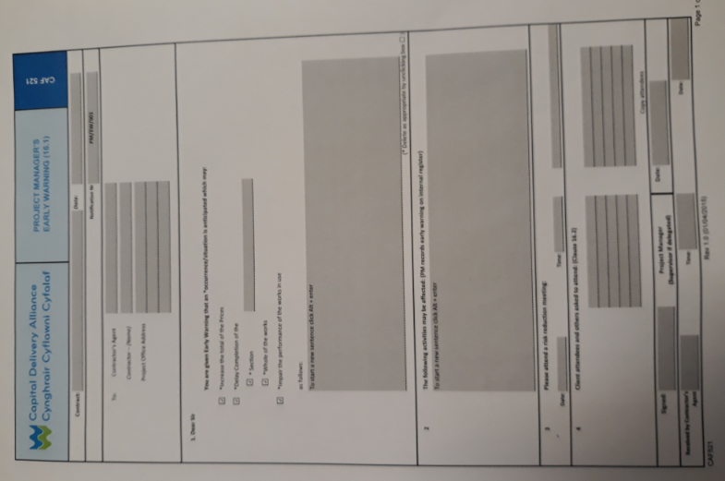

- Appendix 2: DCWW (2019), Example of a Compensation event notice, Dwr Cymru Welsh Water, UK:


