Digital Skills 1 Assignment

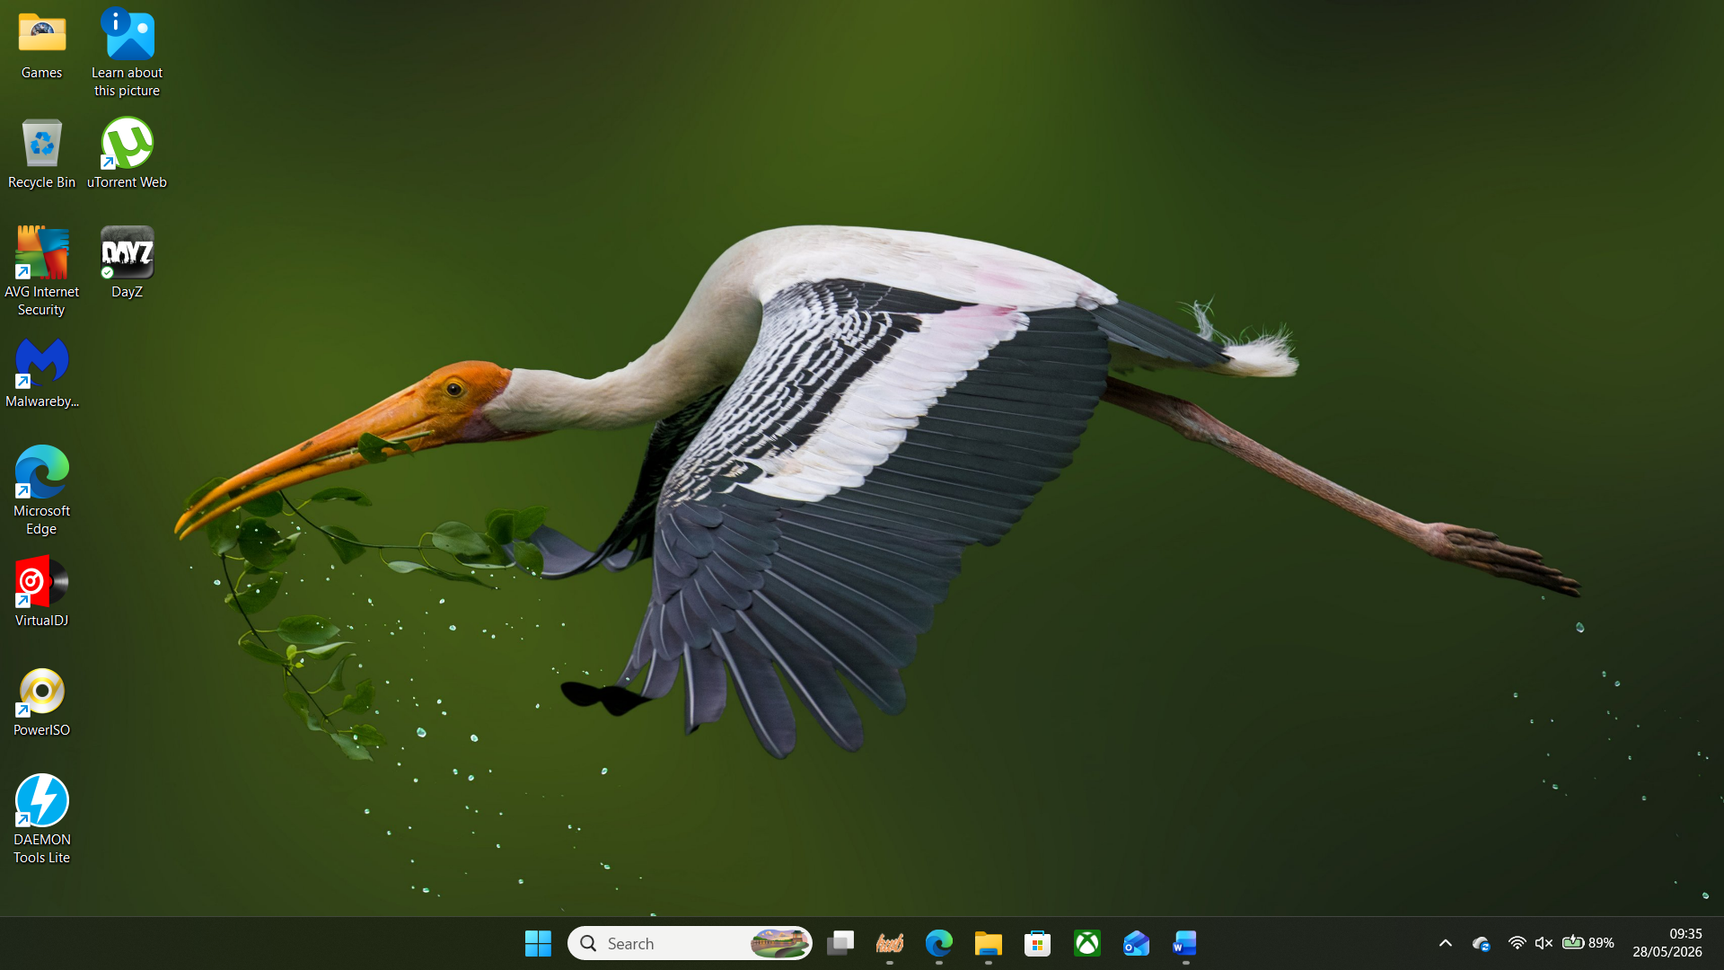
This screenshot shows the home screen of my laptop with the programs I use.

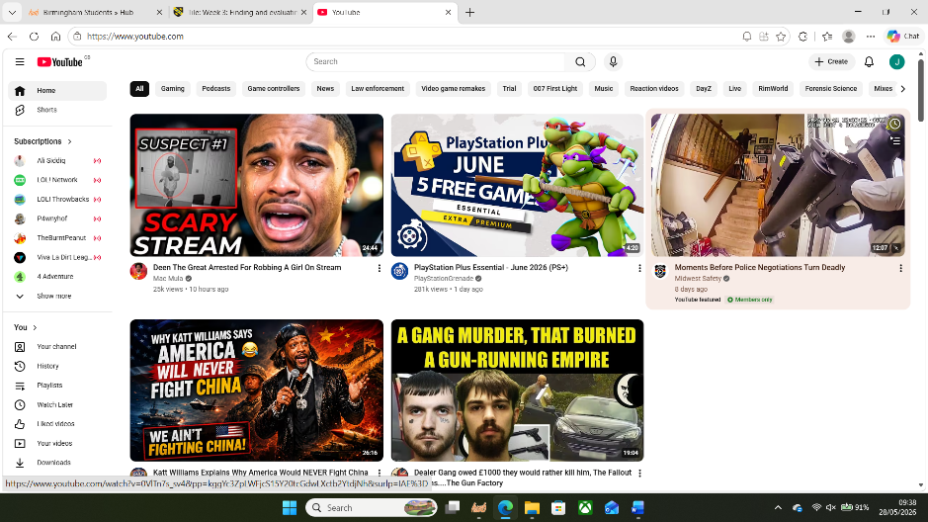
This screenshot shows my home screen of YouTube which is the digital app I use the most for entertainment, information, news and music.

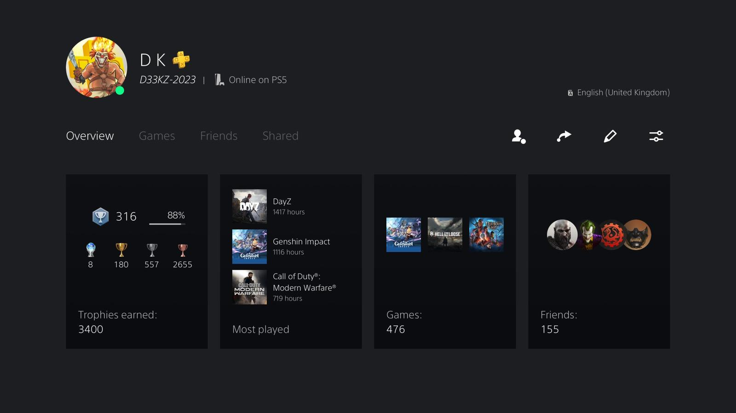
This is an overview of my PlayStation profile that I use to play games with friends.

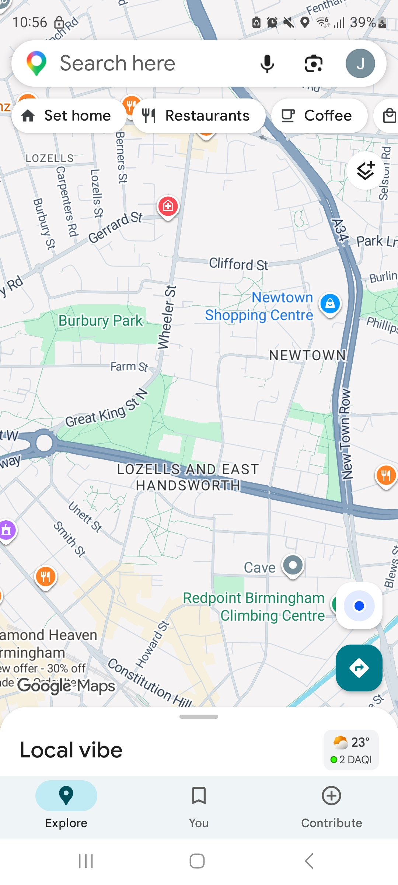
This is a screenshot of Google Maps which I use to travel and not get lost.

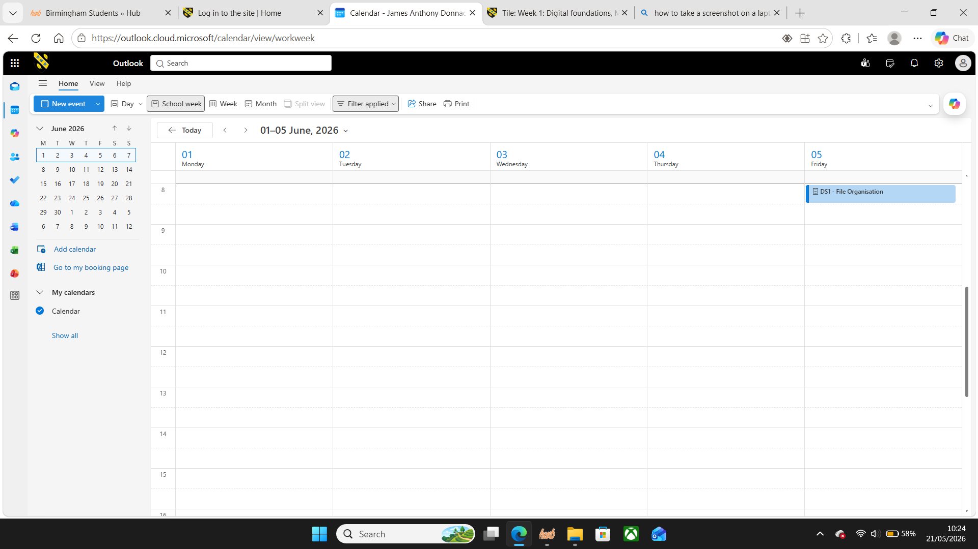
This screenshot shows me using the calendar on Microsoft Outlook to remind me of the assignment deadline.

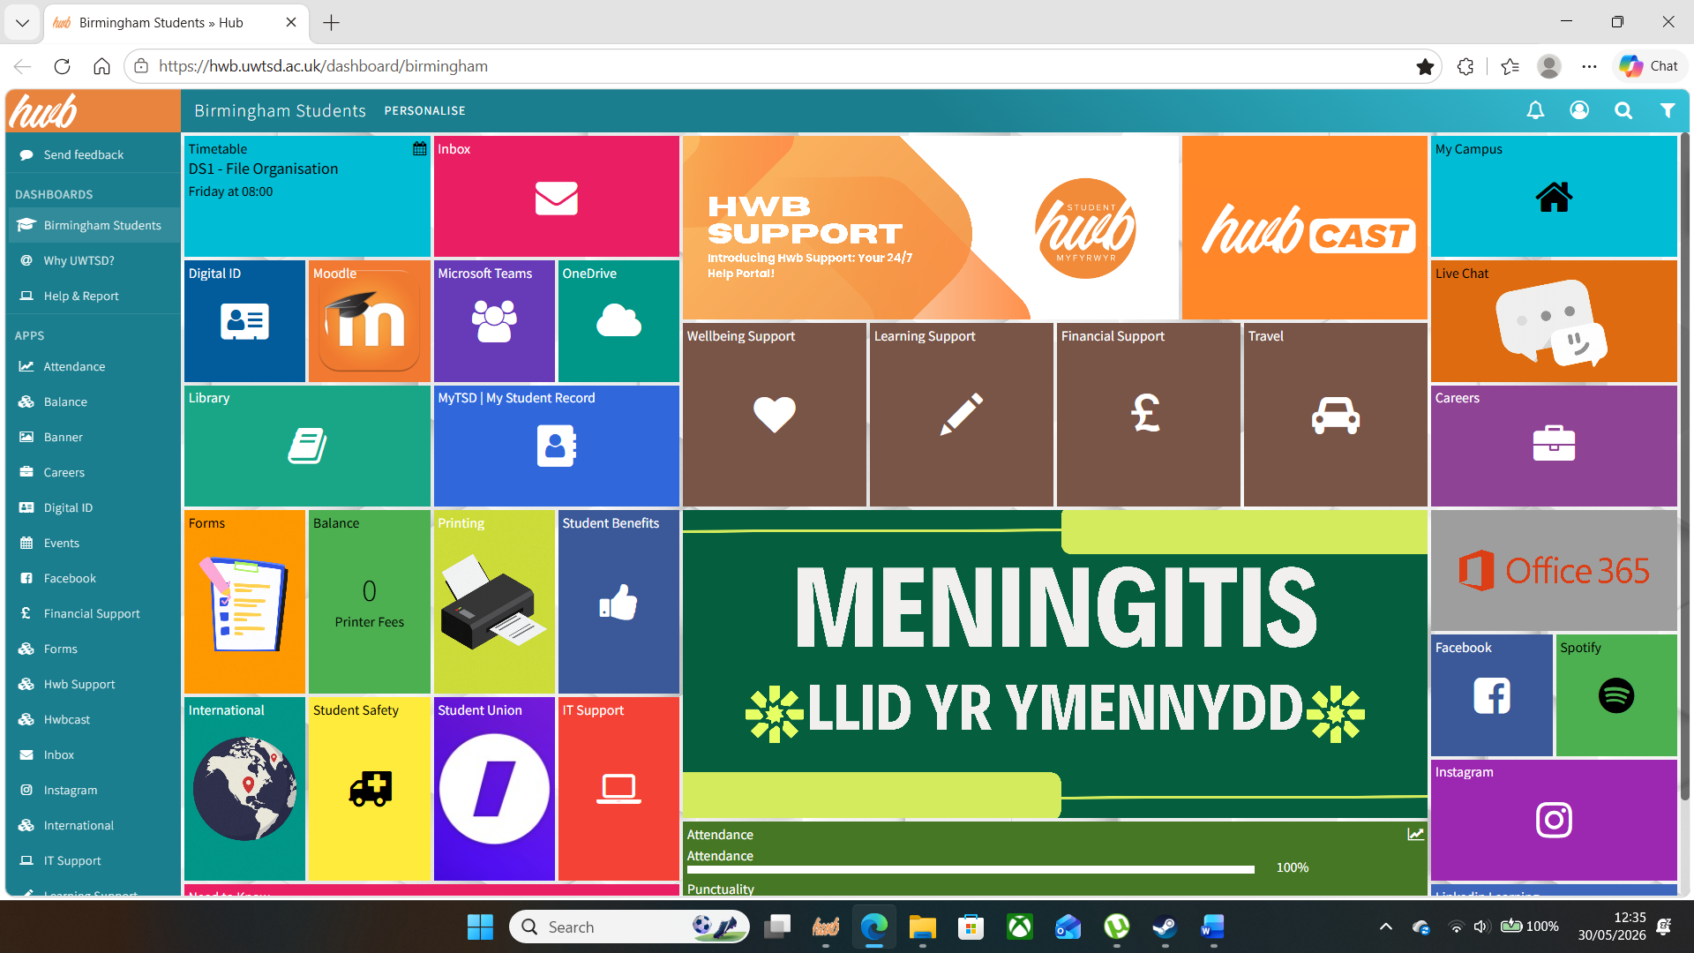
This screenshot shows the student hub that I use to access the universities features, modules and help if I need it.

My Short Reflection

I feel confident using digital technology and I am always looking for new ways to expand that knowledge. This module has helped me to remember some skills using a PC/Laptop that I haven’t had to put into effect for many years, so it’s been refreshing and I’m excited to learn more to expand my proficiency in all aspects. I am more than positive that anything I do not know will be adapted to and picked up very quickly so I’m not nervous about diving headfirst into anything unfamiliar.

Submission Checklist
Before you submit, please check:
​​​ ☒ I added 4–6 screenshots
☒ I wrote short sentences for each screenshot
☒ I wrote my short reflection
☒ My work is my own
☒ My file opens correctly
​​☒ My file opens correctly

