ANALYSING AND SOLVING PROBLEMS
ACCA4019

Optimising Group Project Meeting Scheduling: A Structured Problem-Solving Approach
JUN 2026
Eren Kulahlioglu (2513628)
University of Wales Trinity Saint David (UWTSD)
Module: Analysing and Solving Problems

Table of Contents
1. Introduction 3
2. Deconstructing the Problem 3
2.1 Breaking the scenario into components 3
2.2 Key variables 3
2.3 Requirements analysis using MoSCoW 4
2.4 Constraints and assumptions 5
3. Proposed Solution 5
3.1 Flowchart 5
3.2 How the process works 7
3.3 Assumptions built into the design 7
4. Reflection and Justification 7
4.1 Problem-solving techniques used 7
4.2 Why this approach is appropriate 8
4.3 Limitations 8
5. Conclusion 8

1. Introduction
Group project work is one of the most useful things a computing course can teach, but it is also one of the most fragile. As soon as five or six students each have their own lecture timetable, a part-time job, and a life outside university, simply finding a two hour window where everyone is free can become harder than the assignment itself. This report looks at that exact problem for a college computing course: students cannot reliably find shared meeting time, some groups fall behind, and the workload ends up split unevenly because the people who happen to be free end up doing more of the talking, and the deciding.
The brief for this assessment asks for a solution that (1) finds meeting times that work for the whole group, (2) keeps timetable conflicts to a minimum, and (3) makes sure meetings happen early enough that the group can still hit its weekly deadline. Rather than jumping straight to "build an app," this report works through the problem the way the module has asked: breaking the situation into smaller pieces, naming the variables and constraints involved, prioritising requirements with MoSCoW, and then designing a generic, logical process expressed as a flowchart that any group, or any piece of software, could follow. The final sections reflect on the problem-solving techniques used and are honest about where the approach still has gaps.

2. Deconstructing the Problem

2.1 Breaking the scenario into components
Abstraction works best when a messy, real-world situation is split into smaller sub-problems that can each be reasoned about on their own, an idea at the heart of systems thinking [4]. The scheduling scenario in the brief can be broken down into four connected sub-problems:
- Data collection capturing what each member's week actually looks like (lectures, shifts, commitments) in a consistent format.
- Overlap detection working out which, if any, time windows are free for everyone at once.
- Selection and ranking choosing the best of the available windows when more than one option exists, or handling the case where none exist.
- Deadline compliance checking that the chosen meeting actually happens early enough to leave time to act on it before the weekly submission point.
Separating the problem this way turns one vague complaint into four smaller, solvable questions, each of which maps onto a distinct stage of the flowchart in Section 3.

2.2 Key variables
Before any logical process can be designed, the things it operates on need to be named precisely. The table below defines the variables used throughout this report.
Variable | Description
MemberAvailability(i) | The set of free time windows for group member i across a standard college week, derived from timetable and job-shift data.
GroupSize (n) | The number of students in the project group; directly affects how hard it is to find overlap.
CommonSlotPool | The intersection of all members' MemberAvailability sets — the candidate meeting times.
Deadline (D) | The date and time by which that week's project milestone must be submitted.
MemberPriority(i) | A tag (Must-have / Should-have / Could-have, taken from the MoSCoW model) marking how essential member i's physical presence is for a given meeting.
ConflictCount(slot) | The number of members who cannot attend a given candidate slot.
MeetingOutcome | A record of whether the meeting was held before the deadline, used to feed back into future scheduling rounds.

2.3 Requirements analysis using MoSCoW
The MoSCoW technique. Must have, Should have, Could have, Won't have .was developed to help teams agree on what a solution actually needs to do before they design it, and it is widely used precisely because it forces a group to admit that not every feature is equally essential [1]. Applying it here keeps the design honest about what is core to solving the scenario and what is a nice extra.
Priority | Requirement | Justification
Must Have | The system must collect each group member's weekly availability (lectures, part-time work shifts, personal commitments). | Without accurate availability data, no valid meeting time can ever be found.
Must Have | The system must identify at least one common time slot that all 'core' members can attend before every weekly deadline. | This is the central purpose of the tool.
Must Have | The system must flag a scheduling conflict when no common slot exists before the deadline. | Silent failure would mean the group misses the deadline without warning.
Should Have | The system should rank multiple possible slots by how many members can attend and how close they sit to the deadline. | Improves meeting quality and workload fairness
Should Have | The system should apply a minimum-conflict rule that relaxes the least important constraint when no perfect slot exists. | Keeps the group moving even under imperfect conditions; a manual override is an acceptable, if weaker, fallback.
Could Have | The system could send automatic notifications or calendar invites once a slot is chosen. | Convenient, and reduces miscommunication, but members could still be told manually.
Could Have | The system could allow members to mark themselves as 'optional' rather than 'must attend' for a given meeting. | Adds flexibility but the process still
Won't Have (this iteration) | The system will not attempt to automatically resolve interpersonal or workload disputes between members. | This is a human, not a scheduling, problem, and is out of scope for a meeting-time tool.

2.4 Constraints and assumptions
A few constraints shape what a realistic solution can promise:
- Availability changes week to week (a student's shift pattern can move), so the process has to be repeatable, not a one-off calculation.
- Group size is small (typically four to six students), which keeps the overlap calculation manageable without needing heavy optimisation software.
- Not every member is equally critical to every meeting a member who is only contributing to one section of the deliverable does not need to be present for every planning session, which is why the MoSCoWstyle priority tag on each member matters.
- The weekly deadline is fixed by the module leader and cannot be moved, so the solution has to work backwards from it rather than around it.

3. Proposed Solution

3.1 Flowchart
The flowchart below was built in Microsoft PowerPoint using its native shape and connector tools, then embedded into this report. It sets out the logical steps of the scheduling process from first contact with the group's availability data through to a completed, on-time meeting, and follows standard flowchart conventions: parallelograms for data input, rectangles for processing steps, diamonds for decisions, and rounded terminators for start and end.
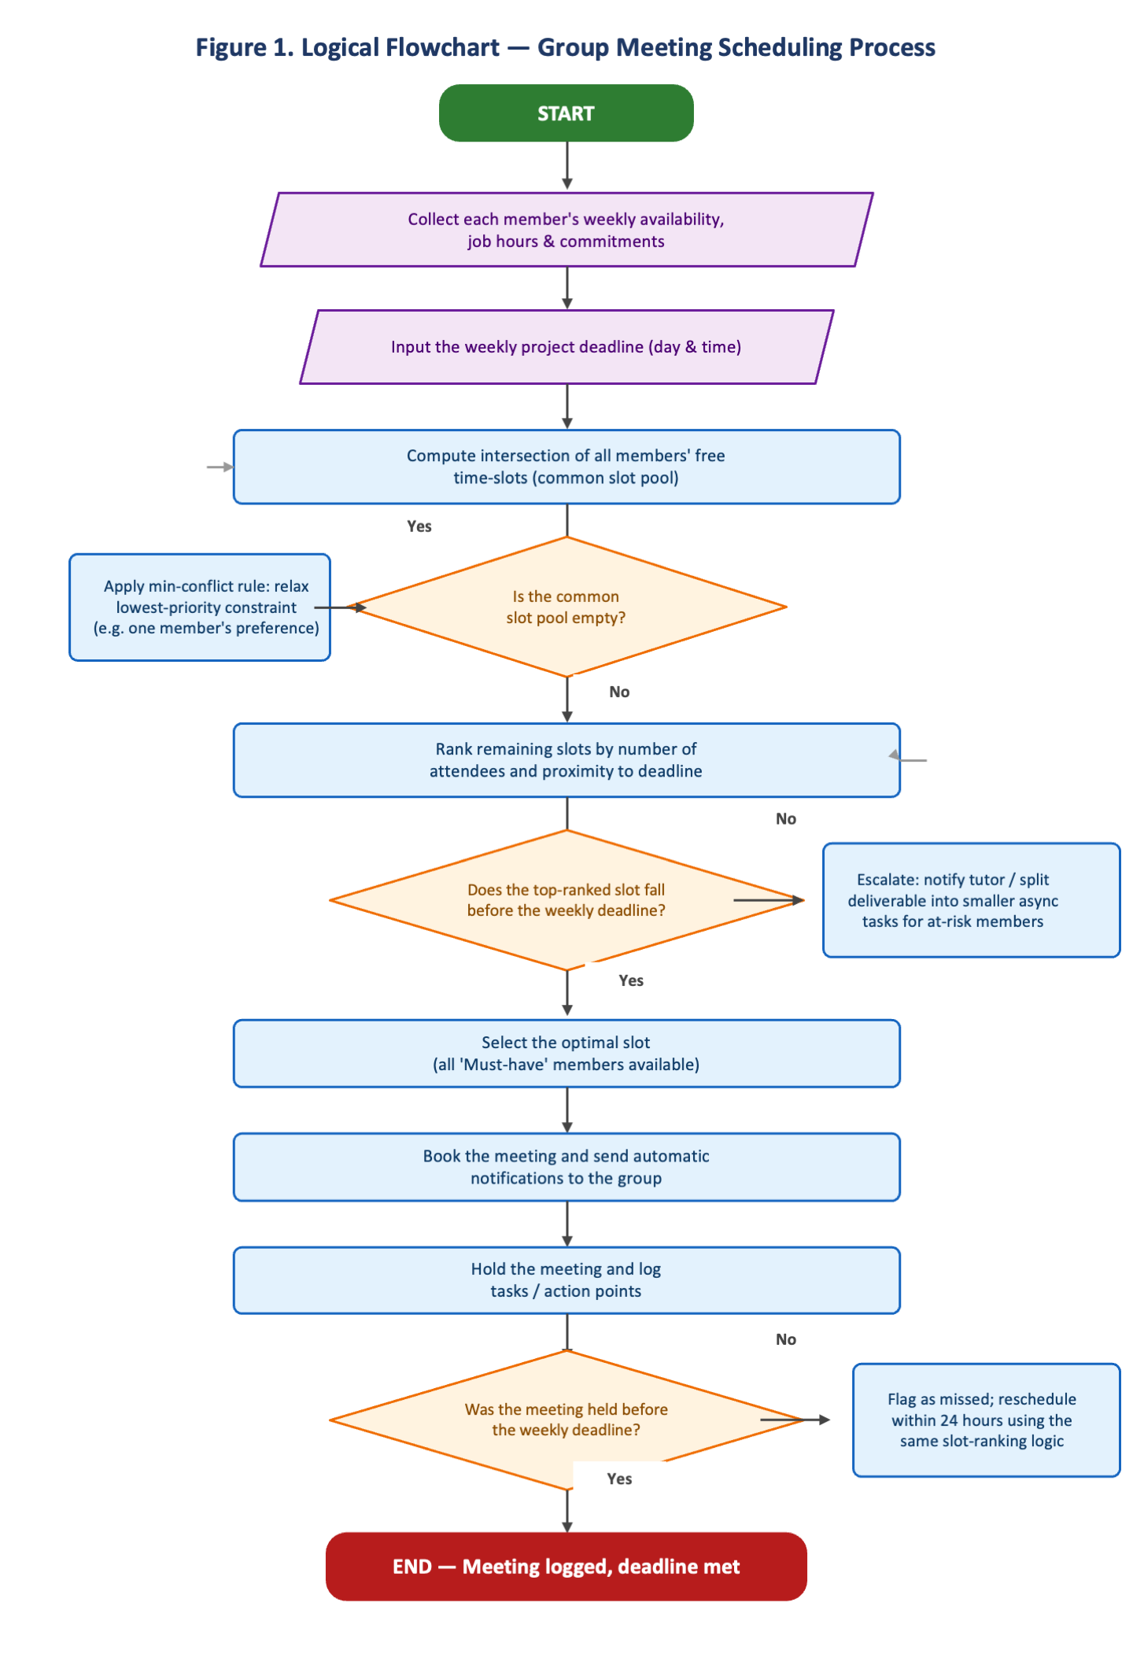
Figure 1. Logical flowchart for the group meeting scheduling process.

3.2 How the process works
The process begins by gathering the raw ingredients of the problem: every member's weekly availability and the deadline that meeting needs to be held against. From there, the flowchart computes the CommonSlotPool by intersecting everyone's free time this is the overlap-detection step identified in Section 2.1.
The first decision point asks whether that pool is empty. This is the situation students describe most often: nobody seems to be free at the same time. Rather than stopping there, the process applies a minimum-conflict rule, a simplified version of techniques used in constraint-satisfaction scheduling research, where the least important constraint is relaxed first for example, treating one member's stated preference as flexible rather than fixed and the overlap is recalculated [2]. This mirrors how real scheduling systems handle over-constrained problems: instead of declaring failure, they look for the assignment that violates the fewest, or least costly, constraints [3].
Once at least one candidate slot exists, the process ranks the remaining options by two factors: how many members can attend, and how soon the slot falls relative to the deadline. The second decision point checks whether the best-ranked slot actually falls before the deadline. If it does not, the group is not left to quietly miss its target the process escalates the issue, for example by notifying a tutor or splitting the task into smaller pieces that individual members can progress asynchronously while a meeting is arranged.
Assuming a suitable slot is found in time, the process moves into booking, holding, and logging the meeting. A final decision point closes the loop by checking whether the meeting was actually held before the deadline; if it was missed for any reason, the flowchart routes back into the ranking step so a replacement slot is found within 24 hours rather than the group drifting until the following week. This feedback loop is what turns the flowchart from a one-off calculation into a repeatable weekly process.

3.3 Assumptions built into the design
- Members submit honest, reasonably accurate availability; the process cannot correct for someone who under-reports their free time.
- A 'meeting' can be short and does not have to be in person the same logic applies whether the group meets in a study room or on a video call.
- Escalation to a tutor is treated as a last resort, used only when the deadline genuinely cannot be met, not as a first response to minor scheduling friction.

4. Reflection and Justification

4.1 Problem-solving techniques used
Two techniques did most of the work in this report. The first was abstraction and subdividing: rather than trying to design one large 'meeting scheduler' straight away, the problem was broken into the four sub-problems in Section 2.1, each of which is small enough to reason about individually. The second was systems thinking, treating the group, its members' timetables, and the weekly deadline as one connected system rather than isolated facts. Checkland's work on systems thinking argues that many real-world, human-centred problems are better understood as a web of interacting parts and perspectives than as a single fixed puzzle with one correct answer [4], which fits this scenario well a scheduling conflict is rarely just a maths problem, it is also about whose time gets treated as flexible and whose does not.
MoSCoW prioritisation, discussed in Section 2.3, was the third technique, and it did more work than it might first appear to. Deciding that automatic notifications are only a 'Could have' rather than a 'Must have', for instance, kept the design focused on the actual bottleneck finding a shared time before the deadline instead of drifting into building a full scheduling app.

4.2 Why this approach is appropriate
A flowchart-based, rule-driven process suits this scenario for a fairly simple reason: it is generic. It does not assume a particular group size, a particular course, or a particular piece of software; it only assumes that each member has a set of free time windows and that there is a deadline to work against. That generality was one of the requirements implied by the brief, which asked for a solution any group in the course could use, not a one-off fix for a single team. Constraint-satisfaction research on scheduling problems shows that even fairly complex, many-participant scheduling tasks can be handled well by systematically finding the assignment with the fewest violated constraints rather than searching for a mythical perfect answer [3], which is exactly the philosophy behind the minimum-conflict step in Section 3.2.
The approach is also appropriate because it does not try to remove humans from the loop entirely. Group work research consistently finds that scheduling and coordination costs, not lack of ability, are among the biggest reasons student teams fall behind, alongside uneven workload [5].

4.3 Limitations
- The flowchart assumes availability data is kept reasonably up to date; if a member's shift pattern changes mid-week without being reported, the CommonSlotPool calculation will be wrong.
- The design assumes a small group. As group size grows, the chance of a genuine common slot shrinks quickly, and the process would eventually need a more formal optimisation method, such as constraint programming, rather than a simple intersection [2], [3].
- The flowchart does not attempt to fix unequal participation directly. it only ensures a fair chance to attend. Whether members actually contribute once they are in the room is a separate, human problem that logistics alone cannot solve [5].

5. Conclusion
Breaking the group-meeting problem down into data collection, overlap detection, ranking, and deadline compliance made it possible to design a single, generic flowchart that addresses all three goals set out in the brief: finding times that work for everyone, minimising conflicts through a ranked, minimum-conflict process, and protecting the weekly deadline through an explicit escalation and reschedule path. MoSCoW prioritisation kept the design focused on what genuinely mattered, and systems thinking was useful for remembering that a scheduling conflict is a people problem wearing a maths problem's clothes. The solution is not perfect it leans on reasonably accurate self-reported availability and works best for small groups but as a generic, repeatable process that any group in the course could apply week after week, it directly answers the difficulty described in the scenario.
References
[1] Agile Business Consortium, "What is MoSCoW Prioritisation?," Agile Business Consortium. [Online]. Available: https://www.agilebusiness.org/resource/what-is-moscow-prioritization/. [Accessed: Aug. 12, 2026].
[2] M. Bofill, J. Coll, M. Garcia, J. Giráldez-Cru, G. Pesant, J. Suy, and M. Villaret, "Constraint solving approaches to the business-to-business meeting scheduling problem," Journal of Artificial Intelligence Research, vol. 74, pp. 263–301, 2022, doi: 10.1613/jair.1.12670.
[3] S. Minton, M. D. Johnston, A. B. Philips, and P. Laird, "Solving large-scale constraint satisfaction and scheduling problems using a heuristic repair method," in Proc. 8th National Conference on Artificial Intelligence (AAAI-90), 1990, pp. 17–24.
[4] P. Checkland, Systems Thinking, Systems Practice: Includes a 30-Year Retrospective. Chichester, U.K.: Wiley, 1999.
[5] Eberly Center, Carnegie Mellon University, "What are the challenges of group work and how can I address them?," Carnegie Mellon University. [Online]. Available: https://www.cmu.edu/teaching/designteach/teach/instructionalstrategies/groupprojects/challenges.html. [Accessed: Aug. 12, 2026].

