University of Wales Trinity Saint David
BA (Hons) Business Management

INDIVIDUAL REPORT: MARKETING FUNDAMENTALS EXTERNAL ANALYSIS & EVALUATION
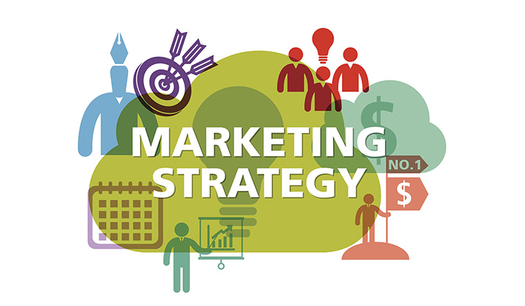
Student Name:Angela Muresan
Student ID:2131060
Lecturer:Piyumika Gamage
Submission date:April 2023
Table of Contents

Introduction 2
Brief overview of the selected company, GSK Plc. 2
Basic description of the company 2
Vision and mission statement of the company 3
Purpose and strategy of the company 3
SWOT analysis of the selected company, GSK Plc. 4
Significant understanding on the process and different stages of Marketing for GSK Plc. 5
Understandability on the role of the marketing environment of the selected company, GSK Plc. 6
Situational analysis models for the specific company, GSK Plc. 6
PESTLE Analysis 6
Porter’s Five Forces Model of GSK Plc. 9
5 C Analysis 11
STP of the chosen company, GSK Plc. 12
Marketing Mix for the selected company, GSK Plc. 13
Conclusion and recommendations 13
Reference List 15

Introduction
This particular individual report is related to the terms of the specific concept based on the marketing fundamentals, external analysis along with the different types of the evolutionary scenes for the chosen organisation of the UK. Here, it can be said that the marketing fundamentals are based on the basic four factors of Place, Price, Product and Promotion. Moreover, external analysis of the selected organisation is based on the particular model. In the meantime, it can also be said that the selected company of the UK is related to the pharmaceutical industry and the name of the company is the GSK Plc. or the GlaxoSmithKline. The purpose of this report is to identify the importance of GSK Plc. Along with this, some advantages and disadvantages of the company will be conducted through this report. Furthermore, this study will focus on the aim of the further success of the company. This report is majorly based on the brief overview of the GSK Plc along with the SWOT analysis, different marketing strategies and understandability of the marketing related role within the selected company of the UK. Along with this, some situational analysis will be conducted for GSK Plc, on the basis of the PESTLE analysis, Porters’ Five Forces Model along with the 5 C related analysis. This present report will also be reflected by the STP process along with the marketing mix based on the chosen company, GSK Plc.

Brief overview of the selected company, GSK Plc.

Basic description of the company
According to the perspective of an article, published by GSK (2020), it has been recognised that the GSK Plc is a Science led global healthcare company from the pharmaceutical industry of the UK. Moreover, this chosen pharmaceutical company of the UK is based on three special purposes. These are included within the terms of the focusing on the help of the people in terms of a more efficient perspective, as well as also observing the better feeling for the long living within the selected organisation (GSK, 2020). Basically, GSK Plc is the healthcare company and this organisation is also the collection of the development and manufacturing of the commercial pharmaceuticals, vaccines as well as the consumers’ health care products. As per the perspective of the last quarter of the FY of 2022, it has been recognised that the total number of employees within the GSK Plc, UK is based on the 70,000. Basic providence of services within the GSK Plc are included within the terms of the Business Operations, Engineering, Marketing and Sales as well as the Research and Development, Technology (Wangari, 2008).
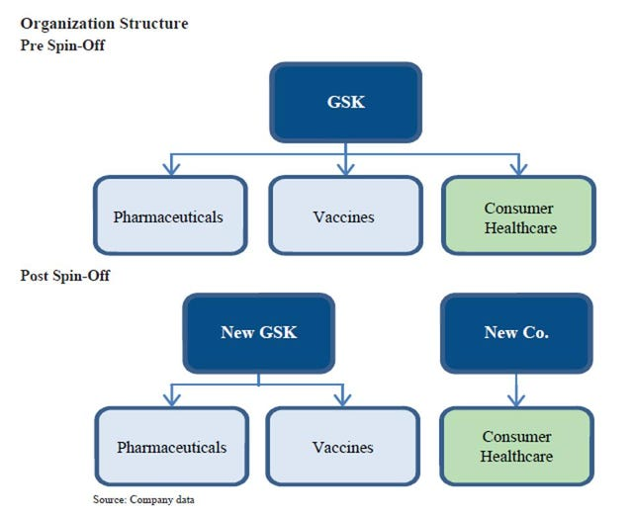
Figure 1: Organisational Structure of GSK Plc
(Source: Joe Cornell, 2021)
On the basis of the afore-mentioned figure 1, it has been recognised that the concept of the demographic figure majorly focuses on the brief organisational structure during the Pre-Spin off era along with the Post Spin Off Era (Joe Cornell, 2021). There are some slight differences related to the organisational structure of the GSK Plc and it is applicable for both the Pre-Spin off era as well as the Post Spin Off Era. According to the statement of Joe Cornell (2021), it has been recognised that the GSK is related to the terms of the three different factors, included within the terms of the Pharmaceuticals, Vaccines and the Consumer Healthcare. Along with this, it has also been observed that during the post spin off era the GSK focuses on the terms of the two segregated parts, included within the terms of the Pharmaceuticals along with the Vaccines. On the other hand, the next branch of the selected company is the New Company, which majorly follows the customer healthcare (Joe Cornell, 2021).

Vision and mission statement of the company
Vision:
Vision of the selected company, the GSK Plc, is majorly focused on the providence of the established opportunity for making the difference towards the millions of lives for every single day (GSK, 2023).
Mission Statement:
Along with this, the mission statement of the GSK Plc is related to the helping of people in terms of a large perspective for living long with feeling better (GSK, 2023).

Purpose and strategy of the company
Specific strategy of the selected company is related to the terms of the focusing on four strategic priorities for attaining the success of the company. These four strategies are included within the terms of the growth of a balanced business, delivery of more products with proper value, simplification of the operating model as well as the focusing on the responsible business (GSK, 2023).

SWOT analysis of the selected company, GSK Plc.

Strengths  - As per the opinion of Aditya Shastri (2021), the most strongest point for GSK Plc is related to the terms of the strong Research and Development of the company.  - It also focuses on the efficient sales along with the distribution network in terms of the global presence.  - Good brand image which establishes the good customer relationship along with the continuous providence of training. | Weaknesses  - Different healthcare frauds included within the terms of the false pricing charges, misleading sales along with the poor delivery of drug’s quality (Aditya Shastri, 2021).  - Highly competitive market among different pharmaceutical companies like Cipla, Novartis, Aurobindo, Sun Pharma and many others.  - Initiation of generic medicine ideas.
Opportunities  - GSK Plc focuses on the growth by acquisition and collaboration.  - Metabolic as well as the respiratory product launching during the recent days of the GSK Plc (Aditya Shastri, 2021).  - Increased opportunities within the GSK Plc during the sudden outbreak of the COVID-19 era. | Threats  - Increased competition within the UK market.  - Increased prices of the newly launched drugs within the GSK Plc.

Table 1: SWOT analysis of the GSK Plc.
(Source: Created by Author)

Significant understanding on the process and different stages of Marketing for GSK Plc.
First of all, it is important to say that GSK Plc or GlaxoSmithKline is related to the global biopharma company of the UK. Along with this, during the present days, the selected company has positively expanded their marketplaces across the whole world. This positive expansion is majorly based on the terms of the incorporation of the advanced marketing strategies within the selected company, GSK Plc. Based on an article, published by GSK (2023), it has also been recognised that the chosen company basically focuses on the terms of the unification of science, advanced technology as well as the different talents of the recruited employees within the UK based pharmaceutical organisation, GSK Plc.
In addition to the just previous section, it has also been recognised that the major marketing strategy of the selected pharmaceutical company of the UK is related to the core promotional as well as the marketing strategies. Along with this, the promotional process of the product related to the GSK Plc is based on the terms of the promotions through the TV commercials. Along with this, it has also been recognised that the major vital process of the marketing strategies of the GSK Plc is related to the terms of the Marketing Mix of 4 P’s, which has gradually converted towards the Marketing Mix of 7 P’s (Othman and Harun, 2021). Thereafter, some other strategies of the marketing within the GSK Plc are included within the terms of the innovation of the products or drugs, different pricing approach of the drugs as well as the promotional planning (Addison and Lawson, 2012)
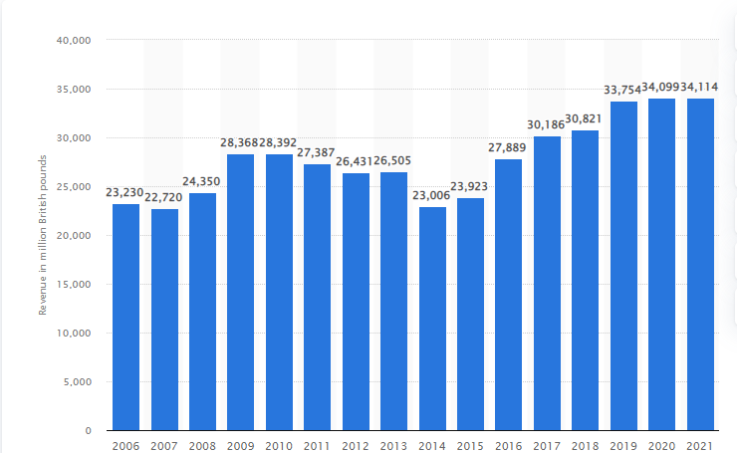
Figure 2: Revenue of GlaxoSmithKline from 2006 to 2021
(Source: Matej Mikulic, 2022)
Based on the aforementioned demographic figure 2, it has been observed that the picturesque is related to the terms of the particular concept based on the revenue of GlaxoSmithKline from 2006 to 2021 (Matej Mikulic, 2022). Along with this, on the basis of the figure 2, it has also been observed that the statistical figure 2, basically focuses on the volatile nature of the graph from the financial year of 2006 to the financial year of 2021. However, it has also been recognised that there is an exponential growth of the revenue of GSK Plc from the FY of 2024 to the FY of 2021 (Matej Mikulic, 2022). The core reason for this significant growth is related to the implications of the importance as well as the advanced marketing strategies within the selected pharmaceutical organisation of the UK, GSK Plc.

Understandability on the role of the marketing environment of the selected company, GSK Plc.
In addition to the previous section, it has also been recognised that this particular portion is related to the specific role of the marketing environment for the chosen pharmaceutical company of the UK, GlaxoSmithKline. Furthermore, it is also important to say that the organisation is based on the terms of the pharmaceutical and multinational company of Britain and also focuses as the biotechnology company, which is famous within the different places of the whole world. The headquarters of the company is related to the terms of London, United Kingdom. As per the recognition of Tien, Phu and Chi (2019), it has been recognised that there are six roles, which are included within the terms of the marketing strategy within an organisation. These roles are based on the terms of the product management, Marketing information management, pricing, selling as well as the distribution and promotion (Darmawan and Grenier, 2021). On the other hand, it has also been recognised that the marketing head of GSK Plc is related to the terms of the Lewis Dowling (Lewis Dowling, 2023). All the marketing strategies and the planning of the marketing strategies along with the implementations of the marketing strategy of the GSK Plc are included within the terms of the opinion of Lewis Dowling. Finally, it can be said that there are both the advantages as well as the hassles related to the implied marketing strategies for the selected organisation of the UK, GSK Plc or the GlaxoSmithKline. Furthermore, the implication of the advantages of marketing strategies will reflect the better profitability of the UK based pharmaceutical company, GSK Plc.

Situational analysis models for the specific company, GSK Plc.

PESTLE Analysis

Factors of the PESTLE analysis | Descriptions of the identified factors
Political Factor | - Implication of Brexit on the policies of the selected company of the pharmaceutical industry (GSK Plc or the GlaxoSmithKline) within the United Kingdom.  - Both the positive as well as the negative impact of the COVID 19 within the political atmosphere of the UK along with the impacts of the COVID 19 on the GSK or the GlaxoSmithKline.
Economic Factor | - Sudden pandemic outbreak of the COVID 19 has negatively impacted on the economic status of the United Kingdom as well as the people from the United Kingdom.  - Negative effect of COVID 19 on the UK economy is related to the recession, poor income of the UK people and lower rate of foreign exchange within the UK.  - As per the identification of an online article, published by Parliament UK (2023), it has been recognised that the concept of the Consumer prices or the Consumer Price Index (CPI) has been observed here. Furthermore, it has increased by 10.1%, as per the report of January, 2023. Moreover, this statistical data has been recognised in terms of the initial month of the present financial year.
Social Factor | - The revenue of GSK is highly related to the demographic factors, which are included within the terms of the Gender, Age, Income status, educational level and geographical location of the people related to the United Kingdom.  - Social factors are related to the terms of the generating of awareness by focusing on the importance of the medicines and drugs (for the respiratory and metabolism increasing drugs) for the betterment of the selected pharmaceutical organisation of the UK.
Technological Factor | - GSK Plc always follows the continuous transformation of advanced technology, which supports medical progress.  - The selected pharmaceutical company of the UK, GSK Plc, majorly follows the technological aspects in terms of the AI (or the Artificial Intelligence) along with the concept of the Machine Learning within the selected company.
Legal Factor | - The government of the UK has implemented some legislations, which are based on the particular medical industry.  - These legislations are the 1848 Public Health Act (Parliament, 2019)  - Along with this, it also focuses on the Medicines Act of 1968 (Ogunwole and Golden, 2021)  - Also emphasises on the Human Medicines Regulations and many others (Detela and Lodge, 2019).
Environmental Factor | - Implications of advanced technology can be focused on the different types of environment pollution, specifically air and water pollution.  - Also focuses on the terms of the 100% renewable energy for the supply of the electricity, which can be helpful for the e-vehicles along with some transportation with the electric energy (Sabadini and Madlener, 2022).
Table 2: PESTLE analysis of the GSK Plc.
(Source: Created by Author)

Porter’s Five Forces Model of GSK Plc.

Factors related to the Porter’s Five Forces Model | Description | Opportunity or Threat
Threat of New Entrants | - There are a large number of rival pharmaceutical companies within the UK (such as Cipla, Novartis, Aurobindo, Sun Pharma and many others). Due to this tough competition among all the pharmaceutical companies of the UK, the selected company, GSK Plc, is continuously engaged with the innovation of new medical products and services. | Opportunity
Bargaining power of Suppliers | - It focuses on the effective supply chain process along with some multiple and efficient suppliers.  - It also focuses on the different product designs along with some versatile and scientific uses of the raw materials. | Opportunity
Competitive Rivalry | - It focuses on the sustainable differentiation related to the establishment of the different types of measuring scales.  - This factor also focuses on the terms of the Collaboration of GSK Plc with its competitors like the collaboration of GSK Plc along with Sanofi (GSK, 2020). | Opportunity
Threat of Substitutes | - GSK has a large base of global customers due to their reputed brand image (Yuyan, 2023). | Opportunity
Bargaining power of Customers | - Rapid innovation of products refers to the huge attraction and reliability towards the organisation. | Opportunity
Table 3: PESTLE analysis of the GSK Plc.
(Source: Created by Author)

5 C Analysis
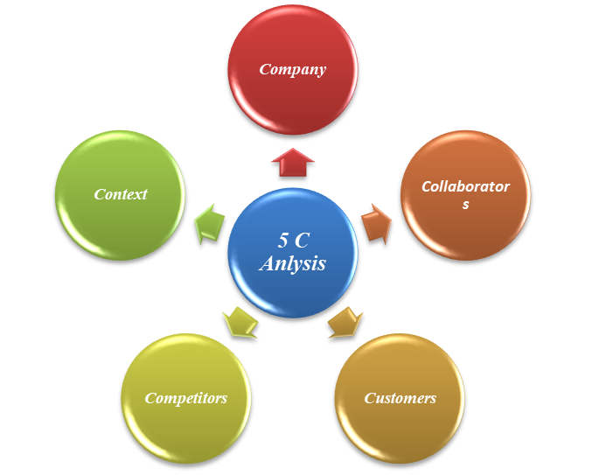
Figure 3: 5 C Analysis
(Source: Created by Author)
Based on the afore-mentioned demographic picture or the figure 1, it has been recognised that the five C analyses are included within the terms of the different five factors. These all factors are included within the terms of the company, collaborators, customers, competitors along with the context of the selected company of the GSK (Lee et al., 2019). All these factors along with their brief discussion will be focused on the terms of the following section. These are included within the terms of the identified five sections.
- Company: Here, the selected pharmaceutical company of the UK is GSK Plc, which was previously known as the GlaxoSmithKline. The headquarter of the organisation is situated within London, England. This global bio pharma company is majorly based on the terms of the British multinational company, which aims to focus on the regular upgradation of the medical sectors.
- Collaborators: This selected pharmaceutical organisation GSK Plc also collaborates their business with Sanofi (GSK, 2020).
- Customers: Due to the reputed brand image of GSK Plc, they have a large group of customers across the whole world.
- Competitors: Some of the competitors of the selected company, GSK Plc are based on Cipla, Novartis, Aurobindo, Sun Pharma and many others.
- Context: The specific context of this analysis is related to the proper situational analysis of the company.

STP of the chosen company, GSK Plc.
The idea of STP majorly focuses on the acronym of the Segmentation, Targeting as well as the Positioning. These all factors are referring towards the selected company, GSK Plc.

Factors of STP | Description related to the GSK Plc
Segmentation | This segmentation is related to the terms of the GSK Plc, which are included within the terms of the demographic areas, market segmentations along with the behavioural perspectives within the particular company.
Targeting | Targeting of the GSK Plc is based on the terms of the particular target audience which are included within the terms of the general public of the UK and it is also applicable for the global target audience from the initial age to the senior citizen.
Positioning | Here, the positioning of the GSK is related to the terms of the recognised brand value of the GSK. Moreover, the brand value of the GSK is related to the high focus of the organisation and global reputation of the organisation.
Table 4: STP analysis of the GSK Plc.
(Source: Created by Author)

Marketing Mix for the selected company, GSK Plc.
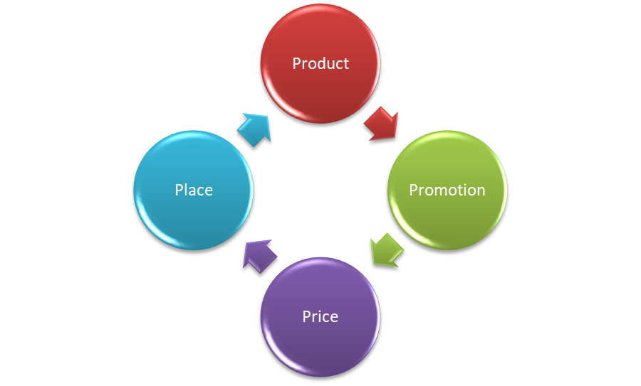
Figure 4: Marketing Mix of 4 P’s
(Source: Created by Author)
The selected company, GSK Plc, majorly focuses on the terms of the four different factors, which are included within the terms of the different factors. These are product, promotion, price as well as the place of the selected organisation. These all factors are based on the terms of the particular concept of the Marketing Mix (Darmawan and Grenier, 2021). The purpose of Marketing Mix is related to the terms of the production of the desired responses from its target market.
Product: Some selected products of the GSK Plc are related to the terms of the Otrivin, Advil, Centrum, Panadol, Voltaren, Sensodyne and many others (GSK, 2022)
Promotion: Some promotional strategies of the GSK Plc are included within the terms of the Marketing mix of 4 P’s along with the unification of science and implications of the advanced technology (GSK, 2022).
Price: Previously, it has been recognised that there were some reasonable prices, which are related to the terms of the different product ranges of the GSK Plc, within the UK. However, newly launched products are slight high in cost.
Place: The selected company majorly focuses on the large number of marketplaces across the whole world.

Conclusion and recommendations
Therefore, based on the aforementioned discussion on the present study, related to the topic of the marketing fundamentals, external analysis along with the different types of the evolutionary scenes for the chosen organisation of the UK, GSK Plc. This particular study is based on the terms of the different models included within the terms of the SWOT, PESTEL, Marketing Mix of 4 P’s and many others. All these things have both the advantageous and the disadvantages perspectives. Moreover, the incorporation of the benefits along with the removal of the negative aspects are important for the future betterment of the selected organisation, GSK Plc. Thereafter, the recommended strategies are the implication of the up to date and advanced strategies and technologies for the future profitability of the selected organisation, GSK Plc.

Reference List
Addison, A. and Lawson, V., 2012. GlaxoSmithKline: the shifting from Patented to Generic Drugs. Retrieved August, 1, p.2015.
Aditya Shastri (2021) Complete SWOT Analysis of GlaxoSmithKline: https://iide.co/case-studies/swot-analysis-of-glaxosmithkline/
Darmawan, D. and Grenier, E., 2021. Competitive Advantage and Service Marketing Mix. Journal of Social Science Studies (JOS3), 1(2), pp.75-80.
Darmawan, D. and Grenier, E., 2021. Competitive Advantage and Service Marketing Mix. Journal of Social Science Studies (JOS3), 1(2), pp.75-80.
Detela, G. and Lodge, A., 2019. EU regulatory pathways for ATMPs: standard, accelerated and adaptive pathways to marketing authorisation. Molecular Therapy-Methods & Clinical Development, 13, pp.205-232.
GSK (2020) GSK Investor Presentation https://www.gsk.com/media/5984/gsk-ir-booklet-may-2020.pdf
GSK (2020) Sanofi and GSK to join forces in unprecedented vaccine collaboration to fight COVID-19: https://www.gsk.com/en-gb/media/press-releases/sanofi-and-gsk-to-join-forces-in-unprecedented-vaccine-collaboration-to-fight-covid-19/
GSK (2022) GSK introduces Haleon to investors: https://www.gsk.com/en-gb/media/press-releases/gsk-introduces-haleon-to-investors/
GSK (2023) Our Vision, Mission and Strategy: https://pk-consumerhealthcare.gsk.com/en-gb/about-us/profile-of-company/#:~:text=GSK%20Consumer%20Healthcare%20follows%20its,provide%20them%20with%20quality%20products.
GSK (2023) Purpose, strategy and culture: https://www.gsk.com/en-gb/company/purpose-strategy-and-culture/#:~:text=We%20are%20a%20global%20biopharma,a%20step%2Dchange%20in%20performance.
Joe Cornell (2021) GlaxoSmithKline To Spin-Off Consumer Healthcare Business By Mid-2022: https://www.forbes.com/sites/joecornell/2021/07/15/glaxosmithkline-to-spin-off-consumer-healthcare-business-by-mid-2022/?sh=77f2846a72d0
Lee, Y., Fong, E., Barney, J.B. and Hawk, A., 2019. Why do experts solve complex problems using open innovation? Evidence from the US pharmaceutical industry. California Management Review, 62(1), pp.144-166.
Lewis Dowling (2023) Head of Marketing - Respiratory at GSK https://uk.linkedin.com/in/lewisdowling#:~:text=Lewis%20Dowling%20%2D%20Head%20Of%20Marketing%20%2D%20GSK%20%7C%20LinkedIn
Matej Mikulic (2022) GlaxoSmithKline's revenue from 2006 to 2021: https://www.statista.com/statistics/266297/glaxosmithkline-revenue-since-2006/
Ogunwole, S.M. and Golden, S.H., 2021. Social determinants of health and structural inequities—root causes of diabetes disparities. Diabetes Care, 44(1), pp.11-13.
Othman, B. and Harun, A.B., 2021. The influence of service marketing mix and umrah service quality on customer satisfaction and customer loyalty towards umrah travel agents in Malaysia. Technium Soc. Sci. J., 22, p.553.
Parliament UK (2023) Rising cost of living in the UK: https://commonslibrary.parliament.uk/research-briefings/cbp-9428/#:~:text=Consumer%20prices%2C%20as%20measured%20by,been%20factors%20causing%20rising%20inflation.
Parliament, U.K., 2019. The 1848 public health act.
Sabadini, F. and Madlener, R., 2022. A smart grid with renewable energy sources, e-vehicles, and storage systems. Smart Grids for Renewable Energy Systems, Electric Vehicles and Energy Storage Systems.
Tien, N.H., Phu, P.P. and Chi, D.T.P., 2019. The role of international marketing in international business strategy. International journal of research in marketing management and sales, 1(2), pp.134-138.
Wangari, J., 2008. Growth through merger: a case study of Glaxosmithkline PLC (Doctoral dissertation, University of Nairobi).
Yuyan, G., 2023. A financial analysis report of three typical biopharmaceutical companies in UK. Academic Journal of Business & Management, 5(1), pp.165-170.

