
Report
Internet Technology and Security

April 23, 2021
Student number: 1904085
Harrison Stone

Table of Contents
Introduction 2
Requirements 2
Implementation 2
Validation 4
HTTP 4
CSS 6
Evaluation 6
Terminology research 6
Usability 6
Accessibility 7
Search engine optimisation 8
Stone music website evaluation 9
Usefulness 9
SEO 9
Accessibility 10
Perceivable 10
Operable 10
Understandable 10
Robust 10
References 11

Introduction
This report is going to go over requirements of the website and how it is going to be implemented. It will also show the finished website and show validation and how to fix the errors that come up during validation. It will also provide and evaluation on the usability accessibility and search engine optimisation.

Requirements
The purpose of the website is to promote drum and bass in the Swansea area and also to showcase some of the best drum and bass artists. It will also allow the users to see what’s on soon near them and click the button to go book to go to the event. It will also provide some video examples of what this genre of music is all about. The target audience would be teenagers to young adults as they are more likely to listen to this type of music and go to the events drinking. This website will be relevant because the drum and bass scene in the UK has been growing massively in the last few years.

Implementation

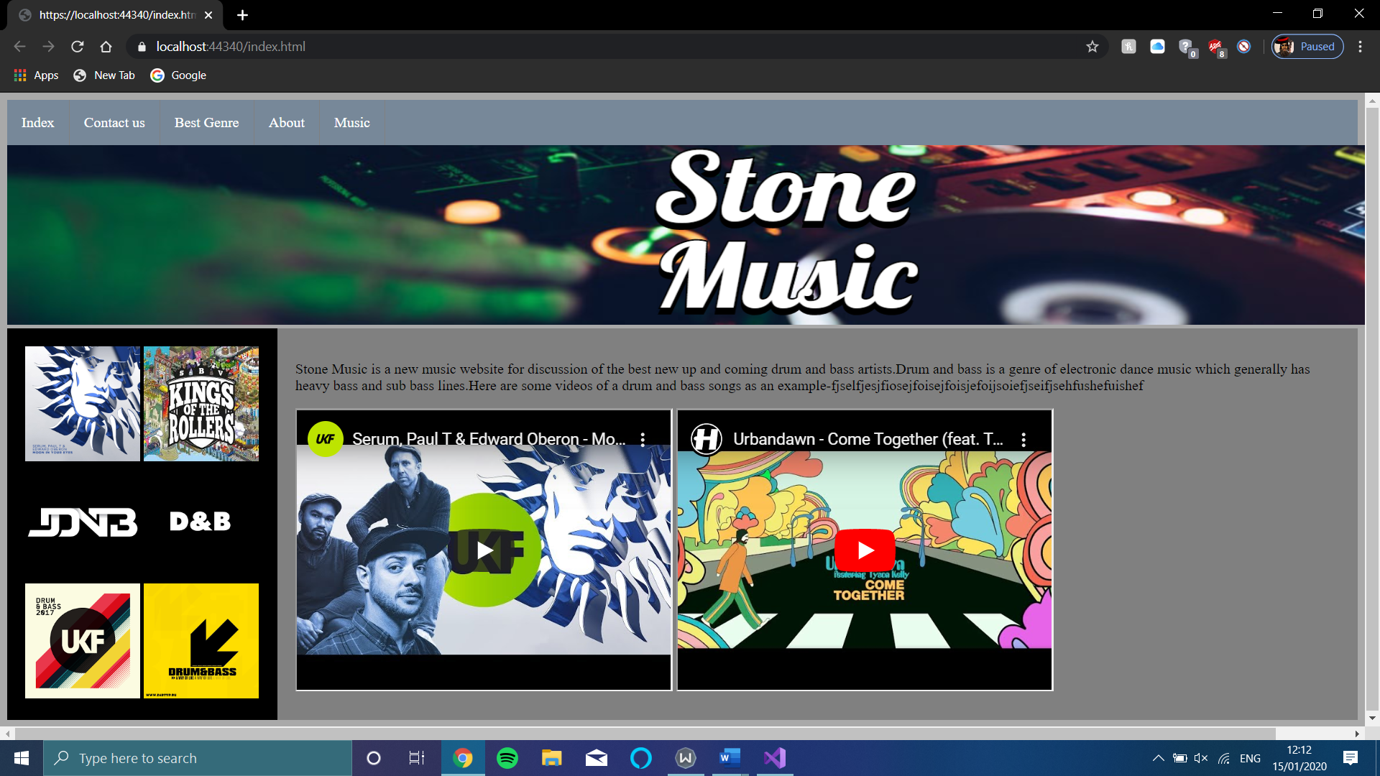
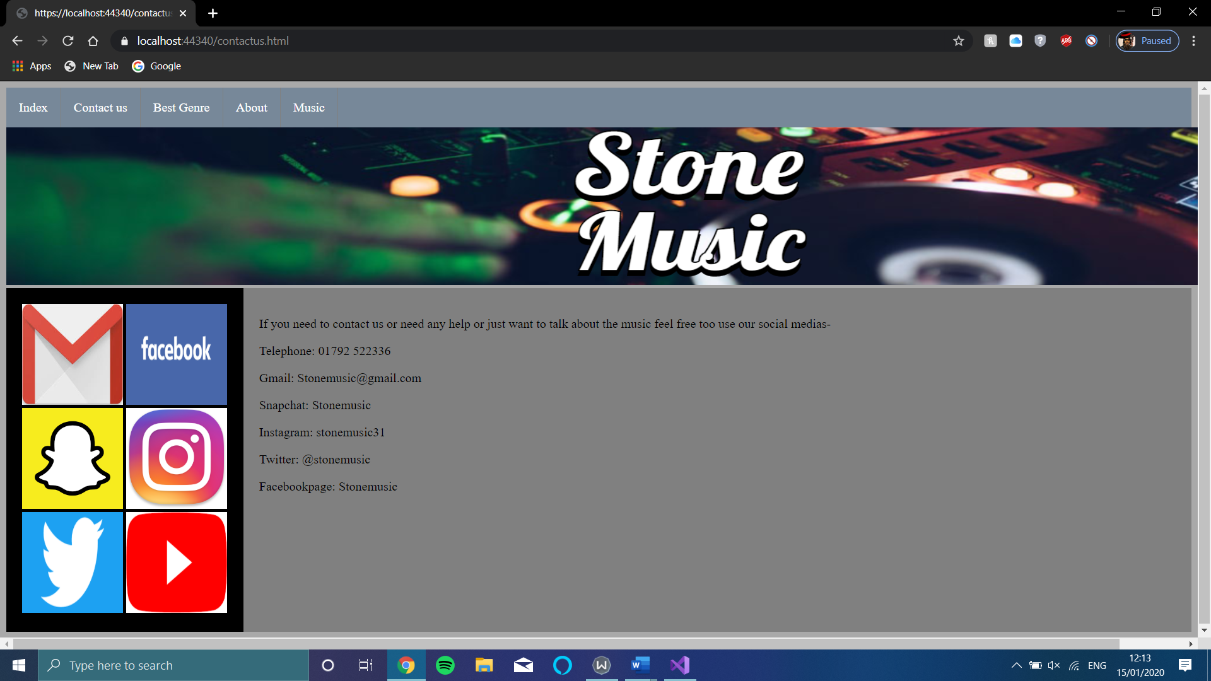
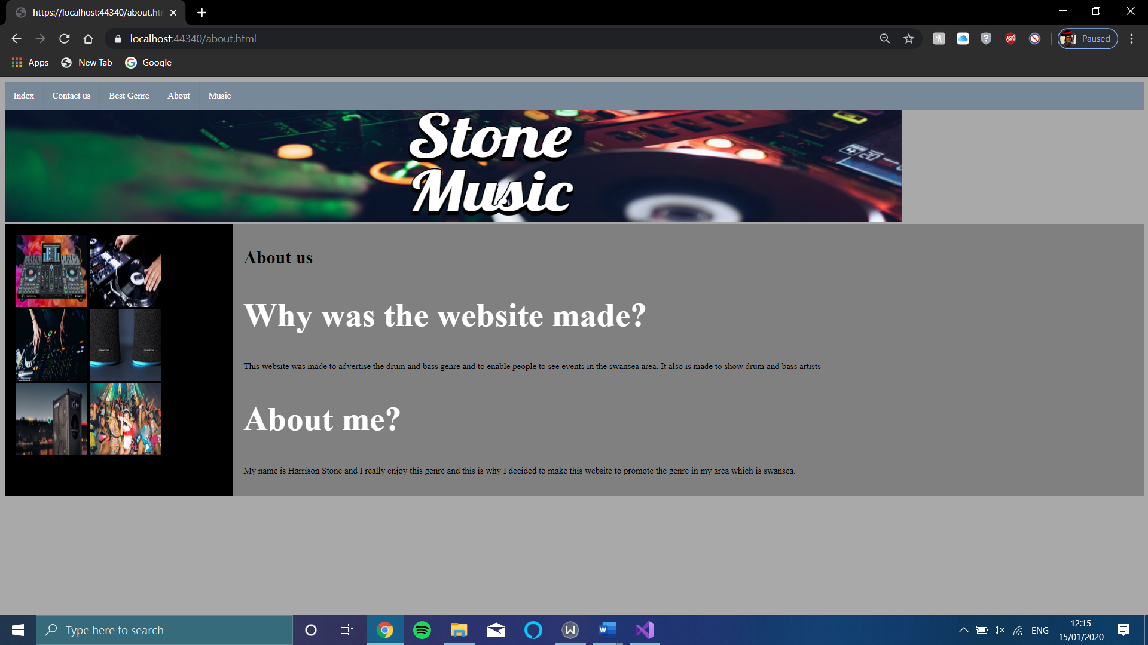
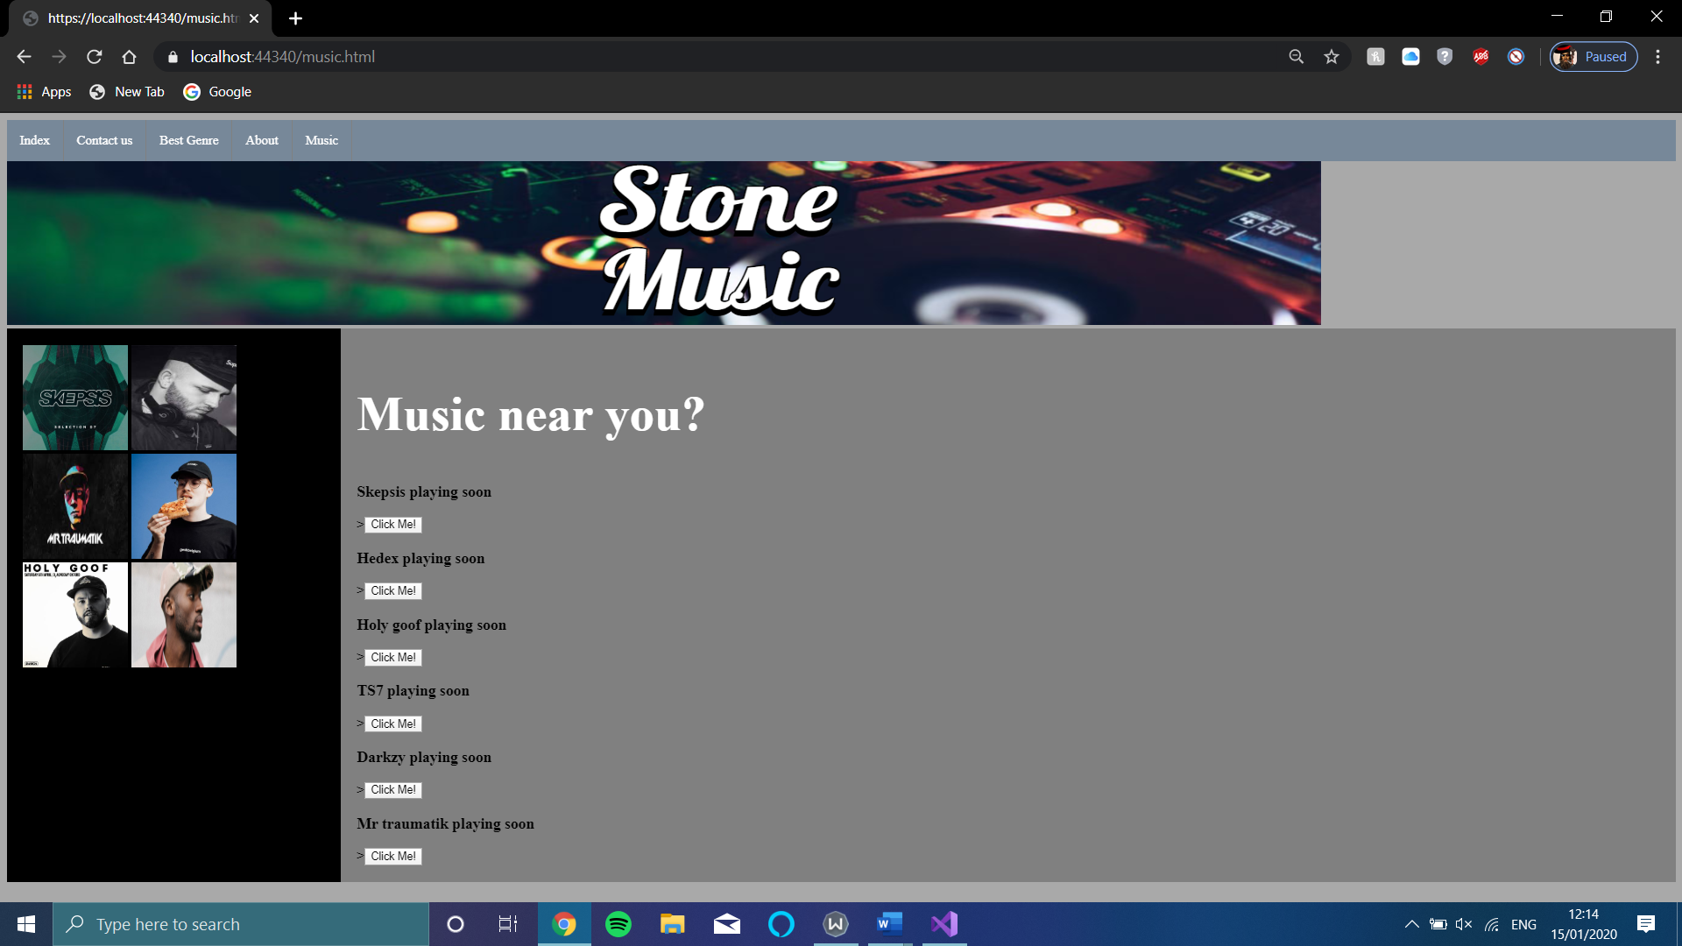

Validation

HTTP
  - Error 1
The first error that validation brought up was that my title element was empty. This was easy to fix as all I needed to do was input text into the “<title>” brackets. This error was on all the pages so now has been corrected.

  - Error 2
The second error that it displayed was there was a space in the link to find the pictures in my folders to fix this I reduced the number of folders it went through, so the link is now just “images/music1.png” for example. This was on all the pages so has now been corrected.
  - Error 3
Error: Attribute ; not allowed on element img at this point.
From line 22, column 5; to line 23, column 46
</ul>↩ <img src="images/banner.png" alt="stone banner"↩ style="width:1600px;height:200px;" ;>↩↩
Attributes for element img:
Global attributes
alt — Replacement text for use when images are not available
src — Address of the resource
srcset — Images to use in different situations (e.g., high-resolution displays, small monitors, etc.)
sizes — Image sizes for different page layouts
crossorigin — How the element handles crossorigin requests
usemap — Name of image map to use
ismap — Whether the image is a server-side image map
width — Horizontal dimension
height — Vertical dimension
referrerpolicy — Referrer policy for fetches initiated by the element
decoding — Decoding hint to use when processing this image for presentation

I could not find a solution to correct this error.
  - Error 4
Error: Bad value images/dj decks.jpg for attribute src on element img: Illegal character in path segment: space is not allowed.
From line 27, column 13; to line 28, column 51
<img src="images/dj decks.jpg" alt="dj decks"↩ style="width:128px;height:128px;">↩
To fix this error all I needed to do was remove the space from the name of the image file.
  - Error 5
Error: Bad value images/unglued remix.jpg for attribute src on element img: Illegal character in path segment: space is not allowed.
From line 26, column 13; to line 27, column 51
<img src="images/unglued remix.jpg" alt="unglued logo"↩ style="width:128px;height:128px;">↩
All I had to do to fix this error was remove the space in the image name.

CSS
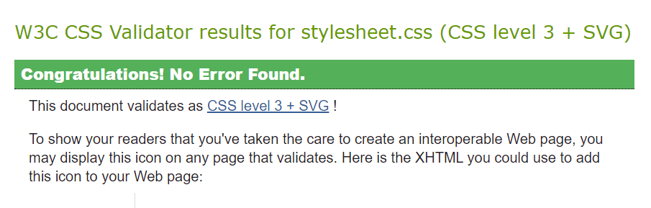

Evaluation

Terminology research

Usability
This term regards “Usability is a more comprehensive concept than is commonly understood by “ease-of-use” or “user friendliness”.” (Brech, 2018)
Things that usability covers are-
- Allowing users to use the website and reach the area they want efficiently and effectively.
- Allowing new users to use the website easily and effectively with little to no guidance.
- Useable by a wide range of users with different capabilities.
- Reducing the amount of possible usage errors.
- Easy to maintain the website.
It has been found that improving the usability of the website has been found to improve the chances of the users of the page to return. “The results of the empirical analysis confirmed that the trust of the user increases when the user perceived that the system was usable and that there was a consequent increase in the degree of website loyalty.” (Carlos Flavian, 2006)
Flavian also found that usability improved the influence that the website had on the user and the overall satisfaction which is likely the cause of the Increased level of loyalty to the website. He also found that it improved the users trust due to increased satisfaction of using the webpage.

Accessibility
Web accessibility is the act of ensuring that the website is usable by people with disabilities which may not be able to use the page like someone who doesn’t require additional support or features. It usually aims to allow users with disabilities to “perceive, understand, navigate, and interact with the Web” and also to “contribute to the Web” (Lawton, 2019).

“Initiative (WAI) [2] for creating accessible Web pages have been developed. In parallel the compliance with these guidelines has been embodied in the legislation of many countries to support better access for people with disabilities. All information and all functionalities provided on a Web page should be accessible and cope with different handling and presentation options that suit a variety of personal needs and preferences, devices and situations of use.” (Kerstin Matausch, 2012)
Disabilities that may require additional help include –
- Visual Impairment
- Deafness or hard of hearing
- Neurological impairment
- Physical impairment
- Unable to speak or use speech capabilities.
Web accessibility also gives benefits to people who don’t have disabilities such as people on smaller devices. And people who are aging and beginning to lose some of their abilities. It will also help people who have an injury such as a broken arm and can’t use the website easily.

There are many different things that you can do to improve accessibility this can include things such as just adding subtitles and headings to lay it out making it easier to find data as it is all structured correctly avoiding skipping heading numbers as screen readers may think some of the page is missing. Other methods include-
- Having a suitable alt text for images
Having a suitable alt text allows screen readers to understand what the image is trying to display without actually needing to see it.
- Giving links a clear name, which is unique
This is key to allowing visually impaired people navigate the webpage as if there is lots of links with the same name as its difficult for them to differentiate between them due to it reading out the link names.
- Use colour carefully
When using colour ensure that you use colours which are suitable for people with colour-blindness as almost 10% of the population are colour blind people. Although it is also a good idea to use colours for some learning disabilities so it is often good to use colour but also using indicators to help people that may not be able to see the colours normally.
- Design forms to be more accessible to people with disabilities.
When form fields are on a webpage, they must be labelled properly so that a screen reader can correctly read it.
- Making a table for data
When making a table for data it is a good idea to use CSS to present it and using titles and for rows and columns makes it easier for people using screen readers to understand.
- Allowing data to be accessed on a keyboard alone.
Doing this allows a user with mobility disabilities to navigate the website ways of doing this include clicking tab and using arrow keys to move around the screen. Another good practice is too adding anchor links to longer pages allowing data to be skipped easily if needed.

There are four key principles or “P.O.U.R” to accessibility which are-
Perceivable – Providing alt texts for images and separating the background of the page to the foreground
Operable - Making it usable on a keyboard alone and providing extra ways for navigation.
Understandable – Make the information or content easy to read and understand. Make the page operate like others so they can predict how to navigate it.
Robust- including current and future technology which will assist people on the site.

Accessibility is a key part of designing a website as making the internet accessible for people with a large range of different capabilities allowing people with disabilities an equal opportunity to view and find new information on the internet. If websites didn’t take this into account, it would make it much more difficult for someone with disabilities to keep up with information they want to know as it would be difficult for them to access or they would need help to access it.

Search engine optimisation

“It's the process of taking steps so your website will have a higher ranking with major search engines when your clients type in specific keywords or phrases such as "animal hospitals" and the name of their city.
Keep in mind the average consumer will only look at websites that show up on the first page of their Internet search. This means your practice's website needs to appear in the top seven listings if you want pet owners to click on your site.” (Donnelly, 2011)

Search engine optimisation is the process of getting the maximum number of users to a webpage. This can be done in numerous ways such as having words relating to what the user searched within the webpage. Also using a relevant title is a good way to improve the SEO of the website. Its also a good idea to have other pages link back to that page as it makes that page look like it has good information. However, these links must be from other more credible websites as fake links can be bought to gain more traffic. Linking a word which relates to the site is a good idea while trying to optimise as it means that other sites can see what your webpage is about allowing people to find it based on those linked words. Webpage reputation also matters as pages which update with good information on a regular basis are more likely to rise up the list within a search engine. Another way to improve SEO is to use meta-tagging which is simply put words relating to the web page in the meta tag section. These words will bring more people to the site as more words they search can link them to the page. Another way of improving SEO is reducing file size. This makes them load quicker meaning that people are more likely to stay on if it loads instantly when clicked.

Search engine optimisation’s role in web design is to differentiate good websites from worse ones showing more credible websites further up which often have better usability and accessibility for users. These sites also often have better information and will be referenced and linked by other websites as a source of quality information.

Stone music website evaluation

Usefulness
The design of the webpage is very easy to navigate for a first-time user as the webpage has a simplistic look with easily visible navigation links at the top of each page. As it has a simplistic design it is easy for the user to perform tasks they want. The speed of the website is very good allowing experienced users to easily navigate the site also with speed and ease. As it simple the user is likely able to remember how to navigate the site if they choose to visit the site again. The webpage does not currently have any errors which means these shouldn’t cause an issue for any user. The website should be satisfying for users to use as it is easy to navigate and has interactive content such as videos. I believe in the future I could improve the overall design of the website as its quite plain and not very visually pleasing. I could also improve the amount of content which the website provides as there is not much information on the site.

SEO
- Have added “<Titles>” tags
Adding a title is a good idea for SEO as it means people searching for these words could find the page.
- Have added content surrounding the subject of the page.
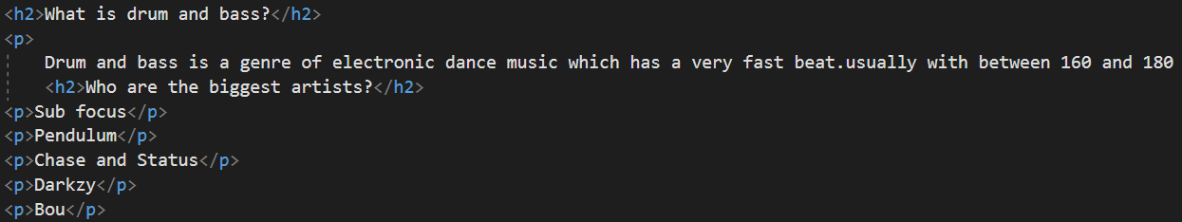
Putting relevant information about the drum and bass genre will increase the SEO of the page as people searching words within this content can then be recommended the website.
- Have used linking pages.
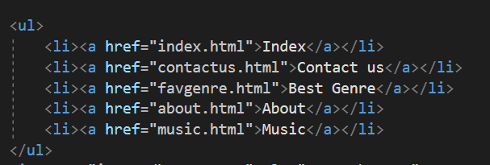
These other relevant pages linking to each other will increase the SEO of the page as a whole.

Accessibility

Using the AXE browser extension, I found that I could improve the accessibility of the web page.

Perceivable
Using an accessibility check showed me that I have properly added alt text to image to allow users using screen readers to understand what the pictures on the website are. However it says the colour contrast on my website is not suitable enough to be accessible by all users so this is an area I could improve in future by changing the colour scheme a little so that people with colour blindness can better understand and access my website.

Operable
Unfortunately, the website doesn’t have a feature making it operable however this would be a good improvement to make in the future to allow accessibility to a wider range of users.

Understandable
My content is understandable however there is some places where I could have added title to make the pages more accessible to users of the site.

Robust
As there is not lots and lots of content on the pages so it is not accessible under this standard of web accessibility.

References

webwisewording.com/usability-definition/
https://www.w3.org/WAI/fundamentals/accessibility-intro/
https://www.sciencedirect.com/science/article/abs/pii/S0378720605000169
https://webaccess.berkeley.edu/resources/tips/web-accessibility
https://blogs.libraries.indiana.edu/redux/2018/06/13/understanding-the-4-principles-of-accessibility/

