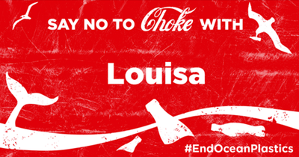
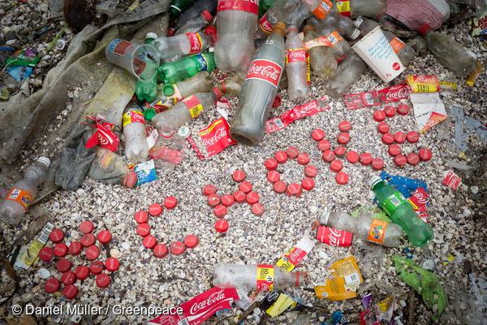
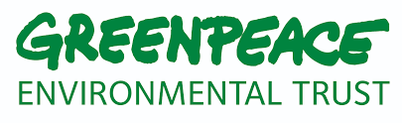
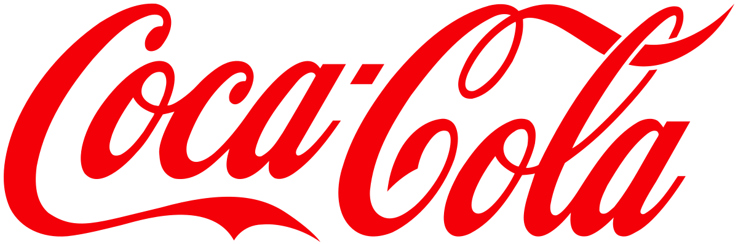
This is where Greenpeace aims to make a change, again referring to our vision we aim to change the way industries, the government and individuals look and think about the earth. That is why we have created several campaigns on plastic footprint in a bid to influence the 6 world’s biggest soft drinks company including Danone and Coca Cola to reduce the amount of plastic they are producing. However, Coca Cola refused to disclose the size of their plastic footprint indicating that it is large and emphasised that “no single company or sector can tackle these problems on their own” (Casson, 2017). They also seemed to shift the blame on to customers for demanding so much of the product, nevertheless there are going to be ways to reduce the number of single-used bottles whether that being increasing the sizes of their small bottles, so consumers have no choice but to buy a bottle that will last longer or by embracing reusable packaging.
To get the message across to Coca Cola it was the start of a long campaign known as “Don’t let coke choke our oceans” that is still ongoing alerting them to the damage they are creating and emphasising that if there is no change now, it will be too late. The campaign consists of many spoofing activities, such as;
- The release of a report against Coca Cola and their plastic production
- Volunteers placing bottle hangers on coke bottles in supermarkets to emphasise their responsibility
- Spreading the “Say no to Choke with Louisa” and “Wish you weren’t here” catchphrases
- Boycotting coke’s online GIF maker with ocean plastics messages
- Targeting coke-branded vending machines and billboards with stickers displaying suffering sea life because of plastic waste
- Releasing a spoof version of Coke’s Christmas advert
- Obtaining half a million signatures on a petition to stop coke choking our oceans
All these activities seemed to have put pressure on Coca Cola’s PR activities as they hired a PR company which can be seen as a strategy to help them “tell a better story” on ocean plastics and have recently tried to release a global plastics ban (Casson, 2017). However, Greenpeace still think it is not good enough as they still put the blame on customers and aren’t looking at reducing their plastic footprint, although they feel their attempts have been successful as they have got one of the largest soft drinks company to admit they play a role in ocean plastic pollution, consider a global strategy and to increase the amount of recycled plastic content they use (Brown, 2018).

Greenpeace is an organisation that has expanded considerably since it was first founded in 1971 by a small group of activists as now they have a presence in more than 40 countries.
Greenpeace stands for positive change through action which is done in many ways from investigating and exposing environmental abuse to targeting the government and decision makers to translate the demand of our campaigns and bring it to action to protect the environment. We target these the most as they have the highest influencing power on both big and small companies.
Their vision is to transform the world by primarily changing the way people think about it. They want all industries, the government and individuals to stop viewing the earth as an unlimited resource and to start treating it as something delicate that needs our protection and careful management. (Greenpeace, 2018)
It is evident that big organisations like Coca Cola are having an impact on our environment as it has been reported that world top firms caused $2.2 trillion of environmental damage in 2010. That was 8 years ago, so imagine the impact they’re having on the evironment now. (Jowit, 2010)
A major issue we have been tackling for years is the amount of plastic in landfill sites, on our beaches and in our ocean and it is suggested that plastics now dominate daily human life in the form of throwaway and single-use products such as drink bottles and cutlery. It has also been highlighted that it is affecting the wildlife in the surrounding areas from whales to birds and David Attenborough has warned in a recent episode of Blue Planet that it is estimated there is now a 1:2 ratio of plastic to plankton and if nothing is done soon, plastic will outweigh fish by 2050. (Kirk, 2017)
Companies are never going to tell you how much plastic they are producing let alone wasting. However, we were able to discover through analysis that Coca cola increased the production of throwaway plastic bottles by well over a billion in 2016, putting their production at over 110 billion bottles each year. In addition, more than half a trillion bottles are produced globally with only a fraction being recycled. The majority are ending up as a plastic mountain in a landfill site or in the ocean as it is though that between 5 million and 13 million ends up being ingested by sea birds, fish and other organisms. (Laville, 2017)

“Don’t let Coke
choke our oceans”

References
Brown, T., 2018. Coca-Cola Released Their Global Plastics Plan – Did They Pass The Test?. [Online]
Available at: https://www.greenpeace.org.uk/coca-cola-released-global-plastics-plan-pass-test/
[Accessed 22 March 2018].
Casson, L., 2017. Coca-Cola's Love Story: Where's the happy ending?. [Online]
Available at: https://www.greenpeace.org.uk/coca-colalovestory/
[Accessed 22 March 2018].
Casson, L., 2017. Greenpeace take on Coca-Cola’s plastic footprint – the campaign so far. [Online]
Available at: https://www.greenpeace.org.uk/greenpeace-coca-cola-plastic-campaign/
[Accessed 22 March 2018].
Greenpeace, 2018. About us. [Online]
Available at: https://www.greenpeace.org.uk/about/
[Accessed 20 March 2018].
Jowit, J., 2010. World's top firms cause $2.2tn of environmental damage, report estimates. [Online]
Available at: https://www.theguardian.com/environment/2010/feb/18/worlds-top-firms-environmental-damage
[Accessed 20 March 2018].
Kirk, A., 2017. Five shocking facts about the scale of plastic pollution that's choking our seas. [Online]
Available at: https://www.telegraph.co.uk/men/the-filter/five-shocking-facts-scale-plastic-pollution-choking-seas/
[Accessed 20 March 2018].
Laville, S., 2017. Coca-Cola increased its production of plastic bottles by a billion last year, says Greenpeace. [Online]
Available at: https://www.theguardian.com/environment/2017/oct/02/coca-cola-increased-its-production-of-plastic-bottles-by-a-billion-last-year-say-greenpeace
[Accessed 22 March 2018].

