

Postgraduate/Distance Learning
Assignment coversheet & feedback form

THIS SHEET MUST BE THE FIRST PAGE OF THE ASSIGNMENT YOU ARE SUBMITTING (DO NOT SEND AS A SEPARATE FILE)

For completion by the student:
Student Name: Maria Meier

Student University Email: 2309714@uwtsd.ac.uk
Module code: HPCA7015  Module title: Foundations in Cultural Astronomy and Astrology | Student ID number:  2309714 |  |  | Educational support needs:  Yes/No
Assignment title: Essay based on a Sky Journal

Assignment due date: 30 November, 2023
This assignment is for the 1st X 2nd 3rd 4th 5th 6th module of the degree
I confirm that this is my original work and that I have adhered to the University policy on plagiarism.
Signed ……………………………………………………………
Email submission: if you are submitting this form via email, please tick this box X
(as a substitute for your signature) to confirm that you agree to the above declaration.
Assignment Mark
1st Marker’s Provisional mark
2nd Marker’s/Moderator’s provisional mark
External Examiner’s mark (if relevant)
Final Mark

NB. All marks are provisional until confirmed by the Final Examination Board.

For completion by Marker 1 :
Comments:

Marker’s signature: |  |  | Date:
For completion by Marker 2/Moderator:

Comments:

Marker’s Signature: |  | Date:
External Examiner’s comments (if relevant)

External Examiner’s Signature: |  | Date:

Maria Meier 2309714 Page 1 of 7

Essay based on a Sky Journal
The Morning Star: Tracking Venus Across Enchanted Skies
Word Count: 2055

This essay explores insights from a sky journal that I kept from October 24 to November 24, 2023. I chose to track the movement of the planet Venus in its iteration as the Morning Star just before sunrise from my backyard situated in the northwestern sector of Albuquerque, New Mexico. The goal of the journal was to identify noteworthy celestial objects during this period and subsequently observe them for changes and patterns.
My methodology aimed to ensure comparable observations, so I scheduled my viewing for one half-hour before official sunrise, positioning myself on a high spot in the yard with a clear view of the sky. Using an iPhone, I captured images of the visible Venus recording my observations, reflections, and occasional facts about the planet in an online journal. On the rare cloudy mornings, I used SkyView Lite, a star-mapping phone app to estimate Venus' location to capture images of the area.
From this process of observation, three themes emerged that I explore in depth in this essay: brightness, motion and enchantment. They will be framed within the context of the quote by Vincent van Gogh, 'Be clearly aware of the stars and infinity on high. Then life seems almost enchanted after all,’ as I explored not just the quantifiable, but also developed reflections drawn from my observations that led me to focus on the sense of wonder invoked by the exercise.

'Be clearly aware of the stars'

Looking out my window at the dark sky, the first thing that came to mind was the age-old rhyme, "star light, star bright, first star I see tonight." Even though it was morning, and I knew factually that the bright object I was looking at was the planet Venus, not a star, considering its light made me realize why earlier cultures would invoke the celestial objects as deities. I decided then that Venus, in its current iteration as the Morning Star, would be the subject of my month-long observation. Early into the process, I wrote regularly about how notable the light Venus emits was and even admitted that at times when its light was coming in my window, I assumed it was the Moon without bothering to check. The role of brightness plays in determining the significance of celestial objects was the first theme of my sky-watching.

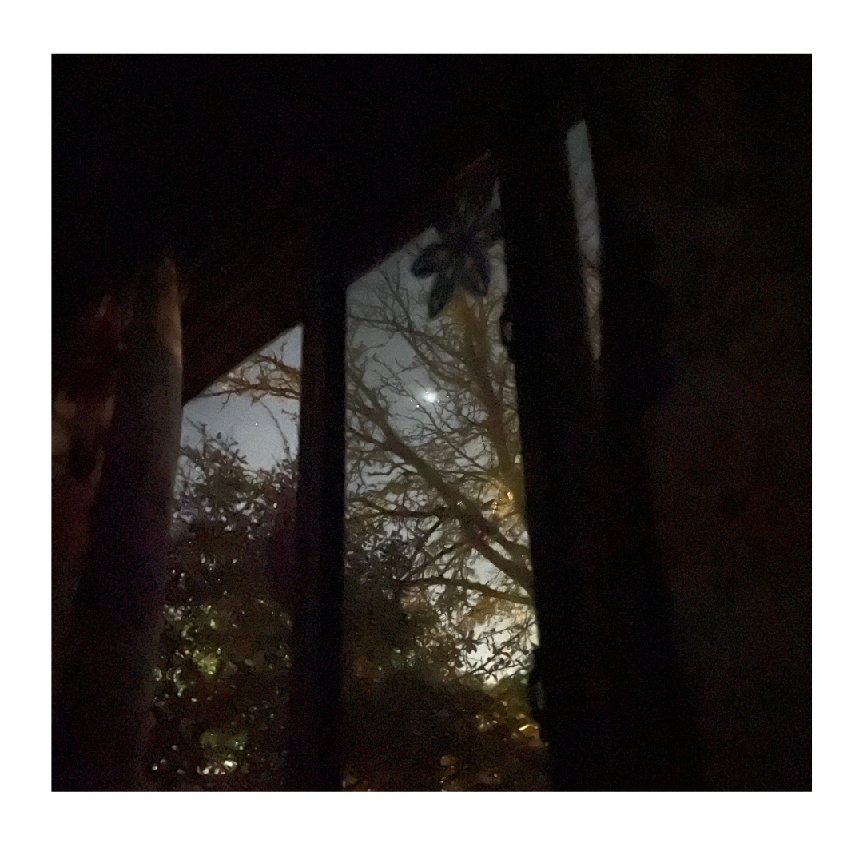
Figure 1 Venus as the Morning Star viewed from my bedroom window on the first day of observations at approx. 5:30 am MDT.

Maria Meier 2309714 Page 2 of 7

As the closest planet to Earth, Venus is often the brightest object in the sky after the Sun and Moon. 'For months at a time, the planet Venus will appear on the eastern horizon before dawn and linger there through daybreak.' While the Moon is over twice as bright due to its proximity to Earth, it is easy to see how Venus's brightness sets it apart and has fascinated scientists and artists for ages.
In his 2nd century work, 'Almagest', the astronomer Ptolemy crafted a catalog of over one thousand visible stars ranked by brightness. He is believed to have built this list based on the work of Hipparchus who began this process two centuries earlier. Ptolemy's work on star brightness is still noted for its accuracy today. Modern astronomers use "apparent magnitude" to measure the brightness of celestial objects. The lower the value of the apparent magnitude, the brighter the object, and the easier it is to see with the naked eye. Venus comes closer to us than any of the other planets, and while the moon appears more than twice as bright as Venus, it is also one hundred times closer. There is an understandably practical reason for relying on brightness, and even today, 'starlight is valuable currency for astronomers.' But the practical can only represent one part of the equation as to why humanity has not just looked to the heavens, but developed their belief systems - their cosmologies, to explain the complex questions of their existence based on what they saw.

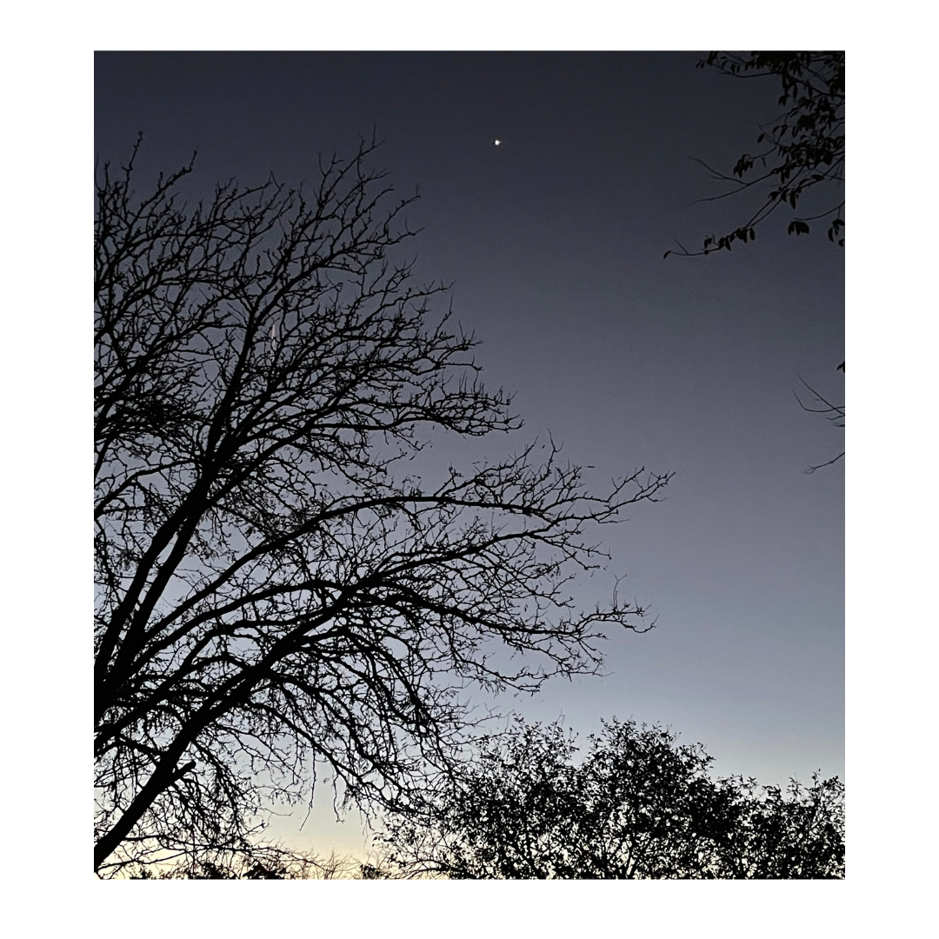
Figure 2 Venus, the Morning Star, shining brightly. Photo by author, Nov. 2, 2023.
Only for four mornings during the month of observation did Venus face competition for the most notable object in the early morning sky. On November 6, I noted in my journal that 'seemingly out of nowhere the Moon appeared today - I was so engaged with Venus, how did I forget about the moon?' In subsequent days, I likened the interaction of the two as a type of 'celestial mating ritual' where the 'Moon

Maria Meier 2309714 Page 3 of 7

seems to be dancing around casting its light trying to get Venus' attention,' until finally on November 9, when I wrote that 'the two celestial bodies seemed to be a happy couple posing for a selfie.'

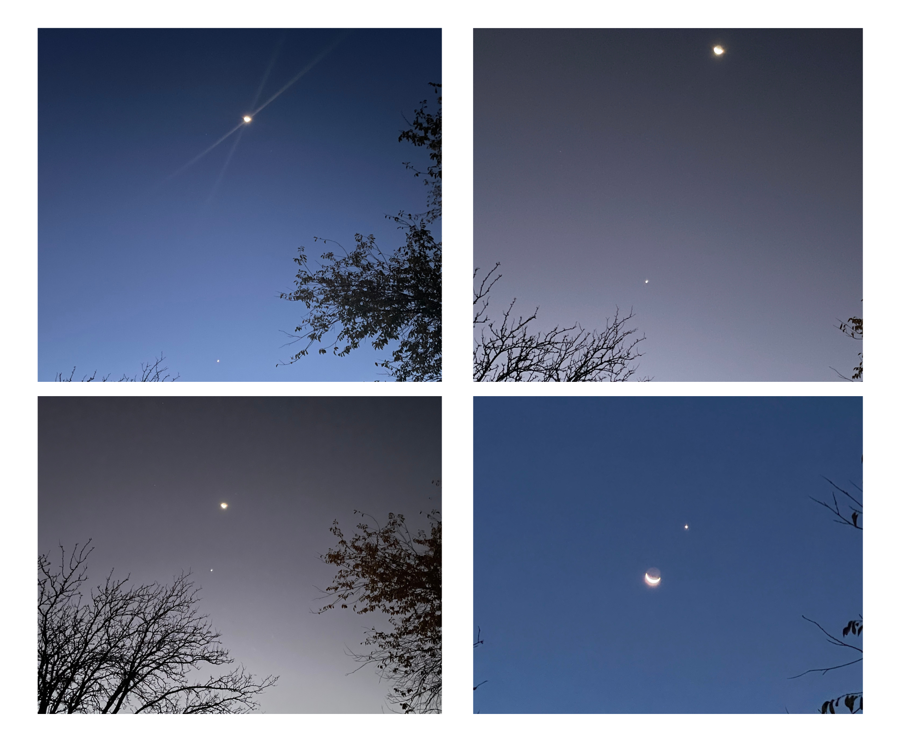

Figure 3 Collage of photos by the author of the dance of Venus and the Moon in the predawn mornings of Nov. 6-9, 2023.
Once drawn in by its brightness, I began my daily watch and quickly learned what would become another significant quality of Venus, the speed of its transit across the sky. While we think of stars as
fixed blinking objects in the sky, Venus was differentiating itself and I noted that motion was going to be a notable feature of this observation process.

'infinity on high'

Due to the combination of Venus and Earth's orbital motions, Venus' apparent speed can be quite fast when it is closer to Earth. When it is on the same side of the Sun as Earth, it can cover a significant portion of the sky over a few weeks at a rate that varies from a few degrees to about one degree per day across the sky. Even though I knew many of these facts, to be observant of a heavenly body regularly is to recognize how dynamic space is. We can be lured into a false sensation that because from our perspective the sky may seem serene and peaceful, these objects are really careening around in their orbits at incredible speeds.
I can recall studying pictures in primary school that showed the planets forming neat, circular, evenly-spaced orbits around the Sun, however, that is far from the truth. As Venus continued its trajectory away from the Earth, it was becoming a small dot taking the perceivable depth of the sky to a much greater distance. Describing possibly a similar vision, van Gogh referred to a distant object he was viewing as 'the mysterious brilliance of a pale star in the blue of infinity.' I was relieved when after only a couple of days, I could tell based on the trees that framed my view, I realized, Venus once again was

Maria Meier 2309714 Page 4 of 7

slowly making its way back towards me enacting the sketch of its orbital pattern I had included in my journal.

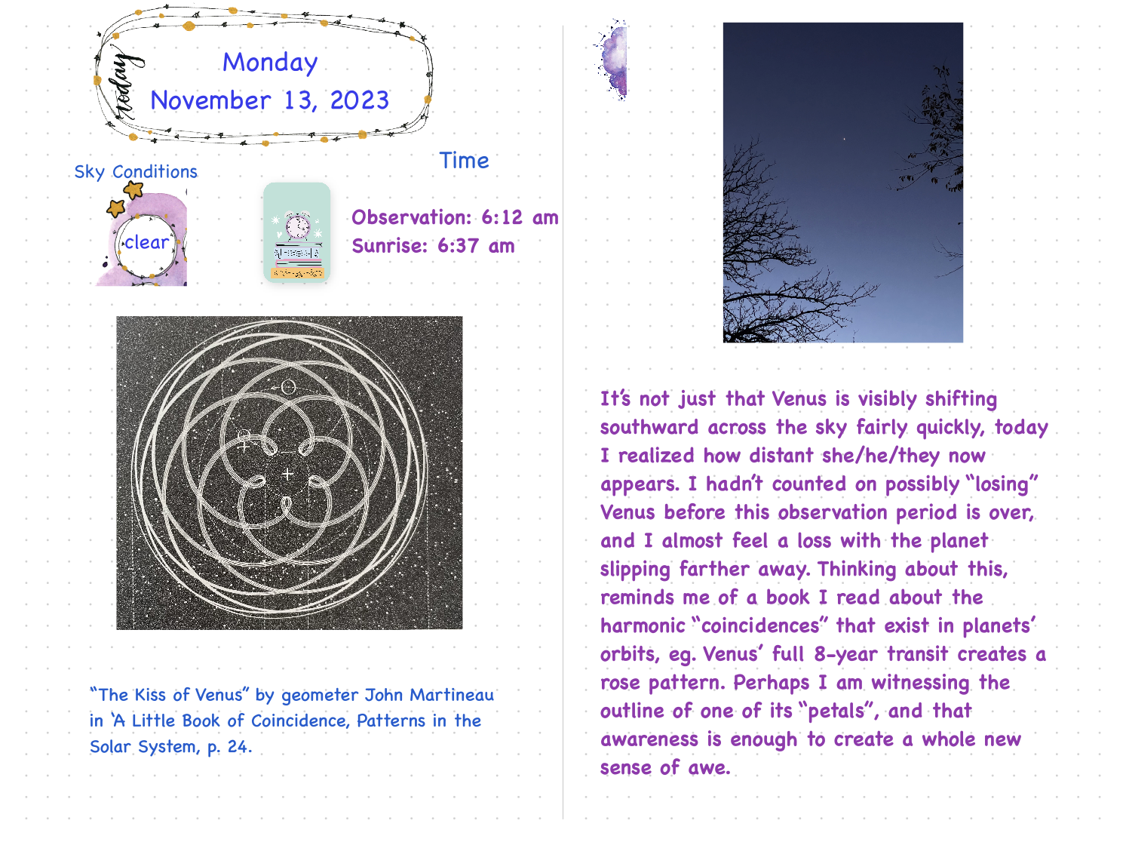
Figure 4 page from my sky journal for Nov. 13 noting the distance of Venus and a sketch of its orbital pattern.

On the final day of observation, I took a panorama photo of my backyard and added notations marking the approximate place in the sky where I viewed Venus through its path across the sky in an upward motion only to trail downward in preparation to repeat the pattern again, for another few of months before
it disappears to later appear in a new iteration as the Evening Star. However, objectively recording brightness and motion was not enough to fully explain the process.

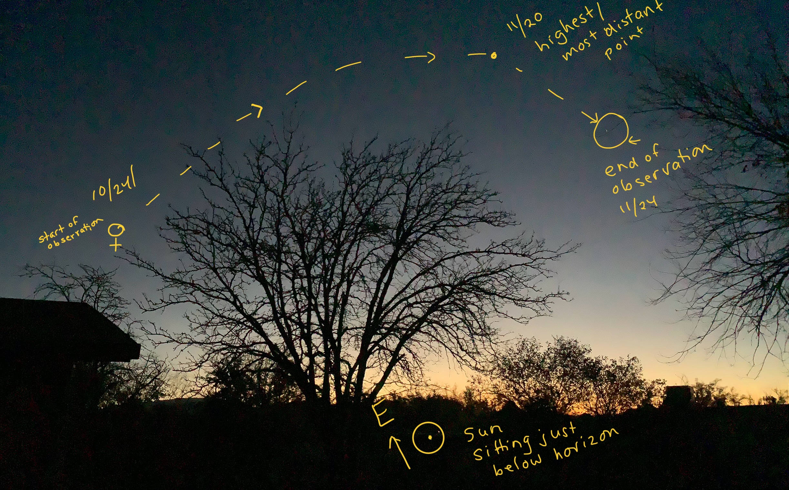

Figure 5 Panorama photo of the path Venus took across the sky during the month of my observations. Photo and notations by the author.

Maria Meier 2309714 Page 5 of 7

'Then life seems almost enchanted after all.’

It did not take long to realize that for me the act of observing the sky daily went far beyond
the academic process of facts and calculation. In the same way that modern science distinguishes the science of astronomy from the practice of astrology, so, too, does modern celestial observations focus on the mathematically quantifiable alone. I would argue that so much is lost in this process.
There is a special feeling of synergy conducting an observation and reflection of the “enchanted” skies from an “enchanted land. The state of New Mexico's nickname is the “Land of Enchantment” it was first used as an acknowledgement of the vast vistas where land and sky merge and transport the observer to somewhere beyond the mundane. When van Gogh urges the reader to ‘be clearly aware of the stars and infinity on high,’ he describes the process of sky-watching as one that infuses a sense of ‘enchantment’ in the viewer. We can only speculate on his choice of this word, but it does invoke a sense of the other-worldliness of the process.
An etymological exploration of the word reveals its shared roots with ‘incantation” or "to chant a magical spell." Over the centuries, the term has evolved to encapsulate a multifaceted concept, blending elements of magic, fascination, and allure. An enchantment captivates and delights, often associated with a magical or spellbinding quality. It suggests a sense of wonder and fascination that goes beyond the ordinary. To be enchanted is to be under the influence of a charm or magic that transforms the mundane into something extraordinary, infusing life with a touch of the magical and the mysteriously beguiling.
In his writings, Aristotle spoke to the four elements that comprise the universe: earth, air, water, and fire, however, he also believed in the concept of ' quintessence' a word that means 'fifth essence', a celestial sphere that he classified as being unchanging and incorruptible. Here in the quintessence, is where the magical spell of enchantment can take hold. Wherever the point of observation occurs, the
very act itself connects us, modern humans, to the acts of our earliest ancestors. In contemplating the stars, we find ourselves connected to a narrative that transcends our individual stories and narratives that span all time.
Though the mythology associated with celestial objects was not the subject of this journal project, it was difficult to immerse oneself in the daily process of sky-watching without reflecting on the context and meanings cultures have assigned to the planets and stars. From the Sumerians' 'the queen of heaven,'' associated with love and beauty and fertility, to the bellicose 'Lord of the Dawn, who battled the rising sun' to the Mexica (Aztec), the meanings of the same object are as diverse as the cultures and their cosmologies. The key is not how their understanding developed, but that across the globe, humans have needed to draw a real-world connection to the non-tangible ether.
Enchantment, therefore, in this context, is not merely a fleeting feeling but, it is as van Gogh calls us to engage in, a profound awareness of the sublime. It’s about acknowledging the vastness of the universe, recognizing our place within it, and marveling at the beauty that surrounds us.

Maria Meier 2309714 Page 6 of 7

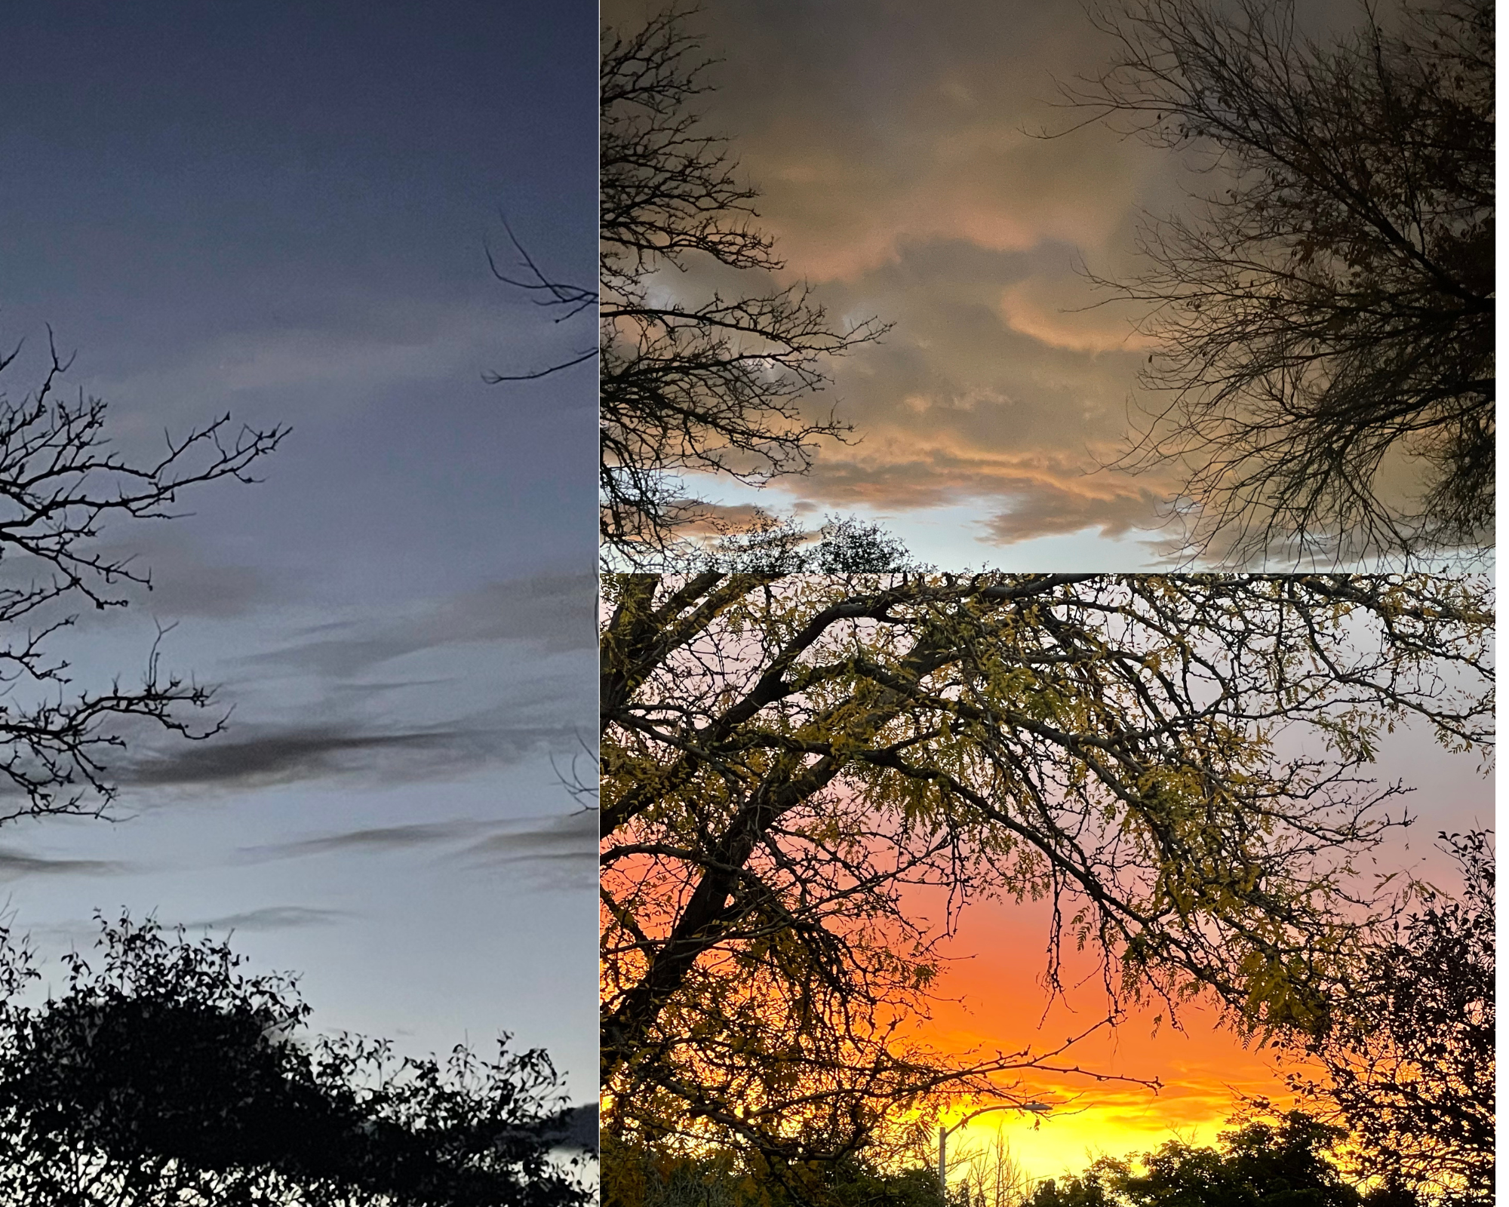
Figure 6 Enchanted skies are not the purview of Venus alone but can be found anywhere simply by looking up. Photos by the author of cloudy mornings when Venus was not visible. Oct. 24- Nov. 24, 2023.
Committing to study the heavens became a very personal one during which time it felt like I was establishing a relationship with the Morning Star. It was with anticipation, that I found myself rushing out each morning to see how far the planet had traversed or what other noticeable changes I could spot. During my one-month-long early morning observation of Venus, I only encountered another human being once as recorded in my journal entry for Sunday, November 12:

As I was snapping pictures, I had the sense that I was being watched. Looking across the yard, I saw a man, who was walking his dog, pause to glance at me. His face was in the shadows, but I could imagine the quizzical look on it - me, in the morning dark, in my fuzzy pink robe in the middle of the yard, taking pictures of seemingly nothing. As soon as he realized that I had seen him, he turned away as if embarrassed and continued walking. It was then that I regretted not waving or calling out to him because I realized how much I wanted him to ask me what I was doing. I wanted to explain, to share my photos, to share my wonder, and ask him if he ever paid attention to anything in the sky with something more than a passing note. But I didn't, and he did what is our default response to most things nowadays - he looked down.

The irony of our scientific and technological advancements in astronomy is that they have taken us further away from the source of awe that inspired the search for answers in the first place. Without a
sense of what Campion calls a ‘numinous awe of the heavens’ or the type of enchantment that van Gogh speaks to, a magical spell that takes us out of the mundane and transports us into a liminal space, we risk losing not just one of the greatest motivators for exploration of our world, but the thread which connects past, present and future as well.

Maria Meier 2309714 Page 7 of 7

Bibliography

Achenbach, Joel, 'Scientists find 6 planets, billions of years old, circling nearby, sun-like star', The Washington Post, 30 November 2023, p. A2.
Campion, Nicholas. A History of Western Astrology: Volumes I. London: Bloomsbury, 2008.
Gogh, Vincent van, and Ronald de Leeuw, The Letters of Vincent van Gogh, London: Penguin Books, 1997.
Hahm, David E. “The Fifth Element in Aristotle’s De Philosophia: A Critical Re-Examination.” The Journal of Hellenic Studies 102 (1982): 60–74. https://doi.org/10.2307/631126.

Martineau, John. A Little Book of Coincidence. New York: Walker & Company, 2000.

MIT Technology Review, The Puzzle of Ancient Star Catalogues and Modern Brightness Corrections, (March 12, 2013) <https://www.technologyreview.com/2013/03/12/179445/ />.

Sobel, Dava. The Planets. New York: Penguin Group, 2005.

Taube, Karl, Aztec and Maya Myths, Austin: University of Texas Press, 1993.

Dava Sobel. The Planets. New York: Penguin Group, 2005, p.49.
MIT Technology Review, The Puzzle of Ancient Star Catalogues and Modern Brightness Corrections, (March 12, 2013) <https://www.technologyreview.com/2013/03/12/179445/ /> [accessed 25 November 2023].
Sobel, p. 51.
Joel Achenbach, 'Scientists find 6 planets, billions of years old, circling nearby, sun-like star', The Washington Post, 30 November 2023, p. A2.
Vincent van Gogh, and Ronald de Leeuw, The Letters of Vincent van Gogh, London: Penguin Books, 1997, p 163.
David E. Hahm “The Fifth Element in Aristotle’s De Philosophia: A Critical Re-Examination.” The Journal of Hellenic Studies 102 (1982): 60–74. https://doi.org/10.2307/631126.
Nicholas Campion, A History of Western Astrology, Volume I: The Ancient World, London: Bloomsbury, 2008, p. 52.
Karl Taube, Aztec and Maya Myths, Austin: University of Texas Press, 1993, p 15.
Campion, p. 5.

