E-Portfolio

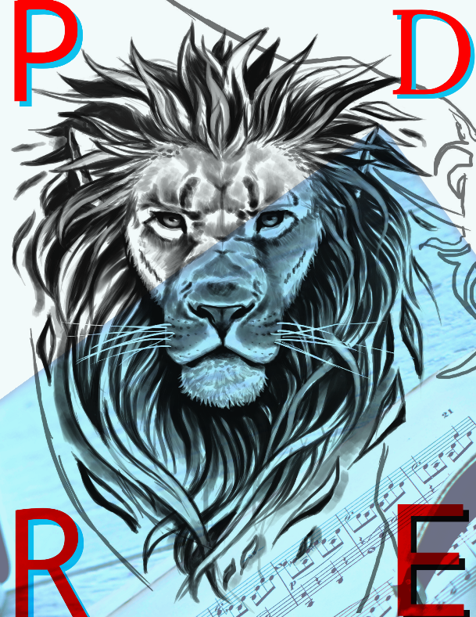
I decided to use a Lion as my logo because the lion symbolize Courage, Pride, Warm, Determine. Which I see that in myself. I take great pride in my music, and I have the courage to out of my comfortable zone to show my music to the people.

https://uowtsd-my.sharepoint.com/:i:/r/personal/2211727_student_uwtsd_ac_uk/Documents/Attachments/My%20project-1.png?csf=1&web=1&e=A0fJop
As for the second logo I decided to do something simple, like having an Ipad with speakers on the main screen which realises the sound of my music on the outside. You can also see the Lion on each of the corners of the logo. To finish it up I have decided to add a laptop with the word written “ride to success” to remind myself about the upcoming path to lead to get to where I need to be.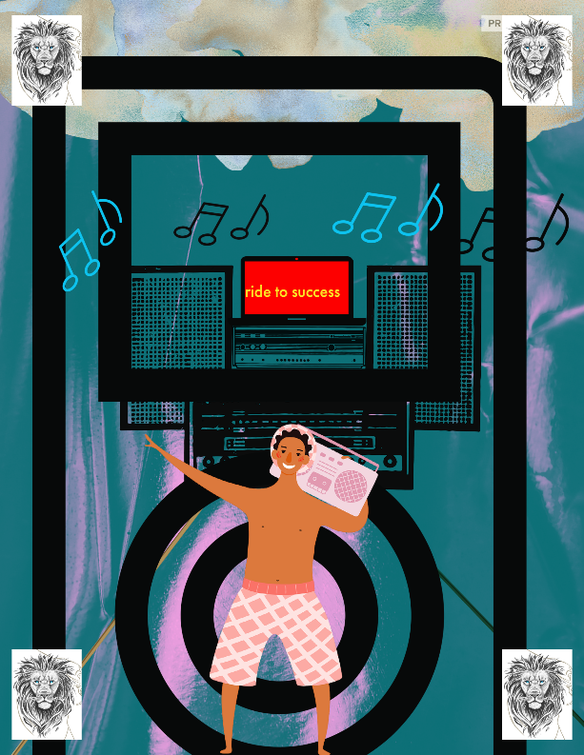
https://uowtsd-my.sharepoint.com/:i:/r/personal/2211727_student_uwtsd_ac_uk/Documents/Attachments/My%20project-2.png?csf=1&web=1&e=bjALXr
As for the other image it just representable of music.

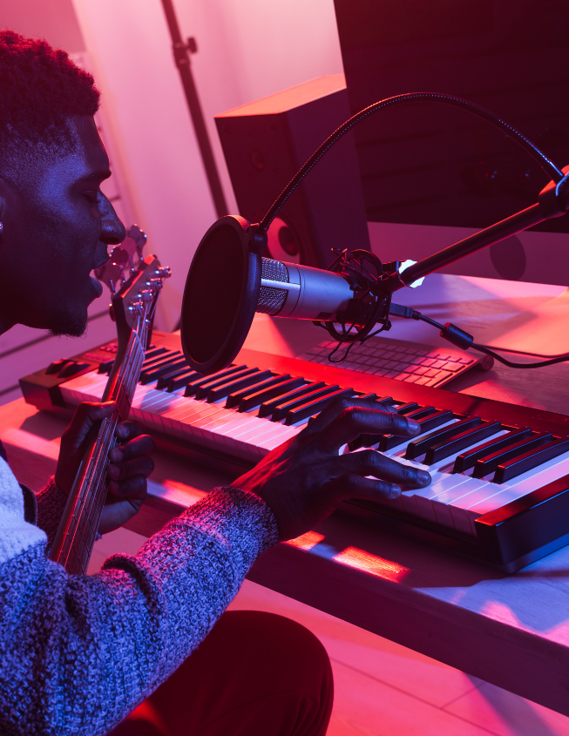

I used Adobe Creative to design the logs. The link of the site will be listed below each image
https://uowtsd-my.sharepoint.com/:i:/r/personal/2211727_student_uwtsd_ac_uk/Documents/Attachments/My%20project-3.png?csf=1&web=1&e=PfE7wD
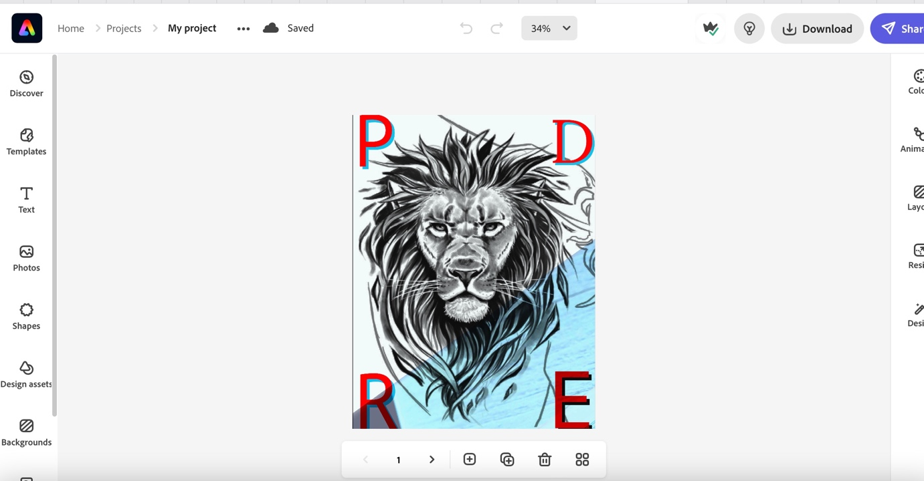
https://express.adobe.com/sp/design/post/urn:aaid:sc:EU:dcd1d631-6632-40de-86e6-8e1ea6534580?x-product=CCHome%2F1.0&guid=593a10bc-7c45-40f4-93dd-77a56a0f39af
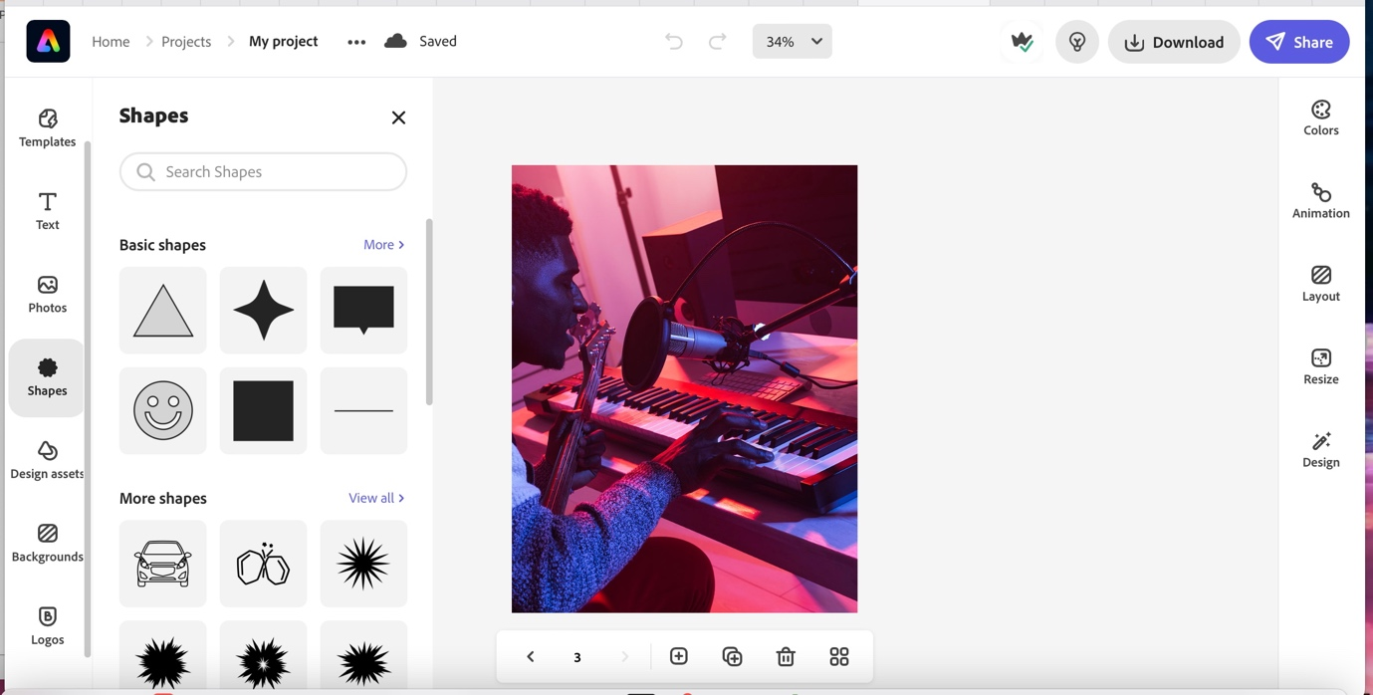
https://express.adobe.com/sp/design/post/urn:aaid:sc:EU:dcd1d631-6632-40de-86e6-8e1ea6534580?x-product=CCHome%2F1.0&guid=593a10bc-7c45-40f4-93dd-77a56a0f39af

Create a Composition Collaboratively:
An original composition (3-minute minimum) must be created in groups larger than two.
Here is a screen of me and my team original 3-minute composition style instrumental which was develop in class. The people who were apart of the team were Luke, Thomas, David, joseph include me, Paul. I specialized more into the mixing the sound of each individual musician as for the rest there they come up with the musical idea from scratch and started playing, recoding on to logic pro.
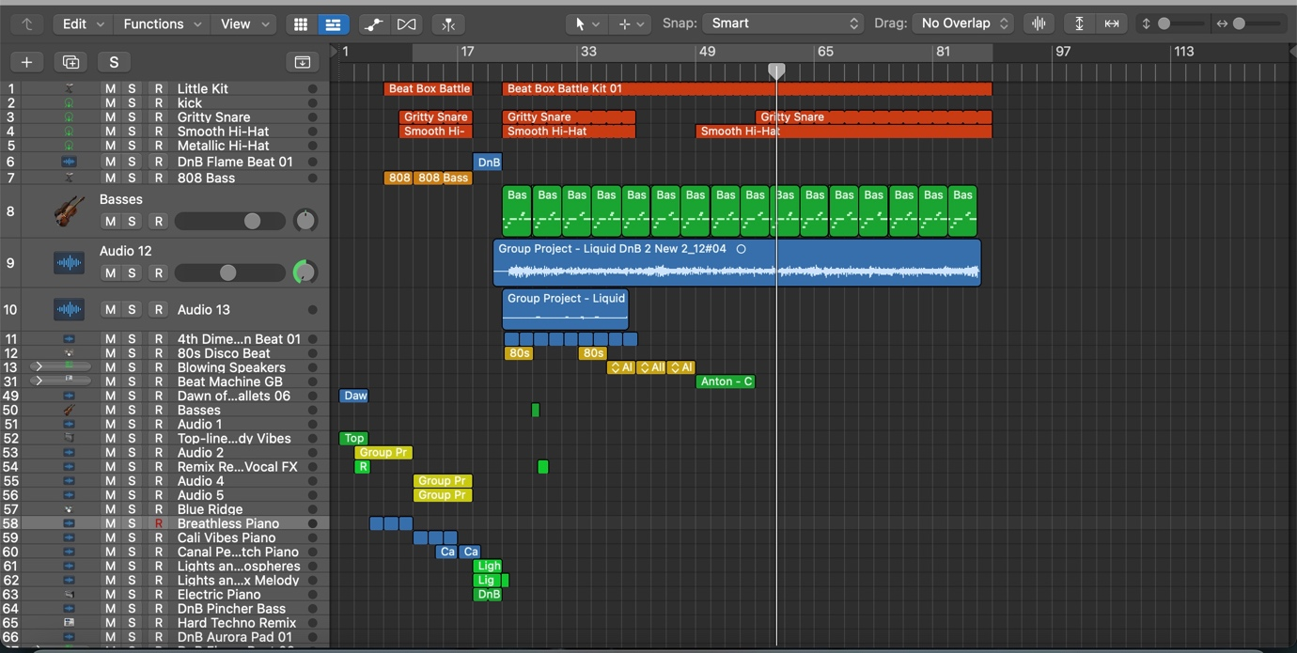
Here is a screenshot of me talking with Tomo’s Hopkins about the instrumental. I have mixed the song and sending it to him so he can also edit. Here is the link below
https://uowtsd-my.sharepoint.com/:u:/r/personal/2211727_student_uwtsd_ac_uk/Documents/Attachments/Group%20Project%20-%20Liquid%20DnB%202%20New%202.logicx.zip?csf=1&web=1&e=NIiO9b
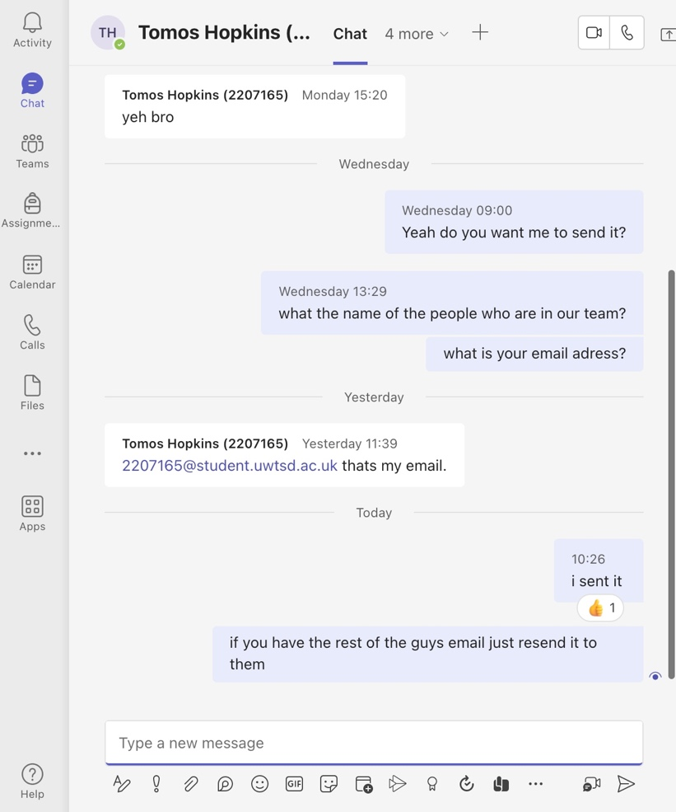
I movie logo for and original video for the assignment
https://uowtsd-my.sharepoint.com/:v:/r/personal/2211727_student_uwtsd_ac_uk/Documents/Attachments/My%20Movie.mp4?csf=1&web=1&e=UQVk2P
the name of the song call “women”
https://uowtsd-my.sharepoint.com/:u:/r/personal/2211727_student_uwtsd_ac_uk/Documents/Attachments/women%20.mp3?csf=1&web=1&e=gJlzEy

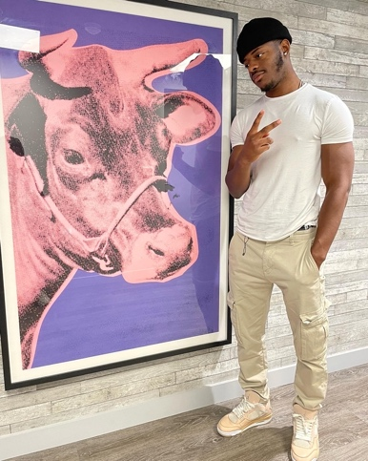
Biography By Paul Mukolonga
My great passion in life is to express myself through music. Though my music I seek to document my own personal experiences of writing song and expressing my own experiences with my audience.
I grew up in The Democratic Republic Of Congo Kinshasa and became fascinated with Music at an early age. This led to want to become my own artist. In 2010 I moved to London started to go to high school and that where my journey begin, I guess. i mean I was always interested to learn how to play the piano at a very young age. I was a shy kid, so I never had the courage and strength to tell the teacher that I want to stay after class and learn to play an instrument.
Throughout the year of growing up I moved from London to Swansea. While being in Swansea I decided that I will start taking on the courage that I once felt I never had and decided to want to become an artist and start expressing myself through my songs. As a versatile artist I began to start the journey by writing, producing, my own sound of music which were R&B, Hip, Hop, Rap, Singing, Story Telling. Anything which will sound good in the ears of my audience.
I also understood that music is energy, it what makes the world go around. Since life is a dance, therefore music is the way to make people dance. It was the way I used to see life. I am still excited to how much power music has and influence the world.
I have a story to tell, and wheatear I make it to the world or not I just want to leave my story behind for the next generation. It’s a dream that I am willing to fulfilled at all cost.
I will be uploading a song I made. And the title is call “Women Love”. The inspiration came from my Ex-girlfriend. We broke up and I felt as if my heart wouldn’t get back into place.

