UNIVERSITY OF WALES TRINITY SAINT DAVID

Module code: ACCC5005
PROJECT MANAGEMENT

Japher Motors Integrated System

Author: Apostol George-Adrian
Student ID: 1807626
Lecturer: Koushik Moudak

Table of Contents
Executive Summary 3
Project Objectives 3
Project Scope 3
Project Deliverables 4
Project milestones 5
Project Techniques and Tools used 5
Gantt chart 8
Network analysis 8
Stakeholder management plan 9
Quality management plan 10
Case Study 10
Quality control tools 10
Risk management plan 11
Risk register 11
Communication plan 12
Appendix 13
Database view 13
Presentation view 16
References 17

Executive Summary
Japher Motors Integrated System wants to upgrade its old and booking payment system to have new features that are compatible with current technological trends. Japher Motors Integrated System operates on a booking and payment system that can take records of deposits paid by customers. However, the management of the company wants to implement a new system which would be able to generate payment costs and then correctly store the inventory of the spare parts available for the company.
The project is stipulated to cost about $26,000. The timeline of the project is estimated to last for 36 days. The project would be carried out using the traditional way. Hence, the project is divided into five phases which are the: Initiation, Planning, Execution, Controlling and the Closing.
A proper description on the stakeholders of the project, the project scope, project deliverables (both hardware and software components), project milestones, budget analysis, risk analysis and the acceptance criteria would be given in the project.

Project Objectives
Japher Motors needs a functional system that will also safeguard stored data and information belonging to customers. Hence, the objectives of the project are stated as follows:
- To have a trending booking and payment system. It would be easily be upgraded to accommodate new features in business operations.
- To acquire a new payment system which is used to store inventory details of spare parts.
- To have a system that can quickly generate payment cost.
- To have a secure booking and payment system that can store large amounts of data
- To have a new booking system that can monitor customers’ history of visits.

Project Scope
The project plan encompasses all the processes, methods, techniques, tools and deliverables to be expected when establishing a new IT booking and payment system for tracking customer purchases and booking their credit purchases for Japher Motors. Japher Motors is looking for a business solution that can improve its customer experience. Improvement of customer experience and employee competency are parts of the strategic plan of most organizations (Spedding and Rose, 2008). It is expected that this customer user experience improvement could be achieved by implementing a new IT payment and booking system into the business processes of the company. The expectations from a current IT system that can support sales and customer personal information storage are high. Hence, this project requires proper planning and budgeting. Within the project, all the activities involved in the starting of the project to its finish would be described. A proper description on the stakeholders of the project, the project scope, project deliverables (both hardware and software components), project milestones, budget analysis, risk analysis and the acceptance criteria would be given in the project.
The deliverables to expect at the end of the project have been listed above. In addition to this, a sample of how the database of the new IT system and the kind of data it will be able to store would be shown using the aid of a database software known as Microsoft Access. The output of the database file would be used to show the type of data and information that would be stored by the new system. The stipulated total budget for this project is $26,000.00, and it includes the cost of labour in carrying out the user training, cost of labour in developing and in implementing the software, software licensing, hardware purchases and the cost of carrying out quality tests for the project.
The stakeholders of this project include Japher Tom, the project sponsor and the CEO of the company, the CIO (Chief Information Officer) who is also the project manager, the IT personnel who forms part of the Project Team, the outsourced vendors and the suppliers. The CEO is the project sponsor of this project. He is responsible for disbursing the needed funds for the project. The project manager controls all the processes involved in the project. The suppliers provide the hardware and software components needed in the project.

Project Deliverables
The deliverables of the project include:
- A new IT system for tracking payments and bookings by customers
- A booking and payment system with the current technological features and high scalability
- Project documents such as the risk register, the project communication and the project charter
- Software license for the new IT systems in the company
- Hardware components such as computers and other devices which are compatible with the new software
- Fast internet connection for the storage of information in the network database of the new IT system

Project milestones
As shown in the Gantt chart (see figure 1), the milestones in the project are marked with rhombus figures on the Gantt chart. The milestones of the project are listed in this table:
Milestone | Date
Project approval | 12/9/2019
Cost and schedule baseline | 12/11/2019
Development of the software | 12/26/2019
Product testing | 1/1/2020
System promotions | 1/8/2020
Go-Live | 1/20/2020

Table 1: Project milestone

Project Techniques and Tools used
The tools and techniques necessary for managing projects are all embedded in many project management software (Glenn, 2010). These project management tools are essential in business communications (Glenn, 2010). The first approach used in managing this project is the traditional approach. The Project Libre software has tools which are essential in managing all the parts of the project (scope, scheduling, budgeting).

The essential tools in the software include the network analysis chart, the Gantt chart, the precedence table, the WBS structure and other charts. The WBS is used to define all activities and tasks entangled in the project. The Gantt chart is used to show the project timeline and to express the components of the WBS visually. The precedence table is where the raw data of activities are entered. The network chart defines the paths taken by the tasks for the project to finish earlier or later than the stipulated time.

The WBS “represents an explicit description of the project’s scope, deliverables and outcomes.” (Norman, Brotherton and Fried, 2010).
The WBS developed by our group helped us to divide the work into manageable sections between the team members and is presented below.

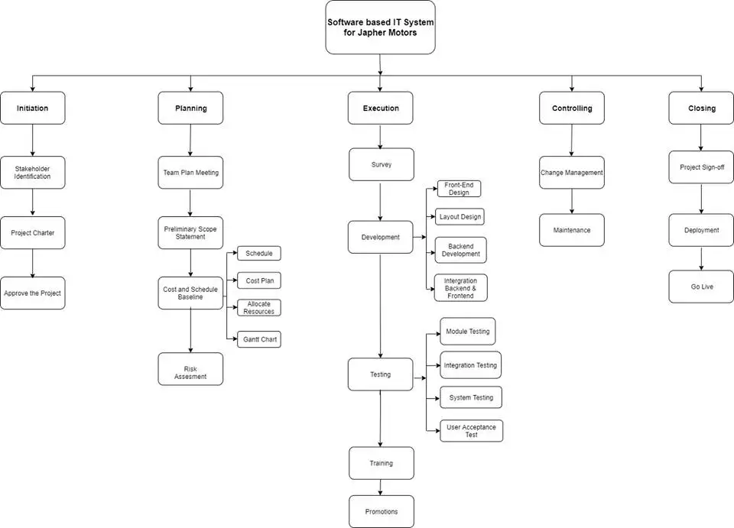

Figure 1: WBS diagram
Also, the duration and dependencies for each task involved in the project can be found in this WBS table:
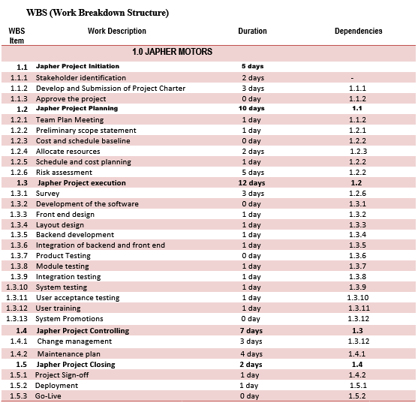

Table 2: WBS

Gantt chart
The Gantt chart is an essential tool in business management and strategic planning (Merna and AL-Thani, 2008). It is a visual representation of the WBS. The figure below shows the precedence table and the project’s Gantt chart.
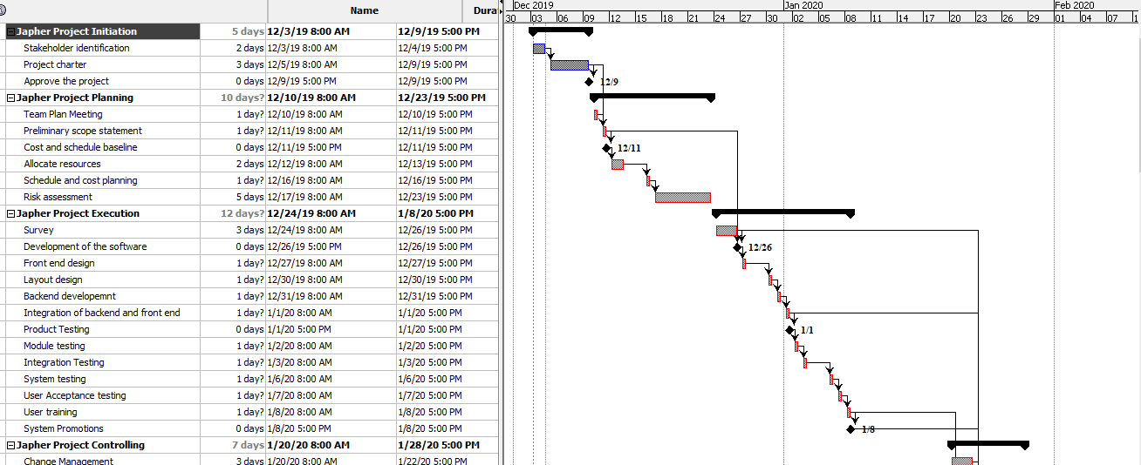
Figure 2: Gantt chart

Network analysis
The figure below shows the project’s system chart. The critical paths are shown in red.
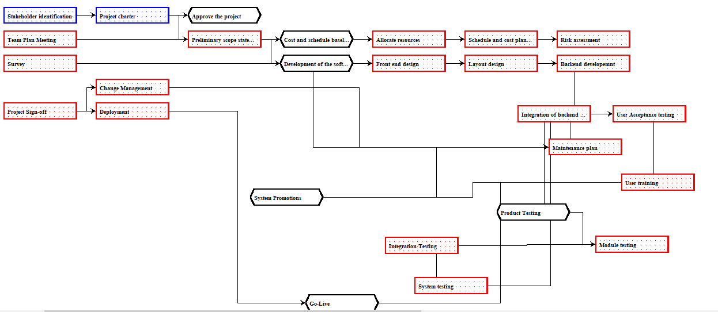
Figure 3: Network diagram

Stakeholder management plan
The stakeholders involved in this project can be adequately managed using the RACI chart. The RACI chart defines the roles of the stakeholders for the project manager according to the project milestones.
The stakeholders of this project include Japher Tom, the project sponsor and the CEO of the company, the CIO (Chief Information Officer) who is also the project manager, the IT personnel who forms part of the Project Team, the outsourced vendors and the suppliers. The CEO is the project sponsor of this project. He is responsible for disbursing the needed funds for the project. The project manager controls all the processes involved in the project. The suppliers provide the hardware and software components needed in the project. “To manage stakeholders effectively, you need to understand what drives the behaviour of your stakeholders and how you can influence this behaviour.” (Eskerod and Jepsen, 2016).

RACI means Responsible, Accountable, Consulted and Informed.

Tasks | CEO | CIO | Project team | Vendors/suppliers
Approval of the project | R | A | C | I
Costing and schedule | C | R | A | I
Software development | I | C | R | A
Go live | I | R | C | A

Table 3: RACI table for stakeholders

Quality management plan
The quality management plan comprises of the two significant forms of evaluation and the case study for the system simulation. The two significant forms of evaluation would be used to assess the quality of the delivered software and to test its security. These two forms of evaluation are known as the summative and formative evaluation.

Case Study
Mr Japher tried to trace the number of times his favourite customer, Mr Harry has visited the company. He queried the database of the new IT system by entering Mr Harry's name into the computer. However, the computer refused him access. It was until one of the IT analysts who designed the software granted him the password that could give him administrator privileges, that he was able to see the number of times Mr Harry has visited the office and what he purchased in those periods.
What this implies is that the system is secured. No unauthorized individual can gain access to the database. Hence, the privacy rights of customers are respected. It is under the NIST and PCI-DSS standards, which are the standards guiding the IT industry. The database is presented in the appendix section (see Appendix).

Quality control tools
The procedure to assure the project’s quality was done with the NIST framework. The NIST framework is a set of guidelines established by the National Information security standards to direct project managers on how an acceptable project in Information Technology should be.
It is recommended for any company receiving payments through encrypted cards via online or offline platforms (Warner, 2017).

Risk management plan
Risks are unpleasant occurrences which can cause a project to be halted or be terminated (Merna and Al-tharni, 2008). The risk management plan is dependent on the use of risk registers in managing the risks involved in the project. The risk register is shown below:

Risk register
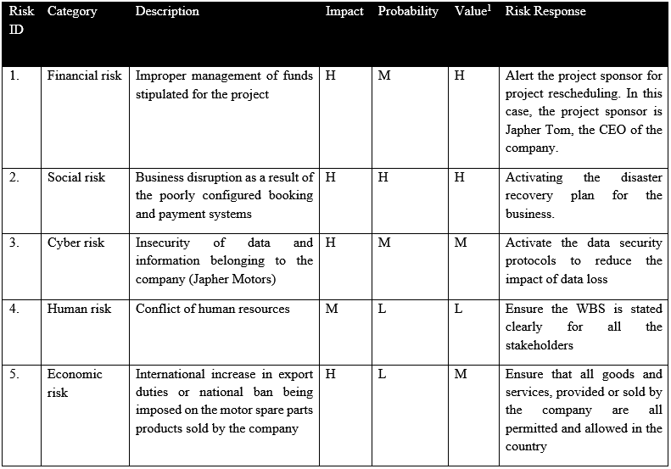
Table 4: Risk register

Communication plan
Communication | Method | Instrument | Frequency | Type | Goals
Project Initiation and evaluation | Face-to-face meetings | Emails, meetings, video calls | Daily for the initial stage | Verbal, non-verbal and written | To evaluate and recommend activities, project team and vendors for the project
Project team members meeting | Face-to-face meetings | Emails, meetings | Daily for the initial stage | Written and verbal | To identify the members of the  project team and to introduce them to the project manager
Project survey | Applying project tools | Emails, social media platforms | Weekly | Written and verbal | To get information and ideas from all stakeholders about the project plan and other parts of the project.
Integration of the backend and front-end components for a new system | Applying project tools | Work Breakdown Structure, Gantt chart | Weekly | Written | To inform the project stakeholders that books are being shipped to Guatemala
The software system goes LIVE | Applying project tools | Social media platforms, emails, meetings | Monthly | Written and verbal | To inform the project stakeholders about this milestone being achieved
Project progress reports | Applying project tools | Work Breakdown Structure, Gantt chart, network analytical tool | Weekly | Written | To inform the project stakeholders about the milestones and deliverables obtained from the project
Project risk assessment | Face-to-face meetings | Risk register | Monthly | Verbal and written | To review the risks that may affect the project even after launching.
Project acceptance/evaluation | Face-to-face meetings | Work Breakdown Structure, Gantt chart, project documents | Monthly at the closing stage | Verbal and written | To ensure that the project meets criteria before being accepted
A communication plan permits the manager of the project to establish good communication with the team. It also allows for easy dissemination of information among all the stakeholders of the project (Spedding and Rose, 2008). The communication plan is presented in the table below:

Table 5: Communication plan

Appendix

Database view
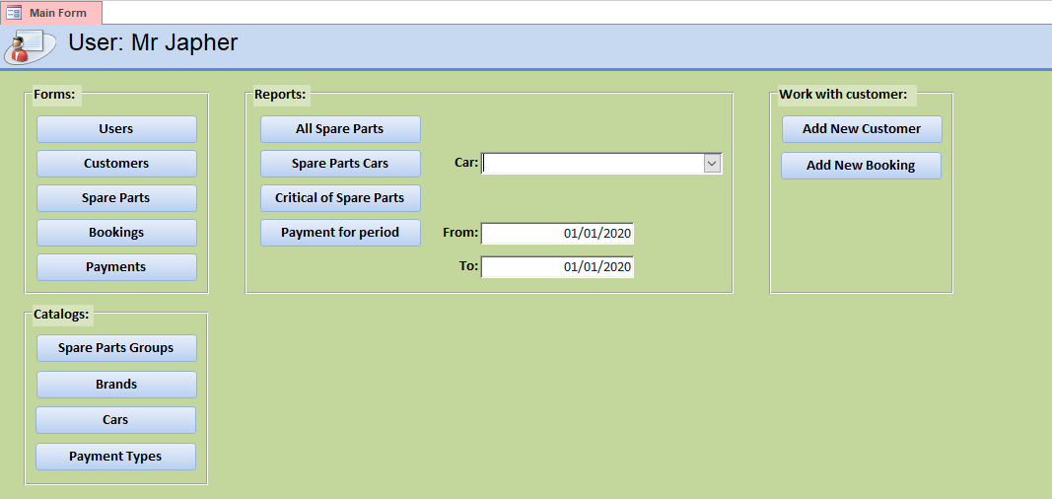
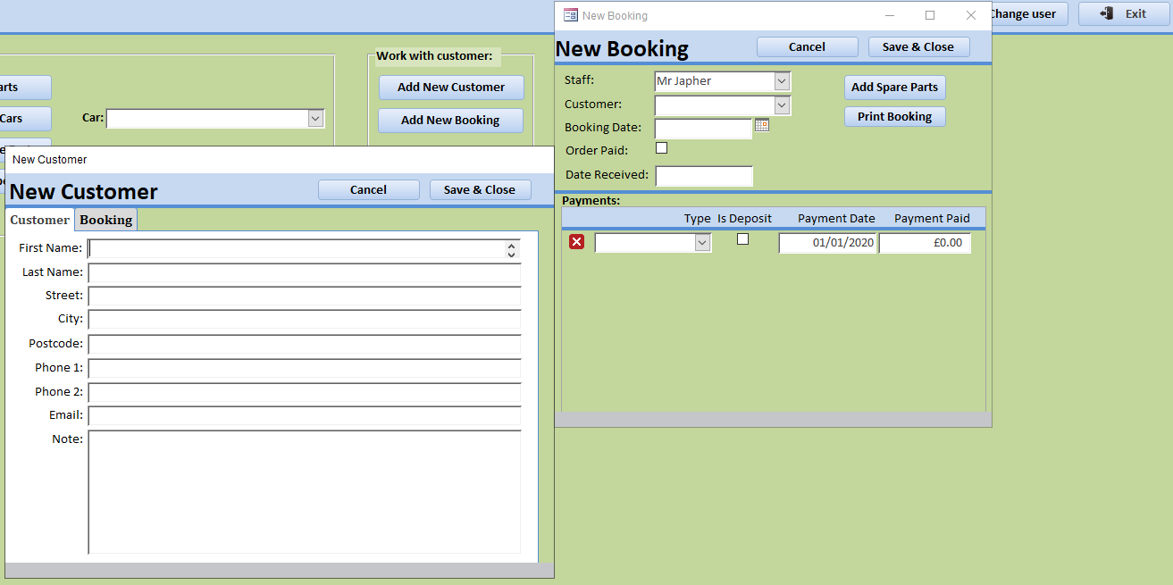
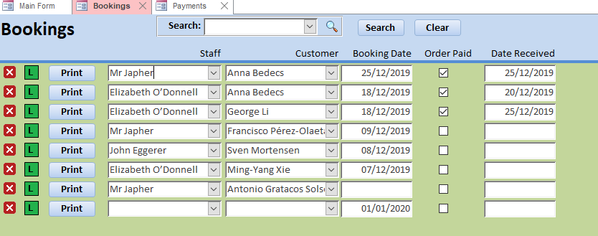
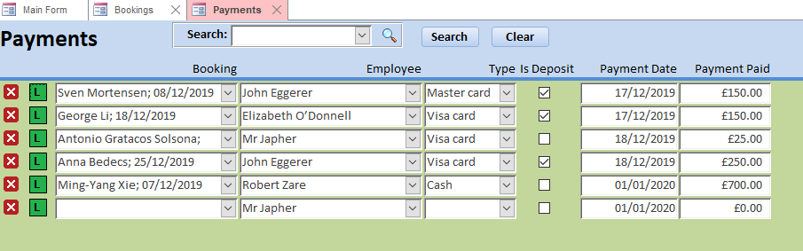
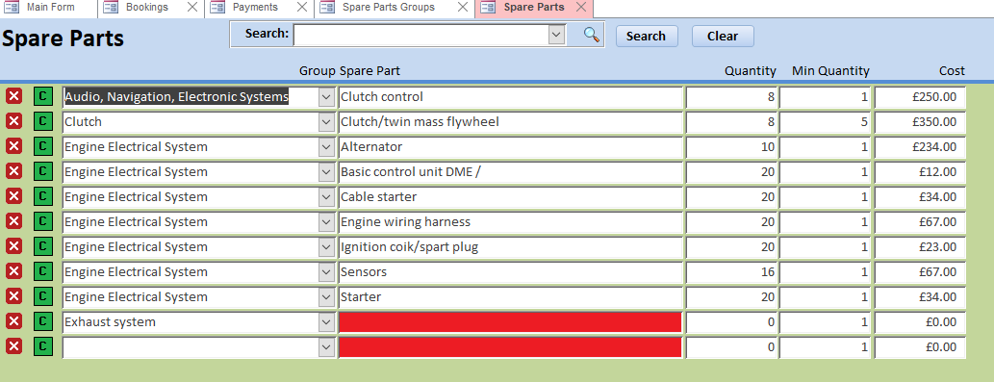

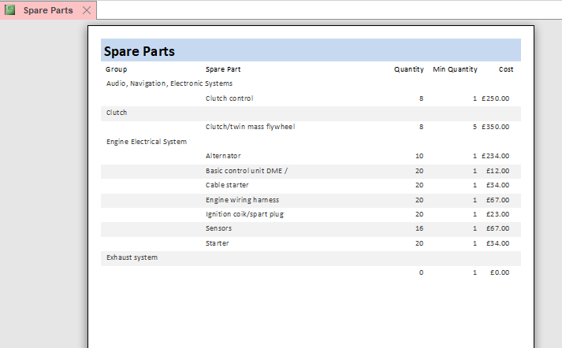

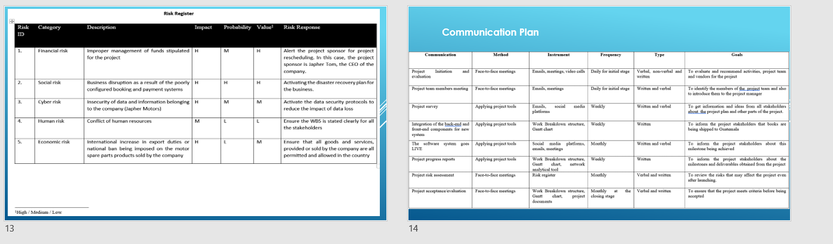
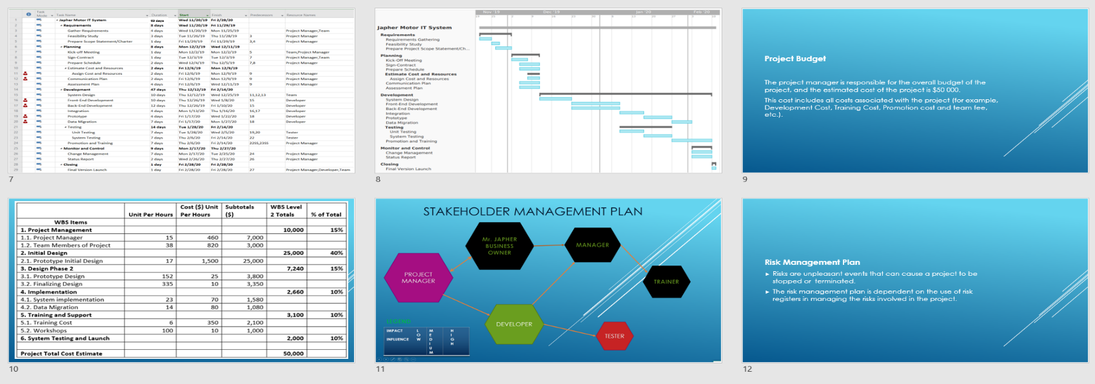
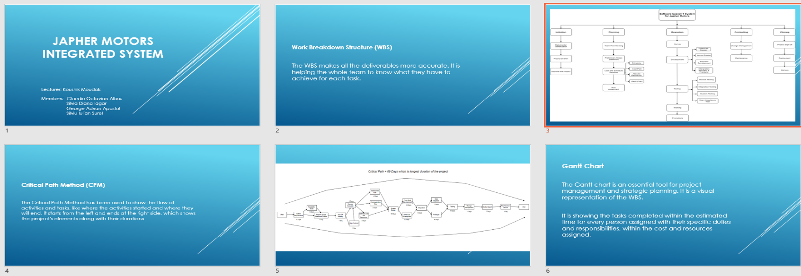
Presentation view

References
- Merna, T. and AL-Thani, F. (2008). Corporate Risk Management, 2nd Edition. 2nd ed. West Sussex, England: John Wiley & Sons Ltd, pp.240, 11-14.
- Spedding, L. and Rose, A. (2008). Business risk management handbook. Oxford: CIMA, p.240.
- Warner, A. (2017). Information Security Costs: Budgeting for Cybersecurity. [online] Blog.procircular.com. Available at: https://blog.procircular.com/information-security-costs-budgeting [Accessed 1 Jan. 2020].
- Glenn, C. (2010). "Two Magic Quadrants for Unified Communications". Seamless Enterprise. Archived from the original on 2010-09-15. Retrieved: 2019-11-26
- Eskerod, P. and Jepsen, A. (2016). Project stakeholder management. Abingdon, Oxon: Routledge.
- Norman, E., Brotherton, S. and Fried, R. (2010). Work breakdown structures. New Jersey: John Wiley & Sons, p.12.

